
DEPARTMENT OF COMPUTER SCIENCE AND ENGINEERING

CPU SCHEDULING

A MINI PROJECT REPORT
in
24CST42 - OPERATING SYSTEMS

Submitted by
AMIRTHAMOZHI V S(24CSR019)
ASMA THASNIM H (24CSR029)
DHARANEESH S C(24CSR057)

in partial fulfilment of the requirements for the award of the degree of
BACHELOR OF ENGINEERING
IN
DEPARTMENT OF COMPUTER SCIENCE AND ENGINEERING
KONGU ENGINEERING COLLEGE (Autonomous)
PERUNDURAI ERODE-638060
APRIL 2026

FACULTY INCHARGE
Dr.N.SHANTHI
SENIOR PROFESSOR / CSE

CODE
INDEX.HTML
<!DOCTYPE html>
<html lang="en">
<head>
<meta charset="UTF-8">
<meta name="viewport" content="width=device-width, initial-scale=1.0">
<title>CPU Scheduling Simulator Pro</title>
<link rel="stylesheet" href="style.css">
</head>
<body>
<div class="app-container">
<aside class="sidebar">
<div class="brand">
<h2>OS Scheduler</h2>
<p>Project Dashboard</p>
</div>

<div class="input-section">
<h3>Add Process</h3>
<div class="input-group">
<label>Process ID</label>
<input type="text" id="pid" placeholder="P1, P2...">

<label>Arrival Time</label>
<input type="number" id="at" value="0" min="0">

<label>Burst Time</label>
<input type="number" id="bt" value="1" min="1">

<div id="priorityInput" class="extra-field">
<label>Priority (Lower = Higher)</label>
<input type="number" id="priority" value="0">
</div>
</div>
<button onclick="addProcess()" class="btn-add">Add to Queue</button>
</div>

<div class="algo-section">
<h3>Algorithm Settings</h3>
<select id="algoSelector" onchange="updateUI()">
<option value="FCFS">First Come First Served</option>
<option value="SJF">SJF (Non-Preemptive)</option>
<option value="SRTF">SRTF (Preemptive SJF)</option>
<option value="Priority">Priority (Non-Preemptive)</option>
<option value="RR">Round Robin</option>
</select>

<div id="quantumInput" class="extra-field">
<label>Time Quantum</label>
<input type="number" id="quantum" value="2" min="1">
</div>

<button onclick="calculate()" class="btn-run">Run Simulation</button>
<button onclick="clearAll()" class="btn-clear">Reset All</button>
</div>

<div class="team-section">
<h3>Presented by</h3>
<ul class="team-list">
<li>24CSR019 - AMIRTHAMOZHI V S</li>
<li>24CSR029 - ASMA THASNIM H</li>
<li>24CSR057 - DHARANEESH S C</li>
</ul>
</div>
</aside>

<main class="main-content">
<div id="welcome-msg">
<h1>CPU Scheduling Simulator</h1>
<p>Enter processes on the left and select an algorithm to begin.</p>
</div>

<div id="result-section" class="hidden">
<div class="card">
<h3>Gantt Chart</h3>
<div id="gantt-chart-wrapper" class="gantt-wrapper"></div>
</div>

<div class="card table-card">
<h3>Calculated Metrics</h3>
<table id="statsTable">
<thead>
<tr>
<th>PID</th>
<th>Arrival</th>
<th>Burst</th>
<th>Finish</th>
<th>Turnaround</th>
<th>Waiting</th>
</tr>
</thead>
<tbody id="tableBody"></tbody>
</table>
</div>

<div class="stats-grid">
<div class="stat-card">
<small>Avg Waiting Time</small>
<h2 id="avgWT">0.00</h2>
</div>
<div class="stat-card">
<small>Avg Turnaround Time</small>
<h2 id="avgTAT">0.00</h2>
</div>
</div>
</div>
</main>
</div>
<script src="script.js"></script>
</body>
</html>
STYLE.CSS
:root {
--primary: #4361ee;
--secondary: #3f37c9;
--success: #4cc9f0;
--danger: #f72585;
--dark: #212529;
--gray: #6c757d;
--light: #f8f9fa;
}

* { box-sizing: border-box; margin: 0; padding: 0; }
body { font-family: 'Segoe UI', Roboto, sans-serif; background: #f0f2f5; color: var(--dark); }

.app-container { display: grid; grid-template-columns: 320px 1fr; min-height: 100vh; }

/* Sidebar Styling */
.sidebar {
background: white;
padding: 30px;
border-right: 1px solid #ddd;
display: flex;
flex-direction: column;
height: 100vh;
position: sticky;
top: 0;
}

.brand h2 { color: var(--primary); font-size: 24px; }
.brand p { font-size: 11px; color: var(--gray); text-transform: uppercase; letter-spacing: 1px; }

h3 { font-size: 12px; margin-bottom: 15px; text-transform: uppercase; color: var(--gray); border-bottom: 1px solid #eee; padding-bottom: 5px; margin-top: 20px; }

.input-group label { display: block; font-size: 11px; font-weight: bold; margin: 8px 0 4px; color: var(--dark); }
input, select { width: 100%; padding: 10px; border: 1px solid #ddd; border-radius: 6px; margin-bottom: 8px; font-size: 14px; }

.extra-field { display: none; background: #f8f9ff; padding: 10px; border-radius: 6px; border-left: 3px solid var(--primary); margin-bottom: 10px; }

/* Buttons */
button { width: 100%; padding: 12px; border: none; border-radius: 6px; font-weight: bold; cursor: pointer; transition: 0.2s; margin-top: 5px; }
.btn-add { background: var(--dark); color: white; }
.btn-run { background: var(--primary); color: white; margin-top: 10px; }
.btn-clear { background: #eee; color: var(--dark); margin-top: 5px; }
button:hover { opacity: 0.9; transform: translateY(-1px); }

/* Team Section */
.team-section { margin-top: auto; padding-top: 20px; border-top: 1px dotted #ccc; }
.team-list { list-style: none; padding: 0; }
.team-list li { font-size: 13px; color: var(--dark); margin-bottom: 6px; padding-left: 15px; position: relative; font-weight: 500; }
.team-list li::before { content: "•"; color: var(--primary); position: absolute; left: 0; font-weight: bold; }

/* Main Content Area */
.main-content { padding: 40px; }
.card { background: white; padding: 25px; border-radius: 12px; box-shadow: 0 4px 12px rgba(0,0,0,0.05); margin-bottom: 25px; }
.hidden { display: none; }

/* Gantt Chart */
.gantt-wrapper { display: flex; width: 100%; height: 50px; border-radius: 8px; overflow: hidden; margin-top: 10px; border: 1px solid #ccc; background: #eee; }
.gantt-block { display: flex; align-items: center; justify-content: center; color: white; font-weight: bold; position: relative; font-size: 12px; min-width: 20px; border-right: 1px solid rgba(255,255,255,0.2); }
.gantt-block span { position: absolute; bottom: -20px; right: 0; color: var(--dark); font-weight: normal; font-size: 10px; }
.p-bg { background: var(--primary); }
.idle-bg { background: #dee2e6; color: #495057; }

/* Table */
table { width: 100%; border-collapse: collapse; }
th { text-align: left; padding: 12px; background: var(--light); font-size: 11px; color: var(--gray); text-transform: uppercase; }
td { padding: 12px; border-bottom: 1px solid #eee; font-size: 14px; }

/* Stats Grid */
.stats-grid { display: grid; grid-template-columns: 1fr 1fr; gap: 20px; }
.stat-card { background: white; padding: 20px; border-radius: 12px; text-align: center; border-bottom: 4px solid var(--success); box-shadow: 0 4px 12px rgba(0,0,0,0.05); }
.stat-card small { color: var(--gray); font-size: 12px; }
.stat-card h2 { color: var(--primary); margin-top: 5px; font-size: 28px; }
SCRIPT.JS
let processes = [];

function updateUI() {
const algo = document.getElementById('algoSelector').value;
document.getElementById('priorityInput').style.display = (algo === 'Priority') ? 'block' : 'none';
document.getElementById('quantumInput').style.display = (algo === 'RR') ? 'block' : 'none';
}

function addProcess() {
const pid = document.getElementById('pid').value || `P${processes.length + 1}`;
const at = parseInt(document.getElementById('at').value);
const bt = parseInt(document.getElementById('bt').value);
const priority = parseInt(document.getElementById('priority').value) || 0;

if (isNaN(at) || isNaN(bt)) return alert("Please enter valid times");

processes.push({ pid, at, bt, priority });
alert(`Process ${pid} added.`);
document.getElementById('pid').value = "";
}

function calculate() {
if (processes.length === 0) return alert("Add some processes first!");

const algo = document.getElementById('algoSelector').value;
let result;

if (algo === "FCFS") result = solveFCFS();
else if (algo === "SJF") result = solveSJF();
else if (algo === "SRTF") result = solveSRTF();
else if (algo === "Priority") result = solvePriority();
else if (algo === "RR") result = solveRR();

render(result);
}

function solveFCFS() {
let local = [...processes].sort((a, b) => a.at - b.at);
let time = 0, gantt = [];
local.forEach(p => {
if (time < p.at) { gantt.push({id: 'Idle', start: time, end: p.at}); time = p.at; }
let start = time;
time += p.bt;
p.ct = time; p.tat = p.ct - p.at; p.wt = p.tat - p.bt;
gantt.push({id: p.pid, start, end: time});
});
return { processes: local, gantt };
}

function solveSJF() {
let local = processes.map(p => ({...p}));
let time = 0, completed = 0, n = local.length, gantt = [];
let isDone = Array(n).fill(false);

while (completed < n) {
let idx = -1, minBT = Infinity;
for (let i = 0; i < n; i++) {
if (local[i].at <= time && !isDone[i] && local[i].bt < minBT) {
minBT = local[i].bt; idx = i;
}
}
if (idx === -1) { time++; continue; }
let start = time;
time += local[idx].bt;
local[idx].ct = time; local[idx].tat = time - local[idx].at; local[idx].wt = local[idx].tat - local[idx].bt;
isDone[idx] = true; completed++;
gantt.push({id: local[idx].pid, start, end: time});
}
return { processes: local, gantt };
}

function solveSRTF() {
let local = processes.map(p => ({...p, rem: p.bt}));
let time = 0, completed = 0, n = local.length, gantt = [];
let lastId = null;

while (completed < n) {
let idx = -1, minRem = Infinity;
for (let i = 0; i < n; i++) {
if (local[i].at <= time && local[i].rem > 0 && local[i].rem < minRem) {
minRem = local[i].rem; idx = i;
}
}
if (idx === -1) { time++; continue; }

if (lastId === local[idx].pid) {
gantt[gantt.length - 1].end++;
} else {
gantt.push({id: local[idx].pid, start: time, end: time + 1});
lastId = local[idx].pid;
}

local[idx].rem--;
time++;
if (local[idx].rem === 0) {
local[idx].ct = time; local[idx].tat = time - local[idx].at; local[idx].wt = local[idx].tat - local[idx].bt;
completed++; lastId = null;
}
}
return { processes: local, gantt };
}

function solveRR() {
const q = parseInt(document.getElementById('quantum').value);
let local = processes.map(p => ({...p, rem: p.bt}));
let time = 0, gantt = [], queue = [], completed = 0;
local.sort((a,b) => a.at - b.at);

let visited = new Set();
time = local[0].at;
queue.push(local[0]);
visited.add(0);

while (completed < local.length) {
let p = queue.shift();
if (!p) { time++; local.forEach((lp, i) => { if(lp.at <= time && !visited.has(i)) { queue.push(lp); visited.add(i); }}); continue; }

let start = time;
let take = Math.min(p.rem, q);
p.rem -= take;
time += take;
gantt.push({id: p.pid, start, end: time});

local.forEach((lp, i) => {
if (!visited.has(i) && lp.at <= time) { visited.add(i); queue.push(lp); }
});
if (p.rem > 0) queue.push(p);
else { p.ct = time; p.tat = p.ct - p.at; p.wt = p.tat - p.bt; completed++; }
}
return { processes: local, gantt };
}

function solvePriority() {
let local = processes.map(p => ({...p}));
let time = 0, completed = 0, n = local.length, gantt = [];
let isDone = Array(n).fill(false);
while (completed < n) {
let idx = -1, minPrio = Infinity;
for (let i = 0; i < n; i++) {
if (local[i].at <= time && !isDone[i] && local[i].priority < minPrio) {
minPrio = local[i].priority; idx = i;
}
}
if (idx === -1) { time++; continue; }
let start = time; time += local[idx].bt;
local[idx].ct = time; local[idx].tat = time - local[idx].at; local[idx].wt = local[idx].tat - local[idx].bt;
isDone[idx] = true; completed++;
gantt.push({id: local[idx].pid, start, end: time});
}
return { processes: local, gantt };
}

function render(res) {
document.getElementById('welcome-msg').classList.add('hidden');
document.getElementById('result-section').classList.remove('hidden');
let gHtml = "", tHtml = "", tWT = 0, tTAT = 0;

const totalTime = res.gantt[res.gantt.length - 1].end;
res.gantt.forEach(g => {
let width = ((g.end - g.start) / totalTime) * 100;
gHtml += `<div class="gantt-block ${g.id==='Idle'?'idle-bg':'p-bg'}" style="width:${width}%">${g.id}<span>${g.end}</span></div>`;
});

res.processes.forEach(p => {
tWT += p.wt; tTAT += p.tat;
tHtml += `<tr><td>${p.pid}</td><td>${p.at}</td><td>${p.bt}</td><td>${p.ct}</td><td>${p.tat}</td><td>${p.wt}</td></tr>`;
});

document.getElementById('gantt-chart-wrapper').innerHTML = gHtml;
document.getElementById('tableBody').innerHTML = tHtml;
document.getElementById('avgWT').innerText = (tWT / res.processes.length).toFixed(2);
document.getElementById('avgTAT').innerText = (tTAT / res.processes.length).toFixed(2);
}

function clearAll() { processes = []; location.reload(); }

OUTPUT SCREEN

Home page: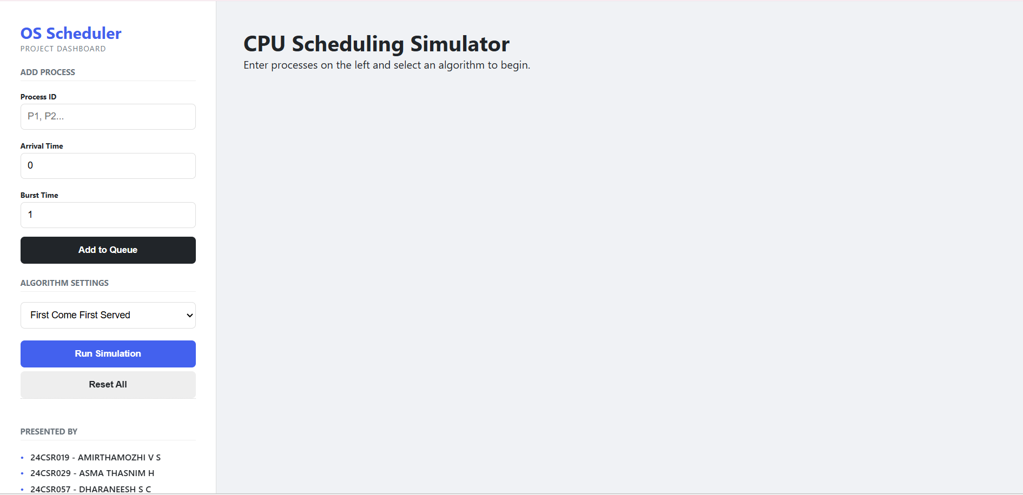

FCFS: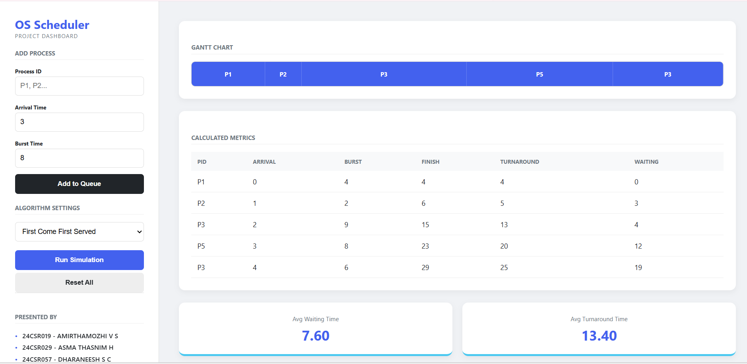

SJF: 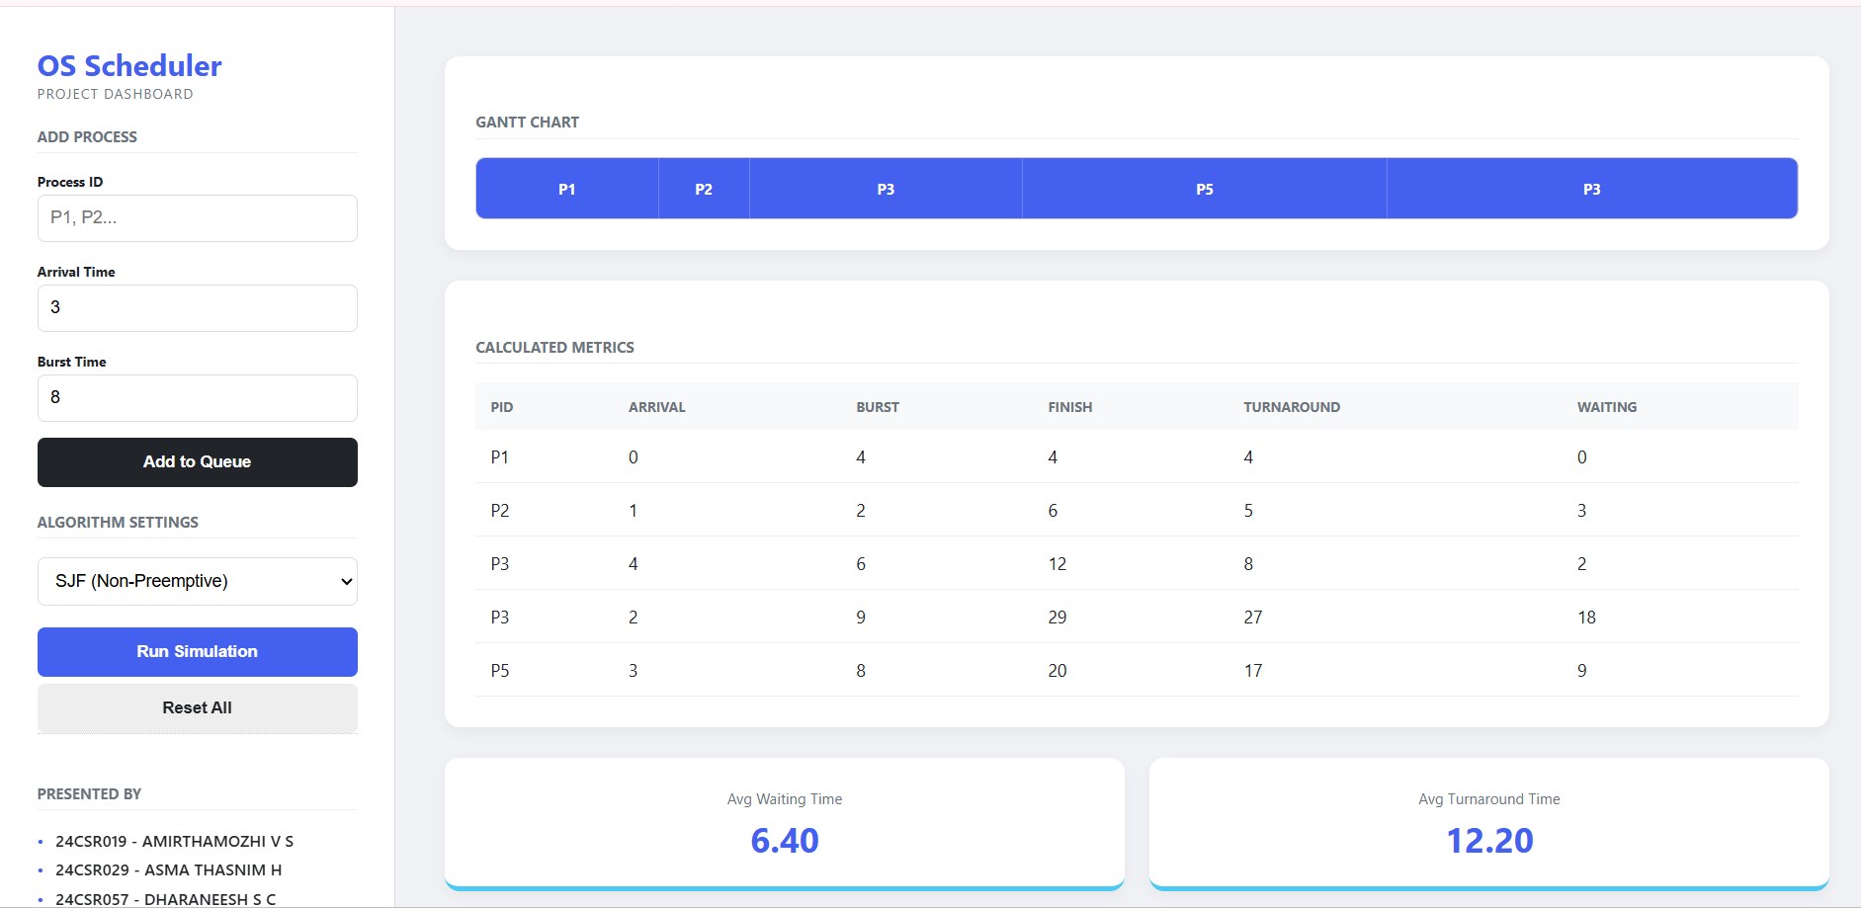

SRTF: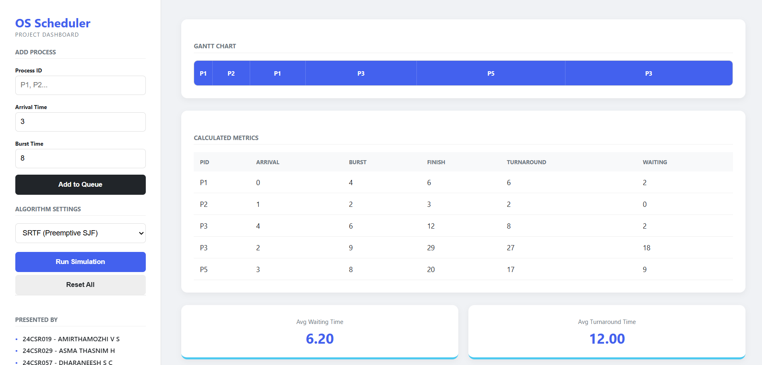

ROUND ROBIN: 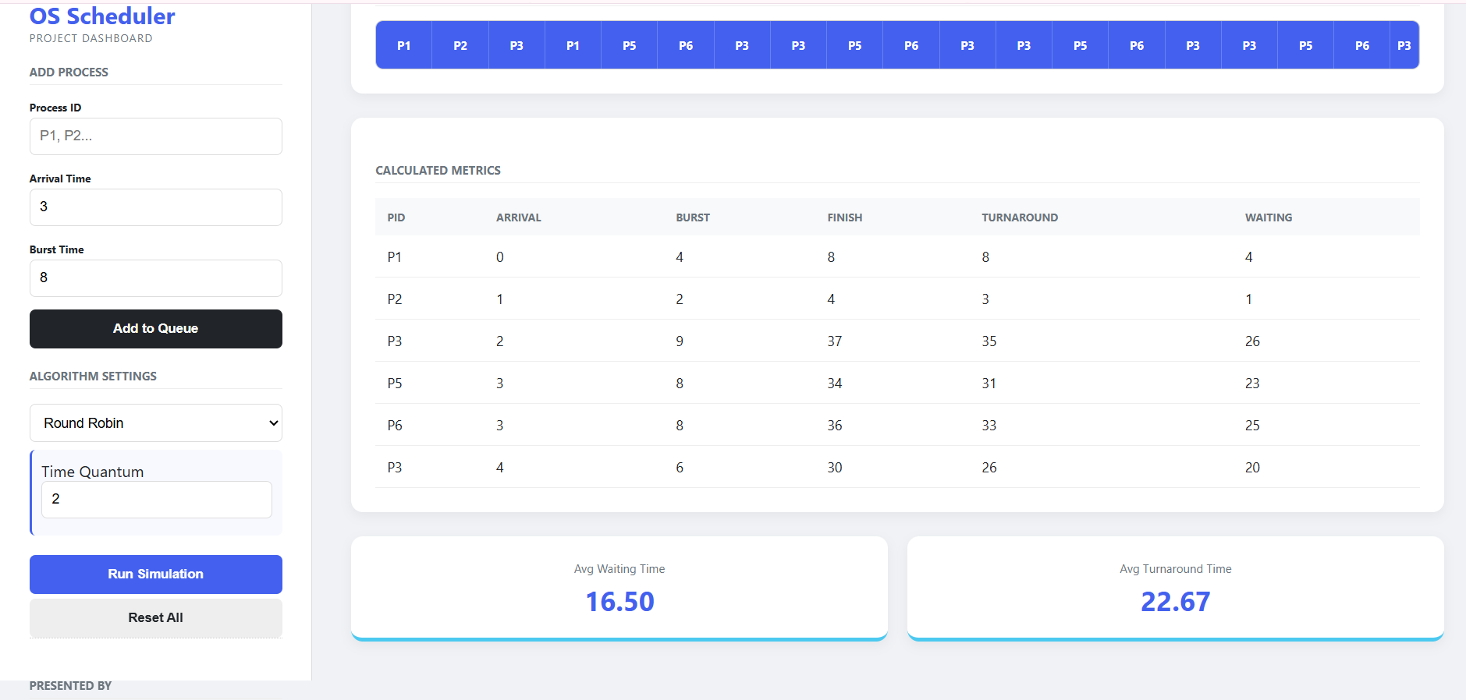

PRIORITY: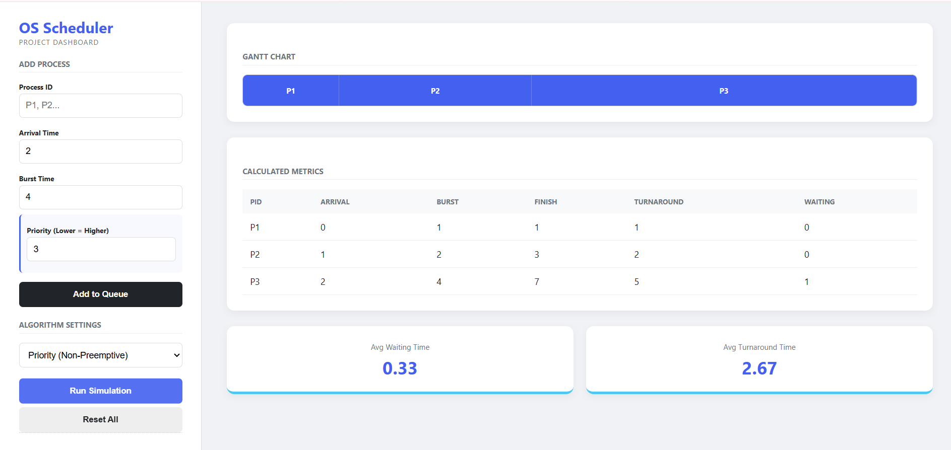

GITHUB LINK
https://github.com/AMIRTHAMOZHIVS/CPU_SCHEDULING

WEBSITE LINK
https://cpu-scheduling-murex-two.vercel.app/

PRESENTATION PHOTOS
