SIG Workshop Elastic Search & Kibana

20th February 2018

Elastic Search [Index]: NoSQL, REST API, distributed, highly available. Great for searching. Well integrated from Log Stash (for gathering and loading data, in real time, for example from log files) and Kibana (for exploring and visualizing data in the Search Index.

In this workshop:

* Get Elastic Search and Kibana up and running in a local Docker based environment
  + Optionally: use cloud based environment
* Create an Elastic Search Index through the REST API and experiment with search options
* Leverage Kibana to explore the search index [documents] in a user friendly, visual way and create several visualizations (tag cloud, geographic map, bar chart, …) on top of the data
* Try out the combination of LogStash, Elastic Search and Kibana for gathering, storing, querying and analyzing log files – in a fully hosted environment

### Resources

Elastic Documentation:

Sources for this workshop: <https://github.com/lucasjellema/sig-elasticsearch-february-2018>

# 1. Prepare your environment

We assume a Docker host on which you can start containers.

Alternatives in case you do not have Docker available to you:

* Use an Elastic Search cloud environment (get a free trial environment at <https://www.elastic.co/cloud/as-a-service> or a $0,055 / hour environment at <https://qbox.io> )
* Install Elastic Seach and Kibana on your local operating system or inside a Virtual Machine (start at <https://www.elastic.co/downloads/elasticsearch> )

Additionally, we will be using Postman – the REST API testing tool: <https://www.getpostman.com/apps> (with downloads for Windows, Mac and Linux).

You may be interested in using the Chrome App ElasticSearch Head that can be installed into Chrome Browse from: <https://chrome.google.com/webstore/detail/elasticsearch-head/ffmkiejjmecolpfloofpjologoblkegm?hl=en-US&utm_source=chrome-ntp-launcher> .

The sources used in this workshop can be acquired from GitHub: <https://github.com/lucasjellema/sig-elasticsearch-february-2018> .

# 2. Quick Take Off – The National Parks data set

In this section, we take a dataset with details on US National Parks, turn it into an Elastic Search Index and explore the data. First we use the REST API to perform a number of searches. Then we turn to Kibana to make these data explorations easier and more fun. Note: from these visual data explorations you may get idea for embedding programmatic queries in your own application, directly against the Elastic Search Index.

The data used in this practice is in the file national-parks-data.json . It was downloaded from the website data.world: https://data.world/kevinnayar/us-national-parks/workspace/file?filename=data.json . I had to prepare the data a little in order to be ingestable into an Elastic Search Index:

* Change the property names longitude and latitude to lon and lat respectively
* Remove the thousands separator (“,”) from the fields that represent numbers (visitors, acres, square_km)

In this lab, we will use Postman to interact with Elastic Search and create the index, the mapping definition and load the data in one bulk operation. Subsequently we will query the data, still through REST calls made from Postman.

## Establish the Connection to Elastic Search

Start Postman.

Import the Postman collection ElasticSearch-NationalParks from file ElasticSearch-NationalParks.postman_collection.json.

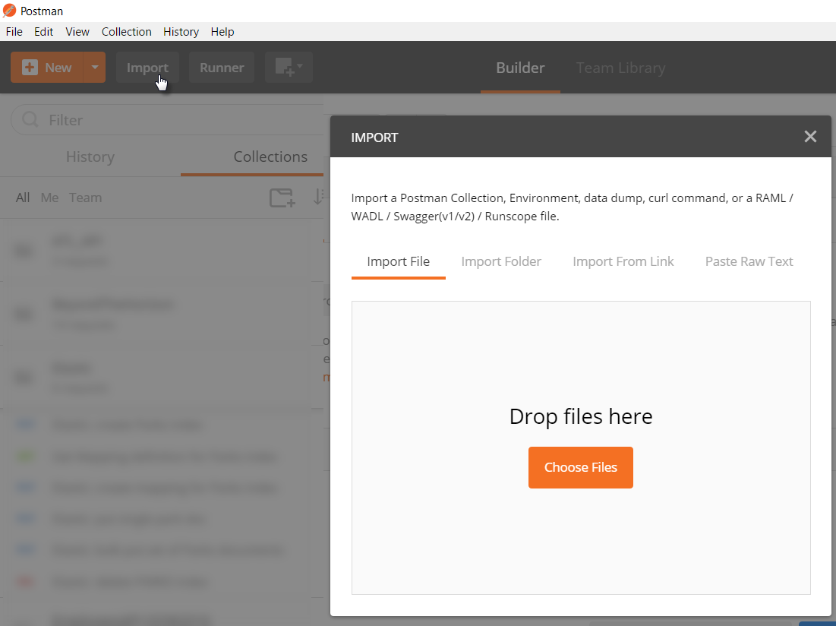

After the import completes, you should see a folder (or collection) called Elastic. It contains definitions for multiple REST API calls to the Elastic Search API.

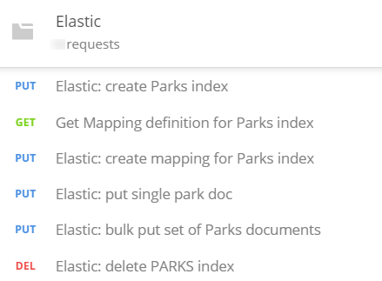

These requests refer to the endpoint of the Elastic Search server you are accessing through an environment variable called {{ELASTIC_HOME}}. Before you can successfully execute these requests, you have to define this variable in an Environment definition in Postman and set its value to whatever the endpoint is in your environment.

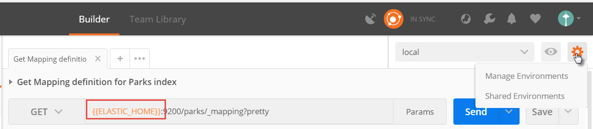

Click on Manage Environments. Then select an existing environment or create a new one. In this environment, define the variable ELASTIC_HOME and set its value according to your local environment:

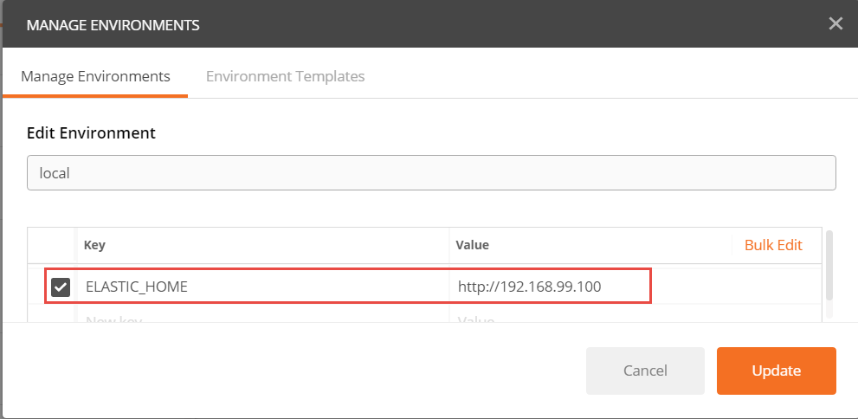

(in my case, I use Docker Quickstart Terminal on Windows. Elastic Search is running in a container inside the Linux Virtual Machine that was setup by Docker Quickstart Terminal to run the Docker Server. This VM is accessed at IP address 192.168.99.100. The container running Elastic Search exposes ports (9200 and 9300) on the Docker Host. These are therefore accessible from the Windows Host machine – where Postman is running – at this IP address.)

To verify the connection, run the Postman Request called *Elastic: check health of server*. Upon a successful response, you can continue. Otherwise you will first have to find out what is wrong and correct it (is the server running did you use the right name for the Postman Environment variable, is the correct environment selected in Postman at the time of making the request, is the IP address used for the ELASTIC_HOME endpoint correct and can you ping that endpoint successfully from the machine where Postman is running?)

## Create the Index and Load the Data

Elastic Search is NoSQL database that allows us to just store JSON document without specifying the structure of those documents in advance. Now that we have a server up and running and we can access it from Postman, nothing is stopping us from loading data into that server and by doing so, creating an index.

Execute the Postman PUT Request *Elastic: bulk put set of Parks documents*. Check the response. It should have response code 200 and contain a logging of all the documents that were created in the index. The data for these documents was in the body of the request. Some 59 documents should be created by this request.

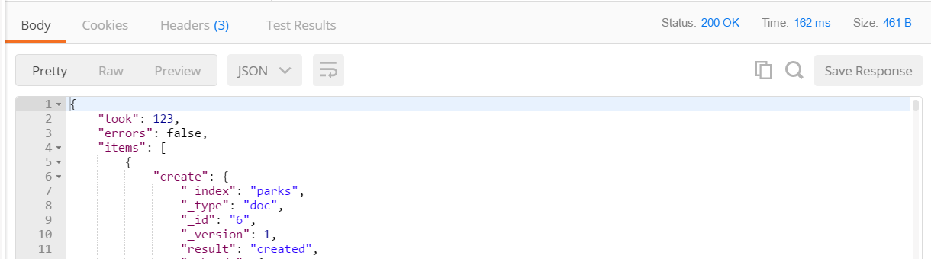

While processing the request, Elastic Search has extracted meta-data about the documents. This meta-data is used for creating inverted indexes that in turn are used during queries.

Execute the request called *Get Mapping definition for Parks index*. The response contains the meta-data that was derived by Elastic Search.

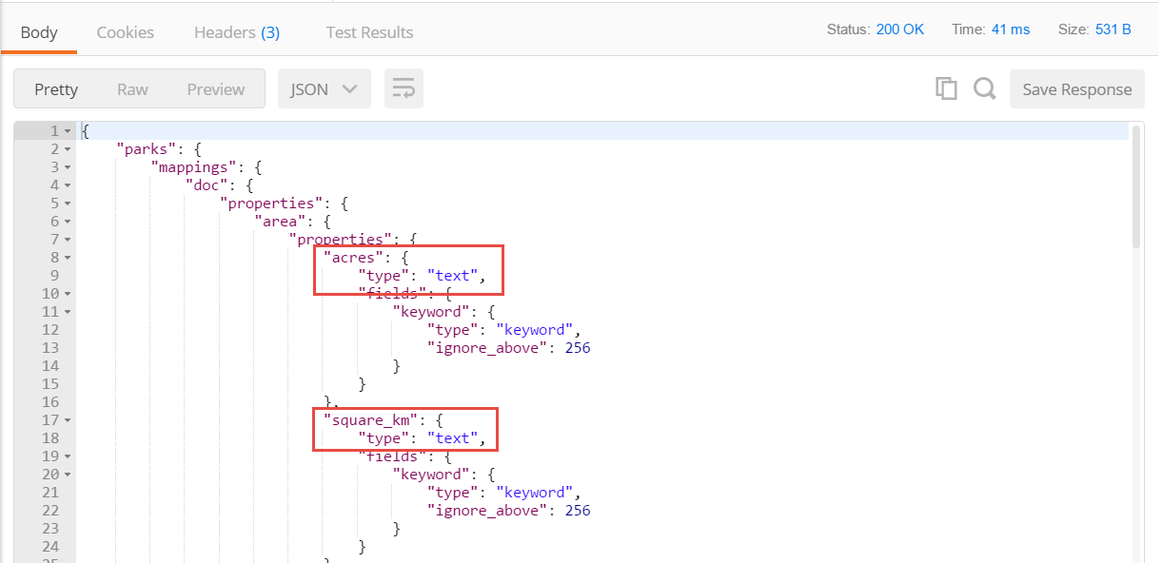

This mapping document tells us about the properties that Elastic Search has identified, the names it will use for these properties and also the type that was assigned to each property. These types determine which operations we can perform on the properties. Numerical properties can be aggregated and used in mathematical operations, but text properties cannot. In the automatically derived mapping document, we can see that properties acres, square_km and visitors have not been identified as numerical. Also the property *date_established_readable* is identified as text – even though we know it to actually contain the textual representation of a date.

Geopoints can be used in geospatial queries. The coordinates property in the national park documents describe a geographical location, but ES has not recognized this property for what it is - but as just a pair of *float* values.

Additionally, some of the text analysis capabilities of Elastic Search depend on the specific language the text is provided in. ES does not derive the language automatically, we have to instruct it when the language is not the default.

In order to fully leverage the querying capabilities of Elastic Search – and the visualization capabilities of Kibana – we should define the mapping definitions for the national park documents ourselves, to help ES do a better job. See the ES documentation on Mapping for more details: <https://www.elastic.co/guide/en/elasticsearch/reference/current/mapping.html> .

We will start from fresh with our index.

Execute Postman request *Elastic: delete PARKS index* to delete the *parks* index. Next, execute request *Elastic: create Parks index*. This creates the index – empty, without data or meta-data.

Now we will add the enriched meta-data – with more instructions for Elastic Search. Execute request *Elastic: create mapping for Parks index*.

Check the body of this request, and find the following refinements:

* Geopoint type for *coordinates*
* Float type for acres and square_km
* Integer type for visitors
* Date type (plus format) for *date_established_readable*
* Type text and fielddata : true for *description*; also: associated custom analyzer std_english with field description (to remove stopwords from this field; see: <https://www.elastic.co/guide/en/elasticsearch/reference/current/configuring-analyzers.html> for details)

Execute request *Elastic: bulk put set of Parks documents* to upload all 59 documents to the index. At this point, Elastic Search has treated the properties in the right way, which will now allow us to query the data in a more meaningful, rich way.

## Query the Data through the REST API

Tbd

Complex queries can be performed using GET requests by stuffing all search instructions in the URL. See the Postman Query *Query Parks - fuzzy, proximity - with query execution explanation*

{{ELASTIC_HOME}}:9200/parks/_search?q=description%3Amountaon~2+visitors%3A<1000000+!(states.title%3AAlaska)&default_operator=AND

and execute it. It returns: parks that have the string "mountaon" in their description - or something that is close to it (our fuzziness allows for up to two character edits distance); we also require (note how the default-operator is explicitly set to AND) the number of visitors to be under 1 Million and these parks are not located in Alaska.

This article describes in a lot of detail how the ES queries through the URL GET interface are constructed: <https://www.compose.com/articles/using-query-string-queries-in-elasticsearch/> Tip: URL Encoding: <https://www.w3schools.com/tags/ref_urlencode.asp> describes how to encode characters such as : (to %3A)

## Use Kibana to Explore the Data

tbd

# 3. Getting Started with Elastic Search

A good way to get started with Elastic Search Index – creating an index, creating some data, performing some queries - is through this tutorial: <http://joelabrahamsson.com/elasticsearch-101/> (even though it is already quite old – the basic principles are all still valid). Go to the heading CRUD to start your interaction with Elastic Search:  
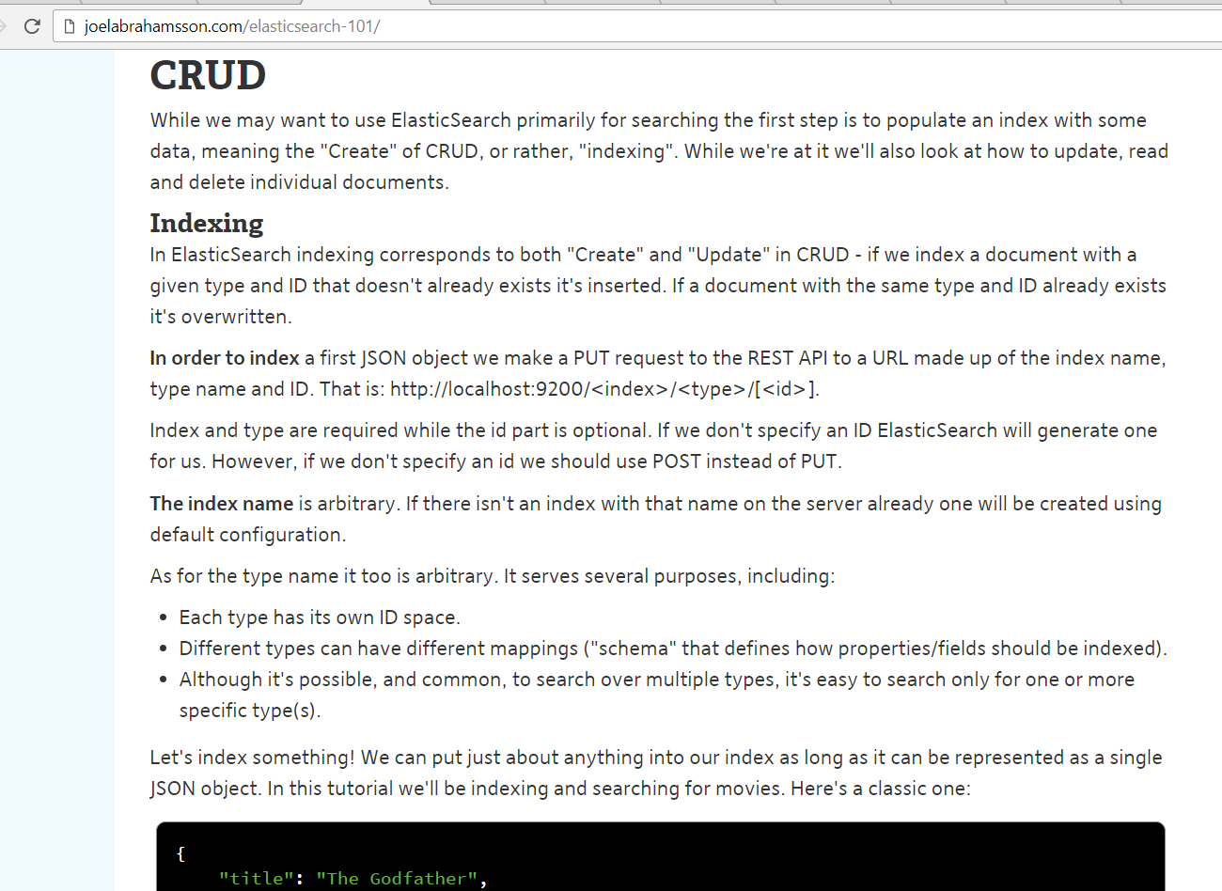

# 4. Getting Started with Kibana

The website of the Elastic Company provides a great tutorial for getting started with Kibana. This tutorial shows you how to:

* Load a sample data set into Elasticsearch
* Define an index pattern in Kibana
* Explore the sample data with [Discover](https://www.elastic.co/guide/en/kibana/6.1/discover.html)
* Set up [visualizations](https://www.elastic.co/guide/en/kibana/6.1/visualize.html) of the sample data
* Assemble visualizations into a [Dashboard](https://www.elastic.co/guide/en/kibana/6.1/dashboard.html)

Access this tutorial at: <https://www.elastic.co/guide/en/kibana/current/getting-started.html>

Note: Kibana visualizations can be embedded in web applications very easily. See this tutorial for the instruction: <https://www.elastic.co/blog/kibana-4-video-tutorials-part-4> (it is nothing more than embedded a snippet of HTML)

# 5. Explore LogStash + Elastic Search + Kibana in fully hosted environment

To get a feel for proessing, storing, analyzing and exploring log file entries – one of the most prominent use cases of the Elastic Stack – you could take a look at a tutorial that provides a handson experience in a hosted environment.

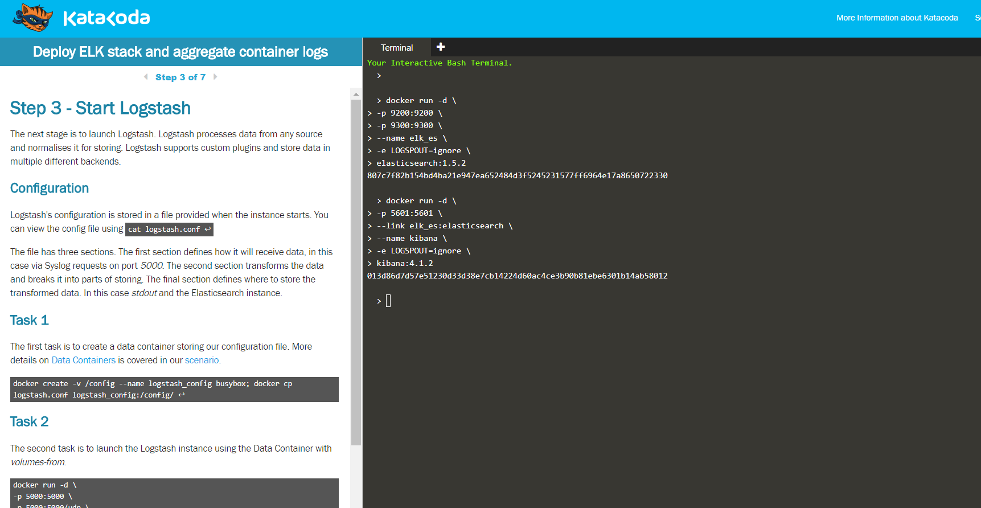

Access this tutorial at KataKoda - <https://www.katacoda.com/courses/docker-production/launch-elk-aggregate-container-logs> .

# 6. Client Libraries for Programmatic Interaction with Elastic Search

Any technology capable of making HTTP REST calls and manipulating JSON can use the generic REST APIs of Elastic Search to interact with any index. Additionally, a number of client libraries is available, that make this interaction easier - higher level, more native and therefore easier and more productive.

An example is the Java High Level REST Client (see: <https://www.elastic.co/guide/en/elasticsearch/client/java-rest/current/java-rest-high.html> ). This is a Java library that you can use in your own application (and that will still perform REST calls under the hood). See this tutorial for a concrete example: <https://qbox.io/blog/rest-calls-new-java-elasticsearch-client-tutorial> .

Client libraries are available for other programming languages as well, such as:

* Python: <https://elasticsearch-py.readthedocs.io/en/master/> (low level) and <https://elasticsearch-dsl.readthedocs.io/en/latest/> (high level).
* PHP: <https://www.elastic.co/guide/en/elasticsearch/client/php-api/current/index.html>
* JavaScript Node (server side)/Browser - <https://github.com/elastic/elasticsearch-js> ; see this tutorial for a quick start introduction: <https://qbox.io/blog/integrating-elasticsearch-into-node-js-application>
* Ruby (and Rails): <https://github.com/elastic/elasticsearch-rails>
* .Net: <https://github.com/elastic/elasticsearch-net>