Hands-on MongoDB Development

Contents

Introduction 2

1 Advanced Query – and a comparison between MongoDB Find and Aggregate vs. (Oracle) SQL 3

2. MongoDB Compass (aka NoSQL Developer) 6

3. Development with NodeJS and MongoDB 9

4. Development with Java and MongoDB 12

## Introduction

In this hands-on, you will be working with MongoDB – in the MongoDB shell on advanced query functionality, with Node.JS and Java to interact from those technologies with a MongoDB database and through MongoDB Compass – a GUI on top of MongoDB.

Each of the sections is optional and do not depend on each other.

The assumption is that you have a running MongoDB server in your workshop environment and that you can connect to that instance through the Mongo Shell.

Additional requirements apply to each of the sections – a Node.JS and npm installation, a Java and Maven installation and a Compass installation.

All sources, instructions and the presentations can be found in this GitHub Repository: <https://github.com/lucasjellema/sig-nosql-mongodb> . You can fetch the contents of this repository as a zip file (<https://github.com/lucasjellema/sig-nosql-mongodb/archive/master.zip> ) or use a git client to clone the repository to your workshop environment.

## 1 Advanced Query – and a comparison between MongoDB Find and Aggregate vs. (Oracle) SQL

In this section, you will perform a number of query actions against a MongoDB database that contains two collections that are similar to data sets frequently used in samples and tutorials for relational databases – especially Oracle Database: Departments and Employees. You will perform a number of MongoDB search operations against these collections – and you can compare what you can do with MongoDB put next to (Oracle) SQL.

A presentation is available that presents 30 queries against MongoDB and Oracle SQL side by side: <https://github.com/lucasjellema/sig-nosql-mongodb/blob/master/mongodb-find-agg-vs-oracle-sql.pptx> - you can use this presentation for reference.

1. Load Data Set from CSV files into MongoDB  
     
   Directory hr-queries contains the data sets in two CSV files: export_dept.csv and export_emp.csv. Two helper files - empFields.txt and deptFields.txt – specify how the mongoimport utility should map the fields in each record to document properties in the MongoDB collection.  
     
   Using the following commands – running the monogimport tool that is installed in the bin directory of your MongoDB installation that also holds the server runtime and the shell – you import the datasets into collections emp and dept in database called hr. The database and the collections will be dropped (if they already exist) and (re)created through these commands.

mongoimport --host 127.0.0.1:27017 --db hr --collection emp --drop --file export_emp.csv --type csv --fieldFile empFields.txt

mongoimport --host 127.0.0.1:27017 --db hr --collection dept --drop --file export_dept.csv --type csv --fieldFile deptFields.txt

1. Run MongoDB Shell and Inspect Collections  
     
   Start the MongoDB shell as you have done before. Switch to database hr:

use hr

Verify whether the collections were created:

show collections

Check the statistics for collection emp:

db.emp.stats()

Check the contents for both collections:

db.emp.find()

db.dept.find()

1. Perform queries

To get started, let’s find the names of all managers:  
  
db.emp.find({"JOB":"MANAGER"},{ENAME:1})

And – find all salesmen, listed by salary descending; only show top 2  
  
db.emp.find({"JOB":"SALESMAN"},{ENAME:1, SAL:1}).sort({'SAL':-1}).limit(2)  
  
Introducing lookup in MongoDB: list all employees (empno and ename) along with the looked up department

db.emp.aggregate(

[ {$lookup:

{

from:"dept",

localField:"DEPTNO",

foreignField:"deptno",

as:"dept"

}

}

, {$project: {

"EMPNO": 1,

"ENAME": 1,

"DEPT": { $arrayElemAt:["$dept", 0]},

}

}

]

)

1. The file sample-hr-queries.txt contains a number of queries, of increasing complexity, that you can try out to see what MongoDB can do in terms of retrieving information.   
     
   You will come across:  
   * aggregation  
   * join & lookup  
   * nested collections  
   * geo spatial search (cities closest to…)  
   * text search  
   * materialized views  
   * stored procedures  
   * facet search

Note: You can compare the MongoDB search commands with their SQL counterparts in the presentation: <https://www.slideshare.net/lucasjellema/comparing-30-mongodb-operations-with-oracle-sql-statements> .

## 2. MongoDB Compass (aka NoSQL Developer)

MongoDB Compass is the GUI visual explorer on top of MongoDB. Note that MongoDB Compass is a separate install that can run in any environment against a MongoDB server in a different environment. You can find the documentation for Compass at: <https://docs.mongodb.com/compass/current/> .

1. Install MongoDB Compass  
     
   Download the MongoDB Compass installer for your environment from <https://www.mongodb.com/download-center?jmp=hero#compass>.  
     
   Run the installer and complete the installation wizard.
2. Run MongoDB Compass and Connect to local MongoDB Server  
     
   Start MongoDB Compass. Enter Hostname – 127.0.0.1 – and Port – 27017 – for your local MongoDB server. Then press Connect:  
   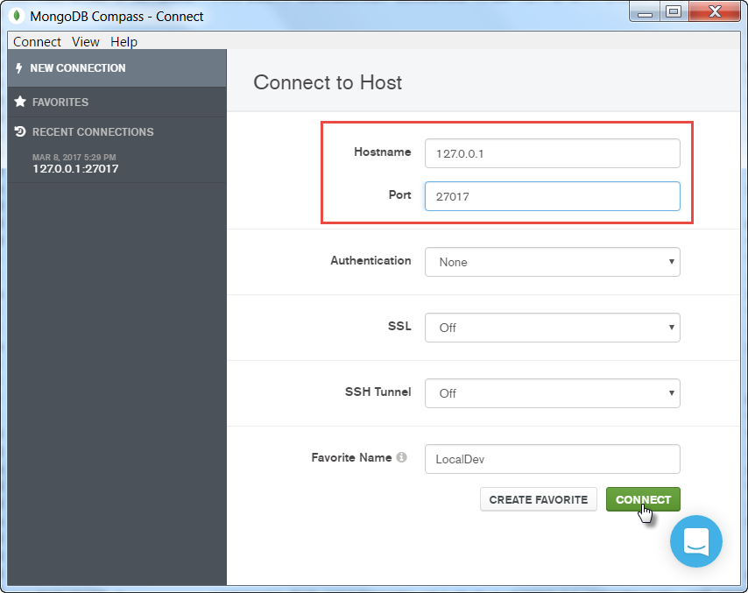  
     
   The connection should be created and you should see a list of databases in your server:  
     
   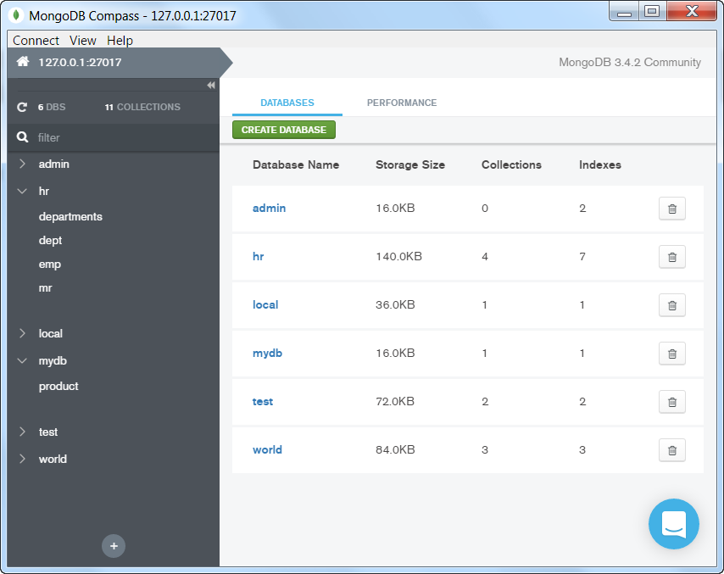
3. Navigate to one of the collections in one of the databases. Explore the collection – the properties (and their values) in the documents. Try to build a query using the collection explorer.  
   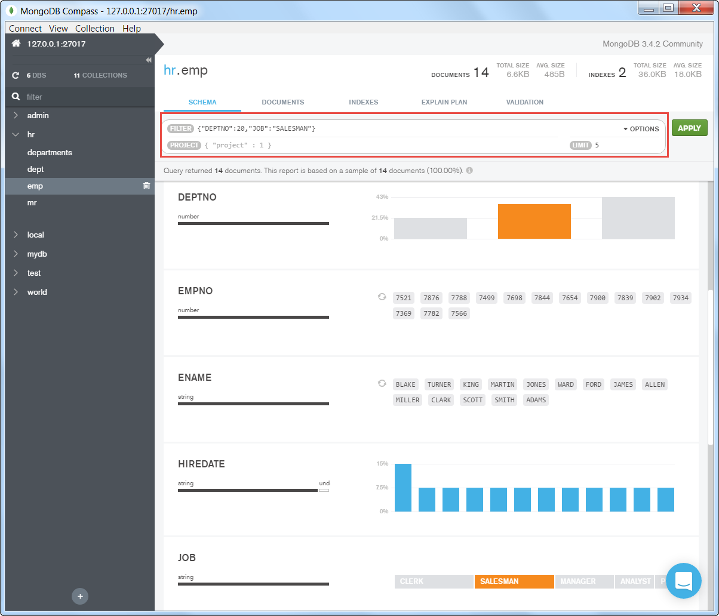
4. Edit one of the records:  
   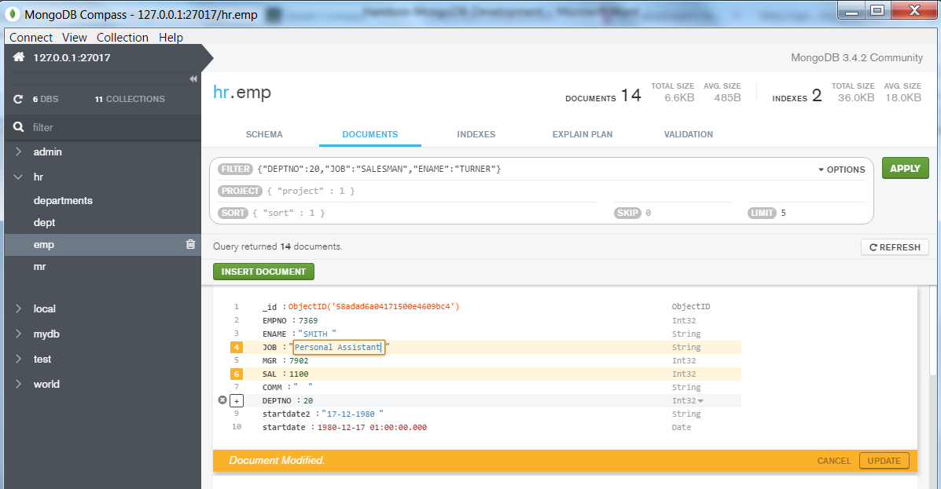  
   and/or add a new record.

## 3. Development with NodeJS and MongoDB

This section requires your workshop environment to include a NodeJS server – a fairly recent version at that, such as v6.10 that includes npm which is also required. You can download NodeJS from <https://nodejs.org/en/download/> .

Note: these practices assume that the countries data set has been loaded into a Mongodb database called *world*. This can easily be done with the following steps:

* open a command line or terminal window in directory *country-queries*.
* import the file countries.csv into collection *countries* in database *world* using the following command (assuming that the bin directory of the MongoDB installation is in the PATH environment variable:  
    
  mongoimport --host 127.0.0.1:27017 --db world --collection countries --drop --file countries.csv --type csv --fieldFile countriesFields.txt

With NodeJS installed and the MongoDB database and collection created, you can turn to the sources in directory MongoDB-NodeJS-Client.

1. Open a command line or terminal window in directory MongoDB-NodeJS-Client.
2. Execute   
     
   npm install  
     
   This will have package.json interpreted by npm, resulting in the download of the MongoDB Driver for NodeJS module as well as a number of dependent modules, all into the node-modules subdirectory:  
   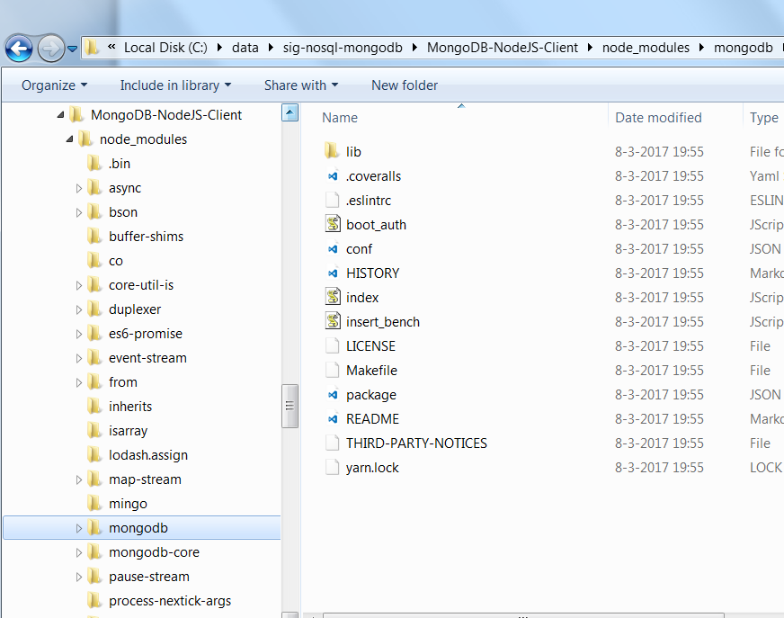
3. Open file connect.js in directory MongoDB-NodeJS-Client in your favorite text editor. Verify and change if required the values of the variables mongodbHost, mongodbPort and mongodbDatabase.  
     
   Then run this NodeJS module, using:  
   node connect
4. Open the file *query6.js*. This file uses Promises instead of asynchronous callbacks. If you prefer the callbacks or have an older version of NodeJS that does not support the Promises, then use file query.js.  
     
   The code performs the following steps – check how these steps are implemented in NodeJS, using the NodeJS driver for MongoDB  
   * connect  
   * fetch the top 20 largest countries (by area) into an array of country objects (and print two randomly selected countries from that array)  
   * retrieve a cursor that returns all countries in Asia; get the number of records from the cursor; iterate through the cursor and write the name of each country returned from the cursor  
   * retrieve through the aggregation framework using an aggregation query object a cursor that returns the largest country for each continent and write out the full country object  
     
   Note how well NodeJS can work with the JSON documents returned from MongoDB: these documents are native data objects in JavaScript and therefore in the NodeJS application.
5. Open the file *crud6.js*. This file uses Promises instead of asynchronous callbacks. If you prefer the callbacks or have an older version of NodeJS that does not support the Promises, then use file crud.js.  
     
   The code performs the following steps – check how these steps are implemented in NodeJS:  
   * connect  
   * create a new collection (or work with an existing one) and add a list of two documents to it in a single statement (insertMany)  
   * verify the creation of the documents by retrieving the newly created documents using a cursor  
   * update one of the records, using a find filters and by applying a complex $set definition – with nested attributes and nested collections  
   * verify the updated document  
   * delete all documents  
   * drop the collection
6. Please feel free to try out some more interaction between NodeJS and MongoDB. The documentation for the driver can be found here: <http://mongodb.github.io/node-mongodb-native/2.0/> .

## 4. Development with Java and MongoDB

aaa