# 2019-08-31. SCAMCOM. Website. Extra work

We want to make it optional and possible to post from, nothing, up to 5 images for each story.

That's why we need to add 6 check boxes here,

# just above or below the BROWSE button.

They should be NO PHOTO, PHOTO 1, PHOTO 2, PHOTO

3, PHOTO 4, PHOTO 5.

You clicked NO PHOTO, whose default photo should be displayed.

It should be possible to post pictures in any order.

When images are displayed in REGISTRY, they should be displayed in ascending order, with PHOTO 1 as the starting image.

TUMBNAIL of the images, they should be displayed when posting,

in connection with the selected CHECK BOX, image no.

Please try to make stylish and easy to understand design, as you always do.

(i have Added multiple image in post story section please check)

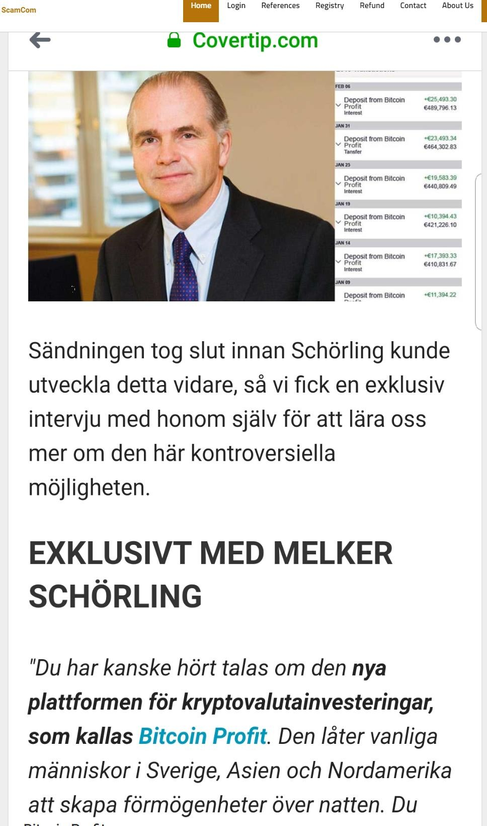

…

in REGISTRY, there must be a large right arrow. > appears in the middle of the right image border.

The same goes for the left arrow. < to be displayed in the middle of the left edge of the screen.

These arrow buttons should manually scroll the images back or forth.

If we scroll image 1, 2, 3, 4, 5 then we re-drill from image 1, continuously.

…

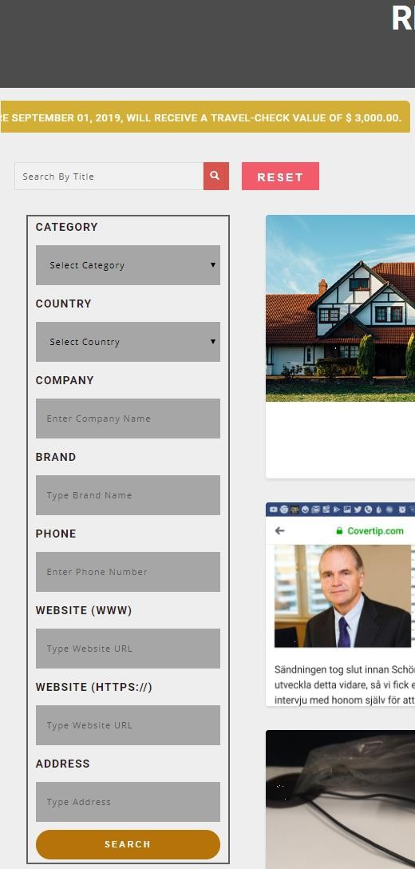

Please change the date to January 01, 2020.

The prize price will change to

$ 1,000.00, $ 500.00, $ 250.00.

(Done ++ )

Search By Title, we want to change it to free text, ie, **Search Text** (Done ++ )

Here it should be possible to search among all posted text in all stories including title.

Search here should work as any regular search, ie if we search for example

Bill = shows all stories where the name Bill appears.

If we apply

Bill Gates = shows all stories where the full name Bill Gates appears. etc. etc.

Here, the magnifying glass will push when searching our database.

RESET works for resetting the SEARCH TEXT field.

The default is English Language,

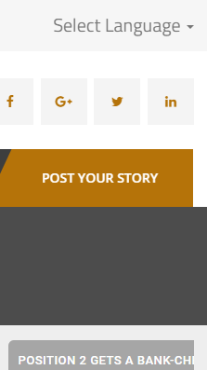

and therefore want the English and English flag visible when the English language is enabled.

If we choose the Swedish language, then the Swedish flag will be visible and Swedish. Etc, etc. with Spanish and German.

…

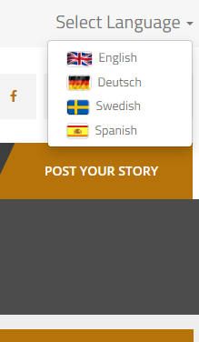

So far you have done a lot of great design and functionality both in our website and in our apps.

We want you to see the work and the design you do for us, as a demonstration of the work you have the knowledge and skills to do in SEOEssence.

Through our website and our apps, hopefully many hundreds of thousands of customers want to see your work and also see your company name, for the first time.

That is - if new customers like what they see, they will most likely want to contact you to make their websites and apps. It sounds reasonable - right?

We are not a local business, located in London or Paris - we are trying to spread our message worldwide.

We will therefore generate new customers for you, from all over the world. And we work with serious customers who hopefully pay for the job they order from you.

In the end, we cannot say how long it will take to reach our goal. It may take 3 or 5 or even 10 years. But about 10,000 new customers with us should generate about 30 new customers for you. Great, right?

# Good luck in the future, is both for you and for us !!!