

Malignant Comment Classifier

Submitted by:

AMIT PURI GOSWAMI

**ACKNOWLEDGMENT**

The project is done under the kind guidance of Mr. Kasif Khan. Some learnings are made from different informative websites to come out of the some difficult situations. The material which is freely available for any aspirants are used for better understanding of concepts of different techniques. Few of them to name are [www.google.com](http://www.google.com), <https://www.ibm.com> etc.

**INTRODUCTION**

* Business Problem Framing

There are so many comments of social media are not appropriate and we need to classify the comments in different offensive categories like malignant, highly_malignant ,rude, threat , abuse loathe.

With the help of data available we need to build a model which can predict that whether the comment falls under any of the above mentioned categories.

* Conceptual Background of the Domain Problem

All the inappropriate comments needs to be identified and removed or the user needs to be blocked to avoid any unwanted comment.

* Review of Literature

It is researched that the problem is very important and inappropriate comment may cause harm to the society so the classification is very important for removal of inappropriate comments to avoid any unforeseen event due to these comments.

* Motivation for the Problem Undertaken

Just to keep society safe is the motivation for the problem.

**Analytical Problem Framing**

* Mathematical/ Analytical Modeling of the Problem

Checked for Null values and found no null. If null values are found then these are replaced with mean and median values which requires statistical calculation by the system.

Data Sources and their formats

We received Data test.csv file it came from one of the social media platform and which contains the data for using in the classification of comments.

* Data Preprocessing Done
* punctuation removal
* splitting the words by space
* applying stemmer and lemmatizer
* recombining the words again for further processing
* Data Inputs- Logic- Output Relationships

Input is comment field which is highly useful to decide the comment is of which category or target label.

* State the set of assumptions (if any) related to the problem under consideration

Previous history of classification is used for further classification

* Hardware and Software Requirements and Tools Used

Basic Hardware are : i5 processor, 8GB RAM, other standard h/w

Softwares used : Jupyter, MS Excel, MS Word

**Model/s Development and Evaluation**

* Identification of possible problem-solving approaches (methods)

Standard process of data cleansing, feature selection, EDA, Outliers Removal, Skewness Removal, Handling Multi collinearity , dividing data in train and test, Standardization, finding best random state, model selection, finding best cv, Parameter finetuning, Finalization of the model and predicting.

* Testing of Identified Approaches (Algorithms)

Algorithms used are

1. SVM
2. MultinomialNB
3. BinaryRelevance

* Run and Evaluate selected models

1. After running and evaluating MultinomialNB

is found to be the best model.

* Key Metrics for success in solving problem under consideration

Best feature selection

* Visualizations

1. histplotplot
2. ScatterPlot

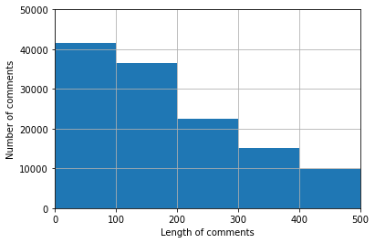

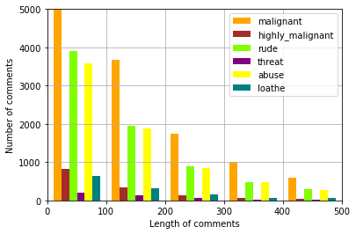

* Interpretation of the Results

Bad or inappropriate comments are classified.

**CONCLUSION**

* Key Findings and Conclusions of the Study

All comments are classified.

* Learning Outcomes of the Study in respect of Data Science

Visualization helps us a lot in understanding the problem and identifying the work which will be suitable for model building.

* Limitations of this work and Scope for Future Work

No. of Target variable are 6 and it is difficult for a standard computer to work upon with huge number of rows.