NEUROQUANT / QUANTEDGE
Monorepo Architecture & Full Project KT Guide
Architecture reconstructed from the uploaded repository snapshot - 27 Aug 2026
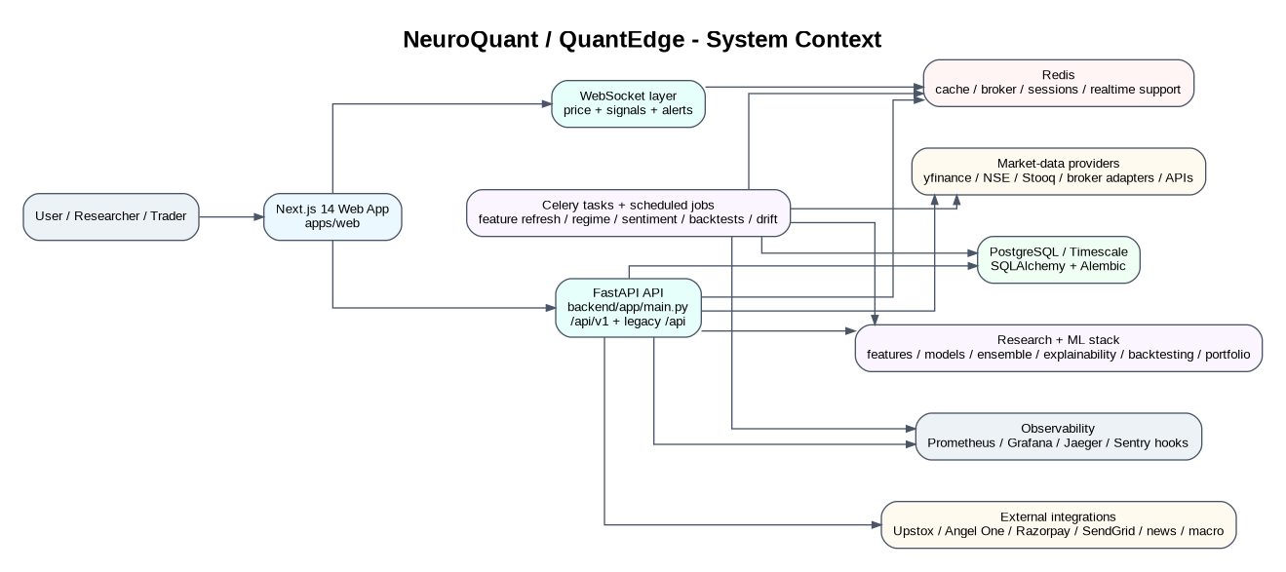
Figure 1. System context and major runtime boundaries.
Purpose: give a new engineer enough architectural context to navigate the project, trace a feature end-to-end, and know where to make changes safely.

1. KT at a Glance
This document is a handoff-oriented architecture guide, not a marketing diagram. It reflects the files present in the uploaded ZIP, including the current working-tree state. It distinguishes the implemented paths from optional or auxiliary infrastructure.
Area | Primary location | What it owns
Web product | apps/web | Next.js UI, route pages, components, hooks, API clients, realtime UI state
Shared frontend packages | packages/ui, packages/types, packages/config | Reusable React UI, TS contracts/declarations, shared config
API / business backend | backend/app | FastAPI routes, auth, market data, signals, predictions, trading, portfolio, payments
Research / ML | backend/research | Features, models, ensemble, explainability, backtesting, portfolio optimization
Background processing | backend/app/tasks, backend/app/core/celery_app.py | Scheduled/async work: data, features, regime, sentiment, backtests, drift/retraining
Persistence | backend/app/database, backend/app/models, alembic | PostgreSQL/SQLite dev DB, SQLAlchemy models, migrations
External integrations | backend/app/providers, services | Market/broker/payment/news/email integrations
Operations | docker-compose.yml, infrastructure/ | Nginx, DB, Redis, observability and supporting containers
Auxiliary service | services/gateway | Separate Python gateway surface; not the main FastAPI runtime path

2. The Mental Model a New Engineer Should Use
Think of the repository as one product with four major planes:
- Experience plane: Next.js pages/components/hooks render dashboards, terminal, research, portfolio, billing and admin surfaces.
- Application plane: FastAPI exposes authenticated REST endpoints and WebSockets; service modules implement market, signal, prediction, portfolio and trading behavior.
- Research plane: backend/research contains reusable ML/statistical modules. It feeds inference/backtesting workflows but is not itself a standalone web service.
- Operations/data plane: PostgreSQL/Redis plus provider integrations and Celery jobs keep the application stateful, scheduled and observable.
The important architectural rule for KT is: do not treat every Python file as an independent microservice. Most backend Python code runs in a single FastAPI process, while Celery provides background execution and the external containers provide infrastructure.

3. Monorepo Structure
stock-market/
├── apps/web/ # Next.js 14 application
├── packages/ui/ # shared UI components
├── packages/types/ # shared TS types/API declarations
├── packages/config/ # shared TS/Tailwind/Next config
├── services/gateway/ # auxiliary Python gateway
├── backend/
│ ├── app/ # FastAPI runtime + services
│ ├── research/ # ML/research library
│ ├── tasks/ # alternate/legacy task layer
│ ├── scripts/ # operational / research scripts
│ ├── alembic/ # DB migrations
│ └── tests/ # backend test suite
├── infrastructure/ # nginx, postgres, redis, prometheus config
├── data/ # local data artifacts
├── docs/ # supplemental docs
├── archive/ # archived material
├── artifacts/ # generated/local artifacts
├── docker-compose.yml
├── turbo.json
├── pnpm-workspace.yaml
└── package.json
Path | Navigation meaning | Key files/folders
apps/web/src/app | User-facing route map | (app), (auth), markets, terminal, research, portfolio, backtest-lab
apps/web/src/components | UI assembly layer | terminal, dashboard, charts, layout, market, alerts
apps/web/src/hooks | Client-side orchestration | useTerminalData, usePriceFeed, useSignalFeed, query hooks
apps/web/src/lib | API/runtime integrations | api clients, contracts, runtime-config, auth helpers
backend/app/api/v1 | REST contract surface | auth, market, signals, predictions, regime, portfolio, paper_trading, trading, payments, etc.
backend/app/services | Domain/application services | market_data, signal_engine, prediction_engine, regime_analyzer, paper_trading, risk_engine, etc.
backend/app/models | Persistence model layer | user, instrument, OHLCV, signal, prediction, portfolio, payment, model metadata
backend/research | Research computation | feature_engineering, models, backtesting, explainability, portfolio, risk
backend/app/tasks | Background jobs used by current app | market data, features, regime, sentiment, backtests, retraining trigger

4. Runtime / Container Architecture
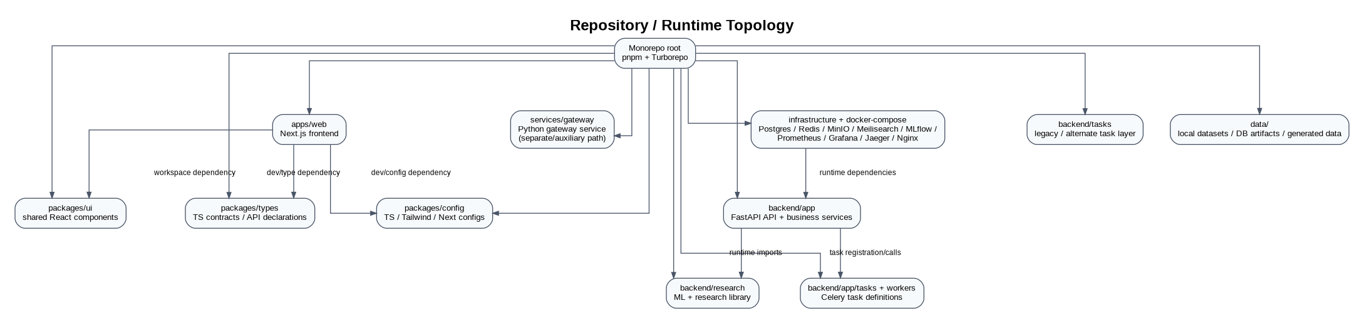
Figure 2. Monorepo package and runtime boundaries.
The repository is a monorepo managed with pnpm + Turbo. The web app consumes workspace packages. The backend is independently built with Python dependencies and is containerized from backend/Dockerfile. docker-compose.yml additionally declares the stateful/observability services.
Runtime | Port in compose | Role | Notes
frontend | 3000 | Next.js web application | Built from root with Dockerfile.web; app depends on backend
backend | 8000 | FastAPI application | Uvicorn starts app.main:app
postgres | 5432 | Primary relational persistence | Timescale image; SQLAlchemy/asyncpg
redis | 6379 | Cache/broker/session/realtime support | Celery broker/backend settings use Redis URLs
nginx | 80/443 | Reverse proxy / edge | Configuration under infrastructure/nginx
minio | 9000/9001 | Object storage support | Declared in compose; artifact storage path is not the only model-artifact mechanism
meilisearch | 7700 | Search service | Declared infrastructure dependency
mlflow | 5000 | Experiment/model tracking support | Declared as supporting infrastructure
prometheus | 9090 | Metrics collection | infrastructure/prometheus/prometheus.yml
grafana | 3001 -> 3000 | Metrics dashboards | paired with Prometheus
jaeger | 16686 | Tracing UI | OpenTelemetry/trace support

5. Backend Entry Point and Request Pipeline
The main runtime starts in backend/app/main.py. That file creates the FastAPI application, configures middleware, imports the Celery app early for task registration, mounts the v1 API router, the QuantEdge academic router, and WebSocket routes, and runs startup/shutdown hooks.
Browser
-> Next.js route / client hook
-> same-origin /api/v1 proxy OR configured API base
-> backend/app/main.py
-> middleware (request id, security headers, rate limit, CORS/trusted host)
-> /api/v1 router
-> endpoint module
-> domain/application service
-> data provider / DB / Redis / research module
-> response schema
-> browser state / page

5.1 API surfaces
Surface | Mount | Purpose
Modern REST | /api/v1 | Primary application API
Academic / compatibility REST | /api | Explicit QuantEdge endpoints such as /api/ohlc/{symbol}, /api/indicators/{symbol}, /api/signals/{symbol}, /api/regime/{symbol}, /api/backtest, /api/paper-trade
WebSocket | WS routes in backend/app/websocket | Live price, signal and alert delivery
Health / readiness | /api/v1/health... | Operational checks
OpenAPI | FastAPI-generated + checked-in openapi.json | Contract discovery and frontend development reference

5.2 REST route map
Domain | Router file | Representative endpoints
Auth | api/v1/auth.py | register, login, refresh, logout, me, forgot/reset password
Market | api/v1/market.py | quote, history, indices, movers, heatmap, search, universe, provider health
Signals | api/v1/signals.py | bulk signals, single signal, signal history
Predictions | api/v1/predictions.py | prediction, forecast, latest, ensemble, history
Regime | api/v1/regime.py | current, history, statistics
Intelligence | api/v1/intelligence.py | economic calendar, correlation graph, factor exposure, monitoring/explainability aliases
Backtest | api/v1/backtest.py | run, status, results
Portfolio | api/v1/portfolio.py | portfolios, holdings, performance, transactions, risk metrics, optimization
Paper trading | api/v1/paper_trading.py | order, positions, history, P&L, cancel, reset
Live trading | api/v1/trading.py | mode, order, kill switch, audit log, Upstox OAuth/status
Alerts | api/v1/alerts.py | list/create/update/delete/history
Payments | api/v1/payments.py | plans, balance, intents, confirm, subscribe, history, subscription, webhook
Users / watchlists | users.py / watchlist.py | profile and symbol list management
Research explanation | api/v1/explain.py | SHAP, attention, counterfactual
Model monitoring | api/v1/models.py | accuracy, drift, ensemble weight history
Admin / blog / notifications / journal | respective routers | operational and product features

6. Frontend Architecture
The web application is a Next.js 14 App Router application. Authenticated routes sit under apps/web/src/app/(app), while login/registration flows are under (auth). The authenticated root redirects to /dashboard in the current snapshot; /terminal is the main trading-focused surface.
Frontend area | Examples | Responsibility
App routes | dashboard, terminal, markets, research, portfolio, backtest-lab, model-monitor, signals | Page-level composition
Components | components/terminal, charts, dashboard, market, layout | Reusable visual/interaction building blocks
Modules | modules/auth, dashboard, signals, payments, admin | Feature-oriented logic
Hooks | useTerminalData, usePriceFeed, useSignalFeed, query hooks | Client orchestration and realtime state
API clients | src/lib/*-api.ts, contracts-api.ts | REST calls and response adaptation
Shared UI | packages/ui | Cross-page visual primitives
Shared contracts | packages/types | TypeScript declarations and API contract helpers
State/data libraries | TanStack Query + Zustand | Server cache and client state

7. Live Terminal Architecture
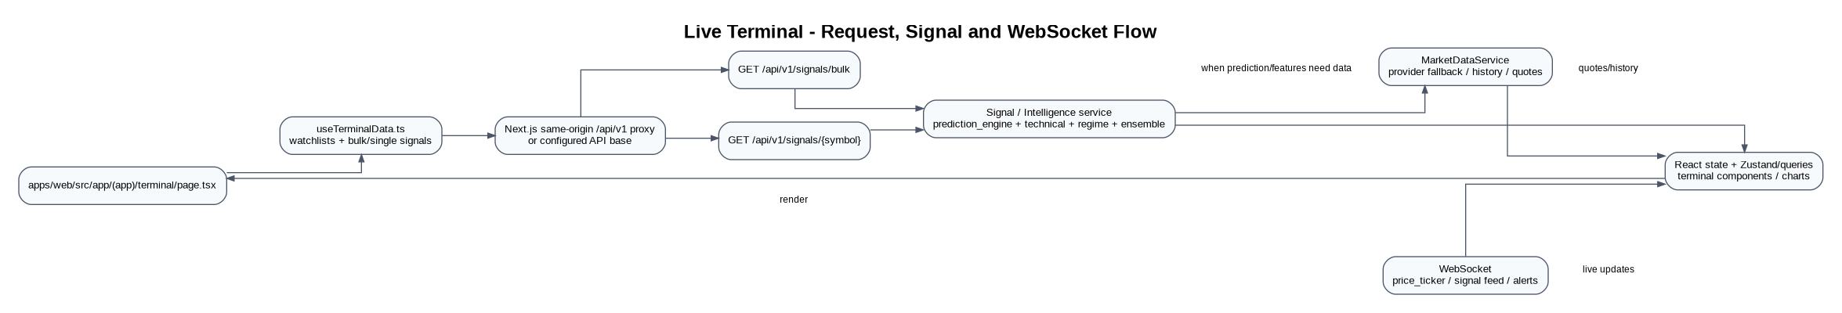
Figure 3. Terminal data lifecycle as implemented in the current frontend/backend split.
The terminal is a good example of the project’s hybrid data pattern: initial state arrives over REST, then the UI is incrementally refreshed through polling and WebSocket updates. apps/web/src/hooks/useTerminalData.ts loads four watchlist buckets, de-duplicates symbols, calls bulk and single signal endpoints, and then reconciles incoming live signals into the displayed rows.
Step | Code location | Behavior
1 | terminal/page.tsx + TerminalLayout | Mount authenticated terminal surface
2 | useTerminalData.ts | Load watchlists; fallback to default symbol set if unavailable
3 | intelligence-api.ts / related clients | Fetch bulk and selected-symbol signal data
4 | backend/api/v1/signals.py + intelligence.py | Resolve signals through backend service logic
5 | prediction_engine / signal_engine / regime | Compute or assemble technical + model + regime signal data
6 | useSignalFeed / usePriceFeed | Maintain live singleton WebSocket streams
7 | Terminal components | Merge REST baseline with live websocket deltas and render charts/panes

8. Market Data Layer
The backend deliberately has multiple data-access paths. The central production-facing abstraction is MarketDataService and the provider/source classes under app/services/data_ingestion and app/providers. The repository also contains direct service integrations such as yfinance, NSE, Stooq, Angel One and Upstox adapters.
Component | Location | Role
MarketDataService | backend/app/services/market_data_service.py | Quotes/history/provider health and higher-level market data access
Provider manager / sources | backend/app/services/data_ingestion/ | Provider abstraction and fallback behavior
NSE source | data_ingestion/nse_source.py | NSE-oriented source path
Stooq / yfinance | data_ingestion/*.py | Fallback/historical market data paths
Angel One | app/providers/angel_one_provider.py | Broker/market-data integration
Upstox | app/services/upstox_service.py + trading router | OAuth/trading integration
Instrument universe | models/instrument.py + universe scripts | Canonical symbol/instrument records

Important KT caveat: the repository documentation itself notes that the current setup should not be represented as an exchange-grade, guaranteed 10,000+ real-time feed. A future scale-out needs a canonical instrument master, a dedicated market-data provider strategy, streaming fan-out, backpressure, health monitoring and replay/recovery.

9. Research and ML Architecture
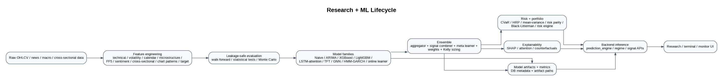
Figure 4. Research, model training, evaluation, inference and explainability lifecycle.
Layer | Directory | Representative modules
Feature engineering | backend/research/feature_engineering | technical, volatility, calendar, microstructure, FF5, sentiment, cross-sectional, chart patterns, target, pipeline
Baselines | models/baselines | naive, ARIMA
Tree models | models/xgboost_model, lightgbm_model | classifiers
Deep sequence models | models/lstm_attention, models/tft | LSTM-attention, Temporal Fusion Transformer
Graph models | models/gnn | graph builder, dataset, trainer, inference, contagion risk
Regime / volatility | models/hmm_garch | HMM, GARCH, forecaster, regime detector
Online learning | models/online_learner | adaptive learner
Ensemble | models/ensemble | orchestrator, aggregator, signal combiner, meta learner, weights, Kelly sizer
Backtesting | research/backtesting | engine, cost model, walk-forward, analytics, Monte Carlo, statistical tests
Explainability | research/explainability | SHAP, attention extraction, counterfactual
Portfolio / risk | research/portfolio, research/portfolio_optimization, research/risk | HRP, CVaR, MVO, risk parity, Black-Litterman and risk calculations

Inference is exposed through the backend service layer rather than through a separate model-serving microservice. For example, predictions.py, intelligence.py and the QuantEdge academic router call service functions such as prediction_engine / detect_regime / explainability helpers. Model metadata and metrics are represented in SQLAlchemy models ModelArtifact and ModelMetric.

10. Model Lifecycle and MLOps
1. Train or evaluate models using backend/scripts and backend/research/model modules.
2. Persist model metadata in model_artifact (model type, version tag, artifact path, hyperparameters, active flag).
3. Persist evaluation statistics in model_metric (accuracy, precision, recall, AUC, Sharpe, cost-adjusted Sharpe, regime breakdown).
4. Use ensemble components to combine model outputs and apply weights / Kelly sizing.
5. Serve predictions through backend inference endpoints and use model-monitoring endpoints for accuracy, drift and ensemble-weight history.
6. Use scheduled drift checks to decide whether retraining should be triggered.
Current Celery beat definitions in backend/app/core/celery_app.py include hourly news sentiment refresh, daily regime-state updates and daily drift checks. In development, task_always_eager is enabled when ENVIRONMENT is development; this changes the operational behavior versus a dedicated worker deployment.

11. Background Jobs and Scheduling
Task | Location | Cadence / trigger | Purpose
update_news_sentiment | app/tasks/sentiment_tasks.py | hourly beat | ingest/update news sentiment
update_regime_states | app/tasks/regime_tasks.py | daily beat | refresh market regime states
check_drift_for_watchlist | app/tasks/retraining_trigger.py | daily beat | drift detection + retraining decision
build_feature_vectors | app/tasks/feature_tasks.py | on demand/scheduled workflows | feature refresh
market_data.* | app/tasks/market_data_tasks.py | operational scripts / jobs | seed universe and historical data
run_backtest_job_task | app/tasks/backtest_tasks.py | API-triggered background job | asynchronous backtest execution

There is also backend/tasks as a second/legacy task layer. A new engineer should verify imports and the active task registration before adding jobs there; current app startup explicitly imports backend/app/tasks/retraining_trigger so the intended Celery task registration is not silently omitted.

12. Data Model - Core Business Entities
Entity | Model | Relationship / why it matters
User | models/user.py | authentication, profile and ownership context
Instrument | models/instrument.py | symbol/instrument master reference
OHLCV | models/ohlcv.py | historical market bars
FeatureVector | models/feature_vectors.py | stored feature representations
Prediction | models/prediction.py | model inference outputs
Signal | models/signal.py | signal history / actionable output
RegimeState | models/regime_states.py | regime classification and state history
ModelArtifact | models/model_artifact.py | trained model metadata and artifact path
ModelMetric | models/model_metric.py | out-of-sample model evaluation
Portfolio / transactions | models/portfolio.py, transactions.py | holdings, cash movement and transactions
PaperTrading | models/paper_trading.py | paper orders/positions/P&L state
Alerts | models/alert.py | user alert definitions/history
Payments | models/payment.py | subscription/payment records
Journal | models/journal.py | user trade/research notes

13. Security Architecture
Security is cross-cutting and implemented primarily under backend/app/core plus auth/router dependencies.
- JWT uses RSA/RS256 with private/public PEM keys; the current code expects paths such as ./keys/private.pem and ./keys/public.pem.
- Passwords are configured for Argon2/bcrypt-style hashing and minimum-complexity policy.
- CSRF, rate limiting, request IDs, security headers, trusted-host validation and CORS are configured in the FastAPI layer.
- Payments and broker integrations are authenticated separately and should be treated as privileged boundaries.
- Upstox order flow includes a server-side per-order value cap configuration.
- The repository snapshot contains local .env files and credential-bearing configuration; do not copy those values into documentation or commits. Rotate exposed credentials if this archive has been shared outside a trusted boundary.

14. Deployment / Operations
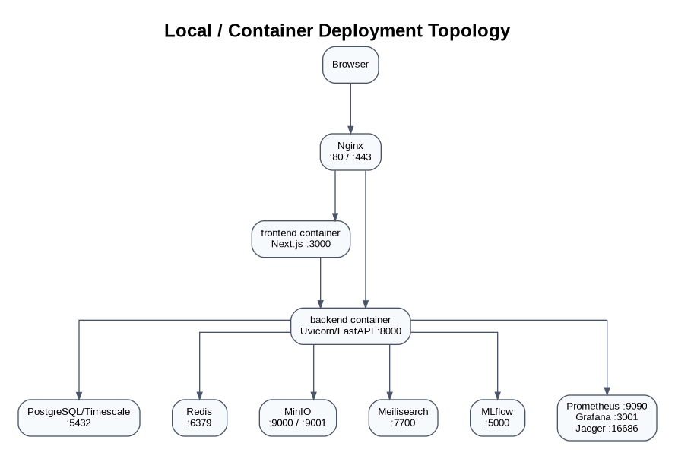
Figure 5. docker-compose deployment topology declared by the repository.
The canonical local/container story is defined by docker-compose.yml. The frontend is built from the repository root; the backend image is built from backend/. Nginx is present as an edge proxy. The compose file also declares observability and supporting infrastructure, but not every declared container is necessarily required for every developer workflow.

15. Configuration Map
Configuration | Primary source | Examples / notes
Backend settings | backend/app/core/config.py + .env | DATABASE_URL, REDIS_URL, JWT paths, provider keys, CORS, feature flags
Frontend runtime API | apps/web/src/lib/runtime-config.ts + env | API base and WebSocket URL selection; local browser prefers same-origin proxy in the current flow
Frontend build | apps/web/package.json / next.config.js / tsconfig | Next.js 14, TypeScript, Tailwind, React Query, Zustand
Monorepo | package.json / pnpm-workspace.yaml / turbo.json | pnpm workspaces + Turbo tasks
DB migrations | backend/alembic | schema changes and migration environment
Infra configs | infrastructure/* | nginx, postgres init, redis, prometheus

16. Critical End-to-End Flows for KT

16.1 Registration / Login
/register -> backend /api/v1/auth/register -> user persistence -> token response / auth state
/login -> /api/v1/auth/login -> JWT/refresh token flow -> authenticated App Router shell -> /dashboard

16.2 Market Quote / History
UI -> /api/v1/market/quote/{symbol} or /history/{symbol}
-> MarketDataService
-> provider/source selection
-> normalize result
-> schema -> UI/chart

16.3 Signal
UI -> /api/v1/signals/{symbol}
-> signal/intelligence endpoint
-> prediction_engine / signal_engine
-> market data + feature/regime/model outputs
-> ensemble signal + confidence + risk levels
-> SignalResponse
-> terminal / signals UI

16.4 Backtest
UI -> POST /api/v1/backtest/run
-> create job
-> background task execute_backtest_job / run_backtest_job_task
-> research.backtesting engine
-> analytics / statistical tests / Monte Carlo
-> persist status/results
-> GET status/results -> UI

16.5 Paper / Live Trading
UI -> paper_trading endpoint OR trading endpoint
-> auth/entitlement/risk checks
-> PaperTradingService OR BrokerAdapter / Upstox integration
-> transaction/order/audit state
-> response + realtime updates

17. Where to Change What
Change needed | Start here | Then inspect
Add/change REST endpoint | backend/app/api/v1/<domain>.py | schema + service + model/test
Change signal logic | backend/app/services/signal_engine.py / signals_service.py | prediction_engine, regime_analyzer, ensemble
Change prediction fusion | backend/app/services/prediction_engine.py | backend/research/models/ensemble/*
Add ML feature | backend/research/feature_engineering/ | target/pipeline + backtest leakage tests
Add/change model | backend/research/models/ | training/evaluation/inference + model artifact/metric handling
Change explainability | backend/research/explainability/ + backend/app/api/v1/explain.py | UI research explanation pages
Change market provider | backend/app/services/data_ingestion/ or providers/ | MarketDataService + health/fallback behavior
Change terminal behavior | apps/web/src/hooks/useTerminalData.ts + components/terminal/ | useSignalFeed/usePriceFeed + API clients
Change shared UI | packages/ui/ | web imports and visual regression
Change persistence | backend/app/models + alembic/ | repositories/services + migration
Change scheduled jobs | backend/app/tasks + backend/app/core/celery_app.py | worker deployment and task registration
Change reverse proxy / infra | infrastructure/ + docker-compose.yml | frontend/backend port/config expectations

18. Known Architectural Caveats New Engineers Should Know
- The repo contains both modern and compatibility/academic endpoint surfaces. Do not create a third API pattern without a deliberate reason.
- There is an auxiliary services/gateway package in addition to the main backend/app FastAPI runtime. Confirm whether a feature actually belongs there before editing it.
- There are two task namespaces: backend/app/tasks and backend/tasks. The current FastAPI startup explicitly imports the app/tasks path for task registration.
- The backend inference path can perform synchronous external data work. The repository notes that prediction and portfolio-performance calls can take several seconds in some local scenarios; concurrency/worker strategy matters.
- The project has a strong research layer, but production claims should follow measured provider/model behavior rather than directory names alone.
- Local development can run with SQLite/dev DB artifacts and eager Celery behavior even though the containerized target uses PostgreSQL/Redis. Always check environment-specific behavior when debugging a defect.
- The Git working tree in the supplied snapshot contains many modifications relative to main. A future engineer should preserve the exact snapshot or branch before large changes.

19. First-Day KT Checklist
1. Read README.md, ARCHITECTURE.md, KT_DOCUMENT.md and LIMITATIONS.md to understand project intent and known issues.
2. Start backend/app/main.py, backend/app/api/v1/router.py and backend/app/core/config.py.
3. Walk one domain end-to-end; terminal/signal is recommended because it touches frontend, API, market data, ML and WebSockets.
4. Read apps/web/src/lib/runtime-config.ts and the relevant API client before changing a frontend/backend call.
5. Understand PostgreSQL/Redis expectations and the difference between local eager Celery and real workers.
6. Inspect backend/research/models/ensemble plus prediction_engine before modifying signal fusion.
7. Run the existing tests/lint/build workflow before making changes so baseline failures are recorded.
8. Never commit secrets from .env files or local key material.

20. Recommended KT Walkthrough Order
1. Product surfaces: dashboard -> terminal -> market -> signals -> research -> portfolio -> backtest -> billing/admin.
2. Frontend internals: route -> component -> hook/query -> API client -> realtime hook.
3. Backend internals: router -> schema -> service -> model/provider/research module.
4. Async internals: endpoint -> task -> Celery configuration -> persistence/result retrieval.
5. ML internals: raw data -> features -> model -> ensemble -> risk -> explanation -> endpoint -> UI.
6. Operations: docker-compose -> Nginx -> FastAPI/Next.js -> PostgreSQL/Redis -> observability.

Appendix A. Source-of-Truth File Map
Topic | Source of truth
Application entrypoint | backend/app/main.py
REST router aggregation | backend/app/api/v1/router.py
Academic compatibility API | backend/app/api/quantedge_router.py
Backend settings | backend/app/core/config.py
Celery configuration | backend/app/core/celery_app.py
Database session/engine | backend/app/database/connection.py
Redis client | backend/app/database/redis_client.py
Frontend runtime config | apps/web/src/lib/runtime-config.ts
Terminal orchestration | apps/web/src/hooks/useTerminalData.ts
Signal engine | backend/app/services/signal_engine.py / signals_service.py
Prediction engine | backend/app/services/prediction_engine.py
Market data | backend/app/services/market_data_service.py
Research features | backend/research/feature_engineering/
Research models | backend/research/models/
Backtesting | backend/research/backtesting/
Explainability | backend/research/explainability/
Portfolio/risk research | backend/research/portfolio/ and backend/research/risk/
DB schema history | backend/alembic/
Container topology | docker-compose.yml
Reverse proxy | infrastructure/nginx/nginx.conf

Appendix B. Current Repository-State Notes
This KT is based on the uploaded 27 Aug 2026 ZIP. The snapshot is a working-tree state rather than a clean historical release: Git metadata indicates the current branch is main with substantial tracked-file modifications relative to the same main commit baseline. The diagrams therefore describe the code that is actually present in the archive, not a hypothetical clean-room architecture.
Security-sensitive files were intentionally not reproduced in this document. Local environment files, private keys, tokens and credential values should stay outside the KT artifact.

B.1 Fast Troubleshooting Map
Symptom | First place to inspect | Likely boundary
Login fails / browser says Failed to fetch | apps/web/src/lib/runtime-config.ts; backend/app/api/v1/auth.py | Frontend API base / proxy / CORS / auth
Redis unhealthy | backend/app/database/redis_client.py; docker-compose.yml | Redis availability or async client usage
Predictions slow | backend/app/services/prediction_engine.py; market_data_service.py | Synchronous provider/network work in inference path
Terminal values stale | useTerminalData.ts; useSignalFeed.ts; backend/app/websocket/ | REST refresh vs WebSocket stream
Backtest remains pending | api/v1/backtest.py; app/tasks/backtest_tasks.py; celery_app.py | Task registration / worker / result persistence
Model says not trained | backend/research/models/ + backend/app/models/model_artifact.py | Artifact activation/versioning / training state
Risk metrics 500 | api/v1/portfolio.py; schemas/portfolio.py; models/portfolio.py | Response field/validation / portfolio state
Provider data missing | market_data_service.py; data_ingestion/*; providers/* | Provider health / fallback / rate limits
Hydration error in terminal | usePriceFeed.ts / useSignalFeed.ts / useSignalAlerts.ts | Server/client initial-state mismatch
Duplicate or missing terminal symbols | useTerminalData.ts; watchlist.py | Watchlist merge/deduplication

B.2 Safe Change Strategy
1. Capture the current Git diff and reproduce the issue before changing code.
2. Identify the owning boundary using the source-of-truth map in Appendix A.
3. Change the narrowest layer first; avoid embedding domain logic directly into route files when an existing service already owns it.
4. Run targeted backend/frontend checks, then the broader build/test workflow.
5. For market/ML changes, verify leakage, provider fallback and latency implications, not only functional output.
6. For trading/payments changes, explicitly test authorization, idempotency, limits, auditability and failure recovery.

