Dropbox Cleaner Setup Guide
This guide explains how to:

1. create a Dropbox app
2. enable the correct Dropbox permissions
3. connect that app to Dropbox Cleaner
4. run a safe first test

This guide covers both:

- Personal Dropbox
- Team Dropbox (admin only)

Nothing in this guide deletes or moves your original files.

Before You Start
You will need:

- a Dropbox account
- Dropbox Cleaner installed on your computer
- internet access
- for Team Dropbox: a Dropbox team admin account

Important:

- Dropbox Cleaner does not ask for your Dropbox password.
- Dropbox authorization happens in your web browser.
- If you change app permissions later, you must reconnect the app in Dropbox Cleaner.

Part 1: Open Dropbox Developers
1. Open this page in your browser:
2. Click App Console.
3. Sign in with Dropbox if Dropbox asks you to.
4. Click Create app.
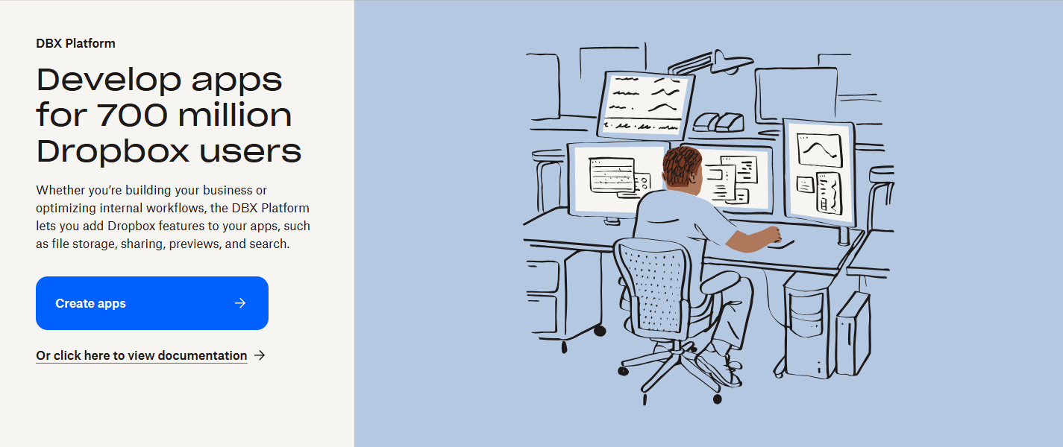

Part 2: Create the App
Dropbox's app-creation screen can change over time. The wording may be slightly different from what you see below. If it is different, choose the option that is closest to the description in this guide.

If You Are Setting Up Team Dropbox
1. Choose the Dropbox app type for team/business access if Dropbox shows separate personal vs team options.
2. Choose Scoped access if Dropbox asks.
3. Choose the option that gives access to the full team Dropbox / full Dropbox / team file access.
  - Do not choose App folder.
4. Give the app a name.
  - Example: Dropbox Cleaner Team Admin
5. Click Create app.

Tip:

- If Dropbox shows both a personal app option and a team-linked app option, choose the team-linked option for Team Dropbox.

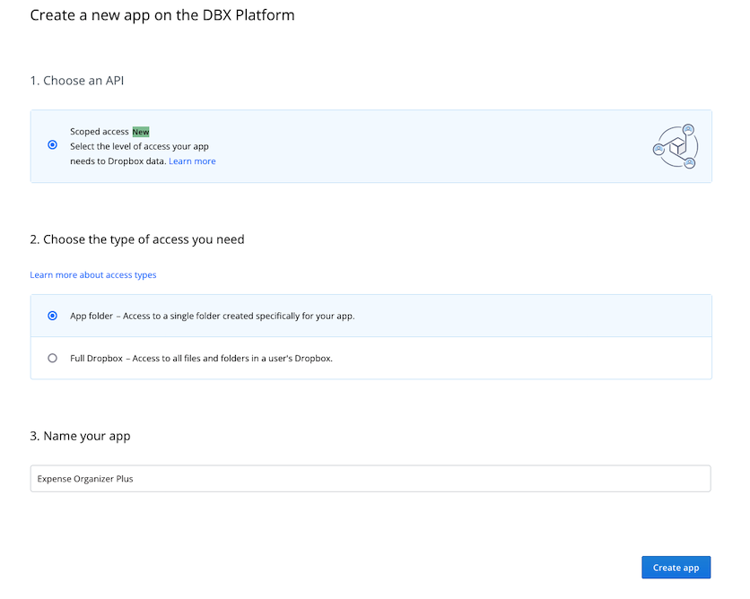

Part 3: Copy the App Key
After the app is created, Dropbox opens the app settings page.

1. Stay on the Settings tab.
2. Find the App key.
3. Copy it.
4. Paste it into a temporary note for later, or leave this page open.

You usually do not need the App secret for Dropbox Cleaner's normal setup.

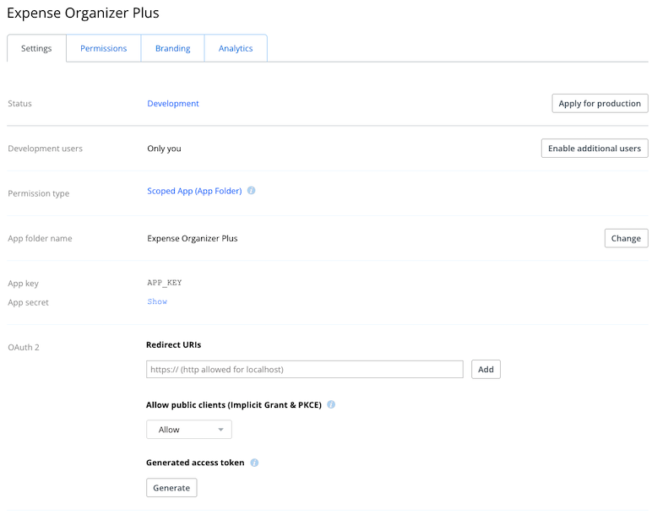

Part 4: Turn On the Correct Permissions
1. In the Dropbox App Console, open the Permissions tab.
2. Turn on the permissions listed below for your mode.
3. If Dropbox shows a Submit, Save, or similar button, click it.

Team Dropbox Permissions
Turn on these permissions:

- account_info.read
- files.metadata.read
- files.content.read
- files.content.write
- team_info.read
- members.read
- team_data.member
- sharing.read
- sharing.write
- files.team_metadata.read
- files.team_metadata.write
- team_data.team_space

Important:

- If you add or change permissions later, Dropbox Cleaner must be reconnected so Dropbox can grant the new scopes.

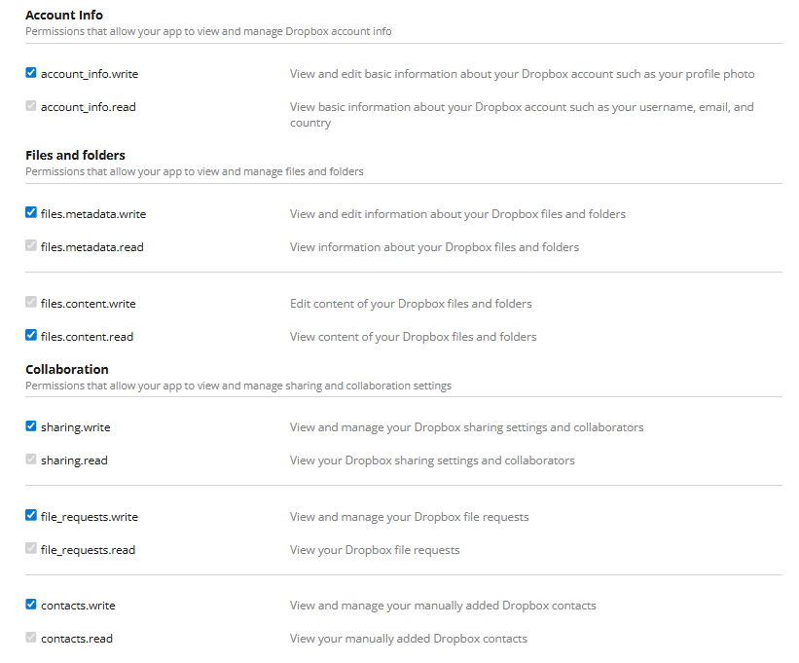
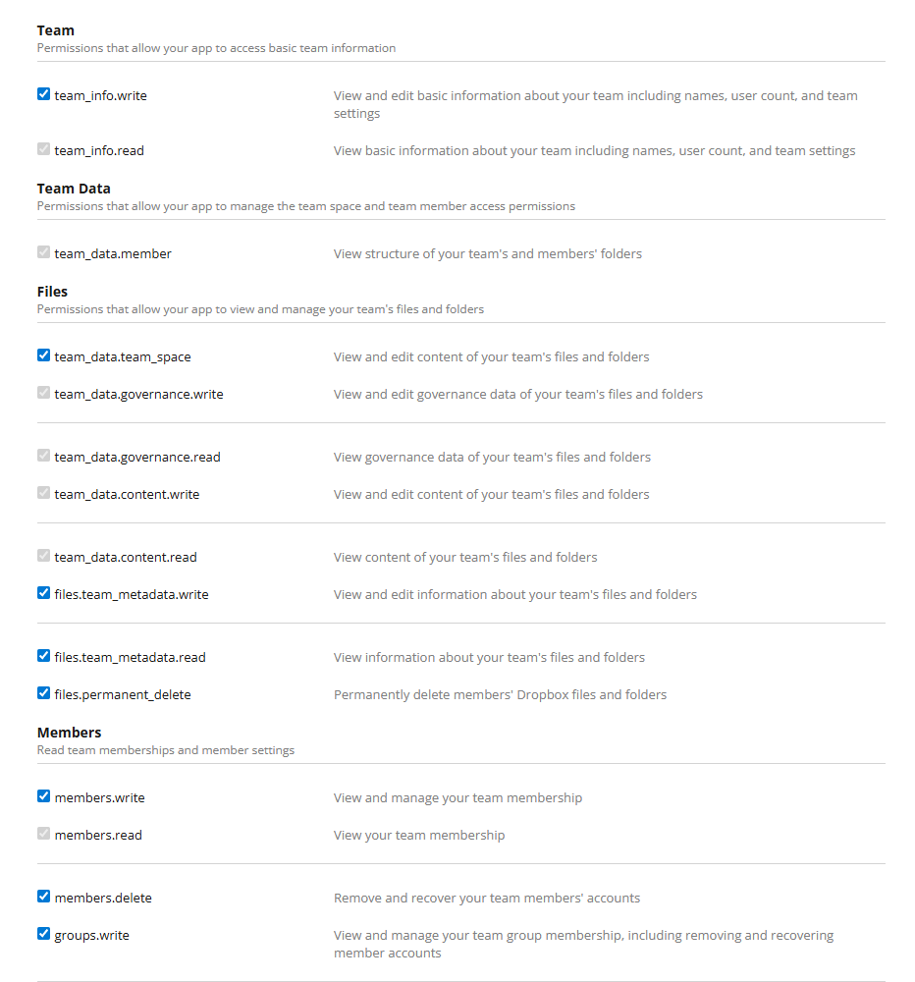

Part 5: If You Use Team Dropbox, Make Sure Your Team Allows the App
Some Dropbox teams block custom apps by default. If you use Team Dropbox, check this before you connect:

1. Sign in to Dropbox as a team admin.
2. Open the Admin console.
3. Go to Settings.
4. Open the Integrations tab.
5. Check whether custom or registered integrations are blocked.
6. If needed, allow your new app.

If Dropbox asks for an app key or app ID:

- the app key is on your app's page in the Dropbox App Console

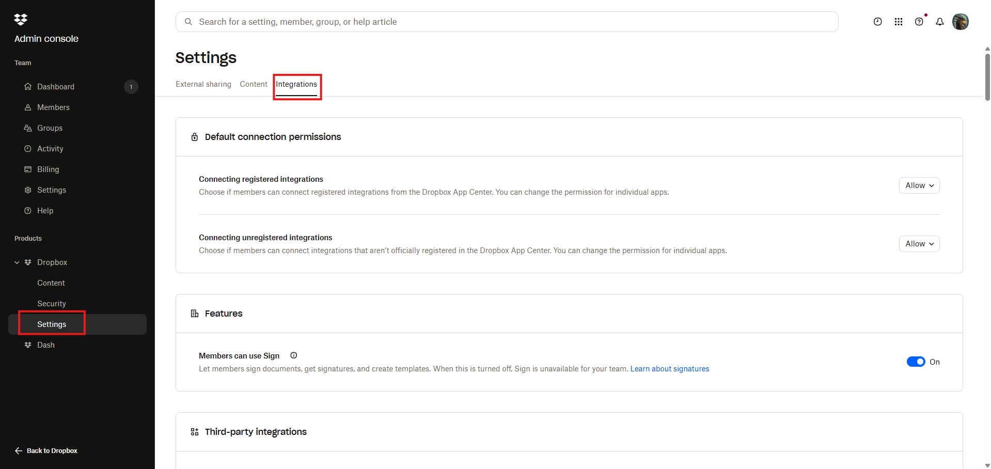

Part 6: Connect the App in Dropbox Cleaner
1. Open Dropbox Cleaner.
2. On the first screen, choose:
  - Personal Dropbox, or
  - Team Dropbox
3. On the connection screen, paste the App key.
4. Click Connect Dropbox.
5. Your browser opens to Dropbox.
6. Sign in if Dropbox asks you to.
7. Review the app name and permissions.
8. Click Allow.
9. Dropbox shows an authorization code.
10. Copy that code.
11. Go back to Dropbox Cleaner.
12. Paste the code into Authorization code.
13. Click Finish connection.
14. When Dropbox Cleaner shows that the connection is verified, click Continue.

This is the Dropbox Cleaner start screen you will see before you choose Personal Dropbox or Team Dropbox:
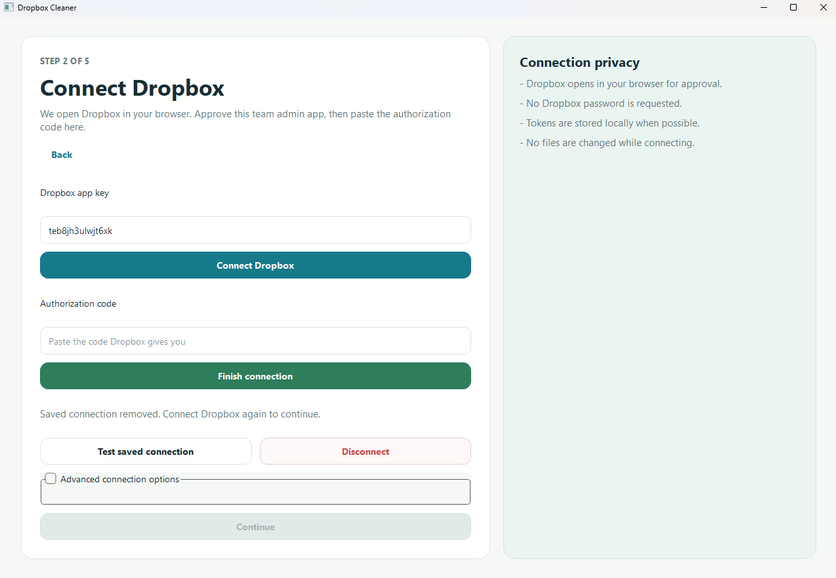
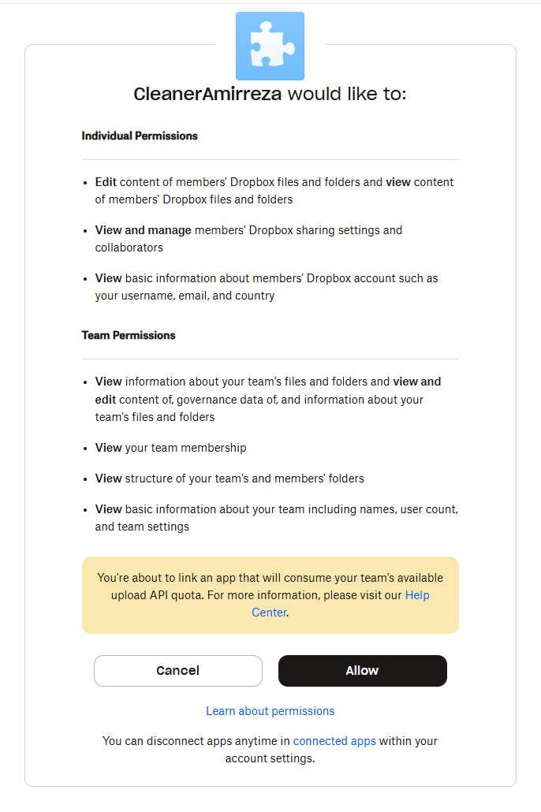

Part 7: Do a Safe First Test
Your first run should be a safe preview.

1. In Dropbox Cleaner, choose a cutoff date and set to Original file date for a better results.
2. Choose an archive folder.
4. Make sure Team coverage is set to Team-owned only.
5. For your first test, select Preview archive.
6. Click Start.
7. Wait for the scan to finish.
8. Review the results.

Preview mode is safe because:

- it does not make Dropbox changes
- it shows what would be copied
- it writes reports you can review first

Recommended first test:

- use a small test folder or an older date range you can verify easily

Part 8: What to Do After Preview Works
Once the preview looks correct:

1. go back to settings
2. switch from Preview archive to Copy to archive
3. run again

Dropbox Cleaner will:

- copy matching files into the archive
- preserve folder structure
- keep the originals in place

It will not:

- delete originals
- move originals
- overwrite existing archive files silently

Common Problems and Fixes

Problem: "The app does not have the required scope"
Cause:

- one or more Dropbox permissions were not enabled

Fix:

1. go back to the Dropbox App Console
2. open Permissions
3. enable the missing permissions
4. save changes if Dropbox shows a save button
5. reconnect the app in Dropbox Cleaner

Problem: Team app cannot connect
Cause:

- the Dropbox team blocks custom apps
- or the approving user is not a team admin

Fix:

1. sign in as a team admin
2. check Admin console -> Settings -> Integrations
3. allow the app if needed
4. reconnect

Problem: Copy run says no_write_permission
Cause:

- the archive folder is in a Dropbox location where the app or admin does not have editor access

Fix:

1. choose a different archive folder
2. or create the archive folder manually in Dropbox first
3. rerun or resume the job

Problem: Files look old in Dropbox but do not match
Cause:

- Dropbox Cleaner may be comparing Dropbox modified date instead of the file's original date

Fix:

1. in Dropbox Cleaner, change the date field to:
  - Original file date, or
  - Oldest available date
2. run the preview again

Best Practice Recommendations
- Use Team Dropbox only with a real team admin account.
- Start with Preview archive before any copy run.
- Keep the archive folder somewhere the app can write to.
- If you change Dropbox app permissions, reconnect the app afterward.
- Keep your app key private.

Official Dropbox References
These official Dropbox pages were used to build this guide:

- Dropbox Getting Started:
  - https://www.dropbox.com/developers/reference/getting-started
- Dropbox OAuth Guide:
  - https://developers.dropbox.com/oauth-guide
- Dropbox Developer Guide:
  - https://www.dropbox.com/developers/reference/developer-guide
- Dropbox Help: Manage apps for your Dropbox team:
  - https://help.dropbox.com/integrations/app-integrations

