SOFTWARE REQUIREMENTS SPECIFICATION
Personal Finance Tracker

Desktop Application | Java Swing

Version 1.1
Prepared by: Development Team
Date: April 2026

Table of Contents
1. Introduction
1.1 Project Overview
1.2 Objectives
2. System Architecture
2.1 Overall Architecture (MVC Pattern)
2.2 Package Structure
2.3 Technology Stack
3. System Design
3.1 Use Case Diagram
3.2 Class Diagram
3.3 ER Diagram (Entity Relationship Diagram)
4. Module Description
4.1 Authentication Module
4.2 Dashboard Module
4.3 Transaction Management
4.4 Account Management
4.5 Budget Management
4.6 Debt Management
4.7 Card Management
4.8 Scheduled Transactions
4.9 Calendar Module
4.10 Tools Module
4.11 User Profile & Settings
5. Database Design
5.1 Tables Description
5.2 Relationships
6. System Features
7. Non-Functional Requirements
7.1 Performance
7.2 Security
7.3 Usability
7.4 Reliability & Data Integrity
7.5 Portability & Compatibility
8. Conclusion

1. Introduction

1.1 Project Overview
The Personal Finance Tracker is a desktop application built with Java Swing that enables users to manage their personal finances comprehensively. It offers modules for account management, transaction tracking, budgeting, debt and credit card management, scheduled payments, calendar views, and financial summaries. The application follows a clean MVC (Model-View-Controller) layered architecture, ensuring separation of concerns, maintainability, and scalability.

1.2 Objectives
The primary objectives of the Personal Finance Tracker are:
- Provide an intuitive, offline-first personal finance management tool.
- Allow users to track income, expenses, and account balances in real time.
- Help users plan their finances through budgeting and scheduled transactions.
- Offer insightful dashboards and reports for better financial awareness.
- Support multiple currencies with dynamic exchange rate conversion.
- Ensure data security through password hashing and isolated user data.

2. System Architecture

2.1 Overall Architecture (MVC Pattern)
The application is designed using a layered architecture that closely follows the Model-View-Controller (MVC) pattern, adapted for a desktop Swing environment:
Model Layer: Plain Java objects (POJOs) representing business entities (User, Account, Transaction, Budget, Debt, Card, Scheduled, Category, UserProfile).
View Layer: Swing components – JFrame (e.g., MainFrame, LoginFrame), JPanel classes (e.g., OverviewPanel, TransactionsPanel), and JDialog classes (e.g., AddTransactionDialog).
Controller Layer: Minimal controller logic; most event handling is performed directly in the View classes. AuthController manages the complete authentication flow including login, registration, and password reset.
Data Access Layer (DAO): Data Access Objects (UserDAO, AccountDAO, TransactionDAO, etc.) encapsulate all database operations using JDBC.
Utility Layer: Reusable helpers (CurrencyFormatter, ExchangeRate, PasswordUtils, SessionManager, Theme).
The diagram below illustrates the high-level architecture:
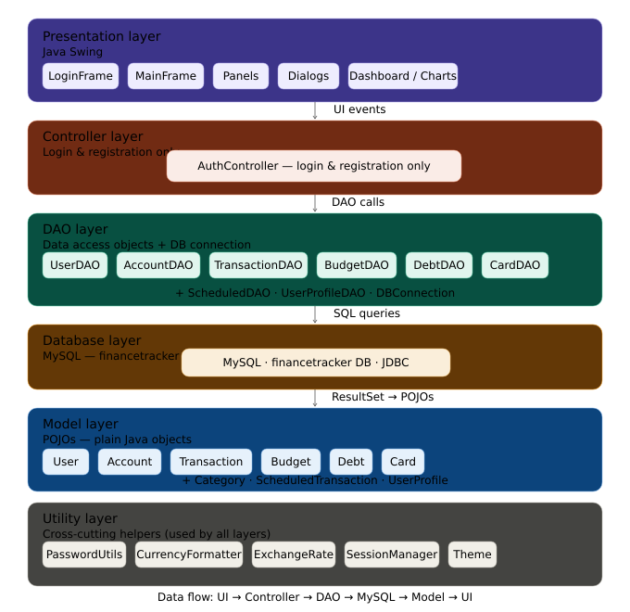

2.2 Package Structure
The application source code is organized into clearly separated packages, each aligned with a distinct architectural layer. This structure enforces the MVC separation and makes the codebase easy to navigate, test, and extend.
Package | Responsibility | Key Classes
model | Domain entities (POJOs). No business logic; pure data containers. | User, Account, Transaction, Budget, Debt, Card, Scheduled, Category, UserProfile
view | All Swing UI components: frames, panels, and dialogs. Handles display and user interaction. | MainFrame, LoginFrame, OverviewPanel, TransactionsPanel, AddTransactionDialog, CalendarPanel
controller | Orchestrates authentication flow and manages application-wide session state. | AuthController
dao | Data Access Objects. Each class maps one entity to its database table via JDBC. | UserDAO, AccountDAO, TransactionDAO, BudgetDAO, DebtDAO, CardDAO, ScheduledDAO, CategoryDAO, UserProfileDAO
util | Stateless helper utilities shared across layers. | CurrencyFormatter, ExchangeRate, PasswordUtils, SessionManager, Theme
db | Database connection management and schema initialization. | DatabaseConnection, SchemaInitializer
resources | Bundled image assets used by the UI. | my_image.png, start_image.png

2.3 Technology Stack
The following technologies and libraries underpin the application:
Layer / Concern | Technology | Notes
Language | Java 17 (LTS) | Target runtime; compatible with Java 11+.
UI Framework | Java Swing (javax.swing) | Cross-platform desktop GUI; styled with FlatLaf or custom UIManager overrides.
Database | MySQL 8.0 (via Connector/J) | Embedded, file-based database. No external server required; ideal for offline-first use.
JDBC Driver | sqlite-jdbc (Xerial) | External relational database running on localhost. InnoDB engine; UTF-8 MB4 charset. Database name: financetracker.
Password Security | BCrypt (jBCrypt library) | SHA-256 via MessageDigest. No salt; single hash.
Currency Conversion | ExchangeRate API (HTTP REST) | Fetches live rates at startup; falls back to cached rates when offline.
Build Tool | Apache Maven or Gradle | Manages dependencies and produces a single executable fat-JAR.
Distribution | Executable JAR / jpackage installer | Packaged as a standalone installer for Windows, macOS, and Linux.

3. System Design

3.1 Use Case Diagram
The use case diagram identifies two primary actors: the Guest (unauthenticated user) and the Authenticated User. Guests are restricted to registration and login. Once authenticated, users gain access to the full feature set including transaction management, budgeting, debt tracking, card management, scheduled transactions, calendar, reporting, and profile settings. Each use case maps directly to one or more modules described in Section 4.
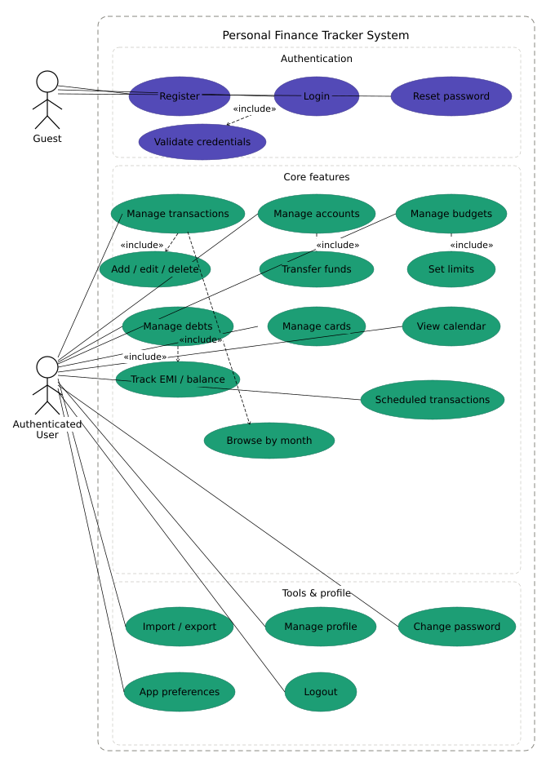

3.2 Class Diagram (Simplified)
The simplified class diagram illustrates the core model classes and their associations. User aggregates Account, Transaction, Budget, Debt, Card, and Scheduled instances. Each Transaction references a Category and is optionally linked to either an Account or a Card. The DAO layer (not shown) provides a one-to-one mapping from each model class to its corresponding database table, keeping persistence logic fully separated from the domain model.
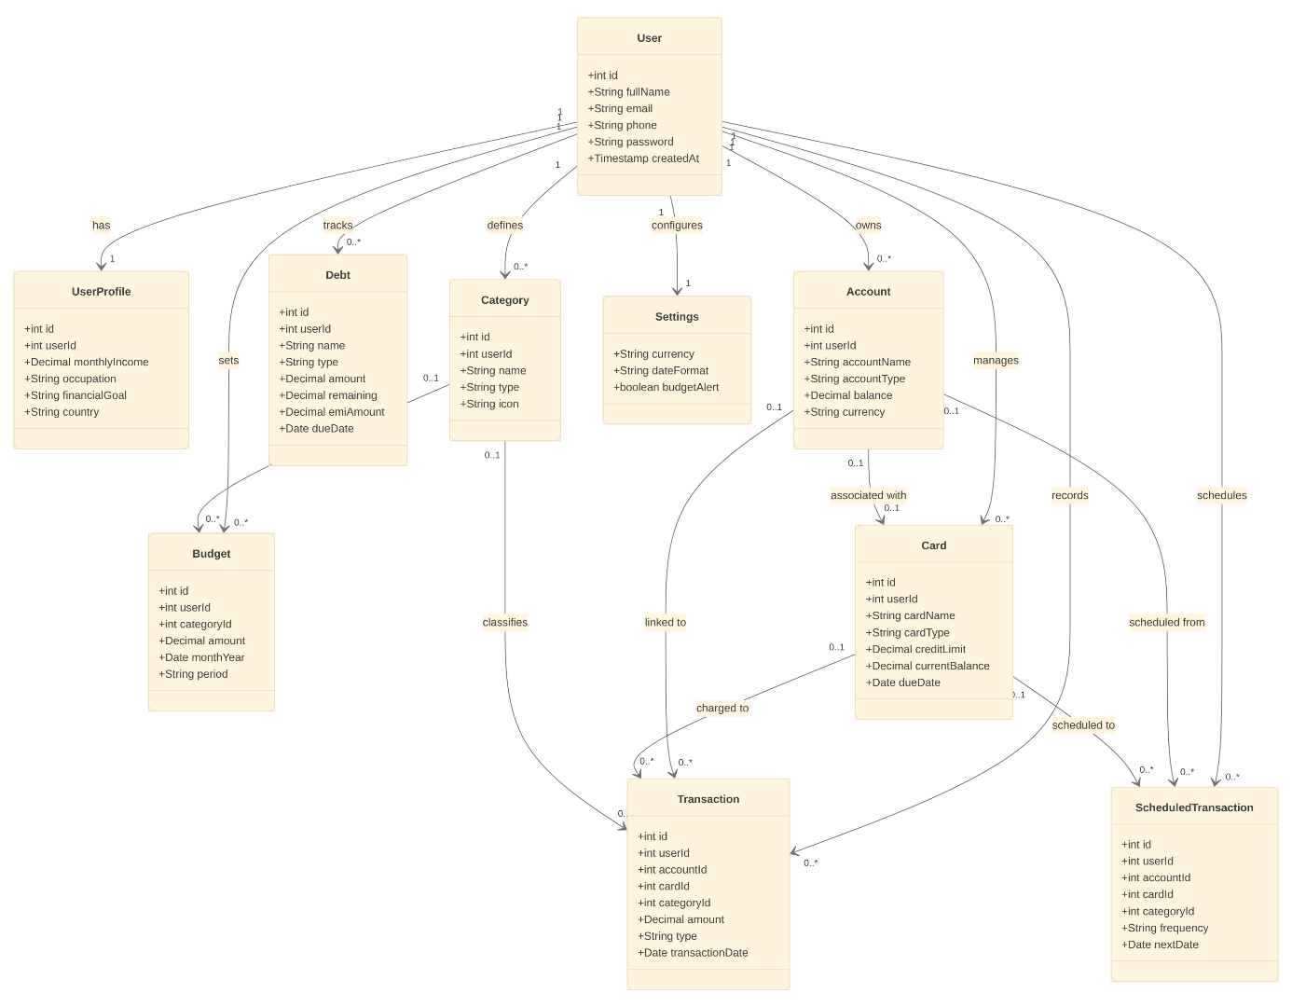

3.3 ER Diagram (Entity Relationship Diagram)
The ER diagram reflects the physical database schema. All tables include a user_id foreign key to enforce strict data isolation between users. The transactions table holds nullable foreign keys to both accounts and cards, since a transaction may originate from either. The user_profiles table maintains a strict one-to-one relationship with users via a UNIQUE constraint on user_id. All monetary amounts are stored as DECIMAL(12,2) values in the user’s base currency; display-layer conversion is handled at runtime by CurrencyFormatter and ExchangeRate utilities.
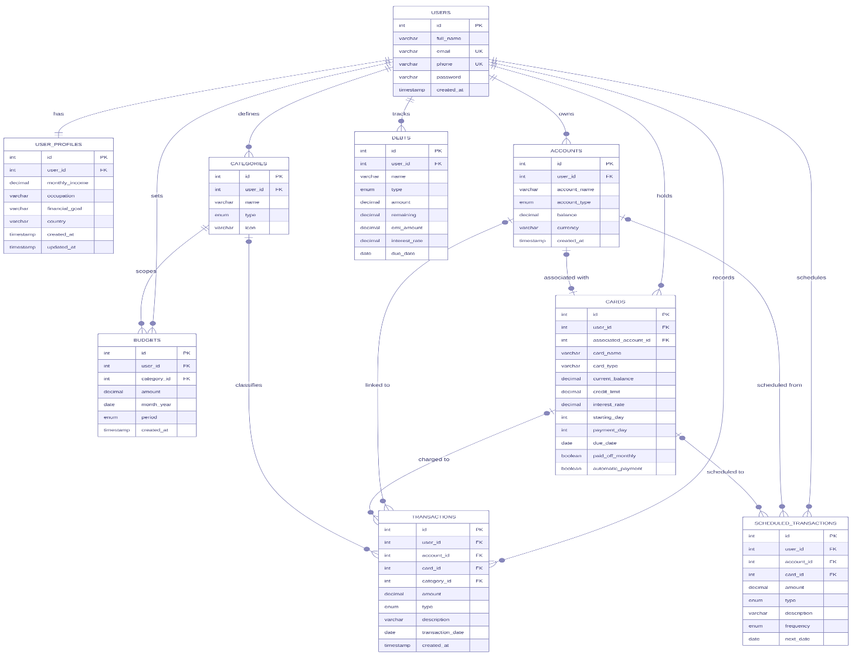

4. Module Description

4.1 Authentication Module
This module handles user registration, login, and password recovery.

Use Case | Description | Related Classes
Login | User enters email/phone and password. System verifies hashed password and starts a session. | LoginFrame, AuthController, UserDAO, PasswordUtils, SessionManager
Registration | New user provides full name, email, phone, and password. System validates uniqueness and stores hashed credentials. | RegistrationFrame, UserDAO, PasswordUtils
Password Reset | User requests OTP via email (simulated). After verification, they can set a new password. | ForgotPasswordFrame, ResetPasswordFrame, UserDAO, PasswordUtils
Stay Logged In | Optional checkbox on LoginFrame. When selected, the user ID is saved in a local properties file. On subsequent launches, tryAutoLogin() bypasses the login screen and opens the dashboard directly. Logging out or unchecking clears the saved ID. | LoginFrame, SessionManager, Settings

4.2 Dashboard Module
The main application window (MainFrame) provides a sidebar navigation and a card-based content area. Key dashboard panels are listed below.

Panel | Description | Key Features
OverviewPanel | Financial snapshot with net worth, income/expense donut charts, account summaries, credit card utilization, and budget progress. | Dynamic data refresh; currency-aware formatting.
SummaryPanel | Tabular monthly and yearly summaries of income, expenses, savings, and savings rate. | Sorted descending (most recent first); centered text.

4.3 Transaction Management

Feature | Description | Classes Involved
Add / Edit / Delete Transaction | Record income or expense with account/card, category, amount, date, and description. | TransactionsPanel, AddTransactionDialog, TransactionDAO, AccountDAO
Automatic Balance Update | When a transaction is saved, the linked account/card balance is updated in a subsequent database operation (sequential, not wrapped in a single JDBC transaction). | TransactionDAO (internal update)
Account Transfer | Facilitates internal fund transfers between two accounts, recorded as paired EXPENSE and INCOME transactions. | TransferDialog, TransactionDAO, AccountDAO
Refresh Propagation | After any change, all relevant panels (Accounts, Overview, Budgets) are refreshed via a callback mechanism. | DataChangeListener (Runnable)

4.4 Account Management
Users can manage their financial accounts across four types: Bank, Wallet, Cash, and Other.

Action | Description | Classes Involved
Add / Edit Account | Provide name, type, initial balance, and currency. | AccountsPanel, AddEditAccountDialog, AccountDAO
Delete Account | Deletion is prevented if the account is referenced by existing transactions. | AccountDAO
View Total Assets | Displayed in the summary card of AccountsPanel. | AccountDAO.getTotalBalance()

4.5 Budget Management
Users can set monthly or yearly spending limits per category.

Feature | Description | Classes Involved
Create / Edit Budget | Select category, amount, period (Monthly/Yearly), and month/year. | BudgetsPanel, AddEditBudgetDialog, BudgetDAO
Progress Tracking | A visual progress bar shows the spent amount vs. the budgeted amount. The bar turns red at 100% usage. A UNIQUE constraint on (user_id, category_id, month_year) prevents duplicate budget entries. | Budget.getPercentage()
Toggle Monthly/Yearly | Switch between monthly and yearly budget views. When Budget Alert is enabled in Preferences, a warning dialog lists over-limit categories once per session. | BudgetsPanel

4.6 Debt Management
Track borrowed or lent money with support for interest rates and EMI options.

Feature | Description | Classes Involved
Add / Edit Debt | Name, type (Borrowed/Lent), total amount, remaining balance, interest rate, due date, and user-entered EMI amount. No automatic EMI calculation is performed. | DebtsPanel, AddEditDebtDialog, DebtDAO
Pay Debt | Opens a payment dialog; creates an EXPENSE transaction (category "Debt Payment") and reduces the debt's remaining amount. | DebtsPanel.payDebt(), TransactionDAO, CategoryDAO
Status Tracking | Shows "Active" or "Cleared" based on the remaining balance. | DebtsPanel

4.7 Card Management
Manage credit and debit cards linked to user accounts.

Feature | Description | Classes Involved
Add / Edit Card | Card name, type, credit limit, current balance, interest rate, billing cycle days, and linked account. | CardsPanel, AddEditCardDialog, CardDAO
Utilization Display | Shows a progress bar of the current balance vs. the credit limit. | CardsPanel

4.8 Scheduled Transactions
Set up recurring transactions that can be processed manually when they fall due.

Feature | Description | Classes Involved
Create / Edit Schedule | Description, amount, frequency (Daily/Weekly/Monthly/Yearly), next date, and category. | ScheduledPanel, AddEditScheduledDialog, ScheduledDAO
Process Due | Converts due scheduled items into actual transactions and advances the next due date. | ScheduledPanel.processDueSchedules()

4.9 Calendar Module
A visual calendar showing transaction dates and scheduled payment events.

Feature | Description | Classes Involved
Monthly Calendar View | Days with transactions or scheduled items are marked with colored dots. Clicking a day displays its transactions. | CalendarPanel, TransactionDAO, ScheduledDAO
Today Highlight | The current date is highlighted for quick reference. | CalendarPanel

4.10 Tools Module
Provides import and export functionality for transaction data.

Feature | Description | Classes Involved
Export to CSV | Exports all user transactions to a CSV file. | ToolsPanel, TransactionDAO
Import from CSV | Parses a CSV file, previews the first 10 rows, and imports valid transactions with duplicate detection, category/account matching. | ToolsPanel, TransactionDAO, CategoryDAO, AccountDAO, CardDAO

4.11 User Profile & Settings

Feature | Description | Classes Involved
User Profile | Displays and edits extended profile information (monthly income, occupation, financial goal, country). | UserProfilePanel, EditProfileDialog, UserProfileDAO
Change Password | Allows an authenticated user to change their password by verifying their current password first. | ChangePasswordDialog, UserDAO, PasswordUtils
Preferences | Set currency (INR/USD/EUR/GBP), date format, and budget alert toggle. Changes are stored in a local properties file via the Settings utility class and applied immediately. | PreferencesPanel, Settings, CurrencyFormatter, ExchangeRate

5. Database Design

5.1 Tables Description
The database schema consists of the following tables:

Table | Purpose
users | Stores authentication details including hashed passwords.
user_profiles | Extended user information (income, occupation, financial goals).
accounts | Financial accounts belonging to users.
categories | Predefined and user-defined transaction categories.
transactions | All income and expense records.
budgets | Monthly or yearly spending limits per category.
debts | Liabilities (borrowed/lent) with interest and EMI information.
cards | Credit/debit cards linked to user accounts.
scheduled_transactions | Recurring transaction templates.

5.2 Relationships
- One-to-Many from users to all other tables (except user_profiles, which maintains a one-to-one relationship). User deletion cascades to all child tables via CASCADE delete rules.
- One-to-Many from accounts and cards to transactions (both nullable; a transaction may be linked to an account, a card, or both). Account/card deletion applies SET NULL on associated transaction rows.
- One-to-Many from categories to transactions and budgets.
- One-to-One between users and user_profiles (enforced by a UNIQUE constraint on user_id).
Refer to the ER Diagram in Section 3.3 for a complete visual representation of these relationships.

6. System Features

Category | Features
Authentication | Secure registration, login, password hashing, OTP-based password reset.
Financial Tracking | Multi-account support, income/expense recording, real-time balance updates.
Budgeting | Category-based budgets (monthly/yearly) with visual progress tracking.
Debt Management | Track borrowed/lent money, interest, EMI, and record payments as transactions.
Credit Cards | Monitor credit limits, outstanding balances, and utilization rates.
Scheduled Transactions | Define recurring payments/income; process them on demand.
Reporting | Dashboard overview, monthly/yearly summaries, and income vs. expense charts.
Calendar | Visual calendar displaying financial events and due scheduled transactions.
Import / Export | CSV import/export of transactions with preview and duplicate detection.
User Preferences | Currency switching with conversion, date format selection, and budget alerts.

7. Non-Functional Requirements
The following non-functional requirements define the quality attributes and operational constraints the system must satisfy, independent of specific feature behaviour.

7.1 Performance
Requirement | Target
Application startup time | The application must reach the login screen within 3 seconds on hardware meeting the minimum specification.
UI responsiveness | All user interactions must respond within 200 ms; database-heavy operations within 1 second.
Transaction load | The system must render a list of up to 10,000 transactions without perceptible lag (< 500 ms).
Currency rate fetch | Exchange rate retrieval must complete within 5 seconds; the UI must remain interactive during the fetch (asynchronous).

7.2 Security
Requirement | Specification
Password storage | All passwords must be hashed using SHA-256 (MessageDigest) before being written to the database. Plaintext passwords must never be logged or persisted.
Session management | SessionManager must clear all in-memory user state on logout. No session token is persisted to disk.
Data isolation | Every database query must be scoped by user_id. Cross-user data access must be structurally impossible through the DAO layer.
SQL injection prevention | All database interactions must use parameterised PreparedStatements. String concatenation in SQL is prohibited.
OTP validity | Password-reset OTPs must expire within 5 minutes of generation and be invalidated immediately after successful use.

7.3 Usability
Requirement | Specification
Learnability | A new user must be able to complete account setup and record their first transaction within 5 minutes, without consulting documentation.
Error messages | All validation errors (empty fields, duplicate email, invalid amounts) must be surfaced in plain language adjacent to the offending field.
Accessibility | The UI must maintain a minimum contrast ratio of 4.5:1 (WCAG AA) for all body text. Interactive controls must be keyboard-navigable.
Consistency | All Add/Edit dialogs must follow a uniform layout: labelled fields in a vertical grid, with Save and Cancel buttons right-aligned at the bottom.

7.4 Reliability & Data Integrity
Requirement | Specification
Transactional writes | Any operation modifying both a transaction record and an account balance must execute within a single database transaction; partial writes must roll back automatically on failure.
Referential integrity | MySQL InnoDB foreign key enforcement ensures referential integrity. Account/card deletions apply SET NULL on dependent transaction rows; user deletion cascades to all child tables.
Duplicate detection (CSV import) | Import must detect duplicates by comparing date, amount, category, and account. Duplicates must be skipped and reported to the user, not silently inserted.

7.5 Portability & Compatibility
Requirement | Specification
Operating systems | The application must run without modification on Windows 10+, macOS 11+, and Ubuntu 20.04+ (or equivalent Linux distributions with a desktop environment).
Java runtime | Compatible with Java 11 through Java 21. The distribution package must bundle a JRE so no pre-installed Java is required on the end-user machine.
Database portability | The application requires a local MySQL 8.0 server. Migration to another system requires exporting the database schema and data. The application itself runs offline with no external network dependencies.
Screen resolution | The UI must be fully usable at 1280 x 720 px and scale gracefully up to 4K resolutions using relative layouts (no hard-coded pixel positions).

8. Conclusion
The Personal Finance Tracker successfully delivers a comprehensive, user-friendly desktop application for managing personal finances. Built on a clean layered architecture with robust data persistence and a modern Java Swing UI, the application demonstrates strong engineering practices throughout.
Key strengths include real-time financial tracking, integrated budgeting and debt management, and flexible user preferences with multi-currency support. The system is designed for maintainability and can be readily extended with additional capabilities such as bank account synchronization, advanced analytics dashboards, or mobile companion applications.

