# Requirements Documentation

Requirements are formed to give a general need for the project to succeed, that should define what different aspects of project needs to include, without being too specific allow for a variety of solutions. Each requirement is then broken in to components, test schemes, and risk to project if the requirement is not implemented.

MoSCoW Definition  
Each requirement as a hierarchy of components within a requirement, that has been presented in to MoSCoW format. Therefore, been defined.

|  |  |  |
| --- | --- | --- |
| **Level** | **Stands for** | **Definition** |
| **M** | **Must(s)** | **Minimal component of the requirement** |
| **S** | **Should(s)** | **Beneficial component of the requirement.** |
| **C** | **Could(s)** | **Beneficial and complex component of the requirement.** |
| **W** | **Won’t(s)** | **Beneficial, but too complex component for the scope of the project** |

Risk Definitions  
Each requirement has an associated risk in the scenario of failed completion. The definitions of which have been evaluated using the following.

|  |  |  |
| --- | --- | --- |
| **Level** | **Severity** | **Definition** |
| **1** | **LOW** | **No impact to the project if incomplete** |
| **2** | **MODERATE** | **Can be resolved easily and quickly with minor improvisation** |
| **3** | **SUBSTANTIAL** | **Can resolve, but is non-trivial and time consuming** |
| **4** | **SEVERE** | **Impacts other requirements, and non-trivial to resolve** |
| **5** | **CRITICAL** | **Project failure** |

# Requirements:

## 1) System Output

Requirement text:  
The system output must give a timestamped latitude and longitude position.

Rationale:  
To standardise communications with the user interface.

MoSCoW:

|  |  |  |  |
| --- | --- | --- | --- |
| Must(s) | Should(s) | Could(s) | Won’t(s) |
| Latitude; Longitude, and Time | N/A | N/A | Latitude; Longitude, time format in real time. |

Test Scheme:

Is the system output in;

|  |  |  |  |
| --- | --- | --- | --- |
| Must(s) | Should(s) | Could(s) | Won’t(s) |
| Latitude; Longitude, and Time? | N/A | N/A | Latitude; Longitude, time format in real time? |

Risk to the project if not complete:  
2

2) GPS-Denied Navigation

Requirement text:  
The system must use celestial navigation techniques to generate position estimates.

Rationale:  
The project requires a method of getting an absolute geo-location to reduce/remove drift. The project is intended to function in GPS denied environments, celestial was selected for its known capabilities in the past.

MoSCoW:

|  |  |  |  |
| --- | --- | --- | --- |
| Must(s) | Should(s) | Could(s) | Won’t(s) |
| Solar and Luna | Constellations | Other celestial bodies | Signals of opportunity; Flight Paths; Depths; Visual SLAM, and weather. |

Test Scheme:  
Can the system can locate a vessel position;

|  |  |  |  |
| --- | --- | --- | --- |
| Must(s) | Should(s) | Could(s) | Won’t(s) |
| Via Solar and/or Luna? | Via Constellations? | Via other celestial bodies? | Without any Celestial body? |

Risk to the project if not complete:  
5

3) Un-interrupted Navigation

Requirement text:  
The system must use an IMU setup, including an accelerometer, gyroscope and magnetometer, to generate position estimates.

Rationale:  
Absolute positing may fail, or take a long-time to compute. As such, having a dead-reckoned position via a IMU can provide interim position estimates. However, they suffer from drift, so using as a stand-alone solution is infeasible.

MoSCoW:

|  |  |  |  |
| --- | --- | --- | --- |
| Must(s) | Should(s) | Could(s) | Won’t(s) |
| Accelerometer, and Gyroscope | Magnetometer | Multiple IMUs | Cheaper IMUs |

Test Scheme:  
The system can track a vessel position using a;

|  |  |  |  |
| --- | --- | --- | --- |
| Must(s) | Should(s) | Could(s) | Won’t(s) |
| 3-axis accelerometer and a 3-axis gyroscope (6-axis IMU)? | 3-axis accelerometer; 3-axis gyroscope, and a 3-axis magnetometer (9-axis IMU)? | Fusion of multiple 6 and 9 axis IMUs? | Fusion of multiple, cost effective, 6 and 9-axis IMUs? |

Risk to the project if not complete:  
4

4) System Accuracy

Requirement text:  
 The system output position estimate must have an accuracy comparable to contemporary systems.

Rationale:  
If the system resultant position estimates are worse than current contemporary methods, then it is unlikely that the system will be useful or be of valuable IP.

MoSCoW:

|  |  |  |  |
| --- | --- | --- | --- |
| Must(s) | Should(s) | Could(s) | Won’t(s) |
| ±10m | ±4m | ±1m | ±0.1m |

Test Scheme:  
When;

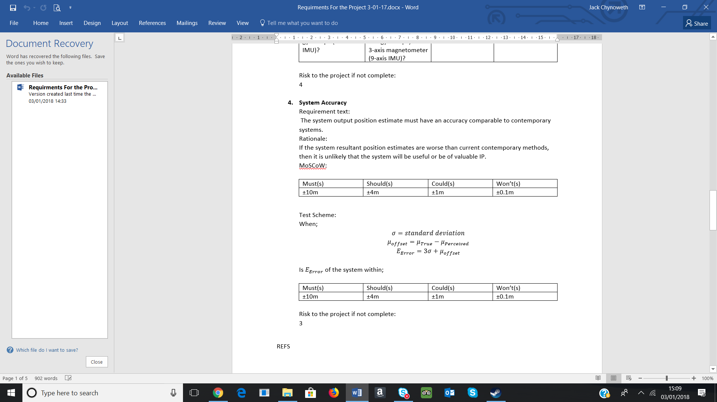

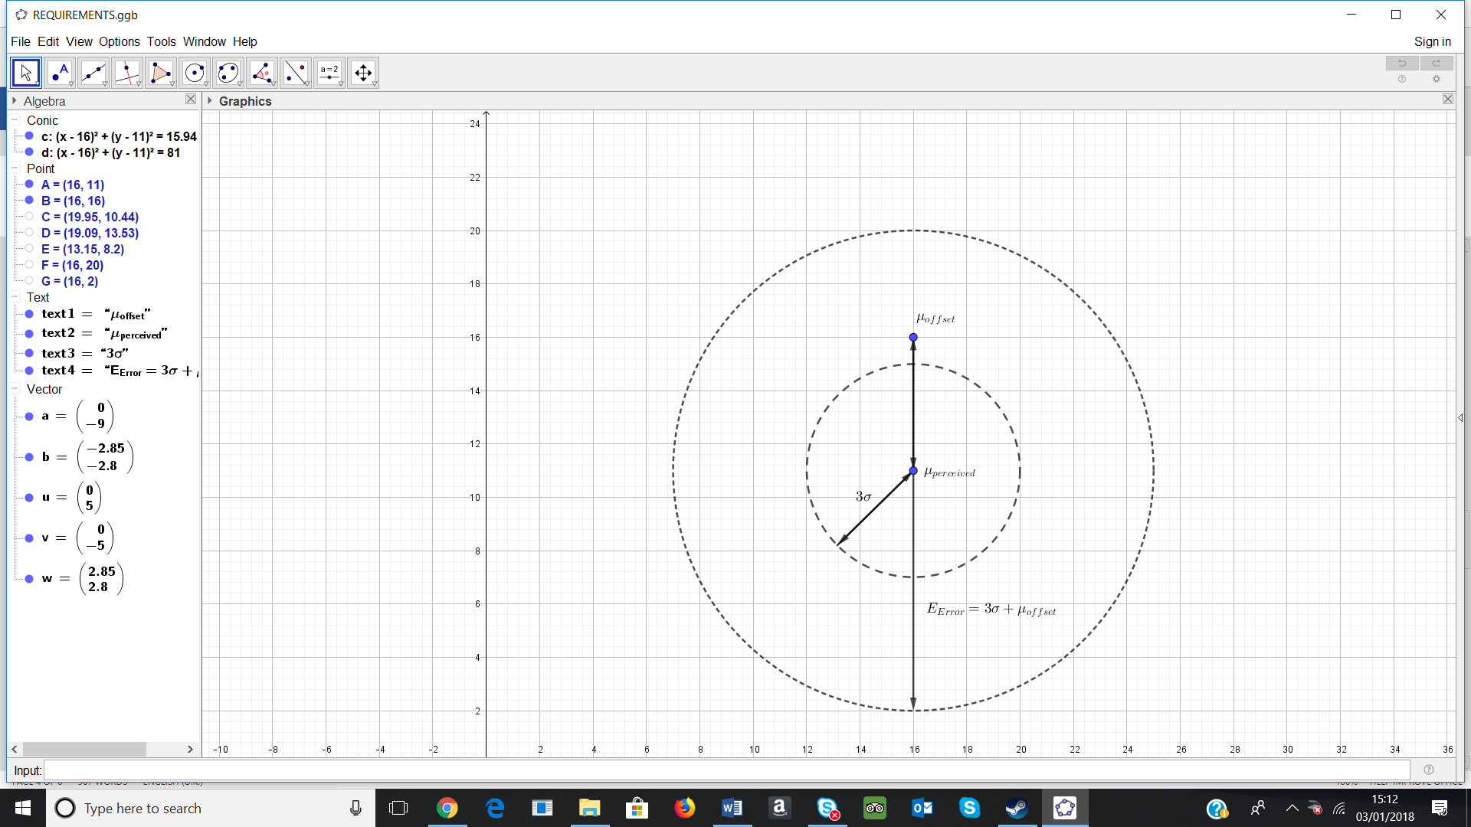

Is $E_{Error}$ of the system within;

|  |  |  |  |
| --- | --- | --- | --- |
| Must(s) | Should(s) | Could(s) | Won’t(s) |
| ±10m | ±4m | ±1m | ±0.1m |

Risk to the project if not complete:  
3

### REFS

<https://en.wikipedia.org/wiki/GLONASS>

<https://en.wikipedia.org/wiki/Galileo_(satellite_navigation>)

<https://en.wikipedia.org/wiki/BeiDou_Navigation_Satellite_System>

<https://en.wikipedia.org/wiki/Global_Positioning_System>

5) Noise Models

Requirements text:  
Noise channel models must be generated and used to implement noise correction methods.

Rationale:  
Sensory systems include noise which can cause errors to accumulate overtime, and decrease the system accuracy. By modelling inherent errors, measures to reduce their impact can be implemented.

### MoSCoW:

|  |  |  |  |
| --- | --- | --- | --- |
| Must(s) | Should(s) | Could(s) | Won’t(s) |
| IMU | Celestial | N/A | N/A |

### Test Scheme:

Have noise channels models significantly improved the accuracy and/or precision of the;

|  |  |  |  |
| --- | --- | --- | --- |
| Must(s) | Should(s) | Could(s) | Won’t(s) |
| IMU tracked position? | Celestial tracked position? | N/A | N/A |

Risk to the project if not complete:  
2

6) Output Units

Requirements:  
The system must provide the user with a variety of standard units to view the system output with.

Rationale:  
Human psychology is an important factor when introducing new technology. By allowing several standards to be displayed, that the user can select from, they should feel more comfortable using it.

### MoSCoW:

|  |  |  |  |
| --- | --- | --- | --- |
| Must(s) | Should(s) | Could(s) | Won’t(s) |
| Latitude; Longitude, and Time | Distance Measurements (SI) | Metric; Imperial, and Celestial, etc. | N/A |

### Test Scheme:

Can the user readily see;

|  |  |  |  |
| --- | --- | --- | --- |
| Must(s) | Should(s) | Could(s) | Won’t(s) |
| Their Latitude; Longitude, and Time format? | The distance travelled, since a given time in SI units? | Their location and distance travelled in a variety of standard units, including,  Metric; Imperial, and Celestial, etc? | N/A |

Risk to the project if not complete:  
1

## 7) System Display

Requirements:  
The system must display the system output using both a textual and graphical display.

Rationale:  
Textual information can be very precise, but difficult to interpret. Graphical information is easy to interpret but may not be very precise or easy to record. The two methods complement each other.

### MoSCoW:

|  |  |  |  |
| --- | --- | --- | --- |
| Must(s) | Should(s) | Could(s) | Won’t(s) |
| Textual | Graphical | Plot on Graphical | N/A |

Test Scheme:  
Can the user readily see;

|  |  |  |  |
| --- | --- | --- | --- |
| Must(s) | Should(s) | Could(s) | Won’t(s) |
| Their location textually? | Their location on a graphical map? | Their location, and where they’ve been, textually and on a graphical map? | N/A |

Risk to the project if not complete:  
1

### REFS

<http://astro.unl.edu/naap/motion1/tc_units.html>

<https://www.maptools.com/tutorials/lat_lon/formats>