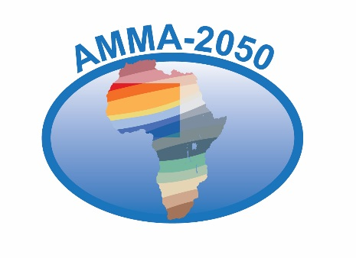

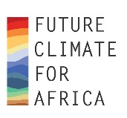Description: Description: Butterfly:Users:candysorrell:WORK:New NERC logo:NERC logo square.eps

**Technical Report No. x.x**

**Atlas of climate CHANGE metrics v1**

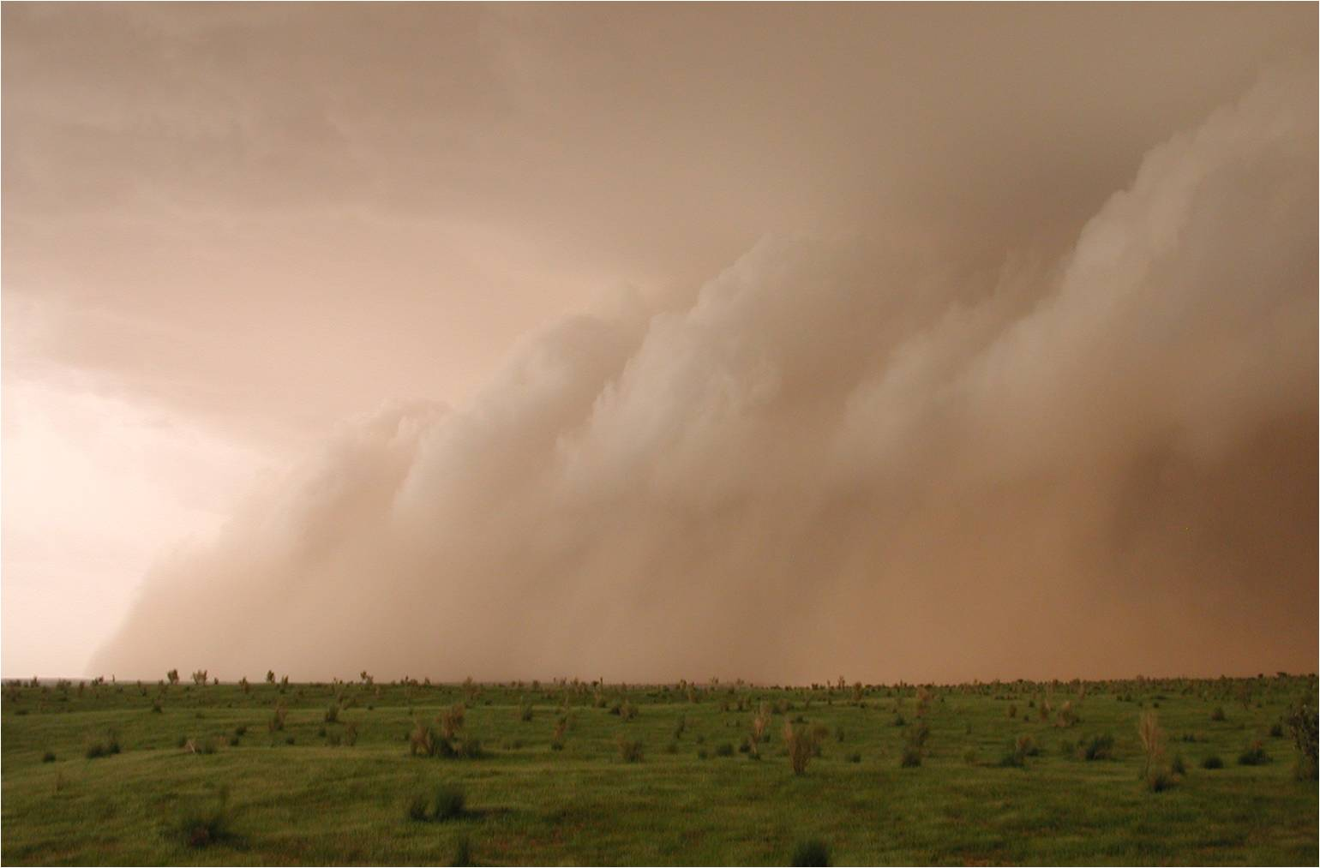

|  |  |
| --- | --- |
| Start date of project: 01 June 2015 Duration: 48 months |  |

Authors: AMMA-2050 Climate Science Team (Adama Bamba, Rory Fitzpatrick, Andy Hartley, Serge Janicot, Cornelia Klein, Nana Ama Browne Klutse, Oumar Konte, Famien Moise, Siny N'Doye, Dave Rowell, Youssouph Sane, Evelyne Toure)

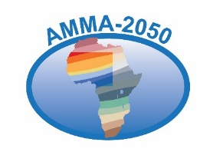Description: Description: Butterfly:Users:candysorrell:WORK:New NERC logo:NERC logo square.eps

AMMA-2050 is funded under the Future Climate for Africa Programme which is supported by funding from the NERC and DFID

The AMMA-2050 project started 01/06/2015 and will continue for 4 years.

|  |  |
| --- | --- |
| Title: |  |
| Authors: | AMMA-2050 Climate Science Team (Adama Bamba, Rory Fitzpatrick, Andy Hartley, Serge Janicot, Cornelia Klein, Nana Ama Browne Klutse, Oumar Konte, Famien Moise, Siny N'Doye, Dave Rowell, Youssouph Sane, Evelyne Toure) |
| Organisations: | Leeds University, CEH, Met Office, IPSL, UFHB, UCC, UCAD, ANACIM |
| Submission date: | 28/11/17 |
| Function: | To provide relevant and up-to-date information on projected climate change in West Africa to climate change impact scientists and technical stakeholders |
| Available from | <https://wiki.ceh.ac.uk/display/AM/Atlases+of+climate+metrics> |

*‘The research leading to these results has received funding from the NERC/DFID Future Climate For Africa programme under the AMMA-2050 project, grant numbers NE/M020428/1 and NE/M019969/1’.*