Due Date  
May 1, 2025

**Name:** Muhammad Ammar Khalid

**OOP**

**Teacher:** Sir Shahid Bhatti

**LAB_EXAM**

**Reg no:** FA24-BCS-137

Comsats University Islamabad, Lahore Campus

Output :

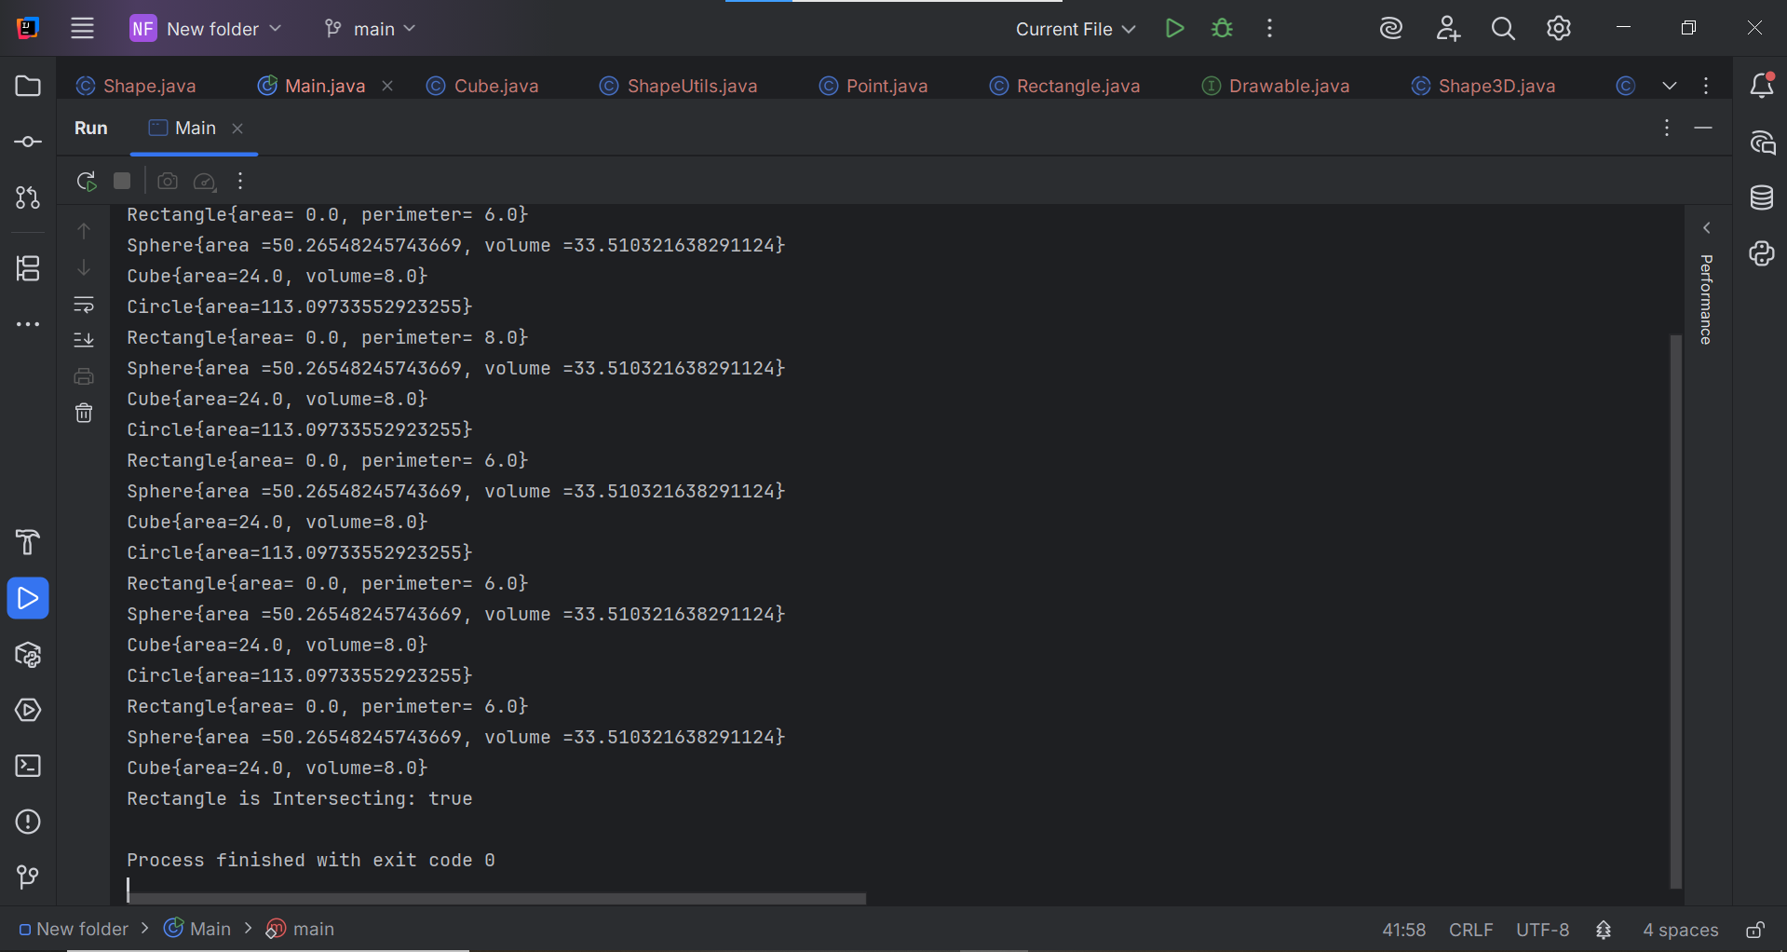

Main Code:

public class Main {  
 public static void main(String[] args) {  
  
 Shape shape;  
 Shape3D shape3D;  
 Shape2D shape2D;  
 Shape2D circle=new Circle("Circle",true,6.0)*;*  
 Shape2D rectangle=new Rectangle("Rectangle",true,3.0,11.0,new Point(3,4))*;*  
 Shape2D rectangle2=new Rectangle("Rectangle2",true,4.0,9.0,new Point(3,4))*;*  
 Shape2D rectangle3=new Rectangle("Rectangle3",true,3.0,11.0,new Point(2,9))*;*  
 Shape3D sphere=new Sphere("Sphere",2.0)*;*  
 Shape3D cube =new Cube("Cube",2.0)*;*  
 Shape[] shapes=new Shape[20];  
 Drawable[] drawables=new Drawable[20]*;*  
 ShapeUtils shapeUtils=new ShapeUtils();  
 shapes[0]=circle;  
 shapes[1]=rectangle;  
 shapes[2]=sphere;  
 shapes[3]=cube;  
 shapes[4]=circle;  
 shapes[5]=rectangle2;  
 shapes[6]=sphere;  
 shapes[7]=cube;  
 shapes[8]=circle;  
 shapes[9]=rectangle3;  
 shapes[10]=sphere;  
 shapes[11]=cube;  
 shapes[12]=circle;  
 shapes[13]=rectangle;  
 shapes[14]=sphere;  
 shapes[15]=cube;  
 shapes[16]=circle;  
 shapes[17]=rectangle3;  
 shapes[18]=sphere;  
 shapes[19]=cube;  
 System.out.println(circle.toString())*;*  
 System.out.println(rectangle.toString())*;*  
 System.out.println(sphere.toString())*;*  
 shapeUtils.displayShapes(shapes);  
 Rectangle r = (Rectangle) rectangle2*;*  
 System.out.println("Rectangle is Intersecting: " +shapeUtils.Intersect(shapes,r ))*;*  
  
  
  
 }  
}