UMAT-OTI: Automatic generation of material and constitutive Jacobians for Abaqus UMATs
Abstract
UMAT-OTI is an open-source source-to-source transformation tool that generates machine-precision derivatives of Abaqus user-material subroutines (UMATs) using order-truncated imaginary (OTI) arithmetic. Every derivative is specified by four elements -- a seed variable, a response variable, an extraction target and a differentiation order -- so one compact contract configures the consistent material tangent DDSDDE, the internal Jacobians of local constitutive solves, higher-order stress derivatives, and the exported point-wise parameter sensitivities DSIGMA_DP and DSTATEV_DP from a single unmodified UMAT. The transformed routine preserves the standard UMAT interface. Every product is checked against a reference that shares no code path with it: on an illustrative J2 model the generated tangent agrees with a closed-form consistent tangent over all 108 entries to 2.52×10^-15, and derivatives through order 4 agree with an independent 80-digit reference over 108 comparisons with 0 failures. Across 41 globally deduplicated sources, 36 are numerically verified by at least one route and 5 are not, each with a recorded reason. Extracting a model's internal Jacobian also audits the one it ships: in 2 of 6 sources the hand-coded Jacobian differs from the independent reference by up to 2.59%, while the extracted one agrees to 5.21×10^-10.
1. Motivation and significance
Abaqus user-material subroutines let researchers implement constitutive models absent from the standard libraries. A UMAT returns the updated stress, the updated internal variables and the material Jacobian DDSDDE, which in Abaqus/Standard is the consistent tangent of the global Newton-Raphson procedure. An inconsistent tangent raises cost, triggers cutbacks or fails outright.
The need for accurate derivatives extends beyond DDSDDE. Many models contain nonlinear solution procedures inside the stress update itself, such as return mapping for plasticity and viscoplasticity, where a local residual is solved for an internal variable. These require internal Jacobians distinct from the tangent handed to Abaqus, so a practical differentiation tool must produce both.
Derivatives are traditionally obtained by manual derivation or finite differences. Manual derivation is exact and remains common practice, but it is labour-intensive, difficult to maintain and prone to human error. Finite-difference approaches are easier to implement but require a careful choice of perturbation size, suffer truncation and round-off error, and grow costly with the number of variables and derivative orders.
Automatic differentiation instead propagates derivative information through the computational graph of the implemented algorithm. Source-transformation tools such as Tapenade and ADIFOR, operator-overloading libraries such as Adept and Sacado, and compiler-based frameworks such as Enzyme have demonstrated these strategies, and the same ideas reached finite-element and constitutive-model development through AceGen, dolfin-adjoint, FEniCS and UMAT4COMSOL. Hypercomplex automatic differentiation encodes derivatives in the coefficients of extended-number algebras; complex-step, hyper-dual, multicomplex and OTI arithmetic all belong to this family, and none suffers the subtraction error of finite differences.
Constitutive models are usually mature Fortran code bases that must keep the interface Abaqus expects, and their authors need derivatives at more than one level. UMAT-OTI applies OTI differentiation directly to that source, leaving the interface intact. The contribution is not a new differentiation method but a framework that adapts one to Abaqus UMAT development, together with the support library, reports and validation artefacts that make the generated code auditable.
2. Software description
A request names what to perturb, what to watch, where to write the result and how many orders to keep. The same request object is constructed by the command line, by the batch runner and by the graphical interface, and all three call one execution path, so a result shown in the interface is produced by the code that produces the published evidence.
The transformation resolves the entry routine's dependency closure -- helper subprograms, INCLUDE files and the modules they need -- lifts the arithmetic to the OTI type, generates the algebra module for the requested number of directions and order, and emits Fortran that compiles against it. 4 of the verified sources are multi-file: their closure is resolved rather than declared, and a helper defined differently in two places is reported as ambiguous instead of being chosen arbitrarily.
Verification is gated. Source identity and closure come first, then transformation, then independent compilation of the original and the transformed routine, then execution of both, then primal parity, then resolution of the reference, and only then the derivative comparison. A case failing an earlier gate contributes no verified derivative rows, and compiling is never reported as verification. Figures 1 and 2 show the interface constructing a request and reporting one such run.
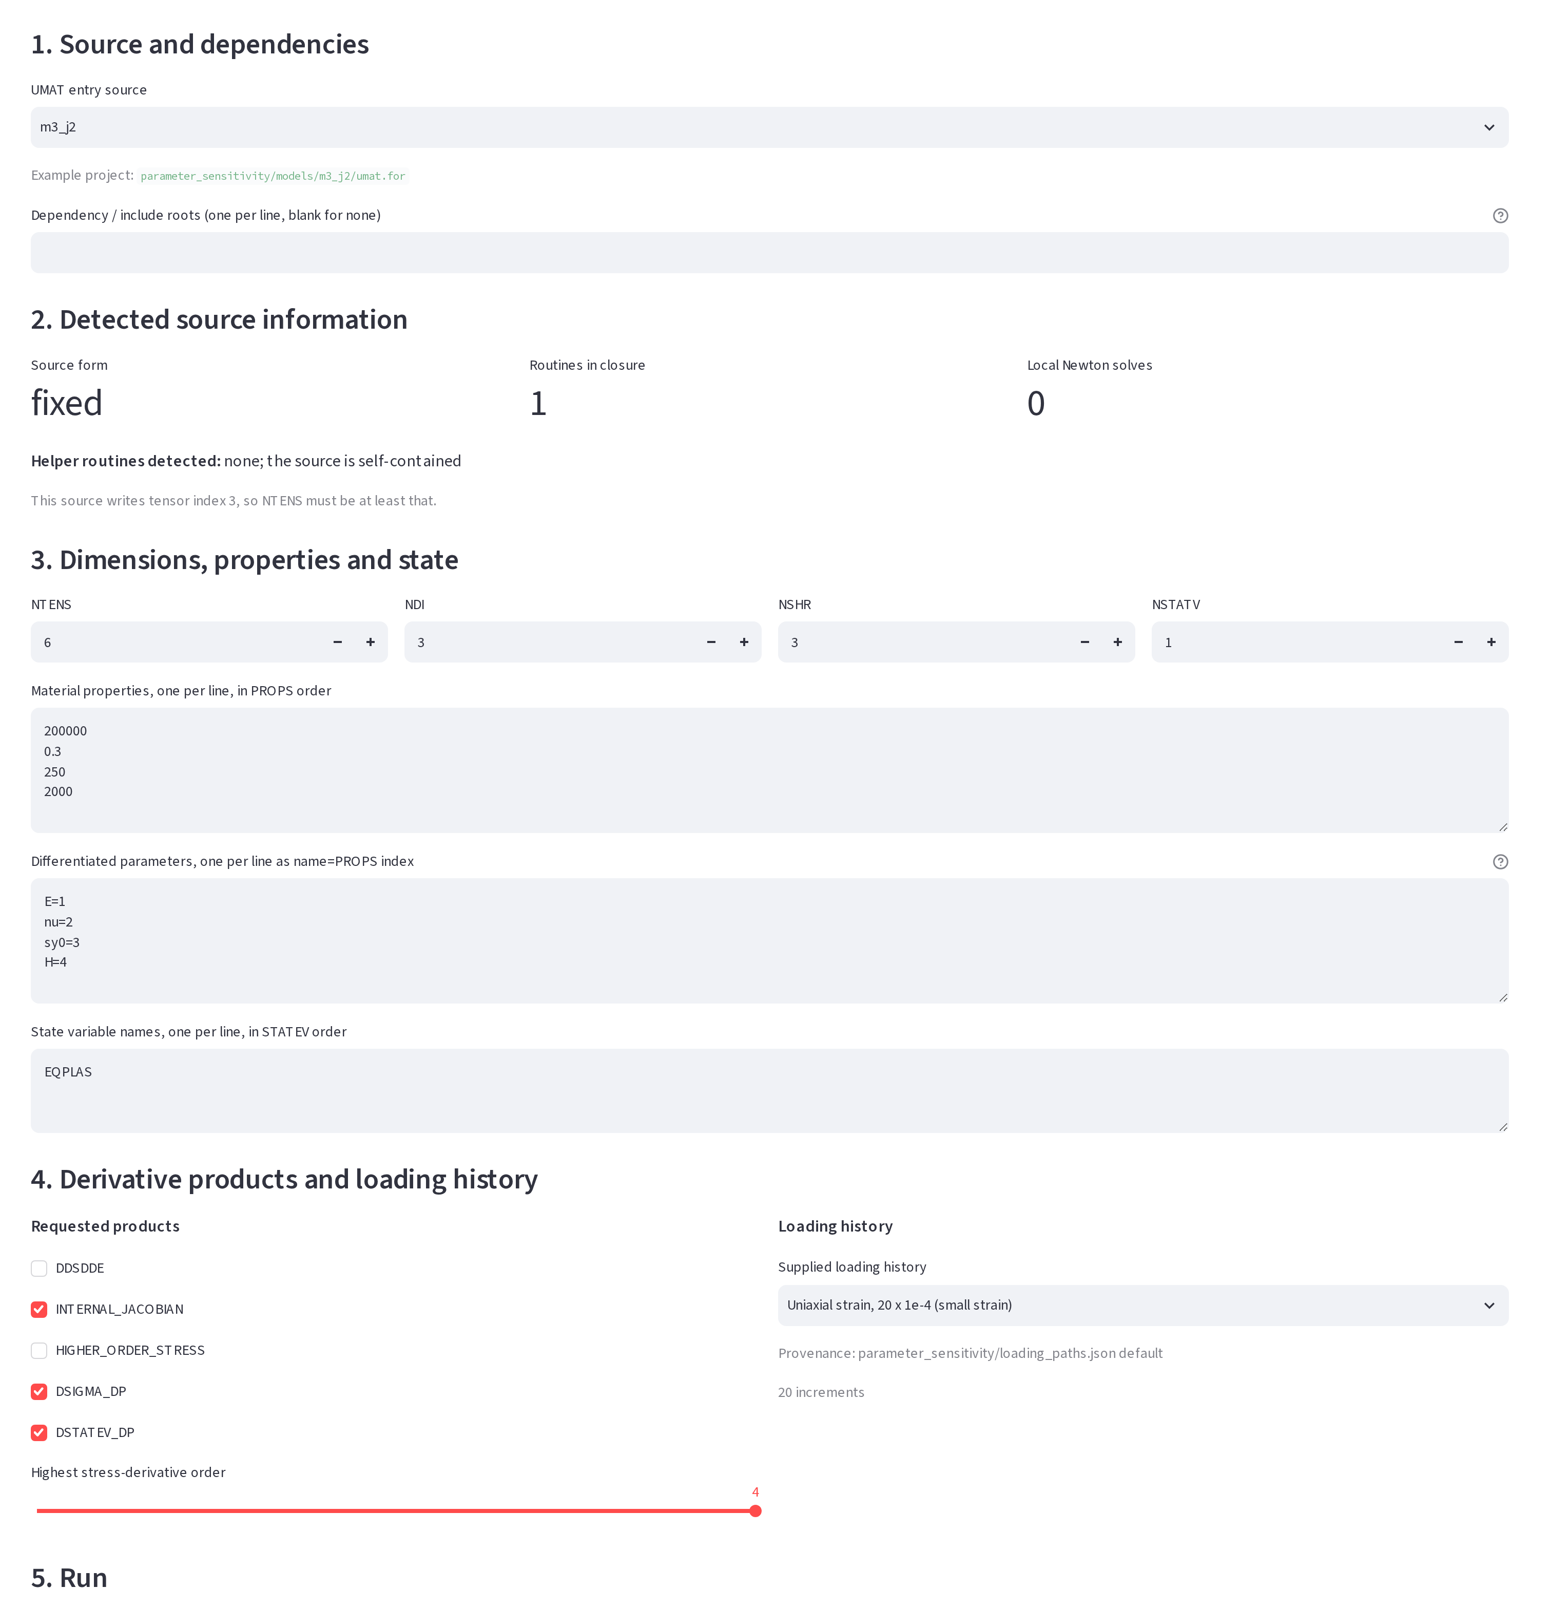
Figure 1. The interface constructing a request: entry source and dependency roots, the source information detected from the file, the tensor and state dimensions, the mapping of material parameters onto PROPS, the requested derivative products, and the supplied loading history.
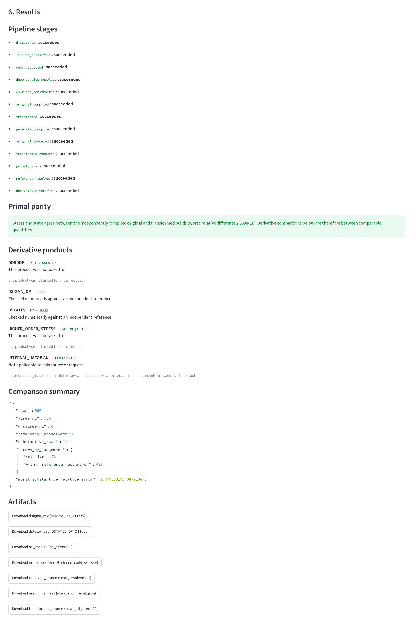
Figure 2. The same interface after a real run. Every pipeline stage carries its own status; primal parity is reported above the derivative section; each product carries an outcome word rather than a colour. INTERNAL_JACOBIAN is reported unsupported for this model, with the reason, because it integrates its law without a local Newton iteration.
3. Illustrative example
One three-dimensional small-strain J2 plasticity model with linear isotropic hardening runs through every derivative product. It has six stress components and one state variable, the accumulated equivalent plastic strain, which makes it history dependent: the stress at the end of an increment depends on the plastic strain inherited from every increment before it. The loading path used throughout begins elastic and yields at increment 16 of 20.
The consistent tangent is checked against two references that fail differently: the closed-form elastoplastic consistent tangent, and an 80-digit centred difference of an independent integrator. Over 108 entries none disagrees. 66 are zeros of the matrix, returned as exactly zero; the remaining 42 agree to 2.52×10^-15, while the two references agree with each other to 4.77×10^-14. Raising the requested order on the same path retains the higher derivatives of the same stress update: 108 comparisons through order 4, 0 failures, worst relative difference 1.94×10^-9 where the quantity is large enough for a relative error to mean anything. Figure 3 collects these.
The parameter sensitivities perturb the material constants rather than the strain. DSIGMA_DP holds the derivative of each stress component with respect to each material parameter and DSTATEV_DP the derivative of the state variable, both at one material point and one increment. The second is needed because the plastic strain carried into an increment already depends on the parameters. Over the full path, 560 comparisons agree with centred differences of the independently compiled original, 0 disagree, and the worst relative difference is 2.48×10^-8. 390 of those rows are exactly zero on both sides: before yield the stress does not depend on the yield stress or the hardening modulus, and the equivalent plastic strain depends on nothing. Those are structural zeros of the model, read from the raw values rather than inferred from a plot. Figure 4 shows both arrays over the path.
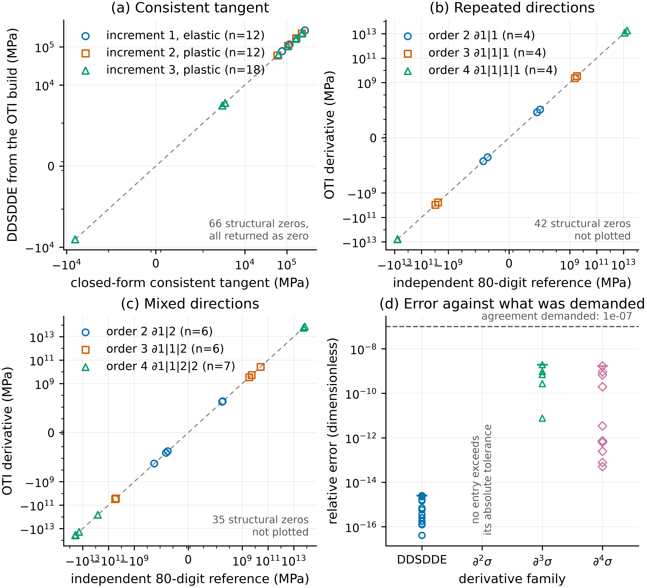
Figure 3. Derivative validation for the illustrative example. (a) the consistent tangent against the closed-form reference; (b) repeated and (c) mixed higher-order stress derivatives against an independent 80-digit reference; (d) where the error sits in each family relative to the agreement demanded of it.
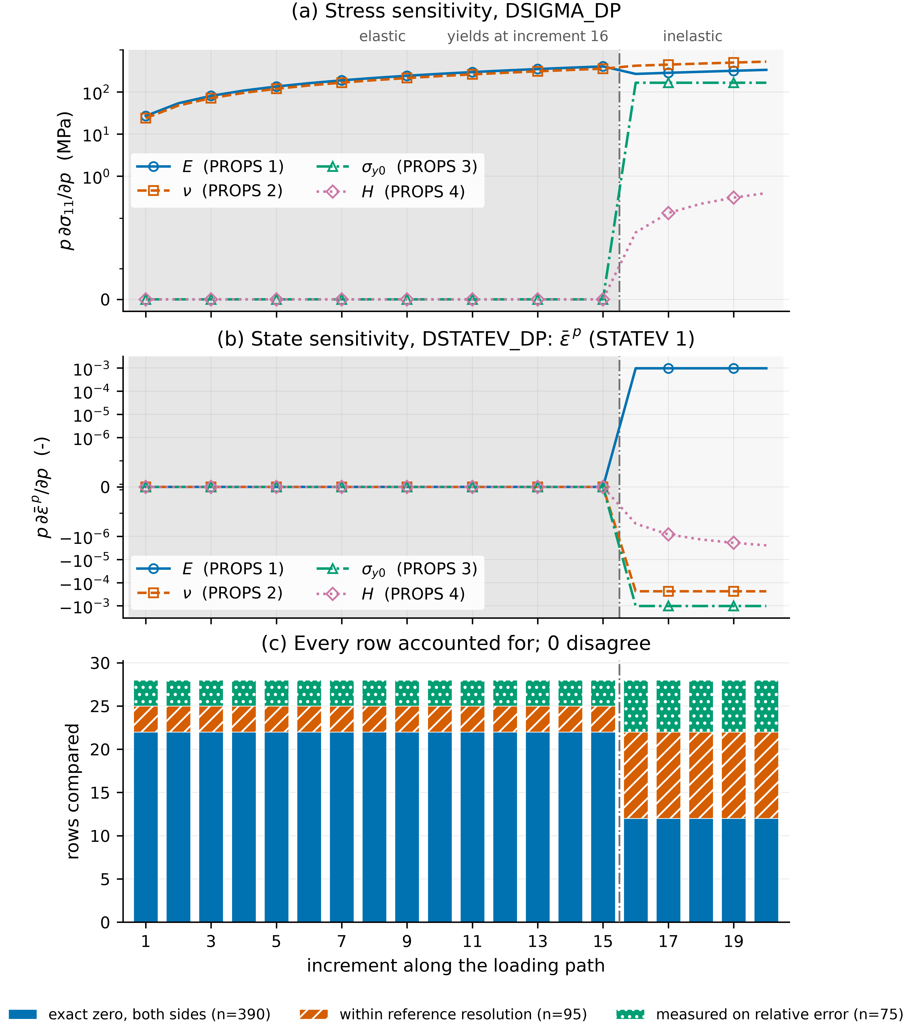
Figure 4. Parameter and state sensitivities over the complete loading path, each curve scaled by its own parameter so all stress curves carry MPa. (a) DSIGMA_DP; (b) DSTATEV_DP; (c) how every compared row was adjudicated, increment by increment.
4. Verification across the collection
Sources are counted after global identity reconciliation. A UMAT reachable both from the in-repository archive and from a pinned upstream snapshot is one implementation with two origins, not two sources: 54 discovered files reduce to 45 distinct implementations across 3 independent upstream repositories, spanning 27 constitutive models. The illustrative example is excluded from every count in this section.
Of 41 collection sources, 24 are verified offline -- transformed, compiled twice, checked for primal parity and compared against an independently replayed reference -- and 17 passed a paired Abaqus round in which the original and transformed subroutines ran as separate jobs on the same deck. 36 are verified by at least one route. The remaining 5 are kept in the denominator with a recorded reason: an ambiguous helper closure, an absent upstream property vector, a failed execution in the archived Abaqus round, and two whose reference cannot adjudicate every row.
Across 19 models the sweep produced 13980 comparisons, 13947 agreeing and 0 disagreeing, with a worst relative difference of 8.19×10^-7. The 33 rows the reference cannot settle are reported by reason rather than pooled: 5 sit below what a centred difference resolves at any step, and 28 sit on the increment where a Drucker-Prager model first yields, where the stencil straddles the kink and returns a secant across it rather than the derivative on the branch the increment took. Those rows withhold their directions rather than being counted either way.
Extracting a model's internal Jacobian also audits the one it ships. Across 6 sources carrying a local Newton solve, the extracted coefficient agrees with centred differences of the independently compiled original to 5.21×10^-10. The hand-coded coefficient is measured against the same reference and is never used as it. In 2 sources it differs by far more: 2.59% in jgomezc1_UMAT_VPDCO and 0.306% in jgomezc1_UMAT_PCO. Both models converge and produce plausible stress, so the drift is invisible without a derivative that follows the implementation. Figure 5 collects the collection results.
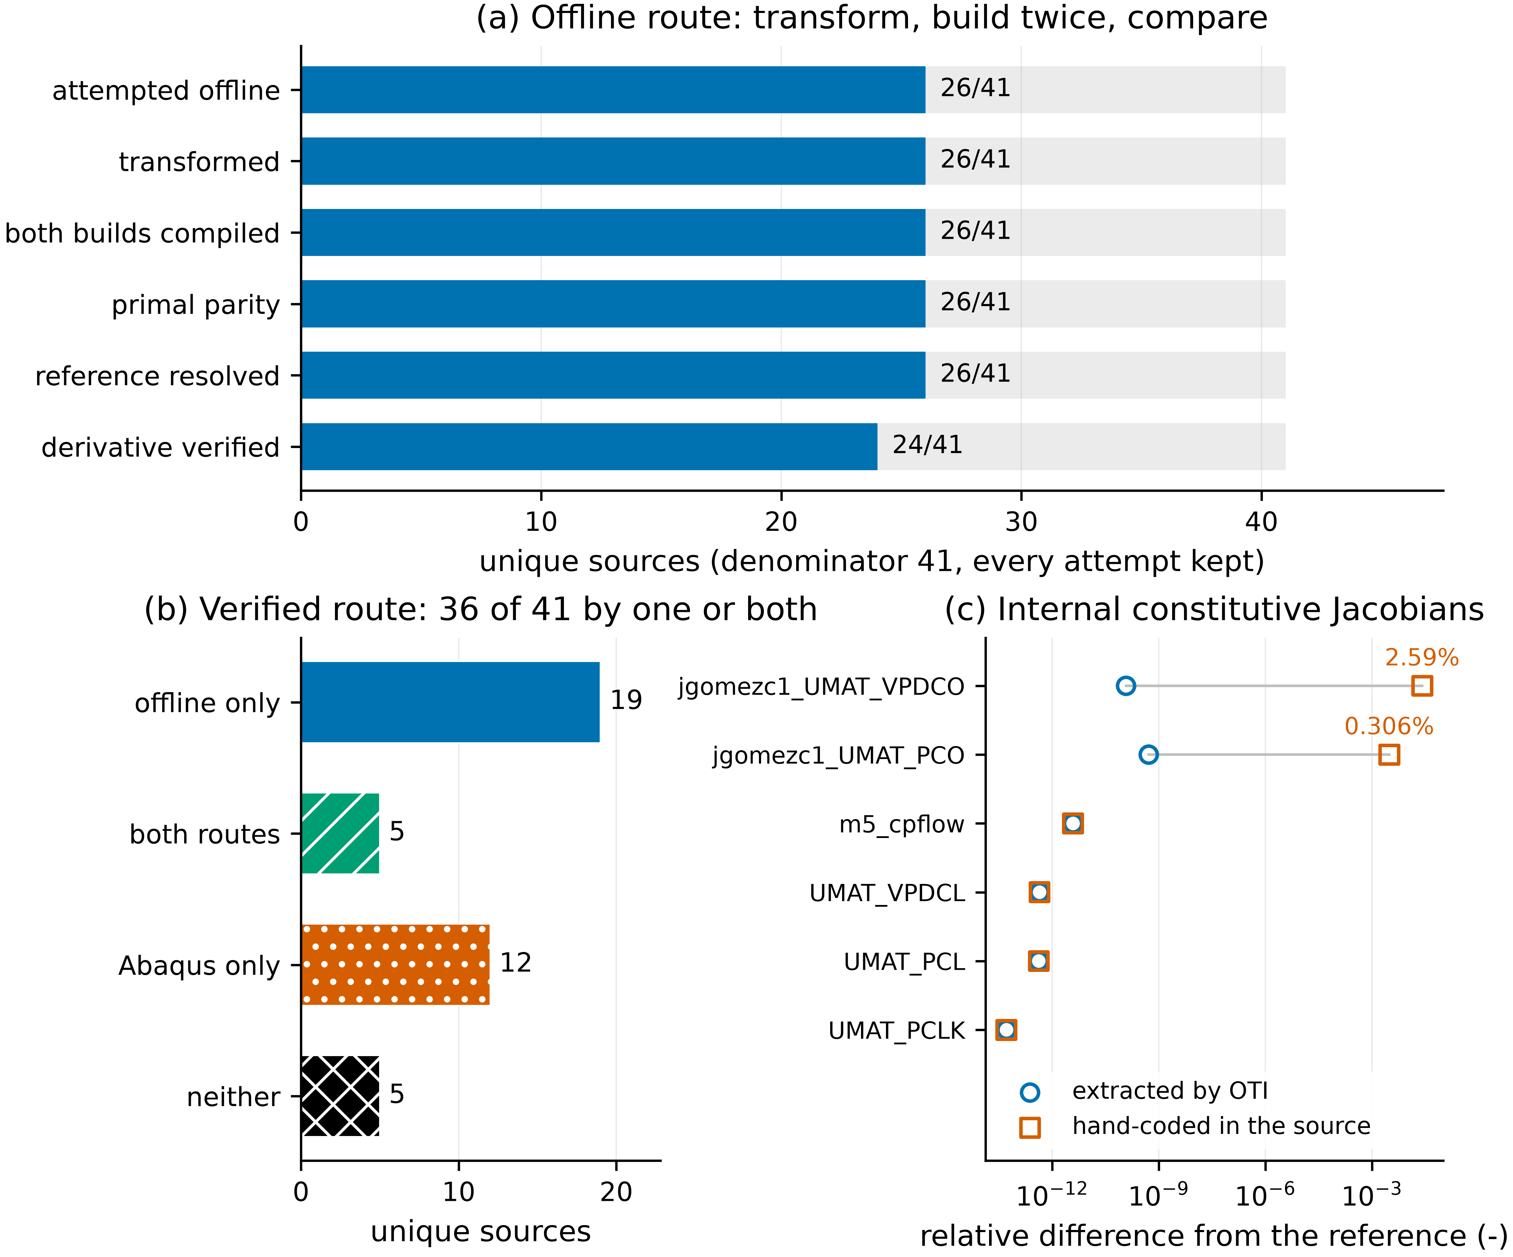
Figure 5. Verification across the deduplicated collection, excluding the illustrative example. (a) the offline route against the whole collection; (b) how many sources each route verified; (c) extracted and hand-coded internal Jacobians against the same independent reference.
5. Impact
UMAT-OTI changes how derivative implementations are maintained. A change to a material model traditionally requires a fresh manual derivation of the tangent and fresh verification of the resulting code. Here the implemented stress update remains the primary representation of the model and the derivatives follow from it automatically, which extends the useful lifetime of existing UMATs.
The products serve different consumers. Accurate tangents improve the robustness of implicit finite-element analysis, internal Jacobians support local return mapping and viscoplastic integration, and higher-order derivatives supply curvature to calibration and to solver strategies that fit more than a straight line. The parameter sensitivities give calibration, uncertainty propagation, inverse identification and surrogate modelling a point-wise derivative of the constitutive response with a documented shape and parameter ordering.
A second contribution is transparency. Every transformation produces the transformed source, the support library, a readable report and optional validation outputs, so the differentiation can be audited and reproduced. A difference against a hand-coded reference is not automatically a transformation error: several of them exposed approximate tangents, drifted internal Jacobians or outright errors in the original UMAT, which makes the software a verification aid as much as a differentiation tool.
6. Conclusions
UMAT-OTI applies order-truncated imaginary arithmetic to existing Abaqus UMAT implementations, preserving the standard interface while generating machine-precision derivatives from the original stress update. One contract, naming a seed, a response, a target and an order, configures the material tangent, the internal constitutive Jacobians, the higher-order stress derivatives and the two exported sensitivities.
Each product was verified against a reference sharing no code path with it, and every case that was attempted is reported whether or not it succeeded. The implementation targets UMAT code paths that can be analysed and transformed automatically; code relying on external helpers, on solver-provided storage, or on library routines that cannot operate on the extended type needs manual preparation first, and the sources where that applies are named in the collection evidence rather than omitted from it.
Acknowledgements
The authors gratefully acknowledge financial support from the National Aeronautics and Space Administration under Grant No. 80NSSC23K1342 and from the National Science Foundation through CAREER Award No. 2237313.

Every numerical value in this manuscript was substituted from the executed evidence at commit 2a19bdd07be36dca0e9a2d14a3a4b770be483a8c by tools/manuscript/build_v5_manuscript.py. Tables are generated separately into paper_results/tables/paper_tables.docx. Main text: 1713 words of a 3000-word limit.

