BATTERY TECHNOLOGIES, CHARGING FUNDAMENTALS, PSYCHOLOGICAL BARRIERS, USER TRUST, AI-BASED SECOND-LIFE BATTERY HEALTH AND AI IN MATERIAL DISCOVERY
Book: Handbook of Smart Electric Vehicles for Intelligent and Predictive Design and Control
Part I: Foundations of Electric Mobility — Chapter 3
Amman Jakhar ^1,* and Sachin Kalsi ^1
^1 Department of Mechanical Engineering, Chandigarh University, Mohali, Punjab-140301
*Corresponding Email: ammanjakhar5000734@gmail.com

Abstract
Electric vehicles (EVs) are rapidly evolving and driving an urgent need for new and improved battery technologies, intelligent charging infrastructure, and user-centric mobility solutions. This chapter gives an extensive introduction to the principles of battery technologies and charging fundamentals that lay the foundation for today's electric mobility. It explores the strengths and weaknesses, features, and drawbacks of leading battery chemistries such as lithium-ion, solid-state, lithium-sulfur, and some of the next-generation energy-storage options. The chapter also covers charging infrastructure, charging standards, fast charging technologies, battery management systems, and their contributions to enhance vehicle performance, safety, and energy efficiency. In addition to the technical considerations, the chapter discusses psychological factors that can impact EV adoption including range anxiety, charging uncertainty, perceived reliability concerns and cost perceptions. The critical role of user trust in influencing EV technology acceptance is examined, which involves transparency and safety, ease of charging, and digital connectivity. Technological progress and human behaviour are given as a crucial ingredient to enable rollout of EVs on a wide scale. The chapter also explores the emerging use of artificial intelligence (AI) which is being used in the field of second-life battery health assessment and management. The use of AI-driven predictive analytics, machine learning algorithms and digital twin technologies allows for the accurate estimation of state of health, remaining useful life and optimal reusability strategies for retired EV batteries, supporting the objectives of the circular economy and enabling sustainable resource use. Additionally, the chapter explores how AI is revolutionizing the field of battery material discovery by streamlining the search and optimization of new electrode, electrolyte, and solid-state materials that offer higher energy density, improved safety, and longer lifespans. This chapter brings together the science of batteries, charging infrastructure, consumer behavior, and the technologies of AI that will shape the future of intelligent electric mobility and sustainable transportation systems.
Keywords: Electric Vehicle Batteries; Charging Infrastructure; User Trust and EV Adoption; Second-Life Battery Health Assessment; Artificial Intelligence in Material Discovery.

1. Introduction
The transition from internal combustion engine vehicles to electric mobility has become one of the defining technological and societal shifts of the twenty-first century, propelled by the imperative to decarbonize transportation, improve urban air quality, and reduce dependence on finite fossil resources [1]. Road transport contributes a substantial fraction of global greenhouse-gas emissions, and electrification of the vehicle fleet is widely regarded as the most tractable pathway toward meaningful reductions when coupled with a progressively cleaner electricity grid [2]. Over the past decade, falling battery costs, supportive policy instruments, and rapid improvements in driving range have transformed the electric vehicle (EV) from a niche curiosity into a mainstream consumer product adopted across diverse markets [3].
At the heart of every EV lies its electrochemical energy-storage system, and the characteristics of that system—energy density, power capability, cycle life, safety, and cost—largely determine the vehicle's performance, price, and customer appeal [4]. Advances in battery chemistry and cell engineering have therefore been the principal enabler of EV competitiveness, while the supporting ecosystem of charging infrastructure, standards, and intelligent management systems governs how conveniently and safely that stored energy can be replenished and used [5]. Yet the diffusion of electric mobility is not a purely technical matter: the decisions of millions of individual consumers are shaped by perceptions, anxieties, and the degree of trust they place in unfamiliar technology [6].
The policy landscape has reinforced these market dynamics, with many jurisdictions announcing timelines to phase out the sale of new internal combustion engine vehicles, mandating fleet-wide emissions reductions, and offering purchase incentives that narrow the price gap between electric and conventional vehicles [2]. Manufacturers have responded by committing enormous capital to battery gigafactories and dedicated electric platforms, signalling that electrification is no longer a hedge but the central strategy of the automotive industry [3]. These commitments have, in turn, intensified competition over the raw materials, cell-manufacturing capacity, and intellectual property that underpin battery performance, making the battery the strategic fulcrum of the entire mobility transition [4]. At the same time, concerns about the sustainability of raw-material extraction and end-of-life management have elevated the circular economy from an afterthought to a design principle, foreshadowing the second-life and recycling themes developed later in this chapter [5].
This chapter integrates the technical and human dimensions of electric mobility within a single narrative. It first surveys the dominant and emerging battery chemistries, then examines charging fundamentals, standards, fast-charging technologies, and battery management systems. The discussion subsequently turns to the psychological barriers that impede adoption and the determinants of user trust. Finally, the chapter explores two frontiers in which artificial intelligence (AI) is reshaping the battery value chain: the assessment and management of second-life battery health in support of the circular economy, and the accelerated discovery of novel battery materials. By connecting electrochemistry, infrastructure, human behaviour, and computational intelligence, the chapter offers a foundation for understanding the intelligent and predictive design of smart electric vehicles [7].

2. Battery Technologies for Electric Vehicles

2.1 Fundamentals of Electrochemical Energy Storage
A rechargeable battery stores and releases electrical energy through reversible electrochemical reactions occurring at two electrodes separated by an ion-conducting electrolyte [8]. During discharge, oxidation at the negative electrode liberates electrons that flow through the external circuit to perform work, while ions migrate internally through the electrolyte to maintain charge neutrality; charging reverses these processes [9]. The practical merit of a cell is captured by several interdependent metrics: gravimetric and volumetric energy density, which dictate range and packaging; power density, which governs acceleration and fast-charge capability; coulombic efficiency; calendar and cycle life; thermal stability; and cost per kilowatt-hour [10]. No single chemistry simultaneously optimizes all of these attributes, so battery selection for a given vehicle platform is inherently an exercise in balancing competing objectives [11].
The performance of a cell is further shaped by its format and integration. Cylindrical, prismatic, and pouch formats each offer distinct trade-offs in mechanical robustness, thermal management, and manufacturing scalability, and cell-to-pack and cell-to-chassis architectures increasingly dissolve the traditional module layer to raise pack-level energy density [12]. Understanding these fundamentals is essential before comparing specific chemistries, because headline cell metrics do not always translate directly into system-level performance once inactive materials, safety margins, and thermal hardware are accounted for [13].
The relationship between cell-level and pack-level energy density is governed by a packaging efficiency that quantifies how much of the pack mass and volume is devoted to active electrochemical material rather than to enclosures, cooling plates, busbars, and structural reinforcement [10]. Historically a considerable fraction of pack mass has been inactive, so cell-to-pack innovations that remove intermediate modules and integrate the pack into the vehicle's load-bearing structure can raise usable energy density substantially without any change in cell chemistry [12]. This systems perspective explains why two vehicles using nominally similar cells can differ markedly in range and cost, and why battery engineering is increasingly a discipline of integration as much as of electrochemistry [11]. Economic metrics are equally decisive: the industry's long-running decline in cost per kilowatt-hour has been the single most important driver of EV affordability, and the trajectory of that cost—shaped by materials prices, manufacturing scale, and chemistry choice—continues to determine how quickly electric vehicles reach price parity with their conventional counterparts [14].

2.2 Lithium-Ion Batteries
Lithium-ion batteries dominate the contemporary EV market owing to a favourable combination of high energy density, good cycle life, and a mature, scalable supply chain [15]. The chemistry is defined principally by its cathode: nickel-manganese-cobalt (NMC) and nickel-cobalt-aluminium (NCA) oxides deliver high energy density suited to long-range vehicles, whereas lithium iron phosphate (LFP) offers lower energy density but superior thermal stability, longer cycle life, and lower cost through the elimination of nickel and cobalt [16]. The resurgence of LFP in mass-market and entry-level vehicles reflects a strategic shift toward affordability, safety, and supply-chain resilience, even at the expense of some driving range [17].
A persistent tension within the nickel-rich cathode family is the trade-off between energy density and stability: raising the nickel content increases capacity and lowers reliance on costly cobalt, but it also tends to compromise structural and thermal stability, accelerating degradation unless mitigated by doping, surface coatings, and single-crystal morphologies [13]. These materials-level refinements, developed in parallel with manufacturing improvements, have allowed high-nickel cells to extend driving range while gradually improving durability [16]. The parallel ascent of LFP demonstrates that the market does not pursue energy density alone; for many buyers and fleet operators, the combination of lower cost, robust cycle life, and intrinsic safety makes LFP the rational choice despite its range penalty, a calculus that has reshaped the competitive landscape of mass-market electric vehicles [17].
Despite its dominance, the conventional lithium-ion cell faces intrinsic limits. Graphite anodes constrain energy density, and incremental gains are increasingly achieved by blending silicon into the anode, which offers far higher theoretical capacity but suffers from large volume expansion that degrades cycle life [18]. Managing this expansion through nanostructured silicon, engineered binders, and electrolyte additives is an active area of development, since even modest silicon fractions can yield meaningful range improvements when their mechanical consequences are controlled [19]. Safety remains a central concern because the liquid organic electrolyte is flammable and vulnerable to thermal runaway if the cell is mechanically damaged, overcharged, or exposed to excessive temperature [20]. Degradation mechanisms—including growth of the solid-electrolyte interphase, lithium plating during fast or cold charging, and active-material cracking—progressively reduce capacity and power over the pack's service life [21]. These limitations motivate the search for next-generation chemistries that can surpass the performance ceiling of incumbent lithium-ion technology.

2.3 Solid-State Batteries
Solid-state batteries replace the flammable liquid electrolyte with a solid ionic conductor, promising a step change in both safety and energy density [22]. By suppressing electrolyte flammability and enabling the use of a lithium-metal anode, solid-state designs can in principle achieve substantially higher gravimetric and volumetric energy density than liquid-electrolyte cells, while reducing the risk of thermal runaway [23]. Solid electrolytes fall into several families—oxides, sulfides, and polymers—each presenting distinct trade-offs among ionic conductivity, mechanical properties, electrochemical stability, and manufacturability [24].
The commercialization of solid-state batteries nonetheless confronts formidable obstacles. Achieving and maintaining intimate, low-resistance contact at the solid-solid interfaces between electrolyte and electrodes is difficult, and interfacial degradation can raise impedance over cycling [25]. The formation and propagation of lithium dendrites through grain boundaries and voids in the solid electrolyte can cause short circuits, while scalable, cost-effective manufacturing of thin, defect-free solid-electrolyte layers remains an unsolved engineering challenge [26]. Consequently, although pilot production and vehicle demonstrations have accelerated, broad market penetration of automotive solid-state cells is still anticipated to unfold progressively rather than abruptly [27].
The three solid-electrolyte families illustrate why no single material has yet prevailed. Oxide electrolytes offer good chemical stability and reasonable conductivity but are hard and brittle, complicating the fabrication of thin layers and intimate electrode contact; sulfide electrolytes achieve the highest ionic conductivities, rivalling liquid electrolytes, but are sensitive to moisture and can react with electrode materials; and polymer electrolytes are flexible and easy to process but typically require elevated temperatures to conduct adequately [24]. Hybrid and composite electrolytes that combine the merits of these families are therefore a prominent research direction, as are protective interlayers and architected interfaces designed to stabilize the critical boundary between the lithium-metal anode and the solid conductor [25]. Because the lithium-metal anode is central to the energy-density promise of solid-state batteries, controlling dendrite nucleation and growth under realistic current densities remains the pivotal scientific challenge gating commercialization [26].

2.4 Lithium-Sulfur and Next-Generation Chemistries
Lithium-sulfur (Li-S) batteries attract intense interest because sulfur is abundant, inexpensive, and offers a very high theoretical capacity, giving the chemistry the potential for exceptional gravimetric energy density well beyond that of lithium-ion [19]. This profile is especially attractive for weight-sensitive applications. However, practical Li-S cells are hampered by the insulating nature of sulfur, large volume changes during cycling, and the polysulfide shuttle effect, in which soluble intermediates migrate between electrodes and cause capacity fade and low coulombic efficiency [28]. Strategies involving engineered carbon-sulfur composites, functional interlayers, and electrolyte additives have substantially improved cycle life, yet volumetric energy density and longevity remain challenges for automotive duty cycles [29].
Beyond Li-S, a diverse portfolio of post-lithium chemistries is maturing. Sodium-ion batteries, which rely on earth-abundant sodium, are emerging as a cost-effective and sustainable complement for stationary storage and entry-level mobility, trading some energy density for supply-chain and low-temperature advantages [30]. Their compatibility with existing lithium-ion manufacturing lines is a significant practical advantage, allowing established producers to diversify chemistry without wholesale retooling, and their superior performance in cold conditions addresses a genuine weakness of lithium iron phosphate in winter climates [12]. Other candidates—including lithium-air, magnesium-ion, and multivalent systems—offer compelling theoretical performance but remain at earlier stages of development [31]. The coexistence of this expanding chemistry landscape signals a future in which battery selection is tailored to the specific requirements of each vehicle segment and use case rather than dominated by a single universal solution [14]. Table 1 summarizes the principal characteristics of the leading and emerging chemistries.
Table 1. Comparison of leading and emerging EV battery chemistries.
Chemistry | Approx. Cell Energy Density (Wh/kg) | Key Strengths | Key Limitations | Maturity
Li-ion NMC/NCA | 200-300 | High energy density, mature supply chain | Cost, cobalt use, thermal runaway risk | Commercial
Li-ion LFP | 150-200 | Low cost, long cycle life, safe | Lower energy density, cold-weather loss | Commercial
Solid-state | 300-500 (projected) | High safety, high energy density | Interfacial resistance, dendrites, cost | Pre-commercial
Lithium-sulfur | 400-600 (projected) | Very high gravimetric energy, low-cost sulfur | Polysulfide shuttle, low volumetric density | Developmental
Sodium-ion | 120-160 | Abundant materials, low cost, cold tolerance | Lower energy density, bulkier packs | Early commercial

3. Charging Fundamentals and Infrastructure

3.1 Charging Levels, Modes, and Standards
The usefulness of an EV depends as heavily on how it is recharged as on how it stores energy, and the charging ecosystem spans a spectrum of power levels and standards [32]. Charging is commonly categorized by power delivery: alternating-current (AC) Level 1 charging from a standard household outlet provides the slowest replenishment and suits overnight top-ups; AC Level 2 charging, using dedicated wall units, serves homes, workplaces, and public destinations with moderate power; and direct-current (DC) fast charging bypasses the onboard charger to deliver high power directly to the battery for rapid en-route replenishment [33]. The onboard charger, which converts AC grid power to DC for the battery, sets the ceiling for AC charging speed, whereas DC fast charging shifts the conversion to the external station [34].
A further architectural dimension is the pack voltage. The migration from roughly four-hundred-volt to eight-hundred-volt system architectures reduces the current required to deliver a given power, which lowers resistive losses, allows lighter cabling, and unlocks higher charging power without proportionally greater heat generation [35]. Higher-voltage platforms thus enable faster charging and more efficient powertrains, but they also demand more capable power electronics and insulation, illustrating the system-level co-design that modern charging performance requires [36].
Interoperability across this ecosystem requires common connector and communication standards, yet the market has evolved several competing standards whose coexistence complicates the driver experience [37]. The Combined Charging System (CCS), CHAdeMO, the connector promoted by a leading manufacturer and increasingly adopted as the North American Charging Standard, and the GB/T standard used in China collectively illustrate regional fragmentation [36]. Standardization bodies and communication protocols governing vehicle-to-charger and charger-to-network interactions are essential for a seamless, reliable, and secure charging experience, and their convergence is a prerequisite for mass adoption [35]. Table 2 contrasts the principal charging levels and their typical attributes.
Table 2. Comparison of EV charging levels and representative characteristics.
Charging Type | Current | Typical Power | Typical Use Case | Indicative Charge Time (to ~80%)
Level 1 (AC) | AC | 1.4-2.4 kW | Home trickle charging | 20-40 hours
Level 2 (AC) | AC | 7-22 kW | Home, workplace, destination | 4-10 hours
DC Fast Charging | DC | 50-150 kW | Public en-route charging | 30-60 minutes
High-Power DC | DC | 150-350 kW | Highway corridors, fleets | 15-30 minutes

3.2 Fast Charging Technologies and Grid Integration
Fast charging is pivotal to overcoming the convenience gap between EVs and conventional vehicles, but delivering very high power without compromising battery health or grid stability is technically demanding [38]. High charging currents generate heat and promote degradation mechanisms such as lithium plating, so advanced thermal management, intelligent charge-current control, and chemistries engineered for fast charge are required to enable rapid replenishment without accelerating capacity fade [39]. Extreme-fast-charging targets, aiming to add significant range within minutes, push cell and cooling design to their limits and demand careful co-optimization of the cell, the thermal system, and the charge protocol [40].
At the system level, the proliferation of high-power charging places substantial stress on the electricity grid, concentrating demand in both time and location [41]. Uncoordinated charging, in which many vehicles begin charging simultaneously upon arrival home in the evening, can coincide with existing demand peaks and overload local distribution infrastructure, necessitating costly upgrades [42]. Smart-charging strategies that modulate charging in response to grid conditions, electricity prices, and renewable-generation availability can flatten demand peaks and improve utilization of clean energy [43]. Predictive forecasting of charging demand across urban networks, increasingly performed with machine-learning models, allows operators to anticipate load and position resources proactively [44].
Vehicle-to-grid and bidirectional charging extend this concept by allowing EV batteries to supply power back to the grid or to buildings, transforming the vehicle fleet into a distributed storage resource that supports grid resilience and the integration of variable renewables [44]. Realizing vehicle-to-grid at scale requires not only technical capability but also business models, market structures, and user incentives that fairly compensate drivers for the use and wear of their batteries, a socio-technical challenge as much as an engineering one [45]. The integration of charging infrastructure with renewable generation and stationary storage—often including repurposed second-life batteries—is increasingly central to sustainable electric mobility, linking the charging theme of this section to the circular-economy discussion that follows [42]. Complementary replenishment approaches, including wireless inductive charging that removes the physical connector and battery-swapping schemes that exchange a depleted pack for a charged one, offer alternative routes to convenience for specific use cases such as fleets and high-utilization vehicles, though each introduces its own standardization and infrastructure demands [37].

3.3 Battery Management Systems
The battery management system (BMS) is the electronic nervous system of the pack, responsible for ensuring that the hundreds or thousands of cells operate safely, efficiently, and within their design envelope [46]. The BMS continuously monitors cell voltages, currents, and temperatures; estimates critical states such as state of charge and state of health; enforces protection limits against overvoltage, undervoltage, overcurrent, and thermal extremes; and balances cells to equalize their charge and maximize usable capacity and lifetime [47]. Accurate state estimation is particularly challenging because the relevant quantities cannot be measured directly and must be inferred from electrical and thermal signals using models or data-driven algorithms [48].
State-of-charge estimation exemplifies the difficulty: it must be inferred continuously from measured voltage and current despite the flat voltage profiles of some chemistries, temperature dependence, hysteresis, and ageing, and errors directly translate into inaccurate range predictions that feed consumer anxiety [46]. A spectrum of methods—from coulomb counting and open-circuit-voltage correlation through model-based Kalman-filter observers to purely data-driven estimators—trades complexity against accuracy and robustness, and the choice reflects the available computation and the criticality of the application [48]. State-of-health estimation is harder still, because capacity fade and resistance growth evolve slowly and nonlinearly, motivating the machine-learning approaches examined later in this chapter [47].
Modern BMS designs increasingly incorporate advanced algorithms, including model-based observers and machine-learning methods, to improve the accuracy of state estimation, to detect faults early, and to optimize charging and thermal control in real time [49]. Thermal management—whether by air, liquid, or refrigerant—works in concert with the BMS to maintain cells within their optimal temperature window, which is essential for performance, fast-charge capability, and longevity [50]. Cells held too cold suffer reduced power and heightened risk of lithium plating during charging, while cells held too hot age rapidly and approach the onset of thermal runaway, so the thermal system and its control logic are central to both safety and durability [20]. By safeguarding safety and prolonging service life, the BMS makes a decisive contribution to the overall performance, reliability, and total cost of ownership of an EV, and it provides the data foundation on which predictive and AI-driven battery analytics are built [51].

4. Psychological Barriers and User Trust in EV Adoption

4.1 Range Anxiety and Charging Uncertainty
Even where EVs are technically capable and economically competitive, their adoption is mediated by consumer psychology, and among the most widely studied barriers is range anxiety—the apprehension that the vehicle will exhaust its charge before reaching a destination or charging point [45]. Range anxiety is often disproportionate to actual driving needs, since typical daily journeys fall well within the range of modern EVs, yet the perceived risk exerts a powerful influence on purchase intentions and on the stress experienced during use [52]. Closely related is charging uncertainty, encompassing worries about the availability, reliability, compatibility, and speed of public charging, which can be as decisive as range itself in shaping confidence [53].
These anxieties are reinforced by the asymmetry between the familiar, dense network of fuelling stations for conventional vehicles and the comparatively sparse and heterogeneous charging landscape confronting many EV drivers [53]. Importantly, range anxiety tends to diminish with direct experience as drivers learn the actual behaviour of their vehicle and the locations of reliable charging, suggesting that familiarity and exposure are powerful remedies [52]. Research into everyday EV use indicates that psychological factors such as a driver's comfortable minimum charge level, prior experience, and trust in the displayed range estimate strongly modulate the stress associated with low charge, independent of the vehicle's objective capability [52]. This insight reframes range anxiety not merely as a hardware limitation to be solved with ever-larger batteries but as a human-factors challenge amenable to better information design, reliable charging access, and accumulated familiarity. Figure 1 maps the principal psychological barriers to EV adoption and the factors that influence them.
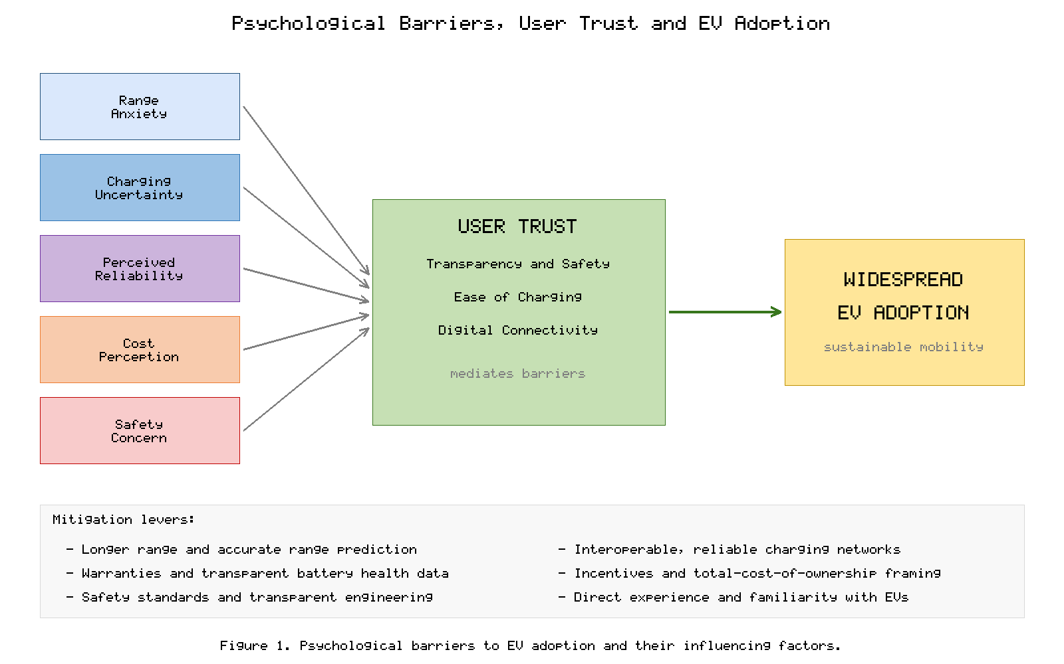
Figure 1. Principal psychological barriers to electric vehicle adoption and their influencing factors.

4.2 Perceived Reliability and Cost Perceptions
Beyond range and charging, consumers weigh the perceived reliability and durability of EV technology, and concerns about battery degradation feature prominently. Many prospective buyers worry that the battery will lose significant capacity or require costly replacement within the ownership period, a perception shaped by experience with consumer-electronics batteries and often more pessimistic than real-world automotive data warrant. Uncertainty about resale value, itself tied to assumptions about battery longevity, further colours the reliability calculus and can deter adoption.
Cost perceptions operate on two distinct planes. The higher purchase price of many EVs relative to comparable conventional vehicles remains a salient barrier, even though lower energy and maintenance costs can yield a favourable total cost of ownership over the vehicle's life [6]. Consumers frequently anchor on the upfront price and discount future savings, so the framing and transparency of lifetime-cost information materially affect decisions [53]. Incentives, financing options, and clear communication of operating-cost advantages are therefore influential levers for overcoming the perceived cost barrier. The decline in battery cost per kilowatt-hour feeds directly into this calculus, since the battery accounts for a large share of vehicle price, and credible evidence of durable battery health reduces the discount that buyers apply for anticipated replacement costs [14].
Adoption is further mediated by social and contextual factors that extend beyond the individual vehicle. Access to convenient home or workplace charging is among the strongest predictors of satisfaction, which raises questions of equity for residents of multi-unit dwellings and under-served areas who lack private charging [42]. Demographic and attitudinal variables, including environmental values, technology affinity, and exposure to EVs through social networks, shape receptiveness, so that adoption tends to cluster and diffuse through communities rather than spreading uniformly [6]. Policymakers and manufacturers who recognize these social dynamics can target infrastructure and information where they most effectively lower the barriers to first-time adoption.

4.3 The Role of User Trust
User trust is a decisive and integrative determinant of EV acceptance, binding together the technical and psychological strands discussed above. Trust in the safety of the battery—its resistance to fire and its behaviour in accidents—is foundational, and is strengthened by transparent communication of safety engineering, rigorous standards, and credible real-world safety records. Trust in the ease and dependability of charging, built through consistent, well-maintained, and interoperable infrastructure, directly shapes the confidence with which consumers approach electric mobility.
Digital connectivity has become a further pillar of trust, as smartphone applications, real-time range and charging information, remote monitoring, and over-the-air updates give drivers visibility and control that reduce uncertainty and reinforce reliability. Transparency about data use and the cybersecurity of connected vehicles is increasingly important, since perceived vulnerability can erode the very trust that connectivity is meant to build. Ultimately, technological progress and human behaviour must advance together: durable, safe, and affordable technology earns trust only when it is communicated transparently and experienced reliably. Table 3 summarizes the major psychological barriers and corresponding mitigation strategies.
Table 3. Psychological barriers to EV adoption and representative mitigation strategies.
Barrier | Underlying Concern | Mitigation Strategy | Trust Dimension
Range anxiety | Running out of charge | Longer range, accurate range prediction, dense charging | Reliability of use
Charging uncertainty | Availability and compatibility | Interoperable, well-maintained networks; live status | Ease of charging
Perceived degradation | Battery wear and replacement cost | Warranties, transparent health data, second-life proof | Durability and safety
Cost perception | High upfront price | Incentives, total-cost-of-ownership framing, financing | Economic confidence
Safety concern | Fire and accident behaviour | Standards, safety records, transparent engineering | Safety and transparency

5. AI-Based Second-Life Battery Health Assessment

5.1 The Second-Life Imperative and the Circular Economy
When an EV battery can no longer meet the demanding power and energy requirements of automotive propulsion, typically after its capacity falls to around seventy to eighty percent of the original, it is not necessarily at the end of its useful life. Such retired batteries often retain substantial residual capacity suitable for less demanding second-life applications, including stationary energy storage, grid support, and renewable-energy buffering. Repurposing these batteries defers recycling, extracts additional value from the embodied materials and energy, and advances the circular-economy objectives of reducing waste and conserving critical resources.
Realizing the second-life opportunity at scale nonetheless requires confident, accurate assessment of the condition of each retired battery, because packs arrive with heterogeneous and often poorly documented usage histories [11]. The central technical challenges are the reliable estimation of a battery's state of health, the prediction of its remaining useful life in a new duty cycle, and the determination of safe and economically optimal reuse pathways [7]. These challenges are precisely where artificial intelligence has emerged as a transformative enabler, turning sparse and noisy operational data into actionable decisions [49].
The economic case for second-life reuse is sensitive to the cost of assessment and reconditioning relative to the value of the recovered storage, which means that the speed and accuracy of health diagnosis directly determine whether repurposing is profitable [5]. Manual testing of every pack is prohibitively slow and expensive, so scalable, automated, data-driven grading is not a convenience but a precondition for a viable second-life industry. Safety adds a further imperative, because repurposing cells whose latent defects or advanced degradation are misdiagnosed can create hazards in the new application; reliable health assessment is therefore simultaneously an economic and a safety function [20]. These pressures explain why artificial intelligence, with its capacity to extract predictive insight from large volumes of operational data, has become indispensable to the second-life value chain [7].

5.2 AI and Machine Learning for State-of-Health and Remaining-Useful-Life Estimation
Estimating the state of health and remaining useful life of a battery is inherently difficult because degradation is a nonlinear, path-dependent process driven by coupled electrochemical, thermal, and mechanical mechanisms that cannot be measured directly [21]. Classical approaches rely on physics-based electrochemical or equivalent-circuit models whose parameters are tuned to observed behaviour, but these models can be computationally demanding and difficult to generalize across chemistries and usage patterns [48]. Data-driven methods, by contrast, learn degradation patterns directly from operational data such as voltage, current, temperature, and capacity measurements collected over the battery's life, sidestepping the need for a complete mechanistic description [49].
Machine-learning algorithms—spanning regression techniques, support-vector methods, random forests, Gaussian-process regression, and a range of deep neural-network architectures including recurrent and convolutional networks—have demonstrated strong performance in estimating state of health and forecasting remaining useful life from historical and real-time data [49]. These methods can capture complex, nonlinear dependencies and adapt to diverse operating conditions, and hybrid schemes that fuse physics-based models with data-driven learning increasingly offer the best balance of accuracy, interpretability, and robustness [7]. Feature engineering from charge-discharge curves, incremental-capacity analysis, and relaxation behaviour further improves predictive fidelity, enabling rapid screening and grading of retired batteries for second-life deployment [47]. A recurring practical obstacle is the scarcity of large, well-labelled degradation datasets spanning diverse chemistries and real-world duty cycles, since full lifetime tests are slow and costly; transfer learning, data augmentation, and the sharing of curated datasets are therefore important enablers of generalizable models [49]. Equally important is the interpretability of predictions, because operators deciding whether to redeploy a pack require not only an estimate but also a defensible, transparent basis for trusting it [51]. Figure 2 depicts a representative AI-driven second-life battery assessment and repurposing workflow.
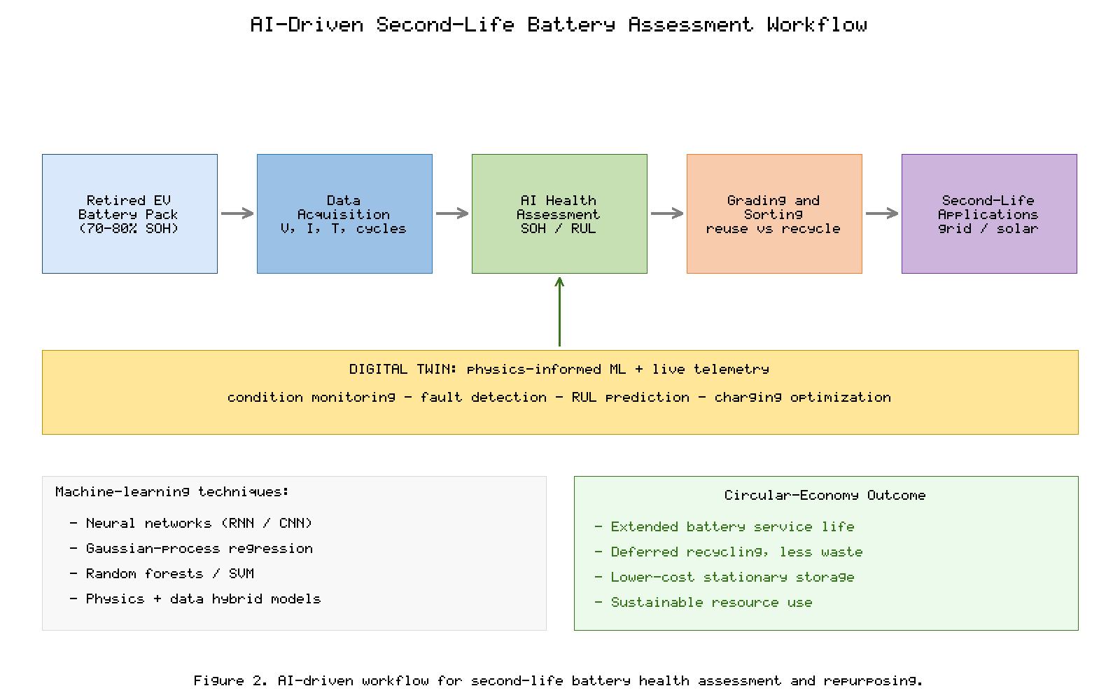
Figure 2. AI-driven workflow for second-life battery health assessment, grading, and repurposing.

5.3 Digital Twins and Predictive Management
Digital-twin technology extends data-driven battery analytics by maintaining a continuously updated virtual replica of a physical battery or pack, synchronized with real-world sensor data throughout its life [51]. The digital twin fuses physics-based modelling with machine learning to simulate internal states that are not directly observable, to predict future behaviour under hypothetical loads, and to support decision-making for maintenance, charging strategy, and reuse [7]. By coupling live telemetry with predictive models, the twin enables condition monitoring, early fault detection, and proactive management that extend safe service life and optimize performance [47]. The same infrastructure can also personalize charging and thermal strategies to individual usage patterns, slowing degradation during first life and thereby increasing the residual value available for second life.
In the second-life context, digital twins are particularly valuable for tracking the evolving health of repurposed packs operating under new duty cycles, allowing operators to anticipate failures, schedule interventions, and maximize the economic and environmental return on the reused asset [51]. AI-driven predictive analytics thus underpin the entire second-life value chain—from the initial grading of retired cells, through the design of safe repurposed systems, to the ongoing management of fielded second-life storage—supporting sustainable resource use and reinforcing the circular-economy rationale for battery reuse [5]. These capabilities also feed back into first-life applications, where the same predictive techniques improve warranty management, residual-value estimation, and consumer confidence in battery longevity [49].
Second-life reuse is ultimately one stage within a broader circular economy that culminates in recycling, where the valuable metals contained in retired cells are recovered and returned to the materials supply chain [3]. Eventually even repurposed batteries reach the end of their safe service life, at which point efficient recovery of lithium, nickel, cobalt, and other constituents reduces dependence on primary mining and lowers the environmental footprint of the battery life cycle [11]. Recycling and reuse are therefore complementary rather than competing strategies: intelligent health assessment determines which pathway is appropriate for each retired pack, while closed-loop recycling ensures that materials are not lost once reuse is no longer viable [5]. Designing batteries and data systems from the outset to support this full life cycle—so that a pack's provenance, chemistry, and usage history travel with it—greatly simplifies both second-life assessment and eventual recycling, and digital passports that carry such information are emerging as an enabler of the circular battery economy [51].

6. Artificial Intelligence in Battery Material Discovery

6.1 Accelerating Discovery Beyond Trial and Error
The historical pace of battery innovation has been constrained by the slow, resource-intensive nature of conventional materials research, in which candidate compounds are synthesized and tested through laborious cycles of trial and error over years or decades. The combinatorial space of possible electrode, electrolyte, and solid-state materials is vast, far exceeding what exhaustive experimentation could ever traverse. Artificial intelligence, combined with high-throughput computation and curated materials databases, is fundamentally changing this paradigm by enabling the rapid, targeted search of enormous chemical and structural spaces for materials with desired properties.
Machine-learning models trained on experimental and computational data—including results from first-principles quantum-mechanical calculations—can predict key properties such as ionic conductivity, electrochemical stability, voltage, and capacity far faster than direct simulation or experiment [7]. This predictive screening allows researchers to prioritize the most promising candidates for synthesis and testing, concentrating scarce experimental resources where they are most likely to yield breakthroughs and dramatically compressing the discovery timeline [22]. The foundation for this capability is the growth of large, openly accessible materials databases populated by high-throughput computation, which provide the training data from which surrogate models learn structure-property relationships [14].
Central to the success of these models is the representation of materials in a form that learning algorithms can exploit, whether through hand-crafted descriptors encoding composition and structure or through graph-based representations that treat a crystal as a network of atoms and bonds [7]. Graph neural networks, in particular, have proven powerful for predicting properties directly from atomic structure, capturing the local chemical environment in a way that generalizes across diverse compositions. The accuracy of any such model, however, is bounded by the quality and coverage of its training data, so curation, standardization, and the inclusion of negative results remain essential and often underappreciated contributions to the field.

6.2 Generative Design, Screening, and Autonomous Experimentation
Beyond predicting the properties of known candidates, AI increasingly participates in the inverse problem of designing new materials with specified target properties. Generative models and optimization algorithms can propose novel compositions and structures tailored to objectives such as higher energy density, improved safety, and longer lifespan, exploring regions of chemical space that human intuition might overlook. Coupled with high-throughput virtual screening, these approaches construct funnels that winnow millions of hypothetical materials down to a tractable set of validated candidates.
The frontier of this field is the autonomous or self-driving laboratory, in which AI planning, robotic synthesis, and automated characterization are integrated into closed feedback loops that iteratively design, make, and test materials with minimal human intervention [7]. Active-learning strategies make these loops highly sample-efficient, directing each experiment toward the most informative next step and accelerating convergence on optimal materials. Applied to electrode materials, electrolytes, and particularly the solid electrolytes central to next-generation solid-state batteries, these AI-driven methods promise to shorten development cycles for safer, higher-performance chemistries [22]. The search for superionic solid electrolytes with high conductivity and electrochemical stability is an especially attractive target, because materials discovery there directly addresses the principal bottleneck confronting solid-state batteries [24].
Despite its promise, AI-driven materials discovery faces real limitations that temper expectations. Predictions are only as reliable as the data and physics underlying them, and a computationally promising candidate may prove impossible to synthesize, unstable under real operating conditions, or incompatible with scalable manufacturing [12]. Bridging the gap between a predicted material and a manufacturable cell requires tight integration of computational discovery with experimental validation and process engineering, and the most effective programmes treat AI not as a replacement for domain expertise but as an amplifier of it [7]. As these tools mature and couple ever more closely with automated experimentation, they are poised to accelerate the arrival of the higher-energy, safer, and longer-lived batteries on which the future of electric mobility depends. Figure 3 illustrates the AI-driven materials-discovery pipeline, and Figure 4 situates AI capabilities across the battery value chain. Table 4 summarizes the principal AI applications spanning battery health and materials discovery.
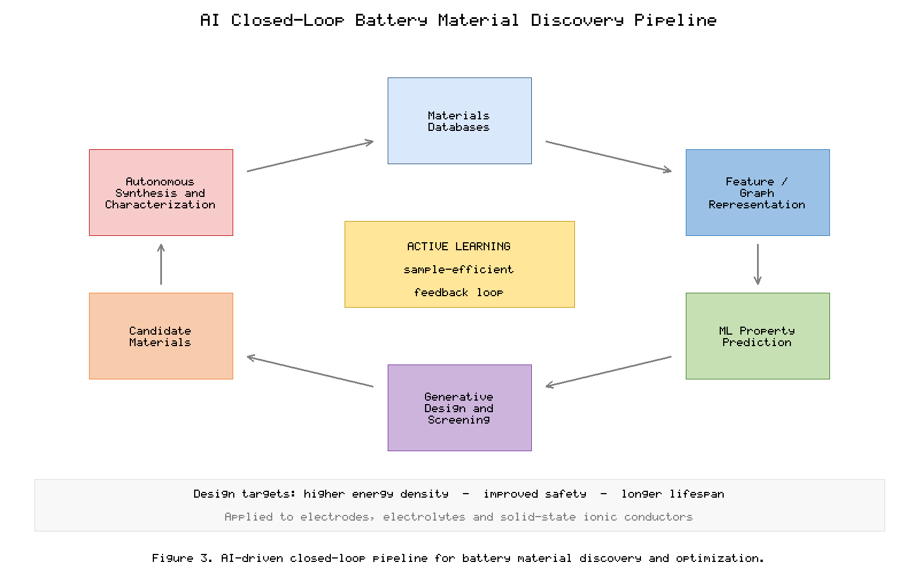
Figure 3. AI-driven closed-loop pipeline for battery material discovery and optimization.
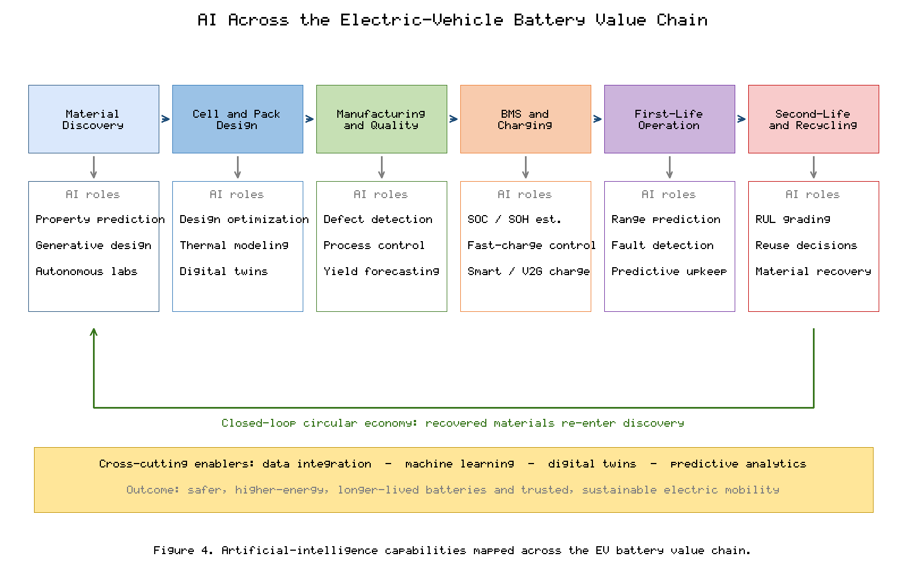
Figure 4. Artificial intelligence capabilities mapped across the electric-vehicle battery value chain.
Table 4. Representative AI applications across battery health assessment and material discovery.
Application Area | AI Technique | Primary Objective | Expected Benefit
State-of-health estimation | Neural networks, Gaussian-process regression | Infer capacity fade from signals | Accurate grading of used cells
Remaining-useful-life prediction | Recurrent/convolutional networks, hybrid models | Forecast lifetime under duty cycle | Safe, optimized second-life reuse
Digital-twin management | Physics-informed ML | Virtual replica for prediction | Proactive maintenance, longevity
Property prediction | ML surrogates of first-principles data | Rapid property screening | Faster candidate prioritization
Inverse material design | Generative models, active learning | Design to target properties | Novel high-performance materials

7. Conclusion and Future Outlook
The intelligent and predictive design of smart electric vehicles rests on the convergence of advanced battery science, robust charging infrastructure, an understanding of human behaviour, and the growing power of artificial intelligence. Battery chemistry continues to advance along multiple parallel paths: incumbent lithium-ion technology is being refined through silicon-enhanced anodes and safer, lower-cost cathode formulations, while solid-state, lithium-sulfur, sodium-ion, and other post-lithium chemistries progress toward the complementary roles each is best suited to fill. No single chemistry will serve every purpose, and the future is one of diversified, application-matched energy storage tailored to distinct vehicle segments and duty cycles.
Charging infrastructure and battery management are advancing in lockstep with the cells themselves, as faster, smarter, and bidirectional charging, coordinated with increasingly capable management systems, turns the vehicle fleet into an active and flexible participant in a cleaner energy system. Yet technology alone cannot guarantee widespread adoption. The psychological barriers of range anxiety, charging uncertainty, perceived reliability, and cost, and above all the user trust that integrates them, must be addressed through transparent communication, dependable experience, and thoughtful design that places the human at the centre of electric mobility.
Artificial intelligence emerges throughout this landscape as a cross-cutting enabler. In the second life of batteries, AI-driven state-of-health and remaining-useful-life estimation, powered by machine learning and digital twins, unlocks the safe and economical reuse of retired packs and advances the circular economy. In materials research, AI compresses discovery timelines by predicting properties, designing novel compositions, and orchestrating autonomous experimentation toward higher energy density, improved safety, and longer life. As these technical and human threads continue to intertwine, intelligent and predictive approaches will remain central to realizing sustainable, trusted, and widely adopted electric mobility.

References
[1] International Energy Agency, "Global EV Outlook 2023: Catching up with climate ambitions," IEA, Paris, 2023.
[2] A. Milev, A. Hastings, and A. Al-Habaibeh, "The environmental and financial implications of expanding the use of electric cars: A case study," Energy Reports, vol. 7, pp. 2626-2637, 2021.
[3] G. Harper, R. Sommerville, E. Kendrick, et al., "Recycling lithium-ion batteries from electric vehicles," Nature, vol. 575, pp. 75-86, 2019.
[4] Y. Ding, Z. P. Cano, A. Yu, J. Lu, and Z. Chen, "Automotive Li-ion batteries: Current status and future perspectives," Electrochemical Energy Reviews, vol. 2, pp. 1-28, 2019.
[5] M. S. Hossain Lipu, M. A. Hannan, A. Hussain, et al., "A review of controllers and optimizations based scheduling operation for battery energy storage system towards decarbonization," Journal of Cleaner Production, vol. 292, 126044, 2021.
[6] F. Liao, E. Molin, and B. van Wee, "Consumer preferences for electric vehicles: a literature review," Transport Reviews, vol. 39, no. 3, pp. 252-275, 2019.
[7] J. Lu, X. Zhao, K. Amine, et al., "Artificial intelligence in battery design and management: opportunities and challenges," Energy Storage Materials, vol. 55, pp. 1-25, 2023.
[8] M. Li, J. Lu, Z. Chen, and K. Amine, "30 years of lithium-ion batteries," Advanced Materials, vol. 30, no. 33, 1800561, 2020.
[9] T. Kim, W. Song, D.-Y. Son, L. K. Ono, and Y. Qi, "Lithium-ion batteries: outlook on present, future, and hybridized technologies," Journal of Materials Chemistry A, vol. 7, pp. 2942-2964, 2019.
[10] W. Liu, T. Placke, and K. T. Chau, "Overview of batteries and battery management for electric vehicles," Energy Reports, vol. 8, pp. 4058-4084, 2022.
[11] S. Doose, J. K. Mayer, P. Michalowski, and A. Kwade, "Challenges in ecofriendly battery recycling and closed material cycles," Sustainability, vol. 13, no. 21, 11844, 2021.
[12] F. Duffner, N. Kronemeyer, J. Tubke, et al., "Post-lithium-ion battery cell production and its compatibility with lithium-ion cell production infrastructure," Nature Energy, vol. 6, pp. 123-134, 2021.
[13] P. K. Nayak, E. M. Erickson, F. Schipper, et al., "Review on challenges and recent advances in the electrochemical performance of high-capacity Li-ion cathodes," Advanced Energy Materials, vol. 10, no. 2, 1902984, 2020.
[14] G. Zubi, R. Dufo-Lopez, M. Carvalho, and G. Pasaoglu, "The lithium-ion battery: State of the art and future perspectives," Renewable and Sustainable Energy Reviews, vol. 89, pp. 292-308, 2019.
[15] Y. Miao, P. Hynan, A. von Jouanne, and A. Yokochi, "Current Li-ion battery technologies in electric vehicles and opportunities for advancements," Energies, vol. 12, no. 6, 1074, 2019.
[16] W. Li, E. M. Erickson, and A. Manthiram, "High-nickel layered oxide cathodes for lithium-based automotive batteries," Nature Energy, vol. 5, pp. 26-34, 2020.
[17] J. Chen, Y. Wang, J. Li, et al., "LiFePO4 batteries for electric vehicles: progress, prospects and sustainability," Journal of Energy Storage, vol. 72, 108638, 2023.
[18] X. Zuo, J. Zhu, P. Muller-Buschbaum, and Y.-J. Cheng, "Silicon based lithium-ion battery anodes: A chronicle perspective review," Nano Energy, vol. 31, pp. 113-143, 2020.
[19] H. Yuan, J.-Q. Huang, H.-J. Peng, et al., "A review of functional binders in lithium-sulfur batteries," Advanced Energy Materials, vol. 10, no. 41, 2001256, 2020.
[20] X. Feng, M. Ouyang, X. Liu, et al., "Thermal runaway mechanism of lithium-ion battery for electric vehicles: A review," Energy Storage Materials, vol. 10, pp. 246-267, 2020.
[21] J. S. Edge, S. O'Kane, R. Prosser, et al., "Lithium-ion battery degradation: what you need to know," Physical Chemistry Chemical Physics, vol. 23, pp. 8200-8221, 2021.
[22] J. Janek and W. G. Zeier, "Challenges in speeding up solid-state battery development," Nature Energy, vol. 8, pp. 230-240, 2023.
[23] Q. Zhao, S. Stalin, C.-Z. Zhao, and L. A. Archer, "Designing solid-state electrolytes for safe, energy-dense batteries," Nature Reviews Materials, vol. 5, pp. 229-252, 2020.
[24] A. Manthiram, X. Yu, and S. Wang, "Lithium battery chemistries enabled by solid-state electrolytes," Nature Reviews Materials, vol. 4, pp. 1-16, 2019.
[25] T. Famprikis, P. Canepa, J. A. Dawson, M. S. Islam, and C. Masquelier, "Fundamentals of inorganic solid-state electrolytes for batteries," Nature Materials, vol. 18, pp. 1278-1291, 2019.
[26] K. J. Kim, M. Balaish, M. Wadaguchi, L. Kong, and J. L. M. Rupp, "Solid-state Li-metal batteries: challenges and horizons of oxide and sulfide solid electrolytes," Advanced Energy Materials, vol. 11, no. 1, 2002689, 2021.
[27] D. H. S. Tan, A. Banerjee, Z. Chen, and Y. S. Meng, "From nanoscale interface characterization to sustainable energy storage using all-solid-state batteries," Nature Nanotechnology, vol. 15, pp. 170-180, 2020.
[28] M. Zhao, B.-Q. Li, X.-Q. Zhang, J.-Q. Huang, and Q. Zhang, "A perspective toward practical lithium-sulfur batteries," ACS Central Science, vol. 6, no. 7, pp. 1095-1104, 2020.
[29] L. Kong, C. Yan, J.-Q. Huang, et al., "Review of advanced energy materials for lithium-sulfur batteries," Energy & Environmental Materials, vol. 4, no. 1, pp. 56-71, 2021.
[30] N. Tapia-Ruiz, A. R. Armstrong, H. Alptekin, et al., "2021 roadmap for sodium-ion batteries," Journal of Physics: Energy, vol. 3, no. 3, 031503, 2021.
[31] Y. Liang, H. Dong, D. Aurbach, and Y. Yao, "Current status and future directions of multivalent metal-ion batteries," Nature Energy, vol. 5, pp. 646-656, 2020.
[32] M. Nicholas and D. Hall, "Lessons learned on early electric vehicle fast-charging deployments," International Council on Clean Transportation, White Paper, 2019.
[33] S. Habib, M. M. Khan, F. Abbas, et al., "A comprehensive study of implemented international standards, technical challenges, impacts and prospects for electric vehicles," IEEE Access, vol. 7, pp. 173856-173880, 2019.
[34] H. Tu, H. Feng, S. Srdic, and S. Lukic, "Extreme fast charging of electric vehicles: A technology overview," IEEE Transactions on Transportation Electrification, vol. 5, no. 4, pp. 861-878, 2019.
[35] C. Jung, "Power up with 800-V systems: The benefits of upgrading voltage power for battery-electric passenger vehicles," IEEE Electrification Magazine, vol. 9, no. 3, pp. 53-58, 2021.
[36] M. Safayatullah, M. T. Elrais, S. Ghosh, R. Rezaii, and I. Batarseh, "A comprehensive review of power converter topologies and control methods for electric vehicle fast charging applications," IEEE Access, vol. 10, pp. 40753-40793, 2022.
[37] A. Ahmad, Z. A. Khan, M. Saad Alam, and S. Khateeb, "A review of the electric vehicle charging techniques, standards, progression and evolution of EV technologies in Germany," Smart Science, vol. 6, no. 1, pp. 36-53, 2020.
[38] A. Tomaszewska, Z. Chu, X. Feng, et al., "Lithium-ion battery fast charging: A review," eTransportation, vol. 1, 100011, 2019.
[39] W. Zhang, X. Wan, X. Wang, et al., "Fast charging of lithium-ion batteries: A review of materials aspects," Advanced Energy Materials, vol. 11, no. 35, 2101518, 2021.
[40] S. Ahmed, I. Bloom, A. N. Jansen, et al., "Enabling fast charging - A battery technology gap assessment," Journal of Power Sources, vol. 441, 227254, 2019.
[41] M. Muratori, "Impact of uncoordinated plug-in electric vehicle charging on residential power demand," Nature Energy, vol. 7, pp. 193-201, 2022.
[42] C. B. Jones, M. Lave, W. Vining, and B. M. Garcia, "Uncontrolled electric vehicle charging impacts on distribution electric power systems," Energies, vol. 14, no. 6, 1688, 2021.
[43] N. Sadeghianpourhamami, J. Deleu, and C. Develder, "Definition and evaluation of model-free coordination of electrical vehicle charging with reinforcement learning," IEEE Transactions on Smart Grid, vol. 11, no. 1, pp. 203-214, 2020.
[44] M. B. Arias, M. Kim, and S. Bae, "Prediction of electric vehicle charging-power demand in realistic urban traffic networks," Applied Energy, vol. 195, pp. 738-753, 2021.
[45] B. K. Sovacool, J. Kester, L. Noel, and G. Zarazua de Rubens, "Actors, business models, and innovation activity systems for vehicle-to-grid (V2G) technology," Energy Research & Social Science, vol. 52, pp. 172-190, 2020.
[46] M. A. Hannan, M. S. H. Lipu, A. Hussain, and A. Mohamed, "A review of lithium-ion battery state of charge estimation and management system in electric vehicle applications: Challenges and recommendations," Renewable and Sustainable Energy Reviews, vol. 78, pp. 834-854, 2019.
[47] L. Zhang, Z. Wang, et al., "A review of supervisory control and management systems for electric vehicle battery packs," Renewable and Sustainable Energy Reviews, vol. 139, 110711, 2021.
[48] R. Xiong, J. Cao, Q. Yu, H. He, and F. Sun, "Critical review on the battery state of charge estimation methods for electric vehicles," IEEE Access, vol. 6, pp. 1832-1843, 2019.
[49] C. Vidal, P. Malysz, P. Kollmeyer, and A. Emadi, "Machine learning applied to electrified vehicle battery state of charge and state of health estimation: State-of-the-art review," IEEE Access, vol. 8, pp. 52796-52814, 2020.
[50] G. Zhao, X. Wang, M. Negnevitsky, and H. Zhang, "A review of air-cooling battery thermal management systems for electric and hybrid electric vehicles," Journal of Power Sources, vol. 501, 230001, 2021.
[51] K. W. See, G. Wang, Y. Zhang, et al., "Critical review and functional safety of a battery management system for large-scale lithium-ion battery pack technologies," International Journal of Coal Science & Technology, vol. 9, no. 1, pp. 1-17, 2022.
[52] T. Franke, M. Rauh, M. Gunther, M. Trantow, and J. F. Krems, "Which factors can protect against range stress in everyday usage of battery electric vehicles?" Human Factors, vol. 61, no. 1, pp. 42-61, 2019.
[53] N. Berkeley, D. Jarvis, and A. Jones, "Analysing the take up of battery electric vehicles: An investigation of barriers amongst drivers in the UK," Transportation Research Part D: Transport and Environment, vol. 63, pp. 466-481, 2019.

