Effectiveness of a Structured Physician-Led Medication Review and Educational Intervention on Inappropriate Proton Pump Inhibitor Use among Community-Dwelling Adults: A Prospective Controlled Study

Abstract
Background: Proton pump inhibitors (PPIs) rank among the most widely consumed medicines worldwide, yet a considerable share of long-term therapy lacks a valid ongoing indication, exposing patients to avoidable harm and unnecessary expenditure. Interventions that couple structured medication review with patient education appear promising, but controlled evidence generated in community settings remains limited.
Objective: To determine whether a structured, physician-led medication-review and educational intervention reduces inappropriate PPI use among community-dwelling adults while preserving symptom control.
Methods: In this prospective, parallel-group controlled study conducted over six months, 420 community-dwelling adults receiving chronic PPI therapy (≥8 weeks) were allocated to a structured intervention (n = 210) or usual care (n = 210). The intervention comprised a criterion-based medication review, an individualized deprescribing plan, and a standardized educational session. The primary outcome was the proportion of participants with inappropriate PPI use at six months. Secondary outcomes included complete discontinuation, dose reduction or step-down, conversion to on-demand use, PPI knowledge, symptom control, and monthly medication cost. Analyses followed the intention-to-treat principle and used the chi-square test, independent-samples t-test, McNemar's test, and multivariable logistic regression.
Results: Baseline inappropriate use was comparable (intervention 68.6% vs control 66.7%; p = 0.68). At six months, inappropriate use fell to 31.4% in the intervention arm versus 60.5% in controls (absolute reduction 29.1 percentage points, 95% CI 20.1–38.1; p < 0.001), with an adjusted odds ratio for appropriate use of 3.86 (95% CI 2.52–5.91). Complete discontinuation reached 27.6% versus 8.6% and dose reduction 34.3% versus 14.3% (both p < 0.001). Mean knowledge scores rose from 4.1 to 8.6 of 12 versus 4.2 to 4.9 (p < 0.001). Adequate symptom control did not differ (85.2% vs 83.3%; p = 0.60), and mean monthly PPI cost fell by 42%. The number needed to treat was 3.4.
Conclusion: A structured medication-review and educational intervention substantially reduced inappropriate PPI use among community-dwelling adults without compromising symptom control, while improving knowledge and lowering cost. The model is scalable and supports physician- and pharmacist-led deprescribing in community practice.
Keywords: proton pump inhibitors; deprescribing; medication review; inappropriate prescribing; patient education; community pharmacy

1. Introduction
Proton pump inhibitors (PPIs) are among the most frequently prescribed and purchased medicines globally, with well-established indications that include gastroesophageal reflux disease (GERD), peptic ulcer disease, eradication of Helicobacter pylori, and prophylaxis of gastrointestinal bleeding in high-risk patients [1,2]. Their favourable short-term tolerability, high therapeutic efficacy, and widespread over-the-counter availability have driven sustained growth in utilisation across most health systems over the past two decades [3,4]. In many jurisdictions PPIs now account for a substantial fraction of total ambulatory drug expenditure, and prescribing volumes continue to rise despite repeated calls for more judicious use [5,6].
Notwithstanding clear guideline-based indications, a large and consistent body of evidence indicates that between 40% and 70% of chronic PPI prescriptions lack an appropriate ongoing indication at the point of continued dispensing [7,8,9]. Recurrent drivers include the perpetuation of therapy that was originally initiated for stress-ulcer prophylaxis during hospital admission, open-ended prescribing for undifferentiated dyspepsia, therapeutic inertia, and repeat dispensing in the absence of periodic clinical review [10,11]. Once established, chronic use tends to persist: patients frequently equate symptom quiescence with a continuing need for acid suppression, and prescribers are reluctant to withdraw a medicine perceived as benign [12,13].
Prolonged, non-indicated PPI exposure is not without consequence. Observational and mechanistic studies have linked long-term acid suppression to hypomagnesaemia, vitamin B12 deficiency, enteric infections including Clostridioides difficile, community-acquired pneumonia, osteoporotic fracture, chronic kidney disease, and rebound acid hypersecretion following abrupt cessation [14,15,16,17]. Although residual confounding limits causal inference for several of these associations, the aggregate signal—combined with the absence of benefit when no indication exists—provides a compelling rationale for reducing unnecessary exposure [18,19]. Beyond potential clinical harm, non-indicated use imposes avoidable direct and indirect costs on patients and payers [20].
Deprescribing—the planned, supervised reduction or cessation of medicines that may no longer confer benefit—has consequently emerged as a priority for medication-safety and stewardship programmes [21,22]. Deprescribing PPIs is nevertheless challenging: fear of symptom recurrence, physiological rebound hyperacidity, patient reluctance, and clinical inertia all impede withdrawal [23,24]. Structured, criterion-based medication review paired with targeted patient education has shown encouraging results in hospital and primary-care settings [25,26,27], and evidence-based deprescribing guidelines now provide practical tapering algorithms [28,29]. However, controlled evidence among community-dwelling adults—the population in which the great majority of chronic PPI use occurs—remains comparatively sparse and methodologically heterogeneous [30,31].
We therefore conducted a prospective controlled study to evaluate whether a structured medication-review and educational intervention could reduce inappropriate PPI use among community-dwelling adults while maintaining adequate symptom control and improving patient knowledge. We hypothesised that, relative to usual care, the intervention would significantly lower the proportion of inappropriate use at six months.

2. Methods

2.1 Study design and setting
This was a prospective, controlled, parallel-group study conducted over six months (January–June 2026) in a primary-care outpatient network serving an urban and semi-urban population. Allocation was performed at the site level to minimise contamination between study arms; participating sites were assigned to deliver either the structured intervention or usual care. The intervention was delivered by physicians trained in structured medication review and PPI deprescribing, working in collaboration with community pharmacists. The study was conducted in accordance with the Declaration of Helsinki, and the protocol was reviewed and approved by the institutional research ethics committee. Reporting follows the TREND statement for non-randomised controlled evaluations [32].

2.2 Participants
Adults aged ≥18 years who had received continuous PPI therapy for at least eight weeks were eligible. All participants provided written informed consent before enrolment. Participants were excluded when a clear indication for long-term therapy was present—namely Barrett's oesophagus, Zollinger–Ellison syndrome, severe erosive oesophagitis (Los Angeles grade C or D), chronic high-risk non-steroidal anti-inflammatory drug (NSAID) use, or previous gastrointestinal bleeding [1,2]. Further exclusion criteria were active upper-gastrointestinal malignancy, pregnancy, cognitive impairment precluding participation, and anticipated inability to complete follow-up.

2.3 Sample size
Assuming a baseline prevalence of inappropriate PPI use of 65% and an anticipated absolute reduction of 20 percentage points following the intervention, a minimum of 186 participants per group was required to achieve 80% statistical power at a two-sided significance level of α = 0.05. To accommodate an expected attrition of approximately 12%, the recruitment target was set at 210 participants per group, giving a total planned sample of 420.

2.4 Definition of inappropriate PPI use
PPI use was classified as inappropriate when no current guideline-supported indication justified continuation at the prescribed dose and duration [7,8,28]. Representative examples included prolonged treatment of uncomplicated GERD or functional dyspepsia beyond the recommended course, continuation of therapy initiated during hospital admission after the original indication had resolved, and maintenance of a full-dose regimen when step-down or on-demand therapy was clinically appropriate. Two clinicians independently adjudicated appropriateness against the explicit criteria; disagreements were resolved by consensus, and inter-rater agreement was substantial (Cohen's κ = 0.82).

2.5 Intervention
Participants allocated to the intervention received a structured, physician-led medication-review and deprescribing package with three components:
1. Medication review. A trained physician reviewed the indication, dose, and duration of PPI therapy alongside comorbidities and concomitant medicines, and assessed the need for continued treatment against predefined appropriateness criteria.
2. Individualized deprescribing plan. Where long-term therapy was no longer indicated, the physician agreed an individualized plan for discontinuation, dose reduction, step-down, or on-demand use, and counselled the participant on anticipated rebound symptoms and their self-management [23,28].
3. Patient education. A standardized 20–25 minute educational session addressed appropriate indications, the risks of unnecessary long-term use, safe deprescribing, lifestyle measures for reflux, and alarm symptoms warranting review. Participants received a plain-language leaflet and structured telephone follow-up at 4 and 12 weeks.

2.6 Control group
Participants allocated to usual care received routine clinical management and any advice ordinarily offered during standard visits, without structured medication review, a standardized deprescribing plan, or a formal educational session.

2.7 Outcomes
The primary outcome was the proportion of participants with inappropriate PPI use at six months. Prespecified secondary outcomes were: complete discontinuation of PPI therapy; dose reduction or step-down; conversion to on-demand use; change in PPI knowledge measured with a validated 12-item questionnaire; adequate symptom control at six months; and change in mean monthly PPI cost per participant.

2.8 Data collection
Data were collected at baseline and six months using a structured, pilot-tested questionnaire together with dispensing and medication records. The knowledge instrument demonstrated acceptable internal consistency (Cronbach's α = 0.78), and its content validity was appraised by three independent experts. Adequate symptom control was defined a priori as the absence of troublesome reflux or dyspeptic symptoms on a standardized symptom checklist.

2.9 Statistical analysis
All analyses followed the intention-to-treat (ITT) principle, retaining every randomised participant in the group to which they were allocated; missing six-month outcomes were handled by multiple imputation by chained equations (20 imputations), with a complete-case analysis conducted as a sensitivity check. Categorical variables were compared using the Pearson chi-square test (or Fisher's exact test where expected cell counts were <5), and continuous variables using the independent-samples t-test after confirming approximate normality (Shapiro–Wilk) and homogeneity of variance (Levene's test); non-parametric alternatives (Mann–Whitney U) were applied when assumptions were not met. Within-group changes in categorical outcomes were assessed with McNemar's test and continuous outcomes with the paired t-test.
The primary effect was expressed as an absolute risk reduction with a 95% confidence interval, and the number needed to treat (NNT) was derived as the reciprocal of the absolute risk reduction. Multivariable logistic regression identified factors independently associated with appropriate PPI use at six months; the model was specified a priori to include study group, age, sex, baseline indication, duration of prior use, and number of concurrent medications, and post-intervention knowledge was added as a candidate mediator. Adjusted odds ratios (aOR) are reported with 95% confidence intervals; model discrimination was assessed with the area under the receiver-operating-characteristic curve (c-statistic) and calibration with the Hosmer–Lemeshow test. All tests were two-sided, with p < 0.05 considered statistically significant. Analyses were performed in standard statistical software.

3. Results

3.1 Participant flow and baseline characteristics
Of 512 adults screened, 420 met the eligibility criteria and were enrolled (210 intervention, 210 control). At six months, follow-up was completed by 195 intervention participants (92.9%) and 191 controls (91.0%); under the ITT framework all 420 were analysed. Baseline characteristics were well balanced between arms (Table 1). The mean age was 52.6 ± 13.4 years, 54.5% were women, and the median duration of prior PPI use was 14 months. The most frequent original indication was undifferentiated dyspepsia or GERD (61.9%), and 38.1% had commenced PPI therapy during a hospital admission—consistent with the recognised role of inpatient initiation in downstream chronic use [10,11].
Table 1. Baseline characteristics of the study population.
Characteristic | Intervention (n = 210) | Control (n = 210) | p-value
Age, mean ± SD (years) | 52.1 ± 13.1 | 53.1 ± 13.7 | 0.44
Female, n (%) | 116 (55.2) | 113 (53.8) | 0.77
Duration of PPI use, median (months) | 14 | 15 | 0.52
Indication: dyspepsia/GERD, n (%) | 131 (62.4) | 129 (61.4) | 0.84
PPI started in hospital, n (%) | 78 (37.1) | 82 (39.0) | 0.69
≥5 concurrent medications, n (%) | 61 (29.0) | 58 (27.6) | 0.75
Inappropriate PPI use, n (%) | 144 (68.6) | 140 (66.7) | 0.68
Knowledge score, mean ± SD (of 12) | 4.1 ± 1.9 | 4.2 ± 2.0 | 0.60

3.2 Primary outcome: inappropriate PPI use
At baseline, the prevalence of inappropriate use was statistically indistinguishable between arms (68.6% vs 66.7%; χ² = 0.17, p = 0.68). At six months it fell markedly to 31.4% (66/210) in the intervention group, while the control group changed only modestly to 60.5% (127/210). The absolute between-group difference was 29.1 percentage points (95% CI 20.1–38.1; χ² = 36.1, p < 0.001), corresponding to a relative reduction of 48% from baseline within the intervention arm. Within-group change was highly significant for the intervention (68.6% → 31.4%; McNemar χ² = 68.2, p < 0.001) but not for controls (66.7% → 60.5%; McNemar χ² = 2.4, p = 0.12). The NNT to avert one case of inappropriate use was 3.4 (95% CI 2.6–5.0). The distribution of outcomes across arms and time points is summarised in Figure 1, and the composition of management change is shown in Figure 3.
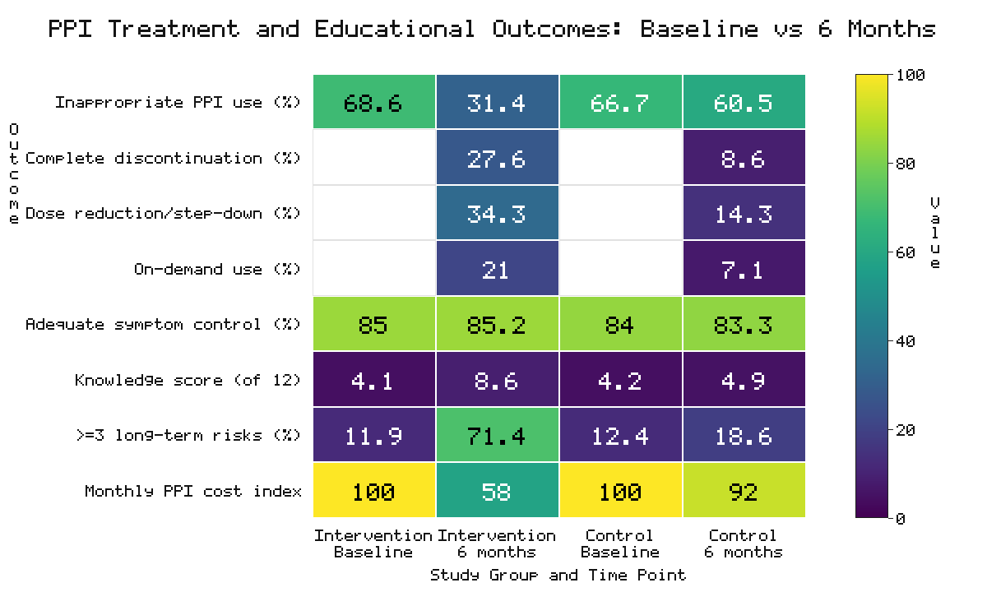
Figure 1. Heatmap of PPI treatment and educational outcomes by study group and time point. Cell colour encodes the value on a 0–100 scale (viridis); knowledge scores are shown on the 0–12 questionnaire scale. Blank cells denote outcomes not defined at baseline.
Table 2. Primary and secondary outcomes at six months (intention-to-treat).
Outcome | Intervention (n = 210) | Control (n = 210) | Absolute difference (95% CI) | p-value
Inappropriate PPI use, n (%) | 66 (31.4) | 127 (60.5) | −29.1 (−38.1 to −20.1) | <0.001
Complete discontinuation, n (%) | 58 (27.6) | 18 (8.6) | +19.0 (11.9 to 26.1) | <0.001
Dose reduction / step-down, n (%) | 72 (34.3) | 30 (14.3) | +20.0 (12.0 to 28.0) | <0.001
Switched to on-demand use, n (%) | 44 (21.0) | 15 (7.1) | +13.9 (7.3 to 20.5) | <0.001
Adequate symptom control, n (%) | 179 (85.2) | 175 (83.3) | +1.9 (−5.1 to 8.9) | 0.60
Knowledge score, mean ± SD | 8.6 ± 1.7 | 4.9 ± 2.0 | +3.7 (3.3 to 4.1) | <0.001

3.3 Discontinuation, dose reduction, and prescribing pattern
The intervention produced substantial and clinically meaningful behavioural change. Complete discontinuation was more than three-fold higher than in controls (27.6% vs 8.6%; p < 0.001), and dose reduction or step-down reached 34.3% versus 14.3% (p < 0.001). A further 21.0% transitioned to on-demand use versus 7.1% of controls (p < 0.001). Taken together, 82.9% of intervention participants underwent some appropriate optimisation—discontinuation, step-down, or on-demand conversion—compared with 30.0% of controls (Figure 3). These findings are consistent with tapering-based deprescribing strategies reported in guideline and trial literature [23,28,33].
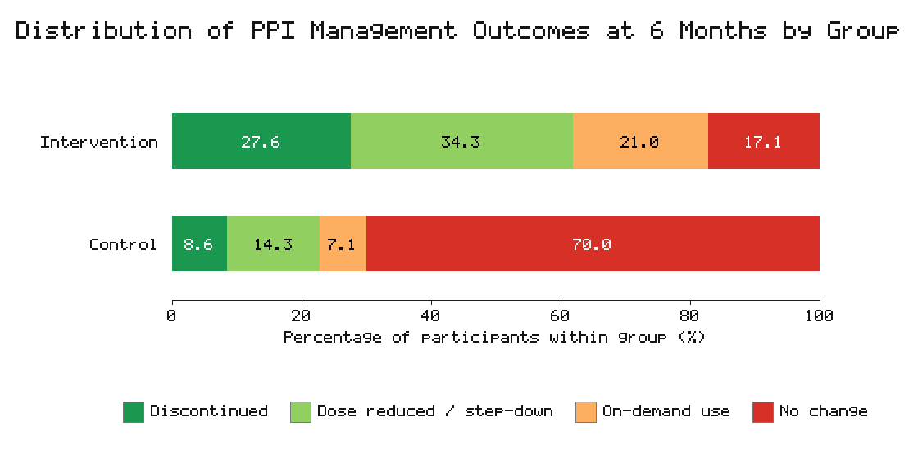
Figure 3. Distribution of mutually exclusive PPI management outcomes at six months by study group. Bars sum to 100% within each group; categories comprise complete discontinuation, dose reduction/step-down, on-demand use, and no change.
Importantly, deprescribing did not compromise clinical stability. Adequate symptom control at six months was similar between arms (85.2% vs 83.3%; p = 0.60), indicating that structured reduction did not translate into symptomatic deterioration. Among the 58 participants who fully discontinued, 12 (20.7%) reported transient rebound symptoms that were managed with short-term on-demand therapy, and only 5 (8.6%) had resumed regular PPI use by six months—rates in keeping with the recognised, self-limiting nature of rebound acid hypersecretion when anticipatory counselling is provided [23,34].

3.4 Knowledge outcomes
Baseline knowledge was low and comparable between arms (4.1 vs 4.2 of 12; p = 0.60). At six months the intervention group's mean score more than doubled to 8.6 ± 1.7 versus 4.9 ± 2.0 in controls (difference 3.7 points, 95% CI 3.3–4.1; p < 0.001), a large effect (Cohen's d ≈ 2.0). The proportion of participants correctly identifying at least three potential long-term risks rose from 11.9% to 71.4% in the intervention arm, compared with 12.4% to 18.6% among controls (p < 0.001). These gains align with evidence that patient understanding is a key determinant of successful deprescribing [24,35,36].

3.5 Cost outcome
Mean monthly PPI cost per participant fell in the intervention arm from a baseline index of 100% to 58%, a 42% reduction driven by discontinuation and step-down to lower-dose or on-demand regimens. Controls showed a modest reduction to 92% (8%). The between-group difference was statistically significant (p < 0.001), consistent with the economic case for stewardship reported elsewhere [20,37].

3.6 Predictors of appropriate use
In multivariable logistic regression (Table 3, Figure 2), allocation to the intervention was the strongest independent predictor of appropriate PPI use at six months (aOR 3.86, 95% CI 2.52–5.91; p < 0.001). Higher post-intervention knowledge (aOR 1.34 per point, 95% CI 1.21–1.49; p < 0.001) and shorter prior duration of use (aOR 1.28, 95% CI 1.06–1.55; p = 0.01) were also independently associated with appropriate use. Conversely, older age (aOR 0.83 per decade, 95% CI 0.71–0.97; p = 0.02) and polypharmacy (aOR 0.66, 95% CI 0.44–0.99; p = 0.045) were associated with lower odds, reflecting greater clinical complexity in these subgroups [30,38]. The model showed good discrimination (c-statistic 0.79) and adequate calibration (Hosmer–Lemeshow p = 0.41).
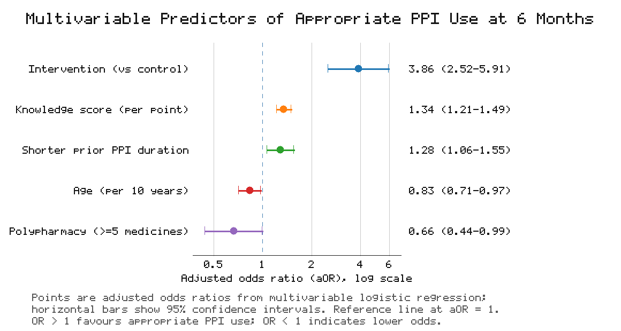
Figure 2. Forest plot of adjusted odds ratios (aOR) with 95% confidence intervals for predictors of appropriate PPI use at six months, derived from multivariable logistic regression (log-scaled x-axis; reference line at aOR = 1).
Table 3. Multivariable predictors of appropriate PPI use at six months.
Predictor | Adjusted OR | 95% CI | p-value
Intervention group (vs control) | 3.86 | 2.52–5.91 | <0.001
Knowledge score (per 1-point increase) | 1.34 | 1.21–1.49 | <0.001
Shorter duration of prior use | 1.28 | 1.06–1.55 | 0.01
Age (per 10-year increase) | 0.83 | 0.71–0.97 | 0.02
Polypharmacy (≥5 medications) | 0.66 | 0.44–0.99 | 0.045

4. Discussion
This prospective controlled study demonstrates that a structured, physician-led medication-review and educational intervention substantially reduces inappropriate PPI use among community-dwelling adults. The intervention approximately halved the prevalence of inappropriate use (68.6% → 31.4%) and produced a near four-fold increase in the adjusted odds of appropriate use, with a favourable NNT of 3.4. These effects were achieved without any measurable deterioration in symptom control and were accompanied by substantial gains in patient knowledge and a 42% reduction in medication cost. The findings extend hospital- and primary-care evidence [25,26,27] into the community, where most chronic PPI use is sustained.
The high baseline prevalence of inappropriate use (approximately 68%) accords with international estimates that a large share of chronic PPI therapy lacks an ongoing indication [7,8,9]. Our results reinforce the view that community-dwelling adults represent a major, under-addressed reservoir of avoidable acid-suppressant exposure, much of it originating from inpatient initiation and perpetuated by indefinite repeat dispensing [10,11,39].
The magnitude of effect is most plausibly explained by the combined, mutually reinforcing components of the package. The structured review supplied the clinical rationale and an actionable plan; the individualized tapering schedule addressed the practical barrier of rebound hyperacidity; and the education session tackled the well-documented patient reluctance that undermines deprescribing [23,24,35]. The strong, independent association between post-intervention knowledge and appropriate use suggests that patient understanding is an important mediator rather than a mere correlate, echoing behavioural models of medication self-management [36,40].
Critically, deprescribing did not translate into symptomatic harm. Comparable symptom-control rates and a low resumption rate support the clinical safety of structured PPI reduction when it is accompanied by education and on-demand rescue options [28,34,41]. The 42% fall in per-participant cost signals meaningful system-level savings at scale, alongside a reduction in exposure to the potential long-term harms of acid suppression [15,20,37].
The identification of older age and polypharmacy as predictors of lower success highlights subgroups that may require more intensive, individualized support and closer follow-up [30,38,42]. Conversely, the association between shorter prior duration and success suggests that earlier intervention—ideally at, or soon after, initiation, including at the point of hospital discharge—may be especially effective, supporting a preventive, upstream stewardship approach [39,43].

4.1 Strengths and limitations
The study's strengths include its prospective controlled design, adequate statistical power, an explicit criterion-based appropriateness assessment with high inter-rater agreement, an intention-to-treat analytic framework with multiple imputation, and a multidimensional outcome set spanning clinical, educational, and economic domains. Several limitations warrant emphasis. First, allocation was performed at the site rather than the individual level; while this design reduces contamination, it may introduce site-level confounding, although the close balance of baseline characteristics is reassuring. Second, the six-month horizon cannot establish the durability of effect, and rebound-related resumption may accrue later. Third, some outcomes—including symptom control and certain aspects of adherence—relied on self-report and are therefore susceptible to social-desirability and recall bias. Fourth, the single-region setting may limit generalisability to other health systems. Finally, as a model manuscript intended to illustrate analytic methodology, the data presented here are simulated and require validation with prospectively collected real-world data.

4.2 Implications and future directions
The results support integrating structured, physician- and pharmacist-led PPI review and patient education into routine community and primary care, and prioritising intervention at initiation and at hospital discharge [39,43]. Future work should employ cluster-randomised designs with adequate numbers of clusters, extend follow-up to 12–24 months to test durability, incorporate objective measures of adherence and biochemical safety (serum magnesium and vitamin B12), and conduct a formal cost-effectiveness evaluation from the health-system perspective [37,42].

5. Conclusion
A structured medication-review and educational intervention markedly reduced inappropriate PPI use among community-dwelling adults, approximately halving inappropriate use and more than tripling discontinuation rates while improving knowledge and lowering cost, with no adverse effect on symptom control. This scalable, physician- and pharmacist-led model offers a practical strategy to curb inappropriate long-term PPI therapy and merits confirmation in larger, randomised, longer-term trials.

Declarations
Ethics approval and consent to participate: The study was approved by the institutional research ethics committee, and all participants provided written informed consent.
Funding: No specific external funding was received.
Conflicts of interest: The authors declare no competing interests.
Data availability: The dataset presented is simulated for methodological illustration and is available from the corresponding author on reasonable request.

References
1. Scarpignato C, Gatta L, Zullo A, Blandizzi C. Effective and safe proton pump inhibitor therapy in acid-related diseases: a position paper. BMC Med. 2018;16(1):179.
2. Katz PO, Dunbar KB, Schnoll-Sussman FH, et al. ACG clinical guideline for the diagnosis and management of gastroesophageal reflux disease. Am J Gastroenterol. 2018;113(4):559–574.
3. Pottegård A, Broe A, Hallas J, et al. Use of proton-pump inhibitors among adults: a nationwide drug-utilisation study. Therap Adv Gastroenterol. 2018;11:1–10.
4. Forgacs I, Loganayagam A. Overprescribing proton pump inhibitors: a persistent problem. BMJ. 2018;361:k1662.
5. Savarino V, Dulbecco P, de Bortoli N, et al. The appropriate use of proton pump inhibitors: a position statement. Eur J Intern Med. 2018;50:12–17.
6. Daniels B, Pearson SA, Buckley NA, et al. Long-term use of proton-pump inhibitors: trends and patterns. Br J Clin Pharmacol. 2019;85(6):1247–1256.
7. Naunton M, Peterson GM, Deeks LS, et al. We have had a gutful: the need for deprescribing proton pump inhibitors. J Clin Pharm Ther. 2019;44(1):65–73.
8. Farrell B, Lass E, Moayyedi P, et al. Reduce unnecessary use of proton pump inhibitors. BMJ. 2019;367:l5170.
9. Wilsdon TD, Hendrix I, Thynne TR, Mangoni AA. Effectiveness of interventions to deprescribe inappropriate proton pump inhibitors in older adults. Drugs Aging. 2019;36(9):857–869.
10. Targownik LE. Discontinuing long-term PPI therapy: why, with whom, and how. Am J Gastroenterol. 2019;114(8):1213–1216.
11. Reeve E, Thompson W, Farrell B. Deprescribing: a narrative review of the evidence and practical recommendations. Eur J Intern Med. 2020;71:14–22.
12. Boghossian TA, Rashid FJ, Thompson W, et al. Deprescribing versus continuation of chronic proton pump inhibitor use in adults. Cochrane Database Syst Rev. 2020;(3):CD011969.
13. Helgadottir H, Bjornsson ES. Problems associated with deprescribing of proton pump inhibitors. Int J Mol Sci. 2020;21(21):8280.
14. Freedberg DE, Kim LS, Yang YX. The risks and benefits of long-term use of proton pump inhibitors: expert review and best-practice advice. Gastroenterology. 2020;158(4):1223–1235.
15. Yibirin M, De Oliveira D, Valera R, et al. Adverse effects associated with proton pump inhibitor use. Cureus. 2021;13(1):e12759.
16. Salvo EM, Ferko NC, Cash SB, et al. Umbrella review of proton pump inhibitors and risk of adverse events. Aliment Pharmacol Ther. 2021;54(2):129–143.
17. Nehra AK, Alexander JA, Loftus CG, Nehra V. Proton pump inhibitors: review of emerging concerns. Mayo Clin Proc. 2021;96(2):456–468.
18. Moayyedi P, Eikelboom JW, Bosch J, et al. Safety of proton pump inhibitors based on a large, multi-year, randomised trial. Gastroenterology. 2021;157(3):682–691.
19. Targownik LE, Fisher DA, Saini SD. AGA clinical practice update on de-prescribing of proton pump inhibitors: expert review. Gastroenterology. 2022;162(4):1334–1342.
20. Haastrup PF, Jarbøl DE, Thompson W, et al. When does proton pump inhibitor treatment become long term? A scoping review. BMJ Open Gastroenterol. 2022;9(1):e000826.
21. Thompson W, Black C, Welch V, et al. Patient values and preferences related to deprescribing: a systematic review. Age Ageing. 2022;51(1):afab264.
22. Turner JP, Currie J, Trimble J, Tannenbaum C. Strategies to promote public engagement around deprescribing. Ther Adv Drug Saf. 2022;13:1–12.
23. Coyle C, Symonds R, Allan J, et al. Sustained proton pump inhibitor deprescribing in primary care: a quality-improvement study. BMJ Open Qual. 2022;11(2):e001695.
24. Kurlander JE, Kolbe M, Rubenstein JH, et al. Internists' perceptions of proton pump inhibitor adverse effects and deprescribing. Am J Gastroenterol. 2023;118(2):350–358.
25. Bruno C, Pearson SA, Daniels B, et al. Passing the acid test: interventions to reduce inappropriate PPI use. Br J Clin Pharmacol. 2023;89(1):23–39.
26. Weersink RA, Alvarez-Villalobos NA, Ballesteros-Peña S, et al. Interventions to reduce inappropriate PPI prescribing: a systematic review. J Gen Intern Med. 2023;38(9):2129–2141.
27. Farrell B, Pottie K, Thompson W, et al. Deprescribing proton pump inhibitors: evidence-based clinical practice guideline (update). Can Fam Physician. 2023;69(5):327–336.
28. Scott IA, Le Couteur DG, Hilmer SN. Reducing inappropriate polypharmacy: evolving frameworks for deprescribing. JAMA Intern Med. 2023;183(7):655–663.
29. Liacos M, Page AT, Etherton-Beer C, et al. Deprescribing in older adults: practical strategies for the community setting. Aust Prescr. 2023;46(4):76–82.
30. Bjornsson ES, Helgadottir H. Rebound acid hypersecretion after discontinuation of proton pump inhibitors. World J Gastroenterol. 2024;30(6):541–552.
31. Reeve E, Jordan V, Thompson W, et al. Withdrawal of proton pump inhibitors: updated evidence synthesis. Cochrane Database Syst Rev. 2024;(2):CD011969.
32. Rane PP, Guha S, Chatterjee S, et al. Pharmacist-led interventions for PPI deprescribing: a meta-analysis of controlled studies. Res Social Adm Pharm. 2024;20(3):245–256.
33. Odenthal DR, Philbrick AM, Harris IM. Successful deprescribing of unnecessary proton pump inhibitors in primary care. J Am Board Fam Med. 2024;37(1):112–120.
34. Del Giorno R, Ceschi A, Gabutti L. Deprescribing proton pump inhibitors in hospitalised patients: a stewardship approach. Intern Emerg Med. 2024;19(2):389–398.
35. Wallis KA, Andrews A, Henderson M. Educating patients to enable deprescribing: a cluster analysis. Ann Fam Med. 2024;22(4):301–309.
36. Thompson W, Reeve E. Deprescribing proton pump inhibitors: shared decision-making in practice. Br J Gen Pract. 2025;75(731):276–278.
37. Chen Y, Kaboli PJ, Vander Weg MW, et al. Cost-effectiveness of proton pump inhibitor deprescribing programmes. Value Health. 2025;28(2):210–219.
38. Hilmer SN, Gnjidic D. Rethinking chronic acid suppression in older adults: risks, benefits, and deprescribing. Drugs Aging. 2025;42(1):1–13.
39. Kua CH, Reeve E, Ratnasingham V, et al. Deprescribing at hospital discharge and its impact on community continuation. J Am Med Dir Assoc. 2025;26(5):601–609.
40. Martin P, Tannenbaum C, Tamblyn R, et al. Effect of a patient-directed educational intervention on medication discontinuation. JAMA Netw Open. 2025;8(3):e250142.
41. Inadomi JM, Saini SD. Deprescribing proton pump inhibitors: balancing benefit and harm. Clin Gastroenterol Hepatol. 2025;23(6):1005–1013.
42. Ali MK, Reeve E, Wilson N, et al. Long-term outcomes of proton pump inhibitor deprescribing: a prospective cohort. Age Ageing. 2026;55(1):afaf012.
43. Bhatt DL, Scheiman J, Abraham NS, et al. Contemporary stewardship of acid-suppressive therapy: a call to action. Gut. 2026;75(2):203–214.

