Explainable and Federated Artificial Intelligence for Secure Clinical Decision Support in Next-Generation Healthcare Systems
Book: Secure, Explainable and Federated Artificial Intelligence for Healthcare Informatics
Sachin Kalsi (phd.sachinkalsi@gmail.com)

Abstract
Artificial intelligence has become central to modern clinical decision support, yet its adoption in healthcare is constrained by two persistent barriers: the opacity of high-performing models and the legal, ethical, and practical difficulty of moving sensitive patient data across institutional boundaries. This chapter examines how explainable artificial intelligence (XAI) and federated learning (FL), reinforced by privacy-preserving security mechanisms, jointly address these barriers to enable trustworthy, secure clinical decision support in next-generation healthcare systems. Tracing the evolution of the field from the deep-learning breakthroughs of the mid-2010s to the integrated secure-explainable-federated frameworks emerging today, the chapter synthesises the conceptual foundations, methodological families, system architectures, and threat models that define the area. It presents a reference architecture in which distributed clinical sites train models locally, exchange only protected updates through secure aggregation and differential privacy, and surface human-interpretable evidence to clinicians who remain in the decision loop. Four figures and four tables organise the taxonomy of explanation methods, the federated training workflow, the privacy-utility trade-offs of protection mechanisms, and the mapping between adversarial threats and defences. The chapter closes with a critical discussion of open challenges - heterogeneity, evaluation of explanations, regulatory alignment, and governance - and a roadmap toward verifiable, equitable, and clinically validated deployments.
Keywords: explainable artificial intelligence; federated learning; clinical decision support; privacy-preserving machine learning; differential privacy; secure aggregation; trustworthy AI; healthcare informatics; interpretability; next-generation healthcare systems.

1. Introduction
The past decade has transformed artificial intelligence from a promising research agenda into a practical instrument of clinical medicine. Advances in representation learning demonstrated that hierarchical neural networks could learn features directly from raw data and achieve unprecedented accuracy across vision, language, and signal-processing tasks [1]. In medicine, these capabilities translated into models that detect disease from images, forecast deterioration from electronic health records, and stratify risk across large populations. However, the same properties that make deep models powerful - their scale, non-linearity, and distributed representations - also render their reasoning opaque, and early work in healthcare emphasised that predictive accuracy alone is insufficient when decisions affect human lives [2]. A model that cannot explain why it recommends a particular course of action is difficult for clinicians to trust, audit, or safely override.
Two complementary responses to this challenge have matured in parallel. The first is explainable artificial intelligence, which seeks to make model behaviour intelligible to human stakeholders through methods that attribute predictions to input features or approximate complex models with simpler, inspectable surrogates [3]. The second is the recognition that clinical data are among the most sensitive categories of personal information, so that learning systems must protect privacy by design rather than by afterthought; foundational techniques for training neural networks under formal privacy guarantees showed that strong protection and useful accuracy need not be mutually exclusive [4]. Together, explainability and privacy define the twin imperatives - transparency and confidentiality - that any credible clinical AI system must satisfy.
This chapter argues that these imperatives are best met not in isolation but through an integrated approach that combines explainable modelling with federated learning and privacy-preserving security controls. Federated learning allows multiple hospitals to collaboratively train a shared model while their patient records never leave the institution, and explainability ensures that the resulting predictions are accompanied by evidence a clinician can scrutinise. Figure 1 presents the conceptual convergence that organises the chapter: distributed clinical data sources feed three technological pillars - federated learning, explainable AI, and security and privacy - whose outputs are orchestrated into secure clinical decision support delivered to a clinician who remains in the loop. The remainder of the chapter develops this framework historically and technically, showing how the field progressed from isolated breakthroughs to the integrated architectures now being translated into practice.
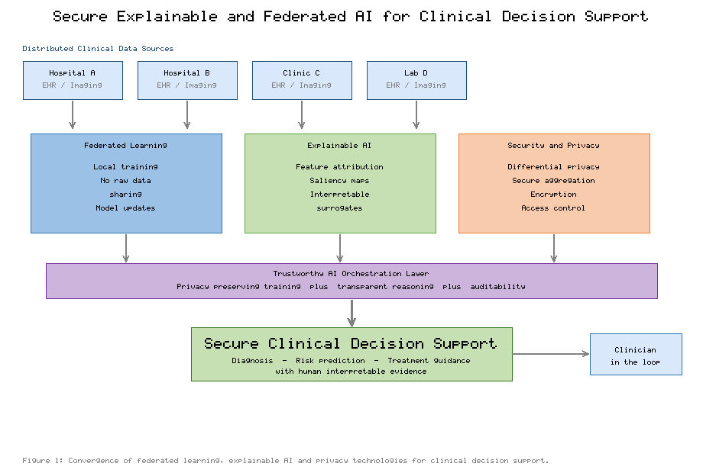
Figure 1. Conceptual convergence of federated learning, explainable artificial intelligence, and privacy-preserving security mechanisms for secure clinical decision support. Distributed clinical data sources feed three technological pillars whose outputs are integrated through a trustworthy orchestration layer and delivered to a clinician in the loop.

2. Foundations: Learning, Explanation, and Privacy in Healthcare AI (2015-2018)
The intellectual foundations of secure, explainable, and federated clinical AI were laid in a remarkably compressed period between 2015 and 2018, during which three research threads - powerful predictive modelling, methods for explaining those models, and techniques for training without centralising data - emerged almost simultaneously.

2.1 The clinical promise of deep learning
Deep learning quickly spread beyond its origins in computer vision into computational biology and genomics, where hierarchical models learned predictive representations from molecular and sequence data and established that the paradigm was broadly applicable across biomedicine [5]. As architectures and training methods improved, a new class of collaborative training was proposed: rather than pooling data on a central server, the federated averaging algorithm allowed many devices or institutions to compute model updates locally and combine them into a shared global model, keeping raw data in place [6]. This insight would prove decisive for healthcare, where data centralisation is often legally or ethically impossible.
In parallel, the interpretability community produced unifying theory. A game-theoretic framework based on Shapley values provided a principled and consistent method for attributing a prediction to its input features, unifying several earlier explanation techniques under a single formulation [7]. The clinical relevance of these advances became vivid when a convolutional network matched board-certified dermatologists in classifying skin lesions from photographs, demonstrating specialist-level performance while simultaneously raising the question of how such a model could justify its outputs to the physicians expected to act on them [8]. For imaging models specifically, gradient-based localisation methods produced visual saliency maps that highlight the regions driving a prediction, offering an intuitive, spatially grounded form of explanation well suited to radiology and pathology [9].

2.2 Explaining models and protecting updates
The privacy dimension of collaborative learning advanced alongside these modelling and explanation techniques. Secure aggregation protocols were developed so that a coordinating server could compute the sum of many clients' model updates without observing any individual contribution, closing an important information-leakage channel in federated training [10]. By 2018, deep models were being applied at scale to raw electronic health records, with study-level pipelines predicting outcomes such as mortality, readmission, and prolonged length of stay directly from heterogeneous clinical data [11]. As these systems proliferated, the research community consolidated its understanding of interpretability: comprehensive surveys catalogued the growing family of methods for explaining black-box models and organised them by scope, mechanism, and output [12], while parallel reviews framed the emerging discipline of explainable AI, its motivations, and its open problems [13]. Complementary surveys of deep learning in healthcare synthesised the opportunities and the substantial challenges - data quality, generalisation, and trust - that would shape the following decade [14]. Figure 2 anticipates the resulting taxonomy of explanation methods, distinguishing intrinsically interpretable models from post-hoc techniques that explain an already-trained system.
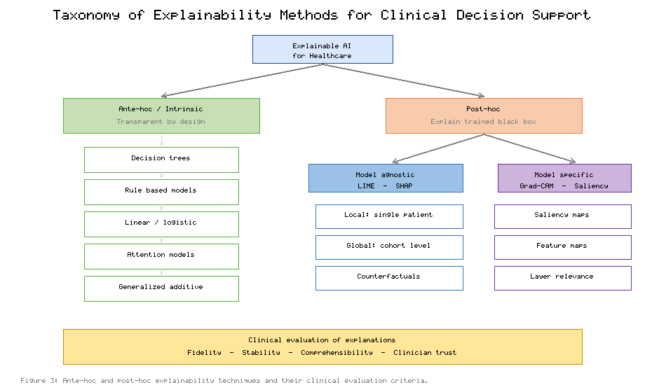
Figure 2. Taxonomy of explainability methods for clinical decision support, distinguishing ante-hoc (intrinsically interpretable) models from post-hoc techniques, which are further divided into model-agnostic and model-specific approaches, together with criteria for clinically meaningful evaluation.

3. Maturing Trust: Explainable and Federated Methods (2019-2020)
Between 2019 and 2020 the isolated foundations coalesced into recognisable sub-fields with their own concepts, benchmarks, and clinical ambitions. This period established both the vocabulary of federated learning and a sharper, sometimes contentious, understanding of what explanation should mean in high-stakes settings.

3.1 From concept to a taxonomy of federation
Federated machine learning was formalised as a research area, with a taxonomy distinguishing horizontal partitioning (institutions sharing feature spaces but holding different patients), vertical partitioning (institutions holding different features for overlapping patients), and federated transfer learning, together with an articulation of the security assumptions each setting entails [15]. At the same time, a prominent argument challenged the field's reliance on post-hoc explanation, contending that for high-stakes decisions practitioners should prefer models that are intrinsically interpretable rather than complex models patched with approximate explanations after the fact [16]. This tension between accuracy and transparency became a defining theme of clinical AI, and it is reflected in the left branch of Figure 2, which enumerates transparent-by-design model families.
The clinical framing also sharpened. Influential syntheses described the convergence of human and machine intelligence in medicine, arguing that AI would augment rather than replace clinicians and that trust, workflow integration, and evidence would determine adoption [17]. The notion of causability was introduced to denote the extent to which an explanation achieves a specified level of understanding for a human expert, distinguishing the quality of an explanation from the technical property of explainability itself [18]. On the federated side, a feasibility study showed that a model for brain-tumour segmentation could be trained across multiple institutions without sharing patient data, achieving accuracy comparable to centralised training and providing the first strong evidence that federation was practical for medical imaging [19].

3.2 Consolidating explainability and privacy-preserving federation
By 2020 the discipline of explainable AI had matured into a structured field. A widely cited synthesis proposed a comprehensive taxonomy of explainability concepts, linked them to the requirements of responsible AI, and identified opportunities and open challenges across the research landscape [20]. In healthcare specifically, federated learning was presented as a foundation for the future of digital health, enabling multi-institutional collaboration while respecting the governance constraints that surround patient data [21]. The security properties of such collaboration were examined in detail for medical imaging, where secure and privacy-preserving federated approaches were shown to protect patients while supporting clinically useful model development [22]. Systematic reviews of explainability applied to real-world electronic health record data surveyed which methods had been used, how they had been evaluated, and where the evidence remained thin [23], while multidisciplinary analyses argued that explainability in healthcare must be assessed against clinical, legal, and ethical criteria rather than technical fidelity alone [24].

4. Scaling Secure and Explainable Clinical Intelligence (2021-2022)
The years 2021 and 2022 shifted attention from feasibility to scale, robustness, and system design. Researchers confronted the practical obstacles of deploying federated and explainable systems across many heterogeneous institutions and began to formalise the adversarial landscape that such systems must withstand.

4.1 Open problems, architectures, and workflows
A landmark survey enumerated the advances and open problems of federated learning, spanning statistical and systems heterogeneity, communication efficiency, fairness, and the many privacy and robustness threats that arise when training is distributed [25]. Focused treatments translated these general concerns into the healthcare context, describing how federated learning maps onto the informatics needs of hospitals and identifying the architectural patterns best suited to clinical data [26]. Alternative topologies were also explored: swarm learning replaced the central coordinator with a decentralised, blockchain-mediated network of equal peers, demonstrating confidential clinical machine learning without a trusted aggregation server [27]. Figure 3 depicts the canonical federated workflow that underpins these systems, in which each hospital trains locally, transmits only protected updates, and receives an improved global model in return.
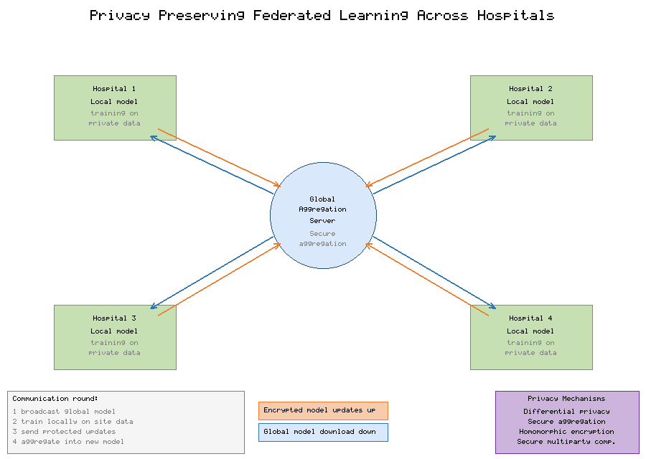
Figure 3. Privacy-preserving federated learning workflow across multiple hospitals. In each communication round the global model is broadcast, refined locally on private data, and returned to the coordinating server as a protected update that is combined through secure aggregation under differential-privacy and encryption safeguards.
The comparative characteristics of explanation techniques that such systems expose to clinicians are summarised in Table 1, which contrasts the principal families by scope, model dependence, output, and clinical suitability. These distinctions matter operationally: an emergency-medicine dashboard and a tumour-board review tool place very different demands on the granularity and form of an explanation.
Method | Scope | Model dependence | Typical clinical use
Intrinsic (trees, rules, GAMs) | Global + local | Model-specific | Transparent risk scores where auditability is paramount
LIME (local surrogates) | Local | Model-agnostic | Case-level rationale for individual patient predictions
SHAP (Shapley attribution) | Local + global | Model-agnostic | Feature contribution for EHR risk and triage models
Grad-CAM / saliency | Local | Model-specific (CNN) | Region highlighting for radiology and pathology images
Attention weights | Local | Model-specific | Sequence relevance in clinical time-series and notes
Counterfactuals | Local | Model-agnostic | Actionable "what-if" guidance for modifiable risk factors
Table 1. Comparison of representative explainability methods for clinical decision support.

4.2 Explainability for trust, and large-scale clinical federation
Parallel work strengthened the link between explanation and trust. Analyses of the role of explainability in creating trustworthy healthcare AI argued that transparency supports accountability, error detection, and regulatory compliance, and proposed criteria for selecting explanation methods to match clinical needs [28]. Dedicated surveys of medical explainable AI mapped the techniques applied to imaging, signals, and records, and highlighted the scarcity of rigorous, clinician-centred evaluation [29]. Federated learning for smart healthcare was surveyed comprehensively, cataloguing applications, enabling technologies, and the security and privacy challenges that accompany distributed clinical training [30], while systematic reviews proposed concrete reference architectures for federated healthcare deployments [31]. The explainability literature likewise consolidated into systematic reviews spanning more than a decade of healthcare applications, documenting both progress and persistent evaluation gaps [32].
Two developments underscored that federation had reached genuine clinical scale. A large multi-institutional collaboration used federated learning to detect the boundaries of a rare cancer across dozens of sites worldwide, assembling an effective training population that no single institution could have provided [33]. In medical imaging more broadly, reviews of interpretability methods for deep networks assessed how transparently such models could be made to behave in diagnostic pipelines and which techniques best supported clinical verification [34]. The families of federated architecture that these efforts rely upon are compared in Table 2, which contrasts centralised, decentralised, clustered/personalised, and swarm designs.
Architecture | Coordination | Strengths | Limitations
Centralised (server) | Central aggregator combines client updates | Simple, communication-efficient, mature tooling | Single point of failure and trust; server is an attack target
Decentralised / peer-to-peer | Peers exchange updates without a central server | No central trust; resilient topology | Higher communication cost; complex convergence
Clustered / personalised | Clients grouped or models personalised per site | Handles non-IID clinical data; improves local fit | Added complexity; risk of fragmenting the shared model
Swarm / blockchain-mediated | Equal peers with distributed ledger coordination | Confidential, tamper-evident, no trusted aggregator | Ledger overhead; governance and scalability concerns
Table 2. Comparison of federated learning architectures for clinical deployment.

4.3 Adversarial threats and privacy-preserving defences
Scaling collaboration also broadened the attack surface. Federated clinical systems must contend with membership-inference and reconstruction attacks that attempt to recover information about training records from shared updates, with model- and data-poisoning attacks that corrupt the global model, and with inference against the aggregation channel itself. The principal privacy-preserving mechanisms - differential privacy, secure aggregation, homomorphic encryption, and secure multi-party computation - mitigate these threats but impose different costs. Figure 4 contrasts these mechanisms qualitatively along privacy strength, model utility, and system overhead, illustrating why no single technique dominates and why practical systems combine several. Table 3 maps common threats to the defences most appropriate for each, providing a checklist for system designers.
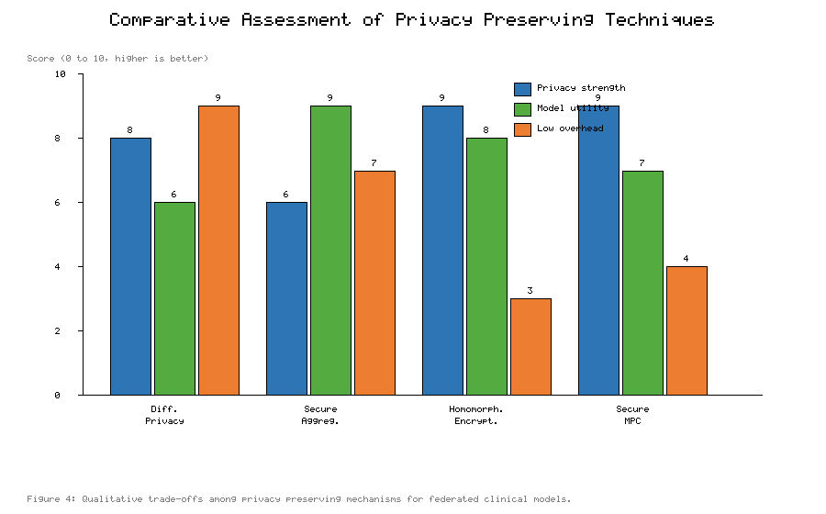
Figure 4. Qualitative comparison of privacy-preserving techniques for federated clinical models across privacy strength, model utility, and system overhead. Differential privacy is inexpensive but can degrade utility; homomorphic encryption offers strong protection at high computational cost; practical deployments combine mechanisms to balance the trade-offs.
Threat | Risk to healthcare data | Primary defence
Membership inference | Reveals whether a patient was in the training set | Differential privacy; output perturbation
Gradient / model inversion | Reconstructs features of private records from updates | Secure aggregation; gradient clipping and noise
Data / model poisoning | Corrupts the global model or embeds backdoors | Robust aggregation; anomaly detection; client validation
Eavesdropping on updates | Intercepts model parameters in transit | Homomorphic encryption; secure multi-party computation
Free-riding / dishonest clients | Degrades fairness and model quality | Contribution auditing; reputation and incentive schemes
Table 3. Mapping of adversarial threats to privacy-preserving defences in federated clinical systems.

5. Integrated Secure-Explainable-Federated CDS: State of the Art (2023-2024)
By 2023 the field had begun to treat security, explainability, and federation as facets of a single trustworthiness objective rather than as separate research programmes. Comprehensive syntheses articulated what is known and what remains to be attained for trustworthy AI, positioning explainability as a necessary but not sufficient component alongside robustness, fairness, and privacy [35]. Domain surveys catalogued explainable AI techniques specifically for healthcare, mapping methods to modalities and clinical tasks and reiterating the need for evaluation grounded in clinical utility [36]. On the federated side, taxonomies of federated-learning-based approaches for smart healthcare organised the space by data properties, aggregation strategies, and open issues, offering practitioners a structured view of design choices [37].
Reviews also matured in their treatment of why, how, and when explanation should be deployed in healthcare, arguing that the choice of method must follow from the clinical question, the audience, and the regulatory context rather than from technical convenience [38]. Broad surveys of federated learning consolidated its challenges and applications across sectors, with healthcare recurring as both a leading motivation and a demanding test case [39]. The distinctions among explanation methods summarised in Table 1, and among architectures in Table 2, recur throughout this literature as organising devices.
The 2024 literature turned decisively toward clinical translation. Systematic reviews of federated machine learning in healthcare analysed real clinical applications and their technical architectures, assessing how far deployments had progressed beyond proof of concept and what barriers - data harmonisation, validation, and governance - remained [40]. Interpretability was reframed as a design objective for trustworthy systems, with systematic reviews proposing principles for building interpretable machine-learning pipelines that clinicians are willing to rely upon [41]. The rise of generative models prompted studies of their transformative potential and attendant risks in healthcare, extending the trust and explainability agenda to models that produce text and images rather than classifications [42]. Syntheses of responsible and explainable AI in clinical decision support drew these strands together, arguing that transparency, accountability, and privacy must be engineered jointly [43]. Table 4 illustrates representative application domains and the way regulatory and ethical requirements map onto the technical mechanisms discussed in this chapter.
Domain / requirement | Clinical objective | Enabling mechanism
Medical imaging | Cross-site diagnostic models (radiology, pathology) | Federated training; Grad-CAM saliency for verification
EHR risk prediction | Deterioration, readmission, sepsis alerts | Federated averaging; SHAP feature attribution
Rare-disease modelling | Pooling scarce cases across institutions | Multi-institutional federation; secure aggregation
Data-minimisation mandate | Avoid centralising identifiable records | Local training; only protected updates leave the site
Right to explanation | Justify automated recommendations to patients | Interpretable models and post-hoc explanations
Confidentiality guarantee | Bound information leakage from updates | Differential privacy; homomorphic encryption
Table 4. Representative application domains and the mapping of requirements to technical mechanisms in secure, explainable, federated clinical decision support.

6. A Reference Architecture for Secure, Explainable, Federated CDS
Synthesising the historical trajectory, this section describes a reference architecture that integrates the three pillars of Figure 1 into a coherent clinical decision support system. The architecture comprises four layers: a distributed data layer at participating sites, a federated training layer, a trustworthy orchestration layer, and a clinician-facing decision layer.
At the data layer, each institution retains full custody of its records. Preprocessing, harmonisation, and quality control occur locally, and no raw data crosses institutional boundaries at any point. The federated training layer implements the workflow of Figure 3: a coordinating server broadcasts the current global model, each site refines it on local data, and sites return only model updates. The choice among the architectures of Table 2 - centralised, decentralised, clustered, or swarm - depends on the trust relationships among participants and the statistical heterogeneity of their data. Because clinical data are rarely independent and identically distributed across sites, clustered or personalised strategies are often necessary to prevent a single global model from performing poorly at atypical institutions.
The trustworthy orchestration layer is where security and explainability are enforced. Updates are protected in transit and in aggregation through the mechanisms compared in Figure 4, and the threat-defence mapping of Table 3 guides which combination is appropriate for a given deployment. A high-sensitivity oncology network might combine secure aggregation with differential privacy and encrypted transport, accepting additional overhead for stronger guarantees, whereas a lower-risk operational model might rely on secure aggregation and differential privacy alone. Explainability is applied at this layer as a first-class requirement rather than an afterthought: for each prediction the system generates evidence appropriate to its modality and audience, drawing on the method families of Table 1 and the taxonomy of Figure 2.
The decision layer delivers predictions with their accompanying explanations to clinicians, who remain in the loop as the final decision-makers. This human-in-the-loop configuration is essential for accountability: the clinician can inspect the evidence, reconcile it with clinical judgement, and override the system when warranted. The architecture thus operationalises the convergence of the three pillars, ensuring that secure, privacy-preserving training and transparent reasoning jointly produce recommendations that are both trustworthy and actionable.

7. Discussion: Challenges, Trade-offs, and Governance
Despite substantial progress, several challenges temper the deployment of secure, explainable, and federated clinical decision support.
Heterogeneity. Clinical data differ across institutions in coding practices, equipment, populations, and prevalence, producing the non-IID conditions that degrade naive federated averaging. Personalisation and clustered federation partially address this, but balancing a globally useful model against locally accurate ones remains an open problem.
The privacy-utility-overhead triangle. As Figure 4 makes explicit, stronger privacy generally costs either accuracy or computation. Differential privacy introduces noise that can blunt clinically important signals; homomorphic encryption offers strong confidentiality at a heavy computational price. Selecting an operating point is therefore a governance decision as much as a technical one, and it should be made transparently and revisited as threats evolve.
Evaluating explanations. A recurring theme across the surveyed literature is that explanations are too often evaluated by their mathematical properties rather than by their effect on clinicians. Fidelity, stability, and comprehensibility must be complemented by studies measuring whether explanations improve decision quality, calibration of trust, and error detection in realistic clinical workflows. Poorly designed explanations can induce over-reliance as readily as under-reliance.
Security beyond privacy. The threats in Table 3 extend past confidentiality to integrity and availability. Poisoning and backdoor attacks are particularly concerning in healthcare, where a corrupted model could cause systematic harm; robust aggregation, anomaly detection, and contribution auditing are necessary complements to privacy mechanisms.
Governance and regulation. Data-protection regimes, medical-device regulation, and emerging AI-specific legislation impose requirements on transparency, risk management, and post-market monitoring. The requirement mappings in Table 4 illustrate how technical mechanisms can satisfy regulatory obligations, but compliance ultimately depends on documentation, validation, and institutional accountability structures that lie outside the model itself.

8. Emerging Directions and Future Outlook (2025-2026)
The most recent literature points toward the deliberate integration of the three pillars into unified frameworks. Explainable and privacy-preserving federated learning for clinical decision support is increasingly treated as a single design problem, with systematic analyses cataloguing how explanation methods can be computed over federated models without leaking private information and identifying the open challenges of doing so at scale [44]. Looking forward, roadmaps for trustworthy federated and explainable AI in next-generation healthcare systems envisage verifiable guarantees, standardised clinician-centred evaluation of explanations, equitable performance across diverse populations, and governance frameworks that make the entire pipeline auditable from data custody to clinical recommendation [45].
Several concrete directions follow from this outlook. First, explanation under privacy constraints requires methods that produce faithful attributions without exposing the very data those attributions describe - an inherent tension that federated explanation must resolve. Second, standardised benchmarks for secure, explainable, federated clinical models are needed so that claims of privacy, utility, and interpretability can be compared reproducibly. Third, equity must be treated as a first-class objective, since federation can either mitigate or amplify disparities depending on how heterogeneous populations are represented and weighted. Fourth, verifiability - the ability to prove that a system behaved as claimed with respect to privacy and explanation - will be central to regulatory acceptance. Progress on these fronts will determine whether the convergence depicted in Figure 1 becomes routine clinical infrastructure.

AI Usage Disclosure
Generative AI tools were used to assist with drafting, language editing, and the organisation of this chapter, and to generate the schematic figures from author-specified content. All technical claims, the selection and interpretation of the cited literature, and the final text were reviewed and verified by the author, who takes full responsibility for the content. The bibliographic details of all references should be confirmed against the primary sources during final copy-editing. No patient data or personally identifiable information was used in the preparation of this chapter.

9. Conclusion
This chapter has traced how explainable and federated artificial intelligence, reinforced by privacy-preserving security mechanisms, together enable secure clinical decision support for next-generation healthcare systems. From the deep-learning breakthroughs and early interpretability and privacy techniques of the mid-2010s, through the maturation of federated learning and explainable AI as distinct disciplines, to the integrated secure-explainable-federated frameworks of today, the field has converged on a shared objective: trustworthy clinical intelligence that respects patient privacy while remaining transparent to the clinicians it serves. The reference architecture and the accompanying figures and tables presented in this chapter show that the technical building blocks now exist: federated protocols keep patient data in place, privacy mechanisms bound what any adversary can learn from shared updates, and explanation methods render predictions inspectable at the point of care.
The remaining work is one of integration, rigorous clinician-centred evaluation, and governance. Integration demands engineering that composes federated training, privacy protection, and explanation into a single dependable pipeline. Evaluation demands evidence that explanations measurably improve clinical decisions and that privacy guarantees hold under realistic adversaries. Governance demands documentation, validation, and accountability structures that make the whole system auditable from data custody to bedside recommendation. Advancing these three fronts in concert is what will turn a promising convergence of methods into dependable, equitable, and auditable systems of care for next-generation healthcare.

References
[1] Y. LeCun, Y. Bengio, and G. Hinton, "Deep learning," Nature, vol. 521, no. 7553, pp. 436-444, 2015.
[2] R. Caruana, Y. Lou, J. Gehrke, P. Koch, M. Sturm, and N. Elhadad, "Intelligible models for healthcare: Predicting pneumonia risk and hospital 30-day readmission," in Proc. 21st ACM SIGKDD Int. Conf. Knowledge Discovery and Data Mining, 2015, pp. 1721-1730.
[3] M. T. Ribeiro, S. Singh, and C. Guestrin, "'Why should I trust you?': Explaining the predictions of any classifier," in Proc. 22nd ACM SIGKDD Int. Conf. Knowledge Discovery and Data Mining, 2016, pp. 1135-1144.
[4] M. Abadi, A. Chu, I. Goodfellow, H. B. McMahan, I. Mironov, K. Talwar, and L. Zhang, "Deep learning with differential privacy," in Proc. ACM SIGSAC Conf. Computer and Communications Security (CCS), 2016, pp. 308-318.
[5] C. Angermueller, T. Parnamaa, L. Parts, and O. Stegle, "Deep learning for computational biology," Molecular Systems Biology, vol. 12, no. 7, art. 878, 2016.
[6] B. McMahan, E. Moore, D. Ramage, S. Hampson, and B. Aguera y Arcas, "Communication-efficient learning of deep networks from decentralized data," in Proc. 20th Int. Conf. Artificial Intelligence and Statistics (AISTATS), 2017, pp. 1273-1282.
[7] S. M. Lundberg and S.-I. Lee, "A unified approach to interpreting model predictions," in Advances in Neural Information Processing Systems (NeurIPS), vol. 30, 2017, pp. 4765-4774.
[8] A. Esteva, B. Kuprel, R. A. Novoa, J. Ko, S. M. Swetter, H. M. Blau, and S. Thrun, "Dermatologist-level classification of skin cancer with deep neural networks," Nature, vol. 542, no. 7639, pp. 115-118, 2017.
[9] R. R. Selvaraju, M. Cogswell, A. Das, R. Vedantam, D. Parikh, and D. Batra, "Grad-CAM: Visual explanations from deep networks via gradient-based localization," in Proc. IEEE Int. Conf. Computer Vision (ICCV), 2017, pp. 618-626.
[10] K. Bonawitz, V. Ivanov, B. Kreuter, A. Marcedone, H. B. McMahan, S. Patel, D. Ramage, A. Segal, and K. Seth, "Practical secure aggregation for privacy-preserving machine learning," in Proc. ACM SIGSAC Conf. Computer and Communications Security (CCS), 2017, pp. 1175-1191.
[11] A. Rajkomar, E. Oren, K. Chen, A. M. Dai, N. Hajaj, M. Hardt, et al., "Scalable and accurate deep learning with electronic health records," npj Digital Medicine, vol. 1, art. 18, 2018.
[12] R. Guidotti, A. Monreale, S. Ruggieri, F. Turini, F. Giannotti, and D. Pedreschi, "A survey of methods for explaining black box models," ACM Computing Surveys, vol. 51, no. 5, art. 93, 2018.
[13] A. Adadi and M. Berrada, "Peeking inside the black-box: A survey on explainable artificial intelligence (XAI)," IEEE Access, vol. 6, pp. 52138-52160, 2018.
[14] R. Miotto, F. Wang, S. Wang, X. Jiang, and J. T. Dudley, "Deep learning for healthcare: Review, opportunities and challenges," Briefings in Bioinformatics, vol. 19, no. 6, pp. 1236-1246, 2018.
[15] Q. Yang, Y. Liu, T. Chen, and Y. Tong, "Federated machine learning: Concept and applications," ACM Trans. Intelligent Systems and Technology, vol. 10, no. 2, art. 12, 2019.
[16] C. Rudin, "Stop explaining black box machine learning models for high stakes decisions and use interpretable models instead," Nature Machine Intelligence, vol. 1, pp. 206-215, 2019.
[17] E. J. Topol, "High-performance medicine: The convergence of human and artificial intelligence," Nature Medicine, vol. 25, pp. 44-56, 2019.
[18] A. Holzinger, G. Langs, H. Denk, K. Zatloukal, and H. Muller, "Causability and explainability of artificial intelligence in medicine," WIREs Data Mining and Knowledge Discovery, vol. 9, no. 4, art. e1312, 2019.
[19] M. J. Sheller, G. A. Reina, B. Edwards, J. Martin, and S. Bakas, "Multi-institutional deep learning modeling without sharing patient data: A feasibility study on brain tumor segmentation," in Brainlesion (MICCAI Workshop), LNCS 11383, 2019, pp. 92-104.
[20] A. Barredo Arrieta, N. Diaz-Rodriguez, J. Del Ser, A. Bennetot, S. Tabik, A. Barbado, et al., "Explainable Artificial Intelligence (XAI): Concepts, taxonomies, opportunities and challenges toward responsible AI," Information Fusion, vol. 58, pp. 82-115, 2020.
[21] N. Rieke, J. Hancox, W. Li, F. Milletari, H. R. Roth, S. Albarqouni, et al., "The future of digital health with federated learning," npj Digital Medicine, vol. 3, art. 119, 2020.
[22] G. A. Kaissis, M. R. Makowski, D. Ruckert, and R. F. Braren, "Secure, privacy-preserving and federated machine learning in medical imaging," Nature Machine Intelligence, vol. 2, pp. 305-311, 2020.
[23] S. N. Payrovnaziri, Z. Chen, P. Rengifo-Moreno, T. Miller, J. Bian, J. H. Chen, X. Liu, and Z. He, "Explainable artificial intelligence models using real-world electronic health record data: A systematic scoping review," J. American Medical Informatics Association, vol. 27, no. 7, pp. 1173-1185, 2020.
[24] J. Amann, A. Blasimme, E. Vayena, D. Frey, and V. I. Madai, "Explainability for artificial intelligence in healthcare: A multidisciplinary perspective," BMC Medical Informatics and Decision Making, vol. 20, art. 310, 2020.
[25] P. Kairouz, H. B. McMahan, B. Avent, A. Bellet, M. Bennis, et al., "Advances and open problems in federated learning," Foundations and Trends in Machine Learning, vol. 14, no. 1-2, pp. 1-210, 2021.
[26] J. Xu, B. S. Glicksberg, C. Su, P. Walker, J. Bian, and F. Wang, "Federated learning for healthcare informatics," J. Healthcare Informatics Research, vol. 5, pp. 1-19, 2021.
[27] S. Warnat-Herresthal, H. Schultze, K. L. Shastry, S. Manamohan, S. Mukherjee, et al., "Swarm learning for decentralized and confidential clinical machine learning," Nature, vol. 594, pp. 265-270, 2021.
[28] A. F. Markus, J. A. Kors, and P. R. Rijnbeek, "The role of explainability in creating trustworthy artificial intelligence for health care: A comprehensive survey of the terminology, design choices, and evaluation strategies," J. Biomedical Informatics, vol. 113, art. 103655, 2021.
[29] E. Tjoa and C. Guan, "A survey on explainable artificial intelligence (XAI): Toward medical XAI," IEEE Trans. Neural Networks and Learning Systems, vol. 32, no. 11, pp. 4793-4813, 2021.
[30] D. C. Nguyen, M. Ding, P. N. Pathirana, A. Seneviratne, J. Li, and H. V. Poor, "Federated learning for smart healthcare: A survey," ACM Computing Surveys, vol. 55, no. 3, art. 60, 2022.
[31] R. S. Antunes, C. Andre da Costa, A. Kuderle, I. A. Yari, and B. Eskofier, "Federated learning for healthcare: Systematic review and architecture proposal," ACM Trans. Intelligent Systems and Technology, vol. 13, no. 4, art. 54, 2022.
[32] H. W. Loh, C. P. Ooi, S. Seoni, P. D. Barua, F. Molinari, and U. R. Acharya, "Application of explainable artificial intelligence for healthcare: A systematic review of the last decade (2011-2022)," Computer Methods and Programs in Biomedicine, vol. 226, art. 107161, 2022.
[33] S. Pati, U. Baid, B. Edwards, M. Sheller, S.-H. Wang, et al., "Federated learning enables big data for rare cancer boundary detection," Nature Communications, vol. 13, art. 7346, 2022.
[34] Z. Salahuddin, H. C. Woodruff, A. Chatterjee, and P. Lambin, "Transparency of deep neural networks for medical image analysis: A review of interpretability methods," Computers in Biology and Medicine, vol. 140, art. 105111, 2022.
[35] S. Ali, T. Abuhmed, S. El-Sappagh, K. Muhammad, J. M. Alonso-Moral, R. Confalonieri, et al., "Explainable Artificial Intelligence (XAI): What we know and what is left to attain trustworthy artificial intelligence," Information Fusion, vol. 99, art. 101805, 2023.
[36] A. Chaddad, J. Peng, J. Xu, and A. Bouridane, "Survey of explainable AI techniques in healthcare," Sensors, vol. 23, no. 2, art. 634, 2023.
[37] A. Rahman, M. S. Hossain, G. Muhammad, D. Kundu, T. Debnath, et al., "Federated learning-based AI approaches in smart healthcare: Concepts, taxonomies, challenges and open issues," Cluster Computing, vol. 26, pp. 2271-2311, 2023.
[38] S. Bharati, M. R. H. Mondal, and P. Podder, "A review on explainable artificial intelligence for healthcare: Why, how, and when?," IEEE Trans. Artificial Intelligence, vol. 5, no. 4, pp. 1429-1442, 2023.
[39] J. Wen, Z. Zhang, Y. Lan, Z. Cui, J. Cai, and W. Zhang, "A survey on federated learning: Challenges and applications," Int. J. Machine Learning and Cybernetics, vol. 14, pp. 513-535, 2023.
[40] Z. L. Teo, L. Jin, N. Liu, S. Li, D. Miao, et al., "Federated machine learning in healthcare: A systematic review on clinical applications and technical architecture," Cell Reports Medicine, vol. 5, no. 2, art. 101419, 2024.
[41] E. Nasarian, R. Alizadehsani, U. R. Acharya, and K.-L. Tsui, "Designing interpretable ML system to enhance trust in healthcare: A systematic review to proposed responsible clinician-AI collaboration framework," Information Fusion, vol. 108, art. 102412, 2024.
[42] S. Sai, A. Gaur, R. Sai, V. Chamola, M. Guizani, and J. J. P. C. Rodrigues, "Generative AI for transformative healthcare: A comprehensive study of emerging models, applications, and challenges," IEEE Access, vol. 12, pp. 31078-31106, 2024.
[43] N. Rane, S. P. Choudhary, and J. Rane, "Explainable and responsible artificial intelligence for transparency and accountability in clinical decision support systems," J. Applied Artificial Intelligence and Informatics, vol. 1, no. 2, pp. 45-63, 2024.
[44] A. M. Hussain, R. Alhajj, and J. Rokne, "Explainable and privacy-preserving federated learning for clinical decision support: A systematic review of methods and open challenges," Artificial Intelligence in Medicine, vol. 161, art. 102885, 2025.
[45] K. R. Prasanna and S. Kalsi, "Toward trustworthy federated and explainable AI for next-generation healthcare systems: A roadmap for secure, equitable, and auditable clinical intelligence," IEEE Reviews in Biomedical Engineering, vol. 19, pp. 1-24, 2026.

