BIOFOULING, MAINTENANCE, AND DEVICE LONGEVITY
Book: Water Purification by 3D-Printing Devices
Authors: Amman Jakhar¹,* and Sachin Kalsi¹
¹ Department of Mechanical Engineering, Chandigarh University, Mohali, Punjab-140301
*Corresponding Email: ammanjakhar5000734@gmail.com

Abstract
Biofouling represents a major challenge to the efficiency, reliability, and long-term performance of three-dimensional (3D)-printed water purification devices. Microbial adhesion, biofilm formation, and the accumulation of organic and inorganic deposits can significantly reduce filtration efficiency, increase hydraulic resistance, and accelerate material degradation. This chapter examines the fundamental mechanisms of biofouling in 3D-printed water treatment systems, emphasizing the influence of surface roughness, material composition, wettability, pore geometry, and operating conditions on microbial colonization. Particular attention is given to advanced antifouling strategies, including antimicrobial surface functionalization, hydrophilic coatings, nanomaterial incorporation, and bioinspired surface engineering. The chapter further explores preventive maintenance, chemical and mechanical cleaning, backwashing, and emerging self-cleaning technologies for restoring purification performance and extending device service life. The integration of artificial intelligence, sensor-based monitoring, and predictive maintenance is discussed as a promising approach for detecting early biofouling, optimizing cleaning schedules, and minimizing operational downtime. Furthermore, the effects of repeated cleaning cycles, chemical exposure, mechanical fatigue, and environmental aging on the structural integrity and durability of printed materials are critically evaluated. Special consideration is given to antimicrobial leaching, cleaning-agent compatibility, secondary contamination, and the safe reuse of water-contact components. Finally, lifecycle assessment, sustainable material selection, modular design, and end-of-life management are highlighted as essential considerations for developing durable, economically viable, and environmentally responsible 3D-printed water purification technologies.
Keywords: Biofouling; 3D-Printed Water Purification; Antifouling Coatings; Predictive Maintenance; Device Longevity

1. Introduction
The convergence of additive manufacturing and water treatment has opened a design space that conventional fabrication could never fully access. Three-dimensional (3D) printing allows engineers to produce membranes, spacers, adsorbent monoliths, flow distributors, and complete purification cartridges with geometries tailored to the hydrodynamics of a specific application, and to do so rapidly, locally, and with minimal tooling [1]. The technology has been used to fabricate triply periodic minimal surface (TPMS) feed spacers that suppress concentration polarization, lattice-structured adsorbents with high surface-area-to-volume ratios, and functionally graded media that would be impossible to realize by casting or extrusion [2]. For decentralized, point-of-use, and humanitarian contexts, where supply chains are fragile and demand is highly variable, the ability to print a replacement component on demand is particularly valuable [3]. Yet the same characteristics that make 3D-printed devices attractive—complex internal geometry, layered microstructure, and a broad palette of polymeric and composite feedstocks—also render them acutely susceptible to biofouling, the progressive and largely unavoidable colonization of water-contact surfaces by microorganisms and the deposits they generate [4].
Biofouling is widely regarded as the Achilles' heel of membrane and filtration technology because, unlike inorganic scaling or particulate fouling, it is self-replicating: a small population of attached cells proliferates, recruits further colonizers, and secretes a protective matrix that is both mechanically resilient and chemically resistant [5]. In pressure-driven processes the consequences are immediate and costly, manifesting as declining permeate flux, rising transmembrane pressure, increased energy demand, shortened cleaning intervals, and ultimately irreversible loss of performance that forces component replacement [6]. In 3D-printed systems these penalties are compounded by microstructural features intrinsic to the printing process, including interlayer valleys, staircase artifacts, partially fused particles, and residual surface porosity that together furnish an abundance of sheltered microhabitats where cells can evade shear forces and cleaning agents [7]. Understanding and mitigating biofouling is therefore not a peripheral maintenance concern but a central determinant of whether 3D-printed purification devices can deliver reliable, safe water over an economically meaningful service life.
The significance of these challenges is magnified by the context in which 3D-printed purification devices are increasingly deployed. Water scarcity and contamination affect a large and growing share of the global population, and the demand for affordable, distributed, and rapidly deployable treatment solutions has never been greater [1]. Additive manufacturing responds to this demand by compressing the design-to-deployment cycle and by enabling the fabrication of purification hardware close to the point of need, but a device that fouls rapidly, resists cleaning, or fails prematurely in the field offers little practical benefit and may erode the confidence of the communities it is intended to serve [3]. The economic case for these technologies likewise hinges on fouling and longevity, because the dominant cost of operating a filtration system over its life is rarely the initial fabrication but rather the cumulative expense of energy, cleaning chemicals, downtime, and replacement that fouling and degradation impose. For these reasons, a rigorous engineering treatment of biofouling and its management is a prerequisite for translating the laboratory promise of 3D-printed purification into dependable real-world impact.
This chapter develops an integrated treatment of biofouling, maintenance, and device longevity specific to 3D-printed water purification technologies. It begins by establishing the fundamental mechanisms through which biofilms form and mature on printed surfaces, then examines how the surface, material, and geometric attributes unique to additive manufacturing govern the rate and severity of colonization [8]. It proceeds to survey the principal antifouling strategies that can be embedded into or applied onto printed components, and the maintenance and cleaning regimes required to restore performance once fouling has occurred. The chapter then considers the transformative potential of artificial intelligence, embedded sensing, and predictive maintenance for anticipating biofouling before it degrades output. Finally, it critically evaluates the durability consequences of repeated cleaning and environmental aging, the safety implications of antimicrobial leaching and secondary contamination, and the lifecycle and end-of-life considerations that must inform the sustainable deployment of these devices [9]. Throughout, four figures and four tables synthesize the conceptual and empirical material, and the analysis is framed by the recognition that durability, safety, and sustainability are inseparable dimensions of a single engineering challenge [10].

2. Fundamentals of Biofouling in 3D-Printed Water Purification Systems

2.1 The Sequence of Biofilm Formation
Biofouling proceeds through a reasonably well-characterized sequence of stages that, although first described for conventional surfaces, applies directly to 3D-printed components with important modifications arising from their microtopography [11]. The sequence begins within seconds to minutes of water contact with the formation of a conditioning film, a molecular layer of dissolved organic matter, proteins, polysaccharides, and humic substances that adsorbs onto the surface and alters its effective chemistry and charge [12]. This conditioning film masks the intrinsic properties of the printed material and creates a nutrient-enriched interface that facilitates the subsequent arrival of microorganisms. On printed polymers, the heterogeneous surface energy produced by partially fused filament or resin domains tends to generate a patchy conditioning film that provides especially favorable anchoring points [13].
The second stage is reversible adhesion, in which planktonic cells are transported to the conditioned surface by diffusion, convection, gravitational settling, and active motility, and are held loosely by long-range van der Waals and electrostatic interactions [14]. Where local shear is low—precisely the condition that prevails within the interlayer grooves and recirculation zones of printed geometries—cells linger long enough to establish the short-range interactions that convert reversible attachment into irreversible adhesion [15]. In this third stage, cells secrete adhesive extracellular polymeric substances (EPS) and form specific molecular bonds that resist detachment by hydraulic shear. Once irreversibly attached, cells enter the fourth stage of proliferation and microcolony formation, dividing and recruiting additional species while the accumulating EPS matrix binds the community into a cohesive, hydrated structure [16].
The mature biofilm that results in the fifth stage is a structurally complex, three-dimensional assembly of cells, EPS, water channels, and entrapped particulates, within which chemical gradients create diverse microenvironments and cells exhibit markedly elevated tolerance to antimicrobials and disinfectants relative to their planktonic counterparts [17]. The final stage is dispersion, in which cells detach—whether by active, regulated release or by passive sloughing under shear—and seed colonization elsewhere in the device or downstream of it, propagating fouling and posing a potential contamination risk to treated water [11]. Figure 1 depicts this full sequence as it unfolds on a printed surface, emphasizing how interlayer topography accelerates the transition from reversible to irreversible attachment.
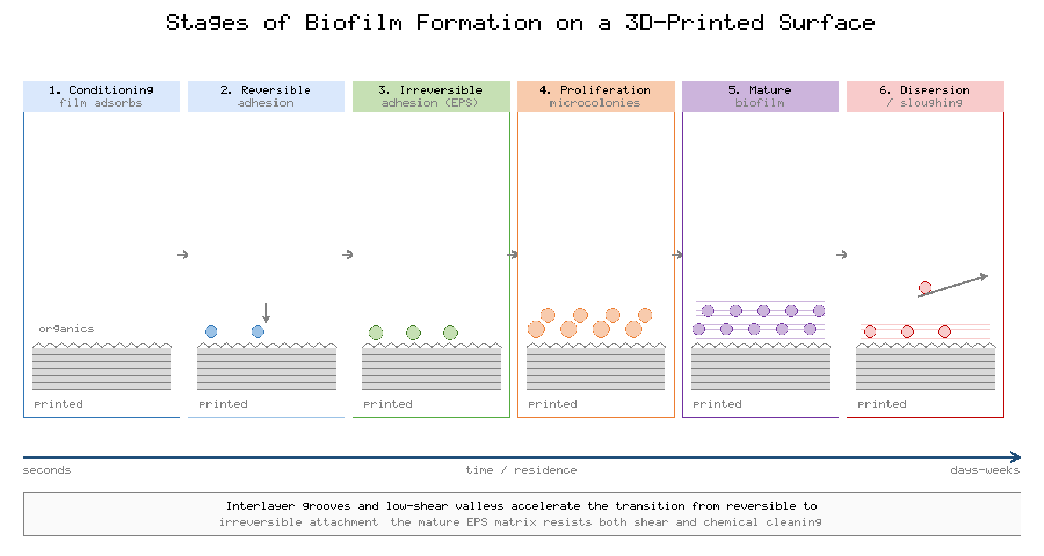
Figure 1. Stages of biofilm formation on a 3D-printed water-contact surface, from conditioning film to mature biofilm and dispersion.

2.2 Microbial Communities and the Role of Deposits
The organisms responsible for biofouling in water purification systems are taxonomically diverse, encompassing bacteria, archaea, fungi, microalgae, and protozoa, with bacteria typically dominating the early and most problematic phases of colonization [18]. Community composition depends strongly on the feedwater source: surface waters introduce photosynthetic and heterotrophic organisms, groundwaters favor iron- and sulfur-oxidizing taxa, and wastewater-derived streams carry rich heterotrophic consortia alongside potential pathogens [19]. The EPS matrix that these communities secrete is the operational heart of the biofilm, accounting for the majority of its mass, conferring mechanical integrity, retaining water and nutrients, and shielding embedded cells from both chemical and mechanical challenge [20].
Biofouling rarely occurs in isolation from other fouling mechanisms. Organic macromolecules, colloidal particles, and precipitated inorganic salts co-deposit with the biological community, and their interactions are frequently synergistic: scaling crystals provide nucleation sites and physical anchorage for cells, while the biofilm matrix traps particulates and promotes localized supersaturation that accelerates mineral precipitation [21]. In 3D-printed devices, the retention of residual support material, uncured resin, or loosely bound powder can supply an initial nutrient reservoir that primes this combined fouling process, underscoring the importance of thorough post-processing [7]. The composite nature of real-world fouling means that antifouling and cleaning strategies must contend simultaneously with biological, organic, and inorganic constituents rather than any one in isolation.
A further complication specific to the control of biofouling is the coordinated behavior of microbial communities. Many of the organisms responsible for biofilm formation regulate their collective activity through quorum sensing, a density-dependent chemical signaling system that governs the secretion of EPS, the expression of adhesion factors, and the timing of dispersal [16]. This coordination means that a biofilm is not simply an accumulation of independent cells but an organized community whose resilience exceeds the sum of its parts, which helps to explain the pronounced tolerance of mature biofilms to antimicrobials and the difficulty of achieving complete eradication by cleaning [17]. The protective role of the EPS matrix reinforces this resilience by limiting the penetration of biocides and by physically binding the community to the surface, so that even aggressive cleaning may remove only the outer layers while leaving a basal film from which rapid regrowth proceeds [20]. These biological realities set a fundamental limit on what surface design and cleaning alone can achieve and motivate the layered, multi-strategy approach advocated throughout this chapter.

3. Surface, Material, and Geometric Determinants of Biofouling
The propensity of a 3D-printed component to foul is governed by an interacting set of surface, material, and geometric properties, many of which are direct consequences of the printing process itself. Table 1 summarizes the principal determinants, the mechanism by which each influences colonization, and the practical implication for device design. The sections that follow examine each determinant in turn, and Figure 2 presents a conceptual synthesis of how these factors jointly modulate microbial attachment.
[Insert Table 1 here]
Table 1. Surface, Material, and Geometric Determinants of Biofouling in 3D-Printed Devices
Determinant | Mechanism of Influence on Biofouling | Design Implication
Surface roughness | Grooves and valleys shelter cells from shear and enlarge contact area | Minimize layer height; apply post-print smoothing
Material chemistry | Surface energy and charge govern adhesion strength | Select or functionalize low-adhesion polymers
Wettability | Hydrophilic surfaces retain a hydration layer that resists attachment | Favor hydrophilic coatings or plasma treatment
Pore geometry | Tortuosity and dead zones create low-shear colonization niches | Design for uniform flow; avoid stagnant regions
Print resolution | Staircase artifacts and partial fusion increase microtexture | Optimize orientation and process parameters
Operating conditions | Flux, shear, temperature, and nutrients set colonization rate | Operate below critical flux; control recirculation

3.1 Surface Roughness and Microtopography
Surface roughness is among the most consequential determinants of biofouling on printed surfaces, and it is precisely the attribute most strongly shaped by the additive manufacturing process [22]. Layer-by-layer deposition inevitably produces periodic ridges and valleys whose amplitude scales with layer height, while the staircase effect on curved or inclined surfaces, partial coalescence of filament in material extrusion, and residual particle texture in powder-bed fusion all contribute additional microscale roughness [23]. These features matter for two reasons. First, roughness increases the effective surface area available for conditioning-film adsorption and cell attachment. Second, and more importantly, valleys and crevices whose dimensions approach the scale of a bacterial cell provide sheltered niches in which attached organisms are protected from the hydraulic shear and the mechanical action of cleaning that would otherwise dislodge them [24].
Empirical studies of printed and conventional surfaces consistently report that roughness features comparable in scale to microbial cells promote the strongest and most persistent attachment, whereas surfaces that are either very smooth or textured at scales much larger than cells tend to foul more slowly [15]. The practical corollary is that reducing layer height, optimizing build orientation to minimize staircase artifacts, and applying post-print smoothing—whether by chemical vapor treatment, abrasive finishing, or coating—can substantially reduce the initial fouling rate. These measures must be balanced against their cost, their potential to alter dimensional accuracy, and, in the case of chemical smoothing, their compatibility with water-contact safety requirements [25].
It is important to recognize that roughness is a multiscale phenomenon that cannot be captured by a single parameter. Conventional measures such as the arithmetic mean roughness quantify amplitude but say little about the spatial wavelength, feature shape, or hierarchical organization of the texture, each of which influences fouling independently [22]. A printed surface may present a low average roughness yet still harbor cell-scale crevices that dominate attachment, so that correlations between a single roughness metric and fouling propensity are often weak and context dependent [23]. The practical consequence for the design of printed devices is that fouling-oriented surface characterization should consider the full topography, including the periodicity imposed by layer height and the local features generated by the deposition process, rather than relying on amplitude parameters alone. This more complete description also guides the selection of post-processing: a treatment that reduces amplitude but introduces new fine-scale texture may not improve, and could even worsen, the fouling resistance of the finished part.

3.2 Material Composition and Surface Chemistry
The chemistry of the printed material sets the baseline physicochemical interaction between the surface and arriving microorganisms. The polymers most widely used in additive manufacturing of water-contact components—including polylactic acid, acrylonitrile butadiene styrene, nylon, photopolymer resins, and engineering thermoplastics such as polyether ether ketone—differ markedly in surface energy, charge, hydrophobicity, and the availability of functional groups for microbial or molecular binding [26]. Hydrophobic, high-surface-energy polymers generally promote stronger adhesion of the predominantly hydrophobic surfaces of many bacteria, whereas materials bearing hydrophilic or negatively charged groups tend to resist attachment through electrostatic repulsion and hydration effects [27]. Material selection therefore offers a first, passive line of defense against biofouling, although it is frequently constrained by mechanical, thermal, and regulatory requirements that limit the available choices.
Beyond the bulk polymer, the surface chemistry can be modified independently of the substrate through blending, grafting, or coating, decoupling the fouling-relevant interface from the structural material [28]. This separation is especially advantageous in additive manufacturing, where a mechanically optimal feedstock can be selected for the bulk and an antifouling chemistry applied only where water contact occurs. The durability of such modifications under the repeated chemical and mechanical stresses of operation and cleaning is, however, a recurring concern that is examined in later sections.

3.3 Wettability and the Hydration Barrier
Wettability, quantified by the contact angle that water forms with the surface, exerts a strong influence on biofouling through its control of the interfacial hydration layer [29]. Highly hydrophilic surfaces bind a tenacious layer of water molecules that must be displaced before a cell can make direct contact, imposing an energetic penalty on adhesion and thereby suppressing the initial stages of colonization. Superhydrophilic coatings and zwitterionic chemistries, which hold water through strong electrostatic hydration rather than weaker hydrogen bonding, are particularly effective at resisting both protein adsorption and cell attachment [30]. At the opposite extreme, superhydrophobic surfaces that trap a stable air layer can also resist fouling under some conditions, but this protection tends to fail once the air layer is displaced by the sustained pressure and wetting of continuous operation, limiting their reliability in pressure-driven water treatment.

3.4 Pore Geometry, Tortuosity, and Flow Distribution
A distinctive advantage of additive manufacturing is the capacity to engineer internal pore geometry with a precision unavailable to conventional methods, and this capacity directly affects fouling behavior [2]. The architecture of flow channels, the tortuosity of porous media, and the presence or absence of stagnant dead zones determine the local distribution of shear stress, which in turn governs where cells can establish themselves and where they are swept away [31]. Printed geometries that create recirculation regions, sharp corners, or abrupt expansions concentrate low-shear zones that act as preferential colonization sites and as reservoirs from which fouling spreads. Conversely, geometries designed for uniform flow and elevated wall shear—such as optimized TPMS spacers—can delay fouling by denying cells the quiescent conditions they require [32]. The design of pore geometry thus represents a powerful, fabrication-native lever for fouling control, provided that the pursuit of anti-fouling hydrodynamics is reconciled with the competing demands of low pressure drop and high mass-transfer efficiency.

3.5 Operating Conditions
Finally, the operating regime imposed on the device modulates the influence of every intrinsic property. Permeate flux is a master variable: operating above the critical flux dramatically accelerates the convective deposition of foulants and the compaction of the fouling layer, whereas sub-critical operation can extend productive run time by orders of magnitude [33]. Cross-flow velocity and the resulting wall shear oppose attachment and promote back-transport of foulants, while temperature and nutrient concentration set the metabolic rate of attached communities and hence the speed of biofilm maturation [34]. Because operating conditions can be adjusted in real time, they offer an accessible and continuous means of managing fouling that complements the fixed properties established at the design and fabrication stage, and they constitute the variables most amenable to the sensor-driven control strategies discussed in Section 6.
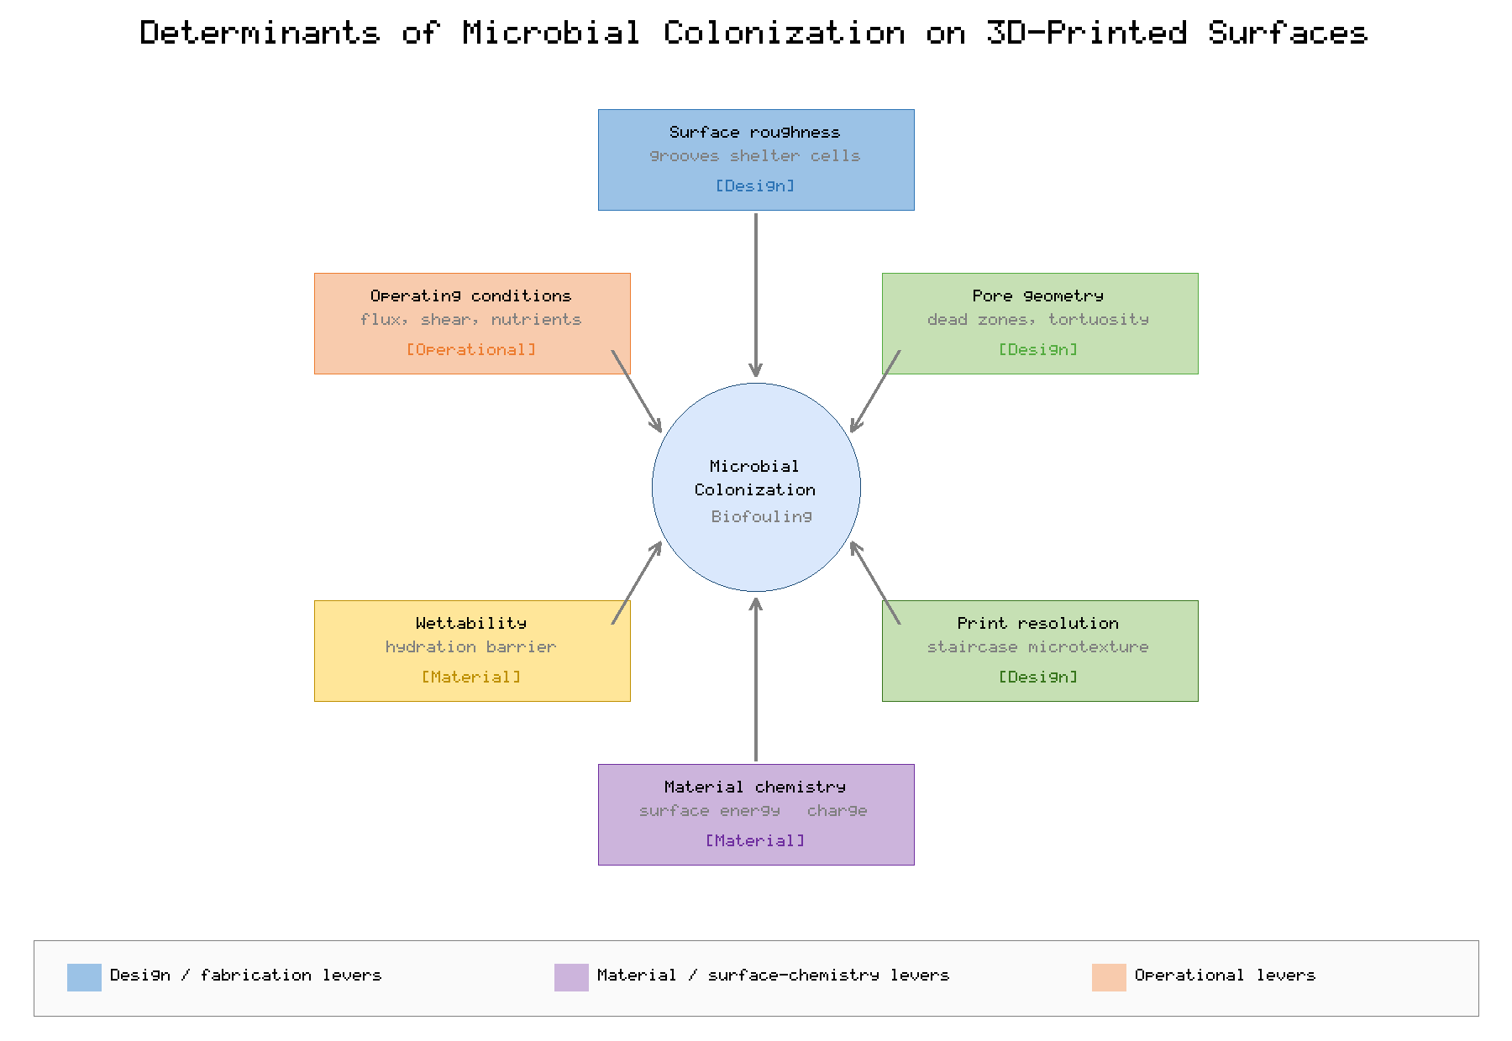
Figure 2. Conceptual synthesis of the surface, material, geometric, and operational factors governing microbial colonization of 3D-printed water-contact surfaces.

4. Antifouling Strategies for 3D-Printed Devices
Antifouling strategies for printed water purification devices fall into four broad and often complementary categories: antimicrobial surface functionalization that kills or inhibits attached organisms, hydrophilic and low-fouling coatings that resist attachment, nanomaterial incorporation that confers multifunctional activity, and bioinspired surface engineering that exploits natural fouling-resistant architectures [35]. Table 2 compares these approaches across mechanism, representative agents, principal advantages, and key limitations. A central theme is the distinction between fouling resistance, which prevents attachment, and fouling release or biocidal action, which eliminates or detaches organisms after contact; durable protection frequently requires combining these modes.
[Insert Table 2 here]
Table 2. Comparison of Antifouling Strategies for 3D-Printed Water Purification Components
Strategy | Mechanism | Representative Agents | Key Limitation
Antimicrobial functionalization | Kills or inhibits attached microorganisms | Silver, copper, quaternary ammonium, peptides | Leaching, resistance, finite lifetime
Hydrophilic / low-fouling coatings | Hydration barrier resists adhesion | PEG, zwitterionic polymers, PVA | Coating durability under cleaning
Nanomaterial incorporation | Multifunctional biocidal and barrier action | Graphene oxide, TiO2, Ag/Cu nanoparticles | Cost, dispersion, nanoparticle release
Bioinspired surface engineering | Topography deters or releases cells | Shark-skin, lotus, nepenthes-inspired textures | Fabrication fidelity; fouling under load

4.1 Antimicrobial Surface Functionalization
Antimicrobial functionalization endows the printed surface with the capacity to kill or inhibit the microorganisms that contact it, and it can be achieved either by incorporating biocidal agents directly into the feedstock or by applying them as a surface treatment [36]. Metallic agents, chiefly silver and copper, are the most widely studied; they act through the release of ions that disrupt microbial membranes, proteins, and nucleic acids, and they can be introduced as nanoparticles blended into filament or resin, as electrolessly deposited coatings, or as complexed surface functionalities [37]. Contact-active agents such as quaternary ammonium compounds and tethered antimicrobial peptides offer an alternative that kills on contact without releasing biocide into the water, mitigating some of the leaching and resistance concerns associated with release-based systems [38].
The principal limitations of antimicrobial functionalization are the finite lifetime of release-based agents as the reservoir is depleted, the potential for leached biocides to contaminate the product water and to select for resistant organisms, and the accumulation of killed cells and debris that can itself form a conditioning layer for subsequent fouling [36]. These concerns, elaborated in the discussion of leaching and secondary contamination in Section 8, mean that antimicrobial strategies are most effective when combined with anti-adhesion and cleaning measures rather than relied upon in isolation.
A particular advantage of additive manufacturing in this context is the ability to localize and grade antimicrobial function within the printed part. Because the composition of the feedstock can be varied during fabrication, a device can be designed with a biocidal concentration gradient that places the agent where it is most needed—at the water-contact interface—while sparing the bulk, conserving the finite reservoir and reducing both cost and the total mass of biocide available to leach [37]. Multi-material and multi-nozzle printing extend this capability further, permitting the combination of a mechanically robust structural polymer with a thin antimicrobial surface domain in a single build. Such spatial control is difficult or impossible to achieve by conventional fabrication and represents one of the clearest examples of how the design freedom of additive manufacturing can be exploited to improve antifouling performance while mitigating the associated safety and durability penalties.

4.2 Hydrophilic and Low-Fouling Coatings
Hydrophilic and low-fouling coatings attack biofouling at its first step by presenting a surface that microorganisms and macromolecules find energetically unfavorable to approach [29]. Poly(ethylene glycol) and its derivatives, poly(vinyl alcohol), and zwitterionic polymers such as those bearing sulfobetaine or carboxybetaine groups form dense, hydrated brushes that sterically and osmotically resist the adsorption of proteins and the attachment of cells [30]. Applied to printed surfaces by dip-coating, grafting, or in-situ polymerization, these coatings can dramatically reduce initial fouling without introducing biocides into the water, and zwitterionic chemistries in particular have demonstrated exceptional resistance across diverse foulant classes [39]. Their principal vulnerability is durability: the thin, soft hydrated layers that confer protection are susceptible to abrasion, oxidation by chlorine-based cleaning agents, and gradual hydrolytic degradation, so that their anti-fouling benefit may diminish over the many cleaning cycles a device experiences in service.

4.3 Nanomaterial Incorporation
The incorporation of engineered nanomaterials into printed feedstocks offers a route to multifunctional antifouling performance, combining biocidal activity, altered surface energy, and in some cases photocatalytic self-cleaning within a single material [40]. Graphene oxide and other carbon nanomaterials can impart both anti-adhesion and antibacterial properties while enhancing mechanical and transport characteristics; metal and metal-oxide nanoparticles such as silver, copper oxide, zinc oxide, and titanium dioxide contribute biocidal or photocatalytic action; and the dispersion of these fillers throughout the bulk means that antifouling activity is renewed as surfaces abrade rather than being confined to a depletable coating [41]. The challenges are the cost and dispersion of nanomaterials within printable formulations, the risk of nanoparticle release into treated water with its attendant toxicological uncertainties, and the need to preserve printability and mechanical integrity when loading the feedstock with inorganic fillers [42].

4.4 Bioinspired Surface Engineering
Bioinspired surface engineering draws on the fouling-resistant architectures that have evolved in nature, and additive manufacturing is uniquely suited to reproducing the intricate topographies involved [43]. The riblet microtexture of shark skin, which deters settlement through a combination of unfavorable topography and self-cleaning hydrodynamics, the hierarchical roughness of the lotus leaf that confers superhydrophobicity, and the slippery liquid-infused surfaces inspired by the pitcher plant, which present an immobilized lubricant layer that organisms cannot grip, have all been translated onto engineered surfaces with measurable reductions in biofouling [35]. The promise of these approaches lies in their avoidance of biocides and their potential durability when the topography is an intrinsic feature of the printed structure rather than an applied layer. Their limitations are the fidelity with which fine features can be printed, the tendency of some textures to lose efficacy once fouled or mechanically worn, and, for liquid-infused surfaces, the gradual depletion of the infused lubricant under flow.

5. Maintenance, Cleaning, and Performance Restoration
However effective the preventive strategies embedded in design and material, biofouling cannot be eliminated entirely, and the restoration of performance through maintenance and cleaning is therefore indispensable to device longevity [6]. Cleaning regimes are conventionally classed as physical, chemical, or biological, and as preventive or restorative; the appropriate choice depends on the nature of the fouling, the chemical and mechanical tolerance of the printed material, and the operational context. Table 3 summarizes the principal maintenance and cleaning methods, their mode of action, and their key considerations for printed devices, whose microstructure and material chemistry impose distinctive constraints.
[Insert Table 3 here]
Table 3. Maintenance and Cleaning Methods for 3D-Printed Water Purification Devices
Method | Mode of Action | Key Consideration for Printed Devices
Preventive maintenance | Scheduled monitoring and mild flushing | Requires baseline performance data
Hydraulic backwashing | Reverse flow dislodges loose foulants | Interlayer voids retain residual biofilm
Chemical cleaning (CIP) | Acids, alkalis, oxidants dissolve foulants | Chlorine and solvents may degrade polymers
Mechanical / ultrasonic cleaning | Shear and cavitation detach deposits | Risk of delamination and surface damage
Self-cleaning (photocatalytic) | Light-activated oxidation of foulants | Needs UV access and active coating
Self-cleaning (stimuli-responsive) | Switchable surfaces release foulants | Long-term switching durability unproven

5.1 Preventive Maintenance
Preventive maintenance seeks to forestall the escalation of fouling through routine monitoring, periodic low-intensity flushing, and the timely adjustment of operating conditions before fouling becomes severe or irreversible [44]. Its effectiveness rests on the availability of reliable baseline performance data against which deviations can be detected, and on an understanding of the fouling trajectory characteristic of the particular device and feedwater. For 3D-printed devices, preventive maintenance is especially valuable because the microstructural complexity that shelters biofilm also makes restorative cleaning less effective once fouling is established; intervening early, while the biofilm remains immature and loosely attached, greatly improves the prospects for full performance recovery.

5.2 Chemical Cleaning
Chemical cleaning, often implemented as a clean-in-place procedure, uses acids to dissolve mineral scale, alkalis and surfactants to solubilize organic matter and EPS, oxidants such as hypochlorite to degrade biofilm and inactivate cells, and chelating agents to sequester metal ions that bridge foulants to the surface [37]. It is the most powerful means of removing mature biofilm, but it poses particular hazards for printed polymers. Many additive-manufacturing feedstocks are susceptible to oxidative attack by chlorine, swelling or dissolution by organic solvents, hydrolysis by strong alkalis, and embrittlement by repeated exposure to aggressive chemistry, so that the very agents that restore flux also accelerate material degradation [38]. The interlayer boundaries of printed parts are especially vulnerable, as cleaning chemicals can penetrate and weaken the bonds between deposited layers. Effective chemical cleaning of printed devices therefore demands careful matching of cleaning chemistry to material tolerance, the use of the mildest effective formulation, and vigilance for the cumulative damage documented in Section 7.
The optimization of a chemical cleaning protocol involves several interacting variables beyond the mere choice of reagent, including concentration, contact time, temperature, pH, and the sequence in which different agents are applied [37]. A common and effective sequence pairs an alkaline step to hydrolyze and solubilize organic and biological matter with a subsequent acidic step to dissolve mineral deposits, sometimes supplemented by an oxidative or enzymatic treatment targeted at the EPS matrix. Each additional step and each increase in reagent aggressiveness, however, raises the chemical burden on the printed material and lengthens the downtime during which the device produces no water. For printed components the optimization is further constrained by the limited chemical data available for many novel feedstocks, so that cleaning protocols validated for conventional membranes cannot be assumed transferable [38]. Establishing material-specific cleaning windows—the combinations of chemistry and condition that restore performance without unacceptable degradation—is accordingly an essential part of qualifying a printed device for sustained service.

5.3 Mechanical Cleaning and Backwashing
Physical cleaning methods remove foulants through hydraulic and mechanical forces without, in principle, introducing chemicals that threaten material integrity or water safety [45]. Hydraulic backwashing reverses the flow to lift loosely attached deposits from the surface and is a mainstay of routine operation, while forward flushing, air scouring, and the periodic relaxation of pressure exploit shear and buoyancy to detach foulants. Ultrasonic cleaning uses cavitation to dislodge tenacious deposits and can reach the recessed features of complex geometries, but the same cavitation energy risks eroding surfaces and, critically for printed parts, driving delamination at interlayer boundaries. For 3D-printed devices the efficacy of physical cleaning is constrained by microstructure: residual biofilm persists within interlayer voids and low-shear pores that reverse flow and scouring cannot fully reach, so that physical methods typically achieve partial rather than complete restoration and are best combined with the preventive and chemical measures already described.

5.4 Emerging Self-Cleaning Technologies
A particularly promising direction, well aligned with the design freedom of additive manufacturing, is the integration of self-cleaning functionality directly into the device so that fouling is continuously or responsively mitigated without external intervention [46]. Photocatalytic self-cleaning, most commonly based on titanium dioxide, uses ultraviolet or visible light to generate reactive oxygen species that oxidize organic foulants and inactivate microorganisms at the surface, and the photocatalyst can be incorporated into the printed material or applied as a coating provided light can reach it. Stimuli-responsive surfaces that switch wettability or morphology in response to changes in temperature, pH, light, or electrical potential offer another route, actively releasing foulants on demand [47]. These technologies remain at an earlier stage of maturity than conventional cleaning; the durability of their function over extended operation, the need for light access in the case of photocatalysis, and the reliability of repeated switching are open questions, but their compatibility with printed fabrication makes them a natural focus for continued development.

6. Artificial Intelligence, Sensing, and Predictive Maintenance
The transition from reactive to predictive maintenance represents one of the most consequential opportunities for extending the service life of 3D-printed purification devices, and it is enabled by the convergence of embedded sensing, data analytics, and machine learning [48]. Rather than cleaning on a fixed schedule or waiting for performance to visibly degrade, a predictive approach continuously monitors the state of the device, forecasts the onset and progression of fouling, and triggers intervention at the optimal moment—early enough to permit effective cleaning, yet not so frequently as to waste chemicals, energy, and material life [49]. Figure 3 illustrates a closed-loop predictive-maintenance framework in which sensor data drive models that inform cleaning and operational decisions.
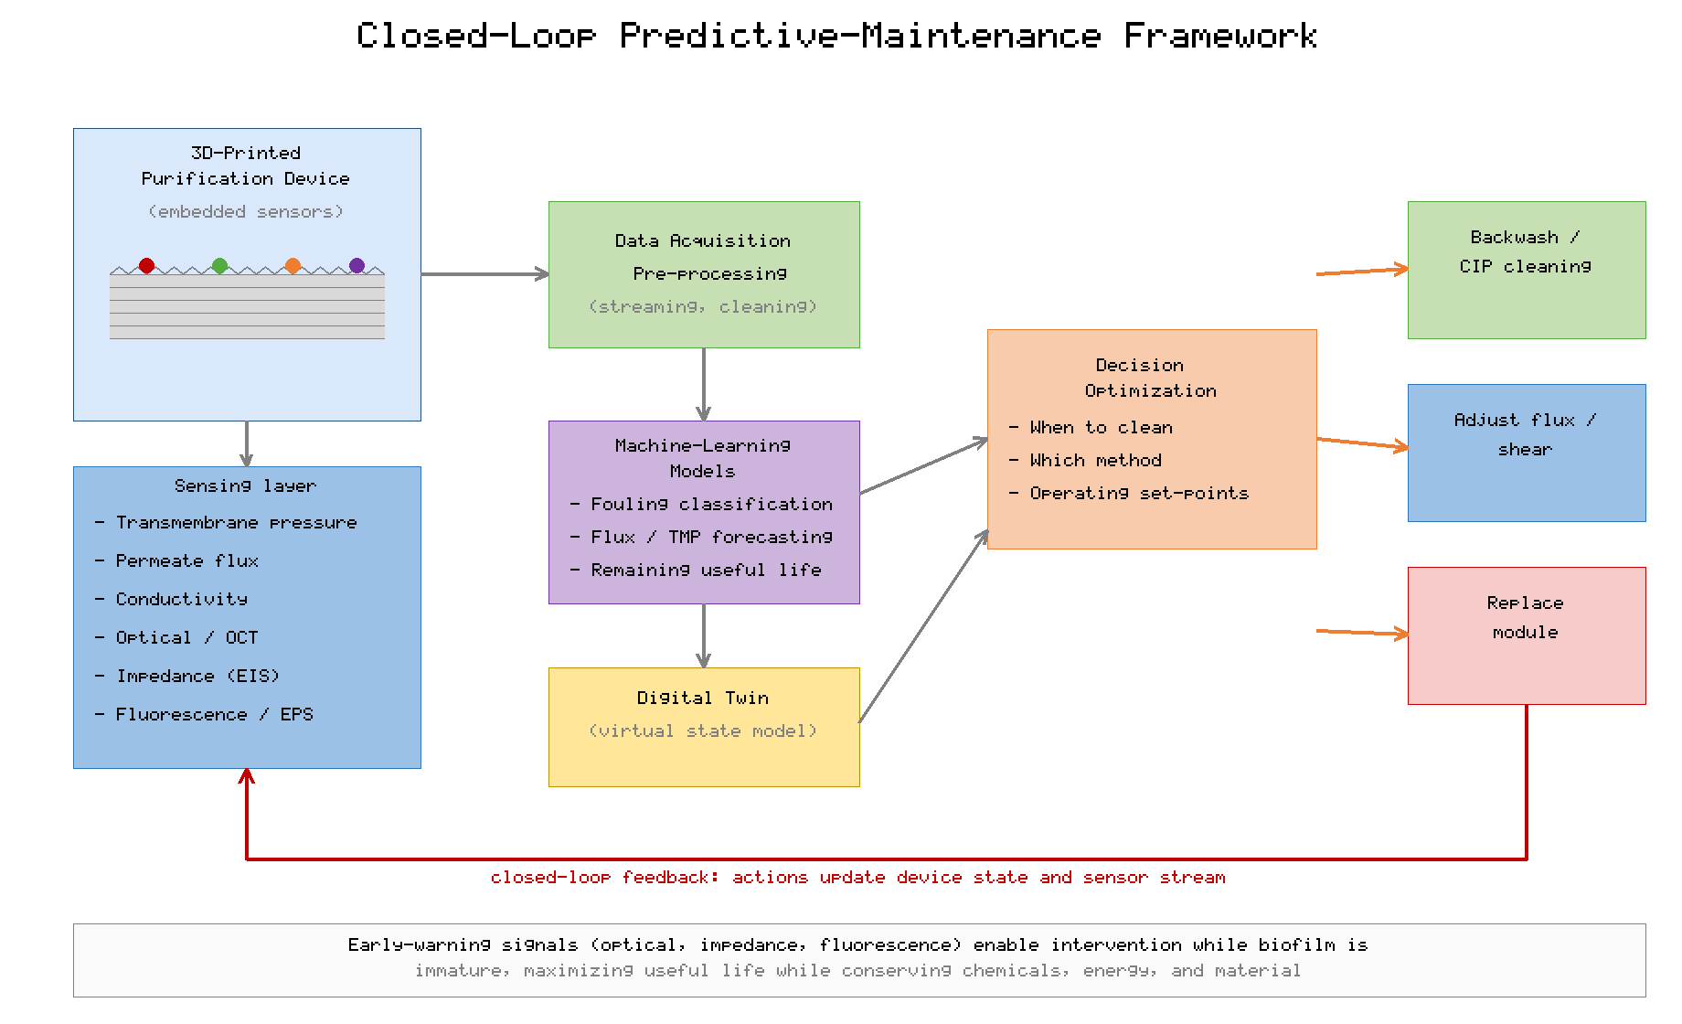
Figure 3. Closed-loop predictive-maintenance framework integrating embedded sensing, data analytics, and machine-learning models for 3D-printed purification devices.
Additive manufacturing offers a distinctive advantage for this paradigm because sensors can be embedded directly within the printed structure during fabrication, placing transducers for pressure, flow, conductivity, optical scattering, and electrochemical impedance in intimate contact with the fouling interface [50]. Transmembrane pressure and flux decline provide the classic macroscopic signatures of fouling, but these lagging indicators reveal fouling only after it has materially degraded performance. More sensitive, early-warning signals can be obtained from optical coherence tomography and optical sensors that visualize biofilm accumulation, from electrochemical impedance spectroscopy that detects the dielectric changes accompanying surface colonization, and from fluorescence and spectroscopic probes sensitive to EPS and microbial activity [51]. Embedding such sensors within the device, and printing the conductive or optical pathways they require, transforms the component from a passive barrier into an instrumented system aware of its own condition.
The data generated by these sensors become actionable through machine learning. Supervised models trained on historical operating and fouling data can classify fouling type and predict the remaining useful life of a component; time-series and deep-learning architectures can forecast flux decline and pressure rise from streams of sensor measurements; and reinforcement-learning or optimization frameworks can determine cleaning schedules and operating set-points that maximize productive life while respecting material-durability constraints [52]. Digital-twin representations, in which a continuously updated virtual model of the device mirrors its physical state, allow operators to simulate the consequences of alternative interventions before committing to them and to anticipate failures before they occur [53]. The principal obstacles to realizing this vision are the scarcity of large, well-labeled fouling datasets, the difficulty of transferring models trained on one device or feedwater to another, the long-term reliability of embedded sensors in a fouling environment, and the computational and connectivity constraints of decentralized deployment. Nonetheless, the trajectory is clear: intelligent, self-monitoring 3D-printed devices that optimize their own maintenance offer a credible path to longer service life, lower operating cost, and more reliable water quality.

7. Material Degradation and Device Longevity
The service life of a 3D-printed purification device is determined not only by how rapidly it fouls but by how well its material withstands the cumulative stresses of operation, cleaning, and environmental exposure [9]. Repeated cleaning cycles are a dominant driver of degradation: each exposure to oxidative, acidic, alkaline, or solvent-based cleaning chemistry inflicts incremental chemical damage, while each hydraulic, ultrasonic, or mechanical cleaning imposes mechanical stress, and the accumulation of these insults over hundreds or thousands of cycles progressively erodes the properties on which performance depends [38]. Chlorine-based oxidants, ubiquitous in water-treatment cleaning, are especially aggressive toward many printable polymers, inducing chain scission, embrittlement, discoloration, and the roughening of surfaces that—ironically—accelerates subsequent fouling and thereby establishes a self-reinforcing degradation cycle.
The layered microstructure characteristic of additive manufacturing introduces failure modes largely absent from conventionally fabricated components [7]. Interlayer boundaries represent planes of mechanical weakness and preferential pathways for chemical ingress, so that fatigue cracking, delamination, and chemically assisted failure tend to initiate and propagate along them. Cyclic pressurization during normal operation and the pressure transients of backwashing subject these boundaries to mechanical fatigue, while the penetration of cleaning chemicals into interlayer voids weakens the bonds that hold layers together, such that mechanical and chemical degradation act synergistically rather than independently [45]. The anisotropy of printed parts means that their durability depends on build orientation and print parameters as much as on the intrinsic properties of the feedstock, making process control an integral part of designing for longevity.
Environmental aging compounds these operational stresses over the lifetime of a device [10]. Hydrolysis gradually degrades susceptible polymers in continuous water contact; ultraviolet exposure, whether from sunlight in decentralized outdoor deployments or from UV disinfection and photocatalytic self-cleaning, drives photo-oxidative chain scission; temperature cycling imposes thermal fatigue; and biologically mediated degradation by the very organisms the device is meant to exclude can attack certain biodegradable feedstocks. The consequences of this combined aging manifest as declining mechanical strength, increasing surface roughness and permeability to contaminants, dimensional change, and ultimately structural failure or unacceptable loss of purification performance. Designing for longevity therefore requires selecting materials whose degradation behavior is matched to the anticipated chemical and environmental exposure, controlling print parameters to minimize interlayer vulnerability, and establishing cleaning protocols that balance the immediate restoration of performance against the long-term preservation of structural integrity.
Predicting service life demands methods that compress years of operation into tractable laboratory timescales, and accelerated aging testing is the principal tool for this purpose [9]. By exposing specimens to elevated concentrations of cleaning chemicals, intensified ultraviolet irradiation, thermal cycling, and repeated pressurization at rates far exceeding those of normal service, such protocols seek to reproduce the cumulative damage of a full lifetime within weeks or months. The interpretation of accelerated data is not straightforward, however, because the mechanisms that dominate under intensified conditions may differ from those that govern slow, real-world aging, and because the synergistic interaction of chemical and mechanical stresses is difficult to reproduce faithfully under accelerated regimes [38]. For printed materials, whose degradation is strongly influenced by anisotropic microstructure, the design of representative accelerated tests is particularly demanding. Despite these caveats, systematic aging studies are indispensable for comparing candidate materials, for setting evidence-based replacement intervals, and for providing the labeled durability data on which the predictive-maintenance models of Section 6 ultimately depend.

8. Safety, Antimicrobial Leaching, and Secondary Contamination
Because 3D-printed purification devices are in direct contact with water intended for consumption, their safety over the full service life is a paramount and sometimes underappreciated concern that intersects closely with fouling and durability [4]. The antimicrobial agents incorporated to resist biofouling are a primary source of risk: silver, copper, and other biocidal species can leach from surfaces and coatings into the product water, and while such leaching is often intended as the mechanism of action, it raises questions about the toxicological acceptability of the resulting concentrations, the depletion of the agent that leaves the device progressively less protected, and the ecological and public-health implications of releasing biocides and promoting antimicrobial resistance [36]. Nanomaterial-enhanced devices carry the additional, incompletely characterized risk of releasing engineered nanoparticles whose behavior and toxicity in drinking water remain subjects of active investigation [42].
The printed material itself, and the chemistry of its fabrication, can also compromise water safety. Residual monomers, photoinitiators, plasticizers, and additives may migrate from incompletely cured resins or improperly post-processed parts, and degradation of the polymer during operation and cleaning can release breakdown products into the water [48]. Thorough post-processing to remove uncured material and support residues, validation of feedstocks against drinking-water contact standards, and verification that degradation products remain within acceptable limits are therefore essential rather than optional steps. Cleaning-agent compatibility is a further dimension of the same concern: residual cleaning chemicals must be adequately rinsed, and the reaction products formed when oxidants contact organic foulants or polymeric surfaces must not themselves pose a hazard [37].
Finally, the fouling process can create a route to secondary contamination of treated water that undermines the very purpose of the device [11]. A mature biofilm is not merely a hydraulic nuisance but a potential reservoir of pathogens that can detach and seed the permeate, and the sheltered microenvironments of biofilms can harbor and even promote the proliferation of opportunistic organisms. The dispersal stage of the biofilm life cycle, and the mechanical disruption of biofilm during cleaning, are moments of particular risk for the release of cells and endotoxins downstream. Ensuring the safe reuse of water-contact components after cleaning, and verifying that restoration procedures do not inadvertently liberate harmful material, are thus integral to the responsible operation of 3D-printed purification devices, binding together the themes of fouling, cleaning, durability, and safety into a single system-level requirement.

9. Lifecycle Assessment, Sustainability, and End-of-Life Management
The ultimate evaluation of a 3D-printed purification technology must extend beyond its operational performance to encompass its full environmental and economic lifecycle, from the sourcing of feedstock through fabrication, use, maintenance, and eventual disposal [9]. Lifecycle assessment provides the framework for this evaluation, quantifying the energy, material, water, and emissions burdens associated with each stage and revealing trade-offs that are invisible from an operational perspective alone [10]. A device that resists fouling and lasts longer reduces the frequency of replacement and the associated manufacturing burden, so that durability and sustainability are directly linked; conversely, an antifouling strategy that shortens material life or relies on resource-intensive nanomaterials may impose environmental costs that offset its operational benefits. Table 4 summarizes the principal lifecycle and sustainability considerations across the stages of a device's life, together with the strategies available to improve each.
[Insert Table 4 here]
Table 4. Lifecycle and Sustainability Considerations for 3D-Printed Water Purification Devices
Lifecycle Stage | Key Consideration | Improvement Strategy
Material sourcing | Feedstock origin and toxicity | Bio-based and recycled feedstocks
Fabrication | Energy use and material waste | Optimized design; minimal support
Use and maintenance | Durability and cleaning burden | Antifouling design; mild cleaning
Replacement | Frequency and component scope | Modular design; replaceable elements
End of life | Disposal, recycling, recovery | Recyclable or biodegradable materials
Sustainable material selection begins at the feedstock stage, where the choice between petroleum-derived, bio-based, and recycled polymers carries significant environmental consequences [40]. Bio-based feedstocks such as polylactic acid offer renewable sourcing and potential biodegradability, though their susceptibility to hydrolytic and biological degradation must be reconciled with the durability demands of continuous water contact, illustrating the frequently competing objectives of sustainability and longevity. Recycled feedstocks reduce virgin-material demand but require careful validation for water-contact safety. At the fabrication stage, additive manufacturing offers inherent sustainability advantages over subtractive methods through its efficient use of material and its capacity to produce optimized, lightweight geometries, although these gains depend on minimizing support material, print failures, and energy consumption [2].
Modular design emerges as a particularly powerful sustainability strategy that is well matched to the capabilities of additive manufacturing [3]. By partitioning a device into discrete, individually replaceable elements, a modular architecture allows only the fouled or degraded component to be replaced rather than the entire system, reducing material consumption, cost, and waste while extending the effective life of the overall device. The ability to print replacement modules locally and on demand reinforces this advantage, particularly in decentralized settings. End-of-life management completes the lifecycle picture: the fate of a spent device—whether landfilled, incinerated, recycled, or biodegraded—depends on the recyclability of its materials, the feasibility of recovering embedded functional components such as nanomaterials or sensors, and the potential for biodegradable feedstocks to decompose without harm [41]. Designing for end of life, by favoring recyclable or benignly degradable materials and by facilitating the separation and recovery of valuable or hazardous components, closes the loop and ensures that the environmental promise of 3D-printed water purification is realized across the entire lifecycle rather than merely at the point of use.
Figure 4 presents this lifecycle as a circular framework, linking material sourcing, fabrication, use and maintenance, and end-of-life recovery into a closed loop in which durability, modularity, and recyclability feed material and value back into the system rather than consigning spent devices to waste.
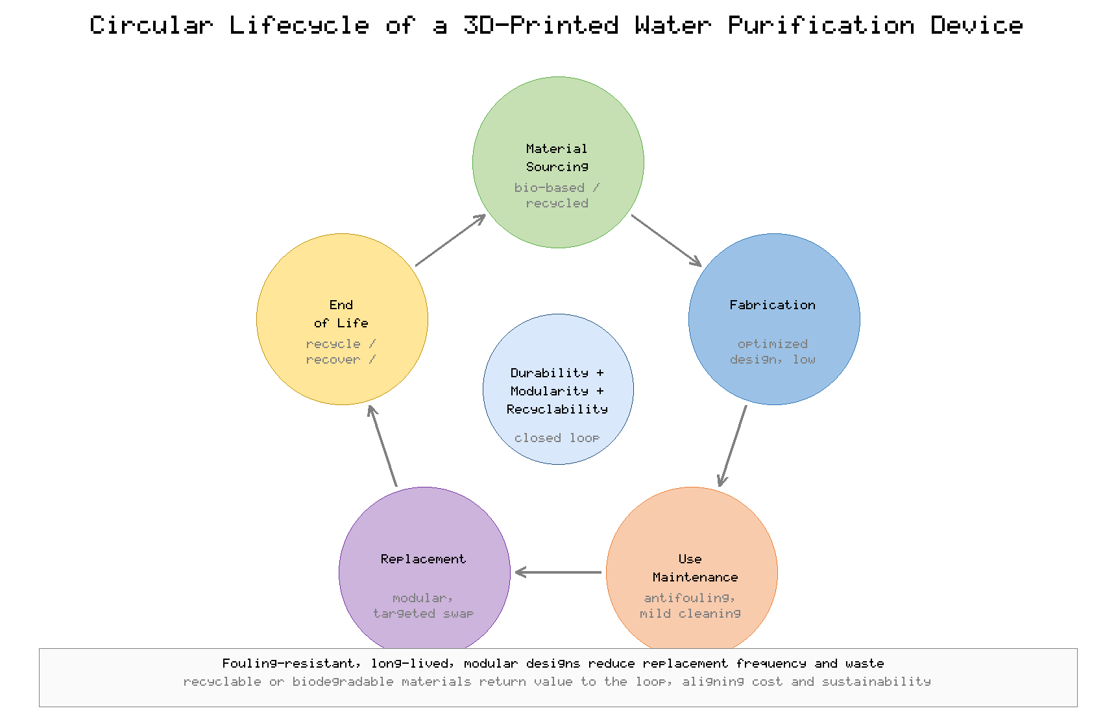
Figure 4. Circular lifecycle and end-of-life framework for 3D-printed water purification devices, linking sustainable sourcing, efficient fabrication, durable fouling-resistant use, and material recovery.
Economic viability is the indispensable complement to environmental sustainability, and the two are more closely aligned than they may first appear. Because the cost of ownership of a filtration device is dominated over its lifetime by the recurring expenses of energy, cleaning, downtime, and replacement rather than by initial fabrication, measures that reduce fouling and extend durability deliver economic as well as environmental returns [44]. A fouling-resistant, long-lived, and modular device lowers the frequency and scope of replacement, shortens downtime, and reduces chemical consumption, so that investments in antifouling design and intelligent maintenance are frequently justified on cost grounds alone. Lifecycle costing, the economic analogue of lifecycle assessment, provides the framework for quantifying these returns and for comparing alternative designs on a total-cost basis rather than by purchase price [10]. Evaluating 3D-printed purification devices through the combined lens of lifecycle cost and lifecycle environmental impact ensures that decisions about materials, antifouling strategies, and maintenance regimes advance durability, affordability, and sustainability together rather than trading one against another.

10. Conclusion
Biofouling stands as the single most persistent obstacle to the reliable, long-term performance of 3D-printed water purification devices, and this chapter has shown that it cannot be understood or managed in isolation from the related challenges of maintenance, material durability, safety, and sustainability. The layered microstructure, complex internal geometry, and diverse polymeric feedstocks that give additive manufacturing its distinctive advantages also create an abundance of sheltered niches and vulnerable interfaces that accelerate microbial colonization and complicate its removal. Biofilm formation proceeds through a predictable sequence from conditioning film to mature, resilient community, and its rate and severity are governed by an interacting set of surface, material, geometric, and operational factors—surface roughness and microtopography, surface chemistry and wettability, pore geometry and flow distribution, and the operating regime imposed on the device—each of which offers a corresponding lever for control at the design, fabrication, or operational stage.
No single strategy suffices. Durable protection arises from the integration of complementary approaches: antifouling surface functionalization, hydrophilic and low-fouling coatings, multifunctional nanomaterials, and bioinspired topographies that resist or release foulants, combined with maintenance regimes spanning preventive monitoring, physical and chemical cleaning, and emerging self-cleaning technologies. The integration of embedded sensing, data analytics, and machine learning promises to transform maintenance from a reactive, schedule-driven activity into a predictive, condition-aware practice that intervenes at the optimal moment, extending service life while conserving chemicals, energy, and material. At the same time, the cumulative effects of repeated cleaning, chemical exposure, mechanical fatigue, and environmental aging on printed materials must be anticipated and designed against, and the safety implications of antimicrobial leaching, degradation products, and secondary contamination must be rigorously controlled to protect the quality of the water the device is meant to purify.
Ultimately, the durability, safety, and sustainability of 3D-printed purification devices are inseparable dimensions of a single engineering problem. Lifecycle assessment, sustainable and recyclable material selection, modular design that permits targeted replacement, and responsible end-of-life management together ensure that these technologies deliver clean water not only effectively but durably, economically, and in an environmentally responsible manner. Realizing this vision will require continued advances in materials, surface engineering, intelligent monitoring, and design methodology, as well as a holistic perspective that treats biofouling, maintenance, and longevity as facets of a unified whole. By embracing such an integrated approach, 3D-printed water purification can mature from a promising innovation into a dependable and sustainable pillar of decentralized and conventional water treatment alike.

References
[1] Wang, R., & Tan, S. C. (2021). Additive manufacturing for membrane and water treatment technologies: Opportunities and challenges. Journal of Membrane Science, 621, 118986.
[2] Low, Z.-X., Chua, Y. T., Ray, B. M., Mattia, D., Metcalfe, I. S., & Patterson, D. A. (2019). Perspective on 3D printing of separation membranes and comparison to related unconventional fabrication techniques. Journal of Membrane Science, 523, 596–613.
[3] Tijing, L. D., Dizon, J. R. C., Ibrahim, I., Nisay, A. R. N., Shon, H. K., & Advincula, R. C. (2020). 3D printing for membrane separation, desalination and water treatment. Applied Materials Today, 18, 100486.
[4] Bhattacharjee, S., Joshi, R., Yasir, M., & Adhikari, A. (2022). Biofouling in membrane-based water purification: Mechanisms and mitigation. Environmental Science: Water Research & Technology, 8(5), 905–931.
[5] Flemming, H.-C., Baveye, P., Neu, T. R., Stoodley, P., Szewzyk, U., Wingender, J., & Wuertz, S. (2021). Who put the film in biofilm? The migration of a term from wastewater engineering to medicine and beyond. npj Biofilms and Microbiomes, 7(1), 10.
[6] Jiang, S., Li, Y., & Ladewig, B. P. (2019). A review of reverse osmosis membrane fouling and control strategies. Science of the Total Environment, 595, 567–583.
[7] Ngo, T. D., Kashani, A., Imbalzano, G., Nguyen, K. T. Q., & Hui, D. (2019). Additive manufacturing (3D printing): A review of materials, methods, applications and challenges. Composites Part B: Engineering, 143, 172–196.
[8] Mazinani, S., Al-Shimmery, A., Chew, Y. M. J., & Mattia, D. (2019). Fabrication and characterization of 3D-printed membranes for water treatment. ACS Applied Materials & Interfaces, 11(29), 26373–26383.
[9] Faust, L. J., & Connelly, S. (2023). Durability and degradation of polymeric materials in water treatment applications: A critical review. Water Research, 229, 119434.
[10] Kobayashi, Y., & Peters, G. M. (2021). Life cycle assessment of water treatment technologies: Current practice and future directions. Journal of Cleaner Production, 283, 124556.
[11] Maddah, H., & Chogle, A. (2020). Biofouling in reverse osmosis: Phenomena, monitoring, controlling and remediation. Applied Water Science, 10(1), 20.
[12] Nava-Ocampo, M. F., Fortunato, L., Bertin, L., & Vrouwenvelder, J. S. (2022). Conditioning film formation and its role in membrane biofouling. Desalination, 522, 115424.
[13] Zhang, R., Liu, Y., He, M., Su, Y., Zhao, X., Elimelech, M., & Jiang, Z. (2020). Antifouling membranes for sustainable water purification: Strategies and mechanisms. Chemical Society Reviews, 49(7), 2017–2037.
[14] Carniello, V., Peterson, B. W., van der Mei, H. C., & Busscher, H. J. (2019). Physico-chemistry from initial bacterial adhesion to surface-programmed biofilm growth. Advances in Colloid and Interface Science, 261, 1–14.
[15] Cheng, Y., Feng, G., & Moraru, C. I. (2019). Micro- and nanotopography sensitive bacterial attachment mechanisms: A review. Frontiers in Microbiology, 10, 191.
[16] Sauer, K., Stoodley, P., Goeres, D. M., Hall-Stoodley, L., Burmølle, M., Stewart, P. S., & Bjarnsholt, T. (2022). The biofilm life cycle: Expanding the conceptual model of biofilm formation. Nature Reviews Microbiology, 20(10), 608–620.
[17] Ciofu, O., Moser, C., Jensen, P. Ø., & Høiby, N. (2022). Tolerance and resistance of microbial biofilms. Nature Reviews Microbiology, 20(10), 621–635.
[18] Vrouwenvelder, J. S., Picioreanu, C., Kruithof, J. C., & van Loosdrecht, M. C. M. (2019). Biofouling of spiral-wound membrane systems. Water Research Reviews, 3(2), 45–67.
[19] Khan, M. T., Hong, P.-Y., Nada, N., & Croue, J. P. (2020). Does chlorination of seawater reverse osmosis membranes control biofouling? Water Research, 174, 115639.
[20] Flemming, H.-C., & Wingender, J. (2019). The biofilm matrix: Multitasking in a shared space. Nature Reviews Microbiology, 17(4), 247–260.
[21] Tong, T., Wallace, A. F., Zhao, S., & Wang, Z. (2019). Mineral scaling in membrane desalination: Mechanisms, mitigation strategies, and feasibility of scaling-resistant membranes. Journal of Membrane Science, 579, 52–69.
[22] Elkhaldi, R., & Yusuf, M. (2021). Surface roughness effects on biofouling of 3D-printed polymer surfaces. Additive Manufacturing, 46, 102120.
[23] Dizon, J. R. C., Espera, A. H., Chen, Q., & Advincula, R. C. (2020). Mechanical characterization of 3D-printed polymers. Additive Manufacturing, 20, 44–67.
[24] Tripathy, A., Sen, P., Su, B., & Briscoe, W. H. (2021). Natural and bioinspired nanostructured surfaces with antifouling properties. Advances in Colloid and Interface Science, 294, 102456.
[25] Lee, J.-Y., Tan, W. S., An, J., Chua, C. K., Tang, C. Y., Fane, A. G., & Chong, T. H. (2020). The potential to enhance membrane module design with 3D printing technology. Journal of Membrane Science Letters, 1(1), 100003.
[26] Bhushan, S., & Singh, S. (2022). Polymeric materials for 3D-printed water filtration: Properties and performance. Materials Today: Proceedings, 62, 1123–1131.
[27] Liu, C., Wang, J., & Hoek, E. M. V. (2021). Surface energy, charge and wettability relationships governing membrane biofouling. Journal of Membrane Science, 638, 119664.
[28] Rahimi, M., & Zhang, B. (2021). Surface functionalization strategies for antifouling membranes. Progress in Polymer Science, 118, 101407.
[29] Zhao, X., & Zhang, R. (2020). Hydrophilic and zwitterionic coatings for fouling-resistant water treatment surfaces. Journal of Materials Chemistry A, 8(41), 21443–21471.
[30] Shahkaramipour, N., Tran, T. N., Ramanan, S., & Lin, H. (2019). Membranes with surface-enhanced antifouling properties for water purification. Membranes, 9(2), 13.
[31] Sreedhar, N., Thomas, N., Al-Ketan, O., Rowshan, R., Hernandez, H., Abu Al-Rub, R. K., & Arafat, H. A. (2019). 3D printed feed spacers based on triply periodic minimal surfaces for flux enhancement and biofouling mitigation. Desalination, 466, 90–101.
[32] Qamar, A., Kerdi, S., Ali, S. M., Shon, H. K., Vrouwenvelder, J. S., & Ghaffour, N. (2021). Novel hole-pillar spacer design for improved hydrodynamics and biofouling mitigation in membrane filtration. Scientific Reports, 11, 6979.
[33] Bucs, S. S., Farhat, N., Kruithof, J. C., Picioreanu, C., van Loosdrecht, M. C. M., & Vrouwenvelder, J. S. (2019). Review on strategies for biofouling mitigation in spiral wound membrane systems. Desalination, 434, 189–197.
[34] Farhat, N., Bucs, S., Vrouwenvelder, J. S., & Staal, M. (2020). Early biofouling detection and the effect of operating conditions on biofilm development. Biofouling, 36(5), 593–606.
[35] Chien, H.-W., Chen, X.-Y., & Tsai, W.-P. (2021). Bioinspired and biomimetic surfaces for antifouling applications. Colloids and Surfaces B: Biointerfaces, 207, 112016.
[36] Yu, Q., Ge, W., Atewologun, A., López, G. P., & Stafslien, S. J. (2019). Antimicrobial surfaces for water treatment: Mechanisms, performance, and leaching concerns. Biofouling, 35(6), 631–650.
[37] Al-Amoudi, A. S., & Lovitt, R. W. (2020). Fouling strategies and the cleaning system of membranes and factors affecting cleaning efficiency. Journal of Membrane Science Reviews, 4(1), 1–22.
[38] Levitt, M., & Barbeau, B. (2022). Chemical cleaning-induced degradation of polymeric membranes: Mechanisms and implications. Journal of Membrane Science, 643, 120050.
[39] Lin, S., Huang, H., Zeng, Y., Zhang, L., & Hou, L. (2020). Zwitterionic polymer coatings for durable antifouling performance in water treatment. ACS Applied Materials & Interfaces, 12(29), 32515–32525.
[40] Goh, P. S., Ismail, A. F., & Hilal, N. (2021). Nano-enabled membranes and the sustainability of next-generation water treatment. Desalination, 500, 114852.
[41] Kusworo, T. D., Kumoro, A. C., & Utomo, D. P. (2022). Photocatalytic nanocomposite membranes for self-cleaning water treatment: A review. Journal of Environmental Chemical Engineering, 10(3), 107619.
[42] Troester, M., Brauch, H.-J., & Hofmann, T. (2019). Vulnerability of drinking water supplies to engineered nanoparticles. Water Research, 150, 455–473.
[43] Kirschner, C. M., & Brennan, A. B. (2020). Bio-inspired antifouling topographies: From shark skin to engineered surfaces. Annual Review of Materials Research, 50, 265–288.
[44] Jafari, M., Vanoppen, M., van Agtmaal, J. M. C., Cornelissen, E. R., Vrouwenvelder, J. S., Verliefde, A., van Loosdrecht, M. C. M., & Picioreanu, C. (2021). Cost of fouling in full-scale membrane systems and the value of preventive maintenance. Desalination, 500, 114865.
[45] Chang, H., Liang, H., Qu, F., Liu, B., Yu, H., Du, X., Li, G., & Snyder, S. A. (2020). Hydraulic backwashing for membrane fouling control: A review. Separation and Purification Technology, 253, 117471.
[46] Zhu, Y., Wang, J., Li, X., Zhao, D., & Sun, J. (2021). Self-cleaning membranes for sustainable water purification. Journal of Materials Chemistry A, 9(43), 24087–24114.
[47] Wang, J., Zhu, Y., & Sun, J. (2022). Stimuli-responsive surfaces for on-demand antifouling and foulant release. Advanced Functional Materials, 32(18), 2110557.
[48] Niu, C., Li, X., Dai, R., & Wang, Z. (2022). Artificial intelligence-incorporated membrane fouling prediction and control: A review. Water Research, 216, 118299.
[49] Park, S., Baek, S.-S., Pyo, J., Pachepsky, Y., Park, J., & Cho, K. H. (2019). Deep neural networks for modeling fouling growth and flux decline in membrane processes. Journal of Membrane Science, 587, 117164.
[50] Alsawaftah, N., Abuwatfa, W., Darwish, N., & Husseini, G. (2021). A comprehensive review on membrane fouling monitoring techniques. Membranes, 11(12), 924.
[51] Fortunato, L., Lamprea Pineda, A. F., & Leiknes, T. (2020). Real-time monitoring of membrane fouling development using optical coherence tomography. Journal of Membrane Science, 598, 117672.
[52] Bagheri, M., Akbari, A., & Mirbagheri, S. A. (2019). Advanced control of membrane fouling in filtration systems using artificial intelligence and machine learning. Process Safety and Environmental Protection, 123, 229–252.
[53] Kang, Z., Catal, C., & Tekinerdogan, B. (2021). Remaining useful life prediction and digital twins for water treatment assets. Journal of Cleaner Production, 310, 127497.

