Artificial Intelligence for Inclusive and Sustainable Workforce Development in Industry 5.0: Advancing Diversity, Equity, and Inclusion through Intelligent Manufacturing

Abstract
The emergence of Industry 5.0 marks a decisive philosophical and operational shift in the trajectory of industrial development, moving beyond the efficiency-centred, automation-driven logic of Industry 4.0 toward a paradigm that is explicitly human-centric, resilient, and sustainable. Within this transition, artificial intelligence (AI) has become both a technological catalyst and a governance challenge, capable of reshaping how manufacturing organisations recruit, develop, protect, and empower their workforce. This chapter examines how AI can be harnessed to advance diversity, equity, and inclusion (DEI) in intelligent manufacturing environments while simultaneously supporting sustainable and equitable workforce development. It argues that the human-centric ethos of Industry 5.0 provides a normative foundation for embedding inclusion into the design of intelligent systems rather than treating fairness as an afterthought. The chapter explores AI-driven recruitment and workforce analytics, human–robot collaboration and inclusive work design, and personalised upskilling and reskilling as mechanisms through which organisations can widen access to opportunity and reduce structural disadvantage. It further analyses the role of AI in employee well-being and occupational safety, the imperatives of ethical and responsible workforce management, and the emergence of AI-enabled green jobs within a circular and low-carbon economy. A structured implementation framework is proposed, integrating organisational, technological, and human dimensions and aligning DEI indicators with corporate sustainability strategy and the Sustainable Development Goals, particularly SDG 5, SDG 8, SDG 9, and SDG 10. The chapter concludes by identifying persistent challenges, including the digital divide, workforce displacement, algorithmic discrimination, and cybersecurity risks, and by charting future directions centred on explainable, trustworthy, and inclusive AI. The central contention is that intelligent manufacturing will only fulfil its transformative promise if technological capability, human competence, organisational capacity, ethical governance, and stakeholder acceptance advance together, so that AI becomes an enabler of dignity, creativity, and shared prosperity rather than a new source of exclusion.
Keywords: Industry 5.0; artificial intelligence; diversity, equity, and inclusion; workforce development; intelligent manufacturing; sustainable employment; human-centric automation; Sustainable Development Goals.

1. Introduction to AI-Enabled Workforce Development in Industry 5.0

1.1 Industry 5.0 and the Evolution toward Human-Centric Manufacturing
The concept of Industry 5.0 has crystallised over recent years as a corrective response to the perceived imbalances of the fourth industrial revolution. Where Industry 4.0 prioritised cyber-physical integration, hyper-automation, and data-driven optimisation, Industry 5.0 reframes the purpose of industrial activity around three interdependent pillars: human-centricity, resilience, and sustainability [1]. Rather than positioning the human worker as a residual element to be automated away, this emerging paradigm places human well-being, creativity, and agency at the centre of production systems, treating advanced technologies as instruments in service of people and planetary boundaries [2]. The transition is therefore not merely technological but normative, redefining what industrial progress is for and whom it should benefit.
This reorientation has profound implications for the manufacturing workforce. The technological substrate of Industry 5.0 remains sophisticated, drawing on artificial intelligence, collaborative robotics, the Internet of Things (IoT), digital twins, edge computing, and intelligent automation [3]. Yet the distinguishing feature is the manner in which these technologies are configured: to augment rather than replace human capability, to adapt to individual differences rather than impose standardisation, and to distribute benefits more broadly across the organisation [4]. Digital twins, for example, are increasingly used not only to simulate production processes but also to model the interaction between workers and machines, enabling ergonomic and cognitive workloads to be optimised for a diverse workforce [5].
The changing character of work in this environment gives rise to new employment models and evolving skill requirements. Routine manual and cognitive tasks are progressively mediated by intelligent systems, while demand grows for hybrid competencies that combine digital literacy with domain expertise, problem-solving, and interpersonal skills [6]. Employment relationships are becoming more fluid, encompassing project-based work, human–machine teaming, and continuous learning as a condition of employability. As Figure 1 illustrates, the human-centric philosophy of Industry 5.0 provides the conceptual scaffolding within which AI can be deployed to enable inclusive workforce development rather than to intensify precarity. Understanding this transition is a prerequisite for appreciating why diversity, equity, and inclusion have become strategic rather than peripheral concerns [7].
It is important to recognise that Industry 5.0 does not repudiate the technological achievements of its predecessor but rather reinterprets their purpose. The cyber-physical systems, advanced analytics, and networked machinery developed under Industry 4.0 remain foundational; what changes is the value framework that governs their deployment [1]. Under the earlier paradigm, the implicit objective was the maximisation of throughput and the minimisation of variability and labour cost, with human workers frequently treated as sources of error to be designed out of the loop. The human-centric turn inverts this logic, asking how machines can be arranged to expand human capability, discretion, and satisfaction while still meeting exacting standards of quality and efficiency [5]. This inversion has direct consequences for equity, because systems optimised solely for efficiency tend to standardise around an idealised worker, whereas systems optimised for human flourishing must accommodate the full range of human variation.
The resilience pillar of Industry 5.0 further reinforces the case for a diverse and adaptable workforce. The disruptions of recent years, from pandemic shocks to supply-chain fragility and geopolitical volatility, have demonstrated that brittle, hyper-optimised production systems can fail catastrophically when confronted with unforeseen conditions [3]. Resilience depends on redundancy, adaptability, and the capacity for rapid reconfiguration, all of which are enhanced by a workforce that is cognitively diverse, broadly skilled, and empowered to exercise judgement. In this light, diversity is not only an ethical commitment but a functional asset, contributing to the robustness of the sociotechnical system as a whole [7]. AI-enabled workforce development, properly conceived, thus serves the resilience agenda by cultivating adaptable talent and by providing the analytical foresight needed to anticipate and absorb shocks.
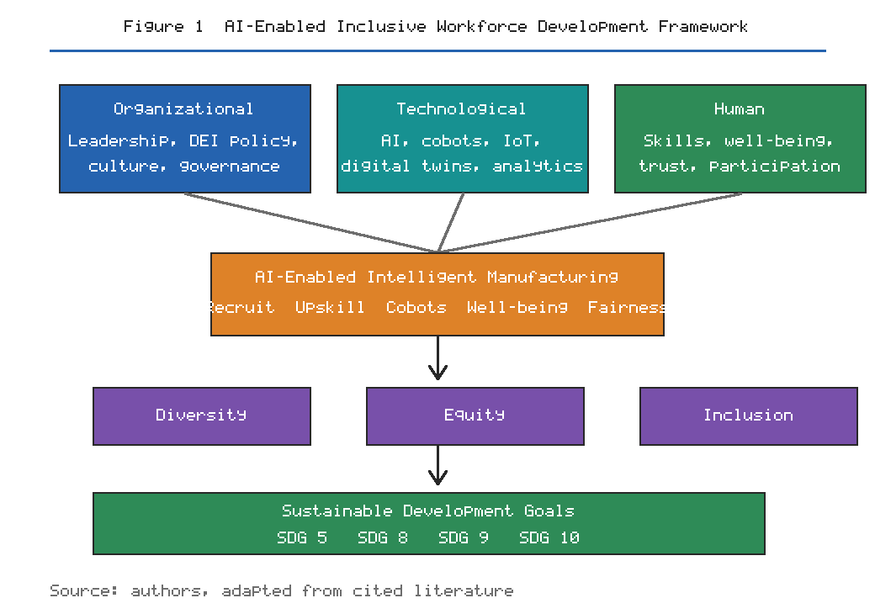
Figure 1. Conceptual framework linking the human-centric, technological, and organisational dimensions of Industry 5.0 to AI-enabled diversity, equity, and inclusion outcomes and the Sustainable Development Goals.

1.2 Diversity, Equity, and Inclusion in the Intelligent Manufacturing Workplace
Diversity in the manufacturing workplace encompasses multiple, intersecting dimensions, including gender, age, cultural and ethnic background, socioeconomic origin, disability status, and the breadth of skills and experience that individuals bring to the organisation [8]. Historically, technology-intensive manufacturing has struggled with persistent underrepresentation, particularly of women and older workers in technical and leadership roles, and with occupational segregation that channels certain groups into lower-paid or less secure positions [9]. The intelligent manufacturing workplace of Industry 5.0 offers an opportunity to disrupt these patterns, but only if diversity is treated as a design parameter rather than a compliance metric.
Equity is conceptually distinct from equality and demands attention to the differentiated starting points of individuals. In the context of intelligent manufacturing, equity concerns arise across the full employment life cycle: in recruitment and selection, in access to training and career development, in compensation and promotion, and in the allocation of opportunities such as high-visibility projects or exposure to emerging technologies [10]. Where AI systems mediate these decisions, they can either mitigate existing inequities by surfacing objective evidence of capability or entrench them by encoding historical bias into ostensibly neutral algorithms [11]. The equity imperative therefore requires deliberate scrutiny of both processes and outcomes.
Inclusion refers to the extent to which diverse individuals experience belonging, voice, and the ability to participate fully in organisational life. Barriers to inclusion in technology-intensive environments are frequently structural and cultural rather than merely individual [12]. They include inaccessible physical and digital environments, the assumption of continuous availability and mobility, unconscious bias in team dynamics, and the marginalisation of workers who lack advanced digital skills. Table 1 summarises the principal dimensions of workforce diversity in intelligent manufacturing, the associated equity risks, and the inclusion levers through which AI-enabled organisations can respond. As the table indicates, the challenge is systemic, spanning recruitment, work design, learning, and culture, and it cannot be resolved through isolated interventions [13].
The three concepts of diversity, equity, and inclusion are analytically distinct yet operationally interdependent, and the failure to distinguish them often undermines organisational initiatives. Diversity without inclusion produces representation without influence, in which underrepresented workers are recruited but neither heard nor retained. Equity without diversity addresses procedural fairness while leaving the composition of the workforce unchanged. Inclusion without equity fosters a superficial sense of belonging that masks persistent structural disadvantage [10]. A coherent DEI strategy for intelligent manufacturing must therefore pursue the three objectives simultaneously, using AI where it can help while remaining alert to the ways in which technology can subvert each of them. The intelligent manufacturing context adds a further layer of complexity, because the digital transformation of work itself creates new axes of advantage and disadvantage that intersect with established ones.
The manufacturing sector carries a particular historical burden in this regard. Long characterised by physically demanding work, gendered occupational cultures, and hierarchical structures, it has often been slow to embrace the flexible arrangements and inclusive practices that facilitate broad participation [9]. As the inclusion levers set out in Table 1 make clear, AI offers concrete instruments for addressing each dimension of disadvantage, from bias-audited recruitment to assistive interfaces and subsidised learning, provided these instruments are applied with intent. The advent of intelligent manufacturing simultaneously threatens and promises to disrupt these patterns. On one hand, the automation of physically arduous tasks removes barriers that historically excluded many workers; on the other, the premium placed on advanced digital skills can create new forms of exclusion for those without access to relevant education and training [12]. Whether the net effect is inclusive or exclusionary depends less on the technology itself than on the deliberate choices organisations make about how to deploy it, whom to involve in its design, and how to distribute its benefits and burdens [13].
Table 1. Dimensions of workforce diversity, associated equity risks, and AI-enabled inclusion levers in intelligent manufacturing.
Diversity dimension | Typical equity risk | AI-enabled inclusion lever
Gender | Occupational segregation and biased screening | Bias-audited recruitment and equitable promotion analytics
Age | Displacement of older workers by automation | Cobot-assisted tasks and adaptive reskilling pathways
Disability | Inaccessible workstations and digital tools | Assistive AI, adaptive interfaces, ergonomic optimisation
Cultural and ethnic | Language and communication barriers | Real-time translation and inclusive interface design
Socioeconomic | Unequal access to digital skills | Subsidised, personalised learning platforms
Skill and cognitive | Narrow definitions of merit | Competency-based, multi-signal assessment

1.3 AI as an Enabler of Sustainable and Inclusive Workforce Development
Positioned appropriately, AI can function as a powerful enabler of sustainable and inclusive workforce development. In the domain of talent management and workforce planning, AI systems can integrate diverse data sources to forecast skill demand, identify emerging roles, and match individuals to opportunities in ways that transcend the limitations of manual planning [14]. Predictive workforce analytics allow organisations to anticipate attrition, model the impact of technological change on different worker groups, and design proactive interventions that protect vulnerable employees rather than leaving them exposed to disruption [15]. Such foresight is a precondition for equitable transition.
Intelligent systems are also increasingly capable of identifying individual and organisational skills gaps with granularity that was previously unattainable. By analysing performance data, learning histories, and evolving job requirements, AI can map the distance between current competencies and future needs, recommending targeted development pathways for each worker [16]. When these capabilities are combined with a commitment to fairness, they can widen access to advancement for groups that have historically been overlooked, provided the underlying data and objectives are themselves scrutinised for bias [17].
The scale of the reskilling challenge facing the global workforce lends urgency to these capabilities. Successive analyses have estimated that a substantial proportion of workers will need significant retraining within the coming decade as tasks are automated and augmented, and that the pace of change is accelerating [6]. Without effective mechanisms to identify who needs which skills and to deliver learning efficiently, the sheer volume of transition required would overwhelm traditional training approaches and leave large numbers of workers stranded. AI-enabled diagnosis and personalisation offer a means of matching the scale of the response to the scale of the challenge, but only if they are deployed with equity as an explicit objective rather than as an incidental by-product [15]. The risk otherwise is that reskilling resources flow disproportionately to workers who are already well positioned, compounding rather than alleviating disadvantage.
Crucially, AI-enabled inclusive workplaces contribute directly to several Sustainable Development Goals. Gender-equitable recruitment and advancement support SDG 5 on gender equality; the creation of decent, secure, and productive employment advances SDG 8; investment in resilient and innovative industrial infrastructure aligns with SDG 9; and the reduction of workplace inequalities contributes to SDG 10 [18]. These linkages, revisited in the framework depicted in Figure 1, demonstrate that inclusive workforce development is not solely an organisational concern but part of a broader societal project. The remainder of this chapter examines how specific AI applications can realise this potential while navigating the attendant risks [19].
Yet the same analysis that reveals AI's enabling potential also cautions against technological determinism. AI does not autonomously produce inclusive outcomes; it operates within organisational, economic, and political structures that shape its effects [14]. A workforce-planning system that accurately forecasts skill demand will nonetheless entrench inequality if the organisation uses its outputs to justify displacement rather than reskilling. Predictive analytics that identify at-risk employees can be used to support them or to manage them out. The ethical valence of AI in workforce development is therefore contingent on the intentions, incentives, and accountability structures that surround it [15]. This chapter proceeds from the premise that AI is best understood as an amplifier of organisational values: where those values are genuinely committed to inclusion and sustainability, AI can accelerate progress; where they are not, AI can accelerate harm. The task for practitioners and researchers alike is to design the sociotechnical conditions under which the former outcome prevails [17].

2. Intelligent Technologies for Diversity, Equity, and Inclusion in Manufacturing

2.1 AI-Driven Recruitment, Talent Acquisition, and Workforce Analytics
Recruitment represents one of the most consequential and contested domains for AI in the workplace, because decisions made at the point of entry shape the composition of the workforce for years to come. AI-based candidate screening and skills assessment tools promise to process large applicant pools efficiently, to evaluate competencies through structured assessments, and to reduce the influence of superficial characteristics that have no bearing on performance [20]. Natural language processing can parse résumés and open-text responses, while game-based and simulation-based assessments can capture problem-solving and collaborative abilities that traditional credentials fail to reveal [21]. In principle, this shift from credential-based to competency-based evaluation can benefit candidates from non-traditional backgrounds.
However, the same technologies carry substantial risk of encoding and amplifying bias. Where historical hiring data reflect discriminatory patterns, machine learning models trained on that data will reproduce them, and may do so at scale and with a veneer of objectivity that makes discrimination harder to detect and challenge [22]. Bias detection and mitigation have therefore become essential components of responsible recruitment systems. Techniques include auditing training data for representational imbalance, testing model outputs for disparate impact across protected groups, applying fairness constraints during model training, and maintaining human oversight of consequential decisions [23]. The effectiveness of these measures depends on organisational willingness to prioritise fairness even where it entails trade-offs against narrow measures of predictive accuracy [24].
A further consideration concerns the interface between AI screening and candidate experience. Even technically fair systems can deter applicants from underrepresented groups if they are experienced as opaque, impersonal, or culturally alien, thereby undermining diversity objectives at the top of the funnel [20]. Inclusive recruitment design must therefore attend not only to the statistical properties of algorithms but also to the accessibility, transparency, and perceived legitimacy of the process from the candidate's perspective. Providing clear explanations of how assessments work, offering accommodations for disabled applicants, and ensuring that assessment formats do not disadvantage particular groups are all essential complements to algorithmic fairness [21]. The most sophisticated bias-mitigation technique is of limited value if the affected populations never enter the pipeline.
Beyond individual hiring decisions, workforce analytics enable organisations to monitor equity at an aggregate level. By analysing patterns in hiring, promotion, compensation, and attrition, AI systems can surface systemic disparities that would otherwise remain invisible, providing an evidence base for corrective action [25]. Figure 2 presents an illustrative comparison of key DEI indicators before and after the adoption of AI-supported, fairness-aware workforce practices, showing improvements in gender balance, older-worker retention, disability inclusion, reskilling completion, and pay equity. Table 2 complements this by mapping specific AI recruitment and analytics capabilities to their DEI contributions and the safeguards required to prevent harm. Taken together, they underline that AI in recruitment is neither inherently fair nor inherently biased; its impact depends on deliberate design and governance [26].
The promotion and progression stage merits particular attention, because inequities that are invisible at the point of hiring frequently accumulate over the course of a career. Analytics that examine the rate at which different groups are promoted, the assignments they receive, and the sponsorship and development opportunities available to them can reveal the subtle mechanisms through which advantage compounds [10]. Where such analysis is conducted transparently and acted upon in good faith, it can interrupt the self-perpetuating dynamics that concentrate senior roles among historically dominant groups. However, the same data can be weaponised or misinterpreted, and aggregate patterns must always be interpreted with an understanding of context and causation rather than treated as mechanical triggers for intervention [25]. The interpretive judgement of skilled human professionals remains indispensable, and workforce analytics should inform deliberation rather than replace it.
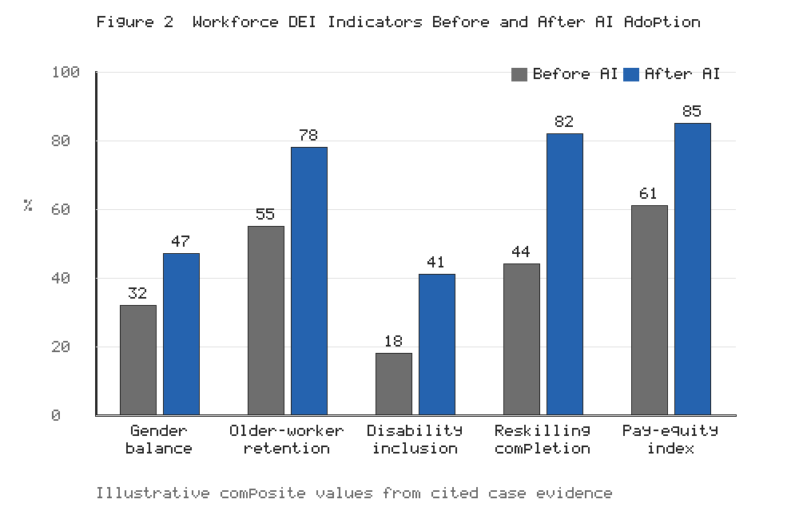
Figure 2. Illustrative workforce diversity, equity, and inclusion indicators before and after the adoption of fairness-aware, AI-supported recruitment and workforce analytics practices.
Table 2. AI recruitment and workforce-analytics capabilities, their DEI contributions, and required safeguards.
AI capability | DEI contribution | Required safeguard
Competency-based screening | Reduces reliance on biased credentials | Validated, job-relevant assessments
Résumé and text analysis | Broadens candidate consideration | Bias audits of training data
Structured video interviews | Standardises evaluation | Removal of proxy variables
Promotion analytics | Reveals advancement disparities | Transparent, explainable criteria
Pay-equity monitoring | Detects compensation gaps | Regular disparate-impact testing
Attrition prediction | Enables retention of at-risk groups | Privacy-preserving data handling

2.2 Human–Robot Collaboration and Inclusive Work Design
A defining feature of Industry 5.0 is the shift from isolated industrial robots operating behind safety cages toward collaborative robots, or cobots, that share physical space and tasks with human workers [27]. This human–robot collaboration reconfigures the division of labour so that machines assume repetitive, physically demanding, or hazardous elements of a task while humans contribute judgement, dexterity, and adaptability. Figure 3 depicts the continuum from coexistence through cooperation and collaboration to AI-mediated augmentation, illustrating how increasing levels of intelligent support can be aligned with human-centric objectives [28]. The inclusive potential of this continuum lies in its capacity to reshape work around human diversity rather than requiring workers to conform to rigid physical and cognitive demands.
AI-assisted ergonomic workplace design is central to realising this potential. By combining sensor data, computer vision, and digital-twin simulation, intelligent systems can assess posture, movement, and workload in real time, adjusting workstation height, tool positioning, and task pacing to reduce strain and injury risk [29]. Such adaptive design is particularly valuable for accommodating the physiological variation across a diverse workforce, enabling a single production cell to support workers of different statures, strengths, and capabilities without stigmatising individual accommodation [30]. Ergonomic intelligence thus becomes a form of universal design embedded in the production system itself.
The emergence of human factors and ergonomics as a research frontier within advanced manufacturing reflects a growing recognition that the physical and cognitive well-being of workers is integral to system performance rather than incidental to it [30]. Where earlier automation frequently intensified the pace and monotony of residual human tasks, human-centric design seeks to allocate tasks between humans and machines in ways that preserve meaning, autonomy, and health. This entails attention not only to musculoskeletal load but also to cognitive workload, attention, and the psychological experience of work [29]. For inclusion, the significance is that thoughtfully designed collaboration can render viable a far wider range of worker capabilities and preferences, transforming the workplace from an environment that selects for a narrow physical and cognitive profile into one that adapts to human diversity.
Safety is a foundational precondition for inclusive human–robot collaboration, since the physical proximity of humans and machines introduces risks that must be rigorously managed. Contemporary cobots incorporate force-limiting actuators, proximity sensing, and AI-based motion prediction that allow them to slow or halt when a human approaches, enabling safe operation without physical barriers [27]. Beyond preventing injury, well-designed safety systems build the trust that is essential for workers to engage confidently with robotic collaborators. Where workers perceive machines as unpredictable or threatening, the psychological burden can offset the physical benefits, particularly for those who are anxious about technology or who have had negative prior experiences [31]. Inclusive collaboration therefore requires attention to the affective and cognitive dimensions of human–robot interaction, not merely the mechanical ones.
The inclusive benefits are especially pronounced for older workers, workers with disabilities, and those with diverse physical or cognitive capabilities. Cobots can extend the productive working lives of ageing employees by shouldering physically taxing tasks, while assistive AI, adaptive interfaces, and augmented-reality guidance can enable workers with disabilities to perform roles that would otherwise be inaccessible [31]. Cognitive support systems can reduce the mental load of complex assembly tasks, benefiting workers with cognitive differences and newcomers alike. Table 3 details how specific human–robot collaboration and inclusive-design technologies address the needs of particular worker groups, and it reinforces the message conveyed in Figure 3 that thoughtfully designed collaboration can transform diversity from a challenge to be managed into a resource to be leveraged [32].
The mapping in Table 3 underscores that no single technology is sufficient in isolation; rather, it is the orchestration of cobots, adaptive workstations, augmented-reality guidance, assistive interfaces, and safety monitoring that produces genuinely inclusive work systems. The demographic significance of these capabilities is difficult to overstate. Many industrialised economies face ageing populations and shrinking labour pools, making the retention and productive engagement of older workers an economic as well as an ethical priority [30]. Human–robot collaboration offers a means of reconciling the physical realities of ageing with the continued contribution of experienced workers, whose tacit knowledge and judgement are often irreplaceable. Similarly, the inclusion of workers with disabilities, who remain substantially underrepresented in manufacturing employment, is advanced when the work environment adapts to the worker rather than requiring the worker to conform to a fixed standard [31]. In this way, the human-centric design principles of Industry 5.0 align inclusion with the practical imperative of making full use of available human talent in the face of demographic constraint.
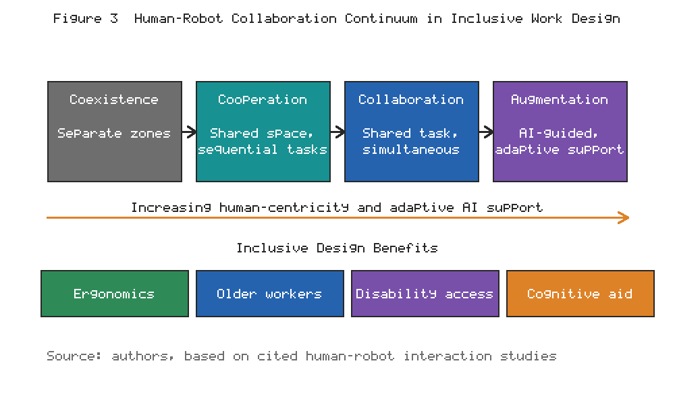
Figure 3. The human–robot collaboration continuum and associated inclusive work-design benefits, from coexistence to AI-mediated augmentation.
Table 3. Human–robot collaboration and inclusive-design technologies mapped to worker groups and inclusion outcomes.
Technology | Primary beneficiary group | Inclusion outcome
Collaborative robots (cobots) | Older and physically limited workers | Reduced physical strain, extended careers
Adaptive workstations | Workers of diverse stature and strength | Ergonomic accommodation without stigma
Augmented-reality guidance | New and reskilling workers | Lower cognitive load and error rates
Assistive AI interfaces | Workers with disabilities | Access to previously infeasible roles
Voice and gesture control | Workers with mobility impairments | Hands-free, flexible interaction
Real-time safety monitoring | All workers | Safer shared human-machine spaces

2.3 Personalized Learning, Upskilling, and Reskilling through AI
The accelerating pace of technological change in Industry 5.0 renders continuous learning a structural necessity rather than an occasional benefit. AI-driven identification of individual competency gaps forms the foundation of effective workforce development, enabling organisations to move beyond generic training toward precisely targeted intervention [33]. By analysing task performance, project outcomes, and the evolving requirements of roles, intelligent systems can construct a dynamic profile of each worker's strengths and development needs, and can compare these against forecasts of future skill demand to prioritise learning that maximises both individual employability and organisational capability [34].
Adaptive learning and intelligent training platforms then translate this diagnostic insight into personalised development experiences. These platforms adjust content, pacing, and modality to suit individual learning styles, prior knowledge, and constraints, and they can deliver learning in the flow of work through microlearning, simulation, and augmented-reality guidance [35]. For a diverse workforce, this adaptivity is a powerful equaliser: it accommodates workers who learn at different speeds, who have caring responsibilities that limit availability, or who lack the confidence and background that formal education traditionally assumes [36]. Personalisation, when designed inclusively, converts training from a one-size-fits-all filter into a bridge that many more workers can cross.
The inclusive potential of adaptive learning is amplified when it is combined with recognition of prior learning and with flexible credentialing. Many capable workers lack formal qualifications yet possess substantial practical competence acquired through experience; AI systems that assess demonstrated ability rather than relying solely on credentials can open pathways that were previously closed [34]. Micro-credentials and modular certifications, validated through intelligent assessment, allow workers to accumulate recognised skills incrementally, fitting learning around the constraints of work and life [35]. This modularity is especially valuable for workers who cannot afford to step away from employment for extended periods of formal study, a group that disproportionately includes those from lower socioeconomic backgrounds and those with caring responsibilities [36]. Inclusive reskilling thus depends not only on the sophistication of the learning technology but on the surrounding architecture of recognition and reward.
Continuous reskilling for emerging Industry 5.0 occupations is essential to ensuring that technological transition does not translate into exclusion. As roles evolve and new occupations emerge at the intersection of digital, physical, and sustainability domains, workers must be supported to transition rather than being discarded [37]. AI can identify viable career pathways, recommend the sequence of skills required to move from a declining role to a growing one, and track progress toward readiness. Figure 4 projects trajectories for reskilling completion, workforce inclusion, and the share of green jobs over a multi-year horizon, illustrating the compounding benefits of sustained investment in AI-enabled learning. This forward-looking view, revisited later in the discussion of green employment, situates reskilling as a cornerstone of both inclusion and sustainability [38].
Nonetheless, the reskilling imperative should not become a mechanism for displacing responsibility onto individual workers. A discourse that frames employability as a purely personal obligation risks blaming workers for structural changes beyond their control and for gaps in provision that are properly the responsibility of employers and public institutions [16]. Genuinely inclusive reskilling requires that organisations invest in accessible learning infrastructure, allocate paid time for development, and share the costs and risks of transition fairly. AI can make reskilling more efficient and better targeted, but it cannot substitute for the institutional commitment and resource allocation that make learning feasible for all workers rather than only for the already advantaged [33]. The distributional question of who bears the costs of transition is therefore inseparable from the technical question of how learning is delivered.
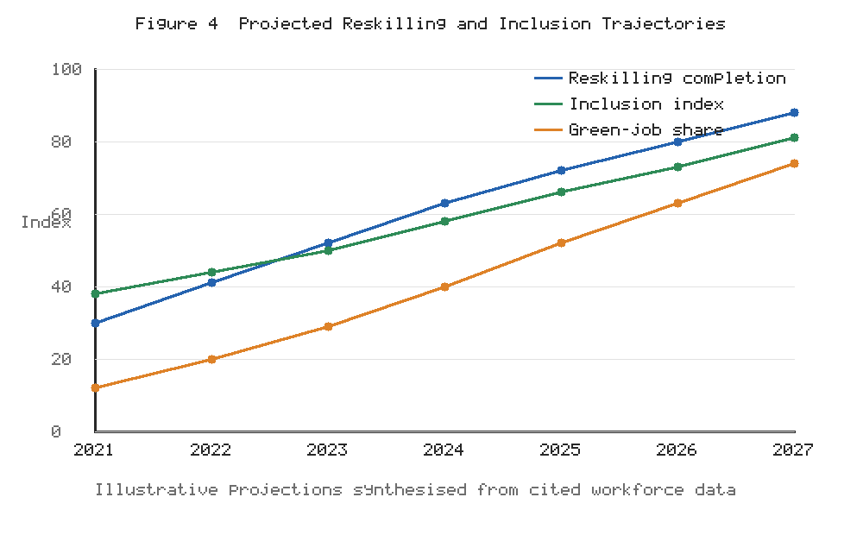
Figure 4. Projected multi-year trajectories for reskilling completion, workforce inclusion, and the share of AI-enabled green jobs under sustained investment in intelligent, personalised learning.

3. Sustainable and Equitable Workforce Transformation through AI

3.1 AI for Employee Well-Being, Safety, and Workplace Inclusion
The human-centric ethos of Industry 5.0 extends beyond productivity to encompass the well-being and safety of workers as ends in themselves. Intelligent occupational health and safety systems use sensor networks, computer vision, and predictive analytics to monitor the workplace environment and to identify hazards before they result in harm [39]. By detecting unsafe conditions, monitoring exposure to noise, heat, or hazardous substances, and analysing patterns of near-misses, these systems enable a proactive rather than reactive approach to safety, disproportionately benefiting workers in the most physically demanding and hazardous roles who have historically borne the greatest risk [40].
Wearable technologies and connected-worker solutions have expanded the range of physiological and environmental signals that can be captured in real time, from heart-rate variability and body temperature to exposure to hazardous agents [40]. When aggregated and analysed intelligently, these data streams can reveal patterns of risk that are invisible to conventional observation, enabling interventions that are both timely and targeted. The inclusive value of such systems lies partly in their capacity to protect workers whose vulnerabilities might otherwise be overlooked, including those with chronic health conditions or those working in the most demanding roles. Yet the intimacy of the data involved makes the governance of these technologies exceptionally sensitive, and their inclusive potential can only be realised where workers trust that the information will be used to protect rather than to penalise them [42].
The predictive identification of workplace risks and worker fatigue represents a particularly significant advance. AI systems can analyse physiological signals, movement patterns, and task data to detect the onset of fatigue, stress, or cognitive overload, prompting interventions such as task rotation, breaks, or workload redistribution [41]. When implemented with appropriate consent and privacy safeguards, such systems can protect vulnerable workers, including those managing health conditions, and can reduce the accidents and errors that fatigue precipitates. The inclusion dimension is important: fatigue and stress are not evenly distributed, and intelligent monitoring can help ensure that the burdens of production do not fall inequitably on particular groups [42].
AI can also support employee well-being and inclusive working environments more broadly. Sentiment analysis of voluntary feedback, coupled with well-being platforms, can help organisations understand the lived experience of diverse employees and detect emerging problems such as isolation, burnout, or exclusion [43]. However, the deployment of such tools raises acute ethical questions concerning surveillance, autonomy, and trust, which must be addressed through transparent purpose limitation and genuine worker participation. The well-being agenda thus exemplifies the broader tension at the heart of workplace AI: the same capabilities that can protect and include can, if misapplied, monitor and control [1].
The psychological safety of the workplace is itself a determinant of inclusion, and it is increasingly recognised as a condition for the effective functioning of diverse teams [43]. Workers who feel able to speak up, to admit uncertainty, and to raise concerns without fear of penalty contribute more fully and are more likely to remain with the organisation. AI-mediated feedback and well-being systems can either strengthen or erode this sense of safety, depending on how they are governed. Systems that are perceived as instruments of evaluation or discipline will suppress candour, whereas those that are genuinely oriented toward support, with clear guarantees about how data will and will not be used, can create channels through which the concerns of marginalised workers become visible to decision-makers [42]. The design choice between support and surveillance is thus consequential not only ethically but functionally, shaping whether the technology advances or undermines the inclusive culture it is meant to serve.

3.2 Ethical AI, Algorithmic Fairness, and Responsible Workforce Management
The ethical governance of AI in workforce management is not an optional supplement but a precondition for legitimacy. Algorithmic bias, arising from unrepresentative data, flawed problem formulation, or the encoding of historical discrimination, can systematically disadvantage protected groups across recruitment, evaluation, and development [11]. Transparency, explainability, and accountability are the principal antidotes: workers and managers must be able to understand how consequential decisions are reached, to interrogate the factors that drove them, and to identify who bears responsibility when systems err [23]. Explainability is particularly important where decisions affect livelihoods, since opaque systems undermine the ability to contest unfair outcomes [4].
Data privacy and the ethical management of employee information constitute a second pillar of responsible practice. Workforce AI systems typically depend on sensitive personal data, including performance records, biometric signals, and behavioural traces, the misuse of which can cause serious harm and erode trust [42]. Responsible management requires clear purpose limitation, data minimisation, robust security, and meaningful worker consent, together with governance structures that constrain function creep. Where monitoring technologies are deployed, the boundary between legitimate safety or well-being objectives and intrusive surveillance must be defined explicitly and enforced [40].
The asymmetry of power between employer and worker complicates the notion of consent in this context. Consent that is a condition of employment, or that is sought under implicit threat of disadvantage, cannot be considered genuinely free, and reliance on such consent to legitimise intrusive monitoring is ethically fragile [42]. Responsible practice therefore looks beyond formal consent to substantive protections, including independent oversight, collective agreement where workers are represented, and hard limits on the collection and use of the most sensitive categories of data. The temptation to expand monitoring incrementally, justifying each extension by reference to safety or productivity, is a recurrent danger, and only firm governance boundaries can prevent the gradual normalisation of pervasive surveillance [42]. The inclusive workplace depends on trust, and trust is corroded by monitoring that workers experience as disrespectful of their autonomy and dignity.
The debate over explainability illustrates the practical difficulty of operationalising these principles. Some of the most predictive machine learning models are also the most opaque, creating an apparent tension between accuracy and interpretability [24]. In high-stakes workforce decisions, however, the case for interpretable models is strong: the ability to understand and justify a decision is not a luxury but a requirement of fairness and accountability, and the marginal predictive gains of opaque models rarely justify the loss of contestability [24]. Where complex models are used, they should be accompanied by robust explanation mechanisms and by human review of consequential outputs. The governance question is not merely technical but institutional, concerning who has the authority to interrogate a system, who is accountable for its decisions, and what recourse is available to those affected [23].
Human oversight and responsible AI governance provide the connective tissue that binds these principles into practice. Rather than delegating consequential decisions wholly to automated systems, responsible organisations maintain meaningful human control, using AI to inform rather than to dictate judgement in high-stakes contexts [17]. This entails clear accountability structures, cross-functional governance bodies, regular auditing, and mechanisms for worker voice in the design and deployment of systems that affect them. Table 4 synthesises the core ethical risks of workforce AI alongside corresponding governance responses and their alignment with the human-centric principles of Industry 5.0, providing a practical reference for organisations seeking to operationalise responsible AI [26].
Worker participation deserves particular emphasis as a governance mechanism, because those most affected by workforce AI are frequently excluded from decisions about its design and deployment. Participatory approaches, in which workers and their representatives contribute to defining the purposes, boundaries, and safeguards of AI systems, improve both the legitimacy and the quality of those systems [26]. Workers possess situated knowledge of their tasks and contexts that designers often lack, and their involvement can surface risks and unintended consequences that would otherwise go unnoticed. Moreover, participation is itself an expression of the human-centric values that Industry 5.0 espouses, treating workers as agents and stakeholders rather than as objects of optimisation [4]. The proliferation of ethics guidelines in recent years has established broad consensus on principles, but the persistent gap between principle and practice can only be closed through concrete governance arrangements that give workers genuine voice [26].
Table 4. Ethical risks of workforce AI, governance responses, and alignment with human-centric Industry 5.0 principles.
Ethical risk | Governance response | Human-centric alignment
Algorithmic bias | Bias audits and fairness constraints | Equity and non-discrimination
Opacity of decisions | Explainable AI and decision logs | Transparency and contestability
Privacy intrusion | Data minimisation and consent | Respect for worker autonomy
Excessive surveillance | Purpose limitation and oversight | Trust and dignity
Automation of judgement | Meaningful human control | Human agency and accountability
Function creep | Governance bodies and audits | Responsible innovation

3.3 AI-Enabled Green Jobs and Sustainable Employment Models
The sustainability pillar of Industry 5.0 connects workforce transformation to the imperative of environmental stewardship, giving rise to AI-enabled green and circular-economy occupations. As manufacturing organisations pursue decarbonisation, resource efficiency, and circularity, new roles emerge in areas such as energy optimisation, remanufacturing, waste valorisation, and sustainable supply-chain management [37]. AI is instrumental in these domains, optimising energy consumption, enabling predictive maintenance that extends asset life, and supporting the design of products for reuse and recycling, thereby generating employment that is both economically and environmentally sustainable [3].
The workforce transition toward low-carbon manufacturing must be managed to ensure that it is just as well as green. Workers in carbon-intensive or soon-to-be-automated roles require pathways into emerging green occupations, and AI-enabled reskilling, as discussed earlier and projected in Figure 4, is central to enabling these transitions without displacement into unemployment or precarity [38]. A just transition also requires attention to the geographic and demographic distribution of new opportunities, so that the communities and workers most exposed to the decline of legacy industries are not excluded from the emerging green economy [15]. Equity and sustainability are, in this sense, deeply intertwined.
The circular economy adds a further dimension to the green-jobs agenda, generating employment in remanufacturing, refurbishment, disassembly, and materials recovery that is often more labour-intensive and geographically distributed than conventional linear production [37]. These characteristics can be favourable for inclusion, creating opportunities in a wider range of locations and for workers with diverse skill profiles. AI supports circular operations by enabling the tracking of materials and components, optimising reverse logistics, and informing the design of products for durability and recyclability, thereby underpinning the business viability of circular models [3]. The convergence of digitalisation and circularity thus opens a distinctive space for employment that is simultaneously sustainable, inclusive, and resilient, provided the transition is managed with attention to the quality and security of the jobs created.
Balancing automation, productivity, employment security, and sustainability is the central strategic challenge of this domain. The human-centric orientation of Industry 5.0 cautions against pursuing productivity and decarbonisation in ways that undermine employment security or worker dignity, and instead advocates configurations in which automation augments human labour and expands the range of meaningful, sustainable work [2]. Achieving this balance requires deliberate policy and organisational choices, informed by workforce analytics and guided by a commitment to shared prosperity, so that the green transition becomes an engine of inclusion rather than a new axis of inequality [18]. The concept of a just transition, developed originally in the context of climate policy, provides a useful normative anchor, insisting that the burdens and benefits of environmental transformation be distributed fairly and that affected workers and communities be actively supported through change [37]. Embedding this principle in the deployment of workforce AI ensures that the pursuit of sustainability reinforces rather than compromises the goals of equity and inclusion.

4. Implementation Framework, Challenges, and Future Directions

4.1 Framework for AI-Enabled Inclusive Workforce Development
Translating the aspirations of the preceding sections into practice requires an integrated implementation framework that addresses organisational, technological, and human dimensions in concert. The organisational dimension encompasses leadership commitment, DEI strategy, governance structures, and an inclusive culture that legitimises the use of AI for equitable ends [7]. The technological dimension concerns the maturity, quality, and interoperability of AI systems, the availability of representative data, and the infrastructure for monitoring and auditing. The human dimension addresses the skills, well-being, trust, and participation of workers, without which even the most sophisticated systems will fail to deliver inclusive outcomes [6]. As depicted in Figure 1, these dimensions are mutually reinforcing, and neglecting any one of them undermines the whole.
Central to the framework is the definition and tracking of DEI indicators and workforce sustainability metrics. Organisations require a balanced set of measures spanning representation, equity in outcomes, inclusion and belonging, and the sustainability of employment, so that progress can be assessed and accountability maintained [10]. Such metrics should be integrated into standard performance management and reporting rather than isolated in periodic diversity reports, and they should be interpreted with sensitivity to context and to the risk that quantification itself can distort behaviour [25]. The indicators illustrated in Figure 2 exemplify the kind of measures that can anchor this monitoring.
Implementation, moreover, is not a single event but a maturation process that unfolds over time. Organisations typically progress from initial experimentation, through the establishment of governance and the scaling of proven applications, toward the deep integration of inclusive AI into strategy and culture [14]. A staged, readiness-based approach allows organisations to build capability incrementally, to learn from early deployments, and to avoid the twin pitfalls of reckless adoption and paralysing caution. Critically, maturity in this domain is not measured by the sophistication of the technology alone but by the degree to which technological, organisational, and human dimensions advance in concert, and by the demonstrable improvement in inclusion and sustainability outcomes over time [7]. Assessment tools that evaluate readiness across these dimensions can help organisations diagnose their current position and prioritise the investments most likely to yield equitable results.
Finally, the framework must integrate AI-enabled workforce strategies with corporate sustainability objectives and the Sustainable Development Goals. Inclusive workforce development should not be pursued in a silo but embedded within the organisation's broader sustainability and social-responsibility commitments, reinforcing and being reinforced by environmental and governance initiatives [18]. This integration ensures coherence, avoids the fragmentation of effort, and positions the organisation to contribute credibly to SDG 5, SDG 8, SDG 9, and SDG 10 while pursuing its commercial objectives. The alignment of internal practice with these external goals is a hallmark of the mature, human-centric organisation envisaged by Industry 5.0 [19]. Reporting frameworks that connect workforce metrics to the SDGs enable organisations to communicate their contribution transparently to investors, regulators, and society, reinforcing accountability and situating inclusive workforce development within the wider movement toward responsible and sustainable business.

4.2 Challenges, Risks, and Organizational Barriers
Notwithstanding its promise, the path to AI-enabled inclusive workforce development is beset by significant challenges. Foremost among these is the digital divide, which manifests as unequal access to the devices, connectivity, and foundational digital skills required to benefit from AI-based opportunities [12]. Within organisations, this divide can mirror and magnify existing socioeconomic inequalities, excluding precisely those workers whom inclusive strategies are intended to support. Addressing it requires investment in accessible infrastructure, subsidised learning, and deliberate outreach to disadvantaged groups, without which AI risks widening rather than narrowing gaps [16].
Workforce displacement and resistance to technological change represent a second cluster of challenges. The prospect of automation naturally generates anxiety, and where change is imposed without consultation or support, resistance and disengagement are predictable responses [6]. Managing this transition demands transparent communication, genuine worker participation, credible commitments to reskilling and redeployment, and attention to the psychological dimensions of change. The human-centric framing of Industry 5.0 provides a constructive narrative, but it must be substantiated by action if it is to command trust rather than cynicism [4].
A further set of risks concerns skills shortages, cybersecurity, privacy, and algorithmic discrimination. The shortage of workers with the hybrid competencies required to build, deploy, and govern AI systems constrains implementation and can itself become a source of inequality if access to such skills is unevenly distributed [33]. Cybersecurity vulnerabilities threaten the integrity of workforce systems and the confidentiality of sensitive employee data, while inadequate privacy protection erodes trust [42]. Algorithmic discrimination, discussed earlier, remains a persistent danger wherever fairness is not actively engineered and monitored [11]. Table 4 and Table 2 together highlight the safeguards through which these risks can be mitigated, but their effectiveness depends on sustained organisational commitment rather than one-off compliance [23].
These challenges are compounded by their tendency to interact and reinforce one another. The digital divide intersects with skills shortages, so that the same populations excluded from digital opportunity are also underrepresented among those building AI systems, perpetuating a lack of diverse perspectives in design [12]. Resistance to change is heightened where workers perceive, often correctly, that the benefits of technology accrue to the organisation while the risks are borne by them. Algorithmic discrimination is more likely and harder to detect where governance is weak and worker voice is absent. Addressing these interlocking challenges therefore requires a systemic rather than a piecemeal response, integrating investment in infrastructure and skills, transparent and participatory governance, and a genuine commitment to sharing the gains of transformation [7]. Organisations that treat these issues as isolated technical problems, rather than as facets of a single sociotechnical challenge, are likely to find that progress in one area is undone by neglect in another.
The organisational barriers to inclusive AI adoption are frequently as significant as the technical ones. Entrenched cultures, misaligned incentives, short-term financial pressures, and the absence of accountability for equity outcomes can all impede progress even where the technological means are readily available [13]. Leadership commitment is repeatedly identified as a decisive factor, since inclusive AI initiatives require sustained investment, the acceptance of trade-offs, and the willingness to confront uncomfortable evidence of disparity. Without such commitment, DEI-oriented AI risks becoming a symbolic exercise, generating impressive dashboards while leaving the underlying distribution of opportunity unchanged [10]. Overcoming these barriers demands not only technical solutions but organisational change management, aligned incentives, and the embedding of inclusion into the core objectives against which leaders and systems are held accountable.

4.3 Future Perspectives: Human-Centric AI and the Next Generation of Industry 5.0
Looking ahead, the trajectory of AI-enabled workforce development will be shaped by advances in explainable, trustworthy, and inclusive AI systems. Research and practice are converging on the recognition that AI systems affecting people's livelihoods must be intelligible, contestable, and demonstrably fair, and that these properties must be designed in from the outset rather than retrofitted [17]. Progress in explainable AI, fairness-aware machine learning, and participatory design offers grounds for optimism, but realising trustworthy systems at scale remains an open challenge requiring interdisciplinary collaboration among technologists, social scientists, and workers themselves [24].
The maturation of AI–human collaboration and augmented intelligence will further reshape the workplace. Rather than framing the future in terms of humans versus machines, the augmented-intelligence perspective envisages complementary configurations in which AI amplifies human judgement, creativity, and empathy while humans provide the contextual understanding, ethical reasoning, and social intelligence that machines lack [28]. As Figure 3 suggests, the movement along the collaboration continuum toward augmentation holds particular promise for inclusion, enabling more workers to contribute productively and meaningfully regardless of their starting capabilities [32]. Designing these collaborations to enhance rather than diminish human agency is a central task for the next generation of Industry 5.0.
This augmentation perspective carries important implications for how the value of human labour is conceived. As routine capabilities are increasingly automated, the distinctively human contributions of creativity, judgement, care, and ethical reasoning become more rather than less valuable, and the design of work should be oriented toward cultivating and rewarding these capacities [5]. For inclusion, this reorientation can be liberating, since it broadens the range of valued contributions beyond the narrow technical proficiencies that some workers may lack, recognising the diverse forms of intelligence and experience that a heterogeneous workforce brings [32]. Yet the outcome is not predetermined: the same technologies could equally be deployed to deskill and control, and the difference lies in the choices organisations make. The next generation of Industry 5.0 will be shaped by whether augmentation is used to enlarge human capability and dignity or to subordinate human workers to the imperatives of the machine.
The convergence of these trends points toward a future in which the boundary between technological and human development becomes increasingly blurred, and in which the success of intelligent manufacturing is measured as much by its human and social outcomes as by its productivity. Realising this future will require the deliberate cultivation of what might be termed sociotechnical literacy among engineers, managers, and workers alike, so that decisions about the design and deployment of AI are made with a full appreciation of their human consequences [4]. It will also require the strengthening of institutions, from professional bodies to regulators to worker organisations, capable of steering technological change toward inclusive and sustainable ends. The trajectory of workforce AI is not fixed by the technology itself but remains open to human choice, and that openness is both the challenge and the opportunity of the present moment.
In synthesis, this chapter has argued that artificial intelligence can be a powerful ally in the pursuit of diversity, equity, and inclusion within the intelligent manufacturing workplaces of Industry 5.0, but that its beneficial potential is neither automatic nor guaranteed. Across recruitment, human–robot collaboration, personalised learning, well-being, ethical governance, and green employment, the same capabilities that can widen access and protect workers can, if misapplied, exclude and control. The decisive variable is the constellation of values, incentives, and governance structures within which AI is embedded. The human-centric philosophy of Industry 5.0 supplies a normative compass, insisting that technology serve human flourishing, resilience, and sustainability rather than the reverse. Translating this philosophy into practice demands the integrated development of organisational, technological, and human capabilities; the disciplined measurement of DEI and sustainability outcomes; and an unwavering commitment to keeping human dignity and agency at the centre of the intelligent manufacturing enterprise. Where these conditions are met, AI can help build workplaces that are not only more productive and sustainable but also fairer, more inclusive, and more genuinely human, advancing the Sustainable Development Goals and demonstrating that technological progress and social progress can, with deliberate effort, be made to reinforce one another.
The regulatory and institutional environment will also shape the trajectory of workforce AI in decisive ways. Emerging frameworks for the governance of AI, together with established labour and anti-discrimination law, are beginning to define the boundaries of acceptable practice, and organisations that anticipate and exceed these requirements will be better positioned than those that treat compliance as a minimum to be grudgingly met [26]. The interplay between regulation, industry standards, and organisational practice is dynamic, and constructive engagement by manufacturers, workers, and researchers can help shape frameworks that are both protective and enabling. In this respect, the future of inclusive workforce AI is not solely a technological question but a matter of collective institutional design, in which the choices made now will condition the options available to future generations of workers [18].
Future research directions should focus on the conditions under which AI genuinely advances sustainable, diverse, equitable, and resilient manufacturing workplaces. Priorities include longitudinal evidence on the DEI impacts of specific AI applications, methods for auditing fairness in complex sociotechnical systems, participatory approaches to system design, and frameworks for aligning workforce AI with the Sustainable Development Goals [19]. There is also a pressing need for interdisciplinary scholarship that bridges the technical, organisational, and social dimensions of the field, since the fragmentation of research along disciplinary lines has hindered the development of integrated understanding. Comparative studies across sectors, regions, and organisational types would help identify which approaches travel well and which are context-dependent, while participatory and worker-centred research methods would ensure that the perspectives of those most affected inform the knowledge base [36]. Overall, the transition toward a human-centric industrial future requires a balanced approach in which technological capability, human competence, organisational capacity, ethical governance, and stakeholder acceptance develop together. A data-driven AI readiness framework can provide organisations with a structured mechanism for identifying gaps, prioritising investments, evaluating progress, and developing responsible AI strategies. The human community should remain at the centre of this transformation so that AI becomes an enabler of creativity, inclusion, personalisation, resilience, and human development rather than simply another layer of technological automation [2].

References
[1] Xu, X., Lu, Y., Vogel-Heuser, B., & Wang, L. (2021). Industry 4.0 and Industry 5.0—Inception, conception and perception. Journal of Manufacturing Systems, 61, 530–535.
[2] Breque, M., De Nul, L., & Petridis, A. (2021). Industry 5.0: Towards a Sustainable, Human-Centric and Resilient European Industry. Publications Office of the European Union, Luxembourg.
[3] Leng, J., Sha, W., Wang, B., Zheng, P., Zhuang, C., Liu, Q., Wuest, T., Mourtzis, D., & Wang, L. (2022). Industry 5.0: Prospect and retrospect. Journal of Manufacturing Systems, 65, 279–295.
[4] Nahavandi, S. (2019). Industry 5.0—A human-centric solution. Sustainability, 11(16), 4371.
[5] Wang, B., Zheng, P., Yin, Y., Shih, A., & Wang, L. (2022). Toward human-centric smart manufacturing: A human-cyber-physical systems (HCPS) perspective. Journal of Manufacturing Systems, 63, 471–490.
[6] World Economic Forum. (2023). The Future of Jobs Report 2023. World Economic Forum, Geneva.
[7] Maddikunta, P. K. R., Pham, Q. V., Prabadevi, B., Deepa, N., Dev, K., Gadekallu, T. R., Ruby, R., & Liyanage, M. (2022). Industry 5.0: A survey on enabling technologies and potential applications. Journal of Industrial Information Integration, 26, 100257.
[8] Roberson, Q. M. (2019). Diversity in the workplace: A review, synthesis, and future research agenda. Annual Review of Organizational Psychology and Organizational Behavior, 6, 69–88.
[9] Nash, M., & Moore, R. (2021). Exploring gendered experiences in STEMM and the role of inclusive workplace cultures. Gender, Work & Organization, 28(4), 1543–1560.
[10] Shore, L. M., Cleveland, J. N., & Sanchez, D. (2018). Inclusive workplaces: A review and model. Human Resource Management Review, 28(2), 176–189.
[11] Raghavan, M., Barocas, S., Kleinberg, J., & Levy, K. (2020). Mitigating bias in algorithmic hiring: Evaluating claims and practices. Proceedings of the ACM Conference on Fairness, Accountability, and Transparency, 469–481.
[12] van Dijk, J. A. G. M. (2020). The Digital Divide. Polity Press, Cambridge.
[13] Nishii, L. H., & Leroy, H. (2022). A multi-level framework of inclusive leadership in organizations. Group & Organization Management, 47(4), 683–722.
[14] Tambe, P., Cappelli, P., & Yakubovich, V. (2019). Artificial intelligence in human resources management: Challenges and a path forward. California Management Review, 61(4), 15–42.
[15] Frey, C. B., & Osborne, M. A. (2017). The future of employment: How susceptible are jobs to computerisation? Technological Forecasting and Social Change, 114, 254–280.
[16] OECD. (2019). OECD Employment Outlook 2019: The Future of Work. OECD Publishing, Paris.
[17] Floridi, L., Cowls, J., Beltrametti, M., Chatila, R., Chazerand, P., Dignum, V., et al. (2018). AI4People—An ethical framework for a good AI society. Minds and Machines, 28(4), 689–707.
[18] United Nations. (2015). Transforming Our World: The 2030 Agenda for Sustainable Development. United Nations, New York.
[19] Vinuesa, R., Azizpour, H., Leite, I., Balaam, M., Dignum, V., Domisch, S., et al. (2020). The role of artificial intelligence in achieving the Sustainable Development Goals. Nature Communications, 11, 233.
[20] Hunkenschroer, A. L., & Luetge, C. (2022). Ethics of AI-enabled recruiting and selection: A review and research agenda. Journal of Business Ethics, 178(4), 977–1007.
[21] Chamorro-Premuzic, T., Winsborough, D., Sherman, R. A., & Hogan, R. (2016). New talent signals: Shiny new objects or a brave new world? Industrial and Organizational Psychology, 9(3), 621–640.
[22] Barocas, S., & Selbst, A. D. (2016). Big data's disparate impact. California Law Review, 104(3), 671–732.
[23] Mehrabi, N., Morstatter, F., Saxena, N., Lerman, K., & Galstyan, A. (2021). A survey on bias and fairness in machine learning. ACM Computing Surveys, 54(6), 1–35.
[24] Rudin, C. (2019). Stop explaining black box machine learning models for high-stakes decisions and use interpretable models instead. Nature Machine Intelligence, 1(5), 206–215.
[25] Angrave, D., Charlwood, A., Kirkpatrick, I., Lawrence, M., & Stuart, M. (2016). HR and analytics: Why HR is set to fail the big data challenge. Human Resource Management Journal, 26(1), 1–11.
[26] Jobin, A., Ienca, M., & Vayena, E. (2019). The global landscape of AI ethics guidelines. Nature Machine Intelligence, 1(9), 389–399.
[27] Villani, V., Pini, F., Leali, F., & Secchi, C. (2018). Survey on human–robot collaboration in industrial settings: Safety, intuitive interfaces and applications. Mechatronics, 55, 248–266.
[28] Wang, L., Gao, R., Váncza, J., Krüger, J., Wang, X. V., Makris, S., & Chryssolouris, G. (2019). Symbiotic human-robot collaborative assembly. CIRP Annals, 68(2), 701–726.
[29] Gualtieri, L., Rauch, E., & Vidoni, R. (2021). Emerging research fields in safety and ergonomics in industrial collaborative robotics: A systematic literature review. Robotics and Computer-Integrated Manufacturing, 67, 101998.
[30] Kadir, B. A., Broberg, O., & da Conceição, C. S. (2019). Current research and future perspectives on human factors and ergonomics in Industry 4.0. Computers & Industrial Engineering, 137, 106004.
[31] Baltrusch, S. J., Krause, F., de Vries, A. W., van Dijk, W., & de Looze, M. P. (2022). What about the human in human-robot collaboration? Ergonomics, 65(5), 719–740.
[32] Demir, K. A., Döven, G., & Sezen, B. (2019). Industry 5.0 and human-robot co-working. Procedia Computer Science, 158, 688–695.
[33] Illanes, P., Lund, S., Mourshed, M., Rutherford, S., & Tyreman, M. (2018). Retraining and Reskilling Workers in the Age of Automation. McKinsey Global Institute.
[34] Faraj, S., Pachidi, S., & Sayegh, K. (2018). Working and organizing in the age of the learning algorithm. Information and Organization, 28(1), 62–70.
[35] Kabudi, T., Pappas, I., & Olsen, D. H. (2021). AI-enabled adaptive learning systems: A systematic mapping of the literature. Computers and Education: Artificial Intelligence, 2, 100017.
[36] Zawacki-Richter, O., Marín, V. I., Bond, M., & Gouverneur, F. (2019). Systematic review of research on artificial intelligence applications in higher education. International Journal of Educational Technology in Higher Education, 16, 39.
[37] International Labour Organization. (2019). Skills for a Greener Future: A Global View. International Labour Office, Geneva.
[38] Bughin, J., Hazan, E., Lund, S., Dahlström, P., Wiesinger, A., & Subramaniam, A. (2018). Skill Shift: Automation and the Future of the Workforce. McKinsey Global Institute.
[39] Podgórski, D., Majchrzycka, K., Dąbrowska, A., Gralewicz, G., & Okrasa, M. (2017). Towards a conceptual framework of OSH risk management in smart working environments based on smart PPE, the Internet of Things and cyber-physical systems. International Journal of Occupational Safety and Ergonomics, 23(1), 1–20.
[40] Patel, V., Chesmore, A., Legner, C. M., & Pandey, S. (2022). Trends in workplace wearable technologies and connected-worker solutions for next-generation occupational safety, health, and productivity. Advanced Intelligent Systems, 4(1), 2100099.
[41] Adão Martins, N. R., Annaheim, S., Spengler, C. M., & Rossi, R. M. (2021). Fatigue monitoring through wearables: A state-of-the-art review. Frontiers in Physiology, 12, 790292.
[42] Ajunwa, I., Crawford, K., & Schultz, J. (2017). Limitless worker surveillance. California Law Review, 105(3), 735–776.
[43] Tkalich, A., Ulfsnes, R., & Moe, N. B. (2022). Toward an agile mindset in software organizations: Well-being and psychological safety. Journal of Systems and Software, 194, 111490.

