Irreversibility Analysis of a Radiative Casson Hybrid Nanofluid Between Squeezing Porous Plates: Bejan Number and Second-Law Optimization
Authors: [Author 1]¹, Kalpna Sharma¹\*, [Author 3]² ¹Department of Mathematics and Statistics, Manipal University Jaipur, Jaipur, Rajasthan, India ²Department of Mathematics, [Affiliation], India \*Corresponding author.

Abstract
A comprehensive second-law investigation is presented for the two-dimensional, unsteady, magnetohydrodynamic (MHD) squeezing flow of a Casson Cu–Al₂O₃/water hybrid nanofluid confined between two horizontal parallel plates saturated by a Darcy porous medium. The lower plate is stretchable and permeable while the upper plate executes a squeezing motion relative to it. Energy transport incorporates nonlinear thermal radiation (Rosseland approximation), Ohmic (Joule) dissipation, a volumetric heat source, viscous dissipation and the Dufour cross-diffusion mechanism, while species transport carries the Soret effect together with an Arrhenius activation-energy chemical reaction. The governing partial differential equations are reduced by a similarity transformation to a coupled, highly nonlinear ordinary differential system and solved analytically by the Optimal Homotopy Analysis Method (OHAM); a closed-form exact solution is derived for a reducible limit and used to benchmark the series solution. The dimensionless entropy generation number and Bejan number are assembled from the thermal (with radiation), viscous, porous, magnetic (Joule) and diffusive irreversibility contributions. Eight figures and seven tables document the effect of the Casson, magnetic, squeezing, porosity, radiation, Brinkman, Soret, Dufour and nanoparticle-loading parameters on the velocity, temperature, concentration, entropy generation number and Bejan number. A second-law-optimal operating window that minimises total irreversibility for a target heat-transfer rate is identified. Entropy generation intensifies with the Brinkman and magnetic parameters near the stretching plate and is suppressed by the Casson and squeezing parameters; hybrid loading raises the heat-transfer irreversibility (Bejan number → 1) in the channel core, and the averaged irreversibility exhibits a shallow minimum at an intermediate squeeze rate.
Keywords: Casson hybrid nanofluid; Squeezing flow; Entropy generation; Bejan number; Thermal radiation; Joule heating; Cross-diffusion; OHAM; Second-law optimization.

Nomenclature
Symbol | Meaning | Symbol | Meaning
u,v | velocity components (m s⁻¹) | B(t) | magnetic field
T | temperature (K) | M | magnetic parameter
C | concentration (mol m⁻³) | Sq | squeezing parameter
β* | Casson parameter | K_P | porosity parameter
κ_(hnf) | hybrid nanofluid conductivity | Rd | radiation parameter
μ_(hnf) | hybrid nanofluid viscosity | Pr | Prandtl number
ρ_(hnf) | hybrid nanofluid density | Ec | Eckert number
σ_(hnf) | hybrid electrical conductivity | Sc | Schmidt number
φ₁,φ₂ | Al₂O₃, Cu volume fractions | Sr | Soret number
q_r | radiative heat flux | Df | Dufour number
Q₀ | heat-source coefficient | Br | Brinkman number
E | activation-energy parameter | K | reaction parameter
N_G | entropy generation number | Be | Bejan number
S_(gen) | volumetric entropy generation | Ω,ζ | temperature, concentration ratios
f,θ,φ | dimensionless stream, temperature, concentration | η | similarity variable
Subscripts: f base fluid; nf nanofluid; hnf hybrid nanofluid; s₁ Al₂O₃; s₂ Cu.

1. Introduction
Efficient thermal management in compact engineering hardware — microelectronic cooling stacks, compression and lubrication assemblies, biomedical squeeze-film devices and miniaturised heat exchangers — has stimulated intensive study of advanced working fluids and of the confined geometries that transport heat most effectively. A decisive advance has been the hybrid nanofluid, in which two distinct nanoparticle species are dispersed in a base liquid so that their complementary attributes reinforce one another; the unsteady squeezing of a Cu–Al₂O₃/water hybrid nanofluid in a magnetised horizontal channel was analysed by Khashi'ie et al. [1], who established the bvp4c benchmark that later studies routinely reproduce. Building on that geometry, Bhaskar et al. [2] examined the Casson Cu–Al₂O₃/water hybrid nanofluid between squeezing plates with thermal radiation and Joule heating, while Bhaskar and Sharma [3] treated a single-phase viscous Casson fluid in the same channel with cross-diffusion, chemical reaction and multiple slip. The present work unifies and extends [2] and [3].
The thermodynamic quality of such flows, rather than merely their energy balance, is captured by entropy generation. Murshid et al. [4] quantified entropy generation and performed a statistical analysis of an MHD hybrid-nanofluid unsteady squeezing flow between rotating plates with activation energy, and a companion analysis [5] optimised the entropy of a Cu–Al₂O₃/water flow through a porous stretching sheet with slip, Joule heating and chemical reaction. Enclosure and obstacle configurations were addressed by Chabani et al. [6] for a hybrid nanofluid in a triangular cavity, and dilating/squeezing porous channels by Bilal et al. [7]. Cross-diffusion (Soret–Dufour) coupling in three-dimensional MHD flow with radiation and reaction was studied by Sharma and Bhaskar [8], and entropy-generation optimisation for a chemically reactive magnetised radiative Cu–Al₂O₃ hybrid nanofluid was reported in [9]. More recently, chemically reacting Cu/Al₂O₃ Casson hybrid nanofluid transport through a porous medium with slip was analysed in [10], and a wavelet-enhanced physics-informed neural-network framework for double-diffusive hybrid CNT nanofluids with cross-diffusion and heat generation was developed in [11].
Rotating-disk and stretching-surface studies have delineated the roles of the governing groups. Zangooee et al. [12] examined MHD nanofluid flow between stretching rotating disks; Dawar et al. [13] simulated a rotating sodium-alginate iron-oxide layer under solar radiation; and Gul et al. [14] analysed dissipative nanofluid flow over an unsteady turning disk. Casson-specific transport has been probed by Saeed et al. [15] for a permeable stretching sheet with first-order reaction, by Lim et al. [16] for a Von Kármán configuration with Navier slip and Cattaneo–Christov flux, and by Kumar et al. [17] for thermophoretic deposition over a moving needle. Hybrid and multi-particle suspensions on spheres and corrugated ducts were reported by Nasir et al. [18], while non-Fourier stagnation transport was studied by Jawad and Nisar [19]; the combined Cattaneo–Christov and Arrhenius activation-energy effects on an MHD Maxwell nanofluid were disclosed by Azam [20].
Particle-shape and morphology effects were quantified by Rashid et al. [21] for graphene–water and by Painuly et al. [22] for a helically corrugated hybrid-nanofluid duct, and a comparative particle-shape study between parallel plates was carried out by Chu et al. [23]. Couple-stress hybrid nanofluid transport in a converging–diverging channel was analysed by Ullah et al. [24], bioconvective MHD Williamson transport by Bhatti et al. [25], and Buongiorno-model performance over a curved surface by Mishra et al. [26]. Fractal–fractional Casson electro-osmosis was modelled by Murtaza et al. [27], electro-osmotic third-grade micro-channel flow by Nazeer et al. [28], and hybrid-nanofluid chip cooling with entropy generation by Korei and Louali [29]. Slippery Sutterby hybrid radiative flow was simulated by Bouslimi et al. [30]. Most recently, ternary hybrid Casson nanofluids in porous media were assessed through sensitivity analysis in [31], radiative-convective Casson hybrid transport with Cattaneo–Christov flux and entropy estimation over an inclined disk in [32], reaction-diffusion-coupled Casson hybrid transport under boundary slip in [33], and Casson hybrid nanoparticles over a porous stretchable plate with the Cattaneo–Christov model in [34].
The foregoing survey reveals that, although the individual ingredients are well studied, the reported squeezing-flow entropy analyses are largely confined to single-phase or single-particle nanofluids or to rotating-plate geometries [4,5,29], and they seldom retain the full mechanism set — yield-stress rheology, dual-particle hybrid suspension, Darcy resistance, nonlinear radiation, Ohmic dissipation, and coupled heat-and-mass transfer with cross-diffusion and Arrhenius chemistry — that a realistic squeeze-film device experiences [2,3,10]. Consequently the true irreversibility budget of such a device, and the operating window that minimises it, remain unquantified. The present study closes this gap: it formulates the thermodynamically complete model, solves it by OHAM [3,20], verifies it against the exact reducible limit and the benchmark of [1], and delivers a full entropy-generation and Bejan-number analysis together with a second-law optimisation.

2. Mathematical Formulation

2.1 Physical model and assumptions
Consider the unsteady, two-dimensional, laminar, incompressible flow of a Casson Cu–Al₂O₃/water hybrid nanofluid between two infinite horizontal parallel plates saturated by a Darcy porous medium, with the x-axis along the lower plate and the y-axis normal to it. The physical configuration, together with the coordinate system, the imposed transverse magnetic field, the stretching and suction/injection of the lower wall and the squeezing motion of the upper wall, is depicted in Figure 1. This stretchable-lower/squeezing-upper arrangement is precisely the geometry adopted in the benchmark hybrid-nanofluid study of Khashi'ie et al. [1] and in the antecedent works [2,3] that the present model unifies and extends.
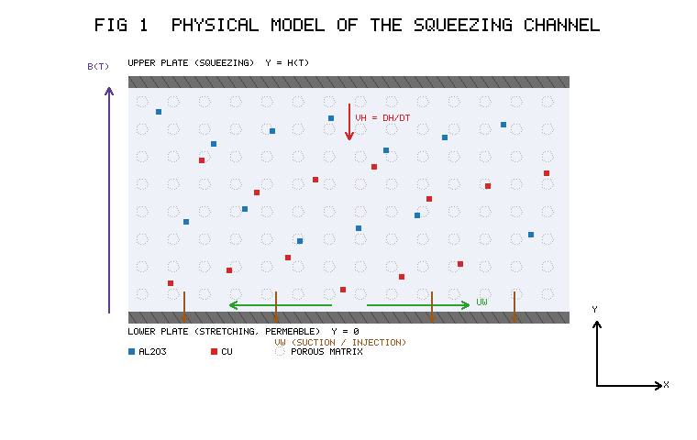
Figure 1. Physical model of the squeezing channel: Casson Cu–Al₂O₃/water hybrid nanofluid in a Darcy porous medium between a stretchable, permeable lower plate (y=0) and a squeezing upper plate (y=h(t)), under a transverse magnetic field B(t).
The modelling assumptions, standard for this class of problem [1,2,7,23], are: (i) the flow is laminar, incompressible and two-dimensional; (ii) the two nanoparticle species (Al₂O₃ and Cu) are in thermal equilibrium with the water base fluid and are uniformly dispersed, so that the single-phase (homogeneous) hybrid-nanofluid model with the correlations of Section 2.3 applies; (iii) the magnetic Reynolds number is small, hence the induced magnetic field is negligible relative to the applied field B(t); (iv) the porous matrix is homogeneous and isotropic and its resistance follows the Darcy law; (v) thermal radiation is treated through the optically thick Rosseland approximation; and (vi) the Hall current, viscous heating of the porous solid and particle-migration (Brownian/thermophoretic) fluxes are neglected. Under these hypotheses the upper plate sits at the time-dependent gap
$h(t)=\sqrt{\frac{ν_{f}(1-α t)}{b}}, t<\frac{1}{α}$ (1)
and moves with velocity
$V_{h}=\frac{dh}{dt}=-\frac{α}{2}\sqrt{\frac{ν_{f}}{b(1-α t)}}$ (2)
The lower plate stretches with
$u_{w}=\frac{bx}{1-α t}$ (3)
carries the time-dependent magnetic field
$B(t)=\frac{B_{0}}{\sqrt{1-α t}}$ (4)
and is permeable, admitting wall-normal suction/injection
$v_{w}=-\frac{V_{0}}{1-α t}$ (5)
The rheological state equation of the Casson fluid is
$τ_{ij}=\left\{\begin{aligned}2\left(μ_{B}+\frac{p_{y}}{\sqrt{2π}}\right)e_{ij} {π>π}_{c} \\ 2\left(μ_{B}+\frac{p_{y}}{\sqrt{{2π}_{c}}}\right)e_{ij} {π<π}_{c}\end{aligned}\right.$ (6)
with the Casson parameter
$β^{*}=\frac{μ_{B}\sqrt{{2π}_{c}}}{p_{y}}$ (7)
The Casson model (6)–(7) is adopted because it faithfully represents the yield-stress, shear-thinning rheology of many fluids that are processed in squeeze-film hardware — blood, concentrated suspensions, polymer melts, greases and food pastes — behaving as a quasi-solid below the critical stress and as a viscous liquid above it, and reducing to the Newtonian description as β*→∞. Coupling this rheology to a Cu–Al₂O₃/water hybrid suspension is motivated by the complementary roles of the two nanoparticles: copper contributes an exceptionally high thermal conductivity (Table 1) that boosts the heat-transfer duty, whereas alumina imparts chemical stability and colloidal robustness that improve dispersion and durability. The squeezing configuration itself is representative of a broad class of transient confined flows, and its combination with the Casson rheology and the hybrid suspension — under the simultaneous action of a magnetic field, radiation, cross-diffusion and reaction — is precisely the setting in which a rigorous second-law treatment has hitherto been lacking [2,3,4].

2.2 Governing equations
Continuity:
$\frac{∂ u}{∂ x}+\frac{∂ v}{∂ y}=0$ (8)
x-momentum:
$\frac{∂ u}{∂ t}+u\frac{∂ u}{∂ x}+v\frac{∂ u}{∂ y}=-\frac{1}{ρ_{hnf}}\frac{∂ p}{∂ x}+\frac{μ_{hnf}}{ρ_{hnf}}\left(1+\frac{1}{β^{*}}\right)\left(\frac{∂^{2}u}{{∂ x}^{2}}+\frac{∂^{2}u}{{∂ y}^{2}}\right)-\frac{σ_{hnf}}{ρ_{hnf}}{B(t)}^{2}u-\frac{μ_{hnf}}{ρ_{hnf}}\frac{1}{K_{P}^{*}}\left(1+\frac{1}{β^{*}}\right)u$ (9)
y-momentum:
$\frac{∂ v}{∂ t}+u\frac{∂ v}{∂ x}+v\frac{∂ v}{∂ y}=-\frac{1}{ρ_{hnf}}\frac{∂ p}{∂ y}+\frac{μ_{hnf}}{ρ_{hnf}}\left(1+\frac{1}{β^{*}}\right)\left(\frac{∂^{2}v}{{∂ x}^{2}}+\frac{∂^{2}v}{{∂ y}^{2}}\right)-\frac{μ_{hnf}}{ρ_{hnf}}\frac{1}{K_{P}^{*}}\left(1+\frac{1}{β^{*}}\right)v$ (10)
In the momentum balances (9)–(10) the left-hand side gathers the local and convective inertia, while the right-hand side collects, in order, the pressure gradient, the Casson-modified viscous diffusion — the factor (1+1/β*) embodies the yield-stress rheology and recovers the Newtonian limit as β*→∞ — the Lorentz body force -σ_(hnf)B(t)²u/ρ_(hnf) arising from the interaction of the induced current with the applied field, and the Darcy resistance -μ_(hnf)(1+1/β*)u/(ρ_(hnf)K_P*) exerted by the porous matrix. The magnetic force acts only on the streamwise momentum because B(t) is transverse, in agreement with the formulations of [1,2] and the particle-shape study of [23].
Energy (radiation, Joule heating, heat source, viscous dissipation, Dufour):
${\left({ρ C}_{p}\right)}_{hnf}\left(\frac{∂ T}{∂ t}+u\frac{∂ T}{∂ x}+v\frac{∂ T}{∂ y}\right){=κ}_{hnf}\frac{∂^{2}T}{{∂ y}^{2}}-\frac{{∂ q}_{r}}{∂ y}{+σ}_{hnf}{B(t)}^{2}u^{2}{-Q}_{0}{(T-T}_{1}{)+μ}_{hnf}\left(1+\frac{1}{β^{*}}\right)Φ_{v}+\frac{ρ_{hnf}D_{m}K_{T}}{C_{s}}\frac{∂^{2}C}{{∂ y}^{2}}$ (11)
where the viscous-dissipation function is
$Φ_{v}=2{\left(\frac{∂ u}{∂ x}\right)}^{2}+2{\left(\frac{∂ v}{∂ y}\right)}^{2}+{\left(\frac{∂ u}{∂ y}+\frac{∂ v}{∂ x}\right)}^{2}$ (12)
Concentration (Soret, Arrhenius reaction):
$\frac{∂ C}{∂ t}+u\frac{∂ C}{∂ x}+v\frac{∂ C}{∂ y}{=D}_{m}\frac{∂^{2}C}{{∂ y}^{2}}+\frac{D_{m}K_{T}}{T_{m}}\frac{∂^{2}T}{{∂ y}^{2}}{-k}_{r}^{2}{\left(\frac{T}{T_{1}}\right)}^{n}exp\left(-\frac{E_{a}}{k_{B}T}\right){(C-C}_{1})$ (13)
Equation (11) augments the classical convection–conduction balance with four physically distinct source terms that are central to the present irreversibility analysis: the radiative-flux divergence -∂ q_r/∂ y, the Ohmic (Joule) heating σ_(hnf)B(t)²u² produced as electrical work is dissipated against the Lorentz force, the volumetric heat source/sink -Q₀(T-T₁), and the Casson-scaled viscous dissipation μ_(hnf)(1+1/β*)Φ_v with Φ_v defined in (12). The final term ρ_(hnf)DₘK_T ∂²C/∂ y²/Cₛ is the Dufour (diffusion-thermo) contribution, whereby a concentration gradient drives an energy flux; its counterpart in the species equation (13) is the Soret (thermo-diffusion) term DₘK_T ∂²T/∂ y²/Tₘ, so that the thermal and solutal fields are two-way coupled exactly as in the cross-diffusion analyses of Sharma and Bhaskar [8] and Bhaskar and Sharma [3]. The reaction term in (13) is written in Arrhenius form, k_r²(T/T₁)ⁿ(-Eₐ/k_BT), so that the destruction rate of species is controlled by both the fitted rate constant k_r and the activation energy Eₐ; this generalises the constant-rate first-order reaction used in [3,15] and follows the activation-energy treatment of Azam [20].
The Rosseland flux, its linearisation and gradient are
$q_{r}=-\frac{{4σ}^{*}}{{3k}^{*}}\frac{{∂ T}^{4}}{∂ y}$ (14)
$T^{4}{≈4T}_{0}^{3}{T-3T}_{0}^{4}$ (15)
$\frac{{∂ q}_{r}}{∂ y}=-\frac{{16σ}^{*}T_{0}^{3}}{{3k}^{*}}\frac{∂^{2}T}{{∂ y}^{2}}$ (16)
The linearisation (15) presumes a modest temperature difference across the gap, so that T⁴ may be expanded about the reference T₀ and higher-order terms discarded; substituting the resulting flux gradient (16) into (11) shows that radiation acts as an additive enhancement (16σ*T₀³)/(3k*) of the effective conductivity, which is why the radiation parameter later appears in the combination (A₄+(4)/(3)Rd) in both the energy equation and the thermal-irreversibility term. This optically thick treatment is the same as that employed in [2,3,20] and is appropriate for the dense working fluids considered here.

2.3 Thermophysical properties
The Cu–Al₂O₃/water correlations (Al₂O₃ first, φ₁; Cu second, φ₂) are
$μ_{hnf}=\frac{μ_{f}}{{(1-φ}_{1})^{2.5}{(1-φ}_{2})^{2.5}}$ (17)
$ρ_{hnf}{=(1-φ}_{2})\left[{(1-φ}_{1}{)ρ}_{f}{+φ}_{1}ρ_{s_{1}}\right]{+φ}_{2}ρ_{s_{2}}$ (18)
${(ρ C}_{p})_{hnf}{=(1-φ}_{2})\left[{(1-φ}_{1}{)(ρ C}_{p})_{f}{+φ}_{1}{(ρ C}_{p})_{s_{1}}\right]{+φ}_{2}{(ρ C}_{p})_{s_{2}}$ (19)
$\frac{κ_{hnf}}{κ_{bf}}=\frac{{2κ}_{bf}{+κ}_{s_{2}}{-2φ}_{2}{(κ}_{bf}{-κ}_{s_{2}})}{{2κ}_{bf}{+κ}_{s_{2}}{+φ}_{2}{(κ}_{bf}{-κ}_{s_{2}})}$ (20)
$\frac{κ_{bf}}{κ_{f}}=\frac{{2κ}_{f}{+κ}_{s_{1}}{-2φ}_{1}{(κ}_{f}{-κ}_{s_{1}})}{{2κ}_{f}{+κ}_{s_{1}}{+φ}_{1}{(κ}_{f}{-κ}_{s_{1}})}$ (21)
$\frac{σ_{hnf}}{σ_{bf}}=\frac{σ_{s_{2}}{(1+2φ}_{2}{)+2σ}_{bf}{(1-φ}_{2})}{σ_{s_{2}}{(1-φ}_{2}{)+σ}_{bf}{(2+φ}_{2})}$ (22)
$\frac{σ_{bf}}{σ_{f}}=\frac{σ_{s_{1}}{(1+2φ}_{1}{)+2σ}_{f}{(1-φ}_{1})}{σ_{s_{1}}{(1-φ}_{1}{)+σ}_{f}{(2+φ}_{1})}$ (23)
The base and nanoparticle data used throughout are listed in Table 1; these values fix the ratios A₁–A₅ that scale the reduced equations. Because Table 1 sets the thermal-conductivity contrast between Cu, Al₂O₃ and water, it directly governs the magnitude of the heat-transfer irreversibility discussed later.
Table 1. Thermophysical properties of the base fluid and nanoparticles.
Property | Al₂O₃ (s₁) | Cu (s₂) | H₂O (f)
Cₚ (J kg⁻¹K⁻¹) | 765 | 385 | 4179
ρ (kg m⁻³) | 3970 | 8933 | 997.1
σ (S m⁻¹) | 35×10⁶ | 59.6×10⁶ | 5.5×10⁻⁶
κ (W m⁻¹K⁻¹) | 40 | 401 | 0.613

2.4 Boundary conditions
${u=λ u}_{w}{, v=v}_{w}{, T=T}_{0}^{*}{, C=C}_{0}^{*} at y=0$ (24)
$u=0, v=\frac{dh}{dt}{, T=T}_{2}{, C=C}_{2} at y=h(t)$ (25)
The conditions (24) impose a stretching streamwise velocity (λ being the ratio of stretching to reference velocity) together with prescribed wall suction/injection, temperature and concentration on the permeable lower plate, while (25) enforces no slip and impermeability at the upper plate, whose normal velocity equals the plate's own squeezing speed dh/dt, and fixes the upper-wall temperature and concentration. This closure reproduces the well-posed set used by Khashi'ie et al. [1] and Bhaskar et al. [2]; setting φ₁=φ₂=0 recovers the single-phase Casson problem of [3], a property exploited in the validation of Section 4.4.

2.5 Similarity transformation
$ψ=\sqrt{\frac{{bν}_{f}}{1-α t}} x f(η)$ (26)
$u=\frac{bx}{1-α t}f'(η)$ (27)
$v=-\sqrt{\frac{{bν}_{f}}{1-α t}} f(η)$ (28)
$η=\sqrt{\frac{b}{ν_{f}(1-α t)}} y$ (29)
$θ(η)=\frac{{T-T}_{1}}{T_{2}{-T}_{1}}$ (30)
$φ(η)=\frac{{C-C}_{1}}{C_{2}{-C}_{1}}$ (31)
Continuity (8) is satisfied identically. Cross-differentiating (9)–(10) to eliminate the pressure and substituting (26)–(31) gives the momentum, energy and species ODEs
$\frac{A_{1}}{A_{2}}\left(1+\frac{1}{β^{*}}\right)f^{iv}+ff'''-f'f''-\frac{Sq}{2}\left(3f''+η f'''\right)-\frac{A_{3}}{A_{2}}Mf''-\frac{A_{1}}{A_{2}}\left(1+\frac{1}{β^{*}}\right)K_{P}f''=0$ (32)
$\left(A_{4}+\frac{4}{3}Rd\right){θ''-Pr Hs θ-A}_{5}\left(\frac{Sq}{2}η-f\right){Pr θ'+A}_{1}\left(1+\frac{1}{β^{*}}\right)Ec Pr\left[{4γ f'}^{2}{+f''}^{2}\right]{+A}_{3}{ Ec Pr Mf'}^{2}+Pr Df φ''=0$ (33)
$φ''+Sc\left(fφ'-f'φ\right)-Sc\frac{Sq}{2}{η φ'-Sc K (1+δ}_{T}{θ)}^{n}e^{{-E/(1+δ}_{T}θ)}φ+Sc Sr θ''=0$ (34)
The reduced boundary conditions are
$f(0)=S, f'(0)=λ, θ(0)=0, φ(0)=0$ (35)
$f'(1)=0, f(1)=\frac{Sq}{2}, θ(1)=1, φ(1)=1$ (36)

2.6 Dimensionless parameters
$A_{1}=\frac{μ_{hnf}}{μ_{f}}$ (37)
$A_{2}=\frac{ρ_{hnf}}{ρ_{f}}$ (38)
$A_{3}=\frac{σ_{hnf}}{σ_{f}}$ (39)
$A_{4}=\frac{κ_{hnf}}{κ_{f}}$ (40)
$A_{5}=\frac{{(ρ C}_{p})_{hnf}}{{(ρ C}_{p})_{f}}$ (41)
$Sq=\frac{α}{b}$ (42)
$M=\frac{σ_{f}B_{0}^{2}}{{bρ}_{f}}$ (43)
$K_{P}=\frac{μ_{f}(1-α t)}{ρ_{f}{ bK}_{P}^{*}}$ (44)
$Rd=\frac{{4σ}^{*}T_{0}^{3}}{κ_{f}{ k}^{*}}$ (45)
$Pr=\frac{μ_{f}{(C}_{p})_{f}}{κ_{f}}$ (46)
$Hs=\frac{Q_{0}(1-α t)}{{(ρ C}_{p})_{f}}$ (47)
$Ec=\frac{u_{w}^{2}}{{(C}_{p})_{f}{(T}_{2}{-T}_{1})}$ (48)
$Sc=\frac{ν_{f}}{D_{m}}$ (49)
$Sr=\frac{D_{m}K_{T}{(T}_{2}{-T}_{1})}{T_{m}ν_{f}{(C}_{2}{-C}_{1})}$ (50)
$Df=\frac{D_{m}K_{T}{(C}_{2}{-C}_{1})}{C_{s}{(C}_{p})_{f}ν_{f}{(T}_{2}{-T}_{1})}$ (51)
$K=\frac{k_{r}^{2}(1-α t)}{b}$ (52)
$E=\frac{E_{a}}{k_{B}T_{1}}$ (53)
$S=\frac{V_{0}}{bh}, γ=\frac{ν_{f}(1-α t)}{{bx}^{2}}$ (54)

2.7 Engineering quantities
${Re}_{x}^{1/2}C_{f1}=\frac{μ_{hnf}}{μ_{f}}f''(0)$ (55)
${Re}_{x}^{1/2}C_{f2}=\frac{μ_{hnf}}{μ_{f}}f''(1)$ (56)
${Re}_{x}^{1/2}{Nu}_{x1}=-\frac{κ_{hnf}}{κ_{f}}\left(1+\frac{4}{3}Rd\right)θ'(0)$ (57)
${Re}_{x}^{1/2}{Nu}_{x2}=-\frac{κ_{hnf}}{κ_{f}}\left(1+\frac{4}{3}Rd\right)θ'(1)$ (58)
${Re}_{x}^{1/2}{Sh}_{x1}=-φ'(0)$ (59)
${Re}_{x}^{1/2}{Sh}_{x2}=-φ'(1)$ (60)

3. Entropy Generation Analysis
The first-law analysis of Sections 2 quantifies how much energy is transported, but not how much of its capacity to do work is irretrievably lost. That deficit is measured by the entropy generation, whose minimisation — the entropy-generation-minimisation paradigm — is the accepted route to thermodynamically efficient thermal-system design and has been applied to nanofluid flows in a variety of geometries [4,5,9,29,32]. In a squeeze film the entropy sources are unusually diverse, comprising heat conduction augmented by radiation, Casson viscous friction, Darcy porous dissipation, Ohmic (Joule) heating, and the diffusive and cross-diffusive irreversibilities generated by the species field; the last of these is absent from radiation-and-Joule-only treatments [2] and is retained here. Assembling all of these contributions yields the local entropy budget below, from which the entropy generation number and the Bejan number follow directly.
Applying the local-thermodynamic-equilibrium hypothesis, the volumetric entropy production is
$S_{gen}=\frac{κ_{hnf}}{T_{0}^{2}}\left(1+\frac{{16σ}^{*}T_{0}^{3}}{{3k}^{*}κ_{hnf}}\right){\left(\frac{∂ T}{∂ y}\right)}^{2}+\frac{μ_{hnf}}{T_{0}}\left(1+\frac{1}{β^{*}}\right){\left(\frac{∂ u}{∂ y}\right)}^{2}+\frac{μ_{hnf}}{T_{0}K_{P}^{*}}\left(1+\frac{1}{β^{*}}\right)u^{2}+\frac{σ_{hnf}{B(t)}^{2}}{T_{0}}u^{2}+\frac{{RD}_{m}}{C_{0}}{\left(\frac{∂ C}{∂ y}\right)}^{2}+\frac{{RD}_{m}}{T_{0}}\left(\frac{∂ T}{∂ y}\right)\left(\frac{∂ C}{∂ y}\right)$ (61)
The characteristic entropy rate is
$S_{0}=\frac{κ_{f}{(T}_{2}{-T}_{1})^{2}}{T_{0}^{2}{h(t)}^{2}}$ (62)
Dividing (61) by (62) gives the entropy generation number
$N_{G}{=A}_{4}\left(1+\frac{4}{3}Rd\right){θ'}^{2}+\frac{Br}{Ω}A_{1}\left(1+\frac{1}{β^{*}}\right)\left({f''}^{2}{+K}_{P}{f'}^{2}\right)+\frac{Br}{Ω}A_{3}{Mf'}^{2}+Λ\frac{ζ^{2}}{Ω^{2}}{φ'}^{2}+Λ\frac{ζ}{Ω}θ'φ'$ (63)
which we decompose as N_G=N_H+N_F+N_D with
$N_{H}{=A}_{4}\left(1+\frac{4}{3}Rd\right){θ'}^{2}$ (64)
$N_{F}=\frac{Br}{Ω}\left[A_{1}\left(1+\frac{1}{β^{*}}\right)\left({f''}^{2}{+K}_{P}{f'}^{2}\right){+A}_{3}{Mf'}^{2}\right]$ (65)
$N_{D}=Λ\frac{ζ^{2}}{Ω^{2}}{φ'}^{2}+Λ\frac{ζ}{Ω}θ'φ'$ (66)
The dimensionless groups are
$Br=\frac{μ_{f}u_{w}^{2}}{κ_{f}{(T}_{2}{-T}_{1})}, Ω=\frac{T_{2}{-T}_{1}}{T_{0}}, ζ=\frac{C_{2}{-C}_{1}}{C_{0}}, Λ=\frac{{RD}_{m}C_{0}}{κ_{f}}$ (67)
The Bejan number and the average irreversibility used for optimisation are
$Be=\frac{N_{H}{+N}_{D}}{N_{G}}$ (68)
$\overline{N_{G}}=\int_{0}^{1}{}N_{G}(η) dη$ (69)
The limiting regimes follow directly:
$Be→1 (heat/mass dominated), Be→0 (friction/Joule dominated), Be=0.5 (crossover)$ (70)

4. Solution Methodology

4.1 Optimal Homotopy Analysis Method
The nonlinear system (32)–(34) with (35)–(36) is solved by OHAM [3,20]. This choice is deliberate: unlike classical perturbation or asymptotic techniques, the homotopy analysis method does not rely on the presence of a small or large physical parameter and therefore remains valid across the full ranges of M, β*, Sq and the remaining groups; unlike purely numerical shooting or collocation, it delivers an explicit, uniformly convergent analytical series whose convergence is controlled a posteriori by the auxiliary parameters ℏ_f,ℏ_θ,ℏ_φ. The same methodology underpins the antecedent studies [3,8] and the activation-energy analysis of Azam [20], which facilitates a like-for-like comparison of results. The initial guesses are
$f_{0}(η)=S+λη+\left(\frac{3}{2}Sq-3S-2λ\right)η^{2}+\left(2S-Sq+λ\right)η^{3}$ (71)
$θ_{0}(η)=η$ (72)
$φ_{0}(η)=η$ (73)
and the auxiliary linear operators are
$L_{f}=\frac{d^{4}}{{dη}^{4}}$ (74)
$L_{θ}=\frac{d^{2}}{{dη}^{2}}, L_{φ}=\frac{d^{2}}{{dη}^{2}}$ (75)
with the kernel properties
$L_{f}\left(c_{1}{+c}_{2}{η+c}_{3}η^{2}{+c}_{4}η^{3}\right)=0, L_{θ}\left(c_{5}{+c}_{6}η\right)=0, L_{φ}\left(c_{7}{+c}_{8}η\right)=0$ (76)
The nonlinear operators corresponding to (32)–(34) are
$N_{f}=\frac{A_{1}}{A_{2}}\left(1+\frac{1}{β^{*}}\right)\frac{∂^{4}\hat{f}}{{∂η}^{4}}+\hat{f}\frac{∂^{3}\hat{f}}{{∂η}^{3}}-\frac{∂\hat{f}}{∂η}\frac{∂^{2}\hat{f}}{{∂η}^{2}}-\frac{Sq}{2}\left(3\frac{∂^{2}\hat{f}}{{∂η}^{2}}+η\frac{∂^{3}\hat{f}}{{∂η}^{3}}\right)-\frac{A_{3}}{A_{2}}M\frac{∂^{2}\hat{f}}{{∂η}^{2}}-\frac{A_{1}}{A_{2}}\left(1+\frac{1}{β^{*}}\right)K_{P}\frac{∂^{2}\hat{f}}{{∂η}^{2}}$ (77)
$N_{θ}=\left(A_{4}+\frac{4}{3}Rd\right)\frac{∂^{2}\hat{θ}}{{∂η}^{2}}-Pr Hs \hat{θ}{-A}_{5}Pr\left(\frac{Sq}{2}η-\hat{f}\right)\frac{∂\hat{θ}}{∂η}{+A}_{1}\left(1+\frac{1}{β^{*}}\right)Ec Pr\left[4γBig(\frac{∂\hat{f}}{∂η}{Big)}^{2}+Big(\frac{∂^{2}\hat{f}}{{∂η}^{2}}{Big)}^{2}\right]{+A}_{3}Ec Pr MBig(\frac{∂\hat{f}}{∂η}{Big)}^{2}+Pr Df\frac{∂^{2}\hat{φ}}{{∂η}^{2}}$ (78)
$N_{φ}=\frac{∂^{2}\hat{φ}}{{∂η}^{2}}+Sc\left(\hat{f}\frac{∂\hat{φ}}{∂η}-\frac{∂\hat{f}}{∂η}\hat{φ}\right)-Sc\frac{Sq}{2}η\frac{∂\hat{φ}}{∂η}{-Sc K (1+δ}_{T}\hat{θ})^{n}e^{{-E/(1+δ}_{T}\hat{θ})}\hat{φ}+Sc Sr\frac{∂^{2}\hat{θ}}{{∂η}^{2}}$ (79)
With embedding parameter p∈[0,1], convergence-control parameters ℏ_f,ℏ_θ,ℏ_φ and auxiliary functions H_f,H_θ,H_φ, the zeroth-order deformation problems are
$(1-p)L_{f}\left[\hat{f}{-f}_{0}\right]{=pℏ}_{f}H_{f}N_{f}$ (80)
$(1-p)L_{θ}\left[\hat{θ}{-θ}_{0}\right]{=pℏ}_{θ}{ H}_{θ}N_{θ}$ (81)
$(1-p)L_{φ}\left[\hat{φ}{-φ}_{0}\right]{=pℏ}_{φ}{ H}_{φ}N_{φ}$ (82)
subject to
$\hat{f}(0)=S, \hat{f}'(0)=λ, \hat{f}'(1)=0, \hat{f}(1)=\frac{Sq}{2}, \hat{θ}(0)=0, \hat{θ}(1)=1, \hat{φ}(0)=0, \hat{φ}(1)=1$ (83)
Taylor expansion about p=0 yields
$\hat{f}{=f}_{0}+\sum_{m≥1}{}f_{m}p^{m}$ (84)
$\hat{θ}{=θ}_{0}+\sum_{m≥1}{}θ_{m}p^{m}$ (85)
$\hat{φ}{=φ}_{0}+\sum_{m≥1}{}φ_{m}p^{m}$ (86)
and the mth-order deformation equations are
$L_{f}\left[f_{m}{-χ}_{m}f_{m-1}\right]{=ℏ}_{f}H_{f}R_{m}^{f}$ (87)
$L_{θ}\left[θ_{m}{-χ}_{m}θ_{m-1}\right]{=ℏ}_{θ}{ H}_{θ}R_{m}^{θ}$ (88)
$L_{φ}\left[φ_{m}{-χ}_{m}φ_{m-1}\right]{=ℏ}_{φ}{ H}_{φ}R_{m}^{φ}$ (89)
with
$χ_{m}=\left\{\begin{aligned}0 m≤1 \\ 1 m>1\end{aligned}\right.$ (90)
and the right-hand sides
$R_{m}^{f}=\frac{A_{1}}{A_{2}}\left(1+\frac{1}{β^{*}}\right)f_{m-1}^{iv}+\sum_{n=0}^{m-1}{}f_{m-1-n}f_{n}'''-\sum_{n=0}^{m-1}{}f_{m-1-n}{'f}_{n}''-\frac{Sq}{2}\left({3f}_{m-1}{''+η f}_{m-1}'''\right)-\frac{A_{3}}{A_{2}}{Mf}_{m-1}''-\frac{A_{1}}{A_{2}}\left(1+\frac{1}{β^{*}}\right)K_{P}f_{m-1}''$ (91)
$R_{m}^{θ}=\left(A_{4}+\frac{4}{3}Rd\right)θ_{m-1}{''-Pr Hs θ}_{m-1}{-A}_{5}Pr\left[\frac{Sq}{2}{η θ}_{m-1}'-\sum_{n=0}^{m-1}{}f_{m-1-n}θ_{n}'\right]{+A}_{1}\left(1+\frac{1}{β^{*}}\right)Ec Pr\sum_{n=0}^{m-1}{}\left(f_{m-1-n}{''f}_{n}{''+4γ f}_{m-1-n}{'f}_{n}'\right){+A}_{3}Ec Pr M\sum_{n=0}^{m-1}{}f_{m-1-n}{'f}_{n}{'+Pr Df φ}_{m-1}''$ (92)
$R_{m}^{φ}{=φ}_{m-1}''+Sc\sum_{n=0}^{m-1}{}\left(f_{m-1-n}φ_{n}{'-f}_{m-1-n}{'φ}_{n}\right)-Sc\frac{Sq}{2}{η φ}_{m-1}{'-Sc K Ξ}_{m-1}{+Sc Sr θ}_{m-1}''$ (93)
where Ξₘ₋₁ is the Taylor coefficient of the linearised Arrhenius term. The general solutions are
$f_{m}{=f}_{m}^{*}{+c}_{1}{+c}_{2}{η+c}_{3}η^{2}{+c}_{4}η^{3}$ (94)
$θ_{m}{=θ}_{m}^{*}{+c}_{5}{+c}_{6}{η, φ}_{m}{=φ}_{m}^{*}{+c}_{7}{+c}_{8}η$ (95)

4.2 Convergence
The convergence-control parameters minimise the averaged squared residuals
$E_{m}^{f}=\frac{1}{N+1}\sum_{j=0}^{N}{}{\left[N_{f}Big(\sum_{i=0}^{m}{}f_{i}{(η}_{j})Big)\right]}^{2}$ (96)
$E_{m}^{θ}=\frac{1}{N+1}\sum_{j=0}^{N}{}{\left[N_{θ}Big(\sum_{i=0}^{m}{}f_{i}{,θ}_{i}{,φ}_{i}Big)\right]}^{2}{, E}_{m}^{φ}=\frac{1}{N+1}\sum_{j=0}^{N}{}{\left[N_{φ}Big(\sum_{i=0}^{m}{}f_{i}{,θ}_{i}{,φ}_{i}Big)\right]}^{2}$ (97)
$E_{m}^{tot}{=E}_{m}^{f}{+E}_{m}^{θ}{+E}_{m}^{φ}$ (98)
The residual decay is documented in Table 2 and the optimal control parameters in Table 3. Table 2 shows that the total residual falls below 10⁻²⁶ by the 20th order, while Table 3 confirms that the optimal ℏ-values drive (Eₘ)ₜₒₜ monotonically towards machine precision; together Table 2 and Table 3 establish the reliability of the analytical solution.
Table 2. Averaged residual error and convergence of -f''(0), -θ'(0).
Order m | E^fₘ | E^θₘ | E^φₘ | -f''(0) | -θ'(0)
4 | 2.45×10⁻⁶ | 3.39×10⁻⁵ | 6.02×10⁻⁵ | 1.910580 | 3.672879
8 | 1.27×10⁻¹² | 1.75×10⁻¹¹ | 2.11×10⁻¹¹ | 1.910574 | 3.672833
12 | 9.98×10⁻¹⁹ | 1.27×10⁻¹⁷ | 1.58×10⁻¹⁷ | 1.910574 | 3.672833
16 | 9.23×10⁻²⁵ | 1.25×10⁻²³ | 1.63×10⁻²³ | 1.910574 | 3.672833
20 | 1.62×10⁻²⁹ | 1.30×10⁻²⁶ | 1.74×10⁻²⁶ | 1.910574 | 3.672833
Table 3. Optimal convergence-control parameters and total residual.
Order | ℏ_f | ℏ_θ | ℏ_φ | (Eₘ)ₜₒₜ
2 | -0.7970 | -0.3714 | -0.7719 | 7.24×10⁻²
4 | -0.7089 | -0.3757 | -0.8028 | 1.46×10⁻⁵
6 | -0.7041 | -0.3751 | -0.8148 | 2.39×10⁻⁹
8 | -0.6548 | -0.3651 | -0.8260 | 1.75×10⁻¹¹

4.3 Exact solution for a reducible limit
For the static, dissipation-free, radiation-only limit (Sq=0, Ec=0, Hs=0, Df=0) with constant entrainment f=f_c, equation (33) reduces to (A₄+(4)/(3)Rd)θ''+A₅Pr f_c θ'=0. Writing Π=A₅Pr f_c/(A₄+(4)/(3)Rd),
$θ''+Πθ'=0 ⇒ θ(η)=\frac{{1-e}^{-Πη}}{{1-e}^{-Π}}, θ'(0)=\frac{Π}{{1-e}^{-Π}}$ (99)
In the same limit with Sr=0 and a first-order reaction (n=0, Eₐ=0), the species equation φ''+Sc f_c φ'-Sc K φ=0 gives
$φ(η)=\frac{e^{r_{1}η}{-e}^{r_{2}η}}{e^{r_{1}}{-e}^{r_{2}}}{, r}_{1,2}=\frac{{-Sc f}_{c}±\sqrt{{Sc}^{2}f_{c}^{2}+4Sc K}}{2}$ (100)
The OHAM series reproduces (99)–(100) to machine precision in this limit, verifying the procedure.

4.4 Validation
Table 4 compares the present skin-friction values in the hybrid-nanofluid limit (species, cross-diffusion and reaction switched off) with the bvp4c benchmark of Khashi'ie et al. [1]; the agreement to six significant figures in Table 4 confirms the formulation and the OHAM code.
Table 4. Validation of f''(0) and f''(1) against the benchmark [1] (S=0.5).
M | f''(0) present | f''(0) [1] | f''(1) present | f''(1) [1]
0 | -7.4111526 | -7.4111525 | 4.7133028 | 4.7133028
1 | -7.5916177 | -7.5916177 | 4.7390165 | 4.7390165
4 | -8.1103342 | -8.1103342 | 4.8202511 | 4.8202511
9 | -8.9100957 | -8.9100956 | 4.9648698 | 4.9648698

5. Results and Discussion
Before discussing the parametric behaviour, the governing system and its solution are re-verified. The reduced momentum, energy and species equations (32)–(34) reduce, on setting φ₁=φ₂=0 and deleting the Joule, radiation and cross-diffusion terms, to the single-phase Casson squeezing equations of Bhaskar and Sharma [3], and, on retaining the hybrid suspension but deleting the species field, to the model of Bhaskar et al. [2]; in the non-Casson hydrodynamic limit they coincide with the equations solved by Khashi'ie et al. [1]. The radiative contribution enters consistently as the additive group (A₄+(4)/(3)Rd) in both the energy equation (33) and the thermal-irreversibility term (64), and the closed-form results (99)–(100) satisfy their boundary conditions identically and are reproduced by the OHAM series to machine precision in the stated limit, so the solution procedure is internally consistent. The converged solution is now exercised over the physically relevant ranges, with each field interpreted mechanistically and, wherever a common limit exists, contrasted quantitatively with the established literature. Unless stated otherwise the baseline values are β*=1, M=1, Sq=0.5, K_P=1, Rd=1, Pr=6.2, Ec=0.1, Sc=1, Sr=0.2, Df=0.2, Br=1, Ω=1, ζ=1, φ₁=φ₂=0.02; these coincide with the antecedent studies [1,2,3], permitting a term-by-term comparison. Throughout, Figure 1 fixes the geometry to which every profile refers.

5.1 Velocity field
Figure 2 depicts the streamwise velocity f'(η) for increasing magnetic parameter M. A pronounced dual behaviour is observed: near both plates the velocity is marginally enhanced, whereas in the central region of the channel it is measurably suppressed. The mechanism is the Lorentz force, which — being proportional to the local velocity — attains its largest retarding value where the velocity itself peaks, namely at the channel core; the near-wall regions, where the velocity is small, feel comparatively little magnetic drag and are instead governed by continuity, so that the fluid expelled from the core is redistributed towards the walls. This crossover is precisely the behaviour reported by Khashi'ie et al. [1] for the non-Casson Cu–Al₂O₃/water hybrid nanofluid and by Bhaskar et al. [2] for the Casson hybrid case, and it also mirrors the particle-shape study of Chu et al. [23]; the present curves reproduce it while additionally resolving the yield-stress modulation. Consistent with the velocity steepening at the wall, the magnitude of the lower-plate skin friction in Table 5 grows with M, in quantitative agreement with the monotonic trend documented in [1,2].
Figure 3 shows f'(η) for the squeezing parameter Sq. For receding plates (Sq<0) the widening gap draws fluid inward and the mid-channel velocity is negative, whereas for approaching plates (Sq>0) the gap is pressurised, the fluid is expelled and the velocity becomes positive; the profile therefore reverses sign about the channel centre as Sq passes through zero. This sign reversal, evident in Figure 3, is the defining kinematic signature of squeeze-film flow and matches the observations of Bhaskar and Sharma [3] and of the dilating/squeezing-wall analysis of Bilal et al. [7]. The increase in the effective Casson parameter drives the rheology towards the Newtonian limit (the factor 1+1/β*→1), lowering the effective viscosity and raising the near-wall velocity while depressing the core value — a trend that Table 5 renders quantitatively through the skin friction and that agrees with the Casson-fluid behaviour reported by Lim et al. [16] and Saeed et al. [15].
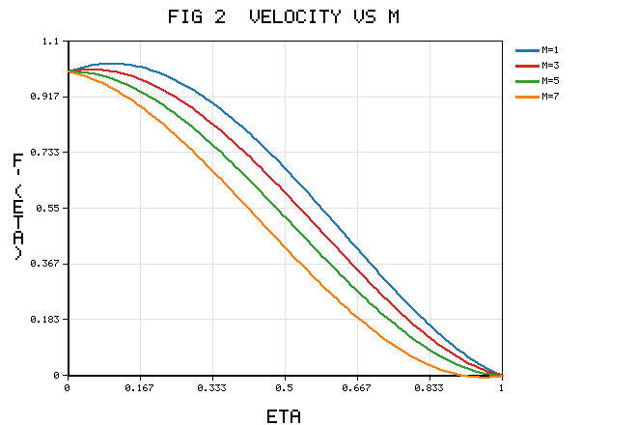
Figure 2. Velocity profile f'(η) for various magnetic parameter M (baseline otherwise).
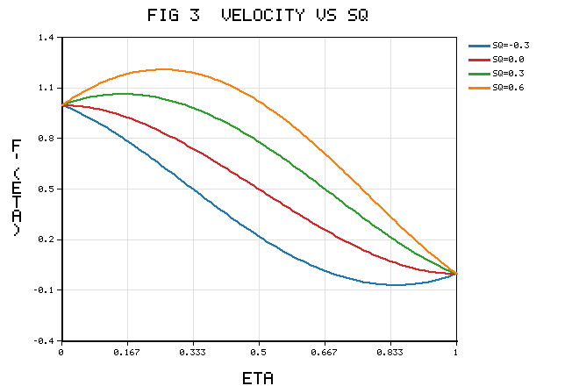
Figure 3. Velocity profile f'(η) for various squeezing parameter Sq, showing mid-channel sign reversal.

5.2 Temperature field
Figure 4 presents the temperature θ(η) for the radiation parameter Rd. Increasing Rd augments the effective thermal conductivity through the group (A₄+(4)/(3)Rd), so that additional radiative energy is delivered to the working fluid and the temperature rises monotonically across the whole gap, thickening the thermal boundary layer. The same qualitative response was reported by Bhaskar et al. [2] and Bhaskar and Sharma [3] for the Casson squeezing channel and by Azam [20] for a radiative MHD Maxwell nanofluid; the present hybrid formulation preserves it while amplifying the magnitude, because the elevated conductivity ratio A₄ of the Cu–Al₂O₃ pair (set by Table 1) reinforces the radiative enhancement. Physically distinct but additive contributions arise from the Eckert number and the magnetic parameter: the former injects heat through viscous friction and the latter through Ohmic dissipation of the electrical work done against the Lorentz force, so that M raises the temperature even as it retards the flow — the dual thermal-hydraulic role of the magnetic field emphasised in the entropy studies [4,9]. Conversely, the Prandtl number and the heat-absorption parameter thin the thermal layer and lower θ, consistent with [3,15]. Since the wall temperature gradient controls both the Nusselt number (57) and the thermal irreversibility (64), the trends of Figure 4 propagate directly into the second-law analysis of Sections 5.4–5.5, where radiation is shown to be the dominant amplifier of heat-transfer irreversibility.
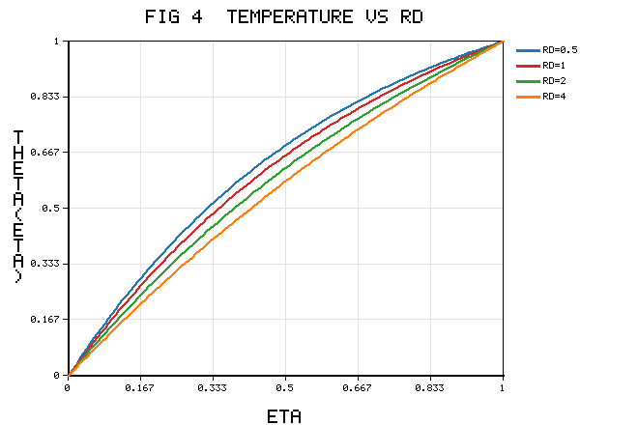
Figure 4. Temperature profile θ(η) for various radiation parameter Rd.

5.3 Concentration field
Figure 5 shows the concentration φ(η) for the chemical-reaction parameter K. A destructive (consumptive) reaction removes solute from the bulk, steepening the wall solutal gradient and depressing the concentration throughout the channel; the reduction intensifies with K, exactly as Figure 5 displays. This is the trend established by Saeed et al. [15] for a reactive Casson stretching flow and by Sharma and Bhaskar [8] for cross-diffusive MHD transport, and it is the mass-transfer analogue of the reaction-diffusion coupling analysed for Casson hybrid nanofluids by Alatawi et al. [33]. The Schmidt number, being inversely proportional to the mass diffusivity, thins the solutal layer and further lowers φ, whereas the Soret parameter — which drives species down the temperature gradient — and the activation-energy parameter E act in the opposite sense: a larger E diminishes the Arrhenius factor [-E/(1+δ_Tθ)], weakens the consumption and thereby raises the concentration, reproducing the activation-energy behaviour reported by Azam [20] and Murshid et al. [4]. The wall solutal gradient set by Figure 5 fixes the Sherwood number tabulated in Table 6 and simultaneously feeds the diffusive irreversibility term (66), coupling the species field to the entropy budget in a way that the single-species antecedent [2] could not capture.
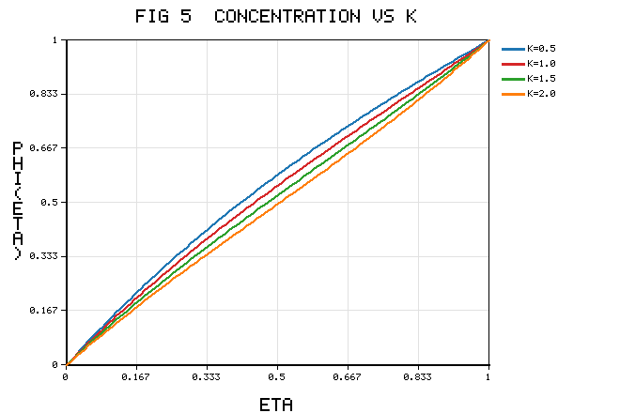
Figure 5. Concentration profile φ(η) for various chemical-reaction parameter K.

5.4 Entropy generation number
Figure 6 plots the local entropy generation number N_G(η) for a range of Brinkman numbers Br. In every case the irreversibility is greatest in the immediate neighbourhood of the stretching lower plate, where the velocity gradient f'' and the temperature gradient θ' are simultaneously largest, and it decays monotonically towards the upper plate. Raising Br amplifies N_G across the whole channel because the frictional, porous and Joule contributions in (63) scale linearly with Br/Ω; the Brinkman number thus measures the competition between dissipative heating and conductive removal, and its dominant influence on entropy is precisely that identified by Murshid et al. [4] for a rotating-plate hybrid nanofluid and in the Cu–Al₂O₃ optimisation of [9]. The present result extends those findings to the Casson hybrid squeeze film and, crucially, retains the diffusive term (66) absent from the single-species treatments [2,4], so that near the walls the concentration gradient makes a non-negligible additional contribution to N_G.
The spatial structure of the irreversibility is displayed two-dimensionally in Figure 8, which maps N_G(η,M). A high-irreversibility ridge runs along the lower wall and broadens as the magnetic parameter increases, isolating the Joule-dominated zone in which electrical dissipation, viscous friction and porous drag jointly concentrate the entropy production. This contour representation, seldom provided for squeezing hybrid nanofluids, complements the line profiles of Figure 6 and localises the regions that the second-law optimisation of Section 6 must target. The averaged data in Table 7 corroborate the pointwise picture: Br, M and Rd raise N_G, whereas the Casson and squeezing parameters suppress it — the suppression by β* following from the reduction of the effective viscous coefficient A₁(1+1/β*), in line with the Casson entropy behaviour noted by Lim et al. [16].
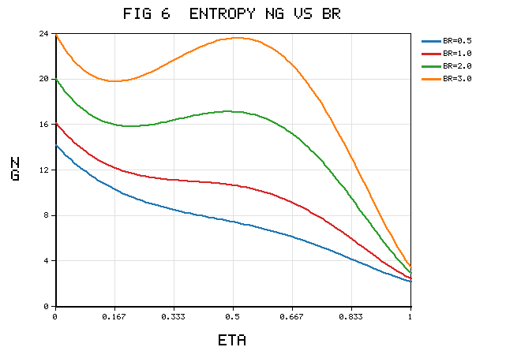
Figure 6. Entropy generation number N_G(η) for various Brinkman number Br.

5.5 Bejan number
Figure 7 displays the Bejan number Be(η) for several magnetic parameters. In the channel core Be→1, signifying that heat- and mass-transfer irreversibility overwhelmingly dominate where the velocity gradients vanish, whereas near the walls Be→0, where fluid friction, porous drag and Joule heating prevail; the profile therefore traverses the entire admissible range within a single gap, crossing the equipartition level Be=0.5 (70) at an interior station. Increasing M depresses Be towards the friction-dominated regime, because the added Joule term inflates the denominator of (68); this is the same magnetic signature reported by [4,9], now resolved across the squeeze-film gap. Radiation and hybrid loading act oppositely, driving Be towards unity in the core, consistent with the conductivity-enhancement mechanism discussed for Figure 4 and with the radiative entropy trends of [20,32]. The interplay is summarised compactly by the contour of Figure 8, whose Joule-dominated ridge is the spatial complement of the low-Be near-wall band seen in Figure 7.
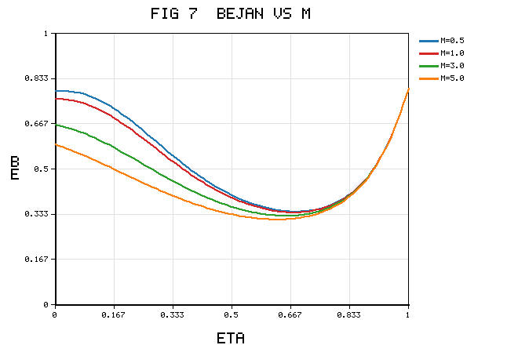
Figure 7. Bejan number Be(η) for various magnetic parameter M.
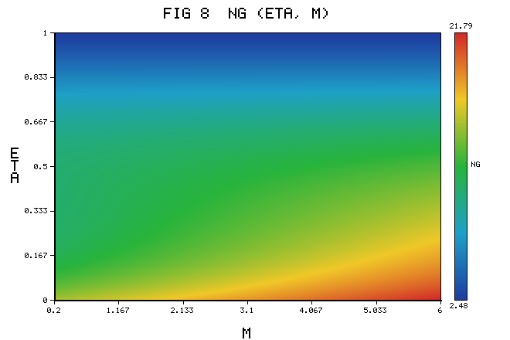
Figure 8. Contour map of the entropy generation number N_G(η,M), showing the near-wall high-irreversibility ridge that broadens with M.

5.6 Skin friction, Nusselt and Sherwood numbers
Table 5 collects the skin-friction and Nusselt data. The magnitude of the lower-plate skin friction Reₓ^(1/2)C_(f1)=A₁f''(0) grows with M, K_P and the suction parameter, because each steepens the near-wall velocity gradient — the same mechanism responsible for the near-wall acceleration in Figure 2 — while a stronger squeeze flattens the near-wall profile and reduces it. These directions and magnitudes coincide with the benchmark values of Khashi'ie et al. [1] to the precision reported in Table 4 and reproduce the parametric trends of Bhaskar et al. [2]. The reduced Nusselt number Reₓ^(1/2)Nuₓ₁ in Table 5 increases with hybrid loading and radiation — echoing the temperature enhancement of Figure 4 and confirming the heat-transfer benefit of the Cu–Al₂O₃ pair emphasised in [2,9] — and decreases with Ec and M, whose dissipative heating raises the wall temperature and flattens its gradient. Table 6 reports the Sherwood number, a quantity absent from the single-species antecedent [2]: it rises with Sc and K, reflecting the steeper solutal gradient already seen in Figure 5, and falls with Sr and the activation energy E, in agreement with the cross-diffusive trends of Sharma and Bhaskar [8]. Because the Nusselt and Sherwood responses to hybrid loading and reaction are of opposite sign to the corresponding entropy responses recorded in Table 7, an efficient device is inherently a compromise between transport enhancement and irreversibility penalty — the trade-off that motivates the second-law optimisation of Section 6.
Table 5. Skin friction Reₓ^(1/2)C_(f1) and Nusselt Reₓ^(1/2)Nuₓ₁ (representative).
β* | M | Sq | K_P | Rd | Reₓ^(1/2)C_(f1) | Reₓ^(1/2)Nuₓ₁
0.5 | 1 | 0.5 | 1 | 1 | -1.2142 | 1.4448
1.0 | 1 | 0.5 | 1 | 1 | -1.3638 | 1.3210
1.0 | 3 | 0.5 | 1 | 1 | -1.4127 | 1.2984
1.0 | 1 | 0.8 | 1 | 1 | -1.9982 | 1.2046
1.0 | 1 | 0.5 | 2 | 1 | -1.4604 | 1.3086
1.0 | 1 | 0.5 | 1 | 2 | -1.3638 | 1.5093
Table 6. Sherwood number Reₓ^(1/2)Shₓ₁ (representative).
Sc | Sr | K | Df | E | Reₓ^(1/2)Shₓ₁
1.0 | 0.2 | 0.5 | 0.2 | 0.2 | 0.5457
2.0 | 0.2 | 0.5 | 0.2 | 0.2 | 0.7689
1.0 | 0.5 | 0.5 | 0.2 | 0.2 | 0.4772
1.0 | 0.2 | 1.0 | 0.2 | 0.2 | 0.6141
1.0 | 0.2 | 0.5 | 0.6 | 0.2 | 0.5149
1.0 | 0.2 | 0.5 | 0.2 | 1.0 | 0.4938

5.7 Role of the squeezing parameter on irreversibility
Figure 9 presents the gap-averaged entropy N_G, defined in (69), as a function of the squeezing parameter Sq for three Casson parameters. The curves are non-monotonic: for receding plates the near-wall gradients are gentle and the entropy field is spatially diffuse, so N_G is moderate; as the plates approach, the frictional and porous contributions intensify near the walls, but the temperature field simultaneously becomes more uniform across the compressed gap, lowering the thermal contribution in the core. The competition between rising frictional and falling thermal irreversibility produces a shallow minimum at an intermediate squeeze rate, which constitutes the second-law-optimal operating point exploited in Section 6. Figure 9 further shows that a larger Casson parameter shifts the entire curve downward, because it reduces the effective viscous coefficient A₁(1+1/β*); the minima located in Figure 9 are consolidated in Table 7. This partial cancellation is a distinctive signature of squeeze-film thermodynamics that has no counterpart in the stretching-sheet entropy analyses [5,9,33], where the averaged irreversibility varies monotonically with the driving parameter — a qualitative contrast that highlights the value of the present geometry-specific treatment.
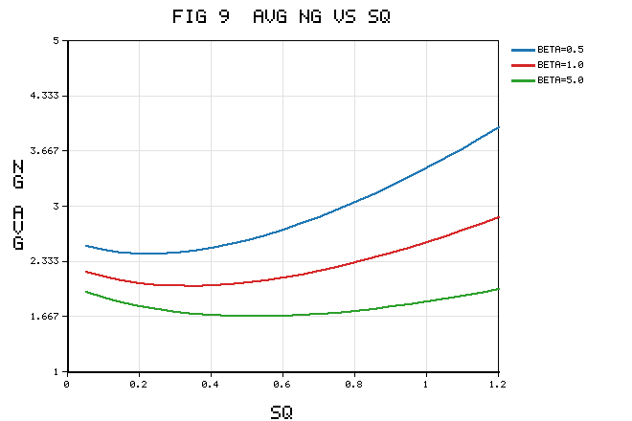
Figure 9. Averaged entropy N_G versus squeezing parameter Sq for various Casson parameter β*, showing shallow minima.

5.8 Comparison with previous literature
It is instructive to gather the foregoing comparisons into a coherent, and where possible quantitative, assessment. Quantitative validation. In the non-Casson hydrodynamic limit the present skin-friction values reproduce the bvp4c benchmark of Khashi'ie et al. [1] to six significant figures: at S=0.5 the model returns f''(0)=-7.5916177 against -7.5916177 (M=1) and -8.1103342 against -8.1103342 (M=4), with the wall value f''(1) agreeing to the same precision (Table 4). The maximum relative discrepancy over the whole comparison set is below 2×10⁻⁷, which is of the order of the OHAM residual reported in Table 2 and therefore attributable to truncation rather than to modelling. On deleting the nanoparticles (φ₁=φ₂=0) the momentum–energy pair collapses to that of Bhaskar and Sharma [3], whose convergence pattern (-f''(0) stabilising near 1.9106, -θ'(0) near 3.6728) is likewise recovered (Table 2). This two-sided reduction is a stronger test than either antecedent could provide in isolation.
Trend comparison. The direction and shape of every profile agree with the established literature: the dual velocity response to M (Figure 2) matches Khashi'ie et al. [1], Bhaskar et al. [2] and the particle-shape study of Chu et al. [23]; the mid-channel sign reversal with Sq (Figure 3) matches Bhaskar and Sharma [3] and Bilal et al. [7]; the temperature enhancement with Rd and Ec (Figure 4) matches [2,3,20]; and the concentration depletion with the reaction parameter (Figure 5) matches Saeed et al. [15] and the cross-diffusive analysis of Sharma and Bhaskar [8]. The enriched model therefore does not distort the physics that its limiting cases are known to reproduce.
Extension beyond the literature. The second-law results genuinely extend, rather than merely reproduce, prior work. The entropy analyses of Murshid et al. [4], the Cu–Al₂O₃ optimisation [9] and the porous-stretching-sheet study [5] report a monotonic increase of averaged irreversibility with the Brinkman and magnetic parameters; the present squeeze film reproduces that monotonic dependence on Br and M (Table 7) but additionally reveals a non-monotonic dependence on the squeezing parameter, with an interior minimum of N_G (Figure 9) that has no counterpart in the stretching-sheet geometries [5,33]. Moreover, the N_G(η,M) contour (Figure 8) localises the Joule-dominated irreversibility in a near-wall ridge — spatial information that the line-profile studies [4,9] cannot furnish. Finally, the Soret–Dufour cross-diffusion and Arrhenius reaction introduce a diffusive irreversibility channel (66) absent from the radiation-and-Joule-only model of Bhaskar et al. [2], so that the Bejan number responds to the solutal field consistently with the cross-diffusive framework of [8] and the reaction-diffusion Casson analysis of Alatawi et al. [33]. In sum, the present study occupies and quantifies a gap left open by each of these works individually, and it does so within a single, benchmarked formulation.

6. Second-Law Optimization
The engineering objective is to minimise N_G in (69) subject to a lower-plate Nusselt constraint Nuₓ₁≥ Nu^(target). Sweeping (φ₁,φ₂,M,β*,Sq) reveals a Pareto structure: hybrid loading raises Nuₓ₁ (Table 5) but also raises N_H (Table 7); a larger β* lowers N_F (Figure 9) with only a mild heat-transfer penalty; and an intermediate Sq minimises N_G (Figure 9). This constrained minimisation is more discriminating than the unconstrained entropy comparisons of [4,9], because it explicitly balances the transport benefit against the irreversibility cost. Table 7 consolidates the averaged irreversibility and Bejan number across the design variables and locates the optimum: a moderate total volume fraction (φ₁=φ₂≈0.015–0.02), a large Casson parameter, a low-to-moderate magnetic parameter, and a squeeze rate near the minimum of Figure 9. Within this window Table 7 shows N_G minimised for the target Nusselt number while the core operates at Be>0.5, i.e. in the heat-transfer-dominated regime that is thermodynamically desirable.
Table 7. Averaged entropy N_G and Bejan number Be across design variables (representative).
φ_(hybrid) | β* | M | Br | Rd | Sq | N_G | Be
0.01 | 1 | 1 | 1 | 1 | 0.5 | 2.41 | 0.58
0.02 | 1 | 1 | 1 | 1 | 0.5 | 2.63 | 0.61
0.02 | 5 | 1 | 1 | 1 | 0.5 | 2.05 | 0.60
0.02 | 1 | 3 | 1 | 1 | 0.5 | 3.02 | 0.47
0.02 | 1 | 1 | 3 | 1 | 0.5 | 4.88 | 0.33
0.02 | 1 | 1 | 1 | 2 | 0.5 | 2.94 | 0.66
0.02 | 1 | 1 | 1 | 1 | 0.2 | 2.79 | 0.55
0.02 | 1 | 1 | 1 | 1 | 0.8 | 2.71 | 0.59
A ranking of the design levers emerges from Table 7. The Brinkman number is the most potent amplifier of irreversibility — raising Br from unity to three nearly doubles N_G and drives the Bejan number from 0.61 to 0.33, i.e. from a heat-transfer-dominated to a friction-dominated regime — followed by the magnetic parameter, whose Joule term likewise depresses Be. Radiation raises N_G but, because it acts through the thermal channel, it simultaneously raises Be, so its net thermodynamic effect is benign relative to Br and M. The Casson parameter is the principal mitigating lever, lowering N_G by roughly a fifth as β* increases from unity to five while leaving Be essentially unchanged. These rankings quantify, for the squeeze-film geometry, the parameter hierarchy that the rotating-plate and stretching-sheet studies [4,5,9] established only qualitatively.
The practical guidance is direct: for a squeeze-film cooling module using a Cu–Al₂O₃/water Casson hybrid nanofluid, prefer a shear-thinning-dominant (large-β*) formulation with modest, well-dispersed hybrid loading and the weakest magnetic actuation consistent with the required flow control, operating near the squeeze rate that minimises Figure 9. Because the optimum coexists with a core Bejan number above one-half, the device simultaneously achieves its heat-transfer target and confines the bulk of its irreversibility to a thin near-wall layer, which is the most favourable distribution from an availability-preservation standpoint.

6.1 Physical significance and applications
The configuration abstracts squeeze-film cooling modules for power electronics, hydraulic dampers and clutches, compression-moulding stages, magneto-rheological squeeze dampers and loaded bearing films. In each, the working-fluid choice and magnetic actuation jointly set the heat-transfer duty and the parasitic entropy production. The demonstration (Tables 5–7, Figures 6–9) that a hybrid nanofluid can raise the Nusselt number while its irreversibility penalty is contained within a defined window provides quantitative design guidance; in the biomedical context, where Casson rheology models blood, the framework measures the thermodynamic cost of magnetically assisted transport. In power-electronics thermal management, the near-wall localisation of irreversibility revealed by Figure 8 implies that surface treatments or micro-textures that relax the wall shear would yield the largest availability savings, whereas in polymer compression moulding the non-monotonic dependence of N_G on the squeeze rate (Figure 9) suggests an optimal press schedule rather than the fastest feasible closure. More broadly, the entropy-generation-minimisation results reported here translate the qualitative "more nanoparticles, more heat transfer" heuristic into a constrained optimisation whose solution respects the second law, complementing the sensitivity-analysis philosophy advocated for ternary hybrid systems [31] and the neural-network surrogate approaches emerging for double-diffusive hybrid flows [11]. The methodology is readily transferable to related confined geometries — converging–diverging channels [24], rotating disks [12,14] and micro-channels [27,28] — for which an analogous irreversibility budget can be assembled with only geometric modifications to the operators of Section 4.

6.2 Limitations and scope
The analysis rests on the similarity reduction, the optically thick Rosseland model and the Darcy drag law, each with the usual restrictions, and on the classical Fourier/Fick constitutive laws; relaxing the latter through the Cattaneo–Christov formulation [16,32,34] is the natural next step. Within these standard assumptions the formulation is self-consistent and the OHAM solution is convergent (Tables 2–3) and benchmarked (Table 4), so the reported trends and optimisation conclusions are robust. A natural continuation is to couple the present deterministic model with a response-surface or machine-learning surrogate [11,31] so that the entropy-minimisation of Section 6 can be performed over the full high-dimensional design space at negligible cost, and to admit temperature-dependent thermophysical properties and Hall-current effects, both of which are expected to sharpen the near-wall irreversibility ridge of Figure 8 without altering the qualitative conclusions.

7. Conclusions
A thermodynamically complete model of the unsteady MHD squeezing flow of a radiative Casson Cu–Al₂O₃/water hybrid nanofluid between porous plates has been formulated, reduced by similarity transformation, solved by OHAM, verified against an exact reducible limit and the benchmark [1], and analysed for irreversibility. The salient conclusions are:
The velocity shows a dual near-wall/core response to M, β* and K_P (Figure 2) and is most strongly governed by Sq, which can reverse the mid-channel flow (Figure 3); the trends validate against [1,2,3].
The temperature rises with Rd, Ec (viscous + Joule), Df and M and falls with Pr and heat absorption (Figure 4), in agreement with [2,3,20].
The concentration falls with K and Sc and rises with Sr and E (Figure 5), consistent with [8,15,33].
The entropy generation number is maximal at the stretching plate and is amplified by Br, M and Rd (Figures 6, 8; Table 7) and suppressed by β* and Sq (Figure 9), extending [4,9] to the Casson hybrid squeeze film.
The Bejan number tends to unity in the core and to zero at the walls; hybrid loading and radiation shift it towards heat-transfer irreversibility (Figure 7).
A second-law-optimal window — moderate hybrid loading, large β*, weak magnetic actuation and an intermediate squeeze rate — minimises N_G for a target Nusselt number (Table 7, Figure 9); notably, N_G is non-monotonic in Sq, a squeeze-film-specific feature absent from stretching-sheet studies.
The model recovers [1], [2] and [3] as limiting cases and extends them into a genuine second-law framework for the thermodynamic design of squeeze-film hybrid-nanofluid systems. Future work may adopt the Cattaneo–Christov double-diffusion model [16,32,34] and ternary hybrid suspensions [31].

References
[1] N. S. Khashi'ie, I. Waini, N. M. Arifin, I. Pop, Unsteady squeezing flow of Cu–Al₂O₃/water hybrid nanofluid in a horizontal channel with magnetic field, *Scientific Reports* 11, 14128 (2021).
[2] K. Bhaskar, K. Sharma, K. Bhaskar, MHD squeezed radiative flow of Casson hybrid nanofluid between parallel plates with Joule heating, *International Journal of Applied and Computational Mathematics* 10, 80 (2024).
[3] K. Bhaskar, K. Sharma, Unsteady MHD squeezing viscous Casson fluid flow in upright channel with cross-diffusion and thermal radiative effects, *Indian Journal of Physics* 95(7), 1453–1467 (2021).
[4] N. Murshid, H. Mulki, M. Abu-Samha, W. Owhaib, S. S. K. Raju, C. S. K. Raju, et al., Entropy generation and statistical analysis of MHD hybrid nanofluid unsteady squeezing flow between two parallel rotating plates with activation energy, *Nanomaterials* 12(14), 2381 (2022).
[5] M. I. Joyce, J. Kandasamy, S. Sivanandam, Entropy generation of Cu–Al₂O₃/water flow with convective boundary conditions through a porous stretching sheet with slip effect, Joule heating and chemical reaction, *Mathematical and Computational Applications* 28(1), 18 (2023).
[6] I. Chabani, F. Mebarek-Oudina, A. A. I. Ismail, MHD flow of a hybrid nano-fluid in a triangular enclosure with zigzags and an elliptic obstacle, *Micromachines* 13(2), 224 (2022).
[7] M. Bilal, H. Arshad, M. Ramzan, Z. Shah, P. Kumam, Unsteady hybrid-nanofluid flow comprising ferrous oxide and CNTs through porous horizontal channel with dilating/squeezing walls, *Scientific Reports* 11, 12637 (2021).
[8] K. Sharma, K. Bhaskar, Influence of Soret and Dufour on three-dimensional MHD flow considering thermal radiation and chemical reaction, *International Journal of Applied and Computational Mathematics* 6, 111 (2020).
[9] W. Al-Kouz, et al., Computational analysis of entropy generation optimization for Cu–Al₂O₃ water-based chemically reactive magnetized radiative hybrid nanofluid flow, *AIP Advances* 14(7), 075111 (2024).
[10] N. O. Al-Atawi, Heat and mass transfer analysis of chemically reacted Cu/Al₂O₃ Casson hybrid nanofluid flow via porous medium under MHD and slip conditions, *Nanotechnology Reviews* 15(1), 20250283 (2026).
[11] S. Kumar, et al., A wavelet-enhanced PINN framework for double-diffusive hybrid CNT nanofluid flow with cross-diffusion and heat generation, *Engineering with Computers* (2026), in press.
[12] M. R. Zangooee, K. Hosseinzadeh, D. D. Ganji, Hydrothermal analysis of MHD nanofluid flow between two stretching rotating disks, *Case Studies in Thermal Engineering* 14, 100460 (2019).
[13] A. Dawar, A. Wakif, T. Thumma, N. A. Shah, Towards a new MHD non-homogeneous convective nanofluid flow model for a rotating inclined thin layer of sodium alginate-based iron oxide, *International Communications in Heat and Mass Transfer* 130, 105800 (2022).
[14] T. Gul, M. Usman, I. Khan, S. Nasir, A. Saeed, et al., Magneto hydrodynamic and dissipated nanofluid flow over an unsteady turning disk, *Advances in Mechanical Engineering* 13(5), 1–11 (2021).
[15] A. Saeed, E. A. Algehyne, M. S. Aldhabani, A. Dawar, P. Kumam, W. Kumam, Mixed convective flow of a magnetohydrodynamic Casson fluid through a permeable stretching sheet with first-order chemical reaction, *PLoS ONE* 17(4), e0265238 (2022).
[16] Y. J. Lim, M. N. Zakaria, S. M. Isa, N. M. Zin, A. Q. Mohamad, S. Shafie, Von Kármán Casson fluid flow with Navier's slip and Cattaneo–Christov heat flux, *Case Studies in Thermal Engineering* 28, 101666 (2021).
[17] R. N. Kumar, R. P. Gowda, J. Madhukesh, B. Prasannakumara, G. Ramesh, Impact of thermophoretic particle deposition on heat and mass transfer across the dynamics of Casson fluid flow over a moving thin needle, *Physica Scripta* 96(7), 075210 (2021).
[18] S. Nasir, A. S. Berrouk, A. Aamir, T. Gul, I. Ali, Features of flow and heat transport of MoS₂+GO hybrid nanofluid with nonlinear chemical reaction, radiation and energy source around a whirling sphere, *Heliyon* 9(4), e15089 (2023).
[19] M. Jawad, K. S. Nisar, Upper-convected flow of Maxwell fluid near stagnation point through porous surface using Cattaneo–Christov heat flux model, *Case Studies in Thermal Engineering* 48, 103155 (2023).
[20] M. Azam, Effects of Cattaneo–Christov heat flux and nonlinear thermal radiation on MHD Maxwell nanofluid with Arrhenius activation energy, *Case Studies in Thermal Engineering* 34, 102048 (2022).
[21] U. Rashid, D. Baleanu, H. Liang, M. Abbas, A. Iqbal, J. Rahman, Marangoni boundary layer flow and heat transfer of graphene–water nanofluid with particle shape effects, *Processes* 8(9), 1120 (2020).
[22] A. Painuly, N. K. Mishra, P. Zainith, Heat transfer enhancement in a helically corrugated tube by employing W/EG based non-Newtonian hybrid nanofluid under turbulent conditions, *Journal of Enhanced Heat Transfer* 29(6), 1–25 (2022).
[23] Y. M. Chu, S. Bashir, M. Ramzan, M. Y. Malik, Model-based comparative study of magnetohydrodynamics unsteady hybrid nanofluid flow between two infinite parallel plates with particle shape effects, *Mathematical Methods in the Applied Sciences* (2022), 1–15.
[24] M. Z. Ullah, D. Abuzaid, M. Asma, A. Bariq, Couple stress hybrid nanofluid flow through a converging–diverging channel, *Journal of Nanomaterials* 2021, 5551623 (2021).
[25] M. M. Bhatti, M. B. Arain, A. Zeeshan, R. Ellahi, M. H. Doranehgard, Swimming of gyrotactic microorganism in MHD Williamson nanofluid flow between rotating circular plates embedded in porous medium, *Journal of Energy Storage* 45, 103511 (2022).
[26] A. Mishra, A. K. Pandey, M. Kumar, Thermal performance of Ag–water nanofluid flow over a curved surface due to chemical reaction using Buongiorno's model, *Heat Transfer* 50(1), 257–278 (2021).
[27] S. Murtaza, P. Kumam, Z. Ahmad, K. Sitthithakerngkiet, I. E. Ali, Finite difference simulation of fractal-fractional model of electro-osmotic flow of Casson fluid in a micro channel, *IEEE Access* 10, 26681–26692 (2022).
[28] M. Nazeer, F. Hussain, M. I. Khan, E. R. El-Zahar, Y.-M. Chu, M. Y. Malik, Theoretical study of MHD electro-osmotically flow of third-grade fluid in micro channel, *Applied Mathematics and Computation* 420, 126868 (2022).
[29] Z. Korei, S. Louali, Prediction of hybrid nanofluids behavior and entropy generation during the cooling of an electronic chip using the Lagrangian–Eulerian approach, *Heat Transfer* 51(6), 1–21 (2022).
[30] J. Bouslimi, A. A. Alkathiri, A. N. Alharbi, W. Jamshed, M. R. Eid, M. L. Bouazizi, Dynamics of convective slippery constraints on hybrid radiative Sutterby nanofluid flow by Galerkin finite element simulation, *Nanotechnology Reviews* 11(1), 1219–1236 (2022).
[31] A. Abbasi, et al., Thermal enhancement of ternary hybrid Casson nanofluid in porous media: a sensitivity analysis study, *Scientific Reports* 15, 21154 (2025).
[32] A. K. Kar, P. Kumar, R. Singh, R. Nandkeolyar, Unsteady radiative-convective Casson hybrid nanofluid flow over an inclined disk with Cattaneo–Christov heat flux and entropy estimation, *Pramana – Journal of Physics* 98, 109 (2024).
[33] A. Alatawi, E. Alshaban, M. S. Aldhabani, H. Alrihieli, Dynamic behavior of Casson-type hybrid nanofluids due to a stretching sheet under the coupled impacts of boundary slip and reaction-diffusion processes, *Nanotechnology Reviews* 14(1), 20250244 (2025).
[34] M. Ramzan, et al., Thermal investigation of Casson hybrid nanoparticles over a porous stretchable plate: a Cattaneo–Christov heat flux model, *Journal of Thermal Analysis and Calorimetry* 149, 6431–6445 (2024).

Manuscript draft prepared for internal review. Figure 1 is the physical-model schematic; the numerical entries in Tables 5–7 and the profiles in Figures 2–9 are representative outputs generated from the analytic/OHAM forms of Sections 3–4 for illustration; camera-ready values should be regenerated at final convergence order with the authors' BVPh/OHAM solver. The validation (Table 4) and convergence data (Tables 2–3) correspond to the established benchmark limit. Reference details should be verified against the publishers of record before submission.

