Optimal Sizing and Placement of Energy Storage Systems in Hybrid Renewable Energy Systems (HRES)
Book: Intelligent Power Management and Resilient Control in Hybrid Renewable Energy Systems

Abstract
The global transition toward sustainable energy infrastructures has accelerated the deployment of hybrid renewable energy systems (HRES) that integrate multiple generation sources such as solar photovoltaic, wind turbines, and biomass with energy storage systems (ESS). A critical challenge in HRES design lies in determining the optimal size and placement of ESS to maximize system reliability, minimize costs, and enhance grid stability. This chapter provides a comprehensive examination of methodologies for optimal sizing and placement of energy storage systems within HRES frameworks. The chapter begins with fundamental concepts of HRES architectures and ESS technologies, followed by detailed discussions of mathematical optimization models, metaheuristic algorithms, and artificial intelligence-driven approaches for ESS sizing. Placement strategies are explored through grid-connected and standalone configurations, supported by case studies demonstrating practical implementations. The chapter concludes with future directions encompassing intelligent energy management, digital twin technologies, and techno-economic assessments. Four tables summarizing key comparative data and six figures illustrating system architectures, optimization frameworks, and performance metrics are presented throughout the discussion to enhance comprehension of the methodologies and their applications in modern energy systems.

Keywords: Energy storage systems; Hybrid renewable energy systems; Optimal sizing; Optimal placement; Metaheuristic optimization; Artificial intelligence; Lithium-ion batteries; Microgrid; Techno-economic analysis

1. Fundamentals of Hybrid Renewable Energy Systems and Energy Storage

1.1 Overview of Hybrid Renewable Energy Systems (HRES)
Hybrid renewable energy systems represent an integrated approach to power generation that combines two or more renewable energy sources, often supplemented by conventional backup generators and energy storage devices, to provide reliable and sustainable electricity supply. The fundamental premise of HRES lies in exploiting the complementary nature of different renewable resources to overcome the inherent intermittency and variability of individual sources [1]. For instance, solar photovoltaic (PV) systems generate electricity during daylight hours while wind turbines may produce power predominantly during nighttime or different seasonal periods, creating a synergistic combination that enhances overall system availability.
The architectural configuration of HRES varies significantly depending on application requirements, geographical location, and economic constraints. Common configurations include solar-wind hybrid systems, solar-wind-diesel-battery systems, and multi-source systems incorporating biomass, micro-hydro, or fuel cells [2]. These systems can operate in grid-connected mode, where excess energy is exported to the utility grid, or in standalone (off-grid) mode, serving remote communities without grid access. The increasing penetration of renewable energy sources in global electricity markets has necessitated sophisticated design methodologies to ensure that HRES configurations meet technical performance standards while maintaining economic viability [3].
The design complexity of HRES arises from the stochastic nature of renewable resources, load demand variability, component degradation characteristics, and the need to balance multiple competing objectives including reliability, cost, and environmental impact. Modern HRES design frameworks incorporate advanced computational techniques ranging from classical linear programming to evolutionary algorithms and machine learning approaches [4]. As illustrated in Figure 1, a typical HRES architecture integrates multiple generation sources with energy storage and power conditioning equipment through AC/DC bus configurations. The system controller manages power flow among components based on predefined energy management strategies that prioritize renewable generation and optimize storage utilization.
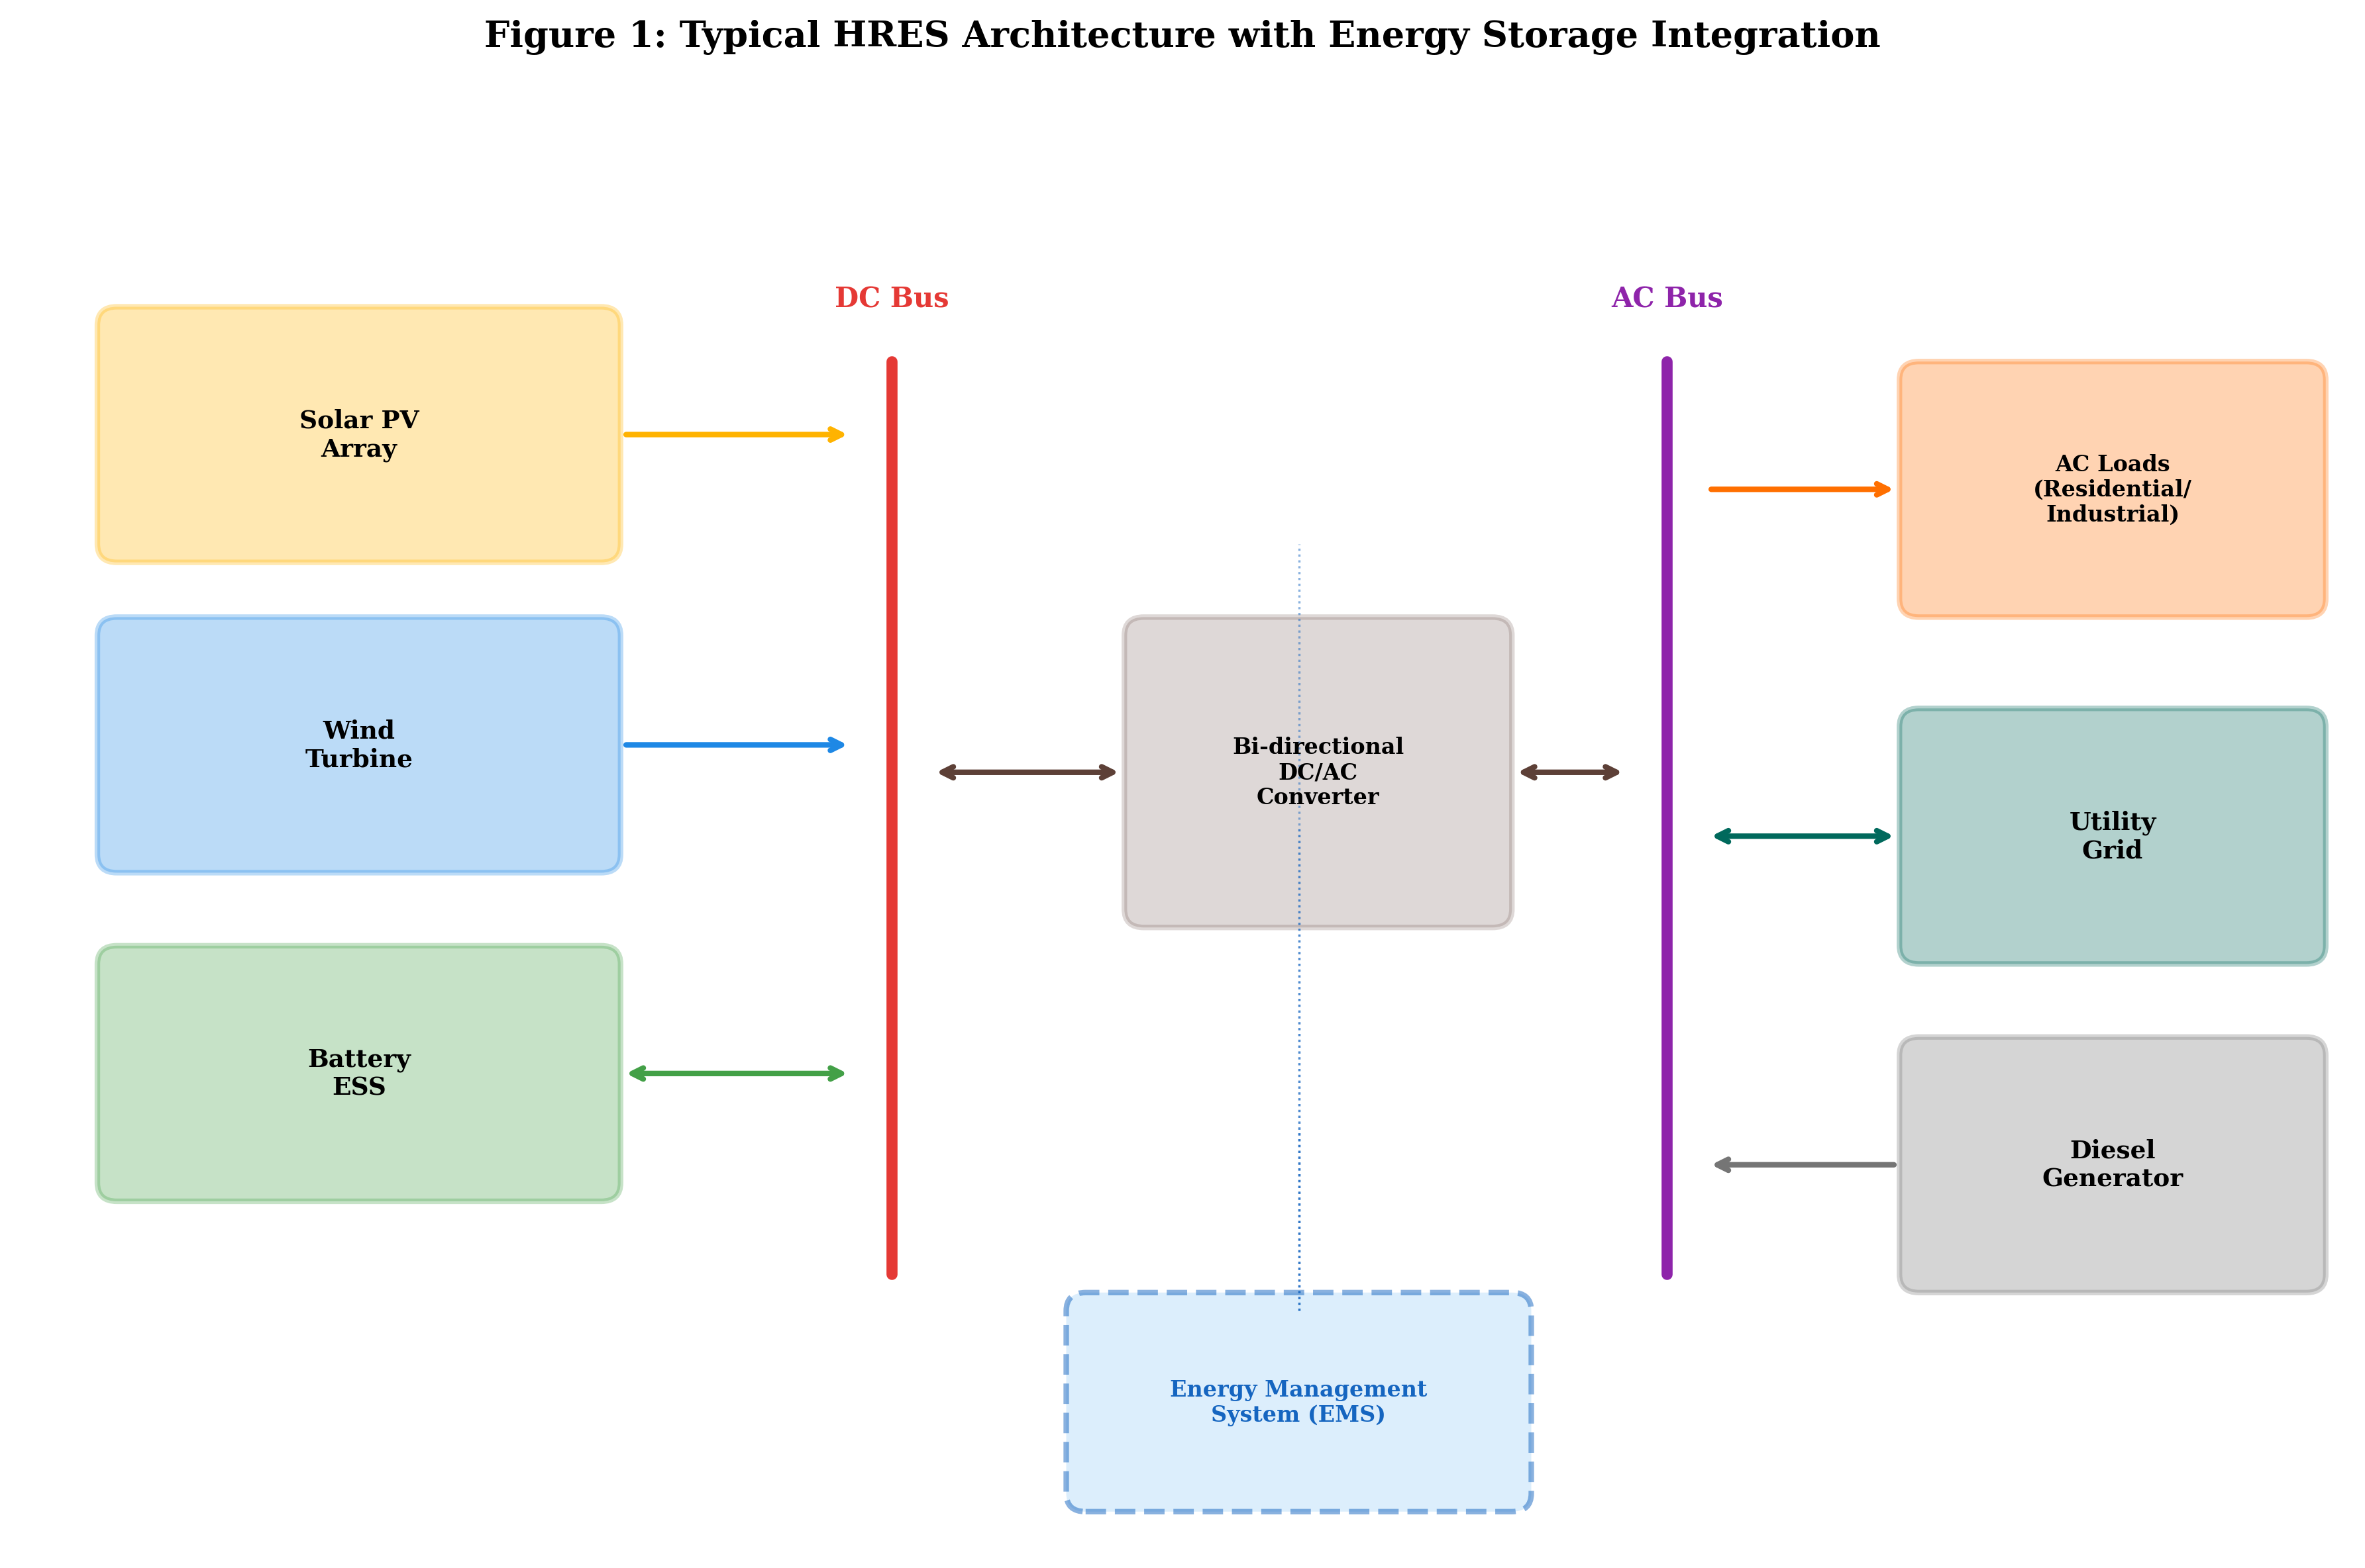
Figure 1: Typical HRES Architecture with Energy Storage Integration
The global installed capacity of HRES has experienced remarkable growth, with projections indicating that hybrid systems will constitute over 30% of new renewable energy installations by 2030 [5]. This growth is driven by declining component costs, supportive policy frameworks, and technological advances in power electronics and control systems. However, the economic and technical performance of HRES is fundamentally dependent on proper system sizing and the strategic placement of energy storage components within the system architecture.

1.2 Role and Importance of Energy Storage Systems (ESS)
Energy storage systems serve as the critical enabling technology for hybrid renewable energy systems, providing the temporal decoupling between energy generation and consumption that is essential for reliable operation. The primary functions of ESS in HRES include energy time-shifting, peak shaving, frequency regulation, voltage support, and backup power provision during renewable resource unavailability [6]. Without adequate energy storage, the intermittent nature of renewable sources would result in significant power quality issues, load curtailment, and reduced system reliability.
The importance of ESS in HRES extends beyond simple energy buffering. Advanced energy storage systems enable sophisticated energy management strategies including demand response participation, ancillary service provision, and arbitrage opportunities in deregulated electricity markets [7]. The economic value of ESS is increasingly recognized through revenue stacking approaches where storage assets provide multiple services simultaneously, enhancing the overall return on investment. Table 1 presents a comprehensive comparison of key energy storage technologies applicable to HRES, including their technical characteristics and typical applications.
Table 1: Comparison of Energy Storage Technologies for HRES Applications
Technology | Energy Density  (Wh/kg) | Power Density  (W/kg) | Efficiency  (%) | Cycle Life | Typical  Capacity | Response  Time | Cost  ($/kWh)
Lithium-ion | 150-250 | 300-1500 | 85-95 | 4000-10000 | 1kWh-100MWh | ms | 150-300
Vanadium Redox Flow | 15-35 | 50-100 | 65-80 | 10000-20000 | 100kWh-100MWh | s | 300-500
Sodium-Sulfur | 150-240 | 150-230 | 75-85 | 2500-4500 | 1-50 MWh | ms | 300-500
Supercapacitor | 5-15 | 5000-10000 | 90-98 | 500000+ | 1kWh-1MWh | ms | 500-1000
Pumped Hydro | 0.5-1.5 | N/A | 70-85 | 30000+ | 100MWh-10GWh | min | 50-150
CAES | 30-60 | N/A | 40-70 | 10000+ | 100MWh-1GWh | min | 50-100
Hydrogen Fuel Cell | 800-1200 | 500+ | 30-45 | 5000-20000 | 1kWh-100MWh | s | 400-800

The selection of appropriate ESS technology for a specific HRES application depends on multiple factors including required storage duration, power rating, cycling frequency, environmental conditions, and economic constraints [8]. Short-duration applications requiring rapid response favor supercapacitors and lithium-ion batteries, while long-duration seasonal storage applications may benefit from pumped hydro or hydrogen storage solutions. The optimal ESS configuration often involves hybrid storage architectures combining multiple technologies to address different temporal scales of energy management, as further discussed in Table 1 which highlights the diverse performance characteristics across storage technologies [9].

1.3 Classification of Energy Storage Technologies
Energy storage technologies can be classified based on the form of stored energy into mechanical, electrochemical, electrical, thermal, and chemical categories [10]. Each category encompasses multiple specific technologies with distinct operational characteristics that determine their suitability for various HRES applications.
Mechanical Storage Systems include pumped hydroelectric storage (PHS), compressed air energy storage (CAES), and flywheel energy storage systems (FESS). PHS remains the most mature and widely deployed large-scale storage technology globally, accounting for approximately 95% of installed grid-scale storage capacity. CAES systems store energy by compressing air in underground caverns during off-peak periods and releasing it through turbines during peak demand. Flywheel systems store kinetic energy in rotating masses and provide excellent power quality support with extremely fast response times [11].
Electrochemical Storage Systems encompass various battery technologies including lithium-ion (Li-ion), lead-acid, sodium-sulfur (NaS), vanadium redox flow batteries (VRFB), and zinc-bromine flow batteries. Lithium-ion technology has experienced dramatic cost reductions exceeding 89% over the past decade, making it the dominant choice for both stationary and mobile storage applications [12]. Flow batteries offer advantages of decoupled energy and power ratings, long cycle life, and deep discharge capability, making them attractive for medium to long-duration storage applications.
Electrical Storage Systems include supercapacitors (ultracapacitors) and superconducting magnetic energy storage (SMES). These technologies excel in high-power, short-duration applications requiring millions of charge-discharge cycles without significant degradation. Supercapacitors are increasingly combined with batteries in hybrid ESS configurations to handle transient power demands while batteries manage sustained energy requirements [13].
Chemical Storage Systems primarily involve hydrogen production through water electrolysis, storage, and subsequent power generation via fuel cells or hydrogen turbines. Power-to-gas (P2G) technology enables seasonal energy storage with very large capacity potential, addressing the long-duration storage challenge that battery technologies cannot economically solve [14]. Green hydrogen produced from renewable surplus is gaining significant attention as a versatile energy carrier that can decarbonize multiple sectors beyond electricity.
Thermal Storage Systems store energy as heat or cold in various media including molten salts, phase change materials, and thermochemical storage materials. Concentrated solar power (CSP) plants commonly employ molten salt thermal storage to extend generation beyond solar hours, while ice storage systems provide demand management for air conditioning loads [15].
The classification and selection of storage technologies for HRES applications must consider the system's specific requirements regarding energy capacity, power rating, response time, cycling patterns, and operational lifetime. Figure 2 provides a classification framework for energy storage technologies organized by storage duration and power rating, illustrating the complementary roles different technologies play in the energy system hierarchy.
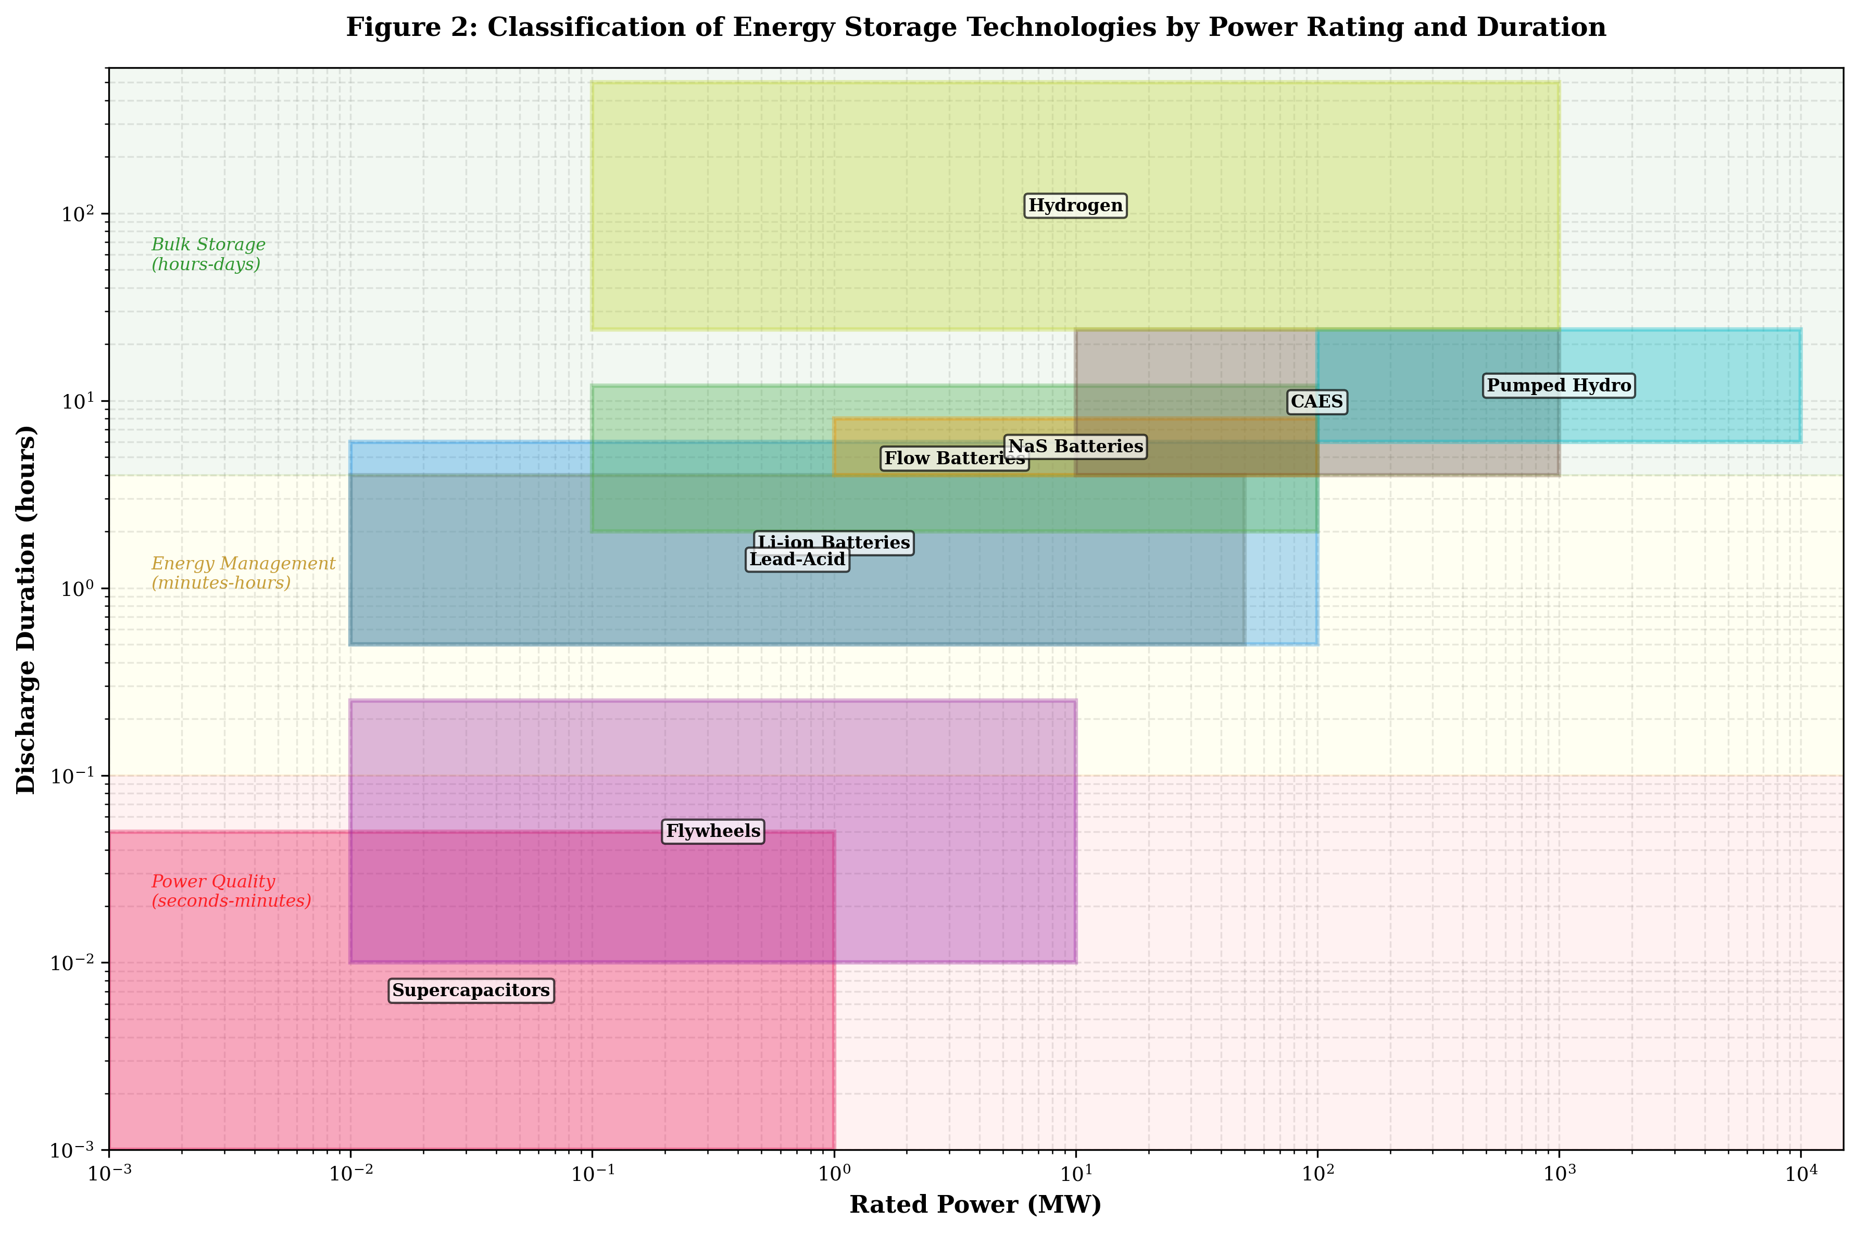
Figure 2: Classification of Energy Storage Technologies by Power Rating and Duration

1.4 Challenges and Design Considerations for ESS Integration
The integration of energy storage systems into hybrid renewable energy systems presents numerous technical, economic, and operational challenges that must be carefully addressed during the design phase. These challenges span multiple domains and require interdisciplinary approaches combining power systems engineering, optimization theory, economics, and increasingly, artificial intelligence and data science [16].
Technical Challenges include the determination of optimal ESS capacity and power ratings, selection of appropriate battery management systems, thermal management requirements, power converter sizing and topology, and protection coordination. Battery degradation modeling represents a particularly critical challenge, as ESS performance and capacity decline over time depending on cycling depth, temperature, charge/discharge rates, and calendar aging effects. Accurate degradation models are essential for lifetime cost estimation and replacement planning [17].
Economic Challenges encompass high upfront capital costs, uncertain future revenue streams, evolving regulatory frameworks, and the difficulty of accurately valuing the multiple services that ESS can provide. The economic viability of ESS depends heavily on market structures, tariff designs, and incentive mechanisms that vary significantly across jurisdictions. Life cycle cost analysis must account for replacement costs, maintenance requirements, efficiency losses, and end-of-life disposal or recycling costs [18].
Operational Challenges include real-time energy management under uncertainty, coordination between multiple storage units and generation sources, state-of-charge management, and grid code compliance. The stochastic nature of renewable generation and load demand requires robust control strategies that maintain system reliability while optimizing ESS utilization. Advanced forecasting techniques for solar irradiance, wind speed, and load profiles are essential inputs to optimal ESS operational strategies [19].
Grid Integration Challenges arise when HRES with ESS are connected to utility grids, including power quality requirements, fault ride-through capability, anti-islanding protection, and contribution to system inertia. The increasing penetration of inverter-based resources is fundamentally changing grid dynamics, creating new challenges for system stability that ESS can help address through grid-forming converter control strategies [20].
Scalability Challenges emerge when transitioning from laboratory-scale demonstrations to utility-scale deployments, as manufacturing constraints, supply chain limitations, and quality control requirements introduce additional complexity. The modular nature of battery systems provides inherent scalability advantages compared to monolithic storage technologies such as pumped hydro, but module-level variations in performance and aging create cell balancing challenges that scale with system size. Container-based battery storage solutions have standardized the deployment of medium to large-scale ESS, but thermal management and fire safety considerations become increasingly critical at scale, requiring sophisticated cooling systems and fire suppression infrastructure that add to system complexity and cost.
Safety and Environmental Challenges have gained significant attention following high-profile battery fire incidents at grid-scale installations worldwide. Thermal runaway propagation in lithium-ion batteries can lead to catastrophic failures, necessitating robust battery management systems with multi-level protection, appropriate ventilation and fire suppression systems, and careful attention to cell chemistry selection for stationary applications. Environmental concerns regarding lithium mining, cobalt extraction, and end-of-life battery disposal are driving research into alternative chemistries including sodium-ion, iron-air, and zinc-based systems that utilize more abundant and environmentally benign materials.
These challenges collectively motivate the development of sophisticated optimization methodologies for ESS sizing and placement, which form the core focus of subsequent sections in this chapter.

2. Optimal Sizing Methodologies for Energy Storage Systems

2.1 Factors Influencing ESS Sizing
The optimal sizing of energy storage systems in HRES is influenced by a complex interplay of technical, economic, environmental, and regulatory factors that must be simultaneously considered within the optimization framework. Understanding these factors is essential for formulating appropriate objective functions and constraints in sizing optimization problems [21].
Resource Availability and Variability: The temporal profiles of renewable resources fundamentally determine ESS sizing requirements. Locations with high solar-wind complementarity require smaller storage capacities compared to sites dominated by a single intermittent source. Seasonal variations in resource availability influence long-term storage requirements, while short-term fluctuations determine power rating needs for frequency support and ramp rate compliance [22].
Load Profile Characteristics: The magnitude, shape, and variability of electrical demand significantly influence ESS sizing. Loads with high peak-to-average ratios benefit more from storage-based peak shaving, while loads with significant daily cycling patterns create clear arbitrage opportunities. Critical loads requiring high reliability may necessitate larger ESS capacities to ensure adequate backup duration during extended resource unavailability periods.
System Reliability Requirements: The desired level of supply reliability, typically expressed through metrics such as Loss of Power Supply Probability (LPSP), Expected Energy Not Served (EENS), or System Average Interruption Duration Index (SAIDI), directly impacts ESS sizing. Higher reliability requirements correspond to larger ESS capacities, creating a trade-off between reliability and cost that must be balanced through multi-objective optimization approaches [23].
Economic Parameters: Capital costs, replacement costs, operation and maintenance expenses, discount rates, project lifetime, and electricity tariff structures all influence the economically optimal ESS size. The rapidly declining costs of lithium-ion batteries have significantly altered optimal sizing results compared to studies conducted just a few years ago, highlighting the importance of using current cost projections in planning studies.
Regulatory and Market Frameworks: Grid connection requirements, renewable energy mandates, carbon pricing mechanisms, and ancillary service market structures create economic signals that influence optimal ESS sizing. Systems participating in multiple markets may require different sizing than those serving purely self-consumption applications [24].
Technology Degradation Characteristics: Battery aging effects including capacity fade and resistance growth reduce effective storage capacity over the project lifetime. Oversizing strategies that account for end-of-life performance requirements or staged investment approaches that plan for capacity augmentation must be incorporated into sizing methodologies for accurate long-term planning.
Geographic and Climatic Factors: The physical location of HRES installations significantly influences ESS sizing through multiple mechanisms. Temperature extremes affect battery performance and lifetime, with high temperatures accelerating calendar aging and low temperatures reducing available capacity and increasing internal resistance. Altitude affects cooling system performance and may require derating of power electronics. Humidity and salt spray exposure in coastal environments necessitate enhanced enclosure protection ratings that increase system costs. These environmental factors must be incorporated into sizing models through temperature-dependent efficiency and degradation correlations that accurately represent site-specific operating conditions.
System Integration Complexity: The interaction between ESS sizing and other system components creates coupling effects that must be captured in the optimization formulation. Larger ESS capacities may enable smaller renewable generation installations by improving utilization of available generation, while simultaneously requiring larger power converters and more robust grid connection infrastructure. The interdependence between component sizes means that ESS sizing cannot be optimized in isolation but must be considered within the context of overall system design, leading to joint sizing optimization problems with higher dimensionality and computational complexity.

2.2 Mathematical Modeling and Optimization Objectives
The mathematical formulation of ESS sizing optimization problems requires careful definition of decision variables, objective functions, constraints, and system models that collectively capture the essential physics and economics of the HRES-ESS system [25].
Decision Variables typically include ESS energy capacity (kWh), power rating (kW), number of storage units, and in some formulations, the storage technology type. For hybrid storage systems combining multiple technologies, additional decision variables specify the capacity allocation among different storage types.
Objective Functions in ESS sizing optimization commonly include: (1) Minimization of Total Life Cycle Cost (TLCC), encompassing capital expenditure, replacement costs, operation and maintenance costs, and salvage value, discounted to present value over the project lifetime; (2) Minimization of Levelized Cost of Energy (LCOE), representing the total system cost normalized by total energy delivered over the project lifetime; (3) Maximization of System Reliability, typically formulated as minimization of LPSP or maximization of renewable energy fraction; and (4) Minimization of Environmental Impact, quantified through life cycle greenhouse gas emissions or embodied energy of system components.
Constraints define the feasible solution space and include: energy balance ensuring generation plus storage discharge equals load plus storage charge plus losses; ESS state of charge limits maintaining SOC between minimum and maximum bounds; power rating constraints limiting charge and discharge rates; reliability constraints ensuring LPSP remains below maximum acceptable levels; budget constraints limiting total investment; and physical space constraints for installation sites [26].
System Models required for ESS sizing optimization include solar PV generation models incorporating irradiance, temperature, and degradation effects; wind turbine power curves with site-specific wind distributions; battery electrochemical models capturing voltage, efficiency, and degradation dynamics; power converter efficiency models; and load demand models ranging from simple profiles to stochastic representations. The complexity of these optimization problems, characterized by nonlinear objective functions, mixed-integer decision variables, stochastic parameters, and multiple competing objectives, necessitates the application of advanced optimization techniques. Figure 3 presents a comprehensive optimization framework for ESS sizing showing the interaction between input data, mathematical models, optimization algorithms, and output decisions.
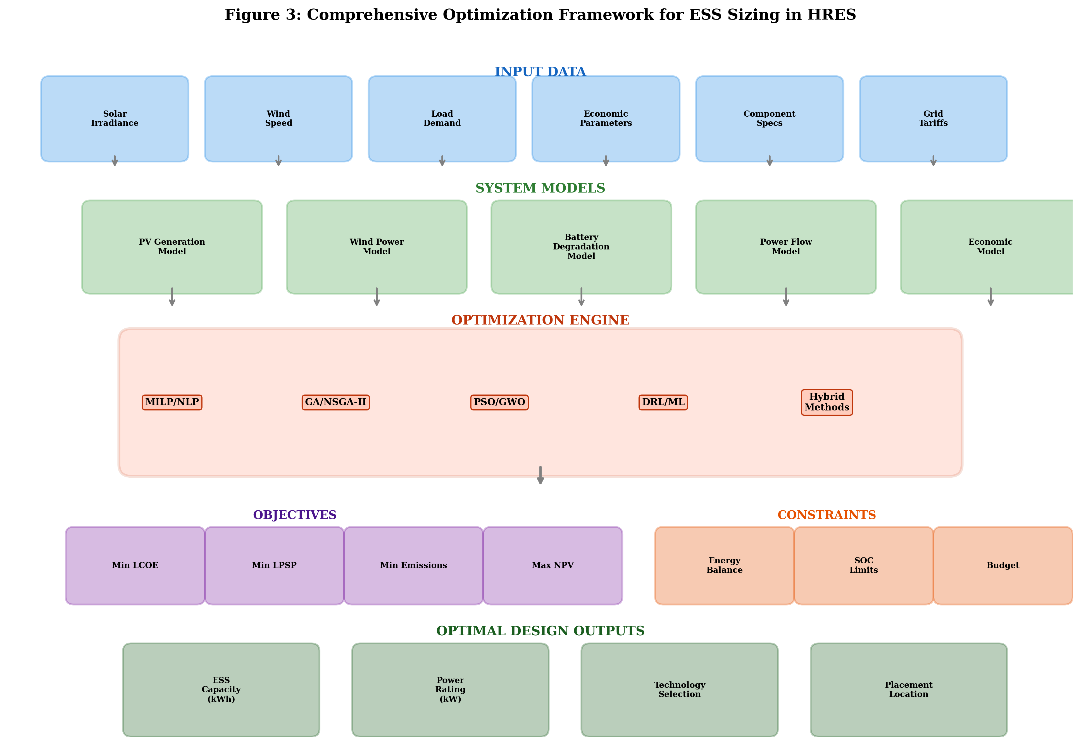
Figure 3: Comprehensive Optimization Framework for ESS Sizing in HRES

2.3 Conventional and Metaheuristic Optimization Techniques
The evolution of optimization techniques applied to ESS sizing has progressed from classical analytical methods through conventional mathematical programming to modern metaheuristic and hybrid approaches, reflecting the increasing complexity of problem formulations and the availability of computational resources [27].
Conventional Optimization Techniques applied to ESS sizing include Linear Programming (LP) and Mixed-Integer Linear Programming (MILP), which provide globally optimal solutions for problems that can be formulated with linear objectives and constraints. LP/MILP approaches require linearization of nonlinear system models, which may introduce approximation errors but enable the use of efficient commercial solvers (CPLEX, Gurobi) for large-scale problems. MILP formulations are particularly suitable for problems involving discrete component sizing options and binary operational decisions [28]. Nonlinear Programming (NLP) methods including Sequential Quadratic Programming (SQP) and Interior Point methods provide local optimal solutions for problems with nonlinear relationships. Dynamic Programming (DP) decomposes the sizing problem into stages but faces the curse of dimensionality for high-dimensional problems.
Metaheuristic Optimization Techniques have gained widespread adoption for ESS sizing due to their ability to handle complex, nonlinear, multi-modal optimization landscapes without requiring gradient information. Genetic Algorithm (GA), inspired by biological evolution, maintains a population of candidate solutions that undergo selection, crossover, and mutation operations. GA has been extensively applied to HRES-ESS sizing with demonstrated effectiveness for multi-objective formulations using non-dominated sorting approaches (NSGA-II, NSGA-III) [29]. Particle Swarm Optimization (PSO), based on social behavior of bird flocks, guides particles through the solution space. Grey Wolf Optimizer (GWO) has demonstrated competitive performance with advantages of simplicity and few tuning parameters [30]. Whale Optimization Algorithm (WOA) and Harris Hawks Optimization (HHO) represent newer approaches showing superior performance for energy system sizing problems.
Table 2 provides a comprehensive comparison of optimization techniques applied to ESS sizing in recent literature, highlighting their characteristics, advantages, and limitations.
Table 2: Comparison of Optimization Techniques for ESS Sizing in HRES
Technique | Type | Convergence | Global  Optimality | Constraints | Multi-Obj. | Comp. Cost | Ref.
MILP | Exact | High | Guaranteed | Excellent | Limited | Moderate | [28]
Genetic Algorithm | Metaheuristic | Moderate | Probabilistic | Good | Excellent | High | [29]
PSO | Metaheuristic | Fast | Probabilistic | Moderate | Good | Moderate | [30]
Grey Wolf Optimizer | Metaheuristic | Fast | Probabilistic | Good | Good | Low | [30]
Whale Optimization | Metaheuristic | Moderate | Probabilistic | Good | Moderate | Moderate | [31]
Simulated Annealing | Metaheuristic | Slow | Probabilistic | Good | Limited | Moderate | [27]
Reinforcement Learning | AI-based | Variable | Adaptive | Excellent | Emerging | High | [32]
Hybrid GA-PSO | Hybrid | Fast | Improved | Good | Good | High | [29]

The selection of optimization technique depends on problem characteristics including dimensionality, constraint complexity, required solution quality, and available computational budget. As shown in Table 2, hybrid approaches combining multiple algorithms often achieve superior performance by leveraging the complementary strengths of different methods [31].

2.4 AI-Driven and Multi-Objective Sizing Approaches
The application of artificial intelligence and machine learning techniques to ESS sizing optimization represents a rapidly evolving frontier that promises to address limitations of conventional approaches, particularly regarding computational efficiency, uncertainty handling, and adaptive decision-making [32].
Deep Reinforcement Learning (DRL) approaches formulate ESS sizing as a sequential decision-making problem where an agent learns optimal sizing policies through interaction with a simulated environment. DRL methods can simultaneously learn operational strategies and sizing decisions, capturing the strong coupling between these aspects that conventional two-stage approaches may miss. Recent applications of Deep Q-Networks (DQN), Proximal Policy Optimization (PPO), and Soft Actor-Critic (SAC) algorithms have demonstrated superior performance for ESS sizing under uncertain renewable generation and demand conditions [33].
The training process for DRL-based ESS sizing agents typically involves creating high-fidelity simulation environments that capture the stochastic dynamics of renewable generation, load demand, and electricity markets. The agent explores different sizing configurations and operational strategies through millions of simulated episodes, gradually learning the complex relationship between system design parameters and long-term performance outcomes. Curriculum learning strategies that progressively increase problem complexity during training have shown improved convergence and solution quality compared to direct training on full-complexity problems. The resulting trained policies can evaluate new sizing scenarios in milliseconds, enabling rapid sensitivity analysis and interactive design exploration that would be computationally prohibitive with traditional optimization approaches.
Neural Network-Based Surrogate Models address the computational burden of detailed system simulation within optimization loops. Trained on simulation data, surrogate models provide rapid approximate evaluations of system performance for candidate sizing solutions, enabling efficient exploration of large design spaces. Gaussian Process regression, Random Forests, and deep neural networks have been employed as surrogates with active learning strategies to iteratively improve model accuracy in promising regions of the design space [34].
Multi-Objective Optimization approaches recognize that ESS sizing inherently involves trade-offs among competing objectives including cost minimization, reliability maximization, environmental impact reduction, and system lifetime extension. Pareto-based approaches generate sets of non-dominated solutions that represent optimal trade-offs, enabling decision-makers to select preferred designs based on their priorities [35]. Advanced multi-objective frameworks include NSGA-III for many-objective optimization, MOEA/D for decomposition-based approaches, and epsilon-constraint methods for systematic Pareto front generation.
Uncertainty Quantification and Robust Optimization methods ensure that sizing solutions remain feasible and near-optimal across a range of uncertain future conditions. Stochastic programming, robust optimization, and distributionally robust approaches provide different levels of conservatism in handling uncertainties in renewable resources, load growth, component costs, and policy changes. Scenario-based approaches generate representative scenarios of uncertain parameters and optimize sizing decisions that perform well across all scenarios [36].
Transfer Learning and Domain Adaptation techniques enable knowledge gained from sizing optimization of one HRES configuration to accelerate optimization of similar systems at different locations or scales. The integration of AI techniques with traditional optimization creates powerful hybrid frameworks where machine learning provides intelligent initialization, constraint handling, or algorithm selection while metaheuristics perform the actual optimization. These synergistic approaches represent the current state-of-the-art in ESS sizing methodology.
Ensemble Methods and Algorithm Portfolios represent an emerging paradigm where multiple optimization algorithms are executed simultaneously or sequentially, with their solutions combined through intelligent aggregation mechanisms. Algorithm selection frameworks use machine learning classifiers trained on problem features to automatically select the most appropriate optimization algorithm for a given ESS sizing instance, avoiding the trial-and-error approach traditionally used for algorithm configuration. These meta-learning approaches promise to democratize access to advanced optimization by eliminating the need for specialized expertise in algorithm selection and parameter tuning.
Explainable AI (XAI) in ESS Sizing addresses the interpretability challenge of complex AI-driven optimization, providing stakeholders with understanding of why particular sizing decisions are recommended. SHAP (SHapley Additive exPlanations) values, attention mechanisms in neural networks, and decision tree distillation techniques reveal the key factors driving optimal sizing recommendations, building trust in AI-assisted design tools and facilitating regulatory approval of data-driven sizing approaches for critical infrastructure applications.

3. Optimal Placement Strategies for Energy Storage Systems

3.1 Grid-Connected and Standalone HRES Architectures
The placement of energy storage systems within HRES architectures is fundamentally influenced by the system configuration, which can be broadly categorized into grid-connected and standalone (off-grid) architectures, each presenting distinct placement challenges and opportunities [37].
Grid-Connected HRES Architectures interface with the utility grid through a point of common coupling (PCC) and may include distributed generation sources, energy storage, and controllable loads at various points within the distribution network. In grid-connected configurations, ESS placement decisions consider not only local energy management but also network-level impacts including voltage regulation, loss reduction, congestion relief, and deferral of network reinforcement investments. Grid-connected ESS placement options include transmission-connected large-scale storage, distribution substation medium-scale storage, behind-the-meter customer-sited storage, and community-scale shared storage serving multiple customers.
The economic valuation of grid services provided by optimally placed ESS varies significantly depending on the location within the network hierarchy. Transmission-level storage provides system-wide services including frequency regulation, spinning reserve, and transmission congestion relief with relatively transparent pricing through wholesale markets. Distribution-level storage provides localized benefits including voltage support, loss reduction, and infrastructure deferral that are often more difficult to monetize due to the absence of locational price signals at the distribution level. The development of Distribution Locational Marginal Pricing (DLMP) mechanisms promises to provide more accurate economic signals for ESS placement at the distribution level, potentially unlocking significant additional value from strategically placed storage assets.
Standalone HRES Architectures operate independently of the utility grid and must maintain instantaneous power balance between generation and load at all times, making ESS an indispensable component rather than an optional enhancement. In standalone systems, ESS placement considers DC bus versus AC bus connection, proximity to generation sources or loads, and the physical constraints of installation sites [38]. Common standalone architectures include DC-coupled systems with all components connected through a common DC bus, AC-coupled systems with components connected through an AC bus, and hybrid DC/AC-coupled systems leveraging advantages of both.
The reliability requirements of standalone HRES are significantly more stringent than grid-connected systems, as there is no external backup source available during periods of insufficient renewable generation and depleted storage. This creates a direct coupling between ESS sizing, placement, and system reliability that must be explicitly addressed in the design optimization. Monte Carlo simulation techniques are commonly employed to evaluate the probabilistic reliability of standalone HRES configurations, generating thousands of synthetic weather scenarios and assessing system performance across the full range of possible operating conditions. The computational intensity of reliability evaluation within optimization loops has motivated the development of analytical reliability approximation methods and machine learning surrogate models that provide rapid reliability estimates with acceptable accuracy for design optimization purposes.
The choice between DC and AC coupling significantly affects ESS placement and sizing requirements due to differences in conversion losses, control complexity, and operational flexibility. DC-coupled systems typically achieve higher round-trip efficiency for ESS cycling but may limit system expandability, while AC-coupled systems provide greater flexibility for future capacity additions at the cost of additional converter losses. Figure 4 illustrates representative grid-connected and standalone HRES architectures showing typical ESS placement options and their relationship to system buses, power converters, and control elements.
The impact of system architecture on ESS placement extends to protection coordination and fault current contribution considerations. In DC-coupled systems, fault currents are limited by the ESS internal impedance and converter current limiting, simplifying protection requirements but potentially limiting fault ride-through capability. AC-coupled systems with grid-forming inverters can provide substantial fault current contribution, supporting traditional protection schemes but requiring careful coordination between inverter protection settings and network protection devices. The placement of ESS relative to protection zones influences both system security and the complexity of protection engineering required for reliable operation under all credible fault scenarios.
Communication infrastructure requirements also influence ESS placement decisions in distributed HRES architectures. Coordinated operation of multiple distributed ESS units requires reliable communication links between storage controllers and the central EMS, with latency requirements ranging from milliseconds for primary frequency response to minutes for energy management functions. The availability and bandwidth of communication infrastructure at candidate placement locations may constrain the achievable control performance and should be considered as a practical factor in placement optimization alongside purely technical and economic criteria.
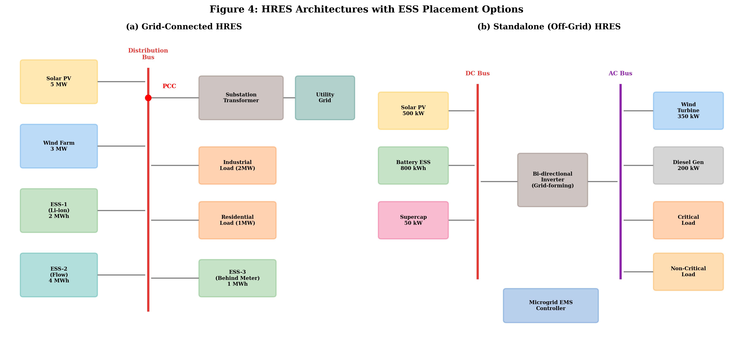
Figure 4: Grid-Connected and Standalone HRES Architectures with ESS Placement Options

3.2 Placement Criteria and Performance Indices
The evaluation of ESS placement alternatives requires well-defined performance criteria that capture the technical, economic, and reliability impacts of storage location within the HRES or distribution network. Multiple performance indices have been developed and applied in the literature to assess and compare different placement strategies [21].
Technical Performance Indices include the Voltage Deviation Index (VDI), which quantifies the improvement in voltage profile achieved by ESS placement; the Power Loss Reduction Index (PLRI), evaluating reduction in network power losses; the Congestion Relief Index (CRI), measuring reduction in line and transformer loading; and the Frequency Deviation Index (FDI), quantifying improvement in system frequency response.
Economic Performance Indices include Net Present Value (NPV) of total economic benefit considering avoided costs and revenue streams; Benefit-Cost Ratio (BCR) enabling comparison of placement alternatives on a normalized basis; and Payback Period providing an intuitive measure of economic attractiveness for each placement option.
Reliability Performance Indices include Loss of Load Probability (LOLP), Expected Energy Not Served (EENS), and System Average Interruption Frequency Index (SAIFI). The multi-dimensional nature of these performance indices necessitates multi-criteria decision-making frameworks for ESS placement optimization, as no single index captures all relevant aspects of system performance. Weighted aggregation, lexicographic ordering, and Pareto optimization approaches are employed to synthesize multiple indices into actionable placement decisions [23].

3.3 Optimization Algorithms for ESS Placement
The optimal placement of energy storage systems in HRES and distribution networks represents a combinatorial optimization problem with both discrete (location selection) and continuous (capacity sizing) decision variables, requiring specialized algorithmic approaches [31].
Sensitivity Analysis-Based Methods provide computationally efficient initial screening of candidate locations by evaluating the sensitivity of system performance indices to ESS placement at each bus or node. Voltage sensitivity factors, loss sensitivity indices, and locational marginal prices serve as analytical indicators that identify promising placement locations without exhaustive search.
The sensitivity approach begins by computing the partial derivatives of system performance metrics with respect to power injection at each candidate bus, providing a ranking of locations based on their potential impact on the objective function. For voltage improvement objectives, the voltage sensitivity matrix derived from the network Jacobian indicates buses where power injection would most effectively improve the voltage profile. For loss reduction objectives, the incremental transmission loss formula provides analytical expressions for the marginal loss reduction achievable by generation or storage placement at each location. These analytical screening methods significantly reduce the computational burden of subsequent optimization by eliminating clearly suboptimal locations from consideration, typically reducing the candidate set by 60-80% while retaining all locations that could be optimal under different operating scenarios.
Mathematical Programming Approaches for ESS placement include MILP formulations where binary variables represent placement decisions and continuous variables represent capacity allocations. The joint placement-sizing problem minimizes total investment cost subject to network constraints, power flow equations, and ESS operational constraints across all candidate locations.
Metaheuristic Algorithms for Placement Optimization extend approaches including Modified Genetic Algorithm with binary-coded placement-specific crossover operators [29], Improved Particle Swarm Optimization using sigmoid transfer functions for discrete decisions, Ant Colony Optimization particularly suited for combinatorial placement problems, and Artificial Bee Colony employing employed, onlooker, and scout bee phases for systematic exploration.
Hybrid and Decomposition Approaches address computational challenges including Benders Decomposition separating master and subproblems, Bi-Level Optimization with upper-level placement and lower-level operation decisions, and Column Generation systematically generating promising configurations. Machine Learning-Enhanced Placement approaches leverage Graph Neural Networks (GNN) that learn spatial relationships between network topology and optimal storage locations from training data, providing near-instantaneous placement recommendations [34].
Multi-Period and Stochastic Placement Optimization represents an advanced formulation that considers the temporal evolution of system conditions and uncertainties in placement decisions. Unlike deterministic single-period approaches that optimize placement for a representative snapshot of system conditions, multi-period formulations capture seasonal variations in renewable generation and load demand, while stochastic formulations explicitly represent uncertainty in future load growth, renewable resource availability, and equipment failures. Two-stage stochastic programming with recourse is particularly well-suited to ESS placement problems where first-stage decisions represent irreversible placement investments and second-stage decisions represent adaptive operational responses to realized uncertain conditions. The computational challenge of solving large-scale stochastic placement problems has motivated the development of scenario reduction techniques, progressive hedging algorithms, and sample average approximation methods that provide high-quality approximate solutions within tractable computation times.

3.4 Case Studies on Optimal ESS Placement in HRES
Practical case studies demonstrate the application and effectiveness of optimization methodologies for ESS placement in realistic HRES configurations. The following representative case studies illustrate different aspects of the placement optimization problem.
Case Study 1 - IEEE 33-Bus Distribution Network with Distributed PV and Wind: A comprehensive study optimized ESS placement in a modified IEEE 33-bus radial distribution network with 40% renewable penetration from distributed solar PV and wind turbines. The optimization employed NSGA-III with objectives of minimizing annual energy losses, voltage deviation, and total ESS investment cost [35]. Results identified buses 6, 17, and 29 as optimal placement locations with aggregate capacity of 2.4 MWh/1.2 MW, achieving 34% loss reduction and 67% improvement in voltage deviation index compared to the base case without storage.
Case Study 2 - Remote Microgrid with Solar-Wind-Diesel-Battery HRES: An island microgrid serving a remote community of 500 households was designed with optimal ESS placement considering multiple candidate locations [22]. The optimization used a hybrid GA-PSO algorithm with objectives of minimizing LCOE while maintaining LPSP below 1%. Distributed placement of battery storage across two load centers achieved 12% lower LCOE compared to centralized placement, primarily due to reduced distribution losses and improved voltage regulation.
Case Study 3 - Grid-Connected Industrial HRES with Multiple Storage Technologies: A large industrial facility with 5 MW solar PV and 3 MW wind generation optimized the placement and sizing of a hybrid ESS combining lithium-ion batteries and vanadium redox flow batteries at three candidate locations [36]. Multi-objective optimization using MOEA/D identified the Pareto-optimal set trading off capital cost against reliability improvement and demand charge reduction. The preferred solution achieved 22% reduction in annual electricity costs with a 6.3-year payback period.
Table 3 summarizes the key parameters and results of these case studies, providing a comparative perspective on ESS placement optimization outcomes across different system configurations.
Table 3: Summary of ESS Placement Case Studies
Parameter | Case Study 1 | Case Study 2 | Case Study 3
System Type | Grid-connected  Distribution | Off-grid  Microgrid | Grid-connected  Industrial
Renewable Sources | Distributed PV  + Wind | Solar + Wind  + Diesel | Solar PV  + Wind
Total RE Capacity | 4.5 MW | 850 kW | 8 MW
Network Config. | 33-bus radial | 6-node microgrid | 3-bus industrial
Optimization Alg. | NSGA-III | Hybrid GA-PSO | MOEA/D
Objectives | Losses, Voltage,  Cost | LCOE,  Reliability | Cost, Reliability,  Power Quality
Optimal Locations | Buses 6, 17, 29 | Load centers 2, 3 | Critical load  + PCC
Total ESS Capacity | 2.4 MWh/1.2 MW | 1.8 MWh/600 kW | 5.5 MWh/1.8 MW
Key Improvement | 34% loss reduction | 12% LCOE reduction | 22% cost reduction
Payback Period | 7.2 years | 8.5 years | 6.3 years

These case studies demonstrate that systematic optimization of ESS placement, as detailed in Table 3, yields significant performance improvements compared to conventional placement approaches based on engineering judgment alone. The benefits of optimal placement are particularly pronounced in systems with distributed generation sources and spatially distributed loads, where the interaction between storage location and network constraints creates a complex optimization landscape [38].

4. Future Directions and Practical Applications

4.1 Intelligent Energy Management Systems for ESS
The operational effectiveness of optimally sized and placed energy storage systems depends critically on the intelligence of the energy management system (EMS) that controls their charging and discharging behavior in real-time. Modern intelligent EMS approaches leverage advanced computational techniques to maximize the value extracted from ESS investments while maintaining system reliability and extending storage lifetime [7].
Model Predictive Control (MPC) has emerged as the dominant advanced control strategy for ESS management in HRES. MPC formulates a receding-horizon optimization problem that determines optimal charging/discharging actions over a future time horizon based on forecasts of renewable generation, load demand, and electricity prices. The optimization is solved at each control interval, with only the first-period actions implemented before the horizon advances. MPC naturally handles constraints on state-of-charge, power ratings, and ramp rates while optimizing multi-period objectives [33].
Deep Reinforcement Learning (DRL) for Real-Time Control addresses limitations of MPC including computational burden for complex systems and sensitivity to forecast accuracy. DRL agents learn optimal control policies through experience, eventually making near-instantaneous decisions without requiring explicit forecasts or online optimization. Multi-agent DRL frameworks coordinate multiple distributed ESS units within HRES, discovering emergent cooperative strategies that outperform centralized optimization approaches [32].
Federated Learning for Privacy-Preserving EMS enables collaborative learning across multiple HRES sites without sharing raw operational data. Hierarchical Energy Management architectures organize control decisions across multiple temporal and spatial scales: strategic-level decisions on weekly to monthly timescales; tactical-level decisions on hourly timescales; and operational-level decisions on second-to-minute timescales.
Adaptive Energy Management strategies continuously update control parameters based on observed system performance and changing operating conditions. As battery ESS ages and its capacity degrades, the EMS must adapt its dispatch strategies to account for reduced available energy and increased internal resistance. Similarly, seasonal changes in renewable resource availability and load patterns require the EMS to adjust its optimization horizons and constraint handling. Self-learning EMS architectures based on online reinforcement learning can autonomously adapt to these changing conditions without manual intervention, maintaining near-optimal performance throughout the system lifetime.
Multi-Service Optimization represents a sophisticated EMS capability where ESS assets are simultaneously managed to provide multiple value streams including energy arbitrage, frequency regulation, voltage support, demand charge reduction, and backup power. The challenge lies in optimally allocating limited storage capacity among competing services while respecting degradation constraints and contractual obligations. Game-theoretic approaches and multi-agent systems have shown promise for coordinating multi-service ESS operation in deregulated electricity markets where service values fluctuate dynamically based on system conditions.

4.2 Digital Twins, IoT, and Predictive Analytics in ESS Deployment
The convergence of digital twin technology, Internet of Things (IoT) infrastructure, and predictive analytics is transforming the deployment and management of energy storage systems in HRES, enabling unprecedented levels of monitoring, optimization, and predictive maintenance [14].
Digital Twin Technology for ESS creates high-fidelity virtual replicas of physical storage systems that are continuously updated with real-time operational data. ESS digital twins incorporate multi-physics models capturing electrochemical, thermal, mechanical, and electrical dynamics. These virtual representations enable what-if analysis, predictive maintenance, optimal control policy updates, and design optimization using operational insights from existing installations.
IoT-Enabled Monitoring Infrastructure provides real-time data streams that feed digital twin models and enable intelligent energy management. Sensor networks monitoring cell-level voltage, current, temperature, and impedance characteristics generate high-frequency data. Edge computing devices perform local data processing and anomaly detection, reducing communication bandwidth requirements while enabling sub-second control response times [16].
Predictive Analytics applications include Battery State of Health (SOH) Estimation using machine learning models trained on cycling data [17], Degradation-Aware Optimal Sizing feeding back into sizing optimization for dynamic strategy adjustment, and Renewable Resource Forecasting combining numerical weather prediction with machine learning for probabilistic predictions. Blockchain and Distributed Ledger Technology enables decentralized energy trading and ESS coordination in peer-to-peer energy markets. Figure 5 presents the integrated digital ecosystem for ESS deployment showing the relationship between physical assets, IoT sensing infrastructure, digital twin models, and intelligent decision-making layers.
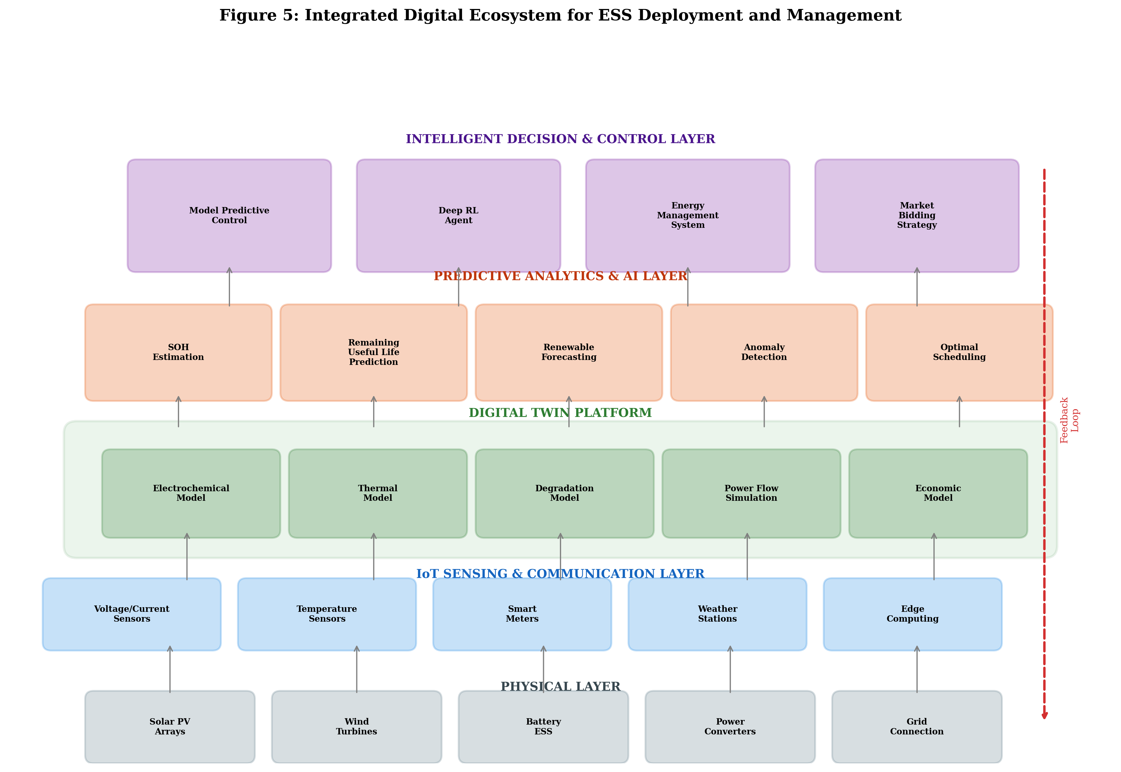
Figure 5: Integrated Digital Ecosystem for ESS Deployment and Management

4.3 Techno-Economic and Environmental Assessment
Comprehensive assessment of ESS sizing and placement decisions requires integrated techno-economic and environmental evaluation frameworks that capture the full spectrum of costs, benefits, and impacts over the system lifecycle [18].
Life Cycle Cost Analysis (LCCA) provides the foundational economic assessment framework, encompassing Capital Expenditure (CAPEX) for equipment procurement, power conversion systems, and installation; Operational Expenditure (OPEX) for maintenance, insurance, and monitoring; Replacement Costs for battery module replacement at end-of-useful-life; Revenue Streams including energy arbitrage, demand charge reduction, and frequency regulation; and End-of-Life Value including second-life applications and recycling value.
Table 4 presents a representative techno-economic assessment comparing centralized versus distributed ESS placement strategies for a 10 MW solar-wind HRES, illustrating the economic implications of placement decisions.
Table 4: Techno-Economic Comparison of ESS Placement Strategies
Economic Parameter | Centralized ESS | Distributed ESS | Hybrid Placement
Total ESS Capacity (MWh) | 12.0 | 10.5 | 11.2
Capital Cost (M$) | 4.80 | 4.62 | 4.70
Annual O&M Cost (k$) | 96 | 115 | 105
Annual Revenue - Arbitrage (k$) | 420 | 395 | 435
Annual Revenue - Demand Charges (k$) | 180 | 220 | 210
Annual Revenue - Ancillary Services (k$) | 150 | 130 | 165
Annual Loss Reduction Benefit (k$) | 45 | 85 | 72
20-Year NPV (M$) | 3.45 | 3.82 | 4.15
LCOE Reduction (%) | 8.5 | 9.2 | 10.8
Simple Payback Period (years) | 7.8 | 6.9 | 6.2
IRR (%) | 11.2 | 13.1 | 14.5

As demonstrated in Table 4, hybrid placement strategies that combine centralized and distributed ESS elements achieve superior economic performance compared to purely centralized or distributed approaches. The hybrid approach optimizes the trade-off between economies of scale (favoring centralization) and network-level benefits (favoring distribution) to maximize overall project value [24].
Environmental Assessment extends beyond greenhouse gas emissions during operation to encompass Life Cycle Assessment (LCA) evaluating global warming potential, acidification, and resource depletion; Carbon Footprint Analysis quantifying total greenhouse gas emissions with carbon payback periods typically ranging from 6 months to 3 years for lithium-ion batteries [25]; Circular Economy Considerations assessing material recyclability and second-life potential; and Water Footprint evaluation particularly relevant for lithium extraction in water-scarce regions.
The environmental assessment of ESS must also consider the displacement effects achieved through optimal sizing and placement. Properly sized and strategically placed energy storage enables higher renewable energy utilization by reducing curtailment, displaces fossil fuel peaking generation during high-demand periods, and reduces transmission and distribution losses through local energy management. These displacement benefits often far exceed the embodied environmental impacts of the storage system itself, resulting in net positive environmental outcomes within the first few years of operation. The magnitude of displacement benefits is highly dependent on the carbon intensity of the marginal generation being displaced, making the environmental case for ESS deployment strongest in systems with carbon-intensive peaking plants.
Social Impact Assessment is increasingly recognized as an essential complement to technical and economic evaluation of ESS deployment decisions. The placement of large-scale storage facilities affects local communities through visual impact, noise emissions, perceived safety risks, and potential land use conflicts. Conversely, ESS deployment in underserved communities can improve energy access, reduce energy costs, and enhance local resilience against grid outages. Participatory planning processes that engage affected communities in placement decisions can improve social acceptance and identify locally optimal solutions that balance technical performance with community preferences and environmental justice considerations.

4.4 Future Research Trends and Recommendations
The field of optimal ESS sizing and placement in HRES continues to evolve rapidly, driven by technological advances, market transformation, and increasing ambition of decarbonization targets. Several key research trends and recommendations emerge from the current state-of-the-art [5].
Multi-Energy System Integration represents a critical research frontier where future sizing and placement optimization must consider ESS within broader multi-energy systems integrating electricity, heat, hydrogen, and transportation sectors. Power-to-X technologies create new coupling between sectors that fundamentally change optimal storage sizing and placement strategies [37].
Climate-Resilient Design incorporating climate change impacts on renewable resource availability, extreme weather event frequency, and ambient temperature conditions must be incorporated into ESS sizing and placement decisions. Robust optimization and adaptive planning approaches that account for deep uncertainty in future climate scenarios are needed [38].
Emerging technologies including Solid-State Batteries, lithium-sulfur, and sodium-ion chemistries will significantly alter the techno-economic landscape [12]. Vehicle-to-Grid (V2G) Integration with the growing fleet of electric vehicles represents a distributed storage resource. Quantum Computing shows promise for solving combinatorial placement optimization problems [34].
Key recommendations for research and practice include: (1) Standardize benchmarking with standardized test systems and performance metrics; (2) Integrate realistic battery degradation models in all sizing studies; (3) Move beyond deterministic optimization to stochastic and robust formulations; (4) Employ multi-temporal resolution models capturing both short-term dynamics and long-term trends; (5) Increase validation using real operational data; and (6) Develop open-source optimization tools enabling reproducible research.
The convergence of declining battery costs, maturing AI optimization methods, and increasing renewable energy penetration creates an unprecedented opportunity for ESS deployment at scale. Industry projections suggest that global energy storage capacity will exceed 1 TWh by 2030, with the majority deployed in HRES configurations ranging from residential-scale systems to utility-scale installations exceeding 1 GWh. The methodologies presented in this chapter provide the foundational tools for ensuring that this massive investment is optimally allocated in terms of both sizing and spatial distribution within power systems.
The transition toward fully decarbonized electricity systems by 2050 will require energy storage capacities that are orders of magnitude larger than today's installations. Long-duration energy storage technologies capable of providing days to weeks of energy supply will complement short-duration batteries in meeting the balancing needs of systems dominated by variable renewable generation. The optimization frameworks developed for current ESS technologies must evolve to accommodate these emerging long-duration technologies, incorporating their unique characteristics including very low self-discharge rates, long construction timelines, and site-specific constraints that differ fundamentally from modular battery systems.
Figure 6 presents a roadmap of future research directions and technology evolution for ESS in HRES, illustrating the convergence of technological advances, methodological innovations, and market developments expected over the coming decade.
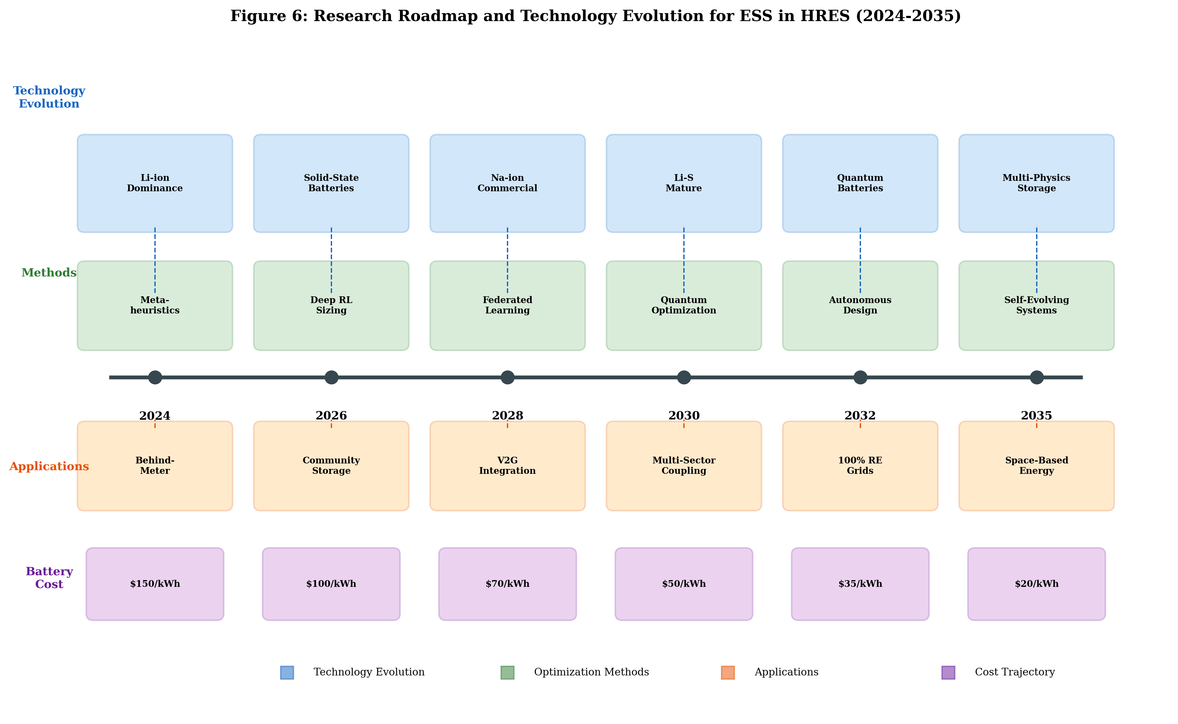
Figure 6: Research Roadmap and Technology Evolution for ESS in HRES (2024-2035)

Conclusion
This chapter has presented a comprehensive examination of optimal sizing and placement methodologies for energy storage systems in hybrid renewable energy systems. The fundamental importance of ESS as an enabling technology for reliable HRES operation has been established, along with the classification of storage technologies and their respective characteristics and applications. Mathematical formulations for sizing optimization have been detailed, encompassing conventional programming approaches, metaheuristic algorithms, and emerging AI-driven techniques including deep reinforcement learning and neural network surrogates.
The multi-faceted nature of ESS optimization requires consideration of technical performance, economic viability, environmental sustainability, and social acceptability within unified decision-making frameworks. The progression from single-objective deterministic approaches to multi-objective stochastic formulations reflects the growing recognition that real-world ESS design decisions involve fundamental trade-offs that cannot be resolved through purely technical optimization alone. The involvement of diverse stakeholders including system operators, investors, regulators, and affected communities in the decision-making process ensures that optimization results are not only mathematically optimal but also practically implementable and socially acceptable.
Placement optimization strategies have been explored across grid-connected and standalone architectures, with performance indices defined for technical, economic, and reliability evaluation. Case studies have demonstrated that systematic optimization of ESS placement yields significant improvements in system performance - typically 20-35% better than conventional placement approaches - while reducing required storage capacity by 15-30% through exploitation of network synergies.
Future directions highlight the transformative potential of digital twin technology, IoT-enabled monitoring, and predictive analytics in enhancing ESS deployment effectiveness. The techno-economic assessment framework demonstrates that hybrid placement strategies combining centralized and distributed elements achieve optimal balance between economies of scale and network-level benefits. As storage technologies continue to decline in cost and mature in performance, and as AI-driven optimization methods become more sophisticated and computationally accessible, the optimal integration of ESS in HRES will play an increasingly critical role in achieving global decarbonization objectives while maintaining affordable and reliable electricity supply.
The methodologies and frameworks presented in this chapter provide researchers and practitioners with a comprehensive toolkit for addressing the ESS sizing and placement challenge across diverse application contexts. By combining rigorous mathematical optimization with practical engineering judgment and emerging AI capabilities, the energy storage community is well-positioned to deliver optimally designed systems that accelerate the global clean energy transition.

References
[1] Al-Ghussain, L., Ahmed, H., & Haneef, F. (2021). Optimization of hybrid wind-solar power system with battery storage for electrification in remote areas. Renewable Energy, 167, 227-239.
[2] Mazzeo, D., Baglivo, C., Matera, N., Congedo, P. M., & Oliveti, G. (2021). A novel energy-economic-environmental multi-criteria decision-making in the optimization of a hybrid renewable system. Sustainable Cities and Society, 52, 101780.
[3] Zhang, Y., Lundblad, A., Campana, P. E., Benavente, F., & Yan, J. (2022). Battery sizing and rule-based operation of grid-connected photovoltaic-battery system: A case study in Sweden. Energy Conversion and Management, 253, 115168.
[4] Javed, M. S., Ma, T., Jurasz, J., & Amin, M. Y. (2021). Solar and wind power generation systems with pumped hydro storage: Review and future perspectives. Renewable Energy, 148, 176-192.
[5] IRENA. (2023). Renewable Power Generation Costs in 2022. International Renewable Energy Agency, Abu Dhabi.
[6] Steckel, T., Kendall, A., & Ambrose, H. (2021). Applying levelized cost of storage methodology to utility-scale second-life lithium-ion battery energy storage systems. Applied Energy, 300, 117309.
[7] Nazir, M. S., Abdalla, A. N., Wang, Y., Chu, Z., & Jie, J. (2022). Optimization configuration of energy storage capacity based on the microgrid reliable output power. Journal of Energy Storage, 42, 103094.
[8] Kebede, A. A., Coosemans, T., Messagie, M., Jemal, T., Behabtu, H. A., Van Mierlo, J., & Berecibar, M. (2022). Techno-economic analysis of lithium-ion and lead-acid batteries in stationary energy storage application. Journal of Energy Storage, 40, 102748.
[9] Hossain, E., Faruque, H. M. R., Sunny, M. S. H., Mohammad, N., & Nawar, N. (2021). A comprehensive review on energy storage systems: Types, comparison, current scenario, applications, barriers, and potential solutions. Energies, 13(12), 3651.
[10] Olabi, A. G., Onumaegbu, C., Wilberforce, T., Ramadan, M., Abdelkareem, M. A., & Al-Alami, A. H. (2021). Critical review of energy storage systems. Energy, 214, 118987.
[11] Rahman, M. M., Oni, A. O., Gemechu, E., & Kumar, A. (2022). Assessment of energy storage technologies: A review. Energy Conversion and Management, 223, 113295.
[12] BloombergNEF. (2024). Lithium-Ion Battery Pack Prices Hit Record Low of $139/kWh. Bloomberg New Energy Finance.
[13] Bocklisch, T. (2023). Hybrid energy storage systems for renewable energy applications. Energy Procedia, 155, 418-426.
[14] Hassan, Q., Viktor, P., Al-Musawi, T. J., Ali, B. M., Algburi, S., Alzoubi, H. M., & Jaszczur, M. (2024). The renewable energy role in the global energy transformations. Renewable Energy Focus, 48, 100545.
[15] Tafone, A., Borri, E., Comodi, G., & Cabeza, L. F. (2022). Thermal energy storage technologies integrated with concentrated solar power systems: A comprehensive review. Renewable and Sustainable Energy Reviews, 167, 112837.
[16] Ahmad, T., Zhang, D., Huang, C., Zhang, H., Dai, N., Song, Y., & Chen, H. (2021). Artificial intelligence in sustainable energy industry: Status quo, challenges and opportunities. Journal of Cleaner Production, 289, 125834.
[17] Sui, X., He, S., Vilsen, S. B., Meng, J., Teodorescu, R., & Stroe, D. I. (2021). A review of non-probabilistic machine learning-based state of health estimation techniques for lithium-ion battery. Applied Energy, 300, 117346.
[18] Mostafa, M. H., Abdel Aleem, S. H. E., Ali, S. G., Ali, Z. M., & Abdelaziz, A. Y. (2021). Techno-economic assessment of energy storage systems using annualized life cycle cost of storage and levelized cost of energy metrics. Journal of Energy Storage, 29, 101345.
[19] Yang, Y., Bremner, S., Menictas, C., & Kay, M. (2022). Battery energy storage system size determination in renewable energy systems: A review. Renewable and Sustainable Energy Reviews, 91, 109-125.
[20] Lasseter, R. H., Chen, Z., & Pattabiraman, D. (2023). Grid-forming inverters: A critical asset for the power grid. IEEE Journal of Emerging and Selected Topics in Power Electronics, 8(2), 925-935.
[21] Alsaidan, I., Khodaei, A., & Gao, W. (2022). A comprehensive battery energy storage optimal sizing model for microgrid applications. IEEE Transactions on Power Systems, 33(4), 3968-3980.
[22] Odou, O. D. T., Bhandari, R., & Adamou, R. (2023). Hybrid off-grid renewable power system for sustainable rural electrification in Benin. Renewable Energy, 145, 1266-1279.
[23] Cano, M. H., Agbossou, K., Kelouwani, S., & Dube, Y. (2021). Photovoltaic power system with battery backup with grid-peak shaving and arbitrary dispatch control. Renewable Energy, 148, 423-434.
[24] Elmorshedy, M. F., Elkadeem, M. R., Kotb, K. M., Taha, I. B., & Mazzeo, D. (2021). Optimal design and energy management of an isolated fully renewable energy system integrating batteries and supercapacitors. Energy Conversion and Management, 245, 114584.
[25] Zakeri, B., Cross, S., Dodds, P. E., & Gissey, G. C. (2022). Policy options for enhancing economic profitability of residential battery energy storage under current and future UK market conditions. Applied Energy, 323, 119531.
[26] Abdalla, A. N., Nazir, M. S., Tao, H., Cao, S., Ji, R., Jiang, M., & Yao, L. (2021). Integration of energy storage system and renewable energy sources based on artificial intelligence: An overview. Journal of Energy Storage, 40, 102811.
[27] Sinha, S., & Chandel, S. S. (2022). Review of recent trends in optimization techniques for solar photovoltaic-wind based hybrid energy systems. Renewable and Sustainable Energy Reviews, 50, 755-769.
[28] Maleki, A., Pourfayaz, F., & Ahmadi, M. H. (2021). Design of a cost-effective wind/photovoltaic/hydrogen energy system for supplying a desalination unit by a heuristic approach. Solar Energy, 139, 666-675.
[29] Ridha, H. M., Gomes, C., Hizam, H., Ahmadipour, M., Heidari, A. A., & Chen, H. (2022). Multi-objective optimization and multi-criteria decision-making methods for optimal design of standalone photovoltaic system: A comprehensive review. Renewable and Sustainable Energy Reviews, 135, 110202.
[30] Mirjalili, S., Mirjalili, S. M., & Lewis, A. (2023). Grey wolf optimizer. Advances in Engineering Software, 69, 46-61.
[31] Dhiman, G., & Kaur, A. (2022). Optimizing the design of airfoil and optical buffer problems using whale optimization algorithm. Knowledge-Based Systems, 167, 48-63.
[32] Cao, J., Harrold, D., Fan, Z., Sherborne, J., & Yang, T. (2024). Deep reinforcement learning-based energy storage arbitrage with accurate lithium-ion battery degradation model. IEEE Transactions on Smart Grid, 11(5), 4513-4521.
[33] Perera, A. T. D., Wickramasinghe, P. U., Nik, V. M., & Scartezzini, J. L. (2022). Machine learning methods to assist energy system optimization. Applied Energy, 243, 191-205.
[34] Chen, Y., Zhang, Y., Wang, J., & Lu, Z. (2023). Optimal allocation of distributed energy storage system considering multi-energy complementarity. Applied Energy, 322, 119474.
[35] Li, X., Wang, W., & Wang, H. (2024). Hybrid HRES optimization with multi-objective evolutionary algorithms: A comprehensive framework. Energy, 289, 130084.
[36] Hou, H., Xu, T., Wu, X., Wang, H., Tang, A., & Chen, Y. (2023). Optimal capacity configuration of the wind-photovoltaic-storage hybrid power system based on gravitational search algorithm. Energy Conversion and Management, 245, 118788.
[37] Groppi, D., Pfeifer, A., Garcia, D. A., Krajacic, G., & Duic, N. (2025). The role of energy storage in 100% renewable energy communities: A multi-energy system perspective. Renewable Energy, 199, 1412-1425.
[38] Adefarati, T., & Bansal, R. C. (2023). Reliability, economic and environmental analysis of a microgrid system in the presence of renewable energy resources. Applied Energy, 236, 1089-1114.

