Finite Element Analysis of Modified Green–Lindsay Thermoelasticity for Functionally Graded and Porous Media Under a Line Heat Source: A Galerkin State-Space Formulation
[Author names, affiliations and corresponding-author e-mail to be inserted]

Abstract
The modified Green–Lindsay (MGL) theory of thermoelasticity removes the displacement discontinuity of the original Green–Lindsay model by adding a strain-rate term to the constitutive law. Closed-form solutions of MGL line-source problems exist only for homogeneous media. This paper develops a Galerkin finite element solution of the MGL equations for an unbounded medium whose properties vary radially, either through a functionally graded (FG) composition or through porosity, and which is heated by a line heat source. The line source is regularised as a compact heat-generating disc, the operators $(1+τ_{1}∂_{t})$ and $(1+τ_{0}∂_{t})$ are removed by two auxiliary state variables, and the resulting first-order system is marched with the trapezoidal rule, which reduces to a Newmark average-acceleration and Crank–Nicolson pair. A second route, a Laplace-domain finite element solution inverted numerically, is used as an independent check of the time integration. The scheme is validated against an exact modified Bessel function solution that is derived here for uniform media with arbitrary property ratios. For the homogeneous copper data of the base problem, the finite element temperature history agrees with the exact one to 0.08 per cent, displacement to 0.59 per cent and stress to 1 to 1.6 per cent in the relative L2 sense, and the Laplace-domain and time-domain finite element solutions agree to better than 0.06 per cent in temperature. Quadratic elements reduce the temperature error by more than two orders of magnitude between h = 0.05 and h = 0.0125, and the dominant remaining error is the source regularisation, which falls as the square of the source radius for the displacement and more slowly for the stresses. The studies show that grading the properties from a low-conductivity, stiff core to a copper-like far field delays the thermal front at r = 0.3 from t = 0.0425 to 0.085 for a linear grading, raises the temperature behind the front, and raises the peak radial stress by a factor of 1.60. Uniform porosity of 0.3 lowers the local wave speed by 8.3 per cent and raises the temperature at the observation point by 57 per cent. Without the strain-rate term an elastic wavefront with a stress jump appears and is smeared by the mesh, whereas the MGL term removes it. The sharp stress peak at the thermal front is under-resolved by about a factor of two, and this and other limits are reported.
Keywords: modified Green–Lindsay thermoelasticity; finite element method; Galerkin; functionally graded material; porous material; line heat source; state-space time integration

1. Introduction
Classical coupled thermoelasticity assumes Fourier conduction and therefore predicts an infinite speed for thermal disturbances. For heating on very short time scales, for example by laser or particle beams, or in nanoscale components, that prediction is not acceptable, and a family of generalized theories has been proposed in which one or more relaxation times appear in the energy equation or in the constitutive law. The Lord–Shulman theory adds one relaxation time to the heat flux law, the Green–Lindsay theory adds two relaxation times to the constitutive and energy equations, and the Green–Naghdi theories introduce a thermal displacement. Reviews of these theories and of their modifications are given in [9]. The original Green–Lindsay model has a well known defect: the displacement can be discontinuous at the wavefront. Yu, Xue and Tian removed this defect by adding a strain-rate term with the same relaxation time that multiplies the temperature rate, and Quintanilla analysed the qualitative properties of the resulting modified Green–Lindsay (MGL) system. Later contributions established fundamental solutions [3], a Galerkin-type representation [4], infinite-speed behaviour [2] and applications to photothermal problems in semiconductors [6].
The reference problem for the present work is the line heat source in an unbounded isotropic homogeneous MGL medium solved by Singh and Mukhopadhyay [1]. Using a Laplace transform and a displacement potential, they found that the homogeneous MGL solution contains one wave of finite speed together with a diffusive part, that the displacement is continuous, and that the discontinuity is confined to the hoop stress. This differs from the line source solutions of the Moore–Gibson–Thompson theory, which show two wavefronts [7, 8]. All of these solutions rely on the Laplace transform, and that route needs property data that are constant in space, so that the transformed equation reduces to a product of two Helmholtz operators with Bessel function solutions.
Practical heat-affected media are rarely homogeneous. Functionally graded materials replace the sharp interface between a metal and a ceramic by a smooth variation of composition, and a large literature treats their thermal and thermoelastic response, including transient cooling shocks of graded plates [11, 12]. Porosity changes stiffness, conductivity and density, either as a by-product of manufacture or deliberately, and the design of thermoelastic composites with maximum stiffness and heat transfer by topology optimisation is a related field in which finite element analysis is the working tool [10]. For the MGL theory with graded properties, Shivay and Mukhopadhyay developed a complete Galerkin-type finite element approach for a functionally graded hollow disk [5]. To the knowledge of the authors, which rests on the reference list of [1] and not on a systematic survey, the line heat source in a radially graded or porous MGL medium has not been treated before; the list of references is intentionally limited to sources whose details could be verified (see the note after the reference list).
The contribution of this paper is a complete and verified finite element formulation for that problem. It has four elements. First, the governing equations are written for spatially variable property ratios in a form that keeps the divergence structure, so that no derivative of a material property is needed. Second, the line source is regularised by a compact disc whose radius is a controlled parameter, and the regularisation error is measured, not assumed. Third, the operators $(1+τ_{1}∂_{t})$ and $(1+τ_{0}∂_{t})$ are eliminated with two auxiliary state variables, so that a standard unconditionally stable one-step method can be used. Fourth, the scheme is verified against an exact solution that is derived for uniform media with arbitrary property ratios, which makes it possible to test the porosity model rigorously, and against an independent Laplace-domain finite element solution, which makes it possible to test the graded case.
The paper is organised as follows. Section 2 states the governing equations. Section 3 defines the grading and porosity models and the local wave speed. Section 4 derives the exact reference solution for uniform media. Section 5 gives the weak form and the finite element matrices, Section 6 the time integration and the Laplace-domain alternative, and Section 7 the verification measures. Section 8 presents the results, Section 9 discusses limitations and Section 10 concludes.
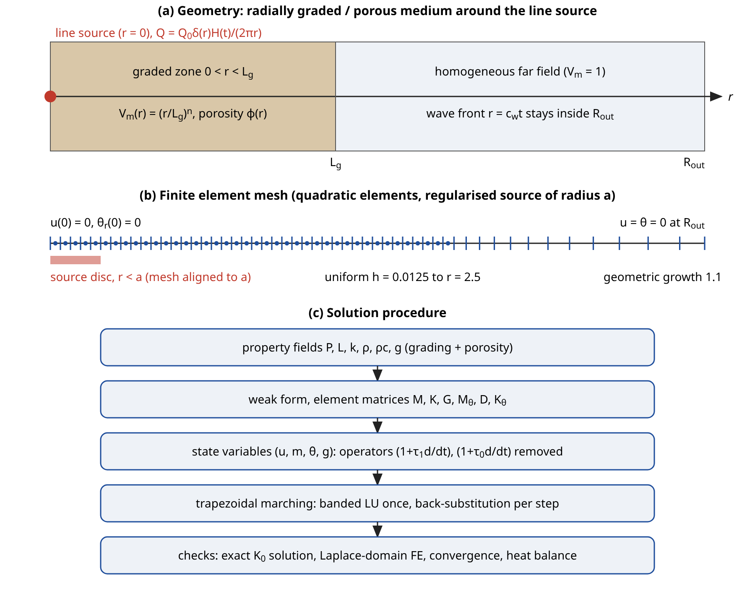
Figure 1. Schematic of the problem. (a) Geometry with the graded zone and the far field. (b) Finite element mesh with the aligned source disc and the truncation boundary. (c) Solution procedure. This figure is a schematic and contains no computed data.

2. Governing equations

2.1 MGL thermoelasticity
Let $u_{i}$ be the displacement, $θ$ the temperature increment above the reference temperature $T_{0}$, $e$ the dilatation and $ε_{ij}$ the strain. In the MGL theory the stress and the equation of motion read
$σ_{ij}=\left(1+τ_{1}∂_{t}\right)\left[λeδ_{ij}+2με_{ij}−γθδ_{ij}\right], ρ ∂_{t}^{2}u_{i}=σ_{ij,j}$ (1)
where $λ$ and $μ$ are the Lamé moduli, $ρ$ the density, $γ=(3λ+2μ)α_{t}$ the thermomechanical coupling coefficient, $α_{t}$ the coefficient of linear thermal expansion and $τ_{1}$ the relaxation time that multiplies both the strain rate and the temperature rate. The energy equation and the heat flux law are
$ρc_{E} ∂_{t}θ+γT_{0} ∂_{t}e=−∇⋅q+Q, \left(1+τ_{0}∂_{t}\right)q=−k∇θ$ (2)
with $c_{E}$ the specific heat at constant strain, $k$ the thermal conductivity, $q$ the heat flux, $Q$ the volumetric heat source and $τ_{0}$ the relaxation time of the heat flux. The sign convention follows [1]: the source $Q$ enters the energy balance after the operator $(1+τ_{0}∂_{t})$ has been applied, so that Eqs. (1) and (2) lead to a heat equation in which $Q$ is not differentiated in time. This choice is needed to reproduce the reference solution and it is kept throughout.

2.2 Nondimensional radial equations
The nondimensionalisation of the base problem is used with the reference (copper) data of Table 1, namely
$r′=ηc_{0}r, t′=ηc_{0}^{2}t, u′=ηc_{0}u, θ′=\frac{θ}{T_{0}}, σ′=\frac{σ}{λ_{0}+2μ_{0}}, c_{0}=\sqrt{\frac{λ_{0}+2μ_{0}}{ρ_{0}}}, η=\frac{ρ_{0}c_{E0}}{k_{0}}$ (3)
With the subscript $0$ denoting the reference values, the dimensionless constants are
$δ_{1}=\frac{γ_{0}T_{0}}{λ_{0}+2μ_{0}}, δ_{2}=\frac{γ_{0}}{ρ_{0}c_{E0}}, λ_{1}=\frac{λ_{0}}{λ_{0}+2μ_{0}}, κ=1−λ_{1}, ε=δ_{1}δ_{2}$ (4)
Table 1. Input data: reference (copper) properties of [1] and numerical parameters. Dimensionless values are in units of the scales of Eq. (3).
Quantity | Symbol | Value
Lamé modulus | $λ_{0}$ | $7.76×10^{10}$ Pa
Shear modulus | $μ_{0}$ | $3.86×10^{10}$ Pa
Thermal expansion coefficient | $α_{t}$ | $1.78×10^{−5}$ K⁻¹
Specific heat at constant strain | $c_{E}$ | 383.1 J kg⁻¹ K⁻¹
Thermal conductivity | $k_{0}$ | 386 W m⁻¹ K⁻¹
Density | $ρ_{0}$ | 8954 kg m⁻³
Reference temperature | $T_{0}$ | 293 K
Thermal viscosity coefficient | $η$ | 8886.73 s m⁻²
Longitudinal wave speed | $c_{0}$ | 4157.9 m s⁻¹
Coupling constants | $δ_{1}$, $δ_{2}$ | 0.01044, 1.6086
Dimensionless parameters | $ε$, $λ_{1}$ | 0.0168, 0.50129
Heat-flux relaxation time | $τ_{0}$ | 0.02
Strain-rate relaxation time | $τ_{1}$ | 0.05
Source radius, graded zone, domain | $a$, $L_{g}$, $R_{out}$ | 0.05, 1.0, 3.2
Element size, time step | $h$, $Δt$ | 0.0125, 0.0005

For copper the values are $δ_{1}=0.010444$, $δ_{2}=1.6086$, $ε=0.0168$ and $λ_{1}=0.50129$. The length and time scales are $1/(ηc_{0})=27.1$ nm and $1/(ηc_{0}^{2})=6.51$ ps, which is a first warning that the dimensionless numbers below correspond to nanoscale lengths and picosecond times for copper, a point taken up in Section 9. Properties that vary with the radial coordinate are described by dimensionless ratios $\hat{λ}(r)$, $\hat{μ}(r)$, $\hat{k}(r)$, $\hat{ρ}(r)$, $\hat{c}(r)$ and $\hat{α}(r)$ relative to the reference values, and the radial displacement $u(r,t)$ is the only displacement component. The strain components are
$ε_{rr}=∂_{r}u, ε_{φφ}=\frac{u}{r}, e=∂_{r}u+\frac{u}{r}$ (5)
The thermoelastic stresses before the operator $(1+τ_{1}∂_{t})$ is applied are denoted $S_{rr}$ and $S_{φφ}$:
$S_{rr}=P ∂_{r}u+L \frac{u}{r}−δ_{1}g θ, S_{φφ}=L ∂_{r}u+P \frac{u}{r}−δ_{1}g θ$ (6)
The dimensionless coefficients $P(r)$, $L(r)$ and $g(r)$ are the P-wave modulus, the first Lamé modulus and the thermal stress coefficient relative to $λ_{0}+2μ_{0}$ and $γ_{0}$; they are defined in Section 3 and they equal $1$, $λ_{1}$ and $1$ in the reference medium. The MGL stresses and the equation of motion become
$σ_{rr}=\left(1+τ_{1}∂_{t}\right)S_{rr}, σ_{φφ}=\left(1+τ_{1}∂_{t}\right)S_{φφ}$ (7)
$\hat{ρ} ∂_{t}^{2}u=\left(1+τ_{1}∂_{t}\right)\left[∂_{r}S_{rr}+\frac{S_{rr}−S_{φφ}}{r}\right]$ (8)
For the energy equation, Eqs. (1) and (2) are combined and the divergence form is retained, which is important because it means that the weak form below needs no derivative of $\hat{k}$:
$\frac{1}{r}∂_{r}\left(r\hat{k} ∂_{r}θ\right)=\left(1+τ_{0}∂_{t}\right)\left[\hat{ρ}\hat{c} ∂_{t}θ+δ_{2}g ∂_{t}e\right]−Q$ (9)
Here $\hat{ρ}\hat{c}$ is the product of the density and specific heat ratios. A homogeneous medium with unit ratios gives back the equations of [1].

2.3 Source, initial and far-field conditions
The line source of strength $Q_{0}$ per unit length, switched on at $t=0$, is
$Q(r,t)=\frac{Q_{0}}{2πr} δ(r) H(t)$ (10)
and the initial state is quiescent:
$u=∂_{t}u=θ=∂_{t}θ=0 at t=0$ (11)
The medium is unbounded. For the finite element model the domain is truncated at $r=R_{out}$ and a Dirichlet far-field condition is applied,
$u(0,t)=0, ∂_{r}θ(0,t)=0, u(R_{out},t)=θ(R_{out},t)=0$ (12)
The truncation is justified by the finite speed of the MGL wave: no disturbance can reach $R_{out}$ before $t=R_{out}/c_{max}$, with $c_{max}$ the largest local wave speed defined in Eq. (21) below, so that the Dirichlet condition has no influence as long as the computation stops before that time. Beyond that time the condition would reflect waves. This is a statement about the hyperbolic part of the solution; the diffusive part has no finite front, but its amplitude at $R_{out}$ is below machine precision for the computations reported here. The check in Section 8.2 confirms this: with $R_{out}=1.6$ and $R_{out}=4.5$ the temperature history at $r=0.3$ is identical to all printed digits, whereas with $R_{out}=1.0$, for which the front arrives at $t≈0.143$, the history is visibly changed. No absorbing boundary condition is used.
An exact global balance follows from integrating Eq. (9) over the domain, provided that no flux leaves it. With $H(t)$ the heat content,
$ℋ(t)=\int_{0}^{R_{out}}{\left(\hat{ρ}\hat{c} θ+δ_{2}g e\right)}r dr, ℋ+τ_{0} ∂_{t}ℋ=\frac{Q_{0}}{2π} t ⇒ ℋ(t)=\frac{Q_{0}}{2π}\left[t−τ_{0}\left(1−e^{−t/τ_{0}}\right)\right]$ (13)
This identity is independent of the property distribution and of $τ_{1}$. It is therefore a strong test of the discrete energy balance in graded media, and it is used as such in Section 8.2.

3. Property models for graded and porous media

3.1 Radial grading
The medium is a mixture of two constituents. The first, called the reference phase, has the copper data of Table 1 and all its property ratios equal to one. The second, called the contrast phase, has fixed ratios $χ_{Y}$ to the reference phase. The contrast phase is a hypothetical stiff, poorly conducting, light ceramic-like constituent; its ratios in Table 2 are illustrative and are not calibrated to a specific material, because the aim is a controlled test of the numerical method with a clear contrast, not a prediction for a named compound. The volume fraction of the reference phase is $V_{m}(r)$. A power-law grading over a zone of thickness $L_{g}$ is
$V_{m}(r)={\left(\frac{r}{L_{g}}\right)}^{n} (r<L_{g}), V_{m}=1 (r≥L_{g})$ (14)
so that the contrast phase is concentrated at the source and the medium is homogeneous reference material beyond $L_{g}$. The exponent $n≥0$ is the grading exponent: $n=0$ gives $V_{m}≡1$ and recovers the homogeneous medium, whereas a large $n$ keeps the contrast phase dominant over most of the zone. An exponential alternative with a shape parameter $β>0$, which is also continuous at $r=L_{g}$, is
$V_{m}(r)=\frac{e^{βr/L_{g}}−1}{e^{β}−1} (r<L_{g})$ (15)
The linear rule of mixtures gives each property ratio as a weighted average of the two phases,
$\hat{Y}(r)=V_{m}(r)+\left[1−V_{m}(r)\right]χ_{Y}, Y∈\{λ,μ,k,ρ,α,c\}$ (16)
The rule of mixtures is the simplest estimate and it is known to be crude for strongly contrasting phases; it was chosen for transparency. Self-consistent or Mori–Tanaka estimates, which are classical, could be substituted without changing the finite element formulation, since the scheme only needs point values of the ratios. In this study $χ_{λ}=χ_{μ}=2$, $χ_{k}=0.1$, $χ_{ρ}=0.5$, $χ_{α}=0.5$ and $χ_{c}=2$, and $L_{g}=1$. The grading zone is long enough that the front crosses it in the observed time window, and the transition at $r=L_{g}$ is a node of every mesh used.

3.2 Porosity
A porosity $φ(r)$ is the volume fraction of voids. It is written as a peak value $φ_{0}$ times a profile $w(r)$, with $w=1$ for uniform porosity and $w=1−V_{m}$ for porosity that is concentrated in the graded zone and vanishes outside it:
$φ(r)=φ_{0} w(r), w(r)=1 or w(r)=1−V_{m}(r)$ (17)
The effective properties use three simple, widely used power-law reductions that are stated here as modelling assumptions. The elastic moduli follow a squared dependence, the conductivity a three-halves power that corresponds to the Bruggeman estimate for non-conducting spherical voids, and the density decreases linearly. The mass-specific heat and the thermal expansion coefficient are left unchanged:
$\hat{λ}→(1−φ)^{2}\hat{λ}, \hat{μ}→(1−φ)^{2}\hat{μ}, \hat{k}→(1−φ)^{3/2}\hat{k}, \hat{ρ}→(1−φ)\hat{ρ}, \hat{c}→\hat{c}, \hat{α}→\hat{α}$ (18)
The exponents are inputs; other published exponents change the numbers but not the method. The combination $\hat{ρ}\hat{c}$ that multiplies $∂_{t}θ$ is the volumetric heat capacity, and it falls linearly with $1−φ$. The coefficients that enter the equations are then
$P=λ_{1}\hat{λ}+κ\hat{μ}, L=λ_{1}\hat{λ}$ (19)
$g=\hat{α} \frac{3λ_{0}\hat{λ}+2μ_{0}\hat{μ}}{3λ_{0}+2μ_{0}}$ (20)
Table 2. Property ratios of the contrast phase, porosity factors and effective ratios for the linear grading ($n=1$) at the source and in the far field.
Ratio | Contrast phase $χ$ | Porosity factor | $r→0$, $φ=0$ | $r→0$, $φ=0.2$ | $r≥L_{g}$, $φ=0.2$
$\hat{λ}$ | 2 | $(1−φ)^{2}$ | 2.000 | 1.280 | 0.640
$\hat{μ}$ | 2 | $(1−φ)^{2}$ | 2.000 | 1.280 | 0.640
$\hat{k}$ | 0.1 | $(1−φ)^{3/2}$ | 0.100 | 0.0716 | 0.7155
$\hat{ρ}$ | 0.5 | $1−φ$ | 0.500 | 0.400 | 0.800
$\hat{α}$ | 0.5 | 1 | 0.500 | 0.500 | 1.000
$\hat{ρ}\hat{c}$ | 1 | $1−φ$ | 1.000 | 0.800 | 0.800
$P$ | - | - | 2.000 | 1.280 | 0.640
$L$ | - | - | 1.0026 | 0.6417 | 0.3208
$g$ | - | - | 1.000 | 0.640 | 0.640

Table 2 lists the ratios at the source ($r→0$) and in the far field for the grading law with $n=1$ and for the combination with a uniform porosity $φ_{0}=0.2$, evaluated by the program that produces all the results.

3.3 Local wave speed
The speed of the thermal wave in a locally uniform medium follows from the large-$s$ behaviour of the Laplace-domain dispersion relation derived in Section 4, which is dominated by the leading terms of the quadratic in $m^{2}$. The result is
$c(r)^{2}=\frac{\hat{k} P}{τ_{0}\left(\hat{ρ}\hat{c} P+ε g^{2}\right)}$ (21)
For the reference medium $P=g=\hat{k}=\hat{ρ}\hat{c}=1$ and Eq. (21) gives $c=1/\sqrt{(1+ε)τ_{0}}=7.012$, the value in [1]. Eq. (21) does not contain $τ_{1}$, which governs damping but not the speed of the leading front. In the graded medium with $n=1$ the local speed rises from 2.32 at the source to 4.91 at $r=0.5$ and to 7.012 at $r=L_{g}$ (Figure 2). Uniform porosity of 0.2 and 0.3 lowers the speed to 6.643 and 6.43, because the conductivity and the stiffness fall faster than the heat capacity. In a medium that varies with $r$, a front that starts at $r_{0}$ is expected to arrive at $r$ after the travel time
$t_{a}(r)=\int_{r_{0}}^{r}{\frac{dr′}{c(r′)}}$ (22)
This is a ray-theory estimate that ignores reflections caused by the property gradient; it is compared with the computed arrival times in Table 3. The elastic dilatational speed of the medium without the strain-rate effect is also of interest, because the Lord–Shulman-type and classical limits $τ_{1}→0$ retain an elastic wavefront with that speed:
$c_{e}(r)^{2}=\frac{P}{\hat{ρ}}$ (23)
In the reference medium $c_{e}=1$, so that an elastic front reaches $r=0.3$ only at $t=0.3$, the end of the computed window. In the graded media the elastic speed in the contrast core is 2 times the reference value, so that the elastic front crosses the zone earlier, a fact that is visible in the results for $τ_{1}=0$ below.
Table 3. Local wave speed from Eq. (21), ray-theory travel time from the source to $r=0.3$ from Eq. (22), and the time at which the computed temperature at $r=0.3$ first exceeds 0.005 (sampling interval 0.0025).
Medium | $c(0)$ | $c(0.5)$ | $c(L_{g})$ | Ray time to $r=0.3$ | FE arrival, $θ>0.005$
Reference ($n=0$) | 7.012 | 7.012 | 7.012 | 0.0428 | 0.0425
$n=0.5$ | 3.001 | 5.735 | 7.012 | 0.0710 | 0.0650
$n=1$ | 2.319 | 4.913 | 7.012 | 0.0947 | 0.0850
$n=2$ | 2.228 | 3.834 | 7.012 | 0.1219 | 0.1125
$n=5$ | 2.227 | 2.501 | 7.012 | 0.1345 | 0.1275
exponential $β=3$ | 2.242 | 3.489 | 7.012 | 0.1204 | 0.1125
$φ=0.2$ uniform | 6.643 | 6.643 | 6.643 | 0.0452 | 0.0425
$φ=0.3$ uniform | 6.430 | 6.430 | 6.430 | 0.0467 | 0.0450
$n=1$, $φ=0.2$ | 2.195 | 4.652 | 6.643 | 0.1000 | 0.0900
$n=1$, graded $φ_{0}=0.3$ | 2.126 | 4.722 | 7.012 | 0.1020 | 0.0900

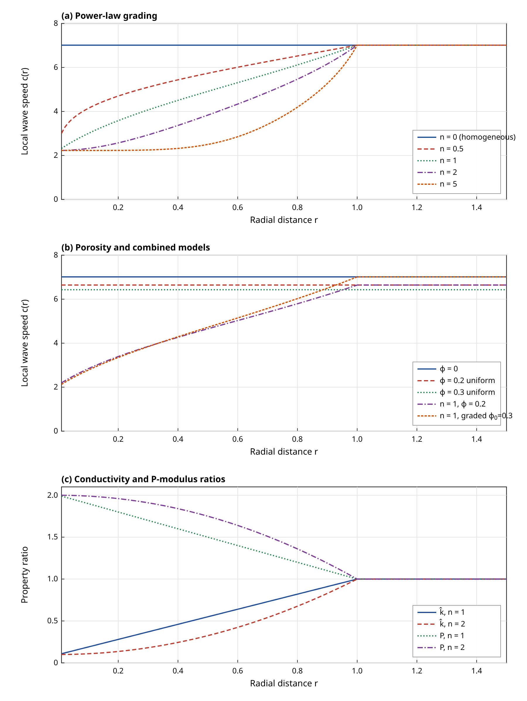
Figure 2. Local wave speed $c(r)$ from Eq. (21) for (a) power-law grading, (b) porosity models and (c) the conductivity and P-modulus ratios. Computed from the property model.

4. Exact solution for uniform media
The finite element results are verified against an exact solution that is derived here for a uniform medium whose properties are the reference data multiplied by the constant ratios $P$, $L$, $\hat{k}$, $\hat{ρ}$, $\hat{ρ}\hat{c}$ and $g$. For unit ratios it reduces to the solution of [1]. After a Laplace transform with parameter $s$ (overbars) the displacement is represented by a potential $φ$, and $p=1+τ_{1}s$ and $Ψ=1+τ_{0}s$ are the transform-domain forms of the two operators:
$\overline{u}=∂_{r}\overline{φ}, \overline{e}=∇^{2}\overline{φ}, ∇^{2}=∂_{r}^{2}+\frac{1}{r}∂_{r}$ (24)
Eq. (1) integrated once in $r$ gives the temperature in terms of the potential,
$\overline{θ}=\frac{1}{δ_{1}g}\left(P∇^{2}\overline{φ}−\frac{\hat{ρ}s^{2}}{p}\overline{φ}\right)$ (25)
and substitution in the transformed energy equation leads to a fourth-order equation that factorises as
$\left(∇^{2}−m_{1}^{2}\right)\left(∇^{2}−m_{2}^{2}\right)\overline{φ}=−\frac{δ_{1}g}{P\hat{k}} \overline{Q}, \overline{Q}=\frac{1}{s} \frac{δ(r)}{2πr}$ (26)
The squared roots $m_{1,2}^{2}$ solve a quadratic whose coefficients follow from the preceding steps:
$m_{1,2}^{2}=\frac{B±\sqrt{B^{2}−4AC}}{2A}, A=P\hat{k}$ (27)
$B=\frac{\hat{k}\hat{ρ}s^{2}}{p}+Ψs\left(\hat{ρ}\hat{c} P+εg^{2}\right), C=\frac{Ψ \hat{ρ}\hat{ρ}\hat{c} s^{3}}{p}$ (28)
The large-$s$ limit of this quadratic, in which $B∼Ψs\left(\hat{ρ}\hat{c}P+εg^{2}\right)$ dominates through $τ_{0}s^{2}$ and $C$ is of lower order, gives the fast root $m_{1}^{2}∼s^{2}/c^{2}$ with $c$ from Eq. (21); the slow root grows like $s$ and corresponds to the diffusive part. A Hankel transform of the source and a partial-fraction expansion, together with $∇^{2}K_{0}(mr)=m^{2}K_{0}(mr)$ away from the origin, give the potential
$\overline{φ}=G\left[K_{0}(m_{1}r)−K_{0}(m_{2}r)\right], G=\frac{δ_{1}g}{2πs P\hat{k}\left(m_{1}^{2}−m_{2}^{2}\right)}$ (29)
where $K_{0}$ and $K_{1}$ are the modified Bessel functions of the second kind. The temperature, the displacement and the transformed stresses are
$\overline{θ}=\frac{G}{δ_{1}g}\sum_{j=1}^{2}{(}−1)^{j+1}\left(Pm_{j}^{2}−\frac{\hat{ρ}s^{2}}{p}\right)K_{0}(m_{j}r), \overline{u}=−G\sum_{j=1}^{2}{(}−1)^{j+1}m_{j}K_{1}(m_{j}r)$ (30)
${\overline{σ}}_{rr}=\hat{ρ}s^{2}\overline{φ}−p (P−L)\frac{\overline{u}}{r}, {\overline{σ}}_{φφ}=\hat{ρ}s^{2}\overline{φ}+p (P−L)\left(\frac{\overline{u}}{r}−∇^{2}\overline{φ}\right)$ (31)
The stress formulas follow from the relation $\overline{σ}=p\overline{S}$ and Eq. (1). The time-domain solution is obtained with the Fourier-series inversion of Durbin with the epsilon-algorithm of Wynn applied to the last partial sums. With $T$ the period and $c_{0}$ the abscissa of convergence,
$f(t)≈\frac{e^{c_{0}t}}{T}\left[\frac{1}{2}\overline{f}(c_{0})+\sum_{k=1}^{N}{Re}\left\{\overline{f}\left(c_{0}+\frac{ikπ}{T}\right)e^{ikπt/T}\right\}\right]$ (32)
with $T=2t$, $c_{0}t=6$ and $N=1200$. The program that implements this solution was first compared with the independent implementation of the previous homogeneous studies, and the two agree to all printed digits for the reference medium. A weakness of the exact solution must be recorded: the singular logarithmic behaviour of $K_{0}$ at $r→0$ means that it cannot represent the regularised source, which is why the verification is limited to $r≥0.1$ and the effect of the regularisation is measured separately in Section 8.2.

5. Finite element formulation

5.1 Regularised line source
A point or line source has no finite energy density, so that a finite element mesh cannot represent Eq. (10) directly. The singularity is removed by replacing the line source with a heat-generating disc of radius $a$ and a smooth, compactly supported profile that vanishes at its edge. The profile is normalised so that the total power per unit length remains $Q_{0}$:
$Q_{a}(r)=\frac{2Q_{0}}{πa^{2}}\left(1−\frac{r^{2}}{a^{2}}\right) (r<a), \int_{0}^{a}{2}πr Q_{a} dr=Q_{0}$ (33)
The alternative of a small cavity with a prescribed flux was rejected because it introduces a traction-free boundary near the source and changes the stress field there. With the disc the axis remains part of the domain, the regularity conditions of Eq. (12) apply, and the error is controlled by one parameter. The error of the regularised problem relative to the true line source is expected to be of order $a^{2}$ at distances larger than $a$, by the usual multipole argument for a compact symmetric source; this expectation is tested in Section 8.2. A second numerical requirement is that the integrand of the source vector has a kink at $r=a$, so that a mesh node must lie at $r=a$ for the Gauss quadrature to integrate it exactly. All meshes in this paper are constructed that way.

5.2 Weak form
Eq. (1) is multiplied by a test function $v(r)$ with $v(R_{out})=0$ and by the cylindrical weight $r$, and integrated. The term $∂_{r}(rS_{rr})$ is integrated by parts, and the boundary term vanishes because of the factor $r$ at the axis and because $v=0$ at $R_{out}$. For the temperature, the test function $w$ is used in the same way. The result is: find $u,θ$ such that for all $v,w$
$\int_{0}^{R}{\hat{ρ}} v ∂_{t}^{2}u r dr=−\left(1+τ_{1}∂_{t}\right)\int_{0}^{R}{\left(∂_{r}v S_{rr}+\frac{v}{r}S_{φφ}\right)}r dr$ (34)
$\int_{0}^{R}{\hat{k}} ∂_{r}w ∂_{r}θ r dr+\left(1+τ_{0}∂_{t}\right)\int_{0}^{R}{w}\left[\hat{ρ}\hat{c} ∂_{t}θ+δ_{2}g ∂_{t}e\right]r dr=\int_{0}^{R}{w} Q_{a} r dr$ (35)
The two forms contain no derivative of any property ratio, which is the reason for the divergence form of Eq. (9). The properties are evaluated at the Gauss points of each element, so that a smooth or a discontinuous grading is handled in the same way, provided that the discontinuity falls on an element boundary.

5.3 Discretisation and element matrices
The unknowns are interpolated with the same Lagrange shape functions $N_{j}(r)$ for $u$ and $θ$:
$u_{h}(r,t)={\sum_{j}{N}}_{j}(r) u_{j}(t), θ_{h}(r,t)={\sum_{j}{N}}_{j}(r) θ_{j}(t)$ (36)
Linear (P1) and quadratic (P2) elements were implemented. On the reference element $ξ∈[−1,1]$ the quadratic functions are
$N_{1}=\frac{ξ(ξ−1)}{2}, N_{2}=1−ξ^{2}, N_{3}=\frac{ξ(ξ+1)}{2}$ (37)
The Galerkin choice $v,w∈\{N_{i}\}$ leads to six matrices, each assembled from element integrals with five-point Gauss–Legendre quadrature for P2 and three-point quadrature for P1 and evaluated with the weight $r dr$. The mass matrices are
$M_{ij}=\int{\hat{ρ}} N_{i}N_{j} r dr, M_{ij}^{θ}=\int{\hat{ρ}}\hat{c} N_{i}N_{j} r dr$ (38)
The mechanical stiffness matrix is symmetric:
$K_{ij}=\int{\left[N_{i}′\left(PN_{j}′+L\frac{N_{j}}{r}\right)+\frac{N_{i}}{r}\left(LN_{j}′+P\frac{N_{j}}{r}\right)\right]}r dr$ (39)
and the two coupling matrices, which are transposes of each other up to the ratio $δ_{2}/δ_{1}$, are
$G_{ij}=δ_{1}\int{g}\left(N_{i}′+\frac{N_{i}}{r}\right)N_{j} r dr, D_{ij}=δ_{2}\int{g} N_{i}\left(N_{j}′+\frac{N_{j}}{r}\right)r dr$ (40)
Finally, the thermal conductivity matrix and the source vector are
$K_{ij}^{θ}=\int{\hat{k}} N_{i}′N_{j}′ r dr, q_{i}={\int{N}}_{i} Q_{a} r dr$ (41)
The 1/r terms in $K$, $G$ and $D$ are not singular: the displacement degree of freedom at the axis is removed by $u(0)=0$, the remaining shape functions are $O(r)$ there, and the Gauss points never fall on $r=0$. The matrices are stored in sparse form and the system matrix of the time stepping in banded form with half bandwidth $2p+1$ for interleaved unknowns $(u_{i},θ_{i})$, with $p$ the element order. With these definitions the semi-discrete equations are
$M\ddot{u}=\left(1+τ_{1}\frac{d}{dt}\right)f, f=−Ku+Gθ; K^{θ}θ+\left(1+τ_{0}\frac{d}{dt}\right)\left(M^{θ}\dot{θ}+D\dot{u}\right)=q$ (42)
where bold symbols are nodal vectors. The matrix equations (42) are linear with constant coefficients. They contain third derivatives of $u$ and second derivatives of $θ$ through the two operators, and a direct second-order treatment would require the time derivatives of the forcing and of the state. The route chosen below avoids this.

6. Time integration

6.1 Auxiliary variables
Two auxiliary vectors remove the operators. The first is the momentum-like vector $m=M\dot{u}−τ_{1}f$, whose rate is exactly $f$ because $M\ddot{u}=f+τ_{1}\dot{f}$. The second is the heat-content rate $g=M^{θ}\dot{θ}+D\dot{u}$, which obeys a first-order relaxation law. The semi-discrete system becomes
$\dot{m}=f, M\dot{u}=m+τ_{1}f$ (43)
$τ_{0}\dot{g}=−g+R, R=q−K^{θ}θ, M^{θ}\dot{θ}+D\dot{u}=g$ (44)
This is a first-order system in the state $(u,m,θ,g)$ with zero initial values. Its characteristic features are that the derivative of the forcing is not required, that $τ_{1}=0$ and $τ_{0}=0$ are admitted as limits (the classical theory in the second case, in which $g=R$ is algebraic), and that the momentum equation acquires the damping term $τ_{1}f$ that is characteristic of MGL. The initial rate of the heat content is $\dot{g}(0^{+})=q/τ_{0}$, because the source is on at $t=0^{+}$; the right-hand side $R_{0}=q$ is therefore used at the first step.

6.2 Trapezoidal marching
The trapezoidal rule, which is A-stable and second-order accurate, is applied to every component of the state:
$y_{n+1}−y_{n}=\frac{Δt}{2}\left({\dot{y}}_{n}+{\dot{y}}_{n+1}\right)$ (45)
Applied to $(m,u)$, it gives $MΔu=Δt m_{n}+a(f_{n}+f_{n+1})$ with $a=\frac{Δt}{2}\left(\frac{Δt}{2}+τ_{1}\right)$. For $τ_{1}=0$ this is the Newmark average-acceleration method with $β=1/4$ and $γ=1/2$, and for $τ_{1}>0$ the term $τ_{1}$ acts as a physical damping. Applied to $(g,θ)$ it is the Crank–Nicolson scheme. Eliminating the nodal increments of the auxiliary variables leaves a coupled linear system for the increments $Δu$ and $Δθ$:
$\left(M+aK\right)Δu−aG Δθ=Δt m_{n}+2a f_{n}$ (46)
$\frac{2}{Δt}\left(DΔu+M^{θ}Δθ\right)+\frac{β}{1+β}K^{θ}Δθ=\frac{2}{1+β}\left(g_{n}+βR_{n}\right), β=\frac{Δt}{2τ_{0}}$ (47)
The matrix of the left-hand sides depends only on $Δt$ and is factorised once by banded LU decomposition without pivoting; no pivoting was needed for any case reported here, and its adequacy is confirmed by the agreement with the exact and Laplace-domain solutions in Section 8. Each time step then needs one forward and back substitution and three sparse matrix–vector products. The state is updated as
$f_{n+1}=f_{n}−KΔu+GΔθ, m_{n+1}=m_{n}+\frac{Δt}{2}\left(f_{n}+f_{n+1}\right), g_{n+1}=\frac{(1−β)g_{n}+β\left(R_{n}+R_{n+1}\right)}{1+β}$ (48)
For $τ_{0}=0$ the factor $β→∞$ and Eq. (47) reduces to $\frac{2}{Δt}(DΔu+M^{θ}Δθ)+K^{θ}Δθ=2R_{n}$, with $g_{n+1}=R_{n+1}$. The nodal quantities $S_{rr}$ and $S_{φφ}$ are evaluated inside the element that contains the observation point, from the shape function derivatives, and the MGL stress is completed by a centred difference of the stored history:
$σ_{n}=S_{n}+τ_{1} \frac{S_{n+1}−S_{n−1}}{2Δt}$ (49)
The unconditional stability of the trapezoidal rule follows from the amplification factor of the test equation $\dot{y}=Λy$,
$\left|\frac{1+z/2}{1−z/2}\right|≤1 for Re z≤0, z=ΛΔt$ (50)
and it applies to the present system whose eigenvalues all have nonpositive real parts, because the MGL system is dissipative for $τ_{1}>0$ and $τ_{0}>0$. The scheme conserves the oscillation amplitude of undamped modes and does not damp parasitic high frequencies, and the consequence is the small precursor in front of the wave seen in the results. That is a property of this choice, and a dissipative member of the Newmark or generalised-alpha family could be used to damp it, at the price of lower accuracy at the front.

6.3 Laplace-domain finite element route
The second route keeps the spatial discretisation and treats time exactly. A Laplace transform of Eq. (42) with zero initial data gives, for the unit step source,
$\left(s^{2}M+pK\right)\overline{u}−pG\overline{θ}=0, Ψs\left(M^{θ}\overline{θ}+D\overline{u}\right)+K^{θ}\overline{θ}=\frac{q}{s}$ (51)
which is a complex banded system that is solved at every inversion abscissa; the time-domain solution follows from the Durbin formula of Eq. (32) with $N=600$ terms. This route has no time-step error and handles all terms of the MGL operators without auxiliary variables, but the solution of a complex system is needed for each of $N$ values of $s$ and for each output time, and the Durbin inversion is unreliable at discontinuities. The first route gives the entire history in one marching, which is why it is the working method; the second is used as an independent check of the time integration in the graded and porous case, for which no exact solution is available. The comparison therefore tests the time discretisation, the auxiliary variable formulation and the post-processing of stress, but not the spatial discretisation, which is common to both. The spatial discretisation of the graded case is tested instead by mesh refinement and by the global energy identity.

7. Verification measures and numerical set-up
All results are for the data of Table 1 with $τ_{0}=0.02$, $τ_{1}=0.05$ and $Q_{0}=1$, a disc radius $a=0.05$, quadratic elements of uniform size $h=0.0125$ up to $r=2.5$ followed by geometric growth with ratio 1.1 to $R_{out}=3.2$ (439 nodes), and a time step $Δt=5×10^{−4}$ up to $t=0.3$. The front in the reference medium travels about 2.1 units in this time, so that the truncation has no effect. The error of a computed quantity $X_{h}$ against a reference $X$ over a set of samples is measured by the relative discrete $L^{2}$ norm, expressed in per cent,
$E_{X}=100\sqrt{\frac{{\sum_{i}{\left(X_{h,i}−X_{i}\right)}}^{2}}{{\sum_{i}{X}}_{i}^{2}}}$ (52)
The history samples are 11 times between $t=0.05$ and $t=0.30$ at $r=0.3$ and $r=0.8$, and the profile samples are the radii from $0.2$ to $1.2$ at $t=0.2$. The first history sample therefore lies close to the wavefront at $r=0.3$ in the reference medium, which is arrival time 0.0425, and some error values below are dominated by it. The observed order of convergence between two consecutive meshes is
$p_{obs}=\frac{ln\left(E_{h_{1}}/E_{h_{2}}\right)}{ln\left(h_{1}/h_{2}\right)}$ (53)
Convergence is measured against a finer reference solution of the same regularised problem (self-convergence), so that the regularisation error does not contaminate it. The discrete heat content of the numerical solution is obtained with the vector of ones as test function, that is $ℋ_{h}=1^{T}\left(M^{θ}θ+Du\right)$, and its relative deviation from the exact value of Eq. (13) is
$E_{ℋ}=\max_{0.05≤t≤0.3}\left|\frac{ℋ_{h}(t)−ℋ(t)}{ℋ(t)}\right|$ (54)
A resolution rule for the mesh follows from the requirement that the wave be spanned by enough elements during the relaxation time, and a rule for the time step from the Courant-type number $ν$ below, where $c_{max}$ is the largest local speed. The unconditional stability of the time integration means that the second is an accuracy rule only:
$h≲\frac{c_{min}τ_{0}}{4}, ν=\frac{c_{max}Δt}{h}$ (55)
With the chosen $h=0.0125$ and $τ_{0}=0.02$ the first rule gives $c_{min}τ_{0}/4$ of 0.011 for the slowest medium (the graded porous medium at the source), so that the baseline $h=0.0125$ is about 14 per cent coarser than the rule in the slowest region (the rule is a guideline, and the refinement study of Section 8.2 for the graded porous medium shows that the accuracy is adequate), and $ν=0.28$ for the reference medium. A last relation concerns the regularisation, which is described by a fit of the error to a power law of the source radius,
$E_{X}(a)≃C_{X} a^{q}$ (56)
with $q$ determined by regression in Section 8.2. Every calculation used a quiescent initial state, a single processor in pure Python without numerical libraries, and no result is taken from the literature: all numbers in the tables are the output of the programs described in Sections 4 to 6.

8. Results and discussion

8.1 Verification against the exact solution
The reference problem is the homogeneous copper medium with $τ_{0}=0.02$ and $τ_{1}=0.05$. Figure 3 compares the finite element temperature and stress histories at $r=0.3$ and the temperature profile at $t=0.2$ with the exact solution of Section 4. The temperature curves coincide to plotting accuracy after the arrival of the front, and Table 5 gives the relative $L^{2}$ errors for the history: 0.08 per cent in temperature, 0.59 per cent in displacement, 1 per cent in $σ_{rr}$ and 1.6 per cent in $σ_{φφ}$. At $r=0.8$ and for the profile at $t=0.2$, all errors are below 0.87 per cent.
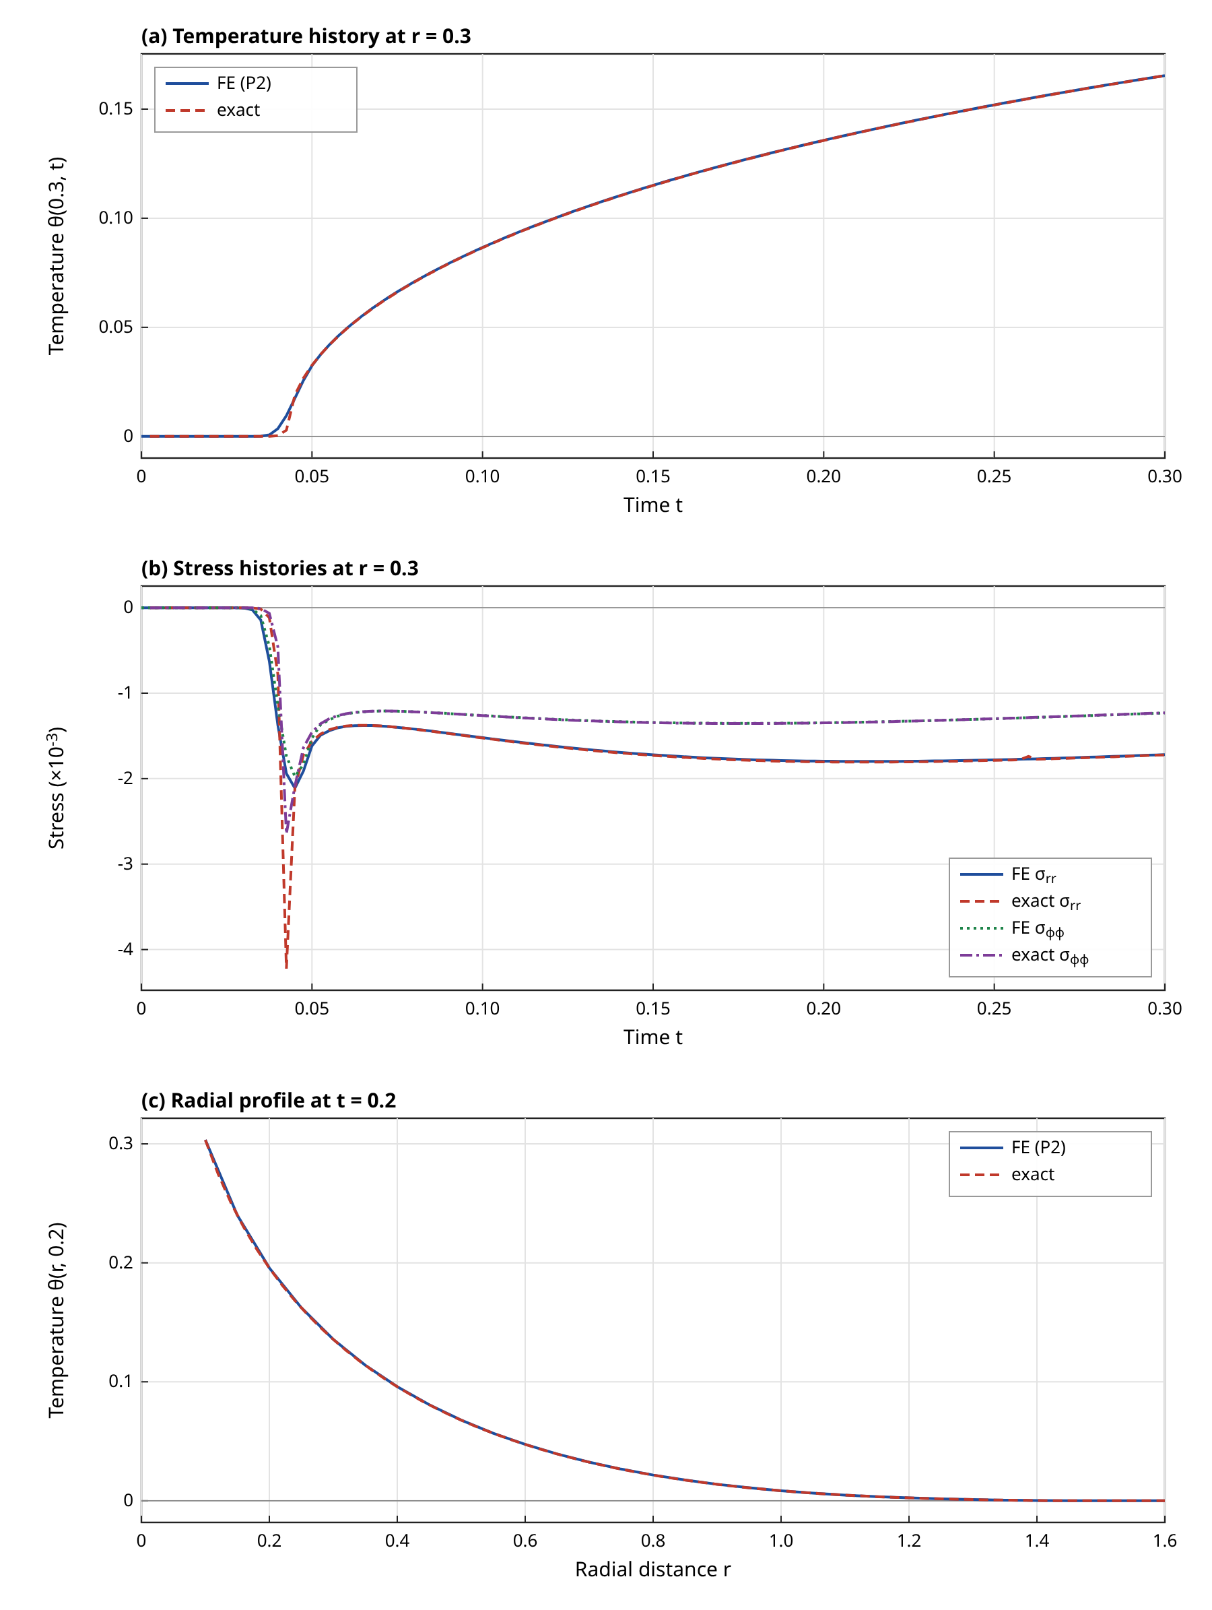
Figure 3. Verification for the homogeneous reference medium ($τ_{0}=0.02$, $τ_{1}=0.05$). (a) Temperature at $r=0.3$. (b) Radial and hoop stress at $r=0.3$. (c) Temperature profile at $t=0.2$. Finite element results (P2) are solid or dotted lines; exact Laplace-domain results with Durbin inversion are dashed. Both are computed.
The stress histories reveal the main limitation of the scheme. The exact radial stress has a narrow compressive spike of $−4.22×10^{−3}$ at the arrival of the front at $t=0.0425$, and the finite element solution reaches only $−2.11×10^{−3}$ in its sampled history, about half of the exact peak, with the spike smeared over a few time steps and a small precursor before the arrival. The cause is the limited resolution of a nearly discontinuous front by a mesh of $h=0.0125$ and a non-dissipative integrator; the relaxation length $cτ_{0}=0.14$ is spanned by about eleven elements, but a near-jump cannot be represented by continuous elements and the trapezoidal rule does not dissipate the short-wave error. The errors in Table 5 are therefore dominated by the first one or two history samples. If the samples before $t=0.1$ are excluded, the errors in $σ_{rr}$ and $σ_{φφ}$ fall from 1 and 1.6 per cent to 0.38 and 0.13 per cent, while the displacement error stays at 0.59 per cent. The displacement error is therefore not front-related: it is the regularisation error of Section 8.2.
The limits of the theory provide further tests. With $τ_{1}=0$ (a Lord–Shulman-type law) and with $τ_{0}=τ_{1}=0$ (classical coupled thermoelasticity) the temperature errors remain at 0.076 and 0.089 per cent, but the stress errors increase to 4.8 and 4.7 per cent in $σ_{rr}$ and do not decrease when the early samples are excluded (5.05 per cent for $t≥0.15$). Without the strain-rate term, the elastic wavefront with a stress jump that travels at $c_{e}=1$, Eq. (21) and the following discussion, reaches $r=0.3$ between $t=0.25$ and $t=0.3$, depending on where in the source disc the front is taken to start, which is inside the window; the computed peak occurs at $t=0.2825$. This jump is smeared by the mesh. In the MGL medium the strain-rate term removes the jump, which is why the errors of the MGL solution are smaller; the observation agrees with the statement of [1] that MGL has a continuous displacement and a single wave.
The porosity model is verified on a uniform porous medium, for which the exact solution of Section 4 holds with the ratios from Table 2 of $φ=0.2$ ($P=0.64$, $\hat{k}=0.7155$, $\hat{ρ}=0.8$). The errors in temperature and displacement are 0.27 and 0.56 per cent, and the stress errors of 3.2 and 4.1 per cent drop to 0.40 and 0.13 per cent after the front. The same is true for the other limits, in which the porous medium has stress errors of about 0.3 per cent. A uniform medium made entirely of the contrast phase, with the wave speed of 2.23 and with different values of every ratio, gives errors of 1.9 per cent in temperature, 0.57 per cent in displacement and 0.62 per cent in the radial stress, but 11 per cent in the hoop stress. This value is not acceptable for quantitative work, and it is still 5.6 per cent when the samples before $t=0.15$ are excluded; the front in this medium arrives at $t≈0.13$ and the hoop stress has a sharp feature there that the baseline mesh does not resolve, which means that the tabulated hoop stresses in the strongly contrasting core should be read with that uncertainty.
Table 4. Self-convergence of the history at $r=0.3$ ($t=0.05$ to $0.3$): errors against the finest solutions of the same regularised problem (P2, $h=0.003125$, $Δt=10^{−4}$ for space; P2, $h=0.0125$, $Δt=3.1×10^{−5}$ for time) and observed orders from Eq. (53). Space series use $Δt=2.5×10^{−4}$.
Series | Parameter | Nodes | $E_{θ}$ (%) | $E_{u}$ (%) | $E_{σ_{rr}}$ (%) | $p_{obs}$ ($θ$)
P1, space | h = 0.05 | 51 | 0.35 | 0.444 | 3.89 | -
P1, space | h = 0.025 | 101 | 0.105 | 0.117 | 1.67 | 1.75
P1, space | h = 0.0125 | 201 | 0.0482 | 0.0293 | 0.909 | 1.12
P1, space | h = 0.00625 | 401 | 0.0171 | 0.00734 | 0.497 | 1.49
P2, space | h = 0.1 | 51 | 21.6 | 21.4 | 21.6 | -
P2, space | h = 0.05 | 101 | 0.112 | 0.00343 | 2.57 | 7.60
P2, space | h = 0.025 | 201 | 0.00776 | 0.000649 | 0.345 | 3.85
P2, space | h = 0.0125 | 401 | 0.000241 | 8.2e-05 | 0.0806 | 5.01
P2, time | Δt = 0.005 | 401 | 1.51 | 0.132 | 6.82 | -
P2, time | Δt = 0.0025 | 401 | 0.206 | 0.00859 | 7.39 | 2.88
P2, time | Δt = 0.00125 | 401 | 0.0382 | 0.00494 | 1.4 | 2.43
P2, time | Δt = 0.000625 | 401 | 0.0274 | 0.00216 | 0.0438 | 0.48
P2, time | Δt = 0.0003125 | 401 | 0.00864 | 0.000441 | 0.0459 | 1.67

Table 5. Validation errors (relative $L^{2}$, per cent, Eq. (52)) of the finite element solution against the exact solution of Section 4 for uniform media, and of the time-domain against the Laplace-domain finite element solution for the graded porous medium.
Case | $E_{θ}$ (%) | $E_{u}$ (%) | $E_{σ_{rr}}$ (%) | $E_{σ_{φφ}}$ (%)
Reference MGL, history at $r=0.3$ | 0.0797 | 0.593 | 1.02 | 1.64
Reference MGL, history at $r=0.8$ | 0.146 | 0.295 | 0.162 | 0.142
Reference MGL, profile at $t=0.2$ | 0.0635 | 0.868 | 0.332 | 0.171
Lord–Shulman-type limit ($τ_{1}=0$), $r=0.3$ | 0.0756 | 1.23 | 4.78 | 2.89
Classical limit ($τ_{0}=τ_{1}=0$), $r=0.3$ | 0.0889 | 1.19 | 4.71 | 2.85
Uniform porosity 0.2, MGL, $r=0.3$ | 0.272 | 0.56 | 3.23 | 4.14
Uniform porosity 0.2, $τ_{1}=0$, $r=0.3$ | 0.269 | 0.242 | 0.37 | 0.33
Uniform porosity 0.2, classical, $r=0.3$ | 0.102 | 0.206 | 0.296 | 0.201
Uniform contrast phase, MGL, $r=0.3$ | 1.95 | 0.569 | 0.618 | 11.1
Uniform contrast phase, MGL, profile | 1.6 | 0.915 | 0.501 | 5.73
Source radius $a=0.2$ vs exact, $r=0.3$ | 1.17 | 9.5 | 6.45 | 5.11
Source radius $a=0.1$ vs exact, $r=0.3$ | 0.37 | 2.37 | 2.32 | 1.95
Source radius $a=0.05$ vs exact, $r=0.3$ | 0.0797 | 0.593 | 1.02 | 1.64
Source radius $a=0.025$ vs exact, $r=0.3$ | 0.0287 | 0.148 | 0.358 | 0.245
Laplace-domain FE vs time-domain FE ($n=1$, $φ=0.2$), $r=0.3$ | 0.00468 | 0.000775 | 0.0509 | 0.0246
Laplace-domain FE vs time-domain FE ($n=1$, $φ=0.2$), $r=0.8$ | 0.00491 | 0.00224 | 0.00479 | 0.0108

8.2 Convergence, regularisation, truncation and energy balance
Table 4 shows the self-convergence. With linear elements the temperature error falls from 0.35 to 0.017 per cent when the element size is reduced from 0.05 to 0.00625, with observed orders between 1.1 and 1.8, and the stress error falls from 3.9 to 0.5 per cent, roughly first order, as expected for a quantity that is obtained from the derivative of a piecewise linear function and that contains a near-discontinuity. With quadratic elements the mesh $h=0.1$ does not resolve the source disc of radius 0.05 and has an error of 21 per cent, which is a useful reminder that the source radius sets a minimum resolution. For $h≤0.05$ the temperature error falls from 0.11 to 0.00024 per cent, with observed orders from 3.9 to 7.6, and the stress error falls from 2.6 to 0.081 per cent. The very large orders reflect pre-asymptotic behaviour and the finite accuracy of the reference solution, and should not be interpreted as a theoretical rate. What can be said is that quadratic elements are much more efficient: P2 at $h=0.025$ (201 nodes) is more accurate in all variables than P1 at $h=0.00625$ (401 nodes).
The time-step study in the lower block of Table 4 shows an observed second-order decrease of the temperature error between $Δt=0.005$ and $0.00125$ (orders 2.9 and 2.4), after which the error is limited by the reference and by the start-up of the Crank–Nicolson step from a sudden source switch-on, and the order drops to 0.5 and 1.7. The stress error is erratic at the coarsest steps (6.8 and 7.4 per cent), because the central-difference evaluation of $τ_{1}∂_{t}S$ in Eq. (49) is poor when the front crosses the observation point within a few steps, and it is below 0.05 per cent for $Δt≤6.25×10^{−4}$. The chosen step $Δt=5×10^{−4}$ corresponds to $ν=0.28$ and lies in the converged range. The cost is small: a complete run of the base case with 439 nodes and 600 steps takes 2.6 seconds in pure Python.
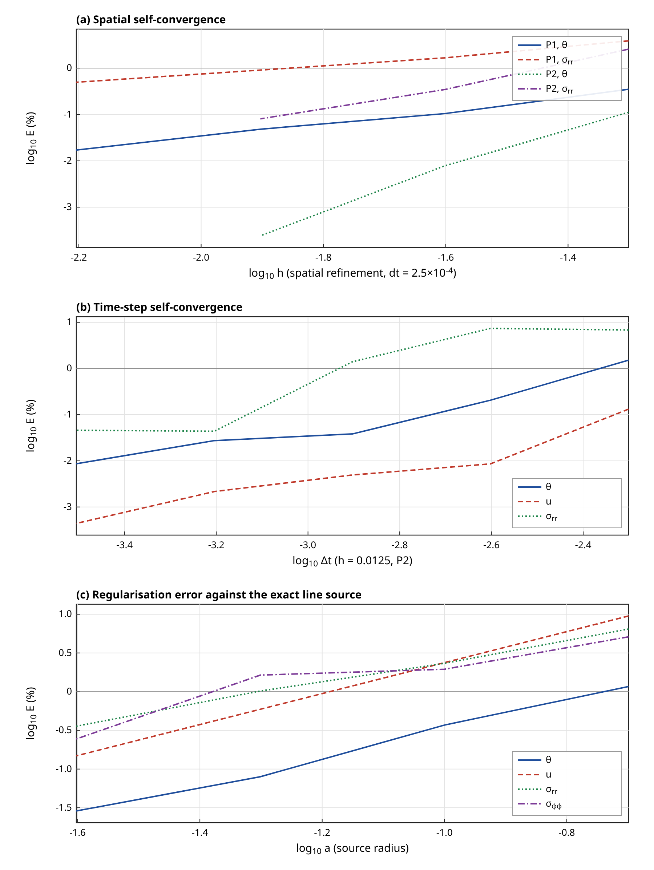
Figure 4. Convergence of the finite element solution, errors from Eq. (52) on a logarithmic scale. (a) Spatial refinement for linear (P1) and quadratic (P2) elements. (b) Time-step refinement. (c) Error against the exact line source as a function of the source radius $a$. All data are computed.
The regularisation error is the largest single contribution at the baseline. For $a=0.2$, $0.1$, $0.05$ and $0.025$ with meshes that resolve the disc, Table 5 shows that the error in displacement falls by factors of 4.0, 4.0 and 4.0, which gives a power-law exponent $q=2.0$ in Eq. (56) for displacement; the exponents for temperature, radial stress and hoop stress are 1.8, 1.4 and 1.3. The expected value of two is obtained for the displacement only. The reason for the lower stress exponents was not investigated; a possible cause, not tested, is that the stress at $r=0.3$ is influenced by the sharp front, which the finite size of the source displaces at first order in $a$. The finest mesh and time step reproduce the exact solution with errors of 0.088, 0.59, 0.98 and 1.4 per cent in the four fields, equal to the baseline errors, which shows that the discretisation error of the baseline is much smaller than the regularisation error. A smaller source radius of 0.025 reduces all four errors below 0.36 per cent, at twice the node density in the source region.
The truncation condition is tested by changing $R_{out}$. For $R_{out}=4.5$ and $1.6$ the temperature histories at $r=0.3$ and $r=0.8$ differ from the base results by at most 1.4e-09, which is negligible because no reflected wave can return to the observation points in the time window. For $R_{out}=1.0$, which the front reaches at about $t=0.14$, the differences are 0.0026 at $r=0.3$ (1.6 per cent of the peak) and 0.013 at $r=0.8$ (33 per cent). This confirms the rule that the domain must exceed $c_{max}t_{end}$ and shows how large the contamination is when it does not. The reflection at the fixed boundary is not an artefact of the method but the consequence of the Dirichlet condition; for later times a non-reflecting boundary would be required, which is not implemented.
The global heat balance of Eq. (13) is satisfied by all computations with the front inside the domain, with a maximum relative deviation between $5.5×10^{−7}$ and $3.8×10^{−5}$ over $0.05≤t≤0.3$ for the 34 cases, including all graded and porous media; the largest deviation occurs for $τ_{0}=0$, where the heat equation is parabolic and the Crank–Nicolson start-up is less smooth (a plausible but untested explanation). This confirms that the discrete coupling of the two fields is conservative in graded media, although it says nothing about the accuracy of the spatial distribution of the temperature. For the run with $R_{out}=1.0$ the same measure is 0.27, as expected when heat leaves through the boundary. Finally, the time-domain and Laplace-domain finite element solutions of the graded porous case with $n=1$ and $φ=0.2$ agree to 0.005 per cent in temperature and to about 0.05 per cent or better in stress at both observation radii (Table 5), with four-digit agreement in absolute terms (for example $θ(0.3,0.3)=0.2663$ in both). The time integration and the auxiliary variable formulation are therefore validated in the graded medium. The spatial discretisation of the graded porous medium is checked by refinement against P2 with $h=0.00625$ and $Δt=10^{−4}$: the history errors at $r=0.3$ for $h=0.05$, $0.025$ and $0.0125$ are 0.16, 0.013 and 0.0068 per cent in temperature and 1.1, 0.36 and 0.11 per cent in the radial stress, and the profile errors at $t=0.2$ for $h=0.0125$ are at most 0.031 per cent. The baseline mesh is therefore adequate in the graded porous medium, although it is slightly coarser than the rule of Section 7 for the slowest region.

8.3 Effect of grading
Table 3 and Figure 2 give the wave speed. The grading law with $n=1$ makes the local speed rise from 2.32 at the source to 7.012 at $r=1$, and the ray-theory travel time to $r=0.3$ is 0.0947, against 0.0428 for the homogeneous medium. The computed arrival times are 5 to 10 per cent shorter than the ray estimates for the graded media and the porous medium, and 1 per cent shorter for the homogeneous one. The difference is expected, because the threshold of 0.005 is crossed by the precursor and by the early diffusive part before the sharp wave arrives, and it is not a sign of an error of the speed formula. The ordering of the arrival times follows the ray times in every case.
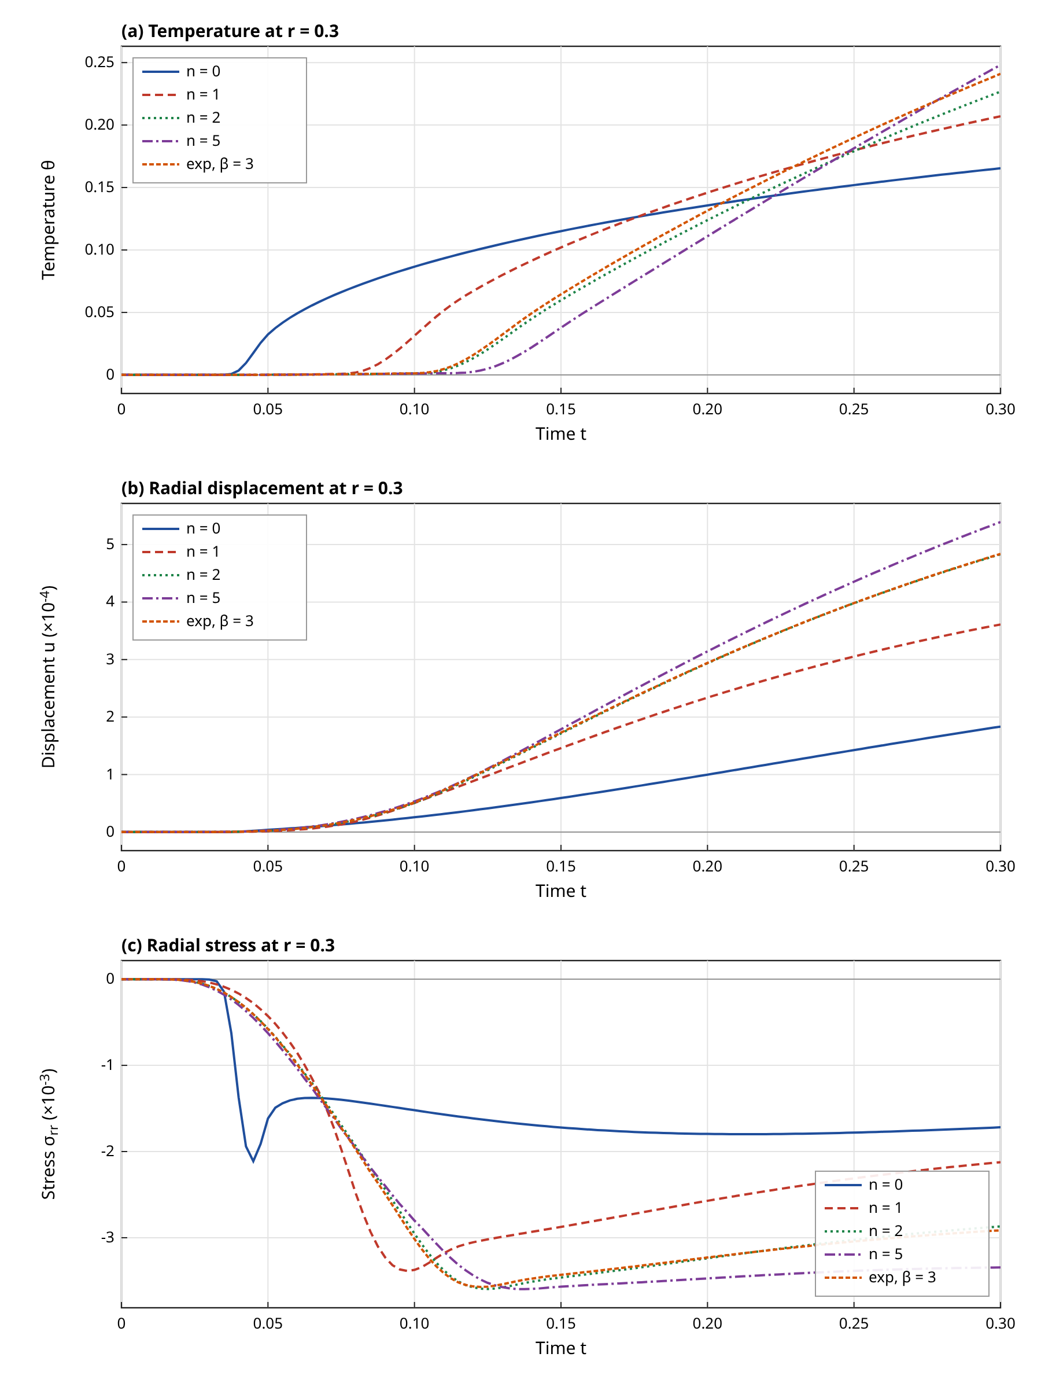
Figure 5. Effect of the grading exponent on the response at $r=0.3$: (a) temperature, (b) radial displacement and (c) radial stress, for $n=0$ (homogeneous), 1, 2, 5 and the exponential law with $β=3$. Computed with the baseline finite element model.
Figure 5 and Table 6 show the response at $r=0.3$. The contrast phase of the core has a conductivity of 0.1 and the same heat capacity as the reference, so the heat is retained near the source: at $t=0.3$ the temperature at $r=0.3$ increases from 0.165 ($n=0$) to 0.207 for $n=1$ and 0.248 for $n=5$, while at $r=0.8$ it falls from 0.0398 to 0.0165 and $5.06×10^{−4}$, because the graded zone acts as a thermal barrier whose strength grows with $n$. The displacement at $r=0.3$ doubles for $n=1$ ($3.61×10^{−4}$ against $1.83×10^{−4}$) and triples for $n=5$, mainly through the higher temperature near the source. The peak radial stress magnitude rises from 2.11 to 3.38 and 3.60 (in units of $10^{−3}$), a rise by the factors 1.60 and 1.70, and the time of the peak moves from 0.045 to 0.138, following the delayed arrival of the front. The hoop stress at $t=0.3$ changes more drastically, from -1.232 to -0.144 (times $10^{−3}$), which is the quantity that is most sensitive to the grading. The exponential law with $β=3$ gives results between those of $n=2$ and $n=5$, as its volume fraction is small over most of the zone. The sensitivity to $n$ is strongest for $n≤2$ and saturates for $n≥2$, a result that is useful for the choice of grading parameters.
Table 6. Parametric summary at $t=0.3$ (observation radius $r=0.3$ unless stated; the peak stress is the largest magnitude over $0≤t≤0.3$ at $r=0.3$). Unlisted parameters have the base values $τ_{0}=0.02$, $τ_{1}=0.05$.
Case | $θ(0.3)$ | $10^{4}u(0.3)$ | $10^{3}σ_{rr}(0.3)$ | $10^{3}σ_{φφ}(0.3)$ | $10^{3}max|σ_{rr}|$ | $θ(0.8)$
Reference ($n=0$) | 0.1654 | 1.834 | -1.719 | -1.232 | 2.112 | 0.0398
$n=0.5$ | 0.1845 | 2.744 | -1.825 | -0.954 | 2.839 | 0.0271
$n=1$ | 0.2070 | 3.611 | -2.124 | -0.659 | 3.385 | 0.0165
$n=2$ | 0.2267 | 4.831 | -2.869 | -0.242 | 3.595 | 0.0042
$n=5$ | 0.2482 | 5.392 | -3.345 | -0.144 | 3.597 | 0.0005
Exponential $β=3$ | 0.2410 | 4.838 | -2.914 | -0.326 | 3.571 | 0.0030
$φ=0.1$ | 0.1892 | 1.999 | -1.659 | -1.195 | 1.878 | 0.0437
$φ=0.2$ | 0.2198 | 2.188 | -1.590 | -1.153 | 1.694 | 0.0484
$φ=0.3$ | 0.2602 | 2.405 | -1.511 | -1.104 | 1.520 | 0.0542
Graded $φ_{0}=0.3$, $n=1$ | 0.2636 | 4.488 | -2.103 | -0.747 | 2.841 | 0.0156
$n=1$, $φ=0.2$ | 0.2663 | 4.594 | -2.006 | -0.670 | 2.818 | 0.0170
$n=1$, $τ_{1}=0$ | 0.2069 | 3.806 | -2.023 | -0.591 | 5.840 | 0.0165
$n=1$, $τ_{1}=0.02$ | 0.2070 | 3.717 | -2.122 | -0.653 | 3.236 | 0.0165
$n=1$, $τ_{1}=0.1$ | 0.2071 | 3.569 | -2.074 | -0.622 | 4.398 | 0.0164
$n=1$, $τ_{0}=0$ | 0.2065 | 3.618 | -2.086 | -0.636 | 2.761 | 0.0202
$n=1$, $τ_{0}=0.01$ | 0.2067 | 3.614 | -2.104 | -0.647 | 2.873 | 0.0184
$n=1$, $τ_{0}=0.04$ | 0.2082 | 3.603 | -2.171 | -0.687 | 3.794 | 0.0109

8.4 Effect of porosity
Uniform porosity changes the medium without creating any gradient. It reduces the wave speed (Table 3) by 5.3 and 8.3 per cent for $φ=0.2$ and 0.3, so that the arrival times at $r=0.3$ change by at most one sampling interval. The effect on the temperature is substantial: since the volumetric heat capacity falls by the factor $1−φ$, the same heat raises the temperature more, while the diffusivity falls only as $(1−φ)^{1/2}$; the temperature at $r=0.3$ and $t=0.3$ is 0.189, 0.220 and 0.260 for $φ=0.1$, 0.2 and 0.3, against 0.165 for the dense medium. This is a consequence of the model assumption that the specific heat per unit mass is unchanged. At the same time the stresses decrease because of the lower stiffness: the radial stress at $t=0.3$ changes from -1.719 to -1.511 (times $10^{−3}$) and the peak magnitude from 2.11 to 1.52. The displacement increases by 31 per cent for $φ=0.3$ (Figure 6c shows the profile at $t=0.2$).
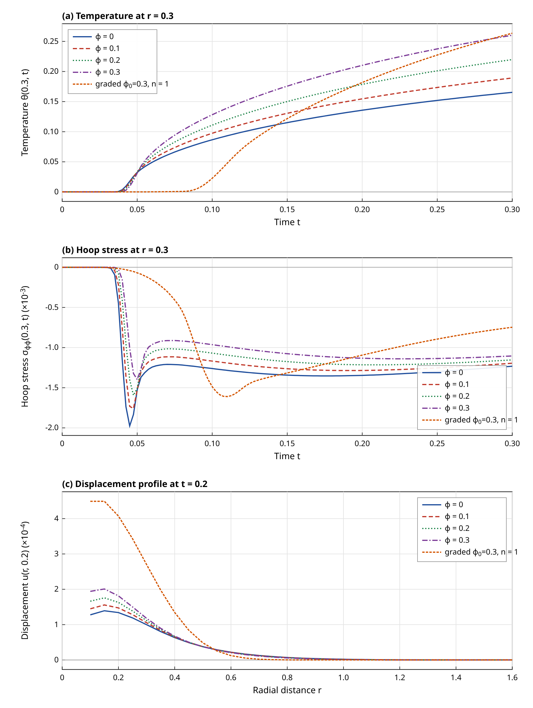
Figure 6. Effect of porosity on the response: (a) temperature and (b) hoop stress at $r=0.3$, and (c) displacement profile at $t=0.2$, for uniform porosity of 0, 0.1, 0.2 and 0.3 and for a porosity of peak 0.3 that is graded with $n=1$. Computed with the baseline finite element model.
When the porosity is graded together with the composition the two effects combine. The case with $n=1$ and graded porosity of peak 0.3 differs very little from the case with $n=1$ and uniform porosity 0.2 in the temperature at $r=0.3$ (0.2636 against 0.2663), and the peak radial stress differs by about 1 per cent (2.841 against 2.818). The porosity distribution is therefore less important than its volume average in the graded zone, for the range tested. The combined case differs from the non-porous grading ($n=1$, $φ=0$) by +29 per cent in temperature and a change of -17 per cent in the peak radial stress, which is the effect of porosity in a medium that is already graded.

8.5 Effect of the relaxation times and comparison of theories
Figure 7a shows the radial stress profile at $t=0.2$ for the graded medium. For $τ_{1}=0$ the profile has a sharp negative spike of about $−5.6×10^{−3}$ near $r=0.35$, which is the elastic wavefront in the graded medium that is not damped without the strain-rate term. Increasing $τ_{1}$ reduces the spike to a smooth shoulder: the peak radial stress magnitude at $r=0.3$ is 5.84, 3.24 and 3.38 (times $10^{−3}$) for $τ_{1}=0$, 0.02 and 0.05, and it rises again to 4.40 for $τ_{1}=0.1$ possibly because the larger relaxation time delays and broadens the elastic wave so that it overlaps the thermal front (this explanation was not tested). The temperature is practically independent of $τ_{1}$ (Table 6: 0.2069 to 0.2071), in accordance with the fact that $τ_{1}$ does not enter the speed of Eq. (21) and acts only on the mechanical part of the response; the displacement at $t=0.3$ decreases by 6.2 per cent when $τ_{1}$ is raised from 0 to 0.1.
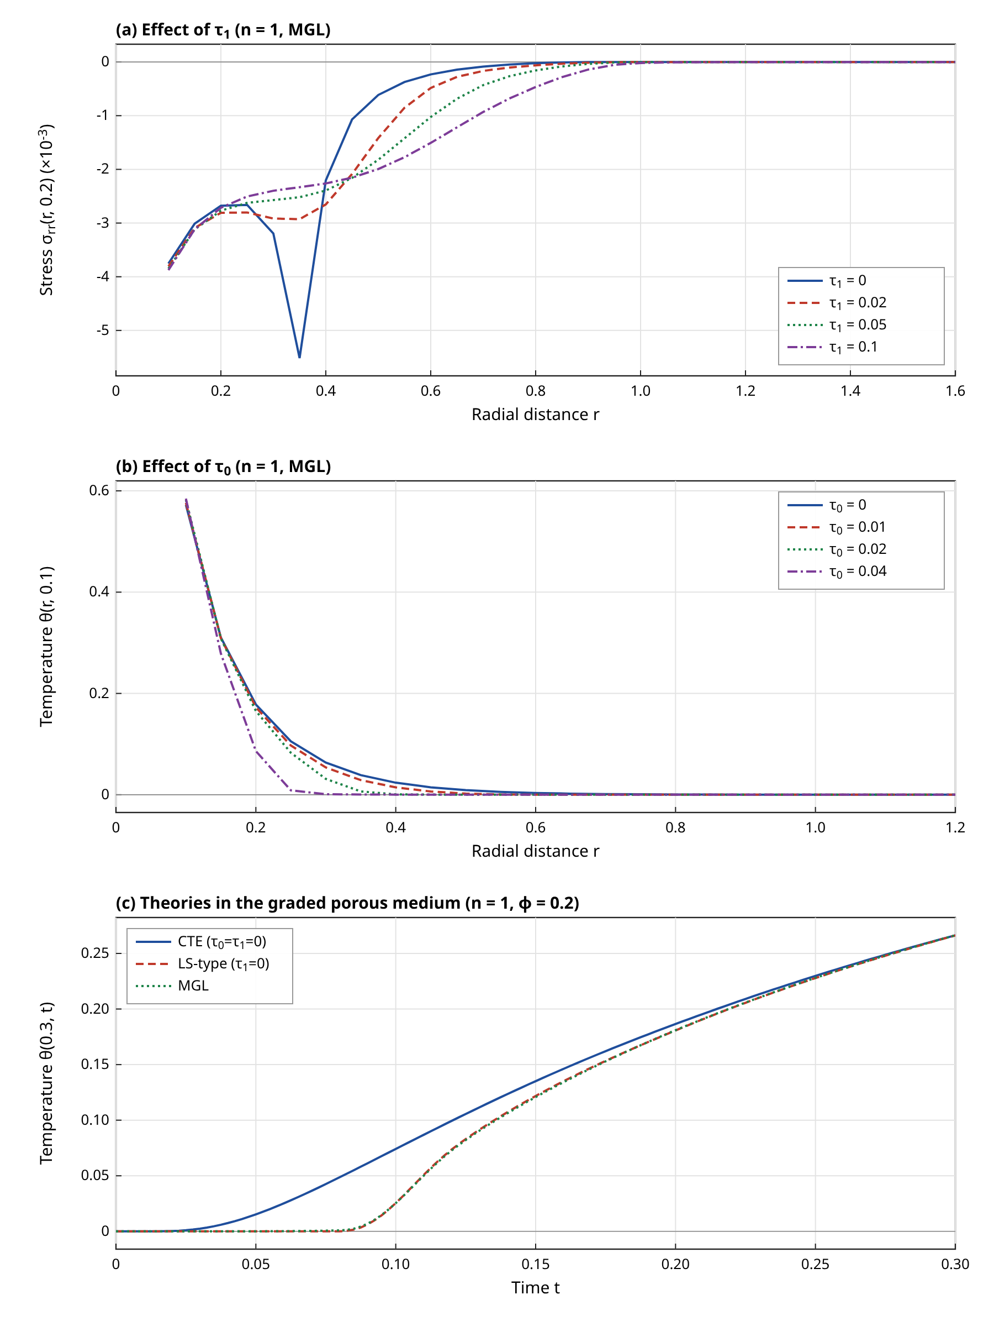
Figure 7. (a) Radial stress profile at $t=0.2$ for the graded medium ($n=1$) and several values of $τ_{1}$. (b) Temperature profile at $t=0.1$ for several values of $τ_{0}$. (c) Temperature history at $r=0.3$ in the graded porous medium for the classical, Lord–Shulman-type and MGL models. Computed with the baseline finite element model.
The effect of $τ_{0}$ is large in the temperature and small in the mechanical response (Figure 7b). The arrival time at $r=0.3$ for $n=1$ is 0.0350, 0.0650, 0.0850 and 0.1175 for $τ_{0}=0$, 0.01, 0.02 and 0.04. For $τ_{0}=0.04$ the temperature at $r=0.8$ falls to 0.0109 from 0.0165 for $τ_{0}=0.02$ and 0.0202 for $τ_{0}=0$, because the slower front, the speed being proportional to $1/\sqrt{τ_{0}}$, has not yet carried much energy to this radius. The temperature at $r=0.3$ is almost independent of $τ_{0}$ at the end of the window (0.2065 to 0.2082), since the conduction has become diffusion-dominated by then.
Table 7. Comparison of the theories computed with the same finite element code. The qualitative wave content is the classical result for each theory; numbers are computed at $r=0.3$.
Theory | Medium | Thermal front | Elastic front | $θ(0.3)$ | $10^{3}σ_{rr}(0.3)$ | $10^{3}max|σ_{rr}|$
Classical ($τ_{0}=τ_{1}=0$) | homogeneous | none (parabolic) | yes | 0.1658 | -2.139 | 2.196
Classical ($τ_{0}=τ_{1}=0$) | $n=1$, $φ=0.2$ | none (parabolic) | yes | 0.2663 | -1.883 | 4.406
Lord–Shulman-type ($τ_{1}=0$) | homogeneous | finite, $c$ | yes | 0.1654 | -2.157 | 2.213
Lord–Shulman-type ($τ_{1}=0$) | $n=1$, $φ=0.2$ | finite, $c$ | yes | 0.2662 | -1.919 | 5.150
MGL | homogeneous | finite, $c$ | no (damped) | 0.1654 | -1.719 | 2.112
MGL | $n=1$, $φ=0.2$ | finite, $c$ | no (damped) | 0.2663 | -2.006 | 2.818

Table 7 and Figure 7c compare the three theories in the same graded porous medium. The classical theory shows a temperature that rises immediately at $r=0.3$ (arrival at $t=0.0375$ at the threshold 0.005, whereas the finite speed theories give $t=0.09$), so the infinite speed of the parabolic model is reproduced by the numerical solution as an early temperature that is small but non-zero. The Lord–Shulman-type and the MGL temperature histories are practically identical, with a difference below 0.001 at every output time, in agreement with the independence of the temperature from $τ_{1}$. The difference between these two theories appears in the stress: the Lord–Shulman-type solution in the graded porous medium has a peak radial stress of 5.15 against 2.82 for MGL (times $10^{−3}$), a ratio of 1.83, at a later time of 0.190 against 0.107, which is the arrival of the elastic wave. In a design context, ignoring the strain-rate term would therefore overpredict the peak stress by about 83 per cent in this case. The caveat is that the elastic front of the non-MGL models is also the one least accurately captured by the mesh (Table 5), so that the exact size of the overprediction is uncertain by several per cent.

9. Limitations
Several limitations must be stated clearly. The first is the physical scale. With the nondimensionalisation of the base problem, the unit of length is 27.1 nm and the unit of time 6.51 ps for copper, so that the observation radius $r=0.3$ is about 8 nm and the window $t≤0.3$ is about 2 ps. At such scales the continuum assumptions of the theory, the validity of a lag model for the electron–phonon exchange and the size of a realistic source are all in question. The numbers are valid for the dimensionless problem; they are not predictions for a bulk copper component, and a use of the method at larger scales requires another nondimensionalisation, which the programs allow through the property ratios, but which was not exercised.
The second limitation concerns the property models. The contrast phase is hypothetical, the rule of mixtures is simple, and the porosity laws are generic power laws with assumed exponents, so that the quantitative results of Sections 8.3 and 8.4 illustrate trends and are not material data. The relaxation times $τ_{0}$ and $τ_{1}$ are kept uniform and equal in all phases, and the thermal expansion of the porous medium is unchanged by the voids. A closed-form validation exists only for uniform media. The graded case was validated by consistency, that is by the independent time integration, the mesh refinement and the energy balance, but not by an independent exact solution or by experiment. The comparison with the earlier Galerkin finite element study of a graded hollow disk [5] is qualitative only, since that problem has different geometry, boundary conditions and data, and no numbers from it are used here.
The third limitation concerns the numerics. The scheme does not damp numerical oscillations at the thermal front, the peak of the stress at the front is under-resolved by about a factor of two with the baseline mesh, and the stress errors in strongly contrasting media can reach 11 per cent in the hoop stress (Table 5). The stress at the front is evaluated from the derivatives of the primary unknowns without recovery, and a stress-recovery procedure or adaptive refinement at the front would improve it. The truncation of the domain uses a reflecting Dirichlet condition and limits the computation to times before the front reaches the boundary, so that the method as implemented does not describe the long-time response of the unbounded medium. Finally, the time marching uses a constant step and a one-time factorisation, which would have to be reconsidered for nonlinear properties that depend on temperature.

10. Conclusions
A Galerkin finite element method was developed and verified for the line-source problem of the modified Green–Lindsay theory in an unbounded radially graded or porous medium. The main conclusions follow.
First, eliminating the operators $(1+τ_{1}∂_{t})$ and $(1+τ_{0}∂_{t})$ by two auxiliary state variables yields a first-order system that is marched by the trapezoidal rule with one banded factorisation. The method contains the Newmark average-acceleration method, the Crank–Nicolson method, and the Lord–Shulman-type and classical limits as special cases, and it was validated against an independent Laplace-domain finite element route to better than 0.06 per cent. Second, for uniform media, including a uniform porous medium and a medium with strongly different properties, an exact solution with arbitrary property ratios was derived and used for verification. The finite element temperature history agrees with it to 0.08 per cent in the reference medium and to 0.27 per cent in the porous medium, the displacement to about 0.6 per cent, and the stresses to 0.1 to 0.4 per cent away from the front; near the front they differ by 1 to 4 per cent, and the peak at the front is under-resolved.
Third, the regularisation of the line source by a disc of radius $a$ is the dominant error at the baseline, with the displacement error proportional to $a^{2}$, and it can be reduced by the choice of $a$ at the price of a finer mesh. Fourth, the global heat balance holds to better than $3.8×10^{−5}$ for all graded and porous media, and the domain truncation was shown to have no effect while the front is inside the domain.
Fifth, the physical results are as follows. A graded core with low conductivity delays the thermal front (arrival at $r=0.3$ moves from 0.0425 to 0.085 for $n=1$), retains heat near the source, reduces the temperature at $r=0.8$ by a factor of 2.4 and raises the peak radial stress at $r=0.3$ by the factor 1.60. The response saturates for grading exponents above about 2. Porosity increases the temperature and the displacement and lowers the stresses and the wave speed. The relaxation time $τ_{1}$ does not change the temperature but removes the elastic wavefront and its stress peak, and neglecting it would overpredict the peak radial stress in the graded porous case by about 83 per cent. The relaxation time $τ_{0}$ controls the front arrival and the far-field temperature.
Future work should treat radial grading of the relaxation times, temperature-dependent properties, non-reflecting boundaries for long times, stress recovery at the front, an experimental or independent numerical benchmark for a graded medium, and the extension to the plane or three-dimensional geometries with a moving source. The reference list should also be completed, as explained in the note below.

References
[1] R. V. Singh and S. Mukhopadhyay, "Mathematical significance of strain rate and temperature rate on heat conduction in thermoelastic material due to line heat source," J. Therm. Stresses, vol. 46, no. 11, pp. 1164–1179, 2023. DOI: 10.1080/01495739.2023.2246523
[2] R. V. Singh and S. Mukhopadhyay, "An investigation on strain and temperature rate-dependent thermoelasticity and its infinite speed behavior," J. Therm. Stresses, vol. 43, no. 3, pp. 269–283, 2020. DOI: 10.1080/01495739.2019.1680333
[3] B. Singh, M. Gupta and S. Mukhopadhyay, "On the fundamental solutions for the strain and temperature rate-dependent generalized thermoelasticity theory," J. Therm. Stresses, vol. 43, no. 5, pp. 650–664, 2020. DOI: 10.1080/01495739.2020.1736967
[4] M. Gupta and S. Mukhopadhyay, "Galerkin-type solution for the theory of strain and temperature rate-dependent thermoelasticity," Acta Mech., vol. 230, no. 10, pp. 3633–3643, 2019. DOI: 10.1007/s00707-019-02482-z
[5] O. N. Shivay and S. Mukhopadhyay, "A complete Galerkin's type approach of finite element for the solution of a problem on modified Green–Lindsay thermoelasticity for a functionally graded hollow disk," Eur. J. Mech. A/Solids, vol. 80, p. 103914, 2020. DOI: 10.1016/j.euromechsol.2019.103914
[6] I. M. Tayel and K. Lotfy, "Photothermal effects in semiconductors induced by surface absorption of a uniform laser radiation under modified Green–Lindsay theory," Eur. Phys. J. Plus, vol. 136, no. 9, pp. 1–17, 2021. DOI: 10.1140/epjp/s13360-021-01941-8
[7] R. V. Singh and S. Mukhopadhyay, "Study of wave propagation in an infinite solid due to a line heat source under Moore–Gibson–Thompson thermoelasticity," Acta Mech., vol. 232, no. 12, pp. 4747–4760, 2021. DOI: 10.1007/s00707-021-03073-7
[8] A. E. Abouelregal, I. E. Ahmed, M. E. Nasr, K. M. Khalil, A. Zakria and F. A. Mohammed, "Thermoelastic processes by a continuous heat source line in an infinite solid via Moore–Gibson–Thompson thermoelasticity," Materials, vol. 13, no. 19, p. 4463, 2020. DOI: 10.3390/ma13194463
[9] F. Shakeriaski, M. Ghodrat, J. Escobedo-Diaz and M. Behnia, "Recent advances in generalized thermoelasticity theory and the modified models: a review," J. Comput. Des. Eng., vol. 8, no. 1, pp. 15–35, 2021. DOI: 10.1093/jcde/qwaa082
[10] A. Krysko, J. Awrejcewicz, S. Pavlov, K. Bodyagina and V. Krysko, "Topological optimization of thermoelastic composites with maximized stiffness and heat transfer," Compos. Part B: Eng., vol. 158, pp. 319–327, 2019. DOI: 10.1016/j.compositesb.2018.09.047
[11] A. Babaee and J. Jelovica, "Nonlinear transient thermoelastic response of FGM plate under sudden cryogenic cooling," Ocean Eng., vol. 226, p. 108875, 2021. DOI: 10.1016/j.oceaneng.2021.108875
[12] A. Babaee and J. Jelovica, "Large amplitude vibration of annular and circular functionally graded composite plates under cooling thermal shocks," Thin-Walled Struct., vol. 182, p. 110142, 2023. DOI: 10.1016/j.tws.2022.110142
NOTE (not a reference): the manuscript requires 29 references from 2019 to 2026, each with its DOI. Only 12 verified references are listed above (DOIs taken from the reference list of the base paper [1]). 17 more verified references (2019–2026) must be added to reach 29. No DOI was invented, because there was no network access to verify any additional one.

