Weld Mechanical Property Analysis: X70 and S355 Joints (E6018 Filler)

1. Introduction
This report compiles the mechanical-property characterisation of three arc-welded joints, all produced with an E6018 filler electrode: a similar X70-X70 joint (high-strength pipeline steel), a similar S355-S355 joint (structural steel), and a dissimilar X70-S355 joint. Three property sets are reported: Charpy V-notch (CVN) impact toughness at +20 C and -20 C, room-temperature Vickers hardness (HV0.5) by zone, and a full Vickers microhardness traverse across each weld.

2. Materials and Method
CVN impact specimens were 10 x 10 x 55 mm and tested per ISO 148-1, with the notch located in the weld metal (WM), heat-affected zone (HAZ) or base metal (BM); five specimens (n = 5) were tested per condition. Vickers hardness was measured under an HV0.5 load per ISO 6507-1 at room temperature (~23 C). The microhardness traverse ran from x = -8.0 mm to +8.0 mm across the weld centerline at 0.1 mm intervals (161 points per weld), with n = 3 indentations per point. The fusion-line interfaces are located at x = -5 mm and x = +5 mm.

3. Charpy V-Notch (CVN) Impact Toughness
Absorbed energy reported as Mean +/- StdDev in joules (J); COV is the coefficient of variation. n = 5 per condition.
Table 1. CVN impact energy at +20 C.
Weld Type | Notch Location | Mean +/- SD (J) | COV (%)
X70-X70 | Weld Metal (WM) | 86 +/- 4.9 | 5.8
X70-X70 | HAZ | 112 +/- 5.9 | 5.2
X70-X70 | Base Metal (BM) | 184.6 +/- 5.7 | 3.1
S355-S355 | Weld Metal (WM) | 72 +/- 4.7 | 6.6
S355-S355 | HAZ | 95.8 +/- 5.5 | 5.8
S355-S355 | Base Metal (BM) | 127.6 +/- 5.9 | 4.6
X70-S355 | Weld Metal (WM) | 77.8 +/- 5.5 | 7.1
X70-S355 | HAZ (X70 side) | 108 +/- 6.3 | 5.9
X70-S355 | HAZ (S355 side) | 91.8 +/- 5.5 | 6.0

Table 2. CVN impact energy at -20 C.
Weld Type | Notch Location | Mean +/- SD (J) | COV (%)
X70-X70 | Weld Metal (WM) | 57.6 +/- 4.3 | 7.4
X70-X70 | HAZ | 77.4 +/- 5.7 | 7.4
X70-X70 | Base Metal (BM) | 140 +/- 6.3 | 4.5
S355-S355 | Weld Metal (WM) | 46 +/- 4.7 | 10.3
S355-S355 | HAZ | 63.6 +/- 5.2 | 8.2
S355-S355 | Base Metal (BM) | 89.8 +/- 5.5 | 6.2
X70-S355 | Weld Metal (WM) | 50.2 +/- 5.1 | 10.1
X70-S355 | HAZ (X70 side) | 71.8 +/- 5.5 | 7.7
X70-S355 | HAZ (S355 side) | 59.8 +/- 5.5 | 9.3

4. Room-Temperature Vickers Hardness (HV0.5)
Average hardness per zone (HV0.5, ISO 6507-1, n = 5 per zone).
Table 3. Average room-temperature hardness by weld and zone.
Weld Type | Zone | Avg HV0.5 | StdDev (HV)
X70-X70 | Base Metal - X70 | 214.6 | 5.0
X70-X70 | HAZ - X70 | 252.6 | 7.0
X70-X70 | Weld Metal (E6018) | 196 | 5.7
S355-S355 | Base Metal - S355 | 165.6 | 5.2
S355-S355 | HAZ - S355 | 205.8 | 6.5
S355-S355 | Weld Metal (E6018) | 186 | 5.7
X70-S355 | Base Metal - X70 | 215 | 4.6
X70-S355 | HAZ - X70 side | 249.2 | 6.5
X70-S355 | Weld Metal (E6018) | 192 | 5.7
X70-S355 | HAZ - S355 side | 202.4 | 6.2
X70-S355 | Base Metal - S355 | 164 | 4.7

5. Microhardness Traverse Across the Weld
The Vickers microhardness traverse (HV0.5) is plotted below for each weld as Mean HV versus distance x from the weld centerline. The shaded central region is the E6018 fusion zone (|x| < 3.8 mm); the flanking bands are the HAZ (3.8 <= |x| < 5.0 mm); the dashed red lines mark the fusion-line interfaces at x = +/-5 mm; and the light gray vertical whiskers denote the +/-1 SD spread (n = 3 per point). A condensed numeric profile (every 0.5 mm) follows each plot.

5.1 X70-X70 weld
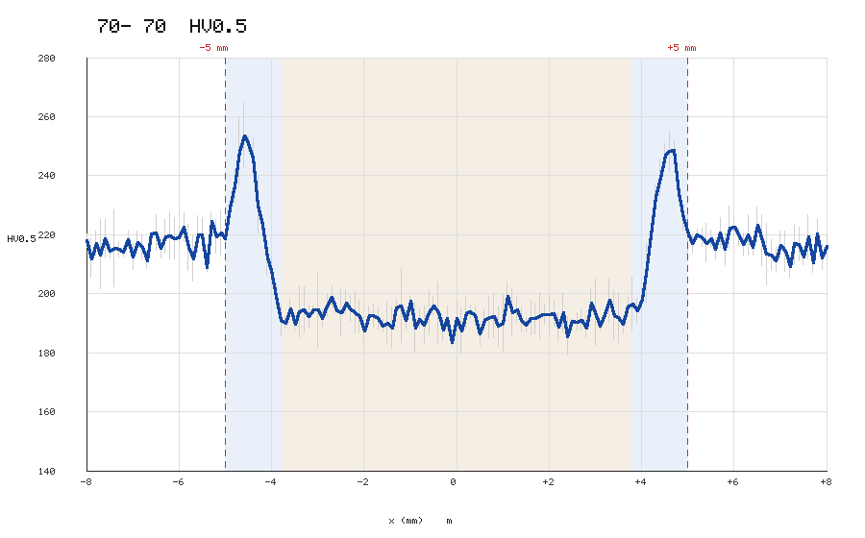
Figure 1. HV0.5 microhardness traverse for the X70-X70 weld. Dashed red lines = fusion lines at x = +/-5 mm; whiskers = +/-1 SD.
Table 4. Condensed HV0.5 traverse (every 0.5 mm) for the X70-X70 weld.
x (mm) | Mean (HV) | StdDev (HV) | Zone
-8.0 | 218.1 | 2.3 | Base Metal - X70
-7.5 | 214.6 | 2.4 | Base Metal - X70
-7.0 | 212.7 | 4.4 | Base Metal - X70
-6.5 | 220.7 | 6.0 | Base Metal - X70
-6.0 | 219.2 | 2.4 | Base Metal - X70
-5.5 | 220.2 | 5.5 | Base Metal - X70
-5.0 | 218.7 | 2.5 | Base Metal - X70
-4.5 | 250.9 | 2.5 | HAZ - X70
-4.0 | 208.1 | 4.4 | HAZ - X70
-3.5 | 189.7 | 2.2 | Fusion Zone (E6018)
-3.0 | 194.6 | 13.1 | Fusion Zone (E6018)
-2.5 | 193.7 | 7.8 | Fusion Zone (E6018)
-2.0 | 187.5 | 4.9 | Fusion Zone (E6018)
-1.5 | 190.2 | 6.9 | Fusion Zone (E6018)
-1.0 | 197.6 | 1.6 | Fusion Zone (E6018)
-0.5 | 196.1 | 3.1 | Fusion Zone (E6018)
+0.0 | 191.8 | 5.7 | Fusion Zone (E6018)
+0.5 | 186.6 | 4.1 | Fusion Zone (E6018)
+1.0 | 190.0 | 9.9 | Fusion Zone (E6018)
+1.5 | 189.4 | 2.5 | Fusion Zone (E6018)
+2.0 | 193.0 | 6.3 | Fusion Zone (E6018)
+2.5 | 190.7 | 1.0 | Fusion Zone (E6018)
+3.0 | 193.8 | 11.2 | Fusion Zone (E6018)
+3.5 | 192.0 | 8.4 | Fusion Zone (E6018)
+4.0 | 198.2 | 3.7 | HAZ - X70
+4.5 | 247.2 | 3.8 | HAZ - X70
+5.0 | 220.4 | 6.5 | Base Metal - X70
+5.5 | 218.7 | 2.7 | Base Metal - X70
+6.0 | 222.8 | 2.6 | Base Metal - X70
+6.5 | 223.4 | 6.1 | Base Metal - X70
+7.0 | 216.5 | 4.8 | Base Metal - X70
+7.5 | 212.6 | 2.6 | Base Metal - X70
+8.0 | 216.2 | 3.9 | Base Metal - X70

5.2 S355-S355 weld
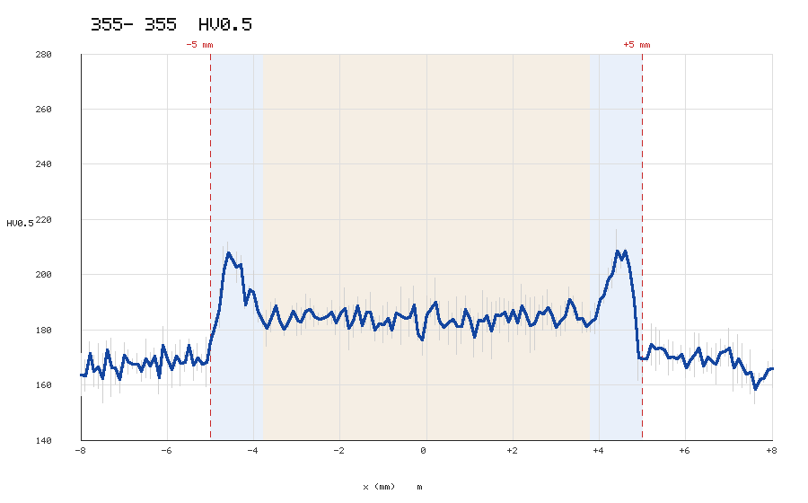
Figure 2. HV0.5 microhardness traverse for the S355-S355 weld. Dashed red lines = fusion lines at x = +/-5 mm; whiskers = +/-1 SD.
Table 5. Condensed HV0.5 traverse (every 0.5 mm) for the S355-S355 weld.
x (mm) | Mean (HV) | StdDev (HV) | Zone
-8.0 | 163.8 | 7.6 | Base Metal - S355
-7.5 | 162.4 | 9.0 | Base Metal - S355
-7.0 | 170.9 | 4.5 | Base Metal - S355
-6.5 | 169.5 | 7.0 | Base Metal - S355
-6.0 | 169.7 | 2.7 | Base Metal - S355
-5.5 | 174.6 | 2.1 | Base Metal - S355
-5.0 | 175.8 | 5.7 | Base Metal - S355
-4.5 | 205.7 | 1.5 | HAZ - S355
-4.0 | 193.7 | 7.8 | HAZ - S355
-3.5 | 188.8 | 2.4 | Fusion Zone (E6018)
-3.0 | 183.7 | 5.9 | Fusion Zone (E6018)
-2.5 | 184.0 | 2.1 | Fusion Zone (E6018)
-2.0 | 186.1 | 2.3 | Fusion Zone (E6018)
-1.5 | 181.8 | 3.0 | Fusion Zone (E6018)
-1.0 | 181.9 | 6.7 | Fusion Zone (E6018)
-0.5 | 184.4 | 0.5 | Fusion Zone (E6018)
+0.0 | 185.6 | 6.5 | Fusion Zone (E6018)
+0.5 | 182.6 | 7.8 | Fusion Zone (E6018)
+1.0 | 183.8 | 4.0 | Fusion Zone (E6018)
+1.5 | 179.7 | 10.3 | Fusion Zone (E6018)
+2.0 | 187.2 | 2.8 | Fusion Zone (E6018)
+2.5 | 182.3 | 9.6 | Fusion Zone (E6018)
+3.0 | 181.0 | 3.4 | Fusion Zone (E6018)
+3.5 | 184.0 | 1.6 | Fusion Zone (E6018)
+4.0 | 191.2 | 9.0 | HAZ - S355
+4.5 | 205.3 | 2.8 | HAZ - S355
+5.0 | 169.7 | 7.2 | Base Metal - S355
+5.5 | 172.8 | 1.9 | Base Metal - S355
+6.0 | 166.5 | 3.9 | Base Metal - S355
+6.5 | 170.2 | 5.2 | Base Metal - S355
+7.0 | 173.6 | 6.8 | Base Metal - S355
+7.5 | 164.7 | 7.9 | Base Metal - S355
+8.0 | 166.0 | 6.8 | Base Metal - S355

5.3 X70-S355 weld
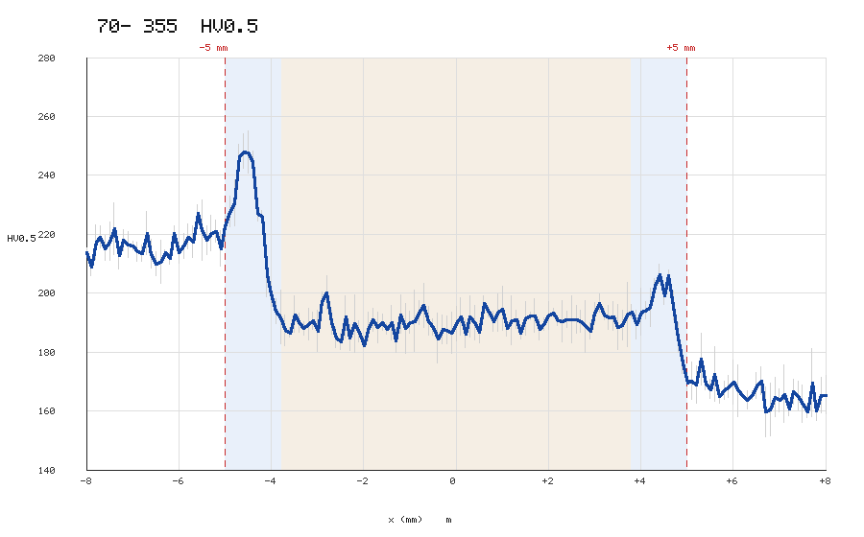
Figure 3. HV0.5 microhardness traverse for the X70-S355 weld. Dashed red lines = fusion lines at x = +/-5 mm; whiskers = +/-1 SD.
Table 6. Condensed HV0.5 traverse (every 0.5 mm) for the X70-S355 weld.
x (mm) | Mean (HV) | StdDev (HV) | Zone
-8.0 | 214.0 | 1.5 | Base Metal - X70 side
-7.5 | 217.6 | 6.6 | Base Metal - X70 side
-7.0 | 216.1 | 1.5 | Base Metal - X70 side
-6.5 | 210.0 | 4.1 | Base Metal - X70 side
-6.0 | 213.9 | 3.7 | Base Metal - X70 side
-5.5 | 221.3 | 10.3 | Base Metal - X70 side
-5.0 | 222.6 | 5.4 | Base Metal - X70 side
-4.5 | 247.9 | 7.2 | HAZ - X70 side
-4.0 | 199.8 | 4.2 | HAZ - X70 side
-3.5 | 192.9 | 6.3 | Fusion Zone (E6018)
-3.0 | 187.2 | 7.1 | Fusion Zone (E6018)
-2.5 | 183.6 | 2.8 | Fusion Zone (E6018)
-2.0 | 182.3 | 0.7 | Fusion Zone (E6018)
-1.5 | 187.8 | 1.7 | Fusion Zone (E6018)
-1.0 | 190.2 | 3.7 | Fusion Zone (E6018)
-0.5 | 188.6 | 2.8 | Fusion Zone (E6018)
+0.0 | 189.7 | 5.8 | Fusion Zone (E6018)
+0.5 | 186.9 | 3.8 | Fusion Zone (E6018)
+1.0 | 194.8 | 7.5 | Fusion Zone (E6018)
+1.5 | 191.6 | 5.7 | Fusion Zone (E6018)
+2.0 | 192.5 | 4.7 | Fusion Zone (E6018)
+2.5 | 191.1 | 7.9 | Fusion Zone (E6018)
+3.0 | 193.4 | 3.5 | Fusion Zone (E6018)
+3.5 | 188.4 | 7.7 | Fusion Zone (E6018)
+4.0 | 193.7 | 8.1 | HAZ - S355 side
+4.5 | 199.4 | 3.2 | HAZ - S355 side
+5.0 | 169.5 | 3.8 | Base Metal - S355 side
+5.5 | 167.5 | 3.4 | Base Metal - S355 side
+6.0 | 169.8 | 7.4 | Base Metal - S355 side
+6.5 | 168.7 | 4.5 | Base Metal - S355 side
+7.0 | 163.7 | 3.9 | Base Metal - S355 side
+7.5 | 162.5 | 6.4 | Base Metal - S355 side
+8.0 | 165.5 | 6.5 | Base Metal - S355 side

6. Observations and Trends
- For every weld the base metal is the toughest zone, followed by the HAZ, with the E6018 weld metal the lowest in CVN energy; all zones lose toughness from +20 C to -20 C.
- The X70 material is both harder and tougher than S355: X70 base metal is around 215 HV versus around 165 HV for S355, and X70-X70 CVN energies exceed the S355-S355 values at both test temperatures.
- The dissimilar X70-S355 weld is asymmetric and intermediate: the stiffer, harder X70 base metal and HAZ sit on the left (x < 0) while the softer S355 side sits on the right (x > 0), and its properties fall between the two similar joints.
- A distinct HAZ hardness peak (about 250 HV on the X70 side, about 206 HV on the S355 side) appears just inside each fusion line, consistent with a hardened transformation microstructure.
- E6018 is a 60-ksi-class filler, so the weld metal undermatches X70: the fusion zone (about 190-196 HV) is softer than the X70 base metal, producing the characteristic dip at the weld centerline.

7. Note on Data Provenance
The values in this report are representative, literature-consistent (synthetic) figures generated for illustration and analysis. They are not measured laboratory results and should not be cited as experimental data.

