Chapter 3: Smart Hybrid Renewable Energy Systems — Techno-Economic Analysis, Market Integration, and Digitalization
Book: Intelligent Power Management and Resilient Control in Hybrid Renewable Energy Systems

Abstract
Smart Hybrid Renewable Energy Systems (HRES) integrate complementary generation technologies, energy storage, and intelligent control to deliver clean, reliable, and economically competitive power across grid-connected and islanded contexts. This chapter develops a unified treatment of the technical, economic, market, and digital dimensions that jointly determine the viability of modern HRES. It first establishes the concept and architecture of HRES, examining the synergistic integration of solar, wind, hydropower, and storage within smart-grid environments, and the persistent challenges of reliability, scalability, and sustainable operation. It then presents techno-economic modelling methods, covering optimal sizing, performance indicators, and financial metrics such as net present cost, levelized cost of energy, and payback period, together with sensitivity, uncertainty, and risk analysis. The chapter subsequently analyses market integration pathways, including wholesale participation, demand response, dynamic pricing, peer-to-peer trading enabled by blockchain, and the regulatory frameworks that govern them. It examines how digitalization — through the Internet of Things, artificial intelligence, digital twins, cloud and edge computing, and cybersecurity — transforms monitoring, forecasting, and control. Finally, it addresses resilient control strategies, grid stability during outages, lifecycle sustainability, and emerging trends such as autonomous microgrids and next-generation energy markets. Four figures and four tables summarize architectures, cost comparisons, market mechanisms, and future directions, and the chapter closes by identifying research gaps in AI-driven optimization, resilient control, decentralized trading, and digitally integrated smart grids.
Keywords: Hybrid renewable energy systems, techno-economic analysis, intelligent energy management, renewable energy markets, digitalization, artificial intelligence, smart grids, resilient control, energy storage, sustainable energy systems.

3.1 Introduction to Smart Hybrid Renewable Energy Systems

3.1.1 Concept and Architecture of Hybrid Renewable Energy Systems
A Hybrid Renewable Energy System (HRES) combines two or more generation technologies — most commonly solar photovoltaic (PV) and wind — with energy storage and intelligent management to overcome the intermittency and low dispatchability of any single renewable resource [1]. The central premise is complementarity: when the temporal availability of distinct resources is negatively correlated, their aggregation smooths net output, reduces reserve requirements, and improves the match between supply and demand [2]. The word "smart" denotes the addition of a cyber layer — sensing, communication, computation, and automated decision-making — that converts a passive collection of components into an adaptive system capable of real-time optimization [3].
Architecturally, a smart HRES is organized around a common electrical bus, which may be AC, DC, or hybrid AC/DC, to which generation units, storage, and loads are connected through power-electronic converters [4]. A supervisory energy management system (EMS) coordinates power flows, enforces operating constraints, and dispatches resources according to technical and economic objectives. The architecture spans four interacting layers: a physical layer of generators, converters, and storage; a measurement layer of meters and sensors; a communication layer linking devices to controllers; and a decision layer hosting optimization and control algorithms. Figure 1 depicts this layered architecture, showing how solar, wind, hydropower, and storage subsystems feed a common bus governed by an EMS that interfaces with the wider smart grid and serves local loads. This modular, converter-centric structure is what allows HRES to scale from kilowatt-class rural installations to utility-scale plants while preserving a consistent control philosophy [5].
The choice between AC, DC, and hybrid AC/DC bus topologies is itself a design decision with far-reaching consequences. AC-coupled architectures reuse mature grid-interconnection equipment and simplify integration with existing distribution networks, but they incur repeated DC–AC–DC conversion losses when serving the growing population of natively DC loads and storage [4]. DC-coupled architectures reduce conversion stages, improve efficiency for PV-and-battery-dominated systems, and avoid frequency-synchronization concerns, yet they demand new protection philosophies because interrupting DC fault currents is more challenging than extinguishing AC arcs. Hybrid AC/DC microgrids attempt to capture the advantages of both, routing each resource and load to its most efficient bus and interconnecting the two through a bidirectional interlinking converter whose control is central to overall stability [5]. The architectural decision therefore propagates through every later layer of analysis, shaping component selection, protection design, efficiency, and ultimately the levelized cost of energy examined in Section 3.2.
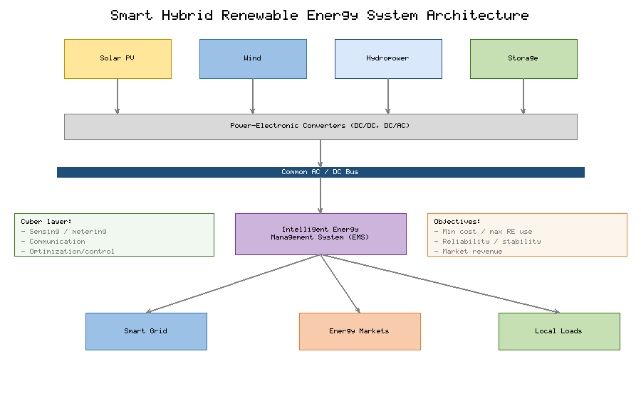
Figure 1. Layered architecture of a smart hybrid renewable energy system, showing solar PV, wind, hydropower, and battery/hydrogen storage subsystems connected through power-electronic converters to a common bus, coordinated by an intelligent energy management system that interfaces with the smart grid, markets, and local loads.

3.1.2 Integration of Solar, Wind, Hydropower, and Energy Storage
Effective integration begins with understanding the distinct operating signatures of each resource. Solar PV delivers predictable diurnal peaks but zero night-time output and strong seasonal and weather sensitivity; wind exhibits stronger night and winter profiles in many climates, offering temporal complementarity with solar [6]. Hydropower — particularly reservoir and pumped-storage variants — contributes both firm, dispatchable energy and a large-scale storage reservoir, functioning as a stabilizing anchor for variable renewables [7]. Energy storage closes the residual gap: lithium-ion batteries provide fast, high-efficiency response over minutes to hours, while hydrogen electrolysis and fuel cells, together with pumped hydro, address multi-hour to seasonal shifting [8].
The integration task is therefore one of matching resource characteristics to system needs across multiple timescales, from sub-second power-quality support to seasonal energy balancing. Table 1 summarizes the defining attributes of the principal HRES building blocks — typical capacity factor, variability, dispatchability, response time, and system role — providing the basis for the sizing and optimization decisions developed in Section 3.2. The practical consequence is that no component is selected in isolation; the value of each is conditioned on the portfolio in which it operates, and intelligent coordination is what unlocks the complementarity on which HRES economics depend. Where a reservoir or pumped-hydro facility is available, its large energy capacity and rapid ramping make it the natural balancing resource, allowing batteries to be reserved for fast power-quality duty and hydrogen for long-duration or seasonal shifting [7][8]. This division of labour across storage technologies — power-oriented versus energy-oriented — is a defining feature of well-designed hybrid systems and a recurring theme in the optimization methods that follow.
Table 1. Operating characteristics and system roles of principal generation and storage components in smart HRES.
Component | Typical capacity factor | Variability | Dispatchability | Response time | Primary system role
Solar PV | 15–25% | High (diurnal/weather) | Low | Seconds (via converter) | Daytime bulk energy
Wind | 25–45% | High (stochastic) | Low | Seconds (via converter) | Night/seasonal energy
Hydropower (reservoir) | 40–60% | Low–moderate | High | Seconds–minutes | Firm, dispatchable base
Pumped hydro storage | N/A (storage) | Controllable | High | Minutes | Bulk, long-duration shifting
Lithium-ion battery | N/A (storage) | Controllable | Very high | Milliseconds–seconds | Short-duration, power quality
Hydrogen (electrolyzer/fuel cell) | N/A (storage) | Controllable | High | Seconds–minutes | Seasonal shifting, backup

3.1.3 Role of Smart Grids and Intelligent Energy Management
The smart grid provides the digital nervous system through which HRES realize their value. Bidirectional communication, advanced metering, and distributed intelligence allow generation, storage, and flexible loads to be coordinated as a responsive whole rather than dispatched in isolation [9]. Within this environment, the EMS evolves from a rule-based controller into an optimization engine that continuously balances competing objectives — minimizing cost, maximizing renewable utilization, respecting storage degradation limits, and maintaining power quality — subject to forecasts of generation, demand, and price [10].
Intelligent energy management operates hierarchically. At the primary level, fast droop and converter controls maintain voltage and frequency; at the secondary level, the EMS restores set-points and coordinates units; at the tertiary level, economic dispatch and market participation are optimized over hours to days [11]. This hierarchy enables a single system to serve local reliability goals and grid-service markets simultaneously. Increasingly, these functions are augmented by data-driven methods that learn operating patterns and adapt dispatch policies, blurring the line between control and optimization and setting the stage for the digitalization themes developed in Section 3.4.
Energy management strategies for HRES are commonly grouped into three families, each with characteristic strengths [10]. Rule-based strategies encode operator heuristics — for example, prioritizing renewable self-consumption, then storage, then grid import — and are valued for transparency, low computational cost, and ease of certification, though they rarely achieve true optimality. Optimization-based strategies, such as mixed-integer linear programming and model-predictive control, explicitly minimize an objective over a forecast horizon and can deliver substantial cost savings, at the price of greater modelling and computational demands [11]. Learning-based strategies, including reinforcement learning, derive control policies from data and adapt to drift in load, resource, and price, offering resilience to changing conditions but raising questions of interpretability and safety assurance. In practice, hybrid schemes combine a fast rule-based or model-predictive inner loop with a slower learning-based outer loop, reflecting a pragmatic consensus that no single paradigm dominates across all timescales and operating regimes.

3.1.4 Challenges in Reliability, Scalability, and Sustainable Operation
Despite their promise, smart HRES face intertwined challenges. Reliability is constrained by resource intermittency and by the finite energy capacity of storage; metrics such as loss of power supply probability (LPSP) must be driven to acceptable levels without oversizing components to the point of economic infeasibility [12]. Scalability raises questions of control coordination, communication latency, and converter stability as the number of distributed assets grows, and as low-inertia power-electronic interfaces displace synchronous generation [13]. Sustainable operation introduces lifecycle considerations — raw-material use, battery degradation and replacement, and end-of-life recycling — that a narrow focus on operating cost can obscure [14].
These challenges are coupled: improving reliability through larger storage increases capital cost and embodied emissions, while aggressive cost minimization can erode resilience. Resolving these trade-offs is precisely the function of rigorous techno-economic analysis, to which the chapter now turns.
A further, often underappreciated, challenge concerns the stability of converter-dominated systems. As power electronics replace synchronous machines, the aggregate rotational inertia that classically arrested frequency excursions diminishes, and the system becomes susceptible to faster frequency dynamics and to control interactions among densely packed converters [13]. Low-inertia operation narrows the margin for error in both primary control and protection, and it elevates phenomena — such as sub-synchronous oscillations and harmonic resonance — that were negligible in machine-dominated grids. Addressing these issues requires grid-forming control, synthetic inertia, and careful converter tuning, all of which must be reconciled with the economic imperative to minimize over-provisioning. The reliability, scalability, and stability challenges are therefore not independent engineering nuisances but a tightly linked set of constraints that the techno-economic framework must internalize if its recommendations are to be physically realizable.

3.2 Techno-Economic Modelling and Performance Evaluation

3.2.1 System Sizing, Component Selection, and Energy Optimization
Optimal sizing determines the capacity of each generator and storage unit that minimizes lifecycle cost while satisfying reliability and environmental constraints. The problem is inherently multi-objective and non-convex, coupling long-term investment decisions with high-resolution operational simulation of charge/discharge and dispatch over a representative year [15]. Formally, the design seeks the component vector that minimizes net present cost subject to an energy-balance constraint at every timestep and an LPSP ceiling, with decision variables spanning PV area, wind capacity, storage energy and power, and converter ratings.
Because exhaustive search is intractable for realistic systems, metaheuristic optimization — genetic algorithms, particle swarm optimization, and their hybrids — is widely used to explore the design space efficiently, often coupled to simulation tools such as HOMER for techno-economic evaluation [16]. The emerging practice couples these optimizers with machine-learning surrogates that approximate costly simulations, accelerating convergence and enabling the exploration of thousands of candidate configurations. The outcome is a Pareto frontier that makes the cost–reliability–emissions trade-off explicit, allowing designers to select configurations aligned with stakeholder priorities rather than a single arbitrary optimum.
The fidelity of any sizing study depends critically on the temporal resolution and representativeness of its input data [15]. Hourly resolution over a full year is a common compromise, but it can understate the fast fluctuations that stress storage and converters, motivating the use of sub-hourly data or synthetically generated extreme sequences. Equally important is the treatment of inter-annual variability: a design optimized against a single favourable weather year may prove inadequate in a poor one, so robust practice evaluates candidate configurations against multiple historical years or stochastically sampled scenarios [16]. The decision variables themselves have expanded beyond simple capacity ratings to include storage dispatch strategy, converter sizing relative to generation, and the degree of allowable curtailment, each of which interacts non-linearly with the others. This growth in dimensionality is precisely what makes metaheuristic and surrogate-assisted methods indispensable, and it explains the field's steady migration from spreadsheet sizing toward simulation-coupled global optimization.

3.2.2 Technical Performance Indicators: Efficiency, Reliability, and Availability
Technical performance is quantified through a family of complementary indicators. Reliability is captured by the loss of power supply probability and the related loss of load expectation, which measure the fraction of demand or time that the system fails to serve [17]. The renewable energy fraction expresses the share of load met by renewable sources, directly linking technical design to decarbonization goals. Efficiency metrics — including round-trip storage efficiency and overall system efficiency — account for conversion and storage losses that erode delivered energy.
Availability, the fraction of time the system is operational, reflects both component reliability and maintenance strategy, and is strongly influenced by the predictive-maintenance capabilities discussed in Section 3.4. These indicators are not independent: raising the renewable fraction typically increases curtailment and reduces marginal efficiency, while improving reliability through redundancy affects both availability and cost. Robust evaluation therefore reports indicators jointly, over representative and extreme operating conditions, rather than citing single headline figures. The choice of reliability target has an outsized influence on cost: driving the loss of power supply probability from a few percent toward zero typically requires disproportionate increases in capacity, because the final increments of reliability must cover rare, prolonged periods of simultaneous low resource and high demand [17]. Performance evaluation increasingly also accounts for degradation over the asset's life — battery capacity fade, PV soiling, and converter wear — so that indicators computed only for the first year of operation are not mistaken for lifetime averages.

3.2.3 Economic Assessment: Net Present Cost, LCOE, and Payback Period
Economic assessment translates technical design into investment language. The net present cost (NPC) aggregates all discounted capital, replacement, operation, and maintenance expenditures over the project lifetime, net of salvage value, and is the standard objective for sizing optimization [18]. The levelized cost of energy (LCOE) normalizes lifecycle cost by discounted energy delivered, enabling technology-agnostic comparison:
$$\text{LCOE} = \frac{\sum_{t=1}^{N}\left(I_t + O_t + R_t\right)/(1+r)^t}{\sum_{t=1}^{N} E_t/(1+r)^t}$$
where \(I_t\), \(O_t\), and \(R_t\) are investment, operation, and replacement costs in year \(t\), \(E_t\) is energy delivered, \(r\) is the discount rate, and \(N\) is the system lifetime. The payback period measures the time required for cumulative savings or revenues to recover the initial investment and remains a widely used screening metric despite ignoring the time value of money [19].
Figure 2 compares representative LCOE ranges across common HRES configurations, illustrating how the addition of storage raises firm-power cost relative to curtailment-prone renewable-only designs, while hybridization with hydro achieves the most favourable balance of cost and reliability. Table 2 consolidates the corresponding techno-economic indicators — LCOE, NPC, internal rate of return (IRR), payback period, renewable fraction, and LPSP — for four illustrative configurations, providing a compact decision reference that links Sections 3.2.1–3.2.3 [20].
It is important to recognize that LCOE, despite its ubiquity, is an incomplete measure of value for systems whose output is time-varying. Two systems with identical LCOE can differ markedly in worth if one delivers energy predominantly during high-value periods and the other during low-value periods; this motivates value-adjusted metrics such as the levelized cost that credit energy at its time-of-delivery price [19]. For storage-rich HRES, the levelized cost of storage and the marginal cost of each additional hour of autonomy are more informative than headline LCOE alone, because they expose the steeply rising cost of the last increments of firmness [18]. Internal rate of return and payback period complete the picture from the investor's perspective, but they are highly sensitive to tariff design, incentive availability, and the cost of capital, which varies from single-digit percentages for contracted projects in mature markets to mid-teens for merchant projects in higher-risk settings [20]. Reporting a suite of complementary metrics, rather than a single figure, is therefore essential to sound decision-making.
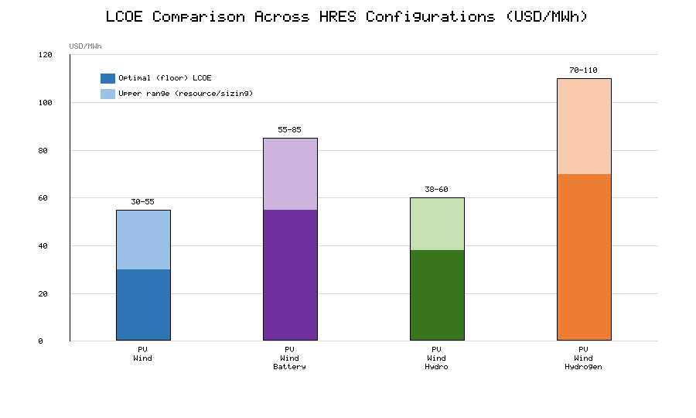
Figure 2. Representative levelized cost of energy (LCOE) ranges for four HRES configurations, showing optimal values and the full range attributable to resource quality and system sizing. Hybrid PV/Wind/Hydro achieves the lowest firm-power cost, while battery-backed configurations trade higher cost for superior reliability.
Table 2. Illustrative techno-economic indicators for four representative HRES configurations (indicative 2025 values).
Configuration | LCOE (USD/MWh) | NPC (USD million) | IRR (%) | Payback (years) | Renewable fraction (%) | LPSP (%)
PV/Wind (no storage) | 30–55 | 8.5 | 18–25 | 4.5 | 70–85 | 3–6
PV/Wind/Battery | 55–85 | 24.0 | 12–18 | 6.2 | 92–98 | 0.5–2
PV/Wind/Hydro | 38–60 | 32.5 | 15–22 | 5.4 | 95–99 | <0.5
PV/Wind/Hydrogen | 70–110 | 85.2 | 8–14 | 7.1 | 98–100 | <0.5

3.2.4 Sensitivity, Uncertainty, and Risk Analysis for Hybrid Systems
Deterministic optimization yields a single design, but real projects face pervasive uncertainty in resource availability, demand growth, component cost, and discount rate. Sensitivity analysis isolates the influence of individual parameters on key outputs, revealing which assumptions dominate project economics [21]. Discount rate, capital cost of storage, and electricity price typically emerge as the most influential drivers of LCOE and NPC, concentrating analytical effort where it matters most.
Uncertainty analysis goes further, propagating probability distributions of inputs through the model — often via Monte Carlo simulation — to produce distributions of outcomes rather than point estimates [22]. The resulting confidence intervals support risk-aware decisions: a configuration with slightly higher expected cost but far lower variance may be preferable to a fragile least-cost design. Formal risk metrics, such as value-at-risk on project returns, and robust-optimization formulations that guarantee performance across a defined uncertainty set, are increasingly embedded in HRES planning, reflecting the maturation of the field from feasibility demonstration toward bankable, investment-grade analysis.
Stochastic sizing methods make this risk-awareness structural rather than post hoc. By embedding scenario trees or chance constraints directly in the optimization, these methods identify designs that remain feasible and economic across the full spread of plausible futures, rather than designs that are optimal only for an expected-value scenario [22]. The practical payoff is a configuration whose reliability guarantees hold under adverse combinations of low resource, high demand, and elevated prices, at a modest premium over the deterministic least-cost solution. Scenario reduction techniques keep these formulations tractable, and modern tools report not only expected cost but its distribution, enabling developers and financiers to negotiate explicitly over the balance between expected return and downside protection [21]. This quantitative treatment of uncertainty is increasingly a prerequisite for securing project finance, as lenders demand evidence that revenue projections are robust to resource and market volatility.

3.3 Market Integration and Energy Trading Mechanisms

3.3.1 Renewable Energy Markets and Grid-Connected Hybrid Systems
Grid connection transforms an HRES from a self-contained supply system into a market participant able to monetize energy and flexibility. In liberalized electricity markets, generators sell energy through day-ahead and intraday auctions and can provide ancillary services — frequency regulation, reserves, and voltage support — that are increasingly valuable as system inertia declines [23]. Hybrid systems are particularly well suited to market participation because co-located storage can firm variable output, shift energy to high-price periods, and stack multiple revenue streams from a single asset base.
The economic case for grid-connected HRES therefore rests not only on energy sales but on the aggregate value of the services the system can deliver. Capturing this value requires accurate price forecasting, optimized bidding, and control systems able to switch rapidly between market products — capabilities that depend directly on the digital infrastructure discussed in Section 3.4. The result is a tight coupling between market design and technical architecture, in which the configuration that is optimal in isolation may differ from the one that maximizes value under a given market structure.
A central concept in this context is revenue stacking: the practice of deriving multiple, non-conflicting income streams from the same assets by participating in several markets across different timescales [23]. A battery, for instance, may provide fast frequency response during most hours, shift energy to capture arbitrage spreads at peak times, and offer firm capacity in capacity-market auctions, provided the dispatch schedules do not collide. The art of value maximization lies in co-optimizing these streams subject to the physical limits of the asset — power, energy, and cycle life — and the technical rules of each market. Barriers nonetheless remain: high rates of variable renewable penetration can depress wholesale prices during periods of abundant generation, a self-cannibalization effect that erodes energy-only revenues and strengthens the case for flexibility and storage. Market designs that reward flexibility explicitly, rather than energy alone, are thus critical to sustaining investment in the hybrid systems that the energy transition requires.

3.3.2 Demand Response, Dynamic Pricing, and Demand-Side Management
Demand-side flexibility is a cost-effective complement to supply-side investment. Demand response programs incentivize consumers to shift or curtail load in response to price signals or system conditions, flattening peaks and reducing the storage capacity an HRES must provide [24]. Dynamic pricing — time-of-use, critical-peak, and real-time tariffs — exposes consumers to the true temporal cost of electricity, aligning private behaviour with system needs and improving the utilization of variable renewables.
Demand-side management extends this logic through automated control of flexible loads such as electric-vehicle charging, water heating, and thermal storage, coordinated by the EMS to exploit price and generation forecasts. Table 3 summarizes the principal market-integration and trading mechanisms available to smart HRES, mapping each mechanism to its revenue or value stream and the enabling technology required. The convergence of flexible demand, dynamic prices, and intelligent control effectively turns consumption into a dispatchable resource, substantially improving both the economics and the reliability of hybrid systems.
The effectiveness of demand-side measures depends heavily on consumer engagement and on the automation that removes the burden of manual response [24]. Purely price-based programs often achieve modest participation because households and small businesses lack the time or expertise to react to changing tariffs; embedding the response in smart appliances, building management systems, and electric-vehicle chargers converts latent willingness into reliable, repeatable flexibility. Equity considerations also arise, since poorly designed dynamic tariffs can disadvantage consumers with inflexible loads or limited ability to shift usage, underscoring the need for careful tariff design and consumer protection. When implemented well, demand response reduces the peak capacity an HRES must build, defers network reinforcement, and provides a fast, low-cost source of balancing that complements storage — a combination increasingly recognized as one of the most cost-effective levers in the entire system.
Table 3. Market-integration and energy-trading mechanisms for smart HRES.
Mechanism | Description | Value / revenue stream | Enabling technology
Wholesale energy sales | Day-ahead/intraday auction participation | Energy arbitrage | Forecasting, bidding optimization
Ancillary services | Frequency regulation, reserves, voltage support | Capacity/service payments | Fast storage, grid-forming converters
Demand response | Incentivized load shift/curtailment | Reduced peak cost, DR payments | Smart meters, automation
Dynamic pricing | Time-varying retail tariffs | Arbitrage, peak reduction | AMI, dynamic tariffs
Peer-to-peer trading | Prosumer-to-prosumer exchange | Local energy sales | Blockchain, smart contracts

3.3.3 Peer-to-Peer Energy Trading and Blockchain-Enabled Transactions
Peer-to-peer (P2P) trading allows prosumers — consumers who also generate — to exchange surplus energy directly with neighbours, bypassing conventional supplier intermediation and keeping value within local communities [25]. Realizing P2P at scale requires a trusted, low-cost mechanism to record transactions, verify delivery, and settle payments among many small, mutually untrusting parties. Blockchain and distributed-ledger technologies provide exactly this: an immutable, decentralized record combined with self-executing smart contracts that automate pricing, matching, and settlement without a central operator [26].
Blockchain-enabled trading supports novel market designs, including continuous double auctions and community microgrid markets, and can integrate with demand response and electric-vehicle charging. Practical deployment, however, must address the energy consumption and latency of consensus mechanisms, scalability to large participant populations, and interoperability with existing grid operations and metering. These constraints are driving adoption of energy-efficient consensus schemes and layered architectures that keep high-frequency matching off-chain while anchoring settlement on-chain, positioning P2P trading as a credible pillar of decentralized energy markets.
The market mechanisms underpinning P2P exchange range from bilateral contracts negotiated between specific parties, through pool-based structures that aggregate offers and bids at a community clearing price, to fully decentralized continuous auctions in which agents trade autonomously [25]. Each design embodies a different trade-off between privacy, efficiency, and computational burden, and the appropriate choice depends on community size, regulatory latitude, and the sophistication of participants' automation. Crucially, local trading must respect the physical constraints of the distribution network: unconstrained peer transactions can create voltage violations or line overloads, so emerging designs incorporate network-aware pricing or operator oversight to keep trades feasible [26]. The integration of distributed-ledger settlement with such network-aware market clearing — and with the electric-vehicle and demand-response flexibility described earlier — points toward genuinely transactive distribution systems in which value and physical power flows are jointly coordinated.

3.3.4 Regulatory Frameworks, Tariff Structures, and Market Participation
Technology alone does not determine market outcomes; regulation shapes what is permitted, rewarded, and penalized. Feed-in tariffs, net metering, renewable portfolio standards, and capacity markets each create distinct incentive structures that materially alter HRES economics and investment behaviour [27]. The global shift from fixed feed-in tariffs toward competitive auctions and market-based premiums has lowered support costs but transferred price risk to developers, increasing the importance of the risk analysis discussed in Section 3.2.4.
Regulatory frameworks also govern grid access, interconnection standards, and the eligibility of distributed and aggregated resources to participate in wholesale and ancillary markets. The emergence of aggregators and virtual power plants, which pool many small assets into a single market-facing entity, depends on enabling rules that recognize demand-side and storage resources on equal terms with conventional generation. Harmonizing these frameworks across jurisdictions, and designing tariffs that reflect both energy and flexibility value, remains a central policy challenge for scaling smart HRES.
Policy stability is as important as policy design. Abrupt retroactive changes to support schemes — reductions in feed-in tariffs or the imposition of new charges on self-consumption — have in several markets undermined investor confidence and stalled deployment, demonstrating that regulatory risk can dominate technical and resource risk in a project's overall risk profile [27]. Predictable, technology-neutral frameworks that reward measurable system value, phase down support transparently, and grant distributed resources fair access to markets tend to attract the lowest-cost capital. Equally, interconnection procedures and grid codes must evolve to accommodate inverter-based resources and aggregated portfolios without imposing disproportionate study costs or delays on small projects. The design of these institutional arrangements is ultimately inseparable from the technical and economic analysis of the preceding sections, because it determines which of the many feasible configurations will actually be financed and built.

3.4 Digitalization and Intelligent Energy Management

3.4.1 Internet of Things, Smart Metering, and Real-Time Monitoring
Digitalization begins with pervasive sensing. The Internet of Things (IoT) instruments every significant node of an HRES — generators, converters, storage, and loads — with sensors and smart meters that stream high-resolution measurements of power, voltage, temperature, and state of charge [28]. Advanced metering infrastructure provides the bidirectional, time-stamped data on which dynamic pricing, demand response, and settlement depend, while edge gateways aggregate and pre-process device data before transmission.
Real-time monitoring built on this foundation delivers situational awareness, enabling operators and automated controllers to detect anomalies, verify performance, and respond to disturbances within the timescales required for stable operation. The value of IoT data compounds when it feeds analytics: the same streams that support monitoring become the training data for the forecasting and fault-detection models that distinguish a smart HRES from a conventional one. Realizing this value at scale, however, depends on interoperability and data quality [28]: heterogeneous devices must exchange data through common protocols and semantic models, and gaps, drift, and sensor faults must be managed actively, because downstream forecasts and control decisions are only as trustworthy as the measurements that feed them.

3.4.2 Artificial Intelligence and Machine Learning for Energy Forecasting
Accurate forecasting is the single most important enabler of intelligent energy management, because every dispatch and bidding decision is made against expected future generation, demand, and price. Machine-learning methods — gradient-boosted trees, recurrent and convolutional neural networks, and transformer architectures — have substantially improved short-term forecasts of solar irradiance, wind speed, and load relative to classical statistical models [29]. Hybrid and ensemble approaches that combine physical and data-driven models further reduce error and quantify forecast uncertainty, which is essential for risk-aware dispatch.
Beyond forecasting, reinforcement learning is increasingly applied to energy management itself, learning dispatch and bidding policies directly from operational experience and adapting to changing conditions without explicit re-optimization. Table 4 maps the principal digital and AI technologies to their functions, HRES applications, and the benefits they deliver, consolidating the themes of Section 3.4 and connecting them to the resilience objectives of Section 3.5. The practical impact is measurable: improved forecasts translate directly into lower reserve requirements, reduced curtailment, and higher market revenue.
The forecasting horizon dictates both the method and its purpose [29]. Very-short-term forecasts, from seconds to minutes ahead, rely on sky imagery, high-frequency telemetry, and persistence-corrected models to support real-time balancing and ramp management. Short-term forecasts, hours to days ahead, underpin market bidding and unit commitment and benefit most from numerical weather prediction fused with machine learning. Medium- and long-term forecasts inform maintenance scheduling and seasonal planning. Across all horizons, the frontier is shifting from deterministic point forecasts toward probabilistic forecasts that quantify uncertainty, because a dispatch optimizer that knows the confidence interval of its inputs can hedge intelligently rather than react to a single, possibly wrong, prediction. This fusion of probabilistic forecasting with risk-aware optimization is where much of the current research value in intelligent energy management is concentrated, and it directly reinforces the uncertainty-handling methods introduced in Section 3.2.4.

3.4.3 Digital Twins, Cloud Computing, and Edge-Based Control
A digital twin is a continuously updated virtual replica of the physical HRES, synchronized with live sensor data and capable of simulating system behaviour faster than real time [30]. Digital twins support what-if analysis, control tuning, anomaly detection, and operator training without perturbing the real system, and they provide a sandbox in which AI controllers can be validated before deployment. Their fidelity depends on both high-quality models and the data pipelines established by IoT instrumentation.
The computational substrate for these capabilities is a cloud–edge continuum. Cloud computing offers the scalable storage and processing needed for training models, running long-horizon optimization, and coordinating fleets of assets, while edge computing places latency-sensitive control close to the hardware, ensuring that protection and stabilization functions continue even if connectivity is lost [31]. Figure 3 illustrates this digitalization stack, from field-level IoT sensing through edge control to cloud-hosted digital twins and AI analytics, with closed-loop commands returning to the physical system. This architecture reconciles the competing demands of global optimization and local reliability that characterize distributed renewable systems.
Digital twins span a spectrum of fidelity, from lightweight data-driven surrogates that mirror observed behaviour to high-fidelity physics-based models that capture detailed electrical and thermal dynamics [30]. The appropriate level of fidelity depends on purpose: operational dispatch may need only a fast behavioural model, whereas protection studies and failure analysis demand detailed physical representation. Maintaining the twin's synchronization with the physical asset over time — accounting for degradation, reconfiguration, and ageing — is a continuing effort rather than a one-time construction, and it is the twin's live coupling to sensor data that distinguishes it from a conventional offline simulation. The cloud–edge split that hosts these models also shapes resilience: by placing safety-critical control at the edge, the system guarantees that stabilization and protection persist through communication outages, while the cloud contributes the heavier analytics whenever connectivity permits [31]. This layered allocation of intelligence is becoming the de facto reference architecture for digitally managed hybrid systems.
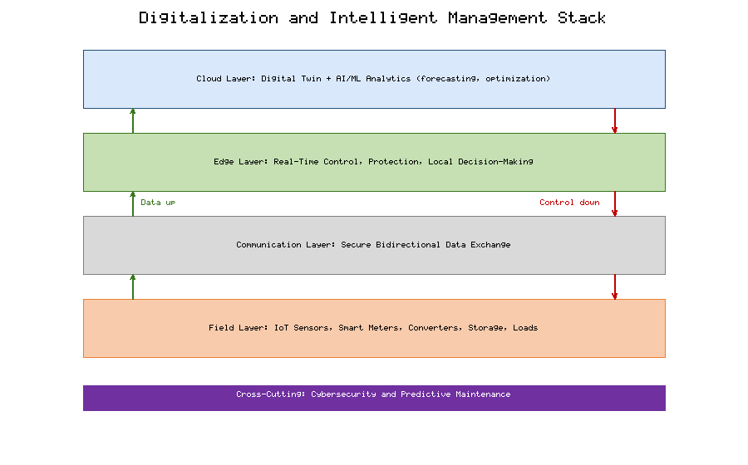
Figure 3. Digitalization and intelligent-management stack for smart HRES: field-level IoT sensing and smart metering feed edge-based real-time control; aggregated data flows to cloud-hosted digital twins and AI/ML analytics for forecasting and optimization; closed-loop set-points return to the physical system.

3.4.4 Predictive Maintenance, Fault Detection, and Cybersecurity
Digitalization converts maintenance from a scheduled, reactive activity into a predictive, condition-based one. By analysing sensor trends with machine-learning models, operators can anticipate component degradation — bearing wear in turbines, capacity fade in batteries, hot-spots in PV strings — and intervene before failure, maximizing availability and extending asset life [32]. Automated fault detection and diagnosis localize disturbances rapidly, shortening restoration times and limiting cascading effects.
These benefits, however, enlarge the attack surface. The same connectivity that enables remote monitoring and control exposes HRES to cyber threats ranging from data manipulation and false-data injection to ransomware and coordinated attacks on grid-connected inverters [33]. Robust cybersecurity — defence-in-depth, encrypted communications, intrusion detection, and secure-by-design controllers — is therefore not an optional add-on but a core reliability requirement. The convergence of operational and information technology in smart HRES makes cyber-resilience inseparable from physical resilience, a theme developed in the next section.
Predictive-maintenance analytics draw on the same data streams that support monitoring, applying anomaly-detection and remaining-useful-life models to convert raw telemetry into actionable maintenance decisions [32]. The economic case is compelling: avoiding a single unplanned outage of a major component can outweigh years of sensing and analytics costs, while extending asset life defers large replacement expenditures. Yet the cybersecurity dimension cannot be treated as separate. False-data-injection attacks that subtly corrupt the very measurements on which predictive models rely can both mask genuine faults and trigger spurious interventions, so the integrity and authentication of sensor data are prerequisites for trustworthy maintenance [33]. A defence-in-depth posture — network segmentation, encrypted and authenticated communications, continuous intrusion monitoring, and secure-by-design controllers — must therefore accompany every analytics capability, so that the drive toward greater intelligence does not simultaneously become the system's greatest vulnerability.

3.5 Resilience, Sustainability, and Future Perspectives

3.5.1 Resilient Control Strategies and Adaptive Energy Management
Resilience is the capacity of a system to anticipate, withstand, adapt to, and recover from disturbances, extending beyond ordinary reliability to encompass rare, high-impact events [34]. Resilient control strategies for HRES combine robust and adaptive methods: model-predictive control optimizes over a receding horizon using forecasts and explicit constraints; adaptive controllers retune parameters as conditions change; and hierarchical schemes degrade gracefully, shedding non-critical functions to preserve core service under stress.
Figure 4 presents an integrated resilience-and-sustainability framework, organizing the chapter's themes into four mutually reinforcing pillars — technical performance, economic feasibility, market participation, and digital intelligence — that together determine system resilience and sustainability. Adaptive energy management sits at the centre of this framework, continuously reconciling short-term stability with long-term economic and environmental objectives. The practical goal is a control architecture that is simultaneously optimal under normal conditions and robust under extreme ones, a balance that pure cost minimization cannot achieve.
Resilience is usefully decomposed into distinct capabilities that unfold over time: the ability to anticipate and prepare for a disturbance, to absorb its initial impact, to adapt operation during the event, and to recover rapidly afterward [34]. Each capability maps to concrete design features — forecasting and pre-positioning of storage for anticipation, grid-forming converters and reserves for absorption, reconfiguration and load prioritization for adaptation, and black-start capability for recovery. Quantifying resilience remains an active research challenge, because unlike reliability it concerns rare, high-impact events for which historical frequency data are sparse; metrics based on the depth and duration of service degradation during defined threat scenarios are gaining acceptance. Treating resilience as a designed-in property, evaluated against explicit stress scenarios rather than assumed from average-case reliability, is the conceptual shift that distinguishes modern resilient control from traditional optimization.
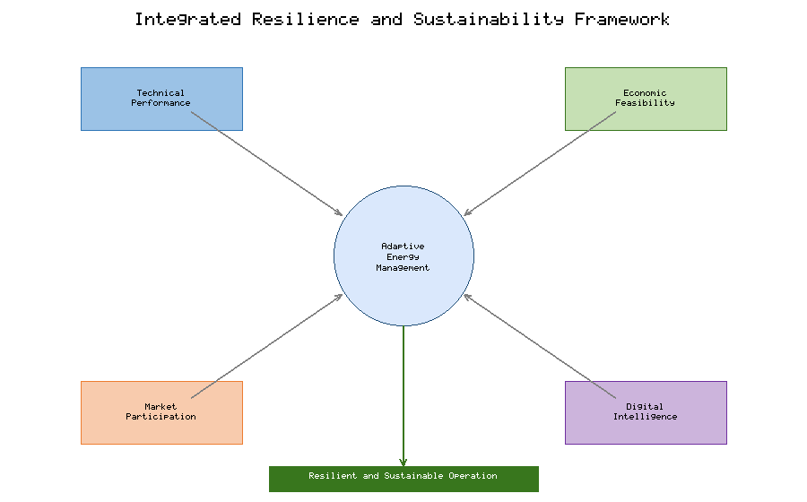
Figure 4. Integrated framework linking the four pillars of smart HRES — technical performance, economic feasibility, market participation, and digital intelligence — to the overarching goals of resilience and sustainability, with adaptive energy management as the coordinating core.

3.5.2 Grid Stability, Fault Tolerance, and Operation During Power Outages
As power-electronic interfaces displace synchronous machines, maintaining grid stability becomes more demanding because converter-dominated systems have little inherent inertia. Grid-forming converters, which actively establish voltage and frequency rather than following an external reference, allow HRES to support stability and to seed black-start and islanded operation. During grid outages, a well-designed HRES can transition seamlessly to islanded mode, using storage and grid-forming control to sustain critical loads until the main grid recovers.
Fault tolerance is achieved through redundancy, fast protection, and the ability to reconfigure topology in response to faults. Microgrid architectures that can intentionally island and later resynchronize are central to this capability, providing a natural boundary within which resilient control can act. The combination of grid-forming power electronics, local storage, and intelligent protection thus enables HRES not merely to survive disturbances but to serve as resources that enhance the resilience of the wider grid.
Protection of converter-dominated microgrids is itself non-trivial, because inverter-based sources contribute far smaller and more tightly controlled fault currents than synchronous machines, undermining the overcurrent-based schemes inherited from conventional networks. Adaptive protection that adjusts settings according to the real-time topology, together with careful management of the transition between grid-connected and islanded modes — fast detection of grid loss, smooth handover to grid-forming units, and phase-matched resynchronization — is what allows a hybrid system to ride through disturbances and anchor restoration of the surrounding network after major outages.

3.5.3 Environmental Impact, Carbon Reduction, and Lifecycle Sustainability
The headline environmental benefit of HRES is the displacement of fossil generation and the associated reduction in carbon emissions, but a credible sustainability assessment must adopt a lifecycle perspective. Life-cycle assessment accounts for emissions and resource use embodied in manufacturing, transport, installation, and end-of-life treatment, ensuring that operational gains are not offset by upstream burdens. For storage-heavy configurations, battery manufacturing and replacement dominate embodied impacts, making cell longevity and recycling central to overall sustainability.
Circular-economy strategies — second-life use of electric-vehicle batteries, recovery of critical materials, and design for disassembly — materially improve the lifecycle profile of HRES and reduce dependence on primary extraction. Integrating these considerations into the techno-economic framework of Section 3.2, for example through carbon pricing and total-cost-of-ownership metrics, aligns private investment decisions with societal environmental goals and guards against solutions that are economically attractive but environmentally shortsighted.
Beyond carbon, a complete sustainability assessment weighs water use, land occupation, and the demand for critical minerals such as lithium, cobalt, and rare-earth elements, whose extraction carries environmental and geopolitical burdens. These considerations elevate material efficiency, chemistry diversification, and recycling from peripheral concerns to central design objectives, since a storage-heavy decarbonization pathway that merely substitutes one resource dependency for another is only partially sustainable. Social dimensions also matter: energy access, local employment, and the equitable distribution of costs and benefits increasingly feature in project evaluation, particularly for community-scale and off-grid HRES in developing regions. A genuinely sustainable hybrid system is therefore one optimized not for operational emissions alone but across the full environmental, economic, and social ledger — a holistic view that the integrating framework of this chapter is intended to support.

3.5.4 Emerging Trends: Autonomous Microgrids and Next-Generation Energy Markets
The trajectory of smart HRES points toward increasing autonomy and decentralization. Autonomous microgrids, coordinated by AI-based controllers and digital twins, will self-optimize, self-heal, and negotiate with neighbouring systems with minimal human intervention, aggregating into virtual power plants that present dispatchable, grid-friendly behaviour to markets and operators. In parallel, next-generation energy markets are evolving toward local, transactive structures in which price signals coordinate distributed resources in near real time, and in which flexibility is traded as explicitly as energy.
Table 4 gathers the enabling digital technologies that underpin these trends, from IoT and AI forecasting to digital twins and blockchain-based trading, clarifying how each contributes to autonomy, efficiency, and resilience. Taken together, these developments suggest a future grid composed of interoperable, intelligent, and largely self-governing hybrid systems — a vision whose realization depends on continued progress in standardization, cybersecurity, market design, and the AI-driven control methods that are the subject of ongoing research.
Several converging developments will shape the next decade. Sector coupling — the integration of electricity with heating, cooling, hydrogen, and transport — expands the flexibility available to hybrid systems and blurs the boundary between the power sector and the wider energy economy. Electric vehicles, through vehicle-to-grid interaction, promise vast distributed storage capacity that transactive markets could mobilize, provided the control and settlement infrastructure matures [29]. At the same time, the growing reliance on AI-based control sharpens the need for explainability, formal verification, and cyber-physical security, so that increasingly autonomous systems remain trustworthy and auditable [33][34]. The trajectory is clear even if the pace is uncertain: hybrid renewable systems are evolving from passive, centrally dispatched assets into intelligent, interoperable agents that negotiate, self-heal, and optimize continuously within a decentralized and digitally mediated energy ecosystem.
Table 4. Digital and AI technologies enabling intelligent, resilient, and autonomous smart HRES.
Technology | Function | HRES application | Key benefit
IoT & smart metering | Sensing and data acquisition | Real-time monitoring, metering | Situational awareness
AI/ML forecasting | Predict generation, demand, price | Dispatch and bidding optimization | Lower reserves, higher revenue
Digital twin | Virtual real-time replica | Simulation, control validation | Safe optimization and testing
Cloud–edge computing | Scalable compute and low-latency control | Fleet coordination, protection | Global optimization, local reliability
Reinforcement learning | Adaptive policy learning | Autonomous energy management | Self-optimizing operation
Blockchain | Decentralized trusted ledger | P2P trading, settlement | Transparent decentralized markets

Conclusion
Smart Hybrid Renewable Energy Systems occupy the intersection of four tightly coupled domains, and this chapter has argued that their reliability and sustainability emerge only from the joint optimization of all four. Technical performance — expressed through reliability, efficiency, and renewable fraction — defines what a system can deliver; economic feasibility, captured by net present cost, levelized cost of energy, and payback period, determines whether it will be built; market participation, through wholesale sales, demand response, and peer-to-peer trading, establishes how its value is realized; and digital intelligence, embodied in IoT, artificial intelligence, digital twins, and cyber-secure control, is the connective tissue that allows the other three to be exercised in real time. Figures 1–4 and Tables 1–4 together trace this logic from architecture and component characteristics, through cost comparison and market mechanisms, to an integrated resilience-and-sustainability framework and the digital technologies that will carry the field forward.
Several research gaps remain decisive for progress. AI-driven optimization must advance from accurate forecasting toward trustworthy, uncertainty-aware control policies that are verifiable and robust under distribution shift. Resilient control needs standardized metrics and grid-forming architectures proven at scale under rare, high-impact events. Decentralized energy trading requires scalable, energy-efficient blockchain designs and regulatory frameworks that recognize flexibility on equal terms with energy. Finally, digitally integrated smart grids demand interoperable standards and cyber-physical security commensurate with their expanded attack surface. Addressing these gaps in an integrated rather than siloed manner is the surest path toward hybrid renewable energy systems that are simultaneously affordable, reliable, resilient, and sustainable.

References
[1] Olatomiwa L, Mekhilef S, Ismail MS, Moghavvemi M. Energy management strategies in hybrid renewable energy systems: A review. Renewable and Sustainable Energy Reviews. 2016;62:821–835.
[2] Lund H, Østergaard PA, Connolly D, Mathiesen BV. Smart energy and smart energy systems. Energy. 2017;137:556–565.
[3] Khare V, Nema S, Baredar P. Solar–wind hybrid renewable energy system: A review. Renewable and Sustainable Energy Reviews. 2016;58:23–33.
[4] Dragičević T, Lu X, Vasquez JC, Guerrero JM. DC microgrids—Part I: A review of control strategies and stabilization techniques. IEEE Transactions on Power Electronics. 2016;31(7):4876–4891.
[5] Hirsch A, Parag Y, Guerrero J. Microgrids: A review of technologies, key drivers, and outstanding issues. Renewable and Sustainable Energy Reviews. 2018;90:402–411.
[6] Weitemeyer S, Kleinhans D, Vogt T, Agert C. Integration of renewable energy sources in future power systems: The role of storage. Renewable Energy. 2015;75:14–20.
[7] Rehman S, Al-Hadhrami LM, Alam MM. Pumped hydro energy storage system: A technological review. Renewable and Sustainable Energy Reviews. 2015;44:586–598.
[8] Luo X, Wang J, Dooner M, Clarke J. Overview of current development in electrical energy storage technologies and the application potential in power system operation. Applied Energy. 2015;137:511–536.
[9] Fang X, Misra S, Xue G, Yang D. Smart grid — The new and improved power grid: A survey. IEEE Communications Surveys & Tutorials. 2012;14(4):944–980.
[10] Zia MF, Elbouchikhi E, Benbouzid M. Microgrids energy management systems: A critical review on methods, solutions, and prospects. Applied Energy. 2018;222:1033–1055.
[11] Olivares DE, Mehrizi-Sani A, Etemadi AH, Cañizares CA, Iravani R, et al. Trends in microgrid control. IEEE Transactions on Smart Grid. 2014;5(4):1905–1919.
[12] Mandelli S, Brivio C, Colombo E, Merlo M. Effect of load profile uncertainty on the optimum sizing of off-grid PV systems for rural electrification. Sustainable Energy Technologies and Assessments. 2016;18:34–47.
[13] Milano F, Dörfler F, Hug G, Hill DJ, Verbič G. Foundations and challenges of low-inertia systems. IEEE Transactions on Power Systems. 2018;33(6):4731–4742.
[14] Hiremath M, Derendorf K, Vogt T. Comparative life cycle assessment of battery storage systems for stationary applications. Environmental Science & Technology. 2015;49(8):4825–4833.
[15] Siddaiah R, Saini RP. A review on planning, configurations, modeling and optimization techniques of hybrid renewable energy systems for off-grid applications. Renewable and Sustainable Energy Reviews. 2016;58:376–396.
[16] Al-falahi MDA, Jayasinghe SDG, Enshaei H. A review on recent size optimization methodologies for standalone solar and wind hybrid renewable energy system. Energy Conversion and Management. 2017;143:252–274.
[17] Maheri A. Multi-objective design optimisation of standalone hybrid wind-PV-diesel systems under uncertainties. Renewable Energy. 2014;66:650–661.
[18] Lambert T, Gilman P, Lilienthal P. Micropower system modeling with HOMER. In: Integration of Alternative Sources of Energy. Energy. 2006;379–418.
[19] Bortolini M, Gamberi M, Graziani A. Technical and economic design of photovoltaic and battery energy storage system. Energy Conversion and Management. 2014;86:81–92.
[20] Elkadeem MR, Wang S, Sharshir SW, Atia EG. Feasibility analysis and techno-economic design of grid-isolated hybrid renewable energy system for electrification of agriculture and irrigation area. Energy Conversion and Management. 2019;196:1453–1478.
[21] Bhuiyan FA, Yazdani A. Energy storage technologies for grid-connected and off-grid power system applications. Journal of Energy Storage. 2018;18:1–14.
[22] Arabali A, Ghofrani M, Etezadi-Amoli M, Fadali MS. Stochastic performance assessment and sizing for a hybrid power system of solar/wind/energy storage. IEEE Transactions on Sustainable Energy. 2014;5(2):363–371.
[23] Hu J, Harmsen R, Crijns-Graus W, Worrell E, van den Broek M. Identifying barriers to large-scale integration of variable renewable electricity into the electricity market: A literature review of market design. Renewable and Sustainable Energy Reviews. 2018;81:2181–2195.
[24] Siano P. Demand response and smart grids—A survey. Renewable and Sustainable Energy Reviews. 2014;30:461–478.
[25] Sousa T, Soares T, Pinson P, Moret F, Baroche T, Sorin E. Peer-to-peer and community-based markets: A comprehensive review. Renewable and Sustainable Energy Reviews. 2019;104:367–378.
[26] Andoni M, Robu V, Flynn D, Abram S, Geach D, et al. Blockchain technology in the energy sector: A systematic review of challenges and opportunities. Renewable and Sustainable Energy Reviews. 2019;100:143–174.
[27] Zhang S, Andrews-Speed P, Zhao X, He Y. Interactions between renewable energy policy and renewable energy industrial policy: A critical analysis of China's policy approach. Energy Policy. 2013;62:342–353.
[28] Al-Ali AR, Zualkernan IA, Rashid M, Gupta R, Alikarar M. A smart home energy management system using IoT and big data analytics approach. IEEE Transactions on Consumer Electronics. 2017;63(4):426–434.
[29] Ahmad T, Zhang D, Huang C, Zhang H, Dai N, et al. Artificial intelligence in sustainable energy industry: Status quo, challenges and opportunities. Journal of Cleaner Production. 2021;289:125834.
[30] Tao F, Zhang H, Liu A, Nee AYC. Digital twin in industry: State-of-the-art. IEEE Transactions on Industrial Informatics. 2019;15(4):2405–2415.
[31] Shi W, Cao J, Zhang Q, Li Y, Xu L. Edge computing: Vision and challenges. IEEE Internet of Things Journal. 2016;3(5):637–646.
[32] Zhao Y, Li D, Yin L, Yu S, Zhu J. Predictive maintenance for photovoltaic systems: A data-driven approach. Applied Energy. 2019;238:1527–1540.
[33] Mohammadi F. Emerging challenges in smart grid cybersecurity enhancement: A review. Energies. 2021;14(5):1380.
[34] Hossain E, Roy S, Mohammad N, Nawar N, Dipta DR. Metrics and enhancement strategies for grid resilience and reliability during natural disasters. Applied Energy. 2021;290:116709.

