AI-Driven Research Support, Research Data Management, and Research Workflows

Abstract
Artificial intelligence (AI) is rapidly reshaping how academic research is conceived, conducted, managed, and communicated. Within the emerging paradigm of Education 5.0—characterized by human-centered, technology-augmented, and value-driven scholarship—AI is no longer a peripheral tool but an integral collaborator across the entire research lifecycle. This chapter examines the foundations, applications, and implications of AI-driven research support, with particular attention to research data management and increasingly automated research workflows. It begins by situating AI within modern academic research, tracing the evolution of intelligent research environments and mapping AI applications across disciplines and research stages. It then explores AI-assisted literature discovery, research planning, and the essential dynamics of researcher–AI collaboration under meaningful human oversight. The chapter subsequently addresses AI-enabled research data management, covering data collection and curation, quality assurance and anomaly detection, intelligent storage and retrieval aligned with FAIR principles, and the governance, security, and privacy imperatives that responsible data stewardship demands. Turning to scholarly productivity, it analyzes AI's role in analysis and interpretation, academic writing, workflow automation, and the safeguarding of reproducibility and research integrity. Finally, it considers the future of scholarly communication, responsible and ethical AI use, the competencies that researchers must develop, and a vision for autonomous, agentic, and sustainable research ecosystems. Throughout, the chapter argues that the value of AI in research is realized not through unchecked automation but through thoughtful integration that amplifies human judgment, protects integrity, and advances the collaborative, intelligent, and equitable knowledge systems envisioned by Education 5.0. The discussion is supported by illustrative figures and comparative tables that synthesize current practice and emerging directions, offering researchers, educators, and institutional leaders a structured framework for adopting AI responsibly and effectively in academic scholarship.
Keywords: artificial intelligence, research data management, research workflows, scholarly communication, reproducibility, Education 5.0, responsible AI, human–AI collaboration.

Section 1: Foundations of AI-Driven Research Support

1.1 Role of AI in Modern Academic Research
The contemporary research enterprise is characterized by an unprecedented expansion in the volume, velocity, and variety of scholarly information. Millions of peer-reviewed articles are published annually, datasets are growing in dimensionality and scale, and interdisciplinary questions increasingly demand the synthesis of knowledge across traditionally siloed fields [1]. In this context, artificial intelligence has become a defining force, offering computational capabilities that extend human cognition rather than merely accelerating existing tasks. AI systems now assist researchers in reading and organizing literature, formulating hypotheses, managing data, running analyses, and communicating findings, transforming research from a predominantly manual craft into a technology-augmented practice [2].

Evolution of AI-enabled research environments
The trajectory of AI in research has evolved through several distinct phases. Early expert systems and rule-based tools of the late twentieth century offered narrow, domain-specific automation, useful but brittle and difficult to generalize [3]. The subsequent rise of statistical machine learning enabled data-driven pattern recognition, allowing systems to learn from examples rather than relying solely on hand-coded rules. The most recent phase, driven by deep learning and large language models (LLMs), has produced general-purpose systems capable of understanding and generating natural language, reasoning across domains, and interacting with researchers in flexible, conversational ways [4]. This evolution has given rise to integrated research environments in which intelligent assistants are embedded directly into reference managers, data analysis platforms, laboratory information systems, and authoring tools, creating a continuous fabric of computational support that spans the research lifecycle [5].
Figure 1 illustrates how AI capabilities now permeate every stage of the research process, from problem formulation to dissemination, supported by a cross-cutting layer of enabling technologies.
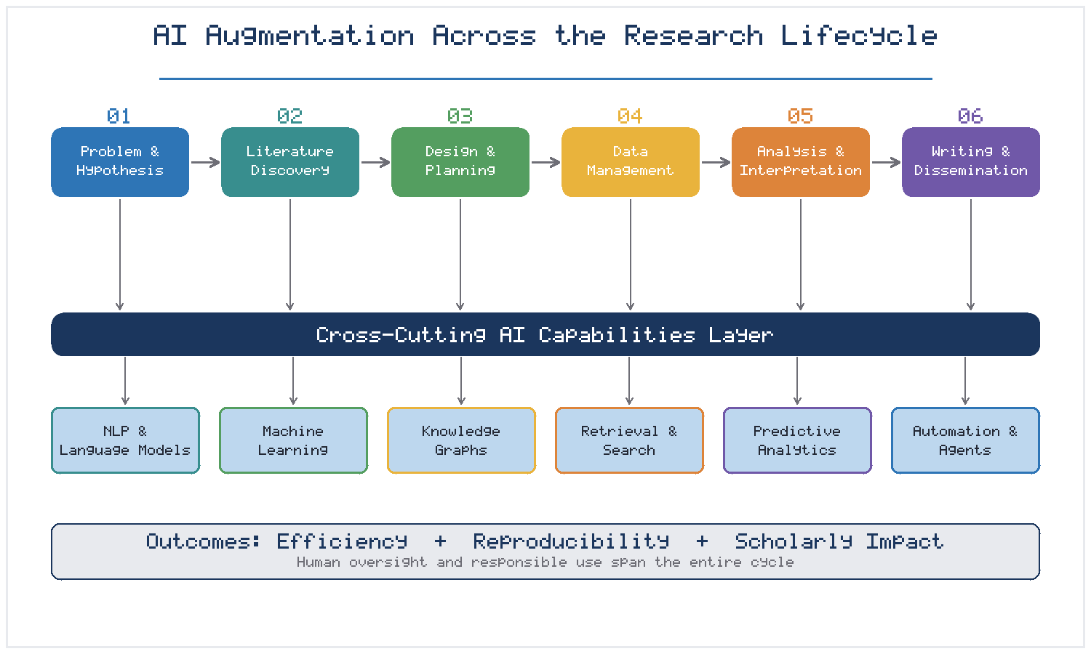
Figure 1. AI augmentation across the research lifecycle, showing stage-specific support underpinned by a cross-cutting layer of enabling AI capabilities.

Applications of AI across disciplines and research stages
The reach of AI extends across virtually all scholarly domains, though its manifestations differ by discipline. In the life sciences, AI accelerates genomic analysis, protein structure prediction, and drug discovery. In the physical sciences, it supports simulation, materials design, and the analysis of vast experimental datasets from instruments such as telescopes and particle detectors [6]. In the social sciences and humanities, natural language processing enables the analysis of large textual corpora, sentiment and discourse analysis, and computational approaches to historically qualitative questions [7]. Across all disciplines, common research stages—literature review, study design, data collection, analysis, interpretation, and writing—are being reshaped by AI tools tailored to each phase, as summarized in Table 1.
The disciplinary diversity of these applications should not obscure a set of shared underlying capabilities. Whether a chemist is screening candidate molecules, a linguist is annotating a historical corpus, or an epidemiologist is modeling disease spread, the same families of techniques—representation learning, probabilistic inference, and large-scale pattern recognition—are being applied to domain-specific problems. This convergence has two important implications. First, methodological advances in one field increasingly transfer rapidly to others, accelerating the overall pace of AI-enabled research. Second, it creates a growing need for cross-disciplinary literacy, as researchers must understand not only their own subject matter but also the computational methods on which their conclusions increasingly depend [5]. The stages depicted in Table 1 should therefore be read not as isolated silos but as points along a continuous, technology-mediated pipeline in which the outputs of one phase become the inputs of the next, and in which weaknesses at any stage—poor data, flawed models, or careless interpretation—can propagate to undermine the whole.

Opportunities for improving research efficiency and productivity
The productivity gains associated with AI adoption are substantial and increasingly well documented. Automated literature screening can reduce the time required for systematic reviews from months to weeks, while intelligent data-cleaning tools can process datasets in hours that would otherwise require days of manual effort [8]. Beyond speed, AI expands the scope of feasible inquiry, allowing researchers to analyze datasets too large or complex for manual examination and to detect subtle patterns that might otherwise escape notice [9]. However, efficiency must be understood as more than acceleration; the deeper opportunity lies in freeing researchers from repetitive tasks so that their expertise can be directed toward creative, interpretive, and critical work that machines cannot perform [10]. Realizing this opportunity requires careful attention to how AI is integrated, ensuring that gains in speed do not come at the expense of rigor, transparency, or scholarly judgment.
It is also important to recognize that the productivity benefits of AI are unevenly distributed and contingent on context. Researchers with access to well-resourced computational infrastructure, licensed tools, and training can extract far greater value from AI than those without, raising concerns about a widening gap between well-funded and under-resourced institutions [10]. Moreover, the apparent efficiency of AI can be illusory if the time saved on one task is offset by the effort required to verify machine outputs, correct errors, or troubleshoot opaque systems. Genuine productivity gains therefore depend not only on the raw capabilities of AI tools but also on the surrounding ecosystem of skills, support, and quality assurance that determines whether those capabilities translate into better research. This systemic view, emphasized throughout this chapter, reframes AI adoption as an organizational and cultural undertaking rather than a purely technical one, and it foreshadows the discussion of researcher competencies and institutional support in Section 4.3.
Table 1. Illustrative AI applications mapped to research stages and representative disciplines.
Research Stage | Representative AI Capability | Example Application | Primary Benefit
Problem formulation | Knowledge graphs; LLM reasoning | Gap identification, hypothesis suggestion | Broader ideation
Literature review | NLP; semantic search | Automated screening and synthesis | Reduced review time
Study design | Recommender systems | Methodology and sample-size guidance | Improved rigor
Data collection | Computer vision; sensor analytics | Automated annotation and capture | Higher throughput
Data management | ML classification | Metadata generation, cleaning | Better quality
Analysis | Statistical ML; deep learning | Pattern recognition, modeling | Deeper insight
Writing | Generative language models | Drafting and editing support | Faster communication
Dissemination | Summarization; personalization | Abstracts and tailored outputs | Wider reach

1.2 AI-Assisted Literature Discovery and Review
The scholarly literature is both the foundation and the bottleneck of research. As publication rates continue to rise, the traditional model of manual literature review—reading, appraising, and synthesizing sources by hand—has become increasingly untenable, particularly for interdisciplinary and rapidly evolving fields [11]. AI-assisted literature discovery addresses this challenge by transforming how researchers find, evaluate, and integrate prior work.

Intelligent search and retrieval of scholarly literature
Conventional keyword search relies on exact lexical matches and often fails to surface conceptually relevant work expressed in different terminology. Modern AI-driven discovery tools instead employ semantic search, representing documents and queries as high-dimensional vectors so that retrieval reflects meaning rather than surface wording [12]. These systems can identify papers that are thematically related even when they share no common keywords, and they can rank results by relevance, novelty, or influence. Citation-graph analysis further enriches discovery by mapping the intellectual lineage of ideas, revealing seminal works, bridging papers, and emerging clusters of activity that a linear search would miss [13]. When combined with LLMs, these tools can respond to natural-language research questions with curated, contextualized reading lists, dramatically lowering the barrier to entering an unfamiliar field.

Automated classification, summarization, and synthesis of research articles
Once relevant literature is identified, AI systems assist in processing it at scale. Automated classification assigns articles to topics, methodologies, or evidence levels, enabling researchers to organize large corpora systematically [14]. Extractive and abstractive summarization condense individual papers into digestible overviews, while multi-document synthesis attempts to integrate findings across many sources into coherent narratives that highlight consensus, contradiction, and open questions [15]. These capabilities are especially valuable in systematic reviews and meta-analyses, where AI can screen thousands of abstracts against inclusion criteria, extract structured data from selected studies, and flag potential inconsistencies for human verification. Importantly, such synthesis remains an assistive rather than autonomous process: the researcher must critically evaluate machine-generated summaries, which may omit nuance or misrepresent complex arguments [16].

Identification of research gaps, trends, and emerging themes
Beyond processing existing knowledge, AI can help researchers see the shape of a field over time. By analyzing large bodies of literature, machine-learning models detect trends in topic prevalence, identify emerging themes before they become mainstream, and reveal underexplored intersections between subfields [17]. Temporal analysis of publication and citation patterns can highlight areas of accelerating interest or stagnation, informing strategic decisions about where to direct research effort. Such gap-identification tools do not replace scholarly intuition but augment it, offering an empirical basis for the judgment that a particular question is timely, tractable, and underserved [18]. The combination of retrieval, synthesis, and trend analysis positions AI as a powerful ally in the earliest and most exploratory phases of inquiry.
At the same time, AI-assisted literature work introduces subtle risks that researchers must actively manage. Retrieval systems can encode popularity biases that privilege highly cited or recent work while overlooking foundational or non-English-language scholarship, potentially narrowing rather than broadening a researcher's view of a field [16]. Automated summaries may reflect the priorities embedded in their training data, and multi-document synthesis can smooth over genuine disagreements in ways that misrepresent the state of knowledge. For these reasons, AI-assisted review is best treated as a means of accelerating discovery and surfacing candidates for closer reading, not as a substitute for the careful, critical engagement with primary sources that scholarship demands. The most effective practice combines the breadth and speed of machine-assisted search with the depth and discernment of human reading, using each to compensate for the weaknesses of the other.

1.3 AI for Research Planning and Problem Formulation
If literature discovery helps researchers understand what is known, research planning helps them decide what to pursue and how. AI is increasingly capable of supporting these upstream, conceptual activities that have traditionally been considered the exclusive province of human expertise.

Supporting research questions and hypothesis development
Large language models and knowledge-graph systems can assist researchers in refining vague interests into precise, answerable questions. By surfacing related concepts, prior findings, and unexplored connections, these tools can prompt novel hypotheses and help articulate the theoretical rationale behind them [19]. In data-rich domains, hypothesis-generation systems analyze existing datasets to propose candidate relationships worth testing, effectively suggesting directions that emerge from patterns in the evidence itself [20]. Such support is generative and exploratory rather than definitive; the researcher retains responsibility for judging which questions are scientifically meaningful, ethically appropriate, and aligned with the broader goals of the field.

Identification of appropriate methodologies and analytical approaches
Choosing the right methodology is a consequential decision that shapes the validity of a study's conclusions. AI-based recommender systems can suggest suitable research designs, sampling strategies, and analytical techniques based on the nature of the research question, the type of data available, and precedents in comparable studies [21]. These systems can also alert researchers to common methodological pitfalls, such as inadequate statistical power, inappropriate model assumptions, or confounding variables that require control [22]. By encoding methodological best practices, AI tools can help less experienced researchers avoid errors and help all researchers consider a wider range of options than they might otherwise recall.

AI-assisted research design and project planning
At the project level, AI supports the translation of research questions into executable plans. Intelligent planning tools can help decompose complex projects into tasks, estimate timelines, allocate resources, and identify dependencies and risks [23]. When integrated with institutional systems, they can assist with grant-proposal preparation, budget planning, and compliance checks, streamlining the administrative dimensions of research. These capabilities are particularly valuable for large, collaborative, and multi-site projects where coordination complexity is high. Nonetheless, effective research design depends on contextual knowledge, disciplinary norms, and ethical considerations that AI cannot fully grasp, underscoring the continuing centrality of the researcher as the decision-maker who interprets and adapts machine suggestions [24].

1.4 Researcher–AI Collaboration and Human Oversight
The transformative potential of AI in research is inseparable from questions about the appropriate division of labor between humans and machines. Rather than framing AI as a replacement for researchers, the most productive perspective treats it as a collaborator whose strengths complement human capabilities.

Human–AI collaboration in academic research
Effective human–AI collaboration recognizes that machines excel at scale, speed, consistency, and pattern detection, while humans excel at contextual understanding, creativity, ethical reasoning, and critical judgment [25]. In practice, this complementarity plays out as an iterative dialogue: the researcher poses questions or defines tasks, the AI generates candidate outputs, and the researcher evaluates, refines, and redirects. This interactive loop, rather than one-shot automation, characterizes the most effective uses of AI in scholarship [26]. Designing research workflows that support such collaboration—through interpretable outputs, easy correction mechanisms, and transparent provenance—is essential to realizing AI's benefits while preserving human agency.

Balancing automation with researcher expertise and judgment
A central tension in AI-augmented research is calibrating how much to automate. Over-reliance on automated outputs risks propagating errors, entrenching biases, and eroding the deep engagement with material that produces genuine understanding [27]. Conversely, underuse forfeits legitimate efficiency gains. The appropriate balance depends on the stakes and reversibility of the task: routine, low-risk activities such as formatting references or screening obvious duplicates can be safely automated, whereas interpretive and consequential judgments demand active human involvement [28]. Researchers must cultivate the discernment to know when to trust, verify, or override machine suggestions—a competency that becomes as important as domain expertise itself.

Responsible use of AI throughout the research lifecycle
Responsible use requires that human oversight be maintained across every stage of the research process, not merely at its conclusion. This entails documenting how AI tools were used, verifying their outputs against domain knowledge and independent evidence, and remaining alert to the limitations and failure modes of the systems employed [29]. It also requires transparency with collaborators, reviewers, and readers about the role AI played in producing a piece of research. As subsequent sections detail, these principles of oversight and accountability recur throughout data management, analysis, writing, and dissemination, forming a connective thread that binds the responsible practice of AI-driven research together.
A useful way to conceptualize meaningful human oversight is to distinguish between humans being "in the loop," "on the loop," and "out of the loop." In the first mode, a person actively reviews and approves each AI action before it takes effect; in the second, the person monitors an otherwise autonomous process and intervenes only when necessary; in the third, the system operates without human involvement. For research, where the stakes for accuracy and integrity are high, the first two modes are almost always appropriate, and the design of AI-augmented workflows should make intervention easy, timely, and informed [26]. This requires that AI systems expose not only their outputs but also their confidence, their reasoning where possible, and the provenance of the evidence on which they rely. When these conditions are met, human oversight becomes not a bureaucratic checkpoint but a genuine safeguard that allows researchers to harness automation while retaining ultimate responsibility for the scholarship produced in their names.

Section 2: AI-Enabled Research Data Management

2.1 Data Collection, Curation, and Organization
Research data management (RDM) has emerged as a critical competency in modern scholarship, driven by the growing scale of data, funder mandates for data sharing, and the recognition that well-managed data is a foundation for reproducible and cumulative science [30]. AI is increasingly woven into every phase of the data lifecycle, beginning with collection, curation, and organization.

AI-assisted acquisition and classification of research data
AI supports data acquisition through automated capture and annotation across many modalities. Computer-vision systems label images and video, speech-recognition tools transcribe interviews and recordings, and sensor-analytics pipelines filter and structure streams of instrument data in real time [31]. Once acquired, machine-learning classifiers organize heterogeneous data into meaningful categories, tagging records by type, source, quality, or subject matter. This automated classification is particularly valuable when data volumes exceed what researchers can feasibly sort by hand, as is increasingly the case in fields ranging from ecology to social media research [32]. The result is a more systematic and consistent organization of data assets from the moment of collection.

Automated metadata generation and data cleaning
Metadata—the descriptive information that makes data discoverable, interpretable, and reusable—is essential but historically neglected because generating it manually is tedious. AI addresses this through automated metadata extraction, inferring descriptive fields from data content and context and proposing standardized annotations that align with community schemas [33]. In parallel, AI-assisted data cleaning detects and corrects errors, standardizes formats, resolves duplicates, and reconciles inconsistent representations of the same entities. These tools learn patterns of typical and atypical values, flagging anomalies for review while automating routine corrections [34]. Together, automated metadata generation and cleaning substantially reduce the effort required to prepare data for analysis and sharing.

Structuring heterogeneous and multidisciplinary datasets
Contemporary research frequently integrates data from disparate sources and disciplines, each with its own formats, vocabularies, and conventions. Harmonizing such heterogeneous data is a significant challenge that AI helps to address through entity resolution, schema matching, and ontology-based integration [35]. By mapping diverse datasets to shared conceptual frameworks, AI enables researchers to combine information that would otherwise remain siloed, unlocking analyses that span multiple domains. Ontology-based integration is particularly powerful because it allows machines to reason about the meaning of data rather than merely its format, enabling, for example, the recognition that two datasets using different terms nonetheless refer to the same underlying concept [35]. The layered architecture through which raw data is progressively acquired, curated, validated, stored, and governed is depicted in Figure 3, which situates these activities within a FAIR-aligned data-management framework. Each layer in this architecture adds structure and assurance: raw sources are transformed into curated, documented, quality-checked, and governed assets, so that data becomes progressively more trustworthy and reusable as it moves through the pipeline. Critically, the effort invested in these early stages pays dividends throughout the research lifecycle, because analyses, reproducibility checks, and downstream sharing all depend on the quality and organization established during collection and curation.
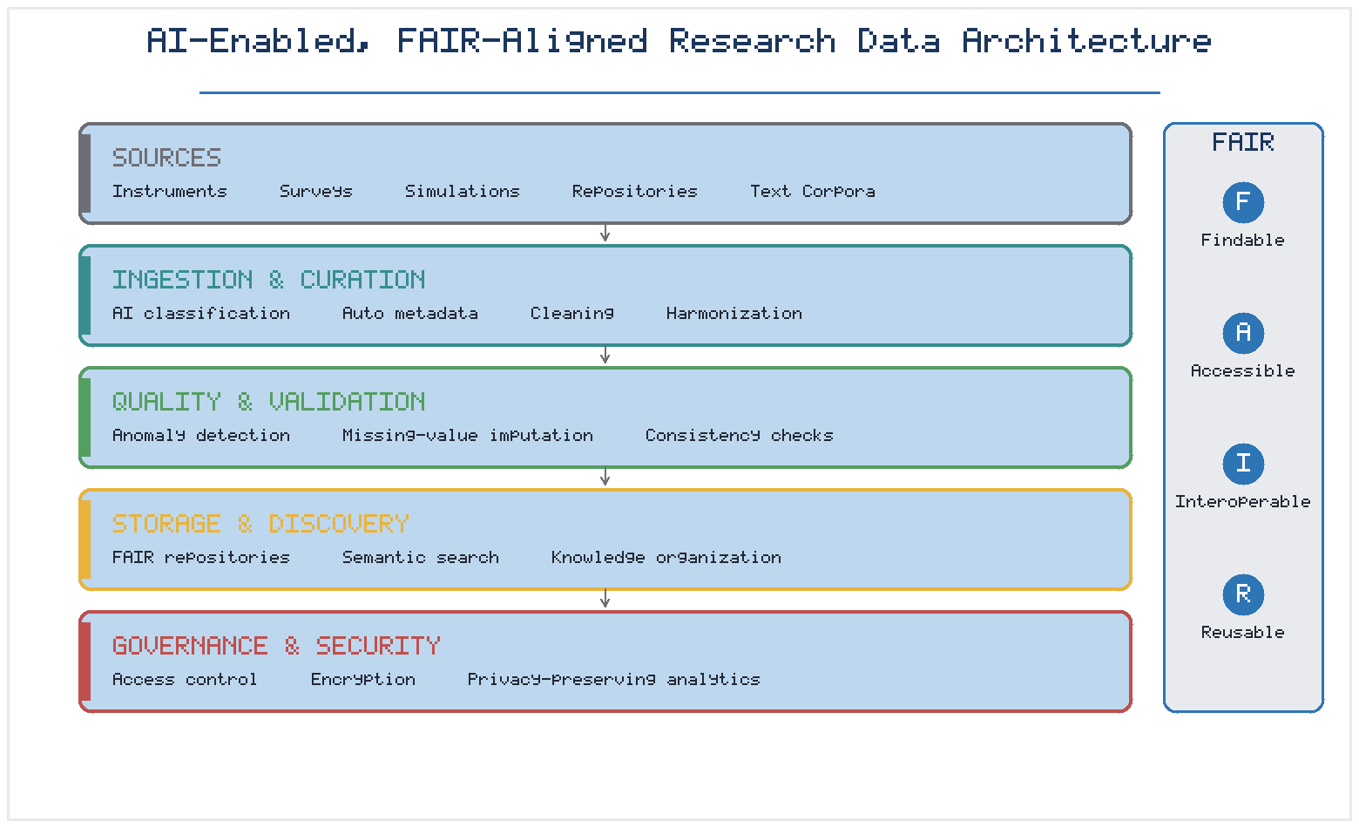
Figure 3. An AI-enabled, FAIR-aligned research data architecture, in which data is progressively acquired, curated, validated, stored, and governed.

2.2 Data Quality, Validation, and Anomaly Detection
The value of any analysis is fundamentally constrained by the quality of the underlying data. Poor-quality data—incomplete, inconsistent, or erroneous—can lead to invalid conclusions and undermine the reproducibility of research [36]. AI provides powerful tools for assuring and improving data quality throughout the research process.

Identification of missing, inconsistent, and erroneous data
Machine-learning methods excel at detecting the subtle irregularities that signal data-quality problems. Statistical and model-based techniques identify missing values, out-of-range entries, and internal inconsistencies, while more sophisticated approaches learn the expected structure of a dataset and flag records that deviate from it [37]. Such automated screening is far more scalable than manual inspection and can catch errors that human reviewers would overlook in large datasets. By surfacing quality issues early, these tools prevent flawed data from propagating through downstream analyses.

Machine-learning approaches to data validation
Beyond error detection, AI supports systematic data validation. Supervised models can learn to distinguish valid from invalid records based on labeled examples, while unsupervised anomaly-detection methods identify unusual patterns without predefined rules [38]. Techniques such as clustering, autoencoders, and isolation forests are increasingly applied to research data to detect outliers, duplicate submissions, and fabricated or manipulated values. These validation methods can be embedded into data pipelines so that quality checks occur automatically as data flows through the system, providing continuous assurance rather than one-time inspection [39].

Improving reliability and reproducibility of research datasets
The ultimate aim of quality assurance is to produce datasets that are reliable and reproducible—that is, datasets on which independent analyses yield consistent results and which other researchers can confidently reuse. AI contributes to this goal not only by improving data quality but also by documenting the validation processes applied, creating an auditable record of how data was checked and corrected [40]. When combined with version control and provenance tracking, these capabilities strengthen the evidentiary foundation of research and support the broader movement toward transparent, reproducible science, as discussed further in Section 3.4. It is worth emphasizing that automated validation is not infallible: models trained on historical data may inherit the very errors and biases they are meant to detect, and overly aggressive cleaning can inadvertently remove genuine but unusual observations that carry important scientific signal. Responsible use therefore requires that automated quality processes be transparent and reversible, preserving the original data alongside any corrections and documenting the rationale for each transformation. This auditability ensures that quality assurance enhances rather than obscures the trustworthiness of the resulting datasets, and it allows independent researchers to evaluate whether the cleaning and validation choices were appropriate for their own intended reuse.

2.3 Intelligent Data Storage, Retrieval, and Sharing
Well-collected and validated data must be stored, organized, and made accessible in ways that support both current analysis and future reuse. AI enhances each of these functions, transforming static data repositories into intelligent knowledge systems.

AI-supported research repositories and data discovery
Modern research repositories increasingly incorporate AI to improve data discovery. Rather than relying solely on manual browsing or exact-match search, intelligent repositories use semantic indexing and recommendation systems to help researchers find relevant datasets, including those they might not have known to look for [41]. Machine learning can suggest related datasets, identify potential collaborators working with similar data, and surface complementary resources across institutional and disciplinary boundaries. These capabilities amplify the value of shared data by making it genuinely findable and usable.

FAIR principles for research data management
The FAIR principles—that data should be Findable, Accessible, Interoperable, and Reusable—have become the guiding framework for responsible data management [42]. AI directly supports each principle: automated metadata and semantic indexing enhance findability; standardized access protocols and intelligent access management support accessibility; ontology mapping and format conversion promote interoperability; and rich provenance and documentation enable reusability. As shown in Figure 3, AI capabilities are layered throughout the data architecture precisely to operationalize these principles at scale, moving FAIR from an aspiration to an achievable standard [43].

Semantic search and intelligent knowledge organization
At the most sophisticated level, AI enables the organization of research data into structured knowledge rather than isolated files. Knowledge graphs represent entities and their relationships, allowing researchers to query data conceptually and to traverse connections across datasets [1]. Semantic search over such structures returns results based on meaning and context, supporting complex, exploratory queries that traditional databases cannot handle. This intelligent knowledge organization transforms data repositories from passive archives into active instruments of discovery, enabling researchers to ask richer questions and obtain more insightful answers.

2.4 Research Data Security, Privacy, and Governance
As AI expands the collection, integration, and sharing of research data, it simultaneously heightens the importance of security, privacy, and governance. Managing sensitive data responsibly is both an ethical obligation and, increasingly, a legal requirement.

Protection of sensitive and confidential research data
Much research data is sensitive, including personal health information, identifiable survey responses, and proprietary or classified material. AI both introduces risks—by enabling re-identification and inference attacks—and offers protections, through automated detection of sensitive content and intelligent classification of data by risk level [2]. Systems can automatically flag records containing personally identifiable information, recommend appropriate handling procedures, and monitor for potential breaches, helping institutions protect confidential data at scale.

Access control, encryption, and privacy-preserving analytics
Effective data protection combines robust access controls with advanced cryptographic and analytical techniques. Beyond conventional encryption and role-based access, privacy-preserving methods allow analysis without exposing raw data: differential privacy adds calibrated noise to protect individuals, federated learning trains models across distributed datasets without centralizing them, and secure multiparty computation enables joint analysis without revealing inputs [3]. These techniques allow researchers to extract insights from sensitive data while honoring privacy commitments, expanding the range of ethically permissible research.

Ethical, legal, and institutional requirements for AI-enabled data management
AI-enabled data management operates within a web of ethical principles, legal regulations, and institutional policies. Data-protection regulations impose obligations regarding consent, purpose limitation, and individual rights, while research-ethics frameworks require responsible stewardship of participant data [4]. Institutions must establish clear governance structures that define responsibilities, approval processes, and accountability for AI-enabled data practices. Table 2 summarizes key dimensions of research data governance and the corresponding AI-enabled safeguards, illustrating how technical measures and policy requirements together constitute a comprehensive approach to responsible data management [5].
Table 2. Dimensions of research data governance and corresponding AI-enabled safeguards.
Governance Dimension | Key Requirement | AI-Enabled Safeguard | Illustrative Risk Addressed
Confidentiality | Protect sensitive data | Automated sensitive-content detection | Unauthorized disclosure
Access management | Limit access to authorized users | Adaptive, role-based access control | Insider misuse
Privacy | Protect individual identities | Differential privacy; federated learning | Re-identification
Integrity | Prevent tampering | Anomaly detection; provenance tracking | Data manipulation
Compliance | Meet legal obligations | Automated policy and consent checks | Regulatory violation
Accountability | Assign responsibility | Audit trails and logging | Untraceable actions

Section 3: AI-Driven Research Workflows and Scholarly Productivity

3.1 AI for Research Analysis and Interpretation
Analysis lies at the heart of research, and it is here that AI's computational strengths are most directly applied. From automating routine statistical procedures to uncovering patterns invisible to conventional methods, AI is expanding both the efficiency and the depth of research analysis.

Automated statistical and computational analysis
AI-powered analytical tools can automate substantial portions of the statistical workflow, from exploratory data analysis to model fitting and diagnostic checking. Automated machine-learning platforms select appropriate algorithms, tune parameters, and evaluate performance with minimal manual intervention, making sophisticated modeling accessible to researchers without extensive computational training [6]. These tools accelerate analysis and promote consistency, though they also demand caution: automation can obscure the assumptions and choices underlying an analysis, and researchers must retain sufficient understanding to interpret and defend their results [7].

Pattern recognition and predictive modeling
One of AI's most valuable contributions is its capacity to recognize complex patterns in high-dimensional data. Deep-learning models detect structures in images, signals, text, and multivariate datasets that would elude human analysts or conventional statistics [8]. Predictive models forecast outcomes, classify observations, and estimate relationships, supporting both descriptive understanding and prospective application. In fields from climate science to biomedicine, such pattern recognition has enabled discoveries that were previously infeasible. Yet predictive power must be paired with interpretability and validation to ensure that models capture genuine relationships rather than spurious correlations [9].

Visualization and interpretation of complex research findings
Making sense of analytical results requires effective visualization and interpretation, domains in which AI increasingly assists. Intelligent visualization tools recommend appropriate chart types, automatically highlight salient features, and generate interactive representations that help researchers explore their findings [10]. Interpretability techniques, such as feature-importance analysis and explanation methods for complex models, help researchers understand why a model produced a particular result. These capabilities support the crucial translation of raw analytical output into meaningful scientific insight, though the ultimate act of interpretation—situating findings within theory and prior knowledge—remains a human responsibility [11].
A persistent challenge in AI-driven analysis is the tension between predictive accuracy and interpretability. The most powerful models are often the least transparent, functioning as "black boxes" whose internal logic is difficult to inspect. In research, where the goal is frequently to understand rather than merely to predict, this opacity can be a serious limitation. Explainable-AI methods attempt to bridge this gap by identifying which inputs most influenced a prediction or by approximating complex models with simpler, interpretable surrogates [9]. However, explanations are themselves approximations that can mislead if taken uncritically. Researchers must therefore treat model outputs as hypotheses to be corroborated through complementary evidence, replication, and theoretical reasoning rather than as conclusions in their own right. This disciplined skepticism distinguishes rigorous AI-augmented analysis from a naive reliance on algorithmic authority, and it is essential to preserving the epistemic standards on which credible research depends.

3.2 AI-Assisted Academic Writing and Documentation
Communicating research through writing is a demanding and time-consuming aspect of scholarship. AI writing tools have advanced rapidly, offering assistance that ranges from mechanical correction to substantive drafting support, while raising important questions about originality and accountability.

Support for drafting, editing, and language enhancement
Large language models can assist researchers at every stage of writing, from generating initial drafts and restructuring arguments to polishing grammar, style, and clarity [12]. Such tools are particularly beneficial for researchers writing in a non-native language, helping to level the linguistic playing field in international scholarship. They can also summarize complex material, suggest alternative phrasings, and adapt tone for different audiences. Used well, these tools reduce the friction of writing and allow researchers to focus on the substance of their arguments; used uncritically, they risk introducing errors, blandness, or inaccuracies that require vigilant review [13].

Automated citation and reference organization
Managing citations and references is a notoriously error-prone task that AI can substantially streamline. Intelligent reference managers automatically extract bibliographic metadata, format citations according to any required style, detect missing or malformed references, and even suggest relevant sources to cite based on the content of a manuscript [14]. These tools reduce clerical burden and improve the accuracy and completeness of scholarly attribution. As with all AI assistance, however, researchers remain responsible for verifying that citations are accurate, appropriate, and faithful to the cited work.

Maintaining academic originality, attribution, and researcher accountability
The use of generative AI in writing raises fundamental questions about originality and authorship. Text produced by language models may inadvertently reproduce existing material, blur the line between the researcher's own ideas and machine-generated content, and complicate the attribution of intellectual contributions [15]. Maintaining academic integrity therefore requires that researchers treat AI output as a draft to be critically revised and owned rather than as a finished product to be submitted. Researchers remain fully accountable for the accuracy, originality, and integrity of their work regardless of the tools used to produce it, a principle that anchors the responsible use of AI in scholarly writing [16].

3.3 Workflow Automation and Research Project Management
Beyond specific tasks, AI is transforming the orchestration of research as a whole, automating routine activities and coordinating the complex, multi-participant workflows that characterize contemporary scholarship.

Automating repetitive research tasks
A great deal of research effort is consumed by repetitive, low-value tasks: reformatting data, running standard analyses, generating routine reports, and managing files. AI-driven automation can handle many of these tasks reliably, freeing researchers to concentrate on intellectually demanding work [17]. Workflow-automation tools chain together sequences of operations—data ingestion, processing, analysis, and reporting—into reproducible pipelines that execute with minimal supervision. Figure 2 presents illustrative data on the adoption of AI tools across research stages, indicating both substantial current use and considerable anticipated growth in automation-intensive activities.
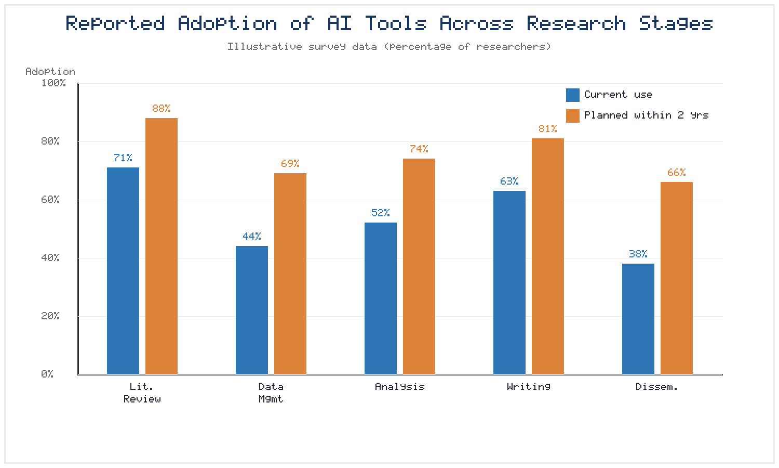
Figure 2. Illustrative reported adoption of AI tools across research stages, contrasting current use with adoption planned within two years.

Intelligent scheduling, collaboration, and progress tracking
Research projects, especially collaborative ones, require careful coordination. AI-enabled project-management tools assist by scheduling tasks, allocating resources, tracking progress against milestones, and identifying bottlenecks before they cause delays [18]. Intelligent collaboration platforms facilitate communication among distributed team members, manage shared documents and data, and maintain awareness of who is doing what. By reducing coordination overhead, these tools enable larger and more complex collaborations than would otherwise be manageable, an increasingly important capability as research becomes more team-based and interdisciplinary [19]. Effective adoption of such tools nonetheless depends on more than their technical features; it requires shared conventions, mutual trust among collaborators, and clarity about how automated recommendations should be weighed against human judgment. Teams that adopt workflow automation without agreeing on these norms risk confusion, duplicated effort, or an unwarranted deference to the tool's suggestions. The most successful collaborations treat AI project-management systems as instruments that support, rather than dictate, collective decision-making, keeping the locus of authority firmly with the research team.

Integration of AI tools with digital research environments
The full potential of workflow automation is realized when AI tools are integrated into cohesive digital research environments rather than used in isolation. Platforms that combine data management, analysis, writing, and collaboration into a unified environment allow information and outputs to flow seamlessly between stages, eliminating manual handoffs and reducing errors [20]. Interoperability standards and application programming interfaces enable diverse tools to work together, creating flexible ecosystems tailored to the needs of particular projects and disciplines. Table 3 compares categories of AI research tools, their representative functions, and the workflow stages they support.
Table 3. Categories of AI research tools mapped to functions and workflow stages.
Tool Category | Representative Function | Workflow Stage Supported | Human Oversight Level
Discovery assistants | Semantic search, synthesis | Literature review | High
Data-management tools | Metadata, cleaning, validation | Data curation | Medium
Analytical platforms | Automated modeling | Analysis | High
Writing assistants | Drafting, editing | Documentation | High
Workflow automators | Pipeline orchestration | Cross-stage execution | Medium
Project managers | Scheduling, tracking | Coordination | Low

3.4 Reproducibility and Research Integrity
Reproducibility—the ability of independent researchers to obtain consistent results using the same data and methods—is a cornerstone of credible science, and its erosion has been a source of widespread concern. AI offers both tools to strengthen reproducibility and, if misused, risks that could undermine it.

Automated documentation of research procedures and workflows
Reproducibility depends on complete and accurate documentation of how research was conducted. AI can automate much of this documentation by capturing the sequence of operations performed, the parameters used, and the versions of data and code involved [21]. Computational notebooks and workflow systems record these details automatically, producing an executable record that others can inspect and rerun. Such automated provenance capture reduces the burden of documentation and increases its reliability, addressing a common cause of irreproducibility—incomplete methodological reporting [22].

Detection of methodological inconsistencies and potential errors
AI can serve as a safeguard against methodological errors and inconsistencies. Automated checking tools can detect statistical mistakes, such as reporting errors and inconsistencies between reported values, and can flag questionable research practices before publication [23]. In peer review and editorial workflows, AI screens manuscripts for common problems, from image manipulation to implausible results, providing an additional layer of scrutiny. These tools do not replace expert review but augment it, catching errors that human reviewers might miss and raising the overall standard of methodological rigor [24].

AI-supported transparency, reproducibility, and responsible research practices
Ultimately, AI can foster a culture of transparency and reproducibility by making rigorous practices easier to adopt. When documentation, validation, and error-checking are automated and integrated into research workflows, transparency becomes the path of least resistance rather than an additional burden [25]. At the same time, the use of AI must itself be transparent: researchers should document how AI contributed to their work so that others can assess and reproduce it. In this way, AI both supports and depends upon the responsible research practices that sustain the credibility of the scholarly enterprise [26].

Section 4: AI, Innovation, and the Future of Scholarly Communication

4.1 AI for Knowledge Dissemination and Scholarly Communication
The value of research is realized only when its findings are communicated and used. AI is reshaping scholarly communication, expanding both the efficiency and the reach of knowledge dissemination while creating new possibilities for engaging diverse audiences.

Intelligent generation of research summaries and graphical abstracts
Communicating complex research concisely is a persistent challenge that AI helps to address. Language models can generate plain-language summaries, structured abstracts, and lay summaries tailored to different readerships, distilling technical findings into accessible forms [27]. AI tools can also assist in creating graphical abstracts and visual summaries that convey key results at a glance, an increasingly important format in a visually oriented information environment. These capabilities help research findings travel further and reach audiences who would not engage with a full technical paper [28].

Personalized dissemination of scholarly findings
AI enables the personalization of scholarly communication, matching research outputs to the interests and needs of individual recipients. Recommendation systems alert researchers to newly published work relevant to their interests, while intelligent alerting services can notify practitioners, policymakers, and the public about findings pertinent to their concerns [29]. Such personalization increases the likelihood that research reaches those who can use it, improving the translation of knowledge into practice. The steady growth in AI-assisted research and communication activities is reflected in the productivity trends illustrated in Figure 4, which shows rising adoption across literature discovery, analysis, and writing over recent years.
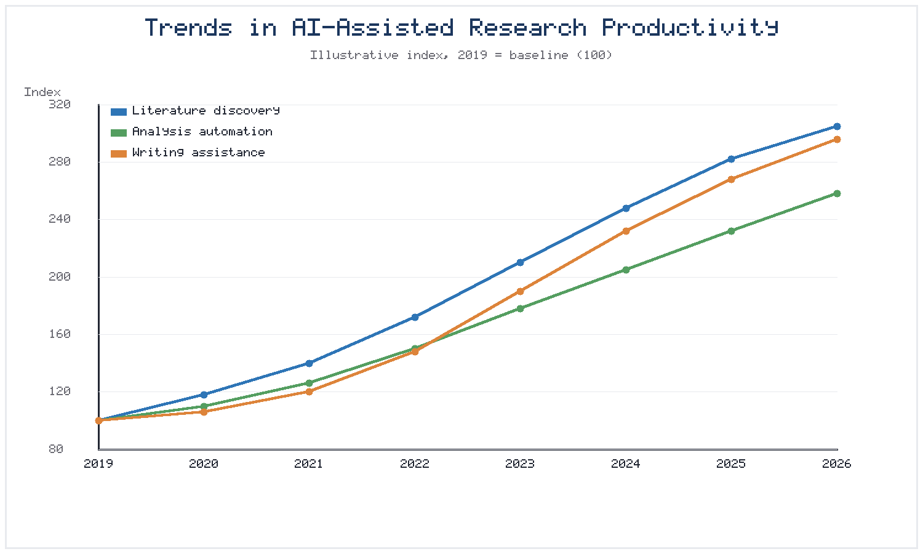
Figure 4. Illustrative trends in AI-assisted research productivity (indexed to a 2019 baseline of 100) across literature discovery, analysis automation, and writing assistance.

AI-supported communication with academic and non-academic audiences
Bridging the gap between specialized research and broader publics is essential for the societal impact of scholarship. AI supports this bridging by adapting content, tone, and format for different audiences, from expert peers to students, journalists, and citizens [30]. Conversational AI systems can answer questions about research findings, explain methods in accessible terms, and support interactive engagement with scientific content. As these tools mature, they promise to democratize access to research knowledge, though care must be taken to ensure that simplification does not distort or misrepresent the underlying science [31].
The same technologies that broaden access, however, also introduce new vectors for the distortion of scientific communication. Automatically generated summaries can strip away the caveats, uncertainties, and boundary conditions that responsible scientists attach to their findings, potentially conveying false certainty to non-expert audiences. There is also a risk that the ease of generating persuasive text could be exploited to produce misleading or fraudulent scientific content at scale. Guarding against these harms requires that AI-supported communication preserve the epistemic humility of good science—foregrounding limitations, quantifying uncertainty, and linking claims to their evidentiary basis. Publishers and institutions have a role to play in setting standards for AI-assisted communication, just as they do for AI-assisted research, ensuring that the drive for reach and accessibility does not compromise the accuracy and trustworthiness that give scholarly communication its value [34].

4.2 Responsible and Ethical Use of AI in Research
The expanding role of AI in research brings significant ethical responsibilities. Realizing AI's benefits while avoiding its harms requires deliberate attention to fairness, transparency, and accountability throughout the research process.

Bias, hallucination, transparency, and explainability
AI systems can perpetuate and amplify biases present in their training data, producing outputs that systematically disadvantage certain groups or entrench existing inequities [32]. Generative models are also prone to hallucination—producing plausible but false information, including fabricated citations and misstated facts—which poses a serious risk in research contexts where accuracy is paramount [33]. Addressing these problems requires transparency about how AI systems work and explainability of their outputs, so that researchers can understand, scrutinize, and appropriately trust or challenge the results. Without such transparency, the use of AI can introduce hidden errors and biases that undermine the integrity of research [34].

Authorship, attribution, and disclosure of AI assistance
The use of AI raises novel questions about authorship and attribution. Emerging consensus holds that AI systems cannot be authors, because they cannot take responsibility for the work, but that their use should be disclosed transparently [35]. Researchers must clearly document how AI tools contributed to their work, distinguishing machine-generated content from human contributions and maintaining accountability for the final product. Journals, funders, and institutions are developing disclosure requirements and authorship guidelines to govern these practices, and researchers must stay abreast of evolving norms [36].

Institutional policies and responsible AI guidelines
Individual good intentions are insufficient without supportive institutional frameworks. Universities, funders, and publishers are increasingly establishing policies that govern the responsible use of AI in research, addressing issues from data protection to disclosure to permissible uses [37]. Effective policies balance enabling innovation with protecting integrity, providing clear guidance without stifling legitimate use. As illustrated conceptually in Figure 1, responsible use and human oversight span the entire research lifecycle, and institutional guidelines should reflect this comprehensive scope rather than addressing AI use in a piecemeal fashion [38].

4.3 AI Readiness and Researcher Competencies
The benefits of AI in research can be realized only if researchers possess the competencies to use these tools effectively and responsibly. Building AI readiness across the research community is therefore a critical priority for Education 5.0.

AI literacy and digital research skills
AI literacy—the ability to understand, evaluate, and appropriately use AI tools—is becoming a fundamental research competency. This encompasses conceptual understanding of how AI systems work, practical skills in using AI tools, and critical awareness of their limitations and risks [39]. Researchers need sufficient understanding to interpret AI outputs, recognize when they may be unreliable, and integrate AI appropriately into their workflows. Digital research skills more broadly, including data management and computational thinking, form the foundation on which AI literacy is built.

Faculty development and researcher training
Developing these competencies requires sustained investment in training and professional development. Structured programs, workshops, and resources help researchers at all career stages acquire and update their AI skills, keeping pace with a rapidly evolving landscape [40]. Faculty development is especially important because experienced researchers may lack familiarity with recent AI tools yet play crucial roles in mentoring students and setting norms. Effective training combines technical instruction with attention to ethical and responsible use, ensuring that competence and conscientiousness develop together [41]. Training should also be differentiated by role and career stage: doctoral students may need foundational instruction in computational methods and research data management, whereas established principal investigators may benefit more from focused updates on emerging tools and evolving policy expectations. Embedding AI literacy into graduate curricula, rather than treating it as an optional add-on, ensures that the next generation of researchers enters the profession already equipped to use these tools critically and responsibly, and helps to normalize the transparent, accountable practices that this chapter advocates.

Institutional support for AI adoption in academic research
Individual competencies must be complemented by institutional support structures. Universities can facilitate responsible AI adoption by providing access to tools and infrastructure, offering technical support and consultation, and creating communities of practice where researchers share knowledge and experience [42]. Table 4 summarizes key researcher competencies for AI-driven research alongside the institutional supports that enable their development, highlighting the shared responsibility of individuals and institutions in building a capable and responsible research community [43].
Table 4. Researcher competencies for AI-driven research and enabling institutional supports.
Competency Area | Description | Enabling Institutional Support | Maturity Indicator
AI literacy | Understand AI capabilities and limits | Foundational training programs | Confident tool selection
Data management | Curate and govern data responsibly | RDM infrastructure and services | FAIR-compliant datasets
Critical evaluation | Assess and verify AI outputs | Guidelines and exemplars | Reliable error detection
Ethical practice | Use AI responsibly and transparently | Policies and ethics review | Consistent disclosure
Technical fluency | Operate AI tools and pipelines | Access to tools and support | Reproducible workflows

4.4 Future Research Ecosystems in Education 5.0
Looking ahead, the integration of AI into research points toward transformed ecosystems in which intelligent systems, human researchers, and supporting infrastructure combine into powerful engines of discovery. Education 5.0 provides a vision for these ecosystems that keeps human values and well-being at the center.

Autonomous and agentic research workflows
The frontier of AI-driven research lies in increasingly autonomous and agentic systems that can pursue research goals with growing independence. Agentic AI—systems capable of planning, acting, and adapting to achieve objectives—may soon conduct multi-step research tasks, from formulating questions to designing experiments and interpreting results, under human supervision [1]. Early demonstrations of automated laboratories and self-driving experimental platforms hint at this future. Such autonomy promises dramatic gains in the pace of discovery, but it also intensifies the need for oversight, accountability, and careful attention to the risks of delegating consequential decisions to machines [2]. As systems assume greater initiative, the questions of who is responsible for their actions, how their decisions can be audited, and how errors are detected and corrected become correspondingly more pressing. An agentic system that formulates a flawed hypothesis, selects an inappropriate method, or misinterprets a result could propagate errors far more quickly than a human researcher, making robust safeguards, transparent logging, and clear lines of accountability indispensable. The trajectory toward autonomy is therefore best understood not as the removal of humans from research but as a shift in the human role from performing tasks to designing, supervising, and validating the systems that perform them—a shift that demands new skills and new institutional arrangements rather than diminished responsibility.

Integration of AI with cloud computing, knowledge graphs, and advanced analytics
Future research ecosystems will be built on the convergence of AI with complementary technologies. Cloud computing provides the scalable infrastructure needed to process massive datasets and run sophisticated models, while knowledge graphs organize the world's scholarly knowledge into structured, queryable form [3]. Advanced analytics, from causal inference to multimodal learning, extend the range of questions AI can help answer. The integration of these technologies into cohesive platforms will create research environments of unprecedented capability, enabling forms of inquiry that are difficult to imagine today [4]. As depicted in Figure 4, the trajectory of adoption suggests continued acceleration as these integrated capabilities mature and diffuse across the research community.

Vision for human-centered, intelligent, collaborative, and sustainable research ecosystems
The ultimate aspiration of Education 5.0 is a research ecosystem that is not merely powerful but also human-centered, equitable, and sustainable. In this vision, AI amplifies human creativity and judgment rather than displacing them, expands access to research capabilities across institutions and regions, and supports research that addresses humanity's most pressing challenges [5]. Achieving this vision requires deliberate choices to design AI systems and research practices around human values, to distribute the benefits of AI broadly, and to attend to the environmental and social sustainability of research infrastructure. The comparative adoption patterns shown in Figure 2 and the governance safeguards outlined earlier remind us that technology alone does not determine outcomes; the responsible, thoughtful integration of AI—guided by human oversight and shared ethical commitments—will determine whether these tools fulfill their promise. If pursued wisely, AI-driven research support, data management, and workflows can help build the collaborative, intelligent, and sustainable knowledge ecosystems that Education 5.0 envisions, advancing not only the efficiency of scholarship but its integrity, inclusivity, and service to society.

References
[1] Xu, Y., Liu, X., Cao, X., Huang, C., Liu, E., Qian, S., et al. (2021). Artificial intelligence: A powerful paradigm for scientific research. The Innovation, 2(4), 100179.
[2] Hutson, M. (2022). Could AI help you to write your next paper? Nature, 611(7934), 192–193.
[3] Russell, S., & Norvig, P. (2021). Artificial Intelligence: A Modern Approach (4th ed.). Pearson.
[4] Bommasani, R., Hudson, D. A., Adeli, E., Altman, R., Arora, S., von Arx, S., et al. (2021). On the opportunities and risks of foundation models. arXiv preprint arXiv:2108.07258.
[5] Wang, H., Fu, T., Du, Y., Gao, W., Huang, K., Liu, Z., et al. (2023). Scientific discovery in the age of artificial intelligence. Nature, 620(7972), 47–60.
[6] Jumper, J., Evans, R., Pritzel, A., Green, T., Figurnov, M., Ronneberger, O., et al. (2021). Highly accurate protein structure prediction with AlphaFold. Nature, 596(7873), 583–589.
[7] Grimmer, J., Roberts, M. E., & Stewart, B. M. (2022). Text as Data: A New Framework for Machine Learning and the Social Sciences. Princeton University Press.
[8] Marshall, I. J., & Wallace, B. C. (2019). Toward systematic review automation: A practical guide to using machine learning tools in research synthesis. Systematic Reviews, 8(1), 163.
[9] Bengio, Y., LeCun, Y., & Hinton, G. (2021). Deep learning for AI. Communications of the ACM, 64(7), 58–65.
[10] Brynjolfsson, E., & Mitchell, T. (2017). What can machine learning do? Workforce implications. Science, 358(6370), 1530–1534.
[11] Bornmann, L., Haunschild, R., & Mutz, R. (2021). Growth rates of modern science: A latent piecewise growth curve approach. Humanities and Social Sciences Communications, 8(1), 224.
[12] Reimers, N., & Gurevych, I. (2019). Sentence-BERT: Sentence embeddings using Siamese BERT-networks. In Proceedings of EMNLP-IJCNLP (pp. 3982–3992).
[13] Kinney, R., Anastasiades, C., Authur, R., Beltagy, I., Bragg, J., Buraczynski, A., et al. (2023). The Semantic Scholar Open Data Platform. arXiv preprint arXiv:2301.10140.
[14] Beltagy, I., Lo, K., & Cohan, A. (2019). SciBERT: A pretrained language model for scientific text. In Proceedings of EMNLP-IJCNLP (pp. 3615–3620).
[15] Cohan, A., Dernoncourt, F., Kim, D. S., Bui, T., Kim, S., Chang, W., & Goharian, N. (2018). A discourse-aware attention model for abstractive summarization of long documents. In Proceedings of NAACL-HLT (pp. 615–621).
[16] van Dis, E. A. M., Bollen, J., Zuidema, W., van Rooij, R., & Bockting, C. L. (2023). ChatGPT: Five priorities for research. Nature, 614(7947), 224–226.
[17] Hope, T., Downey, D., Weld, D. S., Etzioni, O., & Horvitz, E. (2023). A computational inflection for scientific discovery. Communications of the ACM, 66(8), 62–73.
[18] Krenn, M., Pollice, R., Guo, S. Y., Aldeghi, M., Cervera-Lierta, A., Friederich, P., et al. (2022). On scientific understanding with artificial intelligence. Nature Reviews Physics, 4(12), 761–769.
[19] Boiko, D. A., MacKnight, R., Kline, B., & Gomes, G. (2023). Autonomous chemical research with large language models. Nature, 624(7992), 570–578.
[20] King, R. D., Rowland, J., Oliver, S. G., Young, M., Aubrey, W., Byrne, E., et al. (2009). The automation of science. Science, 324(5923), 85–89.
[21] Cockburn, A., Dragicevic, P., Besançon, L., & Gutwin, C. (2020). Threats of a replication crisis in empirical computer science. Communications of the ACM, 63(8), 70–79.
[22] Munafò, M. R., Nosek, B. A., Bishop, D. V. M., Button, K. S., Chambers, C. D., Percie du Sert, N., et al. (2017). A manifesto for reproducible science. Nature Human Behaviour, 1(1), 0021.
[23] Perkel, J. M. (2021). Ten computer codes that transformed science. Nature, 589(7842), 344–348.
[24] Baker, M. (2016). 1,500 scientists lift the lid on reproducibility. Nature, 533(7604), 452–454.
[25] Rahwan, I., Cebrian, M., Obradovich, N., Bongard, J., Bonnefon, J.-F., Breazeal, C., et al. (2019). Machine behaviour. Nature, 568(7753), 477–486.
[26] Dellermann, D., Ebel, P., Söllner, M., & Leimeister, J. M. (2019). Hybrid intelligence. Business & Information Systems Engineering, 61(5), 637–643.
[27] Bender, E. M., Gebru, T., McMillan-Major, A., & Shmitchell, S. (2021). On the dangers of stochastic parrots: Can language models be too big? In Proceedings of FAccT (pp. 610–623).
[28] Amershi, S., Weld, D., Vorvoreanu, M., Fourney, A., Nushi, B., Collisson, P., et al. (2019). Guidelines for human–AI interaction. In Proceedings of CHI (pp. 1–13).
[29] Wilkinson, M. D., Dumontier, M., Aalbersberg, I. J., Appleton, G., Axton, M., Baak, A., et al. (2016). The FAIR Guiding Principles for scientific data management and stewardship. Scientific Data, 3(1), 160018.
[30] Tenopir, C., Rice, N. M., Allard, S., Baird, L., Borycz, J., Christian, L., et al. (2020). Data sharing, management, use, and reuse: Practices and perceptions of scientists worldwide. PLOS ONE, 15(3), e0229003.
[31] Esteva, A., Chou, K., Yeung, S., Naik, N., Madani, A., Mottaghi, A., et al. (2021). Deep learning-enabled medical computer vision. npj Digital Medicine, 4(1), 5.
[32] Christin, D. (2020). Data science and machine learning in ecology and environmental research. Methods in Ecology and Evolution, 11(10), 1225–1237.
[33] Tolk, A., & Ören, T. (2021). Metadata and ontologies for research data management. Data Science Journal, 20(1), 34.
[34] Ilyas, I. F., & Chu, X. (2019). Data Cleaning. ACM Books.
[35] Hogan, A., Blomqvist, E., Cochez, M., d'Amato, C., Melo, G. de, Gutierrez, C., et al. (2021). Knowledge graphs. ACM Computing Surveys, 54(4), 71.
[36] Nosek, B. A., Hardwicke, T. E., Moshontz, H., Allard, A., Corker, K. S., Dreber, A., et al. (2022). Replicability, robustness, and reproducibility in psychological science. Annual Review of Psychology, 73, 719–748.
[37] Chandola, V., Banerjee, A., & Kumar, V. (2009). Anomaly detection: A survey. ACM Computing Surveys, 41(3), 15.
[38] Liu, F. T., Ting, K. M., & Zhou, Z.-H. (2012). Isolation-based anomaly detection. ACM Transactions on Knowledge Discovery from Data, 6(1), 3.
[39] Stodden, V., Seiler, J., & Ma, Z. (2018). An empirical analysis of journal policy effectiveness for computational reproducibility. Proceedings of the National Academy of Sciences, 115(11), 2584–2589.
[40] Wing, J. M. (2019). The data life cycle. Harvard Data Science Review, 1(1).
[41] Dwork, C., & Roth, A. (2014). The algorithmic foundations of differential privacy. Foundations and Trends in Theoretical Computer Science, 9(3–4), 211–407.
[42] Kairouz, P., McMahan, H. B., Avent, B., Bellet, A., Bennis, M., Bhagoji, A. N., et al. (2021). Advances and open problems in federated learning. Foundations and Trends in Machine Learning, 14(1–2), 1–210.
[43] Stahl, B. C. (2021). Artificial Intelligence for a Better Future: An Ecosystem Perspective on the Ethics of AI and Emerging Digital Technologies. Springer.
Note: Figures are presented as embedded images; all tables and figures are original and prepared for this chapter. Illustrative survey and index values in Figures 2 and 4 are provided for demonstration and should be replaced with verified data prior to formal publication.

