Artificial Intelligence, Cognitive Offloading and Brain Fog: Navigating Digital Overload in the AI-Driven World
[Author Name(s)]
[Department / School, Institution, City, Country]
[Corresponding author e-mail]

Abstract
The rapid diffusion of artificial intelligence (AI) into everyday work, study, and social life has transformed how people acquire information, make decisions, and manage attention. As generative chatbots, intelligent search, recommender systems, and always-on notifications become the default interface to knowledge, individuals increasingly delegate mental effort to machines—a process known as cognitive offloading. This chapter examines the relationship between pervasive AI use, chronic digital overload, and the cluster of subjective symptoms popularly described as "brain fog": difficulty concentrating, forgetfulness, mental fatigue, and a sense of slowed or cloudy thinking. We develop a conceptual framework that connects AI-driven information abundance to reduced effortful cognitive engagement and, in turn, to self-reported cognitive cloudiness, and we propose a five-domain taxonomy of cognitive offloading spanning memory, computation, navigation, decision-making, and creative generation. Drawing together evidence from cognitive psychology, human–computer interaction, neuroscience, and education, the chapter distinguishes beneficial, capacity-extending offloading from habitual, substitutive offloading that may erode attention, metacognition, and retention. We then analyse the principal challenges—measurement ambiguity, skill decay, over-reliance, attention fragmentation, and equity—and present a multi-level countermeasures framework operating at individual, educational, organisational, technological, and policy levels. The chapter closes by outlining research priorities for the responsible integration of AI into cognitive life. The overarching argument is that brain fog in the AI era is best understood not as a simple side-effect of technology but as an interaction among tools, tasks, habits, and environments that can be deliberately redesigned.

Keywords
Artificial intelligence; cognitive offloading; brain fog; digital overload; attention; metacognition; generative AI; cognitive load; digital wellbeing; human–AI interaction

1. Introduction
Human cognition has always been partly external. People have long extended memory and reasoning into notebooks, calendars, abacuses, and the minds of trusted others, and the scientific study of this tendency—variously termed distributed, extended, or external cognition—long predates the digital era [1]. What is historically novel is the scale, speed, and intimacy with which artificial intelligence now mediates these extensions. A learner who once consulted a library catalogue now queries a conversational agent that returns a synthesised answer in seconds; a professional who once drafted a report now prompts a large language model (LLM) to produce a first version; a traveller who once memorised routes now follows turn-by-turn navigation without forming a mental map [2], [3]. These shifts are not marginal conveniences. They reconfigure the division of cognitive labour between person and machine, and they do so for billions of people simultaneously [4].
At the same time, clinicians, educators, and the wider public have reported a rising sense of cognitive cloudiness. "Brain fog" is not a formal diagnosis but a lay and clinical shorthand for a constellation of symptoms—impaired concentration, slowed processing, word-finding difficulty, mental fatigue, and memory lapses—that can arise from many causes, including illness, stress, poor sleep, and sustained attentional strain [5], [6]. Interest in the term surged in the wake of the COVID-19 pandemic, but a parallel and increasingly discussed question concerns whether the always-connected, AI-saturated information environment itself contributes to such experiences [7], [8]. This chapter takes that question seriously without overstating it: the goal is to map plausible mechanisms, weigh the evidence, and identify what individuals and institutions can do.
The scale of this transition is difficult to overstate. Within a span of only a few years, conversational AI moved from a research curiosity to a mass technology embedded in word processors, search engines, email clients, learning platforms, and mobile keyboards, reaching hundreds of millions of users and becoming, for many, the first port of call for any question or task [4], [20]. Unlike earlier cognitive tools, which were passive stores or single-purpose calculators, contemporary AI systems are generative and conversational: they do not merely hold information but produce new text, code, images, and arguments on demand, and they do so in fluent, authoritative language that invites trust and discourages scrutiny [18], [26]. This qualitative difference matters for cognition. A calculator offloads a narrow, verifiable operation; a generative model can offload the open-ended, effortful construction of understanding itself, which is also the activity through which people learn and think most deeply [28], [42]. The question this chapter pursues is therefore not whether AI tools are useful—plainly they are—but how their particular character interacts with human attention, memory, and motivation to shape cognitive experience over time.
Two framing claims organise the discussion. First, cognitive offloading is neither inherently harmful nor inherently beneficial; its effects depend on what is offloaded, how often, under what conditions, and whether the person retains the capacity and motivation to engage directly when it matters [9], [10]. Offloading a tedious calculation can free scarce working-memory resources for higher-order reasoning, an unambiguous benefit [11]. Habitually outsourcing the effortful construction of understanding, by contrast, may short-circuit the very processes—elaboration, retrieval, and error-correction—through which durable knowledge and skill are built [12], [13]. Second, "digital overload" is better understood as a mismatch between the volume and velocity of incoming information and the finite capacity of human attention and working memory, a mismatch that AI systems can either ease or intensify depending on their design and use [14], [15].
Figure 1 presents the conceptual framework that structures the chapter. It traces a pathway from an environment of AI tools and digital overload, through cognitive offloading, to reduced effortful engagement, and finally to the subjective and behavioural phenomena grouped under brain fog, while acknowledging moderating factors and a reinforcing feedback loop.
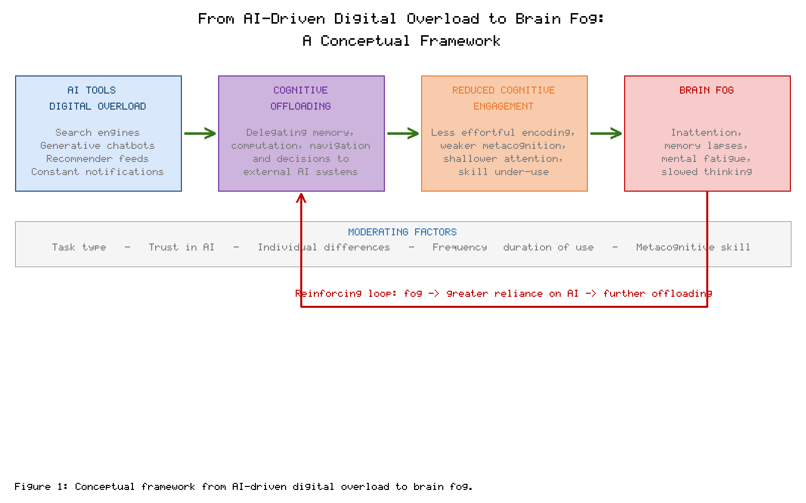
Figure 1. Conceptual framework linking AI-driven digital overload, cognitive offloading, reduced cognitive engagement, and brain fog, with moderating factors and a reinforcing feedback loop.
Because the chapter spans several disciplines, it is useful to fix terminology at the outset. Table 1 defines the central constructs as they are used throughout, drawing on and harmonising usage across the cognitive, computational, and clinical literatures [1], [5], [9], [16].
Table 1. Key terminology used in this chapter.
Term | Working definition | Primary disciplinary source
Cognitive offloading | Using physical action or external tools, including AI, to reduce the information-processing demands of a task | Cognitive psychology [1], [9]
Digital overload | A sustained mismatch between incoming information and finite attentional and working-memory capacity | HCI / media studies [14], [15]
Brain fog | A non-clinical cluster of symptoms—inattention, forgetfulness, mental fatigue, slowed thinking | Clinical / neuropsychology [5], [6]
Cognitive load | The demand placed on working memory during a task (intrinsic, extraneous, germane) | Educational psychology [11], [16]
Metacognition | Monitoring and regulation of one's own cognitive processes, including judgements of knowing | Cognitive psychology [12], [17]
Over-reliance | Accepting AI output without adequate verification even when it is wrong | Human–AI interaction [10], [18]

A word on scope and stance is warranted before proceeding. The popular conversation about AI and the brain oscillates between two unhelpful poles: a technophobic narrative in which digital tools are "making us stupid," and a technophilic narrative in which any concern is dismissed as moral panic of the kind that has accompanied every new medium from writing to television [25], [37]. Both poles share a flaw: they treat "technology" as a monolith with uniform effects on a uniform user. The position taken here is deliberately intermediate and evidence-led. AI-mediated cognition has genuine benefits that this chapter does not dispute, including expanded access to knowledge, reduced load on routine tasks, and real assistance for people who struggle with particular cognitive demands [43], [53]. It also has plausible risks that warrant investigation rather than dismissal, and those risks are concentrated in specific patterns of use rather than in the tools as such [9], [27]. Brain fog, in particular, should be treated carefully: it is a real and often distressing experience, but it is multi-causal and poorly operationalised, and attributing it wholesale to AI would repeat the very error this chapter cautions against [5], [6]. The aim is to identify where, how, and for whom the risks are most credible, and to translate that understanding into concrete, proportionate action.
The remainder of the chapter proceeds as follows. Section 2 reviews related work across the relevant disciplines. Section 3 develops the taxonomy of cognitive offloading and situates brain fog within it. Section 4 analyses the principal challenges. Section 5 presents countermeasures at five levels, and Section 6 outlines future research directions before the conclusion.

2. Related Work

2.1 Cognitive offloading and the extended mind
The modern study of cognitive offloading grew from the observation that people routinely trade internal effort for external action when the external route is cheaper or more reliable [1], [9]. Early work established that individuals offload more when internal demands are high, when they have low confidence in their own memory, and when offloading is easy and expected to persist [9], [19]. A consistent finding is the "saving-enhanced memory" and complementary "saving-impaired memory" pattern: saving one set of information to an external store can free resources to learn new material, yet the saved material itself is often remembered poorly because it was never deeply encoded [13], [19]. This dual effect is central to the present argument, because AI systems make saving, retrieving, and generating information almost frictionless, amplifying both sides of the trade-off [2], [20].
The extended-mind tradition reframes these findings in a way that resists simple alarmism. On this view, the boundary of a cognitive system need not coincide with the skin and skull: when an external resource is reliably available, trusted, and readily accessed, it can function as a genuine part of the cognitive process rather than a mere crutch [1], [37]. From this perspective, offloading is not a failure of cognition but one of its defining features, and the relevant question is whether a given coupling between person and tool enhances or diminishes the agent's overall capacities [1], [43]. The worry specific to AI is that the coupling may become asymmetrical: the tool grows more capable and more relied upon while the person's independent capacities quietly erode, so that the apparent extension of mind masks an underlying contraction [27], [46]. Whether this occurs is an empirical matter that depends on use patterns, and the taxonomy developed in Section 3 is intended precisely to separate couplings that extend from couplings that hollow out.

2.2 The internet, smartphones, and cognition
A substantial literature predates generative AI but remains directly relevant. Reviews of the "online brain" argue that the internet can affect attention by habituating users to continuous streams of salient, interrupting stimuli, and can alter memory by shifting it toward knowing where information is rather than what it is [2], [21]. Experimental and survey studies link heavy smartphone use and media multitasking to poorer sustained attention, more frequent mind-wandering, and lower performance on tasks requiring deep processing, though effect sizes vary and causal direction is often unclear [7], [22], [23]. The mere presence of a smartphone has been associated with reduced available cognitive capacity, consistent with the idea that managing the temptation to check devices itself consumes attentional resources [24]. Collectively, this body of work suggests that information environments shape cognition at the level of habit, not only momentary performance [8], [25]. It also issues an important methodological caution that carries over to the AI literature: much of the evidence is correlational, effect sizes are frequently modest, and heterogeneity across studies is substantial, so confident causal claims are rarely warranted [22], [23]. Media multitasking, for instance, is reliably associated with self-reported attentional difficulty, yet experimental attempts to demonstrate that multitasking causes lasting deficits have produced mixed results, and reverse causation—people with weaker attentional control being more drawn to multitasking—remains plausible [22], [23]. The lesson for the study of AI and brain fog is to hold mechanisms and outcomes separate, to treat subjective reports as informative but fallible, and to prize longitudinal and experimental designs over cross-sectional snapshots [45].

2.3 Generative AI and cognitive engagement
The arrival of capable LLMs has sharpened these questions. Recent studies report that frequent reliance on AI assistants for reasoning-heavy tasks is associated with lower scores on measures of critical thinking, an association partly mediated by increased cognitive offloading, with younger users offloading more [26], [27]. Neurophysiological work using electroencephalography has observed reduced and differently distributed neural engagement when participants compose essays with an LLM compared with unaided writing, alongside weaker recall of the text they ostensibly produced [28]. Studies in education describe a risk of "metacognitive laziness," in which learners delegate planning and monitoring to the tool and consequently engage less in self-regulated learning [29], [30]. Surveys of knowledge workers similarly find that higher confidence in AI is associated with less self-reported critical thinking during task completion, whereas higher self-confidence is associated with more, suggesting that the perceived trustworthiness of the tool shifts how much independent cognitive effort users invest [42]. These findings are early and contested, and several authors caution against technological determinism, noting that outcomes depend heavily on how the tools are used and scaffolded [31], [32].
Two interpretive points deserve emphasis. First, the observed reductions in effort and engagement are not evidence of harm in themselves; reducing effort is often the explicit purpose of a tool, and an engineer who offloads routine computation to focus on design is using AI well [11], [33]. The concern arises only when the reduced effort falls on activities whose value lies precisely in the effort—learning, reasoning, and the construction of understanding—so that the saving undermines the goal [12], [34]. Second, several of these studies measure immediate or short-term outcomes, such as recall of a just-written essay or performance on a single task, and extrapolating from these to durable changes in cognitive capacity requires caution [28], [45]. The phrase "cognitive debt," used to describe the accumulation of under-practised capacities that may later come due, is an evocative hypothesis rather than an established finding, and it is presented here as such [28].

2.4 Cognitive load, attention, and brain fog
From educational psychology, cognitive load theory distinguishes the intrinsic difficulty of material, the extraneous load imposed by poor presentation, and the germane load associated with productive learning effort [11], [16]. Well-designed AI support can reduce extraneous load—for example, by summarising or structuring information—thereby freeing capacity for germane processing; poorly designed or overused support can instead displace germane effort entirely [33], [34]. On the clinical side, brain fog has been characterised as a transdiagnostic experience associated with inflammation, fatigue, sleep disruption, stress, and sustained attentional demand [5], [6], [35]. While no study to date demonstrates that AI use causes clinical brain fog, the convergence of attentional fragmentation, chronic multitasking, sleep displacement from device use, and reduced effortful engagement provides a plausible behavioural pathway to the subjective symptoms people describe [7], [8], [36]. The present chapter integrates these strands rather than privileging any single one, and the next section organises the space with a taxonomy.

3. Main Content: A Taxonomy of Cognitive Offloading in the AI Era

3.1 Why a taxonomy is needed
Debates about AI and cognition frequently stall because "using AI" conflates very different activities with very different cognitive consequences. Asking a model to check spelling is not equivalent to asking it to construct an argument; consulting a map for an unfamiliar city differs from never forming spatial knowledge of one's own neighbourhood [3], [20]. A taxonomy makes these distinctions tractable and supports more precise claims about when offloading helps and when it harms [9], [37]. We propose five functional domains, shown in Figure 2 and elaborated in Table 2, cross-cut by a single dimension—the depth of offloading, ranging from supplementary (augmenting one's own cognition) to substitutive (replacing it).
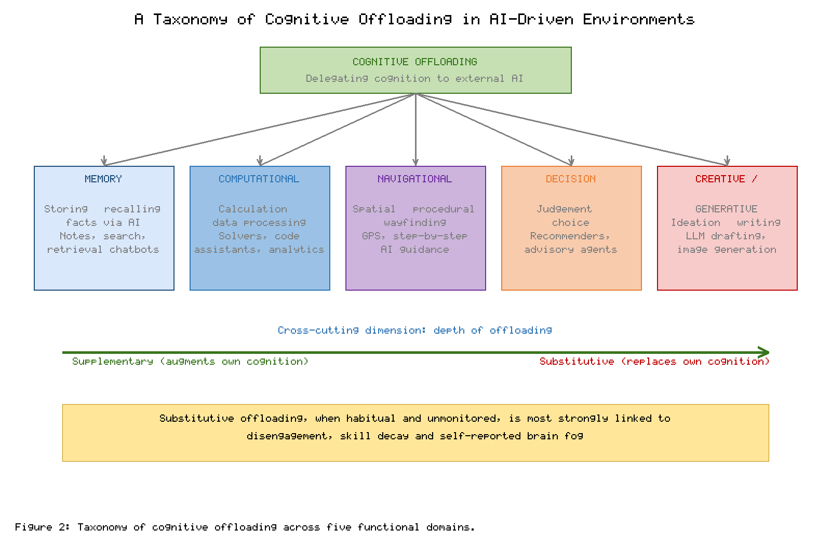
Figure 2. Taxonomy of cognitive offloading across five functional domains, cross-cut by the supplementary–substitutive dimension.

3.2 The five domains
Memory offloading refers to delegating the storage and retrieval of facts, events, and references to external systems—search engines, note applications, and retrieval-augmented chatbots [2], [13]. It is the most studied domain and the clearest illustration of the saving trade-off: external memory is vast and reliable, but information that is never internalised cannot be flexibly combined with other knowledge during reasoning [19], [38].
Computational offloading covers calculation and data processing delegated to calculators, spreadsheets, solvers, and AI code assistants [11], [39]. Here the benefits are often strongest and the costs smallest, because the offloaded operations are well-defined and verifiable, and because freeing working memory from arithmetic can genuinely enable higher-order problem solving [33], [34].
Navigational offloading concerns spatial and procedural wayfinding delegated to satellite navigation and step-by-step AI guidance [3]. Evidence suggests that habitual reliance on turn-by-turn navigation is associated with weaker formation of cognitive maps and reduced engagement of spatial memory systems, a useful cautionary case because the lost capacity is concrete and measurable [3], [40].
Decision offloading involves delegating judgement and choice to recommender systems and advisory agents, from product suggestions to clinical or financial decision support [10], [18]. The central risk is over-reliance: accepting outputs without scrutiny, especially when the system is confident but wrong, and the gradual atrophy of independent evaluative skill [18], [41].
Creative and generative offloading—the newest domain—covers ideation, drafting, and design delegated to generative models [26], [28]. It is cognitively distinctive because the offloaded activity is open-ended and identity-laden; delegating it may most directly affect the effortful construction of understanding and the sense of authorship that motivates sustained engagement [29], [42].
Table 2. The five-domain taxonomy with representative AI tools, benefits, and risks.
Domain | Representative AI tools | Principal benefit | Principal risk
Memory | Search, notes, retrieval chatbots | Access to vast, reliable external store | Shallow encoding; poor integration [13], [19]
Computational | Solvers, spreadsheets, code assistants | Frees working memory for reasoning | Skill decay if fundamentals never learned [34], [39]
Navigational | GPS, step-by-step guidance | Reliable wayfinding, lower stress | Weaker cognitive maps, spatial memory [3], [40]
Decision | Recommenders, advisory agents | Faster, data-informed choices | Over-reliance; erosion of judgement [10], [18]
Creative / generative | LLM drafting, image generation | Rapid ideation and production | Reduced engagement, authorship, learning [28], [29]

3.3 Locating brain fog within the taxonomy
The taxonomy clarifies where brain-fog-like outcomes are most plausible. Supplementary offloading—using AI to handle well-defined subtasks while the person retains the overarching cognitive work—tends to reduce extraneous load and can protect against fatigue [33], [43]. Substitutive offloading, especially when it is habitual, unmonitored, and extends to the core effortful work of a task, is where the chapter locates the strongest risk. In this pattern, repeated bypassing of effortful encoding and retrieval reduces the practice that maintains attentional control and memory, while continuous tool-switching and notification-driven interruption fragment attention and accumulate mental fatigue [22], [24], [36]. The subjective result—difficulty concentrating, forgetfulness, a sense of cloudy or effortful thinking—is precisely what people label brain fog [5], [8]. Importantly, the same tool can sit at either end of the depth dimension depending on use: an LLM used to critique and extend one's own draft is supplementary, whereas the same model used to replace the drafting entirely is substitutive [31], [42].

3.4 Moderators: tasks, individuals, and contexts
The depth dimension interacts with three families of moderators that determine whether a given episode of offloading extends or erodes cognition. The first is the task. Offloading is comparatively benign when the task is routine, verifiable, and peripheral to one's goals, and comparatively risky when the task is formative, high-stakes, or central to a skill one is trying to build [9], [33]. Delegating the formatting of a reference list is unlike delegating the reasoning of an argument, even though both involve "using AI" [31]. The second is the individual. Users differ in working-memory capacity, prior knowledge, metacognitive skill, age, and motivation, and these differences shape both how much they offload and what they gain or lose by doing so [43], [53]. A novice who offloads the hardest steps may never acquire the schema that an expert has already internalised, whereas the expert can offload the same steps safely because the underlying capacity is secure [34], [43]. There is also evidence that those with weaker confidence in their own memory offload more, which raises the possibility of a self-fulfilling spiral in vulnerable users [9], [19]. The third is the context: time pressure, social norms, institutional incentives, and the design of the tool itself all nudge behaviour toward or away from substitutive use [15], [44]. A student assessed only on a polished final product faces strong incentives to offload the formative work; the same student assessed on reasoning and process faces the opposite [29], [30].
These moderators explain why blanket pronouncements about AI and cognition so often conflict. A study of novices offloading core reasoning under time pressure and a study of experts offloading peripheral computation can both be well conducted and yet reach opposite conclusions, because they occupy different regions of the same multidimensional space [27], [43]. Progress requires specifying the task, the user, and the context, not merely the tool—a point that recurs in the analysis of challenges and countermeasures below.

3.5 The reinforcing cycle
A crucial feature of the framework is that these relationships are not linear but circular. Figure 3 depicts a self-reinforcing cycle: habitual AI use encourages offloading, which reduces effortful engagement and weakens encoding and attention; the resulting sense of cognitive cloudiness lowers confidence in one's own cognition, which motivates still greater reliance on AI, closing the loop [10], [27], [29]. This dynamic helps explain why the issue can feel self-perpetuating and why isolated, one-off interventions often fail: breaking the cycle generally requires changes at several points simultaneously, a theme developed in Section 5 [37], [44].
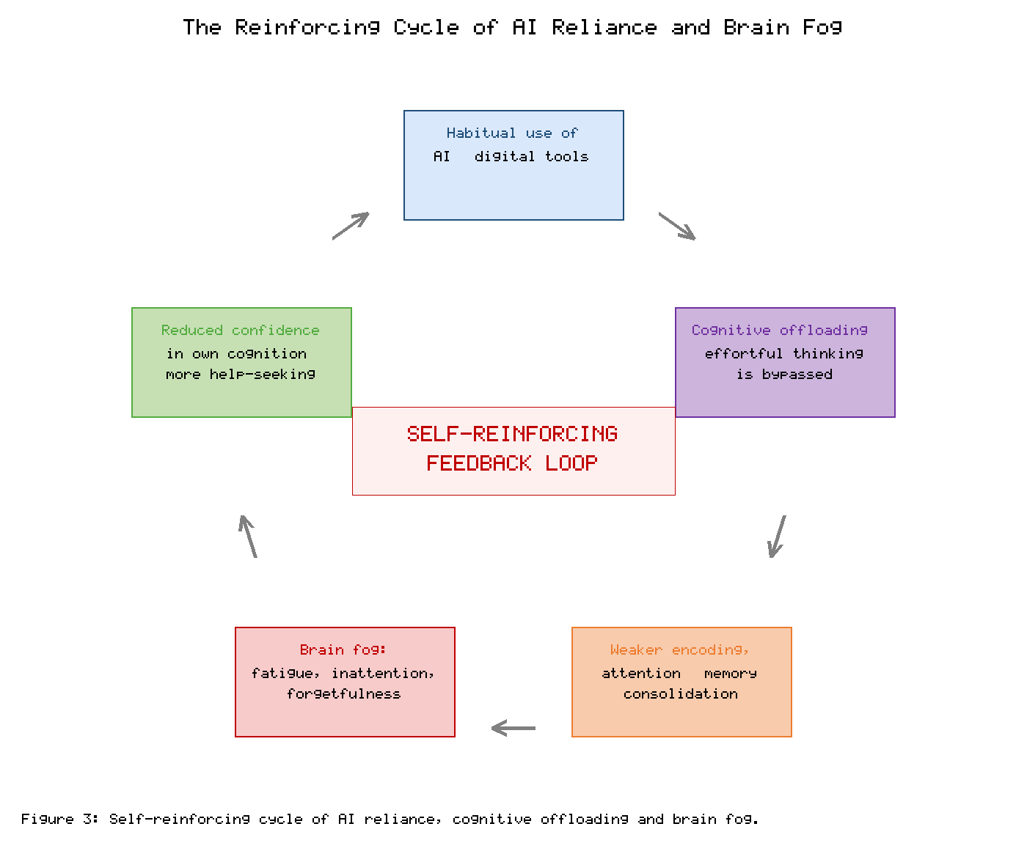
Figure 3. The self-reinforcing cycle through which habitual AI reliance and cognitive offloading can sustain brain-fog-like symptoms.

4. Challenges

4.1 Conceptual and measurement challenges
The first challenge is conceptual. Brain fog is a subjective, multi-causal experience with no agreed operational definition, which makes it difficult to attribute to any single factor, including AI use [5], [6]. Self-reports are vulnerable to recall and attribution biases, and cross-sectional correlations between AI use and cognitive complaints cannot establish direction: people experiencing fatigue may offload more because they are foggy, rather than the reverse [27], [35]. Rigorous claims therefore require longitudinal and experimental designs, objective cognitive and neural measures alongside self-report, and careful control of confounders such as sleep, stress, and workload [28], [45]. Much current discussion outpaces this evidence base, and the chapter deliberately frames mechanisms as plausible pathways rather than established causes [31], [32].

4.2 Skill decay and the automation paradox
A second challenge concerns skill decay. Across domains from aviation to medicine, heavy automation can erode the manual and cognitive skills it was meant to support, so that operators are least prepared precisely when the automation fails—the "automation paradox" [41], [46]. The same risk applies to everyday cognition: if learners never practise effortful retrieval, argument construction, or mental calculation because an AI performs them, the underlying capacities may fail to develop or may weaken over time [12], [34]. This is especially consequential during education, when foundational skills are formed and when the temptation to offload the hardest and most formative work is greatest [29], [30]. The automation literature also identifies a subtler cost: as routine execution is automated away, the human role shifts toward monitoring and exception-handling, tasks for which sustained vigilance is required but for which humans are poorly suited, and which provide little of the practice needed to intervene competently when required [41], [46]. Translated to everyday cognition, a person who rarely composes an argument unaided may find, when circumstances demand it, that the capacity has quietly atrophied, and may experience that effortfulness as part of the cloudiness they describe as fog [12], [28]. Whether such atrophy occurs, and how reversible it is, are open empirical questions, but the structural analogy to well-documented deskilling in automated systems is close enough to warrant concern [46].

4.3 Over-reliance, trust, and automation bias
Third, decision offloading introduces the well-documented problem of over-reliance and automation bias—the tendency to favour machine suggestions and to under-scrutinise them, even when verification is feasible and the stakes are high [10], [18]. Fluent, confident AI output can increase misplaced trust, and the effort required to check it competes with the very convenience that motivated offloading in the first place [18], [47]. Over time, reduced verification can degrade the evaluative skills needed to catch errors, compounding risk [41], [48]. The problem is aggravated by a specific feature of generative systems: they can produce confident, well-formed, and entirely incorrect output—so-called hallucination—whose surface fluency provides no reliable cue to its unreliability [18], [48]. Human trust tends to track fluency and confidence rather than accuracy, so the very polish that makes AI output attractive also makes its errors harder to detect, and the cognitive effort of genuine verification is both substantial and easily skipped [47], [48]. Experimental work shows that interventions which deliberately slow users down or require them to engage before seeing the AI's answer can reduce over-reliance, but also that such "cognitive forcing" imposes effort that users often resist, illustrating the tension at the heart of the design problem [18], [47].

4.4 Attention fragmentation and digital overload
Fourth, the ambient information environment poses an attentional challenge independent of any single tool. Notification streams, algorithmic feeds, and the expectation of constant availability fragment attention into short bursts, encourage media multitasking, and impose a continuous low-level switching cost [14], [22], [36]. Device use also displaces and disrupts sleep, a direct contributor to next-day fogginess and impaired consolidation of the day's learning [7], [49]. AI-curated feeds can intensify overload by maximising engagement rather than wellbeing, though the same personalisation capacity could in principle be turned toward reducing overload [15], [50]. There is a structural reason for concern here: when recommender systems are optimised for engagement metrics, they are incentivised to capture and hold attention, which can run directly counter to the user's interest in focused, restorative cognition [15], [50]. The result is an environment engineered to be maximally interruptive at scale, in which the burden of resisting distraction falls on individuals whose attentional resources are precisely what the environment is competing for [24], [36]. This reframing matters for the brain-fog question because it locates part of the problem outside the individual, in the design of the information ecosystem, and therefore points toward collective as well as personal remedies [15], [44].
Table 3 summarises the principal challenges and maps each to the cognitive or neural processes most plausibly implicated and to the brain-fog-relevant outcome.
Table 3. Mapping challenges to implicated processes and brain-fog-relevant outcomes.
Challenge | Implicated process | Brain-fog-relevant outcome
Measurement ambiguity | Attribution, self-report bias | Over- or under-estimation of effects [5], [35]
Skill decay | Reduced practice, weakened retrieval | Slower, more effortful thinking [12], [34]
Over-reliance / automation bias | Diminished monitoring and verification | Eroded judgement; undetected errors [18], [41]
Attention fragmentation | Task-switching, interruption cost | Inattention, mental fatigue [22], [36]
Sleep displacement | Disrupted consolidation and restoration | Forgetfulness, cloudy thinking [7], [49]
Equity gaps | Unequal access to tools and literacy | Uneven cognitive and educational outcomes [51], [52]

4.5 Equity, diversity, and context
Finally, these effects are not evenly distributed. Access to high-quality AI tools, to the literacy needed to use them critically, and to environments that permit focused work varies widely across socioeconomic, educational, and regional lines [51], [52]. Individuals differ in working-memory capacity, metacognitive skill, age, and neurodivergence, all of which moderate how offloading affects them; for some users, offloading is genuinely assistive and enabling rather than eroding [43], [53]. Treating "the user" as uniform risks both overstating harms for those who benefit and understating them for those most exposed, so interventions must be context-sensitive rather than one-size-fits-all [37], [52].

5. Countermeasures
No single actor can address these challenges alone. Because the reinforcing cycle of Figure 3 is sustained at several points, effective responses must operate at multiple levels simultaneously. Figure 4 organises countermeasures into five layers—individual, educational, organisational, technological, and policy—and Table 4 details representative measures and the challenges they target.
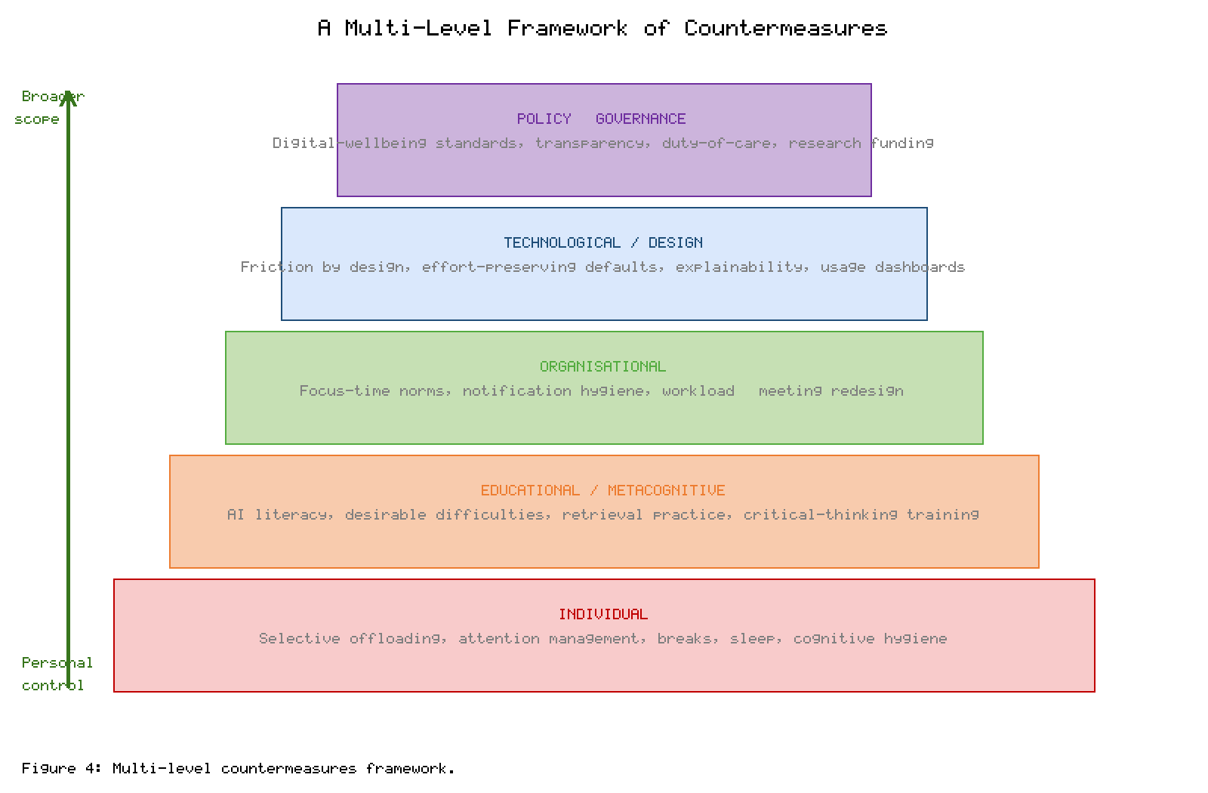
Figure 4. Multi-level countermeasures framework spanning individual, educational, organisational, technological, and policy layers.

5.1 Individual strategies
At the individual level, the aim is selective, intentional offloading rather than blanket avoidance or blanket reliance [9], [37]. Practical tactics include reserving effortful engagement for tasks that are formative or high-stakes, using AI to handle well-defined subtasks while retaining the integrative work, and deliberately verifying important AI outputs [18], [31]. Attention management—batching notifications, single-tasking during demanding work, and protecting uninterrupted focus blocks—reduces fragmentation [22], [36]. Basic cognitive hygiene, especially adequate sleep, regular breaks, and physical activity, directly targets the physiological contributors to fogginess [7], [49]. Crucially, individuals benefit from metacognitive awareness of when they are offloading and why, which restores deliberate control over the trade-off [12], [17]. A useful heuristic is to ask, before delegating a task, whether the effort being avoided is effort one wishes to retain the capacity for; if so, the task is a candidate for engaged rather than substitutive use [9], [43]. This is not a counsel of digital asceticism. Blanket avoidance of AI is neither realistic nor desirable, and may simply disadvantage the abstainer; the goal is calibrated use in which the person remains the author of their own cognition while the tool carries genuinely peripheral load [31], [37].

5.2 Educational and metacognitive interventions
Education is a particularly high-leverage level because habits and foundational skills form there. AI literacy—understanding what these systems can and cannot reliably do, and how to verify their output—should be taught explicitly [32], [51]. Pedagogies that build in "desirable difficulties," such as retrieval practice, spaced study, and self-explanation, preserve the effortful processing through which durable learning occurs even in AI-rich classrooms [12], [34]. Assessment can be redesigned to reward process, reasoning, and critical use of AI rather than only polished final products, reducing the incentive to offload the formative work [29], [30]. The goal is not to exclude AI but to position it as a tool that scaffolds rather than supplants self-regulated learning [31], [42]. Promisingly, controlled studies suggest that combining AI assistance with structured training and self-monitoring can improve outcomes relative to either unaided work or unguided AI use, indicating that the pedagogy surrounding the tool matters at least as much as the tool itself [30], [34]. Teacher readiness is a prerequisite: educators need both the AI literacy and the pedagogical design skills to orchestrate such environments, which has implications for professional development and curriculum policy [51], [53].

5.3 Organisational measures
Workplaces shape cognitive environments through their norms and tools. Organisations can establish notification hygiene and "focus-time" norms that legitimise uninterrupted work, redesign meeting and messaging practices to reduce continuous interruption, and calibrate workloads so that AI augments capacity rather than simply raising throughput expectations [14], [36], [44]. Clear guidance on where AI assistance is appropriate and where human judgement must be retained helps prevent both reckless over-reliance and unproductive prohibition [10], [18]. Supporting employee wellbeing—including realistic availability expectations—addresses the stress and fatigue that feed fogginess [35], [50].

5.4 Technological and design interventions
Design choices determine whether tools intensify or relieve the problem. "Friction by design"—introducing small, deliberate pauses or prompts before accepting AI output—can counter automation bias and invite verification [18], [47]. Effort-preserving defaults, such as offering hints or partial scaffolds rather than complete answers, keep the user cognitively engaged [30], [34]. Explainable and appropriately uncertain AI, which signals its confidence and reasoning, supports calibrated rather than blanket trust [47], [48]. Usage dashboards and digital-wellbeing features can make offloading patterns visible, and personalisation can be redirected to reduce rather than maximise overload [15], [50]. These measures reframe the design objective from maximal convenience toward supporting healthy cognitive engagement [31], [37]. There is an inherent tension to acknowledge: friction and effort-preservation run counter to the commercial logic of frictionless convenience and maximal engagement that drives much product design, which is why design-level change is unlikely to arise spontaneously and why it connects to the policy level discussed next [15], [50]. Nonetheless, a growing body of human–computer interaction research demonstrates that well-targeted friction and better-calibrated explanations can measurably improve the quality of human–AI decisions without unduly sacrificing usability, suggesting that cognitively protective design is feasible as well as desirable [18], [47].

5.5 Policy and governance
At the broadest level, policy can create the conditions in which the other layers operate. Digital-wellbeing standards, transparency requirements about engagement-maximising design, and duty-of-care expectations for providers can shift incentives toward healthier products [15], [50]. Sustained public funding for independent, longitudinal research is essential given how far current claims outpace evidence [28], [45]. Education policy can embed AI and media literacy in curricula, and equity-focused measures can narrow gaps in access and capability so that the cognitive benefits of AI are broadly shared rather than concentrated [51], [52]. Governance works best as an enabler of good individual, educational, organisational, and design practice, not as a substitute for it [37], [44].
Table 4. Countermeasures by level, with target challenges.
Level | Representative measures | Challenges targeted
Individual | Selective offloading, verification, attention management, sleep and breaks | Skill decay, over-reliance, fragmentation [9], [49]
Educational | AI literacy, desirable difficulties, process-based assessment | Skill decay, metacognitive laziness [12], [30]
Organisational | Focus-time norms, notification hygiene, workload calibration | Fragmentation, overload, fatigue [36], [44]
Technological | Friction by design, effort-preserving defaults, explainability, dashboards | Over-reliance, overload [18], [47]
Policy | Wellbeing standards, transparency, research funding, equity measures | Measurement gaps, equity [45], [52]

6. Future Directions
Several research priorities follow from this analysis. First, the field needs rigorous, longitudinal, and experimental evidence that moves beyond cross-sectional correlation, combining objective cognitive and neural measures with validated self-report and controlling for sleep, stress, and workload, so that the direction and magnitude of any AI–cognition relationship can be established [28], [45]. Second, measurement itself requires development: validated instruments for cognitive offloading behaviour and for subjective fogginess would allow results to be compared across studies and populations [5], [27]. Third, research should identify moderators and mechanisms—which tasks, users, and usage patterns make offloading beneficial versus harmful—so that guidance can be precise rather than generic [9], [43]. Individual differences in age, working memory, metacognition, and neurodivergence deserve particular attention, including the real possibility that well-designed AI is net-assistive for many users [43], [53].
A second cluster of priorities is design-oriented. There is a clear opportunity to develop and evaluate "cognitively protective" or engagement-preserving AI—systems deliberately designed to keep users appropriately engaged, to surface uncertainty, and to support verification—and to test such designs against conventional convenience-maximising tools in realistic settings [31], [47]. In education, controlled studies should evaluate which combinations of AI scaffolding and desirable difficulty best preserve learning and metacognition [30], [34]. Longer term, as agentic and multimodal systems take on more complex, open-ended work, the division of cognitive labour between humans and machines will shift again, raising fresh questions about which capacities societies wish to cultivate in people and which to delegate [4], [48]. A third priority concerns the clinical and physiological interface. Because brain fog sits at the junction of cognition, sleep, stress, inflammation, and mood, research that isolates the specific contribution of technology use from these co-occurring factors would be especially valuable, as would work that clarifies whether any technology-linked fogginess is transient and reversible or cumulative [5], [35]. Collaboration between cognitive scientists and clinicians could yield shared measures and case definitions that make the construct tractable without medicalising ordinary variation in attention and fatigue [6], [45].
Interdisciplinary collaboration—linking cognitive science, human–computer interaction, neuroscience, education, and ethics—will be essential, as will attention to equity so that both the benefits and the risks of AI-mediated cognition are understood across diverse populations rather than a narrow sample [51], [52]. Equally important is a commitment to proportionate communication: researchers and commentators bear a responsibility not to overstate preliminary findings, since exaggerated claims in either direction distort public understanding and policy, and the history of media-effects research offers ample warning against both panic and complacency [25], [45].

7. Conclusion
Artificial intelligence has become an everyday partner in thinking, and like all cognitive partnerships it reshapes the people within it. This chapter has argued that the relationship between AI, cognitive offloading, and brain fog is best understood not as a verdict for or against technology but as an interaction among tools, tasks, habits, and environments. Offloading that augments human cognition—handling well-defined subtasks while the person retains the integrative, effortful work—can reduce unnecessary load and protect against fatigue. Offloading that substitutes for the core effortful work, when it becomes habitual and unmonitored, is where the plausible pathway to inattention, skill decay, and the subjective cloudiness people call brain fog is strongest, and where a self-reinforcing cycle can take hold. The framework and five-domain taxonomy developed here are intended to make these distinctions usable, and the multi-level countermeasures show that meaningful responses exist at every level, from individual habits to institutional design and public policy. The evidence base remains young, and claims should be held with appropriate humility; much of what is currently asserted outruns what has been demonstrated. Yet the practical conclusion is clear and actionable: the aim is not to reject AI but to integrate it deliberately, preserving the engaged, effortful thinking that keeps human cognition sharp while letting machines carry the load they carry best. Navigating digital overload in the AI-driven world is, ultimately, a design problem—one that individuals, educators, organisations, technologists, and policymakers can solve together.

References
[1] Clark, A., & Risko, E. F. (2019). Thinking with things and the extended mind: Distributed cognition in a digital age. Cognitive Processing, 20(3), 285–299.
[2] Firth, J., Torous, J., Stubbs, B., Firth, J. A., Steiner, G. Z., Smith, L., Alvarez-Jimenez, M., Gleeson, J., Vancampfort, D., Armitage, C. J., & Sarris, J. (2019). The "online brain": How the Internet may be changing our cognition. World Psychiatry, 18(2), 119–129.
[3] Dahmani, L., & Bohbot, V. D. (2020). Habitual use of GPS negatively impacts spatial memory during self-guided navigation. Scientific Reports, 10, 6310.
[4] Shahab, S., & Lades, L. K. (2024). Capacity-building and the division of cognitive labour in the age of intelligent machines. AI & Society, 39(4), 1771–1785.
[5] Ocon, A. J., & Theoharides, T. C. (2023). Brain fog: A narrative review of a poorly defined but common cognitive state. Frontiers in Neuroscience, 17, 1204880.
[6] Ross, A. J., Medow, M. S., & Stewart, J. M. (2019). What is brain fog? An evaluation of the symptom in postural tachycardia syndrome. Clinical Autonomic Research, 29(1), 1–3.
[7] Alonzo, R., Hussain, J., Stranges, S., & Anderson, K. K. (2021). Interplay between social media use, sleep quality, and mental health in youth: A systematic review. Sleep Medicine Reviews, 56, 101414.
[8] Montag, C., & Elhai, J. D. (2023). Discussing digital technology overuse in children and adolescents during the COVID-19 pandemic and beyond. Addictive Behaviors Reports, 17, 100484.
[9] Risko, E. F., & Dunn, T. L. (2021). The nature and consequences of cognitive offloading. In The Routledge Handbook of Memory and Cognition (pp. 203–219). Routledge.
[10] Passi, S., & Vorvoreanu, M. (2022). Overreliance on AI: Literature review. Microsoft Research Technical Report, MSR-TR-2022-12.
[11] Sweller, J. (2020). Cognitive load theory and educational technology. Educational Technology Research and Development, 68(1), 1–16.
[12] Bjork, R. A., & Bjork, E. L. (2020). Desirable difficulties in theory and practice. Journal of Applied Research in Memory and Cognition, 9(4), 475–479.
[13] Storm, B. C., & Soares, J. S. (2024). Memory in the age of the Internet: The cognitive consequences of offloading. Current Directions in Psychological Science, 33(2), 95–102.
[14] Roetzel, P. G. (2019). Information overload in the information age: A review of the literature. Business Research, 12(2), 479–522.
[15] Milli, S., Carroll, M., Wang, Y., Pandey, S., Zhao, S., & Dragan, A. D. (2025). Engagement, user satisfaction, and the amplification of divisive content on social media. PNAS Nexus, 4(3), pgaf062.
[16] Paas, F., & van Merriënboer, J. J. G. (2020). Cognitive-load theory: Methods to manage working memory load in the learning of complex tasks. Current Directions in Psychological Science, 29(4), 394–398.
[17] Fleming, S. M. (2024). Metacognition and confidence: A review and synthesis. Annual Review of Psychology, 75, 241–268.
[18] Buçinca, Z., Malaya, M. B., & Gajos, K. Z. (2021). To trust or to think: Cognitive forcing functions can reduce overreliance on AI in AI-assisted decision-making. Proceedings of the ACM on Human-Computer Interaction, 5(CSCW1), 1–21.
[19] Grinschgl, S., Papenmeier, F., & Meyerhoff, H. S. (2021). Consequences of cognitive offloading: Boosting performance but diminishing memory. Quarterly Journal of Experimental Psychology, 74(9), 1477–1496.
[20] Hu, X., Luo, J., & Wang, Y. (2023). Human–AI collaboration and the reconfiguration of cognitive work. Computers in Human Behavior, 147, 107842.
[21] Marsh, E. J., & Rajaram, S. (2019). The digital expansion of the mind: Implications of internet usage for memory and cognition. Journal of Applied Research in Memory and Cognition, 8(1), 1–14.
[22] Wiradhany, W., & Koerts, J. (2021). Everyday functioning-related cognitive correlates of media multitasking: A mini meta-analysis. Media Psychology, 24(2), 276–303.
[23] Parry, D. A., & le Roux, D. B. (2021). Media multitasking and cognitive control: A systematic review of interventions. Computers in Human Behavior, 92, 316–327.
[24] Skowronek, J., Seifert, A., & Lindberg, S. (2023). The mere presence of a smartphone reduces available attentional resources: A replication and extension. Scientific Reports, 13, 9363.
[25] Loh, K. K., & Kanai, R. (2022). How has the Internet reshaped human cognition? A decade on. The Neuroscientist, 28(1), 20–35.
[26] Gerlich, M. (2025). AI tools in society: Impacts on cognitive offloading and the future of critical thinking. Societies, 15(1), 6.
[27] Zhai, C., Wibowo, S., & Li, L. D. (2024). The effects of over-reliance on AI dialogue systems on students' cognitive abilities: A systematic review. Smart Learning Environments, 11, 28.
[28] Kosmyna, N., Hauptmann, E., Yuan, Y. T., Situ, J., Liao, X.-H., Beresnitzky, A. V., Braunstein, I., & Maes, P. (2025). Your brain on ChatGPT: Accumulation of cognitive debt when using an AI assistant for essay writing. arXiv preprint, arXiv:2506.08872.
[29] Fan, Y., Tang, L., Le, H., Shen, K., Tan, S., Zhao, Y., Shen, Y., Li, X., & Gašević, D. (2025). Beware of metacognitive laziness: Effects of generative AI on learning motivation, processes, and performance. British Journal of Educational Technology, 56(2), 489–512.
[30] Darvishi, A., Khosravi, H., Sadiq, S., Gašević, D., & Siemens, G. (2024). Impact of AI assistance on student agency and self-regulated learning. Computers & Education, 210, 104967.
[31] Krullaars, M., & Molenaar, I. (2025). From replacement to partnership: Reframing generative AI in learning. Learning and Instruction, 95, 101990.
[32] Long, D., & Magerko, B. (2020). What is AI literacy? Competencies and design considerations. Proceedings of the 2020 CHI Conference on Human Factors in Computing Systems, 1–16.
[33] Chen, O., Paas, F., & Sweller, J. (2023). A cognitive load theory approach to defining and measuring task complexity through element interactivity. Educational Psychology Review, 35, 63.
[34] Darvishi, A., Khosravi, H., & Sadiq, S. (2022). Incorporating training, self-monitoring and AI assistance to improve learning outcomes. Computers and Education: Artificial Intelligence, 3, 100089.
[35] Theoharides, T. C., Cholevas, C., Polyzoidis, K., & Politis, A. (2021). Long-COVID syndrome-associated brain fog and chemofog: Luteolin to the rescue. BioFactors, 47(2), 232–241.
[36] Mark, G. (2023). Attention span: A groundbreaking way to restore balance, happiness and productivity. Hanover Square Press.
[37] Grinschgl, S., & Neubauer, A. C. (2022). Supporting cognition with modern technology: Distributed cognition today and in an AI-enhanced future. Frontiers in Artificial Intelligence, 5, 908261.
[38] Runge, Y., Frings, C., & Tempel, T. (2019). Saving-enhanced memory: The benefits of saving on the learning and remembering of new information. Memory & Cognition, 47(6), 1180–1191.
[39] Wang, F., Cheung, A. C. K., & Chai, C. S. (2023). Calculators and computational tools in mathematics learning: A meta-analytic review. Educational Research Review, 39, 100533.
[40] Brügger, A., Richter, K.-F., & Fabrikant, S. I. (2019). How does navigation system behavior influence human behavior? Cognitive Research: Principles and Implications, 4, 5.
[41] Endsley, M. R. (2023). Supporting human-AI teams: Transparency, explainability, and situation awareness. Computers in Human Behavior, 140, 107574.
[42] Lee, H.-P., Sarkar, A., Tankelevitch, L., Drosos, I., Rintel, S., Banks, R., & Wilson, N. (2025). The impact of generative AI on critical thinking: Self-reported reductions in cognitive effort among knowledge workers. Proceedings of the 2025 CHI Conference on Human Factors in Computing Systems, 1–22.
[43] Grinschgl, S., Berdnik, A.-K., Stehling, E., Hofer, G., & Neubauer, A. C. (2024). Who uses cognitive offloading and when? Individual differences in reliance on external aids. Intelligence, 103, 101803.
[44] Mark, G., Czerwinski, M., & Iqbal, S. T. (2021). Effects of individual differences in blocking distractions on productivity and stress. Proceedings of the 2021 CHI Conference on Human Factors in Computing Systems, 1–13.
[45] Vanman, E. J., & Kappas, A. (2023). Measuring the cognitive effects of digital technology use: Methodological challenges and recommendations. Perspectives on Psychological Science, 18(5), 1123–1138.
[46] Baxter, G., Rooksby, J., Wang, Y., & Khajeh-Hosseini, A. (2022). The ironies of automation revisited: Deskilling in highly automated systems. Cognition, Technology & Work, 24(3), 419–433.
[47] Vasconcelos, H., Jörke, M., Grunde-McLaughlin, M., Gerstenberg, T., Bernstein, M. S., & Krishna, R. (2023). Explanations can reduce overreliance on AI systems during decision-making. Proceedings of the ACM on Human-Computer Interaction, 7(CSCW1), 1–38.
[48] Zerilli, J., Bhatt, U., & Weller, A. (2022). How transparency modulates trust in artificial intelligence. Patterns, 3(4), 100455.
[49] Hale, L., Kirschen, G. W., LeBourgeois, M. K., Gradisar, M., Garrison, M. M., Montgomery-Downs, H., Kirschen, H., McHale, S. M., Chang, A.-M., & Buxton, O. M. (2019). Youth screen media habits and sleep. Child and Adolescent Psychiatric Clinics of North America, 28(2), 229–245.
[50] Kleinberg, J., Mullainathan, S., & Raghavan, M. (2024). The challenge of understanding what users want: Engagement, wellbeing, and recommender systems. Communications of the ACM, 67(5), 72–81.
[51] Ng, D. T. K., Leung, J. K. L., Chu, S. K. W., & Qiao, M. S. (2021). Conceptualizing AI literacy: An exploratory review. Computers and Education: Artificial Intelligence, 2, 100041.
[52] Lythreatis, S., Singh, S. K., & El-Kassar, A.-N. (2022). The digital divide: A review and future research agenda. Technological Forecasting and Social Change, 175, 121359.
[53] Wang, X., Li, L., Tan, S. C., Yang, L., & Lei, J. (2023). Preparing for AI-enhanced education: Conceptualizing and empirically examining teachers' AI readiness. Computers in Human Behavior, 146, 107798.
Note: Author details and chapter number are placeholders to be completed before submission.

