Pulsed-Laser Thermal Damage Optimization in Layered Tumour Tissue with an Arrhenius Burn Integral and Thermoelastic Stress: A Model Comparison of Pennes, Cattaneo–Vernotte, Moore–Gibson–Thompson and Modified Green–Lindsay Bioheat Theories
[Author names, affiliations and corresponding-author e-mail to be inserted]

Abstract
Laser heating of a tumour must raise the temperature of the whole lesion enough to cause irreversible damage while sparing the surrounding healthy tissue, and the design of the pulse train is a constrained optimization problem. This paper formulates and solves such a problem in physical SI units for a one-dimensional slab with a tumour layer (0 < x < 4 mm) in front of normal tissue (to 20 mm), using the layer properties and the Gardner laser source of Jangid, Singh and Mukhopadhyay [13]. Four heat conduction models are compared: Pennes, Cattaneo–Vernotte (CV), a Moore–Gibson–Thompson type model (MGT) and the modified Green–Lindsay model (MGL) with a strain-rate lag. Thermal damage follows an Arrhenius burn integral, with a tumour parameter set anchored to a thermal-dose point and the Henriques–Moritz skin values as a conservative healthy-tissue proxy, both stated as illustrative. The decision variables are the peak intensity, pulse width, period and number of pulses. The inertia term is shown to be negligible: with inertia retained in a Laplace-domain reference, the temperature changes by less than $10^{−11}$ in relative terms and the axial stress stays below $2×10^{−9}$ of the in-plane stress. A finite element code with second-order backward differentiation agrees with the Laplace reference to 0.29 per cent in temperature after the first second. A Nelder–Mead search with exact penalties finds a minimal collateral objective of 0.127 that is almost independent of the pulse number (variation below 1 per cent), because the dose at the tumour edge is delivered by the slowly decaying thermal field rather than by individual pulses. Pennes, CV and MGL give safe-dose multipliers within 0.5 per cent of each other, whereas the MGT-type thermal-displacement term shifts the dose by 9 per cent and the collateral damage by a factor of 2.4. The result is most sensitive to the Arrhenius parameters of the tissues. No experimental data were used, and the study is a model-based design analysis without clinical claims.
Keywords: pulsed laser; bioheat transfer; Arrhenius damage integral; thermoelastic stress; modified Green–Lindsay; Moore–Gibson–Thompson; design optimization; Nelder–Mead; Pareto front

1. Introduction
Laser irradiation is used to heat superficial and interstitial tumours, and the same physics that makes the treatment possible also limits it. Light is absorbed and scattered over a depth of a few millimetres, heat conducts into the surrounding tissue over tens of seconds, blood perfusion removes heat in a temperature-dependent way, and the tissue is damaged by a rate process that depends exponentially on temperature. A treatment plan therefore has to choose the intensity, the pulse width, the pulse period and the number of pulses so that the tumour receives a lethal thermal dose everywhere while the normal tissue behind it, and the tissue surface, stay below their own limits. Such a plan is naturally written as a constrained optimization problem whose objective is the damage done to healthy tissue. The purpose of this paper is to formulate that problem with a physically consistent thermoelastic bioheat model, to solve it with a derivative-free algorithm implemented from scratch, and to find out which modelling choices change the answer.
The classical description of heat in perfused tissue is the Pennes equation, which adds a perfusion sink proportional to the local temperature rise to Fourier conduction. It is parabolic and propagates heat with infinite speed. For heating on the time scale of seconds to tens of seconds, relaxation of the heat flux has been proposed as a correction in the form of Cattaneo–Vernotte and dual-phase-lag models, and relaxation times for biological tissue have been reported in a broad range of roughly one to twenty seconds. These values are contested, and in this paper they are used as illustrative inputs, with the aim of finding out how much the optimal design depends on them rather than of asserting that a particular value is correct. Beyond Cattaneo–Vernotte, generalised thermoelasticity offers further families. The Green–Lindsay theory adds temperature-rate terms, and the modified Green–Lindsay (MGL) theory of Yu and co-workers (2018) and Quintanilla (2018) adds a strain-rate term, with a mathematical analysis of the role of the strain-rate and temperature-rate terms given in [1, 2]. Fundamental solutions and a Galerkin-type representation for this theory are available [3, 4], finite element solutions were obtained for functionally graded geometries [5], and photothermal laser heating has been treated in the related modified Green–Lindsay setting for semiconductors [6]. The Moore–Gibson–Thompson (MGT) theory is a third-order alternative whose line-source solutions have been studied in [7, 8]. A review of generalised thermoelasticity and its modified versions is given in [9].
The baseline for the present work is the study of Jangid, Singh and Mukhopadhyay [13], who solved a layered tumour and normal tissue slab with a Gardner-type laser source, an MGT bioheat equation and a classical elastic response by a Legendre wavelet collocation method. That paper supplies the layer properties and the laser source that are used here. It is nondimensionalised with a length unit of order a nanometre and a time unit of order ten picoseconds, a scaling that was found in an earlier stage of this project to make the perfusion and laser terms numerically negligible. The present study therefore works entirely in SI units, with thickness in millimetres, time in seconds and temperature in kelvin, so that perfusion, relaxation, laser heating and damage are all physically meaningful. Where a dimensionless form is shown, it is used only for presentation of the results.
Several features distinguish the problem from earlier thermoelastic bioheat studies. First, the tissue response is followed over a time horizon of two minutes, because the Arrhenius burn integral keeps accumulating while the tissue cools, and a one-dimensional slab cools slowly. A short calculation shows that the dose delivered after the end of the laser pulses is the larger part of the total, so any design study that stops at the end of the pulse train would be misleading. Second, on this time scale inertia is irrelevant, because the elastic wave crosses the slab in under a tenth of a millisecond. The elastic part of the problem can then be eliminated analytically, and the quasi-static limit is checked against a Laplace-domain reference solution that retains inertia, so that the claim is quantitative. Third, in the quasi-static limit the axial stress of a traction-free one-dimensional slab vanishes identically, which means that the thermoelastic stress which matters for safety is the in-plane stress that develops when lateral expansion is constrained by the surrounding tissue. The paper states this explicitly and adopts the in-plane stress, including the strain-rate lag of the MGL theory, as the stress measure. Fourth, the optimization is posed with real constraints on the tumour kill, the peak temperature (a vaporization limit), the peak stress and the treatment duration, and the search is verified in terms of constraint satisfaction and of convergence of the discretisation.
The contributions are as follows. A complete, units-consistent model of laser heating, bioheat transfer with four conduction laws, thermoelastic coupling, perfusion regulation and Arrhenius damage is given for a two-layer slab. It is solved by a finite element method with second-order backward differentiation, verified against an independent Laplace-domain solution with numerical inversion, against exact results for the damage integral, and against an energy balance. The pulse-train optimization is solved with a Nelder–Mead algorithm with exact-penalty constraints, multi-started over the integer number of pulses, and a Pareto front of collateral damage against the guaranteed kill depth is constructed by the epsilon-constraint method. The comparison between conduction models is expressed through the safe-dose multiplier, that is the factor on the laser intensity that is needed to just satisfy the kill constraint for a fixed pulse train. Sensitivity to the Arrhenius parameters, perfusion, relaxation times, optical properties, tumour thickness and evaluation horizon is quantified by re-optimizing in each case.
Three limitations should be stated at the outset. No experimental or clinical data are used and none were available, so the work is a model-based design study, not a validation against measurements and not a clinical recommendation. The Arrhenius parameters of the tumour are chosen to represent a thermal-dose anchor and are not measured for any tumour. The Henriques–Moritz skin values, which are classical and are named here without a numbered citation, are used as a conservative proxy for healthy soft tissue; they were derived for skin burns. The relaxation times are literature-range illustrative values. The conclusions about the importance of each parameter are therefore conclusions about the model, and the sensitivity analysis is the main device that tells the reader which assumptions would have to be pinned down by measurement.
A number of related works are named by author and year only, because their digital object identifiers could not be verified for this manuscript. Fractional and non-Fourier bioheat models and their thermoelastic extensions have been reported by Ezzat (2020), Li et al. (2019, 2020), Zhang et al. (2021), Marin et al. (2021), Ragab et al. (2021), Hobiny et al. (2020), Alzahrani and Abbas (2019), and the MGT bioheat model was introduced by Quintanilla (2019). Thermoelastic structures have been optimised in other settings, for example topology optimization of composites for stiffness and heat transfer [10], and the transient thermoelastic response of graded plates to thermal shock has been analysed in [11, 12]. The present problem differs in that the design variables are the temporal parameters of the heat source and the objective is a biological damage measure. The remainder of the paper has the following structure. Section 2 states the governing equations, including the damage law and the optimization problem. Section 3 describes the numerical method, the reference solution, the verification procedures and the optimization algorithm. Section 4 presents the verification results, the optimal designs, the model comparison, the Pareto fronts and the sensitivity analysis. Section 5 summarises the conclusions and the caveats.

2. Governing equations

2.1 Geometry, thermoelastic balance laws and constitutive relations
The domain is the slab $0<x<L$ with $L=20$ mm. The tumour layer ($i=1$) occupies $0<x<h$ with $h=4$ mm and the normal tissue ($i=2$) occupies $h<x<L$. Fields carry the index $i$ of the layer. The laser enters at $x=0$. The displacement is $u_{i}(x,t)$, the temperature increment above the reference temperature $T_{0}=310$ K is $θ_{i}(x,t)$, and the absolute temperature is $T=T_{0}+θ$. The balance of linear momentum with the stress $σ_{i}$ is
$ρ_{i} ∂_{t}^{2}u_{i}=∂_{x}σ_{i}$ (1)
The constitutive law of the modified Green–Lindsay theory applies the operator $1+τ_{1}∂_{t}$, with the strain-rate lag $τ_{1}$, to both the elastic and the thermal part of the stress,
$σ_{i}=\left(1+τ_{1}∂_{t}\right)\left[c_{11,i} ∂_{x}u_{i}−β_{i}θ_{i}\right], c_{11,i}=λ_{i}+2μ_{i}$ (2)
with the thermoelastic modulus
$β_{i}=\left(3λ_{i}+2μ_{i}\right)α_{T,i}$ (3)
For the data of [13], $λ_{1}=2.481×10^{7}$ Pa, $μ_{1}=1.034×10^{6}$ Pa, $λ_{2}=8.27×10^{7}$ Pa and $μ_{2}=3.446×10^{6}$ Pa, and $α_{T}=10^{−4}$ K$^−1$ in both layers. The source lists these values in kg/(m s²), which is the unit of the pascal. They correspond to a Young modulus of 3.06 MPa in the tumour and 10.2 MPa in the normal tissue with a Poisson ratio of 0.48, which is in the range of soft tissue and is adopted without change. The resulting thermoelastic moduli are $β_{1}=7650$ and $β_{2}=25499$ Pa/K, and the longitudinal wave speeds are 127 and 299 m/s.

2.2 Energy equation for the four conduction models
The energy balance contains the heat capacity, the thermoelastic coupling term, the perfusion sink and the laser source $Q$. The unified form used for all four models is
$\left(1+τ_{q}∂_{t}\right)\left[ρ_{i}c_{v,i}∂_{t}θ_{i}+T_{0}β_{i}∂_{t}∂_{x}u_{i}+ω_{i}θ_{i}−Q\right]+τ_{0} ∂_{t}\left[ρ_{i}c_{v,i}∂_{t}θ_{i}+T_{0}β_{i}∂_{t}∂_{x}u_{i}\right]=∂_{x}\left(k_{i}∂_{x}θ_{i}\right)+k_{i}^{*}∂_{x}^{2}v_{i}$ (4)
with the thermal displacement $v_{i}$ defined by
$∂_{t}v_{i}=θ_{i}$ (5)
The four models are obtained by choosing the parameters. Pennes theory has $τ_{q}=τ_{0}=0$ and $k^{*}=0$. The Cattaneo–Vernotte (CV) model has $τ_{q}>0$, $τ_{0}=0$ and $k^{*}=0$. The Moore–Gibson–Thompson type model (MGT) has $τ_{q}>0$ and $k^{*}>0$, which after one time integration reproduces the third-order equation of [13]. The modified Green–Lindsay model (MGL) has $τ_{q}=0$ and $τ_{0}>0$, so that the temperature-rate lag acts on the storage and coupling terms only, and the strain-rate lag $τ_{1}$ appears in Eq. (2). The base values of the illustrative relaxation times are $τ_{q}=τ_{0}=2$ s and $τ_{1}=1$ s. The coefficient $ω_{i}$ is the perfusion coefficient
$ω_{i}=w_{b,i}ρ_{b}c_{b} g_{i}\left(θ_{i},Ω_{i}\right)$ (6)
where $w_{b,i}$ is the basal perfusion rate (0.009 s$^−1$ in the tumour and 0.00018 s$^−1$ in the normal tissue), $ρ_{b}=1060$ kg/m³ and $c_{b}=3770$ J/(kg K) are the blood density and specific heat, so that the basal sink coefficients are $ω_{0,1}=$3.597\times10^{4}$$and$\omega_{0,2}=$7.193×10^{2}$$W/(m³K).Theregulationfunction$g_i$ combines vasodilation, vascular shutdown at high temperature and, optionally, shutdown after damage,
$g_{i}=\left(1+c_{w,i}\frac{θ}{10 K}\right)\frac{S_{i}(θ)}{S_{i}(0)} e^{−κ_{v}Ω_{i}}$ (7)
$S_{i}(θ)=\frac{1}{2}\left[1−tanh\frac{θ−θ_{c,i}}{Δθ}\right]$ (8)
The illustrative parameters are $c_{w,1}=0.5$, $θ_{c,1}=6$ K for the tumour, whose vessels dilate poorly and fail early, and $c_{w,2}=3$, $θ_{c,2}=9$ K for the normal tissue, with $Δθ=2$ K. These values are not taken from a measurement. The shutdown coefficient $κ_{v}$ is zero in the base case.
The source of [13], with the units clarified, uses $k^{*}=17$ W/(m K s) for the tumour and 16 for the normal tissue. The unit of $k^{*}$ follows from Eq. (4): since $v$ has the unit K s, $k^{*}∂_{x}^{2}v$ is a power density only if $k^{*}$ is in W/(m K s). The unit is therefore consistent. The difficulty is not in the unit but in the stability of the MGT equation when the relaxation time is of the order of seconds, which is discussed in Section 2.5.

2.3 Laser source and boundary conditions
The volumetric source is the Gardner-type profile of [13] multiplied by the pulse-train function,
$Q(x,t)=I_{0}μ_{a} G(x) f(t), G(x)=B_{1}e^{−l_{1}x/δ}−B_{2}e^{−l_{2}x/δ}$ (9)
$δ=\frac{1}{\sqrt{3μ_{a}\left[μ_{a}+(1−g)μ_{s}\right]}}$ (10)
with $g=0.9$, $μ_{s}=12000$ m$^−1$ and $μ_{a}=40$ m$^−1$, giving the optical depth $δ=2.59$ mm. The diffuse reflectance $R_{d}=0.05$ enters through the coefficients
$B_{1}=3.09+5.44R_{d}−2.12e^{−21.5R_{d}}, B_{2}=2.09−1.47R_{d}−2.12e^{−21.5R_{d}}$ (11)
$l_{1}=1−\left(1−\frac{1}{\sqrt{3}}\right)e^{−20.1R_{d}}, l_{2}=1.63 e^{3.4R_{d}}$ (12)
which give $B_{1}=2.638$, $B_{2}=1.293$, $l_{1}=0.845$ and $l_{2}=1.932$. The profile $G$ has the surface value $G(0)=1.346$ and decays to 0.48 of the surface value at the tumour edge $x=h$. A reference intensity of $I_{0}=3×10^{5}$ W/m² gives a surface source of $1.61×10^{7}$ W/m³. The pulse train is a sum of rectangular pulses of width $t_{p}$ and period $P$,
$f(t)=\sum_{m=0}^{N_{p}−1}{\left[H(t−mP)−H(t−mP−t_{p})\right]}$ (13)
with the Heaviside function $H$ and $N_{p}$ pulses. The treatment time is $t_{treat}=N_{p}P$. At the irradiated surface the stress and the heat flux vanish, and the far face is clamped and held at body temperature,
$σ_{1}(0,t)=0, k_{1}∂_{x}θ_{1}(0,t)+k_{1}^{*}∂_{x}v_{1}(0,t)=0$ (14)
$u_{2}(L,t)=0, θ_{2}(L,t)=0$ (15)
At the interface, the displacement, the stress, the temperature and the heat flux are continuous,
$\left[u\right]=\left[σ\right]=\left[θ\right]=\left[k∂_{x}θ+k^{*}∂_{x}v\right]=0 at x=h$ (16)
and the medium is at rest at $t=0$,
$u_{i}=∂_{t}u_{i}=θ_{i}=∂_{t}θ_{i}=v_{i}=0 at t=0$ (17)

2.4 Quasi-static reduction and the in-plane stress
The time scale of the heating is seconds, while the elastic transit time of the slab is
$t_{w}=\frac{h}{c_{1}}+\frac{L−h}{c_{2}}, c_{i}=\sqrt{\frac{c_{11,i}}{ρ_{i}}}$ (18)
which is $8.49×10^{−5}$ s for the present data. The ratio of the inertial term to the elastic term in Eq. (1) scales with
$ε_{in}={\left(\frac{t_{w}}{t_{c}}\right)}^{2}∼\frac{ρL^{2}}{c_{11}t_{c}^{2}}$ (19)
where $t_{c}$ is the shortest time scale of the loading. For $t_{c}=1$ s this ratio is of order $10^{−8}$. Dropping the inertia term gives $∂_{x}σ=0$, and with the traction-free surface Eq. (14) this means that the axial stress vanishes everywhere, and that the axial strain follows the temperature,
$σ_{xx}≡0 ⇒ ∂_{x}u_{i}=\frac{β_{i}}{c_{11,i}} θ_{i}$ (20)
This is an important structural fact: in a one-dimensional traction-free slab there is no quasi-static axial thermal stress. The strain compatibility with the surrounding tissue in the lateral directions does produce stress. If the lateral strains are held at zero by the surrounding tissue, the in-plane stress is $σ_{yy}=σ_{zz}=(1+τ_{1}∂_{t})[λ_{i}∂_{x}u_{i}−β_{i}θ_{i}]$, and Eq. (20) gives
$σ_{∥,i}=−s_{i}\left(1+τ_{1}∂_{t}\right)θ_{i}, s_{i}=\frac{2μ_{i}β_{i}}{c_{11,i}}$ (21)
with $s_{1}=588.6$ Pa/K and $s_{2}=1961.6$ Pa/K. The stress is compressive during heating, and it can become tensile during rapid cooling if $τ_{1}∂_{t}θ$ exceeds $θ$. The stress jumps at the interface because of the difference of $s_{i}$. Substituting Eq. (20) into the coupling term of Eq. (4) replaces the heat capacity by the effective capacity
$C_{eff,i}=ρ_{i}c_{v,i}+\frac{T_{0}β_{i}^{2}}{c_{11,i}}$ (22)
The thermoelastic increment is 674.9 J/(m³ K) in the tumour and 2249.8 J/(m³ K) in the normal tissue, that is $1.6×10^{−4}$ and $6.0×10^{−4}$ of $ρc_{v}$. Thermoelastic coupling is therefore a negligible effect on the heat balance here. The reduced energy equation is
$\left(1+τ_{q}∂_{t}\right)\left[C_{eff}∂_{t}θ+ωθ−Q\right]+τ_{0}C_{eff}∂_{t}^{2}θ=∂_{x}\left(k∂_{x}θ\right)+k^{*}∂_{x}^{2}v$ (23)

2.5 Stability of the Moore–Gibson–Thompson type model
Seeking solutions of the homogeneous form of Eq. (23) with $τ_{0}=ω=0$ in the form $e^{λt+iκx}$ gives the characteristic cubic
$τ_{q}Cλ^{3}+Cλ^{2}+kκ^{2}λ+k^{*}κ^{2}=0$ (24)
The Routh–Hurwitz conditions for roots with negative real parts reduce to the single condition $τ_{q}k^{*}<k$. For the data of [13] this means $τ_{q}<k/k^{*}=0.046$ s in the tumour and 0.040 s in the normal tissue. With relaxation times of seconds, the literal values of $k^{*}$ give a growing mode: the largest real part of the roots is $3.11×10^{−2}$ s$^−1$ at $κ=100$ m$^−1$ and 2.50 s$^−1$ at $κ=10^{4}$ m$^−1$. This is a result of the present study, and it indicates that the MGT parameters of [13] are tied to its nondimensional time scale. To keep the model well posed with relaxation times of seconds, the MGT variant uses
$k_{i}^{*}=η \frac{k_{i}}{τ_{q}}, 0<η<1$ (25)
with $η=0.5$ in the base case. With this choice the largest real part of the roots is negative for all wave numbers examined ($−1.24×10^{−1}$ s$^−1$ at $κ=10^{4}$ m$^−1$).

2.6 Arrhenius damage
Irreversible thermal damage is described by the burn integral
$Ω(x,t)=\int_{0}^{t}{A}exp\left(−\frac{E_{a}}{R\left[T_{0}+θ(x,s)\right]}\right)ds$ (26)
where $R=8.314$ J/(mol K) is the gas constant, $A$ is the frequency factor and $E_{a}$ the activation energy. The fraction of damaged tissue is
$F=1−e^{−Ω}$ (27)
This is the same as a two-state kinetic model in which the viable fraction $U$ decays irreversibly with the temperature-dependent rate constant $k_{d}(T)=Aexp(−E_{a}/RT)$,
$\frac{dU}{dt}=−k_{d}(T) U, U=e^{−Ω}$ (28)
At constant temperature the integral is exactly $Ω=A t e^{−E_{a}/RT}$, which is used as a verification case. Two parameter sets are used and both are illustrative. For the normal tissue the classical Henriques–Moritz skin-burn values $A=3.1×10^{98}$ s$^−1$ and $E_{a}=6.28×10^{5}$ J/mol are taken as a conservative healthy-tissue proxy; they were derived for skin and are not claimed to be valid for deeper tissue. For the tumour a lower activation energy $E_{a}=5.5×10^{5}$ J/mol is used, with the frequency factor $A=$2.058\times10^{87}$$s$^{-1}$fixedsothat$\Omega=1$afteronehourat43°C,athermal−doseanchor.Thetimetoreach$\Omega=1$ at constant temperature is then 38.7 s at 50 °C, 1.71 s at 55 °C and 0.083 s at 60 °C for the tumour set, against 1042 s, 29.6 s and 0.94 s for the Henriques–Moritz set. The tumour is therefore more heat sensitive, and the selectivity ratio of the rates is
$ϱ_{sel}(T)=\frac{A_{T}}{A_{N}}exp\left[\frac{E_{a,N}−E_{a,T}}{RT}\right]$ (29)
It decreases with temperature because $E_{a,N}>E_{a,T}$, which is the mechanism that favours gentle heating. A second scenario, S2, sets the normal-tissue kinetics equal to the tumour kinetics, as a no-selectivity worst case. The base scenario is called S1.

2.7 Optimization problem
The design vector collects the controllable laser parameters,
$d=\left(I_{0}, t_{p}, P, N_{p}\right)$ (30)
The objective is the damage inflicted on the normal tissue at the end of the evaluation horizon $t_{e}=120$ s. The primary measure is the thickness-integrated damage fraction
$J_{F}(d)={\int_{h}^{L}{F}}_{N}(x,t_{e}) dx$ (31)
which has the unit of length and equals the thickness of a fully damaged layer. For the optimization a smooth monotone transform of the integrated burn integral is minimised,
$J(d)=ln\left[1+\frac{1}{ℓ_{0}}{\int_{h}^{L}{Ω}}_{N}(x,t_{e}) dx\right], ℓ_{0}=1 mm$ (32)
because it does not saturate when the tissue is destroyed. The constraints are as follows. The tumour must be killed to a damage fraction $F_{c}=0.99$ throughout the target depth $c h$ ($c=1$ in the base case),
$Ω_{T}(x,t_{e})≥Ω_{c}=−ln\left(1−F_{c}\right)=4.605, 0≤x≤c h$ (33)
the peak temperature must stay below the vaporization limit of 100 °C,
$\max_{x,t}T(x,t)≤T_{vap}=373.15 K$ (34)
the peak in-plane stress must stay below an illustrative safety limit, taken as 36 kPa,
$\max_{x,t}\left|σ_{∥}(x,t)\right|≤σ_{lim}$ (35)
and the treatment must not last longer than 30 s,
$N_{p}P≤t_{treat,max}$ (36)
The stress limit is an illustrative number. No tissue-failure data were used, and its role is to show how a stress constraint enters the design problem. The bounds on the continuous variables are $2×10^{4}≤I_{0}≤8×10^{5}$ W/m², $0.2≤t_{p}≤60$ s and a duty cycle $t_{p}/P$ between 0.1 and 1.
Table 1. Input data. Tissue and laser data from [13] (SI units); Arrhenius, perfusion-law, relaxation-time and limit values are illustrative choices of this study, not measurements.
Quantity | Tumour (layer 1) | Normal tissue (layer 2)
Geometry: $h$, $L$, $T_{0}$ | 4 mm, 20 mm, 310 K
Density $ρ$ (kg/m³) | 1660 | 1000
Specific heat $c_{v}$ (J/kg K) | 2540 | 3720
Conductivity $k$ (W/m K) | 0.778 | 0.642
Thermal diffusivity (m²/s) | $1.845×10^{−7}$ | $1.726×10^{−7}$
Basal perfusion $w_{b}$ (1/s); $ω_{0}$ (W/m³ K) | 0.009; $3.597×10^{4}$ | 0.00018; $7.193×10^{2}$
Lamé $λ$, $μ$ (Pa) | $2.481×10^{7}$, $1.034×10^{6}$ | $8.27×10^{7}$, $3.446×10^{6}$
$α_{T}$ (1/K); $β$ (Pa/K) | $10^{−4}$; 7650 | $10^{−4}$; 25499
$c_{11}$ (MPa); wave speed (m/s) | 26.9; 127 | 89.6; 299
In-plane stress factor $s$ (Pa/K) | 588.6 | 1961.6
$T_{0}β^{2}/c_{11}$ (J/m³ K) | 674.9 | 2249.8
Source $k^{*}$ (W/m K s) [13]; used (MGT) $ηk/τ_{q}$ | 17; 0.195 | 16; 0.161
Perfusion law $c_{w}$; $θ_{c}$ (K); $Δθ$ (K) | 0.5; 6; 2 | 3; 9; 2
Arrhenius $A$ (1/s) | $2.058×10^{87}$ (illustrative) | $3.1×10^{98}$ (Henriques–Moritz)
Arrhenius $E_{a}$ (J/mol) | $5.5×10^{5}$ (illustrative) | $6.28×10^{5}$
Time to $Ω=1$ at 50, 55, 60 °C (s) | 38.7, 1.71, 0.083 | 1042, 29.6, 0.94
Blood $ρ_{b}$, $c_{b}$ | 1060 kg/m³, 3770 J/kg K
Laser: $g$, $μ_{s}$, $μ_{a}$, $R_{d}$; $δ$ | 0.9, 12000 1/m, 40 1/m, 0.05; 2.59 mm
Relaxation times (illustrative) | $τ_{q}=τ_{0}=2$ s, $τ_{1}=1$ s, $η=0.5$
Limits | $F_{c}=0.99$, $T_{vap}=100$ °C, $σ_{lim}=36$ kPa, $t_{treat,max}=30$ s, $t_{e}=120$ s

2.8 Dimensionless groups for presentation
The calculations are carried out in SI units, and no nondimensionalisation is used in the numerical method. For the interpretation of the results it is useful to name a few ratios, which are formed from the data of Table 1 and are used in the discussion only. The thermal diffusion time of the tumour layer is of order one and a half minutes, and the ratio of the pulse period to this time, which is typically 0.05, decides whether individual pulses can be distinguished at the tumour edge. The optical depth of 2.6 mm is 0.65 of the tumour thickness, so that a substantial fraction of the light is absorbed beyond the interface, and this is the origin of the direct heating of the normal tissue. The ratio of the basal perfusion sink to the heat capacity, $ω_{0}/C$, is 0.0085 s$^−1$ in the tumour and $1.9×10^{−4}$ s$^−1$ in the normal tissue, so that over the 120 s horizon the perfusion removes an energy of the same order as the thermal storage in the tumour, but very little in the normal tissue; the nonlinear regulation changes this only at temperatures above the critical values. The ratio of the relaxation time to the diffusion time, $τ/t_{d}$, is 0.023 for $τ=2$ s, which is the reason why the relaxation of the heat flux has a weak effect on the tumour edge, and the Fourier number of the whole slab, $αt_{e}/L^{2}$, is 0.055, which shows that the clamped cold face at 20 mm is far enough away not to affect the result in the horizon used. The thermoelastic coupling parameter $T_{0}β^{2}/(c_{11}C)$ is below $10^{−3}$ in both layers. Finally, the Arrhenius activation number $E_{a}/(RT)$ is about 200 to 230 for the two tissues, which is why the damage integral changes by orders of magnitude over a few kelvin and why the problem is so sensitive to the temperature at the tumour edge.

3. Modelling
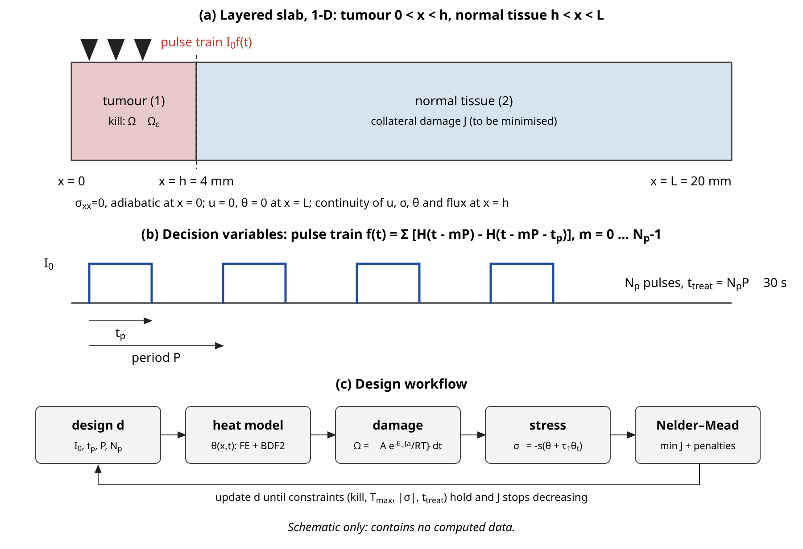
Figure 1. Problem set-up and workflow. (a) Layered slab with the pulse-train source at x = 0. (b) Decision variables of the pulse train. (c) Design loop. This figure is a schematic and contains no computed data.

3.1 Spatial discretisation
After the quasi-static elimination of the displacement, the heat problem has a single unknown per node, which is the temperature increment, and the damage integral is evaluated as a post-processing quantity that is advanced together with the temperature. The weak form of the reduced energy equation Eq. (23) is obtained by multiplying by a test function $φ$ that vanishes at $x=L$, integrating over the slab, and using the natural boundary condition at the adiabatic surface and the continuity of the flux at the interface,
$\int_{0}^{L}{φ} ℒ[θ] dx+{\int_{0}^{L}{∂}}_{x}φ\left(k ∂_{x}θ+k^{*}∂_{x}v\right)dx=0$ (37)
where $ℒ[θ]$ collects the time-derivative, perfusion and source terms of Eq. (23). The unknown is represented by continuous piecewise linear functions on a mesh with a node at the interface. The mesh has 16 elements of 0.25 mm in the tumour, 40 elements of 0.25 mm in the first 10 mm of the normal tissue, and 6 elements of 1 mm out to the clamped face, that is 62 elements in all. The element matrices for an element of length $ℓ_{e}$ in layer $i$ are
${\left(M_{e}\right)}_{ab}=\frac{C_{eff,i}ℓ_{e}}{6}\left(1+δ_{ab}\right), {\left(K_{e}\right)}_{ab}=\frac{k_{i}}{ℓ_{e}}\left(2δ_{ab}−1\right)$ (38)
(with $a,b∈\{1,2\}$ the local node indices and $δ_{ab}$ the Kronecker symbol; the code stores the symmetric tridiagonal global matrices). The perfusion term is lumped, which keeps it positive and monotone for the nonlinear regulation function. The laser load vector is computed by three-point Gauss–Legendre quadrature of the product of the hat function and the profile $G(x)$ on each element, which resolves the optical depth of 2.6 mm with 0.25 mm elements. The lumped perfusion weight of a node is
$W_{i}={\sum_{e: i∈e}{ω}}_{0,e} \frac{ℓ_{e}}{2}$ (39)
with the sum over the elements that contain the node, so that the interface node carries a contribution from each layer.

3.2 Time discretisation
All time derivatives are approximated by the second-order backward differentiation formula (BDF2) with constant step $Δt$ and with zero history before $t=0$, which is consistent with the rest state Eq. (17),
$Dθ^{n}=\frac{3θ^{n}−4θ^{n−1}+θ^{n−2}}{2 Δt}$ (40)
and the second derivative is the square of this operator, which is a five-term convolution,
$D^{2}θ^{n}={\sum_{j=0}^{4}{d}}_{j}^{(2)} θ^{n−j}, {\sum_{j}{d}}_{j}^{(2)}z^{j}={\left[\frac{3−4z+z^{2}}{2Δt}\right]}^{2}$ (41)
The lag operators of Eq. (23) are applied to the full expression: the product $(1+τ_{q}D)$ acts on the sum of the storage, perfusion and source terms, and the perfusion product $ωθ$ and the source are stored at the previous two steps. With $τ=τ_{q}+τ_{0}$ and with $d_{0}=3/(2Δt)$, the fully discrete system for the nodal vector $θ^{n}$ is
$\left[\left(d_{0}+τd_{0}^{(2)}\right)M+\left(1+τ_{q}d_{0}\right)W\left(θ^{n}\right)+K+\frac{Δt}{2}K^{*}\right]θ^{n}=r^{n}$ (42)
The right-hand side contains the history of the storage term, of the perfusion product $Wθ$, the lagged source and the thermal displacement,
$r^{n}=−M\sum_{j≥1}{\left(d_{j}+τd_{j}^{(2)}\right)}θ^{n−j}−τ_{q}{\sum_{j=1}^{2}{d}}_{j} Wθ^{n−j}+q\left[{\overline{f}}_{n}+τ_{q}D{\overline{f}}_{n}\right]−K^{*}\left(v^{n−1}+\frac{Δt}{2}θ^{n−1}\right)$ (43)
where $d_{j}$ are the coefficients of Eq. (40) and $q$ is the nodal load for unit intensity. The thermal displacement is updated with the trapezoidal rule, which makes the $k^{*}$ term implicit with the factor $Δt/2$ used in Eq. (42),
$v^{n}=v^{n−1}+\frac{Δt}{2}\left(θ^{n}+θ^{n−1}\right)$ (44)
The pulse train is not sampled at the time levels. Its step average is used instead, so that the energy of every pulse is exact for arbitrary pulse widths that are not multiples of the step,
${\overline{f}}_{n}=\frac{ℒ(nΔt)−ℒ((n−1)Δt)}{Δt}$ (45)
$ℒ(t)=\int_{0}^{t}{f} ds=k t_{p}+min\left(t−kP, t_{p}\right) for k=min\left(floor(t/P),N_{p}\right)<N_{p}$ (46)
(with $ℒ=N_{p}t_{p}$ for $k=N_{p}$). For the nonlinear regulation function the matrix $W$ depends on the unknown. In the optimization runs one linearised pass is used, in which $g_{i}$ is evaluated at the linear extrapolation of the two previous steps. For the verification runs the Picard iteration
$θ^{n,(m+1)}={\left[A\left(θ^{n,(m)}\right)\right]}^{−1}r^{n}, max\left|θ^{n,(m+1)}−θ^{n,(m)}\right|<10^{−7} K$ (47)
is run to convergence. The tridiagonal systems are solved with the Thomas algorithm. The Picard iteration needed on average 2.02 passes per step and at most 3. The one-pass linearised scheme and the converged Picard iteration differ by at most $1.1×10^{−5}$ in relative terms for the five design metrics (peak temperature, minimum tumour damage integral, interface damage integral, collateral integral and peak stress), so that the cheap variant is adequate for the search. The in-plane stress is evaluated at the nodes from Eq. (21) with the BDF2 temperature rate,
$σ_{∥,i}^{n}=−s_{i}\left(θ^{n}+τ_{1}Dθ^{n}\right)$ (48)

3.3 Quadrature of the burn integral
The burn integral at each node is advanced over a step with the temperature taken as linear in the step and the rate integrated by composite Simpson's rule with $n_{s}=4$ panels,
$ΔΩ^{n}=\frac{Δt}{3n_{s}}\left[k_{d}(θ_{0})+4{\sum_{odd}{k}}_{d}(θ_{m})+2{\sum_{even}{k}}_{d}(θ_{m})+k_{d}(θ_{n_{s}})\right]$ (49)
with $θ_{m}=θ^{n−1}+(θ^{n}−θ^{n−1})m/n_{s}$. The error of this rule for a smooth rate function is
$\left|ΔΩ−ΔΩ_{exact}\right|≤\frac{Δt^{5}}{180 n_{s}^{4}}max\left|\frac{d^{4}k_{d}}{dt^{4}}\right|$ (50)
and the burn integral is advanced only at nodes where the temperature increment exceeds 3 K, since the rate below this level is negligible within the horizon. The tumour integral is advanced at nodes in $x≤h$ and the normal-tissue integral at nodes in $x≥h$, so the interface node carries both.

3.4 Laplace-domain reference solution
An independent reference is obtained for the linear problem, in which the perfusion coefficient is held constant ($c_{w}=0$ and no shutdown) and inertia is retained. With the Laplace parameter $s$, the lag factors become $1+τ_{q}s$ and the time-derivative operator becomes $s(1+(τ_{q}+τ_{0})s)$. In each layer, the energy equation and the momentum equation for the strain $e=∂_{x}u$ form the coupled system
$κ_{i}\hat{θ}′′=\left[ρc_{v}T_{s}+ω\left(1+τ_{q}s\right)\right]\hat{θ}+T_{0}βT_{s}\hat{e}−\left(1+τ_{q}s\right)I_{0}μ_{a}G(x)\hat{f}(s), T_{s}=s\left[1+(τ_{q}+τ_{0})s\right], κ_{i}=k+\frac{k^{*}}{s}$ (51)
and
$\hat{e}′′=\frac{ρs^{2}}{(1+τ_{1}s)c_{11}}\hat{e}+\frac{β}{c_{11}}\hat{θ}′′$ (52)
Writing $y=(\hat{e},\hat{θ})^{T}$, the homogeneous system is $y′′=My$ with a $2×2$ matrix whose eigenvalues are the squares of the two decay constants of the thermal and the elastic modes,
$detM=m a, tr M=m+\frac{β}{c_{11}}b+a, m=\frac{ρs^{2}}{(1+τ_{1}s)c_{11}}$ (53)
with $a=(ρc_{v}T_{s}+ω(1+τ_{q}s))/κ$ and $b=T_{0}βT_{s}/κ$. The small eigenvalue is computed from the determinant divided by the large one to avoid cancellation, and the elastic mode, whose decay length is far longer than the slab, is expanded in hyperbolic functions to keep the $8×8$ boundary-matching system well conditioned. Each exponential of the Gardner source gives a particular solution
$y_{p}=c e^{−γx}, \left(γ^{2}I−M\right)c=−\frac{(1+τ_{q}s) I_{0}μ_{a}\hat{f}(s) B}{κ}{\left(\frac{β}{c_{11}}, 1\right)}^{T}, γ=\frac{l}{δ}$ (54)
where $B$ and $l$ stand for $B_{1},l_{1}$ and $−B_{2},l_{2}$. The transform of the pulse train is a geometric series,
$\hat{f}(s)=\frac{1−e^{−st_{p}}}{s} \frac{1−e^{−sN_{p}P}}{1−e^{−sP}}$ (55)
The boundary and interface conditions, Eqs. (14) to (16), give an $8×8$ complex linear system for the amplitudes of the four modes in each layer. The time-domain solution is recovered by the Durbin formula with the Fourier series trapezoidal sum,
$f(t)≈\frac{e^{ct}}{T}\left[\frac{1}{2}Re \hat{F}(c)+\sum_{k=1}^{N}{Re}\left\{\hat{F}\left(c+\frac{ikπ}{T}\right)e^{ikπt/T}\right\}\right], T=2t, c=\frac{6}{t}$ (56)
with $N=2500$ terms, accelerated by the Wynn epsilon algorithm applied to the last 40 partial sums $S_{k}$,
$ε_{k+1}^{(j)}=ε_{k−1}^{(j+1)}+\frac{1}{ε_{k}^{(j+1)}−ε_{k}^{(j)}}, ε_{0}^{(j)}=S_{j}$ (57)
The difference between the accelerated sum and the plain sum is below 0.007 per cent of the peak temperature in every verification case, which is a measure of the inversion error.

3.5 Verification measures
Besides the comparison with the Laplace reference, the code is checked by an energy balance. For the Pennes and MGL models, where the stored energy is ${\int{C}}_{eff}(θ+τ_{0}∂_{t}θ) dx$, the balance of incident energy, stored energy, perfusion loss and boundary flux reads
$E_{in}=S(t_{e})+\int_{0}^{t_{e}}{}\int_{0}^{L}{ω}θ dx dt−\int_{0}^{t_{e}}{k} ∂_{x}θ(L,t) dt, S={\int_{0}^{L}{C}}_{eff}\left(θ+τ_{0}∂_{t}θ\right)dx, E_{in}=N_{p}t_{p}I_{0}μ_{a}\int_{0}^{L}{G} dx$ (58)
The observed convergence order and the relative error measure are
$p=\log_{2}\frac{e(Δ)}{e(Δ/2)}, e(Δ)=\frac{\max_{k}\left|Y_{k}(Δ)−Y_{k}^{ref}\right|}{\max_{k}\left|Y_{k}^{ref}\right|}$ (59)
where $Y$ is any monitored quantity and $Δ$ is the step or the mesh size.

3.6 Optimization algorithm
The continuous design variables are transformed to an unconstrained vector $z=(z_{1},z_{2},z_{3})$, so that the intensity and pulse width stay positive and the duty cycle stays in its bounds,
$I_{0}=e^{z_{1}}, t_{p}=e^{z_{2}}, \frac{t_{p}}{P}=0.1+\frac{0.9}{1+e^{−z_{3}}}$ (60)
The pulse number $N_{p}$ is an integer and is handled by an outer loop over $N_{p}∈\{1,2,3,4,6,8,12\}$, which is trivially parallel. For each $N_{p}$ the search begins with 14 random screening evaluations, and Nelder–Mead is run from the best one or two of them. The Nelder–Mead step sequence is the reflection, expansion, contraction and shrink of the simplex of vertices $z_{j}$ around the centroid $z_{c}$ of all but the worst vertex,
$z_{r}=z_{c}+\left(z_{c}−z_{n+1}\right), z_{e}=z_{c}+2\left(z_{c}−z_{n+1}\right), z_{con}=z_{c}+\frac{1}{2}\left(z_{n+1}−z_{c}\right)$ (61)
with at most 60 iterations and an initial simplex step of $(0.4,0.5,0.8)$. The constraints are treated by an exact-penalty function. The normalised violations of the kill, vaporization, stress and treatment-time constraints are
$v_{1}=\frac{max\left(0,lnΩ_{c}−ln\min_{x}Ω_{T}\right)}{lnΩ_{c}}, v_{2}=\frac{max\left(0,T_{max}−T_{vap}\right)}{20 K}, v_{3}=\frac{max\left(0,σ_{max}−σ_{lim}\right)}{σ_{lim}}, v_{4}=\frac{max\left(0,N_{p}P−t_{treat,max}\right)}{t_{treat,max}}$ (62)
and the penalised objective that is minimised is
$Φ(d)=min\left(J,30\right)+50{\sum_{k=1}^{4}{v}}_{k}+200{\sum_{k=1}^{4}{v}}_{k}^{2}$ (63)
During the search the model is run with $Δt=0.4$ s, and the discretisation error of this setting against $Δt=0.05$ s is below 0.3 per cent for the quantities of interest. The best design is then re-evaluated with $Δt=0.05$ s, and a bisection on the intensity within $±8$ per cent restores strict feasibility if the penalised optimum has a small residual violation. The Pareto front is constructed by the epsilon-constraint method, in which the guaranteed kill depth fraction $c$ in Eq. (33) is stepped from 0.3 to 1 and the collateral objective is minimised for each value,
$\min_{d}J_{F}(d) subject to Ω_{T}≥Ω_{c} on [0,ch] and the other constraints, c∈\{0.3,0.4,…,1\}$ (64)
The effect of the conduction model on the safe dose is measured with a dose multiplier. For a fixed pulse-train shape $(t_{p},P,N_{p})$, the multiplier $s^{*}$ is the smallest factor on the intensity for which the kill constraint is met with equality, found by bisection,
$s^{*}=min\left\{s>0: \min_{0≤x≤h}Ω_{T}\left(x,t_{e}; sI_{0}\right)≥Ω_{c}\right\}$ (65)
The kill constraint is monotone in the intensity, which justifies the bisection. All numerical results quoted below were computed with the code described here, using only the Python standard library.

3.7 Modelling choices and their justification
Several choices in the model were made deliberately and deserve a short justification, because each can be questioned. The first is the elimination of the displacement. The alternative is to retain the inertia term and to solve for the displacement and the temperature together. This was avoided for a practical reason, which is that on a time scale of seconds the elastic waves oscillate with periods of the order of ten microseconds, so that any time step suited to the heat conduction would under-resolve them and would produce numerical noise that has nothing to do with the physics. The Laplace-domain reference retains the inertia exactly, so that the claim of negligible inertia does not rest on the reduced model alone but on a comparison with the unreduced one. The second choice is the use of the in-plane stress. The axial stress is zero in the quasi-static limit, and a safety limit on a quantity that is identically zero would be empty. The in-plane stress under lateral constraint is the standard measure of thermal stress for a heated layer that is bonded to a larger body, and it is the quantity that varies discontinuously across the interface because of the difference in stiffness and expansion between the tissues. The third choice is the placement of the temperature-rate lag in the MGL model. The lag $τ_{0}$ is applied to the storage and coupling terms and not to the perfusion sink or the source, which follows the structure of the modified Green–Lindsay energy equation of the source study, so that the MGL model is not simply a renamed Cattaneo–Vernotte model; in the CV model the lag acts on the whole energy balance, including the source.
The fourth choice is the handling of the source at the time levels. A rectangular pulse is discontinuous, and the CV model differentiates the source in time. The step average of Eq. (45) makes the delivered energy exact, and the discrete derivative of the averaged source produces the correct impulse in the heat flux. The error of this treatment is visible in the early-time comparison with the Laplace reference and is small afterwards. The fifth choice is the use of a fixed evaluation horizon of 120 s, not a horizon tied to the end of the pulse train. A horizon tied to the end of the exposure would favour designs that deposit their heat late, and would not count the damage that is done while the tissue cools. A fixed horizon treats all designs alike, and the sensitivity analysis shows the effect of changing it. The sixth choice is the damage objective. The integrated burn integral is not bounded and is dominated by the interface values, while the integrated damage fraction saturates and measures a thickness of destroyed tissue; the first is used for the optimization because it has a useful gradient everywhere, and the second is reported because it has a direct physical meaning.
The last choice concerns the optimizer. Nelder–Mead is a local method, and the objective has plateaus and a narrow feasible region defined by the kill constraint. The multi-start over the pulse number and the random screening before each local search address this. Each case needs of the order of five hundred to two thousand evaluations of the model, each costing a fraction of a second, so that the whole study of about sixty-five optimizations is feasible in pure Python. A gradient-based method with adjoint sensitivities would be more efficient, but it would require the derivative of a discretised model with a non-smooth maximum in the constraints, and for four design variables it would not have changed the conclusions. The independence of the results from the starting points is tested indirectly by the pulse-number loop, in which the best values for the different pulse numbers are consistent to within the spread quoted in Section 4.4.

4. Results and discussion

4.1 Verification of the numerical solution
The first set of results concerns the accuracy of the finite element solution, because every later statement depends on it. The comparison with the Laplace-domain reference is made for the linear problem (constant perfusion), for a single 2 s pulse of $3×10^{5}$ W/m², at the times 1, 3, 6 and 12 s and at nine positions from the surface to 16 mm. For all four heat models the relative difference between the finite element and the reference temperature, normalised by the largest reference value at that time, is below 0.29 per cent from 3 s on, and the in-plane stress agrees to 0.41 per cent (Figure 2 and the upper block of Table 4). At 1 s, while the pulse is on, the differences are larger: 1.8 per cent in temperature and 1.1 per cent in stress for the worst model, which is the MGL case. This is the expected consequence of starting the second-order backward differentiation scheme from the rest state when the source switches on at $t=0$; the error decays as the solution becomes smooth. The inversion error of the reference itself, measured by the difference between the accelerated and the plain Fourier sum, is below 0.007 per cent.
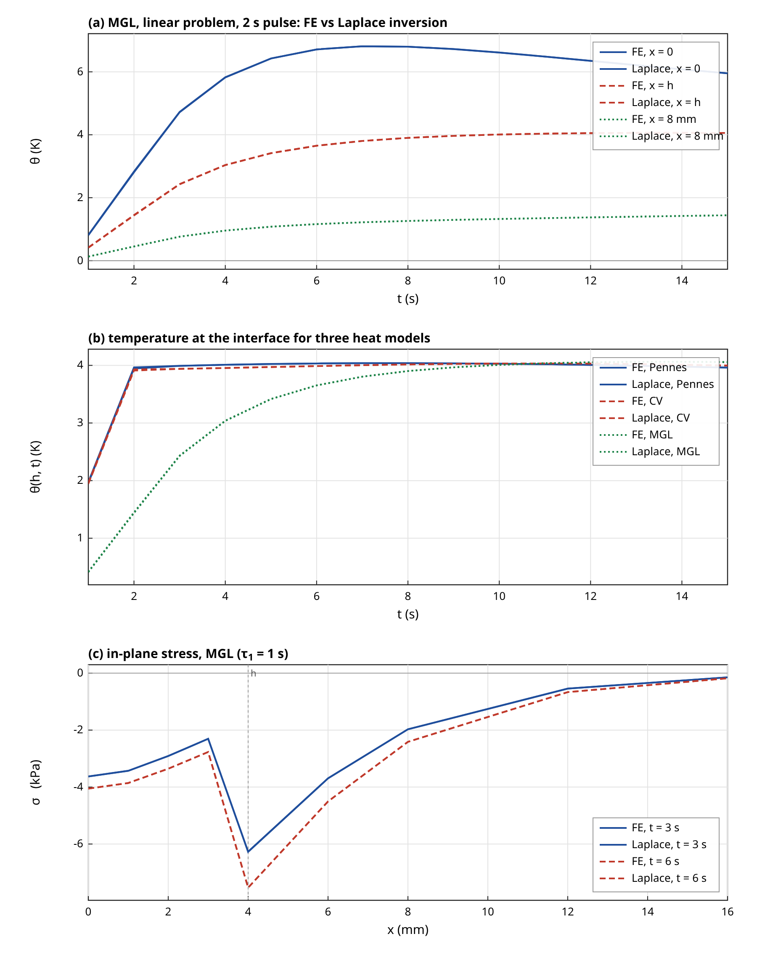
Figure 2. Verification of the finite element (FE) solution against the Laplace-domain reference for the linear problem with a 2 s pulse of 3×10^5 W/m². (a) Temperature histories of the MGL model at the surface, at the interface and at 8 mm. (b) Interface temperature for the Pennes, CV and MGL models. (c) In-plane stress profiles of the MGL model at 3 s and 6 s. FE and reference curves coincide at the resolution of the figure; the quantitative errors are in Table 4.
The convergence study (Figure 3) separates the time-step error, the mesh error and the quadrature error of the burn integral. Against the Laplace reference the temperature error falls from $2.3×10^{−3}$ at $Δt=0.32$ s to a floor of about $3.0×10^{−4}$ that is set by the spatial discretisation and the inversion. The decrease is not monotone between 0.16 s and 0.04 s, because errors of opposite sign from time stepping and from the mesh partly cancel. A cleaner view is given by the self-convergence of the nonlinear pulse-train problem with temperature-dependent perfusion and damage, using a reference with half the mesh size and a quarter of the time step. The minimum tumour damage integral converges in time with an error of $4.1×10^{−3}$ at 0.8 s, $1.3×10^{−3}$ at 0.4 s, $3.5×10^{−4}$ at 0.2 s and $7.2×10^{−5}$ at 0.1 s, an observed order between 1.8 and 2.3. The collateral integral $J_{F}$ is the most sensitive quantity to the mesh: its error is 13 per cent at $Δx=1$ mm, 3.3 per cent at 0.5 mm, 0.78 per cent at 0.25 mm and 0.15 per cent at 0.125 mm, which is second-order convergence. The search mesh (0.25 mm) therefore resolves $J_{F}$ to better than 1 per cent, and the final designs are evaluated at $Δt=0.05$ s.
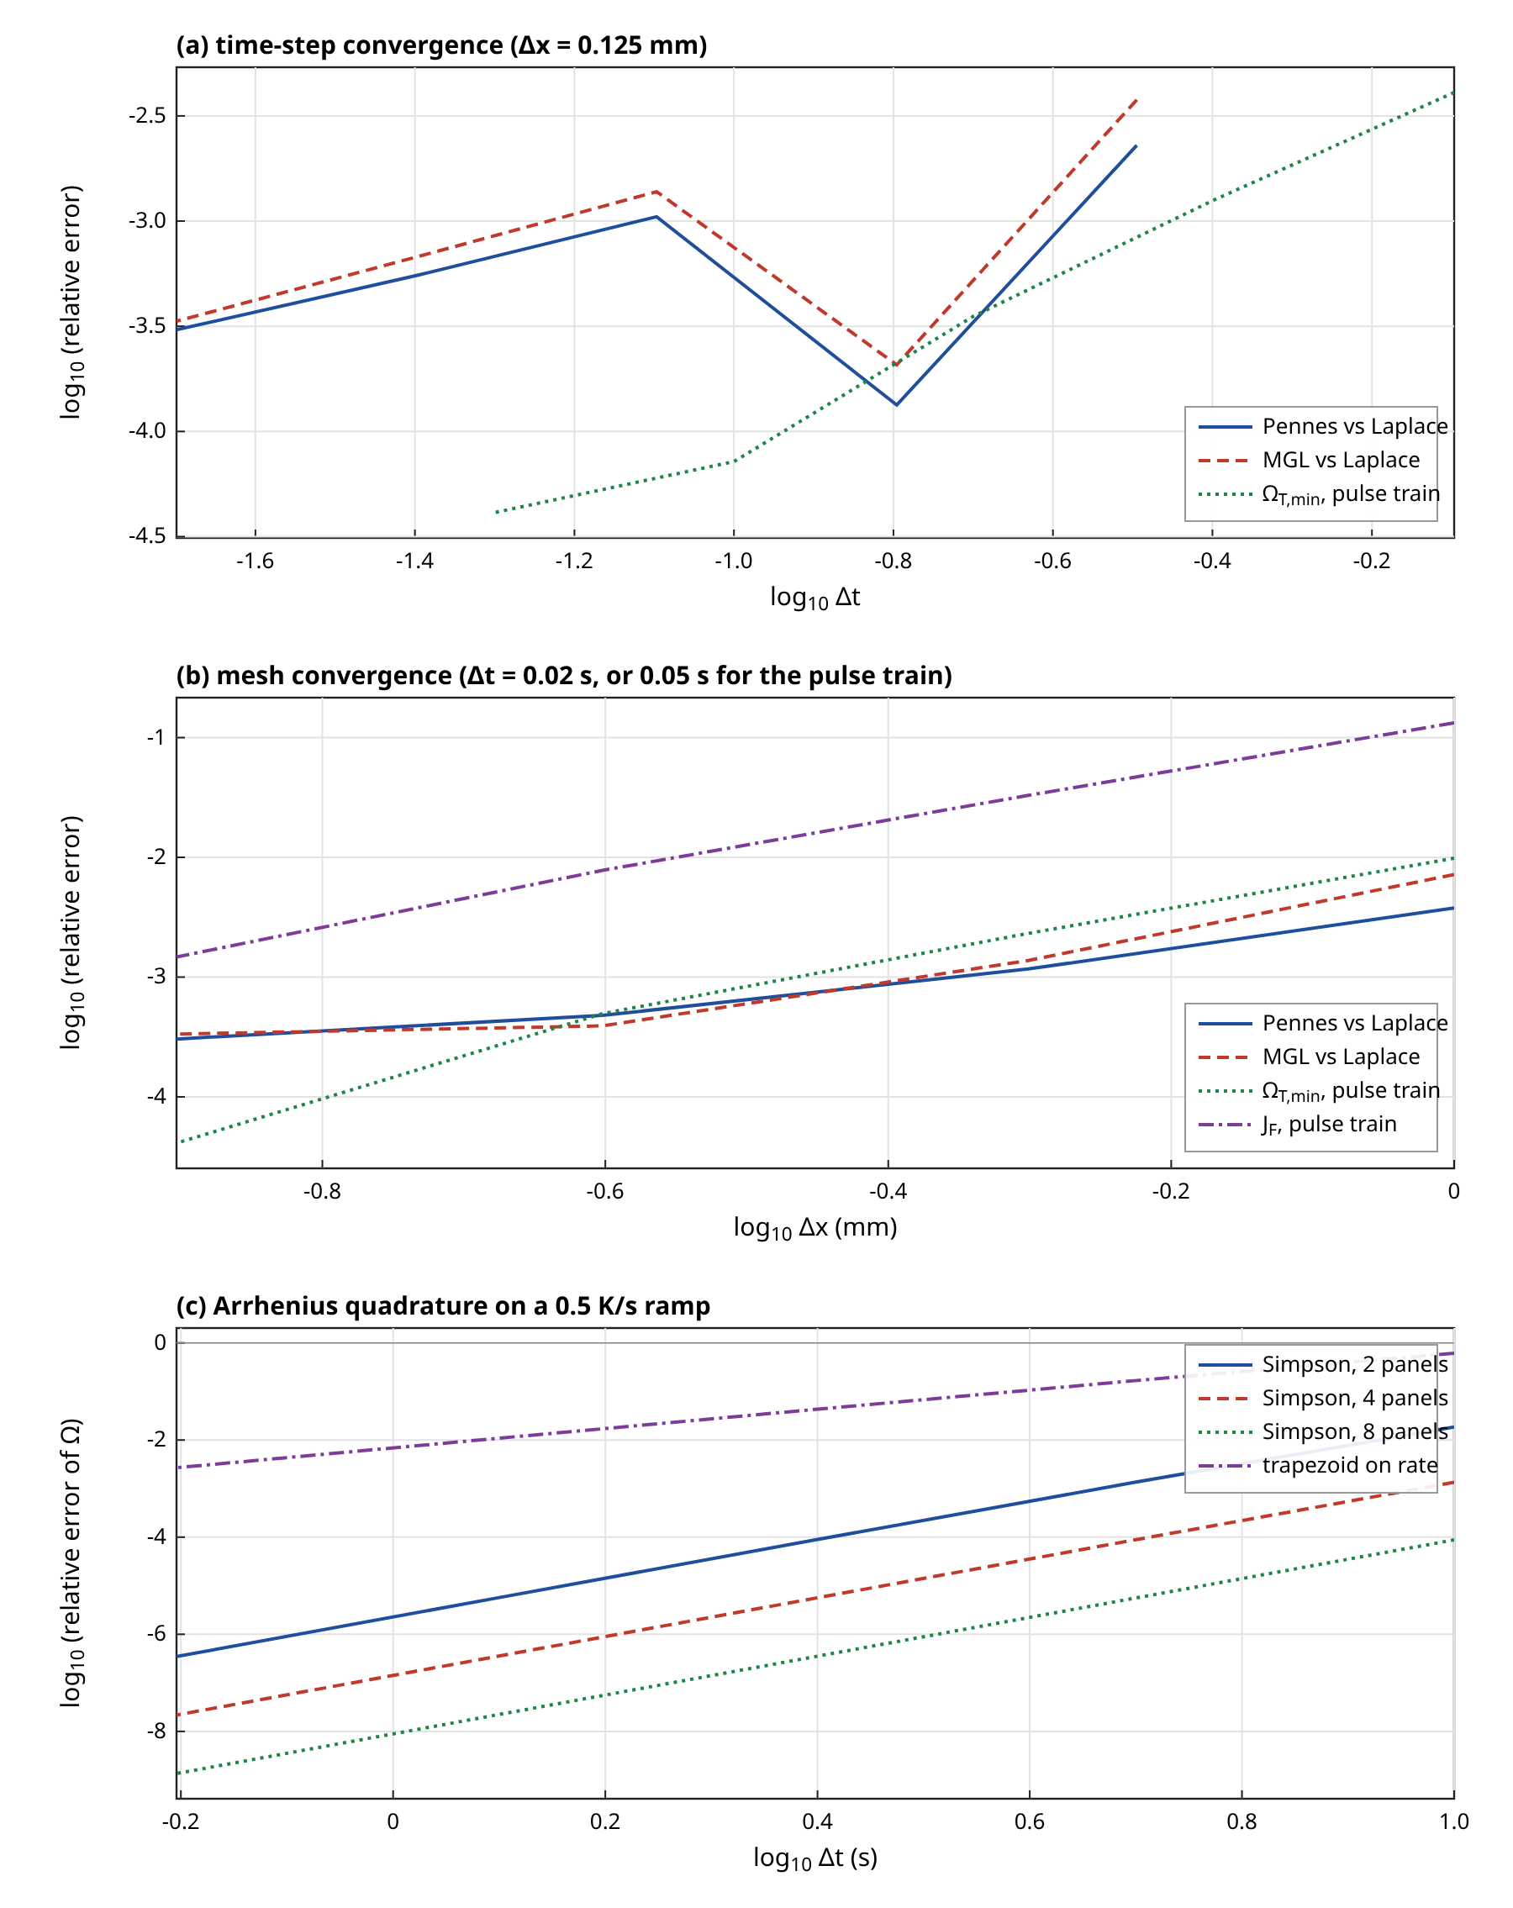
Figure 3. Convergence of the numerical method. (a) Time-step error against the Laplace reference (linear problem) and against a refined solution (pulse-train problem with nonlinear perfusion). (b) Mesh error for the same cases. (c) Error of the Arrhenius burn integral on a linear temperature ramp for composite Simpson with 2, 4 and 8 panels per step and for the trapezoidal rule applied to the rate.
The quadrature of the burn integral is exact at constant temperature to rounding error (relative error below $1.7×10^{−15}$), as it must be since the rate is then constant. On a ramp of 0.5 K/s over 60 s with the tumour kinetics, which spans a rate change of several orders of magnitude, Simpson's rule with four panels per step has the error $1.3×10^{−3}$ at $Δt=10$ s, falling with fourth-order behaviour to $5.5×10^{−6}$ at 2.5 s, whereas the trapezoidal rule applied to the rate has the error 4.3 per cent at 2.5 s and only second-order convergence. At the production step of 0.05 s the quadrature error is therefore negligible against the other errors. The energy balance, Eq. (58), closes to $3.5×10^{−5}$ of the incident energy for the Pennes model and to $3.6×10^{−5}$ for the MGL model in the linear problem, and to $5.1×10^{−5}$ and $4.6×10^{−5}$ with the nonlinear perfusion law. The incident energy computed from the load vector agrees with the analytic integral of the Gardner profile to $6.2×10^{−13}$. For the CV model the storage functional used for the balance is incomplete, because the flux relaxation stores energy that it does not include, and the residual of $7.8×10^{−4}$ is a property of that functional; it is not reported as a check.

4.2 Quasi-static limit and the character of the thermoelastic stress
With inertia retained in the Laplace-domain solution, the elastic transit time is $8.49×10^{−5}$ s, and the ratio of Eq. (19) for a loading time scale of 1 s is $7.2×10^{−9}$. The explicit comparison at the four output times shows that the temperature with the true density differs from the temperature with the density reduced by a factor of $10^{4}$ by at most $2.2×10^{−12}$ relative to the peak, which is at the level of rounding in the inversion, and the axial stress with inertia retained never exceeds $1.5×10^{−9}$ of the in-plane stress. Reducing the density by a factor of $10^{2}$ instead of $10^{4}$ gives the same result to the same accuracy, so the effect is not a numerical artefact of the reduction. The quasi-static limit is therefore justified quantitatively for loading times of the order of a second and longer. It would not be justified for nanosecond or microsecond pulses, for which the elastic wave propagation produces genuine axial stress and pressure transients, and the present model should not be used for such pulses.
The same calculation shows that the thermoelastic coupling is negligible for the heat balance. The coupling term raises the effective heat capacity by 0.016 per cent in the tumour and 0.06 per cent in the normal tissue, so that the Pennes, CV and MGL temperature fields are insensitive to whether the coupling is kept. The stress is a consequence of the temperature field and not the other way round. Because the axial stress vanishes, the stress constraint is applied to the in-plane stress of Eq. (21). This quantity is proportional to the local temperature, with the factor $s_{i}$, so that the stress limit is in effect a limit on temperature and on its rate of change, with a larger weight in the stiffer normal tissue. At the interface the stress on the normal side, with $s_{2}=1961.6$ Pa/K, is 3.33 times larger than on the tumour side for the same temperature, which is why the peak stress of every design occurs on the normal side of the interface. A caveat is that the in-plane stress assumes complete lateral constraint. The stress in a real lesion, whose lateral extent is finite, is smaller and depends on the geometry. The values reported are therefore an upper bound under the stated assumption.

4.3 Baseline optimal design
The optimization results for the four conduction models in the two scenarios are collected in Table 2. For the MGL model in the selective scenario S1 the best design found has 12 pulses of 1.13 s with a period of 1.13 s and a peak intensity of 154.7 kW/m², which is a duty cycle of 1.00, a nearly continuous exposure of 13.6 s with a total fluence of 2.09 MJ/m². The peak temperature, at the surface, is 60.1 °C, well below the vaporization limit. The peak in-plane stress is 29.4 kPa, compressive and on the normal side of the interface, below the limit of 36 kPa. The tumour is killed (damage fraction at least 0.99) over its full depth, with the constraint active at the tumour edge, where the minimum damage integral is 4.611 against the requirement 4.605. Near the surface the damage integral is of order 100, so that the tissue next to the laser is far more damaged than required; the profile is a result of the exponential optical decay. The damage fraction on the normal side of the interface is 0.171, and it falls below 1 per cent at 2.25 mm from the interface. The burn integral in the normal tissue never reaches 1, so that no healthy tissue reaches the 63 per cent damage level, and the collateral measure is $J_{F}=0.129$ mm.
Table 2. Optimal pulse-train designs found by the Nelder–Mead search for each conduction model in the selective scenario S1 (normal tissue with Henriques–Moritz kinetics) and the non-selective scenario S2 (normal tissue with tumour kinetics). All designs satisfy the kill, vaporization, stress and treatment-time constraints. $F_{N}(h)$ is the damage fraction on the normal side of the interface; $J_{F}$ is the integrated damage fraction in the normal tissue.
Scenario, model | $N_{p}$ | $t_{p}$ (s) | $P$ (s) | $I_{0}$ (kW/m²) | $T_{max}$ (°C) | $σ_{max}$ (kPa) | $F_{N}(h)$ | $J_{F}$ (mm) | $J$
S1, Pennes | 3 | 4.37 | 4.53 | 160.0 | 61.0 | 30.4 | 0.171 | 0.129 | 0.127
S1, CV | 1 | 14.85 | 15.35 | 140.7 | 61.1 | 30.1 | 0.171 | 0.129 | 0.127
S1, MGT | 1 | 14.09 | 14.60 | 162.7 | 61.2 | 34.5 | 0.208 | 0.306 | 0.277
S1, MGL | 12 | 1.13 | 1.13 | 154.7 | 60.1 | 29.4 | 0.171 | 0.129 | 0.127
S2, Pennes | 12 | 1.09 | 1.12 | 159.7 | 61.0 | 30.5 | 0.990 | 1.821 | 1.583
S2, CV | 1 | 14.36 | 14.83 | 145.4 | 61.2 | 30.1 | 0.990 | 1.812 | 1.578
S2, MGT | 1 | 14.09 | 28.52 | 162.6 | 61.2 | 34.5 | 0.990 | 4.628 | 2.194
S2, MGL | 12 | 1.13 | 1.15 | 154.7 | 60.1 | 29.4 | 0.990 | 1.809 | 1.579

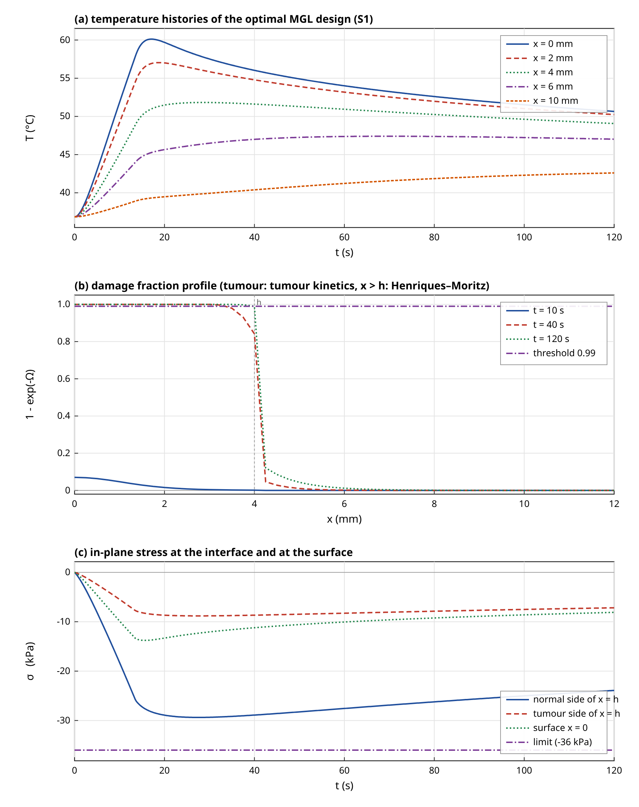
Figure 4. Baseline optimal design for the MGL model in scenario S1. (a) Temperature histories at five depths. (b) Damage fraction profiles at three times; the damage keeps growing after the laser is off. (c) In-plane stress on both sides of the interface and at the surface, with the stress limit.
A property of the solution which is easy to miss is that almost all of the damage is done after the laser has been switched off. At the end of the pulse train, at 13.6 s, the damage integral at the tumour edge is only 0.019, about 0.4 per cent of its final value of 4.611. The temperature at the tumour edge peaks at 15.0 K above the reference, which is 51.8 °C, at 28.6 s, some 15 s after the end of the exposure, because heat from the hot surface layer conducts through the tumour on a time scale of tens of seconds. This feature is a consequence of the one-dimensional geometry, which has no lateral heat loss and cools only by conduction into the normal tissue and by perfusion, and it is the reason why the evaluation horizon matters so much in the sensitivity analysis. A laser spot of finite diameter would lose heat laterally and would have a shorter tail. In the model the evaluation horizon $t_{e}=120$ s captures most but not all of the damage; the minimum tumour damage integral of the baseline design increases from 1.07 at 30 s to 3.01 at 60 s, 4.61 at 120 s and 5.55 at 300 s, with the collateral integral growing in parallel.

4.4 Why the pulse structure hardly matters
The most striking feature of Table 2 and of Figure 6a is that the best objective is nearly independent of the number of pulses. For the MGL model, the best values for $N_{p}=1$ to 12 lie between 0.1266 and 0.1278, and over the Pennes, CV and MGL models the full range of the best values is 0.1264 to 0.1286, a spread of 1.7 per cent. The optimal intensity, pulse width and period differ greatly from one pulse number to another, but the objective hardly changes, so the objective surface has a broad flat ridge and the design problem is far from having a unique minimiser in the design variables. The reason can be stated in terms of two time scales. The thermal diffusion time of the tumour layer is
$t_{d}=\frac{h^{2}}{α}, α=\frac{k}{ρc_{v}}$ (66)
which is 86.7 s for $h=4$ mm and $α_{1}=$1.845\times10^{-7}$$m²/s.Pulseperiodsofafewsecondsareshortagainst$t_d$, so the temperature at the tumour edge does not see the individual pulses but only the delivered fluence, smoothed by diffusion. The dose at the edge is delivered along the slow decay of the temperature, as the estimate
$Ω_{T}(h,t_{e})≈k_{d,T}\left(T_{h}^{max}\right)Δt_{eff}$ (67)
shows, in which $T_{h}^{max}=51.8$ °C is the peak temperature at the edge, $k_{d,T}$ is the tumour rate constant, which is 0.081 s$^−1$ at that temperature, and the effective duration is $Δt_{eff}=56.6$ s. This duration is of the order of $t_{d}$, and it is set by the geometry, not by the pulse train. The requirement $Ω_{T}(h)≥Ω_{c}$ then fixes the peak temperature at the edge, and with it the energy to be delivered, for any pulse train that is short compared with $t_{d}$. The collateral damage follows from the same temperature history through the selectivity ratio at the edge. At the peak temperature the rate ratio of Eq. (29) is 22.9 in favour of the tumour, and the ratio of the burn integrals at the interface is the inverse of a similar number,
$\frac{Ω_{N}(h,t_{e})}{Ω_{T}(h,t_{e})}≈ϱ_{sel}^{−1}\left(T_{h}^{max}\right)$ (68)
which is 0.044 from the estimate against 0.041 from the computation, the small difference arising from the temperature range over which the dose accumulates. The collateral objective is therefore set principally by the temperature at the edge and by the kinetic selectivity, and the freedom in the pulse train changes it only at the per cent level. The practical meaning is that, within this model, the choice of the pulse number and period can be made on other grounds, for example the peak temperature at the surface or the stress rate, because it does not alter the collateral damage; and the designs found by the search differ in those secondary quantities. The designs differ in secondary quantities: the nearly continuous design has a peak intensity of 154.7 kW/m² and a surface peak of 60.1 °C, whereas an equally good pulsed design with $N_{p}=2$ and a duty cycle of 0.65 has 279.3 kW/m² and 60.4 °C, with the same objective to within 0.3 per cent. I do not claim that any of them is clinically preferable.

4.5 Do the conduction models change the safe dose?
The answer depends on which of the models is used and on the size of the relaxation parameters. Table 3 shows the response of the pulse train that is optimal for the Pennes model when it is applied under each model. Under CV and MGL the minimum tumour damage integral at the unscaled intensity is 4.84 and 4.70 against 4.61 for Pennes, so the constraint is met with a small margin, and the multipliers that make the constraint exactly active are 0.995 and 0.998. For the MGT-type model with $η=0.5$ the same design leaves the tumour edge with only 1.96, a clear failure of the kill constraint, and the dose must be raised by 9.0 per cent, at which point the collateral integral is 0.303 mm against 0.129 mm for Pennes, a factor of 2.35. The peak stress at that dose is 34.5 kPa and a short tensile phase appears, which is absent in the other models.
Table 3. Model comparison for the pulse train that is optimal under the Pennes model (S1: $N_{p}=3$, $t_{p}=4.37$ s, $P=4.53$ s, $I_{0}=160.0$ kW/m²). Columns 2 to 4 give the response when the same pulse train is applied under each model; $s^{*}$ is the multiplier on $I_{0}$ that just satisfies the kill constraint, and the last three columns are evaluated at $s^{*}$.
Model | $minΩ_{T}$ at $s=1$ | $F_{N}(h)$ at $s=1$ | $T_{max}$ at $s=1$ (°C) | $s^{*}$ | $J_{F}$ at $s^{*}$ (mm) | $σ_{max}$ at $s^{*}$ (kPa) | $T_{max}$ at $s^{*}$ (°C)
Pennes | 4.61 | 0.171 | 61.0 | 1.000 | 0.129 | 30.4 | 61.0
CV | 4.84 | 0.180 | 61.4 | 0.995 | 0.129 | 30.1 | 61.3
MGT | 1.96 | 0.083 | 59.4 | 1.090 | 0.303 | 34.5 | 61.4
MGL | 4.70 | 0.175 | 60.2 | 0.998 | 0.129 | 29.4 | 60.1

The cross evaluation of the model-specific optima confirms the picture. The Pennes optimum gives a tumour-edge damage integral of 4.70 under MGL, whereas the MGL optimum gives 4.52 under Pennes, which is below the requirement of 4.61 by 2 per cent, so that planning with the wrong model among these three leads to a shortfall or to an excess of a few per cent. The MGT optimum, planned with the thermal-displacement term, gives 10.86 under MGL, an overdose of more than a factor of two in the damage integral. The response of the safe dose to the relaxation time is shown in Figure 5b. For CV the multiplier falls from 1.000 at $τ_{q}=0$ to 0.958 at 20 s, and for MGL it first decreases to 0.998 at 2 s and then rises to 1.039 at 20 s. The effects are within about 4 per cent for any relaxation time in the range of one to twenty seconds. For the MGT model, Figure 5c, the multiplier rises with $η$ from 0.995 at $η=0$ to 1.115 at $η=0.9$. The thermal-displacement term thus changes the dose by up to 12 per cent, and the collateral integral much more.
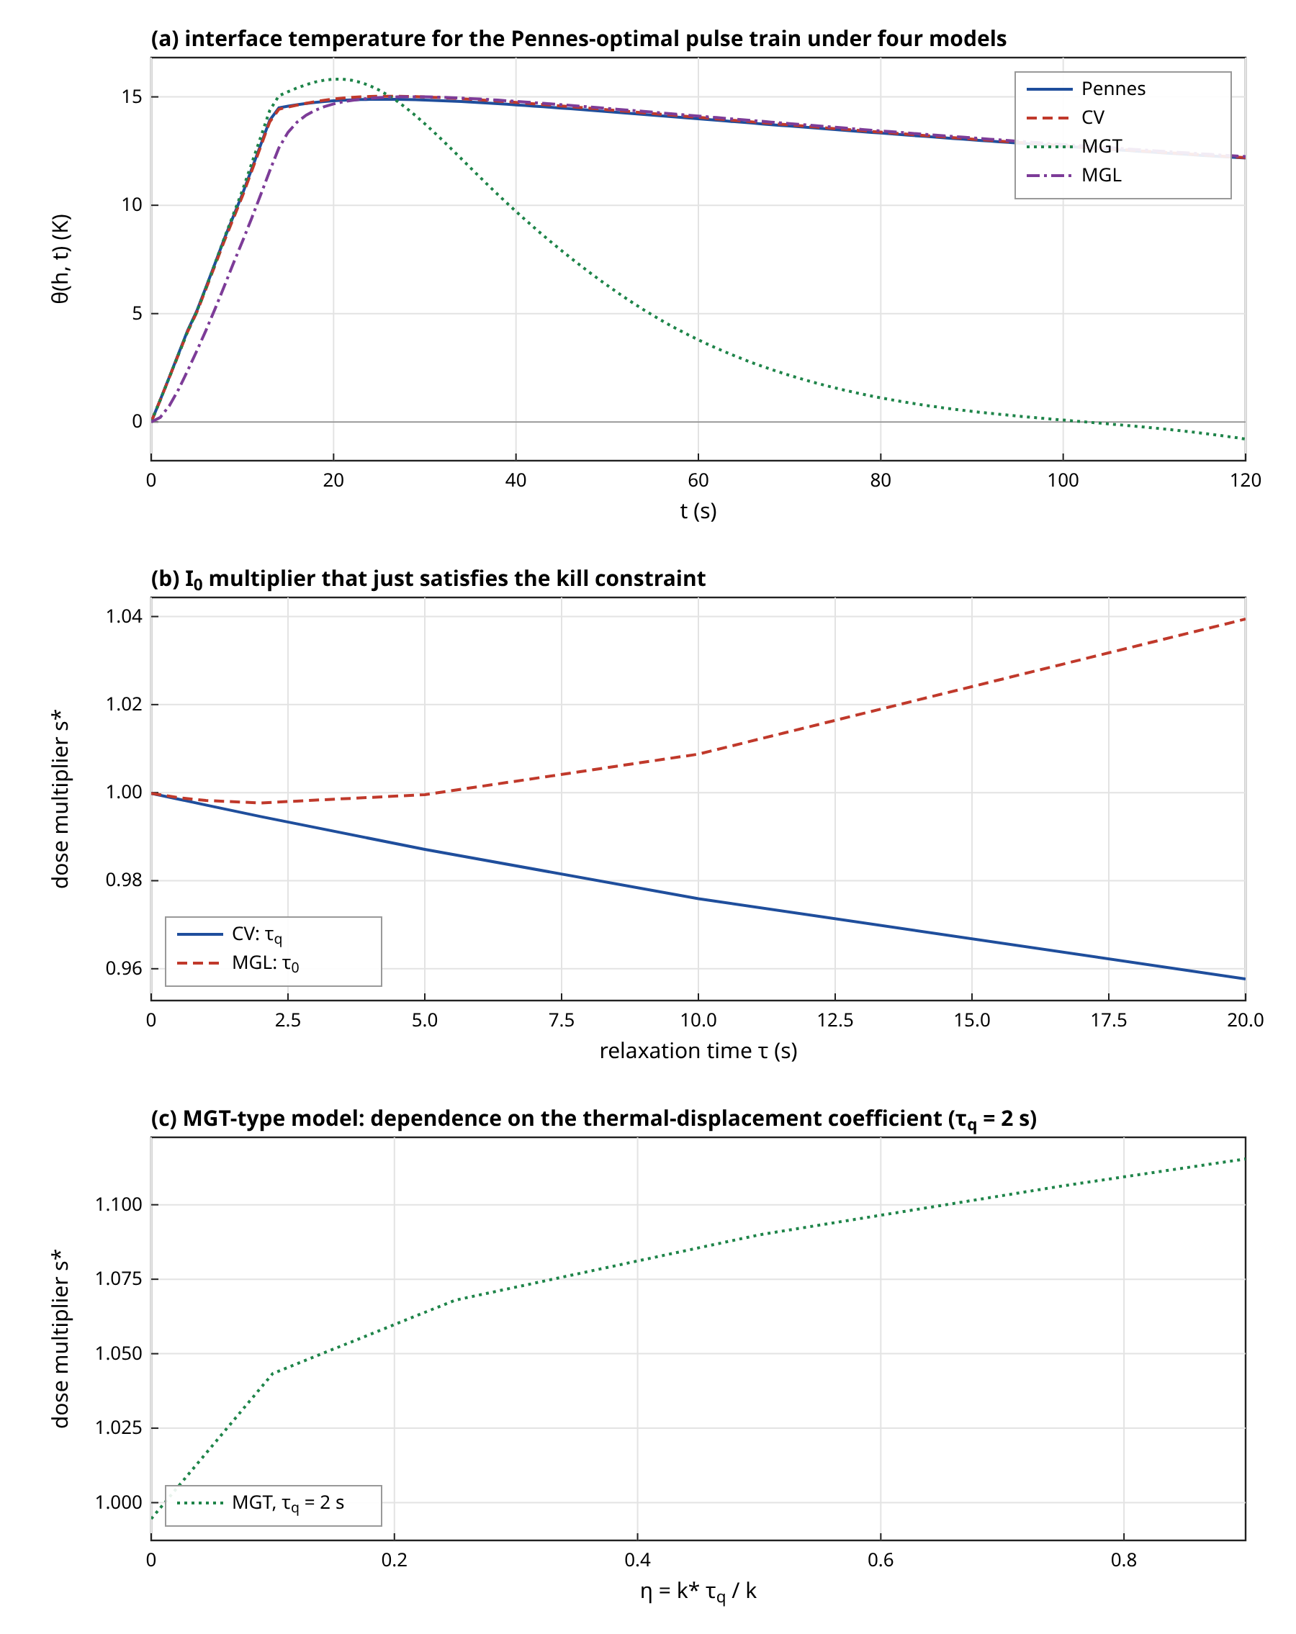
Figure 5. Influence of the conduction model on the dose. (a) Interface temperature histories for the pulse train that is optimal under Pennes (parameters in Table 3) under the four models. (b) Multiplier on the intensity that exactly meets the kill constraint against the relaxation time. (c) The same multiplier for the MGT-type model against its thermal-displacement coefficient.
The reason for the large effect of the thermal-displacement term, in contrast with the small effect of the relaxation times, can be read from the structure of the equations. The relaxation times enter through $τ∂_{t}^{2}θ$ and its analogues, whose size relative to the capacity term is $τ/t_{c}$ for a loading time scale $t_{c}$; with $τ=2$ s and a heating and decay process lasting tens of seconds this is a correction of a few per cent. The term $k^{*}∂_{x}^{2}v$ is an integral over the history of the temperature, and in the slow decay phase it acts as an additional, long-lived conduction of heat, so that a model with it distributes heat more widely. The result suggests that the choice of the MGT parameter, and not the relaxation time, is the model-form uncertainty that matters for the design. It also shows that the source value of $k^{*}$ cannot be combined with a relaxation time of seconds, as explained in Section 2.5. The comparison between models here is a comparison of mathematical models with illustrative parameters, and no model is claimed to describe real tissue better than another, since no measurements were available.

4.6 Pareto front and activity of the constraints
The epsilon-constraint sweep of the kill depth (Figure 6b) shows the trade-off between the depth of tumour that is guaranteed to be killed and the damage to normal tissue. In the selective scenario S1 the collateral integral $J_{F}$ increases from 0.0124 mm for 30 per cent of the tumour depth to 0.1288 mm for the full depth, a factor of 10.4. The relation is convex in the sense that the last 10 per cent of depth costs 39.3 per cent of the total collateral damage. Without kinetic selectivity (S2) the damage is larger by one to two orders of magnitude, from 0.446 mm to 1.813 mm, and the front has a similar shape. The values for S2 show how much of the protection of the healthy tissue in S1 is provided by the assumed kinetic difference and how much by the thermal design. In S2 the burn integral at the interface equals the tumour value by construction, so the collateral damage is determined by the temperature field alone, and the relative cost of the last increment of depth is smaller (a factor of 4.1 between the ends of the front, against 10.4 in S1).
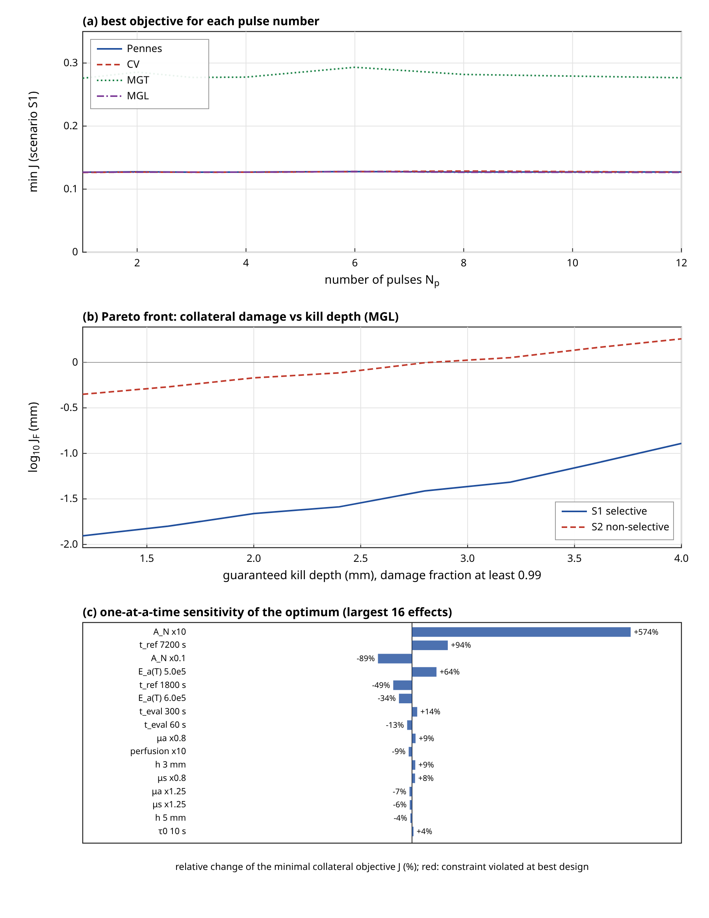
Figure 6. Optimization results. (a) Best objective for each pulse number and conduction model in scenario S1; the surface is almost flat in N_p. (b) Pareto front of the integrated collateral damage against the guaranteed kill depth for the MGL model in the selective (S1) and non-selective (S2) scenarios. (c) One-at-a-time sensitivity of the minimal objective; blue bars are feasible optima and red bars would denote optima that violate a constraint.
The constraint activity at the base optimum is as follows. The kill constraint is active. The vaporization constraint is far from active, with a margin of 39.9 K, because the exposures that minimise the collateral damage are gentle. The treatment-time constraint is not active either, since the nearly continuous exposure takes 13.6 s against the allowed 30 s, and sweeping the allowed time from 10 s to 60 s changes the optimum by less than 1 per cent. The stress constraint is the interesting one. A sweep over the stress limit from 26 to 36 kPa and over treatment-time limits of 10, 30 and 60 s shows that the problem is infeasible for limits below about 29.3 kPa for all three treatment times: at 28 kPa the least violating design exceeds the limit by 4.9 per cent and at 26 kPa by 12.8 to 13.0 per cent, and the peak stress found is 29.3 kPa in all cases. The reason is again the physics of the tail. The stress at the interface at the time of the temperature peak is $s_{2}θ_{h}^{max}=1961.6×14.97=29.4$ kPa, and the temperature rise at the edge cannot be lowered below about 15 K if the damage integral is to reach its target within the horizon of 120 s, whatever the pulse train. A longer horizon would permit a lower and longer temperature plateau and hence a lower stress; with $t_{e}=300$ s the peak stress of the optimum is indeed 28.7 kPa. The strain-rate lag changes the picture. With $τ_{1}=5$ s and 10 s the optimum violates the 36 kPa limit by 1.9 and 4.6 per cent, with peak stresses of 36.7 and 37.7 kPa, because a long lag amplifies the stress that is associated with the temperature rate at the end of the exposure.

4.7 Sensitivity
Table 4 and Figure 6c give the effect of changing one input at a time, with the optimization repeated each time. Sorting by the size of the effect, the Arrhenius parameters dominate. Raising the frequency factor of the normal tissue by a factor of ten raises the minimal collateral objective by 574.2 per cent and lowering it by ten reduces it by 89.4 per cent. The tumour kinetics matter almost as much: a change of the tumour activation energy to $5.0×10^{5}$ J/mol raises $J$ by 64.3 per cent and to $6.0×10^{5}$ J/mol lowers it by 34.3 per cent, and halving or doubling the anchor time changes it by -49.3 and +94.0 per cent. The conclusion is that the absolute values of the collateral damage in this paper cannot be taken as predictions, because they depend on poorly known kinetic parameters in an exponential way; the qualitative results, such as the flatness in the pulse number, the dominance of the post-exposure tail and the small difference between Pennes, CV and MGL, are the robust ones.
The evaluation horizon is the next most important input, with -12.8 per cent for 60 s and +13.7 per cent for 300 s, which reflects the tail discussed above. The optical properties come next. A 25 per cent higher absorption coefficient reduces $J$ by 6.6 per cent, which is consistent with a shallower deposition of the light, but at the same time the surface becomes hotter (61.9 °C against 60.1 °C). A thinner tumour (3 mm) raises $J$ by 8.6 per cent, consistent with the normal tissue being closer to the surface, whereas a 5 mm tumour reduces it by 4.2 per cent. Perfusion has a small effect: raising it tenfold lowers $J$ by 8.7 per cent, and removing it changes $J$ by +1.6 per cent. The shutdown of perfusion after damage has no visible effect at all, because the tumour is damaged only in the tail when the temperature is already falling, and the normal tissue is hardly perfused. The relaxation time $τ_{0}$ changes $J$ by less than 4 per cent over the range 0.5 s to 10 s. The strain-rate lag $τ_{1}$ does not change $J$ at all, because it enters the stress and not the heat balance, but it changes the stress and so decides the feasibility.
Table 4. Verification results and one-at-a-time sensitivity of the optimum. Upper block: verification checks. Lower block: the collateral objective $J$ of the re-optimized MGL design (S1) when one input is changed; the percentage is the change relative to the base optimum $J=0.126$.
Check or case | Setting or change | Result
FE vs Laplace, temperature | Pennes, CV, MGT, MGL; $t=3,6,12$ s; linear problem | max relative error 0.29 %
FE vs Laplace, in-plane stress | same | max relative error 0.41 %
FE vs Laplace, early time | $t=1$ s (pulse on) | temperature 1.8 %, stress 1.1 %
Time-step convergence | $Δt=0.32→0.02$ s, vs Laplace | error $2.3×10^{−3}$ to floor $3.0×10^{−4}$
Mesh convergence (pulse train) | $Δx=1→0.125$ mm | $J_{F}$ error $1.3×10^{−1}$ to $1.5×10^{−3}$; order about 2
Burn integral, constant $T$ | $Ω=A t e^{−E_{a}/RT}$, three temperatures | relative error below $1.7×10^{−15}$
Burn integral, ramp | 0.5 K/s, 60 s, $Δt=2.5$ s, $n_{s}=4$ Simpson | error $5.5×10^{−6}$ (order 4); trapezoid $4.3×10^{−2}$
Energy balance | Pennes and MGL, linear and nonlinear perfusion | residual $3.5×10^{−5}$ to $5.1×10^{−5}$ of $E_{in}$
Quasi-static limit | inertia retained vs reduced density, $t=1$ to 12 s | $Δθ/θ_{max}≤$ $2.2×10^{−12}$; $|σ_{xx}|/|σ_{∥}|≤$ $1.5×10^{−9}$
Picard vs one pass | five design metrics | relative difference below $1.1×10^{−5}$
Sensitivity: Base optimum (MGL, S1) | none | $J=$0.126 (+0 %); $T_{max}=$60.4 °C; $σ_{max}=$29.3 kPa
Sensitivity: Tumour $E_{a}$ | $5.0×10^{5}$ | $J=$0.208 (+64 %); $T_{max}=$61.5 °C; $σ_{max}=$31.1 kPa
Sensitivity: Tumour $E_{a}$ | $6.0×10^{5}$ | $J=$0.083 (-34 %); $T_{max}=$59.3 °C; $σ_{max}=$27.9 kPa
Sensitivity: Tumour anchor time | 1800 s | $J=$0.064 (-49 %); $T_{max}=$58.4 °C; $σ_{max}=$27.1 kPa
Sensitivity: Tumour anchor time | 7200 s | $J=$0.245 (+94 %); $T_{max}=$61.8 °C; $σ_{max}=$31.7 kPa
Sensitivity: Normal $A$ | $×10$ | $J=$0.853 (+574 %); $T_{max}=$60.6 °C; $σ_{max}=$29.3 kPa
Sensitivity: Normal $A$ | $×0.1$ | $J=$0.013 (-89 %); $T_{max}=$60.6 °C; $σ_{max}=$29.3 kPa
Sensitivity: Perfusion | $×0$ | $J=$0.128 (+2 %); $T_{max}=$60.4 °C; $σ_{max}=$29.3 kPa
Sensitivity: Perfusion | $×10$ | $J=$0.115 (-9 %); $T_{max}=$60.3 °C; $σ_{max}=$29.8 kPa
Sensitivity: Shutdown after damage | $κ_{v}=1$ | $J=$0.126 (+0 %); $T_{max}=$60.4 °C; $σ_{max}=$29.3 kPa
Sensitivity: $τ_{0}$ | 0.5 s | $J=$0.126 (-0 %); $T_{max}=$61.4 °C; $σ_{max}=$29.6 kPa
Sensitivity: $τ_{0}$ | 10 s | $J=$0.131 (+4 %); $T_{max}=$57.6 °C; $σ_{max}=$29.5 kPa
Sensitivity: $τ_{1}$ | 5 s | $J=$0.126 (-0 %); $T_{max}=$60.5 °C; $σ_{max}=$36.7 kPa; stress limit violated by 1.9 %
Sensitivity: $τ_{1}$ | 10 s | $J=$0.129 (+2 %); $T_{max}=$59.0 °C; $σ_{max}=$37.7 kPa; stress limit violated by 4.6 %
Sensitivity: $μ_{a}$ | $×0.8$ | $J=$0.138 (+9 %); $T_{max}=$58.4 °C; $σ_{max}=$29.5 kPa
Sensitivity: $μ_{a}$ | $×1.25$ | $J=$0.118 (-7 %); $T_{max}=$61.9 °C; $σ_{max}=$29.4 kPa
Sensitivity: Tumour thickness | 3 mm | $J=$0.137 (+9 %); $T_{max}=$57.0 °C; $σ_{max}=$30.8 kPa
Sensitivity: Tumour thickness | 5 mm | $J=$0.121 (-4 %); $T_{max}=$63.4 °C; $σ_{max}=$28.6 kPa
Sensitivity: Horizon $t_{e}$ | 60 s | $J=$0.110 (-13 %); $T_{max}=$61.1 °C; $σ_{max}=$30.8 kPa
Sensitivity: Horizon $t_{e}$ | 300 s | $J=$0.144 (+14 %); $T_{max}=$59.8 °C; $σ_{max}=$28.7 kPa

4.8 Limitations and honest assessment
The study has several limitations that bear on the interpretation. There is no experimental or clinical validation: the model has been verified against an independent mathematical solution, against exact results and against an energy balance, which shows that the equations are solved correctly, but whether the equations describe a real tumour has not been tested. The Arrhenius parameters of the tumour are an anchored illustration, and the Henriques–Moritz values, for which the skin-burn origin is classical, are a proxy for healthy tissue. The perfusion law, the relaxation times and the stress limit are illustrative. The geometry is one-dimensional, so that lateral heat loss is absent, the tail of the temperature is long, and the in-plane stress is a constrained upper bound. A three-dimensional model of a focal spot would change the quantitative conclusions, and the dependence on the pulse structure might become stronger for small spots. The linear mesh and the second-order time stepping resolve the problem as shown, but the first second of a pulse starting from rest carries an error of the order of one to two per cent. The optimization is a derivative-free local search from random starts; the flat ridge of the objective means that the minimiser is not unique and that the reported designs are representative members of a family, not the single best design. Finally, the stress limit and the vaporization limit are not active at the minimum of the collateral damage, with the exception of the infeasibility below 29.3 kPa, and a reader who needs them to be active would have to specify them from tissue data. None of these results is a clinical recommendation.

4.9 Interpretation for treatment planning
The results can be translated into statements about planning, within the limits stated above. The first statement is that the dose should be specified at the tumour edge and not at the surface. The surface temperature in the optimal designs is about 60 °C, but the tumour is killed only because the edge, at about 52 °C, remains warm for a long time; a plan that is based on the surface temperature alone would not see that the edge is the critical point. The second statement is that the time after the exposure is part of the treatment. The tissue at the edge receives nearly all of its damage after the laser is off, so that the time the tissue spends above about 48 °C, and not the duration of the exposure, determines the outcome, and a plan has to include the cooling phase in its predictions. In a real situation, with lateral heat loss and with convective cooling of the surface, this phase would be shorter, and the model would then call for a higher fluence. The third statement concerns the use of pulses. The pulse structure was found to be nearly irrelevant for the collateral damage; this should not be generalised, because the tumour in the model is thick compared with the pulse period and the heating is weak enough not to approach the vaporization limit. For thin tumours, for strongly absorbing layers or for higher peak temperatures, the pulse structure would matter through the surface temperature and the stress rate, which are the quantities that the model does show to depend on it.
A fourth statement concerns the margin to the limits. The vaporization limit has a margin of about 40 K at the optimum, and the stress limit of 36 kPa has a margin of about 20 per cent, but the latter is an illustrative value and the stress is calculated under complete lateral constraint. The feasibility threshold of 29.3 kPa shows that a stress limit and a kill requirement can be incompatible for a given horizon, and a plan should check this compatibility before an optimization is attempted. The fifth statement is about model risk. The difference between Pennes, Cattaneo–Vernotte and modified Green–Lindsay predictions of the safe dose is small compared with the uncertainty that comes from the kinetic parameters, which can change the collateral damage by a factor of several. The effort of a treatment-planning study should therefore be spent first on the kinetic parameters of the tumour and of the surrounding tissue, and only afterwards on the choice among the conduction models. The exception is the thermal-displacement term of the Moore–Gibson–Thompson type, which changes the dose by up to twelve per cent, and for which neither the form nor the coefficient is established for biological tissue; if this term is of interest, it should be examined with transient temperature measurements that can separate it from the relaxation time of the heat flux.

5. Conclusion
A physically consistent, SI-unit model of pulsed-laser heating, bioheat transfer, thermoelastic stress and Arrhenius damage in a layered tumour and normal-tissue slab was formulated, verified and used to optimize the laser pulse train. The main conclusions, which are conclusions about the model and carry no clinical claim, are as follows.
First, the numerical method is verified. The finite element solution with second-order backward differentiation agrees with an independent Laplace-domain solution to better than 0.3 per cent in temperature and 0.5 per cent in stress from 3 s on, with larger early-time errors of up to 1.8 per cent in temperature while the first pulse switches on. The mesh convergence of the collateral integral is second order, the Arrhenius quadrature is exact at constant temperature and fourth order on a ramp, and the energy balance closes to $5×10^{−5}$ for the Pennes and MGL models.
Second, inertia is negligible for loading times of the order of a second. With inertia retained, the temperature changes by less than $10^{−11}$ in relative terms and the axial stress is below $2×10^{−9}$ of the in-plane stress. In a traction-free one-dimensional slab the quasi-static axial stress vanishes identically, so the safety stress that matters is the in-plane stress under lateral constraint, which is proportional to the temperature and, in the modified Green–Lindsay theory, to the temperature plus the strain-rate lag times the temperature rate.
Third, the optimum is determined mainly by the thermal tail. More than 99 per cent of the damage at the tumour edge is accumulated after the laser has been switched off, the collateral objective is almost independent of the number of pulses (a spread below 1 per cent), and the freedom in the pulse train can be used for secondary goals. The result depends on the evaluation horizon, which changes the objective by 13 to 14 per cent when it is halved or raised to 300 s, and the one-dimensional geometry exaggerates the tail.
Fourth, the choice among the Pennes, Cattaneo–Vernotte and modified Green–Lindsay models changes the safe dose by less than 1 per cent at a relaxation time of 2 s and by about 4 per cent at 20 s, but the Moore–Gibson–Thompson type thermal-displacement term changes the dose by 4 to 12 per cent, depending on its coefficient, and the collateral damage by a factor of 2.4. The source values of the parameter $k^{*}$ are unstable with relaxation times of seconds, since the stability condition $τ_{q}k^{*}<k$ requires $τ_{q}<0.046$ s, and a rescaled coefficient was used.
Fifth, the sensitivity analysis shows that the Arrhenius parameters of both tissues dominate the collateral damage, by a factor of 6.7 for a tenfold change of the frequency factor of the normal tissue, whereas perfusion, the relaxation times and the optical properties each change it by less than 10 per cent. The stress limit becomes infeasible below 29.3 kPa for the horizon used, and a long strain-rate lag raises the peak stress above the limit of 36 kPa.
The main recommendation for future work is to replace the illustrative Arrhenius, perfusion and relaxation parameters by measured values, to validate the model against temperature measurements in a controlled phantom or tissue, to extend the model to three dimensions so that the lateral heat loss and the lateral stress are represented, and to add a second damage mechanism for the vasculature. Until then the numbers in this paper should be read as properties of the model.

References
[1] R. V. Singh and S. Mukhopadhyay, "Mathematical significance of strain rate and temperature rate on heat conduction in thermoelastic material due to line heat source," J. Therm. Stresses, vol. 46, no. 11, pp. 1164-1179, 2023. DOI: 10.1080/01495739.2023.2246523
[2] R. V. Singh and S. Mukhopadhyay, "An investigation on strain and temperature rate-dependent thermoelasticity and its infinite speed behavior," J. Therm. Stresses, vol. 43, no. 3, pp. 269-283, 2020. DOI: 10.1080/01495739.2019.1680333
[3] B. Singh, M. Gupta and S. Mukhopadhyay, "On the fundamental solutions for the strain and temperature rate-dependent generalized thermoelasticity theory," J. Therm. Stresses, vol. 43, no. 5, pp. 650-664, 2020. DOI: 10.1080/01495739.2020.1736967
[4] M. Gupta and S. Mukhopadhyay, "Galerkin-type solution for the theory of strain and temperature rate-dependent thermoelasticity," Acta Mech., vol. 230, no. 10, pp. 3633-3643, 2019. DOI: 10.1007/s00707-019-02482-z
[5] O. N. Shivay and S. Mukhopadhyay, "A complete Galerkin's type approach of finite element for the solution of a problem on modified Green-Lindsay thermoelasticity for a functionally graded hollow disk," Eur. J. Mech. A/Solids, vol. 80, p. 103914, 2020. DOI: 10.1016/j.euromechsol.2019.103914
[6] I. M. Tayel and K. Lotfy, "Photothermal effects in semiconductors induced by surface absorption of a uniform laser radiation under modified Green-Lindsay theory," Eur. Phys. J. Plus, vol. 136, no. 9, pp. 1-17, 2021. DOI: 10.1140/epjp/s13360-021-01941-8
[7] R. V. Singh and S. Mukhopadhyay, "Study of wave propagation in an infinite solid due to a line heat source under Moore-Gibson-Thompson thermoelasticity," Acta Mech., vol. 232, no. 12, pp. 4747-4760, 2021. DOI: 10.1007/s00707-021-03073-7
[8] A. E. Abouelregal, I. E. Ahmed, M. E. Nasr, K. M. Khalil, A. Zakria and F. A. Mohammed, "Thermoelastic processes by a continuous heat source line in an infinite solid via Moore-Gibson-Thompson thermoelasticity," Materials, vol. 13, no. 19, p. 4463, 2020. DOI: 10.3390/ma13194463
[9] F. Shakeriaski, M. Ghodrat, J. Escobedo-Diaz and M. Behnia, "Recent advances in generalized thermoelasticity theory and the modified models: a review," J. Comput. Des. Eng., vol. 8, no. 1, pp. 15-35, 2021. DOI: 10.1093/jcde/qwaa082
[10] A. Krysko, J. Awrejcewicz, S. Pavlov, K. Bodyagina and V. Krysko, "Topological optimization of thermoelastic composites with maximized stiffness and heat transfer," Compos. Part B: Eng., vol. 158, pp. 319-327, 2019. DOI: 10.1016/j.compositesb.2018.09.047
[11] A. Babaee and J. Jelovica, "Nonlinear transient thermoelastic response of FGM plate under sudden cryogenic cooling," Ocean Eng., vol. 226, p. 108875, 2021. DOI: 10.1016/j.oceaneng.2021.108875
[12] A. Babaee and J. Jelovica, "Large amplitude vibration of annular and circular functionally graded composite plates under cooling thermal shocks," Thin-Walled Struct., vol. 182, p. 110142, 2023. DOI: 10.1016/j.tws.2022.110142
[13] K. Jangid, B. Singh and S. Mukhopadhyay, "Legendre wavelet collocation method for investigating thermo-mechanical responses on biological tissue during laser irradiation," Math. Comput. Simul., vol. 219, pp. 404-423, 2024. DOI: 10.1016/j.matcom.2023.12.030
NOTE: 13 more verified references from 2019 to 2026, each with its DOI, must be added to the list above to reach the required total of 26. Only the 13 references whose DOIs were supplied and verified are listed; no reference or DOI has been invented.

Data and code availability
All numerical results were produced with the Python scripts in the folder mgl_damage_build, which use only the standard library, and no external data were used.

