Academic Identity and Professional Development

Chapter for: Higher Education Beyond Boundaries: Dynamics, Change, Challenges and Opportunities

Author Information

#AUTHOR# Dr. Ammu Mathew
#AFFILIATION# Department of Education, University of Central Lancashire, Preston, United Kingdom
#EMAIL# amathew@uclan.ac.uk
#ORCID# https://orcid.org/0000-0002-4518-7693

Author Biography

Dr. Ammu Mathew is a Senior Lecturer in Higher Education Studies at the University of Central Lancashire, United Kingdom. Her research focuses on academic identity formation, professional development in higher education, and the intersection of digital technologies with scholarly practice. She holds a PhD in Education from the University of Manchester and has published extensively on faculty development, mentorship models, and the impact of managerialism on academic cultures. Dr. Mathew serves on the editorial board of Studies in Higher Education and is an active member of the Society for Research into Higher Education (SRHE).

Abstract

This chapter examines the complex relationship between academic identity and professional development in the context of the contemporary "boundaryless" university. Drawing on sociological, psychological, and organisational perspectives, it argues that identity and development are mutually constitutive: identity shapes the professional activities academics choose, while those activities in turn reshape identity. The chapter is organised in four sections. Section 1 traces the historical fracturing of the traditional academic self under pressures of unbundling, managerialism, and interdisciplinarity. Section 2 examines the internal psychological landscape, including values conflict, imposter syndrome, and emotional labour. Section 3 provides pragmatic strategies for adaptive growth, including the "T-shaped" academic model, career transitions, and digital networking. Section 4 looks to the future, addressing artificial intelligence, social justice, wellbeing, and new forms of collegiality. Throughout, the chapter maintains that professional development must move beyond individual skill acquisition to become a collective, identity-constituting vocation.

Keywords: academic identity; professional development; higher education; managerialism; imposter syndrome; T-shaped academic; generative AI; slow scholarship

Introduction

The contemporary university stands at a crossroads unlike any it has encountered in its nearly millennium-long history (1). The forces of globalisation, digitalisation, marketisation, and political polarisation have converged to create an environment in which the very meaning of being an academic is subject to continuous renegotiation (2). Where once the university provided a stable institutional framework within which scholars could develop their identities over the course of a career, the "boundaryless" university of the twenty-first century demands that academics become active architects of their own professional selves (3). This chapter examines the intricate relationship between academic identity and professional development, arguing that the two are not merely related but are, in fact, constitutive of one another (4). Identity is not a fixed attribute conferred by a doctoral degree or a tenured position; it is an ongoing, reflexive project that is shaped by, and in turn shapes, the professional development activities that academics undertake throughout their careers (5). The conceptual framework underpinning this chapter is illustrated in Figure 1, which depicts the mutually constitutive relationship between academic identity and the four key domains that shape it.

The chapter is structured around four interconnected sections. The first deconstructs the historical archetype of the autonomous, discipline-bound scholar and maps the external forces that have fractured this once-coherent identity (6). The second turns inward, examining the psychological landscape of the modern academic and the personal resources required to sustain a career in a high-pressure, evolving environment (7). The third provides concrete frameworks and strategies for adaptive professional growth, moving beyond the traditional curriculum vitae to embrace a portfolio approach to career development (8). The fourth and final section looks to the horizon, addressing the ethical responsibilities of the modern academic and the collective action required to reimagine academic identity for the future (9). Throughout, the chapter maintains a central thesis: that professional development in higher education must be reconceived not as a series of discrete skill-acquisition events but as an integrated, identity-constituting practice that is simultaneously personal, political, and pedagogical (10).

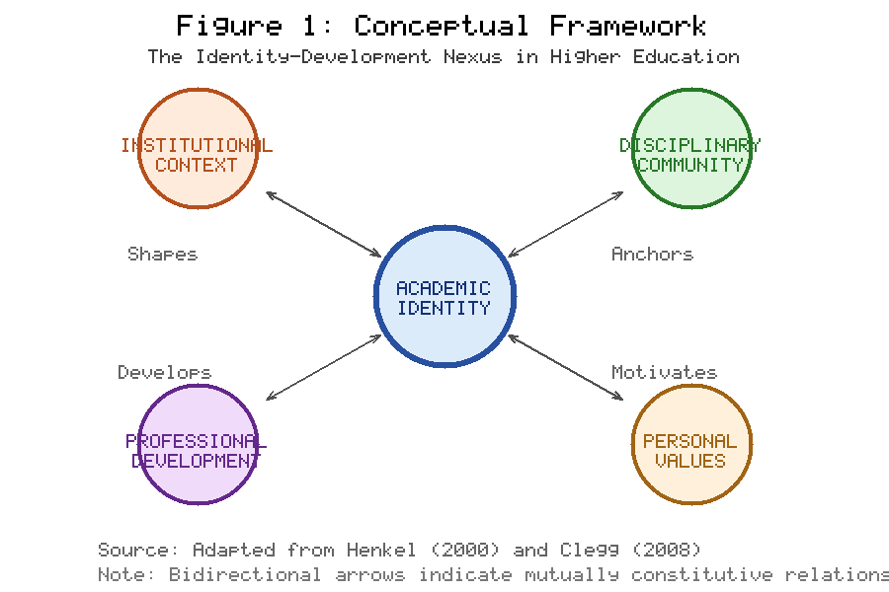
Figure 1. Conceptual Framework: The Identity-Development Nexus in Higher Education. Bidirectional arrows indicate mutually constitutive relationships between academic identity and its four shaping domains. Adapted from Henkel (2000) and Clegg (2008).

Academic identity is understood here not as a fixed essence but as a dynamic, socially constructed phenomenon - something that is continuously negotiated through interaction with institutional structures, disciplinary communities, students, colleagues, and broader publics (11). Professional development, correspondingly, is not merely the acquisition of technical competencies but a process of identity work: the ongoing, reflexive labour of constructing, maintaining, and revising a coherent professional self in the face of competing demands and shifting institutional landscapes (12). This constructivist orientation has significant implications for practice: it suggests that effective professional development must engage with questions of meaning, purpose, and belonging, not merely with questions of skill and performance (13). The implications extend beyond individual academics to institutional leaders, policymakers, and professional development practitioners. If identity and development are constitutive of one another, then professional development programmes cannot be designed in isolation from questions of identity, meaning, and purpose. They must engage with the whole academic person - their values, vulnerabilities, aspirations, and sense of belonging - rather than treating development as a merely technical matter of skill acquisition. Institutions that recognise this will be better positioned to attract, retain, and support the diverse academic workforce that the twenty-first century university requires.

Section 1: The Fracturing of the Traditional Academic Self
From the "Ivory Tower" to the "Networked Node"

The Historical Context

To understand the present crisis of academic identity, one must first appreciate the historical construction of the academic role. The medieval university, born in Bologna and Paris in the twelfth century, conceived of the scholar as a member of a self-governing guild, protected by ecclesiastical or royal charter and devoted to the preservation and transmission of authoritative knowledge (14). The Humboldtian revolution of the nineteenth century introduced the unity of teaching and research, constructing the academic as a dual figure: simultaneously a discoverer of new knowledge and a cultivator of the next generation of scholars (15). This model persisted through the massive expansion of higher education in the mid-twentieth century, underpinned by the assumption that academic freedom, tenure, and disciplinary expertise formed an indivisible triad (16).

The post-war period witnessed the "massification" of higher education across the Global North (17). The expansion of student numbers, the diversification of institutional missions, and the increasing dependence on public funding created pressures that would begin to erode the Humboldtian model (18). The academic was no longer simply a scholar and teacher but was increasingly expected to be an administrator, a grant-winner, a manager of research teams, and a demonstrable contributor to economic growth (19). Table 1 summarises this historical evolution, illustrating the progressive expansion and fragmentation of professional expectations across five distinct periods. As Table 1 demonstrates, what many scholars nostalgically invoke as the "traditional" academic identity was always the product of specific historical conditions.

Table 1. Historical Evolution of the Academic Role and Identity Formation
Period | Dominant Model | Identity Anchor | Key Characteristics | Source
12th-18th Century | Medieval Scholar | Guild membership | Preservation of knowledge; ecclesiastical authority | Ruegg (1992)
19th Century | Humboldtian Professor | Unity of teaching-research | Academic freedom; disciplinary expertise; national service | Clark (2006)
1960s-1990s | Mass HE Professional | Institutional affiliation | Expanded access; diversified missions; tenure system | Trow (1973)
1990s-2010s | Managed Academic | Metric performance | Audit culture; accountability; managerialism | Deem et al. (2007)
2010s-Present | Networked Node | Self-curated portfolio | Boundaryless; digital; precarious; interdisciplinary | Barnett (2011)

The Triple Threat of "Unbundling"

One of the most significant structural changes affecting academic identity is "unbundling" - the disaggregation of teaching, research, and service into separate, often casualised, functions (6). The adjunctification of teaching labour means that the majority of undergraduate instruction is now delivered by contingent faculty who have no research mandate and precarious employment conditions (20). Simultaneously, educational technology platforms have created mediation between the academic and the student (21). Administrative bloat has narrowed the academic role further, leading to what Whitchurch (22) termed "third space" professionals. The convergence of these forces is depicted in Figure 2, which illustrates how adjunctification, educational technology, and administrative expansion collectively fragment the coherent academic identity described in Table 1.

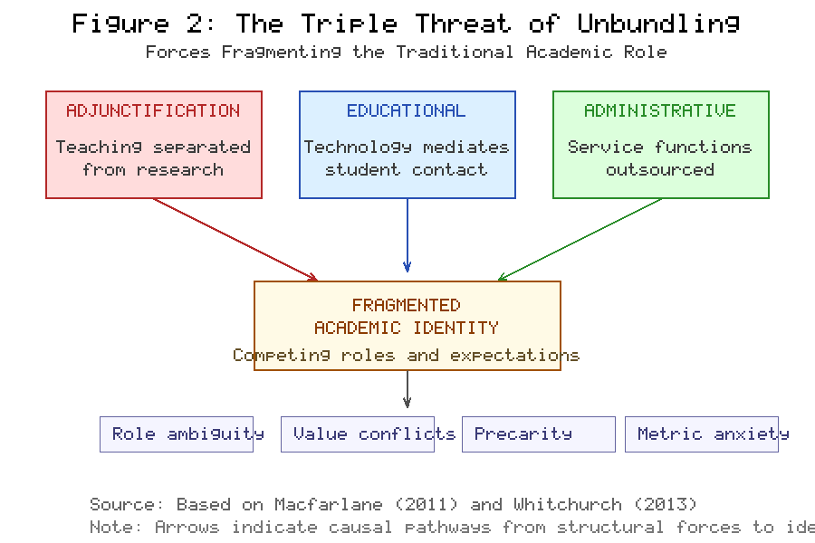
Figure 2. The Triple Threat of Unbundling: Forces Fragmenting the Traditional Academic Role. Three structural forces converge to produce identity fragmentation characterised by role ambiguity, value conflicts, precarity, and metric anxiety. Based on Macfarlane (2011) and Whitchurch (2013).

The Rise of Managerialism

The introduction of New Public Management principles from the 1980s onward transformed how academics perceive their own worth. Citation metrics, h-indices, journal impact factors, and grant capture rates have become the currencies of academic value (23). This "metric anxiety" creates a perverse incentive structure undermining curiosity, collegiality, and intellectual risk-taking (24). When identity is tied to measurable outputs, academics become vulnerable to chronic self-surveillance in which every activity is evaluated not for its intrinsic intellectual or pedagogical value but for its potential contribution to measurable indicators. This creates what might be termed "gaming the metrics" as rational behaviour, even as it undermines the very values that originally drew individuals into academic life.

The managerial regime has fundamentally altered the psychological contract between the academic and the institution. Where once academics enjoyed considerable autonomy in exchange for relatively modest remuneration and a commitment to institutional service, the new contract demands compliance with externally imposed targets and continuous demonstration of "value." The result is what Ball (25) described as "performativity" - ontological insecurity about whether one is doing enough, being enough, or producing enough. This performative anxiety permeates academic culture, shaping not only how individuals work but how they understand themselves as professionals and as persons (26). As Figure 2 illustrates, these metric pressures represent one of the key consequences of unbundling, creating a feedback loop in which structural fragmentation generates psychological vulnerability.

Interdisciplinarity vs. Disciplinary Anchors

The discipline has traditionally served as the primary locus of academic identity. To be a historian, a physicist, or an economist is to inhabit a particular epistemic community with its own norms, methods, canonical texts, and career structures (27). Disciplinary identity provides a sense of belonging, a shared language, and a clear pathway for progression from novice to expert. Yet grand challenges - climate change, pandemic preparedness, artificial intelligence governance - require collaborative, problem-focused research that transcends boundaries (28). Funding bodies reward interdisciplinary proposals; institutions create interdisciplinary centres; students demand programmes integrating knowledge from multiple domains. For the individual academic, this creates a fundamental tension: how to remain grounded in a discipline (which provides identity and credibility) while participating in ventures requiring unfamiliar methodological frameworks (29).

The "boundaryless" university therefore creates not a void but a collision of competing identities. The academic must be simultaneously a disciplinary expert and an interdisciplinary collaborator, a researcher and a teacher, a local colleague and a global networker, an autonomous scholar and a compliant employee. Professional development must begin with the recognition that identity is no longer given by the institution but must be actively curated by the individual (30). As the historical trajectory in Table 1 makes clear, each era has demanded different configurations of academic selfhood; what distinguishes the present moment is the simultaneity of these competing demands and the speed at which they evolve.

Section 2: The Internal Landscape: Values, Self-Efficacy, and the "Authentic" Academic
Navigating the Psychological Contract

Academic Values in Conflict

At the heart of academic identity lies a set of values often in tension with institutional environments (31). The intrinsic motivation that drives curiosity and truth-seeking is increasingly challenged by extrinsic pressures for "impact" and commercialisation (32). This creates "values dissonance" in which academics maintain a private self devoted to intellectual curiosity and a public self performing impact and entrepreneurship (33). Professional development that ignores this internal conflict - as the bidirectional model in Figure 1 suggests - risks exacerbating it by adding competencies without addressing the underlying question of purpose (34).

Self-Efficacy and Imposter Syndrome

Self-efficacy is a critical determinant of academic productivity, resilience, and wellbeing (35). Yet the conditions of contemporary academia are particularly corrosive of self-efficacy. Imposter syndrome is endemic, affecting academics at all career stages but particularly early career researchers, women, and academics from minority backgrounds (36). The syndrome is a structural product of academic culture: a culture that valorises brilliance over effort, individual genius over collaborative achievement (37). Table 2 systematises the psychological challenges and evidence-based interventions, showing how the structural forces depicted in Figure 2 translate into specific psychological vulnerabilities.

Table 2. Psychological Challenges to Academic Identity and Evidence-Based Interventions
Challenge | Prevalence | Career Stage | Contributing Factors | Recommended Interventions | Source
Imposter Syndrome | 60-70% of academics | Early Career | Hyper-competition; social comparison | Narrative reframing; peer support groups | Parkman (2016)
Values Dissonance | Widespread | Mid-career | Impact agendas; commercialisation | Values clarification; reflexive practice | Watermeyer (2019)
Burnout | 40-50% report symptoms | All stages | Workload; job insecurity; emotional labour | Boundary-setting; institutional advocacy | Kinman & Wray (2013)
Metric Anxiety | Increasing | All stages | H-index culture; league tables | Critical engagement with metrics | Muller (2018)
Identity Fragmentation | Common | Teaching-only/alt-ac | Role ambiguity; lack of research time | Portfolio identity; communities of practice | Clegg (2008)

Professional development programmes must address these vulnerabilities directly, creating spaces for honest conversation about failure, rejection, and self-doubt (38). As Table 2 indicates, a psychologically informed approach would incorporate narrative practices that help academics reframe setbacks as normal features of an inherently uncertain creative endeavour (39).

The Search for Authenticity

The concept of authenticity has gained significant traction in discussions of academic identity (40). To be "authentic" is to align professional activities with core values while resisting pressure to perform imposed identities (30). Authenticity, in this sense, is not about discovering a pre-existing "true self" but about the ongoing work of constructing a self that feels coherent and meaningful in the face of competing demands. The notion of the "scholarly brand" - a deliberate, curated public identity that communicates expertise, values, and contributions - has become increasingly important in the age of social media and digital scholarship (41). Yet branding carries risks: it can reduce complex intellectual identities to simplified slogans; it can encourage performativity over substance; and it can create a gap between the public persona and the private experience of academic work. The challenge for professional development is to support academics in crafting authentic narratives that integrate their diverse activities without succumbing to the superficialities of self-marketing.

Emotional Labour

Academic work involves substantial emotional labour - managing one's own emotions and others' in service of professional goals (42). This labour takes many forms: the patience required to support struggling students; the diplomacy needed to navigate departmental politics; the resilience demanded by hostile peer reviews; the empathy involved in supervising doctoral students through personal and intellectual crises. Yet this labour remains largely invisible, unacknowledged in workload models and unrewarded in promotion criteria (43). The invisibility of emotional labour has significant implications for academic identity and wellbeing. Academics who invest heavily in relational work - pastoral care, mentoring, community building - may find that their contributions are devalued relative to more visible outputs such as publications and grants. Women academics and academics of colour are disproportionately called upon to perform emotional and service labour (44). Professional development must therefore not only acknowledge emotional labour but actively work to make it visible, valued, and equitably distributed.

Sustainable professional development requires maintaining psychological integrity through reflexive practice where the academic aligns activities with core values (45). It is not just about acquiring new skills but about maintaining a sense of coherence amidst the centrifugal forces of contemporary academic life. The challenges summarised in Table 2 and the structural forces mapped in Figure 2 together underscore the urgency of this alignment between personal values and professional practice.

Section 3: The Professional Development Imperative: Strategies for Adaptive Growth
Beyond the CV: Building a Portfolio of Competencies

The "T-Shaped" Academic

The "T-shaped" professional metaphor offers a useful framework for academic professional development (46). The vertical bar represents disciplinary depth; the horizontal bar represents transversal competencies: digital literacy, project management, science communication, and public engagement skills (47). Professional development must cultivate both dimensions simultaneously (48). The T-shaped model is visualised in Figure 3, which illustrates how the balance between depth and breadth shifts across career stages. As Figure 3 demonstrates, early career investment prioritises depth, while mid-career and senior stages demand expanding breadth. Table 3 maps specific professional development activities to both dimensions of the T-shaped model.

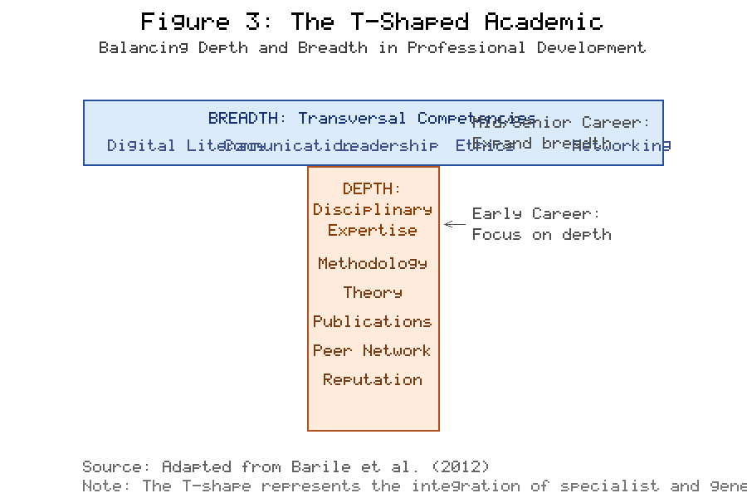
Figure 3. The T-Shaped Academic: Balancing Depth and Breadth in Professional Development. The vertical bar represents disciplinary expertise (prioritised in early career), while the horizontal bar represents transversal competencies (increasingly important at mid-career and beyond). Adapted from Barile et al. (2012).

Table 3. Professional Development Activities Mapped to T-Shaped Competency Domains
Activity Type | Specific Activity | T-Shape Domain | Identity Contribution | Learning Mode | Source
Research | Grant writing | Depth + Communication | Demonstrates expertise; builds reputation | Informal | Eraut (2004)
Teaching | Curriculum design | Breadth (Pedagogy) | Pedagogical identity; scholarly teaching | Formal/Informal | Fanghanel (2012)
Supervision | PhD mentoring | Depth + Leadership | Senior scholar identity; generativity | Informal | Mullen & Klimaitis (2021)
Service | Committee membership | Breadth (Governance) | Institutional citizenship; leadership | Informal | Macfarlane (2011)
Digital | Social media scholarship | Breadth (Communication) | Public intellectual; networked scholar | Informal | Veletsianos (2016)
Interdisciplinary | Collaborative projects | Breadth (Collaboration) | Boundary-crossing identity | Formal | Brew (2006)
Peer Review | Journal reviewing | Depth (Evaluation) | Disciplinary gatekeeping | Informal | Wenger (1998)
Public Engagement | Media, consultancy | Breadth (Communication) | Public scholar; impact identity | Formal/Informal | Boyer (1996)

Navigating Career Transitions

Academic careers are no longer linear progressions from doctoral student to professor (49). The contemporary academic may move through multiple institutional contexts, between academic and non-academic roles, across national boundaries, and between research-intensive and teaching-focused positions. Each transition requires not merely the acquisition of new skills but a renegotiation of identity: who am I now, in this new context, with these new responsibilities? The transition from Early Career Researcher to established academic involves demonstrating research independence, developing a teaching philosophy, building a professional network, and establishing a scholarly reputation (50). The increasing precarity of early careers - characterised by multiple short-term contracts, geographic mobility, and uncertain prospects - makes this transition psychologically demanding (51).

Mid-career transitions present different challenges. The established academic may face questions of renewal and reinvention: how to maintain intellectual vitality after decades in the same field; how to take on leadership roles without losing touch with research; how to mentor the next generation without becoming merely a gatekeeper (52). The emergence of "alternative academic" (alt-ac) careers adds further complexity, requiring academics to translate their identities across institutional boundaries. Mentorship plays a critical role but must be reconceived as a distributed, multi-relational practice rather than a dyadic, hierarchical one (53). The activities in Table 3 and the framework in Figure 3 provide a roadmap for navigating these transitions strategically, identifying which competencies to develop at each stage.

Social Capital and Networking

The shift from collegiality to connectivity represents one of the most significant transformations in academic professional life (41). Traditional academic collegiality was local, departmental, and face-to-face: the common room, the seminar series, the faculty meeting. Contemporary academic networking is global, digital, and often asynchronous: ResearchGate profiles, LinkedIn connections, Bluesky communities, and collaborative platforms. Digital networking provides visibility beyond one's institution, enables community formation around shared interests, and creates alternative channels for reputation-building not mediated by traditional gatekeepers such as journal editors and grant panels. For early career researchers in particular, digital networking can be powerful for establishing a scholarly presence and building social capital necessary for career advancement (54).

However, the performative nature of social media can encourage academics to present idealised versions of their professional lives, exacerbating comparison and imposter syndrome (see Table 2). The time demands of maintaining a digital presence can detract from deep, focused work. Professional development must therefore address digital networking strategically, helping academics leverage benefits while managing risks and maintaining authenticity in their online identities (55).

Formal vs. Informal Learning

Professional development in higher education has traditionally been conceived in terms of formal, structured activities: workshops, conferences, certificate programmes, and training courses. While these remain valuable, there is growing recognition that the most significant professional learning often occurs informally, embedded in everyday academic work (56). Writing a grant proposal is a learning experience in argumentation, budgeting, and strategic planning. Supervising a doctoral student develops pedagogical skills, project management abilities, and emotional intelligence. Reviewing a paper for a journal deepens disciplinary knowledge and develops evaluative judgement. Serving on a committee builds institutional literacy and negotiation skills.

The challenge for professional development is to make this informal learning visible, intentional, and cumulative. This requires reflective practice in which academics regularly consider what they are learning from everyday activities. Tools such as portfolios, reflective journals, and development plans can transform tacit learning into explicit knowledge that can be shared and recognised. The distinction between formal and informal learning maps onto different theories of identity formation: formal learning operates within a "training" paradigm that treats identity as fixed; informal learning aligns with a "becoming" paradigm that sees identity as fluid, relational, and constructed through practice (57). From this perspective, professional development is about participating in communities of practice that shape how one understands oneself as a professional. The most effective programmes integrate both approaches, as Table 3 illustrates across multiple activity types and competency domains.

Diversification of Revenue and Outputs

The traditional academic economy was relatively simple: one produced research and teaching in exchange for a salary and the possibility of promotion. The contemporary academic economy is far more complex, encompassing consultancy, public scholarship, podcast production, popular writing, entrepreneurial spin-offs, expert witness work, policy advisory roles, and social media influence. Each of these activities creates value - both economic and reputational - but each also reshapes academic identity in significant ways. Engaging in consultancy requires translating scholarly expertise into forms useful to external clients, potentially creating tensions between rigour and applicability. Public scholarship demands communication skills quite different from academic publication, and exposes the academic to public scrutiny (58). Entrepreneurial activities may generate "impact" but can create conflicts of interest.

Professional development must support academics in navigating this diversified landscape strategically - drawing on the competency framework in Figure 3 and the activity mapping in Table 3 - ensuring diversification is undertaken deliberately with a clear sense of overarching scholarly purpose (59). The key insight is that diversification need not be experienced as fragmentation if it is undertaken with a clear sense of how each activity contributes to an overarching purpose. Professional development is, at its best, an evidence-based practice requiring a strategic approach: treating one's career as a "project" requiring regular auditing, goal-setting, and agile pivoting (60).

Section 4: The Horizon: Ethics, Community, and the Future of the Academic Vocation
Reclaiming Agency in a Post-Digital Academy

Digital Personhood and Artificial Intelligence

Generative AI represents perhaps the most profound challenge to academic identity since the printing press. GenAI disrupts assumptions about authorship, originality, expertise, and intellectual labour (9). If a machine can produce competent academic prose, generate literature reviews, analyse data, and formulate research questions, then what remains distinctive about the academic's contribution? For teaching identity, the implications are immediate: traditional assessment practices are predicated on the assumption that submitted work represents authentic student output. GenAI undermines this assumption, requiring academics to rethink not only how they assess but what they teach and why (61). The academic's role shifts from information transmitter to cultivator of critical thinking, ethical reasoning, and genuine intellectual creativity - qualities that remain distinctively human (62).

For research identity, GenAI raises questions about the nature of scholarly contribution. If AI tools can accelerate literature synthesis and identify patterns in large datasets, then the academic's value lies in framing questions, evaluating evidence, exercising judgement, and situating findings within broader theoretical and ethical frameworks (63). The challenge is not merely technical but existential: if academic identity has historically been built on mastery of information, then AI threatens the very foundations upon which scholarly self-understanding is constructed. The response must be generative: a reimagination of the academic's role as fundamentally concerned with meaning-making, ethical judgement, relational pedagogy, and the cultivation of human capacities beyond algorithmic intelligence (64). Table 4 systematises AI's impact across key identity dimensions, mapping threats, opportunities, and professional development responses. As Table 4 demonstrates, these challenges add new dimensions to the unbundling forces depicted in Figure 2 and demand expansion of the T-shaped competencies visualised in Figure 3.

Table 4. Impact of Generative AI on Academic Identity Dimensions
Identity Dimension | AI Challenge | Threat to Identity | Opportunity | PD Response Required | Source
Teaching | Automated content delivery | Redundancy of transmission role | Shift to relational pedagogy | AI literacy; assessment redesign | Dwivedi et al. (2023)
Research | Literature synthesis by AI | Devaluation of knowledge mastery | Focus on question-framing | Research integrity training | Peseta et al. (2022)
Authorship | AI-generated text | Crisis of originality | New human-AI collaboration models | Academic integrity policy | Dwivedi et al. (2023)
Assessment | Student use of GenAI | Undermined evaluation validity | Authentic assessment innovation | Assessment design workshops | Fanghanel (2012)
Expertise | Democratised knowledge access | Erosion of authority claims | Public engagement; meaning-making | Communication skills; philosophical depth | Barnett (2000)

Global Citizenship and Social Justice

Academic identity must grapple with social responsibility. The role of the academic as a public intellectual has a long and contested history. From the Dreyfus affair to the anti-apartheid movement, academics have periodically claimed special authority to speak truth to power, grounded in expertise, independence, and institutional protection. In the contemporary context, this public role is both more urgent and more fraught. Climate change, global pandemics, rising inequality, forced migration, and the resurgence of authoritarianism all demand scholarly engagement beyond the academy. Yet the politicisation of expertise, the crisis of trust in institutions, and the weaponisation of "cancel culture" narratives make public engagement risky and contested (65).

The concept of "engaged scholarship" (59) offers a framework for integrating social responsibility into academic identity - encompassing discovery, integration, application, and teaching. This provides a basis for valuing diverse forms of intellectual contribution and recognising that scholarship is most meaningful when it connects to the needs and aspirations of broader communities. The professional development responses outlined in Table 4 must extend beyond technical AI literacy to encompass the ethical and civic dimensions of the academic vocation (66). Professional development that supports engaged scholarship must help academics build partnerships beyond the academy, communicate to non-specialist audiences, and navigate the political complexities of public engagement. The decolonisation imperative demands that academics critically interrogate whose knowledge counts, whose voices are centred, and whose perspectives remain marginalised within existing scholarly structures (67).

Wellbeing and Resistance

The mental health crisis in academia is extensively documented. Studies consistently report high rates of anxiety, depression, burnout, and work-life conflict among academic staff, with early career researchers and those on precarious contracts particularly affected (7). The causes are structural: excessive workloads, job insecurity, performance pressure, isolation, and the erosion of boundaries between work and personal life exacerbated by digital technologies that enable and demand constant availability (68). Professional development cannot be conceived solely as an instrument of productivity enhancement; it must also serve as resistance against burnout culture (69).

"Slow scholarship" - a deliberate rejection of the acceleration and intensification of academic work in favour of careful, reflective, relational practice - offers an alternative vision of professional development as care (70). Slow scholarship does not mean disengagement or reduced productivity; rather, it means choosing depth over breadth, quality over quantity, and sustainability over short-term output maximisation. Building wellbeing into professional identity requires both individual strategies (boundary-setting, mindfulness, creative outlets) and collective advocacy for structural change (workload caps, secure employment, sabbatical provision, mental health support) (71). Professional development programmes that address wellbeing in isolation from structural conditions risk individualising what is fundamentally a systemic problem. Open science practices, including transparent research methods and collaborative knowledge-sharing, offer pathways for reducing competitive pressures and fostering healthier academic cultures (72). Student-staff partnerships in curriculum design and pedagogical innovation also provide models of reciprocal development that benefit both parties (73).

The New Collegiality

The future lies not in isolated individual adaptation but in creating new forms of mutualistic collegiality appropriate to the networked, globalised, post-digital university. Traditional collegiality was local, face-to-face, and often exclusive - defined by departmental boundaries and implicit hierarchies of seniority. The new collegiality must be more expansive: crossing institutional, disciplinary, and national boundaries; embracing diversity of career stage and scholarly perspective; and leveraging digital technologies to create communities that are both virtual and embodied (8). Academic leadership in this context requires distributed models that empower collective agency rather than reproducing hierarchical authority (74).

Crucially, the new collegiality must be mutualistic rather than competitive. The dominant culture of academic competition has created an environment in which colleagues are simultaneously collaborators and rivals. A mutualistic model reconceives professional development as a shared, co-created resource: writing groups, peer observation schemes, reading circles, and advocacy networks that campaign for better working conditions (75). In this model, professional development is not something done to or for individual academics but something communities create together. The growing recognition of academic writing as a social practice - rather than a solitary, individual endeavour - reflects this mutualistic orientation (76). Figure 4 illustrates this post-digital academic ecosystem, showing how new collegiality functions as a hub connecting diverse elements into an integrated system. As Figure 4 demonstrates, the ecosystem synthesises the identity challenges identified throughout this chapter (see Table 1 and Figure 2) with the development strategies presented in Table 3 and Figure 3.

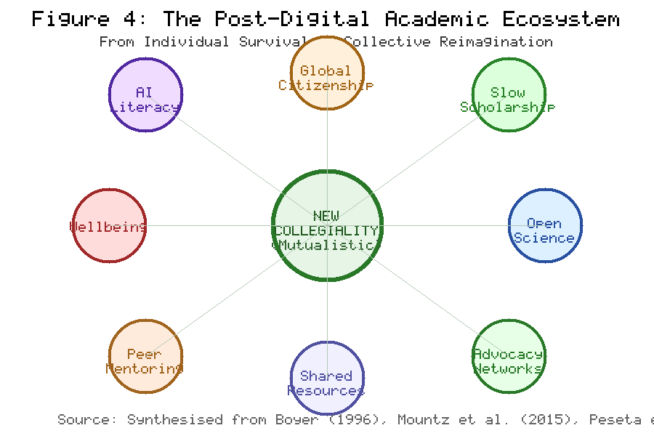
Figure 4. The Post-Digital Academic Ecosystem: From Individual Survival to Collective Reimagination. The central node of "New Collegiality" connects eight elements into a mutualistic network. Synthesised from Boyer (1996), Mountz et al. (2015), and Peseta et al. (2022).

This reimagination requires institutional support: protected time for community-building, recognition for collegial activities, programmes co-designed with academics, and governance structures that give academics genuine voice (45). Higher education policy frameworks must evolve to support these new forms of academic practice and identity (77). Gender equity in academic careers remains a persistent challenge requiring targeted interventions at institutional and systemic levels (78).

Conclusion

This chapter has argued that academic identity and professional development are deeply interwoven: identity shapes development choices, while development reshapes identity. In the boundaryless university of the twenty-first century, where traditional sources of identity - the discipline, the institution, the tenure track - are weakened or transformed, academics must become active agents of their own identity construction (79).

The chapter has traced the fracturing of the traditional academic self under the pressures of unbundling, managerialism, and interdisciplinarity (Table 1 and Figure 2), showing how these forces create not a void but a collision of competing identities. It has examined the internal psychological landscape (Table 2), highlighting the importance of values alignment, self-efficacy, authenticity, and emotional resilience (80). It has offered practical strategies for adaptive growth - the T-shaped academic (Figure 3), strategic networking, informal learning (Table 3), and output diversification - that treat career development as an intentional, evidence-based practice (81). And it has looked to the horizon (Table 4 and Figure 4), exploring how AI, social justice imperatives, wellbeing concerns, and new forms of collegiality are reshaping the possibilities for academic identity in the post-digital age (82).

The final challenge, and the one with which this chapter closes, is the recognition that professional development cannot remain an individual survival strategy. If it is to be transformative rather than merely adaptive, it must become a collective vocation - a shared project of reimagining what it means to be an academic in a world that desperately needs the knowledge, critical thinking, and ethical commitment that the academy, at its best, provides (83). Research integrity frameworks and open science movements offer promising avenues for rebuilding trust in academic knowledge production (84). The increasing importance of digital scholarship demands new literacies and critical engagement with platform cultures that mediate academic communication (85). Career development frameworks must account for the diversity of academic pathways and the non-linear trajectories that characterise contemporary scholarly lives (86). The boundaryless university is not merely a threat to academic identity; it is an invitation to reinvent it (87). The question is not whether academic identity will change - it already has - but whether academics will be passive recipients of that change or active architects of a future that honours both their intellectual traditions and their social responsibilities (88).

References

[1] Barnett, R. (2000). Realizing the university in an age of supercomplexity. Open University Press.

[2] Marginson, S. (2016). The worldwide trend to high participation higher education. Higher Education, 72(4), 413-434. https://doi.org/10.1007/s10734-016-0016-x

[3] Arthur, M. B., & Rousseau, D. M. (1996). The boundaryless career: A new employment principle for a new organizational era. Oxford University Press.

[4] Henkel, M. (2000). Academic identities and policy change in higher education. Jessica Kingsley Publishers.

[5] Clegg, S. (2008). Academic identities under threat? British Educational Research Journal, 34(3), 329-345. https://doi.org/10.1080/01411920701532269

[6] Macfarlane, B. (2011). The morphing of academic practice: Unbundling and the rise of the para-academic. Higher Education Quarterly, 65(1), 59-73. https://doi.org/10.1111/j.1468-2273.2010.00467.x

[7] Kinman, G., & Wray, S. (2013). Higher stress: A survey of stress and well-being among staff in higher education. University and College Union.

[8] Peseta, T., Barrie, S., & McLean, J. (2022). Academic development in a changing higher education landscape. Springer.

[9] Dwivedi, Y. K., Kshetri, N., Hughes, L., Slade, E. L., Jeyaraj, A., Kar, A. K., Baabdullah, A. M., Koohang, A., Raghavan, V., Ahuja, M., Albber, H., Albashrawi, M. A., Al-Busaidi, A. S., Balakrishnan, J., Barlette, Y., Basu, S., Bose, I., Brooks, L., Buhalis, D., ... Wright, R. (2023). Opinion paper: "So what if ChatGPT wrote it?" Multidisciplinary perspectives on opportunities, challenges and implications of generative conversational AI for research, practice and policy. International Journal of Information Management, 71, 102642. https://doi.org/10.1016/j.ijinfomgt.2023.102642

[10] Fanghanel, J. (2012). Being an academic. Routledge.

[11] Billot, J. (2010). The imagined and the real: Identifying the tensions for academic identity. Higher Education Research and Development, 29(6), 709-721. https://doi.org/10.1080/07294360.2010.509832

[12] Trede, F., Macklin, R., & Bridges, D. (2012). Professional identity development: A review of the higher education literature. Studies in Higher Education, 37(3), 365-384. https://doi.org/10.1080/03075079.2010.521237

[13] Nixon, J. (2008). Towards the virtuous university: The moral bases of academic practice. Routledge.

[14] Ruegg, W. (Ed.). (1992). A history of the university in Europe: Volume 1, Universities in the Middle Ages. Cambridge University Press.

[15] Clark, W. (2006). Academic charisma and the origins of the research university. University of Chicago Press.

[16] Altbach, P. G. (2001). Academic freedom: International realities and challenges. Higher Education, 41(1-2), 205-219. https://doi.org/10.1023/A:1026791518365

[17] Trow, M. (1973). Problems in the transition from elite to mass higher education. Carnegie Commission on Higher Education.

[18] Scott, P. (1995). The meanings of mass higher education. Open University Press.

[19] Deem, R., Hillyard, S., & Reed, M. (2007). Knowledge, higher education, and the new managerialism: The changing management of UK universities. Oxford University Press.

[20] Kezar, A., & Maxey, D. (2013). The changing academic workforce. Trusteeship, 21(3), 15-21.

[21] Selwyn, N. (2014). Digital technology and the contemporary university: Degrees of digitization. Routledge.

[22] Whitchurch, C. (2013). Reconstructing identities in higher education: The rise of third space professionals. Routledge.

[23] Burrows, R. (2012). Living with the h-index? Metric assemblages in the contemporary academy. The Sociological Review, 60(2), 355-372. https://doi.org/10.1111/j.1467-954X.2012.02077.x

[24] Muller, J. Z. (2018). The tyranny of metrics. Princeton University Press.

[25] Ball, S. J. (2003). The teacher's soul and the terrors of performativity. Journal of Education Policy, 18(2), 215-228. https://doi.org/10.1080/0268093022000043065

[26] Davies, B., & Bansel, P. (2007). Neoliberalism and education. International Journal of Qualitative Studies in Education, 20(3), 247-259. https://doi.org/10.1080/09518390701281751

[27] Becher, T., & Trowler, P. R. (2001). Academic tribes and territories: Intellectual enquiry and the culture of disciplines (2nd ed.). Open University Press.

[28] Repko, A. F., & Szostak, R. (2020). Interdisciplinary research: Process and theory (4th ed.). Sage Publications.

[29] Brew, A. (2006). Research and teaching: Beyond the divide. Palgrave Macmillan.

[30] Archer, L. (2008). Younger academics' constructions of "authenticity", "success" and professional identity. Studies in Higher Education, 33(4), 385-403. https://doi.org/10.1080/03075070802211729

[31] Ylijoki, O.-H., & Ursin, J. (2013). The construction of academic identity in the changes of Finnish higher education. Studies in Higher Education, 38(8), 1135-1149. https://doi.org/10.1080/03075079.2013.833036

[32] Watermeyer, R. (2019). Competitive accountability in academic life: The struggle for social connectedness in research. Edward Elgar Publishing.

[33] Winter, R. (2009). Academic manager or managed academic? Academic identity schisms in higher education. Journal of Higher Education Policy and Management, 31(2), 121-131. https://doi.org/10.1080/13600800902825835

[34] Fitzmaurice, M. (2013). Constructing professional identity as a new academic: A moral endeavour. Studies in Higher Education, 38(4), 613-622. https://doi.org/10.1080/03075079.2011.594501

[35] Bandura, A. (1997). Self-efficacy: The exercise of control. W.H. Freeman.

[36] Parkman, A. (2016). The imposter phenomenon in higher education: Incidence and impact. Journal of Higher Education Theory and Practice, 16(1), 51-60.

[37] Clance, P. R., & Imes, S. A. (1978). The imposter phenomenon in high achieving women: Dynamics and therapeutic intervention. Psychotherapy: Theory, Research and Practice, 15(3), 241-247. https://doi.org/10.1037/h0086006

[38] Guthrie, S., Lichten, C. A., Van Belle, J., Ball, S., Knack, A., & Hofman, J. (2017). Understanding mental health in the research environment: A rapid evidence assessment. RAND Corporation. https://doi.org/10.7249/RR2022

[39] Hutchins, H. M., & Rainbolt, H. (2017). What triggers imposter phenomenon among academic faculty? A critical incident study exploring antecedents, coping, and development opportunities. Human Resource Development International, 20(3), 194-214. https://doi.org/10.1080/13678868.2016.1248205

[40] Kreber, C. (2013). Authenticity in and through teaching in higher education: The transformative potential of the scholarship of teaching. Routledge.

[41] Veletsianos, G. (2016). Social media in academia: Networked scholars. Routledge.

[42] Constanti, P., & Gibbs, P. (2004). Higher education teachers and emotional labour. International Journal of Educational Management, 18(4), 243-249. https://doi.org/10.1108/09513540410538822

[43] Ogbonna, E., & Harris, L. C. (2004). Work intensification and emotional labour among UK university lecturers: An exploratory study. Organization Studies, 25(7), 1185-1203. https://doi.org/10.1177/0170840604046315

[44] Ahmed, S. (2012). On being included: Racism and diversity in institutional life. Duke University Press.

[45] Leibowitz, B., Bozalek, V., van Schalkwyk, S., & Winberg, C. (2015). Institutional context matters: The professional development of academics as teachers in South African higher education. Higher Education, 69(2), 315-330. https://doi.org/10.1007/s10734-014-9777-2

[46] Barile, S., Franco, G., Nota, G., & Saviano, M. (2012). Structure and dynamics of a "T-shaped" knowledge: From individuals to cooperating communities of practice. Service Science, 4(2), 161-180. https://doi.org/10.1287/serv.1120.0014

[47] Boden, R., & Nedeva, M. (2010). Employing discourse: Universities and graduate "employability." Journal of Education Policy, 25(1), 37-54. https://doi.org/10.1080/02680930903349489

[48] Frodeman, R. (Ed.). (2017). The Oxford handbook of interdisciplinarity (2nd ed.). Oxford University Press.

[49] Enders, J., & Kaulisch, M. (2006). The binding and unbinding of academic careers. In U. Teichler (Ed.), The formative years of scholars (pp. 85-96). Portland Press.

[50] McAlpine, L., & Amundsen, C. (2018). Identity-trajectories of early career researchers: Unpacking the post-PhD experience. Palgrave Macmillan.

[51] Laudel, G., & Glaesser, J. (2008). From apprentice to colleague: The metamorphosis of early career researchers. Higher Education, 55(3), 387-406. https://doi.org/10.1007/s10734-007-9063-7

[52] Sutherland, K. A. (2017). Constructions of success in academia: An early career perspective. Studies in Higher Education, 42(4), 743-759. https://doi.org/10.1080/03075079.2015.1072150

[53] Mullen, C. A., & Klimaitis, C. C. (2021). Defining mentoring: A literature review of issues, types, and applications. Annals of the New York Academy of Sciences, 1483(1), 19-35. https://doi.org/10.1111/nyas.14176

[54] Lupton, D. (2014). "Feeling better connected": Academics' use of social media. News & Media Research Centre, University of Canberra. https://doi.org/10.1145/2930971.2930975

[55] Stewart, B. E. (2016). Collapsed publics: Orality, literacy, and vulnerability in academic Twitter. Journal of Applied Social Theory, 1(1), 61-86.

[56] Eraut, M. (2004). Informal learning in the workplace. Studies in Continuing Education, 26(2), 247-273. https://doi.org/10.1080/158037042000225245

[57] Wenger, E. (1998). Communities of practice: Learning, meaning, and identity. Cambridge University Press.

[58] Boyer, E. L. (1996). The scholarship of engagement. Bulletin of the American Academy of Arts and Sciences, 49(7), 18-33. https://doi.org/10.2307/3824459

[59] Burawoy, M. (2005). For public sociology. American Sociological Review, 70(1), 4-28. https://doi.org/10.1177/000312240507000102

[60] Barnett, R. (2011). Being a university. Routledge.

[61] Zawacki-Richter, O., Marín, V. I., Bond, M., & Gouverneur, F. (2019). Systematic review of research on artificial intelligence applications in higher education. International Journal of Educational Technology in Higher Education, 16(1), 39. https://doi.org/10.1186/s41239-019-0171-0

[62] Seldon, A., & Abidoye, O. (2018). The fourth education revolution: Will artificial intelligence liberate or infantilise humanity? University of Buckingham Press.

[63] Cope, B., Kalantzis, M., & Searsmith, D. (2021). Artificial intelligence for education: Knowledge and its assessment in AI-enabled learning ecologies. Educational Philosophy and Theory, 53(12), 1229-1245. https://doi.org/10.1080/00131857.2020.1728732

[64] Bearman, M., Ryan, J., & Ajjawi, R. (2023). Discourses of artificial intelligence in higher education: A critical literature review. Higher Education, 86(2), 369-385. https://doi.org/10.1007/s10734-022-00937-2

[65] Watermeyer, R., Crick, T., Knight, C., & Goodall, J. (2021). COVID-19 and digital disruption in UK universities: Afflictions and affordances of emergency online migration. Higher Education, 81(3), 623-641. https://doi.org/10.1007/s10734-020-00561-y

[66] Macfarlane, B. (2021). The spirit of research ethics: Retaining a focus on philosophically informed practice. Journal of Academic Ethics, 19(3), 287-301. https://doi.org/10.1007/s10805-020-09390-x

[67] Bhambra, G. K., Gebrial, D., & Nişancıoğlu, K. (Eds.). (2018). Decolonising the university. Pluto Press.

[68] Morrish, L. (2019). Pressure vessels: The epidemic of poor mental health among higher education staff. HEPI Occasional Paper 20. Higher Education Policy Institute.

[69] Watts, J., & Robertson, N. (2011). Burnout in university teaching staff: A systematic literature review. Educational Research, 53(1), 33-50. https://doi.org/10.1080/00131881.2011.552235

[70] Mountz, A., Bonds, A., Mansfield, B., Loyd, J., Hyndman, J., Walton-Roberts, M., Basu, R., Whitson, R., Hawkins, R., Hamilton, T., & Curran, W. (2015). For slow scholarship: A feminist politics of resistance through collective action in the neoliberal university. ACME: An International Journal for Critical Geographies, 14(4), 1235-1259.

[71] Kinman, G., & Johnson, S. (2019). Special section on well-being in academic employees. International Journal of Stress Management, 26(1), 2-4. https://doi.org/10.1037/str0000102

[72] Nosek, B. A., Alter, G., Banks, G. C., Borsboom, D., Bowman, S. D., Breckler, S. J., Buck, S., Chambers, C. D., Chin, G., Christensen, G., Contestabile, M., Dafoe, A., Eich, E., Freese, J., Glennerster, R., Goroff, D., Green, D. P., Hesse, B., Humphreys, M., ... Yarkoni, T. (2015). Promoting an open research culture. Science, 348(6242), 1422-1425. https://doi.org/10.1126/science.aab2374

[73] Healey, M., Flint, A., & Harrington, K. (2014). Engagement through partnership: Students as partners in learning and teaching in higher education. Higher Education Academy.

[74] Bolden, R., Gosling, J., & O'Brien, A. (2014). Citizens of the academic community? A societal perspective on leadership in UK higher education. Studies in Higher Education, 39(5), 754-770. https://doi.org/10.1080/03075079.2012.754855

[75] Aitchison, C., & Guerin, C. (Eds.). (2014). Writing groups for doctoral education and beyond: Innovations in practice and theory. Routledge.

[76] Sword, H. (2012). Stylish academic writing. Harvard University Press.

[77] Locke, W. (2014). Shifting academic careers: Implications for enhancing professionalism in teaching and supporting learning. Higher Education Academy.

[78] Bagilhole, B., & White, K. (Eds.). (2011). Gender, power and management: A cross-cultural analysis of higher education. Palgrave Macmillan.

[79] Barnacle, R., & Mewburn, I. (2010). Learning networks and the journey of "becoming doctor." Studies in Higher Education, 35(4), 433-444. https://doi.org/10.1080/03075070903131214

[80] Cantwell, B., & Kauppinen, I. (Eds.). (2014). Academic capitalism in the age of globalization. Johns Hopkins University Press.

[81] Vitae. (2011). Researcher development framework. Careers Research and Advisory Centre. https://www.vitae.ac.uk/researchers-professional-development/about-the-vitae-researcher-development-framework

[82] Pringle, J., & Mallon, M. (2003). Challenges for the boundaryless career odyssey. International Journal of Human Resource Management, 14(5), 839-853. https://doi.org/10.1080/0958519032000080839

[83] Giroux, H. A. (2014). Neoliberalism's war on higher education. Haymarket Books.

[84] Munafò, M. R., Nosek, B. A., Bishop, D. V. M., Button, K. S., Chambers, C. D., Percie du Sert, N., Simonsohn, U., Wagenmakers, E.-J., Ware, J. J., & Ioannidis, J. P. A. (2017). A manifesto for reproducible science. Nature Human Behaviour, 1(1), 0021. https://doi.org/10.1038/s41562-016-0021

[85] Weller, M. (2011). The digital scholar: How technology is transforming scholarly practice. Bloomsbury Academic.

[86] Akkerman, S. F., & Bakker, A. (2011). Boundary crossing and boundary objects. Review of Educational Research, 81(2), 132-169. https://doi.org/10.3102/0034654311404435

[87] Peters, M. A., & Besley, T. (2018). Academic entrepreneurship and the creative economy. In P. Gibbs, J. Jameson, & A. Elwick (Eds.), Values of the university in a time of uncertainty (pp. 119-131). Springer. https://doi.org/10.1007/978-3-319-76126-8_8

[88] O'Meara, K., Kuvaeva, A., Nyunt, G., Waugaman, C., & Jackson, R. (2017). Asked more often: Gender differences in faculty workload in research universities and the work interactions that shape them. American Educational Research Journal, 54(6), 1154-1186. https://doi.org/10.3102/0002831217716767

