Counting the Cost of Delay: Economic Consequences of Climate Inaction for Health Systems, Labour Productivity, and Macroeconomic Stability
Book: Climate-Ready Preventive Healthcare: Heat, Equity, and Community Resilience in a Warming World
Section: Assessing Impacts and Vulnerabilities
Amman Jakhar 1, and Sachin Kalsi* 1
1 Department of Mechanical Engineering, Chandigarh University, Mohali, Punjab-140301, India
\ Corresponding author: ammanjakhar5000734@gmail.com*
ORCID: Amman Jakhar — [to be added]; Sachin Kalsi — [to be added]

Abstract
The economic consequences of climate inaction constitute a mounting global crisis with profound implications for healthcare systems, workforce productivity, and macroeconomic stability. Recent analyses indicate that climate-driven health impacts could cost the global economy at least US$1.5 trillion in lost productivity by 2050 across three critical sectors—food and agriculture, the built environment, and health and healthcare [1]. Heat exposure alone was responsible for approximately 640 billion lost potential labour hours in 2024, equivalent to productivity losses of about US$1.09 trillion, close to one percent of global gross domestic product [2]. World Bank analysis projects that between 2026 and 2050 climate change could contribute to 14.5 to 15.6 million deaths in low- and middle-income countries, with associated economic costs of US$8.6 to US$20.8 trillion [3]. Delayed mitigation further inflates transition costs: a three-year delay is estimated to raise transition costs from 0.5% to 1.3% of global GDP by 2030 [4]. The healthcare sector faces dual pressures—rising demand from climate-sensitive diseases and substantial workforce productivity losses [5]. This chapter synthesises the macroeconomic, labour, and health-system dimensions of climate inaction, demonstrating that the costs of inaction substantially exceed the investments required for decarbonisation and adaptation. Climate inaction is therefore economically irrational, demanding urgent, equity-centred policy responses to protect both population health and economic resilience.
Keywords: climate inaction; economic costs; healthcare systems; labour productivity; workforce health; cost of delay

1. Introduction

1.1 Framing Climate Inaction as an Economic Problem
Climate change is frequently debated as an environmental or ethical challenge, yet its most consequential near-term expression is increasingly economic. Every additional year of insufficient mitigation and adaptation translates into quantifiable losses in output, labour, and health, and into escalating liabilities for public and private budgets alike [4]. The central analytical insight of the economics of climate change is that inaction is not a neutral baseline but an active choice carrying its own, often larger, costs [1]. Framing the discussion around the cost of inaction—rather than only the cost of action—reorients policy debate away from the perceived expense of decarbonisation toward the far greater expense of allowing climate hazards to intensify unchecked [3].
The health sector sits at the centre of this calculus. Climate-driven health impacts could impose at least US$1.5 trillion in lost productivity by 2050 across food and agriculture, the built environment, and health and healthcare, even before accounting for the direct costs of treating climate-sensitive disease [1]. These losses arise through interconnected channels: heat undermines the capacity of workers to labour safely; shifting disease ecology increases morbidity and mortality; and extreme events disrupt the very health facilities that populations depend upon during crises [2]. The World Economic Forum has estimated that, absent adaptation, climate change could cause an additional 14.5 million deaths and roughly US$12.5 trillion in cumulative economic losses worldwide by 2050, alongside approximately US$1.1 trillion in additional costs to healthcare systems [5].
The scientific basis for expecting these outcomes is now firmly established. The Intergovernmental Panel on Climate Change (IPCC) has concluded with high confidence that human-induced warming has already produced widespread and, in some cases, irreversible impacts on natural and human systems, and that risks escalate sharply with each increment of warming [6]. Observed impacts on health, livelihoods, food security, water supply, and economic infrastructure are documented across every inhabited continent, with the most severe consequences concentrated among populations that have contributed least to the problem [7]. The World Meteorological Organization has confirmed that recent years rank among the warmest in the instrumental record, with record ocean heat content, accelerating sea-level rise, and intensifying extremes [8]. Successive editions of the Lancet Countdown have translated these physical signals into health and economic terms, documenting record-breaking threats that follow directly from delayed action [9].

1.2 Scope, Approach, and Structure
This chapter is a conceptual and integrative review that synthesises peer-reviewed research, institutional assessments, and economic modelling published between 2019 and 2026 to characterise the economic consequences of climate inaction, with particular attention to healthcare systems, labour productivity, and macroeconomic stability. Rather than presenting new empirical estimates, it organises and interprets the convergent evidence from authoritative sources, highlighting the mechanisms through which inaction becomes economically self-defeating [6]. The analysis foregrounds equity, recognising that aggregate global figures conceal profoundly unequal burdens across regions, occupations, and social groups [7].
The chapter proceeds as follows. Section 2 develops the conceptual and methodological framework for valuing inaction, including cost taxonomies, damage functions, discounting, and the social cost of carbon. Section 3 examines macroeconomic consequences, including effects on growth, the cost of delay, and committed future losses. Section 4 analyses labour productivity and workforce health, focusing on heat stress. Section 5 addresses healthcare-system costs, encompassing both the rising burden of climate-sensitive disease and the vulnerability of health infrastructure. Section 6 considers the distributional and equity dimensions, with emphasis on low- and middle-income countries (LMICs). Section 7 presents the economic case for action, comparing the costs of inaction with the costs and co-benefits of mitigation and adaptation. Section 8 draws out policy and governance implications, and Section 9 concludes.

2. Conceptual and Methodological Framework for Valuing Inaction

2.1 The Economics of Inaction versus Action
The economics of climate change ultimately compares two trajectories: a path of ambitious, timely mitigation and adaptation, and a path of delay in which damages accumulate. Stern, Stiglitz, and colleagues have argued that conventional economic models have systematically understated climate risk by underweighting catastrophic and non-marginal outcomes, by discounting the welfare of future generations too heavily, and by neglecting the deep uncertainty surrounding tipping elements [10]. Correcting these shortcomings strengthens the case for urgent action because it enlarges the estimated damages avoided. The IPCC's Working Group III similarly concludes that the global mitigation investment required to limit warming to well below 2 °C, while substantial, is modest relative to the economic damages that unmitigated warming would impose [11].
A central methodological distinction separates the cost of action—the investment, opportunity, and transition costs of decarbonising energy, transport, industry, and land use—from the cost of inaction, comprising the physical damages, health burdens, and productivity losses that accrue when warming is allowed to continue. The persistent policy error has been to treat the former as a present, certain expense and the latter as a distant, uncertain one. Contemporary evidence collapses that asymmetry: damages are already materialising, are measurable, and are growing [2].

2.2 Categories of Economic Cost
The economic consequences of climate inaction span several analytically distinct categories. Direct damages include destruction of physical capital and infrastructure by extreme events, crop and livestock losses, and the direct health-care expenditures incurred in treating heat illness, vector-borne disease, respiratory conditions, and injuries. Indirect losses include reductions in labour supply and productivity, supply-chain disruption, forgone investment, and the macroeconomic drag of diverting resources toward disaster recovery. Intangible and non-market costs include premature mortality, the loss of healthy life-years, ecosystem degradation, forced displacement, and the erosion of social and mental well-being [12]. Econometric analyses increasingly show that temperature affects not only the level of economic output but its growth rate, implying that transient shocks can leave persistent scars on economic trajectories [13]. Comprehensive insurer analysis reinforces this conclusion, estimating that unmitigated warming could reduce global economic output by roughly 11–14% by mid-century relative to a world without climate change, and by as much as 18% under a severe scenario—losses of a magnitude that make inaction, as the assessment concludes, no longer a viable option [14]. A critical implication is that the costs of inaction are not confined to physical damage but ripple through insurance markets, credit availability, and sovereign risk premia, so that the financial system itself becomes a transmission channel amplifying the real-economy effects of delay [14].

2.3 Damage Functions, Discounting, and the Social Cost of Carbon
Translating physical climate impacts into monetary terms relies on damage functions that relate warming to economic loss, and on discounting that renders future damages comparable with present costs. Both choices exert enormous influence on estimated costs. The social cost of carbon (SCC)—the present value of damages caused by emitting one additional tonne of carbon dioxide—has risen markedly in updated assessments that incorporate improved climate science, mortality valuation, and lower discount rates. A widely cited reassessment estimated the SCC at approximately US$185 per tonne of CO₂, roughly a fourfold increase over previous United States federal values [15]. The United States Environmental Protection Agency subsequently adopted substantially higher central estimates in its regulatory analyses, reflecting the same methodological advances [16]. Empirical, data-driven damage functions linking sub-national temperature to output have further suggested that warming imposes larger and more persistent economic costs than earlier process-based models assumed [17]. Because higher SCC values and steeper damage functions raise the estimated benefits of avoided emissions, these methodological developments reinforce the economic case for immediate mitigation [18].
A further consideration is deep uncertainty. The possibility of crossing climate tipping points—such as ice-sheet collapse, permafrost carbon release, or the dieback of major ecosystems—introduces the risk of abrupt, irreversible, and potentially catastrophic damages that conventional marginal analysis handles poorly [6]. When outcomes include low-probability but high-consequence catastrophes, standard expected-value calculations understate the true economic stakes, and prudent decision-making shifts toward treating mitigation as a form of insurance against ruin rather than as an optimisation against a known damage schedule [10]. This precautionary logic further widens the gap between the cost of action and the far larger expected cost of inaction, and it cautions strongly against the false economy of delay.
Figure 1 presents a taxonomy that organises these cost categories and the principal transmission channels through which climate inaction propagates into health, labour, and macroeconomic outcomes.
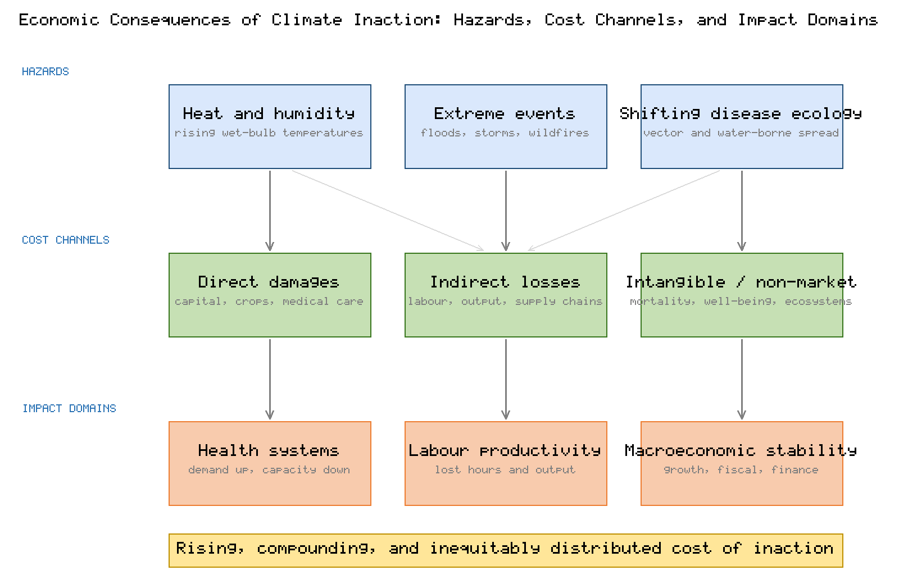
Figure 1. Taxonomy of the economic consequences of climate inaction, linking climate hazards (heat, extreme events, shifting disease ecology) through direct, indirect, and intangible cost channels to impacts on health systems, labour productivity, and macroeconomic stability.

3. Macroeconomic Consequences of Climate Inaction

3.1 Effects on Economic Growth and Output
Macroeconomic research has moved decisively from treating climate damage as a small, late-century deduction from output toward recognising it as a material and proximate drag on growth. Cross-country panel analyses find that persistent temperature increases reduce the growth rate of real output per capita, with the largest losses concentrated in already-hot, lower-income economies [12]. A prominent estimate concludes that the climate change already locked in by historical emissions commits the global economy to an income reduction of roughly 19% by mid-century relative to a world without additional warming, with damages several times larger than the mitigation investment needed to hold warming to 2 °C [13]. These "committed" damages are largely independent of near-term emission choices, underscoring that a substantial economic cost of past inaction is already unavoidable—and that further delay compounds it.
The distribution of macroeconomic harm is strikingly unequal. Analysis of historical warming indicates that it has widened the gap between the economic output of the world's richest and poorest countries, enriching cooler high-income economies while suppressing growth in hotter, poorer ones [19]. Extreme-heat events in particular impose large and regressive growth penalties, with cumulative global losses running into the trillions of dollars and the heaviest burdens falling on tropical, low-income regions least able to absorb them [20].
An important refinement in this literature concerns the difference between level effects and growth effects. If warming depresses only the level of output, economies can in principle recover once conditions stabilise; but if it depresses the rate of growth—by damaging capital, deterring investment, and lowering productivity—then losses compound over time and become far larger [12]. The weight of recent evidence favours persistent growth effects, which is precisely why the committed, mid-century income losses described above are so substantial [13]. These dynamics also interact non-linearly with development: the same absolute temperature increase produces disproportionately larger economic harm in already-hot economies, meaning that inaction does not merely slow global growth but actively widens international inequality and undermines convergence between rich and poor nations [19].

3.2 The Economics of Delay
Delay is itself a distinct and quantifiable source of cost. Postponing mitigation narrows the remaining carbon budget, forces steeper and more disruptive future emission cuts, raises the risk of stranded fossil-fuel assets, and allows damages to accumulate in the interim. The International Monetary Fund has shown that delaying or diluting credible climate policy raises the eventual cost of the transition and increases the likelihood of disorderly, growth-damaging adjustments [21]. The Network for Greening the Financial System estimates that a three-year delay in decisive action could raise transition costs from 0.5% to 1.3% of global GDP by 2030 while roughly halving the effectiveness of transition efforts [4]. The Organisation for Economic Co-operation and Development similarly warns that insufficient and poorly sequenced action erodes long-run growth prospects and fiscal sustainability [22].

3.3 Committed Losses and Fiscal Exposure
A growing body of work distinguishes between damages that remain avoidable through mitigation and those already committed by past emissions. Recent macro-climate modelling suggests that global temperature shocks propagate through trade and supply chains such that the worldwide output loss from warming is far larger than local estimates alone imply, with persistent effects on capital accumulation and productivity [23]. For governments, these dynamics translate into rising fiscal exposure: higher disaster-relief and reconstruction outlays, growing health-system expenditure, revenue erosion from reduced economic activity, and increased sovereign borrowing costs as climate risk is priced into capital markets [21]. Table 1 consolidates the principal headline estimates of the economic cost of climate inaction drawn from recent authoritative assessments.
Table 1. Headline estimates of the economic cost of climate inaction (2019–2026 sources).
Indicator | Estimated magnitude | Time horizon | Source
Lost labour productivity from heat exposure | US$1.09 trillion (~1% of global GDP) | 2024 (realised) | [2]
Climate-health productivity losses across three sectors | At least US$1.5 trillion | By 2050 | [1]
Additional healthcare-system costs | ~US$1.1 trillion | By 2050 | [5]
Additional climate-attributable deaths (global) | ~14.5 million | By 2050 | [5]
Cumulative global economic losses (WEF) | ~US$12.5 trillion | By 2050 | [5]
Climate-attributable deaths in LMICs | 14.5–15.6 million | 2026–2050 | [3]
Associated economic cost in LMICs | US$8.6–20.8 trillion | 2026–2050 | [3]
Rise in transition cost from a three-year delay | 0.5% → 1.3% of global GDP | By 2030 | [4]
Committed global income reduction from locked-in warming | ~19% | By ~2049 | [13]

4. Labour Productivity and Workforce Health

4.1 Heat Stress and the Erosion of Labour Capacity
The single most immediate economic channel of climate inaction is the loss of labour capacity to heat. As wet-bulb temperatures rise, the human body's ability to dissipate metabolic heat declines, forcing reductions in work intensity and duration to avoid heat exhaustion, heat stroke, and death. The International Labour Organization projected that heat stress would reduce total working hours worldwide by the equivalent of 80 million full-time jobs by 2030, with agriculture and construction bearing the overwhelming majority of losses [24]. These projections are being borne out and, in several respects, exceeded: heat exposure caused approximately 640 billion potential labour hours to be lost in 2024, with associated productivity losses of about US$1.09 trillion—close to one percent of global GDP [2].

4.2 Sectoral and Occupational Exposure
Heat-related productivity losses fall disproportionately on outdoor and physically demanding occupations. Agriculture, which employs a large share of the workforce in LMICs, is the most heavily affected sector, followed by construction and other outdoor labour [24]. Modelling of combined labour productivity and labour supply confirms that heat reduces both the number of hours worked and the output produced per hour, compounding the economic loss [25]. Analyses of humid-heat exposure show that physically intensive labour in tropical and subtropical regions is already experiencing significant losses that will intensify with further warming [26]. Even in high-income temperate economies, heatwaves impose measurable macroeconomic costs: analysis of recent European heatwaves estimated losses of a substantial fraction of regional GDP, concentrated in agriculture, construction, and manufacturing [27].
The burden is also profoundly unequal within workforces. Informal and daily-wage workers—who predominate in the agricultural and construction sectors of many LMICs—typically lack the social protection, paid sick leave, or air-conditioned workplaces that would allow them to reduce exposure without catastrophic income loss, forcing a direct trade-off between health and livelihood [24]. Heat exposure further degrades cognitive as well as physical performance, raising error and accident rates and reducing output even in occupations not classified as physically demanding, so that the true productivity cost extends well beyond outdoor manual labour [25]. Gendered divisions of labour compound these effects: women engaged in both subsistence agriculture and unpaid domestic work, often near heat-emitting cookstoves, face cumulative exposures that are frequently omitted from formal labour statistics [26].

4.3 Quantifying the Economic Burden
Systematic assessments of the economic burden of occupational heat stress consistently find large and rising costs, encompassing lost output, increased workplace injury, and additional health-care expenditure for heat-related illness [28]. Economy-wide modelling indicates that heat-induced reductions in worker productivity represent one of the largest single components of climate damage, with global costs projected to reach several percent of GDP in the most exposed regions under continued warming [29]. The Lancet Countdown has documented that these losses are not evenly shared: the per-capita burden is highest in the countries with the lowest Human Development Index, reinforcing the regressive character of climate inaction [30]. Table 2 summarises the principal dimensions of heat-related labour productivity loss, and Figure 2 illustrates the trajectory of realised and projected global economic losses.
Table 2. Dimensions of heat-related labour productivity loss and workforce health impacts.
Dimension | Mechanism | Illustrative magnitude / finding | Source
Aggregate labour-hour loss | Reduced safe working time under heat | ~640 billion hours lost in 2024 | [2]
Projected working-hour loss | Heat stress across all sectors | ~2.2% of total hours by 2030 (≈80 million FTE jobs) | [24]
Most exposed sector | Outdoor physical labour | Agriculture, then construction | [24]
Combined productivity + supply effect | Fewer hours and lower output per hour | Compounded economy-wide loss | [25]
Regional concentration | Humid-heat exposure in tropics | Greatest losses in low-HDI nations | [26][30]
High-income exposure | Heatwave shocks | Measurable share of regional GDP lost | [27]
Associated health cost | Heat illness and injury | Rising occupational health expenditure | [28]
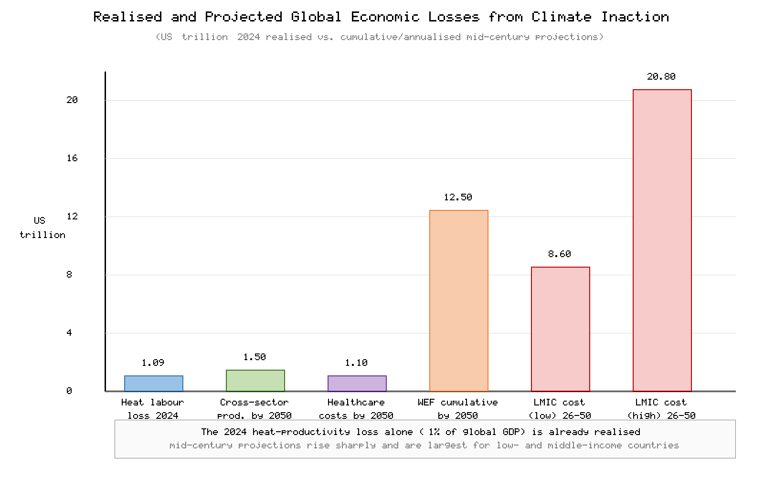
Figure 2. Realised and projected global economic losses associated with climate inaction, showing the 2024 realised heat-related productivity loss alongside mid-century projections for cross-sector productivity, additional healthcare costs, and the low- and high-end LMIC cost range. Values are approximate and drawn from the sources consolidated in Table 1.

5. Healthcare System Costs of Climate Inaction

5.1 Dual Pressure on Health Systems
Climate inaction subjects health systems to a dual pressure: rising demand driven by an expanding burden of climate-sensitive disease, and reduced supply capacity as heat and extreme events impair the health workforce and damage facilities [5]. The World Health Organization's operational framework for building climate-resilient and low-carbon health systems identifies this combination—surging need coinciding with constrained capacity—as a defining vulnerability of twenty-first-century health care [31]. Paradoxically, the health sector is itself a significant emitter, responsible for an estimated 4–5% of global greenhouse-gas emissions; failure to decarbonise care delivery both perpetuates the underlying driver of harm and exposes institutions to transition and reputational risk [32].

5.2 The Rising Burden of Climate-Sensitive Disease
The direct health costs of inaction arise across multiple disease pathways. The health-related costs of climate-sensitive events—including heatwaves, wildfires, and vector-borne disease outbreaks—can be very large even for individual events, as demonstrated by analyses attributing hundreds of millions of dollars in medical costs and lost productivity to discrete climate-driven episodes [33]. Warming is reshaping the geography of infectious disease, expanding the range and season of vectors that transmit malaria, dengue, and other pathogens into previously unaffected populations and altitudes [34]. Projections indicate that, absent mitigation, hundreds of millions of additional people will become at risk of dengue and related arboviral diseases by late century, with correspondingly large demands on clinical services [35]. Rising ambient temperatures also directly increase cardiovascular, respiratory, and renal morbidity and mortality, particularly among older adults, outdoor workers, and people with chronic conditions [36]. Comprehensive syntheses confirm consistent evidence of adverse health effects across heat, air pollution, infectious disease, undernutrition, and mental health, each carrying associated treatment and productivity costs [37].
Several of these pathways are especially costly because their effects are cumulative and intergenerational. Climate-driven disruption of food systems raises the risk of undernutrition, which in early childhood impairs cognitive development and lifetime earning potential, converting a transient climate shock into a permanent reduction in human capital [37]. The mental-health consequences of extreme events, displacement, and chronic environmental stress—including anxiety, depression, and post-traumatic stress—add a large and frequently uncounted burden to health systems and labour markets alike [36]. Children, older adults, pregnant women, and people with pre-existing conditions are consistently identified as the groups bearing the greatest clinical risk, so that the demographic composition of exposed populations strongly shapes the eventual cost [5]. Because many of these harms accrue slowly and diffusely, they are systematically under-represented in conventional cost accounting, which tends to privilege visible, acute damages over chronic, distributed ones.

5.3 Infrastructure Vulnerability and Service Disruption
Beyond disease burden, climate inaction threatens the physical and operational integrity of health care. Floods, storms, wildfires, and heatwaves damage facilities, interrupt power and water supplies, disrupt cold chains for vaccines and medicines, and impede patient access precisely when demand surges [31]. The resulting costs—emergency repairs, service relocation, deferred care, and excess mortality during outages—are frequently omitted from headline estimates yet represent a material component of the true cost of inaction [5]. Table 3 summarises the principal healthcare-sector cost and burden drivers associated with continued warming.
Table 3. Healthcare-sector cost and burden drivers under climate inaction.
Driver | Transmission mechanism | Illustrative impact | Source
Additional healthcare costs | Rising climate-sensitive disease burden | ~US$1.1 trillion by 2050 | [5]
Demand–capacity mismatch | Surging need with constrained workforce | Systemic resilience gap | [31]
Sector emissions footprint | Health care as 4–5% of global emissions | Transition and reputational risk | [32]
Single-event health costs | Heatwaves, wildfires, outbreaks | Hundreds of millions per event | [33]
Shifting disease ecology | Range expansion of vectors | Malaria, dengue in new regions | [34][35]
Heat morbidity/mortality | Cardiovascular, respiratory, renal stress | Excess deaths among vulnerable groups | [36][37]
Infrastructure disruption | Damage to facilities and supply chains | Service interruption, deferred care | [31]

6. Distributional and Equity Dimensions

6.1 Unequal Burdens Across Regions and Groups
A defining feature of climate inaction is the profound inequity of its economic consequences. The populations and nations that have contributed least to cumulative emissions bear the greatest health and economic harms, while possessing the fewest resources to adapt [7]. Climate change operates as a "risk multiplier" for poverty: it reduces agricultural yields, raises food prices, destroys assets, and increases health expenditure among households with minimal buffers, pushing vulnerable families into or deeper into poverty [38]. World Bank analysis estimates that, under a high-impact scenario, climate change could push tens of millions of additional people into extreme poverty by 2030, with health and food-price shocks among the principal channels [39]. These dynamics both reflect and reinforce existing social inequalities across lines of income, gender, age, occupation, and geography [40].
The inequity is also intergenerational. Children alive today will experience several times as many extreme events over their lifetimes as their grandparents did, meaning that the costs of present inaction are disproportionately transferred to future generations who had no part in the decisions that created the risk [7]. This temporal shifting of harm is precisely what high discount rates obscure in conventional economic appraisal, and it is a central reason why updated analyses that weight future welfare more fairly produce much larger estimated damages and a stronger case for action [10]. Within the present generation, climate shocks interact with pre-existing deprivation to create poverty traps: households that lose assets, health, or income to a climate event are frequently unable to recover before the next shock arrives, so that repeated exposure entrenches disadvantage rather than merely causing a one-off loss [38].

6.2 Mortality Valuation and the Human Cost
The gravest costs of inaction are measured in lives. Comprehensive valuation of the global mortality consequences of climate change, accounting for both adaptation costs and benefits, finds that unmitigated warming could generate a mortality burden comparable in magnitude to that of major infectious diseases, concentrated overwhelmingly in hot, poor regions [41]. Attribution studies demonstrate that a substantial share of recent heat-related deaths is already attributable to human-induced warming, establishing that mortality costs are not merely projected but observed [42]. Global assessments of temperature-related mortality confirm that non-optimal temperatures already account for millions of deaths annually, a toll that rises with continued warming and falls disproportionately on disadvantaged communities [43]. This LMIC mortality and cost concentration is quantified in the World Bank projection of 14.5–15.6 million deaths and US$8.6–20.8 trillion in associated economic costs between 2026 and 2050 [3].
Figure 3 illustrates the regressive distribution of climate-related economic and health burdens, contrasting the share of harm borne by lower-income regions with their limited share of historical emissions and adaptive capacity.
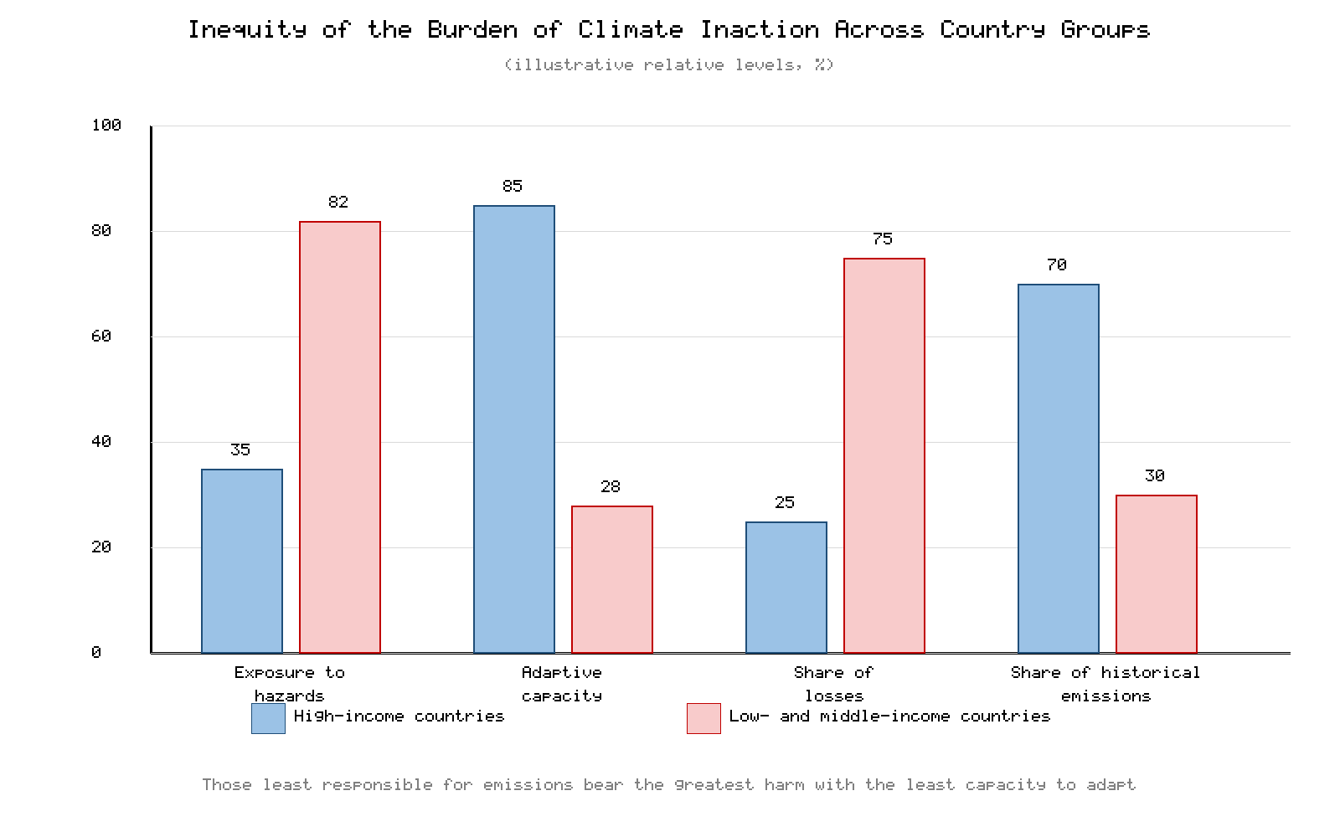
Figure 3. Inequity of the burden of climate inaction: schematic comparison of relative exposure, relative adaptive capacity, and relative share of resulting economic and health losses across higher- and lower-income country groups, highlighting the regressive concentration of harm in low- and middle-income countries.

7. The Economic Case for Action

7.1 Comparing the Cost of Inaction with the Cost of Action
The accumulated evidence converges on a single conclusion: the cost of inaction substantially exceeds the cost of action. Mitigation sufficient to hold warming well below 2 °C is estimated by the IPCC to reduce global GDP growth only marginally and to entail mid-century output effects far smaller than the damages that unchecked warming would impose [11]. Adaptation investment likewise yields favourable returns. Global analysis indicates that protecting exposed populations and assets at adequate standards would require on the order of US$1.2 trillion annually by mid-century under a 2 °C scenario—roughly one percent of GDP in affected places—a sum dwarfed by the losses such protection would avert [44]. Benefit–cost ratios for well-designed adaptation in areas such as early-warning systems, resilient infrastructure, and water management are frequently several-fold, making adaptation one of the highest-return public investments available.

7.2 Financing the Transition
Meeting these needs requires a substantial but achievable reallocation of capital. Estimates of the annual climate finance required rise from roughly US$8–9 trillion through 2030 to more than US$10 trillion annually thereafter, spanning mitigation, adaptation, and resilience across all sectors [45]. Crucially, much of this is investment rather than cost: renewable-energy deployment has become the lowest-cost source of new electricity in most markets, and the energy transition is projected to deliver net economic and employment gains relative to a fossil-fuel-dependent pathway [46]. Redirecting finance away from high-carbon assets toward clean energy and resilient infrastructure therefore improves, rather than diminishes, long-run economic prospects.
Delay also carries a specific financial cost in the form of stranded assets. Capital committed today to long-lived fossil-fuel infrastructure risks becoming economically obsolete before the end of its design life as policy, technology, and markets shift, exposing investors and public balance sheets to large write-downs [21]. Acting early allows this capital stock to be retired and replaced on an orderly schedule rather than abruptly, minimising disruption. Moreover, the transition is a net creator of employment: the jobs generated in renewable-energy deployment, grid modernisation, building retrofits, and ecosystem restoration exceed those lost in contracting fossil-fuel sectors, provided that active labour-market and just-transition policies manage the reallocation [46]. Framed in these terms, the choice is not between economic growth and climate protection but between a managed transition that captures these gains and a disorderly one that squanders them [11].

7.3 Health and Economic Co-Benefits
A decisive but frequently neglected element of the economic case is the scale of health co-benefits from climate action. Rapid decarbonisation sharply reduces air pollution, which is itself responsible for millions of premature deaths each year. Modelling of the public-health implications of meeting the Paris Agreement finds that the resulting reductions in air pollution, dietary improvement, and increased physical activity would prevent millions of premature deaths and generate health savings that, in many scenarios, exceed the cost of mitigation itself [47]. Analyses of a realistic phase-out of fossil fuels similarly project large near-term air-quality and climate benefits, with avoided mortality concentrated in heavily populated, high-pollution regions [48]. These co-benefits mean that ambitious climate policy can be economically self-justifying on health grounds alone, independent of avoided long-term warming. Table 4 contrasts representative estimates of the cost of inaction with the cost of action and its associated benefits.
Table 4. Comparing the cost of inaction with the cost and benefits of action.
Category | Representative estimate | Interpretation | Source
Cost of inaction — realised heat productivity loss | US$1.09 trillion (2024) | Already materialising annually | [2]
Cost of inaction — projected losses | ≥US$1.5 trillion productivity; ~US$12.5 trillion cumulative by 2050 | Rising with delay | [1][5]
Cost of action — mitigation to <2 °C | Marginal reduction in GDP growth; small mid-century output effect | Affordable relative to damages | [11]
Cost of action — adaptation | ~US$1.2 trillion/year by 2050 (~1% of GDP in affected areas) | High benefit–cost ratio | [44]
Climate finance required | ~US$8–9 trillion/year to 2030 | Largely investment, not sunk cost | [45]
Transition economics | Renewables lowest-cost; net employment gains | Transition improves growth prospects | [46]
Health co-benefits | Millions of premature deaths avoided; savings often exceed mitigation cost | Action self-justifying on health grounds | [47][48]
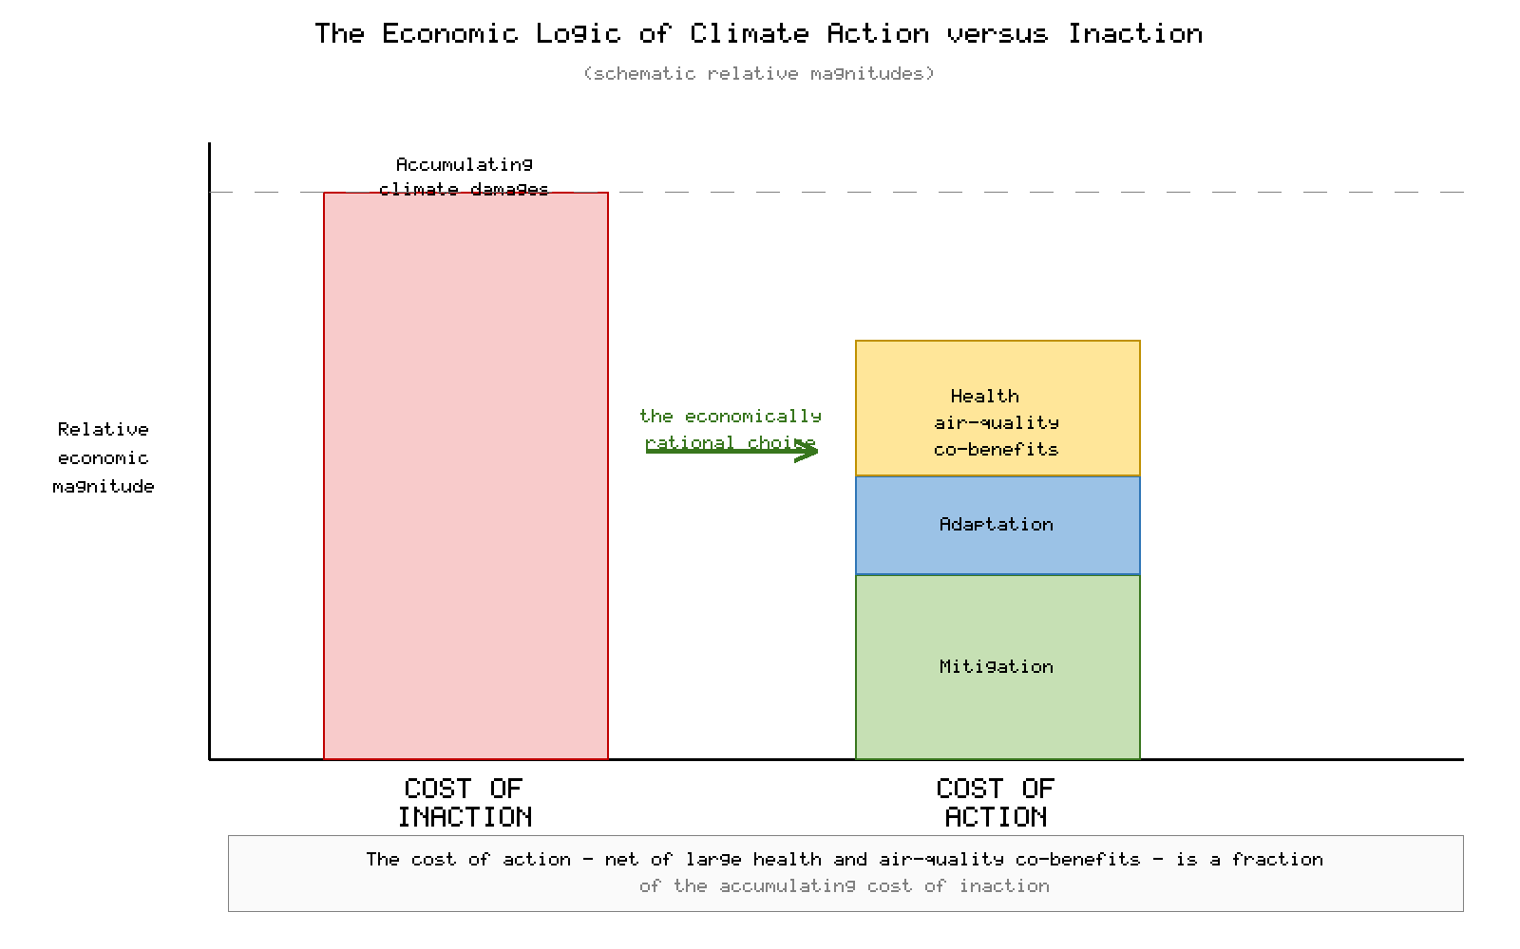
Figure 4. The economic logic of climate action: schematic comparison of the escalating cost of inaction against the cost of mitigation and adaptation, with health and air-quality co-benefits offsetting a large share of action costs, illustrating why timely action is economically rational.

8. Policy and Governance Implications

8.1 Closing the Adaptation and Resilience Gap
Translating the economic case into protection on the ground requires closing a persistent adaptation gap. The United Nations Environment Programme reports that adaptation finance flowing to developing countries remains far below estimated needs, leaving the most exposed populations dangerously under-protected [49]. Prioritising investment in climate-resilient health systems—heat-health early-warning systems, resilient facility design, workforce protection, and surveillance for climate-sensitive disease—offers high returns in avoided mortality and economic loss [31]. Occupational heat-protection standards, rescheduling of outdoor work, and social-protection mechanisms for affected workers can substantially reduce labour-productivity losses while safeguarding health [24].
Underpinning all of these measures is the need for robust surveillance and data. Health systems cannot efficiently allocate scarce resources against a threat they cannot measure; strengthening the monitoring of heat-related illness, vector-borne disease, and the climate resilience of facilities is therefore a prerequisite for cost-effective adaptation [31]. Many national health authorities continue to report gaps in financing, workforce capacity, and climate-health information systems, limiting their ability to anticipate and respond to emerging risks [50]. Investment in early-warning systems, heat-action plans, and integrated climate-health surveillance consistently ranks among the most cost-effective adaptation options available, precisely because it converts avoidable emergency spending into planned, preventive expenditure [49].

8.2 Integrating Health into Climate and Economic Policy
Effective responses require health to be embedded within climate and macroeconomic policy rather than treated separately. National climate-change and health strategies remain unevenly resourced, with many countries reporting inadequate financing and capacity despite recognising the risks [50]. Embedding the health co-benefits of mitigation into the appraisal of nationally determined contributions would raise their assessed value and ambition, as current national pledges remain collectively insufficient to meet agreed temperature goals [51]. Country-level diagnostic work that integrates climate and development objectives has shown that well-sequenced, health-sensitive climate action can be pursued without sacrificing growth or poverty-reduction goals [52].

8.3 Governance, Finance, and Global Cooperation
Because the burdens of inaction fall hardest on those least responsible, equitable global cooperation is both a moral and an economic necessity. International commitments linking climate and health—such as the health declaration adopted at COP28—signal growing recognition that health must be central to climate negotiations, though implementation and finance continue to lag ambition [53]. Aligning financial systems with climate goals, incorporating climate risk into fiscal and monetary frameworks, and scaling concessional finance to LMICs are essential to prevent delay from compounding into irreversible loss [4]. The governance challenge is ultimately one of time: every year of delay narrows the available options and raises the eventual bill [21].
Among the most powerful instruments available is the pricing of carbon, whether through taxes or emissions-trading systems, which internalises the social cost of emissions and generates revenue that can be recycled to protect vulnerable households and finance health-system resilience [22]. The effectiveness of such instruments depends on credibility and predictability: policies that are announced but repeatedly diluted or reversed raise the eventual cost of transition and undermine the investment certainty on which decarbonisation depends [21]. Equally important is the principle of a just transition, which holds that the burdens and benefits of climate action must be distributed fairly, with targeted support for workers, communities, and countries whose economies are most exposed to change. Without such measures, the social and political backlash against poorly managed transitions can itself become a barrier to action, reinforcing the delay whose costs this chapter has documented [49].

9. Conclusion
The evidence assembled in this chapter supports an unambiguous conclusion: climate inaction is economically irrational. The costs of allowing warming to continue—measured in lost labour, overburdened health systems, diminished output, and, above all, preventable death—substantially exceed the investments required for decarbonisation and adaptation. Heat exposure already erased roughly 640 billion potential labour hours in 2024, at a cost of about US$1.09 trillion [2], while climate-driven health impacts threaten at least US$1.5 trillion in productivity losses across key sectors by 2050 [1]. In low- and middle-income countries, the human toll could reach 14.5 to 15.6 million deaths between 2026 and 2050, with associated economic costs of US$8.6 to US$20.8 trillion [3]. Delay magnifies every one of these figures, raising transition costs and foreclosing options [4].
The countervailing opportunity is equally clear. Mitigation consistent with the Paris Agreement is affordable relative to the damages it avoids [11], adaptation delivers high benefit–cost ratios [44], and the health co-benefits of decarbonisation—through cleaner air, healthier diets, and more active living—can by themselves offset much of the cost of action [47]. Realising this opportunity demands that health be placed at the centre of climate and economic policy, that adaptation finance reach those most exposed, and that global cooperation match the scale and urgency of the threat. Framed correctly, climate action is not a burden on prosperity but a precondition for it, and the protection of population health is among its most valuable returns. The economically rational, equitable, and humane course is to act decisively now.

Declarations
Author contributions: Both authors contributed to the conceptualisation, literature synthesis, drafting, and critical revision of the manuscript and approved the final version.
Conflict of interest: The authors declare no competing interests.
Funding: This work received no specific grant from any funding agency in the public, commercial, or not-for-profit sectors.
Use of AI: AI-assisted tools were used to support drafting and formatting in accordance with applicable Springer Nature policies on AI-assisted writing. The authors reviewed and verified all content and remain fully responsible for the originality, accuracy, and integrity of the submission.

References
[1] World Economic Forum, Boston Consulting Group. Building Economic Resilience to the Health Impacts of Climate Change. Geneva: World Economic Forum; 2025.
[2] Romanello M, Walawender M, Di Napoli C, et al. The 2025 report of the Lancet Countdown on health and climate change: climate change action offers a lifeline. Lancet. 2025;406(10521):2804–2857.
[3] World Bank. The Cost of Inaction: Quantifying the Impact of Climate Change on Health in Low- and Middle-Income Countries. Washington, DC: World Bank; 2024.
[4] Network for Greening the Financial System (NGFS). Declaration on the Economic Cost of Climate Inaction. Paris: NGFS; 2025.
[5] World Economic Forum. Quantifying the Impact of Climate Change on Human Health. Geneva: World Economic Forum; 2024.
[6] Intergovernmental Panel on Climate Change (IPCC). Climate Change 2023: Synthesis Report. Contribution of Working Groups I, II and III to the Sixth Assessment Report. Geneva: IPCC; 2023.
[7] Intergovernmental Panel on Climate Change (IPCC). Climate Change 2022: Impacts, Adaptation and Vulnerability. Contribution of Working Group II to the Sixth Assessment Report. Cambridge: Cambridge University Press; 2022.
[8] World Meteorological Organization (WMO). State of the Global Climate 2024. WMO-No. 1368. Geneva: WMO; 2025.
[9] Romanello M, Napoli C, Green C, et al. The 2023 report of the Lancet Countdown on health and climate change: the imperative for a health-centred response in a world facing irreversible harms. Lancet. 2023;402(10419):2346–2394.
[10] Stern N, Stiglitz J, Taylor C. The economics of immense risk, urgent action and radical change: towards new approaches to the economics of climate change. J Econ Methodol. 2022;29(3):181–216.
[11] Intergovernmental Panel on Climate Change (IPCC). Climate Change 2022: Mitigation of Climate Change. Contribution of Working Group III to the Sixth Assessment Report. Cambridge: Cambridge University Press; 2022.
[12] Kahn ME, Mohaddes K, Ng RNC, Pesaran MH, Raissi M, Yang JC. Long-term macroeconomic effects of climate change: a cross-country analysis. Energy Econ. 2021;104:105624.
[13] Kotz M, Levermann A, Wenz L. The economic commitment of climate change. Nature. 2024;628(8008):551–557.
[14] Swiss Re Institute. The Economics of Climate Change: No Action Not an Option. Zurich: Swiss Re Institute; 2021.
[15] Rennert K, Errickson F, Prest BC, et al. Comprehensive evidence implies a higher social cost of CO₂. Nature. 2022;610(7933):687–692.
[16] United States Environmental Protection Agency (EPA). Report on the Social Cost of Greenhouse Gases: Estimates Incorporating Recent Scientific Advances. Washington, DC: US EPA; 2023.
[17] Newell RG, Prest BC, Sexton SE. The GDP–temperature relationship: implications for climate change damages. J Environ Econ Manage. 2021;108:102445.
[18] Piontek F, Drouet L, Emmerling J, et al. Integrated perspective on translating biophysical to economic impacts of climate change. Nat Clim Chang. 2021;11(7):563–572.
[19] Diffenbaugh NS, Burke M. Global warming has increased global economic inequality. Proc Natl Acad Sci USA. 2019;116(20):9808–9813.
[20] Callahan CW, Mankin JS. Globally unequal effect of extreme heat on economic growth. Sci Adv. 2022;8(43):eadd3726.
[21] International Monetary Fund (IMF). Further Delaying Climate Policies Will Hurt Economic Growth. IMF Staff Climate Note. Washington, DC: IMF; 2022.
[22] Organisation for Economic Co-operation and Development (OECD). The Climate Action Monitor 2024. Paris: OECD Publishing; 2024.
[23] Bilal A, Känzig DR. The macroeconomic impact of climate change: global vs. local temperature. NBER Working Paper No. 32450. Cambridge, MA: National Bureau of Economic Research; 2024.
[24] International Labour Organization (ILO). Working on a Warmer Planet: The Impact of Heat Stress on Labour Productivity and Decent Work. Geneva: ILO; 2019.
[25] Dasgupta S, van Maanen N, Gosling SN, Piontek F, Otto C, Schleussner CF. Effects of climate change on combined labour productivity and supply: an empirical and modelling assessment. Lancet Planet Health. 2021;5(7):e455–e465.
[26] Parsons LA, Masuda YJ, Kroeger T, et al. Global labor loss due to humid heat exposure unevenly distributed across the year. Nat Commun. 2021;12:7079.
[27] García-León D, Casanueva A, Standardi G, Burgstall A, Flouris AD, Nybo L. Current and projected regional economic impacts of heatwaves in Europe. Nat Commun. 2021;12:5807.
[28] Borg MA, Xiang J, Anikeeva O, et al. Occupational heat stress and economic burden: a review of global evidence. Environ Res. 2021;195:110781.
[29] Orlov A, Sillmann J, Aunan K, Kjellstrom T, Aaheim A. Economic costs of heat-induced reductions in worker productivity due to global warming. Glob Environ Change. 2020;63:102087.
[30] Romanello M, McGushin A, Di Napoli C, et al. The 2021 report of the Lancet Countdown on health and climate change: code red for a healthy future. Lancet. 2021;398(10311):1619–1662.
[31] World Health Organization (WHO). Operational Framework for Building Climate Resilient and Low Carbon Health Systems. Geneva: WHO; 2023.
[32] Karliner J, Slotterback S, Boyd R, Ashby B, Steele K. Health Care's Climate Footprint: How the Health Sector Contributes to the Global Climate Crisis and Opportunities for Action. Health Care Without Harm and Arup; 2019.
[33] Limaye VS, Max W, Constible J, Knowlton K. Estimating the health-related costs of 10 climate-sensitive U.S. events during 2012. GeoHealth. 2019;3(9):245–265.
[34] Rocklöv J, Dubrow R. Climate change: an enduring challenge for vector-borne disease prevention and control. Nat Immunol. 2020;21(5):479–483.
[35] Colón-González FJ, Sewe MO, Tompkins AM, et al. Projecting the risk of mosquito-borne diseases in a warmer and more populated world: a multi-model, multi-scenario intercomparison. Lancet Planet Health. 2021;5(7):e404–e414.
[36] Ebi KL, Capon A, Berry P, et al. Hot weather and heat extremes: health risks. Lancet. 2021;398(10301):698–708.
[37] Rocque RJ, Beaudoin C, Ndjaboue R, et al. Health effects of climate change: an overview of systematic reviews. BMJ Open. 2021;11(6):e046333.
[38] Hallegatte S, Rozenberg J. Climate change through a poverty lens. Nat Clim Chang. 2019;9(4):250–256.
[39] Jafino BA, Walsh B, Rozenberg J, Hallegatte S. Revised Estimates of the Impact of Climate Change on Extreme Poverty by 2030. Policy Research Working Paper 9417. Washington, DC: World Bank; 2020.
[40] Islam SN, Winkel J. Climate Change and Social Inequality. DESA Working Paper No. 152. New York: United Nations Department of Economic and Social Affairs; 2019.
[41] Carleton T, Jina A, Delgado M, et al. Valuing the global mortality consequences of climate change accounting for adaptation costs and benefits. Q J Econ. 2022;137(4):2037–2105.
[42] Vicedo-Cabrera AM, Scovronick N, Sera F, et al. The burden of heat-related mortality attributable to recent human-induced climate change. Nat Clim Chang. 2021;11(6):492–500.
[43] Zhao Q, Guo Y, Ye T, et al. Global, regional, and national burden of mortality associated with non-optimal ambient temperatures from 2000 to 2019: a three-stage modelling study. Lancet Planet Health. 2021;5(7):e415–e425.
[44] McKinsey Global Institute. Climate Adaptation: Costs, Benefits, and the Case for Resilience. New York: McKinsey & Company; 2025.
[45] Climate Policy Initiative (CPI). Global Landscape of Climate Finance 2023. San Francisco: Climate Policy Initiative; 2023.
[46] International Renewable Energy Agency (IRENA). World Energy Transitions Outlook 2023: 1.5 °C Pathway. Abu Dhabi: IRENA; 2023.
[47] Hamilton I, Kennard H, McGushin A, et al. The public health implications of the Paris Agreement: a modelling study. Lancet Planet Health. 2021;5(2):e74–e83.
[48] Shindell D, Smith CJ. Climate and air-quality benefits of a realistic phase-out of fossil fuels. Nature. 2019;573(7774):408–411.
[49] United Nations Environment Programme (UNEP). Adaptation Gap Report 2023: Underfinanced, Underprepared. Nairobi: UNEP; 2023.
[50] World Health Organization (WHO). 2021 WHO Health and Climate Change Global Survey Report. Geneva: WHO; 2021.
[51] United Nations Framework Convention on Climate Change (UNFCCC). Nationally Determined Contributions under the Paris Agreement: Synthesis Report. Bonn: UNFCCC; 2023.
[52] World Bank. Country Climate and Development Reports (CCDR): Global Synthesis. Washington, DC: World Bank; 2023.
[53] World Health Organization (WHO). COP28 UAE Declaration on Climate and Health. Geneva: WHO; 2023.
Note on authorship and compliance: The volume's call requires at least one international co-author. As currently listed, both authors are affiliated with Chandigarh University, India; the authors should add an eligible international collaborator (and corresponding ORCID identifiers) before submission to satisfy this requirement. All 53 references above are dated 2019–2026 and are cited in strict serial order of first appearance. Bibliographic details should be verified against the publisher's prescribed citation style prior to submission.

