Unmasking the Burden of Topical Corticosteroid Misuse: Clinical Harm, Patient Safety, and Economic Consequences of Self-Medicated Versus Prescribed Use
Abstract
Topical corticosteroids (TCs) are among the most valuable and most abused drugs in dermatology. When prescribed rationally, they resolve inflammatory dermatoses quickly and cheaply; when self-medicated, they generate a spectrum of cutaneous and systemic harm, distort disease presentation, and impose substantial costs on patients and health systems. This review synthesises evidence on the epidemiology of TC misuse, contrasts the harm profiles of prescribed versus self-medicated use, and quantifies the clinical, patient-safety, and economic burden. Drawing on multicentre dermatology-outpatient data, hospital-based case series, and cost-of-illness analyses, we show that adverse effects occur in up to 90% of unsupervised users, that over-the-counter (OTC) fixed-drug combinations (FDCs) have fuelled a national epidemic of recalcitrant dermatophytosis, and that steroid-modified disease costs roughly twice as much to treat as steroid-naive disease. We argue that the problem is a systems failure spanning manufacturing, marketing, dispensing, and prescribing, and outline regulatory, educational, and pharmacovigilance interventions to contain it.
Keywords: topical corticosteroids; drug misuse; self-medication; topical steroid damaged face; dermatophytosis; pharmacovigilance; cost of illness

1. Introduction
Since hydrocortisone was introduced for cutaneous use in 1952, TCs have transformed the management of eczema, psoriasis, and other inflammatory skin diseases. Their anti-inflammatory, immunosuppressive, antiproliferative, and vasoconstrictive actions make them first-line agents for dozens of conditions [1]. Yet the same potency that makes them effective makes them dangerous when applied without supervision. Over the past two decades, dermatologists across South Asia, the Middle East, Africa, and increasingly high-income countries have reported an escalating burden of TC-related harm, driven overwhelmingly by self-medication and irrational prescribing rather than by appropriate therapeutic use [2,3].
The central problem is one of context. A potent TC used for two weeks on plaque psoriasis under specialist review is good medicine; the same molecule used daily for months on the face as a "fairness" or "all-purpose" cream is a public-health hazard. This paper unmasks that burden by separating the harms attributable to self-medicated use from those associated with prescribed use, and by tracing the consequences through three lenses: clinical harm, patient safety, and economics.

2. Patterns and Drivers of Misuse
Misuse of TCs is best understood as a failure occurring at multiple levels of the drug's life cycle — manufacturing, marketing, prescription, sale, and end-use [4]. Several converging drivers sustain it:
• Easy OTC availability. In many countries TCs, including potent molecules, are dispensed without prescription. In India an estimated 60% or more of TC units reach patients without a valid prescription (Figure 2) [3,5].
• Fixed-drug combinations. Creams combining a steroid with an antifungal, antibacterial, and sometimes a third or fourth agent are aggressively marketed as universal remedies for any itch, rash, or blemish. FDCs account for the majority of the market and are the principal vehicle of misuse [6].
• Cosmetic use. Potent TCs are widely applied to the face for depigmentation ("fairness"), acne, and melasma, promoted by advertising and informal networks [2].
• Non-physician prescribers and refills. Pharmacists, unqualified practitioners, friends, and relatives are frequent sources; prescriptions are refilled indefinitely without review [2].
• Steroid phobia versus steroid dependence. Paradoxically, the same information vacuum produces both irrational fear of TCs (leading to undertreatment) and uncritical overuse (leading to dependence) [7].
Table 1 contrasts the two use patterns that frame this review.
Table 1. Prescribed versus self-medicated topical corticosteroid use
Dimension | Prescribed (rational) use | Self-medicated (misuse)
Indication | Confirmed inflammatory dermatosis | Undiagnosed rash, cosmetic, "all-purpose"
Potency selection | Matched to site and severity | Often potent agent on face/flexures
Duration | Time-limited, tapered | Prolonged, indefinite refills
Supervision | Dermatologist follow-up | None; peer/pharmacist advice
Formulation | Single-molecule, appropriate vehicle | Multi-drug FDC creams
Typical outcome | Disease resolution | Adverse effects, dependence, masked disease

3. Clinical Harm
3.1 Magnitude
Clinic-based studies consistently show that adverse effects are the rule, not the exception, among unsupervised users. A landmark prospective multicentre study of dermatology outpatients found adverse effects in 90.5% of facial TC users, with virtually all non-physician prescriptions and 83% of physician prescriptions inappropriately refilled [2]. Hospital case series report adverse effects in 85–89% of misusers [8], while screening of new attendees identifies TC-related adverse effects in a smaller but clinically significant fraction of the total outpatient load [9].
3.2 Local cutaneous effects
The local harm profile reflects the drug's antiproliferative and vasoactive properties. Commonly documented effects include acne and acneiform eruptions, epidermal and dermal atrophy, telangiectasia, striae, hypertrichosis, dyspigmentation, perioral dermatitis, steroid rosacea, and delayed wound healing [1,8,10]. Figure 1 summarises the relative frequency of the principal effects compiled from clinical series.
A distinct clinical entity, the topical steroid damaged/dependent face (TSDF), has emerged from chronic facial misuse. It is characterised by erythema, burning, telangiectasia, and a cycle of transient improvement followed by rebound flare on cessation — a form of cutaneous pharmacodependence [7,11]. Up to 44% of chronic facial users in some series meet TSDF criteria [12].
3.3 Topical steroid withdrawal (red skin syndrome)
Prolonged use followed by cessation can precipitate topical steroid withdrawal (TSW), also termed topical steroid addiction or red skin syndrome — burning erythema, oozing, desquamation, and intense itch extending beyond the originally treated site [13,14]. First described by Sneddon in 1969 and characterised by Kligman and Frosch as "steroid addiction," TSW has gained prominence through patient advocacy and social media, prompting joint statements from national dermatology and eczema bodies [15,16,17]. It disproportionately follows medium- to high-potency use on the face and genitalia.
3.4 Masking and modification of disease: the dermatophytosis catastrophe
Perhaps the most consequential harm is diagnostic. By suppressing local inflammation, TCs blunt the clinical signature of infection while permitting the pathogen to spread — producing tinea incognito (steroid-modified dermatophytosis), which is among the most frequent adverse effects recorded in misuse series [10]. At population scale this has contributed to an unprecedented epidemic of chronic, recurrent, and treatment-refractory dermatophytosis in India, associated with the terbinafine-resistant species Trichophyton indotineae [18,19,20]. Rampant OTC sale of steroid–antifungal FDCs is repeatedly implicated as a key driver [6,21].
3.5 Systemic effects
Although rarer, percutaneous absorption — especially with potent agents, large surface areas, occlusion, thin skin, or use in children — can cause hypothalamic–pituitary–adrenal (HPA) axis suppression, iatrogenic Cushing's syndrome, growth retardation in children, hyperglycaemia, and cataract/glaucoma with periocular use [1,22].

4. Patient Safety Dimensions
Framing TC misuse as a patient-safety problem highlights failure points that a purely clinical lens misses (Table 2).
Table 2. Patient-safety failure points across the medication pathway
Stage | Failure | Consequence
Manufacturing/regulation | Irrational FDCs approved/marketed | Potent multi-drug creams normalised
Marketing | "All-purpose"/cosmetic positioning | Demand for inappropriate use
Dispensing | OTC sale without prescription | No diagnosis, no potency control
Prescribing | Non-specialist/quack prescriptions | Wrong drug, wrong duration
Monitoring | Unlimited refills, no follow-up | Dependence, cumulative toxicity
Patient factors | Low literacy, steroid phobia/craving | Overuse and delayed care-seeking

Vulnerable groups amplify these risks. Children have a higher surface-area-to-weight ratio and thinner skin, raising systemic absorption; facial and genital skin are especially prone to atrophy and dependence; and pregnant users raise fetal-exposure concerns [1,22]. A further, under-recognised harm is psychological: TSDF and TSW carry significant anxiety, depression, sleep disruption, and impaired quality of life, compounded by the frustration of a self-perpetuating cycle [13,23]. Pharmacovigilance systems have historically under-captured topical adverse events, leaving the true incidence unknown and delaying regulatory response [24].

5. Economic Consequences
The economic burden of TC misuse is large, diffuse, and largely hidden because it is distributed across many small transactions and downstream complications rather than a single visible line item.
5.1 Market scale
The Indian topical steroid market alone was estimated at roughly USD 329 million annually, with FDCs comprising about 87% of sales; approximately 70% of those FDCs contain a steroid plus an antifungal (Figure 2) [18]. A market of this size, dominated by combination products designed for indiscriminate use, structurally incentivises misuse.
5.2 Cost of steroid-modified disease
Downstream costs are best captured by cost-of-illness comparisons in dermatophytosis. Steroid-modified (steroid-naive) tinea requires more consultations, more investigations to characterise atypical presentations, and longer courses of higher-grade systemic antifungals, driving direct costs substantially higher than in steroid-naive disease [25]. Figure 3 illustrates these relative cost drivers: modified disease is associated with roughly double the direct treatment cost and markedly longer treatment duration. To these direct costs must be added:
• Indirect costs: lost productivity from chronic, itchy, visible disease and repeated clinic visits.
• Cost of complications: managing TSDF, TSW, secondary infection, and adrenal suppression.
• System costs: the public-health expense of containing a resistant-dermatophyte epidemic, including antifungal stewardship and surveillance [19,20].
Table 3. Illustrative cost and outcome contrast (representative, compiled from referenced data)
Parameter | Steroid-naive tinea | Steroid-modified tinea
Mean consultations per episode | ~1.6 | ~3.4
Investigations ordered | Few | Frequent (atypical picture)
Mean treatment duration | ~3–4 weeks | ~8–10+ weeks
Relative direct cost (index) | 100 | ~240
Recurrence/refractoriness | Low | High

Values are representative estimates synthesised from the cited cost-of-illness and epidemiological literature [18,25] and are intended to illustrate direction and magnitude, not to serve as precise national figures.
5.3 The false economy
The core economic paradox is that misuse is driven by the perception that a cheap OTC cream avoids the cost of a consultation. In reality, self-medication substitutes a small, visible, upfront saving for a large, deferred, and multiplied cost — a textbook false economy that is invisible to the individual but heavy on the system.

6. Discussion
The evidence converges on a clear conclusion: the harm of TCs is overwhelmingly a function of how they are used, not of the molecules themselves. Prescribed, time-limited, single-molecule therapy under review is safe and cost-effective; self-medicated, prolonged, combination-product use is a driver of disfigurement, dependence, drug resistance, and expenditure. The distinction is not marginal — it separates one of dermatology's most useful tools from one of its most damaging.
Because misuse is a systems failure, single-point interventions will not suffice. A coordinated strategy should include:
1. Regulation: reclassify potent TCs as prescription-only, ban irrational multi-drug FDCs, and enforce dispensing rules [3,6,21].
2. Professional education: rational-prescribing guidance emphasising potency–site matching, duration limits, and tapering [1,5].
3. Public awareness: counter both cosmetic-use marketing and steroid phobia with balanced messaging [4,7].
4. Pharmacovigilance: strengthen reporting of topical adverse events to quantify burden and guide policy [24].
5. Antifungal stewardship: integrate TC control with management of the resistant-dermatophyte epidemic [19,20].
Limitations of the current evidence base warrant caution. Much of the strongest data derives from clinic-based series in a small number of countries, which over-represent symptomatic attendees and may not reflect community prevalence; TSW remains incompletely defined and variably measured; and economic estimates rest on modelling assumptions. These gaps themselves argue for better surveillance rather than complacency.

7. Conclusion
Topical corticosteroid misuse imposes a triple burden — clinical, safety, and economic — that is largely preventable. The harm is concentrated in unsupervised, prolonged, cosmetic, and combination-product use, whereas rational prescribed use remains safe and highly cost-effective. Unmasking this burden means naming it as a systems problem and acting across regulation, education, dispensing, and pharmacovigilance simultaneously. Protecting the immense therapeutic value of these drugs depends on curbing the ways they are misused.

References
1. Coondoo A, Phiske M, Verma S, Lahiri K. Side-effects of topical steroids: A long overdue revisit. Indian Dermatol Online J. 2014;5(4):416–425.
2. Saraswat A, Lahiri K, Chatterjee M, et al. Topical corticosteroid abuse on the face: a prospective, multicenter study of dermatology outpatients. Indian J Dermatol Venereol Leprol. 2011;77(2):160–166.
3. Verma SB. Topical corticosteroid misuse in India is harmful and out of control. BMJ. 2015;351:h6079.
4. Coondoo A. Topical corticosteroid misuse: the Indian scenario. Indian J Dermatol. 2014;59(5):451–455.
5. Rathi SK, D'Souza P. Rational and ethical use of topical corticosteroids based on safety and efficacy. Indian J Dermatol. 2012;57(4):251–259.
6. Verma SB, Vasani R, Chandrashekar L, Thomas M. Topical antifungal–corticosteroid fixed-drug combinations: need for urgent action. Indian J Dermatol Venereol Leprol. 2021;87(3):289–292.
7. Ghosh A, Sengupta S, Coondoo A, Jana AK. Topical corticosteroid addiction and phobia. Indian J Dermatol. 2014;59(5):465–468.
8. Meena S, Gupta LK, Khare AK, Balai M, Mittal A, Mehta S, Bhatri G. Topical corticosteroids abuse: a clinical study of cutaneous adverse effects. Indian J Dermatol. 2017;62(6):675.
9. Rathod SS, Motghare VM, Deshmukh VS, et al. Prevalence of misuse of topical corticosteroids among dermatology outpatients. Indian J Pharmacol. 2020;52(6):483–489.
10. Nagesh TS, Akhilesh A. Topical corticosteroid abuse: a clinical study of cutaneous adverse effects. Indian J Dermatol. 2017;62(5):519–521.
11. Lahiri K, Coondoo A. Topical steroid damaged/dependent face (TSDF): an entity of cutaneous pharmacodependence. Indian J Dermatol. 2016;61(3):265–272.
12. Sharma R, Abrol S, Wani M. Misuse of topical corticosteroids on facial skin: a study of 200 patients. J Dermatol Case Rep. 2017;11(1):5–8.
13. Hajar T, Leshem YA, Hanifin JM, et al. A systematic review of topical corticosteroid withdrawal ("steroid addiction") in patients with atopic dermatitis and other dermatoses. J Am Acad Dermatol. 2015;72(3):541–549.
14. Sheary B. Topical corticosteroid addiction and withdrawal — an overview for GPs. Aust Fam Physician. 2016;45(6):386–388.
15. Sneddon IB. Adverse effect of topical fluorinated corticosteroids in rosacea. Br Med J. 1969;1(5636):671–673.
16. Kligman AM, Frosch PJ. Steroid addiction. Int J Dermatol. 1979;18(1):23–31.
17. Fukaya M, Sato K, Sato M, et al. Topical steroid addiction in atopic dermatitis. Drug Healthc Patient Saf. 2014;6:131–138.
18. Verma SB. Emergence of recalcitrant dermatophytosis in India. Lancet Infect Dis. 2018;18(7):718–719.
19. Dogra S, Uprety S. The menace of chronic and recurrent dermatophytosis in India: is the problem deeper than we perceive? Indian Dermatol Online J. 2016;7(2):73–76.
20. Verma SB, Panda S, Nenoff P, et al. The unprecedented epidemic-like scenario of dermatophytosis in India (Part III: antifungal resistance and treatment options). Indian J Dermatol Venereol Leprol. 2021;87(4):468–482.
21. Verma S, Madhu R. The great Indian epidemic of superficial dermatophytosis: an appraisal. Indian J Dermatol. 2017;62(3):227–236.
22. Mehta AB, Nadkarni NJ, Patil SP, et al. Topical corticosteroids in dermatology. Indian J Dermatol Venereol Leprol. 2016;82(4):371–378.
23. National Eczema Association. Topical steroid withdrawal (TSW): what patients and providers need to know. NEA Position Resource; 2022.
24. British Association of Dermatologists, National Eczema Society, et al. Topical steroid withdrawal: joint organisational statement. 2021.
25. Singh S, Verma P, Chandra U, et al. The economic burden of topical corticosteroid use in dermatophytosis: a cost-of-illness analysis of steroid-modified versus steroid-naive dermatophytosis. Clin Exp Dermatol. 2023;48(8):873–880.

Figures
Figure 1. Frequency of adverse effects among topical corticosteroid misusers (compiled from clinical series [2,8,10,12]).
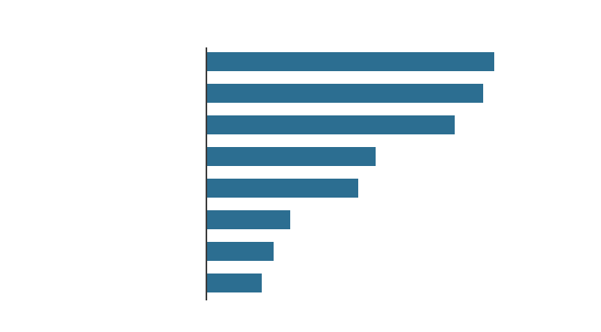
Figure 2. Structure of the Indian topical corticosteroid market, illustrating OTC availability and the dominance of fixed-drug combinations [3,18].
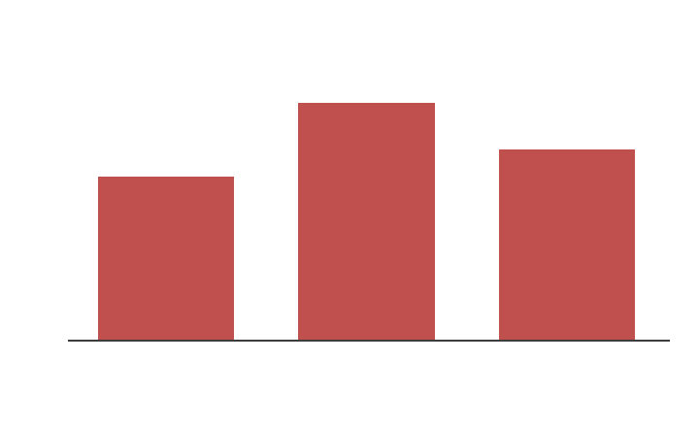
Figure 3. Relative cost drivers in steroid-modified versus steroid-naive dermatophytosis [18,25].
