Artificial Intelligence-Driven Consumer Behavior Analytics and Personalized Customer Engagement: Emerging Trends, Challenges, and Future Directions

Abstract
The rapid advancement of artificial intelligence (AI) has fundamentally transformed how organizations understand, predict, and engage with consumers. This chapter presents a comprehensive examination of AI-driven consumer behavior analytics and personalized customer engagement, encompassing the evolution from traditional market research to sophisticated AI-enabled analytical platforms. The chapter explores how machine learning, deep learning, natural language processing, and generative AI technologies are being leveraged to decode complex consumer behaviors, enabling unprecedented levels of personalization in marketing and customer engagement strategies. A systematic analysis of AI-based consumer segmentation, behavioral prediction, recommendation systems, and intelligent customer relationship management is provided. The chapter further examines emerging technologies including large language models, edge AI, digital twins, and autonomous marketing systems that are reshaping the consumer analytics landscape. Critical challenges related to data privacy, algorithmic bias, transparency, and organizational readiness are discussed within the context of responsible AI adoption. A strategic framework integrating data, analytics, intelligence, personalization, and engagement layers is proposed to guide organizations in implementing AI-driven customer engagement initiatives. The chapter concludes with future research directions emphasizing human-centric, sustainable, and trustworthy AI in marketing, offering researchers and practitioners a roadmap for navigating the evolving intersection of artificial intelligence and consumer behavior science.
Keywords: Artificial Intelligence; Consumer Behavior Analytics; Personalized Marketing; Machine Learning; Customer Engagement; Recommendation Systems; Natural Language Processing; Generative AI; Customer Relationship Management; Ethical AI

Introduction
The digital transformation of commerce and communication has generated an unprecedented volume of consumer behavioral data, creating both extraordinary opportunities and formidable challenges for organizations seeking to understand and engage their customers [1]. The global consumer data market is projected to grow substantially in the coming years, reflecting the increasing recognition of data as a strategic asset for competitive advantage. In this rapidly evolving landscape, artificial intelligence has emerged as the critical enabler of advanced consumer analytics, offering capabilities that far exceed traditional analytical approaches in terms of speed, scale, sophistication, and predictive accuracy [2]. The convergence of expanding data availability, advancing AI technologies, and intensifying competitive pressures has made AI-driven consumer behavior analytics not merely an option but an imperative for organizations across virtually every industry sector.
Consumer behavior, encompassing the processes through which individuals select, purchase, use, and dispose of products and services, has always been central to marketing theory and practice [3]. However, the complexity and dynamism of modern consumer behavior, shaped by digital connectivity, social influence, information abundance, and rapidly shifting preferences, demands analytical capabilities that transcend human cognitive limits. The modern consumer is connected, informed, empowered, and increasingly expects brands to understand their individual needs without explicit communication. AI technologies including machine learning, deep learning, natural language processing, and most recently generative AI provide the computational intelligence necessary to decode these complex behavioral patterns and translate them into actionable engagement strategies [4].
Personalized customer engagement represents the practical application of consumer behavioral insights, delivering individually tailored experiences that recognize each customer as unique in their preferences, needs, and decision-making processes [5]. The evolution from mass marketing through market segmentation to individualized personalization reflects the progressive refinement of both consumer understanding and delivery capabilities, with AI serving as the technological catalyst that makes true one-to-one engagement feasible at scale. Research demonstrates that effective personalization can increase marketing return on investment by 5-8 times while reducing customer acquisition costs by up to 50%, highlighting the substantial economic motivation driving adoption. This chapter provides a comprehensive examination of the current state, emerging trends, challenges, and future directions of AI-driven consumer behavior analytics and personalized customer engagement.
The chapter is organized into four major sections. Section 1 establishes the foundations by examining the evolution of AI in consumer analytics, the data ecosystem supporting these capabilities, and AI-based segmentation and prediction techniques. Section 2 explores AI-enabled personalization including recommendation systems, intelligent CRM, and omnichannel engagement. Section 3 addresses emerging technologies, ethical challenges, and implementation barriers. Section 4 proposes a strategic framework and identifies future research directions. Throughout the chapter, practical examples, comparative analyses, and visual frameworks illustrate the concepts discussed, providing value for both academic researchers and industry practitioners [6]. The integration of theoretical perspectives with practical implementation considerations ensures relevance across stakeholder groups, while the forward-looking discussion of emerging technologies and research opportunities positions the chapter as a guide for future development in this rapidly advancing field.

1. Foundations of AI-Driven Consumer Behavior Analytics

1.1 Evolution of Artificial Intelligence in Consumer and Marketing Analytics
The application of artificial intelligence in consumer and marketing analytics represents one of the most significant technological transformations in modern business practice. The evolution from traditional market research methodologies to AI-enabled analytics platforms has fundamentally altered how organizations understand consumer behavior and make strategic marketing decisions [7]. Traditional approaches to consumer analytics relied primarily on surveys, focus groups, and statistical sampling techniques that provided periodic snapshots of consumer preferences and attitudes [8]. While these methods offered valuable insights, they were inherently limited by temporal constraints, sample size restrictions, and the inability to capture the dynamic nature of consumer decision-making processes. Market researchers were constrained to analyzing small representative samples, with results often becoming outdated before they could be fully implemented in marketing strategies.
The emergence of digital technologies in the early 2000s initiated a paradigm shift in consumer analytics, introducing web analytics, customer relationship management systems, and email marketing platforms that enabled organizations to track and analyze digital consumer interactions [9]. This digital transformation generated unprecedented volumes of consumer data, creating both opportunities and challenges for marketing practitioners. Organizations could now observe actual consumer behaviors rather than relying solely on self-reported preferences, providing more accurate and timely insights into decision-making processes. The subsequent integration of machine learning algorithms into marketing analytics platforms marked a watershed moment, enabling automated pattern recognition, predictive modeling, and real-time decision-making capabilities that far exceeded human analytical capacity [10]. These algorithms could process millions of customer records simultaneously, identifying complex patterns and relationships that would be impossible for human analysts to detect.
Deep learning and natural language processing technologies have further revolutionized the field, enabling sophisticated analysis of unstructured data including text, images, audio, and video content generated by consumers across digital platforms [11]. These technologies facilitate sentiment analysis, emotion detection, and contextual understanding that provide nuanced insights into consumer motivations and preferences. The ability to analyze consumer-generated content at scale has opened new frontiers in understanding brand perception, product satisfaction, and emerging consumer needs. The most recent evolution involves the integration of generative AI and large language models, which are enabling autonomous content generation, conversational marketing, and hyper-personalized customer interactions at scale [12]. As illustrated in Figure 1, this evolutionary trajectory demonstrates the progressive sophistication of AI applications in consumer analytics, from descriptive to autonomous analytics capabilities.
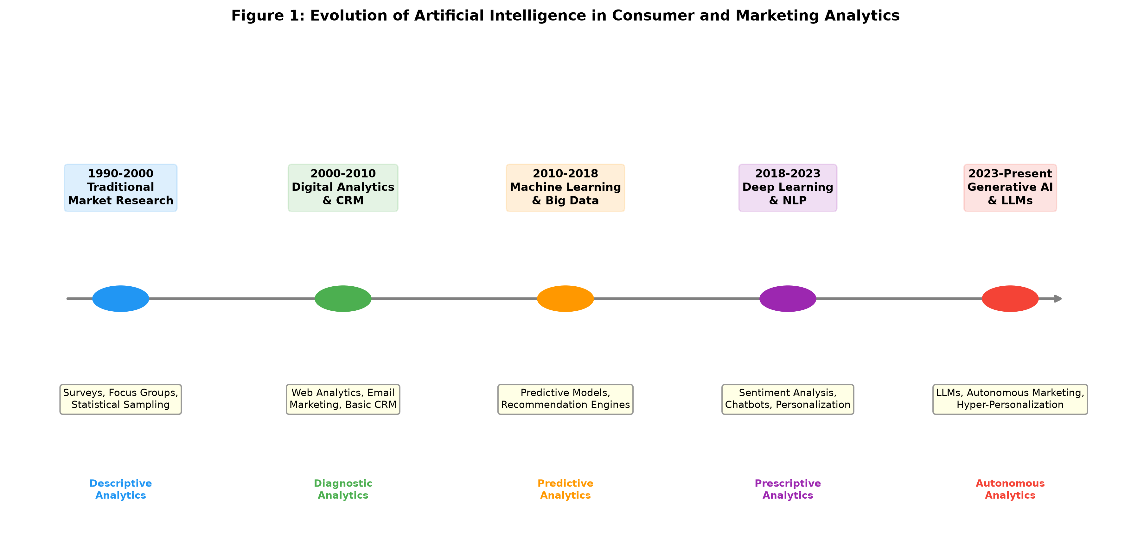
Figure 1: Evolution of Artificial Intelligence in Consumer and Marketing Analytics

The transformation enabled by AI extends beyond analytical capabilities to encompass fundamental changes in organizational approaches to consumer understanding. Modern AI systems can process millions of data points in real-time, identify subtle behavioral patterns invisible to human analysts, and generate actionable recommendations with unprecedented speed and accuracy [13]. This capability has shifted the marketing paradigm from reactive, campaign-based approaches to proactive, continuously adaptive engagement strategies that respond to individual consumer needs in real-time. The implications extend to organizational structures, with data science teams becoming integral to marketing functions and AI literacy becoming a core competency for marketing professionals at all levels [14]. Organizations that have successfully adopted AI-driven analytics report improvements of 20-30% in marketing efficiency and 10-20% increases in customer conversion rates, demonstrating the substantial commercial impact of these technologies.

1.2 Consumer Behavior Data and AI-Based Analytical Techniques
The foundation of AI-driven consumer analytics rests upon the availability and quality of diverse consumer data sources. Contemporary organizations access both structured data, including transactional records, demographic information, and CRM entries, and unstructured data encompassing social media posts, customer reviews, browsing behaviors, and multimedia content [15]. The integration of Internet of Things (IoT) devices has further expanded the data ecosystem, providing real-time behavioral data from connected devices, wearables, and smart environments that offer unprecedented visibility into consumer activities and preferences [16]. The volume of consumer data generated globally continues to grow exponentially, with estimates suggesting that the average consumer generates approximately 1.7 megabytes of data per second through digital interactions, creating a rich but challenging analytical landscape.
Social media platforms constitute particularly rich sources of consumer behavioral data, generating vast quantities of text, image, and video content that reflect consumer opinions, preferences, and social influences [17]. Transaction data provides direct evidence of purchase decisions, while browsing and clickstream data reveals the cognitive processes underlying consumer decision-making. Location data from mobile devices adds spatial context to consumer behaviors, enabling understanding of physical movement patterns, store visitation, and geographic preferences. The combination of these diverse data sources creates comprehensive consumer profiles that enable sophisticated analytical techniques to extract meaningful insights [18]. However, the heterogeneity and volume of these data sources present significant integration challenges that require advanced data engineering capabilities.
AI-based analytical techniques applied to consumer data span three primary categories: predictive analytics, prescriptive analytics, and real-time analytics [19]. Predictive analytics employs machine learning algorithms including random forests, gradient boosting, support vector machines, and neural networks to forecast future consumer behaviors based on historical patterns. These models can predict purchase probability, product preferences, channel preferences, and timing of future purchases with increasing accuracy as data volumes grow. Prescriptive analytics extends beyond prediction to recommend optimal actions, utilizing reinforcement learning and optimization algorithms to identify the most effective marketing interventions for each consumer segment or individual [20]. Real-time analytics leverages stream processing and edge computing to analyze consumer behavior as it occurs, enabling immediate personalization and response. Table 1 presents a comparative analysis of these analytical approaches and their applications in consumer behavior analytics.
Table 1: Comparative Analysis of AI-Based Analytical Techniques in Consumer Behavior Analytics
Analytical Approach | Key Technologies | Applications | Time Horizon | Accuracy Level
Predictive Analytics | ML, Random Forests, Neural Networks | Purchase prediction, Churn forecasting, Demand planning | Short to Medium-term | High (75-92%)
Prescriptive Analytics | Reinforcement Learning, Optimization | Next-best-action, Campaign optimization, Dynamic pricing | Real-time to Short-term | Moderate-High (70-88%)
Real-time Analytics | Stream Processing, Edge AI, CEP | Instant personalization, Fraud detection, Live recommendations | Immediate | High (80-95%)
Descriptive Analytics | Statistical Analysis, Data Mining | Customer profiling, Segmentation, Trend identification | Historical | Very High (90-98%)
Diagnostic Analytics | Causal Inference, Attribution Models | Campaign attribution, Behavior explanation, Path analysis | Historical | Moderate (65-82%)

The effectiveness of AI-based analytical techniques depends critically on data quality, integration capabilities, and the appropriateness of algorithmic selection for specific analytical objectives [21]. Organizations face significant challenges in harmonizing data from disparate sources, ensuring data accuracy and completeness, and maintaining compliance with evolving privacy regulations. The development of customer data platforms (CDPs) and data management platforms (DMPs) has partially addressed these challenges by providing unified data architectures that consolidate consumer information across touchpoints [22]. These platforms enable the creation of unified customer views that serve as the foundation for AI-driven analytics, combining first-party, second-party, and third-party data into coherent profiles that support advanced segmentation and prediction. Feature engineering, the process of transforming raw data into meaningful input variables for machine learning models, remains a critical determinant of analytical success, with recent advances in automated feature engineering and feature stores streamlining this process significantly.

1.3 AI-Based Consumer Segmentation and Behavioral Prediction
Consumer segmentation has been transformed by AI technologies that enable dynamic, multi-dimensional clustering of consumers based on behavioral patterns, preferences, and predicted future actions [23]. Traditional segmentation approaches relied on static demographic and psychographic categories, often failing to capture the complexity and fluidity of modern consumer behavior. These traditional approaches typically segmented markets into four to eight broad groups, missing the rich heterogeneity within segments that AI can now reveal. AI-driven segmentation employs unsupervised learning algorithms including k-means clustering, hierarchical clustering, DBSCAN, and self-organizing maps to identify natural consumer groupings within high-dimensional data spaces [24]. These algorithms can simultaneously consider hundreds of behavioral variables, identifying segments that reflect the true complexity of consumer differences rather than simplified categorical distinctions. The result is often the discovery of dozens or even hundreds of micro-segments, each with distinct behavioral patterns, communication preferences, and value potential that inform differentiated engagement strategies.
Advanced deep learning approaches, particularly autoencoders and variational autoencoders, enable the discovery of latent consumer segments that may not be apparent through traditional analytical methods [25]. These techniques can identify micro-segments of consumers with highly specific behavioral patterns, enabling precision marketing approaches that target individual needs and preferences. Graph neural networks applied to social network data reveal community structures and influence patterns that inform social-aware segmentation strategies. The integration of temporal dynamics through recurrent neural networks and transformer architectures further enhances segmentation by capturing the evolution of consumer behaviors over time, recognizing that consumers may transition between segments as their needs, circumstances, and preferences change [26]. The comprehensive framework for AI-based consumer segmentation is illustrated in Figure 2, demonstrating the interconnection between data sources, analytical techniques, and personalization outcomes.
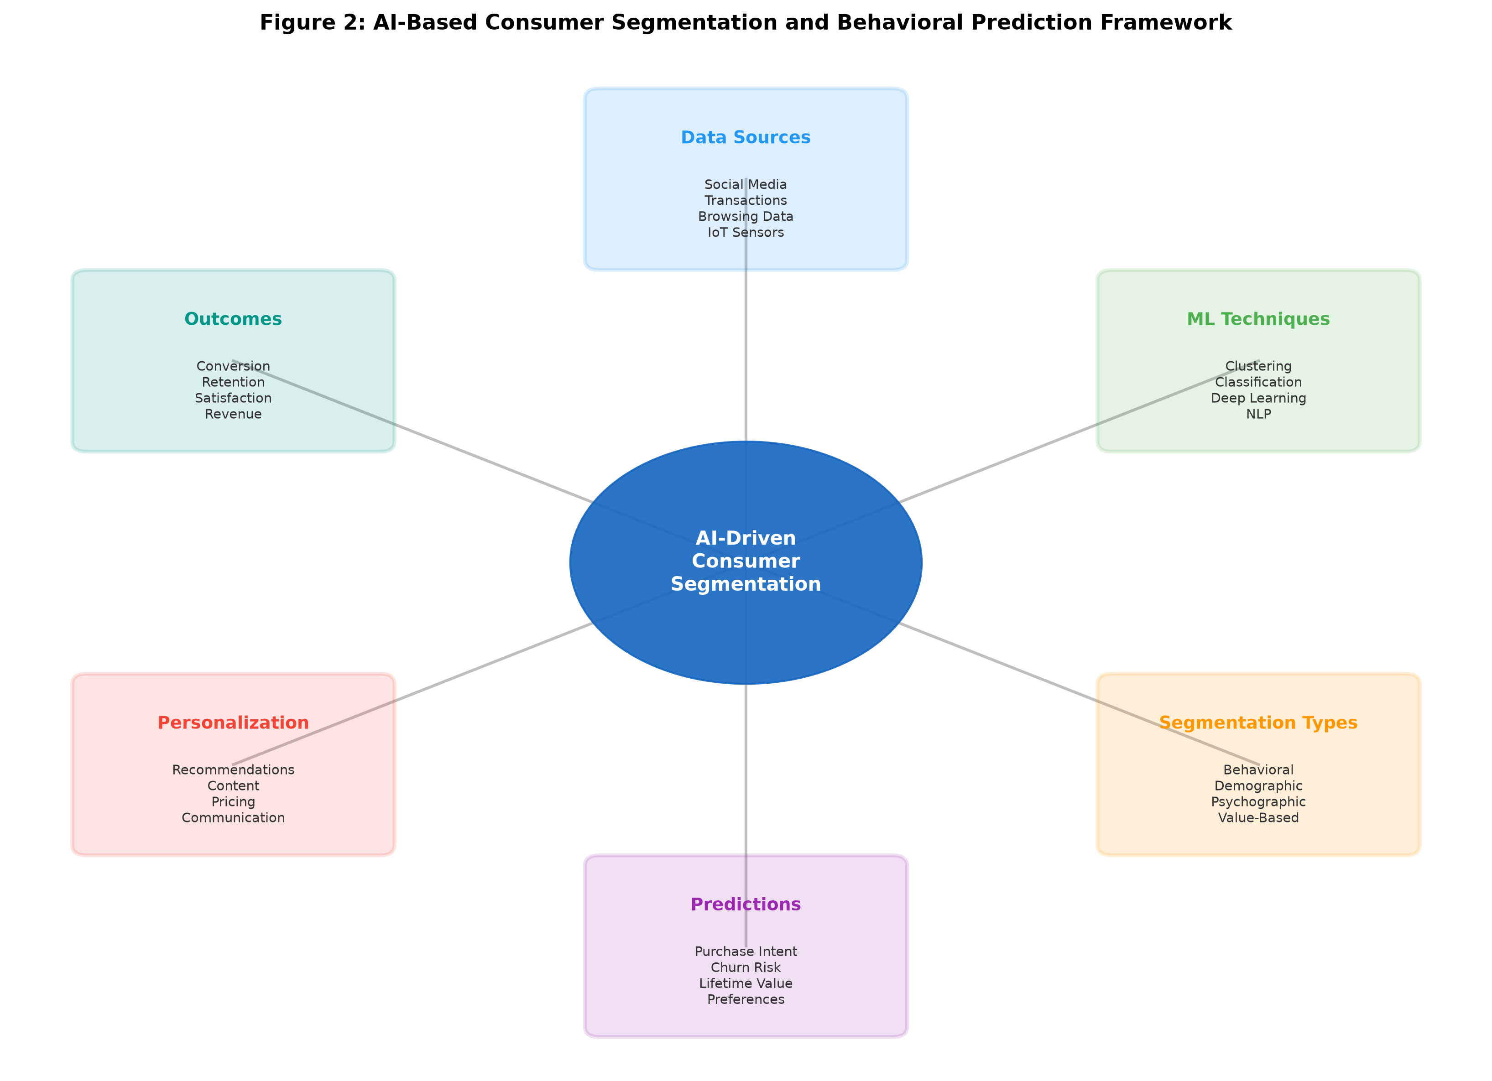
Figure 2: AI-Based Consumer Segmentation and Behavioral Prediction Framework

Behavioral prediction represents a critical application of AI in consumer analytics, encompassing purchase intention prediction, preference forecasting, and churn prediction [27]. Machine learning models trained on historical behavioral data can identify early indicators of purchase intent, enabling proactive engagement strategies that reach consumers at optimal moments in their decision-making processes. Purchase prediction models typically achieve accuracy rates of 75-92% depending on data availability and the prediction horizon, with short-term predictions demonstrating higher accuracy than long-term forecasts. Churn prediction models, leveraging survival analysis and gradient boosting algorithms, enable organizations to identify at-risk customers and implement retention interventions before customer departure [28]. These models analyze engagement patterns, satisfaction indicators, competitive interactions, and life event triggers to generate churn risk scores that prioritize retention efforts. Sentiment and emotion analysis powered by natural language processing provides additional predictive power by capturing attitudinal shifts that precede behavioral changes, as detailed in Table 1 above.
The accuracy and reliability of AI-based predictions depend on multiple factors including data recency, feature engineering quality, model architecture selection, and the stability of underlying behavioral patterns [29]. Ensemble methods combining multiple prediction models have demonstrated superior performance in consumer behavior prediction tasks, achieving accuracy improvements of 15-25% over single-model approaches. Techniques such as stacking, bagging, and boosting combine the strengths of different algorithms while mitigating individual weaknesses. The continuous learning capabilities of modern AI systems enable models to adapt to evolving consumer behaviors, maintaining prediction accuracy even as market conditions and consumer preferences change [30]. Transfer learning approaches allow models developed in one domain or market to be adapted for new contexts, accelerating deployment while maintaining performance. The framework shown in Figure 2 illustrates how these prediction capabilities integrate with segmentation and personalization to create a comprehensive analytical ecosystem.

2. AI-Enabled Personalized Customer Engagement

2.1 Recommendation Systems and Hyper-Personalized Marketing
Recommendation systems represent one of the most commercially successful applications of AI in consumer engagement, generating significant revenue for organizations across retail, entertainment, media, and financial services sectors [31]. Industry reports indicate that recommendation systems drive approximately 35% of purchases on major e-commerce platforms and account for over 80% of content consumption on streaming services, demonstrating their substantial influence on consumer decision-making. These systems leverage collaborative filtering, content-based filtering, and hybrid approaches to predict consumer preferences and suggest relevant products, services, and content. Collaborative filtering algorithms analyze patterns of user-item interactions to identify similarities between users or items, generating recommendations based on the preferences of similar users or the characteristics of similar items [32].
Content-based filtering approaches analyze the attributes of items and the explicit or implicit preferences of individual users to generate personalized recommendations [33]. These systems build detailed profiles of user preferences based on features of items they have previously interacted with, enabling recommendations even for new users with limited interaction history. Modern hybrid systems combine multiple recommendation strategies, incorporating contextual information such as time, location, device, social context, and current emotional state to enhance recommendation relevance. Deep learning-based recommendation systems, utilizing architectures including deep neural networks, attention mechanisms, graph neural networks, and transformer models, have demonstrated superior performance in capturing complex non-linear relationships between users and items [34]. These architectures can model sequential user behaviors, capturing temporal patterns in preferences that enable predictions of evolving interests.
Hyper-personalization extends beyond traditional recommendation by integrating real-time behavioral signals, contextual awareness, and predictive intelligence to deliver individually tailored experiences across all customer touchpoints [35]. This approach leverages streaming data processing to capture and respond to consumer behaviors as they occur, enabling dynamic content adaptation, personalized pricing, and context-aware messaging. Unlike traditional personalization that operates on historical profiles, hyper-personalization adapts in real-time to current context, mood, and micro-moment needs. The integration of reinforcement learning enables continuous optimization of personalization strategies, learning from each interaction to improve future recommendations through exploration-exploitation balancing [36]. Multi-armed bandit algorithms and contextual bandits provide principled approaches to balancing the exploitation of known preferences with exploration of potentially valuable new options. Table 2 presents a comprehensive comparison of recommendation system approaches and their respective capabilities.
Table 2: Comparative Analysis of Recommendation System Approaches for Consumer Engagement
Approach | Methodology | Strengths | Limitations | Use Cases
Collaborative Filtering | User-item interaction patterns | Discovers unexpected preferences, No content analysis needed | Cold start problem, Sparsity issues | E-commerce, Streaming media, Social platforms
Content-Based Filtering | Item attributes & user profiles | No cold start for items, Transparent recommendations | Limited diversity, Feature engineering required | News, Academic papers, Job matching
Hybrid Systems | Combination of multiple methods | Overcomes individual limitations, Higher accuracy | Increased complexity, Computational cost | Major platforms (Amazon, Netflix, Spotify)
Deep Learning-Based | Neural networks, Attention, GNNs | Captures complex patterns, Scalable, Contextual | Requires large data, Black-box nature | Real-time personalization, Visual recommendations
Reinforcement Learning | Sequential decision optimization | Adaptive, Long-term optimization, Exploration | Training instability, Reward design | Dynamic pricing, Sequential recommendations

2.2 AI-Powered Customer Relationship Management
The integration of artificial intelligence into customer relationship management (CRM) systems has transformed these platforms from passive data repositories into active intelligence systems capable of predicting customer needs, automating interactions, and optimizing relationship strategies [37]. Intelligent CRM systems leverage machine learning to analyze customer interaction histories, identify behavioral patterns, and generate insights that inform engagement decisions. These systems continuously learn from new data, adapting their predictions and recommendations to reflect evolving customer relationships. The global AI-CRM market has experienced significant growth, reflecting the recognized value of embedding intelligence directly into relationship management workflows [38].
Customer lifetime value (CLV) prediction represents a critical capability of AI-powered CRM systems, enabling organizations to identify high-value customers, optimize resource allocation, and design retention strategies proportionate to customer value [39]. Advanced CLV models incorporate multiple behavioral dimensions including purchase frequency, average order value, product diversity, engagement intensity, and referral behavior to generate comprehensive value assessments. Probabilistic models including the Beta-Geometric/Negative Binomial Distribution (BG/NBD) model combined with deep learning extensions provide sophisticated forecasts of future customer value under uncertainty. Churn prediction models integrated within CRM systems enable proactive retention interventions, with studies demonstrating that AI-powered churn prediction can reduce customer attrition by 20-35% compared to traditional approaches [40]. Early intervention based on churn risk scores enables targeted retention offers, personalized re-engagement campaigns, and proactive service recovery that address customer concerns before they escalate to departure.
AI-powered chatbots and virtual assistants have emerged as transformative tools for customer engagement, providing 24/7 availability, consistent service quality, and scalable interaction capacity [41]. Modern conversational AI systems powered by large language models can understand nuanced customer queries, maintain contextual awareness across conversations, and provide personalized responses that reflect individual customer histories and preferences. These systems handle routine inquiries autonomously while seamlessly escalating complex issues to human agents, optimizing the balance between automation efficiency and service quality [42]. Research indicates that well-implemented chatbots can resolve 60-80% of routine customer queries without human intervention while maintaining satisfaction scores comparable to human agents for these interaction types. The conversational marketing paradigm enabled by these technologies represents a fundamental shift from one-way communication to interactive, relationship-building dialogues that generate insights while delivering value to customers. Natural language generation capabilities allow these systems to craft personalized messages that reflect individual communication preferences and relationship contexts.

2.3 Omnichannel Customer Experience and Engagement
The contemporary consumer engages with brands across multiple channels including websites, mobile applications, social media platforms, physical stores, email, and emerging channels such as voice assistants and augmented reality environments [43]. The average consumer now uses six or more channels during a single purchase journey, creating complex interaction patterns that require sophisticated analytical capabilities to understand and optimize. AI-enabled omnichannel engagement systems integrate data and interactions across all touchpoints to deliver consistent, personalized experiences regardless of channel. These systems maintain unified customer profiles that capture the complete interaction history, enabling seamless transitions between channels without loss of context or personalization quality [44]. The challenge of maintaining consistency while adapting to channel-specific constraints and opportunities requires sophisticated orchestration capabilities that AI systems are uniquely positioned to provide.
Real-time personalization across channels requires sophisticated orchestration capabilities that determine optimal content, timing, and channel selection for each customer interaction. AI systems analyze individual channel preferences, temporal patterns, response history, and engagement metrics to determine the most effective communication strategy for each customer at each moment [45]. Multi-touch attribution models powered by machine learning allocate credit across touchpoints in the customer journey, enabling optimization of cross-channel resource allocation. The integration of predictive models enables anticipatory engagement, reaching customers with relevant content before they actively seek information or make decisions. For instance, predictive models can identify when a customer is likely entering a purchase consideration phase and proactively deliver relevant content through their preferred channel at optimal timing.
Customer journey mapping enhanced by AI provides comprehensive visibility into the paths consumers take across touchpoints, identifying friction points, drop-off stages, and optimization opportunities [46]. Machine learning algorithms analyze journey data to identify common patterns, predict likely next steps, and recommend interventions that improve conversion and satisfaction outcomes. Process mining techniques applied to journey data reveal actual customer paths that often differ significantly from designed journeys, highlighting areas where experience falls short of expectations. The personalized customer engagement ecosystem, as depicted in Figure 3, illustrates how the integration of data, analytics, intelligence, personalization, and engagement layers creates a comprehensive framework for delivering AI-enabled customer experiences.
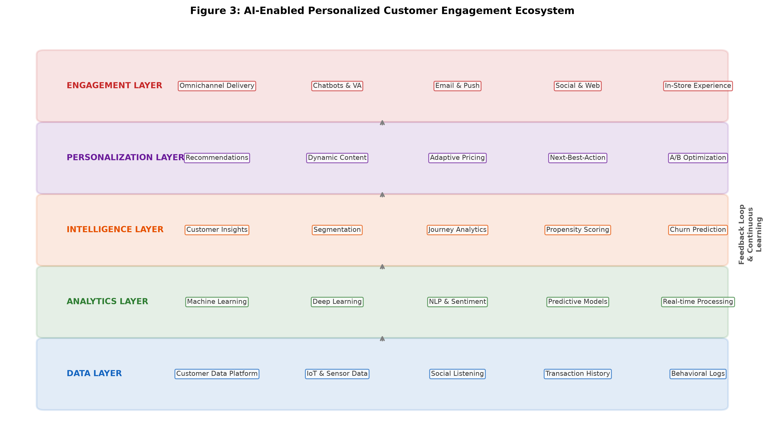
Figure 3: AI-Enabled Personalized Customer Engagement Ecosystem

The effectiveness of omnichannel engagement is measured through multiple metrics including customer satisfaction scores, net promoter scores, conversion rates, and customer effort scores across individual channels and the integrated experience [47]. AI systems continuously optimize engagement strategies based on these metrics, conducting automated experimentation and attribution analysis to determine the contribution of each touchpoint to overall customer outcomes. Advanced experimentation platforms enable continuous A/B and multivariate testing at scale, automatically allocating traffic to winning variations and adapting strategies based on performance data. As shown in Figure 3, the feedback loop connecting engagement outcomes to the data and analytics layers enables continuous improvement of personalization algorithms and engagement strategies. The measurement of incremental lift attributable to AI-driven personalization, compared to baseline non-personalized approaches, provides organizations with clear evidence of value creation and guides investment decisions in analytical capabilities.

3. Emerging Trends, Challenges, and Responsible AI Adoption

3.1 Emerging Technologies Transforming Consumer Analytics
The landscape of consumer analytics continues to evolve rapidly with the emergence of transformative technologies that expand the boundaries of what is analytically possible. Generative AI and large language models (LLMs) represent perhaps the most significant recent development, enabling automated content creation, sophisticated conversational interfaces, and unprecedented natural language understanding capabilities [1]. These models can generate personalized marketing content, product descriptions, and customer communications at scale while maintaining quality and relevance that approaches or equals human-created content. The application of LLMs in consumer analytics extends to advanced sentiment analysis, consumer intent classification, the synthesis of insights from vast textual data sources, and the generation of creative marketing strategies tailored to specific consumer segments [2]. Organizations are deploying generative AI to create thousands of personalized content variations simultaneously, enabling true individual-level content personalization at a scale previously impossible.
Edge AI and Internet of Things (IoT) technologies enable real-time behavioral analytics at the point of consumer interaction, eliminating latency associated with cloud-based processing and enabling immediate personalization responses [3]. Smart retail environments equipped with computer vision, proximity sensors, and edge computing capabilities can analyze in-store behavior in real-time, delivering personalized offers and experiences as consumers navigate physical spaces. These systems can detect product interactions, measure dwell time, analyze facial expressions for engagement signals, and coordinate with digital displays to present personalized content. The convergence of edge computing with 5G connectivity creates opportunities for immersive, responsive consumer experiences that blur the boundaries between physical and digital engagement channels [4]. Augmented reality applications powered by edge AI enable interactive product visualization, virtual try-on experiences, and contextual information overlays that enhance the physical shopping experience with digital intelligence.
Digital twin technology applied to consumer analytics creates virtual representations of individual customers or customer segments, enabling simulation and optimization of engagement strategies without real-world experimentation [5]. These digital twins incorporate behavioral models, preference profiles, contextual factors, and decision-making patterns to predict consumer responses to various marketing interventions, enabling risk-free strategy testing and optimization. Organizations can simulate the impact of pricing changes, product launches, campaign creative, and channel strategies on virtual customer populations before committing resources to real-world implementation. Intelligent customer experience platforms integrating these emerging technologies represent the next frontier of consumer analytics, as presented in Table 3.
Table 3: Emerging Technologies Transforming Consumer Analytics and Engagement
Technology | Key Capabilities | Consumer Analytics Applications | Maturity Level | Expected Impact
Generative AI / LLMs | Content generation, NLU, Reasoning | Personalized content, Conversational AI, Insight synthesis | Growth | Transformative
Edge AI / IoT | Real-time processing, Low latency | In-store analytics, Immediate personalization, Context awareness | Early Growth | High
Digital Twins | Simulation, Prediction, Optimization | Strategy testing, Journey simulation, Scenario planning | Emerging | High
Computer Vision | Image/video analysis, Object detection | Visual search, Emotion detection, Store analytics | Growth | Moderate-High
Federated Learning | Privacy-preserving ML, Distributed training | Cross-organization insights, Privacy-compliant models | Early | Moderate
Quantum Computing | Optimization, Pattern recognition | Complex segmentation, Portfolio optimization | Experimental | Potentially Transformative

3.2 Ethical, Privacy, and Governance Challenges
The extensive collection and AI-driven analysis of consumer data raises fundamental ethical concerns regarding privacy, autonomy, and the responsible use of personal information [6]. Consumers increasingly express concern about the volume of data collected about their behaviors, the opacity of AI systems that process this data, and the potential for manipulation through highly targeted personalization. Research indicates that while consumers appreciate relevant personalized experiences, they become uncomfortable when personalization reveals the extent of data collection or when recommendations feel inappropriately intimate or predictive. The tension between personalization benefits and privacy costs represents a central challenge for organizations implementing AI-driven consumer engagement strategies [7]. The concept of the "personalization paradox" captures this tension, where consumers simultaneously desire personalized experiences and feel violated by the surveillance necessary to enable them.
Algorithmic bias in consumer analytics systems poses significant risks to fairness and equity, potentially perpetuating or amplifying existing societal biases in marketing and service delivery [8]. AI systems trained on historical data may inherit biases present in that data, leading to discriminatory outcomes in areas including credit decisions, pricing, service quality, and opportunity access. For example, recommendation systems trained on historical purchase data may systematically under-serve demographic groups that have been historically marginalized in certain product categories. Addressing algorithmic bias requires proactive approaches including diverse and representative training data, bias detection and mitigation techniques, adversarial debiasing methods, and ongoing monitoring of model outputs for discriminatory patterns [9]. The challenge of transparency and explainability in AI decision-making is particularly acute in consumer-facing applications where individuals have a legitimate interest in understanding how decisions affecting them are made. Explainable AI (XAI) techniques including SHAP values, LIME, and attention visualization provide partial solutions, but achieving meaningful transparency without sacrificing model performance remains an active research challenge.
Regulatory frameworks including the General Data Protection Regulation (GDPR), California Consumer Privacy Act (CCPA), and emerging AI-specific legislation such as the EU AI Act establish requirements for consent, data minimization, purpose limitation, and individual rights that constrain AI-driven consumer analytics practices [10]. Organizations must navigate complex and evolving regulatory landscapes while maintaining analytical capabilities, requiring sophisticated governance frameworks that balance innovation with compliance. The right to explanation embedded in GDPR creates particular challenges for complex AI systems whose decision-making processes may be difficult to articulate in human-understandable terms. The development of privacy-enhancing technologies including federated learning, differential privacy, homomorphic encryption, and synthetic data generation offers potential pathways for maintaining analytical power while respecting privacy constraints [11]. These technologies enable organizations to derive insights from sensitive data without exposing individual records, but their implementation adds complexity and may reduce analytical precision.

3.3 Challenges in Implementing AI-Driven Personalization
The implementation of AI-driven personalization systems faces numerous practical challenges that extend beyond technological capabilities to encompass organizational, cultural, and strategic dimensions [12]. Data quality issues including incompleteness, inconsistency, duplication, and staleness significantly impact the effectiveness of AI models, with studies indicating that poor data quality reduces model performance by 25-40% in consumer prediction tasks. Many organizations struggle with data silos where valuable customer information remains isolated in departmental systems, preventing the creation of comprehensive customer views necessary for effective personalization. Data interoperability challenges arise from the proliferation of marketing technology systems, each maintaining separate data stores with inconsistent schemas and definitions [13].
Model accuracy and reliability present ongoing challenges, particularly in rapidly changing market environments where historical patterns may not predict future behaviors [14]. The phenomenon of concept drift, where the statistical properties of target variables change over time due to evolving consumer preferences, competitive dynamics, or external events, requires continuous model monitoring and retraining to maintain prediction quality. Model monitoring systems must detect performance degradation quickly and trigger appropriate responses, whether automated retraining or human review. Scalability challenges emerge as organizations attempt to deliver personalized experiences to millions of customers simultaneously, requiring distributed computing architectures, efficient algorithm implementations, and intelligent caching strategies [15]. The computational cost of generating real-time recommendations for large customer bases at millisecond latencies demands sophisticated infrastructure investment and optimization.
Organizational readiness encompasses the human capabilities, cultural orientation, and structural alignment necessary to effectively leverage AI-driven personalization [16]. Many organizations lack the data science talent, cross-functional collaboration practices, and decision-making frameworks necessary to translate AI insights into effective engagement strategies. The gap between AI capability and organizational ability to act on AI-generated insights represents a significant barrier to value realization. Change management challenges include resistance from marketing teams accustomed to intuition-based decision-making, insufficient executive understanding of AI capabilities and limitations, and misalignment between technology investments and business strategy. The balance between personalization and consumer autonomy represents a philosophical challenge, as excessively precise personalization may create filter bubbles, reduce consumer exploration and serendipity, or be perceived as invasive, ultimately undermining trust and engagement [17]. Achieving the optimal level of personalization requires understanding individual preferences for personalization intensity and respecting boundaries between helpful customization and unwelcome intrusion. Organizations must develop nuanced personalization policies that adapt intensity based on context, relationship stage, and individual comfort levels.

4. Future Directions and Strategic Framework for AI-Driven Engagement

4.1 Future Evolution of Intelligent Consumer Analytics
The future evolution of intelligent consumer analytics will be characterized by increasing autonomy, adaptability, and sophistication in AI systems that understand and engage with consumers [18]. Autonomous marketing systems capable of independently planning, executing, and optimizing campaigns represent the next evolutionary stage, reducing human intervention requirements while maintaining strategic alignment [19]. These systems will leverage advances in reinforcement learning and multi-agent systems to coordinate complex marketing activities across channels, audiences, and objectives simultaneously. Unlike current systems that optimize individual campaign elements, autonomous marketing will manage entire portfolios of marketing activities, balancing short-term conversion objectives with long-term relationship building and brand equity development.
Adaptive AI systems that continuously learn from consumer interactions and environmental changes will enable truly responsive engagement strategies that evolve in real-time [20]. Unlike current systems that require periodic retraining with batched data, future adaptive systems will incorporate online learning capabilities that immediately incorporate new information into decision-making processes. These systems will detect and respond to emerging trends, competitive actions, and environmental changes without human intervention, maintaining relevance and effectiveness in rapidly changing markets. Meta-learning approaches will enable systems to learn how to learn from new types of consumer behaviors, accelerating adaptation to novel market conditions and emerging consumer segments. The emerging role of multimodal AI, capable of simultaneously processing and generating text, images, audio, and video, will enable richer consumer understanding and more engaging personalized content delivery [21]. Multimodal models will analyze consumer responses across sensory channels, understanding not just what consumers say but how they respond emotionally and behaviorally to different content types and formats.
The integration of causal inference techniques with machine learning will enable AI systems to move beyond correlation-based predictions to understand the causal mechanisms underlying consumer behavior [22]. This capability will enable more effective intervention design, as organizations can identify not just what consumers are likely to do, but what actions will actually influence their behavior. Causal AI will distinguish between correlation and causation in marketing attribution, providing more accurate estimates of marketing effectiveness and enabling better resource allocation decisions. Instrumental variable approaches, difference-in-differences methods, and structural causal models adapted for high-dimensional marketing data will provide rigorous frameworks for causal identification. The convergence of neuroscience insights with AI will further enhance consumer understanding, incorporating knowledge of cognitive processes, decision-making heuristics, emotional responses, and attention patterns into predictive models [23]. Neuromarketing data combined with AI analysis will reveal subconscious consumer responses that traditional behavioral data cannot capture, providing deeper understanding of purchase motivations and brand relationships. Eye-tracking data, electrodermal activity, and facial coding integrated with AI will enable real-time assessment of consumer engagement and emotional response to marketing stimuli.

4.2 Strategic Framework for AI-Driven Personalized Customer Engagement
Based on the comprehensive analysis presented in this chapter, a strategic framework for AI-driven personalized customer engagement is proposed, integrating five interconnected layers: data foundation, analytics engine, intelligence layer, personalization platform, and engagement orchestration [24]. This framework, illustrated in Figure 4, provides organizations with a structured approach to building and operating AI-driven engagement capabilities while maintaining ethical standards and organizational alignment. The framework recognizes that successful AI-driven engagement requires coordinated investment across technology, data, talent, and organizational dimensions rather than isolated technology implementations.
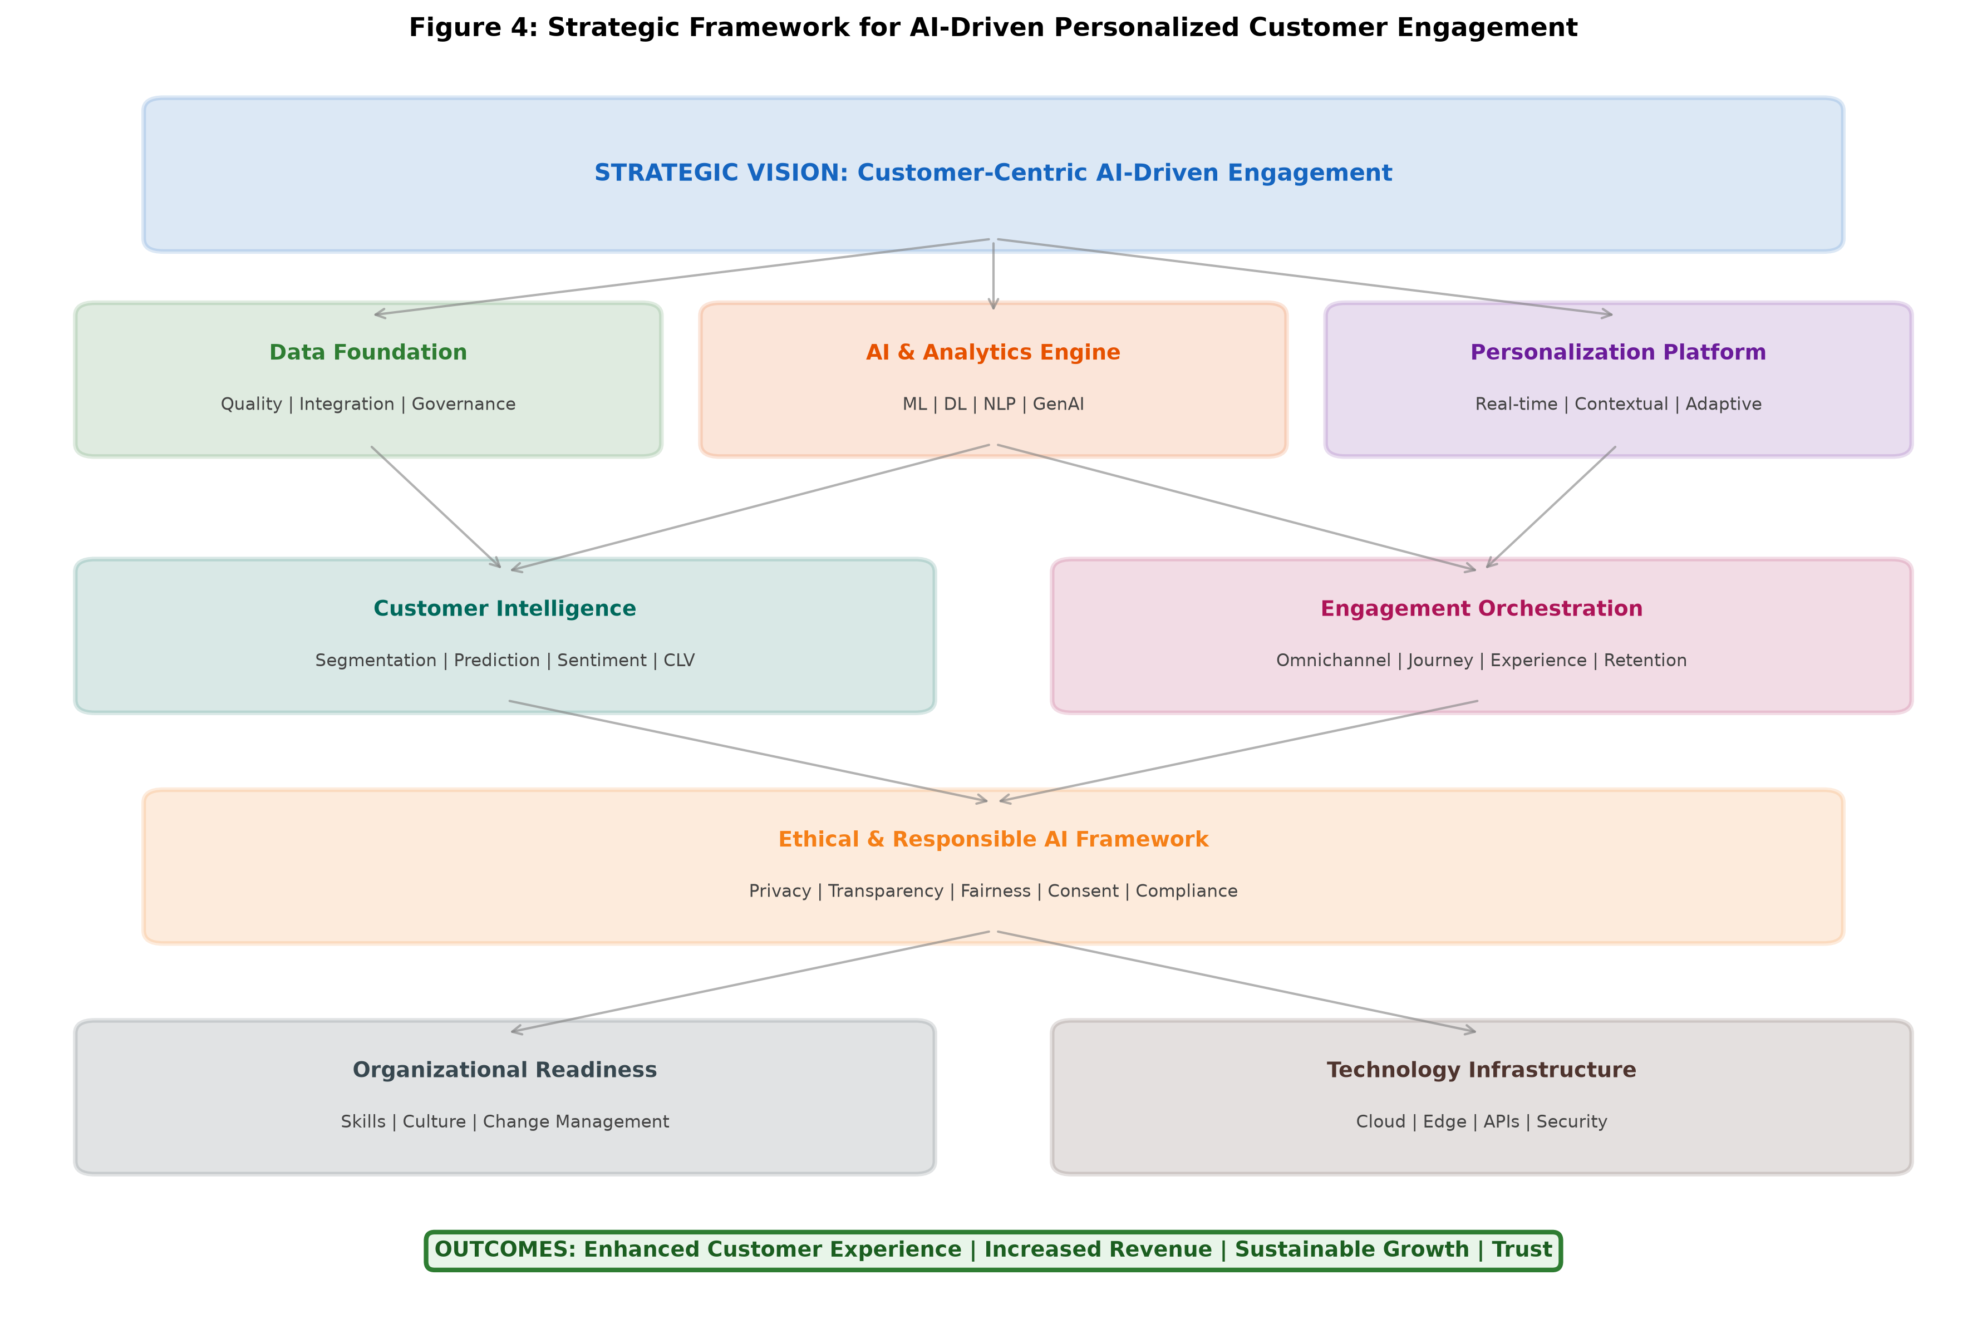
Figure 4: Strategic Framework for AI-Driven Personalized Customer Engagement

The data foundation layer establishes the infrastructure for collecting, integrating, and governing consumer data across all sources and touchpoints. This layer encompasses customer data platforms, data quality management systems, data governance frameworks, and consent management mechanisms that ensure data availability, accuracy, and compliance [25]. Without a robust data foundation, subsequent analytical layers cannot perform effectively regardless of algorithmic sophistication. The analytics engine layer deploys machine learning, deep learning, natural language processing, and increasingly generative AI capabilities to transform raw data into predictive and prescriptive insights. This layer includes model development environments, training infrastructure, model registry and versioning systems, and automated retraining pipelines that maintain model currency. The intelligence layer synthesizes analytical outputs into actionable customer intelligence including segmentation, propensity scores, lifetime value estimates, and behavioral predictions [26]. This layer translates complex analytical outputs into business-meaningful intelligence that can inform decisions across the organization.
The personalization platform layer translates customer intelligence into individualized experiences through recommendation engines, dynamic content systems, decision engines, and real-time optimization algorithms [27]. This layer determines what content, offers, and experiences to deliver to each customer based on their unique profile, current context, and predicted needs. Advanced personalization platforms incorporate contextual awareness, recognizing that optimal personalization varies by situation, mood, and immediate context rather than relying solely on historical preferences. The engagement orchestration layer manages the delivery of personalized experiences across channels, optimizing timing, channel selection, frequency, and message sequencing to maximize customer value and satisfaction while respecting communication preferences and fatigue thresholds [28].
The strategic framework incorporates cross-cutting concerns including ethical AI governance, organizational readiness, and technology infrastructure that support all layers [29]. Ethical governance ensures that AI systems operate within defined fairness, transparency, and accountability parameters, with monitoring systems that detect and flag potential issues before they impact consumers. Organizational readiness encompasses talent development, process redesign, and cultural transformation necessary to operate AI-driven engagement effectively. As depicted in Figure 4, the framework emphasizes the importance of feedback loops that connect engagement outcomes back to the data and analytics layers, enabling continuous learning and improvement. The integration of AI with business intelligence and marketing strategy ensures that AI-driven capabilities align with organizational objectives and create measurable business value [30]. Human-AI collaboration remains central to the framework, recognizing that optimal outcomes emerge from the combination of AI analytical power with human creativity, judgment, and ethical reasoning. Table 4 provides detailed implementation guidance for each framework layer.
Table 4: Strategic Framework Implementation Components for AI-Driven Customer Engagement
Framework Layer | Key Components | AI Technologies | Success Metrics | Implementation Priority
Data Foundation | CDP, Data Lake, Governance | ETL Automation, Data Quality ML | Data completeness >95%, Integration speed | Critical (Phase 1)
Analytics Engine | ML Platform, Model Registry | Deep Learning, NLP, AutoML | Model accuracy, Training efficiency | High (Phase 1-2)
Intelligence Layer | Insight Generation, Segmentation | Clustering, Prediction, Scoring | Prediction accuracy, Segment stability | High (Phase 2)
Personalization Platform | Recommendation, Content, Decisions | RL, Contextual Bandits, NCF | Recommendation relevance, CTR uplift | High (Phase 2-3)
Engagement Orchestration | Channel Management, Journey Engine | Multi-arm Bandit, Sequence Models | Engagement rate, NPS, Conversion | Medium (Phase 3)
Ethical Governance | Bias Monitoring, Privacy, Consent | Fairness ML, Federated Learning | Compliance rate, Bias metrics | Critical (All Phases)

4.3 Research Opportunities and Future Perspectives
The intersection of artificial intelligence and consumer behavior analytics presents numerous research opportunities that span technological, methodological, and theoretical dimensions [31]. From a technological perspective, the application of foundation models and multimodal AI to consumer understanding remains largely unexplored, offering opportunities to develop more comprehensive and nuanced models of consumer behavior that integrate textual, visual, auditory, and behavioral signals. Research into privacy-preserving AI techniques including federated learning, differential privacy, and secure multi-party computation for consumer analytics is critical for enabling continued innovation within increasingly restrictive regulatory environments [32]. The development of AI systems that can learn effectively from limited data through few-shot and zero-shot learning approaches addresses the practical challenge of data scarcity in niche markets or for new product categories.
Methodological opportunities include the development of causal inference frameworks for marketing AI, enabling systems to move beyond predictive accuracy to understand the mechanisms through which marketing interventions influence consumer behavior [33]. The integration of experimental methods with observational AI enables more rigorous evaluation of AI system effectiveness and provides insights into the causal pathways through which personalization creates value. Research into the long-term effects of AI-driven personalization on consumer welfare, market dynamics, competition, and societal outcomes represents an important area that extends beyond immediate commercial applications. The development of evaluation frameworks that capture the full spectrum of AI system impacts, including unintended consequences, distributional effects, and ecosystem externalities, is essential for responsible advancement of the field [34].
The paradigm of responsible and human-centric AI in marketing requires fundamental research into consumer preferences regarding AI-mediated interactions, the psychological effects of algorithmic personalization, and the design of AI systems that enhance rather than diminish consumer agency [35]. Future research should investigate how transparency and explainability in AI systems affect consumer trust, engagement, and purchase behavior, how algorithmic recommendations influence consumer exploration, diversity of consumption, and satisfaction over time, and how AI-driven personalization can be designed to promote long-term consumer welfare alongside organizational objectives [36]. The investigation of consumer perceptions of AI fairness, the factors that influence acceptance or rejection of AI-mediated experiences, and the role of perceived control in shaping responses to personalization represent critical areas for behavioral research.
The future directions for sustainable, trustworthy, and customer-centric AI adoption encompass the development of governance frameworks that enable innovation while protecting consumer interests, the creation of industry standards for responsible AI in marketing, and the establishment of interdisciplinary research programs that bring together computer scientists, marketing scholars, ethicists, psychologists, and policymakers [37]. Cross-disciplinary collaboration is essential because the challenges at the intersection of AI and consumer behavior span technical, behavioral, ethical, and regulatory domains that no single discipline can address comprehensively. The ultimate goal is the development of AI systems that create genuine value for consumers while supporting organizational sustainability, operating within ethical boundaries that maintain public trust and social license for AI-driven consumer engagement [38]. Research programs that combine technical innovation with rigorous evaluation of societal impact will be essential for guiding the responsible development of the field.
Specific research priorities include the development of standardized benchmarks for evaluating AI-driven personalization systems across dimensions of accuracy, fairness, privacy preservation, and consumer welfare [39]. The creation of open datasets and shared evaluation frameworks would accelerate research progress while enabling meaningful comparison across approaches. Additionally, longitudinal studies examining the cumulative effects of AI-driven personalization on consumer decision-making quality, satisfaction, and autonomy are needed to understand the long-term implications of these systems [40]. The investigation of cultural differences in consumer responses to AI-mediated experiences represents another important frontier, as personalization strategies effective in one cultural context may not transfer directly to others. Finally, research into the design of AI systems that actively promote consumer learning, exploration, and informed decision-making rather than simply optimizing short-term engagement metrics will be critical for ensuring that AI-driven engagement serves long-term consumer interests [41].

5. Conclusions
This chapter has provided a comprehensive examination of artificial intelligence-driven consumer behavior analytics and personalized customer engagement, tracing the evolution from traditional market research to sophisticated AI-enabled analytical platforms. The analysis demonstrates that AI technologies including machine learning, deep learning, natural language processing, and generative AI have fundamentally transformed organizational capabilities for understanding, predicting, and engaging with consumers [42]. The integration of these technologies enables unprecedented levels of personalization, delivering individually tailored experiences across multiple channels and touchpoints while continuously learning and adapting to evolving consumer behaviors and preferences.
The examination of recommendation systems, intelligent CRM, and omnichannel engagement reveals that AI-powered personalization generates measurable improvements in customer satisfaction, conversion rates, retention, and organizational revenue when implemented effectively [43]. However, the analysis also highlights significant challenges related to data quality, algorithmic bias, privacy compliance, organizational readiness, and the philosophical tension between personalization depth and consumer autonomy that must be addressed for successful implementation. The emerging technologies discussed, including generative AI, edge computing, digital twins, and federated learning, represent promising frontiers that will further expand the capabilities and applications of AI in consumer analytics while potentially addressing some current limitations [44].
The strategic framework proposed in this chapter provides organizations with a structured approach to building AI-driven engagement capabilities, integrating data, analytics, intelligence, personalization, and engagement layers within an ethical governance structure [45]. The framework emphasizes the importance of continuous learning, human-AI collaboration, and responsible AI practices that maintain consumer trust and regulatory compliance. The layered approach enables organizations to build capabilities progressively, establishing strong foundations before advancing to more sophisticated personalization and orchestration capabilities.
Future research directions emphasize the need for interdisciplinary approaches that combine technological innovation with ethical reasoning, consumer psychology, and societal awareness to ensure that AI-driven consumer engagement creates genuine value for all stakeholders [46]. The development of causal AI, adaptive systems, and multimodal analytics will continue to expand analytical capabilities, while responsible AI frameworks and privacy-enhancing technologies will address growing societal expectations for transparency, fairness, and consumer protection. As the field continues to mature, the organizations and researchers that prioritize consumer welfare alongside commercial objectives will be best positioned to build sustainable competitive advantage through AI-driven engagement [47]. Success in this evolving landscape will belong to organizations that can harness the full power of AI while maintaining the trust, respect, and genuine value delivery that sustain long-term customer relationships. The path forward requires not only technical excellence but also ethical leadership, organizational commitment to responsible innovation, and genuine dedication to creating mutual value for organizations and the consumers they serve.

References
[1] Davenport, T., Guha, A., Grewal, D., & Bressgott, T. (2020). How artificial intelligence will change the future of marketing. Journal of the Academy of Marketing Science, 48(1), 24-42.
[2] Wedel, M., & Kannan, P. K. (2016). Marketing analytics for data-rich environments. Journal of Marketing, 80(6), 97-121.
[3] Kumar, V., & Reinartz, W. (2018). Customer relationship management: Concept, strategy, and tools (3rd ed.). Springer.
[4] Huang, M. H., & Rust, R. T. (2021). A strategic framework for artificial intelligence in marketing. Journal of the Academy of Marketing Science, 49(1), 30-50.
[5] Arora, N., Ensslen, D., Fiedler, L., Liu, W. W., Robinson, K., Stein, E., & Schüler, G. (2021). The value of getting personalization right—or wrong—is multiplying. McKinsey Digital Report.
[6] Peres, R., Schreier, M., Schweidel, D., & Sorescu, A. (2023). On ChatGPT and beyond: How generative artificial intelligence may affect research, teaching, and practice. International Journal of Research in Marketing, 40(4), 735-740.
[7] Chintagunta, P. K., Hanssens, D. M., & Hauser, J. R. (2016). Marketing science and big data. Marketing Science, 35(3), 341-342.
[8] Verhoef, P. C., Kooge, E., & Walk, N. (2016). Creating value with big data analytics. Routledge.
[9] Ansari, A., & Mela, C. F. (2003). E-customization. Journal of Marketing Research, 40(2), 131-145.
[10] Ma, L., & Sun, B. (2020). Machine learning and AI in marketing—Connecting computing power to human insights. International Journal of Research in Marketing, 37(3), 481-504.
[11] Hartmann, J., Huppertz, J., Schamp, C., & Heitmann, M. (2019). Comparing automated text classification methods. International Journal of Research in Marketing, 36(1), 20-38.
[12] Dwivedi, Y. K., Kshetri, N., Hughes, L., Slade, E. L., Jeyaraj, A., Kar, A. K., & Wright, R. (2023). Opinion paper: "So what if ChatGPT wrote it?" Multidisciplinary perspectives on opportunities, challenges and implications of generative conversational AI. International Journal of Information Management, 71, 102642.
[13] Liu, X., Lee, D., & Srinivasan, K. (2019). Large-scale cross-category analysis of consumer review content on sales conversion leveraging deep learning. Journal of Marketing Research, 56(6), 918-943.
[14] Davenport, T. H., & Ronanki, R. (2018). Artificial intelligence for the real world. Harvard Business Review, 96(1), 108-116.
[15] Ng, I. C., & Wakenshaw, S. Y. (2017). The Internet-of-Things: Review and research directions. International Journal of Research in Marketing, 34(1), 3-21.
[16] Libai, B., Bart, Y., Bommer, S., Boysen, N., & Keiningham, T. (2020). Brave new world? On AI and the management of customer relationships. Journal of Interactive Marketing, 51(1), 44-56.
[17] Schweidel, D. A., & Moe, W. W. (2014). Listening in on social media: A joint model of sentiment and venue format choice. Journal of Marketing Research, 51(4), 387-402.
[18] Lemon, K. N., & Verhoef, P. C. (2016). Understanding customer experience throughout the customer journey. Journal of Marketing, 80(6), 69-96.
[19] Misra, K., Schwartz, E. M., & Abernethy, J. (2019). Dynamic online pricing with incomplete information using multiarmed bandit experiments. Marketing Science, 38(2), 226-252.
[20] Agrawal, A., Gans, J., & Goldfarb, A. (2018). Prediction machines: The simple economics of artificial intelligence. Harvard Business Review Press.
[21] Verhoef, P. C., Stephen, A. T., Kannan, P. K., Luo, X., Abhishek, V., Andrews, M., & Zheng, Y. (2017). Consumer connectivity in a complex, technology-enabled, and mobile-oriented world. Journal of Interactive Marketing, 40, 1-18.
[22] Kim, S. Y., Jung, T. S., Suh, E. H., & Hwang, H. S. (2006). Customer segmentation and strategy development based on customer lifetime value. Expert Systems with Applications, 31(1), 101-107.
[23] De Caigny, A., Coussement, K., & De Bock, K. W. (2018). A new hybrid classification algorithm for customer churn prediction. European Journal of Operational Research, 270(2), 760-772.
[24] Kim, A. J., & Johnson, K. K. P. (2016). Power of consumers using social media: Examining the influences of brand-related user-generated content on Facebook. Computers in Human Behavior, 58, 98-108.
[25] Kingma, D. P., & Welling, M. (2019). An introduction to variational autoencoders. Foundations and Trends in Machine Learning, 12(4), 307-392.
[26] Vaswani, A., Shazeer, N., Parmar, N., Uszkoreit, J., Jones, L., Gomez, A. N., Kaiser, L., & Polosukhin, I. (2017). Attention is all you need. Advances in Neural Information Processing Systems, 30.
[27] Lemmens, A., & Croux, C. (2006). Bagging and boosting classification trees to predict churn. Journal of Marketing Research, 43(2), 276-286.
[28] Ascarza, E. (2018). Retention futility: Targeting high-risk customers might be ineffective. Journal of Marketing Research, 55(1), 80-98.
[29] Zhang, S., Yao, L., Sun, A., & Tay, Y. (2019). Deep learning based recommender system: A survey and new perspectives. ACM Computing Surveys, 52(1), 1-38.
[30] Agrawal, A., Gans, J., & Goldfarb, A. (2022). Power and prediction: The disruptive economics of artificial intelligence. Harvard Business Review Press.
[31] Jannach, D., & Jugovac, M. (2019). Measuring the business value of recommender systems. ACM Transactions on Management Information Systems, 10(4), 1-23.
[32] Koren, Y., Bell, R., & Volinsky, C. (2009). Matrix factorization techniques for recommender systems. Computer, 42(8), 30-37.
[33] Lops, P., De Gemmis, M., & Semeraro, G. (2011). Content-based recommender systems: State of the art and trends. Recommender Systems Handbook, 73-105. Springer.
[34] Covington, P., Adams, J., & Sargin, E. (2016). Deep neural networks for YouTube recommendations. Proceedings of the 10th ACM Conference on Recommender Systems, 191-198.
[35] Chaffey, D., & Ellis-Chadwick, F. (2019). Digital marketing: Strategy, implementation and practice (7th ed.). Pearson Education.
[36] Li, L., Chu, W., Langford, J., & Schapire, R. E. (2010). A contextual-bandit approach to personalized news article recommendation. Proceedings of the 19th International Conference on World Wide Web, 661-670.
[37] Buttle, F., & Maklan, S. (2019). Customer relationship management: Concepts and technologies (4th ed.). Routledge.
[38] Salesforce Research. (2022). State of the connected customer (5th ed.). Salesforce.
[39] Rathore, M. M., Shah, S. A., Shukla, D., Bentafat, E., & Bakiras, S. (2021). The role of AI, machine learning, and big data in digital twinning: A systematic literature review. IEEE Access, 9, 32030-32052.
[40] Shi, W., Cao, J., Zhang, Q., Li, Y., & Xu, L. (2016). Edge computing: Vision and challenges. IEEE Internet of Things Journal, 3(5), 637-646.
[41] Lambrecht, A., & Tucker, C. (2019). Algorithmic bias? An empirical study of apparent gender-based discrimination in the display of STEM career ads. Management Science, 65(7), 2966-2981.
[42] Luo, X., Tong, S., Fang, Z., & Qu, Z. (2019). Frontiers: Machines vs. humans: The impact of artificial intelligence chatbot disclosure on customer purchases. Marketing Science, 38(6), 937-947.
[43] Homburg, C., Jozić, D., & Kuehnl, C. (2017). Customer experience management: Toward implementing an evolving marketing concept. Journal of the Academy of Marketing Science, 45(3), 377-401.
[44] Voigt, P., & Von dem Bussche, A. (2017). The EU general data protection regulation (GDPR): A practical guide. Springer International Publishing.
[45] Fader, P. S., & Hardie, B. G. (2009). Probability models for customer-base analysis. Journal of Interactive Marketing, 23(1), 61-69.
[46] Salesforce Research. (2022). State of the connected customer (5th ed.). Salesforce.
[47] Agrawal, A., Gans, J., & Goldfarb, A. (2022). Power and prediction: The disruptive economics of artificial intelligence. Harvard Business Review Press.

