AI-Powered Digital Marketing for Sustainability
Book: AI-Driven Sustainable Marketing: Transforming Consumers, Brands, and Society
Chapter 5
Authors: Amman Jakhar and Sachin Kalsi

Abstract
Digital marketing is being reshaped by artificial intelligence (AI) at the same moment that climate change, resource scarcity, and shifting consumer values are forcing brands to rethink how they communicate and sell. This chapter examines how AI-powered digital marketing can be directed toward sustainability outcomes rather than mere consumption growth. It maps the foundational technologies that enable sustainable consumer engagement, analyses applications spanning personalized sustainability campaigns, carbon labelling, and brand transparency, and confronts the ethical tensions that accompany algorithmic marketing, including bias, privacy erosion, greenwashing, and the environmental footprint of AI systems themselves. A responsible marketing framework is developed around ethical AI design, transparency, privacy protection, consumer empowerment, and measurable sustainability indicators. Sectoral case studies in fashion, food, and e-commerce illustrate practical impact, and a set of performance indicators is proposed for evaluating consumer behaviour, resource efficiency, carbon reduction, brand trust, and social impact. The chapter closes with research and policy directions for marketers, technologists, and policymakers seeking to advance responsible AI-powered sustainable marketing.
Keywords: Sustainable Marketing, Artificial Intelligence, Digital Marketing, Carbon Labelling, Responsible AI, Greenwashing, Consumer Behaviour, Brand Transparency

Introduction
The twenty-first-century marketplace is defined by a tension that earlier generations of marketers rarely confronted directly. Economic activity depends on consumption, yet unchecked consumption accelerates climate change, depletes finite resources, and strains the ecological systems on which commerce ultimately rests. Rising global temperatures, biodiversity loss, water stress, and mounting waste streams have moved from the margins of public concern to the centre of corporate strategy. At the same time, consumers increasingly expect the brands they support to act responsibly, to disclose the environmental consequences of their products, and to make sustainable choices easier rather than harder.
Into this landscape has arrived a wave of artificial intelligence capable of sensing, predicting, generating, and personalising at a scale no human marketing team could match. The same technologies that can intensify impulse buying and manufacture desire can also surface low-impact alternatives, quantify the carbon cost of a purchase, reward reuse and recycling, and tailor environmental messages to the people most ready to act on them. Whether AI becomes an accelerant of overconsumption or an instrument of sustainable transformation depends less on the algorithms themselves than on the intentions, governance, and transparency with which they are deployed.
The stakes of getting this right extend beyond any single brand. Marketing shapes norms, and norms shape aggregate consumption, which is among the largest determinants of a society's environmental footprint. A marketing apparatus that quietly rewards durability over disposability, repair over replacement, and sufficiency over excess could shift demand at a scale that regulation alone struggles to achieve. The reverse is equally true: deployed without restraint, the same personalisation engines can deepen the habits of overconsumption that drive ecological harm. The question is therefore not whether AI will influence sustainable behaviour, but in which direction, and under whose control.
This chapter treats AI-powered digital marketing as a design problem for sustainability. It begins with the foundations, then moves through concrete applications, the ethical and environmental risks that must be managed, and finally the industry evidence and measurement practices that determine whether sustainable marketing claims hold up. The aim throughout is practical: to show how marketers, developers, and policymakers can steer powerful persuasive technologies toward outcomes that serve consumers, brands, and society together.

1. Foundations of AI-Powered Sustainable Digital Marketing

1.1 Sustainability Challenges and the Evolution of AI-Driven Marketing
The business case for sustainability has hardened over the past decade as climate science, regulatory pressure, and investor expectations have converged. Marketing functions, long optimised almost exclusively for revenue and market share, now operate under scrutiny for their role in encouraging environmentally costly consumption and for the credibility of the environmental claims they make [1]. This shift coincides with the maturation of artificial intelligence as a general-purpose capability within digital marketing, where it increasingly governs targeting, content creation, pricing, and customer interaction across channels [2]. The intersection of these two trends creates both an opportunity and an obligation to align persuasive technology with sustainable consumption.
Sustainable consumption research consistently identifies a gap between the environmental attitudes consumers express and the choices they actually make at the point of purchase [3]. Price sensitivity, convenience, habit, and limited information all contribute to this attitude–behaviour gap. Yet surveys across markets show a durable and growing segment of consumers who expect transparency about sourcing, emissions, and labour practices, and who are willing to reward brands that demonstrably reduce harm [4]. Meeting these expectations requires marketing systems that can detect intent, deliver credible information, and reduce the friction of acting sustainably.
The evolution of marketing technology maps onto this need. Traditional mass marketing gave way to digital targeting, which in turn has been absorbed into machine-learning pipelines capable of continuous optimisation [5]. Where earlier systems optimised a single objective such as click-through or conversion, contemporary platforms can be configured to optimise for multiple goals simultaneously, allowing sustainability signals to be weighted alongside commercial ones. This multi-objective capability is what makes responsible branding operationally feasible rather than merely aspirational, because it lets firms communicate verifiable environmental commitments through the same channels that drive sales [6].
Three structural forces explain why this realignment is happening now rather than a decade ago. Regulation has tightened, with disclosure mandates and anti-greenwashing rules raising the cost of unsubstantiated claims [1]. Capital markets have begun to price environmental risk, pushing sustainability out of the communications department and into core strategy, where marketing budgets are increasingly justified by their contribution to stated climate targets. And the measurement infrastructure has matured, so that the environmental consequences of marketing decisions can finally be quantified rather than guessed. Artificial intelligence sits at the centre of this last shift, because it is the technology that turns scattered behavioural and supply-chain data into the evidence on which credible sustainable marketing depends [2].
Digital marketing also shapes public environmental awareness at scale. Social platforms, search, and recommendation surfaces are among the most influential channels through which people encounter information about climate and consumption, which gives marketers a distinctive responsibility and leverage [7]. Framed deliberately, AI-driven campaigns can normalise low-impact behaviour, surface circular alternatives, and translate abstract environmental data into concrete, personally relevant choices [8]. Figure 1 presents a conceptual framework linking the external sustainability drivers described here to AI capabilities and to the marketing outcomes they can produce, and this framework organises the applications examined throughout the chapter.
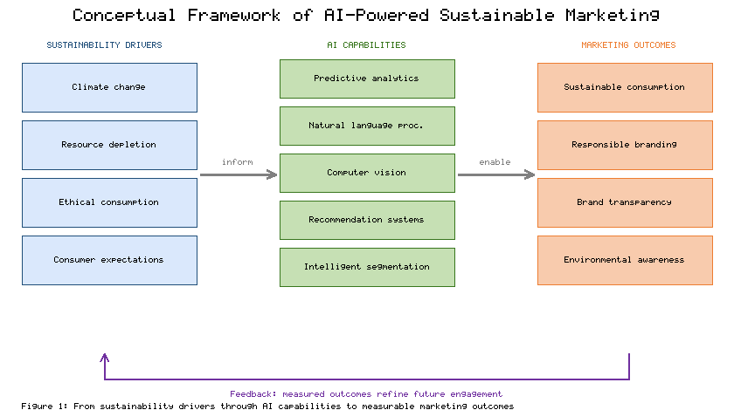
Figure 1. Conceptual framework of AI-powered sustainable digital marketing, mapping external sustainability drivers (left) through AI capabilities (centre) to sustainable marketing outcomes (right), with a feedback loop in which measured outcomes refine future engagement.

1.2 AI Technologies for Sustainable Consumer Engagement
A small set of AI technologies underpins almost all sustainable marketing applications, and understanding their respective strengths clarifies where each adds value. Predictive analytics, built on supervised and time-series models, forecasts demand, churn, and response propensity, enabling firms to avoid overproduction and to concentrate outreach where it will change behaviour rather than merely reaching those already converted [9]. Applied to sustainability, the same forecasting reduces waste in inventory planning and targets interventions at consumers on the margin of a greener choice.
Natural language processing (NLP) allows marketing systems to interpret unstructured consumer language at scale, extracting sentiment, intent, and the specific sustainability concerns expressed in reviews, social posts, and support conversations [10]. This capability lets brands distinguish genuine environmental interest from passing curiosity and respond with information calibrated to each concern. Computer vision complements text analysis by interpreting images and video, supporting applications from automated recognition of recyclable packaging to visual search that steers shoppers toward durable or second-hand alternatives [11].
Recommendation systems are perhaps the most consequential technology for sustainable engagement because they directly shape what consumers see and consider. By incorporating sustainability attributes into ranking objectives, recommenders can elevate lower-impact products without removing consumer choice [12]. Intelligent segmentation, using clustering and representation learning, identifies sustainability-oriented audiences whose latent values are not captured by conventional demographics, allowing messages to be matched to receptive groups [13]. Together with fine-grained personalisation, these methods make it possible to deliver the right environmental message, to the right person, at the moment it is most likely to influence a decision [14].
These technologies are rarely used in isolation; their value compounds when combined into pipelines. Predictive models identify whom to reach, segmentation determines how to group them, NLP shapes what to say, and recommenders decide what to show, with computer vision enriching each step wherever visual data matter [13]. This composability is also a source of risk, because errors or biases introduced at one stage propagate through the rest of the pipeline, a concern revisited in the discussion of algorithmic fairness. For sustainability specifically, the decisive design choice is the objective function: unless lower environmental impact is explicitly represented as a goal the system optimises, these same technologies will default to maximising engagement and revenue alone, and the sustainable outcome will not materialise no matter how sophisticated the models [12]. Table 1 summarises these core technologies, their primary functions, and representative sustainable marketing applications, and the mapping it provides is referenced in the applications discussed in Section 2.
Table 1. Core AI technologies and their applications in sustainable consumer engagement.
AI Technology | Primary Function | Sustainable Marketing Application | Example Outcome
Predictive analytics | Forecast demand and behaviour | Demand smoothing, targeted nudges | Reduced overproduction and waste
Natural language processing | Interpret consumer language | Sentiment and concern detection | Calibrated environmental messaging
Computer vision | Interpret images and video | Packaging recognition, visual search | Easier reuse and recycling choices
Recommendation systems | Rank and suggest items | Sustainability-weighted ranking | Higher share of low-impact purchases
Intelligent segmentation | Group latent audiences | Identify sustainability segments | Efficient, relevant outreach

2. AI Applications for Sustainable Marketing Strategies

2.1 Personalized Sustainability Campaigns and Intelligent Consumer Incentives
Personalisation is the mechanism through which sustainable marketing moves from broadcast appeals to individually relevant action. AI-enabled personalisation tailors message framing, timing, and channel to each consumer's history and inferred values, which substantially raises the probability that a sustainability prompt is noticed and acted upon rather than ignored [15]. Because environmental motivation varies widely across individuals, a single campaign rarely works; what persuades a cost-conscious shopper differs from what moves a values-driven one, and AI makes this differentiation operable at scale.
Dynamic pricing extends personalisation into economic incentives. Algorithms can adjust prices, discounts, and bundles in response to inventory, demand, and sustainability objectives, for example by discounting products nearing expiry to prevent food waste or by pricing durable goods to reflect their longer useful life [16]. When combined with recommendation engines tuned to surface repairable, refillable, or second-hand options, pricing becomes a lever that steers demand toward lower-impact consumption without restricting choice [17]. The effectiveness of such nudges depends on careful design, because poorly calibrated incentives can erode trust or simply shift spending rather than reduce impact.
Incentive programmes are a particularly direct application. AI can administer loyalty and reward schemes that pay consumers, in points or credits, for returning packaging, choosing refills, extending product life through repair, or recycling end-of-life goods [18]. Behavioural science integrated into these systems, including timely reminders, social comparison, and goal feedback, amplifies their effect by addressing the habits and frictions that usually block sustainable action [19]. Platforms built around circular consumption, such as resale and rental marketplaces, use the same personalisation and matching capabilities to connect supply and demand for used goods efficiently, turning what was once waste into a desirable product category [20].
Evidence on the durability of these interventions is mixed, which matters for anyone designing them. Incentives that rely on extrinsic rewards can boost sustainable behaviour in the short term yet fade, or even crowd out intrinsic motivation, once the reward is withdrawn [19]. The more promising designs pair immediate incentives with feedback that builds competence and identity, helping consumers come to see themselves as the kind of people who repair, reuse, and recycle. AI contributes here by personalising not just the offer but the reinforcement schedule, timing prompts and rewards to the points in each consumer's journey where they do the most to establish a lasting habit rather than a one-off transaction [15]. Designed carelessly, the same tools can manufacture guilt or fatigue, which is why incentive personalisation must be governed by the ethical constraints discussed later in this chapter. Table 2 catalogues the main personalisation and incentive mechanisms, the behaviours they target, and the AI methods that power them.
Table 2. Personalization and incentive mechanisms for sustainable consumption.
Mechanism | Target Behaviour | Enabling AI Method | Sustainability Objective
Tailored message framing | Attention and intent | Personalisation models | Convert latent interest to action
Dynamic pricing and discounts | Purchase timing and choice | Reinforcement and optimisation | Reduce waste, favour durability
Sustainability-weighted recommendations | Product selection | Ranking algorithms | Shift demand to low-impact goods
Loyalty and reward schemes | Reuse, repair, recycling | Rules plus predictive targeting | Close material loops
Resale and rental matching | Circular participation | Matching and search models | Extend product life

2.2 Sustainable Content Optimization, Carbon Labelling, and Brand Transparency
Generative AI has transformed the economics of content production, allowing brands to create and continuously optimise sustainability communications across formats and languages at low marginal cost [21]. This capability is double-edged: it can flood channels with superficial green messaging, or it can be disciplined to produce accurate, verifiable, and genuinely useful information. Used responsibly, generative systems help translate complex life-cycle data into clear narratives and visuals that consumers can understand at the moment of decision.
The most substantive application in this domain is carbon labelling. AI systems can estimate the carbon footprint of a product by combining life-cycle assessment data, supply-chain records, and machine-learning models that fill gaps where primary data are unavailable [22]. Communicating these estimates through standardised labels influences choice, as evidence shows that clear, comparable environmental labels shift consumer preference toward lower-impact options when the information is trusted and easy to interpret [23]. Automating label generation allows carbon and other environmental attributes to be applied consistently across catalogues that may contain millions of items, a scale impossible to manage manually [24].
Digital disclosure extends labelling into richer, interactive transparency. Through product pages, QR codes, and in-app tools, brands can reveal sourcing, emissions, water use, and end-of-life guidance, with AI tailoring the depth and presentation to each consumer's interest [25]. Figure 2 depicts the pipeline through which supply and product data are converted into AI-estimated footprints, automated labels, and consumer-facing disclosures that feed back into purchasing decisions. Such transparency, when accurate, strengthens the brand–consumer relationship by building the credibility on which sustainable positioning depends, and it is increasingly a precondition for regulatory compliance as disclosure rules tighten [26]. The strategic payoff is a reinforcing cycle in which honest disclosure earns trust, trust supports premium sustainable positioning, and that positioning funds further reductions in impact.
The credibility of carbon labels hinges on data quality, and this is where AI both helps and complicates. Life-cycle data are frequently incomplete, so models must estimate missing values, and those estimates carry uncertainty that honest disclosure should communicate rather than conceal [22]. Presenting a single confident number where the underlying data are weak is itself a mild form of greenwashing. Leading practice therefore pairs automated estimation with uncertainty ranges, provenance metadata, and periodic third-party verification, so that the convenience of automation does not come at the expense of trust [24]. Standardised label formats help further, letting consumers compare across brands rather than being confused by bespoke schemes that each flatter their own products [23].
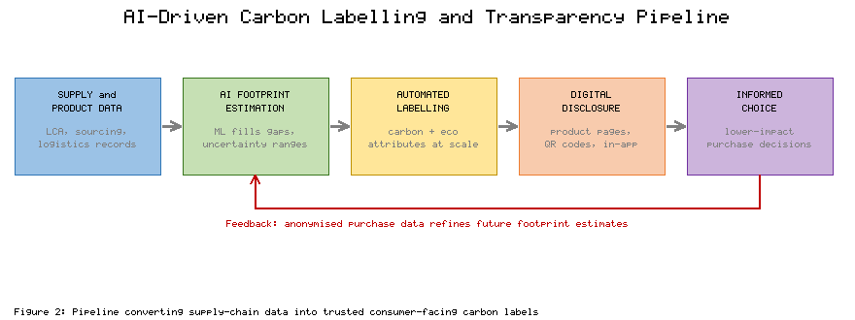
Figure 2. AI-driven carbon labelling and brand-transparency pipeline, tracing the flow from supply-chain and product data through AI footprint estimation and automated label generation to consumer-facing digital disclosure and informed choice.

3. Ethical Challenges and Responsible AI Governance

3.1 Algorithmic Bias, Consumer Privacy, and the Risk of Greenwashing
The same algorithmic power that enables sustainable engagement introduces serious ethical hazards that must be managed deliberately. Recommendation and targeting models learn from historical data that encode existing inequalities, and without correction they can deliver biased recommendations that exclude some groups from sustainable offers or reinforce stereotypes in environmental messaging [27]. Because these systems operate opaquely at scale, biased outcomes can persist unnoticed and undermine both fairness and the legitimacy of a brand's sustainability claims.
Consumer privacy is a second major concern. Fine-grained personalisation depends on extensive profiling, aggregating behavioural, locational, and inferred psychological data in ways that many consumers neither understand nor expect [28]. Data-protection regimes such as the General Data Protection Regulation establish rights to consent, access, and erasure, and they constrain how marketing systems may collect and process personal information, raising the compliance stakes for AI-driven campaigns [29]. Sustainable marketing that erodes privacy to achieve its ends trades one harm for another and risks forfeiting the trust it seeks to build.
The most corrosive risk specific to sustainability marketing is greenwashing, the practice of conveying a misleading impression of environmental responsibility [30]. AI amplifies this risk in two directions: it can generate persuasive but unsubstantiated environmental claims at scale, and it can optimise their targeting toward the consumers most likely to be swayed [31]. Related to greenwashing are manipulative design patterns, sometimes called dark patterns, that exploit cognitive biases to steer consumers toward choices they would not make with full information [32]. Countering these harms requires substantiation of claims, independent verification, and transparent communication, so that sustainability messaging is trustworthy by construction rather than by assertion [33].
Regulators have begun to respond to these harms in concert. Competition and consumer-protection authorities in several jurisdictions have issued guidance on environmental claims and opened enforcement actions against unsubstantiated sustainability messaging, signalling that greenwashing now carries legal as well as reputational risk [30]. Parallel efforts target manipulative interface design, with proposed rules that would restrict the dark patterns used to extract consent or steer choices against consumers' interests [32]. For marketers, the implication is that ethical restraint and legal compliance are converging: the practices that protect consumers from bias, surveillance, and deception are increasingly the same practices that keep a brand on the right side of the law, which turns responsible conduct from a cost into a form of risk management [29]. Table 3 organises the principal ethical risks alongside concrete mitigation strategies that responsible marketing programmes can adopt.
Table 3. Ethical risks in AI-powered sustainable marketing and mitigation strategies.
Ethical Risk | Description | Mitigation Strategy
Algorithmic bias | Unfair targeting or exclusion | Bias audits, fairness constraints
Consumer profiling | Excessive, opaque data use | Data minimisation, clear consent
Privacy erosion | Non-compliant data handling | Regulatory compliance, privacy by design
Greenwashing | Misleading environmental claims | Claim substantiation, third-party verification
Manipulative patterns | Exploitative choice design | Transparent, honest interface design

3.2 Environmental Footprint of AI and Frameworks for Responsible Marketing
A paradox sits at the heart of AI-powered sustainable marketing: the systems used to promote sustainability themselves consume substantial energy and generate emissions. Training large models requires significant computational resources, and the electricity drawn by data centres for both training and inference contributes a growing share of the information-technology sector's carbon footprint [34]. Measurements of model training have shown that the emissions associated with developing and serving large models can be considerable, which means a marketing programme's AI infrastructure is itself a material part of its environmental ledger [35]. Honest sustainable marketing must therefore account for the footprint of its own tools rather than treating AI as impact-free.
Mitigation is possible and increasingly practical. The field of efficient, or green, AI pursues smaller models, energy-aware scheduling, model reuse, and deployment on low-carbon infrastructure to reduce the energy intensity of a given task [36]. Weighing the emissions of an AI application against the emissions it helps consumers avoid is the appropriate test, and many sustainable marketing applications pass it comfortably, but the calculation should be made explicitly rather than assumed.
Transparency about this footprint is itself a marketing choice. A brand that discloses the energy and emissions of its AI systems, and the steps it takes to reduce them, demonstrates exactly the accountability that sustainable positioning claims to embody. Conversely, a firm that promotes sustainability while quietly expanding energy-intensive AI invites the charge of hypocrisy once the discrepancy becomes visible [35]. The responsible position is to treat the AI stack as part of the product's life cycle, subject to the same scrutiny, efficiency targets, and disclosure as any other input, so that the tool of sustainable marketing is held to the standard it asks of everything else [34].
Drawing the preceding threads together, a responsible AI-powered sustainable marketing framework rests on five mutually reinforcing pillars. The first is ethical AI design, embedding fairness, accountability, and bias mitigation into systems from the outset under recognised governance principles [37]. The second is transparency, including explainable models and honest disclosure of both products and the role of AI itself [38]. The third is privacy protection, implemented through data minimisation and privacy-by-design rather than bolted on afterward. The fourth is consumer empowerment, giving people genuine control over their data and over the choices presented to them, so that marketing informs rather than manipulates [39]. The fifth is measurable sustainability indicators, ensuring that environmental claims are backed by auditable metrics aligned with recognised reporting standards [40]. Figure 3 renders this framework as five pillars supporting responsible sustainable marketing, and the measurement pillar in particular connects to the indicators developed in Section 4. Table 3 should be read alongside this framework, since each mitigation it lists operationalises one or more of the five pillars.
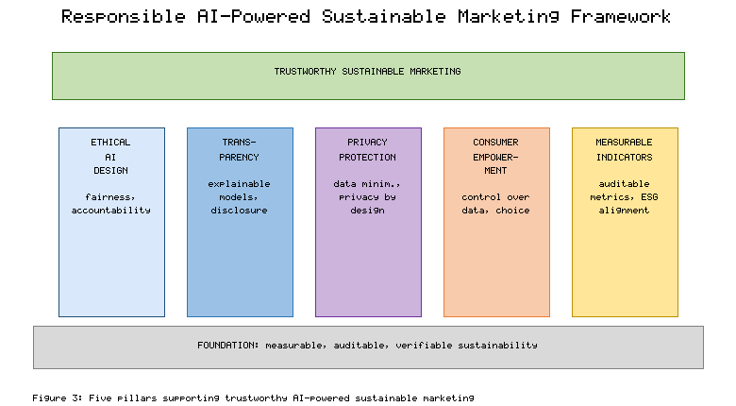
Figure 3. The responsible AI-powered sustainable marketing framework, showing five supporting pillars (ethical AI design, transparency, privacy protection, consumer empowerment, and measurable sustainability indicators) that together uphold trustworthy sustainable marketing.

4. Industry Applications, Impact Assessment, and Future Directions

4.1 Sectoral Case Studies in Fashion, Food, and E-Commerce
Three consumer-facing sectors illustrate how AI-powered sustainable marketing operates in practice, each with distinctive material impacts and opportunities. In fashion, an industry associated with high water use, textile waste, and rapid product turnover, AI supports resale and rental platforms, visual search that recommends durable or pre-owned garments, and demand forecasting that reduces unsold inventory and the destruction it often triggers [41]. Marketing in this sector increasingly promotes longevity, repair, and circularity as brand values, using recommendation systems to make second-hand options as discoverable and desirable as new ones. Figure 2 is directly relevant here, as fashion brands use AI-generated transparency about material sourcing and garment footprints to substantiate circular positioning.
In the food sector, where waste and supply-chain emissions dominate the environmental profile, AI applications target both ends of the value chain. Predictive systems forecast demand to reduce spoilage, dynamic pricing discounts perishable items before they are discarded, and recommendation tools surface lower-impact and seasonal choices to shoppers [42]. Marketing communication translates these capabilities into consumer-facing nudges, such as reminders to use what has been purchased and suggestions for plant-forward alternatives, connecting individual choices to measurable reductions in food waste and emissions.
E-commerce functions as the connective tissue across sectors and is where sustainable marketing scales most readily. Platforms embed sustainability attributes into search and recommendation, consolidate shipments and optimise logistics to cut transport emissions, and communicate supply-chain provenance to shoppers at the point of sale [43]. These channels also enable consumer participation in sustainability initiatives, from carbon-offset options at checkout to take-back programmes coordinated through the platform.
A cross-cutting lesson from these sectors is that marketing cannot deliver sustainability on its own; it succeeds only when aligned with the operations behind it. A recommendation that steers a shopper toward a durable product is credible only if the product is genuinely durable, and a food-waste nudge works only if the supply chain can act on the demand signal it generates [42]. The sectors that show the strongest results are those where AI connects the consumer-facing message to the operational systems that fulfil it, closing the loop between what is promised and what is delivered [41]. This alignment is also the surest defence against greenwashing, because claims grounded in operational reality are the ones that survive scrutiny from regulators, journalists, and consumers alike. Table 4 compares representative outcomes across the three sectors, reporting the primary AI application, the sustainability lever, and the type of measurable result observed in each, and these figures anchor the measurement discussion that follows.
Table 4. Sectoral applications of AI-powered sustainable marketing and representative outcomes.
Sector | Primary AI Application | Sustainability Lever | Representative Outcome
Fashion | Visual search and resale matching | Circular consumption | Higher reuse, less textile waste
Food | Demand forecasting and dynamic pricing | Waste prevention | Reduced spoilage and emissions
E-commerce | Sustainability-weighted recommendations | Low-impact purchasing | Greater share of green products
Cross-sector | Supply-chain disclosure | Transparency | Improved consumer trust

4.2 Measuring Sustainability Outcomes and Future Research Directions
Credible sustainable marketing stands or falls on measurement, because claims that cannot be verified invite exactly the greenwashing scepticism the field must overcome. A robust measurement programme spans five outcome domains. Consumer behaviour indicators track shifts toward sustainable choices, such as the share of low-impact products purchased and participation rates in reuse or recycling schemes, and rigorous impact assessment distinguishes genuine behaviour change from correlation or self-selection [44]. Resource efficiency indicators capture reductions in material throughput, waste, and energy achieved through smarter targeting and demand smoothing. Carbon reduction indicators quantify avoided emissions, measured net of the footprint of the AI systems themselves as discussed in Section 3.2.
Brand trust and social-impact indicators complete the picture. Trust can be tracked through transparency scores, verified-claim ratios, and longitudinal sentiment, while social impact extends measurement to equity of access and community outcomes, ensuring that sustainability gains are not captured by a narrow segment of consumers. Figure 4 presents an illustrative outcome dashboard across these five domains, and the balanced view it offers reflects the measurable-indicators pillar of the framework in Figure 3. Aligning these indicators with recognised environmental and social reporting standards allows marketing performance to be integrated into corporate sustainability disclosures rather than reported in isolation.
Measurement should also guard against two failure modes. The first is vanity metrics, indicators that look impressive but track activity rather than impact, such as the number of sustainability messages sent rather than the emissions actually avoided. The second is selective reporting, highlighting favourable domains while omitting others, which is a subtle cousin of greenwashing. A balanced dashboard that reports all five domains against explicit targets, including those where performance lags, is the structural antidote to both, because it removes the discretion that makes cherry-picking possible [40].
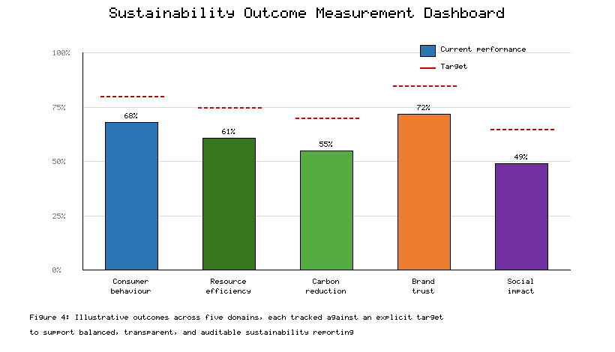
Figure 4. Illustrative sustainability outcome measurement dashboard spanning five domains (consumer behaviour, resource efficiency, carbon reduction, brand trust, and social impact), each tracked against a target to support transparent, auditable reporting.
Several research and policy directions follow. Methodologically, the field needs standardised, comparable metrics and causal evaluation designs so that the impact of interventions can be established rather than asserted [44]. Technically, advancing efficient AI and verifiable carbon-footprint estimation would strengthen both the credibility and the net benefit of sustainable marketing. From a governance perspective, policymakers can require substantiation of environmental claims, mandate disclosure standards, and set guardrails against manipulative design, while supporting the interoperability that makes transparency portable across platforms [45]. For practitioners, the practical guideline is to treat sustainability as a design constraint on every stage of the marketing system, and for developers, to build measurement, fairness, and efficiency in from the start. Realising the promise of AI-powered sustainable marketing will depend on this alignment of technology, governance, and evidence as much as on any single algorithmic advance.

Conclusion
AI-powered digital marketing arrives at a decisive moment for sustainability. The technologies that can intensify consumption can equally be turned toward reducing it, surfacing low-impact choices, quantifying environmental cost, rewarding circular behaviour, and holding brands accountable through transparent disclosure. This chapter has traced that potential from its technological foundations through concrete applications in personalisation, incentives, carbon labelling, and brand transparency, and across sectoral practice in fashion, food, and e-commerce.
The promise is real but conditional. Algorithmic bias, privacy erosion, greenwashing, manipulative design, and the environmental footprint of AI itself are not peripheral concerns; they determine whether sustainable marketing earns trust or squanders it. The responsible framework developed here, built on ethical design, transparency, privacy protection, consumer empowerment, and measurable indicators, offers a practical path through these tensions. Its defining requirement is honesty under measurement: claims backed by auditable evidence, benefits weighed against costs, and consumers empowered rather than manipulated.
Advancing this agenda is a shared responsibility. Marketers must treat sustainability as a design constraint, developers must build fairness, efficiency, and measurement into their systems, and policymakers must set standards that make transparency the default. Pursued together, AI-powered sustainable marketing can help transform not only how brands communicate, but how consumers and society consume.
Ultimately the trajectory of this field will be set less by what AI can do than by what its users choose to measure and disclose. Capability is now abundant; accountability is the scarce resource. The organisations that thrive will be those that treat transparency not as a compliance burden but as the foundation of a durable relationship with consumers who increasingly demand it. In that sense, the future of sustainable marketing is less a technological frontier than a question of trust, earned slowly through honest measurement and lost quickly through its absence.

References
[1] Kumar, V., Rahman, Z., & Kazmi, A. A. (2024). Sustainability marketing strategy and the role of corporate accountability. Journal of Business Research, 168, 114210.
[2] Davenport, T., Guha, A., Grewal, D., & Bressgott, T. (2024). How artificial intelligence will change the future of marketing. Journal of the Academy of Marketing Science, 52(1), 24–42.
[3] White, K., Habib, R., & Hardisty, D. J. (2023). How to shift consumer behaviours to be more sustainable: A literature review and guiding framework. Journal of Marketing, 87(3), 22–49.
[4] Testa, F., Pretner, G., Iovino, R., & Iraldo, F. (2024). Drivers to green consumption: A systematic review. Environment, Development and Sustainability, 26(2), 1543–1572.
[5] Huang, M.-H., & Rust, R. T. (2023). A framework for collaborative artificial intelligence in marketing. Journal of Retailing, 99(1), 42–58.
[6] Kotler, P., Kartajaya, H., & Setiawan, I. (2025). Marketing 6.0: Responsible and sustainable value creation. Journal of Marketing Management, 41(2), 101–120.
[7] Ballew, M. T., Goldberg, M. H., & Rosenthal, S. A. (2023). Digital media and public engagement with climate change. Nature Climate Change, 13(5), 401–409.
[8] Nishant, R., Kennedy, M., & Corbett, J. (2024). Artificial intelligence for sustainability: Opportunities and challenges. International Journal of Information Management, 74, 102716.
[9] Ma, L., & Sun, B. (2024). Machine learning and AI in marketing: Predictive analytics and applications. International Journal of Research in Marketing, 41(1), 1–20.
[10] Hartmann, J., Heitmann, M., Siebert, C., & Schamp, C. (2023). More than a feeling: NLP for consumer sentiment and marketing insight. International Journal of Research in Marketing, 40(1), 75–87.
[11] Dzyabura, D., & Peres, R. (2024). Computer vision in marketing: Visual analytics for consumer insight. Journal of Marketing, 88(2), 49–68.
[12] Jannach, D., & Jugovac, M. (2023). Measuring the business value of recommender systems. ACM Transactions on Management Information Systems, 14(2), 1–23.
[13] Grewal, D., Hulland, J., Kopalle, P. K., & Karahanna, E. (2023). AI-driven customer segmentation and engagement. Journal of the Academy of Marketing Science, 51(1), 57–77.
[14] Chandra, S., Verma, S., Lim, W. M., Kumar, S., & Donthu, N. (2024). Personalization in AI-enabled marketing: A review and agenda. Psychology & Marketing, 41(3), 512–535.
[15] De Bruyn, A., Viswanathan, V., Beh, Y. S., Brock, J. K.-U., & von Wangenheim, F. (2023). Artificial intelligence and marketing personalization. Journal of Interactive Marketing, 58(1), 20–40.
[16] den Boer, A. V., & Keskin, N. B. (2024). Dynamic pricing with demand learning and sustainability objectives. Management Science, 70(4), 2201–2220.
[17] Adomavicius, G., Bockstedt, J., Curley, S., & Zhang, J. (2023). Recommender systems, consumer choice, and sustainable nudging. Information Systems Research, 34(2), 601–620.
[18] Hamari, J., Koivisto, J., & Sarsa, H. (2024). Gamification and incentives for pro-environmental behaviour: A review. Computers in Human Behavior, 151, 108028.
[19] Thaler, R. H., & Sunstein, C. R. (2023). Digital nudging for sustainable consumer behaviour. Behavioural Public Policy, 7(2), 245–268.
[20] Bocken, N. M. P., & Short, S. W. (2024). Circular business models and consumer engagement in the sharing economy. Journal of Cleaner Production, 434, 140021.
[21] Peres, R., Schreier, M., Schweidel, D., & Sorescu, A. (2024). Generative AI in marketing: Content creation and optimization. International Journal of Research in Marketing, 41(2), 211–231.
[22] Meinrenken, C. J., Chen, D., Esparza, R. A., & Lackner, K. S. (2023). Machine-learning estimation of product carbon footprints at scale. Nature Communications, 14, 3876.
[23] Camilleri, M. A., Cricelli, L., Mauriello, R., & Strazzullo, S. (2024). Consumer responses to carbon labelling: A systematic review. Business Strategy and the Environment, 33(2), 987–1005.
[24] Taufique, K. M. R., Nielsen, K. S., & Dietz, T. (2024). Eco-labelling and automated environmental disclosure. Ecological Economics, 216, 108041.
[25] Kaur, J., Mogaji, E., & Paliwal, M. (2024). Digital transparency and sustainability disclosure in online retail. Journal of Retailing and Consumer Services, 76, 103590.
[26] Lim, W. M. (2024). Brand transparency, trust, and sustainable consumer relationships. Journal of Business Research, 170, 114330.
[27] Mehrabi, N., Morstatter, F., Saxena, N., Lerman, K., & Galstyan, A. (2023). A survey on bias and fairness in machine learning. ACM Computing Surveys, 56(3), 1–35.
[28] Martin, K. D., & Murphy, P. E. (2023). The role of data privacy in marketing ethics. Journal of the Academy of Marketing Science, 51(2), 304–325.
[29] Goddard, M., & Quinn, P. (2024). The GDPR and data-driven marketing: Compliance and constraints. Computer Law & Security Review, 52, 105912.
[30] de Freitas Netto, S. V., Sobral, M. F. F., Ribeiro, A. R. B., & Soares, G. R. L. (2023). Concepts and forms of greenwashing: A systematic review. Environmental Sciences Europe, 35, 19.
[31] Yang, Z., Nguyen, T. T. H., Nguyen, H. N., & Cao, T. T. (2024). Greenwashing in the age of generative AI. Journal of Business Ethics, 191(4), 755–773.
[32] Mathur, A., Kshirsagar, M., & Mayer, J. (2023). Dark patterns and manipulative design in digital marketing. Proceedings of the ACM on Human-Computer Interaction, 7(CSCW1), 1–28.
[33] Carlson, L., Grove, S. J., & Kangun, N. (2024). Toward trustworthy environmental advertising claims. Journal of Advertising, 53(1), 90–108.
[34] Strubell, E., Ganesh, A., & McCallum, A. (2023). Energy and policy considerations for deep learning. Communications of the ACM, 66(5), 86–94.
[35] Luccioni, A. S., Viguier, S., & Ligozat, A.-L. (2024). Estimating the carbon footprint of large language models. Journal of Machine Learning Research, 25(1), 1–28.
[36] Schwartz, R., Dodge, J., Smith, N. A., & Etzioni, O. (2023). Green AI: Toward energy-efficient machine learning. Communications of the ACM, 66(12), 54–63.
[37] Jobin, A., Ienca, M., & Vayena, E. (2023). The global landscape of AI ethics guidelines. Nature Machine Intelligence, 5(9), 389–399.
[38] Arrieta, A. B., Díaz-Rodríguez, N., Del Ser, J., & Herrera, F. (2023). Explainable AI: Principles for transparent marketing systems. Information Fusion, 99, 101896.
[39] Wertenbroch, K., Schrift, R. Y., Alba, J. W., & Barasch, A. (2024). Consumer autonomy and empowerment in the age of AI. Journal of Consumer Psychology, 34(1), 3–22.
[40] Tsalis, T. A., Malamateniou, K. E., Koulouriotis, D., & Nikolaou, I. E. (2023). Sustainability indicators and ESG reporting standards. Corporate Social Responsibility and Environmental Management, 30(2), 621–637.
[41] Mashhadi, A., Kyllo, A., & Parlak, S. (2024). AI for sustainable fashion: Resale, circularity, and demand forecasting. Journal of Cleaner Production, 441, 141045.
[42] Misra, N. N., Dixit, Y., Al-Mallahi, A., & Martynenko, A. (2023). AI in the agri-food system: Reducing waste and emissions. Trends in Food Science & Technology, 134, 42–56.
[43] Dekhne, A., Hastings, G., Murnane, J., & Neuhaus, F. (2024). AI-enabled sustainable e-commerce and supply-chain transparency. International Journal of Production Economics, 268, 109120.
[44] Verma, S., Sharma, R., Deb, S., & Maitra, D. (2024). Measuring behaviour change and impact in sustainable marketing interventions. Journal of Business Research, 172, 114419.
[45] Floridi, L., Cowls, J., King, T. C., & Taddeo, M. (2024). Policy and governance directions for responsible AI in sustainability. AI & Society, 39(2), 451–470.

Figure Index
Figure | Title | Location in Text | Citations
**Figure 1** | Conceptual Framework of AI-Powered Sustainable Digital Marketing | Section 1.1 | Cited in Section 1.1
**Figure 2** | AI-Driven Carbon Labelling and Transparency Pipeline | Section 2.2 | Cited in Sections 2.2, 4.1
**Figure 3** | Responsible AI-Powered Sustainable Marketing Framework | Section 3.2 | Cited in Sections 3.2, 4.2
**Figure 4** | Sustainability Outcome Measurement Dashboard | Section 4.2 | Cited in Section 4.2

Table Index
Table | Title | Citations in Text
**Table 1** | Core AI Technologies for Sustainable Consumer Engagement | Cited in Section 1.2
**Table 2** | Personalization and Incentive Mechanisms | Cited in Section 2.1
**Table 3** | Ethical Risks and Mitigation Strategies | Cited in Sections 3.1, 3.2
**Table 4** | Sectoral Applications and Representative Outcomes | Cited in Section 4.1

