Chapter 12
Industrial Translation, Scale-Up, Regulatory Aspects, Artificial Intelligence Integration, Market Potential, and Future Perspectives
Abstract
Microbial-derived bio-nanomaterials represent a paradigm shift in sustainable nanotechnology, offering green, cost-effective, and scalable alternatives to conventional chemical and physical synthesis methods. This chapter provides a comprehensive examination of the multidimensional challenges and opportunities associated with translating laboratory-scale microbial nanomaterial synthesis to industrial production. The discussion encompasses scale-up strategies, manufacturing technologies, quality-by-design approaches, and economic considerations essential for commercial viability. Regulatory frameworks governing biomedical and environmental applications are critically analyzed, alongside toxicological assessments, biosafety protocols, and environmental risk evaluation. The transformative role of artificial intelligence in optimizing microbial synthesis parameters, predicting nanomaterial properties, enabling real-time process control, and accelerating materials discovery is thoroughly explored. Market potential, commercialization pathways, intellectual property landscapes, and investment opportunities are evaluated across biomedical and environmental sectors. Finally, future perspectives addressing next-generation bio-nanomaterials, convergence of biotechnology with nanotechnology and artificial intelligence, and a comprehensive research roadmap are presented to guide the sustainable development of this rapidly evolving field.
Keywords: Microbial bio-nanomaterials; Industrial scale-up; Regulatory frameworks; Artificial intelligence; Machine learning; Quality-by-design; Commercialization; Green nanotechnology; Sustainable manufacturing; Future perspectives
Section I: Industrial Translation and Scale-Up of Microbial-Derived Bio-Nanomaterials
12.1 From Laboratory Synthesis to Industrial Production
The transition of microbial-derived bio-nanomaterials from laboratory proof-of-concept demonstrations to reproducible, large-scale industrial manufacturing constitutes one of the most significant challenges facing contemporary green nanotechnology [1]. While numerous studies have successfully demonstrated the biosynthesis of metallic, metal oxide, and semiconductor nanoparticles using bacteria, fungi, algae, and yeast at bench scale, the fundamental requirements for industrial translation demand systematic approaches to process standardization, reproducibility, and economic viability [2]. The laboratory-to-industry gap is characterized by multiple technical, economic, and regulatory barriers that must be addressed through integrated strategies combining microbiology, process engineering, and materials science [3].
The fundamental challenge of industrial translation lies in maintaining the precise control over nanoparticle characteristics that is achievable in small-scale laboratory settings while operating at volumetric scales orders of magnitude larger. Laboratory synthesis typically involves carefully controlled flask experiments with volumes ranging from milliliters to a few liters, where parameters such as mixing uniformity, temperature homogeneity, and precursor distribution are inherently well-controlled. At industrial scales exceeding thousands of liters, maintaining equivalent parameter uniformity requires sophisticated engineering solutions addressing heat and mass transfer limitations, mixing dead zones, and gradients in dissolved oxygen and nutrient concentrations that inevitably arise in large-volume systems.
Furthermore, the economic landscape of industrial biosynthesis must account for the total cost of goods including upstream processing costs for media preparation and sterilization, the fermentation process itself, and extensive downstream processing required to isolate and purify nanoparticles from complex biological matrices. Supply chain considerations for metal precursors, culture media components, and specialty chemicals must ensure reliable sourcing at industrial quantities while maintaining consistent quality specifications. Workforce requirements span microbiology, biochemical engineering, analytical chemistry, and quality assurance disciplines, necessitating interdisciplinary teams with specialized training in both biological processes and nanomaterial characterization.
The selection of appropriate microbial strains represents the foundational decision in scaling biosynthesis processes. Industrial strains must demonstrate robust growth characteristics, high nanoparticle yields, tolerance to process perturbations, and genetic stability over extended cultivation periods [4]. Organisms such as Bacillus subtilis, Pseudomonas aeruginosa, Aspergillus niger, Saccharomyces cerevisiae, and Chlorella vulgaris have emerged as promising candidates due to their well-characterized metabolic pathways, established fermentation protocols, and generally recognized as safe (GRAS) status [5]. The substrate selection, including metal precursor concentration, carbon and nitrogen sources, and trace elements, must be optimized for both nanoparticle quality and production economics [6].
Process standardization requires the development of detailed standard operating procedures encompassing inoculum preparation, fermentation conditions, metal salt addition timing and concentration, and harvest protocols [7]. Batch-to-batch consistency remains a critical challenge, as biological systems inherently exhibit variability in enzyme expression levels, metabolic activity, and reducing capacity. Statistical process control methods, including control charts, capability indices, and design of experiments approaches, provide systematic frameworks for monitoring and maintaining product consistency [8]. The implementation of process analytical technology (PAT) enables real-time monitoring of critical process parameters including pH, dissolved oxygen, temperature, optical density, and nanoparticle formation kinetics [9].
Seed train development represents another critical aspect of industrial translation, requiring optimization of inoculum propagation stages to ensure consistent cell density, viability, and metabolic state at the time of production-scale inoculation. The number of seed stages, transfer volumes, and timing of transfers must be validated to prevent genetic drift, maintain production strain characteristics, and ensure reproducible performance across manufacturing campaigns. Master and working cell bank systems, following pharmaceutical industry best practices, provide characterized starting materials with documented identity, purity, and stability profiles essential for regulatory compliance and manufacturing consistency.
Table 1: Comparison of Microbial Strains for Industrial Bio-Nanomaterial Production
Microbial Strain | Nanoparticle Type | Size Range (nm) | Key Advantages | Scalability Rating
Bacillus subtilis | Ag, Au, ZnO | 5-50 | GRAS status, robust growth, high yield | High
Pseudomonas aeruginosa | Ag, Au, Pd | 10-100 | Versatile, multiple metals, fast synthesis | Medium-High
Aspergillus niger | Ag, Au, Fe₃O₄ | 20-80 | High enzyme production, scalable fermentation | High
Saccharomyces cerevisiae | Au, Ag, CdS | 2-30 | Food-grade, well-established bioprocess | Very High
Chlorella vulgaris | Ag, Au, TiO₂ | 5-40 | Photosynthetic, CO₂ utilization, sustainable | Medium
Lactobacillus sp. | Ag, Au, Se | 10-60 | Probiotic, biocompatible, safe handling | High

12.2 Scale-Up Strategies and Manufacturing Technologies
Bioreactor design and selection constitute critical determinants of successful scale-up for microbial nanomaterial production [10]. Stirred-tank bioreactors remain the most widely employed configuration due to their well-understood mixing characteristics, scalability, and established design correlations. However, the unique requirements of nanomaterial biosynthesis, including controlled metal ion delivery, maintenance of optimal redox conditions, and prevention of nanoparticle aggregation, necessitate modifications to conventional bioreactor designs [11]. Alternative configurations including airlift reactors, membrane bioreactors, packed-bed systems, and microfluidic platforms offer specific advantages for particular microbial systems and nanoparticle types [12].
The selection of appropriate bioreactor configuration depends on multiple factors including the microbial system employed, oxygen requirements, shear sensitivity, nanoparticle formation mechanism (intracellular versus extracellular), and target production scale. For extracellular biosynthesis, where nanoparticles form in the culture supernatant through interaction of secreted enzymes and metabolites with metal precursors, stirred-tank and airlift configurations provide adequate mixing while enabling straightforward product recovery. Intracellular biosynthesis processes require additional cell disruption and extraction steps, favoring reactor configurations that maximize biomass production and facilitate efficient harvest. Immobilized cell systems using biofilm reactors or entrapped cultures offer advantages of continuous operation and simplified product separation for certain applications.
Process intensification strategies aim to maximize volumetric productivity while minimizing resource consumption and waste generation. Continuous production approaches, including chemostat cultivation and perfusion systems, offer advantages over batch processes including steady-state operation, consistent product quality, reduced downtime, and improved space-time yields [13]. Fed-batch strategies with programmed nutrient and metal precursor feeding profiles enable precise control over microbial growth phases and nanoparticle nucleation and growth kinetics [14]. The integration of in-situ product removal techniques prevents product inhibition and enables continuous harvesting of nanoparticles from the culture medium.
Scale-up correlations derived from dimensional analysis and similarity principles guide the transition from small-scale to large-scale bioreactors while maintaining equivalent process performance. Key dimensionless groups including Reynolds number (characterizing flow regime), power number (relating impeller power to fluid properties), and Damköhler number (comparing reaction rate to transport rate) provide frameworks for maintaining process similarity across scales. However, perfect geometric and dynamic similarity is rarely achievable in practice, requiring empirical validation of scale-up correlations through intermediate pilot-scale studies. Computational fluid dynamics (CFD) modeling provides additional insights into mixing patterns, shear stress distributions, and mass transfer characteristics at different scales, enabling rational selection of operating parameters for large-scale bioreactors prior to expensive pilot trials.
Optimization of microbial growth conditions and nanoparticle synthesis parameters requires systematic approaches including response surface methodology, Taguchi methods, and evolutionary optimization algorithms [15]. Critical parameters encompassing temperature, pH, agitation speed, aeration rate, metal precursor concentration, incubation time, and biomass-to-substrate ratio must be simultaneously optimized to achieve desired nanoparticle characteristics including size distribution, morphology, crystallinity, and surface properties [16]. As illustrated in Figure 1, the scale-up process involves multiple stages from flask-scale optimization through pilot-plant validation to full industrial production.

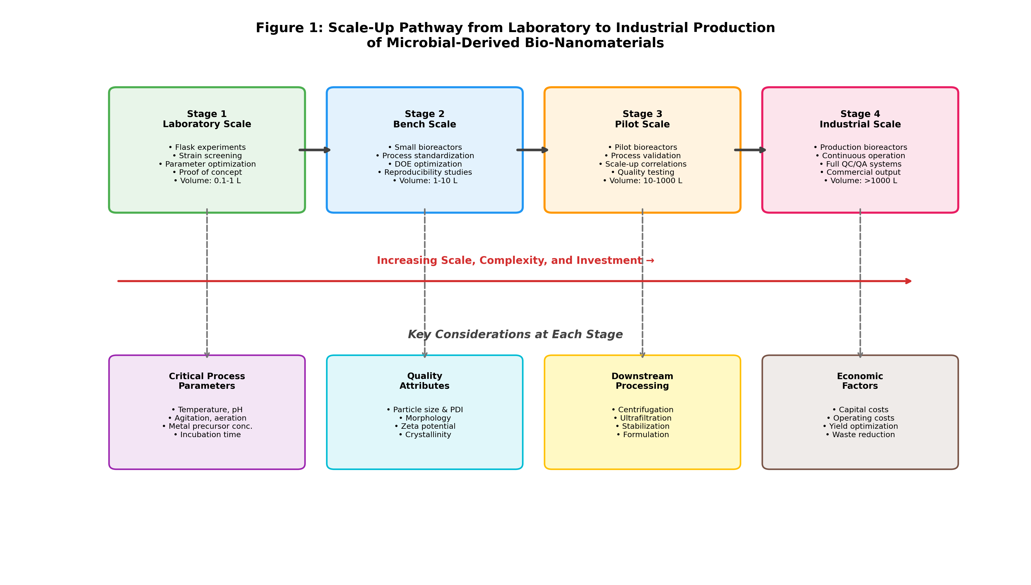
Figure 1: Schematic representation of the scale-up pathway from laboratory to industrial production of microbial-derived bio-nanomaterials, showing critical process parameters, quality attributes, and economic considerations at each stage.
Downstream processing encompasses the critical operations of nanoparticle separation, purification, stabilization, and formulation [17]. Centrifugation, ultrafiltration, dialysis, and chromatographic methods are employed individually or in combination to separate nanoparticles from residual biomass, culture medium components, and unreacted precursors. Stabilization strategies including capping agent addition, lyophilization, spray drying, and encapsulation ensure long-term storage stability and preservation of functional properties [18]. The formulation stage adapts purified nanomaterials for specific end-use applications, incorporating considerations of dispersibility, biocompatibility, and application-specific performance requirements.
The challenge of downstream processing is further complicated by the need to preserve the biological capping agents that naturally form on microbially-synthesized nanoparticles. These biogenic surface coatings, composed of proteins, polysaccharides, and other biomolecules, often contribute significantly to nanoparticle stability, biocompatibility, and functional properties. Overly aggressive purification procedures that strip these biological layers may compromise the unique advantages of biosynthesized nanomaterials. Therefore, purification strategies must balance the removal of unwanted contaminants with preservation of beneficial surface functionalities, requiring careful optimization for each specific nanoparticle system and intended application.
12.3 Quality-by-Design and Economic Considerations
The Quality-by-Design (QbD) paradigm, originally developed for pharmaceutical manufacturing, provides a systematic framework for ensuring consistent quality in bio-nanomaterial production [19]. This approach requires identification of critical quality attributes (CQAs) including nanoparticle size, polydispersity index, zeta potential, crystalline structure, surface chemistry, and biological activity. Corresponding critical process parameters (CPPs) that influence these quality attributes must be identified through risk assessment and experimental investigation [20]. The establishment of a design space defining acceptable ranges for all CPPs ensures that operation within this multidimensional space consistently produces nanomaterials meeting predefined quality specifications.
Risk assessment tools including Ishikawa diagrams, failure mode and effects analysis (FMEA), and fault tree analysis provide systematic methodologies for identifying potential sources of variability and their impact on product quality. These tools enable prioritization of critical parameters requiring tight control versus those with minimal impact on final product attributes. Process validation studies, typically conducted at pilot scale, confirm that the identified design space boundaries consistently produce acceptable product when operated under anticipated commercial manufacturing conditions. Continued process verification during commercial manufacturing ensures ongoing state of control through statistical monitoring of quality attributes and process parameters.
Economic analysis of microbial nanomaterial production must comprehensively evaluate capital expenditure, operating costs, raw material inputs, energy consumption, labor requirements, and waste treatment costs [21]. Techno-economic assessments comparing biosynthesis with conventional chemical reduction and physical methods consistently demonstrate the potential for cost advantages, particularly when utilizing waste substrates, operating under ambient conditions, and eliminating hazardous reagents [22]. However, current limitations including lower volumetric productivity, longer processing times, and more complex purification requirements partially offset these advantages and represent targets for process optimization.
Sensitivity analysis of techno-economic models reveals that nanoparticle yield concentration and downstream processing efficiency represent the most influential cost drivers for microbial biosynthesis. Improvements in these parameters through strain engineering, process optimization, and advanced purification technologies would most rapidly improve economic competitiveness. Revenue models must also consider the premium pricing achievable for green-certified and sustainably-produced nanomaterials in markets where environmental credentials command value. Government incentives including tax credits for green manufacturing, carbon pricing mechanisms, and preferential procurement policies for sustainable products can further improve the economic case for biological production routes by internalizing environmental costs currently borne by society rather than manufacturers.
Table 2: Economic and Sustainability Comparison of Nanomaterial Synthesis Methods
Parameter | Microbial Biosynthesis | Chemical Reduction | Physical Methods
Capital Investment | Moderate ($0.5-2M) | High ($2-5M) | Very High ($5-20M)
Operating Costs ($/kg) | $50-200 | $100-500 | $500-2000
Energy Consumption | Low (ambient conditions) | Moderate (heating required) | High (extreme conditions)
Hazardous Reagents | None/Minimal | Multiple toxic chemicals | Inert gases, high vacuum
Waste Generation | Biodegradable, minimal | Toxic chemical waste | Minimal but energy-intensive
Carbon Footprint (kg CO₂/kg) | 5-15 | 20-80 | 50-200
Scalability Timeline | 2-4 years to industrial | 1-2 years (established) | Limited scalability

Life-cycle assessment (LCA) provides a comprehensive methodology for evaluating the environmental impacts associated with bio-nanomaterial production across all stages from raw material extraction through end-of-life disposal [23]. Comparative LCA studies have demonstrated that microbial synthesis routes typically exhibit lower carbon footprints, reduced energy intensity, decreased hazardous waste generation, and improved resource efficiency compared to chemical and physical alternatives [24]. Resource efficiency can be further enhanced through integration with waste valorization strategies, utilizing agricultural residues, industrial effluents, or food processing wastes as both growth substrates and reducing agents for nanoparticle synthesis.
Section II: Regulatory, Safety, and Translational Considerations
12.4 Regulatory Frameworks for Microbial-Derived Nanomaterials
The regulatory landscape governing microbial-derived nanomaterials is complex, fragmented, and continues to evolve as understanding of nanomaterial properties and biological interactions advances [25]. Different regulatory jurisdictions employ varying approaches to nanomaterial classification, with implications for required testing, documentation, and approval pathways. In the United States, the Environmental Protection Agency (EPA) regulates nanomaterials under the Toxic Substances Control Act (TSCA), while the Food and Drug Administration (FDA) oversees biomedical applications under existing pharmaceutical, medical device, or cosmetic regulatory frameworks [26]. The European Union applies the Registration, Evaluation, Authorization, and Restriction of Chemicals (REACH) regulation with specific provisions for nanomaterials, requiring detailed characterization and safety data [27].
The regulatory challenge is compounded by the dual biological-nanomaterial nature of these products, which may simultaneously trigger requirements from both biotechnology and nanotechnology regulatory frameworks. In many jurisdictions, the use of living microorganisms in manufacturing processes invokes biosafety regulations governing genetically modified organisms, contained use requirements, and environmental release protocols, even when the final nanomaterial product contains no viable organisms. This regulatory complexity creates uncertainty for manufacturers and may require engagement with multiple regulatory agencies for a single product, significantly increasing time and cost for market authorization. Pre-submission meetings with regulatory authorities and early engagement strategies can help clarify requirements and avoid costly development pathway errors.
Product classification determines the applicable regulatory pathway and associated requirements for microbial-derived nanomaterials. Materials intended for drug delivery applications must navigate pharmaceutical regulatory frameworks requiring extensive preclinical and clinical testing [28]. Those designed for environmental remediation may fall under environmental protection regulations with different data requirements. The biological origin of these materials introduces additional considerations regarding microbial safety, sterility assurance, and potential immunogenicity of residual biological components. Documentation requirements encompass detailed manufacturing records, quality control specifications, stability data, and comprehensive physicochemical characterization using standardized methods.
International regulatory harmonization remains challenging due to differing national approaches to nanomaterial definition, risk assessment methodologies, and acceptable safety margins [29]. Organizations including the International Organization for Standardization (ISO), the Organisation for Economic Co-operation and Development (OECD), and the International Council for Harmonisation (ICH) are developing standardized testing protocols, characterization methods, and risk assessment frameworks to facilitate international regulatory convergence. The establishment of mutual recognition agreements and common technical standards would significantly reduce regulatory burden and accelerate market access for bio-nanomaterial products across multiple jurisdictions.
12.5 Toxicological, Biosafety, and Environmental Risk Assessment
Comprehensive toxicological assessment of microbial-derived nanomaterials encompasses evaluation of cytotoxicity, genotoxicity, immunotoxicity, and chronic biological effects through both in vitro and in vivo testing paradigms [30]. Cytotoxicity studies employing standardized assays including MTT, WST-1, LDH release, and live/dead staining across relevant cell lines provide initial safety screening. Genotoxicity assessment through Ames tests, comet assays, micronucleus tests, and chromosomal aberration analysis evaluates potential mutagenic effects [31]. Immunotoxicity evaluation addresses concerns regarding nanoparticle-induced inflammatory responses, complement activation, and potential autoimmune effects.
The unique physicochemical properties of nanoparticles, including their high surface area-to-volume ratio, quantum effects, and ability to cross biological barriers, necessitate toxicological evaluation strategies that go beyond conventional chemical toxicity testing. Nanoparticle-specific considerations include the potential for lysosomal disruption, mitochondrial dysfunction, oxidative stress generation, and interference with cellular signaling pathways. Furthermore, standard toxicological assays may produce artifactual results due to nanoparticle interference with assay reagents, optical measurements, or enzymatic reactions, requiring careful validation of assay suitability for each specific nanomaterial system. Dose metrics for nanoparticle toxicology remain debated, with mass concentration, particle number, surface area, and particle volume each proposed as the most relevant dose descriptor depending on the mechanism of toxicity.
The biological origin of microbial-derived nanomaterials introduces unique biosafety considerations including potential microbial contamination, endotoxin presence, residual nucleic acids, and allergenic proteins [32]. Rigorous purification protocols and quality control testing must ensure removal of microbial components below acceptable safety thresholds. Nanoparticle stability under physiological conditions, potential for protein corona formation, and long-term degradation behavior influence biocompatibility and must be characterized under relevant exposure scenarios. The biogenic capping layers present on microbially-synthesized nanoparticles may actually enhance biocompatibility compared to chemically-synthesized counterparts, though this requires systematic validation [33].
Environmental fate assessment evaluates the behavior of released bio-nanomaterials in aquatic, terrestrial, and atmospheric compartments [34]. Parameters including dissolution rate, aggregation behavior, sedimentation, and transformation under environmental conditions determine exposure concentrations for ecological receptors. Bioaccumulation potential through food web transfer and biomagnification in higher trophic levels requires investigation through standardized ecotoxicity testing with representative organisms. Risk mitigation strategies encompass exposure minimization through containment, safe-by-design approaches incorporating biodegradability, and end-of-life management protocols ensuring responsible disposal or recycling of nanomaterial-containing products.
Environmental transformation processes significantly alter the properties, behavior, and potential impacts of released bio-nanomaterials over time. Processes including oxidation, sulfidation, dissolution, and interaction with natural organic matter can fundamentally change nanoparticle surface chemistry, aggregation state, and bioavailability. For example, silver nanoparticles released into aquatic environments undergo sulfidation to form silver sulfide, dramatically reducing their dissolution rate and antimicrobial activity. Understanding these transformation pathways is essential for accurate environmental risk assessment, as the pristine manufactured form may differ substantially from the environmentally-relevant species to which organisms are actually exposed. Long-term mesocosm and field studies provide critical data on transformation kinetics and ultimate environmental fate under realistic conditions that cannot be replicated in short-term laboratory studies.
As depicted in Figure 2, the comprehensive risk assessment framework for microbial-derived bio-nanomaterials integrates hazard identification, exposure assessment, dose-response characterization, and risk management into a cohesive decision-making process.

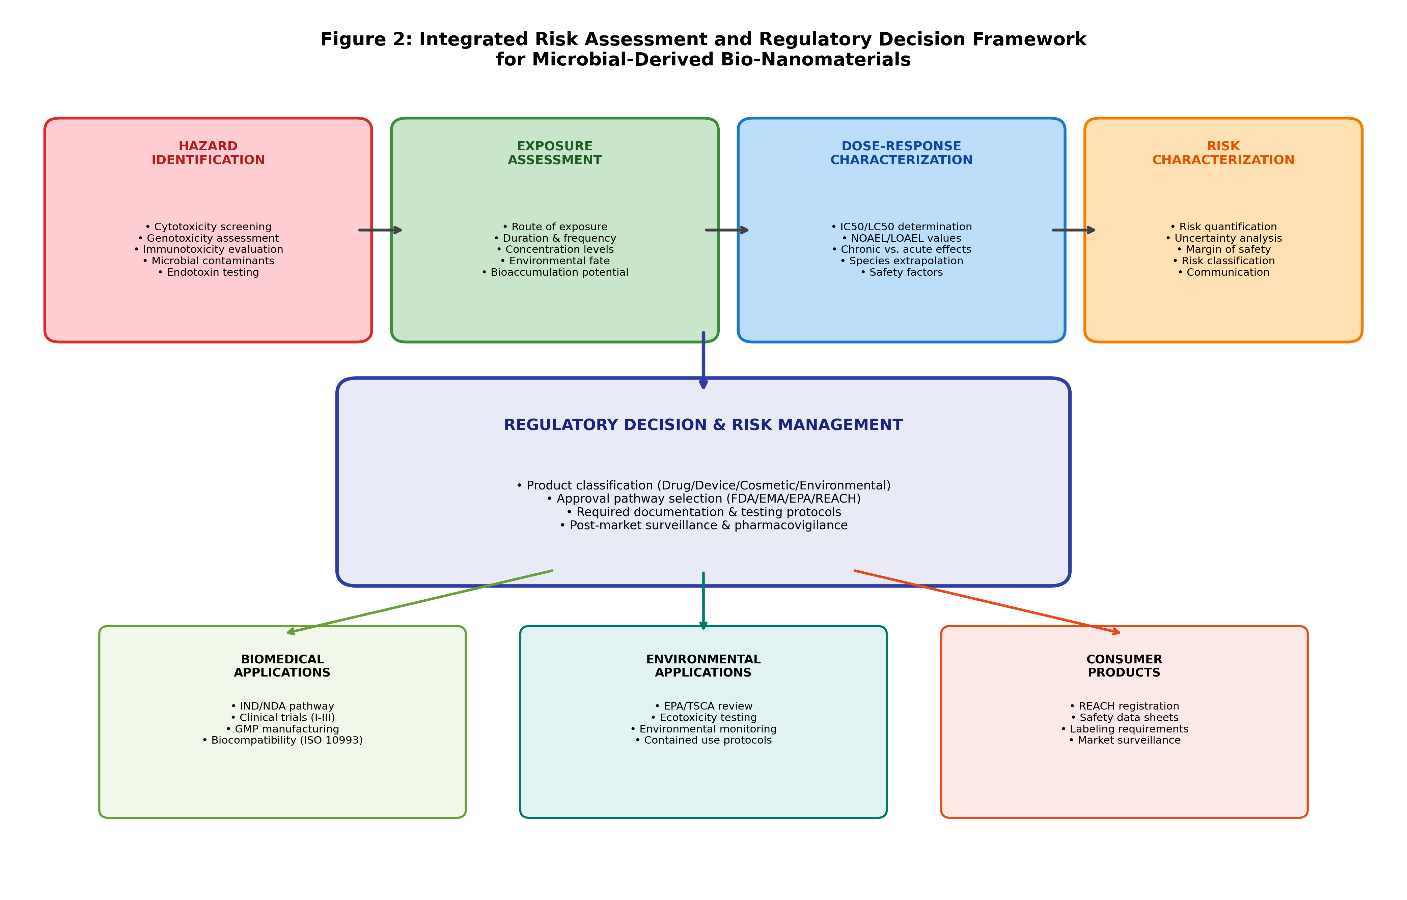
Figure 2: Integrated risk assessment and regulatory decision framework for microbial-derived bio-nanomaterials, illustrating the pathway from hazard identification through regulatory decision-making to application-specific approval routes.
12.6 Clinical and Environmental Translation
Preclinical validation of microbial-derived nanomaterials for biomedical applications follows established pharmaceutical development paradigms adapted for nanomaterial-specific considerations [35]. This encompasses comprehensive physicochemical characterization, in vitro efficacy and safety assessment, pharmacokinetic and biodistribution studies in animal models, and demonstration of therapeutic efficacy in disease-relevant models. The transition from preclinical to clinical studies requires Investigational New Drug (IND) applications supported by manufacturing process validation, stability data, and toxicology packages meeting regulatory standards.
The preclinical development pathway for nanomaterial-based therapeutics typically requires demonstration of dose-response relationships, identification of maximum tolerated doses, characterization of absorption, distribution, metabolism, and excretion (ADME) properties, and evaluation of potential off-target effects in relevant organ systems. For nanomaterials intended for systemic administration, particular attention must be directed toward hemocompatibility, complement activation, and potential accumulation in reticuloendothelial system organs including liver and spleen. The development of appropriate in vitro-in vivo correlations (IVIVC) for nanomaterial pharmacokinetics remains an active area of research that would significantly accelerate preclinical development timelines.
Field validation of microbial-derived nanomaterials for environmental applications requires demonstration of performance under realistic environmental conditions including variable pH, temperature, ionic strength, natural organic matter, and competing contaminants [36]. Pilot-scale field trials evaluate long-term stability, sustained activity, potential ecological impacts, and practical implementation requirements. The development of application-specific formulations, delivery systems, and deployment strategies ensures effective performance while minimizing unintended environmental consequences.
Ethical considerations surrounding the development and deployment of microbial-derived nanomaterials encompass responsible innovation principles, stakeholder engagement, transparency, and equitable benefit sharing [37]. Public acceptance requires effective communication of both benefits and risks, addressing concerns regarding novel biological technologies and nanomaterial safety. Traceability systems enabling tracking of nanomaterials throughout their lifecycle support responsible stewardship and facilitate recall procedures if safety concerns emerge post-market.
The social license to operate for bio-nanomaterial technologies depends critically on transparent engagement with diverse stakeholders including patient advocacy groups, environmental organizations, local communities near production facilities, and the general public. Lessons from previous public controversies surrounding genetically modified organisms and nanotechnology highlight the importance of early, inclusive, and honest dialogue about both potential benefits and legitimate uncertainties. Citizen science initiatives, public deliberation forums, and accessible educational resources can build informed public understanding while ensuring that societal values and concerns are appropriately reflected in research priorities and governance frameworks.
Section III: Artificial Intelligence Integration and Market Potential
12.7 AI-Driven Design and Optimization of Bio-Nanomaterials
Artificial intelligence and machine learning have emerged as transformative tools for accelerating the design, optimization, and discovery of microbial-derived bio-nanomaterials [38]. Traditional experimental approaches to nanomaterial development rely on iterative trial-and-error optimization across multidimensional parameter spaces, requiring extensive time and resource investment. Machine learning algorithms, including random forests, support vector machines, neural networks, and gradient boosting methods, can learn complex relationships between synthesis parameters and nanoparticle properties from historical experimental data, enabling predictive design of materials with targeted characteristics [39].
The application of AI to bio-nanomaterial development addresses a fundamental limitation of traditional approaches: the curse of dimensionality inherent in multi-parameter optimization problems. A typical microbial nanomaterial synthesis involves optimization of ten or more independent variables, each potentially interacting non-linearly with others. Full factorial experimental exploration of such parameter spaces would require thousands to millions of experiments, far exceeding practical resource constraints. Machine learning approaches overcome this limitation by learning from relatively sparse experimental data and generalizing to unexplored regions of parameter space, enabling efficient identification of optimal conditions with orders of magnitude fewer experiments than exhaustive search strategies.
The prediction of nanoparticle size, morphology, composition, and functionality from microbial synthesis conditions represents a primary application of machine learning in bio-nanomaterial research. Training datasets encompassing microbial species, growth conditions, metal precursor type and concentration, pH, temperature, reaction time, and resulting nanoparticle properties enable the development of quantitative structure-property relationship (QSPR) models [40]. These models can subsequently guide experimental design by identifying optimal synthesis conditions for achieving desired material specifications without exhaustive experimental screening.
AI-assisted optimization of microbial synthesis parameters employs advanced optimization algorithms including Bayesian optimization, genetic algorithms, and reinforcement learning to efficiently navigate complex parameter landscapes [41]. Bayesian optimization is particularly well-suited for bio-nanomaterial development as it balances exploration of unknown parameter regions with exploitation of promising conditions, achieving optimal solutions with minimal experimental iterations. The integration of active learning frameworks enables AI systems to autonomously design and request informative experiments, creating closed-loop optimization cycles that rapidly converge on optimal synthesis conditions.
Digital twin technology creates virtual representations of microbial biosynthesis processes, incorporating mechanistic models, empirical correlations, and real-time sensor data to simulate process behavior under varying conditions [42]. These digital replicas enable scenario analysis, process optimization, troubleshooting, and operator training without disrupting actual production. Predictive modeling combines thermodynamic, kinetic, and transport models with data-driven approaches to forecast nanoparticle nucleation, growth, and aggregation dynamics. Automated high-throughput platforms integrating robotic liquid handling, parallelized microbioreactors, and automated characterization enable rapid experimental exploration guided by AI-directed experimental design.
Figure 3 illustrates the integrated AI-driven workflow for bio-nanomaterial design, encompassing data collection, model training, optimization, and experimental validation in a closed-loop discovery cycle.

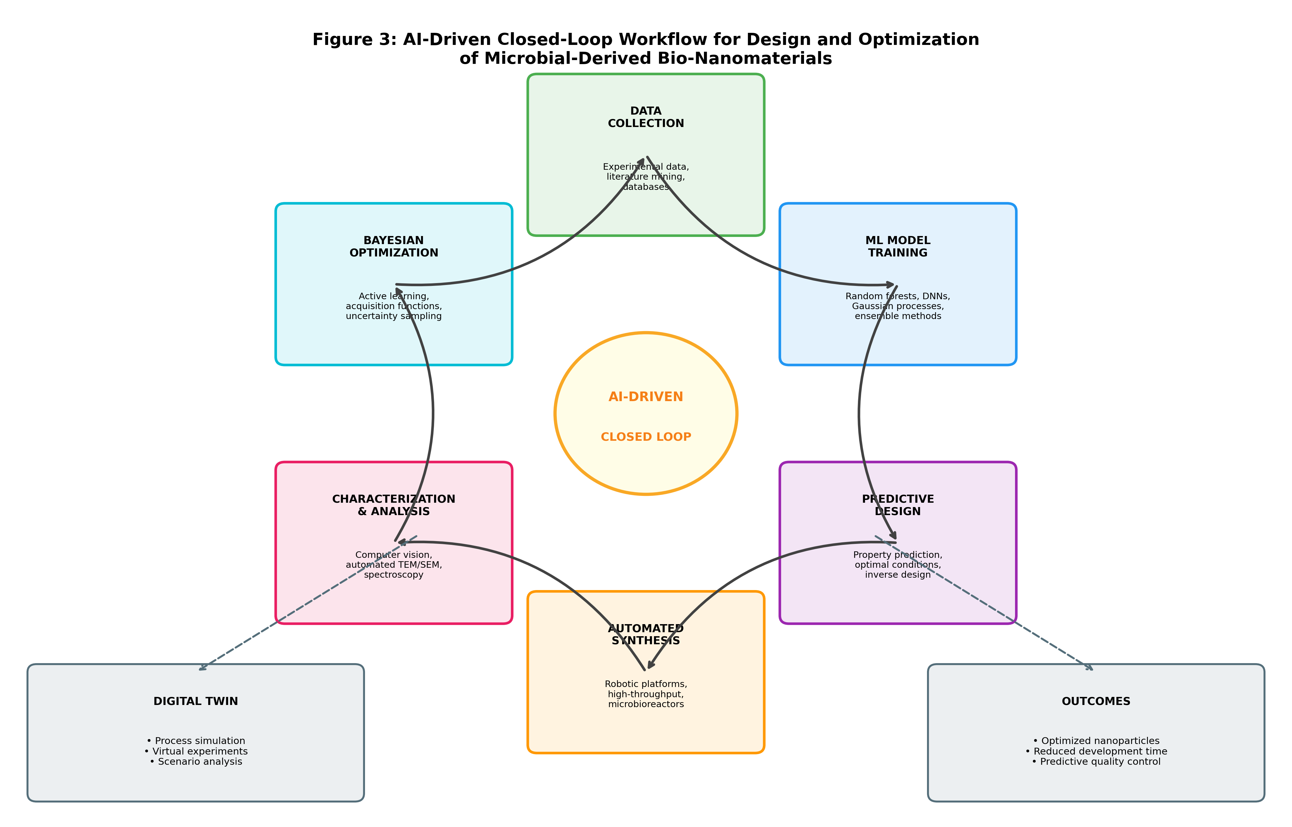
Figure 3: AI-driven closed-loop workflow for design and optimization of microbial-derived bio-nanomaterials, showing the iterative cycle of data collection, model training, predictive design, automated synthesis, characterization, and Bayesian optimization.
12.8 AI-Enabled Characterization, Quality Prediction, and Process Control
Computer vision and deep learning techniques have revolutionized nanoparticle characterization by enabling automated analysis of microscopy images [43]. Convolutional neural networks (CNNs) trained on transmission electron microscopy (TEM) and scanning electron microscopy (SEM) images can automatically identify, segment, and measure individual nanoparticles, providing rapid and objective size distribution, morphology classification, and aggregation state assessment. These approaches dramatically reduce analysis time while eliminating operator bias inherent in manual image analysis [44].
Beyond basic size and shape analysis, advanced deep learning architectures enable extraction of subtle morphological features, lattice fringe analysis from high-resolution TEM images, and automated identification of crystal defects, twin boundaries, and surface reconstruction patterns. Transfer learning approaches allow models pre-trained on large microscopy image datasets to be fine-tuned for specific nanoparticle systems with relatively small amounts of labeled training data, making these techniques accessible even to laboratories with limited computational resources and training datasets. The integration of computer vision with automated microscopy platforms enables high-throughput characterization of thousands of nanoparticles per sample, providing statistically robust descriptions of size distributions and morphological heterogeneity.
AI-based prediction of nanomaterial stability, toxicity, antimicrobial activity, and environmental performance leverages quantitative structure-activity relationship (QSAR) models trained on curated datasets [45]. Predictive toxicology models correlate physicochemical descriptors including size, surface charge, composition, and surface area with biological endpoints, enabling in silico safety screening prior to expensive experimental testing. Similarly, antimicrobial activity predictions based on nanoparticle characteristics can guide rational design of optimized antimicrobial formulations for specific pathogen targets.
The development of reliable predictive models requires high-quality, standardized datasets that currently remain limited in the bio-nanomaterial field. Data heterogeneity arising from different measurement protocols, characterization techniques, and reporting standards across research groups creates challenges for model training and validation. Initiatives to establish community-wide data standards, shared repositories, and minimum reporting requirements would significantly enhance the quality and utility of predictive models. Furthermore, the incorporation of uncertainty quantification into predictions ensures that model limitations are transparently communicated, enabling appropriate use of computational predictions in decision-making processes for material selection and process design.
Intelligent monitoring and process control systems employ sensor fusion, time-series analysis, and anomaly detection algorithms to maintain optimal production conditions and identify deviations requiring corrective action [46]. Real-time spectroscopic measurements including UV-visible absorption, dynamic light scattering, and fluorescence spectroscopy provide continuous information on nanoparticle formation kinetics. Machine learning models trained on historical process data and quality outcomes enable predictive quality control, forecasting final product characteristics from early-stage process measurements and enabling proactive process adjustments.
The implementation of Industry 4.0 concepts in bio-nanomaterial manufacturing creates smart production environments where interconnected sensors, actuators, and control systems operate as cyber-physical systems capable of autonomous decision-making. Edge computing deployed at the bioreactor level enables real-time processing of high-frequency sensor data without latency associated with cloud-based systems, supporting millisecond-level control responses to detected process disturbances. Digital records maintained through blockchain or distributed ledger technologies provide immutable batch records supporting regulatory compliance, traceability, and supply chain transparency. The integration of augmented reality interfaces enables operators to visualize real-time process data, AI-generated recommendations, and predictive maintenance alerts in intuitive formats that support rapid and informed decision-making during manufacturing operations.
Table 3: AI/ML Applications in Bio-Nanomaterial Research and Development
Application Domain | ML/AI Algorithm | Input Features | Performance/Outcome
Size Prediction | Random Forest, ANN | pH, temp, concentration, time | R² = 0.91-0.96
Morphology Classification | CNN, ResNet | TEM/SEM images | Accuracy >95%
Toxicity Prediction | SVM, Gradient Boosting | Size, charge, composition | AUC = 0.88-0.94
Synthesis Optimization | Bayesian Optimization | Process parameters (6-12) | 40-60% fewer experiments
Antimicrobial Activity | Deep Neural Networks | NP properties, pathogen type | R² = 0.87-0.93
Stability Prediction | Ensemble Methods | Zeta potential, pH, ionic strength | MAE < 5%
Process Monitoring | LSTM, Autoencoders | Time-series sensor data | 99.2% anomaly detection

12.9 Commercialization and Market Opportunities
The global nanomaterials market continues to experience robust growth, with projections indicating expansion from approximately USD 11.3 billion in 2023 to over USD 36.4 billion by 2030, driven by increasing demand across healthcare, electronics, energy, and environmental sectors [47]. Bio-nanomaterials represent a rapidly growing segment within this market, benefiting from growing consumer preference for sustainable products, tightening environmental regulations, and demonstrated performance advantages in specific applications. The healthcare nanomedicine market alone is projected to exceed USD 350 billion by 2028, presenting substantial opportunities for microbial-derived nanomaterials in drug delivery, diagnostics, tissue engineering, and antimicrobial applications [48].
Market segmentation analysis reveals distinct value propositions for microbial bio-nanomaterials across different application sectors. In the pharmaceutical industry, the premium pricing achievable for biocompatible, well-characterized nanomaterials with demonstrated safety profiles can offset higher production costs associated with biological manufacturing. In environmental applications, the lower unit costs enabled by ambient-condition biosynthesis and waste substrate utilization provide competitive advantages over chemically-synthesized alternatives for large-volume, lower-value applications such as wastewater treatment and soil remediation. The agricultural sector represents an emerging market where biosynthesized nanomaterials for crop protection, nutrient delivery, and soil health improvement align with growing demand for sustainable agricultural inputs and reduced chemical pesticide use.
Emerging biomedical applications of microbial-derived nanomaterials span diverse therapeutic and diagnostic domains. Silver nanoparticles biosynthesized by bacteria and fungi demonstrate potent antimicrobial activity against drug-resistant pathogens, addressing critical unmet medical needs in wound healing, medical device coatings, and infection control [49]. Gold nanoparticles produced by microorganisms exhibit excellent biocompatibility for photothermal therapy, drug delivery vehicles, and diagnostic biosensors. Magnetic iron oxide nanoparticles synthesized by magnetotactic bacteria find applications in magnetic resonance imaging contrast enhancement, targeted drug delivery, and hyperthermia cancer treatment.
Environmental applications represent equally significant commercial opportunities for microbial-derived nanomaterials [50]. Wastewater treatment applications utilize biosynthesized nanoparticles for heavy metal removal, organic pollutant degradation, and pathogen inactivation. Biosensing platforms incorporating biogenic nanomaterials enable rapid, sensitive, and cost-effective detection of environmental contaminants. Sustainable remediation technologies employing bio-nanomaterials for soil and groundwater cleanup offer advantages of enhanced biodegradability and reduced secondary pollution compared to conventional nanomaterials.
Market drivers for bio-nanomaterial commercialization include increasing regulatory pressure toward green chemistry, corporate sustainability commitments, consumer demand for eco-friendly products, and demonstrated cost advantages in specific applications [51]. However, commercialization barriers encompass limited production capacity, regulatory uncertainty, lack of standardized specifications, and insufficient long-term safety data. Intellectual property strategies must protect novel microbial strains, synthesis processes, and application-specific formulations while navigating complex patent landscapes in both biotechnology and nanotechnology domains.
Technology transfer mechanisms connecting academic research with industrial implementation require strengthened pathways including industry-sponsored research programs, technology licensing agreements, spin-off company creation, and collaborative development partnerships. Venture capital and government funding agencies increasingly recognize the commercial potential of bio-nanomaterial technologies, though investment levels remain below those needed to support the expensive pilot-scale and clinical validation studies required for market entry. Public funding instruments specifically targeting the scale-up valley of death between laboratory demonstration and commercial production would address this critical funding gap. Strategic partnerships between established nanomaterial companies and biotechnology firms offer complementary capabilities for accelerating commercialization, combining downstream market access and application expertise with biological production know-how.
As represented in Figure 1, the scale-up pathway directly influences commercial viability, while Figure 2 demonstrates how regulatory compliance enables market access through systematic risk management approaches.
Section IV: Future Perspectives and Emerging Research Directions
12.10 Next-Generation Microbial Bio-Nanomaterials
Genetic engineering and synthetic biology approaches are creating next-generation microbial platforms specifically optimized for nanomaterial production [52]. Metabolic engineering strategies enhance relevant biosynthetic pathways, overexpress metal-reducing enzymes, and introduce novel functionalities not present in wild-type organisms. CRISPR-Cas9 genome editing enables precise modification of microbial genomes to improve nanoparticle yield, control morphology, and incorporate surface-displayed functional peptides [53]. Synthetic biology toolkits allow construction of engineered microbial consortia where different species perform complementary functions in nanoparticle synthesis, capping, and functionalization.
The rational design of microbial nanomaterial factories through synthetic biology represents a fundamental advance beyond traditional strain selection and optimization approaches. By understanding the genetic and biochemical basis of nanoparticle biosynthesis at molecular resolution, researchers can now engineer strains with precisely defined capabilities including controlled expression of specific reductase enzymes, programmed secretion of designer capping agents, and inducible production systems that decouple growth from nanomaterial synthesis phases. Modular genetic circuits enable construction of biosensor-coupled feedback systems that autonomously adjust synthesis conditions in response to real-time monitoring of nanoparticle formation, creating self-regulating production systems with enhanced consistency and reduced need for external process control interventions.
Smart, stimuli-responsive bio-nanomaterials represent an emerging class of advanced functional materials exhibiting triggered responses to environmental stimuli including pH, temperature, light, magnetic fields, and specific molecular signals [54]. Microbial synthesis can produce nanoparticles with inherent stimuli-responsiveness through biological capping molecules that undergo conformational changes under specific conditions. Multifunctional hybrid bio-nanomaterials combining therapeutic, diagnostic, and targeting capabilities within single nanostructures enable theranostic applications in personalized medicine. The integration of multiple metallic components within single nanoparticles through sequential or simultaneous microbial reduction creates bimetallic and multi-metallic structures with synergistic properties.
The integration of green synthesis principles with circular bioeconomy concepts creates sustainable manufacturing frameworks that maximize resource utilization and minimize environmental impact [55]. Waste-to-nanomaterial strategies convert agricultural residues, food processing wastes, industrial effluents, and electronic waste into value-added nanomaterials through microbial transformation. These approaches simultaneously address waste management challenges while producing high-value products, exemplifying circular economy principles. The coupling of microbial nanomaterial synthesis with other bioprocesses including biofuel production, bioremediation, and enzyme manufacture creates integrated biorefinery concepts with improved overall process economics.
12.11 Convergence of Biotechnology, Nanotechnology, and Artificial Intelligence
The convergence of artificial intelligence, microbiology, and nanotechnology is creating unprecedented opportunities for autonomous material discovery and accelerated innovation cycles [56]. Self-driving laboratories integrating AI-directed experimental design, robotic execution, automated characterization, and machine learning analysis can autonomously explore vast compositional and process spaces without human intervention. These platforms dramatically accelerate the pace of bio-nanomaterial discovery while generating comprehensive, standardized datasets that enhance predictive model accuracy [57].
The concept of autonomous experimentation represents a paradigm shift from traditional researcher-directed investigation to AI-directed exploration of materials space. In this new paradigm, human researchers define high-level objectives and constraints while AI systems autonomously formulate hypotheses, design experiments, execute synthesis and characterization procedures through robotic platforms, interpret results, and iteratively refine their understanding through each experimental cycle. Early demonstrations of self-driving laboratory concepts in materials science have achieved discovery rates ten to one hundred times faster than traditional approaches, suggesting transformative potential when applied to the complex parameter spaces of microbial nanomaterial synthesis.
Multi-omics integration combining genomics, transcriptomics, proteomics, and metabolomics data with nanoparticle characterization provides holistic understanding of microbial nanomaterial biosynthesis mechanisms [58]. Systems biology approaches reveal the complex regulatory networks governing metal reduction, nanoparticle nucleation, and biological capping processes. Computational modeling at multiple scales, from molecular dynamics simulations of metal-biomolecule interactions through agent-based models of microbial populations to process-scale computational fluid dynamics, enables hierarchical understanding and optimization of biosynthesis processes.
The integration of multi-omics data with machine learning creates powerful predictive frameworks that connect genotype to nanomaterial phenotype through complex metabolic and regulatory intermediaries. Genome-scale metabolic models can predict which genetic modifications will enhance flux through metal-reducing pathways, while transcriptomic and proteomic data validate these predictions under actual production conditions. Metabolomic profiling identifies the specific biological reducing agents, capping molecules, and stabilizing compounds produced during nanoparticle biosynthesis, providing targets for metabolic engineering to enhance production of desired functionalities. This systems-level understanding represents a fundamental advance toward rational, predictive design of microbial nanomaterial production systems rather than empirical optimization approaches that have dominated the field to date.
Personalized biomedical nanomaterials represent a frontier application where AI-guided design creates patient-specific therapeutic formulations optimized for individual disease characteristics, genetic backgrounds, and treatment responses [59]. Application-specific environmental technologies leveraging AI-optimized bio-nanomaterials address site-specific contamination profiles, environmental conditions, and remediation objectives. The combination of real-time environmental sensing with adaptive nanomaterial deployment creates intelligent remediation systems capable of autonomous response to changing contamination conditions.
The realization of personalized nanomedicine requires integration of patient-specific data including genomic profiles, disease biomarkers, pharmacogenomic information, and treatment history with AI models capable of designing nanomaterial formulations optimized for individual therapeutic needs. This vision extends beyond simple dose adjustment to encompass customized nanoparticle size, surface functionalization, drug loading, and release kinetics tailored to each patient's unique biological context. While technically ambitious, rapid advances in both AI capabilities and automated nanomaterial synthesis platforms are bringing this vision progressively closer to practical realization within the coming decade.
Table 4: Future Research Directions and Technology Roadmap for Microbial Bio-Nanomaterials
Research Direction | Enabling Technology | Timeline | Expected Impact
CRISPR-engineered strains | Synthetic biology, genome editing | 1-3 years | High: 10x yield improvement
Self-driving NP laboratories | AI, robotics, automation | 2-5 years | Very High: 100x discovery speed
Digital twin bioprocesses | IoT, cloud computing, ML | 2-4 years | High: Real-time optimization
Personalized nanomedicines | AI design, patient genomics | 5-10 years | Transformative: Precision medicine
Smart remediation systems | Sensors, AI, responsive NPs | 3-7 years | High: Autonomous cleanup
Circular bioeconomy integration | Waste valorization, LCA | 1-5 years | Medium-High: Zero-waste production
Multi-omics guided synthesis | Systems biology, bioinformatics | 2-5 years | High: Mechanistic understanding
Autonomous material discovery | AGI, quantum computing | 10-15 years | Transformative: New material classes

12.12 Future Challenges, Opportunities, and Research Roadmap
Despite remarkable progress in microbial bio-nanomaterial research, several fundamental challenges must be addressed to realize the full potential of this field [60]. Scalability remains the foremost technical challenge, requiring development of production systems capable of manufacturing ton-scale quantities while maintaining the precise size, morphology, and functional characteristics achieved at laboratory scale. Reproducibility challenges arising from inherent biological variability necessitate robust process control strategies, standardized protocols, and comprehensive understanding of the biological mechanisms underlying nanoparticle formation [61].
Addressing scalability requires parallel advancement across multiple fronts: development of high-productivity microbial strains through metabolic engineering, design of purpose-built bioreactor systems optimized for nanomaterial production, implementation of continuous manufacturing approaches that eliminate batch-to-batch variability, and establishment of robust supply chains for metal precursors and biological inputs at industrial scale. Furthermore, downstream processing must be scaled proportionally, with particular attention to maintaining nanoparticle quality during large-volume concentration, purification, and formulation operations. The development of platform technologies applicable across multiple nanoparticle types would significantly reduce the engineering effort required for each new product, accelerating the overall pace of commercialization across the field.
Regulatory uncertainty continues to impede commercialization efforts, as regulatory frameworks struggle to keep pace with rapid technological advancement in both nanotechnology and biotechnology [62]. The development of internationally harmonized regulatory standards specifically addressing bio-nanomaterials would reduce market entry barriers and provide clearer development pathways for industry. Toxicity concerns, while partially mitigated by the biological origin of these materials, require long-term safety studies addressing chronic exposure scenarios, environmental accumulation potential, and intergenerational effects that cannot be assessed through short-term testing alone.
The development of standardized protocols, comprehensive databases, performance benchmarks, and international guidelines represents essential infrastructure for advancing the field [63]. Open-access databases cataloging microbial synthesis conditions, resulting nanomaterial properties, and application performance would accelerate research progress and enable meta-analyses identifying universal principles. Standardized characterization protocols ensure comparability across studies, while performance benchmarks enable objective assessment of progress toward application-relevant targets. International collaboration through dedicated research networks, shared facilities, and coordinated funding programs would maximize research efficiency and impact.
The role of international standards organizations in establishing consensus measurement methods, reference materials, and terminology cannot be overstated. Currently, the absence of standardized methods for characterizing bio-nanomaterials makes comparison across studies extremely difficult and impedes regulatory assessment. Priority areas for standardization include methods for determining biogenic capping agent composition and quantity, protocols for assessing long-term stability under defined storage conditions, standardized antimicrobial susceptibility testing methods adapted for nanoparticle formulations, and harmonized environmental toxicity testing protocols that account for nanoparticle-specific behavior in test systems. The development of certified reference nanomaterials produced by biological synthesis would provide essential quality benchmarks for the entire research community.
Long-term prospects for sustainable industrial production of microbial-derived bio-nanomaterials are highly favorable, driven by converging trends in sustainability requirements, regulatory evolution, technological maturation, and market demand [64]. The integration of advanced biotechnology tools including synthetic biology and metabolic engineering with artificial intelligence and automation is expected to overcome current productivity and reproducibility limitations within the next decade. As illustrated in Figure 3, the AI-driven optimization workflow will be central to achieving these advances, while the risk assessment framework shown in Figure 4 ensures that accelerated development maintains appropriate safety standards.
The establishment of dedicated research centers and public-private partnerships focusing specifically on bio-nanomaterial scale-up and commercialization would provide critical infrastructure and expertise currently lacking in the field. Investment in shared pilot-scale manufacturing facilities would lower barriers to entry for academic researchers and small companies, enabling translation of promising laboratory discoveries without requiring each organization to independently develop expensive production capabilities. Training programs developing the specialized interdisciplinary workforce combining microbiology, nanotechnology, engineering, and data science skills would address current human capital constraints limiting the pace of progress in this rapidly evolving field.

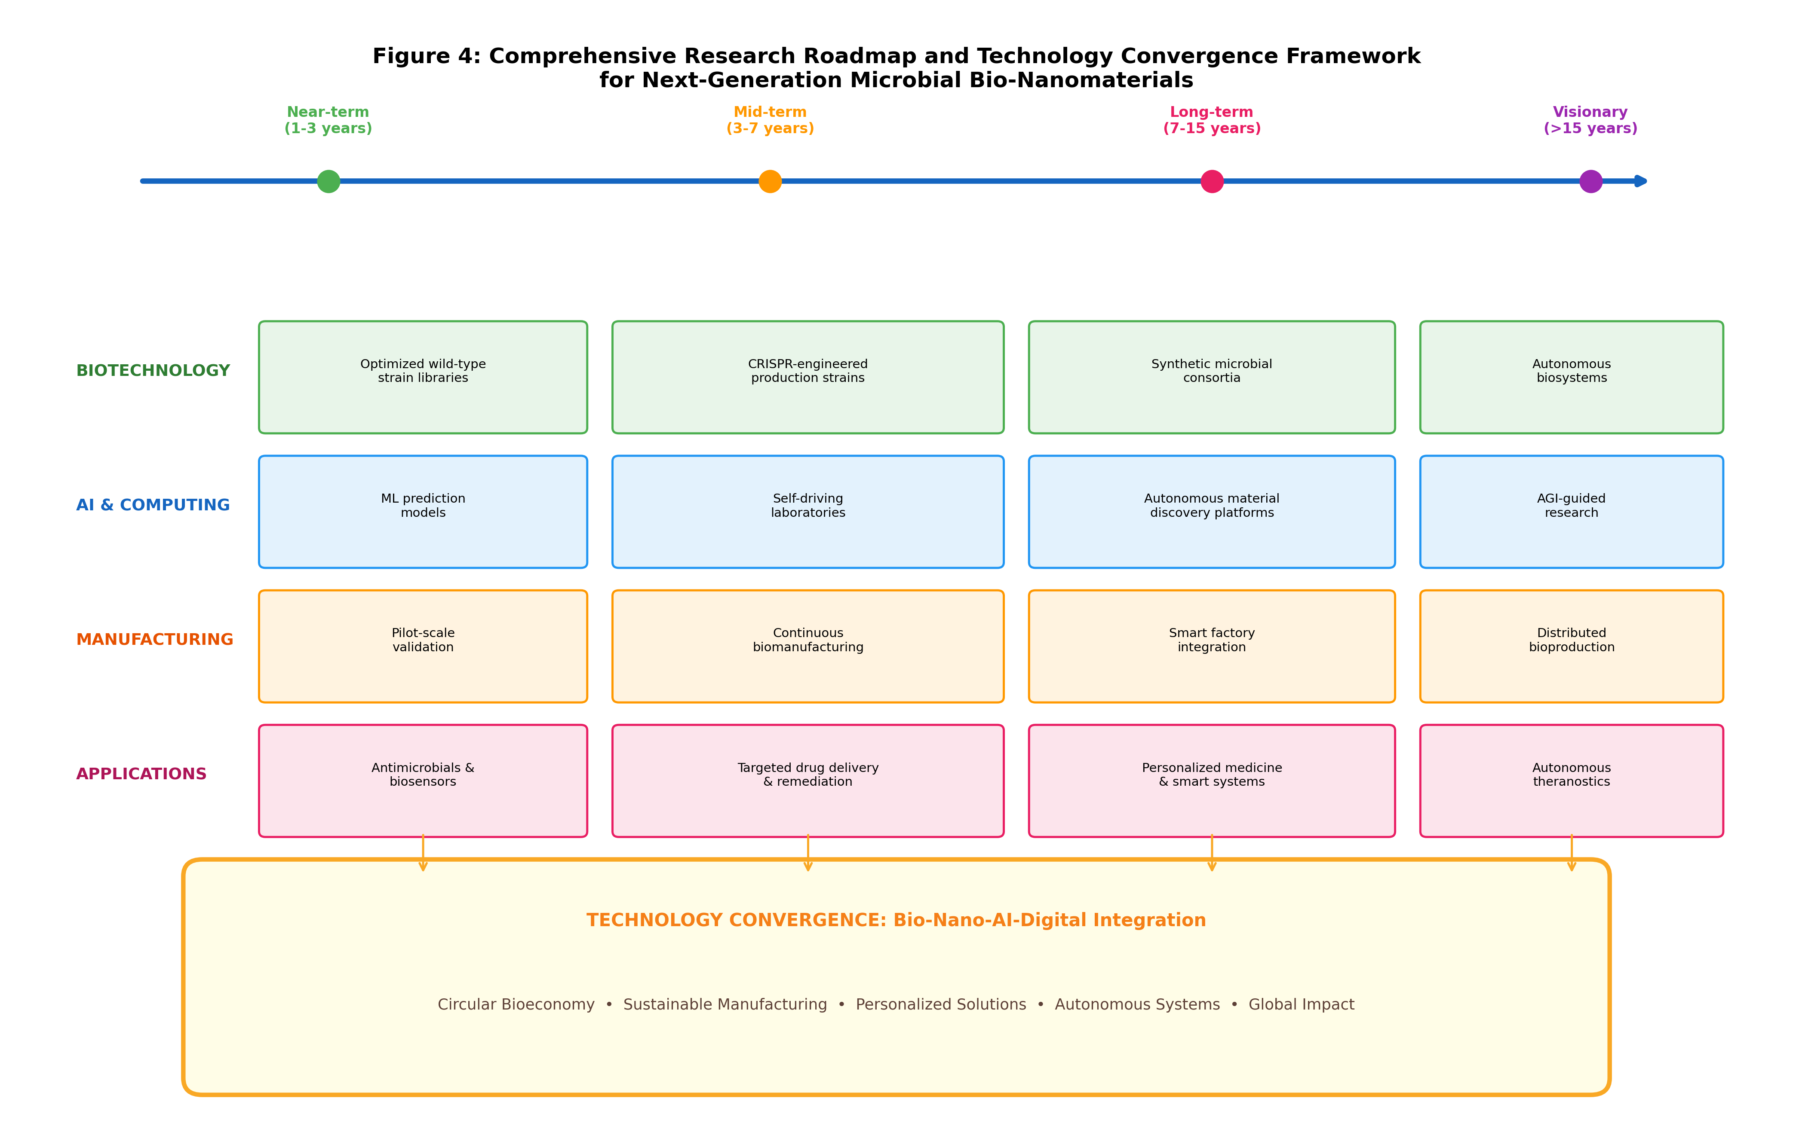
Figure 4: Comprehensive research roadmap and technology convergence framework for next-generation microbial bio-nanomaterials, showing near-term to visionary timelines across biotechnology, AI, manufacturing, and application domains.
The next generation of biomedical applications will increasingly leverage personalized, AI-designed nanomaterials optimized for individual patient needs, while environmental applications will employ intelligent, adaptive nanomaterial systems capable of autonomous response to contamination events [65]. The convergence of microbial nanotechnology with digital technologies, advanced manufacturing, and circular economy principles positions this field at the forefront of sustainable innovation with transformative potential across multiple sectors of the global economy.
In conclusion, the field of microbial-derived bio-nanomaterials stands at a critical inflection point where decades of fundamental research are converging with enabling technologies in artificial intelligence, synthetic biology, advanced manufacturing, and digital infrastructure to enable practical industrial implementation. The challenges of scalability, reproducibility, regulatory compliance, and market acceptance are substantial but increasingly tractable through the integrated approaches described in this chapter. Success will require sustained investment in both fundamental understanding and translational infrastructure, close collaboration between academic researchers, industry partners, and regulatory authorities, and commitment to responsible innovation principles that ensure the benefits of this technology are realized safely and equitably. The potential rewards—sustainable, cost-effective nanomaterial production supporting applications from personalized medicine to environmental restoration—justify the continued pursuit of these ambitious goals and position microbial bio-nanotechnology as a cornerstone of the emerging sustainable bioeconomy.

References
[1] Iravani, S. (2014). Bacteria in nanoparticle synthesis: current status and future prospects. International Scholarly Research Notices, 2014, 359316.
[2] Narayanan, K.B., & Sakthivel, N. (2010). Biological synthesis of metal nanoparticles by microbes. Advances in Colloid and Interface Science, 156(1-2), 1-13.
[3] Li, X., Xu, H., Chen, Z.S., & Chen, G. (2011). Biosynthesis of nanoparticles by microorganisms and their applications. Journal of Nanomaterials, 2011, 270974.
[4] Hulkoti, N.I., & Taranath, T.C. (2014). Biosynthesis of nanoparticles using microbes—a review. Colloids and Surfaces B: Biointerfaces, 121, 474-483.
[5] Khandel, P., & Shahi, S.K. (2018). Mycogenic nanoparticles and their bio-prospective applications: current status and future challenges. Journal of Nanostructure in Chemistry, 8, 369-391.
[6] Ovais, M., Khalil, A.T., Ayaz, M., Ahmad, I., Nethi, S.K., & Mukherjee, S. (2018). Biosynthesis of metal nanoparticles via microbial enzymes: a mechanistic approach. International Journal of Molecular Sciences, 19(12), 4100.
[7] Mohd Yusof, H., Mohamad, R., Zaidan, U.H., & Abdul Rahman, N. (2019). Microbial synthesis of zinc oxide nanoparticles and their potential application as an antimicrobial agent. Journal of Animal Science and Biotechnology, 10, 57.
[8] Singh, P., Kim, Y.J., Zhang, D., & Yang, D.C. (2016). Biological synthesis of nanoparticles from plants and microorganisms. Trends in Biotechnology, 34(7), 588-599.
[9] Gahlawat, G., & Choudhury, A.R. (2019). A review on the biosynthesis of metal and metal salt nanoparticles by microbes. RSC Advances, 9(23), 12944-12967.
[10] Fang, X., Wang, Y., Wang, Z., Jiang, Z., & Dong, M. (2019). Microorganism assisted synthesized nanoparticles for catalytic applications. Energies, 12(1), 190.
[11] Srivastava, S.K., & Constanti, M. (2012). Room temperature biogenic synthesis of multiple nanoparticles by Pseudomonas aeruginosa SM1. Journal of Nanoparticle Research, 14, 831.
[12] Deplanche, K., Caldelari, I., Mikheenko, I.P., Sargent, F., & Macaskie, L.E. (2010). Involvement of hydrogenases in the formation of highly catalytic Pd(0) nanoparticles. Microbiology, 156(9), 2630-2640.
[13] Sriramulu, M., & Sumathi, S. (2018). Biosynthesis of palladium nanoparticles using Saccharomyces cerevisiae extract. Advances in Natural Sciences: Nanoscience and Nanotechnology, 9(2), 025018.
[14] Gudikandula, K., & Charya Maringanti, S. (2016). Synthesis of silver nanoparticles by chemical and biological methods and their antimicrobial properties. Journal of Experimental Nanoscience, 11(9), 714-721.
[15] Saxena, J., Sharma, P.K., Sharma, M.M., & Singh, A. (2016). Process optimization for green synthesis of silver nanoparticles by Sclerotinia sclerotiorum. SpringerPlus, 5, 861.
[16] Moghaddam, A.B., Namvar, F., Moniri, M., et al. (2015). Nanoparticles biosynthesized by fungi and yeast: a review. Molecules, 20(9), 16540-16565.
[17] Siddiqi, K.S., & Husen, A. (2016). Fabrication of metal nanoparticles from fungi and metal salts: scope and application. Nanoscale Research Letters, 11, 98.
[18] Guilger-Casagrande, M., & Lima, R.D. (2019). Synthesis of silver nanoparticles mediated by fungi: a review. Frontiers in Bioengineering and Biotechnology, 7, 287.
[19] Rathore, A.S., & Winkle, H. (2009). Quality by design for biopharmaceuticals. Nature Biotechnology, 27(1), 26-34.
[20] Yu, L.X., Amidon, G., Khan, M.A., et al. (2014). Understanding pharmaceutical quality by design. AAPS Journal, 16(4), 771-783.
[21] Kuppusamy, P., Yusoff, M.M., Maniam, G.P., & Govindan, N. (2016). Biosynthesis of metallic nanoparticles using plant derivatives. Saudi Pharmaceutical Journal, 24(4), 473-484.
[22] Rajan, A., Vilas, V., & Philip, D. (2015). Studies on catalytic, antioxidant, antibacterial and anticancer activities of biogenic gold nanoparticles. Journal of Molecular Liquids, 212, 331-339.
[23] Gavankar, S., Suh, S., & Keller, A.F. (2012). Life cycle assessment at nanoscale: review and recommendations. International Journal of Life Cycle Assessment, 17, 295-303.
[24] Pourzahedi, L., & Eckelman, M.J. (2015). Comparative life cycle assessment of silver nanoparticle synthesis routes. Environmental Science: Nano, 2(4), 361-369.
[25] Bleeker, E.A., de Jong, W.H., Geertsma, R.E., et al. (2013). Considerations on the EU definition of a nanomaterial. Regulatory Toxicology and Pharmacology, 65(1), 119-125.
[26] FDA (2022). Nanotechnology guidance documents. U.S. Food and Drug Administration Center for Drug Evaluation and Research.
[27] European Commission (2018). Commission Regulation (EU) 2018/1881 amending REACH Regulation as regards nanomaterials. Official Journal of the European Union, L308, 1-20.
[28] Ventola, C.L. (2017). Progress in nanomedicine: approved and investigational nanodrugs. Pharmacy and Therapeutics, 42(12), 742-755.
[29] Rasmussen, K., Rauscher, H., Mech, A., et al. (2018). Physico-chemical properties of manufactured nanomaterials. JRC Science for Policy Report.
[30] Schins, R.P., & Knaapen, A.M. (2007). Genotoxicity of poorly soluble particles. Inhalation Toxicology, 19(sup1), 189-198.
[31] Singh, N., Manshian, B., Jenkins, G.J., et al. (2009). NanoGenotoxicology: the DNA damaging potential of engineered nanomaterials. Biomaterials, 30(23-24), 3891-3914.
[32] Dobrovolskaia, M.A., & McNeil, S.E. (2007). Immunological properties of engineered nanomaterials. Nature Nanotechnology, 2(8), 469-478.
[33] Shankar, P.D., Shobana, S., Karuppusamy, I., et al. (2016). A review on the biosynthesis of metallic nanoparticles using bio-components of microalgae. Enzyme and Microbial Technology, 95, 28-44.
[34] Lowry, G.V., Gregory, K.B., Apte, S.C., & Lead, J.R. (2012). Transformations of nanomaterials in the environment. Environmental Science & Technology, 46(13), 6893-6899.
[35] Anselmo, A.C., & Mitragotri, S. (2019). Nanoparticles in the clinic: an update. Bioengineering & Translational Medicine, 4(3), e10143.
[36] Gehrke, I., Geiser, A., & Somborn-Schulz, A. (2015). Innovations in nanotechnology for water treatment. Nanotechnology, Science and Applications, 8, 1-17.
[37] Owen, R., Macnaghten, P., & Stilgoe, J. (2012). Responsible research and innovation. Science and Public Policy, 39(6), 751-760.
[38] Barnard, A.S., & Motevalli, B. (2019). Using machine learning to predict the properties of nanoparticles. Nanoscale, 11(48), 23165-23172.
[39] Tao, H., Wu, T., Aldeghi, M., et al. (2021). Nanoparticle synthesis assisted by machine learning. Nature Reviews Materials, 6(8), 701-716.
[40] Yan, X., Sedykh, A., Wang, W., Yan, B., & Zhu, H. (2020). Construction of a web-based nanomaterial database. Nature Communications, 11, 2519.
[41] Häse, F., Roch, L.M., & Aspuru-Guzik, A. (2019). Next-generation experimentation with self-driving laboratories. Trends in Chemistry, 1(3), 282-291.
[42] Udugama, I.A., Gargalo, C.L., Yamashita, Y., et al. (2021). Digital twin in biomanufacturing: challenges and opportunities. Systems Microbiology and Biomanufacturing, 1, 257-274.
[43] Modarres, M.H., et al. (2017). Neural network for nanoscience scanning electron microscope image recognition. Scientific Reports, 7, 13282.
[44] Xu, M., Papageorgiou, D.P., Abidi, S.Z., et al. (2017). A deep convolutional neural network for classification of red blood cells. PLoS Computational Biology, 13(10), e1005746.
[45] Puzyn, T., Rasulev, B., Gajewicz, A., et al. (2011). Using nano-QSAR to predict the cytotoxicity of metal oxide nanoparticles. Nature Nanotechnology, 6(3), 175-178.
[46] Mowbray, M., Savage, T., Wu, C., et al. (2022). Machine learning for biochemical engineering: a review. Biochemical Engineering Journal, 172, 108054.
[47] Grand View Research (2023). Nanomaterials Market Size, Share & Trends Analysis Report. Grand View Research Industry Report.
[48] Allied Market Research (2023). Nanomedicine Market by Application, Modality, and Indication. Allied Market Research Report.
[49] Durán, N., Durán, M., de Jesus, M.B., et al. (2016). Silver nanoparticles: a new view on mechanistic aspects on antimicrobial activity. Nanomedicine, 12(3), 789-799.
[50] Cecchin, I., Reddy, K.R., Thomé, A., et al. (2017). Nanobioremediation: integration of nanoparticles and bioremediation. International Biodeterioration & Biodegradation, 119, 419-428.
[51] Inshakova, E., & Inshakov, O. (2017). World market for nanomaterials: structure and trends. MATEC Web of Conferences, 129, 02013.
[52] Chen, Y., Banerjee, D., Mukhopadhyay, A., & Petzold, C.J. (2020). Systems and synthetic biology tools for advanced bioproduction hosts. Current Opinion in Biotechnology, 64, 101-109.
[53] Luo, C.H., Shanks, J.V., & Bravo, L. (2016). Genetically encoded biosensors for monitoring enzyme function. Analytical Chemistry, 88(17), 8381-8389.
[54] Wei, M., Gao, Y., Li, X., & Serpe, M.J. (2017). Stimuli-responsive polymers and their applications. Polymer Chemistry, 8(1), 127-143.
[55] Heimann, K. (2016). Novel approaches to microalgal and cyanobacterial cultivation for bioenergy. Current Opinion in Biotechnology, 38, 183-189.
[56] Stach, E., DeCost, B., Kusne, A.G., et al. (2021). Autonomous experimentation systems for materials development. Matter, 4(9), 2702-2726.
[57] Coley, C.W., Eyke, N.S., & Jensen, K.F. (2020). Autonomous discovery in the chemical sciences part II. Angewandte Chemie International Edition, 59(52), 23414-23436.
[58] Kim, G.B., Kim, W.J., Kim, H.U., & Lee, S.Y. (2020). Machine learning applications in systems metabolic engineering. Current Opinion in Biotechnology, 64, 1-9.
[59] Mitchell, M.J., Billingsley, M.M., Haley, R.M., et al. (2021). Engineering precision nanoparticles for drug delivery. Nature Reviews Drug Discovery, 20(2), 101-124.
[60] Khan, I., Saeed, K., & Khan, I. (2019). Nanoparticles: properties, applications and toxicities. Arabian Journal of Chemistry, 12(7), 908-931.
[61] Jeevanandam, J., Barhoum, A., Chan, Y.S., et al. (2018). Review on nanoparticles and nanostructured materials. Beilstein Journal of Nanotechnology, 9, 1050-1074.
[62] Falkner, R., & Jaspers, N. (2012). Regulating nanotechnologies: risk, uncertainty and the global governance gap. Global Environmental Politics, 12(1), 30-55.
[63] ISO (2020). ISO/TS 80004 Nanotechnologies—Vocabulary. International Organization for Standardization Technical Specification.
[64] Saleh, T.A. (2020). Nanomaterials: classification, properties, and environmental toxicities. Environmental Technology & Innovation, 20, 101067.
[65] Bayda, S., Adeel, M., Tuccinardi, T., et al. (2020). The history of nanoscience and nanotechnology. Molecules, 25(1), 112.

