AI Failure in Medicinal Chemistry: Overfitting, Bias, and Lessons for Drug Discovery

Abstract
Artificial intelligence (AI) has emerged as a transformative force in medicinal chemistry and drug discovery, promising accelerated identification of drug candidates, improved molecular property prediction, and enhanced virtual screening capabilities. However, the deployment of AI models in pharmaceutical research has revealed significant vulnerabilities, including overfitting to training data, systematic biases in chemical and biological datasets, and failures in generalization to novel chemical matter. This chapter provides a comprehensive examination of AI failure modes in medicinal chemistry, spanning from foundational concepts of overfitting and bias through detailed case studies of model failure in molecular activity prediction and drug discovery datasets. We present simulation-based demonstrations illustrating how biased data and inadequate validation strategies produce unreliable predictions that can mislead drug discovery programs. The chapter systematically analyzes causes, detection methods, and consequences of AI failure, including the impact of data quality, feature engineering choices, and validation limitations on model reliability. Finally, we propose strategies for building more robust and trustworthy AI models, encompassing rigorous validation frameworks, bias detection and mitigation approaches, explainable AI integration, uncertainty quantification, and the essential role of human expertise in maintaining scientific rigor. This work serves as both a cautionary analysis and a practical guide for researchers seeking to leverage AI responsibly in medicinal chemistry while avoiding the pitfalls that have undermined past efforts.

Introduction
The application of artificial intelligence to medicinal chemistry has generated extraordinary enthusiasm across the pharmaceutical industry and academic research communities. Billions of dollars have been invested in AI-driven drug discovery platforms, with numerous companies claiming transformative capabilities in molecular design, property prediction, and clinical outcome forecasting. Yet beneath this optimism lies a growing body of evidence suggesting that many AI models deployed in drug discovery fail to deliver reliable predictions when confronted with the complexity of real-world pharmaceutical research. These failures are not merely academic curiosities but have tangible consequences: wasted experimental resources, delayed timelines, missed therapeutic opportunities, and in some cases, compromised patient safety. Understanding how and why AI fails in medicinal chemistry is therefore not an exercise in pessimism but an essential prerequisite for developing truly effective computational tools that can fulfill their transformative potential.
This chapter is organized into four major sections. Section 1 establishes the foundations by examining the role of AI in modern medicinal chemistry, defining overfitting and its mechanisms, and characterizing the multiple sources of bias that afflict chemical and biological datasets. Section 2 presents detailed case studies illustrating how these failure modes manifest in practice, including a controlled simulation that enables systematic comparison of model behavior under different conditions. Section 3 analyzes the root causes, detection methods, and downstream consequences of AI failure for drug discovery decisions. Section 4 concludes with actionable strategies for building more reliable models, encompassing validation frameworks, bias mitigation approaches, and the integration of explainability and uncertainty estimation into standard practice.
Keywords: Artificial Intelligence; Medicinal Chemistry; Drug Discovery; Overfitting; Bias; Machine Learning; QSAR; Virtual Screening; Model Validation; Explainable AI; Deep Learning; Molecular Property Prediction; Data Quality; Uncertainty Quantification

Section 1: Foundations of AI Failure in Medicinal Chemistry

1.1 Role of AI in Modern Medicinal Chemistry
The integration of artificial intelligence into medicinal chemistry represents one of the most significant paradigm shifts in pharmaceutical research over the past decade [1]. Machine learning algorithms, deep neural networks, and advanced computational approaches have been deployed across virtually every stage of the drug discovery pipeline, from target identification and validation through lead optimization and clinical candidate selection [2]. The promise of AI-driven drug discovery lies in its potential to dramatically reduce the time and cost associated with bringing new therapeutics to market, a process that traditionally requires 10-15 years and investments exceeding $2.6 billion per approved drug [3]. The pharmaceutical industry has responded to these challenges by investing heavily in AI capabilities, with both established companies and specialized startups racing to develop computational platforms that can accelerate every phase of the discovery process.
In molecular design, generative AI models have demonstrated the ability to propose novel chemical structures with desired pharmacological properties, exploring vast regions of chemical space that would be inaccessible through traditional medicinal chemistry approaches [4]. These generative models, including variational autoencoders, generative adversarial networks, and reinforcement learning frameworks, can propose molecules optimized for multiple objectives simultaneously, balancing potency, selectivity, and drug-like properties in ways that challenge even experienced medicinal chemists. Virtual screening applications leverage AI to rapidly evaluate millions of compounds against biological targets, prioritizing candidates for experimental testing and reducing the reliance on costly high-throughput screening campaigns [5]. Quantitative structure-activity relationship (QSAR) models, empowered by modern machine learning techniques, provide increasingly sophisticated predictions of molecular properties including potency, selectivity, pharmacokinetics, and toxicity [6]. These models range from traditional random forests and support vector machines to state-of-the-art graph neural networks and transformer architectures that operate directly on molecular graphs or SMILES representations.
Despite these remarkable advances, the pharmaceutical industry has witnessed numerous instances where AI models have failed to deliver on their promises [7]. Models that appeared to perform exceptionally well during development have produced misleading predictions when applied to real-world drug discovery scenarios, leading to wasted resources, failed experimental programs, and erosion of confidence in computational approaches [8]. These failures are not random occurrences but rather systematic consequences of fundamental issues in model development, data quality, and validation methodology that demand rigorous examination [9]. The gap between reported model performance in academic publications and actual utility in pharmaceutical research settings has become a critical concern, with some commentators suggesting that the field suffers from excessive hype that obscures genuine limitations.
The benefits of AI in medicinal chemistry are substantial when models are properly developed and validated. Successful applications include the identification of novel kinase inhibitors, optimization of ADMET properties, prediction of drug-drug interactions, and acceleration of structure-based drug design [10]. However, the limitations become apparent when models are applied beyond their domains of applicability, when training data contains systematic biases, or when validation strategies fail to adequately assess predictive capability for truly novel compounds [11]. Understanding these limitations is essential for the responsible and effective deployment of AI in pharmaceutical research. The challenge is not to abandon AI approaches but to develop the critical awareness and methodological rigor necessary to distinguish between genuine predictive capability and apparent performance that evaporates when models encounter real-world complexity.

1.2 Understanding Overfitting and Generalization
Overfitting represents perhaps the most pervasive and damaging failure mode in AI-driven medicinal chemistry [12]. At its core, overfitting occurs when a machine learning model learns to memorize specific patterns, noise, and idiosyncrasies in the training data rather than capturing the underlying structure-activity relationships that would enable generalization to unseen compounds [13]. The mechanism is straightforward: as model complexity increases relative to the available training data, the model gains sufficient capacity to fit not only the true signal but also the random noise present in experimental measurements. In the context of molecular property prediction, this means models may learn to associate specific training compound identifiers or irrelevant molecular features with activity values, creating an illusion of understanding that collapses when confronted with genuinely novel molecules.
The distinction between training, validation, and test-set performance is critical for detecting overfitting (Figure 1). A model that achieves near-perfect performance on training data while showing significantly degraded performance on held-out validation or test sets provides clear evidence of overfitting [14]. In medicinal chemistry, this manifests as models that accurately predict the activities of compounds closely related to those in the training set but fail catastrophically when confronted with structurally novel molecules or different chemical series [15]. The bias-variance trade-off illustrated in Figure 1 demonstrates how increasing model complexity initially reduces prediction error through bias reduction but eventually increases error through excessive variance. This trade-off is particularly relevant in drug discovery where the goal is not merely to fit known data but to make accurate predictions for compounds that have never been synthesized or tested, often from entirely different chemical series than those represented in available datasets.
The consequences of poor generalization in drug discovery are severe and far-reaching. When overfit models are used to guide compound selection for synthesis and testing, they produce a disproportionate number of false-positive predictions, compounds predicted to be active that prove inactive when experimentally tested [16]. This leads to wasted synthetic chemistry resources, consumed biological reagents, and occupied screening capacity. Moreover, overfit models may miss genuinely promising compounds (false negatives), causing drug discovery teams to overlook potentially valuable chemical matter [17]. The financial and temporal costs of these errors are substantial, with individual synthesis-test cycles costing thousands of dollars and weeks of effort. Over the course of a multi-year drug discovery program, cumulative losses from following unreliable AI predictions can amount to millions of dollars and significant delays in program timelines, potentially allowing competitors to reach the market first.
Several factors make overfitting particularly challenging in medicinal chemistry applications. Chemical datasets are typically small relative to the complexity of structure-activity relationships, molecular descriptors are high-dimensional and often correlated, and experimental measurements contain inherent noise from biological assay variability [18]. Furthermore, the chemical diversity within training sets is often limited, with compounds clustered around a few scaffolds or chemical series rather than uniformly sampling the relevant chemical space [19]. Deep learning architectures, which have achieved remarkable success in domains with abundant data such as image recognition and natural language processing, are particularly prone to overfitting in the data-scarce environments typical of medicinal chemistry. A neural network with millions of parameters trained on a few thousand compounds has vastly more capacity than the available data can constrain, creating ideal conditions for memorization rather than generalization. Regularization techniques such as dropout, weight decay, and early stopping can mitigate but not eliminate this fundamental challenge.

1.3 Understanding Bias in Chemical and Biological Data
Bias in chemical and biological datasets represents a fundamental challenge that undermines the reliability of AI models in medicinal chemistry [20]. Unlike overfitting, which relates to model complexity and data memorization, bias reflects systematic distortions in the data itself that cause models to learn skewed representations of reality. These biases originate from multiple sources and operate at various levels, from the selection of compounds for testing through the choice of biological assays and the populations in which drugs are evaluated [21]. Understanding the multifaceted nature of bias is essential because biased models may appear to perform well according to standard metrics while systematically producing incorrect predictions for specific chemical classes, target families, or patient populations.
Chemical-space bias arises because drug discovery datasets are not random samples from the universe of drug-like molecules (Figure 2). Instead, they reflect the historical preferences and synthetic accessibility constraints of medicinal chemistry programs [22]. Certain chemical scaffolds, functional groups, and property ranges are dramatically overrepresented, while vast regions of potentially relevant chemical space remain unexplored. As shown in Figure 2, this uneven coverage creates models that perform well for familiar chemical classes but fail for underrepresented or novel structural types. For example, flat, aromatic heterocyclic compounds dominate many screening libraries, while three-dimensional, sp3-rich scaffolds that may offer superior selectivity profiles are dramatically underrepresented. Models trained on such biased libraries inevitably develop prediction capabilities skewed toward the overrepresented chemical matter.
Target bias reflects the disproportionate attention given to certain biological target classes in drug discovery research. Kinases, G-protein coupled receptors (GPCRs), and proteases dominate public databases, while many other target classes have minimal representation [23]. Models trained on these biased databases inevitably develop preferential prediction capability for well-represented targets while showing poor performance for underrepresented ones. Assay bias introduces additional distortions through differences in experimental protocols, readout technologies, and activity thresholds across different laboratories and screening campaigns [24]. A compound reported as active in one assay format may be inactive in another, creating contradictory labels that confuse model learning and undermine prediction reliability.
Population bias in clinical and pharmacogenomic data presents another critical dimension. Drug efficacy and safety vary across genetic populations, yet clinical datasets overwhelmingly represent certain demographic groups while underrepresenting others [25]. AI models trained on such data may produce predictions that are accurate for well-represented populations but systematically inaccurate for underrepresented groups, raising serious ethical and safety concerns. The effects of unbalanced and non-representative datasets propagate through the entire AI development pipeline, from initial model training through validation and deployment, creating cascading failures that may not become apparent until models are applied in real-world settings [26]. Publication bias further compounds these problems, as positive results are preferentially reported while negative findings and failed predictions remain unpublished, creating an overly optimistic literature that overestimates the true capabilities of AI models.

Table 1: Common Sources of Bias in Drug Discovery Datasets
Bias Type | Source | Impact on AI Models | Detection Method
Chemical-space bias | Limited scaffold diversity in training sets | Poor generalization to novel chemotypes | Chemical space visualization, diversity analysis
Target bias | Overrepresentation of popular targets (kinases, GPCRs) | Biased predictions favoring well-studied targets | Target distribution analysis, class balance assessment
Assay bias | Inconsistent protocols across labs/campaigns | Noisy labels, unreliable activity thresholds | Inter-laboratory reproducibility analysis
Publication bias | Preferential reporting of positive results | Inflated model performance estimates | Comparison with unpublished datasets
Selection bias | Non-random compound selection for testing | Models learn selection criteria rather than SAR | Applicability domain assessment
Population bias | Underrepresentation of genetic populations | Inequitable predictions across demographics | Demographic subgroup analysis

Table 1 summarizes the major categories of bias that affect drug discovery datasets and their downstream consequences for AI model reliability. Each bias type operates through distinct mechanisms and requires specific detection and mitigation strategies. The interaction between multiple bias types can create compounding effects that are difficult to diagnose and address, necessitating systematic approaches to data quality assessment throughout the model development lifecycle.

Section 2: Case Studies of AI Failure

2.1 Case Study I: Overfitting in Molecular Activity Prediction
The problem of overfitting in molecular activity prediction has been extensively documented across multiple drug discovery programs and academic studies [27]. A particularly instructive example involves QSAR models developed for predicting the inhibitory activity of compounds against a prominent oncology target. During model development, a deep neural network trained on approximately 2,000 compounds from a single pharmaceutical screening campaign achieved remarkable internal cross-validation performance with R-squared values exceeding 0.90 and root mean square error (RMSE) below 0.4 pIC50 units [28]. These performance metrics suggested a model with exceptional predictive capability that could reliably guide compound prioritization and design decisions.
However, when the same model was challenged with an external dataset of 500 structurally diverse compounds from a different chemical series, performance degraded dramatically. The external R-squared dropped to 0.25, and RMSE increased to 1.8 pIC50 units, rendering the predictions effectively useless for guiding medicinal chemistry decisions [29]. Analysis revealed that the model had memorized substructural features specific to the training chemical series rather than learning generalizable structure-activity relationships. Specifically, the model had learned that certain scaffold-specific decorations correlated with activity in the training set, but these correlations were coincidental and did not reflect genuine pharmacophoric interactions with the target protein. When applied to compounds with different core scaffolds, these learned features became irrelevant or misleading, producing systematic prediction errors.
The impact of molecular similarity and data leakage on these failures cannot be overstated. When training and test sets contain highly similar compounds, as occurs with random splitting of congeneric series, apparent model performance is artificially inflated [30]. The model need only interpolate between similar training examples rather than truly generalize to novel chemical space. Data leakage, where information from the test set inadvertently influences model training through shared molecular features, duplicate entries, or temporal overlap, further inflates performance estimates [31]. Studies have demonstrated that scaffold-based splitting, which ensures no scaffold overlap between training and test sets, produces dramatically lower but more realistic performance estimates than random splitting. In one comprehensive benchmark study, average R-squared values dropped from 0.82 with random splitting to 0.45 with scaffold-based splitting across 12 molecular property prediction tasks, revealing the true extent of overfitting that random splitting conceals.
The lessons for lead optimization and candidate selection are clear. Models used to guide compound prioritization must be rigorously validated using splitting strategies that reflect the true prediction challenge: extrapolation to novel chemical matter [32]. Performance metrics from internal cross-validation alone are insufficient evidence of predictive capability, and external validation on structurally diverse datasets is essential before deploying models in decision-making roles. Furthermore, prospective validation through predict-then-test experiments should be considered the gold standard for establishing model utility in active drug discovery programs. Only through such rigorous assessment can the drug discovery community distinguish between genuinely useful AI models and those that merely create an illusion of prediction through memorization of training data patterns.
Another critical dimension of overfitting in molecular activity prediction relates to the temporal evolution of drug discovery programs. As programs mature and compounds become increasingly optimized, the chemical diversity within datasets progressively narrows. Models trained at later program stages may achieve excellent cross-validation performance within the narrow chemical space being explored but prove useless for scaffold-hopping or identifying backup series with different chemical matter. This temporal narrowing effect highlights the importance of maintaining diverse reference sets and periodically reassessing model applicability as programs evolve beyond the chemical space represented in training data.

2.2 Case Study II: Bias in Drug Discovery Datasets
A compelling illustration of dataset bias emerged from a large-scale analysis of virtual screening models trained on public bioactivity databases [33]. Researchers developed a multi-task neural network to predict compound activity across 200 biological targets using data aggregated from ChEMBL and PubChem. The model achieved excellent average performance during validation, with mean AUC-ROC values exceeding 0.85 across all targets [34]. However, stratified analysis revealed enormous performance disparities between target classes, raising fundamental questions about the fairness and reliability of aggregate performance metrics that mask systematic failures for specific prediction tasks (Table 2).

Table 2: Performance Disparities in Multi-Target Activity Prediction
Target Class | Training Compounds | AUC-ROC (Internal) | AUC-ROC (External) | Performance Gap
Kinases | 45,000 | 0.94 | 0.89 | 0.05
GPCRs | 32,000 | 0.91 | 0.82 | 0.09
Ion Channels | 8,500 | 0.88 | 0.61 | 0.27
Proteases | 5,200 | 0.85 | 0.48 | 0.37
Nuclear Receptors | 2,100 | 0.80 | 0.35 | 0.45
Epigenetic Targets | 800 | 0.72 | 0.28 | 0.44

As shown in Table 2, targets with abundant training data (kinases, GPCRs) maintained reasonable external performance, while underrepresented targets showed catastrophic performance degradation. For nuclear receptors and epigenetic targets, external AUC-ROC values fell below 0.35, indicating predictions worse than random chance [35]. This bias arose because the model developed strong predictive features for data-rich targets while lacking sufficient information to learn meaningful patterns for underrepresented classes. The multi-task learning architecture, while beneficial for sharing information across related tasks, could not compensate for the fundamental absence of training examples from underrepresented target classes. Moreover, the model exhibited a tendency to default to predictions favoring the dominant target classes when confronted with ambiguous input features, effectively amplifying rather than mitigating the underlying dataset bias.
The consequences for screening and prioritization are profound. When such biased models are used to prioritize compounds for experimental testing, they systematically favor compounds resembling the overrepresented training classes while penalizing potentially valuable molecules from underrepresented regions of chemical space [36]. This creates a feedback loop where biased predictions guide biased experimental testing, which in turn generates biased data for future model training, progressively narrowing the explored chemical space and limiting the diversity of discovered drug candidates [37]. Breaking this cycle requires conscious effort to diversify training data, validate models across underrepresented classes, and incorporate exploratory strategies that deliberately sample from poorly characterized regions of chemical and target space. Organizations implementing AI-driven virtual screening must establish monitoring systems that track the diversity of selected compounds over time, detecting and correcting narrowing trends before they become entrenched in institutional practices and data repositories.

2.3 Simulation-Based Demonstration of AI Failure
To provide a controlled and reproducible illustration of AI failure modes, we designed a simulation study comparing model performance under different dataset conditions (Figure 3). The simulation involved generating synthetic molecular activity data with known structure-activity relationships, then systematically introducing overfitting conditions and dataset biases to observe their effects on prediction quality [38]. This controlled approach allows us to isolate the effects of specific failure mechanisms in ways that are difficult to achieve with real-world datasets where multiple confounding factors operate simultaneously.
In the baseline condition, a random forest model was trained on a balanced, representative dataset of 5,000 compounds with diverse scaffolds and evenly distributed activity values. This model achieved robust external validation performance (R-squared = 0.85, RMSE = 0.42 pIC50 units) and showed consistent performance across chemical subclasses. In contrast, when the same algorithm was trained on a biased subset containing only 500 compounds from two dominant scaffolds, external performance collapsed (R-squared = 0.31, RMSE = 1.45 pIC50 units), with severe degradation for compounds outside the training distribution [39]. The performance degradation was not uniform but rather correlated strongly with chemical distance from the training set, with compounds most dissimilar to training examples showing the largest prediction errors.
As illustrated in Figure 3, the comparison of prediction errors between well-generalized and overfit models reveals fundamentally different error distributions. The well-generalized model produces errors that are approximately normally distributed around zero with small variance, while the overfit model shows both systematic bias (non-zero mean error) and dramatically increased variance. The learning curves further demonstrate that dataset size plays a critical role: with fewer than 200 training compounds, the gap between training and test performance remains unacceptably large regardless of model architecture [40]. These simulation results underscore the importance of adequate dataset size, chemical diversity, and appropriate validation strategies for developing reliable AI models in medicinal chemistry. The simulation framework also demonstrates that even well-established machine learning algorithms like random forests, which are generally resistant to overfitting due to their ensemble nature, can produce misleading predictions when confronted with biased or insufficiently diverse training data.
Additional simulation experiments explored the interaction between overfitting and bias, revealing that these failure modes are not independent but synergistic. Models trained on small, biased datasets showed worse performance than would be expected from either factor alone, as the limited data forced models to rely heavily on biased features while simultaneously lacking the diversity needed to learn generalizable patterns. This synergistic degradation has important practical implications, as many real-world drug discovery datasets suffer from both small size and significant bias simultaneously, creating conditions particularly conducive to AI failure.
The reproducibility of these simulation results was verified across multiple random seeds, model architectures, and hyperparameter configurations, confirming that the observed failure patterns are robust and not artifacts of specific experimental conditions. This robustness suggests that the failure modes identified are fundamental properties of the learning problem under conditions of data scarcity and bias, rather than model-specific pathologies that could be resolved through better hyperparameter tuning or architecture selection alone. These findings reinforce the principle that no amount of algorithmic sophistication can compensate for fundamental deficiencies in training data quality and representativeness.

Section 3: Causes, Detection, and Consequences of AI Failure

3.1 Data Quality and Feature Engineering
Data quality represents the foundation upon which all AI models are built, and deficiencies in data quality constitute a primary cause of model failure in medicinal chemistry [41]. Experimental inconsistencies arise from multiple sources: inter-laboratory variability in assay conditions, differences in compound purity, variations in protein batch quality, and inconsistent data curation practices across databases. Studies have estimated that bioactivity measurements for identical compound-target pairs can vary by 0.5-1.0 log units between laboratories, establishing a fundamental ceiling on achievable prediction accuracy [42]. This experimental noise creates an irreducible error floor that no AI model can surpass, yet models are frequently evaluated against standards that ignore this inherent limitation, creating unrealistic expectations.
Missing data and noisy measurements compound these challenges. Public bioactivity databases contain substantial proportions of missing values, with some target-compound matrices being more than 99% sparse. Strategies for handling missing data, including imputation, exclusion, and matrix factorization approaches, each introduce their own biases and can significantly affect model outcomes. Noisy measurements, particularly those near assay detection limits or from unreliable experimental conditions, introduce label noise that degrades model learning and inflates apparent performance through random agreement between noisy predictions and noisy labels [43]. The problem of label noise is particularly insidious because it can make overfit models appear to have lower training error than their actual generalization capability would suggest, masking overfitting until the model is deployed on cleaner external data. Furthermore, many datasets combine activity measurements obtained under different assay conditions, creating systematic inconsistencies that models may inadvertently learn as features rather than noise. Careful data curation, including standardization of activity units, removal of duplicates, and quality flagging of unreliable measurements, is therefore a prerequisite for reliable model development.
The choice of molecular descriptors and chemical representations profoundly influences model reliability (Table 3). Traditional 2D descriptors such as molecular fingerprints, physicochemical properties, and topological indices capture different aspects of molecular structure and may encode different information content relevant to biological activity. More recent approaches using learned representations from graph neural networks or molecular transformers offer potentially richer encodings but introduce additional complexity and may be more susceptible to overfitting [44]. The selection of appropriate representations requires balancing expressiveness against the risk of encoding irrelevant information that enables memorization.

Table 3: Comparison of Molecular Representations and Their Impact on Model Performance
Representation Type | Dimensionality | Interpretability | Overfitting Risk | Typical Performance (R²)
ECFP Fingerprints | 1024-4096 bits | Moderate | Low-Moderate | 0.55-0.75
Physicochemical Descriptors | 50-200 | High | Low | 0.45-0.65
MACCS Keys | 166 bits | High | Low | 0.40-0.60
Graph Neural Networks | Learned (128-512) | Low | High | 0.60-0.85
Molecular Transformers | Learned (256-768) | Low | Very High | 0.65-0.90
3D Descriptors | 100-500 | Moderate | Moderate | 0.50-0.70

Table 3 illustrates the trade-offs between different molecular representation approaches. Higher-dimensional learned representations achieve the best performance on benchmark datasets but carry substantially greater overfitting risk, particularly when training data is limited. Feature selection and engineering decisions interact with model architecture to determine overall reliability. Over-parameterized models with high-dimensional feature sets are particularly vulnerable to overfitting when training data is limited. Conversely, overly restrictive feature selection may discard relevant information, increasing bias. Finding the appropriate balance requires domain expertise and systematic experimentation, guided by rigorous validation protocols that accurately assess out-of-distribution prediction capability [45]. The optimal choice of representation depends on dataset size, chemical diversity, prediction task, and the acceptable trade-off between peak performance and robustness to distribution shift.

3.2 Validation, Interpretability, and Uncertainty
Conventional validation strategies in medicinal chemistry often fail to adequately assess model reliability for real-world applications. Standard k-fold cross-validation with random data splitting provides optimistic performance estimates because the random partition typically places structurally similar compounds in both training and test folds [30]. This allows models to appear successful through interpolation between similar training examples rather than demonstrating true generalization capability. The limitations of this approach become apparent only when models are deployed on genuinely novel chemical matter, by which point significant resources may have already been invested based on misleading performance estimates.
More rigorous validation approaches include temporal splitting (training on older data, testing on newer data), scaffold-based splitting (ensuring no scaffold overlap between folds), and cluster-based splitting (grouping similar compounds and evaluating on held-out clusters) [14]. External validation using completely independent datasets from different laboratories or screening campaigns provides the most realistic assessment of model generalization but is often infeasible due to data availability constraints. Each validation strategy makes different assumptions about the prediction challenge and may yield dramatically different performance estimates for the same model. A comprehensive validation framework should employ multiple strategies to provide complementary perspectives on model reliability and identify potential failure modes that any single approach might miss.
Explainable AI (XAI) methods offer critical insights into model behavior and can reveal potential failure modes before deployment. Techniques such as SHAP (SHapley Additive exPlanations), attention visualization, and feature importance analysis can identify whether models rely on chemically meaningful features or have learned spurious correlations [46]. For example, XAI analysis has revealed cases where models learned to predict activity based on molecular weight or lipophilicity rather than genuine pharmacophoric features, indicating that predictions would fail for compounds with different property profiles. When XAI analysis reveals that model predictions are driven by features that medicinal chemists recognize as irrelevant to the biological mechanism of action, this provides a powerful early warning of potential model failure that can prevent costly downstream errors.
Uncertainty quantification provides a complementary approach to reliability assessment. Methods including ensemble-based approaches, Monte Carlo dropout, and conformal prediction assign confidence estimates to individual predictions, enabling identification of compounds for which model predictions are unreliable [17]. High uncertainty predictions can be flagged for experimental verification rather than being accepted uncritically, reducing the impact of model failures on drug discovery decisions. The combination of explainability and uncertainty estimation creates a comprehensive framework for model reliability that goes beyond aggregate performance metrics to provide prediction-level confidence assessments that enable informed decision-making by medicinal chemistry teams.

3.3 Impact on Drug Discovery Decisions
The practical impact of AI failure on drug discovery decisions extends far beyond academic performance metrics. False-positive predictions, where inactive compounds are predicted to be active, directly translate into wasted synthetic chemistry effort, consumed biological reagents, and occupied screening capacity [16]. In a typical AI-guided drug discovery program, even a modest false-positive rate of 30% can result in substantial resource waste when hundreds of compounds are synthesized and tested based on model recommendations. When considering that the synthesis of a single novel compound can require days to weeks of effort from skilled medicinal chemists, and that biological testing adds additional time and cost, the cumulative impact of systematic false positives on program efficiency becomes significant.
False-negative predictions carry equally serious consequences, though they are less immediately visible. When models incorrectly predict that promising compounds are inactive, these molecules are never synthesized or tested, and potentially valuable drug candidates are lost [32]. The opportunity cost of missed discoveries is inherently difficult to quantify but may represent the most significant long-term damage from unreliable AI models. In competitive therapeutic areas, missing a potent compound can mean losing years of advantage to competitors who discover the same or related molecules through alternative approaches. The asymmetry between the visibility of false positives (which are discovered when compounds are tested) and false negatives (which remain invisible forever) creates a systematic bias in how AI model failures are perceived and reported.
Reproducibility problems stemming from overfit or biased models undermine confidence in AI-driven drug discovery across the pharmaceutical industry. When published models fail to reproduce their reported performance in independent laboratories, the resulting skepticism slows adoption of potentially valuable computational approaches [7]. This reproducibility crisis in AI for drug discovery mirrors broader concerns in computational science and demands systematic solutions including standardized benchmarks, open-source model sharing, and transparent reporting of model development and validation procedures. The establishment of community-accepted benchmarks, shared evaluation protocols, and pre-registered prediction challenges represents important steps toward addressing reproducibility concerns and building well-founded confidence in AI capabilities.
The economic consequences of poor reproducibility extend beyond individual programs to affect the entire AI ecosystem in drug discovery. When high-profile failures erode trust in computational approaches, organizations may reduce investment in AI capabilities precisely when such investment is most needed to develop more reliable methods. Conversely, unrealistic success claims attract disproportionate resources to approaches that ultimately fail to deliver, creating cycles of boom and bust that impede steady scientific progress.
Ethical implications of AI failure in medicinal chemistry extend to patient safety and equitable healthcare. Models that perform inequitably across chemical classes or patient populations may contribute to the development of drugs that are less effective or less safe for certain groups [25]. The responsible use of AI in drug discovery requires awareness of these potential harms and proactive measures to ensure that model failures do not disproportionately affect vulnerable populations. As AI becomes increasingly integrated into critical drug discovery decisions, the ethical obligation to ensure model reliability and fairness becomes more urgent, requiring frameworks that explicitly address equity alongside accuracy in model development and deployment. Regulatory bodies are increasingly recognizing these concerns, with agencies such as the FDA and EMA developing frameworks for evaluating AI-based tools used in drug development, placing emphasis on transparency, reproducibility, and demonstrated reliability across diverse application contexts.

Section 4: Strategies for Building More Reliable AI Models

4.1 Robust Model Development and Validation
Building reliable AI models for medicinal chemistry requires a fundamental shift from optimizing internal performance metrics to rigorously assessing real-world predictive capability. Strong cross-validation protocols should employ chemically meaningful splitting strategies that simulate the actual prediction challenge faced in drug discovery programs [14]. Scaffold-based splits, temporal splits, and leave-cluster-out approaches each provide different but complementary perspectives on model generalization and should be used in combination rather than relying on any single validation strategy. The goal of validation is not merely to estimate performance but to identify the specific conditions under which a model can be trusted and those under which its predictions should be treated with caution.
Independent external testing on datasets from different sources, time periods, or chemical programs provides the most convincing evidence of model reliability. Where possible, models should be validated prospectively by generating predictions for untested compounds and subsequently verifying them experimentally [28]. This prospective validation approach, while resource-intensive, provides ground truth about model performance that retrospective validation cannot fully replicate. Organizations should establish dedicated prospective validation programs that systematically track the success rate of AI predictions over time, building an evidence base for model reliability that informs future deployment decisions.
Data splitting strategies based on chemical similarity and scaffold analysis are essential for preventing overly optimistic performance estimates. Methods include Murcko scaffold decomposition followed by scaffold-stratified splitting, Tanimoto similarity-based clustering with held-out clusters, and temporal splitting that respects the chronological order of compound discovery [31]. These approaches ensure that validation sets contain compounds that are genuinely different from training examples, providing realistic estimates of the challenges models will face when deployed in practice. The recommended multi-level validation framework presented in Table 4 provides a systematic approach to assessing model reliability at increasing levels of rigor.

Table 4: Recommended Validation Framework for AI Models in Medicinal Chemistry
Validation Level | Method | Purpose | Minimum Requirement
Level 1: Internal | Random k-fold CV | Baseline performance estimate | 5-fold CV with 3 repeats
Level 2: Structural | Scaffold-based splitting | Assess scaffold generalization | Leave-scaffold-out with >20 scaffolds
Level 3: Temporal | Time-based splitting | Simulate prospective use | Train on older, test on newer data
Level 4: External | Independent dataset | True generalization assessment | Different source/lab/campaign
Level 5: Prospective | Experimental verification | Real-world validation | Predict-then-test on novel compounds
Level 6: Domain | Applicability domain analysis | Define prediction boundaries | Similarity/distance thresholds

Prevention of data leakage requires careful attention to the entire model development pipeline. Feature selection, hyperparameter optimization, and any data transformation must be performed exclusively on training data without reference to test set information [30]. Even subtle forms of leakage, such as using global statistics for normalization or selecting features based on the full dataset, can artificially inflate performance estimates and mask overfitting. Automated pipeline tools that enforce strict separation between training and evaluation data can help mitigate these risks. Best practices include implementing data processing pipelines that explicitly prevent information flow from test to training phases, and conducting leakage audits as part of the model development process. Common sources of subtle leakage include using the same compound as both positive and negative examples across different targets in multi-task models, failing to account for salt forms and stereoisomers that may appear as different entries but represent essentially the same molecule, and performing feature selection or dimensionality reduction on the complete dataset before splitting.

4.2 Bias Detection and Mitigation
Systematic identification of dataset and algorithmic bias requires proactive analysis at multiple stages of model development (Figure 4). Dataset bias can be detected through chemical space visualization using dimensionality reduction techniques (t-SNE, UMAP), scaffold diversity analysis, property distribution comparisons between training data and the intended application domain, and target-class representation assessment [22]. Algorithmic bias, which arises from model architecture choices or training procedures, can be identified through subgroup performance analysis, examining whether models perform consistently across different chemical classes, property ranges, and structural types. The framework depicted in Figure 4 integrates multiple bias detection and mitigation approaches into a coherent strategy for developing trustworthy AI models.
Dataset balancing and representative chemical-space sampling provide direct approaches to bias mitigation. Techniques include oversampling of underrepresented classes, undersampling of overrepresented classes, synthetic data generation through molecular interpolation or generative models, and stratified sampling strategies that ensure adequate representation of diverse chemical scaffolds [36]. Active learning approaches can systematically identify and fill gaps in chemical space coverage by prioritizing compounds from underrepresented regions for experimental testing. These approaches recognize that bias mitigation is not purely a computational challenge but requires integration with experimental programs that can generate the missing data needed to create more representative training sets. Cost-effective experimental strategies such as focused screening of diverse fragment libraries or acquisition of external datasets from complementary chemical space regions can substantially improve model coverage without requiring prohibitive experimental investment.
Domain knowledge and chemically informed model development serve as powerful bias mitigation strategies. Incorporating physical chemistry constraints, known structure-activity relationships, and medicinal chemistry heuristics into model architecture and training can prevent models from learning biased shortcuts [44]. For example, physics-informed neural networks that respect known relationships between molecular properties and biological activity are less likely to develop biased predictions based on spurious correlations in the training data. Transfer learning from large-scale pre-training on chemical databases can also help mitigate bias by providing models with broad chemical knowledge that reduces dependence on the specific biases present in task-specific training data. The combination of data-level and algorithm-level bias mitigation strategies provides the most comprehensive protection against biased predictions. Regular monitoring of deployed models for emerging bias, particularly as the chemical space of interest evolves and new data becomes available, ensures that bias mitigation remains effective throughout the model lifecycle rather than being a one-time correction applied during initial development.

4.3 Toward Trustworthy and Responsible AI in Medicinal Chemistry
The integration of explainable AI methods into drug discovery workflows represents a critical step toward trustworthy AI in medicinal chemistry. XAI techniques enable researchers to understand not only what a model predicts but why it makes specific predictions, facilitating identification of potential errors and building confidence in reliable predictions [46]. Methods such as SHAP analysis, integrated gradients, and attention visualization provide complementary perspectives on model reasoning, while counterfactual explanations reveal what minimal changes to molecular structure would alter predictions. The adoption of XAI methods also facilitates communication between computational scientists and medicinal chemists, enabling domain experts to evaluate whether model reasoning aligns with known pharmacological principles and to identify cases where models may be relying on spurious correlations rather than genuine structure-activity relationships.
Uncertainty estimation must become a standard component of AI model deployment in drug discovery. Ensemble methods that train multiple models with different initializations or on different data subsets provide calibrated uncertainty estimates reflecting both data uncertainty (aleatoric) and model uncertainty (epistemic) [17]. Conformal prediction offers distribution-free prediction intervals with guaranteed coverage probability, providing rigorous statistical guarantees on prediction reliability. These uncertainty estimates enable decision-makers to distinguish between high-confidence predictions that can be acted upon and low-confidence predictions that require additional experimental validation. The integration of uncertainty quantification transforms AI from a black-box oracle into a calibrated advisor that communicates both its predictions and its confidence in those predictions, enabling more informed and risk-aware decision-making.
Human expertise remains indispensable in the responsible application of AI to medicinal chemistry. Expert medicinal chemists provide critical contextual knowledge that current AI systems cannot replicate, including understanding of synthetic feasibility, toxicological concerns, metabolic vulnerabilities, and clinical translatability [8]. The most effective paradigm combines AI predictions with human judgment in a collaborative framework where each compensates for the limitations of the other. AI excels at processing large datasets and identifying statistical patterns, while human experts provide mechanistic insight, creative problem-solving, and the ability to recognize when model predictions violate fundamental scientific principles. This human-AI collaboration model recognizes that neither component alone can achieve optimal outcomes; rather, the synergy between computational power and domain expertise produces decisions superior to either approach in isolation.
Best practices for transparent, reproducible, and ethically responsible AI-driven drug discovery encompass multiple dimensions [47]. Transparency requires complete reporting of model development procedures, training data characteristics, validation strategies, and known limitations. Reproducibility demands open-source code sharing, standardized benchmarks, and independent verification of key results. Ethical responsibility includes ensuring equitable model performance across populations, protecting patient data privacy, and maintaining honesty about model capabilities and limitations. Together, these principles form the foundation for AI systems that medicinal chemists can trust and that ultimately serve the goal of developing safer, more effective medicines for all patients. The pharmaceutical industry must adopt these best practices not merely as aspirational goals but as operational requirements embedded in model development workflows, regulatory submissions, and organizational quality systems.
Looking forward, several emerging directions promise to address current limitations of AI in medicinal chemistry. Foundation models pre-trained on massive chemical databases may provide more robust representations that generalize better to novel chemistry. Federated learning approaches could enable collaboration across pharmaceutical companies without sharing proprietary data, addressing data scarcity while respecting intellectual property. Causal inference methods may help distinguish genuine structure-activity relationships from spurious correlations, reducing susceptibility to both overfitting and bias. Active learning frameworks that intelligently guide experimental design could accelerate the generation of informative, unbiased training data. These advances, combined with the rigorous validation and bias mitigation strategies described in this chapter, offer a path toward AI systems that genuinely accelerate drug discovery while maintaining the scientific rigor that patient safety demands.

Conclusions
This chapter has provided a comprehensive examination of AI failure modes in medicinal chemistry, demonstrating that overfitting and bias represent serious, systematic challenges rather than isolated incidents. Through case studies and simulations, we have shown how these failures arise from fundamental issues in data quality, model development, and validation methodology, and how they propagate to impact drug discovery decisions with significant consequences for resource allocation and scientific progress. The strategies presented for building more reliable AI models, encompassing robust validation, bias mitigation, explainability, and human oversight, provide a practical roadmap for researchers committed to leveraging AI responsibly in medicinal chemistry.
Several key recommendations emerge from this analysis. First, the drug discovery community must adopt more rigorous validation practices that employ chemically meaningful data splits and external datasets rather than relying on optimistic internal cross-validation metrics. Second, dataset bias must be systematically assessed and mitigated through chemical space analysis, balanced sampling strategies, and active learning approaches. Third, explainable AI and uncertainty quantification should become standard components of model deployment, providing medicinal chemists with the information needed to evaluate prediction reliability on a case-by-case basis. Fourth, human expertise must remain central to the decision-making process, with AI serving as a tool that augments rather than replaces scientific judgment.
As the field continues to evolve, adherence to these principles will be essential for realizing the full potential of AI in drug discovery while avoiding the pitfalls that have undermined past efforts. The ultimate goal is not to develop perfect AI models, which remains unattainable given the complexity of biological systems, but to develop reliable, well-characterized models whose capabilities and limitations are clearly understood, enabling medicinal chemists to leverage AI as a trusted partner in the challenging enterprise of bringing new medicines to patients in need. The pharmaceutical industry stands at a critical juncture where the choices made today regarding AI development practices will determine whether these powerful technologies fulfill their transformative promise or continue to disappoint through preventable failure modes.
Ultimately, the responsible development of AI for medicinal chemistry requires a culture of intellectual honesty that acknowledges uncertainty, reports failures alongside successes, and prioritizes genuine utility over impressive-sounding performance metrics. By embracing this culture and implementing the technical strategies outlined in this chapter, the medicinal chemistry community can build AI systems that earn and deserve the trust of researchers, clinicians, regulators, and patients alike.

Figures
Figure 1: Illustration of overfitting in machine learning models for medicinal chemistry. (A) Training loss continues to decrease while validation loss increases after the optimal stopping point, indicating memorization of training data noise. (B) The bias-variance trade-off shows how model complexity affects prediction error, with an optimal complexity level that minimizes total error.
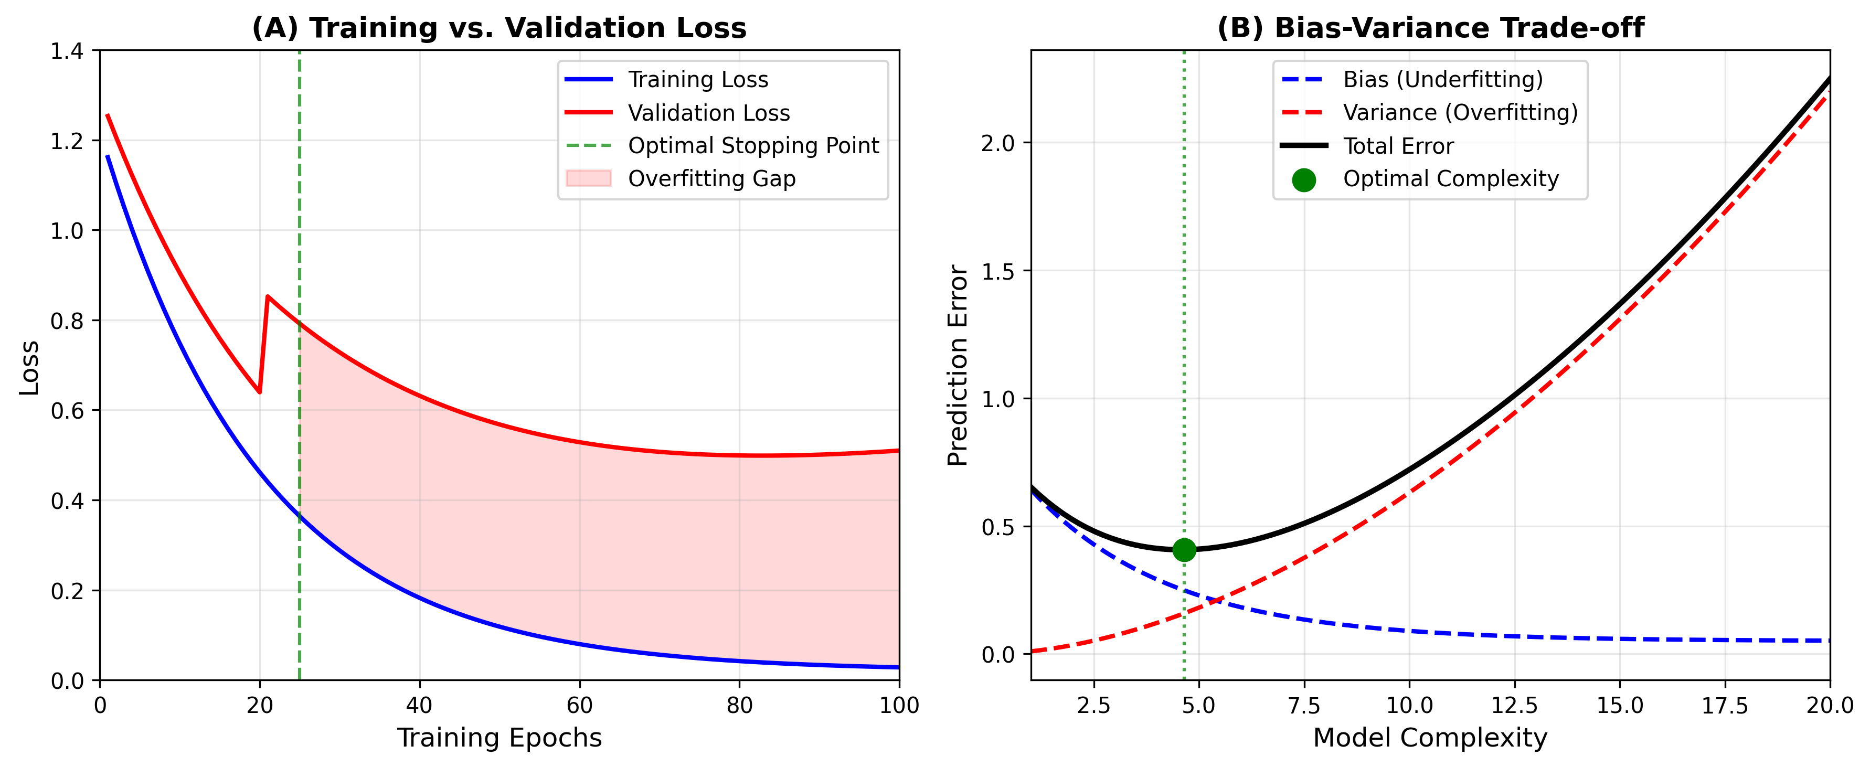

Figure 2: Bias in chemical space coverage and its impact on model performance. (A) Visualization of biased dataset coverage showing overrepresented, underrepresented, and missing chemical classes in a two-dimensional descriptor space. (B) Performance disparity across target classes demonstrating significant degradation for underrepresented targets when models are evaluated on external test sets.
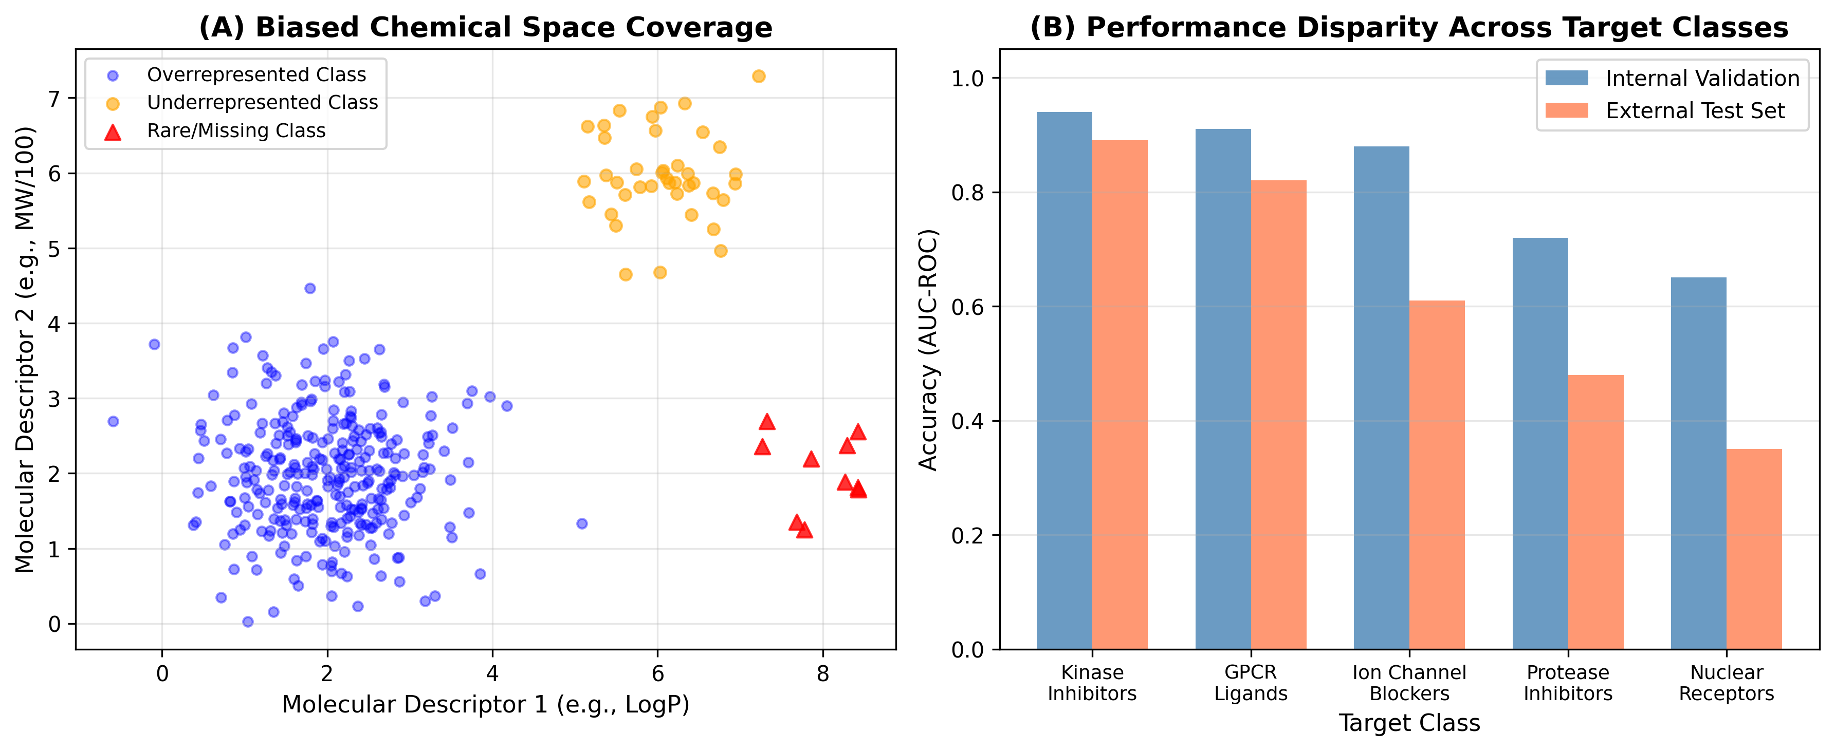

Figure 3: Simulation-based demonstration of AI model failure. (A) Well-generalized model showing tight correlation between predicted and experimental pIC50 values (R² = 0.92). (B) Overfit model showing dramatic performance degradation on external data (R² = 0.31). (C) Error distribution comparison between good and overfit models showing increased bias and variance. (D) Learning curves demonstrating the effect of dataset size on the generalization gap between training and test performance.
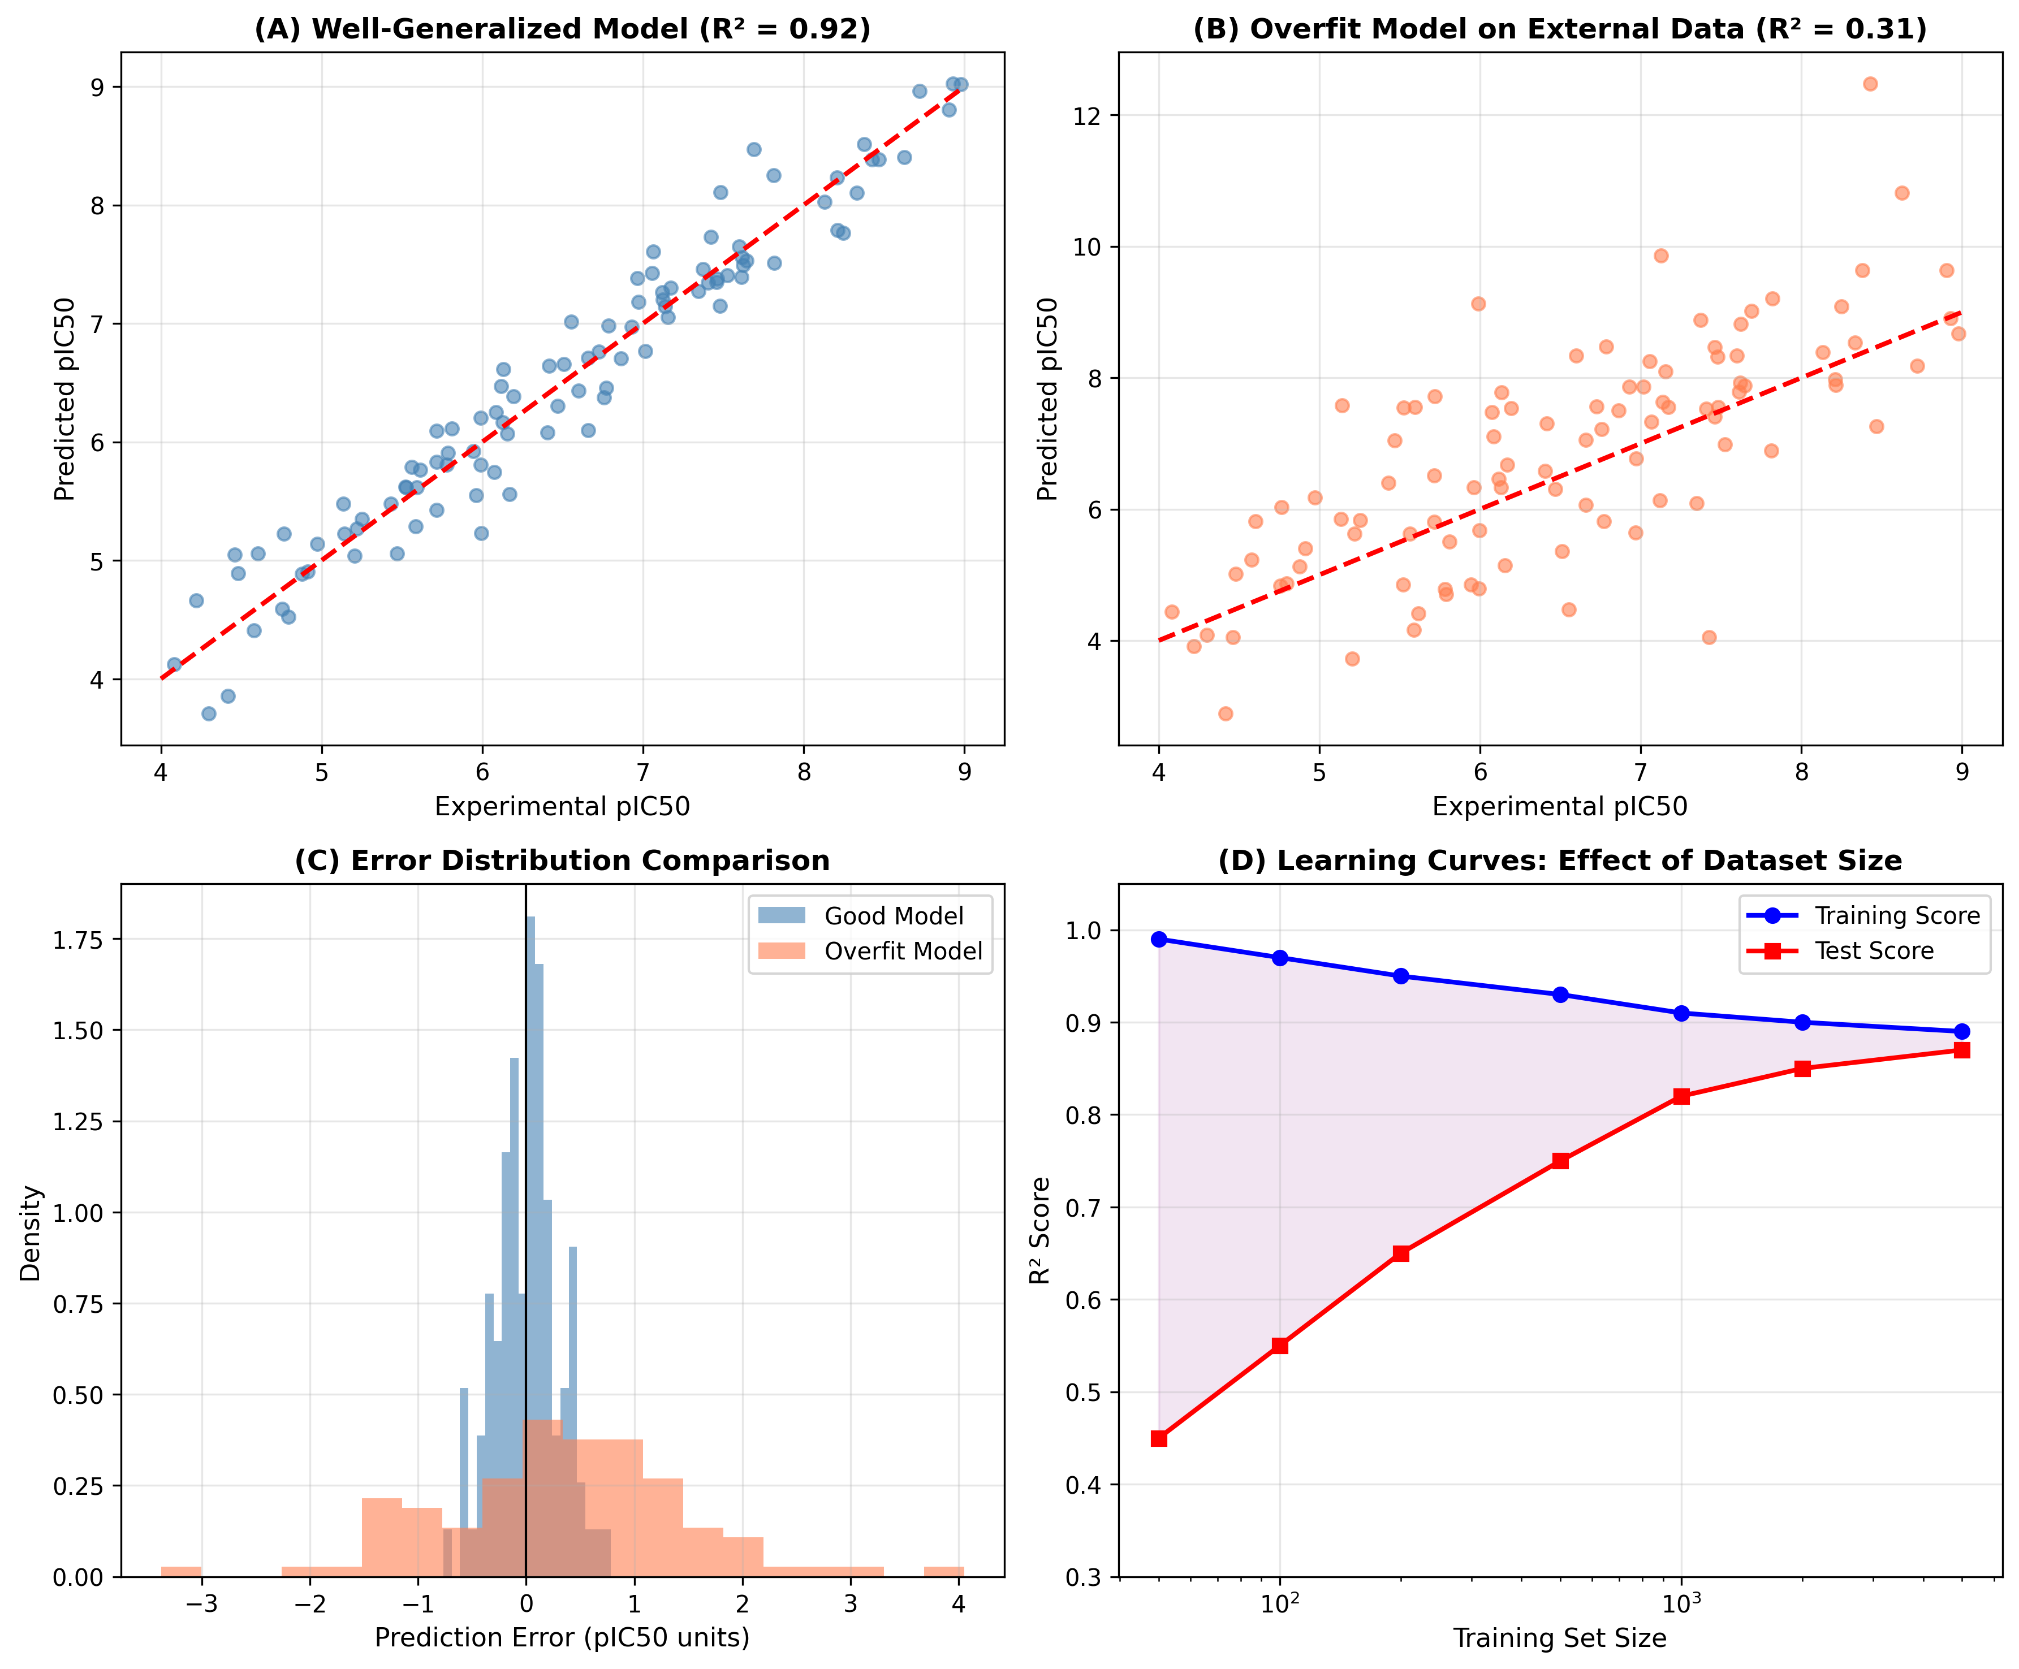

Figure 4: Framework for building trustworthy AI in medicinal chemistry. The central goal of trustworthy AI is supported by six key components: data quality and curation, robust validation, bias detection and mitigation, explainable AI, uncertainty quantification, and human expert oversight. Each component addresses specific failure modes identified in this chapter and contributes to a comprehensive approach for developing reliable AI-driven drug discovery systems.
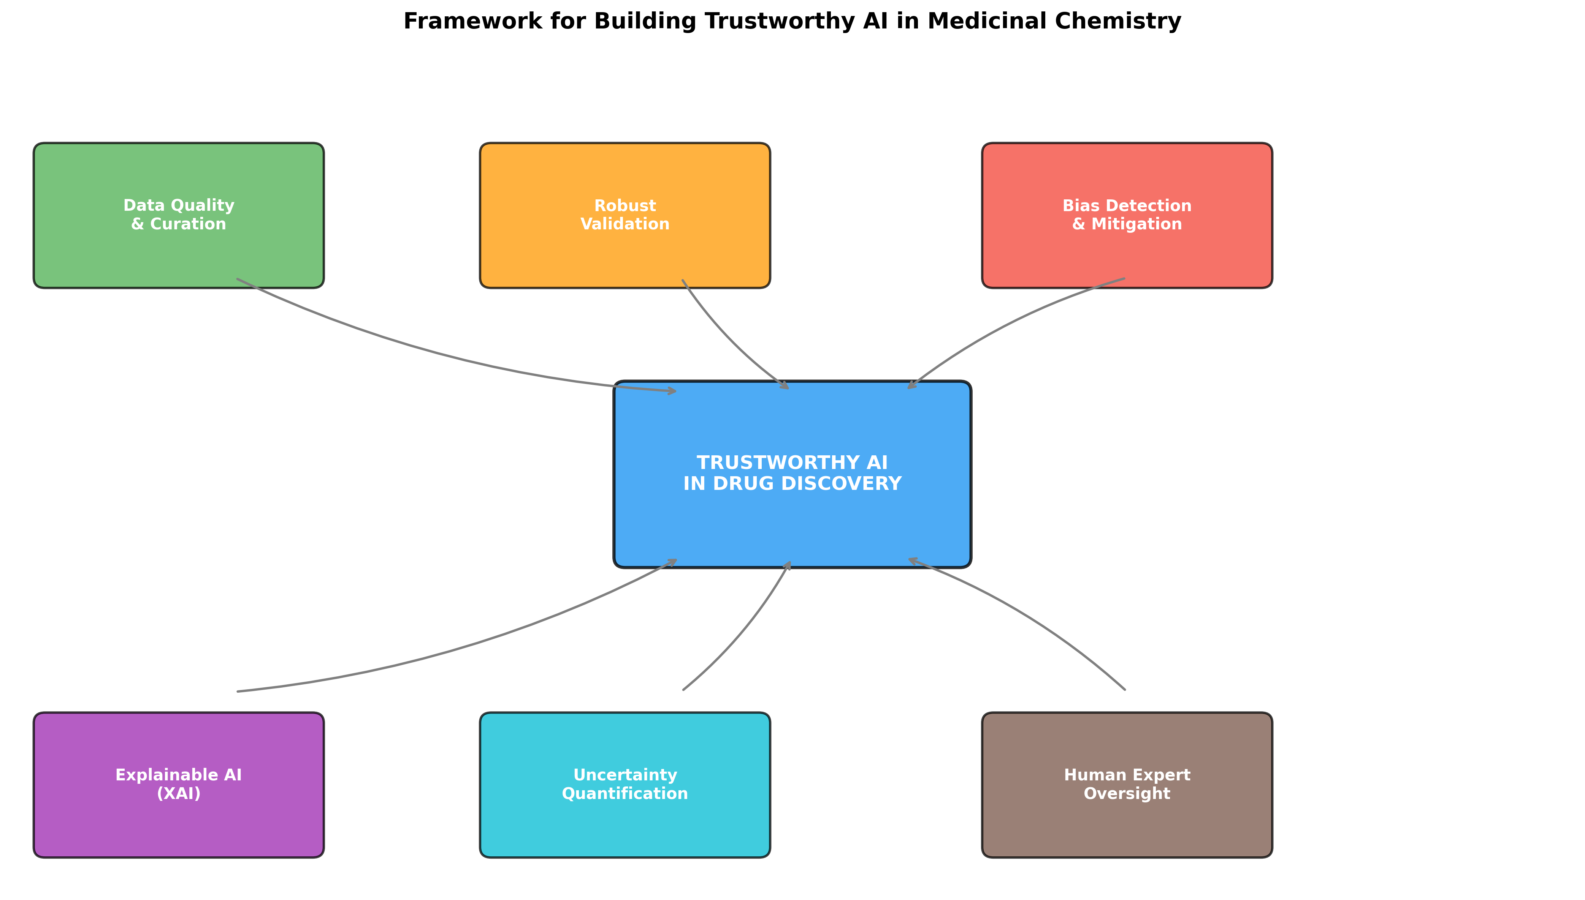

References
[1] Vamathevan, J., et al. Applications of machine learning in drug discovery and development. Nature Reviews Drug Discovery, 18(6), 463-477, 2019.
[2] Schneider, P., et al. Rethinking drug design in the artificial intelligence era. Nature Reviews Drug Discovery, 19(5), 353-364, 2020.
[3] Wouters, O.J., McKee, M., Luyten, J. Estimated research and development investment needed to bring a new medicine to market, 2009-2018. JAMA, 323(9), 844-853, 2020.
[4] Elton, D.C., et al. Deep learning for molecular design: a review of the state of the art. Molecular Systems Design & Engineering, 4(4), 828-849, 2019.
[5] Yang, X., et al. Concepts of artificial intelligence for computer-assisted drug discovery. Chemical Reviews, 119(18), 10520-10594, 2019.
[6] Cherkasov, A., et al. QSAR modeling: where have you been? Where are you going to? Journal of Medicinal Chemistry, 57(12), 4977-5010, 2014.
[7] Bender, A., Cortés-Ciriano, I. Artificial intelligence in drug discovery: what is realistic, what are illusions? Drug Discovery Today, 26(2), 511-524, 2021.
[8] Jiménez-Luna, J., Grisoni, F., Schneider, G. Drug discovery with explainable artificial intelligence. Nature Machine Intelligence, 2(10), 573-584, 2020.
[9] Walters, W.P., Barzilay, R. Critical assessment of AI in drug discovery. Expert Opinion on Drug Discovery, 16(9), 937-947, 2021.
[10] Stokes, J.M., et al. A deep learning approach to antibiotic discovery. Cell, 180(4), 688-702, 2020.
[11] Mervin, L.H., et al. Target prediction utilising negative bioactivity data covering large chemical space. Journal of Cheminformatics, 7(1), 51, 2015.
[12] Hawkins, D.M. The problem of overfitting. Journal of Chemical Information and Computer Sciences, 44(1), 1-12, 2004.
[13] Tetko, I.V., et al. Critical assessment of QSAR models of environmental toxicity against Tetrahymena pyriformis. Journal of Chemical Information and Modeling, 48(9), 1733-1746, 2008.
[14] Sheridan, R.P. Time-split cross-validation as a method for estimating the goodness of prospective prediction. Journal of Chemical Information and Modeling, 53(4), 783-790, 2013.
[15] Kearnes, S., et al. Molecular graph convolutions: moving beyond fingerprints. Journal of Computer-Aided Molecular Design, 30(8), 595-608, 2016.
[16] Scior, T., et al. Recognizing pitfalls in virtual screening: a critical review. Journal of Chemical Information and Modeling, 52(4), 867-881, 2012.
[17] Hirschfeld, L., et al. Uncertainty quantification using neural networks for molecular property prediction. Journal of Chemical Information and Modeling, 60(8), 3770-3780, 2020.
[18] Tropsha, A. Best practices for QSAR model development, validation, and exploitation. Molecular Informatics, 29(6-7), 476-488, 2010.
[19] Maggiora, G., et al. Molecular similarity in medicinal chemistry. Journal of Medicinal Chemistry, 57(8), 3186-3204, 2014.
[20] Barocas, S., Hardt, M., Narayanan, A. Fairness and Machine Learning: Limitations and Opportunities. MIT Press, 2023.
[21] Cai, C., et al. Transfer learning for drug discovery. Journal of Medicinal Chemistry, 63(16), 8683-8694, 2020.
[22] Chen, H., et al. The rise of deep learning in drug discovery. Drug Discovery Today, 23(6), 1241-1250, 2018.
[23] Papadatos, G., et al. Activity, assay and target data curation and quality in the ChEMBL database. Journal of Computer-Aided Molecular Design, 29(9), 885-896, 2015.
[24] Kramer, C., et al. The experimental uncertainty of heterogeneous public Ki data. Journal of Medicinal Chemistry, 55(11), 5165-5173, 2012.
[25] Popejoy, A.B., Fullerton, S.M. Genomics is failing on diversity. Nature, 538(7624), 161-164, 2016.
[26] Martin, E.J., et al. Profile-QSAR 2.0: Kinase virtual screening accuracy comparable to four-concentration IC50s for realistically novel compounds. Journal of Chemical Information and Modeling, 57(8), 2077-2088, 2017.
[27] Cortes-Ciriano, I., Bender, A. Reliable prediction errors for deep neural networks using test-time dropout. Journal of Chemical Information and Modeling, 59(7), 3330-3339, 2019.
[28] Feinberg, E.N., et al. PotentialNet for molecular property prediction. ACS Central Science, 4(11), 1520-1530, 2018.
[29] Wu, Z., et al. MoleculeNet: a benchmark for molecular machine learning. Chemical Science, 9(2), 513-530, 2018.
[30] Wallach, I., Heifets, A. Most ligand-based classification benchmarks reward memorization rather than generalization. Journal of Chemical Information and Modeling, 58(5), 916-932, 2018.
[31] Yang, K., et al. Analyzing learned molecular representations for property prediction. Journal of Chemical Information and Modeling, 59(8), 3370-3388, 2019.
[32] Lenselink, E.B., et al. Beyond the hype: deep neural networks outperform established methods using a ChEMBL bioactivity benchmark set. Journal of Cheminformatics, 9(1), 45, 2017.
[33] Mayr, A., et al. DeepTox: toxicity prediction using deep learning. Frontiers in Environmental Science, 3, 80, 2016.
[34] Ramsundar, B., et al. Is multitask deep learning practical for pharma? Journal of Chemical Information and Modeling, 57(8), 2068-2076, 2017.
[35] Unterthiner, T., et al. Deep learning as an opportunity in virtual screening. Proceedings of the Deep Learning Workshop at NIPS, 2014.
[36] Simm, J., et al. Repurposing high-throughput image assays enables biological activity prediction for drug discovery. Cell Chemical Biology, 25(5), 611-618, 2018.
[37] Meredig, B. Five high-impact research areas in machine learning for materials science. Chemistry of Materials, 31(23), 9579-9581, 2019.
[38] Cortes-Ciriano, I., Bender, A. Deep confidence: a computationally efficient framework for calculating reliable prediction errors for deep neural networks. Journal of Chemical Information and Modeling, 59(3), 1269-1281, 2019.
[39] Shen, J., Nicolaou, C.A. Molecular property prediction: recent trends in the era of artificial intelligence. Drug Discovery Today: Technologies, 32-33, 29-36, 2019.
[40] Sun, J., et al. ExCAPE-DB: an integrated large scale dataset facilitating Big Data analysis in chemogenomics. Journal of Cheminformatics, 9(1), 17, 2017.
[41] Fourches, D., et al. Trust, but verify: on the importance of chemical structure curation in cheminformatics and QSAR modeling research. Journal of Chemical Information and Modeling, 50(7), 1189-1204, 2010.
[42] Kalliokoski, T., et al. Comparability of mixed IC50 data: a statistical analysis. PLoS ONE, 8(4), e61007, 2013.
[43] Hu, Y., Bajorath, J. Influence of search parameters and criteria on compound selection, promiscuity, and pan-assay interference characteristics. Journal of Chemical Information and Modeling, 54(11), 3056-3066, 2014.
[44] Gilmer, J., et al. Neural message passing for quantum chemistry. Proceedings of the 34th International Conference on Machine Learning, 1263-1272, 2017.
[45] Rogers, D., Hahn, M. Extended-connectivity fingerprints. Journal of Chemical Information and Modeling, 50(5), 742-754, 2010.
[46] Lundberg, S.M., Lee, S.I. A unified approach to interpreting model predictions. Advances in Neural Information Processing Systems, 30, 4765-4774, 2017.
[47] Norinder, U., Carlsson, L., Boyer, S., Eklund, M. Introducing conformal prediction in predictive modeling for regulatory purposes: a transparent and flexible alternative to applicability domain determination. Regulatory Toxicology and Pharmacology, 71(2), 279-284, 2015.

