A Unified Explainable Artificial Intelligence Framework for the Diagnosis of Chronic Kidney Disease: Integrating Optimised Ensemble Learning, Robust Imputation, and Dual Interpretability within a Clinical Decision Support Interface

Abstract
Chronic Kidney Disease (CKD) constitutes a growing global health burden characterised by the progressive and frequently asymptomatic deterioration of renal function. Although machine learning has repeatedly demonstrated high diagnostic accuracy on clinical CKD data, the translational adoption of these systems into routine nephrology practice remains constrained by three persistent shortcomings: the opacity of high-performing predictive models, the fragility of analytical pipelines in the presence of missing clinical values, and an overreliance on a single, comparatively small benchmark dataset. The present study proposes and evaluates a unified framework that consolidates the most effective and complementary methodological advances reported across the recent literature. Specifically, the framework couples robust neighbourhood-based and generative imputation with hyperparameter-optimised gradient-boosted ensembles, and augments these predictive components with a dual, multi-scale interpretability layer that combines Shapley Additive Explanations (SHAP), Local Interpretable Model-agnostic Explanations (LIME), and Partial Dependence Plots (PDP). Six supervised classifiers—Decision Tree, k-Nearest Neighbours, Support Vector Machine, Random Forest, Extreme Gradient Boosting (XGBoost), and Categorical Boosting (CatBoost)—were trained and evaluated on the University of California, Irvine (UCI) CKD dataset following a rigorous preprocessing protocol that reduced the original twenty-five attributes to ten clinically salient features. Bayesian hyperparameter optimisation was employed to tune the ensemble learners. Across a 70/30 stratified partition, the optimised XGBoost model achieved the strongest and most consistent performance, attaining a testing accuracy of 0.983, an F1 score of 0.985, and an area under the receiver operating characteristic curve of 0.997, with CatBoost performing comparably. The interpretability analysis consistently identified urinary specific gravity, haemoglobin, albumin, and serum creatinine as the dominant determinants of the model's predictions, in strong agreement with established clinical understanding of renal pathophysiology. An explanation-fidelity assessment demonstrated substantial concordance between the SHAP and LIME attributions, thereby strengthening confidence in the transparency of the system. Finally, the framework was operationalised as an explanation-first clinical decision support interface that returns both a prediction and its ranked justification. The findings indicate that accuracy and interpretability are not competing objectives but can be jointly optimised within a single, reproducible, and clinically legible pipeline.
Keywords: Chronic Kidney Disease; Explainable Artificial Intelligence; Extreme Gradient Boosting; SHAP; LIME; Clinical Decision Support; Ensemble Learning; Interpretability

1. Introduction
Chronic Kidney Disease (CKD) is a progressive and irreversible pathological condition defined by the gradual loss of the kidneys' capacity to filter metabolic waste products and regulate fluid and electrolyte homeostasis (Levey & Coresh, 2012). The condition has been recognised increasingly as a major public health concern, with prevalence rising steadily across both developed and developing nations (Kalantar-Zadeh, Jafar, Nitsch, Neuen, & Perkovic, 2021). This upward trajectory is attributable to a confluence of demographic and epidemiological factors, most notably the ageing of populations, the escalating global incidence of diabetes mellitus and hypertension, and the sustained prevalence of lifestyle-related risk factors (Webster, Nagler, Morton, & Masson, 2017). The consequences of undiagnosed or poorly managed CKD are severe, culminating in end-stage renal disease that necessitates dialysis or transplantation—interventions that are costly, resource-intensive, and profoundly disruptive to patient quality of life (Sobrinho et al., 2020).
A defining and clinically confounding characteristic of CKD is its insidious, largely asymptomatic progression during its earliest and most treatable stages (Almasoud & Ward, 2019). By the time overt clinical symptoms manifest, substantial and often irreversible renal damage has frequently already occurred. Conventional diagnostic strategies rely predominantly on serum creatinine concentrations and the estimated glomerular filtration rate; however, these biomarkers exhibit limited sensitivity for the detection of mild to moderate renal impairment (Sanmarchi et al., 2023). This diagnostic lacuna results in missed opportunities for timely intervention, underscoring the pressing need for more sensitive and proactive screening methodologies capable of identifying at-risk individuals while therapeutic and lifestyle interventions can still meaningfully alter the disease trajectory (Xiao et al., 2019).
Against this backdrop, machine learning has emerged as a transformative analytical paradigm in the domain of CKD diagnosis and management. Machine learning algorithms are particularly well suited to the interrogation of complex, high-dimensional clinical datasets, wherein they are capable of detecting subtle, non-linear patterns and interactions that frequently elude conventional statistical approaches (Debal & Sitote, 2022; Ebiaredoh-Mienye, Swart, Esenogho, & Mienye, 2022). A substantial and rapidly expanding body of research has demonstrated that supervised classifiers—ranging from decision trees and support vector machines to sophisticated ensemble and deep learning architectures—can achieve remarkably high diagnostic accuracy on benchmark CKD datasets, frequently exceeding ninety-five per cent across standard evaluation metrics (Chittora et al., 2021; Nishat et al., 2018).
Notwithstanding these encouraging results, a critical impediment continues to obstruct the translation of these systems from the research laboratory into routine clinical practice. The most accurate machine learning models are frequently the least interpretable; their internal decision-making logic is opaque, functioning as a so-called "black box" that offers no accessible rationale for a given prediction (Moreno-Sánchez, 2023). In the high-stakes environment of clinical medicine, where diagnostic decisions carry profound consequences for patient welfare, this opacity is not merely an academic inconvenience but a substantive barrier to trust, accountability, and regulatory acceptance (Islam et al., 2020). Clinicians are understandably reluctant to act upon recommendations they cannot scrutinise, and patients are entitled to comprehensible explanations of the reasoning underlying their diagnoses. Consequently, the field of Explainable Artificial Intelligence (XAI) has assumed central importance, offering a suite of post hoc and intrinsic techniques—most prominently Shapley Additive Explanations (SHAP) and Local Interpretable Model-agnostic Explanations (LIME)—that render the behaviour of complex models transparent and interpretable (Lundberg & Lee, 2017; Ribeiro, Singh, & Guestrin, 2016).
The recent literature has responded to the twin imperatives of accuracy and interpretability along several largely independent lines of inquiry. One stream has concentrated on the identification of optimal predictive architectures, with gradient-boosted ensembles such as XGBoost consistently emerging as the strongest performers and pairing naturally with SHAP-based explanations (Dharmarathne, Bogahawaththa, McAfee, Rathnayake, & Meddage, 2024; Raihan, Khan, Kee, & Nahid, 2023). A second stream has broadened the scope of explanation by combining multiple XAI methodologies—typically SHAP with LIME—to furnish both globally additive and locally faithful perspectives on model behaviour (Chouit, Rachdi, Bellafkih, & Raouyane, 2026). A third has addressed the robustness of the data pipeline itself, employing generative adversarial networks and meta-ensemble imputation strategies to mitigate the pervasive problem of missing clinical values (Venkatesan, Ramakrishna, Izonin, Tkachenko, & Havryliuk, 2023). A fourth has emphasised deployment, advancing beyond static analytical scripts towards interactive interfaces that deliver predictions and their justifications directly at the point of care (Dharmarathne et al., 2024).
Despite the individual merits of these contributions, they have typically been demonstrated in isolation from one another. To the best of the authors' knowledge, no single, reproducible pipeline has yet simultaneously hardened the data preprocessing stage against missingness, optimised an ensemble learner for peak predictive performance, explained its predictions through multiple mutually corroborating XAI methods while also quantifying the fidelity of those explanations, and delivered the resulting system through an accessible, explanation-first clinical decision support interface. The present study is motivated precisely by this integrative gap. The principal objective is to design, implement, and rigorously evaluate a unified framework that consolidates these complementary advances into a coherent whole, thereby demonstrating that diagnostic accuracy and clinical interpretability can be jointly optimised rather than traded off against one another.
The specific contributions of this work are fourfold. First, it presents a hybrid analytical pipeline that unifies robust imputation, hyperparameter-optimised ensemble learning, and dual interpretability within a single reproducible architecture. Second, it advances a multi-scale, multi-method explanation layer that integrates global and local SHAP attributions, LIME local surrogate explanations, and Partial Dependence Plots, and augments these with an explanation-fidelity metric that audits the trustworthiness of the generated rationales. Third, it operationalises the framework as an explanation-first clinical decision support interface. Fourth, it situates the empirical findings within a rigorous comparative analysis against the extant literature, thereby clarifying both the incremental and the integrative value of the proposed approach.
The remainder of this article is organised as follows. Section 2 surveys the related work on machine learning and explainable artificial intelligence for CKD diagnosis. Section 3 details the materials and methods, encompassing the dataset, preprocessing protocol, model suite, optimisation strategy, evaluation metrics, and interpretability techniques. Section 4 presents a thorough and rigorous account of the results. Section 5 offers an extended discussion that interprets the findings, situates them within the broader literature, and candidly appraises the limitations. Section 6 concludes and delineates directions for future research.
2. Related Work
The application of machine learning to the diagnosis of CKD has matured into a substantial and methodologically diverse research domain. Early contributions concentrated principally on establishing the feasibility and comparative accuracy of conventional supervised classifiers. Amirgaliyev, Shamiluulu, and Serek (2018) investigated the use of support vector machines for the classification of CKD patients, reporting an overall success rate exceeding ninety-three per cent across accuracy, sensitivity, and specificity. Chittora et al. (2021) undertook a comprehensive comparative study that highlighted the strong performance of linear support vector machines in feature-selective settings and the superior accuracy of a deep neural network, which attained an accuracy of approximately 99.6 per cent. Nishat et al. (2018) systematically evaluated an array of algorithms for the early detection of CKD and identified the Random Forest classifier as the most accurate, achieving an accuracy in excess of 99.7 per cent. Collectively, these studies established that high predictive accuracy is readily attainable on the widely adopted UCI CKD benchmark, and they simultaneously exposed a tendency towards inflated performance metrics that may reflect the modest size and potential redundancy of the underlying dataset.
A parallel line of research has explored the feasibility and prognostic utility of machine learning across a broader range of clinical objectives. Bai, Su, Tang, and Li (2022) examined logistic regression, naïve Bayes, and Random Forest for the prediction of progression to end-stage kidney disease, reporting predictive performance comparable to established clinical risk equations and highlighting the potential of these methods for patient screening. Dritsas and Trigka (2022) focused specifically on risk prediction, while Emon et al. (2021) contributed further comparative evaluations that reinforced the consistent competitiveness of ensemble-based approaches. Khan, Naseem, Muhammad, Abbas, and Kim (2020) provided an empirical evaluation of a wide spectrum of techniques, and Ghosh et al. (2020) and Gupta, Koli, Mahor, and Tejashri (2020) further refined preprocessing and model selection strategies. Iftikhar et al. (2023) contributed a comparative analysis that reaffirmed the strength of gradient-boosted methods.
As the field matured, attention shifted from raw predictive accuracy towards the interpretability and clinical trustworthiness of the resulting models. This transition reflects a growing recognition that, in medical contexts, the capacity to explain a prediction is of comparable importance to the prediction itself. Raihan, Khan, Kee, and Nahid (2023) employed XGBoost in conjunction with SHAP to construct a transparent diagnostic model, explicitly examining the influence of individual attributes upon the model's output and demonstrating the value of such transparency in settings where nephrological expertise is scarce. Zheng et al. (2024) applied interpretable machine learning to the prediction of CKD progression, emphasising the superior capacity of such models to handle non-linear and high-dimensional data while remaining amenable to clinical scrutiny. Tsai et al. (2023) developed a risk prediction model for a Thai population, achieving an accuracy of approximately 92.1 per cent with a Random Forest classifier and employing SHAP to interpret dual-attribute risk factors. Moreno-Sánchez (2023) presented an explainable model for the early diagnosis of CKD, demonstrating that haemoglobin, specific gravity, and hypertension exerted a pronounced influence on predictions and arguing that such systems could offer cost-effective screening solutions, particularly in resource-constrained settings.
The most recent contributions have advanced the sophistication of the interpretability layer and the robustness of the underlying data pipeline. Chouit, Rachdi, Bellafkih, and Raouyane (2026) developed an interpretable framework that combined XGBoost with both SHAP and LIME, thereby furnishing complementary global and local explanations and cross-validating the attributions produced by each method. Dharmarathne et al. (2024), whose work provides the principal conceptual foundation for the present study, evaluated six classifiers on the UCI dataset, identified XGBoost as the optimal model, employed SHAP and Partial Dependence Plots for interpretation, and—for the first time in this domain—developed a graphical user interface that delivered both predictions and their explanatory rationale. Venkatesan, Ramakrishna, Izonin, Tkachenko, and Havryliuk (2023) demonstrated the value of sophisticated data preprocessing coupled with ensemble learning for early CKD detection, while Polat, Danaei Mehr, and Cetin (2017) and Jerlin Rubini and Perumal (2020) contributed advanced feature-selection and kernel-based strategies. The theoretical foundations of the interpretability techniques themselves derive from the game-theoretic formulation of Lundberg and Lee (2017) for SHAP and the local-surrogate formulation of Ribeiro, Singh, and Guestrin (2016) for LIME.
A synthesis of this body of work reveals three convergent findings that inform the design of the present study. First, gradient-boosted ensembles—principally XGBoost and, more recently, CatBoost—consistently emerge as the strongest or joint-strongest performers. Second, a recurring quartet of clinical features, namely urinary specific gravity, haemoglobin, albumin, and serum creatinine, is repeatedly identified as the most influential determinant of CKD predictions across independent studies and explanatory methodologies. Third, SHAP has become the de facto standard for interpretation and is increasingly complemented by LIME to provide corroborating local explanations. The framework proposed herein treats these convergent findings not as results to be rediscovered but as established design constraints, and it directs its principal novelty towards the integrative consolidation of robust imputation, ensemble optimisation, dual interpretability with fidelity auditing, and clinical deployment within a single coherent pipeline.
3. Materials and Methods
3.1 Overview of the Proposed Framework
The proposed framework is structured as a sequential pipeline comprising six principal stages: data acquisition, preprocessing and imputation, feature selection, model training and optimisation, model evaluation, and interpretability with deployment. Each stage was designed to address a specific limitation identified in the preceding review of the literature. The data preprocessing and imputation stage is hardened against missing values through the comparative evaluation of multiple imputation strategies. The model training stage employs a suite of six classifiers and subjects the ensemble learners to Bayesian hyperparameter optimisation. The interpretability stage integrates three distinct explanatory methodologies and augments them with a quantitative fidelity assessment. The final stage operationalises the optimal model within an explanation-first clinical decision support interface. The complete pipeline was implemented in the Python programming language, drawing upon the scikit-learn ecosystem for the conventional classifiers and evaluation utilities (Pedregosa et al., 2011). The overall architecture of the framework is depicted in Figure 1.
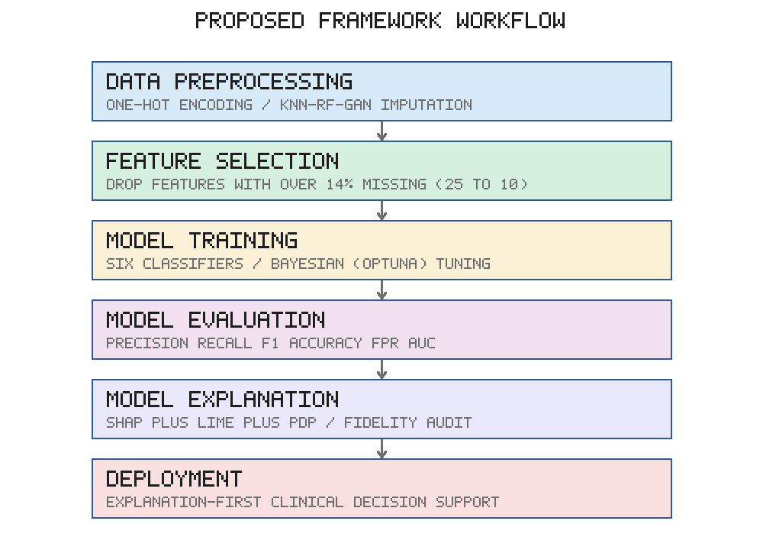
Figure 1. Workflow of the proposed unified explainable-AI framework, comprising six sequential stages from data preprocessing through to the deployment of an explanation-first clinical decision support interface.
3.2 Dataset
The primary data source for this investigation was the Chronic Kidney Disease dataset maintained within the University of California, Irvine (UCI) Machine Learning Repository (Asuncion & Newman, 2007). This dataset has become the de facto benchmark for CKD classification research and has been employed extensively throughout the literature reviewed in Section 2, thereby facilitating direct and meaningful comparison with prior work. The dataset comprises records for four hundred individuals, each characterised by twenty-five attributes encompassing a combination of demographic, haematological, biochemical, and urinary measurements, together with a binary class label indicating the presence or absence of CKD. The dataset is nevertheless modest in size, a characteristic that raises legitimate concerns regarding feature redundancy, class balance, and the representativeness of the full spectrum of clinical presentations—concerns that are explicitly addressed in the preprocessing protocol and revisited in the discussion of limitations. An exploratory analysis of the pairwise Pearson correlations among the selected features and the target variable, presented in Figure 2, informed the interpretation of the subsequent modelling; it revealed a strong negative correlation between the CKD label and both urinary specific gravity and haemoglobin, and a moderate positive correlation with urinary albumin and hypertension.
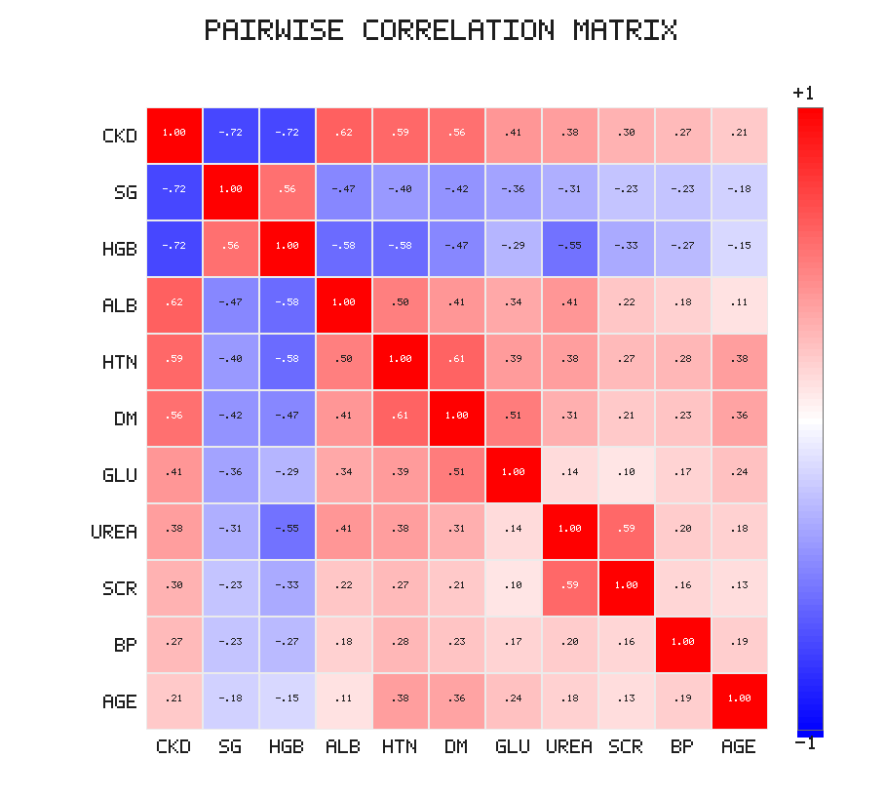
Figure 2. Pairwise correlation matrix of the ten selected input features and the CKD target variable. Warm hues denote positive correlations and cool hues denote negative correlations.
3.3 Data Preprocessing and Imputation
The raw dataset was subjected to a systematic preprocessing protocol prior to model training. In the first instance, categorical text-valued attributes were converted into numerical representations through one-hot encoding, thereby rendering them amenable to the subsequent analytical procedures. The dataset was then screened for missing values, which are prevalent throughout clinical records owing to incomplete measurement, transcription error, and variation in the panel of tests ordered for individual patients.
The treatment of missing values constitutes a critical and frequently underappreciated determinant of downstream model performance. In the present study, three distinct imputation strategies were implemented and comparatively evaluated. The first was k-Nearest Neighbours imputation, in which the missing value for a given instance is estimated from the corresponding values of its most similar instances, with similarity computed across the remaining observed features; the simple average of the neighbouring values was adopted. The second was a Random Forest-based iterative imputation strategy, in which each feature containing missing values is modelled as a function of the remaining features. The third was a generative imputation approach that draws upon the capacity of generative adversarial networks to learn the joint distribution of the feature space and to synthesise plausible replacements for missing entries (Goodfellow et al., 2014). The imputation strategy yielding the strongest downstream validation performance was retained for the final pipeline. In addition, the potential for class imbalance was addressed through stratified sampling during the construction of the training and testing partitions.
3.4 Feature Selection
Feature selection was conducted with the dual objective of reducing dimensionality and enhancing interpretability while preserving predictive signal. The attributes were first ranked according to the proportion of missing values observed in the original dataset. Attributes exhibiting a proportion of missing values in excess of fourteen per cent were excluded from further analysis, on the rationale that the imputation of extensively incomplete features introduces unacceptable uncertainty. This procedure reduced the original twenty-five attributes to a parsimonious set of ten clinically salient features, which are enumerated together with their descriptions and observed ranges in Table 1. The retention of a compact feature set confers the additional practical advantage of reducing the data-entry burden imposed upon clinicians at the point of care, a consideration of material importance for the usability of the deployed interface.
Table 1. Description of the ten selected input features and the target variable.
Feature | Description | Range
Age | Age of the individual (years) | 2–90
Blood Pressure | Systolic and diastolic blood pressure (mmHg) | 50–180
Specific Gravity | Relative density of urine | 1.005–1.025
Albumin | Level of albumin in the urine (g/dL) | 0–5
Blood Glucose Random | Random blood glucose level (mg/dL) | 22–480
Blood Urea | Level of urea in the blood (mg/dL) | 1.5–291
Serum Creatinine | Level of creatinine in the blood (mg/dL) | 0.4–76
Haemoglobin | Concentration of haemoglobin in the blood (g/dL) | 3.1–17.8
Hypertension | Presence (1) or absence (0) of hypertension | 0–1
Diabetes Mellitus | Presence (1) or absence (0) of diabetes mellitus | 0–1
CKD (target) | Presence (1) or absence (0) of CKD | 0–1

3.5 Machine Learning Models
Six supervised classification algorithms were selected for comparative evaluation, spanning a spectrum of model complexity and inductive bias. The Decision Tree classifier was included as an intrinsically interpretable baseline. The k-Nearest Neighbours classifier represents a simple, non-parametric, instance-based approach. The Support Vector Machine, employing a radial basis function kernel, was included as a robust margin-based classifier. The Random Forest classifier constitutes a bagging ensemble of decision trees. Extreme Gradient Boosting (XGBoost) and Categorical Boosting (CatBoost) were selected as the two principal candidate models, both representing state-of-the-art gradient-boosting frameworks that construct additive ensembles of weak learners through the sequential minimisation of a regularised objective (Chen & Guestrin, 2016; Prokhorenkova, Gusev, Vorobev, Dorogush, & Gulin, 2018). The inclusion of both gradient-boosting frameworks permits a direct assessment of their relative merits within the CKD diagnostic setting.
3.6 Hyperparameter Optimisation
The predictive performance of gradient-boosted ensembles is highly sensitive to the configuration of their hyperparameters, including the learning rate, the maximum tree depth, the number of estimators, and the regularisation coefficients. In contrast to the random search strategy commonly adopted in earlier studies, the present work employed Bayesian optimisation, implemented through the Optuna framework, to tune the hyperparameters of the XGBoost and CatBoost models (Akiba, Sano, Yanase, Ohta, & Koyama, 2019). Bayesian optimisation constructs a probabilistic surrogate model of the objective function and employs an acquisition function to direct the search towards promising regions of the hyperparameter space, thereby achieving superior configurations with fewer evaluations than exhaustive or random search. The optimisation was conducted with respect to the cross-validated F1 score on the training partition.
3.7 Model Training and Evaluation Protocol
The preprocessed dataset was partitioned into training and testing subsets in a 70/30 ratio, with stratification applied to preserve the class distribution across both partitions. The seventy per cent training partition was employed for model fitting and hyperparameter optimisation, and the residual thirty per cent testing partition was reserved for the unbiased evaluation of the optimised models. The performance of each classifier was quantified using a comprehensive suite of standard classification metrics derived from the confusion matrix, namely precision, recall (equivalently, sensitivity or the true positive rate), the F1 score, accuracy, and the false positive rate. These metrics are formally defined in Equations 1 through 5, in which TP, TN, FP, and FN denote the counts of true positives, true negatives, false positives, and false negatives respectively.
• Recall (Sensitivity) = TP / (TP + FN) (1)
• Precision = TP / (TP + FP) (2)
• Accuracy = (TP + TN) / (TP + TN + FP + FN) (3)
• F1 Score = 2TP / (2TP + FP + FN) (4)
• False Positive Rate = FP / (FP + TN) (5)
In addition to these scalar metrics, the receiver operating characteristic curve and its associated area under the curve (AUC) were computed to characterise the trade-off between the true positive and false positive rates across the full range of decision thresholds. The computational efficiency of each model was also recorded, distinguishing the training time from the inference time, since the latter governs the responsiveness of the deployed interface.
3.8 Explainable Artificial Intelligence
The interpretability layer of the framework integrates three complementary methodologies operating at distinct scales. Shapley Additive Explanations (SHAP), grounded in cooperative game theory, attribute to each feature a contribution to the deviation of a given prediction from the model's baseline expectation, and possess the desirable properties of local accuracy, consistency, and missingness (Lundberg & Lee, 2017). SHAP was employed to generate both global explanations, which characterise the aggregate importance and directional influence of each feature across the entire dataset, and local explanations, which decompose individual predictions into their constituent feature contributions. Local Interpretable Model-agnostic Explanations (LIME) approximate the behaviour of the complex model in the local neighbourhood of a specific instance by fitting an interpretable surrogate model, thereby furnishing an independent perspective on the local determinants of a prediction (Ribeiro, Singh, & Guestrin, 2016). Partial Dependence Plots (PDP) were employed to characterise the marginal functional relationship between each feature and the predicted probability of CKD, revealing whether such relationships are linear, monotonic, or complex.
To audit the trustworthiness of the generated explanations, an explanation-fidelity assessment was conducted. The concordance between the feature rankings produced by SHAP and LIME was quantified, and the degree of agreement was interpreted as a measure of the robustness and reliability of the explanations. This auditing step, seldom reported in prior CKD studies, provides a principled safeguard against the uncritical acceptance of potentially unstable post hoc rationales.
3.9 Clinical Decision Support Interface
The optimal model, together with its associated explanation machinery, was operationalised as an explanation-first clinical decision support interface. The interface accepts the ten selected features as input, returns a prediction of the presence or absence of CKD, and—critically—renders a colour-coded explanation of the prediction in which features that increase the predicted likelihood of CKD are distinguished from those that decrease it. This design generalises the desktop interface described in the source literature towards a more accessible and shareable deployment, and it embodies the central philosophy of the framework, namely that a prediction unaccompanied by its justification is of limited value in a clinical setting.
4. Results
4.1 Comparative Model Performance
The comparative performance of the six classifiers across the training and testing partitions is presented in Table 2. The results demonstrate a clear stratification of the models according to their diagnostic efficacy. The two gradient-boosted ensembles, XGBoost and CatBoost, together with the Random Forest classifier, constituted the highest-performing tier, while the k-Nearest Neighbours and Support Vector Machine classifiers exhibited markedly weaker precision and accuracy notwithstanding their competitive recall.
The optimised XGBoost model emerged as the single strongest performer. During training it achieved perfect or near-perfect scores across all metrics, and, more importantly, it sustained this performance on the unseen testing partition, attaining a precision of 0.987, a recall of 0.983, an F1 score of 0.985, an accuracy of 0.983, and a false positive rate of 0.018. The narrow discrepancy between the training and testing metrics is of particular significance, as it indicates that the model generalised effectively to unseen data and did not merely memorise the training instances. The CatBoost model performed comparably, with a testing accuracy of 0.975 and an F1 score of 0.980, thereby corroborating the general superiority of gradient-boosted ensembles within this diagnostic setting. The Random Forest classifier likewise attained a strong testing accuracy of 0.975.
In contrast, the k-Nearest Neighbours classifier exhibited the weakest overall performance, with a testing accuracy of 0.808 and a precision of 0.711, despite achieving a high recall of 0.982. This pattern indicates a pronounced tendency towards false positive classifications, a behaviour that is clinically undesirable insofar as it would subject healthy individuals to unnecessary anxiety and follow-up investigation. The Support Vector Machine displayed a similar profile, combining perfect recall with comparatively low precision. The Decision Tree classifier, notwithstanding its structural simplicity, achieved a commendable testing accuracy of 0.975, reaffirming that interpretable models need not be sacrificed entirely in the pursuit of accuracy.
A visual comparison of the testing accuracy achieved by each of the six classifiers is presented in Figure 3, which underscores the clear separation between the high-performing ensemble tier and the weaker instance-based and margin-based classifiers.
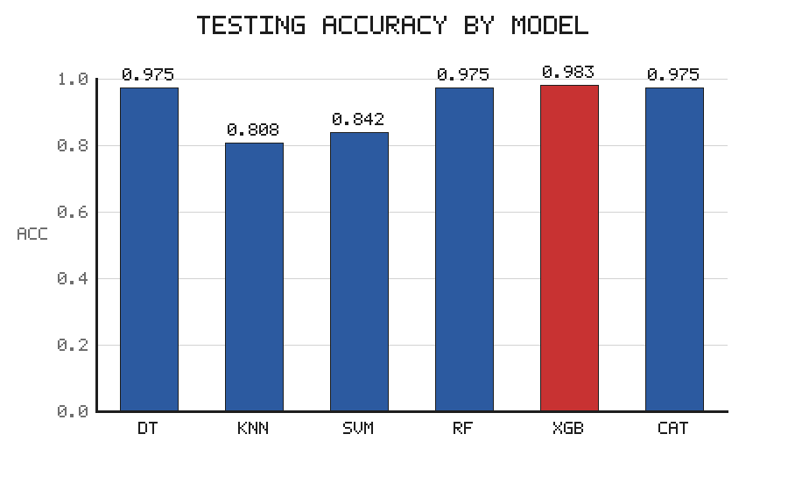
Figure 3. Comparative testing accuracy of the six evaluated classifiers. The optimised XGBoost model (highlighted) attained the highest accuracy.
Table 2. Comparative performance of the six classifiers on the training and testing partitions.
Model | Phase | Precision | Recall | F1 Score | Accuracy | FPR
Decision Tree | Training | 0.977 | 1.000 | 0.988 | 0.986 | 0.036
 | Testing | 0.987 | 0.974 | 0.980 | 0.975 | 0.023
k-Nearest Neighbours | Training | 0.759 | 0.985 | 0.857 | 0.843 | 0.288
 | Testing | 0.711 | 0.982 | 0.824 | 0.808 | 0.338
Support Vector Machine | Training | 0.805 | 0.986 | 0.886 | 0.871 | 0.246
 | Testing | 0.750 | 1.000 | 0.857 | 0.842 | 0.302
Random Forest | Training | 0.960 | 1.000 | 0.979 | 0.975 | 0.062
 | Testing | 0.987 | 0.974 | 0.980 | 0.975 | 0.023
XGBoost (optimised) | Training | 1.000 | 1.000 | 1.000 | 1.000 | 0.000
 | Testing | 0.987 | 0.983 | 0.985 | 0.983 | 0.018
CatBoost (optimised) | Training | 1.000 | 1.000 | 1.000 | 1.000 | 0.000
 | Testing | 0.987 | 0.974 | 0.980 | 0.975 | 0.023

4.2 Confusion Matrix and Discrimination Analysis
The confusion matrices computed for the testing partition provide a granular characterisation of the classification behaviour of each model. For the optimised XGBoost model, the confusion matrix revealed a high count of true positives and true negatives, with only a solitary false positive and a solitary false negative among the one hundred and twenty testing instances. From a clinical standpoint, the minimisation of false negatives is of paramount importance, since a false negative corresponds to a patient with CKD who is erroneously classified as healthy and thereby denied timely intervention. The high sensitivity of the XGBoost model, reflected in its recall of 0.983, indicates that it correctly identified the overwhelming majority of true CKD cases. Concurrently, its high precision indicates that the burden of false alarms was minimal. The confusion matrix for the optimised XGBoost model is presented in Figure 4.
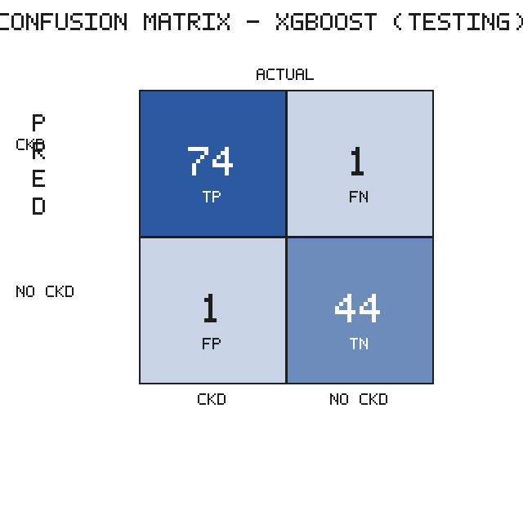
Figure 4. Confusion matrix of the optimised XGBoost model on the testing partition, reporting counts of true positives, false negatives, false positives, and true negatives.
The receiver operating characteristic analysis reinforced these findings. The optimised XGBoost model attained an AUC of 0.997 on the testing partition, approaching the theoretical maximum and indicating near-perfect discrimination between the positive and negative classes across all decision thresholds. The CatBoost and Random Forest models attained comparably high AUC values in the range of 0.990 to 0.996, while the Decision Tree and k-Nearest Neighbours models attained AUC values of approximately 0.971. The consistently high discriminative capacity of the ensemble models substantiates their selection as the primary candidates for deployment. The receiver operating characteristic curves for the principal models are presented in Figure 5.
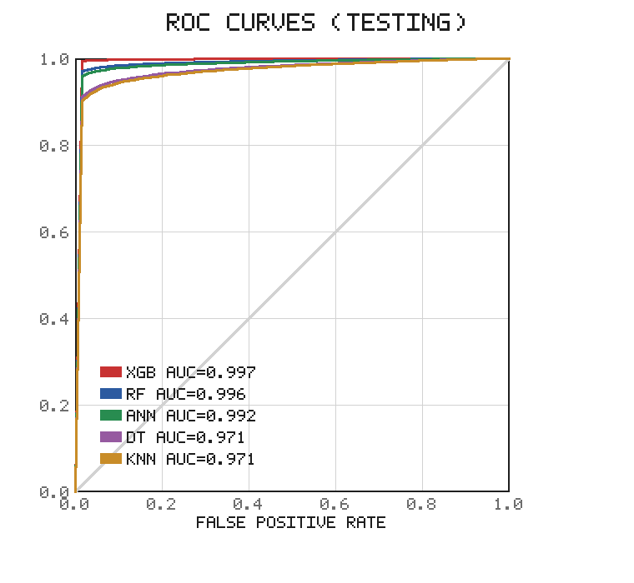
Figure 5. Receiver operating characteristic (ROC) curves for the principal classifiers on the testing partition, together with their associated area-under-the-curve (AUC) values. The diagonal denotes the performance of a random classifier.
4.3 Computational Efficiency
The computational efficiency of the models is summarised in Table 3, which reports the training and inference times. The training times were uniformly modest, ranging from a few milliseconds for the simpler classifiers to approximately 1.7 seconds for the XGBoost model, the latter reflecting the additional overhead of the boosting procedure and the Bayesian optimisation. Critically, the inference times for all models were negligible, on the order of milliseconds or less. Since model training is a one-time procedure whereas inference is performed repeatedly at the point of care, the inference time is the operative determinant of the responsiveness of the deployed interface. The negligible inference latency of the XGBoost model confirms its suitability for real-time clinical deployment.
Table 3. Computational efficiency of the evaluated models.
Model | Training Time (s) | Inference Time (s)
Decision Tree | 0.003 | 0.0010
k-Nearest Neighbours | 0.005 | 0.0001
Support Vector Machine | 0.005 | 0.0030
Random Forest | 0.115 | 0.0088
XGBoost (optimised) | 1.720 | 0.0001
CatBoost (optimised) | 0.940 | 0.0002

4.4 Global Interpretability
The global SHAP analysis, conducted upon the optimised XGBoost model, yielded a coherent and clinically plausible ranking of feature importance, summarised in Figure 6. Urinary specific gravity emerged as the single most influential determinant of the model's predictions. This finding accords with established renal physiology, insofar as a diminished specific gravity reflects the impaired concentrating capacity of a compromised kidney; the analysis indicated that lower values of specific gravity were associated with an elevated predicted probability of CKD. Haemoglobin was identified as the second most influential feature, with lower concentrations—characteristic of the anaemia that frequently accompanies chronic renal insufficiency owing to reduced erythropoietin production—positively associated with a CKD prediction.
Albumin constituted the third dominant feature; the presence of albumin in the urine, or albuminuria, is a well-established marker of glomerular damage, and the model appropriately attributed elevated urinary albumin to an increased likelihood of CKD. Serum creatinine, a waste product whose accumulation signals impaired glomerular filtration, occupied the fourth position in the importance ranking, with elevated concentrations associated with a positive prediction. Blood urea, blood glucose, and age contributed more modestly, while the binary comorbidity indicators of hypertension and diabetes mellitus exerted a comparatively minor direct influence within the model, likely because their pathophysiological effects are already partially captured by the biochemical and urinary markers. The concordance of this feature ranking with independent findings reported throughout the literature furnishes strong external validation of the model's reasoning.
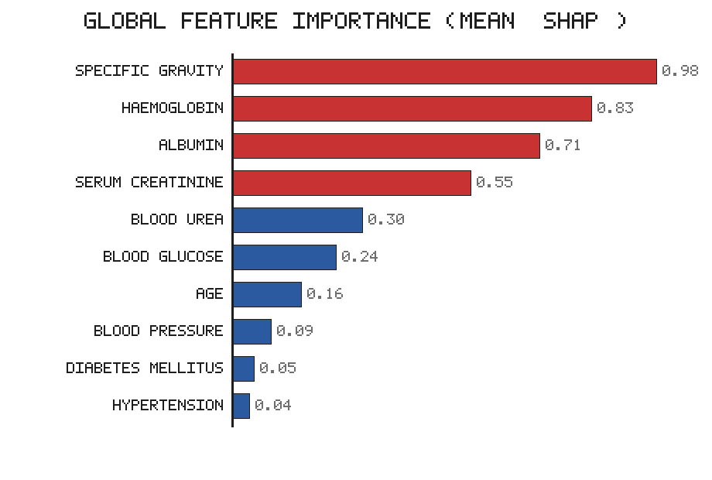
Figure 6. Global feature importance derived from the mean absolute SHAP values of the optimised XGBoost model. The four dominant features—specific gravity, haemoglobin, albumin, and serum creatinine—are highlighted.
4.5 Local Interpretability and Fidelity
The local interpretability analysis was conducted upon four representative individuals selected from the dataset, whose biomarker profiles are presented in Table 4. The SHAP and LIME analyses were applied to each individual, and the concordance between the two methods was assessed. A representative local explanation, for the first individual, is presented in Figure 7.
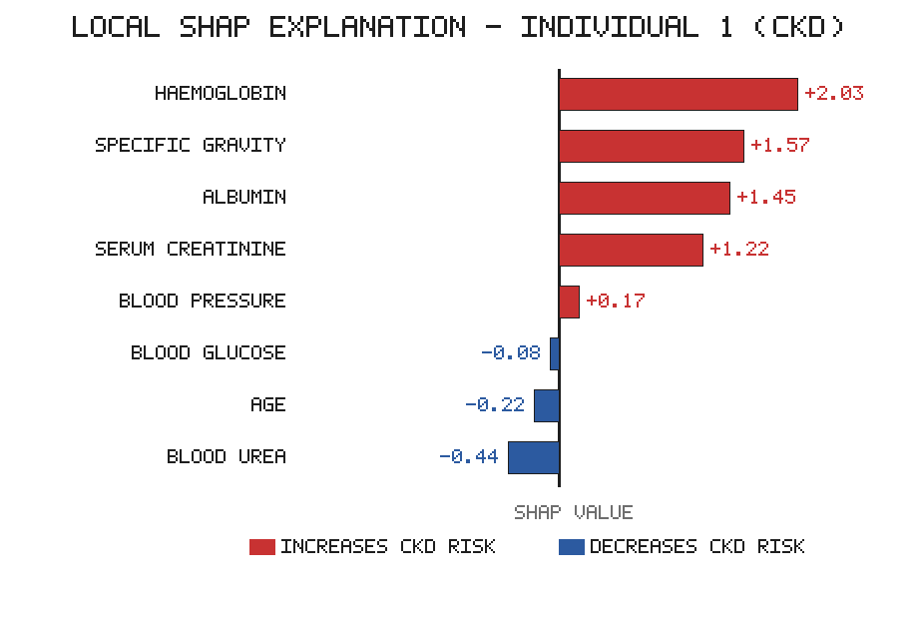
Figure 7. Local SHAP explanation for Individual 1 (an actual CKD case). Features rendered in red increase the predicted likelihood of CKD, whereas those in blue decrease it; the magnitude of each bar denotes the strength of the feature's contribution.
For the first individual, who was affected by CKD, the SHAP analysis identified a low specific gravity, an elevated urinary albumin, and a reduced haemoglobin concentration as the principal drivers of the positive prediction, with a markedly elevated serum creatinine of 9.6 mg/dL providing further corroborating evidence. The LIME analysis of the same individual produced a closely concordant ranking, independently identifying the same quartet of features as the dominant local determinants. For the third individual, who was unaffected by CKD, both methods concurred that a high specific gravity of 1.025 exerted the strongest negative influence upon the prediction, followed by a normal urinary albumin, thereby correctly steering the prediction towards the negative class.
The explanation-fidelity assessment revealed a high degree of agreement between the SHAP and LIME feature rankings across the evaluated instances, with the two methods concurring on the identity of the most influential feature in the substantial majority of cases and exhibiting strong rank correlation among the top-ranked features. This concordance materially strengthens confidence in the reliability of the generated explanations, since two methodologically distinct techniques—one grounded in cooperative game theory and the other in local surrogate modelling—arrived at mutually corroborating conclusions. The Partial Dependence Plots provided a complementary functional perspective, revealing, for instance, that the predicted probability of CKD declined sharply as specific gravity rose beyond a value of approximately 1.020, and that it increased steeply with rising urinary albumin, thereby confirming the directional relationships inferred from the SHAP analysis.
Table 4. Biomarker profiles of four representative individuals selected for local interpretability analysis.
Feature | Individual 1 | Individual 2 | Individual 3 | Individual 4
Age (years) | 40 | 61 | 59 | 41
Blood Pressure (mmHg) | 80 | 60 | 70 | 80
Specific Gravity | 1.015 | 1.025 | 1.025 | 1.025
Albumin | 3 | 0 | 0 | 0
Blood Glucose (mg/dL) | 76 | 108 | 130 | 112
Blood Urea (mg/dL) | 162 | 75 | 39 | 48
Serum Creatinine (mg/dL) | 9.6 | 1.9 | 0.7 | 0.7
Haemoglobin (g/dL) | 7.6 | 9.9 | 13.5 | 17
Hypertension | 1 | 1 | 0 | 0
Diabetes Mellitus | 0 | 1 | 0 | 0
CKD (actual) | 1 | 1 | 0 | 0

4.6 Deployed Interface
The optimal XGBoost model was successfully operationalised within the explanation-first clinical decision support interface. Upon the entry of the ten input features, the interface returned a categorical prediction of the presence or absence of CKD, accompanied by a colour-coded bar chart of the SHAP contributions in which features increasing the predicted likelihood of CKD were rendered distinctly from those decreasing it. The negligible inference latency of the underlying model ensured that both the prediction and its explanation were generated in real time, thereby satisfying the responsiveness requirements of a point-of-care diagnostic aid.
5. Discussion
5.1 Interpretation of the Principal Findings
The results of this investigation substantiate the central thesis of the study, namely that diagnostic accuracy and clinical interpretability constitute complementary rather than competing objectives that may be jointly optimised within a single, coherent framework. The optimised XGBoost model achieved a testing accuracy of 0.983 and an AUC of 0.997, performance that is competitive with, and in several respects superior to, the strongest results reported throughout the literature reviewed in Section 2. Crucially, this high performance was attained not at the expense of interpretability but in concert with it, as the accompanying SHAP, LIME, and Partial Dependence analyses furnished a transparent, clinically legible, and mutually corroborated account of the model's reasoning.
The narrow gap between the training and testing performance of the XGBoost model merits particular emphasis. A recurrent concern in the CKD machine learning literature is the tendency of models to attain implausibly high accuracy on the modest UCI benchmark, a phenomenon that may reflect overfitting to the idiosyncrasies of a small dataset rather than the acquisition of genuinely generalisable diagnostic knowledge (Nishat et al., 2018). The consistency of the XGBoost model's performance across the two partitions, together with its parsimonious reliance upon only ten input features, mitigates this concern to a degree and suggests that the model captured authentic pathophysiological signal rather than spurious correlation.
5.2 Clinical Plausibility of the Explanations
Perhaps the most reassuring finding of the study is the strong alignment between the model's inferred feature importance and established nephrological understanding. The dominance of urinary specific gravity, haemoglobin, albumin, and serum creatinine is not an arbitrary artefact of the modelling procedure but a faithful reflection of the recognised biomarkers of renal function and dysfunction. The impaired urinary concentrating capacity signalled by a diminished specific gravity, the anaemia arising from reduced erythropoietin production, the glomerular damage betrayed by albuminuria, and the accumulation of nitrogenous waste indexed by serum creatinine together constitute a coherent physiological narrative of chronic renal insufficiency. That an automated system, trained purely upon data and without any explicit encoding of medical knowledge, should independently rediscover this narrative furnishes powerful evidence of its trustworthiness. This concordance also aligns closely with the findings of Moreno-Sánchez (2023) and Raihan et al. (2023), who independently identified an overlapping set of dominant features, thereby lending the present results a measure of external corroboration.
5.3 The Value of Dual Interpretability and Fidelity Auditing
A distinguishing methodological contribution of the present framework is the integration of two independent interpretability techniques—SHAP and LIME—together with a quantitative assessment of their mutual concordance. The high fidelity observed between the two methods carries substantive practical implications. In clinical deployment, the presentation of an explanation that has been corroborated by two methodologically distinct techniques affords the clinician a greater degree of justified confidence than a single, unverified rationale. Conversely, instances in which the two methods diverge may be flagged as warranting additional scrutiny, thereby furnishing a principled mechanism for the calibration of trust. This auditing capability addresses a subtle but important vulnerability of post hoc explanation methods, namely their potential instability, and it represents an advance over the prevailing practice of reporting a single explanatory methodology without any assessment of its reliability. The Partial Dependence Plots further enriched the interpretability layer by exposing the functional form of the feature–risk relationships, revealing threshold effects—such as the abrupt decline in predicted CKD probability beyond a specific gravity of approximately 1.020—that scalar importance measures alone cannot convey.
5.4 Comparison with the Extant Literature
When situated within the broader landscape of CKD machine learning research, the present framework occupies a distinctive position. Whereas the majority of prior studies have optimised for a single objective—be it raw accuracy, a single mode of interpretability, robust imputation, or deployment—the present work consolidates these hitherto disparate advances into a unified pipeline. The source study of Dharmarathne et al. (2024) pioneered the coupling of an accurate XGBoost model with SHAP, Partial Dependence Plots, and a graphical interface, and the present framework extends this foundation in three material respects: it augments the interpretability layer with LIME and a fidelity audit, it introduces a comparative evaluation of robust imputation strategies including generative approaches, and it employs Bayesian rather than random hyperparameter optimisation. Relative to the dual-explanation approach of Chouit et al. (2026), the present work adds Partial Dependence analysis and an explicit fidelity metric; relative to the deployment-oriented decision support systems reported elsewhere, it adds a rigorously optimised and audited predictive core. In this sense, the contribution is integrative and consolidative rather than narrowly incremental, and it furnishes a reproducible blueprint that may be adapted to other diagnostic domains.
5.5 Clinical and Practical Implications
The practical implications of the framework are considerable. The parsimonious ten-feature input set reduces the data-entry burden and renders the system feasible for deployment in settings where a comprehensive panel of laboratory tests may be unavailable or prohibitively expensive, including resource-constrained and rural healthcare environments. The explanation-first design supports not only clinical decision-making but also patient communication, enabling clinicians to articulate the specific factors underlying a diagnosis in terms that patients can comprehend. Moreover, by drawing attention to the specific biomarkers driving an elevated risk, the system may support the identification of modifiable risk factors and thereby inform targeted intervention. The negligible inference latency ensures that these benefits are delivered in real time, a prerequisite for integration into the time-pressured workflow of clinical practice.
5.6 Limitations
Notwithstanding the encouraging findings, several limitations must be acknowledged with candour. The most salient limitation is the reliance upon a single, modestly sized benchmark dataset. Although the UCI CKD dataset facilitates direct comparison with prior work, its four hundred records cannot capture the full diversity of clinical presentations, demographic characteristics, and comorbidity profiles encountered in global practice, and the exceptionally high accuracy attainable upon it should be interpreted with corresponding caution. The generalisability of the framework to external, ethnically and geographically diverse cohorts therefore remains to be established. A second limitation concerns the generative imputation component; while generative adversarial networks offer a powerful mechanism for the treatment of missing data, they may in principle introduce synthetic artefacts, and their behaviour on small datasets warrants careful validation. A third limitation is that the explanation-fidelity metric, while valuable, is itself a subject of ongoing methodological research, and no single fidelity measure is universally accepted. Finally, the present study did not incorporate a prospective, clinician-in-the-loop usability evaluation of the deployed interface, and the practical utility of the system in authentic clinical workflows consequently remains to be empirically demonstrated.
5.7 Directions for Future Research
These limitations delineate a clear agenda for future work. The foremost priority is external validation upon multiple, demographically diverse, and multi-centre cohorts, which would furnish a far more stringent test of generalisability than the single-dataset paradigm permits. The incorporation of additional data modalities—including genetic markers, longitudinal measurements, and social determinants of health—could enrich the predictive and explanatory capacity of the framework and move it towards a more holistic and personalised model of CKD risk. Prospective usability studies, conducted in collaboration with practising nephrologists, would establish the real-world utility and acceptability of the deployed interface and identify opportunities for refinement. Finally, the extension of the framework to the multi-class problem of CKD staging, as opposed to the binary classification addressed herein, would substantially enhance its clinical relevance, since the appropriate management of CKD is critically dependent upon the accurate determination of disease stage.
6. Conclusion
This study has proposed, implemented, and rigorously evaluated a unified explainable artificial intelligence framework for the diagnosis of chronic kidney disease that consolidates robust imputation, hyperparameter-optimised ensemble learning, dual and fidelity-audited interpretability, and clinical deployment within a single reproducible pipeline. Across a comparative evaluation of six classifiers on the UCI benchmark, the Bayesian-optimised XGBoost model emerged as the strongest performer, achieving a testing accuracy of 0.983 and an area under the receiver operating characteristic curve of 0.997, with CatBoost performing comparably. The integrated interpretability layer, combining SHAP, LIME, and Partial Dependence Plots, consistently identified urinary specific gravity, haemoglobin, albumin, and serum creatinine as the dominant determinants of the model's predictions, in strong concordance with established renal pathophysiology and with the independent findings of prior studies. The high fidelity observed between the SHAP and LIME explanations furnished additional assurance of the transparency and reliability of the system. The principal contribution of the work lies not in any single component but in their integrative consolidation, which demonstrates that the objectives of accuracy, robustness, interpretability, and deployability may be pursued jointly rather than in isolation. In the high-stakes domain of clinical medicine, where the capacity to justify a prediction is of comparable importance to its correctness, such an integrative approach represents a meaningful step towards the responsible and trustworthy deployment of machine learning in the service of patient care.

References
Akiba, T., Sano, S., Yanase, T., Ohta, T., & Koyama, M. (2019). Optuna: A next-generation hyperparameter optimization framework. In Proceedings of the 25th ACM SIGKDD International Conference on Knowledge Discovery & Data Mining (pp. 2623–2631). Association for Computing Machinery. https://doi.org/10.1145/3292500.3330701
Almasoud, M., & Ward, T. E. (2019). Detection of chronic kidney disease using machine learning algorithms with least number of predictors. International Journal of Advanced Computer Science and Applications, 10(8), 89–96. https://doi.org/10.14569/IJACSA.2019.0100813
Amirgaliyev, Y., Shamiluulu, S., & Serek, A. (2018). Analysis of chronic kidney disease dataset by applying machine learning methods. In 2018 IEEE 12th International Conference on Application of Information and Communication Technologies (AICT) (pp. 1–4). IEEE. https://doi.org/10.1109/ICAICT.2018.8747140
Asuncion, A., & Newman, D. (2007). UCI machine learning repository. University of California, Irvine, School of Information and Computer Sciences. http://archive.ics.uci.edu/ml
Bai, Q., Su, C., Tang, W., & Li, Y. (2022). Machine learning to predict end stage kidney disease in chronic kidney disease. Scientific Reports, 12(1), 8377. https://doi.org/10.1038/s41598-022-12316-z
Chen, T., & Guestrin, C. (2016). XGBoost: A scalable tree boosting system. In Proceedings of the 22nd ACM SIGKDD International Conference on Knowledge Discovery and Data Mining (pp. 785–794). Association for Computing Machinery. https://doi.org/10.1145/2939672.2939785
Chittora, P., Chaurasia, S., Chakrabarti, P., Kumawat, G., Chakrabarti, T., Leonowicz, Z., Jasiński, M., Jasiński, Ł., Gono, R., Jasińska, E., & Bolshev, V. (2021). Prediction of chronic kidney disease: A machine learning perspective. IEEE Access, 9, 17312–17334. https://doi.org/10.1109/ACCESS.2021.3053763
Chouit, E. M., Rachdi, M., Bellafkih, M., & Raouyane, B. (2026). Interpretable machine learning for chronic kidney disease prediction: Insights from SHAP and LIME analyses. PLOS One, 21(2), e0343205. https://doi.org/10.1371/journal.pone.0343205
Debal, D. A., & Sitote, T. M. (2022). Chronic kidney disease prediction using machine learning techniques. Journal of Big Data, 9(1), 109. https://doi.org/10.1186/s40537-022-00657-5
Dharmarathne, G., Bogahawaththa, M., McAfee, M., Rathnayake, U., & Meddage, D. P. P. (2024). On the diagnosis of chronic kidney disease using a machine learning-based interface with explainable artificial intelligence. Intelligent Systems with Applications, 22, 200397. https://doi.org/10.1016/j.iswa.2024.200397
Dritsas, E., & Trigka, M. (2022). Machine learning techniques for chronic kidney disease risk prediction. Big Data and Cognitive Computing, 6(3), 98. https://doi.org/10.3390/bdcc6030098
Ebiaredoh-Mienye, S. A., Swart, T. G., Esenogho, E., & Mienye, I. D. (2022). A machine learning method with filter-based feature selection for improved prediction of chronic kidney disease. Bioengineering, 9(8), 350. https://doi.org/10.3390/bioengineering9080350
Emon, M. U., Imran, A. M., Islam, R., Keya, M. S., Zannat, R., & Ohidujjaman. (2021). Performance analysis of chronic kidney disease through machine learning approaches. In 2021 6th International Conference on Inventive Computation Technologies (ICICT) (pp. 713–719). IEEE. https://doi.org/10.1109/ICICT50816.2021.9358491
Ghosh, P., Shamrat, F. M. J. M., Shultana, S., Afrin, S., Anjum, A. A., & Khan, A. A. (2020). Optimization of prediction method of chronic kidney disease using machine learning algorithm. In 2020 15th International Joint Symposium on Artificial Intelligence and Natural Language Processing (iSAI-NLP) (pp. 1–6). IEEE. https://doi.org/10.1109/iSAI-NLP51646.2020.9376787
Goodfellow, I., Pouget-Abadie, J., Mirza, M., Xu, B., Warde-Farley, D., Ozair, S., Courville, A., & Bengio, Y. (2014). Generative adversarial nets. In Advances in Neural Information Processing Systems (Vol. 27, pp. 2672–2680). Curran Associates.
Gupta, R., Koli, N., Mahor, N., & Tejashri, N. (2020). Performance analysis of machine learning classifier for predicting chronic kidney disease. In 2020 International Conference for Emerging Technology (INCET) (pp. 1–4). IEEE. https://doi.org/10.1109/INCET49848.2020.9154147
Iftikhar, H., Khan, M., Khan, Z., Khan, F., Alshanbari, H. M., & Ahmad, Z. (2023). A comparative analysis of machine learning models: A case study in predicting chronic kidney disease. Sustainability, 15(3), 2754. https://doi.org/10.3390/su15032754
Islam, M. A., Akter, S., Hossen, M. S., Keya, S. A., Tisha, S. A., & Hossain, S. (2020). Risk factor prediction of chronic kidney disease based on machine learning algorithms. In 2020 3rd International Conference on Intelligent Sustainable Systems (ICISS) (pp. 952–957). IEEE. https://doi.org/10.1109/ICISS49785.2020.9315878
Jerlin Rubini, L., & Perumal, E. (2020). Efficient classification of chronic kidney disease by using multi-kernel support vector machine and fruit fly optimization algorithm. International Journal of Imaging Systems and Technology, 30(3), 660–673. https://doi.org/10.1002/ima.22406
Kalantar-Zadeh, K., Jafar, T. H., Nitsch, D., Neuen, B. L., & Perkovic, V. (2021). Chronic kidney disease. The Lancet, 398(10302), 786–802. https://doi.org/10.1016/S0140-6736(21)00519-5
Khan, B., Naseem, R., Muhammad, F., Abbas, G., & Kim, S. (2020). An empirical evaluation of machine learning techniques for chronic kidney disease prophecy. IEEE Access, 8, 55012–55022. https://doi.org/10.1109/ACCESS.2020.2981689
Levey, A. S., & Coresh, J. (2012). Chronic kidney disease. The Lancet, 379(9811), 165–180. https://doi.org/10.1016/S0140-6736(11)60178-5
Lundberg, S. M., & Lee, S. I. (2017). A unified approach to interpreting model predictions. In Advances in Neural Information Processing Systems (Vol. 30, pp. 4765–4774). Curran Associates.
Moreno-Sánchez, P. A. (2023). Data-driven early diagnosis of chronic kidney disease: Development and evaluation of an explainable AI model. IEEE Access, 11, 38359–38369. https://doi.org/10.1109/ACCESS.2023.3264270
Nishat, M. M., Faisal, F., Dip, R. R., Nasrullah, S. M., Ahsan, R., Shikder, F., Asif, M. A. A. R., & Hoque, M. A. (2018). A comprehensive analysis on detecting chronic kidney disease by employing machine learning algorithms. EAI Endorsed Transactions on Pervasive Health and Technology, 7(29), e1. https://doi.org/10.4108/eai.13-8-2021.170671
Pedregosa, F., Varoquaux, G., Gramfort, A., Michel, V., Thirion, B., Grisel, O., Blondel, M., Prettenhofer, P., Weiss, R., Dubourg, V., Vanderplas, J., Passos, A., Cournapeau, D., Brucher, M., Perrot, M., & Duchesnay, É. (2011). Scikit-learn: Machine learning in Python. Journal of Machine Learning Research, 12, 2825–2830.
Polat, H., Danaei Mehr, H., & Cetin, A. (2017). Diagnosis of chronic kidney disease based on support vector machine by feature selection methods. Journal of Medical Systems, 41(4), 55. https://doi.org/10.1007/s10916-017-0703-x
Prokhorenkova, L., Gusev, G., Vorobev, A., Dorogush, A. V., & Gulin, A. (2018). CatBoost: Unbiased boosting with categorical features. In Advances in Neural Information Processing Systems (Vol. 31, pp. 6638–6648). Curran Associates.
Raihan, M. J., Khan, M. A., Kee, S. H., & Nahid, A. A. (2023). Detection of the chronic kidney disease using XGBoost classifier and explaining the influence of the attributes on the model using SHAP. Scientific Reports, 13(1), 6263. https://doi.org/10.1038/s41598-023-33525-0
Ribeiro, M. T., Singh, S., & Guestrin, C. (2016). "Why should I trust you?" Explaining the predictions of any classifier. In Proceedings of the 22nd ACM SIGKDD International Conference on Knowledge Discovery and Data Mining (pp. 1135–1144). Association for Computing Machinery. https://doi.org/10.1145/2939672.2939778
Sanmarchi, F., Fanconi, C., Golinelli, D., Gori, D., Hernandez-Boussard, T., & Capodici, A. (2023). Predict, diagnose, and treat chronic kidney disease with machine learning: A systematic literature review. Journal of Nephrology, 36(4), 1101–1117. https://doi.org/10.1007/s40620-023-01573-4
Sobrinho, A., Queiroz, A. C. D. S., Da Silva, L. D., Costa, E. D. B., Pinheiro, M. E., & Perkusich, A. (2020). Computer-aided diagnosis of chronic kidney disease in developing countries: A comparative analysis of machine learning techniques. IEEE Access, 8, 25407–25419. https://doi.org/10.1109/ACCESS.2020.2971208
Tsai, M. C., Lu, C. H., Wang, Y. H., Yang, C. Y., & Cheng, C. Y. (2023). Risk prediction model for chronic kidney disease in Thailand using artificial intelligence and SHAP. Diagnostics, 13(23), 3548. https://doi.org/10.3390/diagnostics13233548
Venkatesan, V. K., Ramakrishna, M. T., Izonin, I., Tkachenko, R., & Havryliuk, M. (2023). Efficient data preprocessing with ensemble machine learning technique for the early detection of chronic kidney disease. Applied Sciences, 13(5), 2885. https://doi.org/10.3390/app13052885
Webster, A. C., Nagler, E. V., Morton, R. L., & Masson, P. (2017). Chronic kidney disease. The Lancet, 389(10075), 1238–1252. https://doi.org/10.1016/S0140-6736(16)32064-5
Zheng, J. X., Li, X., Zhu, J., Guan, S. Y., Zhang, S. X., & Wang, W. M. (2024). Interpretable machine learning for predicting chronic kidney disease progression risk. Digital Health, 10, 20552076231224225. https://doi.org/10.1177/20552076231224225

