Differential Equations and Dynamical Systems in Biology
Book: Biomathematics — A New Horizon of Science and Engineering

Abstract
Living systems are inherently dynamic: populations rise and fall, diseases spread and recede, metabolic concentrations oscillate, and tissues grow and pattern themselves in space and time. Differential equations and the broader theory of dynamical systems provide the natural mathematical language for describing how such biological quantities change. This chapter develops a coherent, application-oriented treatment of differential equations and dynamical systems as they arise across biology, beginning with the philosophy and mechanics of mathematical modeling and progressing to advanced nonlinear phenomena and emerging computational frontiers. We first establish the foundations of ordinary differential equation modeling, distinguishing deterministic and stochastic formulations and reviewing analytical and numerical solution strategies. We then examine canonical biological growth laws, including exponential and logistic dynamics, and their role in ecology and microbiology. Building on these foundations, we introduce the theory of stability and equilibrium analysis, showing how linearization and Jacobian-based reasoning classify steady states, and we apply these tools to predator-prey, competition, mutualism, and multi-species interaction models. Phase-plane methods, nullclines, trajectories, and limit cycles are used to interpret oscillatory and cyclic biological behavior. The chapter subsequently turns to physiological and epidemiological applications, developing models of metabolic regulation, blood glucose and hormone control, cardiovascular and neuronal dynamics, and compartmental disease-spread models of the SIR, SIS, and SEIR families, including the effects of vaccination and intervention. Reaction-diffusion equations extend the framework into space, capturing pattern formation, tumor growth, and dispersal. Finally, we survey nonlinear dynamics and bifurcation theory, computational approaches to parameter estimation and validation, and emerging directions in multiscale modeling, data-driven dynamical systems, and machine learning for precision medicine, synthetic biology, and systems biology. Throughout, the emphasis is on how mathematical structure illuminates biological mechanism, enabling not only description but prediction, control, and design of living systems.
Keywords: differential equations; dynamical systems; mathematical biology; stability analysis; predator-prey models; epidemiology; reaction-diffusion; bifurcation theory; computational modeling; systems biology.

1. Foundations of Differential Equations in Biological Systems

1.1 Mathematical Modeling of Biological Processes
Mathematics has become indispensable to the biological sciences because it converts qualitative intuition about living systems into precise, testable statements about change. Where a verbal description might assert that a bacterial culture "grows quickly at first and then levels off," a mathematical model specifies the exact functional relationship between the rate of growth and the current state of the system, allowing quantitative prediction and comparison with experiment [1]. The shift from descriptive to quantitative biology, accelerated over the past century, has transformed fields as diverse as ecology, epidemiology, physiology, and molecular biology, and it rests fundamentally on the theory of differential equations [2]. A differential equation encodes a mechanistic hypothesis: it states how the instantaneous rate of change of a biological quantity depends on the quantity itself, on other interacting variables, and on external influences.
The power of this approach lies in its capacity to bridge scales and mechanisms. A single framework can represent the kinetics of an enzyme, the growth of a tumor, the interaction of competing species, or the transmission of an infectious disease, differing only in the specific terms that appear in the governing equations [3]. This universality is not accidental; it reflects the fact that biological change, like physical change, is fundamentally about rates, fluxes, and balances. The role of mathematics, then, is to make explicit the assumptions that connect these rates to observable states, and to reveal consequences of those assumptions that would be invisible to unaided reasoning [4].
Constructing a biological model begins with identifying the relevant variables, the quantities whose evolution we wish to track, such as population sizes, concentrations, or densities. These are distinguished from parameters, which represent rates, capacities, and coefficients that are held fixed within a given scenario but may vary across conditions or organisms [5]. The distinction is central: variables are the unknowns solved for, while parameters characterize the biological context and must be estimated from data. A model's credibility depends on both the biological plausibility of its parameter values and the sensitivity of its predictions to those values [6].
Every model rests on assumptions, and the art of modeling lies in choosing assumptions that are simple enough to permit analysis yet rich enough to capture the essential biology [7]. Common simplifying assumptions include spatial homogeneity, in which the system is treated as well-mixed; the neglect of age or size structure; the assumption of constant environmental conditions; and the treatment of large populations as continuous rather than discrete. Each assumption trades realism for tractability, and a responsible modeler states these assumptions explicitly and examines their consequences [8]. Model formulation, therefore, is an iterative process of proposing a structure, confronting it with data, and refining assumptions in light of discrepancies.
A foundational choice in biological modeling is between deterministic and stochastic formulations. Deterministic models, expressed as differential equations, assume that the future state of a system is completely determined by its present state and the governing equations; given the same initial conditions, the system always follows the same trajectory [9]. Such models are appropriate when populations are large and random fluctuations average out, as in the dynamics of a dense microbial culture or a large host population during an epidemic. The logistic growth of a bacterial population in a well-controlled bioreactor is well captured by a deterministic ordinary differential equation because the enormous number of cells makes chance events negligible at the population level [10].
Stochastic models, by contrast, explicitly represent the randomness inherent in biological processes: the chance timing of a birth, death, reaction, or contact event. When populations are small, when rare events matter, or when demographic noise can drive a system to extinction, stochastic formulations become essential [11]. The extinction of a small endangered population, the stochastic switching of a genetic circuit, or the fade-out of an infection in a small community cannot be adequately described by deterministic equations, which would predict smooth, inevitable trajectories. The choice between paradigms is thus dictated by the biological question and the scale of the system, and modern biomathematics increasingly employs hybrid approaches that combine deterministic and stochastic descriptions across scales [12]. A useful heuristic is that deterministic differential equations describe the average, or expected, behavior of a large ensemble, while stochastic formulations additionally quantify the fluctuations about that average; when the fluctuations are small relative to the mean, the deterministic description suffices, and when they are comparable to the mean, the stochastic structure cannot be ignored. This chapter concentrates on the deterministic, differential-equation formulation, which remains the dominant and most analytically tractable framework, while noting throughout where stochastic effects would modify the conclusions.
It is worth emphasizing that a model is not a replica of reality but a purposeful abstraction, and its value is judged not by completeness but by usefulness in answering a specific question. The same biological system may be represented by many different models of varying complexity, each appropriate to a different purpose: a coarse model may suffice to explain a qualitative phenomenon such as the existence of oscillations, whereas a detailed model may be required to make quantitative clinical predictions. The discipline of modeling therefore involves continual judgment about the appropriate level of detail, guided by the principle that a model should be as simple as possible but no simpler than the question demands [7]. This principle of parsimony, balanced against the need for biological fidelity, animates every stage of the modeling process and recurs implicitly throughout the applications developed in this chapter.

1.2 Ordinary Differential Equations in Biology
The most widely used mathematical objects in biological modeling are ordinary differential equations (ODEs), which describe how one or more variables change with respect to a single independent variable, almost always time. A first-order ODE expresses the rate of change of a state variable as a function of the current state and time, and its general form can be written as
(dx)/(dt) = f(x, t) (1)
where $x$ denotes the biological quantity of interest and $f$ encodes the mechanistic rules governing its change [13]. Much of mathematical biology concerns the construction of appropriate functions $f$ and the analysis of the resulting dynamics. When several interacting quantities are involved, such as multiple species or chemical species, the single equation generalizes to a coupled system in which each variable's rate of change may depend on all the others. In vector form, an $n$-dimensional biological system is written compactly as
(dx)/(dt) = f(x, t), x = (x₁, x₂, …, xₙ) (2)
where $\mathbf{x}$ is the state vector collecting all interacting variables and $\mathbf{f}$ is the corresponding vector of rate functions [14]. This compact notation unifies the treatment of single-variable models and large multi-species or multi-compartment systems, since the same theorems on existence, uniqueness, and stability apply regardless of dimension.
Higher-order differential equations, involving second or higher derivatives, arise naturally when the biology involves acceleration, inertia, or memory. The dynamics of a beating heart, the mechanics of muscle contraction, and certain neuronal models involve second-order terms [15]. A key theoretical result is that any higher-order ODE can be rewritten as an equivalent system of first-order equations by introducing auxiliary variables for the derivatives, which is why the theory and numerical treatment of first-order systems are so central [16]. This reduction unifies the analysis: whether a model is stated as a single higher-order equation or a large first-order system, the same conceptual and computational machinery applies.
A differential equation alone does not determine a unique biological trajectory; it must be supplemented by initial conditions or boundary conditions. Initial conditions specify the state of the system at the starting time, such as the initial size of a population or the initial concentration of a metabolite, and they select a particular solution from the infinite family permitted by the equation [17]. Initial-value problems dominate temporal biological modeling because we typically know the present state and wish to project forward. Boundary conditions, which specify the state or flux at the edges of a spatial domain, become essential in spatially extended models such as reaction-diffusion systems, where they represent physical constraints like impermeable membranes or fixed concentrations at a tissue boundary [18].
Solving biological ODEs proceeds by analytical or numerical techniques. Analytical solutions, expressed in closed form, are available only for special classes of equations, chiefly linear equations and a handful of nonlinear equations amenable to separation of variables or clever substitution [19]. When available, analytical solutions are invaluable because they expose the full parametric dependence of the dynamics. The exponential and logistic growth models, discussed below, are prized precisely because they admit explicit solutions that reveal how growth rate and carrying capacity shape the trajectory [20]. However, the overwhelming majority of realistic biological models are nonlinear and lack closed-form solutions, making numerical integration the workhorse of applied biomathematics. Methods ranging from the simple Euler scheme to sophisticated adaptive Runge-Kutta and implicit solvers approximate the solution by advancing the state in small time steps, and the choice of method balances accuracy, stability, and computational cost [21]. The simplest such scheme, the explicit Euler method, updates the state over a small step $h$ according to
x_(k+1) = xₖ + h f(xₖ, tₖ) (3)
where $x_k$ approximates the solution at time $t_k = t_0 + k h$; higher-order methods refine this update to achieve greater accuracy for the same step size [21]. The reliability of numerical solutions depends on careful attention to step size, error control, and the potential stiffness of the equations, issues that recur throughout computational biology [22].

1.3 Population Growth and Basic Biological Models
Population growth provides the canonical entry point to biological dynamics, both historically and pedagogically. The simplest hypothesis is that a population grows at a rate proportional to its current size, reflecting the idea that each individual reproduces independently at a fixed per-capita rate. This assumption yields the exponential growth model
(dN)/(dt) = rN (4)
where $N$ is population size and $r$ is the intrinsic per-capita growth rate [23]. Integrating this equation from an initial population $N_0$ produces the explicit solution
N(t) = N₀ e^(rt) (5)
which predicts unbounded geometric increase when $r > 0$ and decay to extinction when $r < 0$ [24]. A convenient summary of exponential dynamics is the doubling time, the interval required for the population to double in size, obtained by setting $N(t) = 2N_0$ in the solution and solving for time to yield
tᵈ = (ln 2)/(r) (6)
a quantity widely used to characterize the speed of microbial growth and the early explosive phase of epidemics [23]. Exponential growth accurately describes the early phase of population expansion when resources are abundant and density effects are negligible, such as the lag-free growth of bacteria in fresh medium or the initial invasion of a species into new habitat. Its unrealistic long-term prediction of infinite growth, however, signals the need for a more refined model that incorporates the finiteness of resources.
The logistic growth model, introduced by Verhulst and rediscovered repeatedly in ecology, remedies this deficiency by making the per-capita growth rate decline as the population approaches a maximum sustainable size called the carrying capacity, denoted $K$ [25]. The logistic equation takes the form
(dN)/(dt) = rN(1 - (N)/(K)) (7)
in which the factor $(1 - N/K)$ represents the diminishing availability of resources as crowding increases [26]. When $N$ is small relative to $K$, this factor is near unity and growth is approximately exponential; as $N$ approaches $K$, the factor tends to zero and growth ceases, producing the characteristic S-shaped, or sigmoidal, trajectory. The logistic equation can be solved analytically to give
N(t) = (K)/(1 + ((K - N₀)/(N₀)) e^(-rt)) (8)
a closed-form expression that has been fitted to countless empirical growth curves [27]. Figure 1 contrasts the unbounded exponential trajectory with the self-limiting logistic curve and its saturation at the carrying capacity, illustrating how a single additional term fundamentally changes the qualitative behavior of the model.
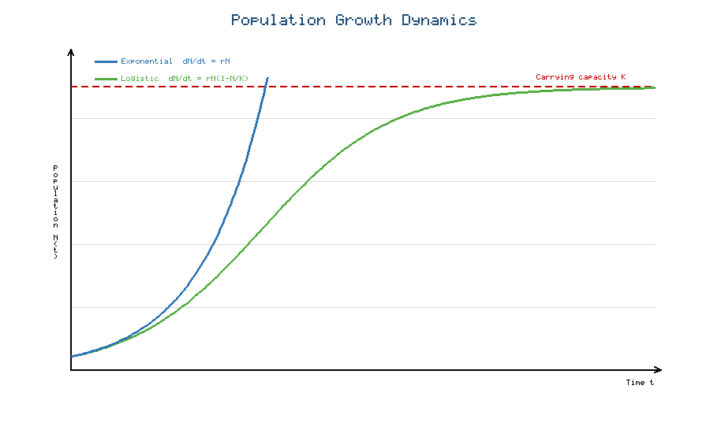
Figure 1. Comparison of exponential growth (blue), which increases without bound, and logistic growth (green), which saturates at the carrying capacity K (dashed red line). The logistic curve exhibits the characteristic sigmoidal shape produced by resource limitation.
The concept of carrying capacity encapsulates resource limitation in a single parameter, and its interpretation depends on the biological context: it may represent the food supply of a habitat, the nutrient availability in a culture, the space available for colonization, or the density at which disease and competition balance reproduction [28]. Modeling resource limitation more explicitly can involve coupling the consumer population to a dynamic resource variable, giving rise to consumer-resource models that generalize the logistic framework and can produce richer behavior including oscillations [29]. Nevertheless, the logistic model remains a remarkably effective first approximation and a building block for more elaborate constructions.
Applications of these basic models span population ecology and microbial growth. In ecology, exponential and logistic models underpin estimates of population viability, harvest sustainability, and invasion dynamics, and they form the null models against which more complex interactions are compared [30]. In microbiology, the logistic and related models describe the growth of bacterial and yeast cultures through lag, exponential, and stationary phases, informing fermentation technology, food safety, and antibiotic dosing strategies [31]. Table 1 summarizes the principal features of the exponential and logistic models, providing a compact reference for their assumptions, solutions, and domains of applicability. The comparison highlights how modeling choices propagate directly into qualitatively different predictions, a theme that recurs throughout the chapter.
Table 1. Comparison of foundational population growth models.
Feature | Exponential model | Logistic model
Governing equation | dN/dt = rN | dN/dt = rN(1 - N/K)
Key parameters | Growth rate r | Growth rate r, carrying capacity K
Long-term behavior | Unbounded growth or decay | Saturation at N = K
Solution shape | J-shaped curve | S-shaped (sigmoidal) curve
Resource limitation | Not represented | Represented via (1 - N/K)
Typical application | Early growth, invasion | Full growth cycle, cultures

2. Dynamical Systems and Biological Interactions

2.1 Stability and Equilibrium Analysis
Once a biological model is expressed as a system of differential equations, a central task is to understand its long-term behavior without necessarily solving the equations explicitly. The theory of dynamical systems provides the tools for this qualitative analysis, and its cornerstone is the concept of an equilibrium point, also called a steady state or fixed point [32]. An equilibrium is a state at which all rates of change vanish simultaneously, so that the system, once there, remains there indefinitely. Formally, for a system $dx/dt = f(x)$, an equilibrium $x^\ast$ satisfies
f(x^*) = 0 (9)
and biologically it corresponds to a balance of opposing processes: births balancing deaths, production balancing degradation, or infection balancing recovery [33]. Locating equilibria is typically the first analytical step, as they organize the entire structure of the dynamics and represent the states toward which, or away from which, the system tends.
Finding an equilibrium is only half the story; its stability determines whether it is biologically observable. A locally stable equilibrium attracts nearby trajectories, so that small perturbations decay and the system returns to the steady state, whereas an unstable equilibrium repels nearby trajectories, so that even tiny disturbances grow and carry the system away [34]. The distinction is crucial: a stable equilibrium represents a robust biological state, such as a healthy homeostatic balance or a persistent ecological community, while an unstable equilibrium, though mathematically valid, is rarely observed because noise inevitably dislodges it [35]. Global stability, a stronger property, requires that trajectories from all admissible initial conditions converge to the equilibrium, guaranteeing that the steady state is reached regardless of the starting configuration, a property of considerable importance when assessing whether a therapy or intervention will succeed from any initial condition [36].
The workhorse technique for assessing local stability is linearization, which approximates the nonlinear dynamics near an equilibrium by a linear system whose behavior is fully understood. The key object is the Jacobian matrix, whose entries are the partial derivatives of the rate functions with respect to the state variables, evaluated at the equilibrium [37]. For a two-variable system with rate functions $f$ and $g$, the Jacobian is
J = [ (∂ f)/(∂ x) , (∂ f)/(∂ y) ; (∂ g)/(∂ x) , (∂ g)/(∂ y) ] (10)
and the eigenvalues of this matrix govern the local behavior [38]. If all eigenvalues have negative real parts, perturbations decay and the equilibrium is stable; if any eigenvalue has a positive real part, the equilibrium is unstable. Complex eigenvalues signal oscillatory approach or departure, foreshadowing the cyclic behavior discussed later. This Jacobian-based analysis, rooted in the Hartman-Grobman theorem, converts a potentially intractable nonlinear question into a straightforward computation of matrix eigenvalues, and it is applied ubiquitously across ecological, epidemiological, and physiological models [39]. For two-dimensional systems in particular, the analysis simplifies further: the equilibrium is stable precisely when the trace of the Jacobian is negative and its determinant is positive, a compact criterion that allows rapid classification of steady states without explicitly computing eigenvalues [34]. When linearization is inconclusive, as occurs when eigenvalues lie exactly on the imaginary axis, more powerful techniques are required. The direct method of Lyapunov, which seeks an energy-like scalar function that decreases along trajectories, can establish stability, including global stability, without solving the equations, and it has become an indispensable tool for proving that biological equilibria such as disease-free states or homeostatic set points are reached from any initial condition [36]. These complementary methods together furnish a rigorous and practical toolkit for the stability analysis that pervades the applications considered in the remainder of this chapter. Table 2 catalogs the principal equilibrium types in two-dimensional systems and their eigenvalue signatures, serving as a reference for interpreting the stability analyses that follow.
Table 2. Classification of equilibria in two-dimensional systems by Jacobian eigenvalues.
Equilibrium type | Eigenvalue condition | Local behavior | Biological interpretation
Stable node | Real, both negative | Monotone convergence | Robust steady state
Unstable node | Real, both positive | Monotone divergence | Repelling state
Saddle point | Real, opposite signs | Mixed attract/repel | Threshold or tipping state
Stable focus | Complex, negative real part | Damped oscillation to rest | Homeostasis with overshoot
Unstable focus | Complex, positive real part | Growing oscillation | Onset of sustained cycles
Center | Purely imaginary | Neutral closed orbits | Conservative oscillation

2.2 Predator-Prey and Species Interaction Models
Among the most celebrated achievements of mathematical biology is the description of predator-prey dynamics through the Lotka-Volterra equations, developed independently by Alfred Lotka and Vito Volterra in the 1920s [40]. The model considers a prey population $x$ that would grow exponentially in the absence of predators and a predator population $y$ that would decline without prey, coupled through an interaction term proportional to the frequency of encounters. The system is written as
(dx)/(dt) = α x - β x y, (dy)/(dt) = δ x y - γ y (11)
where $\alpha$ is the prey growth rate, $\gamma$ the predator death rate, and $\beta$ and $\delta$ measure the efficiency of predation and the conversion of consumed prey into new predators [41]. The remarkable prediction of this model is the emergence of sustained, out-of-phase oscillations: prey abundance rises, fueling a predator increase, which then depletes the prey, causing predators to decline and allowing prey to recover, in an endless cycle. Figure 2 displays both the time series of these coupled oscillations and the corresponding closed orbit in the phase plane, together with the interior equilibrium about which the populations cycle. Historical data on lynx and hare pelts, and on Adriatic fish catches, provided early empirical support for such cyclic dynamics [42].
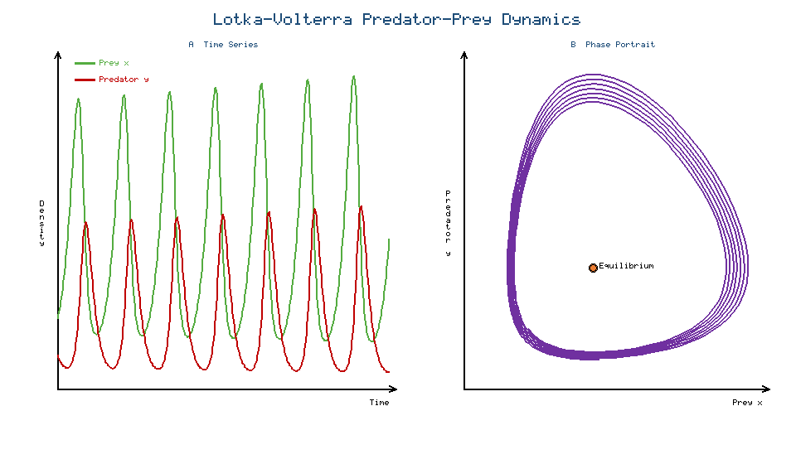
Figure 2. Lotka-Volterra predator-prey dynamics. Panel A shows the out-of-phase oscillations of prey (green) and predator (red) densities over time. Panel B shows the corresponding closed orbit in the phase plane, encircling the interior equilibrium (orange point).
The classical Lotka-Volterra model, while illuminating, rests on strong idealizations, notably the unbounded prey growth in the absence of predators and the neutral stability of its cycles, whose amplitude depends entirely on initial conditions [43]. Realistic refinements introduce logistic self-limitation of the prey, saturating functional responses that account for predator satiation, and spatial or age structure, all of which can convert the neutrally stable cycles into either a stable equilibrium or a robust limit cycle. These extensions illustrate a recurring lesson: the qualitative behavior of an interaction model is exquisitely sensitive to the mathematical form of its interaction terms, and Figure 2 should be read as the idealized baseline against which such refinements are compared.
Beyond predation, species interact through competition, mutualism, and more complex multi-species webs. The competition model describes two species vying for shared resources, each depressing the other's growth, and is often formulated as a coupled pair of logistic equations with cross-inhibition terms. For competitors 1 and 2 the dynamics read
(dN₁)/(dt) = r₁ N₁(1 - (N₁ + α₁₂ N₂)/(K₁)), (dN₂)/(dt) = r₂ N₂(1 - (N₂ + α₂₁ N₁)/(K₂)) (12)
where the competition coefficients $\alpha_{12}$ and $\alpha_{21}$ quantify the per-capita effect of each species on the other [4]. Analysis of this system reveals the conditions for competitive exclusion, in which one species drives the other to extinction, versus stable coexistence, in which both persist, a dichotomy that underlies the ecological principle that species must differ sufficiently in resource use to coexist [7]. Mutualism, in which species benefit one another, is modeled with positive interaction terms and can enhance the equilibrium densities of both partners, though unrealistic formulations may predict runaway growth unless saturation is imposed [12]. Multi-species interaction networks, incorporating chains and webs of predation, competition, and mutualism, extend these ideas to community ecology, where the stability of large interacting systems becomes a subtle question relating diversity to resilience [30].

2.3 Phase-Plane Analysis and Biological Dynamics
For systems of two interacting variables, the phase plane offers a powerful geometric perspective that complements algebraic stability analysis. Rather than plotting each variable against time, the phase plane plots one variable against the other, so that the state of the system is a single point and its evolution traces a curve called a trajectory [34]. The collection of representative trajectories constitutes the phase portrait, a global map of the system's behavior that reveals equilibria, the flow of the dynamics, and the fate of trajectories from any starting point. This geometric viewpoint is especially valuable in biology because it exposes qualitative features, such as the existence of cycles or the presence of multiple stable states, that may be obscured in time-series plots [37].
The organizing curves of a phase portrait are the nullclines, defined as the loci where one of the rate functions vanishes. Along the $x$-nullcline the variable $x$ is momentarily unchanging, and along the $y$-nullcline the variable $y$ is stationary; the intersections of the two nullclines are precisely the equilibria of the system [38]. Nullclines partition the phase plane into regions within which the direction of flow is consistent, allowing the modeler to sketch the qualitative dynamics by hand and to reason about the sign of each variable's change in each region. This technique makes the phase plane an intuitive laboratory for exploring how parameter changes reshape the flow and relocate equilibria.
A phenomenon of profound biological importance revealed by phase-plane analysis is the limit cycle, an isolated closed trajectory toward which neighboring trajectories spiral, representing self-sustained oscillation whose amplitude and period are intrinsic to the system rather than determined by initial conditions [39]. Unlike the neutrally stable cycles of the classical Lotka-Volterra model, a stable limit cycle is robust to perturbation, making it the appropriate mathematical description of genuinely periodic biological rhythms. Oscillatory and cyclic behavior pervades biology: circadian clocks, the cell cycle, glycolytic oscillations, hormonal pulsatility, cardiac rhythms, and neural bursting are all naturally interpreted as limit-cycle dynamics [15]. Phase-plane reasoning explains how such rhythms arise from the interplay of positive and negative feedback with appropriate time delays, and it clarifies why some perturbations reset a rhythm while others merely shift its phase. The interpretation of oscillations as trajectories in phase space thus unifies a vast range of biological clocks and rhythms under a single dynamical framework [22].

3. Differential Equation Models in Physiology and Epidemiology

3.1 Mathematical Models of Physiological Processes
Physiology, the study of how living organisms function, is fundamentally about regulation and dynamics, making it a natural domain for differential equation modeling. Homeostasis, the maintenance of stable internal conditions despite external fluctuation, is precisely the biological manifestation of a stable equilibrium, and the transient responses of physiological systems to perturbation are the transient dynamics of the underlying equations [16]. Modeling biochemical and metabolic pathways begins with the law of mass action and enzyme kinetics, in which reaction rates depend on reactant concentrations. The Michaelis-Menten description of enzyme-catalyzed reactions, in which the reaction velocity saturates as substrate concentration increases, gives rise to nonlinear rate terms that appear throughout metabolic modeling. For a substrate concentration $s$, the reaction velocity is
v = (V_(max) s)/(Kₘ + s) (13)
where $V_{\max}$ is the maximal velocity and $K_m$ is the Michaelis constant, the substrate concentration at which the rate is half-maximal [3]. This saturating form confers on pathways their characteristic switch-like and buffering behaviors and is the archetype of the nonlinear terms that make biological dynamics so rich. Networks of such reactions, represented as large systems of coupled ODEs, form the basis of systems biology models of metabolism, signaling, and gene regulation [5].
A paradigmatic physiological application is the regulation of blood glucose by the hormones insulin and glucagon. A minimal model treats glucose concentration and insulin concentration as coupled variables, with glucose stimulating insulin secretion and insulin promoting glucose uptake, forming a negative feedback loop that maintains glucose within a narrow range [6]. Such models, ranging from the classic minimal model of glucose kinetics to elaborate multi-compartment representations, are used clinically to interpret glucose tolerance tests, to characterize insulin sensitivity, and to design artificial pancreas control algorithms for diabetes management [8]. The same logic extends to other hormone regulation systems, including the pulsatile secretion of reproductive and stress hormones, where feedback loops with delays generate the rhythmic patterns essential to endocrine function [11].
Beyond biochemistry, differential equations describe cardiovascular and neuronal dynamics at the level of organs and cells. Cardiovascular models represent blood pressure, flow, and vessel compliance through systems analogous to electrical circuits, capturing the pulsatile dynamics of the circulation and informing the understanding of hypertension and heart failure [15]. Neuronal dynamics are famously described by the Hodgkin-Huxley equations, a system of coupled nonlinear ODEs relating membrane voltage to the gating of ion channels, which quantitatively reproduces the generation and propagation of the action potential [39]. Reduced models such as the FitzHugh-Nagumo system distill this behavior into two variables amenable to phase-plane analysis, revealing the excitable and oscillatory dynamics that underlie neural signaling. Table 3 surveys representative physiological models, their state variables, and their clinical or scientific significance, underscoring the breadth of differential-equation modeling across the physiological hierarchy.
Table 3. Representative differential equation models in physiology.
Physiological system | State variables | Modeling feature | Application
Enzyme kinetics | Substrate, product | Michaelis-Menten saturation | Metabolic engineering
Glucose-insulin | Glucose, insulin | Negative feedback loop | Diabetes management
Endocrine rhythms | Hormone concentrations | Delayed feedback | Reproductive and stress physiology
Cardiovascular | Pressure, flow, volume | Compliance and resistance | Hypertension, heart failure
Neuronal (Hodgkin-Huxley) | Voltage, gating variables | Ionic conductances | Action potential, neural coding

3.2 Epidemic and Disease-Spread Models
The mathematical modeling of infectious disease is among the most socially consequential applications of dynamical systems, providing the quantitative foundation for public health policy. The framework rests on compartmental models, in which the host population is partitioned into classes according to disease status, and differential equations describe the flow of individuals between compartments [9]. The foundational SIR model divides the population into Susceptible ($S$), Infected ($I$), and Recovered ($R$) individuals, with susceptibles becoming infected through contact with infectious individuals and infectious individuals recovering at a constant rate. The governing equations are
(dS)/(dt) = -β (S I)/(N), (dI)/(dt) = β (S I)/(N) - γ I, (dR)/(dt) = γ I (14)
where $\beta$ is the transmission rate, $\gamma$ the recovery rate, and $N$ the total population [10]. Figure 3 presents both the compartmental flow structure and the characteristic epidemic curves generated by these equations, showing the depletion of susceptibles, the rise and fall of the infected class, and the accumulation of the recovered.
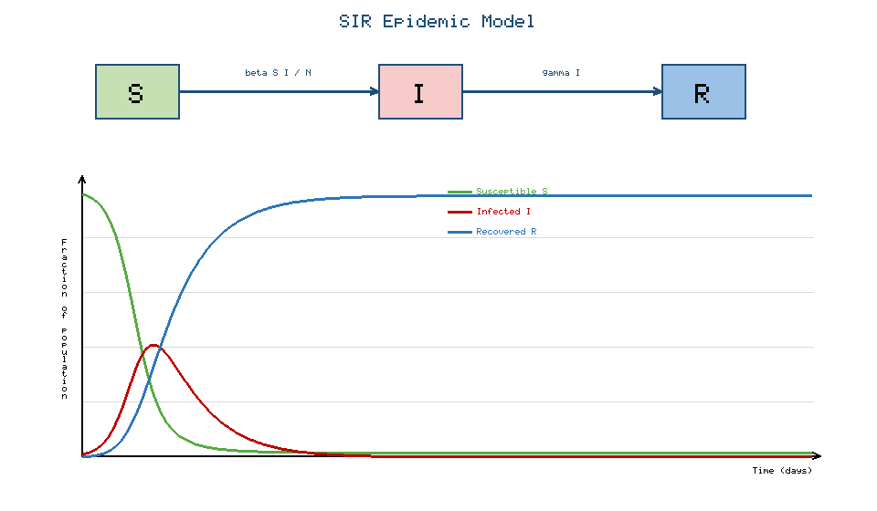
Figure 3. The SIR epidemic model. The top panel shows the compartmental flow from Susceptible to Infected to Recovered, governed by transmission rate beta and recovery rate gamma. The lower panel shows the resulting epidemic curves: susceptibles (green) decline, infecteds (red) peak and subside, and recovereds (blue) accumulate.
A quantity of paramount importance emerging from the SIR framework is the basic reproduction number, $R_0$, defined as the average number of secondary infections produced by a single infectious individual introduced into a wholly susceptible population. For the SIR model it is given by
R₀ = (β)/(γ) (15)
and it functions as a threshold parameter: if $R_0 > 1$ an epidemic can grow, whereas if $R_0 < 1$ the infection dies out [1]. This threshold, derived directly from the stability analysis of the disease-free equilibrium, is one of the most influential concepts in epidemiology and guides the assessment of outbreak potential and the design of control measures [24]. The SIS model, appropriate for infections that confer no lasting immunity such as many bacterial and sexually transmitted diseases, omits the recovered class and returns individuals directly to the susceptible pool, producing dynamics that can settle to an endemic equilibrium rather than a single epidemic wave [26]. The SEIR model inserts an Exposed ($E$) compartment representing a latent period during which individuals are infected but not yet infectious, an essential refinement for diseases such as measles and COVID-19 where incubation delays materially affect transmission dynamics. The dynamics of the exposed class take the form
(dE)/(dt) = β (S I)/(N) - σ E (16)
where $\sigma$ is the rate at which exposed individuals become infectious, so that $1/\sigma$ is the mean latent period; the remaining compartments are modified accordingly to conserve the total population [29].
These models directly inform vaccination and intervention strategies. Vaccination effectively moves individuals from the susceptible to the recovered compartment, reducing the pool available for transmission, and the concept of herd immunity follows quantitatively. The critical vaccination fraction required to prevent sustained transmission is
p_c = 1 - (1)/(R₀) (17)
so that if the fraction vaccinated exceeds $p_c$, the effective reproduction number falls below one and the infection cannot spread through the population, protecting even the unvaccinated [10]. Similar reasoning quantifies the impact of social distancing, quarantine, and treatment, each of which modifies specific parameters or flows in the compartmental structure. The predictive use of such models during epidemics, including the COVID-19 pandemic, demonstrated both their value in projecting healthcare demand and the importance of parameter uncertainty and behavioral change, spurring extensions incorporating age structure, spatial spread, and time-varying transmission [31].

3.3 Reaction-Diffusion and Spatial Biological Models
Many biological phenomena unfold not only in time but also in space, requiring the extension of ordinary differential equations to partial differential equations that include spatial derivatives. The central construct is the reaction-diffusion equation, which combines local reaction kinetics with the spatial spreading of substances by diffusion. For a single diffusing chemical species $u$ with concentration varying over space and time, the equation reads
(∂ u)/(∂ t) = D (∂² u)/(∂ x²) + f(u) (18)
where $D$ is the diffusion coefficient, the second spatial derivative represents diffusive transport, and $f(u)$ captures local reactions or growth [18]. Diffusion processes in biological tissues describe the movement of oxygen, nutrients, signaling molecules, and drugs through cells and extracellular matrix, and the diffusion term alone, in the absence of reaction, yields the classical spreading and smoothing of concentration gradients fundamental to transport physiology [22].
The coupling of reaction and diffusion produces one of the most striking results in mathematical biology: the spontaneous emergence of spatial pattern from an initially uniform state. Alan Turing showed that a system of two or more reacting and diffusing chemicals, an activator and an inhibitor with differing diffusion rates, can undergo a diffusion-driven instability that amplifies small spatial fluctuations into stable, periodic patterns [4]. This Turing mechanism provides a compelling mathematical explanation for morphogenesis and the formation of biological patterns such as animal coat markings, pigmentation stripes and spots, and the regular spacing of anatomical structures [7]. The counterintuitive insight that diffusion, ordinarily a homogenizing process, can generate rather than erase pattern remains a cornerstone of developmental biology and continues to inspire experimental and theoretical work [12].
Reaction-diffusion and related spatial models find application in tumor growth, morphogenesis, and population dispersal. Models of tumor growth couple the proliferation of cancer cells with their diffusive invasion into surrounding tissue and with the diffusion of nutrients and oxygen, reproducing the observed advance of tumor margins and informing strategies for therapy and imaging interpretation [3]. In developmental biology, reaction-diffusion models formalize how morphogen gradients and patterning networks establish the body plan. In ecology, the spatial spread of invasive species, the propagation of epidemics across landscapes, and the formation of vegetation patterns in arid ecosystems are all captured by reaction-diffusion frameworks, in which traveling-wave solutions describe the advancing front of an invading population or infection [30]. These spatial extensions demonstrate that the dynamical-systems perspective, enriched with spatial structure, provides a unified account of biological organization across scales from the subcellular to the landscape [2].

4. Advanced Dynamical Systems and Emerging Applications

4.1 Nonlinear Dynamics and Bifurcation Theory
Biological systems are overwhelmingly nonlinear: rates saturate, feedback loops amplify or suppress, and interactions multiply rather than add. This nonlinearity is not a mathematical inconvenience but the very source of biological richness, for it permits behaviors impossible in linear systems, including multiple stable states, thresholds, hysteresis, and self-sustained oscillation [35]. Nonlinear feedback lies at the heart of biological complexity: positive feedback can create switches and bistability, in which a system rests in one of two alternative stable states and can be flipped between them by a sufficient stimulus, while negative feedback with delay generates the oscillations underlying biological clocks [39]. Understanding how these nonlinear mechanisms combine to produce robust yet flexible behavior is a central goal of dynamical systems biology [22].
The mathematical framework for understanding how qualitative behavior changes as conditions vary is bifurcation theory. A bifurcation is a qualitative change in the structure of a dynamical system, such as the creation or destruction of equilibria or the onset of oscillation, occurring as a parameter crosses a critical value [37]. The saddle-node bifurcation, in which a stable and an unstable equilibrium collide and annihilate, provides the mathematical signature of a tipping point, where a gradual change in conditions triggers an abrupt and often irreversible transition, relevant to ecosystem collapse, disease emergence, and cellular fate decisions [40]. The transcritical bifurcation, in which two equilibria exchange stability as they pass through one another, appears naturally at epidemic thresholds, where the disease-free and endemic equilibria exchange stability as $R_0$ crosses unity [24]. The Hopf bifurcation, in which a stable equilibrium loses stability and gives rise to a limit cycle as a pair of complex eigenvalues crosses the imaginary axis, explains the birth of sustained oscillations in physiological and ecological systems [15].
The emergence of multiple equilibria and oscillations through these bifurcations endows biological systems with their capacity for decision-making, memory, and rhythm. Bistable switches, arising through saddle-node bifurcations, enable cells to make irreversible commitments such as entering the cell cycle or differentiating, while oscillators born through Hopf bifurcations drive the periodic processes of life [11]. Figure 4 provides a schematic of a Hopf bifurcation, showing how a stable focus loses stability as a parameter increases and a stable limit cycle of growing amplitude emerges, together with representative phase-plane insets illustrating the spiral convergence before, and the sustained oscillation after, the bifurcation. The unifying message of bifurcation theory is that dramatic biological transitions often reflect the smooth crossing of a mathematical threshold, so that understanding the bifurcation structure of a model reveals the conditions under which health becomes disease, coexistence becomes extinction, or quiescence becomes oscillation [35].
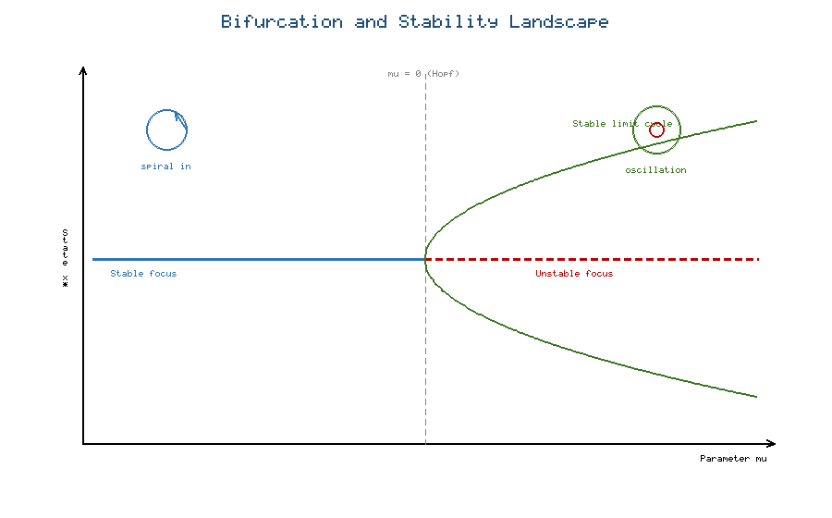
Figure 4. Schematic of a Hopf bifurcation. As the parameter mu increases through zero, the stable focus (blue, spiral convergence) loses stability and becomes an unstable focus (red), while a stable limit cycle (green envelope) of growing amplitude emerges, producing sustained oscillations.

4.2 Computational Approaches to Biological Dynamical Systems
Because realistic biological models are almost always nonlinear and high-dimensional, computational methods are indispensable for their analysis. Numerical integration, the approximation of solutions by stepping forward in time, is the foundation, and the choice of algorithm profoundly affects accuracy and efficiency [21]. Explicit methods such as the Runge-Kutta family are efficient for many problems, but biological models frequently exhibit stiffness, in which processes occur on vastly different time scales, as when fast enzyme kinetics couple to slow gene expression, requiring specialized implicit solvers to maintain stability without prohibitively small time steps [22]. Simulation allows the modeler to explore behaviors inaccessible to analysis, to visualize trajectories and phase portraits, and to conduct in-silico experiments that complement laboratory work [16].
A critical and often underappreciated challenge is parameter estimation, the inference of model parameters from experimental data. Biological parameters such as reaction rates, transmission coefficients, and carrying capacities are rarely measured directly and must instead be estimated by fitting model output to observations, typically by minimizing a measure of discrepancy between prediction and data [6]. This inverse problem is complicated by noisy measurements, limited data, and the possibility that different parameter combinations produce indistinguishable outputs, a phenomenon known as parameter identifiability that must be assessed to ensure that estimates are meaningful [8]. Closely related is sensitivity analysis, which quantifies how strongly model outputs depend on each parameter, identifying the parameters that most influence predictions and thereby guiding both experimental design and model simplification [5]. Sensitivity analysis also reveals which aspects of a model are robust and which are fragile, informing the confidence that can be placed in its conclusions.
Computational tools for model validation and prediction close the modeling loop. Validation compares model predictions against independent data not used in fitting, testing whether the model captures genuine biological mechanism rather than merely interpolating the training data [1]. Techniques such as cross-validation, uncertainty quantification, and Bayesian inference provide principled means of assessing predictive reliability and of propagating parameter uncertainty into prediction intervals [31]. Table 4 organizes the principal computational tasks in biological dynamical-systems modeling, their purposes, and representative methods, providing a roadmap for the computational workflow that transforms a proposed model into a validated predictive tool. The maturation of open-source software ecosystems has made these once-specialized techniques broadly accessible, accelerating the adoption of quantitative modeling across biology [2].
Table 4. Computational tasks in biological dynamical systems modeling.
Task | Purpose | Representative methods | Key challenge
Numerical integration | Solve ODE and PDE systems | Runge-Kutta, implicit solvers | Stiffness, step-size control
Parameter estimation | Fit models to data | Least squares, maximum likelihood | Identifiability, noise
Sensitivity analysis | Rank parameter influence | Local and global sensitivity | High dimensionality
Model validation | Test predictive accuracy | Cross-validation, held-out data | Overfitting
Uncertainty quantification | Bound prediction reliability | Bayesian inference, Monte Carlo | Computational cost

4.3 Emerging Directions in Biomathematical Modeling
The frontier of biomathematics is expanding rapidly, driven by advances in data acquisition, computation, and machine learning. A prominent direction is the development of multiscale and hybrid mathematical models that integrate processes across levels of biological organization, from molecules to cells to tissues to organisms [3]. Such models may couple stochastic descriptions of low-copy-number molecular events with deterministic descriptions of bulk concentrations, or link intracellular signaling networks to tissue-level mechanics, capturing emergent behavior that no single-scale model could reproduce [12]. Hybrid formulations that combine continuous differential equations with discrete, agent-based, or rule-based components are increasingly used to model heterogeneous populations of cells, spatially structured tissues, and the interplay of individual behavior with population dynamics [30].
Perhaps the most transformative development is the rise of data-driven dynamical systems and machine learning in biological modeling. Where traditional modeling posits governing equations from mechanistic first principles, data-driven approaches seek to learn dynamical structure directly from data, using methods that discover governing equations, infer interaction networks, or approximate complex dynamics with neural networks [2]. Physics-informed and biology-informed neural networks blend mechanistic constraints with the flexibility of machine learning, enabling the assimilation of large, heterogeneous datasets while preserving interpretability and respecting known conservation laws [31]. These hybrid modeling and machine-learning strategies promise to overcome the twin bottlenecks of unknown model structure and unmeasured parameters that have long limited the reach of purely mechanistic approaches [5].
The applications of these emerging methods are far-reaching, with particular promise in precision medicine, synthetic biology, and systems biology. In precision medicine, patient-specific dynamical models, calibrated to individual data, aim to predict disease progression and optimize therapy, tailoring interventions to the unique dynamics of each patient rather than to population averages [6]. In synthetic biology, dynamical systems theory guides the rational design of genetic circuits that implement switches, oscillators, and logic functions, turning the analysis of natural dynamics into a discipline of engineering new biological behavior [39]. In systems biology, comprehensive dynamical models of cellular networks integrate genomic, proteomic, and metabolomic data to yield a holistic, predictive understanding of cellular function in health and disease [8]. Across all these frontiers, differential equations and dynamical systems remain the conceptual backbone, now augmented by unprecedented data and computational power, ensuring that the mathematical study of living systems will continue to deepen our understanding and expand our capacity to intervene [4].

5. Conclusion
Differential equations and dynamical systems constitute the mathematical foundation upon which modern quantitative biology is built. From the deceptively simple exponential and logistic growth laws to the intricate reaction-diffusion mechanisms of morphogenesis, from the graceful oscillations of predator and prey to the threshold dynamics of epidemics, a common mathematical language describes how living systems change, interact, and organize themselves across scales [1]. The analytical tools of equilibrium and stability analysis, linearization, phase-plane geometry, and bifurcation theory transform biological questions into tractable mathematical ones, revealing why some states persist while others collapse, why some systems oscillate while others settle, and why gradual change can trigger abrupt transition [37]. The computational tools of numerical integration, parameter estimation, sensitivity analysis, and validation turn these models into instruments of prediction and design, while emerging multiscale, hybrid, and data-driven approaches are extending the reach of biomathematics into precision medicine, synthetic biology, and systems biology [2].
The enduring lesson of this chapter is that mathematical structure illuminates biological mechanism. A single additional term converts unbounded growth into self-limiting saturation; a change in the form of an interaction term converts a stable equilibrium into a sustained rhythm; the crossing of a bifurcation threshold converts health into disease or coexistence into extinction. By making the assumptions of biological reasoning explicit and deriving their consequences with rigor, differential equation models do not merely describe life; they explain it, predict it, and increasingly enable us to engineer it. As data and computation continue to grow, the partnership between mathematics and biology will only deepen, ensuring that dynamical systems remain at the center of the new horizon of science and engineering that biomathematics represents [12].

References
[1] Murray, J. D. (2002). Mathematical Biology I: An Introduction (3rd ed.). Springer.
[2] Edelstein-Keshet, L. (2005). Mathematical Models in Biology. Society for Industrial and Applied Mathematics.
[3] Keener, J., & Sneyd, J. (2009). Mathematical Physiology (2nd ed.). Springer.
[4] Britton, N. F. (2003). Essential Mathematical Biology. Springer.
[5] Ellner, S. P., & Guckenheimer, J. (2006). Dynamic Models in Biology. Princeton University Press.
[6] Bertalanffy, L. von (1969). General System Theory: Foundations, Development, Applications. George Braziller.
[7] Kot, M. (2001). Elements of Mathematical Ecology. Cambridge University Press.
[8] Alon, U. (2019). An Introduction to Systems Biology: Design Principles of Biological Circuits (2nd ed.). CRC Press.
[9] Anderson, R. M., & May, R. M. (1991). Infectious Diseases of Humans: Dynamics and Control. Oxford University Press.
[10] Hethcote, H. W. (2000). The mathematics of infectious diseases. SIAM Review, 42(4), 599-653.
[11] Goldbeter, A. (1996). Biochemical Oscillations and Cellular Rhythms. Cambridge University Press.
[12] Strogatz, S. H. (2015). Nonlinear Dynamics and Chaos (2nd ed.). Westview Press.
[13] Boyce, W. E., & DiPrima, R. C. (2012). Elementary Differential Equations and Boundary Value Problems (10th ed.). Wiley.
[14] Hirsch, M. W., Smale, S., & Devaney, R. L. (2013). Differential Equations, Dynamical Systems, and an Introduction to Chaos (3rd ed.). Academic Press.
[15] Glass, L., & Mackey, M. C. (1988). From Clocks to Chaos: The Rhythms of Life. Princeton University Press.
[16] Fall, C. P., Marland, E. S., Wagner, J. M., & Tyson, J. J. (Eds.) (2002). Computational Cell Biology. Springer.
[17] Braun, M. (1993). Differential Equations and Their Applications (4th ed.). Springer.
[18] Grindrod, P. (1996). The Theory and Applications of Reaction-Diffusion Equations (2nd ed.). Oxford University Press.
[19] Zill, D. G. (2018). A First Course in Differential Equations with Modeling Applications (11th ed.). Cengage.
[20] Verhulst, P.-F. (1838). Notice sur la loi que la population suit dans son accroissement. Correspondance Mathematique et Physique, 10, 113-121.
[21] Butcher, J. C. (2016). Numerical Methods for Ordinary Differential Equations (3rd ed.). Wiley.
[22] Ermentrout, B. (2002). Simulating, Analyzing, and Animating Dynamical Systems. SIAM.
[23] Malthus, T. R. (1798). An Essay on the Principle of Population. J. Johnson.
[24] Diekmann, O., Heesterbeek, J. A. P., & Metz, J. A. J. (1990). On the definition and computation of the basic reproduction ratio R0. Journal of Mathematical Biology, 28(4), 365-382.
[25] Pearl, R., & Reed, L. J. (1920). On the rate of growth of the population of the United States. Proceedings of the National Academy of Sciences, 6(6), 275-288.
[26] Brauer, F., & Castillo-Chavez, C. (2012). Mathematical Models in Population Biology and Epidemiology (2nd ed.). Springer.
[27] Tsoularis, A., & Wallace, J. (2002). Analysis of logistic growth models. Mathematical Biosciences, 179(1), 21-55.
[28] Gotelli, N. J. (2008). A Primer of Ecology (4th ed.). Sinauer Associates.
[29] Hethcote, H. W., & van den Driessche, P. (1991). Some epidemiological models with nonlinear incidence. Journal of Mathematical Biology, 29(3), 271-287.
[30] May, R. M. (1973). Stability and Complexity in Model Ecosystems. Princeton University Press.
[31] Baker, R. E., Pena, J.-M., Jayamohan, J., & Jerusalem, A. (2018). Mechanistic models versus machine learning, a fight worth fighting for the biological community? Biology Letters, 14(5), 20170660.
[32] Guckenheimer, J., & Holmes, P. (1983). Nonlinear Oscillations, Dynamical Systems, and Bifurcations of Vector Fields. Springer.
[33] Perko, L. (2001). Differential Equations and Dynamical Systems (3rd ed.). Springer.
[34] Jordan, D. W., & Smith, P. (2007). Nonlinear Ordinary Differential Equations (4th ed.). Oxford University Press.
[35] Kuznetsov, Y. A. (2004). Elements of Applied Bifurcation Theory (3rd ed.). Springer.
[36] Khalil, H. K. (2002). Nonlinear Systems (3rd ed.). Prentice Hall.
[37] Wiggins, S. (2003). Introduction to Applied Nonlinear Dynamical Systems and Chaos (2nd ed.). Springer.
[38] Arnold, V. I. (1992). Ordinary Differential Equations. Springer.
[39] Izhikevich, E. M. (2007). Dynamical Systems in Neuroscience: The Geometry of Excitability and Bursting. MIT Press.
[40] Lotka, A. J. (1925). Elements of Physical Biology. Williams & Wilkins.
[41] Volterra, V. (1926). Fluctuations in the abundance of a species considered mathematically. Nature, 118, 558-560.
[42] Elton, C., & Nicholson, M. (1942). The ten-year cycle in numbers of the lynx in Canada. Journal of Animal Ecology, 11(2), 215-244.
[43] Rosenzweig, M. L., & MacArthur, R. H. (1963). Graphical representation and stability conditions of predator-prey interactions. The American Naturalist, 97(895), 209-223.

