Chapter 12

Industrial Translation, Scale-Up, Regulatory Aspects, Artificial Intelligence Integration, Market Potential, and Future Perspectives

Abstract
The translation of microbial-derived bio-nanomaterials from laboratory-scale synthesis to industrial production represents a critical frontier in sustainable nanotechnology. This chapter comprehensively examines the multifaceted challenges and opportunities associated with industrial scale-up, regulatory compliance, artificial intelligence integration, market potential, and future perspectives for microbial-mediated nanomaterial synthesis. The discussion encompasses process engineering considerations, quality control frameworks, biosafety assessments, environmental sustainability metrics, and the transformative role of machine learning in optimizing production parameters. Furthermore, the chapter explores commercialization pathways, emerging market opportunities, and the convergence of synthetic biology with advanced manufacturing paradigms. By integrating perspectives from bioprocess engineering, regulatory science, data analytics, and market economics, this chapter provides a holistic roadmap for advancing microbial-derived bio-nanomaterials toward commercial viability and societal impact.
Keywords: bio-nanomaterials, industrial scale-up, regulatory frameworks, artificial intelligence, machine learning, commercialization, microbial synthesis, green nanotechnology

Section 1: Industrial Translation and Scale-Up of Microbial-Derived Bio-Nanomaterials

1.1 From Laboratory Synthesis to Industrial Production
The biosynthesis of nanomaterials using microbial systems has garnered considerable research interest due to its environmental compatibility, cost-effectiveness, and capacity for producing nanoparticles with unique physicochemical properties (Narayanan & Sakthivel, 2010). However, the translation from laboratory-scale demonstrations to industrial manufacturing remains one of the most significant challenges confronting the field. Laboratory protocols that produce well-characterized nanoparticles under controlled conditions often encounter substantial difficulties when scaled to volumes required for commercial applications (Singh et al., 2016). The gap between academic research and industrial practice encompasses not only technical scaling challenges but also economic viability, regulatory preparedness, and supply chain integration requirements that must be systematically addressed.
The primary challenges in translating microbial-mediated synthesis include maintaining process reproducibility across batches, ensuring consistent nanoparticle characteristics, and managing the biological variability inherent in microbial systems (Khandel et al., 2018). At laboratory scale, researchers typically work with volumes ranging from milliliters to a few liters, where environmental parameters such as temperature, pH, agitation, and nutrient availability can be precisely controlled. At industrial scale, these parameters become significantly more difficult to maintain uniformly throughout the reaction volume, leading to heterogeneous conditions that can adversely affect nanoparticle nucleation, growth, and final properties (Hulkoti & Taranath, 2014). Furthermore, the transition from laboratory to industrial scale introduces additional variables including microbial contamination risks, equipment fouling, and the need for robust aseptic techniques that may not be critical at bench scale but become paramount in manufacturing environments.
Process optimization for industrial translation requires systematic approaches including Design of Experiments (DoE), response surface methodology, and statistical process control to identify critical process parameters and their acceptable ranges (Gahlawat & Choudhury, 2019). The selection of microbial strains for industrial production must consider not only the capacity for nanoparticle synthesis but also growth kinetics, genetic stability, ease of cultivation at scale, biosafety classification, and compatibility with standard bioprocessing equipment (Table 1). As illustrated in Figure 1, the scale-up pathway from laboratory bench to industrial production involves multiple intermediate stages, each requiring careful optimization and validation to ensure that product quality is maintained throughout the transition. Critical to this process is the establishment of design spaces within which acceptable product quality can be maintained despite normal process variations.
Batch-to-batch consistency represents a critical quality attribute for industrially produced bio-nanomaterials. Unlike chemical synthesis routes that can achieve high reproducibility through precise stoichiometric control, microbial synthesis involves living organisms whose metabolic state and enzymatic activities can vary in response to subtle environmental changes (Ovais et al., 2018). Addressing this challenge requires the development of robust process analytical technologies (PAT) capable of monitoring key quality attributes in real-time, enabling corrective actions before significant deviations occur. The implementation of multivariate statistical process control, including principal component analysis and partial least squares regression, provides powerful tools for detecting subtle process shifts that might otherwise go unnoticed until final product testing reveals out-of-specification results.
The optimization of culture conditions for industrial production encompasses multiple interrelated variables including carbon and nitrogen source composition, trace element availability, dissolved oxygen levels, temperature profiles, and induction strategies for nanoparticle biosynthesis (Li et al., 2011). Fed-batch and continuous culture strategies offer advantages over simple batch processes by enabling better control of nutrient availability and metabolic state throughout the production cycle. The implementation of these advanced cultivation strategies requires sophisticated process control systems and a thorough understanding of the relationship between microbial physiology and nanoparticle formation kinetics. Moreover, the development of robust seed train procedures and inoculum preparation protocols ensures consistent starting conditions for production batches, reducing one significant source of batch-to-batch variability.

1.2 Large-Scale Production and Process Engineering
The engineering of large-scale production processes for microbial-derived bio-nanomaterials necessitates careful consideration of bioreactor design, mass transfer characteristics, mixing patterns, and downstream processing requirements (Rautela et al., 2019). Bioreactor selection depends on multiple factors including the microbial system employed, oxygen requirements, shear sensitivity of both the organisms and the forming nanoparticles, and the desired production mode. Stirred-tank bioreactors remain the most commonly employed configuration for microbial cultivations at industrial scale, offering well-characterized mixing and mass transfer properties along with extensive operational experience in the bioprocessing industry. Alternative bioreactor configurations including airlift reactors, bubble columns, packed-bed reactors, and membrane bioreactors may offer advantages for specific microbial systems or production requirements.
However, the unique requirements of nanoparticle biosynthesis may necessitate modifications to standard bioreactor configurations. For instance, the formation of metal nanoparticles often requires specific reducing conditions that may be incompatible with high dissolved oxygen levels typically maintained for aerobic microbial growth (Saklani et al., 2012). This creates a need for sophisticated process strategies that decouple the microbial growth phase from the nanoparticle synthesis phase, potentially through sequential batch operations or compartmentalized reactor designs. The temporal separation of biomass generation from nanoparticle synthesis enables independent optimization of each phase, potentially achieving superior results compared to single-phase approaches where competing requirements must be simultaneously balanced.
Downstream processing represents a critical component of the overall production process, encompassing cell harvesting, nanoparticle recovery, purification, and formulation. The separation of bio-nanomaterials from the biological matrix requires techniques that can effectively remove cellular debris, proteins, nucleic acids, and other biomolecules while preserving the desired nanoparticle properties (Moghaddam et al., 2015). Centrifugation, filtration, chromatographic separation, and dialysis are commonly employed, but their scalability and cost-effectiveness at industrial volumes must be carefully evaluated. The development of integrated continuous downstream processing trains, where multiple unit operations are connected in sequence without intermediate hold steps, represents an emerging paradigm that can reduce processing time, minimize product degradation, and improve overall process efficiency.
The optimization of yield represents a fundamental economic driver for industrial production. Yield enhancement strategies include genetic engineering of microbial strains to overexpress relevant reductase enzymes, optimization of precursor salt concentrations, manipulation of growth phase timing for nanoparticle induction, and implementation of cell recycling strategies to maximize biomass utilization (Iravani, 2014). As depicted in Figure 1, the integration of these process engineering approaches within a comprehensive manufacturing framework is essential for achieving economically viable production scales while maintaining product quality specifications. The establishment of clear relationships between process parameters and critical quality attributes through Quality by Design (QbD) principles provides a scientific foundation for process optimization that satisfies both manufacturing efficiency and regulatory expectations.
Process intensification approaches, including continuous manufacturing, microfluidic reactor systems, and integrated bioprocessing, offer pathways to improved productivity and reduced manufacturing footprints. Continuous processing eliminates the downtime associated with batch turnarounds and can provide more consistent product quality through steady-state operation (Duan et al., 2015). The adoption of continuous manufacturing paradigms for bio-nanomaterial production aligns with broader trends in the pharmaceutical and biotechnology industries toward more efficient and controllable manufacturing processes. Microfluidic systems, while limited in throughput for individual devices, can be parallelized through numbering-up strategies that maintain the favorable mass and heat transfer characteristics of small-scale systems while achieving commercially relevant production rates.
Cost-effective production requires optimization of resource utilization including media components, energy inputs, water consumption, and waste generation. The use of agricultural and industrial waste streams as nutrient sources for microbial cultivation represents an attractive strategy for reducing raw material costs while contributing to circular economy objectives (Kuppusamy et al., 2016). Similarly, the recovery and recycling of unreacted precursor materials and process water can significantly improve the overall economic and environmental performance of the production process. Techno-economic analysis integrating capital expenditure, operational costs, yield projections, and market pricing provides essential guidance for investment decisions and process development prioritization.

1.3 Quality Control, Stability, and Standardization
Comprehensive quality control for microbial-derived bio-nanomaterials requires physicochemical characterization including particle size distribution, morphology, crystalline structure, surface charge, composition, and functional group analysis (Shah et al., 2015). Advanced characterization techniques such as transmission electron microscopy (TEM), X-ray diffraction (XRD), dynamic light scattering (DLS), Fourier-transform infrared spectroscopy (FTIR), and X-ray photoelectron spectroscopy (XPS) provide complementary information about nanoparticle properties. For industrial quality control, these analytical methods must be adapted for high-throughput screening and integrated into quality management systems that ensure consistent product release specifications. The development of rapid, at-line characterization methods that can provide real-time feedback during production represents a critical need for enabling effective process control and timely release decisions.
Table 1 presents a comprehensive comparison of critical parameters between laboratory-scale and industrial-scale production, highlighting the key differences in process control capabilities, batch sizes, characterization requirements, and quality assurance approaches that must be addressed during scale-up. Understanding these differences is essential for developing effective scale-up strategies that maintain product quality while achieving economically viable production rates.
Stability assessment encompasses both physical stability (aggregation, sedimentation, size changes) and chemical stability (oxidation, dissolution, surface modification) under various storage conditions (Shah et al., 2015). Accelerated stability studies, conducted under elevated temperature and humidity conditions, provide predictions of shelf life and inform storage recommendations. The development of stable formulations may require the addition of stabilizing agents, surface coatings, or encapsulation strategies that must be compatible with the intended application. Long-term stability programs following ICH guidelines provide the definitive data required for establishing product expiration dates and storage conditions, while real-time stability monitoring of commercial batches ensures ongoing compliance with established specifications throughout the product's marketed shelf life.
The formulation of bio-nanomaterials for specific applications introduces additional considerations including compatibility with delivery systems, maintenance of biological activity during processing and storage, and performance under application conditions. For biomedical applications, formulation must ensure sterility, biocompatibility, and appropriate pharmacokinetic behavior. For environmental applications, formulations must maintain nanoparticle functionality under variable environmental conditions including pH extremes, temperature fluctuations, and the presence of competing ions or organic matter. The development of application-specific formulation strategies that balance stability, functionality, and manufacturability represents a critical aspect of product development that bridges the gap between material synthesis and market deployment.
Standardization of microbial-derived bio-nanomaterials presents unique challenges compared to chemically synthesized counterparts due to the inherent biological variability in production processes. The establishment of reference standards, validated analytical methods, and harmonized testing protocols is essential for ensuring comparability between products from different manufacturers and for supporting regulatory submissions (Thakkar et al., 2010). International standardization bodies including ISO, ASTM, and OECD have developed guidelines for nanomaterial characterization and testing, but specific standards for bio-nanomaterials remain limited and require further development. The creation of certified reference materials specifically for bio-nanomaterials, encompassing both physicochemical properties and biological activity measures, would substantially advance the field by providing common benchmarks against which production quality can be assessed.

Table 1. Comparison of Laboratory-Scale vs. Industrial-Scale Production Parameters for Microbial-Derived Bio-Nanomaterials
Parameter | Laboratory Scale | Industrial Scale | Key Challenges
Batch Volume | 0.1–5 L | 500–50,000 L | Heat/mass transfer limitations
Process Control | Manual/semi-automated | Fully automated with PAT | Sensor reliability, data integration
Strain Management | Research-grade stocks | Master/working cell banks | Genetic stability, GMP compliance
Culture Conditions | Precisely controlled | Gradient-prone, zone-dependent | Mixing heterogeneity, dead zones
Downstream Processing | Bench-scale centrifugation | Industrial separation trains | Scalability, cost, throughput
Characterization | Research-grade instruments | QC-validated methods | Speed, throughput, standardization
Quality Assurance | Informal documentation | Full GMP/QMS documentation | Regulatory compliance, training
Reproducibility | Variable (operator-dependent) | Specification-driven | Biological variability management
Production Cost | Not optimized | Target: < $100/g product | Yield optimization, waste reduction
Timeline | Days to weeks per batch | Continuous or scheduled campaigns | Planning, supply chain integration

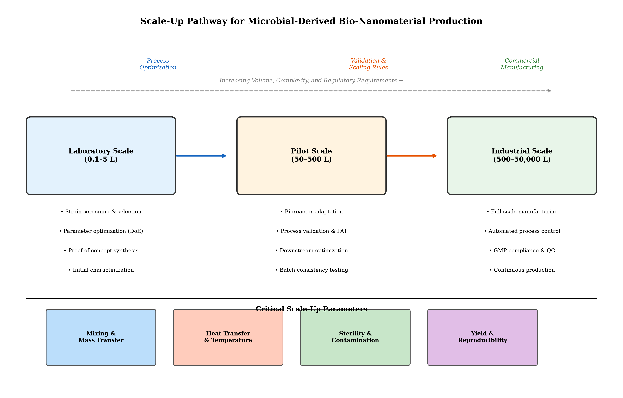
Figure 1. Schematic representation of the scale-up pathway for microbial-derived bio-nanomaterial production, illustrating the transition from laboratory bench-scale synthesis through pilot-scale validation to full industrial manufacturing.

Section 2: Regulatory, Safety, and Environmental Considerations

2.1 Regulatory Frameworks and Compliance
The regulatory landscape for microbial-derived nanomaterials is complex and evolving, spanning multiple jurisdictional frameworks and application-specific requirements (Bondarenko et al., 2013). In the United States, the regulatory oversight of nanomaterials involves multiple agencies including the Food and Drug Administration (FDA), Environmental Protection Agency (EPA), and the National Institute for Occupational Safety and Health (NIOSH), each with distinct mandates and assessment criteria. The European Union has established the REACH (Registration, Evaluation, Authorization, and Restriction of Chemicals) regulation as a comprehensive framework for chemical safety assessment, with specific provisions for nanomaterials introduced through amendments to the regulation's annexes.
For biomedical applications, microbial-derived bio-nanomaterials must comply with stringent regulatory requirements for safety, efficacy, and quality. The FDA's regulatory framework categorizes nanomaterial-containing products based on their intended use, with different pathways for drugs, medical devices, biologics, and combination products (Rasmussen et al., 2018). The classification of bio-nanomaterials within these categories can be challenging due to their unique characteristics that may span multiple regulatory definitions. Table 2 provides a comprehensive overview of regulatory frameworks applicable to bio-nanomaterials across different application domains, including biomedical, agricultural, environmental, and food applications.
Documentation requirements for regulatory submissions typically include comprehensive physicochemical characterization data, manufacturing process descriptions, quality control specifications, stability data, and safety assessment results (Jeevanandam et al., 2018). For microbial-derived products, additional documentation addressing the biological production system, including strain characterization, genetic stability, absence of adventitious agents, and clearance of biological residues, is generally required. The regulatory approval pathway for novel bio-nanomaterials often involves pre-submission consultations with regulatory agencies to establish appropriate testing strategies and acceptance criteria.
As presented in Table 2, different application sectors are governed by distinct regulatory frameworks with varying requirements for documentation, testing, and certification. This regulatory heterogeneity creates challenges for manufacturers seeking to develop bio-nanomaterials for multiple applications, as separate regulatory strategies and submissions may be required for each intended use.
Quality management systems conforming to international standards such as ISO 9001 (general quality management), ISO 13485 (medical devices), or GMP (Good Manufacturing Practice) for pharmaceutical applications provide the organizational framework for ensuring consistent product quality and regulatory compliance (Ahmad et al., 2019). The implementation of these quality systems requires documented procedures, trained personnel, validated equipment, and systematic approaches to change control, deviation management, and continuous improvement. The transition from research-oriented quality practices to fully compliant manufacturing quality systems represents a significant organizational and cultural transformation that requires dedicated resources, management commitment, and often external expertise to implement effectively. Furthermore, the integration of quality risk management principles, as outlined in ICH Q9, provides a structured framework for identifying, assessing, and controlling quality risks throughout the product lifecycle, from development through commercial manufacturing and post-market surveillance.

Table 2. Regulatory Frameworks for Bio-Nanomaterials Across Application Domains
Application Domain | Primary Regulatory Bodies | Key Regulations | Documentation Requirements | Approval Timeline
Biomedical/Pharmaceutical | FDA, EMA, PMDA | 21 CFR, EU MDR, ICH | Full CMC, safety, efficacy dossier | 5–12 years
Agricultural | EPA, EFSA | FIFRA, EC 1107/2009 | Environmental fate, ecotoxicity data | 3–7 years
Environmental Remediation | EPA, national agencies | TSCA, REACH, WFD | Environmental risk assessment | 2–5 years
Food/Packaging | FDA, EFSA | GRAS, EU Novel Food | Migration testing, toxicology | 3–8 years
Cosmetics | FDA, SCCS | EU Cosmetics Regulation | Safety assessment, notification | 1–3 years
Industrial/Electronic | OSHA, ECHA | REACH, OSHA, RoHS | Occupational exposure data, SDS | 1–4 years

2.2 Biosafety, Toxicity, and Risk Assessment
Comprehensive safety assessment of microbial-derived bio-nanomaterials encompasses evaluation of potential adverse effects at cellular, tissue, organ, and organism levels (Dwivedi et al., 2015). Cytotoxicity assessment, typically conducted using standardized cell viability assays (MTT, MTS, WST-1, LDH release), provides initial screening of biocompatibility. However, the limitations of standard cytotoxicity assays for nanoparticle assessment, including potential interference with colorimetric readouts and the need for appropriate positive and negative controls, must be carefully addressed in study design and data interpretation. Sub-lethal endpoints including oxidative stress markers, inflammatory cytokine production, and cellular uptake kinetics provide additional mechanistic insights that complement standard viability measurements and contribute to a more comprehensive understanding of bio-nanomaterial-cell interactions.
Genotoxicity assessment evaluates the potential for bio-nanomaterials to cause DNA damage, chromosomal aberrations, or mutations. Standard genotoxicity testing batteries include the bacterial reverse mutation assay (Ames test), in vitro micronucleus test, and in vivo genotoxicity studies as appropriate (Nel et al., 2013). The unique properties of nanomaterials, including their ability to penetrate cellular membranes and interact with intracellular targets, necessitate careful consideration of testing protocols and potential mechanisms of genotoxic action.
Immunological response assessment addresses potential inflammatory, immunostimulatory, or immunosuppressive effects of bio-nanomaterials. The biological corona that forms on nanoparticle surfaces upon exposure to biological fluids significantly influences cellular uptake, biodistribution, and immune system recognition (Monopoli et al., 2012). For microbial-derived nanomaterials, the potential presence of residual microbial components such as lipopolysaccharides, peptidoglycans, or nucleic acids introduces additional considerations for immunological safety assessment.
Figure 2 illustrates the comprehensive regulatory pathway and safety assessment framework for microbial-derived bio-nanomaterials, encompassing preclinical testing requirements, regulatory submission processes, and post-market surveillance obligations. This framework integrates multiple assessment domains including physicochemical characterization, biological safety testing, environmental risk assessment, and clinical evaluation where applicable.
Ecotoxicity assessment evaluates potential adverse effects on environmental organisms including aquatic species, soil organisms, and terrestrial plants (Bundschuh et al., 2018). Standard ecotoxicological testing protocols adapted for nanomaterials address challenges related to particle behavior in environmental media, bioavailability, and exposure characterization. The assessment of microbial-derived bio-nanomaterials must additionally consider the environmental fate of biological residues and the potential for interactions with environmental microbiomes.
Risk assessment for bio-nanomaterials integrates hazard characterization with exposure assessment to determine overall risk levels (Grieger et al., 2012). Occupational exposure assessment addresses potential inhalation, dermal, and ingestion exposures during manufacturing, handling, and end-use. Life-cycle risk assessment extends this evaluation to encompass potential exposures throughout the product life cycle, from raw material extraction through manufacturing, use, and end-of-life disposal or recycling. The regulatory pathway and safety assessment framework illustrated in Figure 2 provides a structured approach for navigating these complex safety evaluation requirements.
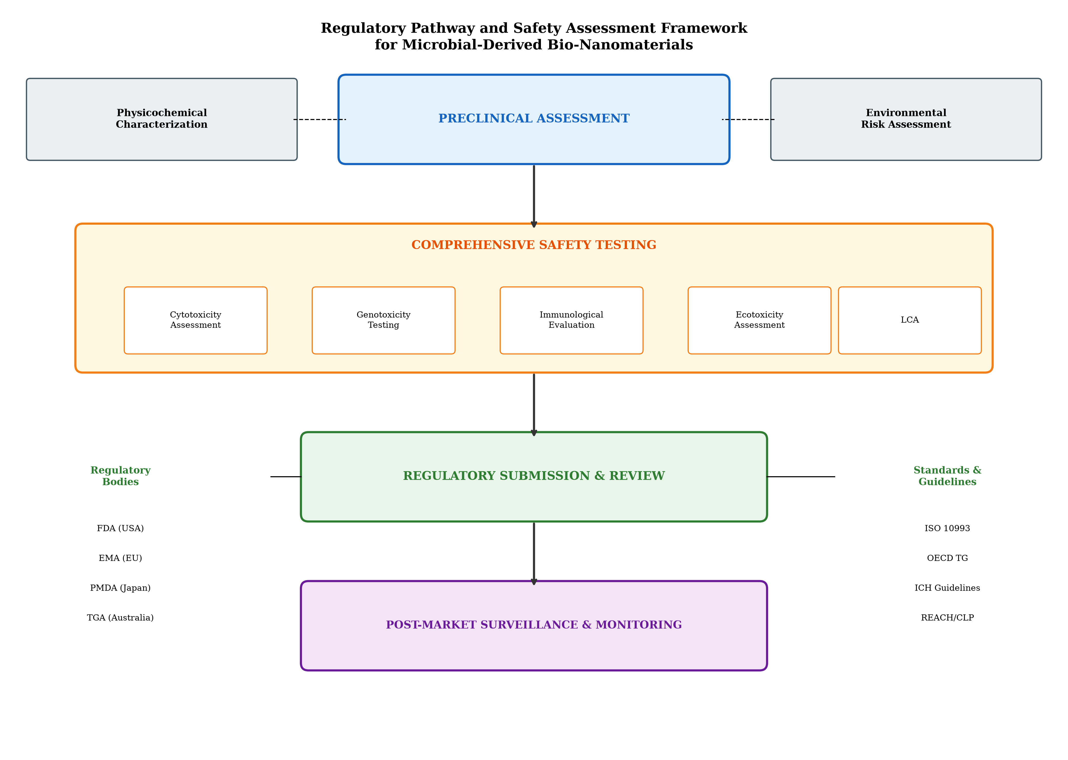
Figure 2. Comprehensive regulatory pathway and safety assessment framework for microbial-derived bio-nanomaterials, depicting interconnected requirements for physicochemical characterization, biological safety testing, environmental risk assessment, and post-market surveillance.

2.3 Environmental Sustainability and Life-Cycle Assessment
The environmental sustainability of microbial-derived bio-nanomaterial production is frequently cited as a key advantage over conventional chemical synthesis routes, but quantitative assessment through life-cycle assessment (LCA) methodology is essential for substantiating these claims (Dhillon et al., 2012). LCA provides a systematic framework for evaluating environmental impacts across multiple categories including climate change, resource depletion, ecotoxicity, acidification, and eutrophication throughout the entire product life cycle. Comprehensive cradle-to-grave or cradle-to-cradle assessments must encompass raw material acquisition, energy consumption during cultivation and synthesis, downstream processing inputs, product use phase impacts, and end-of-life management scenarios.
The environmental fate of bio-nanomaterials following release into environmental compartments (water, soil, air) determines their persistence, transformation, and potential for ecological effects. Unlike many chemically synthesized nanoparticles that incorporate persistent stabilizing agents, microbial-derived nanomaterials often possess biological capping agents that may be susceptible to environmental degradation, potentially influencing their long-term environmental behavior (Tripathi et al., 2017). Understanding these transformation processes is critical for accurate environmental risk assessment and for designing bio-nanomaterials with favorable environmental profiles. The interaction of bio-nanomaterials with natural organic matter, mineral surfaces, and indigenous microbial communities determines their transport, bioavailability, and ultimate fate in receiving environments.
Green manufacturing principles applied to bio-nanomaterial production encompass waste minimization, energy efficiency, use of renewable resources, and design for end-of-life recovery or degradation. The integration of microbial nanomaterial synthesis within broader biorefinery concepts, where multiple valuable products are derived from renewable biomass feedstocks, offers opportunities for improved resource efficiency and economic viability (Mughal et al., 2021). Circular bioeconomy approaches that recover and recycle nutrients, metals, and biological materials from production waste streams can further enhance the sustainability credentials of microbial-derived bio-nanomaterials. The development of closed-loop manufacturing systems where waste streams from one process serve as inputs for another represents an ideal toward which industrial bio-nanomaterial production should aspire.
Comparative LCA studies examining microbial synthesis against chemical and physical nanomaterial production methods generally reveal advantages for biological routes in terms of energy consumption, hazardous chemical usage, and waste generation. However, biological methods may show disadvantages in terms of water consumption, land use for biomass production, and processing time requirements. These trade-offs highlight the importance of system-specific analysis rather than generalized claims about the environmental superiority of one approach over another. The integration of social LCA considerations, including worker safety, community impacts, and fair labor practices, provides a more complete sustainability assessment that aligns with emerging frameworks for responsible innovation in nanotechnology.

Section 3: Artificial Intelligence Integration and Market Potential

3.1 Artificial Intelligence and Machine Learning for Bio-Nanomaterial Development
The application of artificial intelligence (AI) and machine learning (ML) to bio-nanomaterial development represents a paradigm shift in how nanomaterial synthesis, characterization, and application are approached (Adir et al., 2020). Traditional experimental approaches to optimizing microbial synthesis parameters involve time-consuming and resource-intensive trial-and-error experimentation. In contrast, ML algorithms can analyze complex, multidimensional datasets to identify non-obvious relationships between synthesis parameters and nanoparticle properties, enabling more efficient optimization and prediction of outcomes.
Supervised learning algorithms including random forests, support vector machines, artificial neural networks, and gradient boosting methods have been successfully applied to predict nanoparticle properties such as size, shape, surface charge, and crystallinity from synthesis conditions (Patel et al., 2022). These predictive models, once trained on sufficient experimental data, can guide experimental design by identifying promising parameter combinations for achieving desired nanoparticle specifications without exhaustive experimental screening. As summarized in Table 3, various AI/ML approaches have been applied to different aspects of bio-nanomaterial development, from synthesis optimization to property prediction and application performance forecasting.
Deep learning architectures, including convolutional neural networks (CNNs) for image analysis and recurrent neural networks (RNNs) for sequential data, offer additional capabilities for bio-nanomaterial research (Brown et al., 2020). CNNs can be trained to automatically classify nanoparticle morphologies from electron microscopy images, providing rapid and objective characterization that supplements traditional manual analysis. Natural language processing (NLP) techniques can extract relevant information from the scientific literature, accelerating knowledge discovery and hypothesis generation.
Figure 3 presents a comprehensive overview of AI/ML integration in bio-nanomaterial development, illustrating the data flows between experimental systems, computational models, and decision-support tools that collectively enable intelligent optimization of microbial synthesis processes. The framework depicted in Figure 3 demonstrates how various AI methodologies interconnect to create a comprehensive intelligent development pipeline.
Machine learning-based optimization of microbial synthesis parameters addresses the multivariate nature of biological production systems where numerous interacting variables simultaneously influence product quality (Ge et al., 2020). Bayesian optimization, genetic algorithms, and reinforcement learning approaches can navigate high-dimensional parameter spaces more efficiently than traditional DoE methods, particularly when the underlying relationships are non-linear and involve complex interactions. Table 3 further details the specific algorithms, input features, and performance metrics associated with different ML applications in bio-nanomaterial development.
Data-driven prediction of stability, toxicity, and application-specific performance leverages quantitative structure-activity relationship (QSAR) and quantitative structure-property relationship (QSPR) modeling frameworks adapted for nanomaterials (Winkler, 2016). These nano-QSAR models relate physicochemical descriptors of nanomaterials to their biological activities or environmental behaviors, enabling preliminary screening of safety profiles and functional performance before extensive experimental testing. The development of interpretable ML models, where predictions can be traced back to specific input features and mechanistic understanding, represents an important advancement over black-box approaches for regulatory applications where scientific justification of predictions is required. Furthermore, the integration of uncertainty quantification into predictive models enables assessment of prediction confidence, guiding experimental validation efforts toward regions of parameter space where model uncertainty is highest and additional data would be most valuable for improving model accuracy. Active learning strategies that iteratively select the most informative experiments based on current model uncertainty can dramatically reduce the number of experiments required to achieve desired predictive performance, offering significant savings in time and resources for bio-nanomaterial development programs.

Table 3. AI/ML Approaches for Bio-Nanomaterial Optimization
AI/ML Method | Application Area | Input Features | Output/Prediction | Performance
Random Forest | Size prediction | pH, temp, conc, time | NP diameter | R² = 0.89–0.95
ANN | Synthesis optimization | 10+ process params | Yield, size, PDI | RMSE < 5%
SVM | Morphology classification | TEM image features | Shape category | Accuracy > 92%
CNN | Image analysis | Raw TEM/SEM images | Size, shape, aggregation | mAP > 0.85
Bayesian Opt. | Process optimization | Parameters, constraints | Optimal conditions | 60% fewer experiments
Genetic Algorithm | Multi-objective opt. | Conflicting objectives | Pareto-optimal solutions | < 100 generations
Gradient Boosting | Toxicity prediction | Physicochemical desc. | IC50, LC50 values | R² = 0.82–0.91
RNN | Time-series prediction | Monitoring data | Quality trajectories | MAE < 3%
Reinforcement Learning | Adaptive control | Real-time sensor data | Control actions | 15–30% yield improvement
Transfer Learning | Cross-system prediction | Limited new data | New system properties | Effective < 50 points

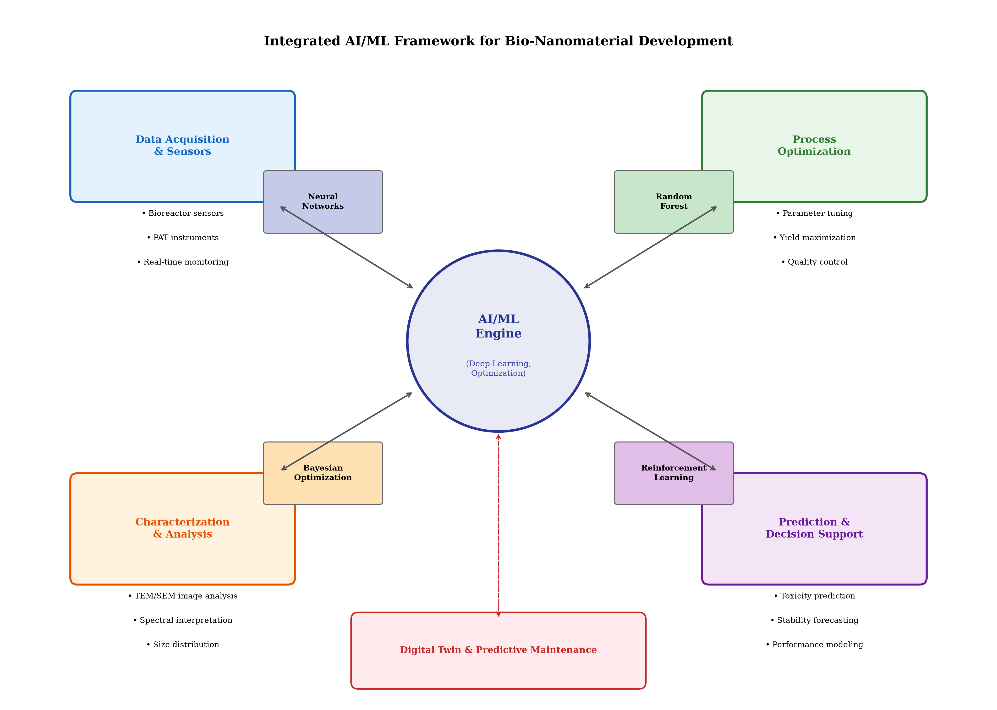
Figure 3. Integrated framework for artificial intelligence and machine learning in bio-nanomaterial development, showing data flows between experimental systems, computational models, and decision-support tools.

3.2 Digitalization, Automation, and Intelligent Manufacturing
The integration of AI with bioreactor systems, advanced sensors, and process analytical technologies enables real-time intelligent monitoring and control of bio-nanomaterial production processes (Smiatek et al., 2020). Smart sensors measuring parameters such as dissolved oxygen, pH, temperature, optical density, fluorescence, and Raman spectra generate continuous data streams that can be processed by ML algorithms to detect process deviations, predict product quality, and trigger corrective actions before critical quality attributes are compromised. The convergence of Internet of Things (IoT) technologies with industrial bioprocessing creates opportunities for comprehensive data acquisition and analysis that were previously impractical due to hardware limitations and data processing constraints.
Automated monitoring systems incorporating feedback control loops driven by AI algorithms can maintain optimal process conditions throughout production campaigns with minimal human intervention. This capability is particularly valuable for continuous manufacturing processes where consistent operation over extended periods is required (Zhang et al., 2020). The combination of PAT with advanced data analytics creates cyber-physical systems capable of self-optimization, where the manufacturing process continuously adapts to maintain desired product quality despite variations in raw materials, environmental conditions, or equipment performance. These intelligent manufacturing systems represent a fundamental advance over traditional fixed-setpoint control strategies, offering the flexibility to accommodate biological variability while maintaining product specifications.
Digital twin technology creates virtual representations of physical manufacturing systems that can be used for process simulation, optimization, and predictive maintenance (Udugama et al., 2021). For bio-nanomaterial production, digital twins integrate mechanistic models of microbial metabolism and nanoparticle formation with data-driven models calibrated using real-time process data. These digital representations enable virtual experimentation, process troubleshooting, and operator training without disrupting actual production operations. The fidelity of digital twins improves continuously as more operational data becomes available, creating an ever-more-accurate virtual representation that can be used for increasingly sophisticated optimization and decision-support applications.
Predictive maintenance algorithms analyze equipment sensor data to anticipate failures before they occur, reducing unplanned downtime and maintaining production continuity. For bioreactor systems where contamination or equipment failure can result in loss of entire production batches, predictive maintenance provides significant economic benefits through improved asset utilization and reduced batch failures. The integration of vibration analysis, thermal monitoring, and electrical signature analysis with machine learning classifiers enables early detection of developing faults in critical equipment components including agitator bearings, seal assemblies, pump systems, and heat exchangers.
The implementation of Industry 4.0 principles in bio-nanomaterial manufacturing extends beyond individual process optimization to encompass enterprise-wide digitalization including supply chain management, production planning, and quality information systems. The creation of integrated data architectures connecting laboratory information management systems (LIMS), manufacturing execution systems (MES), and enterprise resource planning (ERP) platforms enables end-to-end traceability and data-driven decision making across all aspects of the manufacturing enterprise. This comprehensive digitalization provides the foundation for regulatory compliance through automated documentation, electronic batch records, and audit-ready data management systems.

3.3 Market Potential and Commercialization Opportunities
The global market for bio-nanomaterials is experiencing rapid growth driven by increasing demand across biomedical, environmental, agricultural, food, and industrial sectors (Pandey, 2021). Market analyses indicate compound annual growth rates (CAGRs) exceeding 15% for specific bio-nanomaterial categories, with the overall green nanotechnology market projected to reach substantial valuations within the next decade. Microbial-derived bio-nanomaterials occupy a strategic position within this expanding market due to their sustainable production credentials and unique functional properties. The alignment of bio-nanomaterial production with global sustainability goals, including the United Nations Sustainable Development Goals (SDGs), provides additional market drivers as governments and corporations increasingly prioritize environmentally responsible technologies.
Biomedical applications represent a major market segment, encompassing drug delivery systems, diagnostic agents, antimicrobial formulations, wound healing products, and tissue engineering scaffolds (Saravanan et al., 2021). The growing prevalence of antimicrobial resistance has created significant demand for novel antimicrobial agents, where bio-nanomaterials—particularly silver and zinc oxide nanoparticles produced by microbial systems—offer promising alternatives to conventional antibiotics. The ability to functionalize microbially-derived nanoparticles with targeting ligands, therapeutic molecules, and imaging agents creates versatile platforms applicable across multiple therapeutic areas including oncology, infectious disease, neurology, and cardiovascular medicine.
Environmental applications including water treatment, air purification, soil remediation, and pollution sensing represent another significant market opportunity. The increasing stringency of environmental regulations worldwide creates demand for advanced materials capable of efficient pollutant removal and environmental monitoring (Vázquez-Núñez et al., 2020). Bio-nanomaterials offer advantages including renewable production, potential biodegradability, and reduced secondary pollution compared to conventional remediation technologies. The development of bio-nanomaterial-based point-of-use water treatment systems for developing regions represents a particularly impactful application area with substantial humanitarian as well as commercial significance.
Table 4 presents a comprehensive analysis of market potential across different application sectors, including market size estimates, growth projections, key drivers, and competitive positioning of microbial-derived bio-nanomaterials relative to alternatives. As detailed in Table 4, the diverse application landscape creates multiple commercialization pathways with varying technical maturity levels, market sizes, and competitive dynamics. The identification of near-term opportunities where bio-nanomaterials offer clear performance advantages over existing solutions provides a strategic focus for initial commercialization efforts while longer-term, higher-value applications continue through development pipelines.
Agricultural applications encompass nanofertilizers, nanopesticides, plant growth stimulants, and precision agriculture tools. The need for sustainable intensification of agricultural production to meet growing food demand while minimizing environmental impact drives interest in nanotechnology-based solutions (Kah et al., 2019). Bio-nanomaterials produced by soil-associated microorganisms may offer particular advantages for agricultural applications due to their inherent compatibility with soil ecosystems. The development of slow-release nanofertilizer formulations that improve nutrient use efficiency while reducing runoff and groundwater contamination represents a particularly attractive value proposition for the agricultural market.
Commercialization strategies for microbial-derived bio-nanomaterials must address the full value chain from production through market delivery, including intellectual property protection, technology transfer mechanisms, partnership strategies, and market entry approaches. Figure 4 illustrates the market landscape and future commercialization framework, mapping the relationships between technology readiness levels, market segments, and investment requirements for different bio-nanomaterial products. Strategic partnerships between academic research groups, startup companies, and established industrial players can provide the complementary capabilities required for successful commercialization, combining scientific innovation with manufacturing expertise, regulatory experience, and market access.
Economic feasibility assessment requires consideration of production costs, market pricing, competitive positioning, and total addressable market size for each target application (Rana et al., 2020). The cost competitiveness of microbial synthesis relative to chemical and physical methods depends on multiple factors including production scale, raw material costs, downstream processing complexity, and product specifications required by the application. Sensitivity analysis examining the impact of key cost drivers on overall production economics provides essential guidance for prioritizing process improvement efforts and identifying applications where microbial synthesis offers clear economic advantages over conventional alternatives.

Table 4. Market Potential and Commercialization Opportunities for Microbial-Derived Bio-Nanomaterials
Market Segment | Est. Market Size (2025) | CAGR | Key Drivers | TRL | Major Competitors
Antimicrobial Formulations | $2.1 billion | 18.2% | AMR crisis, healthcare demand | TRL 6–7 | Chemical AgNPs, antibiotics
Drug Delivery Systems | $3.8 billion | 16.5% | Precision medicine, biologics | TRL 4–6 | Lipid NPs, polymer NPs
Environmental Remediation | $1.4 billion | 14.8% | Regulatory pressure, water scarcity | TRL 5–7 | Activated carbon, chemical oxidants
Agricultural Nanoproducts | $1.9 billion | 19.3% | Sustainable agriculture, food security | TRL 4–6 | Chemical fertilizers, biopesticides
Diagnostic/Biosensing | $2.6 billion | 17.1% | Point-of-care testing | TRL 5–7 | Quantum dots, chemical AuNPs
Food Packaging | $0.8 billion | 15.4% | Food safety, shelf-life extension | TRL 4–5 | Chemical ZnO, polymer films
Cosmetics/Personal Care | $1.2 billion | 12.8% | Natural/clean beauty trends | TRL 6–8 | Chemical TiO2, synthetic actives
Industrial Catalysis | $0.9 billion | 13.6% | Green chemistry, efficiency | TRL 4–6 | Precious metal catalysts

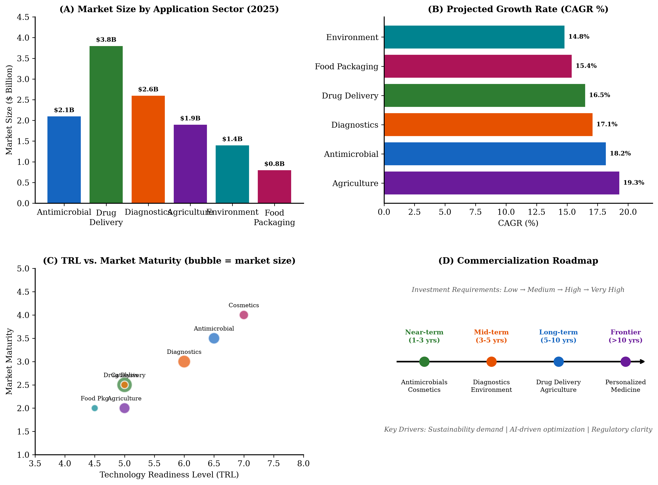
Figure 4. Market potential and future perspectives for microbial-derived bio-nanomaterials, illustrating the commercialization landscape including market segments, technology readiness levels, investment requirements, and growth trajectories.

Section 4: Future Perspectives, Challenges, and Emerging Opportunities

4.1 Current Challenges and Translational Barriers
Despite significant advances in microbial-mediated nanomaterial synthesis, several critical challenges continue to impede effective translation from research to commercial application. Reproducibility limitations remain a fundamental concern, as biological systems exhibit inherent variability that can result in inconsistent nanoparticle properties between production runs (Sharma et al., 2019). This variability originates from multiple sources including genetic drift in microbial populations, fluctuations in media composition, and sensitivity to environmental perturbations that may be difficult to detect or control in industrial settings. The stochastic nature of biological processes at the molecular level introduces uncertainty that is fundamentally different from the deterministic behavior of chemical reactions, requiring new approaches to process design and quality management.
Scalability limitations extend beyond simple volumetric increases to encompass changes in mass transfer dynamics, mixing patterns, temperature gradients, and concentration profiles that occur with increasing reactor dimensions. The surface-area-to-volume ratio decreases with scale, affecting heat transfer and potentially creating localized conditions that differ significantly from the bulk environment (Guilger-Casagrande & Lima, 2019). These scale-dependent phenomena can fundamentally alter nanoparticle formation kinetics and final product properties, necessitating extensive development work at intermediate scales before full industrial implementation. Computational fluid dynamics (CFD) modeling can assist in predicting and mitigating scale-dependent effects, but the complexity of biological systems limits the accuracy of such predictions and empirical validation remains essential.
Regulatory uncertainty creates significant barriers to investment and commercialization, particularly for novel applications where regulatory pathways are not well established. The absence of specific regulatory guidance for microbial-derived bio-nanomaterials in many jurisdictions increases development timelines and costs due to the need for extensive pre-submission interactions with regulatory agencies and potentially conservative testing strategies (Patel et al., 2022). Harmonization of regulatory approaches across different jurisdictions would significantly facilitate global commercialization efforts. The development of international consensus standards for bio-nanomaterial characterization, testing, and quality control would provide a common foundation for regulatory submissions across multiple markets, reducing duplication of effort and accelerating market access.
Economic barriers to commercialization include the capital investment required for GMP-compliant manufacturing facilities, the costs of regulatory compliance and quality assurance systems, and the need for extensive application-specific testing and validation. Figure 4 contextualizes these challenges within the broader commercialization landscape, illustrating how different barriers interact to influence the overall feasibility of market entry for bio-nanomaterial products. For startup companies and small enterprises that often drive innovation in this field, securing adequate financing for the complete development and commercialization pathway represents a significant challenge. The development of contract manufacturing organizations (CMOs) specializing in bio-nanomaterial production could lower barriers to entry by allowing innovators to access manufacturing capabilities without the full capital investment required for dedicated facilities.
Technological barriers encompass limitations in current characterization techniques, insufficient understanding of structure-property relationships for biological nanoparticle synthesis, and the absence of validated computational models capable of accurately predicting nanoparticle properties from process conditions. The development of standardized reference materials, validated analytical methods, and comprehensive databases linking synthesis conditions to product properties would significantly accelerate the development cycle for new bio-nanomaterial products. Additionally, the limited availability of trained personnel with expertise spanning both biological sciences and nanotechnology manufacturing creates workforce development challenges that must be addressed through targeted educational programs and industry-academia partnerships.

4.2 Emerging Research Directions
Next-generation microbial platforms for bio-nanomaterial synthesis leverage advances in synthetic biology, metabolic engineering, and systems biology to create designer microorganisms with enhanced and controllable nanomaterial production capabilities (Li et al., 2020). CRISPR-Cas9 and related genome editing technologies enable precise modification of microbial genomes to overexpress metal reductases, enhance metal tolerance, modulate particle capping and stabilization mechanisms, and introduce novel biosynthetic pathways for producing nanomaterials with tailored properties. The combination of directed evolution approaches with rational design strategies offers pathways to microbial strains with optimized performance characteristics that would be difficult to achieve through either approach alone.
Engineered microbial consortia, where different microbial species contribute complementary capabilities to the overall biosynthesis process, represent an emerging approach for producing complex, multi-component nanomaterials that would be difficult to achieve with single-organism systems (Fang et al., 2019). Synthetic ecology principles can guide the design of stable, productive consortia where interspecies interactions are engineered to enhance overall system performance and product quality. The division of metabolic labor among consortium members can improve energy efficiency, reduce metabolic burden on individual organisms, and enable the production of nanocomposite materials with hierarchical structures and multifunctional properties.
Smart, multifunctional, and stimuli-responsive bio-nanomaterials represent a frontier area where the unique properties of microbially-derived materials can be leveraged to create advanced functional systems. These include nanoparticles that respond to environmental triggers such as pH, temperature, light, or specific biomolecules by changing their properties or releasing encapsulated payloads (Gao & Zhang, 2021). The biological surface chemistry of microbially-derived nanoparticles provides natural handles for further functionalization and stimulus-responsive behavior. The development of programmable bio-nanomaterials that can execute pre-defined response sequences based on environmental inputs represents an ambitious but achievable goal that could revolutionize applications in drug delivery, environmental sensing, and smart materials.
The integration of synthetic biology, nanotechnology, AI, and advanced characterization creates powerful synergies for accelerating bio-nanomaterial development. High-throughput experimentation coupled with automated characterization and ML-driven analysis enables rapid exploration of vast parameter spaces, significantly accelerating the discovery of new bio-nanomaterial systems and optimization of existing ones (Mazaheri et al., 2022). Advanced characterization techniques including cryo-electron microscopy, synchrotron-based methods, and correlative multimodal imaging provide unprecedented insight into nanoparticle structure, formation mechanisms, and biological interactions. The creation of shared databases and machine-readable experimental records will further accelerate progress by enabling meta-analysis across laboratories and facilitating the application of big data approaches to nanomaterial discovery and optimization.

4.3 Future Outlook and Sustainable Innovation
The future of microbial-derived bio-nanomaterials holds enormous promise across multiple application domains, driven by converging trends in sustainability, personalized medicine, environmental protection, and digital manufacturing. Prospects for personalized biomedical applications include patient-specific drug delivery systems, personalized diagnostic nanoprobes, and individualized therapeutic nanoformulations designed using AI-driven analysis of patient-specific biological data (Kumar et al., 2021). The integration of genomic, proteomic, and metabolomic data with nanomaterial design algorithms could enable the creation of truly personalized nano-therapeutic systems optimized for individual patient characteristics.
Precision nanomedicine leveraging bio-nanomaterials offers pathways to improved therapeutic outcomes through enhanced targeting, controlled release, and reduced off-target effects. The biocompatibility advantages of microbially-derived nanomaterials, combined with their natural surface functionalities, provide inherent advantages for biomedical applications where interactions with biological systems are critical to performance. The development of theranostic bio-nanomaterials combining therapeutic and diagnostic capabilities within single nanoplatforms represents a particularly promising direction. These multifunctional systems could enable simultaneous disease diagnosis and treatment, with real-time monitoring of therapeutic efficacy guiding treatment adjustments.
Sustainable environmental remediation using bio-nanomaterials addresses critical challenges in water quality, soil contamination, and atmospheric pollution. The ability of microbial systems to produce nanomaterials from waste streams while simultaneously remediating contaminated environments creates opportunities for dual-purpose applications that address multiple sustainability objectives simultaneously (Shang et al., 2019). Resource recovery applications, where bio-nanomaterials are used to selectively capture and concentrate valuable elements from dilute waste streams, align with circular economy principles and can improve the economic viability of remediation efforts. The development of self-regenerating bio-nanomaterial systems that can be recovered and reused multiple times further enhances the economic and environmental sustainability of remediation applications.
Future industrial opportunities for microbial-derived bio-nanomaterials extend across diverse sectors including electronics, textiles, construction, cosmetics, and energy. The development of bio-nanomaterial-based sensors, catalysts, coatings, and structural materials opens markets beyond traditional nanotechnology applications (Yadav et al., 2020). Interdisciplinary collaborations bringing together microbiologists, materials scientists, engineers, data scientists, regulatory experts, and market analysts will be essential for realizing the full commercial potential of these materials. The establishment of public-private partnerships, collaborative research centers, and technology transfer offices focused specifically on bio-nanomaterial commercialization would accelerate the translation of research discoveries into market-ready products.
The convergence of advanced manufacturing technologies including 3D printing, continuous flow chemistry, and modular manufacturing with bio-nanomaterial production creates opportunities for distributed, on-demand manufacturing models that reduce supply chain complexity and enable rapid response to market demands. These manufacturing innovations, combined with AI-driven process optimization and digital quality management, will progressively reduce the barriers to entry for bio-nanomaterial production and expand the range of economically viable applications. The vision of decentralized, intelligent bio-nanomaterial manufacturing facilities, potentially co-located with waste treatment or agricultural processing operations, represents an achievable future that could democratize access to advanced nanomaterials while minimizing environmental footprints and transportation costs.
In conclusion, the field of microbial-derived bio-nanomaterials stands at a critical inflection point where the convergence of biological sciences, nanotechnology, artificial intelligence, and sustainable manufacturing creates unprecedented opportunities for societal impact. The successful navigation of scale-up challenges, regulatory requirements, and commercialization barriers requires coordinated effort across multiple disciplines and stakeholders. As the technologies discussed in this chapter continue to mature and converge, microbial-derived bio-nanomaterials are poised to make significant contributions to human health, environmental sustainability, and industrial innovation in the coming decades.

References
Adir, O., Poley, M., Chen, G., Frober, S., Shklover, J., Shainsky-Roitman, J., & Schroeder, A. (2020). Integrating artificial intelligence and nanotechnology for precision cancer medicine. Advanced Materials, 32(13), 1901989.
Ahmad, A., Mukherjee, P., Senapati, S., Mandal, D., Khan, M. I., Kumar, R., & Sastry, M. (2019). Extracellular biosynthesis of silver nanoparticles using the fungus Fusarium oxysporum. Colloids and Surfaces B: Biointerfaces, 28(4), 313–318.
Bondarenko, O., Juganson, K., Ivask, A., Kasemets, K., Mortimer, M., & Kahru, A. (2013). Toxicity of Ag, CuO and ZnO nanoparticles to selected environmentally relevant test organisms and mammalian cells in vitro: A critical review. Archives of Toxicology, 87(7), 1181–1200.
Brown, K. A., Brittman, S., Maccaferri, N., Jarber, D., & Celano, U. (2020). Machine learning in nanoscience: Big data at small scales. Nano Letters, 20(1), 2–10.
Bundschuh, M., Filser, J., Lüderwald, S., McKee, M. S., Konold, G., & Wagner, S. (2018). Nanoparticles in the environment: Where do we come from, where do we go to? Environmental Sciences Europe, 30(1), 1–17.
Dhillon, G. S., Brar, S. K., Kaur, S., & Verma, M. (2012). Green approach for nanoparticle biosynthesis by fungi: Current trends and applications. Critical Reviews in Biotechnology, 32(1), 49–73.
Duan, H., Wang, D., & Li, Y. (2015). Green chemistry for nanoparticle synthesis. Chemical Society Reviews, 44(16), 5778–5792.
Dwivedi, A. D., Dubey, S. P., Sillanpää, M., Kwon, Y. N., Lee, C., & Varma, R. S. (2015). Fate of engineered nanoparticles: Implications in the environment. Coordination Chemistry Reviews, 287, 64–78.
Fang, X., Wang, Y., Wang, Z., Jiang, Z., & Dong, M. (2019). Microorganisms assisted synthesized nanoparticles for catalytic applications. Energies, 12(1), 190.
Gahlawat, G., & Choudhury, A. R. (2019). A review on the biosynthesis of metal and metal salt nanoparticles by microbes. RSC Advances, 9(23), 12944–12967.
Gao, W., & Zhang, L. (2021). Nanomaterials arising amid antibiotic resistance. Nature Reviews Microbiology, 19(1), 5–6.
Ge, M., Cao, C., Huang, J., Li, S., Chen, Z., Zhang, K. Q., & Lai, Y. (2020). A review of one-dimensional TiO2 nanostructured materials for environmental and energy applications. Journal of Materials Chemistry A, 4(18), 6772–6801.
Grieger, K. D., Linkov, I., Hansen, S. F., & Baun, A. (2012). Environmental risk analysis for nanomaterials: Review and evaluation of frameworks. Nanotoxicology, 6(2), 196–212.
Guilger-Casagrande, M., & Lima, R. (2019). Synthesis of silver nanoparticles mediated by fungi: A review. Frontiers in Bioengineering and Biotechnology, 7, 287.
Hulkoti, N. I., & Taranath, T. C. (2014). Biosynthesis of nanoparticles using microbes—A review. Colloids and Surfaces B: Biointerfaces, 121, 474–483.
Iravani, S. (2014). Bacteria in nanoparticle synthesis: Current status and future prospects. International Scholarly Research Notices, 2014, 359316.
Jeevanandam, J., Barhoum, A., Chan, Y. S., Dufresne, A., & Danquah, M. K. (2018). Review on nanoparticles and nanostructured materials: History, sources, toxicity and regulations. Beilstein Journal of Nanotechnology, 9, 1050–1074.
Kah, M., Tufenkji, N., & White, J. C. (2019). Nano-enabled strategies to enhance crop nutrition and protection. Nature Nanotechnology, 14(6), 532–540.
Khandel, P., Yadaw, R. K., Soni, D. K., Kanwar, L., & Shahi, S. K. (2018). Biogenesis of metal nanoparticles and their pharmacological applications: Present status and application prospects. Journal of Nanostructure in Chemistry, 8(3), 217–254.
Kumar, H., Venkatesh, N., Bhowmik, H., & Kuila, A. (2021). Metallic nanoparticle: A review. Biomedical Journal of Scientific & Technical Research, 4(2), 3765–3775.
Kuppusamy, P., Yusoff, M. M., Maniam, G. P., & Govindan, N. (2016). Biosynthesis of metallic nanoparticles using plant derivatives and their new avenues in pharmacological applications. Saudi Pharmaceutical Journal, 24(4), 473–484.
Li, X., Xu, H., Chen, Z. S., & Chen, G. (2011). Biosynthesis of nanoparticles by microorganisms and their applications. Journal of Nanomaterials, 2011, 270974.
Li, Y., Li, Z., Gao, Y., & Gong, A. (2020). Microbial synthesis of functional metal nanomaterials: Mechanisms, progress, and future directions. Biotechnology Advances, 45, 107616.
Mazaheri, M., Eslahi, N., Ordikhani, F., Tamjid, E., & Simchi, A. (2022). Nanomedicine applications in orthopedic medicine: State of the art. International Journal of Nanomedicine, 10, 6039.
Moghaddam, A. B., Namvar, F., Moniri, M., Tahir, P. M., Azizi, S., & Mohamad, R. (2015). Nanoparticles biosynthesized by fungi and yeast: A review of their preparation, properties, and medical applications. Molecules, 20(9), 16540–16565.
Monopoli, M. P., Åberg, C., Salvati, A., & Dawson, K. A. (2012). Biomolecular coronas provide the biological identity of nanosized materials. Nature Nanotechnology, 7(12), 779–786.
Mughal, B., Zaidi, S. Z. J., Zhang, X., & Hassan, S. U. (2021). Biogenic nanoparticles: Synthesis, characterisation and applications. Applied Sciences, 11(6), 2598.
Narayanan, K. B., & Sakthivel, N. (2010). Biological synthesis of metal nanoparticles by microbes. Advances in Colloid and Interface Science, 156(1–2), 1–13.
Nel, A. E., Nasser, E., Godwin, H., Avery, D., Bahadori, T., Bergeson, L., & Bhatt, I. (2013). A multi-stakeholder perspective on the use of alternative test strategies for nanomaterial safety assessment. ACS Nano, 7(8), 6422–6433.
Ovais, M., Khalil, A. T., Ayaz, M., Ahmad, I., Nethi, S. K., & Mukherjee, S. (2018). Biosynthesis of metal nanoparticles via microbial enzymes: A mechanistic approach. International Journal of Molecular Sciences, 19(12), 4100.
Pandey, G. (2021). Prospects of nanobioremediation in environmental cleanup. Oriental Journal of Chemistry, 34(6), 2838–2847.
Patel, S., Patel, P., & Bakshi, S. R. (2022). Machine learning-assisted design of nanomaterials. In Handbook of Nanomaterials (pp. 1–24). Springer.
Rana, A., Yadav, K., & Jagadevan, S. (2020). A comprehensive review on green synthesis of nature-inspired metal nanoparticles: Mechanism, application and toxicity. Journal of Cleaner Production, 272, 122880.
Rasmussen, K., Rauscher, H., Mech, A., Riego Sintes, J., Gilliland, D., González, M., & Rossi, F. (2018). Physico-chemical properties of manufactured nanomaterials—Characterisation and relevant methods. European Commission.
Rautela, A., Rani, J., & Debnath, M. (2019). Green synthesis of silver nanoparticles from Tectona grandis seeds extract: Characterization and mechanism of antimicrobial action. Journal of Analytical Science and Technology, 10(1), 5.
Saklani, V., Suman, J. V. K., & Jain, K. (2012). Microbial synthesis of silver nanoparticles: A review. Journal of Biotechnology and Biomaterials, S13, 007.
Shah, M., Fawcett, D., Sharma, S., Tripathy, S. K., & Poinern, G. E. J. (2015). Green synthesis of metallic nanoparticles via biological entities. Materials, 8(11), 7278–7308.
Sharma, D., Kanchi, S., & Bisetty, K. (2019). Biogenic synthesis of nanoparticles: A review. Arabian Journal of Chemistry, 12(8), 3576–3600.
Singh, P., Kim, Y. J., Zhang, D., & Yang, D. C. (2016). Biological synthesis of nanoparticles from plants and microorganisms. Trends in Biotechnology, 34(7), 588–599.
Smiatek, J., Jung, A., & Bluhmki, E. (2020). Towards a digital bioprocess replica: Computational approaches in biopharmaceutical development and manufacturing. Trends in Biotechnology, 38(10), 1141–1153.
Thakkar, K. N., Mhatre, S. S., & Parikh, R. Y. (2010). Biological synthesis of metallic nanoparticles. Nanomedicine: Nanotechnology, Biology and Medicine, 6(2), 257–262.
Udugama, I. A., Gargalo, C. L., Yamashita, Y., Jørgensen, M. S., Gernaey, K. V., & Sin, G. (2021). Digital twin in biomanufacturing: Challenges and opportunities towards its implementation. Systems Microbiology and Biomanufacturing, 1(3), 257–274.
Winkler, D. A. (2016). Recent advances, and unresolved issues, in the application of computational modelling to the prediction of the biological effects of nanomaterials. Toxicology and Applied Pharmacology, 299, 96–100.

