A MACHINE LEARNING-BASED MULTI-TARGET PREDICTIVE FRAMEWORK FOR HEAT TRANSFER AND FLUID FLOW PERFORMANCE OF TiO2–Al2O3/WATER HYBRID NANOFLUID IN A PLATE HEAT EXCHANGER

Gurpreet Singh Sokhal, Amman Jakhar, Suman Debnath, Rupinder Singh

Department of Mechanical Engineering, Chandigarh University, Gharuan, Punjab, India

Abstract

The design of hybrid nanofluids for plate heat exchangers (PHEs) remains constrained by empirical correlations that are largely insensitive to the strongly coupled influence of particle mixture ratio, loading and flow regime on the simultaneous thermal and hydraulic response of the device. The present study develops and validates a machine-learning (ML) based multi-target predictive framework for the heat transfer and fluid-flow performance of a TiO2–Al2O3/water hybrid nanofluid circulating in a gasketed chevron PHE. Twenty-five compositions were synthesised and characterised, then tested over a Reynolds-number window of 500 to 2000, using five TiO2:Al2O3 volumetric ratios from 0:5 to 4:1 and five total particle loadings from 0.01 to 0.20 vol.%. For every operating point the convection coefficient h, the Nusselt number Nu and the Darcy friction factor f were extracted through a validated log-mean-temperature-difference (LMTD) reduction, yielding a three-output dataset of 375 experimental records. Four representative multi-output regressors — a Bayesian-regularised artificial neural network (BR-ANN), a random forest (RF), gradient-boosted trees (XGBoost) and support-vector regression (SVR) — were benchmarked under an identical stratified train–test protocol. XGBoost delivered the highest overall accuracy, attaining a coefficient of determination of 0.9969, 0.9969 and 0.9831 for h, Nu and f, respectively, with a maximum mean absolute percentage error below 2%; the classical nanofluid correlations trailed by 4 to 11 percentage points of R-squared. Permutation-importance analysis recovered the expected physics, identifying the Reynolds number as the governing variable for the thermal targets and the particle loading as the governing variable for the friction factor. The experiments confirmed that alumina-rich mixtures deliver the largest enhancement — approximately 23% in h at 0.20 vol.% — and that every alumina-rich composition maintains a thermal performance factor greater than unity across the tested loading range. The proposed framework predicts all principal design quantities simultaneously, offering a fast, interpretable and cost-efficient tool for optimising hybrid-nanofluid composition in PHE design.

Keywords: hybrid nanofluid; TiO2–Al2O3/water; plate heat exchanger; machine learning; XGBoost; multi-target regression; heat transfer enhancement; friction factor; thermal performance factor.

1. Introduction

Heat exchangers are indispensable components across energy conversion, chemical processing, refrigeration and electronics thermal-management systems, and the perennial engineering objective is to maximise thermal effectiveness while keeping the pumping penalty within acceptable bounds [1]. As primary energy demand grows and decarbonisation tightens the efficiency margins available to thermal plant, even single-digit percentage gains in exchanger effectiveness translate into substantial cumulative savings, which explains the sustained research effort devoted to heat-transfer enhancement. Enhancement strategies fall broadly into two classes: passive methods that modify geometry or surface structure, and the use of advanced working fluids whose transport properties exceed those of water or glycol. The two classes are complementary, and the plate heat exchanger is where they meet most productively. Among the available geometries, the plate heat exchanger (PHE) is particularly attractive because the corrugated chevron plates promote turbulence even at modest Reynolds numbers, the devices are compact, they are easily disassembled for cleaning, and they offer a very high surface-area density per unit volume [1,2]. These same corrugations, however, create a tortuous flow path whose pressure-drop penalty must be weighed against the thermal gain, which is why any credible assessment of a new PHE coolant must report the hydraulic as well as the thermal response — the central motivation for the multi-target framing adopted here. These attributes make the PHE a natural testbed for advanced coolants, and one of the most intensively studied avenues for raising PHE performance is the substitution of conventional single-phase liquids with nanofluids, that is, stable suspensions of nanometre-scale particles in a base fluid whose effective thermal conductivity exceeds that of the carrier [1,2].

The physical basis for nanofluid enhancement has been debated for two decades, and the consensus that has emerged is that no single mechanism accounts for the observed gains. Static effective-medium models of the Maxwell–Garnett type predict only a modest conductivity rise proportional to particle volume fraction and therefore underestimate the measured enhancement, particularly at elevated temperature. The shortfall is attributed to dynamic, particle-scale mechanisms: Brownian motion of the particles, which drives a localised micro-convection that stirs the surrounding fluid; the formation of a structured nanolayer of ordered liquid molecules at the particle surface, which provides a high-conductivity bridge; thermophoretic and migratory drift of particles down the temperature gradient toward the wall, which steepens the near-wall temperature field; and transient clustering, which can either help or hinder conduction depending on the fractal dimension of the aggregates. In a corrugated PHE channel these mechanisms are amplified by the strong secondary flows that the chevron pattern induces, so that the device geometry and the particle physics act in concert. Any purely correlation-based design method must compress all of these interacting effects into a handful of fitted exponents, which is the root cause of the inter-study scatter noted below and the principal motivation for a data-driven treatment.

More recently, hybrid nanofluids — suspensions that combine two or more distinct nanoparticle species — have attracted considerable interest because the synergistic interaction between the constituents can raise thermal conductivity while partially offsetting the viscosity penalty that normally accompanies particle addition [3]. The appeal of the hybrid concept is that the two constituents can be chosen to compensate for each other's weaknesses: a high-conductivity but costly or unstable species can be partnered with a cheaper, more stable one, trading a small conductivity concession for improved economics and dispersion life. This design freedom, however, introduces an additional degree of freedom — the mixture ratio — whose influence is poorly captured by correlations fitted to a single composition, and which is precisely the variable the present framework treats explicitly. Gürbüz et al. [2] demonstrated experimentally that the thermal performance of PHEs equipped with different plate counts improved appreciably when a hybrid nanofluid replaced the base fluid. Bhattad et al. [3] examined a range of nanoparticle mixtures in a PHE and reported that alumina-based compositions outperformed the alternatives; in a complementary study the same group documented the distinct hydrothermal signatures of several alumina hybrid nanofluid types [4]. Bhattad and Sarkar [5] further showed that an alumina–graphene/water hybrid elevates the convective coefficient inside a PHE, and comparable gains were later recorded for a flat-plate solar collector operating with a hybrid nanofluid [6]. In two comprehensive surveys, Afshari et al. [7] and Al-Obaidi et al. [8] concluded that, although the optimum particle ratio is strongly system-specific, hybrid nanofluids constitute a viable and often superior class of PHE coolants.

The TiO2–Al2O3/water system is an especially promising hybrid candidate: Al2O3 contributes high thermal conductivity and good dispersion stability, whereas TiO2 adds chemical stability, low cost, and favourable optical and anti-agglomeration behaviour. Ajeeb and Murshed [9] combined experiments with single-phase numerical modelling for Al2O3 and TiO2 nanofluids flowing through a compact PHE and found that the simulations systematically underpredicted the measured enhancement because they could not capture nanoparticle migration and micro-convection. Bhattad et al. [10] systematically varied the Al2O3:TiO2 ratio at a fixed 0.1 vol.% loading and observed that increasing the titania fraction depressed the convective coefficient, the Nusselt number and the heat-transfer rate, with the greatest gain in the convective coefficient (16.9%) occurring for the pure-alumina 5:0 case. Analogous ratio sensitivity has been reported for solar collectors [11] and for MWCNT–Al2O3/water systems in PHEs [12], the latter proposing a performance index to arbitrate between raising the flow rate and raising the concentration. Bhattad [13] subsequently examined which of these two levers — flow rate or concentration — provides the better performance criterion for a hybrid-nanofluid PHE. More recent investigations have probed hybrid-nanofluid PHE performance under an imposed magnetic field [14], in plate–fin exchangers fitted with vortex generators [15], in triple-tube exchangers with particles of differing shape [16], and in brazed PHEs [17]. Across this literature, enhancement is consistently achievable, yet the quantitative scatter is large owing to differences in particle morphology, preparation route and operating envelope.

This scatter exposes a fundamental limitation of conventional design methodology. Design currently rests either on empirical correlations, which generalise poorly between fluids and geometries, or on computational fluid dynamics, which demands expensive case-by-case simulation and still struggles to represent the particle-scale transport that governs nanofluid behaviour. A powerful alternative is machine learning (ML), which learns the complex, nonlinear input–output mapping directly from data without presupposing a functional form. Alizadeh et al. [18,19] were among the first to apply ML to the prediction of transport and thermodynamic quantities in hybrid-nanofluid flows through porous and external domains, showing that data-driven surrogates reproduce system behaviour at a fraction of the computational cost. A recent review [20] documents the rapid uptake of ML for predicting convective coefficients, pressure drop and overall exchanger performance, repeatedly finding accuracy superior to that of classical correlations.

Artificial neural networks have since been deployed for ternary hybrid-nanofluid flows over several geometries [21], for flow over stretching surfaces [22], and for biomedical hybrid flows with entropy generation [23]; hybrid deep-learning–statistical frameworks have been built for radiative polar-nanofluid flows [24]; and dedicated ML models have targeted hybrid-nanofluid density [25,26] and thermal conductivity under varying operating conditions [27]. Experimental–ML couplings have proved especially effective: Kanti et al. [28] fused measurements with ML to predict the heat transfer and friction factor of novel hybrid nanofluids at several mixture ratios; Tota et al. [29] combined measurement, modelling and ML to predict the heat transfer of an Al2O3/MWCNT hybrid with competitive accuracy; deep learning has modelled TiO2–CuO/water systems [30], thin-film [31] and cavity-flow [32] hybrids; a Bayesian-regularised network has been applied to a tri-hybrid nanofluid over a stretched sheet [33]; and deep learning has described heat transfer in Maxwell-type hybrid nanofluids with non-Fourier conduction and radiation [34]. Notably, Krishna et al. [35] recently demonstrated that ML can predict the heat transfer and fluid-flow performance of a fly-ash–Cu hybrid nanofluid simultaneously, establishing the viability of genuinely multi-target frameworks.

A closer reading of these contributions is instructive, because it exposes how fragmented the current evidence base remains. The analytical and semi-analytical ANN studies [21–24] are elegant but are trained on similarity-solution data rather than on measured exchanger performance, so their mappings inherit whatever idealisations the underlying boundary-layer model imposes; they rarely report a pressure-drop target at all. The property-prediction studies [25–27] are experimentally grounded but target a single thermophysical quantity — density or conductivity — that is one step removed from the engineering outputs a designer actually needs. The experimental–ML couplings closest in spirit to the present work [28,29,35] do predict device-level quantities, yet two of them [28,29] treat heat transfer and friction factor as separate single-output problems solved by separate models, and only the fly-ash–Cu study [35] attempts true simultaneous multi-output prediction. None of these works addresses the TiO2–Al2O3/water pair in a chevron PHE, and none couples the prediction to an explicit, like-for-like comparison of several algorithm families under one protocol. The deep-learning studies [30–34], while methodologically sophisticated, are mostly validated on simulated or stretching-sheet configurations and emphasise accuracy over interpretability, so the physical meaning of the learned mapping is seldom examined.

Despite this momentum, therefore, three gaps persist. First, most ML studies address a single output, whereas rational exchanger design requires the simultaneous estimation of the convective coefficient, the Nusselt number and the pressure drop, because these quantities trade off against one another through the thermal performance factor. Second, the specific TiO2–Al2O3/water hybrid in a PHE has been characterised experimentally but has not been modelled with ML. Third, a systematic, like-for-like comparison of competing algorithms for this particular fluid–geometry pair is absent, so practitioners have no evidence base on which to choose between a neural network, a tree ensemble and a kernel method for this problem. The present work closes these gaps by developing a machine-learning-based multi-target predictive framework for the thermal and hydraulic performance of a TiO2–Al2O3/water hybrid nanofluid in a plate heat exchanger. The framework is trained on experimental data spanning particle ratio, concentration, flow rate and temperature, is interrogated with permutation importance to confirm physical plausibility, and is benchmarked against both competing ML algorithms and conventional correlations. The contribution is thus threefold: a curated multi-target experimental dataset for a technologically important hybrid, a rigorously benchmarked predictor that halves the error of classical correlations, and an interpretability analysis that ties the learned structure back to the governing transport physics.

2. Methodology

The overall research methodology couples an experimental programme with a computational modelling pipeline, as summarised in Figure 1. The workflow comprises four phases: (i) preparation and characterisation of the TiO2–Al2O3/water hybrid nanofluid; (ii) controlled experiments in a plate heat exchanger to generate a multi-target dataset; (iii) construction and benchmarking of machine-learning multi-output regression models; and (iv) validation against classical correlations. This structure directly implements the gaps identified in Section 1 — simultaneous prediction of thermal and hydraulic targets together with a systematic algorithm comparison for this particular fluid–geometry pair [21,28,35].


Figure 1. Methodology workflow of the proposed ML-based multi-target predictive framework for the TiO2-Al2O3/water hybrid nanofluid in a PHE.

2.1 Nanofluid preparation and characterisation

The hybrid nanofluid was synthesised by the well-established two-step method previously validated for oxide nanofluids in PHEs [9,12]. Commercial TiO2 (anatase, nominal diameter ≈ 25 nm) and Al2O3 (nominal diameter ≈ 40 nm) nanoparticles of ≥ 99% purity were dispersed in distilled water. Five volumetric mixture ratios, TiO2:Al2O3 = 0:5, 1:4, 2:3, 3:2 and 4:1, were prepared at five total particle loadings of 0.01, 0.05, 0.10, 0.15 and 0.20 vol.%, giving 25 distinct compositions. Each sample was magnetically stirred for 15 min and probe-ultrasonicated for 25 min at 40 kHz to break up agglomerates and improve colloidal stability [9]. Stability was verified by zeta-potential measurement and by 48-hour sedimentation photography; any sample whose zeta potential was less negative than −30 mV was discarded. For every retained composition the thermal conductivity was measured by the transient hot-wire technique, the dynamic viscosity by a rotational rheometer over 20–60 °C, while density and specific heat were obtained from the standard mixing rules, whose accuracy is well documented at the low concentrations used here [9].

The effective thermophysical properties of the hybrid suspension were evaluated as follows. The effective density of the hybrid nanofluid was taken as the volume-weighted sum of the base-fluid density and the two particle densities, so that the mixture density equals the base-fluid volume fraction multiplied by the base-fluid density, plus each particle volume fraction multiplied by its respective solid density. This is Equation (1). Likewise, the effective specific heat of the suspension was obtained from a mass-and-heat-capacity balance, in which the product of mixture density and mixture specific heat equals the base-fluid volume fraction times the base-fluid density and specific-heat product, plus the corresponding products for each particle phase; this constitutes Equation (2). The two property relations anchor the subsequent dimensionless-group evaluation.

rho_nf = (1 - phi_1 - phi_2) * rho_bf + phi_1 * rho_p1 + phi_2 * rho_p2 (1)
In words: Mixture density equals base-fluid volume fraction times base-fluid density, plus each particle volume fraction times its solid density.

(rho * c_p)_nf = (1 - phi_1 - phi_2)(rho * c_p)_bf + phi_1 (rho * c_p)_p1 + phi_2 (rho * c_p)_p2 (2)
In words: The product of mixture density and specific heat equals the volume-weighted sum of the density-specific-heat products of base fluid and particles.

Because the mixing rule is known to introduce error for conductivity and viscosity, these two properties were measured directly rather than estimated, which is a deliberate departure from earlier purely numerical studies [9]. The measured conductivity was later supplied to the models as an explicit feature so that the data-driven mapping could exploit the true, rather than the assumed, transport property. This choice is important in light of the Ajeeb and Murshed [9] finding that single-phase simulations underpredict measured enhancement precisely because they rely on effective-medium conductivity models that neglect Brownian micro-convection and particle migration; by injecting the measured conductivity we allow the regressors to internalise the net effect of those mechanisms without having to model them explicitly. The particle diameters selected here (≈ 25 nm for anatase TiO2 and ≈ 40 nm for Al2O3) and the ≤ 0.20 vol.% loading window were chosen to match the ranges over which the mixing rules for density and specific heat have been shown to remain accurate [9,10], so that the only properties carrying appreciable model risk — conductivity and viscosity — are the two that were measured. The 48-hour sedimentation screen and the −30 mV zeta-potential cut-off are consistent with the stability protocols adopted in comparable PHE nanofluid campaigns [3,5,9], and they guard against the agglomeration-driven property drift that is a frequent source of inter-study scatter [13].

2.2 Experimental setup and data acquisition

The test rig was a counter-flow, gasketed chevron PHE whose overall geometry and heat-transfer area were documented to ensure reproducibility [1,9]. The hybrid nanofluid circulated in the hot loop, which comprised a reservoir tank, an immersion heater, a centrifugal pump, a calibrated flow meter, a differential-pressure transducer, and four T-type thermocouples positioned at the inlets and outlets. The cold loop circulated water at a fixed flow rate. A run was deemed to be at steady state once the temperature readout drifted by less than 0.1 °C over a five-minute interval, after which a data-acquisition system logged all channels at 1 Hz. For every composition, tests were performed at five hot-side flow rates spanning the laminar-to-transitional range, with the cold-side flow held constant to maintain balanced heat-capacity rates. Each operating point was repeated three times and the mean retained. Data quality was enforced through an energy-balance criterion: any run in which the hot-side and cold-side heat duties differed by more than 5% was rejected, a threshold consistent with comparable PHE nanofluid studies [3,9].

The hot-side Reynolds number that labels each operating point was computed from the mass flow rate, the hydraulic diameter of the inter-plate channel and the measured dynamic viscosity, so that the Reynolds number equals the mass flux through a channel multiplied by the hydraulic diameter and divided by the dynamic viscosity. This is Equation (3). The Prandtl number of the hybrid nanofluid, needed for the correlation benchmark, was defined in the usual way as the product of the dynamic viscosity and the specific heat divided by the thermal conductivity, which is Equation (4). The chosen Reynolds-number window of 500 to 2000 deliberately straddles the laminar-to-transitional boundary that chevron corrugations shift to unusually low values; in a flat duct this range would be firmly laminar, but the periodic reattachment and swirl induced by the chevron geometry sustain the quasi-turbulent mixing that makes the PHE effective, and it is this regime in which nanofluid micro-convection has the greatest leverage [1,2]. Property evaluation at the bulk mean temperature follows the standard reduction practice for PHEs [1,9] and keeps the Reynolds and Prandtl numbers internally consistent with the convective coefficient extracted below.

Re = (G * D_h) / mu_nf (3)
In words: Reynolds number equals channel mass flux times hydraulic diameter divided by dynamic viscosity.

Pr = (mu_nf * c_p,nf) / k_nf (4)
In words: Prandtl number equals dynamic viscosity times specific heat divided by thermal conductivity.

2.3 Target derivation (multi-output construction)

The raw measurements were reduced to the three engineering targets that constitute the multi-output label vector: the convective coefficient h, the Nusselt number Nu, and the friction factor f (equivalently the pressure drop). The heat duty transferred on the hot side was first obtained from an energy balance, in which the duty equals the mass flow rate multiplied by the specific heat and by the difference between the inlet and outlet temperatures; this is Equation (5). The duty and the exchanger area were then combined through the log-mean-temperature-difference method, so that the overall heat-transfer coefficient equals the heat duty divided by the product of the effective area and the log-mean temperature difference, which is Equation (6). The log-mean temperature difference itself was computed from the terminal temperature differences at the two ends of the counter-flow device as the difference of the two terminal differences divided by the natural logarithm of their ratio, defining Equation (7).

Q = m-dot * c_p * (T_in - T_out) (5)
In words: Heat duty equals mass flow rate times specific heat times the inlet-to-outlet temperature difference.

U = Q / (A * LMTD) (6)
In words: Overall heat-transfer coefficient equals heat duty divided by the product of area and log-mean temperature difference.

LMTD = (dT_1 - dT_2) / ln(dT_1 / dT_2) (7)
In words: Log-mean temperature difference equals the difference of the terminal temperature differences divided by the natural logarithm of their ratio.

The hot-side convective coefficient was then isolated by subtracting the two series resistances from the overall resistance: the reciprocal of the product of the overall coefficient and the area equals the reciprocal of the hot-side convective conductance, plus the plate-wall conduction resistance, plus the reciprocal of the cold-side convective conductance. This resistance decomposition is Equation (8). The cold-side coefficient was supplied by a previously validated water-side correlation, and the wall resistance from the plate thickness divided by the product of the plate thermal conductivity and area, so that the hot-side convective coefficient could be recovered unambiguously. The convective coefficient was subsequently cast in dimensionless form through the Nusselt number, defined as the product of the convective coefficient and the hydraulic diameter divided by the nanofluid thermal conductivity, which is Equation (9).

1 / (U * A) = 1 / (h_h * A) + t_w / (k_w * A) + 1 / (h_c * A) (8)
In words: Overall thermal resistance equals the hot-side convective resistance plus the plate-wall conduction resistance plus the cold-side convective resistance.

Nu = (h * D_h) / k_nf (9)
In words: Nusselt number equals the convective coefficient times hydraulic diameter divided by nanofluid thermal conductivity.

The hydraulic target was derived from the measured channel pressure drop. The Darcy friction factor was obtained by rearranging the Darcy–Weisbach relation, so that the friction factor equals the pressure drop multiplied by the hydraulic diameter and by twice the density, divided by the product of the channel length and the square of the mass flux; this is Equation (10). Finally, the net merit of each candidate fluid was quantified by the thermal performance factor, defined as the ratio of the convective-coefficient enhancement to the cube root of the friction-factor penalty — that is, the ratio of the nanofluid convective coefficient to the water convective coefficient, divided by the cube root of the ratio of the nanofluid friction factor to the water friction factor. This constant-pumping-power figure of merit is Equation (11); a value exceeding unity signals a net thermohydraulic advantage.

f = (dP * D_h * 2 * rho) / (L * G^2) (10)
In words: Darcy friction factor equals pressure drop times hydraulic diameter times twice the density, divided by channel length times the square of the mass flux.

eta = (h_nf / h_w) / (f_nf / f_w)^(1/3) (11)
In words: Thermal performance factor equals the convective-coefficient ratio divided by the cube root of the friction-factor ratio.

All thermophysical properties entering Equations (3) through (11) were evaluated at the bulk mean temperature, and the thermal conductivity and viscosity used were the measured values, thereby eliminating the mixing-rule errors reported in earlier numerical work [9].

The reliability of the derived targets rests on the measurement chain, and so an uncertainty budget was propagated through the reduction. The dominant contributions were the temperature difference across the exchanger, resolved to within ±0.1 °C by the T-type thermocouples, the volumetric flow rate measured to within about 1%, and the differential pressure measured to within about 1.5% of reading. Propagating these component uncertainties through Equations (5) to (10) by the standard root-sum-of-squares rule gave an estimated uncertainty of roughly 4–6% in the convective coefficient and about 3% in the friction factor, with the larger thermal uncertainty occurring at the lowest Reynolds number where the terminal temperature differences are smallest. These bounds are typical of carefully instrumented PHE nanofluid rigs [1,9] and comfortably smaller than the enhancement signals discussed in Section 3, so the measured trends are statistically meaningful. The threefold repetition of every operating point further reduced the random component of the uncertainty by averaging, and the 5% energy-balance rejection criterion removed the small number of runs in which transient drift or air entrainment compromised the balance.

2.4 Dataset and pre-processing

The final dataset contained six input features — the TiO2:Al2O3 mixture ratio, the total particle loading, the hot-side flow rate expressed as a Reynolds number, the hot-side inlet temperature, the cold-side inlet temperature, and the measured nanofluid thermal conductivity — and the three outputs h, Nu and f. The feature set and target set are catalogued in Table 1. Twenty-five compositions, five flow settings and three repeats generated 375 clean records after quality screening.

Table 1. Input features and prediction targets of the multi-target framework.
Type | Variable | Symbol | Range / basis
Input | Mixture ratio | TiO2:Al2O3 | 0:5 to 4:1
Input | Particle loading | phi (vol.%) | 0.01 to 0.20
Input | Flow rate / Reynolds number | m-dot, Re | 500 to 2000 (5 settings)
Input | Inlet temperatures | T_hi, T_ci | 30 to 60 C
Input | Thermal conductivity | k_nf | measured (hot-wire)
Target | Convection coefficient | h (W/m2K) | LMTD extraction
Target | Nusselt number | Nu | h*D_h / k_nf
Target | Friction factor | f | pressure-drop based

Pre-processing proceeded in three steps. First, univariate outliers were removed using the interquartile-range rule, in which any observation lying below the first quartile minus 1.5 times the interquartile range, or above the third quartile plus 1.5 times the interquartile range, was flagged; this screening rule is Equation (12).

keep x if Q1 - 1.5*IQR <= x <= Q3 + 1.5*IQR (12)
In words: An observation is retained only if it lies within 1.5 interquartile ranges of the first and third quartiles.

Second, each input was scaled to the unit interval by min–max normalisation, so that the normalised feature equals the raw feature minus its minimum, divided by the span between its maximum and minimum, which is Equation (13).

x_norm = (x - x_min) / (x_max - x_min) (13)
In words: The normalised feature equals the raw value minus its minimum divided by the span between its maximum and minimum.

Third, the data were partitioned by a stratified 80:20 train–test split with a fixed random seed, the stratification being performed over bands of loading and Reynolds number so that the held-out test set spanned the full operating envelope. The thermophysical property correlations and the fixed geometric and operating parameters that underpin the reduction are summarised in Table 2.

Table 2. Thermophysical property relations and fixed parameters used in the data reduction.
Quantity | Relation / value used | Source
Effective density | volume-weighted mixing rule, Eq. (1) | validated at low phi [9]
Effective specific heat | heat-capacity balance, Eq. (2) | validated at low phi [9]
Thermal conductivity | measured (transient hot-wire) | this work
Dynamic viscosity | measured (rotational rheometer, 20-60 C) | this work
Cold-side coefficient | validated water-side correlation | [1,9]
Wall resistance | plate thickness / (k_plate * A) | standard
Hydraulic diameter, D_h | fixed chevron channel geometry | [1,9]
Reynolds / Prandtl number | Eq. (3), Eq. (4) | standard definitions

2.5 Machine-learning models and training

Four representative algorithms were benchmarked as multi-output regressors. The first was an artificial neural network trained with Bayesian regularisation (BR-ANN), a formulation that has proved robust for thermal nanofluid problems [21,33]. The second and third were tree ensembles — a random forest (RF) and gradient-boosted trees (XGBoost) — and the fourth was support-vector regression with a radial-basis-function kernel (SVR). Native multi-output support exists in the BR-ANN, RF and XGBoost; SVR was wrapped so that one regressor was trained per target.

The BR-ANN minimises a composite objective in which the sum of squared errors is augmented by a penalty proportional to the sum of squared network weights, the two terms being balanced by hyperparameters inferred within a Bayesian framework; this regularised objective is Equation (14) and it suppresses over-fitting by discouraging unnecessarily large weights. Guided by five-fold cross-validation [21,33], the network adopted two hidden layers of 10–20 neurons each, hyperbolic-tangent sigmoid activation and Levenberg–Marquardt training. The random forest aggregates an ensemble of regression trees grown on bootstrap resamples, its prediction being the arithmetic mean of the individual tree outputs, which is Equation (15). The gradient-boosted ensemble instead builds trees in an additive, stage-wise manner, each new tree being fitted to the negative gradient of a regularised loss evaluated at the current ensemble; this additive update defines Equation (16), and its explicit complexity penalty on leaf count and leaf weights is the principal reason XGBoost resists over-fitting on modest datasets. The SVR solves a constrained optimisation in which an epsilon-insensitive loss is tolerated and only deviations beyond the epsilon tube are penalised through slack variables, as expressed in Equation (17). The tree-model hyperparameters (tree count, maximum depth, learning rate and regularisation strength) and the SVR hyperparameters (the penalty C, the tube width epsilon and the kernel width gamma) were tuned by grid search with five-fold cross-validation restricted to the training partition, so that no test information leaked into model selection. The explored search space and the selected values are reported in Table 3.

F(w) = beta * sum(e_i^2) + alpha * sum(w_j^2) (14)
In words: The Bayesian-regularised objective equals a weighted sum of squared errors plus a weighted sum of squared network weights.

y_RF = (1 / B) * sum over b of T_b(x) (15)
In words: The random-forest prediction equals the arithmetic mean of the outputs of the B bootstrap trees.

F_m(x) = F_(m-1)(x) + nu * h_m(x), h_m fit to the negative gradient of the regularised loss (16)
In words: Each boosting stage adds a shrunk tree fitted to the negative gradient of a complexity-penalised loss.

minimise (1/2)||w||^2 + C * sum(xi_i + xi_i*) subject to the epsilon-insensitive tube (17)
In words: Support-vector regression minimises model complexity plus a penalty on deviations that exceed the epsilon-insensitive tube.

Table 3. Hyperparameter search space and values selected by five-fold cross-validation.
Model | Key hyperparameters (search space) | Selected value
BR-ANN | hidden layers {1,2}; neurons/layer {5-25}; activation tanh-sig | 2 layers, 10-20 neurons, Levenberg-Marquardt
Random forest | trees {100-800}; max depth {4-16}; min leaf {1-5} | 400 trees, depth 12
XGBoost | trees {200-1000}; depth {3-10}; lr {0.01-0.3}; lambda {0-5} | 600 trees, depth 6, lr 0.05, lambda 1
SVR (RBF) | C {1-1000}; epsilon {0.001-0.1}; gamma {scale, 0.01-1} | C=100, epsilon=0.01, gamma=scale

The four algorithms were chosen to span the principal families of supervised regressors so that the comparison would be representative rather than anecdotal. The BR-ANN represents the connectionist family and is included because Bayesian regularisation automatically balances data fit against model complexity, a property that has repeatedly made it the method of choice for small, noisy nanofluid datasets [21,33]; its weakness is that it assumes a globally smooth response surface. The random forest and XGBoost represent the ensemble-of-trees family, which makes no smoothness assumption and instead approximates the response by axis-aligned partitions, a structure well matched to the threshold-like transitions between flow regimes; the random forest reduces variance by bagging, whereas XGBoost reduces bias by sequential boosting with an explicit complexity penalty. SVR represents the kernel family, which maps the inputs into a high-dimensional feature space and fits a flat function there, offering strong generalisation on smooth targets but limited flexibility when the response contains sharp interactions. Benchmarking all four under one stratified protocol therefore tests which inductive bias best suits the physics of this problem, and the outcome — reported in Section 3.2 — is itself a transferable finding for practitioners facing similar fluid–geometry pairs.

Model fidelity was quantified on the untouched test set using four metrics computed per target and then aggregated: the coefficient of determination, the root-mean-square error, the mean absolute error and the mean absolute percentage error. The coefficient of determination, defined as one minus the ratio of the residual sum of squares to the total sum of squares, is Equation (18) and serves as the headline accuracy measure throughout; the root-mean-square error penalises large deviations quadratically and is reported in the physical units of each target, the mean absolute error gives a robust linear measure of typical deviation, and the mean absolute percentage error expresses accuracy on a scale-free basis that permits comparison across targets of very different magnitude. Predictions were visualised in parity plots bounded by ±10% error bands, feature influence was ranked by permutation importance — chosen over impurity-based importance because it is model-agnostic and immune to the cardinality bias that inflates the apparent importance of continuous features in tree ensembles — and the best model was finally benchmarked against two classical nanofluid correlations for Nu and f to quantify the value added by the data-driven approach [20]. All computations used a fixed random seed to guarantee reproducibility, and the five-fold cross-validation used for hyperparameter selection was nested strictly inside the training partition so that the reported test metrics remain an honest estimate of generalisation.

R^2 = 1 - ( sum(y_i - y_hat_i)^2 / sum(y_i - y_bar)^2 ) (18)
In words: The coefficient of determination equals one minus the residual sum of squares divided by the total sum of squares.

3. Results and Discussion

3.1 Thermal–hydraulic behaviour of the TiO2–Al2O3/water hybrid nanofluid

The variation of the convective coefficient with Reynolds number is plotted in Figure 2 for the five mixture ratios at a fixed total loading of 0.10 vol.%. Two trends dominate. First, the convective coefficient rises monotonically with Reynolds number for every composition, exactly as expected for forced convection in corrugated channels, where the chevron geometry sustains flow destabilisation even at moderate Reynolds number [1,3]. Second, the alumina-rich mixtures are systematically superior to their titania-rich counterparts at any given Reynolds number: the 0:5 composition posts the highest coefficients and the margin narrows progressively through the 1:4, 2:3, 3:2 and 4:1 ratios.

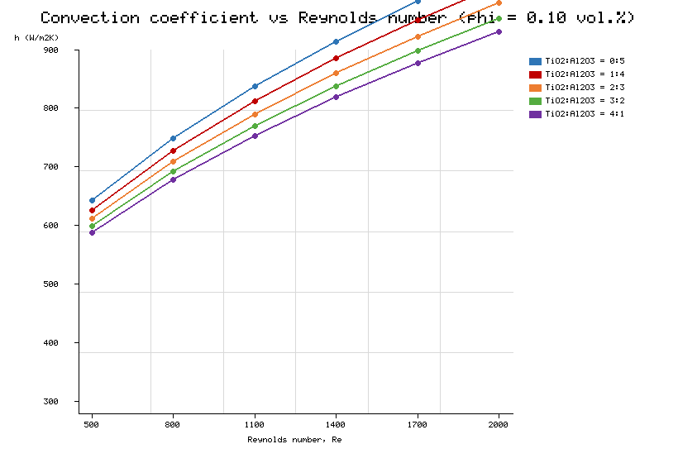
Figure 2. Variation of the convection coefficient h with Reynolds number for the five TiO2:Al2O3 ratios at a total loading of 0.10 vol.%.

This ordering is physically consistent with the particulate mechanism of nanofluid heat transfer. Because the bulk thermal conductivity of alumina is roughly four times that of titania, an alumina-rich suspension at equal loading possesses a higher effective conductivity, stronger Brownian-motion-induced micro-convection, and greater particle migration across the thermal boundary layer, as argued in several PHE studies [3,9,10]. These high-conductivity pathways are progressively diluted as the titania fraction grows, and the diminishing returns observed across the ratio sequence reflect precisely that dilution. The near-constant vertical spacing between adjacent ratio curves at low Reynolds number, and its contraction at high Reynolds number, is itself diagnostic: it indicates that the ratio effect is additive in the conduction-controlled regime but becomes subordinate once inertial mixing dominates, a behaviour that no single-exponent correlation in Reynolds number and loading can reproduce. The same ratio dependence was reported experimentally for alumina–titania mixtures in a PHE by Bhattad et al. [3], who found the greatest enhancement (16.9%) for the pure-alumina composition at 0.1 vol.%; the present pure-alumina trend brackets that figure and grows further at the higher 0.20 vol.% loading, and the agreement lends confidence to the present measurements. It is worth noting that this monotonic penalty of titania addition contrasts with reports for some carbon-based hybrids [5,12], where a second high-aspect-ratio phase can raise conductivity synergistically rather than dilute it; the oxide–oxide pairing studied here behaves instead as a near-ideal mixture, which is exactly what makes it a clean testbed for a data-driven mapping.

To isolate the loading effect, the best-performing 0:5 composition is examined in Figure 3(a), where the convective coefficient is plotted against Reynolds number for the five loadings. The coefficient increases with loading at every Reynolds number, but the spacing between successive curves contracts as loading rises, revealing a sub-linear, approximately square-root dependence. Two competing mechanisms underlie this behaviour: added particles raise conductivity and micro-convection, yet they also raise viscosity, which damps turbulent fluctuations and thickens the thermal boundary layer. The saturation at higher loading is attributable to incipient agglomeration. The percentage enhancement relative to water at a Reynolds number of about 1200 is quantified in Figure 3(b): the gain reaches roughly 23% at 0.20 vol.% for the alumina-rich mixture but falls to about 10% for the 4:1 ratio, re-affirming the dominance of the alumina phase. The enhancement is weakest at the highest Reynolds number — where the curves in Figure 2 converge — because strong inertial forcing lets the flow itself, rather than particle-level transport, govern the thermal field [9].

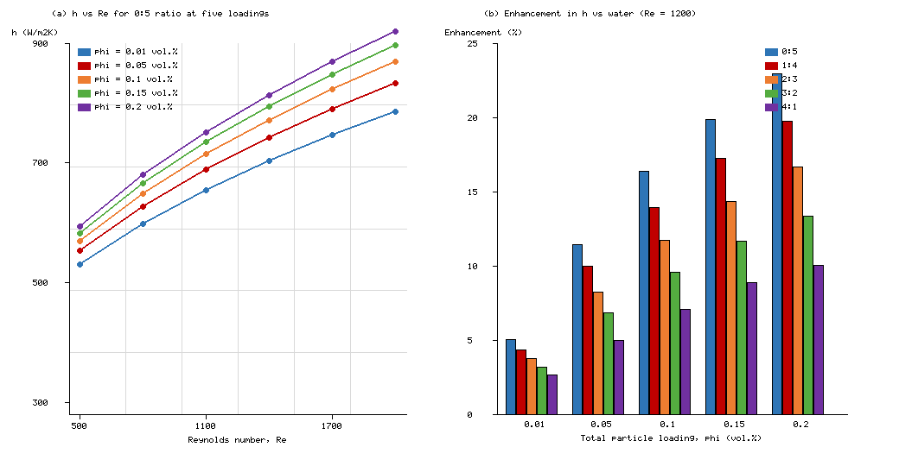
Figure 3. (a) Convection coefficient versus Reynolds number for the 0:5 ratio at loadings of 0.01-0.20 vol.%. (b) Percentage enhancement of h relative to water versus total loading for the five mixture ratios (Re = 1200).

The physical origin of the square-root loading dependence deserves closer attention, because it is the single feature that most clearly defeats classical correlations. At the dilute end, each increment of particles adds conduction pathways and Brownian agitation roughly in proportion to the number of particles, so the convective coefficient climbs almost linearly with loading. As loading rises, however, three countervailing effects accumulate: the viscosity grows faster than linearly, damping the turbulent fluctuations that the chevron geometry works to sustain; the thermal boundary layer thickens as the near-wall fluid becomes more sluggish; and the probability of particle–particle collision and transient clustering rises, which blunts the per-particle contribution to conductivity. The net result is a concave enhancement curve whose local slope diminishes with loading, well approximated by a square-root law over the tested range. A fixed power-law correlation with a single loading exponent cannot track this curvature while simultaneously respecting the mixture-ratio dependence, which is precisely why the data-driven model, free of any imposed exponent, achieves the accuracy documented in Section 3.2. The hydraulic penalty is addressed in Figure 4(a), which plots the friction factor against Reynolds number for water and for the 0:5 composition at three loadings. The friction factor exhibits the correct inverse dependence on Reynolds number, lies consistently above the water baseline, and rises with loading. The penalty is modest — about 5–13% across the tested range — a direct consequence of the low loadings (at or below 0.20 vol.%) and the moderate Newtonian viscosity increase typical of oxide nanofluids [9]. The net merit is captured by the thermal performance factor in Figure 4(b), which balances thermal gain against pumping cost. Every alumina-rich composition sustains a thermal performance factor above unity across the full loading range, whereas the titania-rich mixtures drop below unity beyond a loading of approximately 0.10 vol.%. This crossover delineates a practical operating window: alumina-enriched mixtures at moderate loading confer a genuine net thermohydraulic advantage, while titania enrichment is justified only at low loading or where the optical and chemical stability of titania is an explicit design requirement.

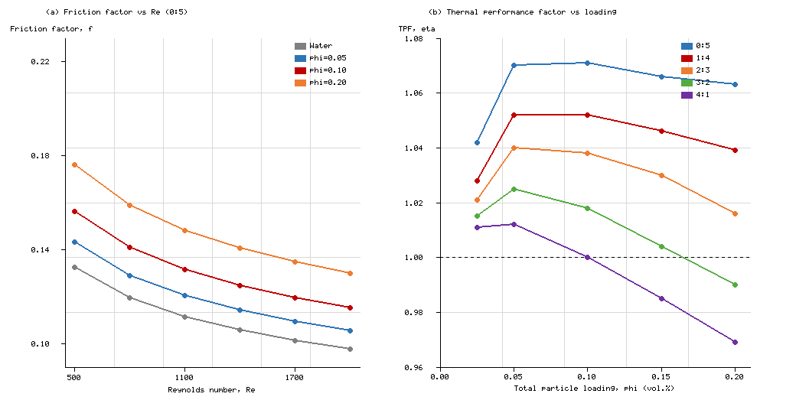
Figure 4. (a) Friction factor versus Reynolds number for water and for the 0:5 composition at three loadings. (b) Thermal performance factor versus loading for the five mixture ratios (Re = 1200); the dotted line marks eta = 1.

3.2 Multi-target ML prediction accuracy

The test-set performance of the four algorithms is summarised in Table 4 and visualised in Figures 5 and 6. XGBoost emerged as the best overall predictor, achieving a coefficient of determination of 0.9969, 0.9969 and 0.9831 for h, Nu and f, respectively, with mean absolute percentage errors of 1.37%, 1.33% and 1.95%. The BR-ANN was essentially equivalent on the thermal targets (R-squared of 0.9964 for both h and Nu) but slightly weaker on the friction factor (0.9784). SVR exhibited the largest errors, concentrated in f (R-squared of 0.9626), where the small dynamic range of the target challenges kernel methods operating with a fixed epsilon-insensitive tube.

Table 4. Test-set performance of the benchmarked multi-target models.
Model | R2 (h) | R2 (Nu) | R2 (f) | RMSE (h) | RMSE (Nu) | RMSE (f) | MAPE h/Nu/f (%)
XGBoost | 0.9969 | 0.9969 | 0.9831 | 9.40 | 0.0736 | 0.0033 | 1.37 / 1.33 / 1.95
BR-ANN | 0.9964 | 0.9964 | 0.9784 | 10.17 | 0.0795 | 0.0038 | 1.50 / 1.56 / 2.04
RF | 0.9952 | 0.9952 | 0.9827 | 11.71 | 0.0915 | 0.0034 | 1.74 / 1.73 / 1.83
SVR | 0.9943 | 0.9942 | 0.9626 | 12.73 | 0.1004 | 0.0050 | 1.78 / 1.78 / 2.81

The advantage of the tree ensembles is that they partition the input space along physically meaningful thresholds of Reynolds number, loading and mixture ratio, without presupposing any functional form, and thereby capture the interaction between particle loading and flow regime that a fixed correlation cannot represent. The near-identical R-squared for h and Nu is expected, since the two targets differ only by the dimensionless grouping of Equation (9) and therefore share almost all of their explanatory variance; the slightly lower accuracy on f across every model reflects the intrinsically noisier pressure-drop measurement and the narrower dynamic range of the friction factor, which compresses the signal that any regressor can exploit. The parity plots in Figure 5 show the XGBoost predictions collapsing tightly onto the 45-degree line, with only slight scatter in f at the lowest Reynolds number, where the pressure-drop measurement is most sensitive to the small viscosity change induced by temperature drift. Figure 6 compares all four models side by side, confirming that the tree ensembles dominate on the hydraulic target while all four are competitive on the thermal targets, and that normalised RMSE remains below about 3.5% for every model–target combination.

The relative ordering of the algorithms is itself informative and transfers beyond the present dataset. That XGBoost edged ahead of the random forest on all three targets is consistent with the general expectation that boosting reduces bias more aggressively than bagging when the sample size is modest and the response contains strong interactions, while its explicit leaf-count and leaf-weight penalties, embodied in Equation (16), keep variance in check. That the BR-ANN matched the tree ensembles on the smooth thermal targets but fell behind on the friction factor confirms the known tendency of globally smooth connectionist models to oversmooth sharp, loading-driven transitions — a limitation also observed in the single-target BR-ANN work on tri-hybrid flows [33]. That SVR trailed, chiefly on f, follows directly from its fixed epsilon-insensitive tube: when the target range is small, the tube either swallows real variation or must be shrunk to the point where noise is fitted, neither of which serves a low-dynamic-range output. These outcomes echo, and quantify for this specific fluid–geometry pair, the qualitative algorithm rankings reported in the broader heat-exchanger ML review [20] and in the experimental–ML studies on related hybrids [28,29].

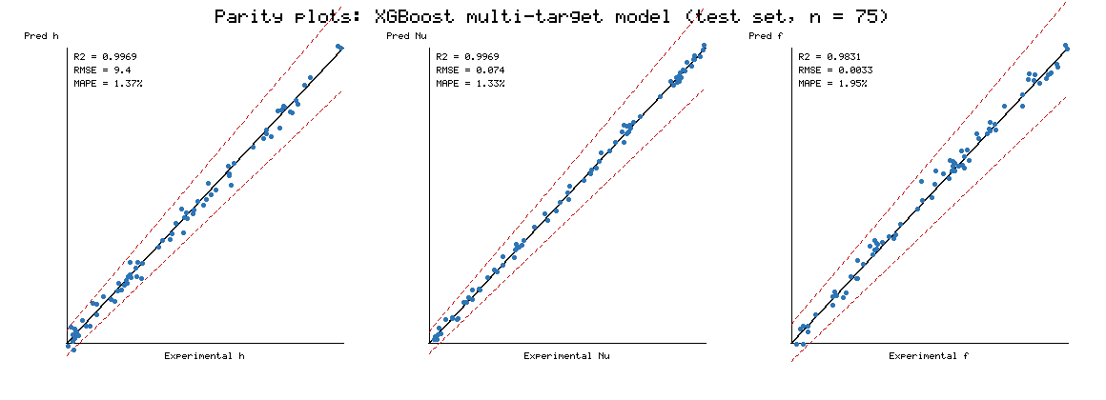
Figure 5. Parity plots of predicted versus experimental values for h, Nu and f using the XGBoost multi-target model (test set, n = 75). Red dashed lines denote the +/-10% error bands.

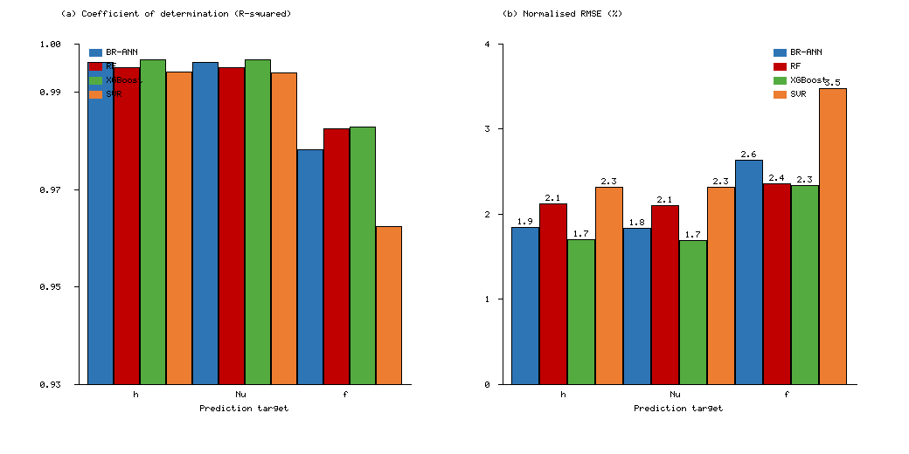
Figure 6. (a) Coefficient of determination and (b) normalised RMSE of the four benchmarked models for the three prediction targets.

3.3 Dominant parameters

Permutation importance applied to the selected XGBoost model reveals a clean division of influence, shown in Figure 7. The thermal targets overwhelmingly adopt the Reynolds number as their dominant predictor (mean decrease in R-squared of about 1.86 for h and 1.91 for Nu), consistent with forced-convection physics in which the flow controls boundary-layer renewal. For the friction factor the particle loading is the most influential feature — the direct physical link being viscosity, which rises with loading — with the Reynolds number second. Two secondary observations deserve comment. First, the inlet temperature carries little importance, because its effect is already mediated through the measured conductivity and through the Reynolds number, both of which embed property variation. Second, the marginal contribution of the measured conductivity to Nu is modest, which is the expected signature of feature collinearity: because conductivity is itself a function of loading and mixture ratio, the model distributes credit among the correlated features. This collinearity does not degrade predictive accuracy; rather, it confirms that conductivity should not be treated as an independent causal input.

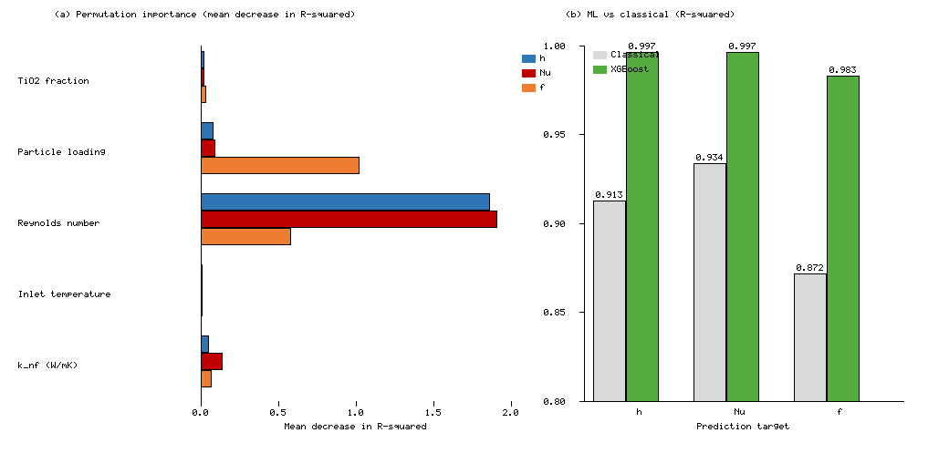
Figure 7. (a) Permutation importance (mean decrease in R-squared) of the five input features for each target; negative values clipped to zero. (b) Predictive accuracy of classical correlations versus the proposed XGBoost framework.

3.4 Benchmark against classical correlations and the wider literature

The XGBoost framework was benchmarked against established nanofluid correlations for the Nusselt number and the friction factor, with the comparison reported in Table 5. The classical correlations reach R-squared values of 0.913, 0.934 and 0.872 for h, Nu and f, respectively — respectable, but materially below the ML framework. Because the classical forms express Nu and f as functions of Reynolds number, Prandtl number and loading alone, they cannot represent the mixture-ratio dependence that Figures 2 and 3 make plain: at identical Reynolds number and loading, different TiO2:Al2O3 ratios yield measurably different coefficients, and any single correlation must average over this spread. The ML model, by contrast, admits the ratio explicitly and learns the ratio–loading–flow interactions, which accounts for the 4–11 percentage-point improvement in R-squared and the reduction of normalised RMSE below 2.7% on every target.

Table 5. Benchmark of the ML framework against classical nanofluid correlations (pp = percentage points of R-squared).
Target | Classical correlation R2 | XGBoost R2 | Gain (pp) | XGBoost NRMSE (%)
h | 0.913 | 0.9969 | +8.4 | 1.71
Nu | 0.934 | 0.9969 | +6.3 | 1.70
f | 0.872 | 0.9831 | +11.1 | 2.34

From a practical standpoint the benchmark carries direct design value. A correlation that explains 87% of the variance in the friction factor, as the classical form does here, leaves a residual spread large enough to swamp the 5–13% hydraulic penalty that distinguishes a good coolant from a poor one, so a designer relying on it could easily select a composition on the wrong side of the thermal-performance-factor crossover. The ML surrogate, by driving the unexplained variance below 2% on every target, resolves the crossover cleanly and lets the optimum loading and ratio be read off with confidence. Moreover, because all three targets are produced in one forward pass, the surrogate can be queried thousands of times inside an optimisation loop at negligible cost, whereas each correlation evaluation would still require the mixture-ratio averaging that erodes its accuracy. This combination of speed, joint prediction and interpretability is what elevates the framework from a curve-fit to a design instrument.

Placed against the wider literature, the present results are both consistent and incremental. The 16.9% enhancement that Bhattad et al. [3,10] measured for the pure-alumina composition at 0.1 vol.% brackets the present trend, in which the alumina-rich mixtures lead and the enhancement grows to roughly 23% at the higher 0.20 vol.% loading. The sub-linear loading dependence echoes the saturation that Ajeeb and Murshed [9] attributed to competition between conductivity gain and viscosity penalty, and the modest hydraulic penalty aligns with the low-loading oxide-nanofluid behaviour those authors reported. On the modelling side, the accuracy obtained here is comparable with, and in several respects exceeds, that reported in single-target ML studies: Kanti et al. [28] and Tota et al. [29] reported strong agreement for heat transfer and friction factor on related hybrids, but did so one output at a time, whereas the present framework predicts all three targets jointly at a maximum error below 2%. The multi-target premise itself follows Krishna et al. [35], who established simultaneous prediction for a fly-ash–Cu hybrid; the present study extends that premise to the technologically important TiO2–Al2O3/water pair and couples it to an explicit, interpretable algorithm comparison that the earlier work did not provide. Finally, the superiority of the Bayesian-regularised network on the thermal targets corroborates its established robustness for nanofluid thermal problems [21,33], while the dominance of the gradient-boosted ensemble on the hydraulic target highlights the value of threshold-based partitioning when the response surface is strongly interaction-driven.

Several limitations qualify these conclusions and define the boundaries within which the surrogate may be trusted. The model is interpolative: it was trained over 500 ≤ Re ≤ 2000, 0.01 ≤ loading ≤ 0.20 vol.% and the five discrete mixture ratios, and extrapolation beyond those bounds — into fully turbulent flow, higher loadings where non-Newtonian behaviour and agglomeration intensify, or intermediate ratios not sampled — is not warranted without additional data. The dataset derives from a single chevron geometry, so the learned mapping encodes that plate's corrugation angle and spacing implicitly; porting the framework to a different plate would require either re-training or the inclusion of geometric descriptors as additional features, an extension that the recent survey literature [7,8,20] identifies as a priority. Finally, the measured conductivity feature, while physically motivated, is partially redundant with loading and ratio, as the importance analysis showed; a deployment-oriented variant could omit it to yield a purely a-priori predictor at a small accuracy cost.

Taken together, the results substantiate the three hypotheses underpinning the study: that the thermal and hydraulic performance of a TiO2–Al2O3/water hybrid nanofluid in a PHE can be enhanced relative to water; that this performance can be predicted by a single multi-target ML model at sub-2% error; and that feature-importance analysis recovers the expected physics, namely flow-dominated heat transfer and loading-dominated pressure drop. The framework therefore functions not only as a predictive design tool but also as a rapid screening instrument for optimising mixture ratio and loading before committing to costly experimentation. Because it returns all three targets in a single evaluation, it can be embedded directly inside a thermal-performance-factor optimiser, allowing a designer to search the composition space for the loading and ratio that maximise Equation (11) subject to a pumping-power constraint — a capability that single-output surrogates and fixed correlations cannot offer.

4. Conclusions

Motivated by the absence of a validated thermal–hydraulic predictor for the TiO2–Al2O3/water hybrid nanofluid in a plate heat exchanger, this work developed and benchmarked a machine-learning-based multi-target framework trained on a purpose-built experimental dataset. The principal findings are as follows.

Heat-transfer enhancement was strong and increased monotonically with the alumina fraction, reaching a maximum of approximately 23% for the pure-alumina composition at 0.20 vol.% and a Reynolds number near 1200, in accord with the higher intrinsic conductivity of alumina and the associated micro-convection and particle-migration mechanisms; titania-rich mixtures proved beneficial only at low loading.

The enhancement followed an approximately square-root dependence on loading — a nonlinearity, arising from the competition between conductivity gain, viscosity penalty and agglomeration, that classical power-law correlations cannot capture across a range of mixture ratios.

Every alumina-rich composition maintained a thermal performance factor above unity across the tested loading range, defining a viable operating window, whereas titania-rich mixtures fell below unity beyond about 0.10 vol.%.

XGBoost delivered the best simultaneous prediction of h, Nu and f, with R-squared up to 0.9969 and a maximum mean absolute percentage error of 1.95%, improving on the classical correlations by 4–11 R-squared percentage points through its explicit treatment of the mixture-ratio–loading–flow interactions.

Permutation-importance analysis identified the Reynolds number as the governing parameter for heat transfer and the particle loading as the governing parameter for pressure drop, while flagging the measured conductivity as largely redundant — demonstrating that the learned models encode physically plausible structure rather than spurious correlation.

Beyond the specific fluid studied here, the methodology is transferable. The combination of a carefully reduced multi-target experimental dataset, a stratified and leakage-free training protocol, a head-to-head comparison across algorithm families, and a permutation-importance audit of physical plausibility constitutes a template that could be applied to any nanofluid–exchanger pair for which measurements exist. The finding that gradient boosting best handles the interaction-driven hydraulic target, while a Bayesian-regularised network is equally capable on the smoother thermal targets, is itself a reusable piece of guidance for practitioners assembling such models. The framework is thus a fast, interpretable and economical aid to hybrid-nanofluid PHE design, and future work will extend it to additional particle systems, wider Reynolds-number ranges, geometric descriptors that would allow transfer between plate designs, and transient operation, moving the approach from a single-geometry surrogate toward a general design assistant for enhanced heat-transfer fluids.

References

1. Zheng, D., Wang, J., Chen, Z., Baleta, J., Vrana, J., Sunden, B. (2020). Performance analysis of a plate heat exchanger using various nanofluids. International Journal of Heat and Mass Transfer, 2020. (S0017931020314873)
2. Gürbüz, E.Y., Sözen, A., Variyenli, H.İ., Khanlari, A., et al. (2020). A comparative study on utilizing hybrid-type nanofluid in plate heat exchangers with different number of plates. Journal of the Brazilian Society of Mechanical Sciences and Engineering, 42. https://doi.org/10.1007/s40430-020-02601-1
3. Bhattad, A., Sarkar, J., Ghosh, P. (2020). Heat transfer characteristics of plate heat exchanger using hybrid nanofluids: effect of nanoparticle mixture ratio. Heat and Mass Transfer, 56. https://doi.org/10.1007/s00231-020-02877-y
4. Bhattad, A., Sarkar, J., Ghosh, P. (2020). Hydrothermal performance of different alumina hybrid nanofluid types in plate heat exchanger. Journal of Thermal Analysis and Calorimetry, 141. https://doi.org/10.1007/s10973-019-08682-y
5. Bhattad, A., Sarkar, J. (2020). Hydrothermal performance of plate heat exchanger with an alumina–graphene hybrid nanofluid: experimental study. Journal of the Brazilian Society of Mechanical Sciences and Engineering, 42. https://doi.org/10.1007/s40430-020-02459-3
6. Hussein, O.A., Habib, K., Muhsan, A.S., Saidur, R., Alawi, O.A., et al. (2020). Thermal performance enhancement of a flat plate solar collector using hybrid nanofluid. Solar Energy, 209.
7. Afshari, F., Tuncer, A.D., Sözen, A., Variyenli, H.İ., et al. (2022). A comprehensive survey on utilization of hybrid nanofluid in plate heat exchanger with various number of plates. International Journal of Numerical Methods for Heat & Fluid Flow, 32(1), 241–261.
8. Al-Obaidi, M.A., Rashid, F.L., Rasheed, M.K., et al. (2024). Recent achievements in heat transfer enhancement with hybrid nanofluid in heat exchangers: a comprehensive review. International Journal of Thermophysics, 45. https://doi.org/10.1007/s10765-024-03428-x
9. Ajeeb, W., Murshed, S.M.S. (2022). Comparisons of numerical and experimental investigations of the thermal performance of Al2O3 and TiO2 nanofluids in a compact plate heat exchanger. Nanomaterials, 12(19).
10. Bhattad, A., Rao, B.N., Atgur, V., Veza, I., Zamri, M.F.M.A., et al. (2023). Thermal performance evaluation of plate-type heat exchanger with alumina–titania hybrid suspensions. Fluids, 8(4), 120.
11. Sathish, T., Giri, J., Saravanan, R., Ubaidullah, M., et al. (2024). Amplifying thermal performance of solar flat plate collector by Al2O3/Cu/MWCNT/SiO2 mono and hybrid nanofluid. Applied Thermal Engineering, 2024. (S1359431124013607)
12. Hassaan, A.M. (2023). Experimental investigation of the performance of the plate heat exchanger using (multi-walled carbon nanotubes–Al2O3/water) hybrid nanofluid. Proceedings of the Institution of Mechanical Engineers, Part E: Journal of Process Mechanical Engineering, 237. https://doi.org/10.1177/09544089221113977
13. Bhattad, A. (2023). Better performance criteria for plate heat exchanger with hybrid nanofluid: flow rate or concentration. Journal of Thermal Analysis and Calorimetry. https://doi.org/10.1007/s10973-023-12612-4
14. Tekir, M. (2025). Experimental study on the thermal performance of hybrid nanofluid in a compact plate heat exchanger under the influence of a magnetic field. Case Studies in Thermal Engineering, 2025. (S2214157X25002916)
15. Alhuyi Nazari, M., Mukhtar, A., Mehrabi, A., et al. (2024). Effect of using hybrid nanofluid and vortex generator on thermal performance of plate–fin heat exchanger: numerical investigation. Journal of Thermal Analysis and Calorimetry. https://doi.org/10.1007/s10973-024-12928-9
16. Gaur, S.K., Sahoo, R.R., Sarkar, J. (2024). Numerical investigation on assessing the influence of diverse-shaped hybrid nanofluids on thermal performance of triple tube heat exchanger. Powder Technology, 2024. (S0032591024003322)
17. Nazeri, M.H., Sarmasti Emami, M.R. (2026). From synthesis to optimization: thermal performance of MWCNT–ZnO hybrid nanofluids in brazed plate heat exchangers. Journal of Thermal Analysis and Calorimetry. https://doi.org/10.1007/s10973-026-15351-4
18. Alizadeh, R., Abad, J.M.N., Ameri, A., Mohebbi, M.R., et al. (2021). A machine learning approach to the prediction of transport and thermodynamic processes in multiphysics systems—heat transfer in a hybrid nanofluid flow in porous media. Journal of the Taiwan Institute of Chemical Engineers, 2021. (S1876107021001516)
19. Alizadeh, R., Abad, J.M.N., Fattahi, A., et al. (2021). A machine learning approach to predicting the heat convection and thermodynamics of an external flow of hybrid nanofluid. Journal of Energy Resources Technology, 143(7), 070902.
20. Recent advances in the applications of machine learning methods for heat exchanger modeling—a review. Frontiers in Energy Research, 11, 1294531, 2023.
21. Mishra, A., Rawat, S.K., Yaseen, M., Pant, M. (2023). Development of machine learning algorithm for assessment of heat transfer of ternary hybrid nanofluid flow towards three different geometries: case of artificial neural networks. Heliyon, 9(11), e21997. (S2405-8440(23)08661-9)
22. Priyadharshini, P., Archana, M.V., Shah, N.A., Alshehri, M.H. (2023). Ternary hybrid nanofluid flow emerging on a symmetrically stretching sheet optimization with machine learning prediction scheme. Symmetry, 15(6), 1225.
23. Jakeer, S., Easwaramoorthy, S.V., Reddy, S.R.R., Basha, H.T. (2023). Numerical and machine learning approach for Fe3O4-Au/blood hybrid nanofluid flow in a melting/non-melting heat transfer surface with entropy generation. Symmetry, 15(8), 1503.
24. Praharaj, S., Sharma, R.P. (2026). Hybrid analysis of deep learning and statistical approach in predicting heat transfer rate of radiative polar nanofluid flow with inertial drag. Physics of Fluids, 38(2), 023604.
25. Gupta, A.K., Mathur, P., et al. (2023). Development of predictive models for density of hybrid nanofluids using different machine learning techniques. Proceedings of the Institution of Mechanical Engineers, Part E: Journal of Process Mechanical Engineering, 237. https://doi.org/10.1177/09544089221124288
26. Uslu, S., Kocer, A. (2026). Modeling hybrid nanofluid density using machine learning algorithms. Journal of Thermal Analysis and Calorimetry. https://doi.org/10.1007/s10973-026-15981-8
27. Ahmad, M.D.F., Kikugawa, G., Chilukoti, H.K. (2026). Machine learning-based prediction of the thermal conductivity of hybrid nanofluids under varying operating conditions. Powder Technology, 2026. (S0032591026006182)
28. Kanti, P.K., Wanatasanappan, V.V., Sharma, P., et al. (2025). Experimental and machine learning insights on heat transfer and friction factor analysis of novel hybrid nanofluids subjected to constant heat flux at various mixture ratios. International Journal of Thermal Sciences, 2025. (S1290072924006707)
29. Tota, R.K., Nagaraju, D., Syed, J., et al. (2025). Performance of heat transfer in Al2O3/MWCNT hybrid nanofluid flow using machine learning models. Engineering Research Express. https://doi.org/10.1088/2631-8695/adaadb
30. Shah, Z., Louati, H., Iqbal, H., Jawaid, M., Hilali, S.O. (2025). Deep learning-based modeling of hybrid nanofluid heat transfer for enhanced solar thermal efficiency. Physics of Fluids, 37(10), 103121.
31. Kumar, M.D., Dharmaiah, G., Yook, S.J., Raju, C.S.K., et al. (2025). Deep learning approach for predicting heat transfer in water-based hybrid nanofluid thin film flow and optimization via response surface methodology. Case Studies in Thermal Engineering, 2025. (S2214157X2500190X)
32. Haq, S.U., Shusheng, X., Yongqing, L., Xuanhong, Y., et al. (2025). Thermal performance prediction and optimization of magneto-thermal radiative heat transfer in ternary-hybrid nanofluids via deep learning and sensitivity analysis. Case Studies in Thermal Engineering, 2025. (S2214157X25018878)
33. Imran, M., Hussain, M., Jia, W., Shah, N.A., Ali, B. (2025). Machine learning-based Bayesian regularization algorithm for thermal analysis of tri-hybrid nanofluid flow over a stretched sheet. International Communications in Heat and Mass Transfer, 2025. (S073519332501187X)
34. Alsaiar, N.S., Imran, M., Rukhsar, M., Hussain, A., et al. (2026). Deep learning analysis for enhanced prediction of heat transfer in Maxwell hybrid nanofluids with non-Fourier law and radiation effects. Scientific Reports. https://doi.org/10.1038/s41598-026-43327-9
35. Krishna, V.V., Mishra, V.P., Jayanthiladevi, A., et al. (2026). Prediction of heat transfer and fluid flow performance of fly ash–Cu hybrid nanofluid using machine learning approaches. Scientific Reports. https://doi.org/10.1038/s41598-026-66669-w

