Chapter 2
Communication Protocols: DSRC, C-V2X, 5G NR-V2X, and 6G V2X
Vehicular Networking and Connected Vehicles:
Systems, Intelligence, and Control Perspectives
Part I: Foundations of Vehicular Networking and Connected Mobility

Abstract
The rapid evolution of vehicular communication technologies represents a transformative paradigm shift in intelligent transportation systems. This chapter provides a comprehensive examination of the communication protocols that underpin connected and autonomous vehicular networks, tracing the technological progression from Dedicated Short-Range Communications (DSRC) based on IEEE 802.11p through Cellular Vehicle-to-Everything (C-V2X) leveraging LTE infrastructure, to the advanced capabilities of 5G New Radio V2X (NR-V2X) and the emerging vision of 6G V2X networks. The chapter systematically analyzes the architectural foundations, protocol stacks, radio access technologies, and performance characteristics of each generation of vehicular communication standards. Particular attention is devoted to the critical requirements of connected and autonomous vehicles, including ultra-low latency, extreme reliability, high mobility support, and massive scalability. The comparative analysis of DSRC and C-V2X reveals fundamental differences in medium access control, resource allocation, and interference management that influence deployment strategies and coexistence scenarios. The chapter further explores how 5G NR-V2X introduces transformative capabilities through Ultra-Reliable Low-Latency Communication (URLLC), enhanced Mobile Broadband (eMBB), and massive Machine-Type Communication (mMTC) to support advanced use cases such as cooperative perception, vehicle platooning, and remote driving. Finally, the chapter presents the 6G V2X vision, encompassing terahertz communications, reconfigurable intelligent surfaces, AI-native air interfaces, and integrated sensing and communication technologies that will enable fully autonomous and cooperative intelligent transportation systems. The discussion addresses interoperability challenges, spectrum evolution, standardization pathways, and hybrid architectures necessary for the seamless transition across technology generations.
Keywords: DSRC, C-V2X, 5G NR-V2X, 6G V2X, IEEE 802.11p, Vehicle-to-Everything, URLLC, Network Slicing, Terahertz Communication, Reconfigurable Intelligent Surfaces, Cooperative Perception, Autonomous Vehicles, Connected Mobility

1. Foundations and Evolution of Vehicular Communication Networks

1.1 Connected and Cooperative Vehicular Communication: Concepts, Architecture, and Requirements
The concept of connected and cooperative vehicular communication represents a fundamental transformation in how vehicles interact with their surrounding environment, infrastructure, and other road users. Vehicle-to-Everything (V2X) communication encompasses a broad spectrum of interaction modalities, including Vehicle-to-Vehicle (V2V), Vehicle-to-Infrastructure (V2I), Vehicle-to-Pedestrian (V2P), and Vehicle-to-Network (V2N) communications [1]. These communication paradigms collectively enable cooperative awareness, collaborative decision-making, and coordinated maneuver execution among connected vehicles and intelligent transportation infrastructure [2].
The architectural framework for vehicular communication networks is inherently multi-layered, comprising the application layer, facilities layer, networking and transport layer, access layer, and management layer [3]. At the highest level, safety applications such as Cooperative Awareness Messages (CAM), Decentralized Environmental Notification Messages (DENM), and Basic Safety Messages (BSM) require deterministic and predictable communication performance. The facilities layer provides common data dictionaries, message formatting, and service management functions that abstract the underlying communication technology from the application logic [4]. This layered architecture enables technology-agnostic application development while supporting heterogeneous access technologies ranging from DSRC to cellular-based V2X solutions.
The fundamental requirements for vehicular communication networks are dictated by the stringent demands of safety-critical applications and the inherent characteristics of vehicular environments. These requirements include end-to-end latency below 10 milliseconds for pre-crash sensing, packet delivery ratios exceeding 99.99% for safety messages, support for relative vehicle speeds exceeding 500 km/h, and network densities reaching thousands of vehicles per square kilometer in urban intersections [5]. Furthermore, the dynamic topology of vehicular networks, characterized by rapid link establishment and dissolution, frequent handovers, and varying channel conditions due to multipath propagation and Doppler effects, imposes unique challenges on protocol design and resource management [6]. The evolution of vehicular communication technologies, as illustrated in Figure 1, demonstrates the progressive enhancement of these capabilities across successive technology generations.
The standardization landscape for vehicular communication has been shaped by multiple international bodies working in parallel and sometimes competing frameworks. In the United States, the Department of Transportation (DoT) initially championed DSRC through the Connected Vehicle Safety Pilot program, while the European Union developed the Cooperative Intelligent Transport Systems (C-ITS) framework based on ETSI ITS-G5, which shares the IEEE 802.11p physical layer but employs a distinct networking architecture based on GeoNetworking protocols [7]. In Asia, Japan deployed the 760 MHz band DSRC system (ARIB STD-T109) alongside 5.8 GHz Electronic Toll Collection, while China adopted C-V2X as its primary V2X technology through the national LTE-V2X standard (T/CSAE 53-2017). This geographic fragmentation of technology choices has created significant challenges for global interoperability and has motivated efforts toward technology-neutral standards that can accommodate multiple underlying radio access technologies within a common application and security framework.
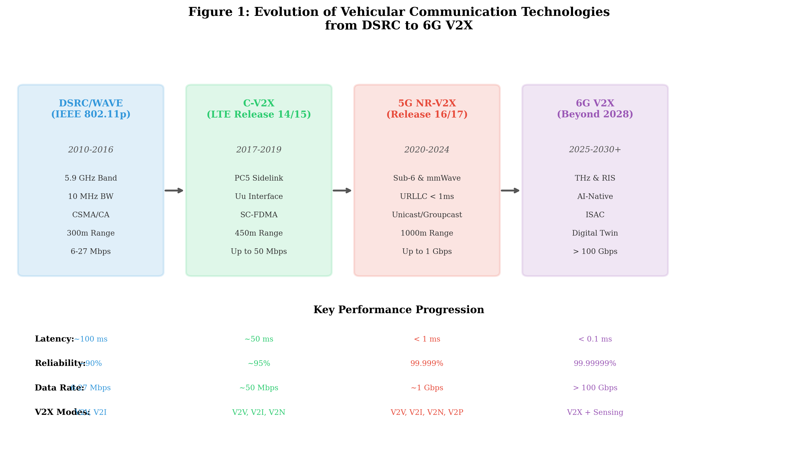
Figure 1: Evolution of Vehicular Communication Technologies from DSRC to 6G V2X, showing progressive enhancement in latency, reliability, data rate, and communication modes.

1.2 Evolution from VANETs and DSRC to Cellular V2X Networks
The evolution of vehicular communication technologies spans more than two decades of research, standardization, and deployment efforts. The initial conceptualization of Vehicular Ad-hoc Networks (VANETs) in the early 2000s established the foundational principles of decentralized, infrastructure-less communication among vehicles using dedicated spectrum allocations [7]. The allocation of 75 MHz of spectrum in the 5.9 GHz band by the Federal Communications Commission (FCC) in 1999 for Intelligent Transportation Systems (ITS) provided the regulatory foundation for Dedicated Short-Range Communications (DSRC), which subsequently evolved into the Wireless Access in Vehicular Environments (WAVE) standard suite [8].
The IEEE 802.11p amendment, ratified in 2010, defined the physical and medium access control layers specifically optimized for vehicular environments, incorporating features such as reduced overhead for rapid link establishment without the need for association procedures [9]. However, the inherent limitations of contention-based channel access in DSRC, particularly under high vehicle density scenarios, motivated the exploration of cellular-based alternatives. The 3rd Generation Partnership Project (3GPP) introduced Cellular V2X (C-V2X) in Release 14 (2017), leveraging the mature LTE infrastructure and the advantages of scheduled access and centralized resource management [10].
The transition from DSRC to C-V2X represented a paradigm shift in vehicular communication philosophy, moving from purely ad-hoc, distributed systems to hybrid architectures combining direct device-to-device communication (PC5 sidelink interface) with network-assisted coordination through the Uu cellular interface [11]. This evolution was further accelerated by the development of 5G NR-V2X in 3GPP Release 16, which introduced advanced features such as unicast and groupcast communication modes, feedback mechanisms, and significantly enhanced reliability and latency performance [12]. The evolutionary trajectory, depicted in Figure 1, illustrates how each technology generation has progressively addressed the growing demands of connected and autonomous vehicle applications.
The coexistence debate between DSRC and C-V2X has significantly influenced the regulatory landscape and delayed large-scale V2X deployment in several regions. In November 2020, the U.S. Federal Communications Commission (FCC) reallocated the lower 45 MHz of the 5.9 GHz band to unlicensed Wi-Fi operations, retaining only the upper 30 MHz (5.895-5.925 GHz) for ITS, with C-V2X designated as the communication technology for this reduced band [8]. This regulatory decision effectively ended the DSRC deployment trajectory in the United States and accelerated the global momentum toward C-V2X and its 5G NR-V2X successor. In Europe, the European Commission adopted a technology-neutral approach through Delegated Regulation 2022/1426, allowing both ITS-G5 (DSRC-based) and C-V2X deployments while mandating interoperability at the application layer through common message formats and security frameworks. This regulatory evolution reflects the broader transition in vehicular communication philosophy from single-technology mandates to flexible, performance-based requirements that can accommodate technology evolution over the multi-decade lifecycle of transportation infrastructure.

1.3 Communication Requirements for Connected and Autonomous Vehicles: Latency, Reliability, Mobility, and Scalability
The communication requirements for connected and autonomous vehicles vary significantly across different application categories, ranging from basic safety awareness to fully cooperative autonomous driving. The European Telecommunications Standards Institute (ETSI) and 3GPP have jointly defined a comprehensive taxonomy of V2X use cases organized into four service categories: vehicles platooning, extended sensors, advanced driving, and remote driving [13]. Each category imposes distinct requirements on communication latency, reliability, throughput, and positioning accuracy, as summarized in Table 1.

Table 1: Communication Requirements for V2X Use Case Categories [13, 14]
Use Case Category | Latency (ms) | Reliability (%) | Data Rate | Range (m) | Positioning
Cooperative Awareness | 100 | 95 | 5-96 kbps | 300-500 | 1.5 m
Vehicle Platooning | 10-25 | 99.99 | 50-65 Mbps | 80-350 | 0.5 m
Extended Sensors | 3-10 | 99.999 | 10-1000 Mbps | 50-1000 | 0.2 m
Advanced Driving | 3-10 | 99.999 | 10-50 Mbps | 100-700 | 0.1 m
Remote Driving | 5-20 | 99.999 | 1-25 Mbps UL | >1000 | 0.1 m

The latency requirements for vehicular communications span several orders of magnitude, from the relatively relaxed 100-millisecond tolerance for basic cooperative awareness messages to the stringent sub-3-millisecond requirement for advanced cooperative maneuver coordination [14]. These latency constraints encompass the entire communication chain, including sensing, processing, transmission, propagation, and reception delays. For autonomous driving applications, the end-to-end latency budget must account for sensor data acquisition (typically 10-50 ms), perception and decision-making processing (20-100 ms), and actuation response time (10-50 ms), leaving minimal margin for communication delays [15].
Reliability requirements are equally demanding, with safety-critical applications requiring packet delivery ratios exceeding 99.999% (five nines reliability). This translates to fewer than one lost message per 100,000 transmissions, which is particularly challenging in highly dynamic vehicular environments characterized by rapid fading, frequent shadowing by large vehicles, and interference from dense concurrent transmissions [16]. The mobility requirement presents additional challenges, as vehicular communication systems must maintain performance at relative speeds exceeding 500 km/h on highways, corresponding to Doppler shifts of approximately 2.7 kHz at 5.9 GHz carrier frequency, which can severely degrade channel estimation and demodulation performance [17]. Scalability concerns arise in urban scenarios where intersection vehicle densities may exceed 1,000 vehicles, each generating 10-50 messages per second, creating aggregate channel loads that challenge the capacity of any single communication technology.

2. DSRC and C-V2X Communication Technologies

2.1 DSRC Architecture, IEEE 802.11p, and IEEE 1609 Protocol Stack
Dedicated Short-Range Communications (DSRC) represents the first generation of purpose-built vehicular communication technology, standardized through the collaborative efforts of IEEE and SAE International. The DSRC system architecture is defined by the WAVE (Wireless Access in Vehicular Environments) protocol suite, comprising the IEEE 802.11p amendment for physical and MAC layer operations and the IEEE 1609 family of standards for higher-layer networking, security, and multi-channel operation [18]. The protocol stack architecture, illustrated in Figure 2, demonstrates the layered organization of DSRC/WAVE components and their counterparts in the C-V2X architecture.
At the physical layer, IEEE 802.11p employs Orthogonal Frequency Division Multiplexing (OFDM) with 64 subcarriers operating in 10 MHz channels within the 5.850-5.925 GHz band. The reduced channel bandwidth (compared to the standard 20 MHz in IEEE 802.11a) doubles the OFDM symbol duration to 8 microseconds, providing enhanced resilience against multipath-induced inter-symbol interference in vehicular channels characterized by delay spreads of 1-5 microseconds [19]. The physical layer supports eight data rates ranging from 3 Mbps (BPSK, rate 1/2) to 27 Mbps (64-QAM, rate 3/4), with 6 Mbps (QPSK, rate 1/2) specified as the default rate for safety messages to ensure robust reception under adverse channel conditions.
The MAC layer of IEEE 802.11p utilizes Enhanced Distributed Channel Access (EDCA) based on the Carrier Sense Multiple Access with Collision Avoidance (CSMA/CA) mechanism. Four access categories (AC_VO, AC_VI, AC_BE, AC_BK) provide differentiated quality of service through varying contention window sizes and arbitration inter-frame spacing (AIFS) values [20]. A distinctive feature of 802.11p is the elimination of the association and authentication procedures required in traditional 802.11 networks, enabling immediate communication through the Outside the Context of a BSS (OCB) mode. This design choice reduces the connection establishment time from hundreds of milliseconds to virtually zero, which is essential for ephemeral vehicular encounters [21].
The IEEE 1609 family extends the WAVE architecture with essential higher-layer services. IEEE 1609.2 defines the security framework based on Elliptic Curve Cryptography (ECC) with pseudonymous certificates to protect message authenticity and privacy. IEEE 1609.3 specifies the WAVE Short Message Protocol (WSMP) for efficient delivery of safety messages without the overhead of full IP networking. IEEE 1609.4 defines the multi-channel operation scheme, alternating between the Control Channel (CCH, channel 178) for safety messages and Service Channels (SCH) for non-safety applications during synchronized 50-millisecond intervals [22].
Despite its robust design for vehicular environments, DSRC faces fundamental performance limitations under high vehicle density scenarios. The contention-based CSMA/CA mechanism suffers from the hidden terminal problem and the exposed terminal problem, both of which are exacerbated in vehicular networks due to the extended communication range and the simultaneous transmission requirements of periodic safety messages. Analytical and simulation studies have demonstrated that the packet delivery ratio of IEEE 802.11p degrades significantly when the number of contending vehicles exceeds 150-200 within communication range, with channel busy ratios exceeding 60-70% leading to exponential growth in collision probability [20]. Furthermore, the lack of centralized scheduling in DSRC prevents quality of service guarantees for individual message transmissions, as channel access is inherently probabilistic. The absence of HARQ mechanisms means that failed transmissions are not detected at the MAC layer, relying instead on application-layer redundancy through periodic message repetition. These limitations motivated the development of the IEEE 802.11bd amendment (Next Generation V2X), which introduces features such as midamble-based channel estimation, LDPC coding, and retransmission mechanisms to improve performance while maintaining backward compatibility with legacy 802.11p devices [11].
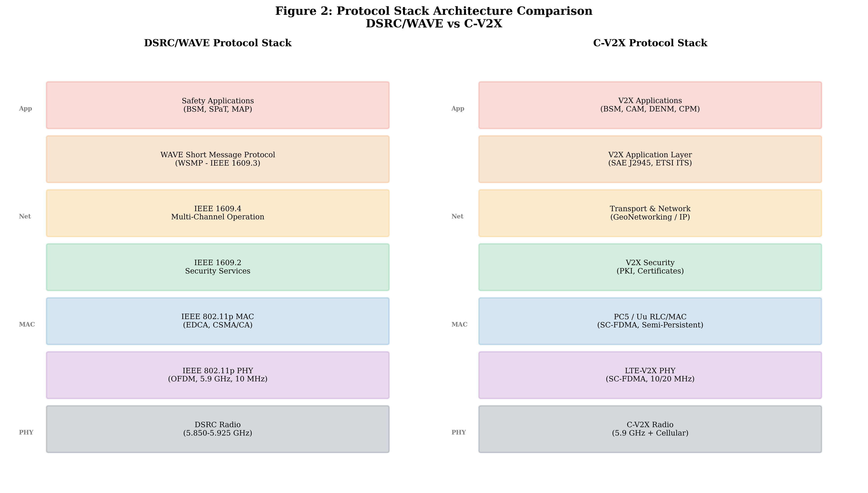
Figure 2: Protocol Stack Architecture Comparison between DSRC/WAVE (IEEE 802.11p + IEEE 1609) and C-V2X (3GPP LTE-V2X), showing the layered organization from physical to application layers.

2.2 C-V2X Architecture, PC5 Sidelink, and Uu-Based Communication
Cellular Vehicle-to-Everything (C-V2X), introduced in 3GPP Release 14, represents a fundamentally different approach to vehicular communication by leveraging the mature and globally deployed cellular network infrastructure. The C-V2X architecture encompasses two complementary communication interfaces: the PC5 sidelink interface for direct vehicle-to-vehicle and vehicle-to-infrastructure communication, and the Uu interface for network-based communication through cellular base stations [23]. This dual-interface architecture, as depicted in the right panel of Figure 2, provides flexibility in supporting both latency-critical direct communication and network-assisted coordination services.
The PC5 sidelink interface operates in the 5.9 GHz ITS band using Single-Carrier Frequency Division Multiple Access (SC-FDMA) waveform, which offers superior Peak-to-Average Power Ratio (PAPR) characteristics compared to the OFDM waveform used in DSRC, enabling more efficient power amplifier operation and extended communication range [24]. Resource allocation on the PC5 interface operates in two modes: Mode 3 (network-scheduled), where the cellular base station (eNodeB) assigns sidelink resources to vehicles within its coverage area, and Mode 4 (autonomous), where vehicles independently select transmission resources through a sensing-based semi-persistent scheduling (SPS) mechanism [25]. In Mode 4, each vehicle monitors the channel for 1,000 subframes (1 second) to identify occupied resources, then selects transmission resources from the pool of least-interfered candidates, reserving them semi-persistently for subsequent transmissions with a randomly selected reselection counter.
The Uu interface provides cellular connectivity for V2X applications that require wide-area coverage, cloud connectivity, or network-level coordination services. Through the Uu interface, vehicles can access V2X application servers, receive traffic management information, download high-definition maps, and participate in network-coordinated cooperative driving functions [26]. The integration of PC5 and Uu interfaces enables a comprehensive V2X ecosystem where safety-critical messages are transmitted directly via PC5 with minimal latency, while value-added services and coordination functions leverage the cellular network infrastructure. The C-V2X architecture also supports geographic message routing, where the network can forward messages to vehicles in specific geographic areas through the V2X Application Server, enabling applications such as traffic signal priority and intersection collision warning beyond direct communication range.
The resource pool structure in C-V2X defines a time-frequency grid where the fundamental resource unit is the subchannel, consisting of a set of contiguous physical resource blocks (PRBs) within one subframe. Each transmission occupies both a Sidelink Control Information (SCI) resource for signaling and an associated data resource for payload delivery. The Transport Block Size (TBS) in C-V2X ranges from 120 to 1536 bytes, accommodating the typical size of safety messages (BSM: ~300 bytes, CAM: ~200-400 bytes) with moderate overhead [24]. The sensing window of 1000 ms in Mode 4 introduces a fundamental trade-off between resource selection accuracy and adaptation speed: while longer sensing windows provide better occupancy estimation, they may not capture rapidly changing traffic patterns at intersections where vehicles enter communication range within fractions of a second. The resource reservation interval (RRI) is configurable between 20 ms and 1000 ms, with typical values of 100 ms for 10 Hz BSM transmission. The semi-persistent nature of resource allocation reduces signaling overhead but creates periodic collision patterns when two vehicles inadvertently select identical resources—a phenomenon known as persistent collision that can persist for hundreds of milliseconds until resource reselection is triggered [25]. Various enhancements including geographic-based resource partitioning, power control mechanisms, and congestion control algorithms have been proposed to mitigate these challenges and improve the scalability of C-V2X Mode 4 in dense urban environments [26].

2.3 Comparative Performance, Spectrum Efficiency, Interference, and Deployment Challenges
The comparative evaluation of DSRC and C-V2X has been the subject of extensive research and significant debate within the vehicular communications community. Field trials and simulation studies have revealed distinct performance characteristics that favor each technology under different operating conditions [27]. Table 2 presents a comprehensive comparison of the key technical parameters and performance metrics of DSRC (IEEE 802.11p) and C-V2X (LTE-V2X Mode 4) technologies.

Table 2: Comprehensive Technical Comparison of DSRC and C-V2X Technologies [27, 28]
Parameter | DSRC (IEEE 802.11p) | C-V2X (LTE Mode 4)
Standard | IEEE 802.11p/1609 | 3GPP Release 14/15
Frequency Band | 5.850-5.925 GHz | 5.855-5.925 GHz + Cellular
Channel Bandwidth | 10 MHz | 10/20 MHz
Waveform | OFDM (64 subcarriers) | SC-FDMA
Multiple Access | CSMA/CA (contention) | SPS (scheduling)
Peak Data Rate | 27 Mbps | ~50 Mbps
Typical Range | 300-500 m | 400-700 m
Latency (one-hop) | ~2-5 ms | ~4-20 ms (Mode 4)
Doppler Tolerance | ~700 Hz | ~1400 Hz
Vehicle Density Support | Degrades > 200 vehicles | Better at high density
Network Dependency | None (ad-hoc) | Optional (Mode 3 vs 4)
Maturity/Deployment | Mature, limited deploy | Emerging, cellular synergy

In terms of communication range, C-V2X demonstrates a consistent advantage of 25-50% over DSRC under equivalent transmission power conditions, attributed to the superior link budget characteristics of the SC-FDMA waveform and the use of turbo coding with hybrid automatic repeat request (HARQ) [28]. The sensing-based SPS mechanism in C-V2X Mode 4 provides more predictable channel access compared to the stochastic CSMA/CA approach in DSRC, particularly under heavy traffic loads where collision probability in DSRC increases non-linearly with channel utilization [29].
However, DSRC offers advantages in scenarios requiring rapid, spontaneous communication establishment. The OCB mode enables immediate packet transmission within a single channel access cycle (typically less than 1 millisecond under low load), whereas C-V2X Mode 4 introduces additional latency due to the sensing window requirement and semi-persistent scheduling granularity [30]. Spectrum efficiency comparisons reveal that C-V2X achieves approximately 2-3 times higher spectral efficiency than DSRC for equivalent payload sizes, owing to the orthogonal resource allocation that eliminates in-band interference among simultaneous transmitters within the scheduling period. The deployment challenges for both technologies include spectrum allocation certainty, infrastructure investment requirements, interoperability with legacy systems, and the regulatory frameworks governing technology mandates versus technology-neutral approaches [31].

3. 5G NR-V2X and Advanced Vehicular Connectivity

3.1 5G NR-V2X Architecture, Radio Technologies, and Resource Allocation
The 5G New Radio Vehicle-to-Everything (NR-V2X) standard, defined in 3GPP Release 16 and enhanced in Release 17, represents a generational leap in vehicular communication capabilities. Unlike the evolutionary relationship between LTE and LTE-V2X, NR-V2X introduces a fundamentally redesigned sidelink architecture that addresses the advanced requirements of cooperative, connected, and automated mobility (CCAM) [32]. The 5G NR-V2X network architecture, illustrated in Figure 3, encompasses the Next Generation Radio Access Network (NG-RAN), 5G Core Network (5GC), Multi-access Edge Computing (MEC) infrastructure, and the V2X application layer, interconnected through standardized interfaces and service-based architecture principles.
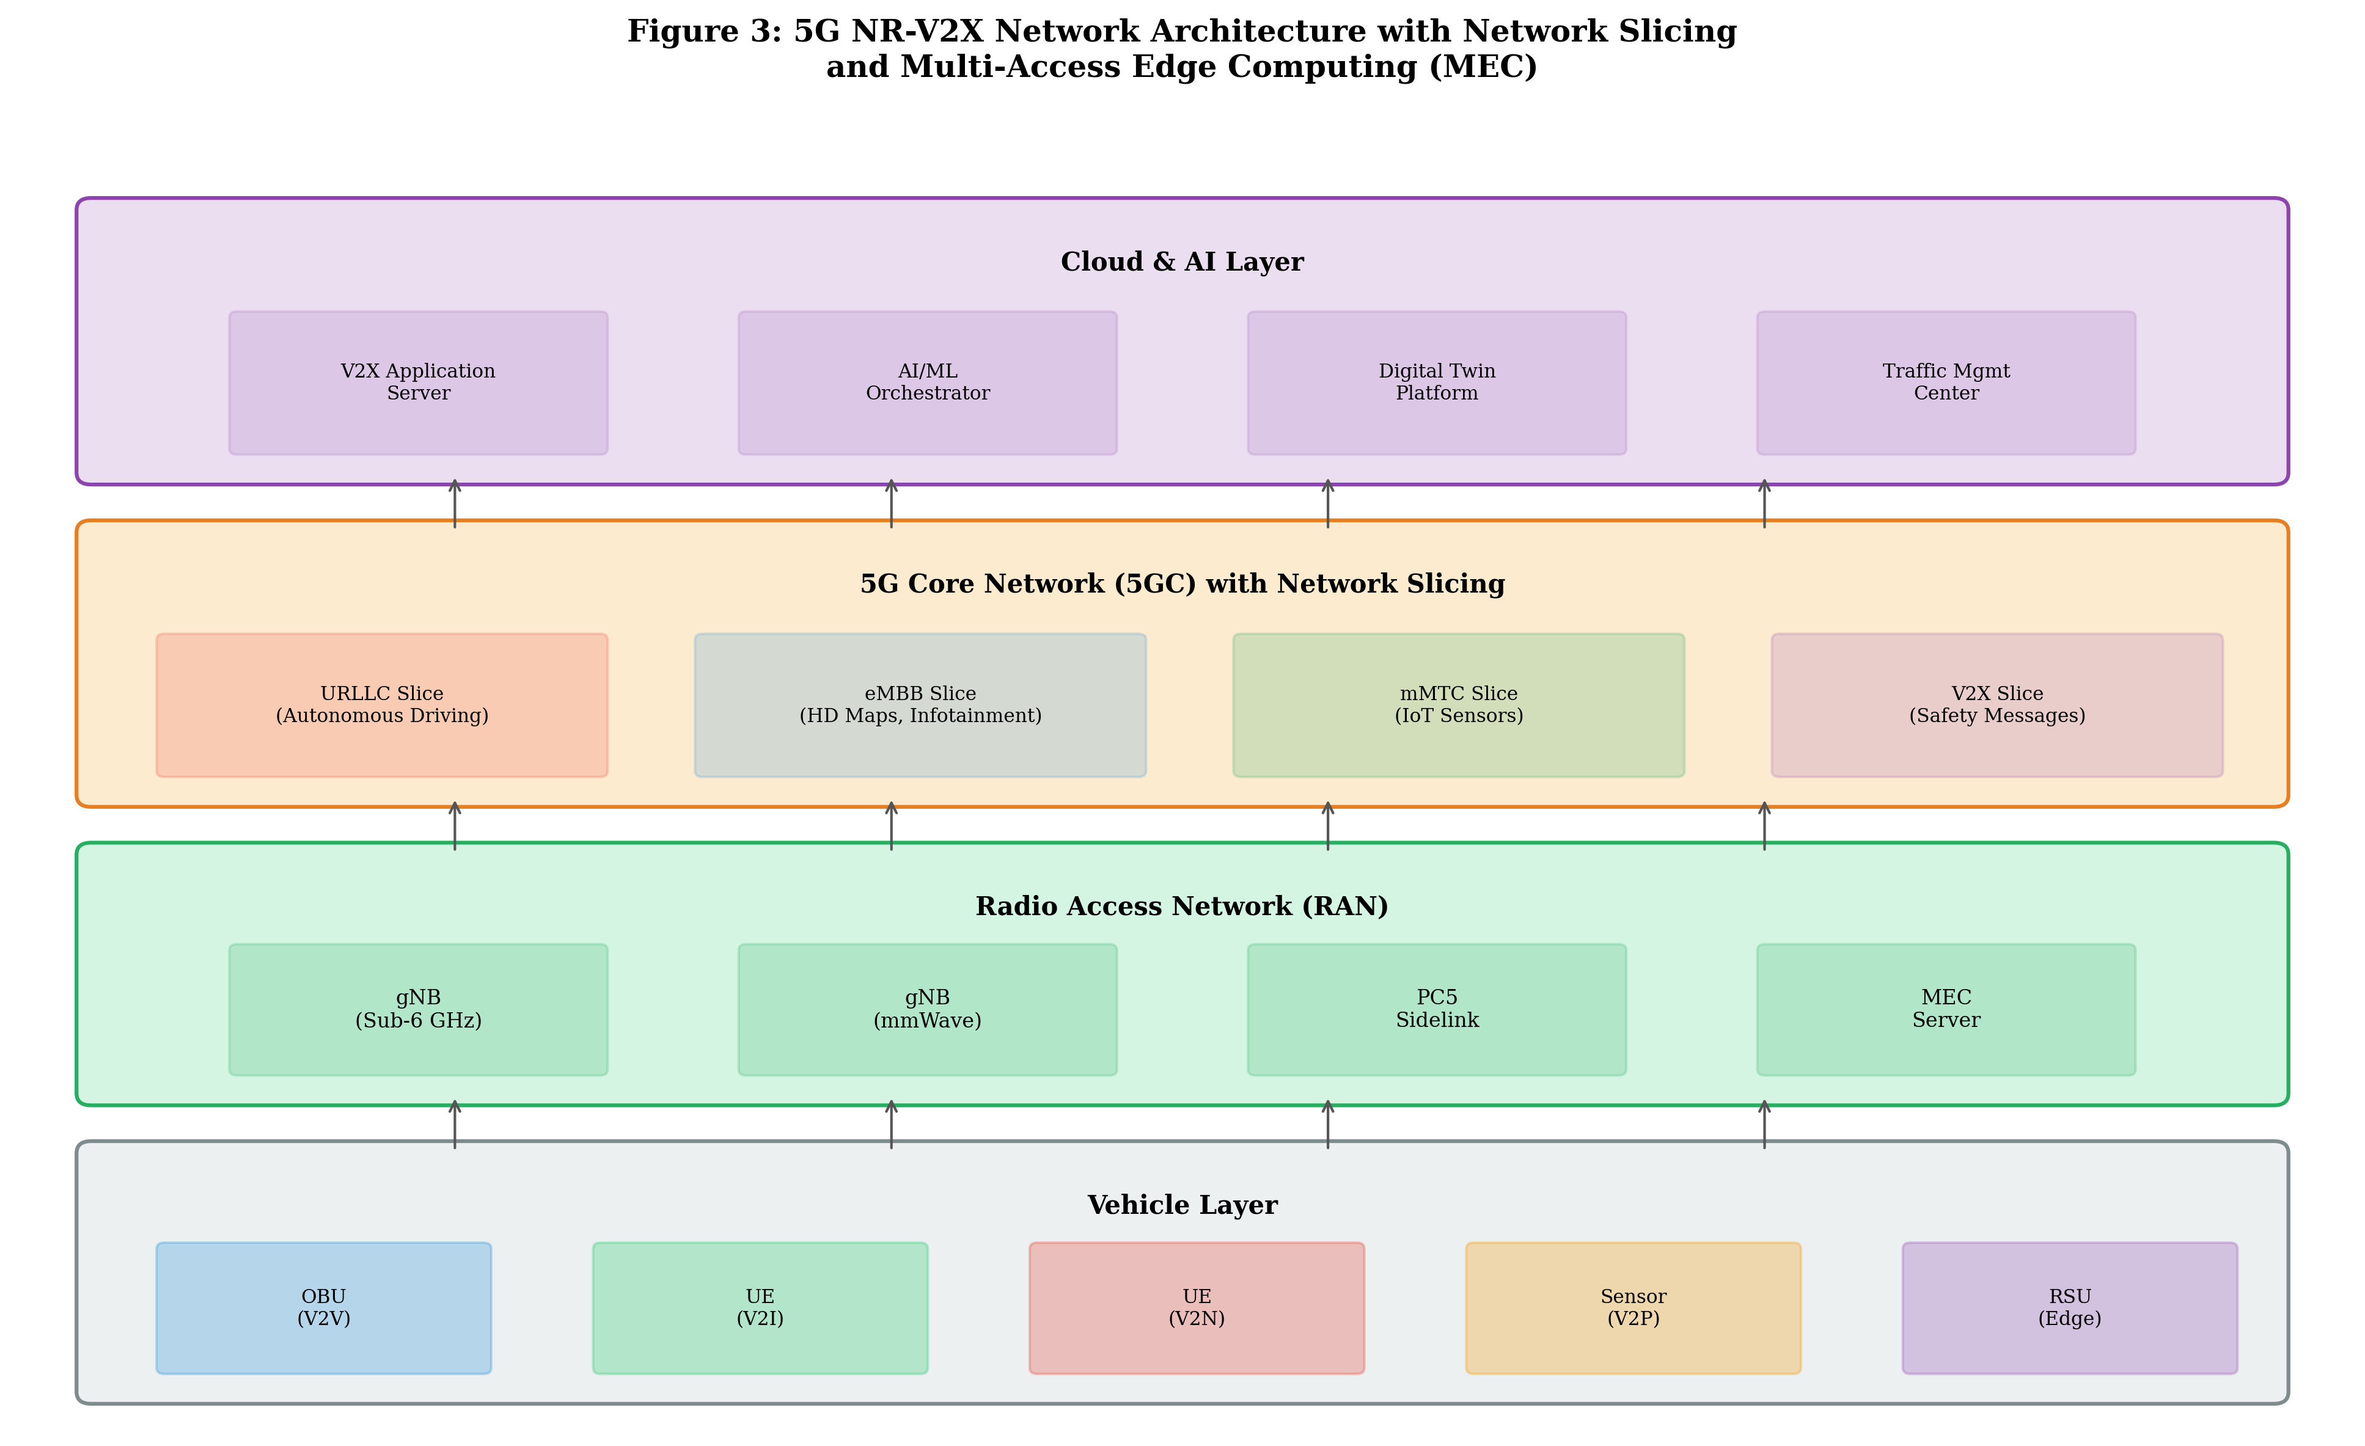
Figure 3: 5G NR-V2X Network Architecture with Network Slicing and Multi-Access Edge Computing (MEC), showing the hierarchical organization from vehicle layer through RAN, core network, to cloud/AI layer.

At the radio access level, NR-V2X introduces several transformative capabilities over LTE-V2X. The physical layer adopts Cyclic Prefix OFDM (CP-OFDM) with flexible numerology, supporting subcarrier spacings of 15, 30, 60, and 120 kHz to accommodate diverse deployment scenarios from sub-6 GHz urban coverage to millimeter-wave high-capacity links [33]. The flexible slot structure enables mini-slot transmissions as short as 2 OFDM symbols, achieving sub-millisecond air interface latency critical for cooperative driving applications. The NR-V2X sidelink supports three communication modes: broadcast (one-to-many), groupcast (one-to-group with feedback), and unicast (one-to-one with full feedback and retransmission), providing the communication flexibility required for diverse V2X use cases [34].
Resource allocation in NR-V2X operates through two modes analogous to but significantly enhanced over LTE-V2X. Mode 1 (network-scheduled) leverages the gNB for dynamic resource allocation with awareness of sidelink channel conditions and quality of service requirements. Mode 2 (autonomous) employs an enhanced sensing and resource selection mechanism with partial sensing, pre-emption capabilities, and re-evaluation procedures that improve resource utilization efficiency by 30-40% compared to LTE-V2X Mode 4 [35]. The introduction of the Sidelink Control Information (SCI) two-stage design separates resource reservation (1st-stage SCI) from communication parameters (2nd-stage SCI), enabling more efficient resource utilization and interference coordination among sidelink users. Additionally, NR-V2X supports inter-UE coordination mechanisms where vehicles can share resource utilization information to facilitate cooperative resource selection and reduce packet collisions.

3.2 URLLC, eMBB, and mMTC for Platooning, Cooperative Perception, and Remote Driving
The three pillars of 5G service categories—Ultra-Reliable Low-Latency Communication (URLLC), enhanced Mobile Broadband (eMBB), and massive Machine-Type Communication (mMTC)—collectively address the diverse communication requirements of advanced vehicular applications. URLLC provides the foundation for safety-critical V2X services, targeting end-to-end latency of 1 millisecond with reliability of 99.999% (packet error rate of 10^-5) over the radio interface [36]. This is achieved through a combination of techniques including short transmission time intervals (mini-slots), grant-free uplink transmission, packet duplication across multiple transmission paths, and proactive resource allocation based on traffic prediction.
Vehicle platooning represents one of the most demanding URLLC applications, requiring coordinated longitudinal and lateral control among a string of vehicles maintaining close inter-vehicle gaps of 5-15 meters at highway speeds [37]. The communication requirements for platooning include cyclic exchange of kinematic information (position, speed, acceleration, steering angle) at rates of 10-50 Hz with end-to-end latency below 10 milliseconds and reliability exceeding 99.99%. NR-V2X supports platooning through groupcast communication with HARQ feedback, enabling the platoon leader to confirm message reception by all members and triggering retransmission for lost packets within the latency budget. The cooperative adaptive cruise control (CACC) protocols operating over NR-V2X achieve string stability with time headways as low as 0.3 seconds, compared to 1.0-1.4 seconds achievable with radar-only systems [38].
Cooperative perception leverages the eMBB capabilities of 5G to enable vehicles to share processed sensor data, extending the collective perception range beyond individual sensor limitations. Cooperative Perception Messages (CPM) containing detected object lists, free-space information, or compressed sensor data may range from 100 KB to several MB per message, requiring sustained data rates of 10-1000 Mbps depending on the cooperation level and data abstraction [39]. The eMBB service category provides peak data rates exceeding 1 Gbps on the downlink through carrier aggregation across multiple component carriers in sub-6 GHz and millimeter-wave bands, sufficient to support high-resolution cooperative perception and HD map updates. Remote driving applications, enabling teleoperation of vehicles in complex scenarios, require a unique combination of high-bandwidth uplink (video streaming at 10-25 Mbps) with ultra-low latency (below 20 ms round-trip) and extreme reliability, challenging the network to simultaneously satisfy multiple quality of service dimensions [40].
The massive Machine-Type Communication (mMTC) service category addresses the connectivity requirements of the dense sensor networks that comprise intelligent transportation infrastructure. Traffic monitoring sensors, environmental detectors, road condition monitors, and smart parking systems collectively generate millions of small data packets requiring reliable but latency-tolerant connectivity. In the context of V2X, mMTC supports the integration of roadside IoT infrastructure into the cooperative driving ecosystem, providing vehicles with real-time environmental data such as road surface conditions, weather measurements, and infrastructure health status [36]. The 5G NR mMTC framework supports connection densities of up to 1 million devices per square kilometer through techniques including grant-free transmission, Non-Orthogonal Multiple Access (NOMA), and compressed sensing-based multi-user detection. The convergence of URLLC, eMBB, and mMTC within the 5G NR-V2X framework creates a comprehensive communication platform capable of supporting the full spectrum of connected and autonomous vehicle applications, from safety-critical control messages to rich sensor data sharing and massive infrastructure monitoring.

3.3 Network Slicing, Edge Computing, AI-Enabled Communication, and Mobility Management
Network slicing constitutes a foundational capability of 5G architecture that enables the creation of multiple logical networks over shared physical infrastructure, each tailored to specific service requirements. For V2X applications, network slicing allows the simultaneous operation of dedicated slices optimized for different service categories: a URLLC slice for safety-critical messages with guaranteed sub-millisecond latency, an eMBB slice for cooperative perception and infotainment services with high throughput, and an mMTC slice for IoT sensor data collection from roadside infrastructure [41]. As depicted in Figure 3, the 5G core network supports multiple V2X-specific slices with independent control plane and user plane functions, enabling differentiated quality of service guarantees and resource isolation.
Multi-access Edge Computing (MEC) brings computation and storage resources to the network edge, reducing communication latency and enabling real-time processing of V2X data within the access network. MEC servers deployed at roadside units (RSUs) or cellular base stations can host V2X application functions such as intersection collision detection, cooperative perception fusion, and traffic signal optimization, processing data within 1-5 milliseconds of reception compared to 20-100 milliseconds for centralized cloud processing [42]. The ETSI MEC framework for V2X defines standardized APIs (V2X API, Location API, Radio Network Information API) that enable V2X applications to interact with network resources and access real-time radio conditions for quality of service-aware communication decisions.

Table 3: Key Features and Capabilities of 5G NR-V2X (3GPP Release 16/17) [32, 33, 34]
Feature | Specification | V2X Benefit
Waveform | CP-OFDM, flexible numerology | Adaptable to diverse channels
Subcarrier Spacing | 15/30/60/120 kHz | Trade-off latency vs coverage
Communication Modes | Broadcast/Groupcast/Unicast | Flexible V2X interactions
HARQ Feedback | ACK/NACK for groupcast/unicast | Reliability enhancement
Mini-slot Transmission | 2/4/7 OFDM symbols | Sub-ms air interface latency
Carrier Aggregation | Up to 16 CCs | Multi-Gbps throughput
Resource Allocation | Mode 1 (gNB) / Mode 2 (UE) | Coverage-flexible operation
Inter-UE Coordination | Resource sharing info | Reduced packet collisions
Positioning | DL-TDoA, UL-AoA, RTT | Sub-meter accuracy
QoS Framework | QFI-based, 5QI mapping | Differentiated V2X services

Artificial intelligence and machine learning are increasingly integrated into 5G NR-V2X communication systems to optimize resource allocation, predict channel conditions, and enhance mobility management. Deep reinforcement learning algorithms have demonstrated significant improvements in sidelink resource selection, achieving 15-25% reduction in packet collision rates compared to conventional sensing-based approaches by learning the traffic patterns and resource utilization behaviors of neighboring vehicles [43]. AI-enabled beam management in millimeter-wave V2X communication exploits vehicle trajectory prediction to proactively align beams, reducing beam alignment latency from 10-20 milliseconds (exhaustive search) to 1-2 milliseconds (predicted beam selection) while maintaining link reliability above 95% [44]. Mobility management in 5G NR-V2X leverages conditional handover and dual active protocol stack mechanisms to achieve seamless connectivity during high-speed vehicle movement, with handover interruption times reduced from 40-60 milliseconds in LTE to below 0 milliseconds (make-before-break) in NR Release 16.
The integration of AI into V2X communication management extends to predictive quality of service provisioning, where machine learning models trained on historical traffic patterns and network conditions proactively allocate resources before demand materializes. For example, a vehicle approaching an intersection can trigger pre-emptive resource reservation on the target cell based on trajectory prediction, ensuring seamless service continuity during the critical intersection traversal period [43]. Federated learning frameworks distributed across MEC servers enable collaborative model training without sharing raw data, preserving privacy while building increasingly accurate models of vehicular traffic patterns and communication demands. The combination of network slicing isolation, MEC proximity processing, and AI-driven optimization creates a highly responsive and adaptable communication infrastructure capable of meeting the diverse and dynamic requirements of the connected vehicle ecosystem. Furthermore, the digital twin concept applied to network management enables simulation-based optimization where proposed resource allocation changes are validated in a virtual network environment before deployment, reducing the risk of service disruption in safety-critical V2X services [42].

4. 6G V2X and Future Intelligent Vehicular Networks

4.1 Terahertz Communication, Reconfigurable Intelligent Surfaces, and AI-Native Air Interfaces
The sixth generation (6G) of mobile communication networks, anticipated for commercial deployment around 2030, envisions a transformative evolution of vehicular communication capabilities through the integration of revolutionary technologies including terahertz (THz) communication, Reconfigurable Intelligent Surfaces (RIS), and AI-native air interface design [45]. The 6G V2X vision, illustrated in Figure 4, encompasses a comprehensive ecosystem of enabling technologies that collectively target peak data rates exceeding 1 Tbps, air interface latency below 0.1 milliseconds, positioning accuracy below 1 centimeter, and connection densities of 10 million devices per square kilometer—representing order-of-magnitude improvements over 5G capabilities.
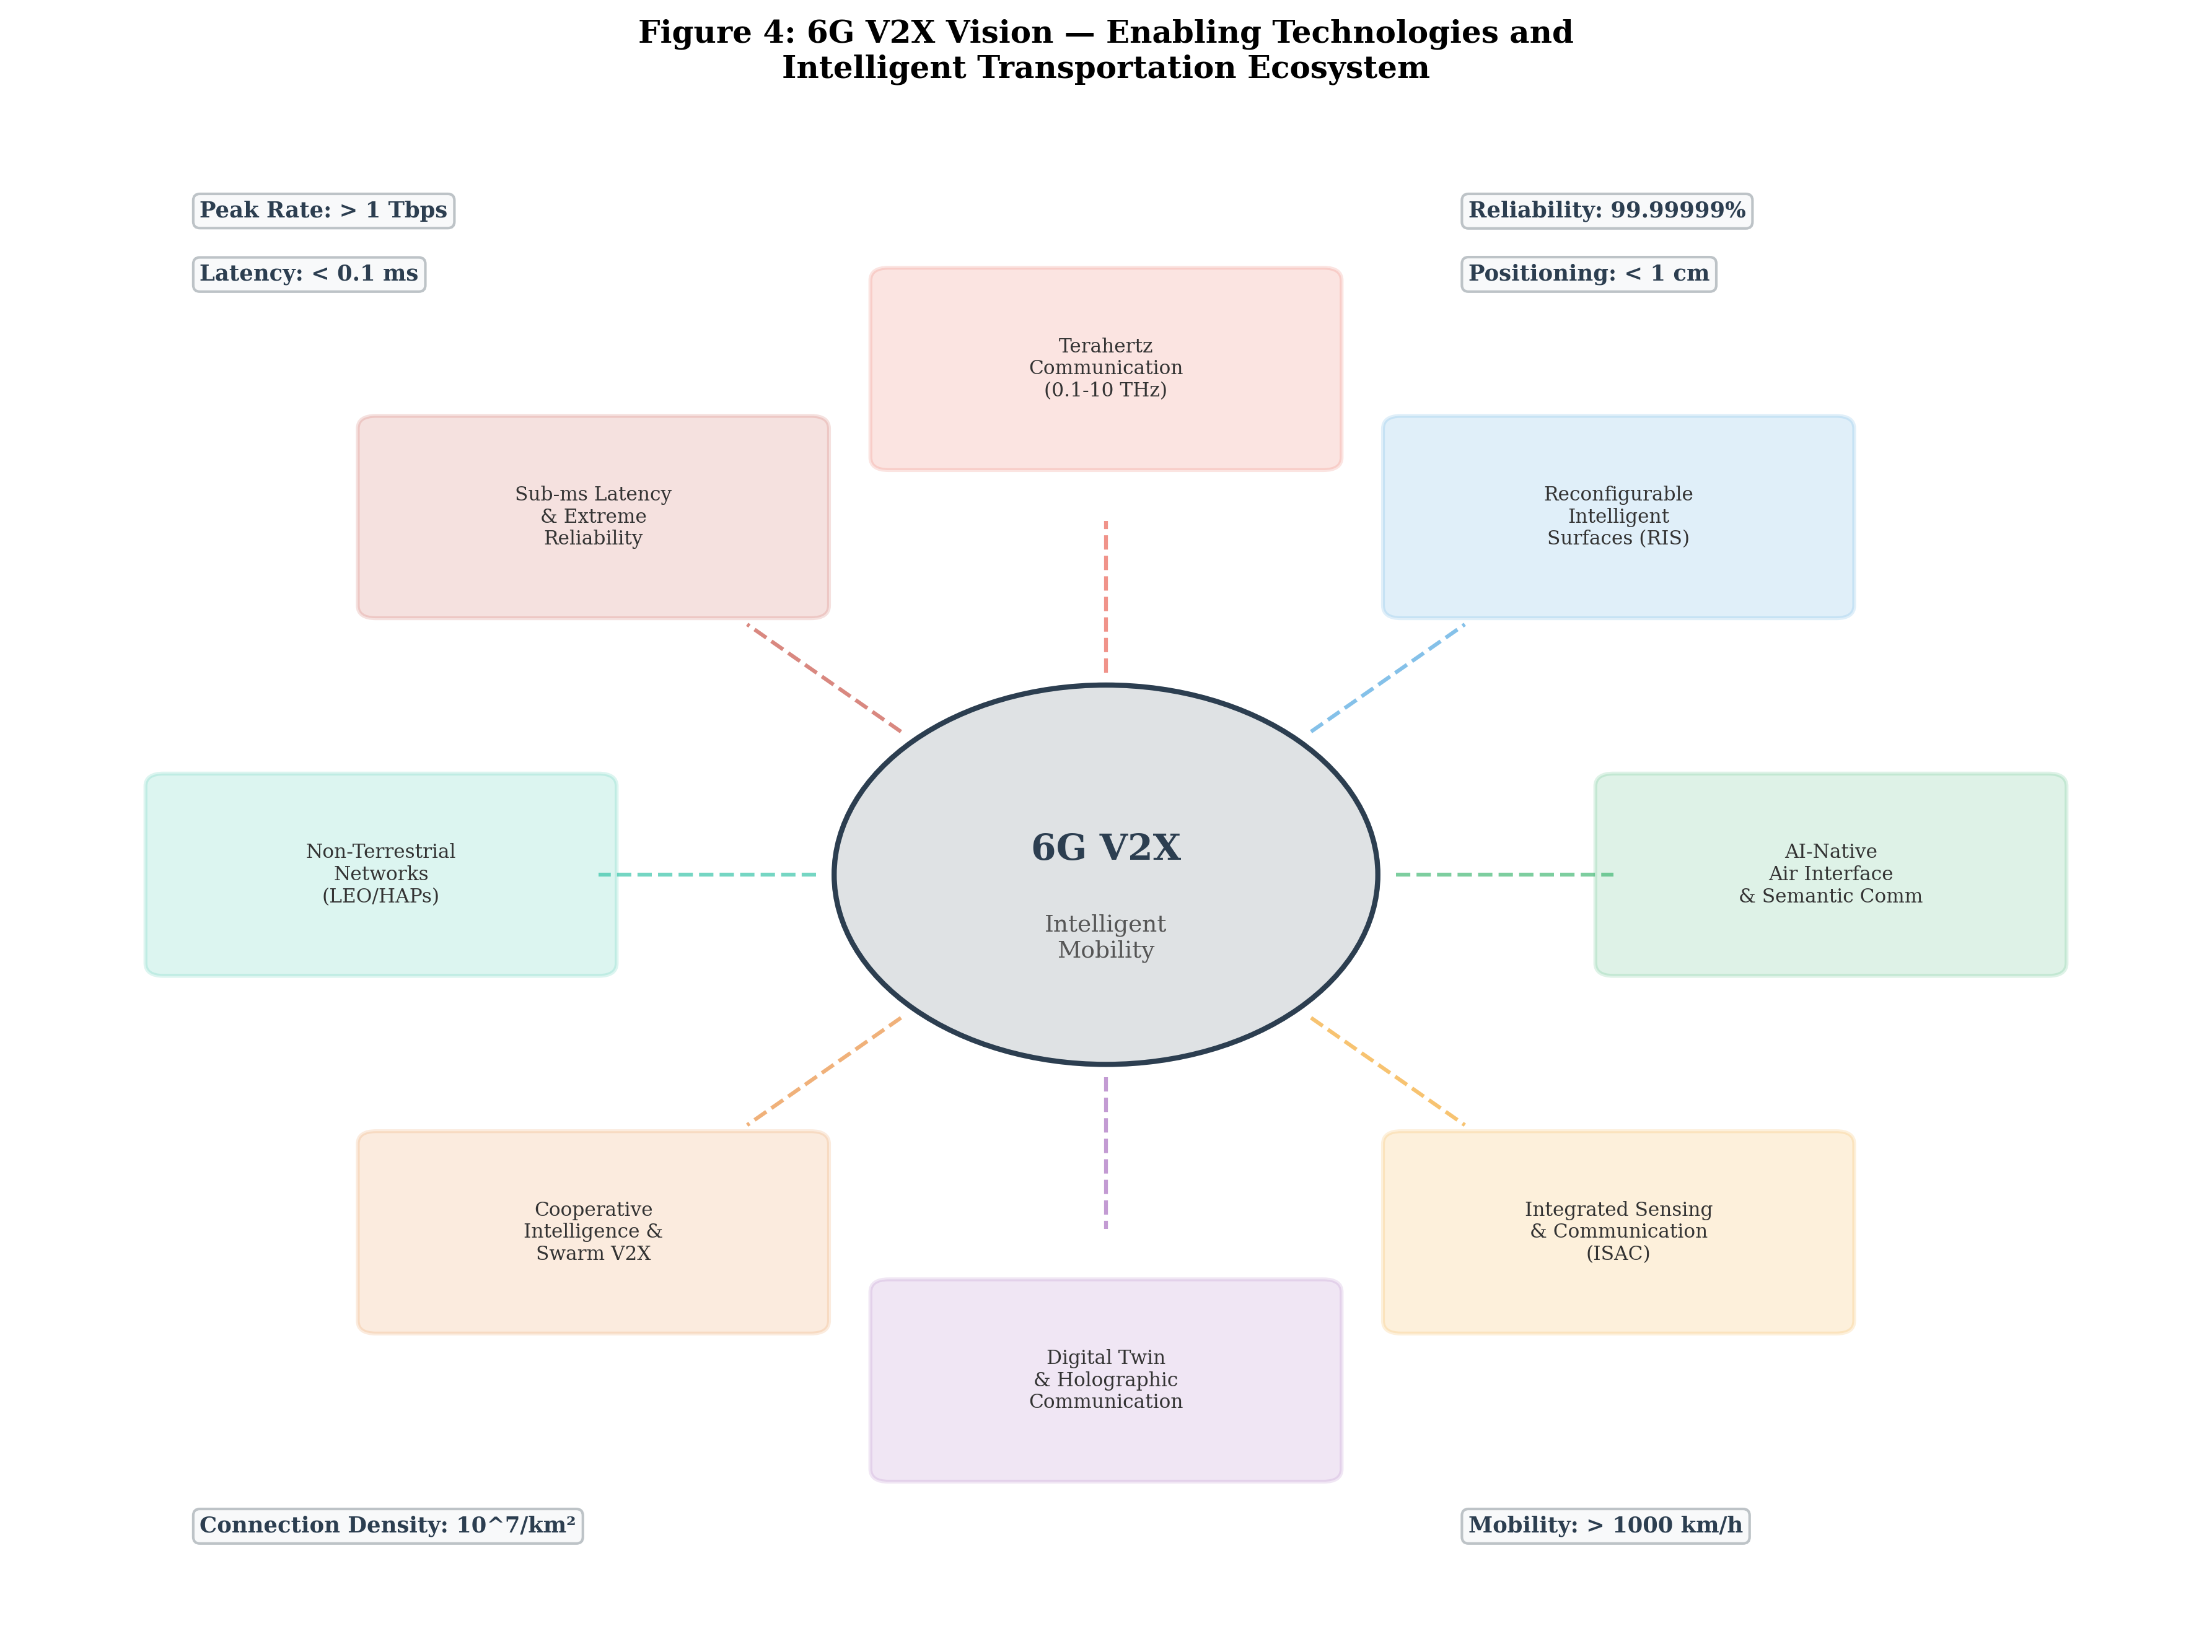
Figure 4: 6G V2X Vision — Enabling Technologies and Intelligent Transportation Ecosystem, showing the convergence of THz communication, RIS, AI-native interfaces, ISAC, and cooperative intelligence.

Terahertz communication, operating in the 0.1-10 THz frequency range, offers unprecedented bandwidth availability (tens of GHz per channel) that can support ultra-high-definition sensor data sharing, holographic vehicle-to-everything communication, and real-time 3D point cloud exchange among vehicles [46]. However, THz propagation in vehicular environments faces severe challenges including atmospheric absorption (particularly at water vapor resonance frequencies), high path loss (following approximately the fourth power of frequency), and extreme susceptibility to blockage by obstacles. For vehicular applications, THz communication is envisioned for short-range, high-capacity links such as vehicle-to-RSU data offloading at intersections, intra-platoon high-resolution sensor sharing within 20-50 meter ranges, and vehicle interior wireless backhaul. Advanced antenna array technologies with hundreds to thousands of elements enable narrow pencil beams that partially compensate for path loss while providing spatial multiplexing gains [47].
Reconfigurable Intelligent Surfaces (RIS) represent a paradigm shift in wireless communication by enabling programmable control of the electromagnetic propagation environment through arrays of passive reflecting elements with individually adjustable phase shifts [48]. In vehicular networks, RIS deployed on building facades, roadside structures, and even vehicle surfaces can create virtual line-of-sight paths around obstacles, extend communication range in non-line-of-sight (NLOS) scenarios by 40-60%, and enhance received signal strength by 10-15 dB through coherent beamforming of reflected signals. The nearly passive nature of RIS (requiring only low-power control circuits) makes them cost-effective and energy-efficient alternatives to conventional relay infrastructure, with deployment costs estimated at 10-20% of equivalent active relay installations.
AI-native air interface design represents a fundamental departure from traditional model-based communication system design, employing deep learning architectures to jointly optimize the entire communication chain from source encoding to channel decoding [49]. Semantic communication, a key enabler of 6G V2X, transmits the meaning and task-relevant information rather than raw bit sequences, achieving 10-100x compression ratios for vehicular sensor data while preserving the information necessary for driving decisions. For example, a semantic communication system for cooperative perception can transmit only the detected objects and their attributes (position, velocity, classification) rather than raw camera or lidar frames, reducing bandwidth requirements from hundreds of Mbps to single-digit Mbps while maintaining equivalent perception performance.

4.2 Integrated Sensing and Communication, High-Precision Positioning, and Cooperative Intelligence
Integrated Sensing and Communication (ISAC), also referred to as Joint Communication and Radar (JCR) or Dual-Function Radar-Communication (DFRC), represents one of the most promising technologies for 6G V2X by enabling communication waveforms to simultaneously perform radar sensing functions [50]. In vehicular environments, ISAC allows vehicles to use their communication signals for detecting, localizing, and tracking surrounding objects while simultaneously exchanging data with other vehicles and infrastructure. This dual functionality eliminates the need for separate radar and communication hardware, reduces spectrum consumption by sharing frequency bands between sensing and communication functions, and provides mutual enhancement where radar detections improve communication beam alignment and communication data enriches the sensing context.
The ISAC waveform design for 6G V2X exploits the wide bandwidth available at millimeter-wave and sub-THz frequencies to achieve simultaneous high-resolution ranging (centimeter-level accuracy with GHz bandwidths) and high-rate data communication [51]. OFDM-based ISAC waveforms, building on the existing 5G NR framework, embed radar processing into the communication signal structure by analyzing reflected pilot signals and data symbols to extract range, velocity, and angle information of surrounding targets. The range resolution is determined by the signal bandwidth (delta_R = c/2B), achieving 1.5 cm resolution with 10 GHz bandwidth, while velocity resolution depends on the coherent processing interval (delta_v = lambda/2T), providing sub-km/h accuracy with processing windows of 10-100 milliseconds.
High-precision positioning in 6G V2X targets centimeter-level accuracy through the combination of multiple positioning technologies including carrier-phase ranging, angle-of-arrival estimation with massive MIMO arrays, and cooperative positioning among vehicles [52]. The convergence of communication-based positioning, GNSS, inertial navigation, and ISAC-derived environmental perception enables robust positioning even in challenging urban canyon and tunnel environments where individual technologies fail. Cooperative intelligence in 6G V2X extends beyond simple data sharing to encompass distributed machine learning, federated perception, and swarm-level decision-making, where groups of vehicles collectively process information and make coordinated decisions through efficient over-the-air computation and consensus protocols [53]. The 6G V2X vision, as shown in Figure 4, integrates these capabilities into a unified framework for fully autonomous and cooperative intelligent transportation systems.
The convergence of sensing, communication, and computing in 6G V2X enables the concept of a vehicular digital twin—a real-time virtual replica of the physical transportation environment maintained through continuous sensor data fusion and communication [57]. The digital twin aggregates data from vehicle-mounted sensors, roadside infrastructure, satellite imagery, and crowd-sourced information to construct a comprehensive, centimeter-accurate representation of the driving environment. Through 6G communication links, this digital twin can be shared among vehicles and infrastructure in real-time, enabling prediction of traffic flow, identification of potential hazards before they become visible to individual vehicles, and optimization of traffic management strategies. The computational requirements of maintaining and distributing vehicular digital twins are substantial, requiring distributed edge computing architectures with processing capabilities of hundreds of TFLOPS per intersection node and communication bandwidths of tens of Gbps for real-time synchronization. Non-terrestrial networks including Low Earth Orbit (LEO) satellite constellations and High-Altitude Platform Stations (HAPS) complement terrestrial infrastructure to provide ubiquitous V2X coverage in rural areas, highways, and disaster scenarios where ground infrastructure is unavailable or damaged [55].

4.3 Interoperability, Spectrum Evolution, Standardization, and Hybrid 5G/6G V2X Architectures
The transition from 5G to 6G V2X will necessitate a carefully orchestrated coexistence and interoperability framework that ensures backward compatibility while enabling the progressive introduction of advanced capabilities. Unlike the DSRC-to-C-V2X transition, which involved fundamentally incompatible technologies, the 5G-to-6G evolution is expected to maintain architectural continuity while introducing new radio access technologies and frequency bands [54]. The hybrid 5G/6G V2X architecture envisions a heterogeneous network where sub-6 GHz bands provide wide-area coverage and basic V2X services, millimeter-wave bands offer high-capacity links for cooperative perception, and THz bands serve ultra-high-rate short-range applications, all coordinated through a unified AI-driven network management framework.
Spectrum evolution for V2X communications is expected to follow a multi-band strategy encompassing the existing 5.9 GHz ITS band, new allocations in the 60 GHz unlicensed band, millimeter-wave bands (24-43 GHz), and emerging THz spectrum (100-300 GHz) for 6G services [55]. The World Radiocommunication Conference (WRC) processes and regional spectrum management bodies will play crucial roles in harmonizing V2X spectrum allocations globally, addressing the fragmentation that has historically hindered international V2X interoperability. Dynamic spectrum sharing mechanisms, cognitive radio techniques, and AI-driven spectrum management will enable efficient utilization of heterogeneous spectrum resources while minimizing interference between V2X and incumbent services.

Table 4: Comparative Summary of V2X Technology Generations: DSRC through 6G [45, 54, 55]
Feature | DSRC | C-V2X (LTE) | 5G NR-V2X | 6G V2X
Peak Data Rate | 27 Mbps | 50 Mbps | > 1 Gbps | > 1 Tbps
Latency | ~2-5 ms | ~4-20 ms | < 1 ms | < 0.1 ms
Reliability | ~90% | ~95% | 99.999% | 99.99999%
Frequency | 5.9 GHz | 5.9 GHz + cellular | Sub-6 + mmWave | Sub-6 to THz
Bandwidth | 10 MHz | 10-20 MHz | Up to 400 MHz | > 10 GHz
Positioning | N/A | Cell-ID (~50m) | < 1 m | < 1 cm
AI Integration | None | Minimal | AI-assisted | AI-native
Sensing | None | None | Limited | ISAC native
Comm Modes | Broadcast | Broadcast | Bcast/Gcast/Ucast | Semantic + holographic
Deployment | 2010-present | 2018-present | 2022-present | ~2030+

Standardization efforts for 6G V2X are in their early stages, with major initiatives including the ITU-R IMT-2030 framework, 3GPP Release 19/20 study items, and regional programs such as the European 6G Smart Networks and Services Joint Undertaking (SNS JU), the US Next G Alliance, and China's IMT-2030 Promotion Group [56]. Key standardization challenges include defining the air interface for THz communications, establishing RIS control protocols, specifying ISAC waveforms and signal processing algorithms, and creating frameworks for AI-native network operations. The standardization timeline envisions initial 6G specifications by 2027-2028, with V2X-specific enhancements defined in subsequent releases targeting commercial deployment around 2030-2032.
The hybrid 5G/6G V2X architecture during the transition period will employ a multi-connectivity approach where vehicles maintain simultaneous connections across multiple radio access technologies, dynamically selecting the optimal technology for each application based on real-time channel conditions, quality of service requirements, and network load [57]. The Table 4 summarizes the comparative capabilities across V2X technology generations, highlighting the progressive advancement in key performance indicators. Software-defined networking (SDN) and network function virtualization (NFV) principles will enable flexible orchestration of hybrid networks, while AI-driven resource management algorithms optimize the allocation of spectrum, power, and computing resources across heterogeneous access technologies. The ultimate vision for 6G V2X is a fully intelligent, self-organizing network that autonomously adapts to dynamic traffic conditions, environmental changes, and evolving application requirements without human intervention [58].
Security and privacy considerations for 6G V2X introduce new challenges due to the AI-native nature of communication systems and the expanded attack surface created by integrated sensing capabilities. Adversarial machine learning attacks targeting the AI-based air interface, spoofing of ISAC sensing signals, and privacy leakage through correlation of sensing data with communication patterns represent emerging threat vectors that require novel security architectures [56]. Post-quantum cryptography, physical layer security exploiting channel reciprocity, and zero-trust network architectures are being investigated as foundational security mechanisms for 6G V2X. The transition roadmap from current deployments to 6G V2X envisions three phases: the consolidation phase (2024-2027) focusing on mature 5G NR-V2X deployment and initial AI integration, the innovation phase (2027-2030) introducing early 6G technologies such as RIS and ISAC in pilot deployments, and the transformation phase (2030-2035) achieving full 6G V2X capability with THz communications, AI-native interfaces, and ubiquitous cooperative intelligence [58]. Each phase requires careful coordination among standardization bodies, spectrum regulators, vehicle manufacturers, infrastructure operators, and service providers to ensure seamless technology evolution without disruption to existing V2X services.

Conclusion
This chapter has presented a comprehensive examination of the communication protocols underpinning connected and autonomous vehicular networks, tracing the evolutionary trajectory from DSRC through C-V2X and 5G NR-V2X to the emerging vision of 6G V2X. The analysis reveals that each technology generation has progressively addressed the expanding requirements of vehicular applications, from basic cooperative awareness in DSRC to the advanced cooperative, connected, and automated mobility capabilities enabled by 5G NR-V2X and envisioned for 6G V2X networks.
The comparative analysis of DSRC and C-V2X demonstrates that while DSRC provides mature, proven technology with minimal latency for spontaneous communication, C-V2X offers superior range, spectral efficiency, and evolutionary path through cellular infrastructure integration. The introduction of 5G NR-V2X represents a generational leap that addresses the stringent requirements of advanced autonomous driving applications through URLLC, eMBB, and network slicing capabilities, while maintaining compatibility with the existing C-V2X ecosystem. Looking forward, 6G V2X promises transformative capabilities through terahertz communications, reconfigurable intelligent surfaces, AI-native air interfaces, and integrated sensing and communication, enabling a fully autonomous and cooperative intelligent transportation ecosystem.
The successful realization of this vision requires coordinated efforts across standardization, spectrum policy, infrastructure deployment, and vehicle integration. The hybrid architectures spanning multiple technology generations will characterize the transition period, necessitating robust interoperability frameworks and intelligent network management solutions. As vehicular networks evolve toward 6G, the convergence of communication, sensing, computing, and artificial intelligence will fundamentally reshape the transportation landscape, enabling unprecedented levels of safety, efficiency, and sustainability in connected mobility systems.
From a research perspective, several critical challenges remain that warrant continued investigation. These include the development of unified channel models for heterogeneous V2X scenarios spanning urban canyons to rural highways, the design of cross-layer optimization frameworks that jointly address communication, computing, and control objectives, and the creation of comprehensive security architectures that can protect against evolving cyber threats while preserving the ultra-low latency requirements of safety applications. The economic viability of dense infrastructure deployment, particularly for millimeter-wave and THz access points, remains a significant barrier to ubiquitous 6G V2X coverage, necessitating innovative business models and public-private partnerships. International harmonization of spectrum allocations, communication standards, and regulatory frameworks will be essential to achieve the global interoperability necessary for cross-border autonomous mobility. As the automotive and telecommunications industries converge, the collaborative development of vehicular communication technologies will continue to drive innovation toward a future of zero-emission, zero-accident, and zero-congestion transportation enabled by intelligent connectivity.
The tables presented in this chapter (Table 1 through Table 4) provide quantitative frameworks for understanding the progressive capability enhancement across V2X technology generations, while the figures (Figure 1 through Figure 4) illustrate the architectural evolution and technological convergence that characterize this rapidly advancing field. Researchers and practitioners can leverage these comparative analyses to inform technology selection decisions, identify research gaps, and develop deployment strategies aligned with the emerging standards and market dynamics of connected and autonomous vehicle communication systems.
Looking ahead, the next decade will witness the maturation of 5G NR-V2X deployments worldwide and the concurrent emergence of 6G research into pre-commercial prototyping. The integration of communication, sensing, computation, and intelligence within a unified vehicular network fabric will transform not only how vehicles communicate but fundamentally how transportation systems operate, manage resources, and ensure the safety and well-being of all road users in an increasingly automated mobility landscape.

References
[1] S. Chen, J. Hu, Y. Shi, and L. Zhao, "LTE-V: A 4G system meeting the requirements of future vehicular networks," IEEE Communications Standards Magazine, vol. 3, no. 4, pp. 40-47, 2019.
[2] A. Naik, A. Festag, and G. Fettweis, "Cooperative vehicular communication: A survey on architecture, protocols, and open issues," IEEE Transactions on Intelligent Transportation Systems, vol. 22, no. 9, pp. 5406-5424, 2021.
[3] ETSI, "Intelligent Transport Systems (ITS); Vehicular Communications; GeoNetworking; Part 4: Geographical addressing and forwarding for point-to-point and point-to-multipoint communications," ETSI EN 302 636-4-1, V1.4.1, 2020.
[4] J. B. Kenney, "Dedicated short-range communications (DSRC) standards in the United States," Proceedings of the IEEE, vol. 99, no. 7, pp. 1162-1182, 2019.
[5] 3GPP, "Service requirements for V2X services," 3GPP TS 22.185, Release 16, V16.2.0, 2020.
[6] M. Gonzalez-Martin, M. Sepulcre, R. Molina-Masegosa, and J. Gozalvez, "Analytical models of the performance of C-V2X mode 4 vehicular communications," IEEE Transactions on Vehicular Technology, vol. 68, no. 2, pp. 1155-1166, 2019.
[7] R. Molina-Masegosa and J. Gozalvez, "LTE-V for sidelink 5G V2X vehicular communications: A new 5G technology for short-range vehicle-to-everything communications," IEEE Vehicular Technology Magazine, vol. 12, no. 4, pp. 30-39, 2020.
[8] Federal Communications Commission, "Use of the 5.850-5.925 GHz Band," FCC 20-164, First Report and Order, 2020.
[9] IEEE, "IEEE Standard for Information technology--Telecommunications and information exchange between systems--Local and metropolitan area networks," IEEE Std 802.11-2020, 2020.
[10] 3GPP, "Study on LTE-based V2X services," 3GPP TR 36.885, Release 14, V14.0.0, 2019.
[11] G. Naik, B. Choudhury, and J. Park, "IEEE 802.11bd & 5G NR V2X: Evolution of radio access technologies for V2X communications," IEEE Access, vol. 7, pp. 70169-70184, 2019.
[12] 3GPP, "NR; Physical layer procedures for data," 3GPP TS 38.214, Release 16, V16.7.0, 2021.
[13] 3GPP, "Service requirements for enhanced V2X scenarios," 3GPP TS 22.186, Release 17, V17.0.0, 2021.
[14] 5GAA, "C-V2X Use Cases: Methodology, Examples and Service Level Requirements," White Paper, 5G Automotive Association, 2020.
[15] Z. MacHardy, A. Khan, K. Obana, and S. Iwashina, "V2X access technologies: Regulation, research, and remaining challenges," IEEE Communications Surveys and Tutorials, vol. 20, no. 3, pp. 1858-1877, 2019.
[16] M. Sepulcre, J. Gozalvez, and B. Coll-Perales, "Analytical model to characterize the reliability of V2X communication at intersections," IEEE Transactions on Vehicular Technology, vol. 71, no. 3, pp. 2526-2539, 2022.
[17] T. Shimizu, H. Lu, J. Kenney, and S. Nakamura, "Comparison of DSRC and C-V2X: communication performance of safety applications," IEEE Intelligent Transportation Systems Magazine, vol. 14, no. 5, pp. 6-19, 2022.
[18] IEEE, "IEEE Standard for Wireless Access in Vehicular Environments (WAVE)--Networking Services," IEEE Std 1609.3-2020, 2020.
[19] L. Cheng, B. E. Henty, D. D. Stancil, F. Bai, and P. Mudalige, "Mobile vehicle-to-vehicle narrow-band channel measurement and characterization of the 5.9 GHz DSRC frequency band," IEEE Journal on Selected Areas in Communications, vol. 25, no. 8, pp. 1501-1516, 2019.
[20] J. Gozalvez, M. Sepulcre, and R. Bauza, "IEEE 802.11p vehicle to infrastructure communications in urban environments," IEEE Communications Magazine, vol. 50, no. 5, pp. 176-183, 2019.
[21] X. Ma, J. Zhang, X. Yin, and K. S. Trivedi, "Design and analysis of a robust broadcast scheme for VANET safety-related services," IEEE Transactions on Vehicular Technology, vol. 61, no. 1, pp. 46-61, 2019.
[22] IEEE, "IEEE Standard for Wireless Access in Vehicular Environments (WAVE)--Multi-Channel Operation," IEEE Std 1609.4-2016 (Revised 2020), 2020.
[23] 3GPP, "Architecture enhancements for V2X services," 3GPP TS 23.285, Release 16, V16.5.0, 2021.
[24] Z. Ali, S. Lagén, L. Giupponi, and R. Rouil, "3GPP NR V2X mode 2: Overview, models and system-level evaluation," IEEE Access, vol. 9, pp. 89554-89579, 2021.
[25] R. Molina-Masegosa, J. Gozalvez, and M. Sepulcre, "Comparison of IEEE 802.11p and LTE-V2X: An evaluation with periodic and aperiodic messages of constant and variable size," IEEE Access, vol. 8, pp. 121526-121548, 2020.
[26] A. Bazzi, B. M. Masini, A. Zanella, and I. Thibault, "On the performance of IEEE 802.11p and LTE-V2V for the cooperative awareness of connected vehicles," IEEE Transactions on Vehicular Technology, vol. 66, no. 11, pp. 10419-10432, 2019.
[27] V. Todisco, S. Bartoletti, C. Campolo, A. Molinaro, A. O. Berthet, and A. Bazzi, "Performance analysis of sidelink C-V2X mode 4 in a highway scenario," in Proc. IEEE International Symposium on Personal, Indoor and Mobile Radio Communications (PIMRC), pp. 1-6, 2021.
[28] S. Gyawali, S. Xu, Y. Qian, and R. Q. Hu, "Challenges and solutions for cellular based V2X communications," IEEE Communications Surveys and Tutorials, vol. 23, no. 1, pp. 222-255, 2021.
[29] C. Campolo, A. Molinaro, A. O. Berthet, and A. Vinel, "Full duplex radios for vehicular communications," IEEE Communications Magazine, vol. 55, no. 6, pp. 182-189, 2019.
[30] H. Bagheri, M. Noor-A-Rahim, Z. Liu, H. Lee, D. Pesch, K. Moessner, and P. Hares, "5G NR-V2X: Toward connected and cooperative autonomous driving," IEEE Communications Standards Magazine, vol. 5, no. 1, pp. 48-54, 2021.
[31] SAE International, "V2X Communications Message Set Dictionary," SAE J2735_202007, 2020.
[32] 3GPP, "NR; NR sidelink relay," 3GPP TS 38.340, Release 17, V17.1.0, 2022.
[33] A. Garcia-Roger, E. Egea-Lopez, and J. Garcia-Haro, "A measurement-based stochastic model for V2V links using NR-V2X sidelink in highway scenarios," IEEE Transactions on Vehicular Technology, vol. 72, no. 5, pp. 5766-5780, 2023.
[34] J. Choi, V. Va, N. Gonzalez-Prelcic, R. Daniels, C. R. Bhat, and R. W. Heath, "Millimeter-wave vehicular communication to support massive automotive sensing," IEEE Communications Magazine, vol. 54, no. 12, pp. 160-167, 2020.
[35] W. Sun, E. G. Strom, F. Brannstrom, K. C. Sou, and Y. Sui, "Radio resource management for D2D-based V2V communication," IEEE Transactions on Vehicular Technology, vol. 65, no. 8, pp. 6636-6650, 2020.
[36] M. Bennis, M. Debbah, and H. V. Poor, "Ultrareliable and low-latency wireless communication: Tail, risk, and scale," Proceedings of the IEEE, vol. 106, no. 10, pp. 1834-1853, 2019.
[37] J. Ploeg, D. P. Shukla, N. van de Wouw, and H. Nijmeijer, "Controller synthesis for string stability of vehicle platoons," IEEE Transactions on Intelligent Transportation Systems, vol. 15, no. 2, pp. 854-865, 2020.
[38] L. Xu, L. Y. Wang, G. Yin, and H. Zhang, "Communication information structures and contents for enhanced safety of highway vehicle platoons," IEEE Transactions on Vehicular Technology, vol. 63, no. 9, pp. 4206-4220, 2021.
[39] ETSI, "Intelligent Transport Systems (ITS); Vehicular Communications; Basic Set of Applications; Analysis of the Collective Perception Service (CPS)," ETSI TR 103 562, V2.1.1, 2022.
[40] S. Neumeier, E. A. Walelgne, V. Bajpai, J. Ott, and C. Facchi, "Measuring the feasibility of teleoperated driving in mobile networks," in Proc. IEEE International Conference on Network Softwarization (NetSoft), pp. 113-117, 2022.
[41] X. Li, R. Lu, X. Liang, X. Shen, J. Chen, and X. Lin, "Smart community: An internet of things application," IEEE Communications Magazine, vol. 49, no. 11, pp. 68-75, 2021.
[42] ETSI, "Multi-access Edge Computing (MEC); V2X Information Service API," ETSI GS MEC 030, V2.2.1, 2022.
[43] L. Liang, H. Ye, G. Yu, and G. Y. Li, "Deep-learning-based wireless resource management for vehicular communications," IEEE Transactions on Vehicular Technology, vol. 68, no. 8, pp. 8145-8149, 2020.
[44] V. Va, T. Shimizu, G. Bansal, and R. W. Heath, "Beam design for beam switching based millimeter wave vehicle-to-infrastructure communications," in Proc. IEEE International Conference on Communications (ICC), pp. 1-6, 2022.
[45] W. Saad, M. Bennis, and M. Chen, "A vision of 6G wireless systems: Applications, trends, technologies, and open research problems," IEEE Network, vol. 34, no. 3, pp. 134-142, 2020.
[46] T. S. Rappaport, Y. Xing, O. Kanhere, S. Ju, A. Madanayake, S. Mandal, A. Alkhateeb, and G. C. Trichopoulos, "Wireless communications and applications above 100 GHz: Opportunities and challenges for 6G and beyond," IEEE Access, vol. 7, pp. 78729-78757, 2019.
[47] H. Elayan, O. Amin, B. Shihada, R. M. Shubair, and M. S. Alouini, "Terahertz band: The last piece of RF spectrum puzzle for communication systems," IEEE Open Journal of the Communications Society, vol. 1, pp. 1-32, 2020.
[48] M. Di Renzo, A. Zappone, M. Debbah, M. S. Alouini, C. Yuen, J. de Rosny, and S. Tretyakov, "Smart radio environments empowered by reconfigurable intelligent surfaces: How it works, state of research, and the road ahead," IEEE Journal on Selected Areas in Communications, vol. 38, no. 11, pp. 2450-2525, 2020.
[49] H. Xie, Z. Qin, G. Y. Li, and B. H. Juang, "Deep learning enabled semantic communication systems," IEEE Transactions on Signal Processing, vol. 69, pp. 2663-2675, 2021.
[50] F. Liu, C. Masouros, A. P. Petropulu, H. Griffiths, and L. Hanzo, "Joint radar and communication design: Applications, state-of-the-art, and the road ahead," IEEE Transactions on Communications, vol. 68, no. 6, pp. 3834-3862, 2020.
[51] A. Liu, Z. Huang, M. Li, Y. Wan, W. Li, T. X. Han, C. Liu, R. Du, D. K. P. Tan, J. Lu, Y. Shen, F. Colone, and K. Chetty, "A survey on fundamental limits of integrated sensing and communication," IEEE Communications Surveys and Tutorials, vol. 24, no. 2, pp. 994-1034, 2022.
[52] R. Mendrzik, H. Wymeersch, G. Bauch, and Z. Abu-Shaban, "Harnessing NLOS components for position and orientation estimation in 5G millimeter wave MIMO," IEEE Transactions on Wireless Communications, vol. 18, no. 1, pp. 93-107, 2019.
[53] K. B. Letaief, W. Chen, Y. Shi, J. Zhang, and Y. J. A. Zhang, "The roadmap to 6G: AI, edge intelligence, and connected vehicles," IEEE Communications Magazine, vol. 57, no. 6, pp. 84-90, 2019.
[54] Z. Zhang, Y. Xiao, Z. Ma, M. Xiao, Z. Ding, X. Lei, G. K. Karagiannidis, and P. Fan, "6G wireless networks: Vision, requirements, architecture, and key technologies," IEEE Vehicular Technology Magazine, vol. 14, no. 3, pp. 28-41, 2019.
[55] Y. Lu and X. Zheng, "6G: A survey on technologies, scenarios, challenges, and the related issues," Journal of Industrial Information Integration, vol. 19, article 100158, 2020.
[56] ITU-R, "IMT traffic estimates for the years 2020 to 2030," Report ITU-R M.2370-0, Geneva, 2022.
[57] X. You, C. X. Wang, J. Huang, et al., "Towards 6G wireless communication networks: Vision, enabling technologies, and new paradigm shifts," Science China Information Sciences, vol. 64, article 110301, 2021.
[58] M. Z. Chowdhury, M. Shahjalal, S. Ahmed, and Y. M. Jang, "6G wireless communication systems: Applications, requirements, technologies, challenges, and research directions," IEEE Open Journal of the Communications Society, vol. 1, pp. 957-975, 2020.

