Design Thinking and Its Integration with Analytical, Systems, and Creative Thinking: A Multimethod Framework for Business Strategy

Abstract
Design thinking has emerged as a powerful approach for addressing complex business challenges through human-centered innovation. However, its full potential is realized only when integrated with complementary cognitive and strategic frameworks. This chapter examines the intersections between design thinking and three critical approaches: analytical decision-making, systems thinking, and creative thinking. Through a comprehensive synthesis of theoretical foundations and practical applications, we develop a multimethod framework that enables organizations to select and combine appropriate thinking approaches based on problem characteristics. The chapter demonstrates how analytical rigor provides evidence-based validation, systems thinking reveals interconnections and emergent behaviors, and creative thinking generates novel possibilities—all enhanced through design thinking's empathic and iterative methodology. Four integrative figures and four comparative tables illustrate the relationships, processes, and applications across these domains. The framework addresses applications in new product development, business model innovation, organizational transformation, and sustainability challenges, concluding with future directions in AI-supported strategic thinking and data-driven creativity.
Keywords: Design thinking, analytical decision-making, systems thinking, creative thinking, business strategy, innovation management, multimethod framework, strategic problem-solving, organizational transformation

Section 1: Design Thinking and Analytical Decision-Making

1.1 Foundations of Analytical Decision-Making Models
Rational and evidence-based decision-making represents a cornerstone of modern management science, rooted in the rational actor model that has dominated organizational theory since the mid-twentieth century [1]. The fundamental premise holds that effective decisions emerge from systematic evaluation of alternatives against clearly defined criteria, utilizing quantitative data and logical reasoning to minimize uncertainty and maximize expected outcomes [2]. This tradition draws upon operations research, statistical analysis, and economic theory to provide managers with structured approaches for navigating complex business environments [3].
The rational decision-making model proceeds through a series of well-defined stages: problem identification, information gathering, alternative generation, criteria establishment, systematic evaluation, and selection of the optimal course of action [4]. Each stage demands rigorous analytical engagement, from the precise definition of objectives to the mathematical comparison of expected utilities across alternatives [5]. Decision trees, cost-benefit analyses, multi-criteria decision analysis, and Bayesian inference represent core tools within this tradition, enabling quantification of both certain and uncertain outcomes [6].
Evidence-based decision-making extends the analytical tradition by emphasizing the systematic collection and evaluation of empirical data to inform strategic choices [7]. Rather than relying upon intuition, tradition, or authority, evidence-based approaches demand that managers ground their decisions in the best available research, organizational data, and contextual information [8]. This approach has gained significant traction in healthcare, education, and increasingly in business management, where randomized controlled trials, meta-analyses, and big data analytics provide unprecedented access to decision-relevant information [9].
Risk assessment constitutes a critical dimension of analytical decision-making, requiring organizations to identify, quantify, and mitigate potential negative outcomes associated with strategic choices [10]. Probability theory, Monte Carlo simulation, sensitivity analysis, and scenario planning enable decision-makers to evaluate the range of possible outcomes and their associated likelihoods [11]. The integration of risk assessment with decision criteria ensures that strategic choices account not only for expected returns but also for downside vulnerability and organizational risk tolerance [12].
However, analytical decision-making faces well-documented limitations. Bounded rationality, as articulated by Simon, recognizes that human cognitive capacity constrains the extent to which truly optimal decisions can be achieved [1]. Information asymmetries, time pressures, cognitive biases, and the inherent complexity of organizational environments mean that analytical models often serve as approximations rather than perfect representations of decision contexts [13]. Furthermore, the analytical tradition may struggle with problems characterized by ambiguity, conflicting stakeholder values, or rapid environmental change—precisely the conditions that design thinking was developed to address [14].

1.2 Design Thinking versus Analytical Decision-Making
Design thinking and analytical decision-making represent fundamentally different orientations toward problem-solving, each embodying distinct epistemological assumptions about the nature of knowledge, problems, and valid approaches to resolution [15]. Understanding these differences is essential for appreciating how their integration can produce superior strategic outcomes.
In problem framing, analytical approaches typically assume that problems can be clearly defined, bounded, and decomposed into manageable components amenable to quantitative analysis [16]. Design thinking, conversely, begins with the recognition that many significant business problems are "wicked"—ill-defined, multi-stakeholder, and resistant to definitive formulation [17]. Where analytical methods seek to reduce ambiguity through precise problem definition, design thinking embraces ambiguity as a source of creative opportunity, using empathic inquiry to reframe problems from the perspective of human needs and experiences [18].
The use of data diverges significantly between these traditions. Analytical decision-making privileges quantitative data—financial metrics, market statistics, operational parameters—processed through formal models to generate actionable insights [19]. Design thinking employs qualitative, ethnographic, and experiential data—observations, interviews, journey maps, personas—to develop deep understanding of human contexts and motivations [20]. The former seeks statistical generalizability; the latter pursues empathic specificity and contextual richness [21].
Decision processes also differ markedly. Analytical approaches follow linear, sequential logic: define, analyze, decide, implement [4]. Design thinking operates through iterative cycles of divergence and convergence: empathize, define, ideate, prototype, test—with frequent loops back to earlier stages as understanding deepens [22]. The analytical tradition aims for optimization; design thinking aims for satisficing through rapid experimentation and learning [23].
The role of intuition presents another point of distinction. While analytical frameworks often position intuition as a source of bias to be overcome through systematic analysis [13], design thinking recognizes intuition—particularly expert intuition informed by deep domain experience—as a valuable input to the creative process [24]. Design practitioners cultivate "abductive reasoning," the ability to generate explanatory hypotheses that can be tested through prototyping and experimentation [25].
Table 1 presents a systematic comparison of these two approaches across multiple dimensions, revealing both their distinctive contributions and potential points of integration.
Table 1: Comparative Analysis of Design Thinking and Analytical Decision-Making
Dimension | Analytical Decision-Making | Design Thinking
Problem framing | Well-defined, decomposable | Ambiguous, human-centered
Primary data | Quantitative, statistical | Qualitative, ethnographic
Reasoning mode | Deductive, inductive | Abductive, analogical
Process structure | Linear, sequential | Iterative, cyclical
Uncertainty approach | Reduce through analysis | Embrace through experimentation
Success metric | Optimal outcome | Desirable, feasible, viable solution
Stakeholder role | Data source | Co-creator
Time orientation | Plan then execute | Learn through doing
Risk management | Ex-ante quantification | Iterative de-risking
Cognitive emphasis | Logic, calculation | Empathy, imagination

Despite these differences, the two approaches are not mutually exclusive. Effective strategic decision-making increasingly requires the ability to move fluidly between analytical rigor and design sensitivity, deploying each approach according to the nature of the challenge at hand [26]. The analytical tradition provides the evaluative criteria and quantitative evidence needed to validate design-generated solutions, while design thinking provides the human insight and creative exploration needed to identify opportunities that pure analysis might overlook [15].

1.3 Integrating Design Thinking with Analytical Models
The integration of design thinking with analytical decision-making models creates a hybrid approach that leverages the strengths of both traditions while compensating for their individual limitations [27]. This integration operates at multiple levels: strategic framing, data integration, process design, and validation methodology.
At the strategic framing level, design thinking's empathic inquiry expands the problem space before analytical methods are applied to evaluate specific alternatives [28]. Rather than beginning with a predefined decision problem, the integrated approach starts with broad exploration of stakeholder needs, pain points, and aspirations, using this understanding to define decision problems that are both analytically tractable and humanly meaningful [15]. This ensures that analytical precision is applied to the right questions—those that matter most to the people the organization serves.
Data integration represents a second critical dimension of synthesis. Human-centered insights generated through design research—ethnographic observations, customer journey maps, empathy maps—complement quantitative market data, financial projections, and operational metrics [29]. The integration creates what might be termed "thick data"—contextually rich, qualitatively grounded information that provides the interpretive framework needed to make quantitative data meaningful and actionable [20]. Organizations that combine these data streams develop more nuanced understanding of market opportunities and customer needs than those relying on either source alone [30].
Figure 1 illustrates the integrated framework showing how design thinking and analytical decision-making converge across the strategic innovation process, from initial problem exploration through validated solution implementation.
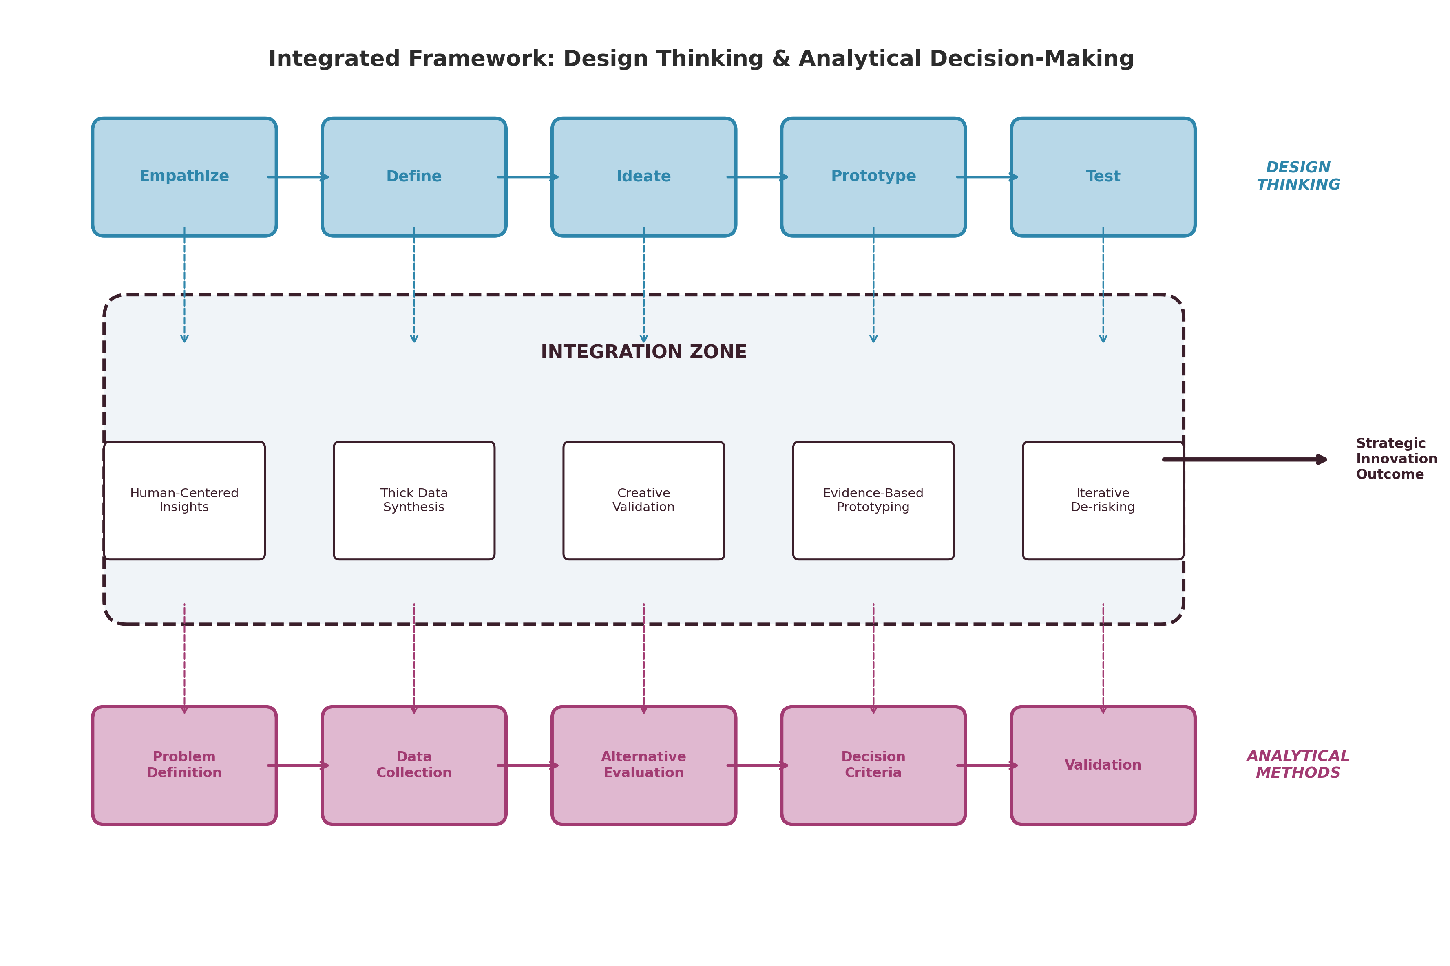
Figure 1: Integrated Framework of Design Thinking and Analytical Decision-Making in Strategic Innovation

In the process dimension, integration involves embedding analytical checkpoints within the iterative design cycle [31]. After divergent ideation generates multiple possible solutions, analytical methods—including financial modeling, market sizing, competitive analysis, and risk assessment—provide the evaluative rigor needed to select the most promising concepts for further prototyping [27]. Similarly, prototype testing can incorporate both qualitative user feedback and quantitative performance metrics, enabling decisions that balance human desirability with technical feasibility and business viability [32].
Validation methodology benefits particularly from integration. Design thinking's rapid prototyping and testing cycles generate experiential evidence about solution desirability, while analytical methods provide the statistical framework for interpreting test results, assessing generalizability, and projecting outcomes at scale [33]. A/B testing, conjoint analysis, and experimental design complement design research methods to create robust validation processes that satisfy both creative and analytical standards of evidence [34].
Strategic applications of this integrated approach span multiple domains. In new product development, design-analytical integration enables organizations to identify unmet needs through empathic research, generate innovative concepts through ideation, and validate market potential through rigorous analysis—all within accelerated development cycles [35]. In strategic planning, the approach allows organizations to combine visionary exploration with evidence-based evaluation, ensuring that strategic choices are both imaginatively ambitious and analytically sound [26].
The integrated approach also addresses the organizational dimension of decision-making. By combining design thinking's collaborative, inclusive processes with analytical decision-making's structured evaluation criteria, organizations can make decisions that are both participatory and rigorous [28]. Cross-functional teams engage in empathic research and creative ideation, generating diverse perspectives that analytical frameworks then synthesize into coherent strategic directions [36].

Section 2: Design Thinking and Systems Thinking

2.1 Principles and Foundations of Systems Thinking
Systems thinking provides a conceptual framework for understanding the behavior of complex, interconnected entities by examining the relationships, interactions, and feedback mechanisms among their constituent parts [37]. Originating in general systems theory and cybernetics, systems thinking has become an essential analytical lens for addressing business challenges that cannot be adequately understood through reductionist approaches alone [38].
The foundational principle of systems thinking holds that the behavior of a system emerges from the interactions among its components rather than from the properties of individual elements considered in isolation [39]. This principle of emergence has profound implications for business strategy, suggesting that organizational performance, market dynamics, and innovation outcomes are properties of interconnected systems that cannot be predicted or managed by examining individual functions, departments, or stakeholders separately [37].
Feedback loops constitute a central concept within systems thinking, describing the circular causal relationships through which system outputs influence subsequent inputs [40]. Reinforcing (positive) feedback loops amplify change, creating virtuous or vicious cycles that can drive exponential growth or accelerating decline. Balancing (negative) feedback loops maintain system stability by counteracting perturbations and returning systems toward equilibrium states [38]. Understanding these feedback structures is essential for predicting how strategic interventions will propagate through organizational and market systems over time [41].
Interdependencies among system elements create complex webs of cause and effect that often produce counterintuitive behaviors [42]. Linear, proportional relationships between cause and effect—assumed by many analytical models—frequently break down in complex systems, where small changes can produce large effects (sensitivity) and large interventions can be absorbed without visible impact (resilience) [39]. These nonlinear dynamics demand analytical approaches that account for interaction effects, time delays, and threshold phenomena [43].
System boundaries define which elements and relationships are considered part of the system under analysis and which are treated as external environmental factors [44]. The choice of system boundaries profoundly influences the conclusions drawn from analysis, as narrowly bounded systems may overlook critical interdependencies with external stakeholders, environmental contexts, or upstream/downstream value chain partners [37]. Effective systems thinking requires conscious, reflective boundary choices that include all elements relevant to understanding system behavior [45].
Stakeholder mapping within systems thinking identifies the multiple actors whose behaviors, interests, and interactions shape system dynamics [44]. Unlike traditional stakeholder analysis, which categorizes stakeholders by power and interest, systems-oriented stakeholder mapping emphasizes the relationships and feedback mechanisms connecting stakeholders, revealing how changes in one stakeholder's behavior propagate through the network to affect others [46].
Causal relationships in complex systems often involve significant time delays between actions and their consequences, creating challenges for learning and adaptation [42]. Organizations that fail to account for these delays may abandon effective strategies prematurely or persist with ineffective ones beyond the point of diminishing returns. Causal loop diagrams and system dynamics models provide tools for mapping and simulating these delayed relationships, enabling more informed strategic decision-making [40].

2.2 Comparing Design Thinking and Systems Thinking
Design thinking and systems thinking share a commitment to addressing complexity but approach it from fundamentally different perspectives and with different primary concerns [47]. Understanding these complementarities is essential for effective integration.
Design thinking adopts a human-centered perspective, beginning with the experiences, needs, and aspirations of individual users, customers, or stakeholders [22]. Its primary unit of analysis is the human being in context—the person using a product, navigating a service, or engaging with an organization. Systems thinking, conversely, adopts a system-oriented perspective, beginning with the structures, relationships, and dynamics that characterize the broader system within which individuals operate [37]. Its primary unit of analysis is the system as a whole—the organization, market, ecosystem, or value network within which individual behaviors are embedded.
Problem framing differs substantially across levels of analysis. Design thinking typically frames problems at the individual or small-group level: How might we improve a customer's experience? How might we address an employee's pain point? [17]. Systems thinking frames problems at organizational, inter-organizational, or ecosystem levels: How do market dynamics create barriers to adoption? How do organizational structures inhibit innovation? [44]. The former seeks solutions that work for specific people; the latter seeks interventions that shift system patterns.
Table 2 presents a detailed comparison of design thinking and systems thinking across key analytical dimensions.
Table 2: Comparative Analysis of Design Thinking and Systems Thinking
Dimension | Design Thinking | Systems Thinking
Primary perspective | Human-centered | System-oriented
Unit of analysis | Individual in context | System as whole
Problem level | Individual/group needs | System patterns/structures
Complexity approach | Prototype and test | Map and model
Change theory | Iterative improvement | Leverage point intervention
Data emphasis | Qualitative experience | Structural relationships
Temporal focus | Present experience | Dynamic behavior over time
Solution form | Product, service, experience | Policy, structure, process
Stakeholder view | Empathic understanding | Network position and influence
Validation method | User testing | Simulation and scenario analysis

In managing complexity, the two approaches employ different strategies. Design thinking manages complexity through decomposition and prototyping—breaking complex challenges into manageable experiments that generate learning through rapid iteration [23]. Systems thinking manages complexity through abstraction and modeling—creating simplified representations of system structures and dynamics that reveal patterns invisible at the level of individual elements [42].
Regarding uncertainty, design thinking addresses uncertainty through experimentation and user feedback, progressively reducing ambiguity through iterative testing of assumptions [32]. Systems thinking addresses uncertainty through scenario development and sensitivity analysis, exploring how different assumptions about system parameters produce different dynamic trajectories [41]. Both approaches acknowledge the fundamental uncertainty of complex environments but employ different strategies for navigating it.
Unintended consequences represent a particular concern for systems thinking, which recognizes that interventions in complex systems often produce effects beyond those intended—sometimes beneficial, sometimes harmful, and often delayed [39]. Design thinking's focus on individual user experience may sometimes overlook these system-level consequences, creating solutions that work well for targeted users but generate negative externalities elsewhere in the system [47]. Conversely, systems thinking's abstract modeling may sometimes lose sight of the human experience that makes solutions meaningful and adoptable [46].

2.3 Integrating Design Thinking with Systems Thinking
The integration of design thinking with systems thinking creates a powerful framework for addressing complex challenges that are simultaneously human-centered and systemically informed [47]. This integration enables organizations to develop solutions that meet individual needs while accounting for system-level dynamics, feedback loops, and potential unintended consequences.
Stakeholder mapping provides a natural integration point between the two approaches. Design thinking's empathy maps and persona development can be combined with systems thinking's network analysis and influence mapping to create rich, multi-dimensional representations of the human and structural landscape within which solutions must operate [46]. This integrated mapping reveals not only what individual stakeholders need and feel but also how their positions within broader systems constrain and enable their behaviors [48].
Process and value network mapping extends this integration to organizational and inter-organizational levels. Design thinking's service blueprints and customer journey maps, which trace individual experiences through organizational touchpoints, can be overlaid upon systems thinking's value stream maps and causal loop diagrams, which reveal the structural and dynamic properties of the systems delivering those experiences [44]. This combination enables organizations to identify intervention points that simultaneously improve individual experiences and shift system dynamics in desirable directions [47].
Figure 2 illustrates the integration of design thinking and systems thinking, showing how human-centered insights inform system-level mapping while systemic analysis guides the design of sustainable, scalable solutions.
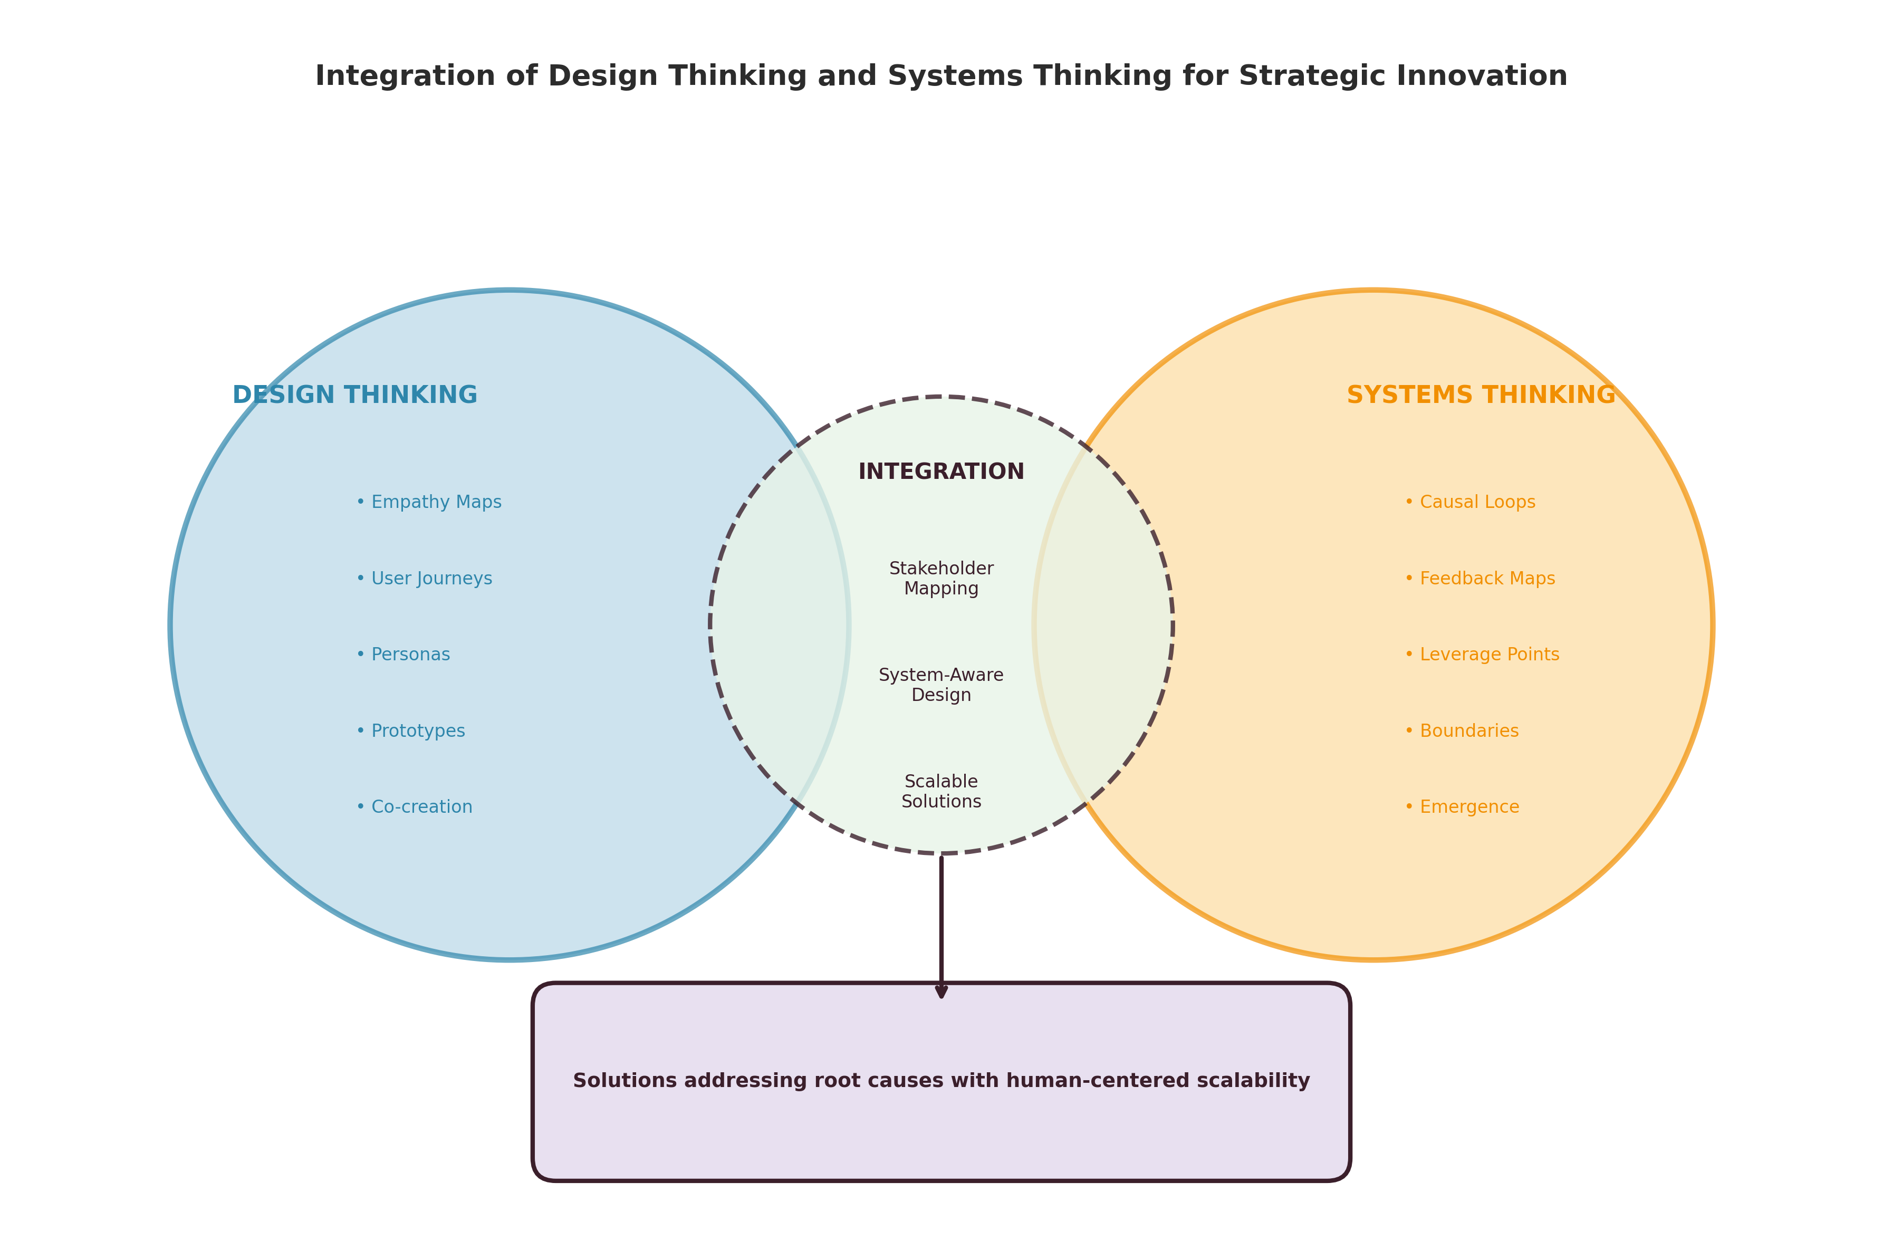
Figure 2: Integration of Design Thinking and Systems Thinking for Strategic Innovation

System maps and causal-loop perspectives offer particular value when designing for strategic innovation. By mapping the feedback structures that maintain current system states, organizations can identify leverage points—places in the system where small, well-designed interventions can produce disproportionately large shifts in system behavior [39]. Design thinking's creative and prototyping capabilities can then be focused on these leverage points, developing solutions that not only meet immediate user needs but also shift underlying system dynamics [48].
Designing solutions that address root causes rather than symptoms requires the combined perspective of both approaches. Design thinking reveals the experiential symptoms—the pain points, frustrations, and unmet needs that signal system dysfunction—while systems thinking reveals the structural causes—the feedback loops, misaligned incentives, and information gaps that produce those symptoms [42]. Solutions designed at the intersection address both dimensions, providing immediate experiential improvement while also modifying the system structures that generated the problem [47].
The integration also enhances the scalability of design-generated solutions. Solutions developed through design thinking often work beautifully at small scale—for the specific users involved in co-creation and testing—but encounter unexpected challenges when scaled across larger and more diverse system contexts [46]. Systems thinking provides the analytical framework for anticipating scaling challenges, identifying necessary adaptations, and designing solutions robust enough to function across varied system conditions [44].

Section 3: Design Thinking and Creative Thinking

3.1 Foundations of Creative Thinking in Business
Creative thinking constitutes the cognitive foundation upon which innovation is built, encompassing the mental processes through which novel and valuable ideas are generated, developed, and refined [49]. In business contexts, creative thinking represents both an individual cognitive capacity and an organizational capability—one that can be cultivated, structured, and directed toward strategic objectives while retaining the spontaneity and openness essential to genuine novelty [50].
Divergent thinking, identified by Guilford as a primary component of creative cognition, involves the generation of multiple, varied, and original ideas in response to open-ended challenges [49]. Characterized by fluency (quantity of ideas), flexibility (variety of categories), originality (unusualness of ideas), and elaboration (detail and development), divergent thinking enables the exploration of broad solution spaces before convergent evaluation narrows options toward implementable solutions [51]. In business contexts, divergent thinking underlies brainstorming, ideation workshops, and the exploratory phases of innovation processes.
Convergent thinking complements divergence by providing the evaluative and selective processes needed to identify the most promising ideas from among many possibilities [50]. While divergent thinking expands the solution space, convergent thinking contracts it—applying criteria of feasibility, viability, and desirability to select concepts worthy of further development [52]. Effective creative processes require skilled alternation between divergent and convergent modes, expanding and contracting the possibility space in iterative cycles [49].
Imagination enables the mental simulation of possibilities that do not yet exist—the ability to envision products, services, experiences, and business models that have no current precedent [53]. In business innovation, imagination provides the cognitive raw material from which breakthrough concepts emerge, allowing innovators to transcend the constraints of current reality and envision fundamentally different futures [50]. Intuition—the rapid, non-conscious pattern recognition that enables experts to identify promising directions without explicit analytical reasoning—complements imagination by providing directional guidance within vast possibility spaces [24].
Associative thinking—the ability to connect disparate ideas, domains, and experiences to generate novel combinations—represents another fundamental creative mechanism [51]. Many business innovations emerge not from entirely new ideas but from novel combinations of existing elements: technologies borrowed from other industries, business models adapted from different contexts, or customer insights connected to emerging capabilities [53]. Cultivating associative thinking requires exposure to diverse knowledge domains and the cognitive flexibility to recognize connections across boundaries [52].
Cognitive barriers to creativity include functional fixedness (the tendency to perceive objects and concepts only in terms of their conventional uses), confirmation bias (the tendency to seek information confirming existing beliefs), and satisficing (the tendency to accept the first adequate solution rather than continuing to search for superior alternatives) [54]. Organizational barriers include hierarchical structures that suppress unconventional ideas, risk-averse cultures that punish failure, time pressures that eliminate exploration, and homogeneous teams that lack the diverse perspectives needed for creative combination [50].

3.2 Design Thinking as a Structured Creative Process
Design thinking provides a structured methodology for channeling creative energy toward meaningful innovation outcomes, offering a disciplined process that neither constrains creativity nor leaves it unguided [22]. This structured approach to creativity distinguishes design thinking from both purely analytical methods (which may suppress creative exploration) and purely creative approaches (which may lack direction and accountability) [55].
Empathy and observation serve as primary sources of creative insight within design thinking. Rather than generating ideas from internal imagination alone, design thinking grounds creativity in deep understanding of human experience [17]. Ethnographic observation, contextual inquiry, empathy interviews, and immersive experience provide designers with rich experiential data that stimulates creative responses to genuine human needs [20]. This empathic grounding ensures that creativity serves human purposes rather than merely expressing personal artistic vision or technical capability [22].
The transition from empathic understanding to creative ideation involves synthesis—the process of distilling observations into actionable insight statements that frame creative challenges in terms of human needs and opportunities [55]. "How might we..." questions translate empathic insights into creative briefs that both constrain and liberate ideation: constraining by specifying the human need to be addressed, liberating by leaving the solution form entirely open [32]. This synthesis represents a critical creative act in itself, requiring both analytical skill and imaginative interpretation.
Ideation techniques within design thinking structure divergent creative processes to maximize both quantity and quality of ideas generated [23]. Brainstorming, brainwriting, SCAMPER, analogical thinking, and constraint manipulation provide specific cognitive strategies for overcoming creative blocks and generating diverse possibilities [51]. The physical and social environment of ideation—visual thinking, collaborative energy, judgment deferral—further supports creative output by reducing psychological barriers and stimulating associative connections [22].
Opportunity identification represents a creative competency that design thinking develops through its emphasis on reframing and perspective-taking [17]. By viewing situations through multiple stakeholder lenses, design thinkers identify opportunities invisible to those operating within single-perspective analytical frameworks. Latent needs—needs that customers cannot articulate because they have never imagined alternatives—become visible through empathic observation and creative interpretation [20].
Table 3 summarizes the key ideation and creative techniques employed within design thinking and their relationship to fundamental creative thinking processes.
Table 3: Design Thinking Ideation Techniques and Creative Thinking Processes
Design Thinking Technique | Creative Process Engaged | Primary Output | Strategic Application
Empathy mapping | Perspective-taking, imagination | User insights | Need identification
How-might-we framing | Problem reframing, divergent thinking | Creative briefs | Opportunity definition
Brainstorming/Brainwriting | Divergent thinking, association | Multiple concepts | Solution generation
Analogical reasoning | Associative thinking, transfer | Novel combinations | Cross-domain innovation
Rapid prototyping | Externalization, experimentation | Tangible concepts | Concept validation
Story boarding | Narrative imagination, sequencing | Experience visions | Service/experience design
Constraint manipulation | Reframing, lateral thinking | Breakthrough ideas | Disruptive innovation
Bodystorming | Embodied cognition, simulation | Experiential insights | Physical/spatial design

Prototyping and experimentation serve as mechanisms for creative learning within design thinking, distinguishing it from creative approaches that generate ideas without testing them [32]. By rapidly building low-fidelity representations of concepts and exposing them to user feedback, design thinking creates iterative learning cycles that progressively refine creative output toward solutions that are simultaneously novel and effective [23]. This experimental orientation transforms creativity from a singular generative act into a continuous learning process [55].

3.3 Complementarity between Design Thinking and Creative Thinking
The relationship between design thinking and creative thinking is one of mutual enhancement: design thinking provides structure, direction, and validation for creative output, while creative thinking provides the generative energy, novelty, and imaginative reach that make design thinking genuinely innovative rather than merely incremental [49].
Moving from creativity to actionable innovation represents a persistent challenge in organizational contexts [50]. Many organizations generate abundant creative ideas but struggle to transform them into implemented innovations that create value. Design thinking addresses this "creativity-implementation gap" by embedding creative ideation within a broader process that includes empathic grounding (ensuring ideas address real needs), prototyping (making ideas tangible and testable), and iterative refinement (progressively adapting ideas to real-world constraints) [55]. This structured pathway from idea to implementation distinguishes design-driven creativity from undirected creative expression.
The combination of structured methods with spontaneous idea generation creates a productive tension that enhances both [52]. Structured creative techniques—brainstorming rules, time constraints, stimulus materials—provide scaffolding that supports creative production without eliminating spontaneity. Simultaneously, allowing space for unexpected insights, serendipitous connections, and intuitive leaps ensures that structured processes do not become mechanical or formulaic [51]. Effective design thinking practitioners develop sensitivity to this balance, knowing when to apply structure and when to allow free exploration.
Figure 3 depicts the complementary relationship between design thinking and creative thinking, illustrating how structured processes and spontaneous creativity interact throughout the innovation cycle.
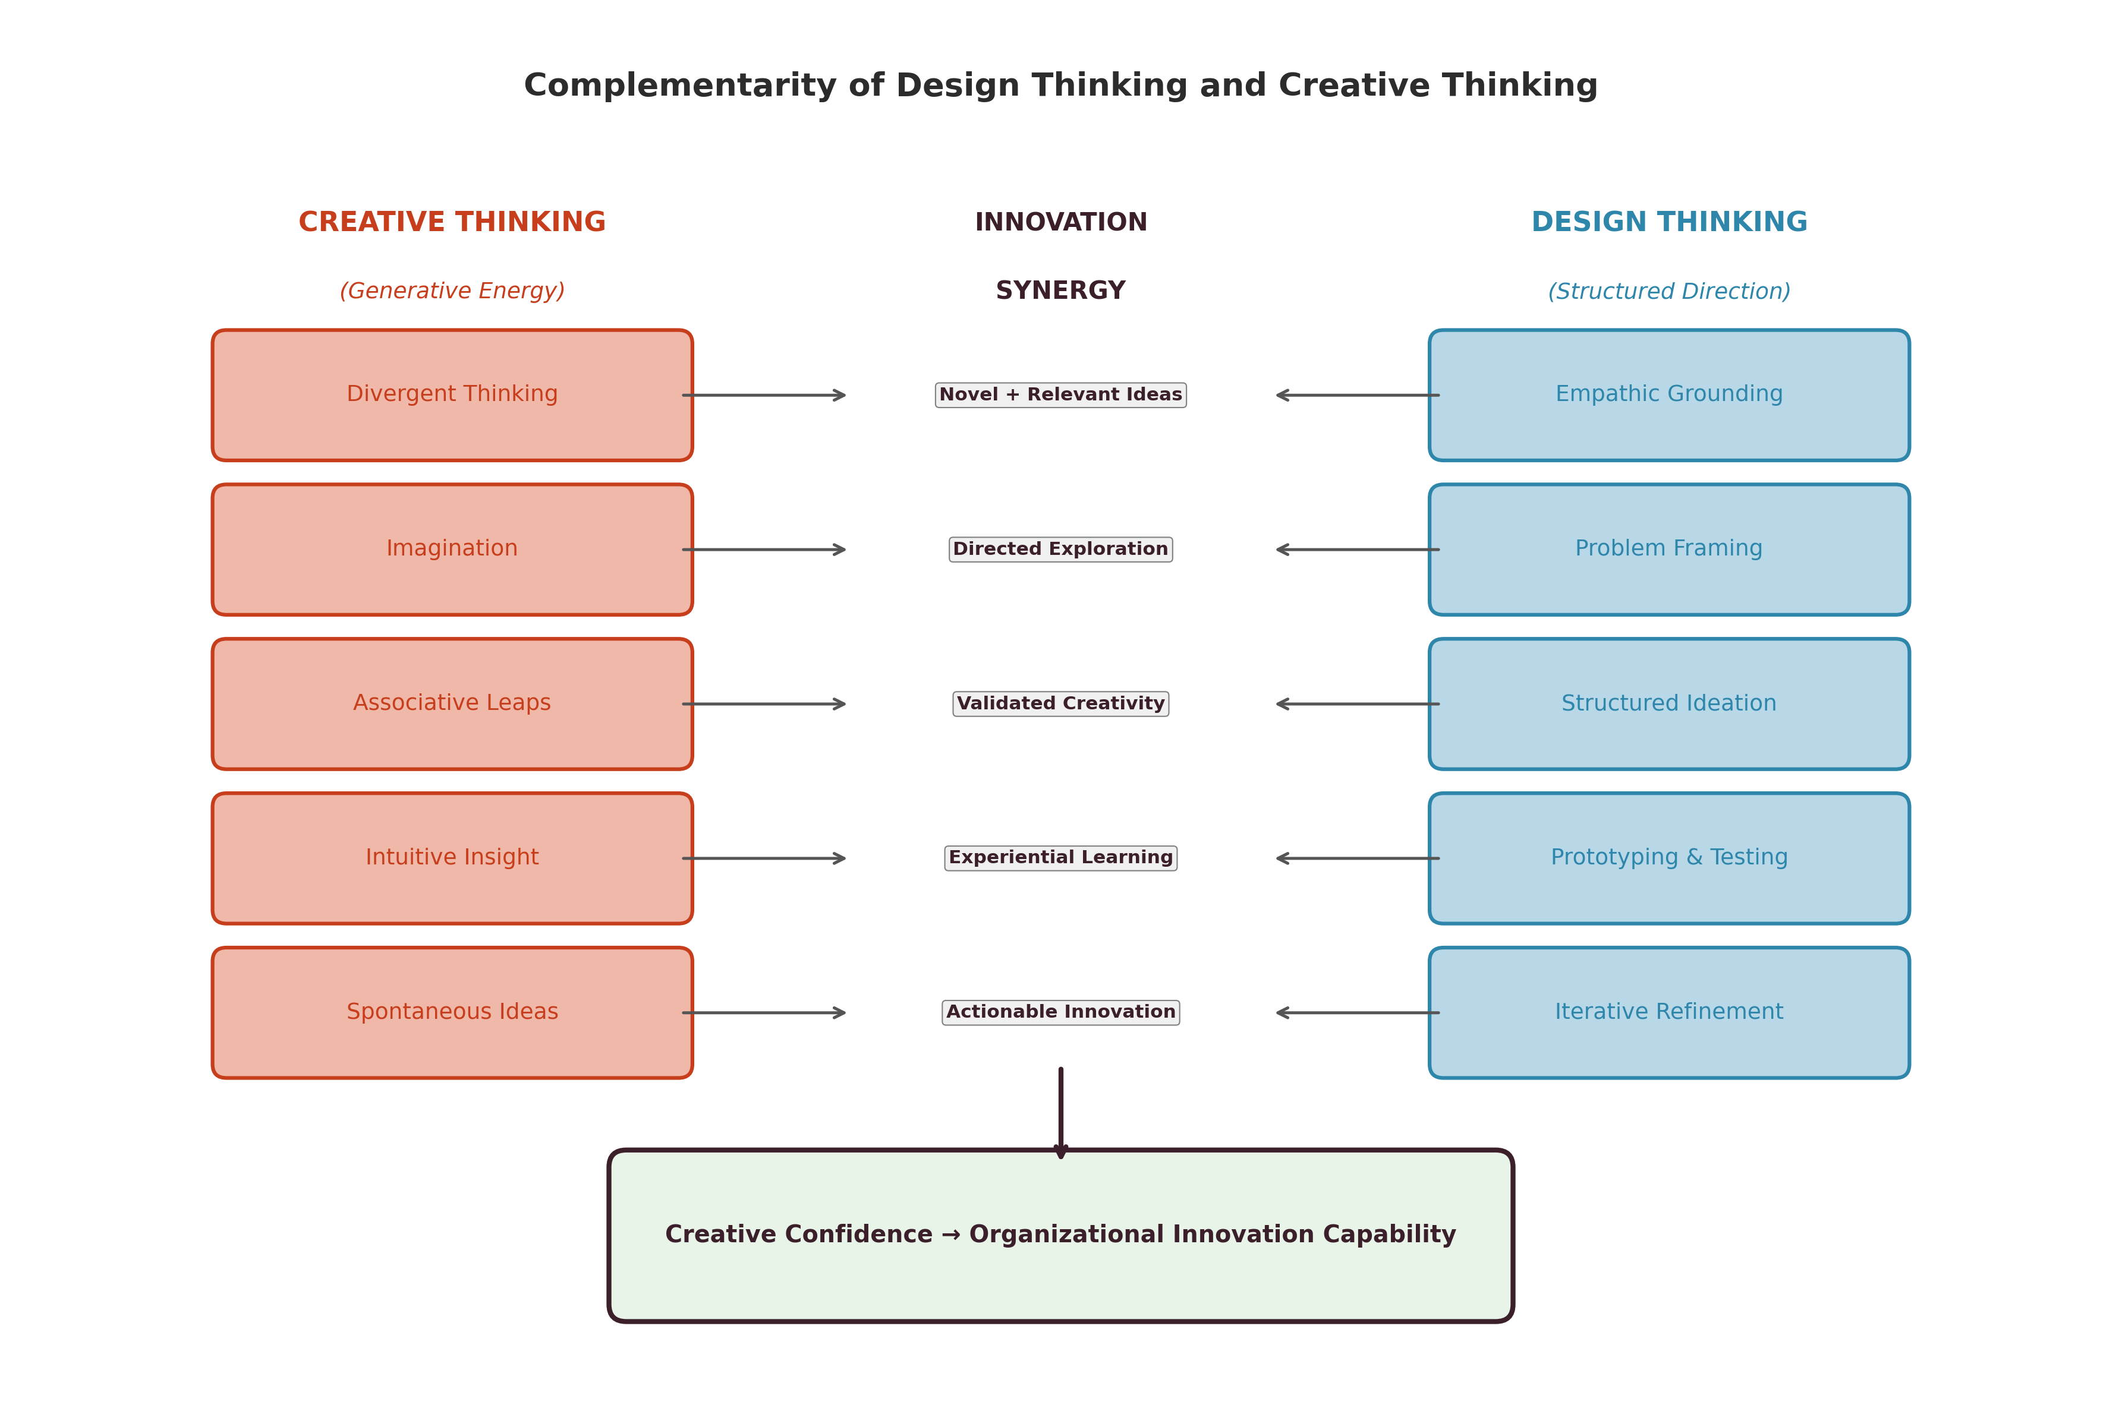
Figure 3: Complementarity of Design Thinking and Creative Thinking in the Innovation Process

Building organizational cultures that support both creativity and experimentation requires attention to multiple dimensions: psychological safety (enabling risk-taking without fear of punishment), resource allocation (providing time and space for exploration), diversity (bringing together varied perspectives and knowledge domains), and leadership support (modeling creative behaviors and valuing experimentation) [50]. Design thinking provides specific practices—studios, sprints, prototyping labs—that instantiate these cultural values in concrete organizational routines [22].
The complementarity extends to individual cognitive development. Practicing design thinking develops creative capabilities—empathic imagination, perspective-taking, comfort with ambiguity, tolerance for iterative failure—that transfer beyond formal design processes into everyday problem-solving and decision-making [54]. Conversely, individuals with strong creative foundations—fluent divergent thinking, rich associative networks, developed imagination—bring enhanced capability to design thinking processes [49].
Organizations that cultivate both capabilities develop what might be termed "creative confidence"—the organizational belief that creative problem-solving can be applied to any challenge, combined with the practical skills and processes needed to deliver results [55]. This confidence enables organizations to approach increasingly ambitious challenges with the expectation that creative solutions can be found, reducing the conservative bias that often limits strategic ambition [53].

Section 4: Integrating Multiple Approaches for Business Strategy

4.1 A Multimethod Framework for Strategic Problem-Solving
The preceding sections have examined the relationships between design thinking and three complementary approaches: analytical decision-making, systems thinking, and creative thinking. This section synthesizes these relationships into a multimethod framework that enables organizations to select, combine, and sequence thinking approaches based on the characteristics of strategic problems they face [27].
The multimethod framework recognizes that different types of strategic challenges demand different cognitive approaches—and that the most complex challenges demand multiple approaches deployed in combination [36]. Rather than advocating for any single methodology as universally superior, the framework provides guidance for matching approaches to problem characteristics and for integrating multiple approaches when problems exhibit multiple types of complexity simultaneously [47].
Four dimensions of problem characteristics guide approach selection within the framework. First, the degree of problem definition: well-defined problems with clear objectives and constraints are amenable to analytical approaches, while ambiguous, stakeholder-dependent problems benefit from design thinking's empathic framing [15]. Second, the degree of system complexity: problems involving multiple interacting elements, feedback loops, and emergent behaviors require systems thinking, while bounded, decomposable problems can be addressed without systemic analysis [37]. Third, the degree of novelty required: problems demanding breakthrough solutions require creative thinking's divergent generation capabilities, while problems requiring optimization of existing approaches rely more heavily on analytical methods [49]. Fourth, the degree of human centrality: problems fundamentally about human experience and behavior benefit from design thinking's empathic methodology, while problems primarily about system structure or resource allocation may be addressed through analytical or systems approaches [22].
Table 4 presents the multimethod framework, mapping problem characteristics to recommended approach combinations and integration strategies.
Table 4: Multimethod Framework for Strategic Problem-Solving
Problem Characteristic | Primary Approach | Supporting Approaches | Integration Strategy
Well-defined, bounded | Analytical | Design (validation), Creative (alternatives) | Analytical frame with creative expansion
Ambiguous, human-centered | Design Thinking | Analytical (validation), Systems (scaling) | Empathic exploration with analytical rigor
Complex, interconnected | Systems Thinking | Design (human lens), Analytical (quantification) | System mapping with human-centered intervention
Novel, breakthrough needed | Creative Thinking | Design (direction), Analytical (feasibility) | Creative generation with structured development
Multi-stakeholder, systemic | Systems + Design | Analytical (evaluation), Creative (ideation) | System-aware, human-centered co-creation
Data-rich, optimization | Analytical + Creative | Design (framing), Systems (context) | Evidence-based innovation with creative stretch
Wicked, multi-dimensional | All four approaches | Sequenced and iterative integration | Full multimethod deployment with adaptive sequencing

The framework emphasizes that approach selection should be dynamic rather than static—evolving as understanding of the problem deepens through initial exploration [28]. A challenge initially perceived as a straightforward analytical optimization may reveal itself, through design research, to be fundamentally about unrecognized human needs. Conversely, a problem initially approached through empathic design may reveal, through systems analysis, that individual-level solutions cannot succeed without addressing systemic barriers [47].
Developing flexible and context-sensitive strategic processes requires organizational capabilities in all four approaches, combined with meta-cognitive awareness of when each is most appropriate [36]. This "ambidextrous" strategic capability enables organizations to move fluidly between distinct modes of thinking, deploying analytical rigor, systemic awareness, creative generation, and empathic design as the situation demands [26]. As illustrated in Table 1 and Table 2 earlier in this chapter, the distinctive characteristics of each approach make them suitable for different aspects of complex strategic challenges.

4.2 Applications Across Business Strategy and Innovation
The multimethod framework finds application across diverse domains of business strategy and innovation, demonstrating its versatility and practical value for organizations facing varied strategic challenges.
New Product and Service Development
New product development represents perhaps the most natural application domain for multimethod integration [35]. The development of genuinely innovative products and services requires creative generation of novel concepts (creative thinking), deep understanding of user needs and experiences (design thinking), evaluation of market potential and financial viability (analytical thinking), and awareness of ecosystem dynamics and competitive responses (systems thinking) [27].
In practice, multimethod product development might begin with empathic research to identify unmet needs, proceed through creative ideation to generate multiple solution concepts, apply analytical evaluation to select the most promising alternatives, and employ systems analysis to understand how new products will interact with existing market ecosystems [30]. The iterative nature of design thinking's prototype-and-test cycles provides the process backbone, while analytical and systems perspectives inform decision points throughout.
As depicted in Figure 1, the integration of analytical validation with design-driven exploration enables organizations to maintain both creative ambition and commercial discipline throughout the development process. Similarly, Table 3 demonstrates how specific design thinking techniques engage different creative processes relevant to product innovation.
Business Model Innovation and Organizational Transformation
Business model innovation presents challenges that are simultaneously creative (requiring novel value propositions and revenue mechanisms), analytical (requiring financial modeling and market analysis), systemic (requiring understanding of value network dynamics), and human-centered (requiring attention to customer experience and organizational change) [48]. The multimethod framework enables organizations to address all these dimensions in coordinated fashion.
Organizational transformation similarly demands multimethod engagement. Systems thinking reveals the structural barriers and feedback loops that maintain current organizational states [42]. Design thinking provides methods for understanding employee experience and co-creating new ways of working [22]. Creative thinking generates novel organizational concepts and metaphors that enable paradigm shifts [53]. Analytical thinking provides the metrics and evidence needed to track transformation progress and evaluate outcomes [7].
Addressing Complex Customer, Market, and Sustainability Challenges
In market-facing applications, the multimethod framework enables organizations to develop deeper understanding of customer segments, competitive dynamics, and value creation opportunities than any single approach permits [30]. Design thinking reveals latent customer needs invisible to conventional market research, systems thinking maps the competitive and ecosystem dynamics that shape market evolution, creative thinking generates novel value propositions and business concepts, and analytical thinking evaluates market size, growth potential, and financial returns [35]. The integration produces market strategies that are simultaneously innovative and evidence-based, customer-centered and systemically aware.
Contemporary sustainability challenges exemplify the type of "wicked problem" that demands full multimethod deployment [17]. Climate change, circular economy transitions, and social equity challenges are simultaneously human-centered (affecting real people with real needs), systemically complex (involving multiple feedback loops and stakeholders), analytically demanding (requiring quantitative modeling of environmental and economic impacts), and creatively challenging (requiring fundamentally new approaches to production, consumption, and value creation) [44].
The multimethod framework enables organizations to approach sustainability challenges from multiple perspectives simultaneously: using design thinking to understand stakeholder experiences and needs, systems thinking to map interdependencies and feedback loops, creative thinking to generate breakthrough alternatives, and analytical thinking to evaluate environmental and economic impacts [47]. This comprehensive engagement increases the likelihood of developing solutions that are simultaneously humanly desirable, systemically sustainable, technically feasible, and economically viable.
Figure 2 demonstrates how systems thinking and design thinking combine to enable organizations to address root causes rather than surface symptoms—a capability particularly relevant to sustainability challenges where interventions targeting symptoms often generate unintended consequences elsewhere in the system. The framework presented in Table 4 provides guidance for selecting and sequencing approaches based on specific challenge characteristics.

4.3 Future Directions: Toward Hybrid Strategic Thinking
The future of strategic thinking lies in the increasing and inevitable integration of human cognitive approaches with artificial intelligence capabilities, creating hybrid systems that combine human creativity, empathy, and judgment with machine learning, computational modeling, and data processing at scales impossible for human cognition alone [56].
AI-Supported Design and Strategic Decision-Making
Artificial intelligence is rapidly transforming each of the four thinking approaches examined in this chapter [56]. In analytical decision-making, machine learning algorithms identify patterns in vast datasets that human analysts could never detect, while predictive models forecast market dynamics and customer behaviors with unprecedented accuracy [9]. In systems thinking, agent-based modeling and network analysis algorithms simulate complex system behaviors, revealing emergent properties and leverage points that manual analysis might miss [43]. In creative thinking, generative AI systems produce novel combinations and variations that expand human ideation capabilities, while natural language processing enables rapid synthesis of diverse knowledge domains [53].
For design thinking specifically, AI offers transformative capabilities across multiple process stages [56]. In the empathy phase, sentiment analysis, behavioral analytics, and natural language processing enable understanding of user needs at scale. In ideation, generative algorithms produce design alternatives that human designers can evaluate, combine, and refine. In prototyping, digital twin technologies and simulation enable rapid testing of concepts without physical fabrication. In validation, machine learning enables real-time analysis of user behavior during testing, identifying patterns of engagement and difficulty that inform iterative refinement [57].
Data-Driven Creativity and Intelligent Systems Thinking
The concept of "data-driven creativity" represents an important emerging paradigm that effectively integrates analytical and creative capabilities [34]. Rather than treating data analysis and creative ideation as separate activities, data-driven creativity uses computational pattern recognition to identify opportunities, anomalies, and connections that stimulate human creative response [30]. Machine learning algorithms trained on vast datasets identify latent market needs, emerging trends, and unexploited combinations that serve as creative stimuli for human innovators [56].
Intelligent systems thinking similarly combines human systemic awareness with advanced computational modeling capabilities [43]. Complex system dynamics that exceed human cognitive capacity for mental simulation can be modeled computationally, enabling exploration of intervention scenarios and their cascading effects through multiple feedback loops simultaneously [41]. Digital twins of organizational and market systems enable strategic experimentation at speeds and scales impossible with physical prototyping alone [57].
Emerging Opportunities for Integrating Design Thinking with Advanced Business Strategy Frameworks
As depicted in Figure 3, the complementarity between structured and spontaneous creative processes finds new expression in human-AI collaborative systems where computational generation complements human evaluation and refinement. Table 4's multimethod framework extends naturally to incorporate AI capabilities within each thinking approach, creating augmented versions of analytical, systems, creative, and design thinking that surpass the capabilities of either human or machine cognition alone.
Figure 4 presents the future-oriented framework for AI-augmented multimethod strategic thinking, illustrating how artificial intelligence capabilities enhance and integrate the four thinking approaches examined throughout this chapter.
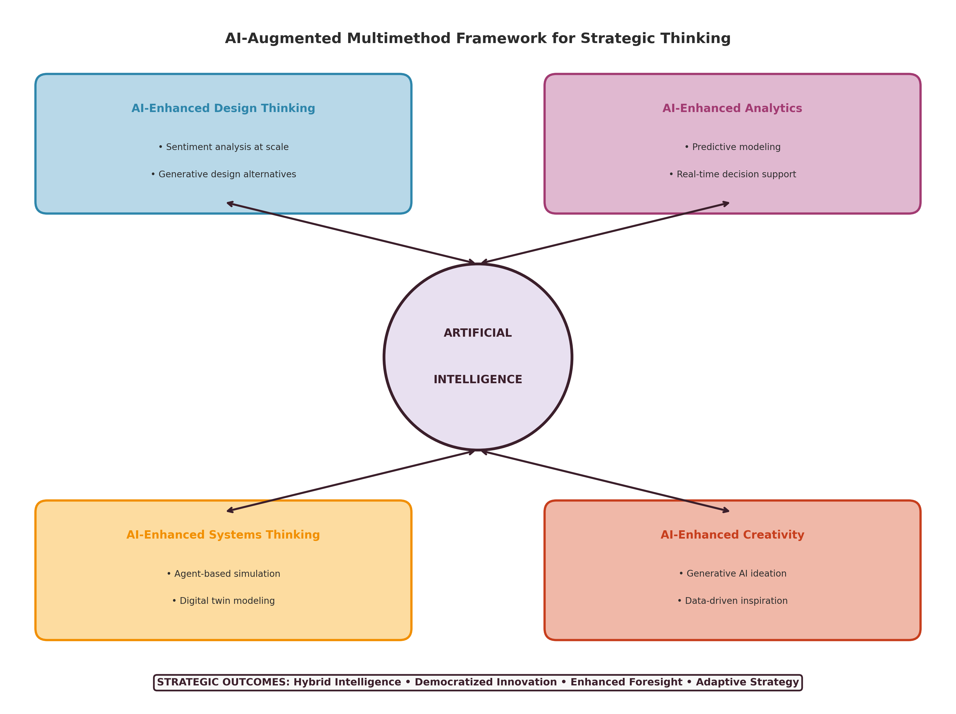
Figure 4: AI-Augmented Multimethod Framework for Future Strategic Thinking

Several emerging opportunities warrant particular attention. First, real-time strategic adaptation enabled by continuous data streams, machine learning models, and automated decision systems that adjust strategic direction in response to environmental changes far faster than traditional planning cycles allow [9]. Second, democratized innovation enabled by AI tools that make design thinking, systems modeling, and analytical capabilities accessible to a broader range of organizational participants, reducing dependence on specialized expertise and enabling distributed innovation across organizational boundaries [56]. Third, enhanced foresight enabled by computational scenario generation and simulation, allowing organizations to explore vastly more strategic alternatives than human cognition alone permits and to identify promising directions that human bias might overlook [43]. Fourth, augmented collaboration enabled by AI-mediated communication and coordination tools that facilitate the integration of diverse thinking styles across geographically distributed teams, enhancing the quality and speed of multimethod strategic processes [57].
The integration of these capabilities demands new organizational forms, leadership competencies, and educational approaches [57]. Organizations must develop "hybrid intelligence"—the ability to effectively combine human and machine capabilities across all four thinking approaches, deploying each where its comparative advantages are greatest while maintaining human oversight and ethical governance [56]. Leaders must develop meta-cognitive awareness of when human judgment should override algorithmic recommendation and when computational analysis should inform human intuition [36]. Educational institutions must prepare future strategists with fluency across all four thinking approaches and the ability to integrate them with AI capabilities in responsible and effective ways [55].

Conclusion
This chapter has examined the productive intersections between design thinking and three complementary strategic approaches: analytical decision-making, systems thinking, and creative thinking. Through systematic comparison and integration, we have developed a multimethod framework that enables organizations to deploy the most appropriate combination of thinking approaches based on specific problem characteristics.
The key contributions of this chapter include: first, systematic comparison of design thinking with each complementary approach, revealing both distinctive contributions and integration opportunities (as summarized in Tables 1 and 2); second, identification of specific integration mechanisms—data integration, process embedding, and validation methodology—through which approaches can be combined effectively (as illustrated in Figures 1 and 2); third, development of a comprehensive multimethod framework (Table 4) that guides approach selection and integration based on problem characteristics; and fourth, articulation of future directions for AI-augmented strategic thinking that extends the framework into emerging technological contexts (Figure 4).
The practical implications for organizations are significant. Rather than adopting any single thinking methodology as a universal solution, organizations should develop capabilities across all four approaches and the meta-cognitive awareness needed to deploy them appropriately. The multimethod framework provides the conceptual architecture for this development, while the specific integration mechanisms identified throughout the chapter provide actionable guidance for implementation. Organizations seeking competitive advantage through innovation must recognize that creative breakthroughs require analytical validation, that systemic awareness enhances design solutions, and that empathic understanding enriches both analytical and creative endeavors.
Furthermore, the educational implications of this framework are substantial. Business schools and professional development programs must move beyond teaching individual methodologies in isolation toward developing integrative competencies that enable practitioners to move fluidly between approaches [55]. Curricula should incorporate experiential learning opportunities that require students to apply multiple thinking approaches to complex challenges, developing both the cognitive flexibility and practical skills needed for multimethod strategic engagement [36]. The development of assessment frameworks that evaluate integrative capability—rather than proficiency in any single approach—represents an important pedagogical challenge for the future.
As business environments continue to increase in complexity, uncertainty, and rate of change, the ability to integrate multiple thinking approaches—human and computational, analytical and creative, systematic and empathic—will become an increasingly critical source of strategic advantage. Organizations that develop this integrative capability will be best positioned to navigate the challenges and opportunities of an increasingly complex strategic landscape. The multimethod framework presented in this chapter provides both the conceptual foundation and practical guidance needed to begin developing this essential strategic capability, while acknowledging that the specific forms of integration will continue to evolve as new tools, technologies, and organizational forms emerge in response to accelerating environmental change and increasingly complex global challenges.

References
[1] Simon, H. A. (1997). *Administrative Behavior: A Study of Decision-Making Processes in Administrative Organizations* (4th ed.). Free Press.
[2] Bazerman, M. H., & Moore, D. A. (2013). *Judgment in Managerial Decision Making* (8th ed.). Wiley.
[3] Hillier, F. S., & Lieberman, G. J. (2021). *Introduction to Operations Research* (11th ed.). McGraw-Hill.
[4] Hammond, J. S., Keeney, R. L., & Raiffa, H. (2015). *Smart Choices: A Practical Guide to Making Better Decisions*. Harvard Business Review Press.
[5] Keeney, R. L. (2013). Foundations for group decision analysis. *Decision Analysis*, 10(2), 103–120.
[6] Goodwin, P., & Wright, G. (2014). *Decision Analysis for Management Judgment* (5th ed.). Wiley.
[7] Pfeffer, J., & Sutton, R. I. (2006). *Hard Facts, Dangerous Half-Truths, and Total Nonsense: Profiting from Evidence-Based Management*. Harvard Business School Press.
[8] Rousseau, D. M. (2012). *The Oxford Handbook of Evidence-Based Management*. Oxford University Press.
[9] Provost, F., & Fawcett, T. (2013). *Data Science for Business: What You Need to Know about Data Mining and Data-Analytic Thinking*. O'Reilly Media.
[10] Aven, T. (2015). *Risk Analysis* (2nd ed.). Wiley.
[11] Vose, D. (2008). *Risk Analysis: A Quantitative Guide* (3rd ed.). Wiley.
[12] Kaplan, R. S., & Mikes, A. (2012). Managing risks: A new framework. *Harvard Business Review*, 90(6), 48–60.
[13] Kahneman, D. (2011). *Thinking, Fast and Slow*. Farrar, Straus and Giroux.
[14] Liedtka, J. (2015). Perspective: Linking design thinking with innovation outcomes through cognitive bias reduction. *Journal of Product Innovation Management*, 32(6), 925–938.
[15] Liedtka, J., & Ogilvie, T. (2011). *Designing for Growth: A Design Thinking Tool Kit for Managers*. Columbia University Press.
[16] Mintzberg, H., Raisinghani, D., & Théorêt, A. (1976). The structure of "unstructured" decision processes. *Administrative Science Quarterly*, 21(2), 246–275.
[17] Buchanan, R. (1992). Wicked problems in design thinking. *Design Issues*, 8(2), 5–21.
[18] Dorst, K. (2011). The core of 'design thinking' and its application. *Design Studies*, 32(6), 521–532.
[19] Davenport, T. H. (2006). Competing on analytics. *Harvard Business Review*, 84(1), 98–107.
[20] Kolko, J. (2015). Design thinking comes of age. *Harvard Business Review*, 93(9), 66–71.
[21] Wang, T. (2016). Why big data needs thick data. *Ethnography Matters*, 1–8.
[22] Brown, T. (2009). *Change by Design: How Design Thinking Transforms Organizations and Inspires Innovation*. HarperBusiness.
[23] Kelley, T., & Kelley, D. (2013). *Creative Confidence: Unleashing the Creative Potential Within Us All*. Crown Business.
[24] Cross, N. (2011). *Design Thinking: Understanding How Designers Think and Work*. Berg Publishers.
[25] Martin, R. (2009). *The Design of Business: Why Design Thinking Is the Next Competitive Advantage*. Harvard Business Press.
[26] Calabretta, G., Gemser, G., & Karpen, I. (2016). Strategic design thinking: An integrated approach for strategic innovation. *Journal of Product Innovation Management*, 33(4), 377–393.
[27] Beverland, M. B., Wilner, S. J., & Micheli, P. (2015). Reconciling the tension between consistency and relevance: Design thinking as a mechanism for brand ambidexterity. *Journal of the Academy of Marketing Science*, 43(5), 589–609.
[28] Elsbach, K. D., & Stigliani, I. (2018). Design thinking and organizational culture: A review and framework for future research. *Journal of Management*, 44(6), 2274–2306.
[29] Micheli, P., Wilner, S. J., Bhatti, S. H., Mura, M., & Beverland, M. B. (2019). Doing design thinking: Conceptual stocktaking, synthesis, and research agenda. *Journal of Product Innovation Management*, 36(4), 431–456.
[30] Verganti, R. (2009). *Design-Driven Innovation: Changing the Rules of Competition by Radically Innovating What Things Mean*. Harvard Business Press.
[31] Seidel, V. P., & Fixson, S. K. (2013). Adopting design thinking in novice multidisciplinary teams: The application and limits of design methods and reflexive practices. *Journal of Product Innovation Management*, 30(S1), 19–33.
[32] Liedtka, J. (2018). Why design thinking works. *Harvard Business Review*, 96(5), 72–79.
[33] Thomke, S. H. (2020). *Experimentation Works: The Surprising Power of Business Experiments*. Harvard Business Review Press.
[34] Anderson, C. (2008). The end of theory: The data deluge makes the scientific method obsolete. *Wired*, 16(7), 108–109.
[35] Ulrich, K. T., & Eppinger, S. D. (2020). *Product Design and Development* (7th ed.). McGraw-Hill.
[36] Boland, R. J., & Collopy, F. (2004). *Managing as Designing*. Stanford University Press.
[37] Meadows, D. H. (2008). *Thinking in Systems: A Primer*. Chelsea Green Publishing.
[38] Senge, P. M. (2006). *The Fifth Discipline: The Art and Practice of the Learning Organization* (Revised ed.). Doubleday.
[39] Sterman, J. D. (2000). *Business Dynamics: Systems Thinking and Modeling for a Complex World*. Irwin/McGraw-Hill.
[40] Forrester, J. W. (1961). *Industrial Dynamics*. MIT Press.
[41] Morecroft, J. D. W. (2015). *Strategic Modelling and Business Dynamics: A Feedback Systems Approach* (2nd ed.). Wiley.
[42] Gharajedaghi, J. (2011). *Systems Thinking: Managing Chaos and Complexity* (3rd ed.). Morgan Kaufmann.
[43] Jackson, M. C. (2019). *Critical Systems Thinking and the Management of Complexity*. Wiley.
[44] Checkland, P. (1999). *Systems Thinking, Systems Practice* (Revised ed.). Wiley.
[45] Midgley, G. (2000). *Systemic Intervention: Philosophy, Methodology, and Practice*. Kluwer Academic/Plenum.
[46] Ackermann, F., & Eden, C. (2011). *Making Strategy: Mapping Out Strategic Success* (2nd ed.). Sage.
[47] Jones, P. H. (2014). Systemic design principles for complex social systems. In G. S. Metcalf (Ed.), *Social Systems and Design* (pp. 91–128). Springer.
[48] Osterwalder, A., & Pigneur, Y. (2010). *Business Model Generation: A Handbook for Visionaries, Game Changers, and Challengers*. Wiley.
[49] Guilford, J. P. (1967). *The Nature of Human Intelligence*. McGraw-Hill.
[50] Amabile, T. M., & Pratt, M. G. (2016). The dynamic componential model of creativity and innovation in organizations: Making progress, making meaning. *Research in Organizational Behavior*, 36, 157–183.
[51] De Bono, E. (2015). *Lateral Thinking: Creativity Step by Step*. Harper Perennial.
[52] Sawyer, R. K. (2012). *Explaining Creativity: The Science of Human Innovation* (2nd ed.). Oxford University Press.
[53] Johnson, S. (2010). *Where Good Ideas Come From: The Natural History of Innovation*. Riverhead Books.
[54] Csikszentmihalyi, M. (2013). *Creativity: The Psychology of Discovery and Invention*. Harper Perennial.
[55] Beckman, S. L., & Barry, M. (2007). Innovation as a learning process: Embedding design thinking. *California Management Review*, 50(1), 25–56.
[56] Verganti, R., Vendraminelli, L., & Iansiti, M. (2020). Innovation and design in the age of artificial intelligence. *Journal of Product Innovation Management*, 37(3), 212–227.
[57] Davenport, T. H., & Ronanki, R. (2018). Artificial intelligence for the real world. *Harvard Business Review*, 96(1), 108–116.

