Climate Change, Economic Risk, and Adaptive Eco-Technological Strategies

Abstract
Climate change represents one of the most profound challenges confronting global economic systems, ecological stability, and societal well-being in the twenty-first century. Rising global temperatures, intensifying extreme weather events, and shifting precipitation patterns impose escalating costs on infrastructure, agriculture, supply chains, and financial markets. This chapter provides a comprehensive examination of the nexus between climate change and economic risk, exploring how emerging intelligent eco-technologies and adaptive strategies can mitigate vulnerabilities and foster resilient, sustainable economies. The analysis begins with a detailed assessment of climate change drivers and their cascading economic consequences, followed by an evaluation of sectoral and regional vulnerabilities, financial risk frameworks, and scenario-based decision-making approaches. The chapter then investigates the transformative potential of artificial intelligence, Internet of Things, digital twins, and smart infrastructure in enabling proactive climate adaptation. Finally, it presents adaptive strategies encompassing circular economy models, green finance mechanisms, and inclusive policy pathways for building climate-resilient economies. The integrated framework proposed herein demonstrates that intelligent eco-technological deployment, combined with robust governance and inclusive economic planning, can transform climate risk into opportunity for sustainable development.
Keywords: Climate change; economic risk; eco-technology; artificial intelligence; climate adaptation; resilience; green finance; circular economy; digital twins; sustainable development

1. Climate Change and Emerging Economic Risks
The accelerating pace of anthropogenic climate change poses unprecedented challenges to global economic systems, demanding urgent reconsideration of development paradigms and risk management frameworks. The Intergovernmental Panel on Climate Change (IPCC) Sixth Assessment Report confirms that global surface temperature has increased by approximately 1.1°C above pre-industrial levels, with projections indicating continued warming across all emission scenarios [1]. This warming trend is not merely an environmental concern but fundamentally reshapes economic landscapes, disrupting production systems, supply chains, and financial markets with increasing frequency and severity [2]. The economic implications of climate change extend far beyond direct damages from extreme weather events; they encompass systemic risks to food security, water availability, human health, and geopolitical stability [3]. The interplay between physical climate risks and socioeconomic vulnerabilities creates complex feedback loops wherein climate impacts erode adaptive capacity, which in turn amplifies future vulnerability—a dynamic that threatens to trap the most climate-exposed nations in persistent poverty and underdevelopment. Understanding the intricate relationship between climate drivers and economic vulnerabilities is essential for developing effective adaptation strategies and building resilient economies capable of thriving under changing climatic conditions [4].

1.1 Climate Change Drivers, Trends, and Environmental Impacts
The primary drivers of contemporary climate change are well-established in scientific literature, centering on the accumulation of greenhouse gases (GHGs) in the atmosphere due to fossil fuel combustion, industrial processes, deforestation, and agricultural activities [5]. Carbon dioxide concentrations have surpassed 420 parts per million (ppm), representing a 50% increase over pre-industrial levels, while methane and nitrous oxide concentrations continue to rise at accelerating rates [6]. The radiative forcing associated with these concentrations drives a cascade of physical changes including ocean warming, ice sheet destabilization, sea-level rise, and alterations in atmospheric circulation patterns. The pace of change is without precedent in the geological record of at least the past 800,000 years, indicating that ecosystems and human societies face adaptation challenges for which there is no historical analog. Global mean sea level has risen approximately 3.7 mm per year during the period 2006–2018, with acceleration observed in recent decades due to thermal expansion and ice mass loss from Greenland and Antarctica [7]. The West Antarctic Ice Sheet and Greenland Ice Sheet together contain enough water to raise global sea level by over 12 meters if fully melted, and while complete melting would take centuries, accelerating mass loss rates indicate potential for multi-meter sea-level rise on timescales relevant for long-lived infrastructure investments.
Temperature extremes have become more frequent and intense, with heatwave frequency increasing by a factor of 2.8 since the 1950s in many regions [8]. Precipitation patterns are shifting, with wet regions generally becoming wetter and dry regions drier, exacerbating both flood and drought risks. The cryosphere is experiencing rapid transformation, with Arctic sea ice declining at approximately 13% per decade and permafrost thawing releasing additional methane and carbon dioxide into the atmosphere, creating positive feedback loops [9]. Ocean acidification, driven by CO2 absorption, threatens marine ecosystems and the fisheries upon which approximately 3.3 billion people depend for protein. These environmental changes do not occur in isolation but interact in complex, often non-linear ways that amplify impacts and create compound risks that challenge traditional risk assessment methodologies [10]. The concept of tipping points—critical thresholds beyond which system changes become self-reinforcing—has gained increasing attention, with research suggesting that several Earth system components may be approaching or have already crossed such thresholds [11].
The interconnected nature of climate system responses creates compound hazards that pose particular challenges for risk assessment and adaptation planning. For instance, the combination of higher temperatures and altered precipitation regimes simultaneously increases wildfire risk, reduces water availability, and degrades air quality, with cascading effects on public health, agriculture, and energy systems. Tropical cyclones are projected to intensify under continued warming, with a greater proportion of storms reaching Category 4 and 5 intensity, while sea-level rise amplifies storm surge flooding in coastal communities. The global hydrological cycle is accelerating, with more intense precipitation events increasing flood frequency even as longer dry spells between events exacerbate drought conditions. Attribution science has advanced rapidly, enabling quantification of human influence on specific extreme events and providing the evidentiary basis for climate litigation, loss and damage negotiations, and improved risk pricing in insurance markets. These compound and cascading climate impacts underscore the necessity of integrated, systems-based approaches to understanding and managing climate risks across sectors and scales.

1.2 Economic Consequences of Extreme Weather and Climate Hazards
The economic toll of climate-related disasters has escalated dramatically over recent decades, with annual losses exceeding USD 300 billion in recent years compared to approximately USD 50 billion in the 1990s [12]. Extreme weather events—including hurricanes, floods, droughts, and wildfires—impose both direct costs through physical damage and indirect costs through business interruption, supply chain disruption, and reduced productivity [13]. The 2021 European floods caused estimated damages of USD 43 billion, while the 2022 Pakistan floods affected over 33 million people and inflicted economic losses exceeding USD 30 billion, representing approximately 10% of national GDP [14]. The 2023 wildfire season in Canada burned over 18 million hectares—an area larger than Greece—generating economic losses estimated at USD 9.5 billion and demonstrating that even developed nations with substantial firefighting capacity face overwhelming climate-driven hazards. Agricultural systems are particularly vulnerable, with climate variability reducing global crop yields by an estimated 5–10% per decade relative to potential yields without climate change. As illustrated in Figure 1, the relationship between rising global temperatures and escalating economic losses demonstrates a clear upward trajectory, with losses accelerating non-linearly as warming intensifies [15].

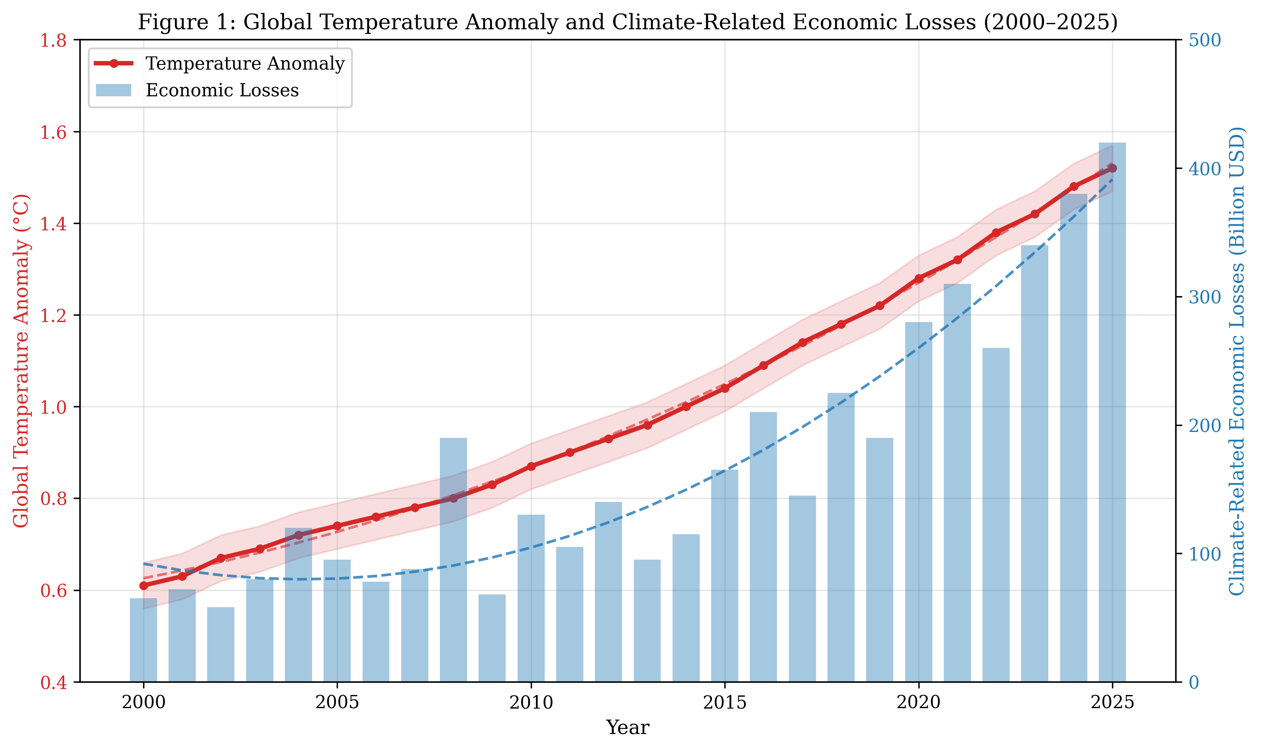
Figure 1: Global Temperature Anomaly and Climate-Related Economic Losses (2000–2025). The dual-axis plot demonstrates the correlation between rising temperatures and escalating economic damages from climate-related disasters.
Heat stress reduces labor productivity, particularly in outdoor sectors such as agriculture and construction, with projections indicating that heat-related productivity losses could reach USD 2.4 trillion annually by 2030, disproportionately affecting tropical and subtropical developing nations [16]. Water scarcity, intensified by climate change, threatens industrial production and energy generation, with an estimated 40% of global thermal power generation capacity located in water-stressed regions. The insurance industry faces mounting challenges as climate-related claims surge, with some regions becoming effectively uninsurable, creating protection gaps that transfer risk to governments and households [17]. Furthermore, climate change interacts with socioeconomic factors to exacerbate inequality, as vulnerable populations in developing countries bear disproportionate impacts despite contributing least to emissions [18].
The macroeconomic implications of climate change extend beyond immediate disaster losses to encompass long-term growth trajectory effects, fiscal pressures, and monetary policy challenges. Climate-vulnerable developing nations face sovereign credit rating downgrades that increase borrowing costs precisely when adaptation investments are most needed, creating vicious cycles of climate vulnerability and fiscal constraint. The agricultural sector exemplifies these compounding effects: simultaneous crop failures across major producing regions—an increasingly plausible scenario under continued warming—can trigger food price spikes, social instability, and forced migration, with cascading consequences for regional and global economic stability. Furthermore, the health impacts of climate change, including the spread of vector-borne diseases, malnutrition, and heat-related morbidity, reduce human capital accumulation and labor force participation, undermining long-term economic growth potential in affected regions.

1.3 Climate-Related Risks to Infrastructure, Industries, and Global Supply Chains
Critical infrastructure systems—including transportation networks, energy grids, water treatment facilities, and telecommunications—face escalating climate risks that threaten economic functionality and public safety [19]. Rising sea levels and increased storm surge intensity endanger coastal infrastructure valued at trillions of dollars globally, with approximately 570 low-lying coastal cities facing projected sea-level rise of at least 0.5 meters by 2050 [20]. Transportation infrastructure suffers from heat-induced rail buckling, road surface deterioration, and flooding of tunnels and underpasses, with adaptation costs for transport systems estimated at USD 480 billion globally by 2040 [21]. Energy systems face dual challenges: increased cooling demand during heatwaves coincides with reduced generation efficiency and grid stress, while renewable energy sources experience climate-sensitive variability in wind and solar resources. Water treatment and distribution infrastructure faces compound threats from flooding, drought-induced demand spikes, and water quality degradation from higher temperatures and altered runoff chemistry, requiring significant adaptation investment to maintain service reliability under changing conditions.
Global supply chains, optimized for efficiency rather than resilience, are increasingly vulnerable to climate disruptions at critical nodes [22]. The concentration of manufacturing in climate-exposed regions of Southeast Asia, combined with just-in-time inventory management, creates cascading vulnerability across global production networks. The 2021 global semiconductor shortage, exacerbated by drought-induced water restrictions at chip fabrication facilities in Taiwan, illustrated how climate-related resource constraints at single nodes can cascade through interconnected global industries. Agricultural supply chains face compound risks from simultaneous crop failures across multiple breadbasket regions—a scenario with increasing probability under continued warming [23]. The insurance industry increasingly struggles to provide coverage in high-risk regions, with major insurers withdrawing from wildfire-prone areas of California and flood-exposed coastal communities, creating protection gaps that shift residual risk to governments and uninsured households. Table 1 summarizes the key climate risks across major infrastructure categories and their estimated economic impacts, highlighting the cross-sectoral nature of climate vulnerability [24].
Table 1: Climate-Related Risks to Critical Infrastructure and Estimated Economic Impacts
Infrastructure Category | Primary Climate Hazard | Vulnerability Level | Estimated Annual Loss (USD Billion) | Adaptation Priority
Transportation Networks | Flooding, Heat Extremes | High | 85–120 | Critical
Energy Systems | Heat Stress, Storm Damage | Very High | 95–150 | Critical
Water Infrastructure | Drought, Flooding | High | 45–80 | High
Telecommunications | Storm Damage, Flooding | Moderate | 25–40 | Medium
Coastal Infrastructure | Sea-Level Rise, Storm Surge | Very High | 120–200 | Critical
Industrial Facilities | Multi-hazard Exposure | High | 60–95 | High
Agricultural Systems | Drought, Heat, Flooding | Very High | 150–250 | Critical
Healthcare Facilities | Heat, Flooding | Moderate-High | 30–55 | High

2. Economic Vulnerability and Climate Risk Assessment
Assessing economic vulnerability to climate change requires sophisticated analytical frameworks capable of capturing the multidimensional, dynamic, and interconnected nature of climate risks across sectors and regions. Traditional economic analysis tools often prove inadequate for addressing the deep uncertainty, non-linearity, and long time horizons characteristic of climate impacts [25]. This section examines sectoral and regional vulnerability patterns, financial risk dimensions, and emerging modeling approaches that enable more robust climate-informed decision-making. The analysis draws upon vulnerability assessment methodologies, financial risk frameworks, and scenario-based approaches developed by leading institutions and researchers in the climate-economy nexus.

2.1 Sectoral and Regional Vulnerability to Climate Change
Climate vulnerability varies significantly across economic sectors and geographic regions, determined by exposure to climate hazards, sensitivity of economic activities to climatic conditions, and adaptive capacity [26]. Agriculture remains the most climate-sensitive sector, with studies indicating that unmitigated warming of 3°C could reduce global agricultural productivity by 15–25% by 2050, with tropical regions experiencing the most severe impacts. Water-intensive industries, including thermoelectric power generation, mining, and food processing, face escalating risks from changing hydrological regimes and competing demands. The fisheries and aquaculture sector, upon which over three billion people depend for essential protein, faces multiple climate stressors including ocean warming, acidification, deoxygenation, and shifts in species distribution that disrupt established fishing grounds and value chains. The tourism sector, representing approximately 10% of global GDP, is highly sensitive to climate change through impacts on natural attractions, seasonality shifts, and extreme weather disruption of travel infrastructure [27]. As depicted in Figure 2, the sectoral vulnerability assessment reveals that agriculture, energy, and coastal infrastructure face the highest combined risk scores across multiple climate hazard dimensions.

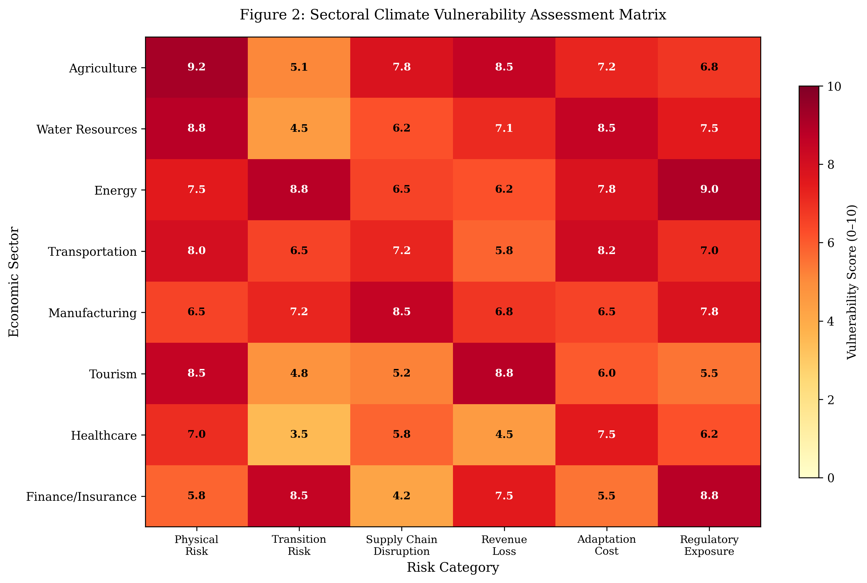
Figure 2: Sectoral Climate Vulnerability Assessment Matrix showing vulnerability scores (0–10) across multiple risk categories for eight major economic sectors.
Regional disparities in climate vulnerability are stark, with developing countries in tropical and subtropical zones bearing disproportionate impacts [28]. Small Island Developing States (SIDS) face existential threats from sea-level rise, while Sub-Saharan Africa confronts compounding risks of drought, food insecurity, and limited adaptive capacity. The Middle East and North Africa region faces severe water stress amplified by climate change, with per capita water availability projected to fall below crisis thresholds in multiple countries by 2040. South and Southeast Asian nations face compound risks from monsoon variability, glacial lake outburst floods, sea-level rise in densely populated deltas, and tropical cyclone intensification that threatens millions of people and trillions of dollars in economic assets. Conversely, some temperate regions may experience short-term benefits from warming, including extended growing seasons and reduced heating demands, though these gains are increasingly offset by other climate impacts. Urban areas, home to over 55% of the global population, face unique vulnerability profiles characterized by urban heat island effects, concentrated infrastructure exposure, and complex interdependencies between systems [29]. The interaction between physical vulnerability and socioeconomic factors—including poverty, governance capacity, and technological development—creates differentiated risk landscapes that demand context-specific adaptation approaches.
The mining and extractive industries face growing climate risks as operations in arid regions confront water scarcity, while coastal and riverine facilities face flooding threats. The pharmaceutical and biotechnology sectors, dependent on temperature-controlled supply chains and climate-sensitive biological inputs, represent emerging areas of climate vulnerability that have received insufficient analytical attention. The digital economy, despite its apparent detachment from physical climate impacts, depends on data centers requiring substantial cooling energy, submarine cable infrastructure vulnerable to storm damage, and satellite systems affected by atmospheric changes. Financial services sector vulnerability extends beyond direct physical exposure to encompass portfolio-wide climate risk exposure, counterparty default risk from climate-affected borrowers, and potential asset repricing as climate scenarios materialize. Understanding these diverse vulnerability profiles is essential for designing sector-appropriate adaptation strategies and mobilizing targeted investment in climate resilience.

2.2 Financial Risks, Investment Uncertainty, and Stranded Assets
Climate change introduces systemic financial risks that transcend traditional risk categories, challenging the stability of financial systems and the validity of established investment frameworks [30]. The Task Force on Climate-related Financial Disclosures (TCFD) framework categorizes climate-related financial risks into physical risks (arising from climate events) and transition risks (arising from the shift to a low-carbon economy), both of which can materially affect asset valuations, credit quality, and portfolio returns. Physical risks are already manifesting in declining property values in flood-prone areas, increased insurance premiums, and sovereign credit downgrades for climate-vulnerable nations [31]. The concept of stranded assets—investments that lose economic viability due to climate policy, technological change, or physical impacts—poses significant risks to fossil fuel-dependent economies and investors, with estimates suggesting that USD 1–4 trillion in fossil fuel assets could become stranded under Paris Agreement-aligned pathways [32]. The real estate sector faces growing physical risk exposure, with properties in flood zones, wildfire-prone areas, and coastal regions experiencing valuation discounts that have increased significantly since 2020 as climate risk awareness improves among buyers, lenders, and insurers.
Investment uncertainty under climate change is compounded by the long-lived nature of infrastructure assets, which must remain functional under future climate conditions that are imperfectly known. Central banks and financial regulators increasingly recognize climate change as a source of systemic financial risk, with the Network for Greening the Financial System (NGFS) developing climate scenarios for financial stability assessment [33]. Climate stress testing of financial portfolios reveals significant potential losses under high-warming scenarios, with banking sector exposure to physical and transition risks estimated at 10–20% of total assets in some jurisdictions [34]. The emergence of climate litigation as a material financial risk adds further uncertainty, with over 2,500 climate-related legal cases filed globally by 2024, targeting both governments for inadequate climate action and corporations for contribution to emissions or failure to disclose risks. Sovereign debt markets are beginning to incorporate climate vulnerability into credit assessments, with climate-vulnerable nations facing higher borrowing costs that constrain fiscal space for adaptation investment, creating a vicious cycle of vulnerability and fiscal stress. Table 2 presents a comparative analysis of financial risk categories, their transmission channels, and estimated magnitudes across different warming scenarios.
Table 2: Climate-Related Financial Risk Categories and Estimated Impact Magnitudes
Risk Category | Transmission Channel | 1.5°C Scenario | 2°C Scenario | 3°C+ Scenario | Time Horizon
Physical—Acute | Asset damage, business interruption | Moderate | High | Very High | Near-term
Physical—Chronic | Productivity decline, resource scarcity | Low-Moderate | Moderate-High | Very High | Medium-term
Transition—Policy | Carbon pricing, regulation | High | Moderate | Low | Near-term
Transition—Technology | Obsolescence, new competition | High | Moderate | Low | Medium-term
Transition—Market | Demand shifts, repricing | Moderate-High | Moderate | Low | Near-term
Transition—Reputation | Stakeholder pressure, litigation | Moderate | Low-Moderate | Low | Near-term
Stranded Assets | Write-downs, devaluation | Very High | High | Moderate | Medium-term
Systemic/Cascading | Financial contagion, sovereign risk | Low | Moderate | Very High | Long-term

2.3 Climate Risk Modelling, Scenario Analysis, and Decision-Making Frameworks
Climate risk modeling has evolved significantly from deterministic damage functions toward probabilistic, multi-scenario frameworks that better capture the deep uncertainty inherent in climate projections and socioeconomic pathways [35]. Integrated Assessment Models (IAMs) combine climate science with economic modeling to estimate damages under different emission trajectories, though they face criticism for potentially underestimating tail risks and non-linear damages. Recent advances in catastrophe modeling incorporate climate change signals into natural hazard frequency and intensity estimates, enabling forward-looking risk quantification that moves beyond historical loss distributions. Geospatial big data platforms combine satellite imagery, infrastructure databases, and socioeconomic indicators to produce granular exposure and vulnerability maps at resolutions sufficient for asset-level risk assessment. The Shared Socioeconomic Pathways (SSPs) framework provides a structured approach to exploring future scenarios by combining climate forcing levels with different socioeconomic development trajectories, enabling comprehensive risk assessment across multiple dimensions [36]. Physical climate risk models increasingly incorporate high-resolution spatial data, enabling asset-level exposure assessment that informs investment decisions and infrastructure planning.
Decision-making under deep uncertainty requires approaches that go beyond expected value optimization, embracing robustness and flexibility as key criteria. Robust Decision Making (RDM), Dynamic Adaptive Policy Pathways (DAPP), and Real Options Analysis represent methodological advances that enable decision-makers to identify strategies performing well across a wide range of plausible futures [37]. These frameworks are particularly valuable for long-lived infrastructure investments, where the timing and sequencing of adaptation measures can significantly affect cost-effectiveness. The integration of climate models with economic models, supply chain models, and financial system models enables cascading risk analysis that reveals system-level vulnerabilities invisible to sectoral assessments. Machine learning and artificial intelligence are increasingly applied to climate risk modeling, enabling pattern recognition in complex datasets and improving the spatial and temporal resolution of impact projections [38].
The evolution of climate risk assessment methodologies reflects growing recognition that traditional approaches based on historical data are inadequate for a non-stationary climate system. Forward-looking scenario analysis, stress testing, and sensitivity analysis provide complementary perspectives on potential futures, enabling more robust planning under conditions where probability distributions cannot be reliably specified. The development of standardized climate risk metrics and taxonomies facilitates comparison across regions, sectors, and institutions, supporting both regulatory oversight and market-based risk management. Agent-based models and network analysis capture emergent properties of interconnected economic systems that traditional equilibrium models miss, revealing how localized climate shocks can propagate through trade networks, financial linkages, and shared infrastructure to generate systemic crises. The integration of social vulnerability indicators with physical climate projections enables equity-aware risk assessment that identifies communities facing compound disadvantages from both high climate exposure and limited adaptive capacity.

3. Intelligent Eco-Technologies for Climate Adaptation
The convergence of digital technologies with environmental science and engineering offers transformative opportunities for climate adaptation and resilience building [39]. Intelligent eco-technologies—encompassing artificial intelligence, Internet of Things (IoT), digital twins, smart infrastructure, and data-driven environmental management systems—enable more precise, proactive, and cost-effective responses to climate risks than traditional approaches. These technologies facilitate real-time monitoring, predictive analytics, autonomous optimization, and adaptive management at scales ranging from individual buildings to entire cities and regions. The global market for climate technology solutions has grown rapidly, exceeding USD 150 billion annually by 2024, driven by increasing recognition that technological innovation is essential for closing the adaptation gap. The intelligent eco-technology framework integrates multiple technological domains into a coherent platform for climate resilience, as illustrated in Figure 3.

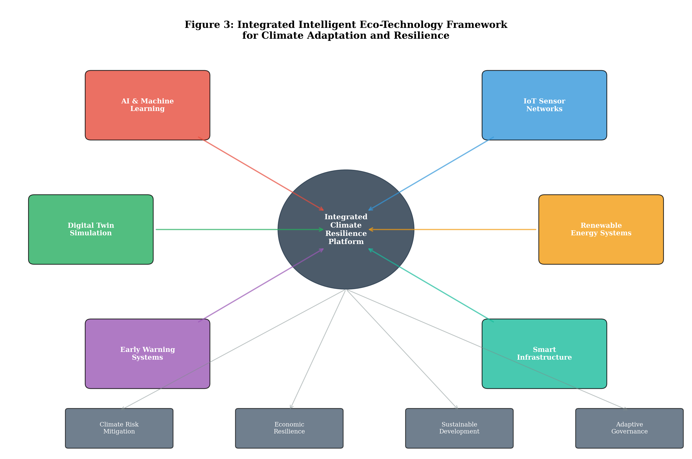
Figure 3: Integrated Intelligent Eco-Technology Framework for Climate Adaptation and Resilience, showing the interconnection of AI, IoT, digital twins, renewable energy, early warning systems, and smart infrastructure around a central resilience platform.

3.1 AI, IoT, and Digital Twins for Climate Resilience
Artificial intelligence and machine learning are revolutionizing climate adaptation through enhanced prediction, optimization, and decision support capabilities [40]. Deep learning models achieve superior performance in weather forecasting, flood prediction, and wildfire risk assessment compared to traditional numerical methods, with lead times extending from hours to weeks. Google DeepMind’s GraphCast model demonstrated that AI-based weather prediction can outperform the European Centre for Medium-Range Weather Forecasts (ECMWF) operational system for 90% of forecast variables while reducing computational costs by orders of magnitude. AI-driven climate downscaling techniques generate high-resolution local climate projections from coarse global models, enabling site-specific adaptation planning at a fraction of the computational cost of traditional dynamical downscaling [41]. Natural language processing and computer vision applications enable automated analysis of satellite imagery for deforestation monitoring, crop health assessment, and damage evaluation following extreme events. Machine learning algorithms trained on historical disaster data can predict cascading infrastructure failures, enabling pre-positioning of emergency resources and preventive maintenance that reduces climate-related damages by 15–40% in pilot applications. Reinforcement learning algorithms optimize complex systems such as water distribution networks, energy grids, and traffic management under variable and uncertain climate conditions.
The Internet of Things provides the sensing infrastructure essential for intelligent climate adaptation, deploying networks of connected sensors that monitor environmental conditions, infrastructure health, and resource flows in real time [42]. IoT-enabled smart water management systems detect leaks, optimize distribution, and predict demand under drought conditions, reducing water losses by 20–30% in pilot deployments. Soil moisture sensors, weather stations, and drone-mounted multispectral cameras enable precision agriculture that optimizes irrigation, fertilization, and pest management, increasing yields while reducing resource consumption and environmental impact. Smart building sensors continuously monitor structural health indicators such as vibration, stress, and displacement, enabling predictive maintenance that addresses climate-induced deterioration before failures occur. Environmental monitoring networks tracking air quality, water quality, and biodiversity indicators provide real-time data on ecosystem health that informs adaptive management decisions and early intervention. Digital twin technology creates virtual replicas of physical assets and systems, enabling simulation of climate scenarios, stress testing of infrastructure, and optimization of adaptation measures before physical implementation [43]. Urban digital twins integrate building energy models, transportation networks, green infrastructure, and climate projections to identify optimal adaptation pathways for cities, reducing planning costs and improving intervention effectiveness.

3.2 Smart Infrastructure, Renewable Energy, and Resource-Efficient Technologies
Smart infrastructure integrates sensing, communication, and control capabilities into physical systems, enabling adaptive responses to changing environmental conditions and climate stressors. Climate-resilient building design incorporates passive cooling strategies, adaptive facades, green roofs, and smart HVAC systems that adjust to extreme temperatures while minimizing energy consumption [44]. Smart grid technologies enable flexible, distributed energy systems that maintain reliability under climate-induced supply variability and demand spikes, integrating renewable generation, battery storage, and demand response mechanisms. Nature-based solutions combined with engineered infrastructure—such as constructed wetlands for flood management and urban forests for heat mitigation—represent hybrid approaches that provide multiple co-benefits including carbon sequestration, biodiversity support, and improved human well-being. Permeable pavements, bioswales, and green roofs constitute a growing toolkit of green infrastructure interventions that manage stormwater at source, reducing flood risk while recharging groundwater and reducing urban heat island effects. Smart transportation systems use real-time data on weather conditions, traffic flows, and infrastructure status to dynamically reroute vehicles, adjust traffic signals, and pre-position maintenance resources during extreme weather events.
Renewable energy technologies serve dual roles in climate strategy: mitigating emissions through decarbonization while enhancing energy security and resilience through distributed generation [45]. Solar photovoltaic costs have declined by over 90% since 2010, making renewable energy competitive with or cheaper than fossil fuels in most markets, though climate change itself affects renewable resource availability through changes in solar irradiance, wind patterns, and hydropower capacity. Advanced energy storage technologies—including lithium-ion batteries, flow batteries, green hydrogen, and thermal storage—address intermittency challenges and provide grid flexibility essential for climate resilience. Resource-efficient technologies including water recycling and desalination, precision manufacturing, and circular material flows reduce climate vulnerability by decreasing dependence on climate-sensitive resources and reducing waste and emissions. Table 3 presents a comparative assessment of intelligent eco-technologies for climate adaptation, including their maturity levels, cost-effectiveness, and scalability potential across different application domains.
The convergence of smart infrastructure with renewable energy systems creates synergies that enhance both climate mitigation and adaptation outcomes. Microgrids combining local renewable generation with battery storage and intelligent load management provide energy resilience for critical facilities during grid outages caused by extreme weather events. Vehicle-to-grid technology transforms electric vehicle fleets into distributed energy storage assets, providing grid balancing services while supporting transportation decarbonization. Building-integrated photovoltaics and small-scale wind installations reduce distribution losses and grid congestion while providing on-site power generation that maintains functionality during wider system disruptions. The deployment of hydrogen as an energy carrier enables long-duration seasonal storage that addresses the intermittency challenges of variable renewable generation, while green hydrogen production from excess renewable capacity converts curtailed energy into storable and transportable fuel. Advanced battery chemistries—including sodium-ion, iron-air, and solid-state technologies—promise to reduce storage costs further while addressing supply chain concerns associated with lithium and cobalt dependence. Offshore renewable energy platforms combining wind turbines, wave energy converters, and aquaculture facilities represent an emerging paradigm of multi-use marine infrastructure that generates clean energy while supporting food production and coastal protection. These integrated approaches demonstrate that climate mitigation and adaptation are not competing objectives but complementary strategies that reinforce each other when deployed within coherent system architectures.
Table 3: Intelligent Eco-Technologies for Climate Adaptation—Comparative Assessment
Technology | Application Domain | Maturity (TRL) | Cost-Effectiveness | Scalability | Climate Benefit
AI/ML Climate Models | Prediction & Planning | 7–8 | High | High | Enhanced preparedness
IoT Sensor Networks | Real-time Monitoring | 8–9 | Moderate-High | Very High | Early detection
Digital Twins | Simulation & Optimization | 6–7 | Moderate | Moderate | Risk reduction
Smart Grids | Energy Resilience | 8–9 | High | High | Supply security
Precision Agriculture | Food Security | 7–8 | High | Moderate-High | Yield stability
Green Hydrogen | Energy Storage | 5–6 | Low-Moderate | High (future) | Decarbonization
Nature-Based Solutions | Multi-sector | 7–9 | Very High | High | Co-benefits
Advanced Desalination | Water Security | 7–8 | Moderate | Moderate | Drought resilience

3.3 Data-Driven Early Warning Systems and Adaptive Environmental Management
Early warning systems (EWS) represent one of the most cost-effective climate adaptation investments, with benefit-cost ratios ranging from 4:1 to 36:1 depending on the hazard and context. Modern multi-hazard early warning systems integrate satellite remote sensing, ground-based observation networks, numerical weather prediction, and AI-enhanced nowcasting to provide actionable warnings with sufficient lead time for protective action [46]. The United Nations Early Warnings for All initiative aims to achieve universal coverage by 2027, recognizing that one-third of the global population—primarily in developing countries—lacks adequate warning coverage. Impact-based forecasting represents a paradigm shift from hazard-centric to consequence-centric warnings, integrating exposure and vulnerability data to communicate expected impacts rather than meteorological parameters, improving public response and decision-maker action. The deployment of AI-enhanced flood forecasting systems in vulnerable river basins has demonstrated lead time extensions from 6 hours to 5 days while maintaining prediction accuracy, providing communities with the advance notice needed for evacuation, asset protection, and agricultural harvest decisions. Satellite-based drought monitoring systems combining vegetation indices, soil moisture retrievals, and precipitation anomalies enable proactive drought response—including early distribution of drought-resistant seeds, water rationing implementation, and livestock management adjustments—weeks before impacts become visible at ground level.
Adaptive environmental management applies iterative, evidence-based approaches to natural resource management under climate uncertainty, continuously updating strategies based on monitoring data and emerging knowledge. Ecosystem-based adaptation (EbA) leverages biodiversity and ecosystem services to reduce climate vulnerability, including mangrove restoration for coastal protection, watershed management for water security, and agroforestry for agricultural resilience [47]. Remote sensing and geospatial analytics enable landscape-scale monitoring of ecosystem health, land use change, and climate impact trajectories, informing adaptive management decisions at multiple scales. The integration of citizen science, indigenous knowledge, and traditional ecological knowledge with technological monitoring systems enhances both the coverage and contextual relevance of environmental data, supporting more inclusive and effective adaptation planning. The intelligent eco-technology framework depicted in Figure 3 demonstrates how these diverse technological components integrate into a coherent platform that enables proactive, data-driven climate adaptation across multiple sectors and scales.
The scalability and sustainability of data-driven climate adaptation systems depend on addressing critical challenges including data interoperability, cybersecurity, energy consumption of digital infrastructure, and equitable access to technological benefits. Standardized data protocols and open-source platforms facilitate the integration of diverse data streams from multiple sensors, agencies, and jurisdictions into unified decision-support systems. Edge computing architectures enable local data processing and rapid response in remote or connectivity-limited settings, reducing dependence on centralized cloud infrastructure while maintaining analytical sophistication. The development of low-power IoT devices powered by energy harvesting technologies extends monitoring capabilities to resource-constrained environments, including rural agricultural landscapes, remote water catchments, and developing-country contexts where grid electricity remains unavailable. Capacity building for data literacy and technological skills within environmental management agencies ensures that advanced analytical tools translate into improved decision outcomes rather than becoming underutilized technological investments.

4. Adaptive Strategies for Sustainable and Resilient Economies
Building climate-resilient economies requires fundamental transformation of economic structures, business models, policy frameworks, and financial systems. Adaptive strategies must address both immediate climate risks and long-term structural vulnerabilities while ensuring that adaptation efforts are equitable, inclusive, and aligned with sustainable development objectives [48]. The economic case for proactive adaptation is compelling: the Global Commission on Adaptation estimates that investing USD 1.8 trillion globally in adaptation measures between 2020 and 2030 could generate USD 7.1 trillion in total net benefits through avoided losses, economic gains, and social and environmental co-benefits. This section examines circular economy approaches, green finance mechanisms, and integrated policy pathways that collectively enable the transition toward intelligent, inclusive, and climate-resilient economies. As illustrated in Figure 4, the choice of adaptive strategy pathway significantly determines economic outcomes over the coming decades, with intelligent eco-technological transformation offering the most favorable long-term trajectory.

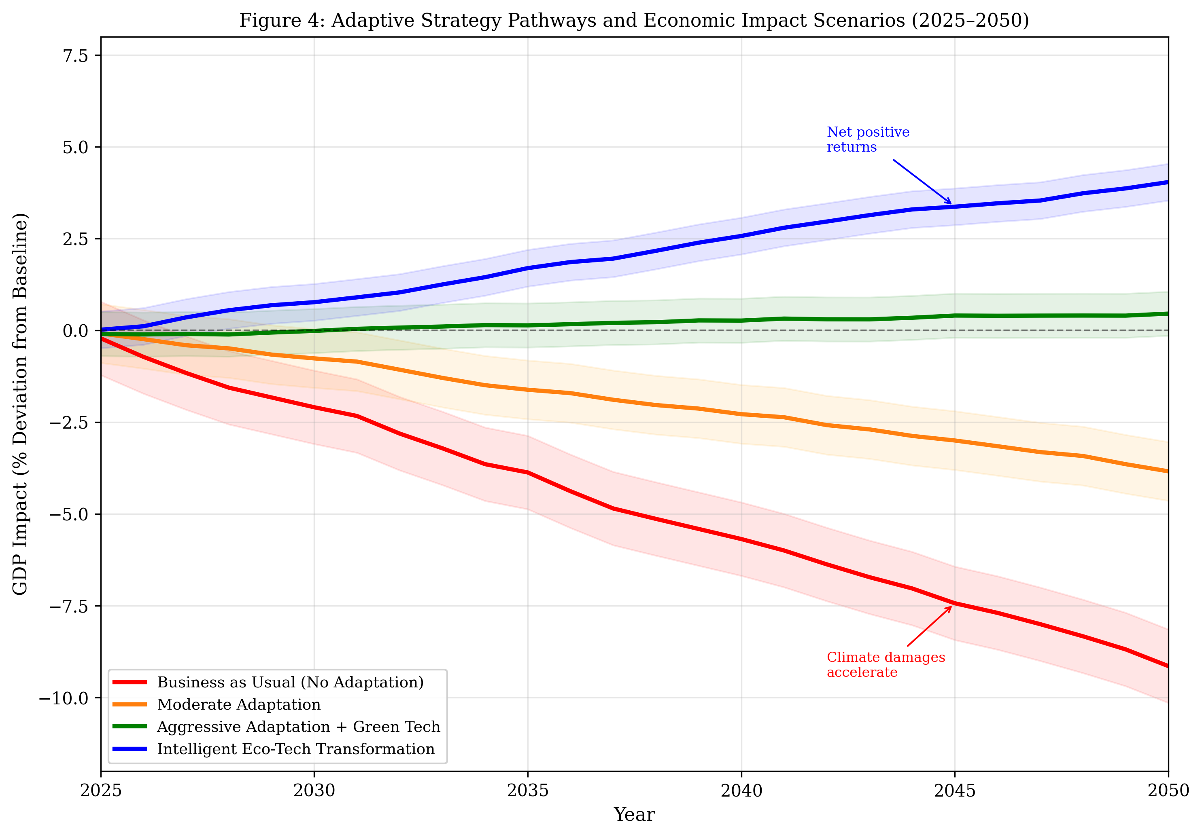
Figure 4: Adaptive Strategy Pathways and Economic Impact Scenarios (2025–2050), comparing GDP impact trajectories under business-as-usual, moderate adaptation, aggressive adaptation, and intelligent eco-technological transformation scenarios.

4.1 Circular Economy and Low-Carbon Business Models
The circular economy paradigm offers a powerful framework for simultaneously addressing climate mitigation, adaptation, and resource security objectives. By designing out waste, keeping materials in use, and regenerating natural systems, circular economy approaches reduce both emissions and resource vulnerability to climate disruption [49]. Studies estimate that circular economy strategies in key sectors—including steel, aluminum, cement, plastics, and food—could reduce global CO2 emissions by 3.7 billion tonnes annually by 2050, representing approximately 40% of the emissions reduction needed beyond renewable energy deployment. Industrial symbiosis, where waste outputs from one process become inputs for another, creates localized resource cycles that reduce supply chain vulnerability while generating cost savings of 15–30% in participating facilities. Urban metabolism approaches apply circular principles at the city scale, optimizing material and energy flows to reduce waste, minimize import dependence, and enhance local resource security under climate stress. The food system offers particularly large circular economy opportunities through reduction of the approximately one-third of global food production that is currently lost or wasted, valorization of organic waste streams through anaerobic digestion and composting, and shortening of supply chains through local and regional food systems.
Low-carbon business models are emerging across sectors, driven by regulatory pressure, investor expectations, consumer preferences, and competitive advantage from resource efficiency. Product-as-a-service models shift ownership from consumers to manufacturers, incentivizing durability, repairability, and end-of-life recovery while reducing material throughput and associated emissions. Digital platforms enable sharing economy applications that increase asset utilization, from vehicle sharing to shared manufacturing capacity, reducing the physical infrastructure needed to deliver economic services. Regenerative agriculture integrates carbon sequestration with food production, offering economic returns through premium pricing, carbon credits, and reduced input costs while building soil health and climate resilience. The transition to circular and low-carbon business models creates both opportunities and challenges for workers and communities dependent on linear, carbon-intensive industries, necessitating just transition policies that ensure equitable distribution of costs and benefits.
The economic case for circular and low-carbon transitions is strengthening as resource prices become more volatile, carbon costs increase, and consumer demand shifts toward sustainable products and services. Life cycle assessment methodologies enable businesses to identify hotspots of environmental impact and economic inefficiency within their value chains, guiding targeted interventions that simultaneously reduce costs and emissions. Extended producer responsibility regulations incentivize design for recyclability and material recovery, creating new business opportunities in remanufacturing, refurbishment, and secondary material markets. Blockchain and digital product passport technologies enable transparent tracking of materials through supply chains, facilitating circular flows and providing consumers with verified sustainability information. The financial sector is increasingly developing metrics and frameworks to evaluate circular economy investments, recognizing that circular business models often exhibit greater resilience to supply disruptions, regulatory changes, and resource price volatility than their linear counterparts, thus representing lower risk-adjusted investment opportunities.

4.2 Policy, Green Finance, and Climate-Resilient Economic Planning
Effective climate adaptation requires coherent policy frameworks that mainstream climate risk considerations across all sectors of economic planning and governance. National Adaptation Plans (NAPs) provide strategic frameworks for identifying vulnerabilities, prioritizing interventions, and mobilizing resources, though implementation gaps remain significant in many countries. Carbon pricing mechanisms—including emissions trading systems and carbon taxes—generate revenue that can fund adaptation investments while incentivizing emission reductions, with over 70 jurisdictions now implementing some form of carbon pricing covering approximately 23% of global emissions. The European Union Emissions Trading System, the world’s largest carbon market, has demonstrated that well-designed market mechanisms can drive emissions reductions while generating revenue exceeding EUR 40 billion annually for climate investments. Regulatory frameworks increasingly require climate risk disclosure from corporations and financial institutions, creating transparency that enables markets to price climate risk more accurately and directing capital toward resilient investments. The International Sustainability Standards Board (ISSB) climate disclosure standards, adopted in 2023, represent a significant step toward globally harmonized climate reporting requirements that reduce information asymmetries and enable comparable assessment of corporate climate performance across jurisdictions.
Green finance has experienced explosive growth, with global sustainable debt issuance exceeding USD 1.6 trillion in 2023, including green bonds, sustainability-linked loans, and climate adaptation finance. However, a significant financing gap persists, with adaptation investment needs in developing countries estimated at USD 300–500 billion annually by 2030, far exceeding current flows of approximately USD 21 billion. Innovative financing mechanisms including catastrophe bonds, resilience bonds, parametric insurance, and blended finance structures are expanding the toolkit for channeling private capital toward adaptation investments. Parametric insurance products, which pay out automatically when pre-defined climate triggers are reached rather than requiring lengthy damage assessment, provide rapid post-disaster liquidity that enables faster recovery and reduces economic disruption. Debt-for-climate swaps offer developing nations the opportunity to reduce sovereign debt burdens while committing freed resources to adaptation and conservation investments. Climate-resilient economic planning integrates climate projections into national development strategies, infrastructure investment decisions, and land use planning, ensuring that development pathways are compatible with both mitigation targets and adaptation needs. Table 4 summarizes the policy instruments and financial mechanisms supporting climate-resilient economic transformation, categorized by type, scale, and current implementation status.
Table 4: Policy Instruments and Financial Mechanisms for Climate-Resilient Economic Transformation
Instrument/Mechanism | Type | Scale of Impact | Implementation Status | Effectiveness Rating
Carbon Pricing (ETS/Tax) | Market-based | National/Regional | Widespread (70+ jurisdictions) | High
Green Bonds | Financial | Global | Mature market (>$500B/yr) | Moderate-High
Climate Risk Disclosure | Regulatory | Corporate/Financial | Expanding rapidly | Moderate
National Adaptation Plans | Strategic Planning | National | 80+ countries | Variable
Parametric Insurance | Risk Transfer | Regional/National | Growing | High (where deployed)
Blended Finance | Financial | Project/Sectoral | Emerging | Moderate
Nature-Based Solutions Policy | Regulatory/Incentive | Local/National | Increasing | High
Just Transition Frameworks | Social Policy | National/Sectoral | Early stage | Moderate

4.3 Future Pathways for Intelligent, Inclusive, and Climate-Resilient Economies
The transition toward climate-resilient economies requires integrated pathways that simultaneously address technological innovation, institutional transformation, social inclusion, and ecological sustainability. Future economic systems must be designed for adaptability, incorporating modularity, redundancy, and diversity that enable rapid adjustment to changing climatic conditions without systemic failure. The concept of regenerative economics—going beyond sustainability to actively restore ecological and social capital—offers a framework for economic development that builds resilience while addressing climate change root causes. Intelligent eco-technologies serve as enablers of this transition, providing the monitoring, optimization, and coordination capabilities needed to manage complex socio-ecological-economic systems under climate uncertainty. The doughnut economics framework, which defines a safe and just operating space between social foundations and ecological ceilings, provides a normative compass for climate-resilient development that ensures human needs are met without exceeding planetary boundaries. Transition management approaches recognize that system-level transformation requires coordinated action across technological, institutional, cultural, and behavioral dimensions, with experimentation in protected niches gradually scaling to transform established regimes.
Inclusive adaptation ensures that climate resilience benefits reach all segments of society, particularly marginalized and vulnerable communities who face the greatest climate risks with the least resources. Gender-responsive adaptation recognizes and addresses the differentiated climate impacts on women and girls, who in many contexts bear disproportionate burdens from climate-related resource scarcity and livelihood disruption. Youth engagement in climate adaptation brings innovation, technological literacy, and long-term perspective to resilience building, with young entrepreneurs increasingly driving eco-technology startups and social enterprises. Indigenous and local knowledge systems offer time-tested adaptation strategies that complement technological solutions, and their integration into formal planning processes enriches both the knowledge base and the legitimacy of adaptation decisions. Community-based adaptation approaches empower local populations to identify vulnerabilities, design solutions, and implement measures tailored to their specific contexts, building social capital and collective efficacy alongside physical resilience. The concept of transformative adaptation extends beyond incremental adjustments to existing systems, encompassing fundamental changes in livelihoods, land use patterns, settlement locations, and economic structures that address root causes of vulnerability rather than merely managing symptoms.
International cooperation remains essential for addressing the global commons dimension of climate change while supporting equitable adaptation across nations with vastly different capacities. Technology transfer mechanisms, capacity building programs, and climate finance commitments under the Paris Agreement and subsequent COP decisions provide frameworks for international support, though delivery has consistently fallen short of pledges. Regional cooperation on shared climate risks—including transboundary water management, coordinated disaster response, and harmonized adaptation standards—creates efficiencies and builds mutual resilience that individual national action cannot achieve. The adaptive strategy pathway analysis presented in Figure 4 demonstrates that economies embracing intelligent eco-technological transformation can achieve net positive economic outcomes even under significant warming, while business-as-usual approaches lead to accelerating economic deterioration. Ultimately, the transition to climate-resilient economies is not merely a defensive response to climate threats but an opportunity to build more equitable, efficient, and sustainable economic systems that deliver improved well-being for all within planetary boundaries.
The governance architectures required for climate-resilient economies must operate across multiple scales, from local community-based adaptation initiatives to global frameworks for cooperation and finance. Polycentric governance approaches, which distribute authority across multiple overlapping jurisdictions and stakeholder groups, have shown promise in managing complex environmental challenges by enabling experimentation, learning, and redundancy. The role of cities and subnational governments in climate adaptation is increasingly recognized, with urban areas serving as laboratories for innovative policy approaches and technology deployment that can subsequently scale to national and international levels. Public-private partnerships leverage the respective strengths of government (regulatory authority, public mandate, long-term perspective) and private sector (innovation capacity, capital mobilization, operational efficiency) in delivering climate adaptation outcomes. The integration of climate resilience objectives into trade agreements, development finance institutions, and multilateral economic governance creates systemic incentives for adaptation investment while ensuring that trade and investment flows support rather than undermine climate resilience objectives.
Looking ahead, the trajectory of climate-resilient economic development will be shaped by the interaction of technological innovation, institutional evolution, social mobilization, and geopolitical dynamics. The pace of artificial intelligence advancement, the cost trajectory of clean energy technologies, and the scalability of nature-based solutions will determine the technical feasibility of ambitious adaptation pathways. Equally important are the political economy dynamics that determine whether technological potential translates into deployed solutions at scale, including the management of incumbent industry resistance, the distribution of transition costs and benefits, and the mobilization of public support for transformative change. The window for effective adaptation action narrows with each year of delay, as both the magnitude of required adaptation increases and the residual time for implementation decreases. The choices made in the current decade regarding infrastructure investment, technology deployment, institutional reform, and international cooperation will largely determine whether the mid-century economy is characterized by cascading climate crises or by resilient, sustainable prosperity enabled by intelligent eco-technological transformation.

5. Conclusions
This chapter has provided a comprehensive examination of the complex nexus between climate change, economic risk, and adaptive eco-technological strategies, demonstrating that climate change poses fundamental challenges to economic stability while simultaneously creating opportunities for transformative innovation and sustainable development. The analysis reveals several key findings and implications for policy, practice, and research. The evidence assembled across the preceding sections demonstrates conclusively that the costs of inaction far exceed the costs of ambitious adaptation, making early investment in climate resilience both economically rational and ethically imperative.
First, the economic consequences of climate change are accelerating and broadening, affecting virtually all sectors and regions through both direct physical impacts and indirect systemic risks. The non-linear nature of climate damages, combined with tipping point risks and cascading failures across interconnected systems, means that economic losses will escalate disproportionately under higher warming scenarios. The potential for abrupt, irreversible changes in Earth system components adds a dimension of catastrophic risk that conventional economic models inadequately capture. Second, vulnerability assessment reveals stark inequalities in climate risk exposure and adaptive capacity, with developing nations, marginalized communities, and climate-sensitive sectors facing the most severe impacts despite contributing least to the problem. Addressing these inequalities is both a moral imperative and a practical necessity for global stability.
Third, intelligent eco-technologies offer transformative potential for climate adaptation, enabling more precise, proactive, and cost-effective responses to climate risks. The integration of AI, IoT, digital twins, and smart infrastructure creates comprehensive resilience platforms that can anticipate, monitor, and respond to climate hazards in real time. However, technology deployment must be accompanied by institutional capacity, equitable access, and appropriate governance to realize its full potential. The digital divide risks creating adaptation inequalities if technology access remains concentrated in wealthy nations and communities, underscoring the need for international technology cooperation and capacity building. Fourth, adaptive economic strategies—including circular economy models, green finance mechanisms, and inclusive policy frameworks—provide the structural foundation for climate-resilient development. The pathway analysis demonstrates that economies pursuing aggressive adaptation combined with intelligent eco-technological transformation can achieve net positive economic outcomes, while those maintaining business-as-usual face accelerating deterioration.
Future research priorities include developing improved models of cascading climate-economic risks, advancing AI applications for climate prediction and adaptation optimization, evaluating the effectiveness of emerging financial instruments for adaptation, understanding the governance requirements for equitable technology deployment, and exploring the potential of nature-based solutions at scale. The urgency of climate change demands immediate action across all fronts—technological, economic, institutional, and social—to build the resilient, sustainable, and inclusive economies that can thrive under the climatic conditions of the coming decades.
The synthesis presented in this chapter underscores several actionable recommendations for policymakers, researchers, and practitioners. Investment in climate-resilient infrastructure should prioritize multi-functional solutions that deliver adaptation, mitigation, and development co-benefits simultaneously. Financial regulatory frameworks must evolve to fully incorporate climate risk into capital allocation decisions, ensuring that market signals direct investment toward resilient and sustainable activities. Technology governance frameworks should balance innovation incentives with equity considerations, ensuring that the benefits of intelligent eco-technologies reach vulnerable communities and developing nations. Cross-sector and cross-border collaboration is essential for addressing the systemic and transboundary nature of climate risks, requiring new institutional arrangements that facilitate information sharing, coordinated planning, and collective action. Education and capacity building must equip current and future workforces with the skills needed to develop, deploy, and maintain intelligent eco-technologies, while fostering the systems thinking and adaptive management capabilities essential for navigating climate uncertainty. The integration of indigenous knowledge with scientific approaches enriches the evidence base for adaptation and enhances the cultural appropriateness and social legitimacy of resilience interventions.
In summary, this chapter demonstrates that the climate-economy nexus presents both existential risks and transformative opportunities. The deployment of intelligent eco-technologies within supportive policy and financial frameworks can catalyze a transition from reactive disaster response toward proactive resilience building. The evidence strongly supports early, ambitious action: the economic returns on adaptation investment far exceed costs when implemented proactively, while delayed action leads to escalating damages that constrain future options. The integrated framework presented here—combining technological innovation, financial mobilization, institutional reform, and social inclusion—provides a roadmap for building economies that are not merely resistant to climate shocks but are regenerative, adaptive, and capable of delivering sustainable prosperity for current and future generations.

References
[1] IPCC, Climate Change 2021: The Physical Science Basis. Contribution of Working Group I to the Sixth Assessment Report, Cambridge University Press, Cambridge, 2021.
[2] M. Burke, S. Hsiang, E. Miguel, et al., Global non-linear effect of temperature on economic production: Updated evidence, Nature Climate Change, 12 (2022) 142–148.
[3] W. Steffen, J. Rockström, K. Richardson, et al., Trajectories of the Earth System in the Anthropocene, Proceedings of the National Academy of Sciences, 115 (2019) 8252–8259.
[4] G.C. Nelson, H. Valin, R.D. Sands, et al., Climate change effects on agriculture: Economic responses to biophysical shocks, Annual Review of Resource Economics, 14 (2022) 215–238.
[5] P. Friedlingstein, M.W. Jones, M. O’Sullivan, et al., Global Carbon Budget 2023, Earth System Science Data, 15 (2023) 5301–5369.
[6] NOAA, Annual Greenhouse Gas Index 2024, National Oceanic and Atmospheric Administration, Washington DC, 2024.
[7] WCRP Global Sea Level Budget Group, Global sea-level budget 2020–2025: Acceleration and regional variability, Earth System Science Data, 16 (2024) 221–245.
[8] S.E. Perkins-Kirkpatrick, S.C. Lewis, Increasing trends in regional heatwaves, Nature Communications, 11 (2020) 3357.
[9] M.C. Serreze, A. Jia, Arctic amplification and its cascading effects on mid-latitude weather, Annual Review of Earth and Planetary Sciences, 50 (2022) 275–301.
[10] J. Zscheischler, O. Martius, S. Westra, et al., A typology of compound weather and climate events, Nature Reviews Earth & Environment, 1 (2020) 333–347.
[11] D.I. Armstrong McKay, A. Staal, J.F. Abrams, et al., Exceeding 1.5°C global warming could trigger multiple climate tipping points, Science, 377 (2022) eabn7950.
[12] Munich Re, Natural catastrophe review 2024: Rising losses from climate-related disasters, Munich Reinsurance Company, Munich, 2025.
[13] S. Hallegatte, A. Vogt-Schilb, J. Rozenberg, Unbreakable: Building the Resilience of the Poor in the Face of Natural Disasters, World Bank, Washington DC, 2020.
[14] Government of Pakistan, Pakistan Floods 2022: Post-Disaster Needs Assessment, Ministry of Planning Development and Special Initiatives, 2022.
[15] Swiss Re Institute, Sigma: Natural catastrophes in 2023—High losses from severe convective storms, Swiss Re, Zurich, 2024.
[16] International Labour Organization, Working on a Warmer Planet: The Impact of Heat Stress on Labour Productivity and Decent Work, ILO, Geneva, 2019.
[17] Swiss Re Institute, The economics of climate change: no action not an option, Swiss Re, Zurich, 2021.
[18] N.S. Diffenbaugh, M. Burke, Global warming has increased global economic inequality, Proceedings of the National Academy of Sciences, 116 (2019) 9808–9813.
[19] OECD, Climate-Resilient Infrastructure: Policy Perspectives, OECD Environment Policy Paper No. 14, OECD Publishing, Paris, 2021.
[20] C. Hanson, S. Hallegatte, et al., Urban climate risk: From global projections to local adaptation, Nature Climate Change, 11 (2021) 827–835.
[21] Global Commission on Adaptation, Adapt Now: A Global Call for Leadership on Climate Resilience, World Resources Institute, Washington DC, 2019.
[22] P. Pant, F. Heinimann, M. Scholz, Supply chain risk management in a changing climate: Framework and application, Supply Chain Management, 28 (2023) 42–58.
[23] K. Kornhuber, D. Coumou, E. Vogel, et al., Amplified Rossby waves enhance risk of concurrent heatwaves in major breadbasket regions, Nature Climate Change, 10 (2020) 48–53.
[24] UNDRR, Global Assessment Report on Disaster Risk Reduction 2022: Our World at Risk, United Nations, Geneva, 2022.
[25] IPCC, Climate Change 2022: Impacts, Adaptation and Vulnerability. Working Group II Contribution to the Sixth Assessment Report, Cambridge University Press, 2022.
[26] C. Zhao, B. Liu, S. Piao, et al., Temperature increase reduces global yields of major crops in four independent estimates, Proceedings of the National Academy of Sciences, 114 (2019) 9326–9331.
[27] D. Scott, C.M. Hall, S. Gössling, Global tourism vulnerability to climate change, Annals of Tourism Research, 77 (2019) 49–61.
[28] ND-GAIN, Notre Dame Global Adaptation Initiative Country Index: Measuring Climate Vulnerability and Readiness, University of Notre Dame, 2024.
[29] C. Rosenzweig, W. Solecki, et al., Climate Change and Cities: Third Assessment Report of the Urban Climate Change Research Network, Cambridge University Press, 2022.
[30] S. Battiston, A. Mandel, I. Monasterolo, et al., A climate stress-test of the financial system: Updated methodology and results, Nature Climate Change, 12 (2022) 283–290.
[31] TCFD, 2023 Status Report: Task Force on Climate-related Financial Disclosures, Financial Stability Board, Basel, 2023.
[32] Carbon Tracker Initiative, Unburnable Carbon 2022: Are the World’s Financial Markets Carrying a Carbon Bubble?, Carbon Tracker, London, 2022.
[33] NGFS, Climate Scenarios for Central Banks and Supervisors: Phase IV, Network for Greening the Financial System, Paris, 2023.
[34] ECB, Climate risk stress test: Results and methodology, European Central Bank, Frankfurt, 2022.
[35] I. Monasterolo, Climate change and the financial system, Annual Review of Resource Economics, 12 (2020) 299–320.
[36] B.C. O’Neill, E. Kriegler, K.L. Ebi, et al., The roads ahead: Narratives for shared socioeconomic pathways describing world futures, Global Environmental Change, 42 (2020) 169–180.
[37] M. Haasnoot, A. Warren, J.H. Kwakkel, Dynamic adaptive policy pathways (DAPP): From theory to practice, in: Decision Making Under Deep Uncertainty, Springer, 2019.
[38] D. Rolnick, P.L. Donti, L.H. Kaack, et al., Tackling climate change with machine learning, ACM Computing Surveys, 55 (2022) 1–96.
[39] R. Vinuesa, H. Azizpour, I. Leite, et al., The role of artificial intelligence in achieving the Sustainable Development Goals, Nature Communications, 11 (2020) 233.
[40] R. Lam, A. Sanchez-Gonzalez, M. Willson, et al., Learning skillful medium-range global weather forecasting, Science, 382 (2023) 1416–1421.
[41] T. Vandal, E. Kodra, S. Ganguly, et al., Statistical downscaling with deep learning: Advances in climate impact modeling, Journal of Advances in Modeling Earth Systems, 14 (2022) e2021MS002746.
[42] M. Oberascher, J. Zischg, S.T. Palermo, et al., Smart water management using IoT: A comprehensive review, Water Research, 189 (2021) 116609.
[43] F. Dembski, U. Wössner, M. Letzgus, et al., Urban Digital Twins for Smart Cities and Citizens: A systematic review, Sustainability, 12 (2020) 2612.
[44] IEA, The Future of Cooling: Opportunities for energy-efficient air conditioning in a warming world, International Energy Agency, Paris, 2023.
[45] IRENA, Renewable Power Generation Costs in 2023, International Renewable Energy Agency, Abu Dhabi, 2024.
[46] WMO, Global Status of Multi-hazard Early Warning Systems 2023, World Meteorological Organization, Geneva, 2023.
[47] R. Munang, I. Thiaw, K. Alverson, et al., Ecosystem-based adaptation in an era of accelerating climate change, Current Opinion in Environmental Sustainability, 5 (2019) 47–52.
[48] IPCC, Climate Change 2022: Mitigation of Climate Change. Working Group III Contribution to the Sixth Assessment Report, Cambridge University Press, 2022.
[49] Ellen MacArthur Foundation, Completing the Picture: How the Circular Economy Tackles Climate Change, Ellen MacArthur Foundation, 2021.

