Front-End Development — Graded Assignment (Weeks 1–6)
Final Output Document (finaloutput)
Student Name : AMMAN JAKHAR
Student UID : 2025EB01187
Date of Birth : 29.08.1986
Date : 25 October 2026

A quick word before the answers. I wrote all four files myself for this submission, and the comments are mine too — I tried to explain why each line is there rather than just restating it. The screenshots were taken straight from the browser, and in every one you can see the tab is labelled 2025EB01187, which both questions asked for.

Question 1 — Student ID Card
For the card I kept the two jobs apart. IDCard.html holds the structure and nothing else, while IDCard_styles.css does all the colouring and spacing. Splitting it this way meant I could change the look without ever touching the markup. I set the page title to my UID so the tab reads 2025EB01187.

Output Screenshot
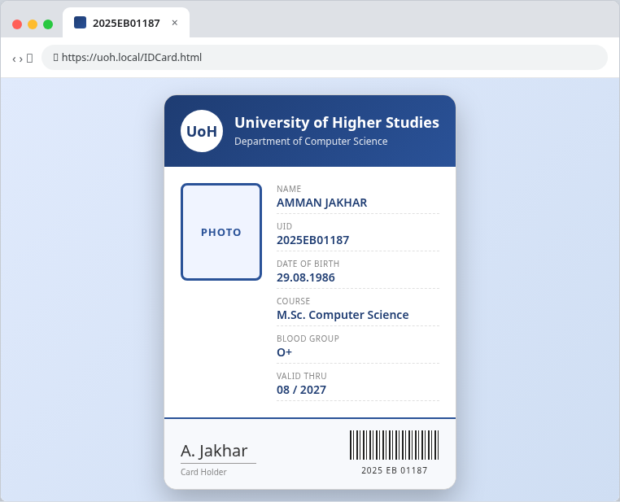
Figure 1 — IDCard.html as it renders in the browser; the tab reads 2025EB01187.

Source — IDCard.html
<!DOCTYPE html> <!-- HTML5 doctype: keeps the browser in standards mode -->
<!--
=====================================================================
QUESTION 1 - STUDENT IDENTITY CARD (the markup)
-----------------------------------------------------------------
Author : AMMAN JAKHAR
UID : 2025EB01187
DOB : 29.08.1986
-----------------------------------------------------------------
My plan for this file:
- keep ONLY the structure here (no colours, no sizes),
- push every visual decision into IDCard_styles.css,
- so that if a teacher asks "where is the layout defined?"
the answer is always "in the stylesheet, not the markup".
I picked a header / body / footer split because a real plastic
ID card is laid out the same way: branding on top, the holder in
the middle, and the signature + barcode along the bottom edge.
=====================================================================
-->
<html lang="en"> <!-- lang="en" helps screen readers pronounce the text -->

<head> <!-- head = information the visitor never sees directly -->
<meta charset="UTF-8"> <!-- UTF-8 so accented names / symbols never turn into gibberish -->
<!-- the viewport line below makes the card behave on a phone instead of looking zoomed-out -->
<meta name="viewport" content="width=device-width, initial-scale=1.0">

<!-- Requirement for Q1: the tab caption has to be my UID, so the title IS the UID -->
<title>2025EB01187</title>

<!-- one external stylesheet; all the "paint" lives there, not here -->
<link rel="stylesheet" href="IDCard_styles.css">
</head>

<body> <!-- body = the part a visitor actually looks at -->

<!-- =============== the whole card sits in one wrapper =============== -->
<!-- I use a single .id-card box so the shadow + rounded corners wrap everything as a unit -->
<div class="id-card">

<!-- ---------- TOP: who issued the card ---------- -->
<!-- header is semantic: it tells browsers/readers "this is introductory banner content" -->
<header class="card-header">
<div class="logo">UoH</div> <!-- stand-in for a crest; initials of the university -->
<div class="university-info"> <!-- the two text lines live together so they align beside the logo -->
<h1 class="university-name">University of Higher Studies</h1> <!-- h1 = the single most important heading -->
<p class="university-sub">Department of Computer Science</p> <!-- a quieter supporting line -->
</div>
</header>

<!-- ---------- MIDDLE: the actual card holder ---------- -->
<!-- main is where the real "content" of the card lives: the photo and the data -->
<main class="card-body">

<!-- left side: a placeholder box where a passport photo would be glued -->
<div class="photo-section"> <!-- wrapper exists so the photo never gets stretched by flexbox -->
<div class="photo"> <!-- the framed rectangle itself -->
<span class="photo-text">PHOTO</span> <!-- just a label until a real image is dropped in -->
</div>
</div>

<!-- right side: one .detail-row per fact, each is a caption stacked over its value -->
<div class="details-section">

<!-- row = Name -->
<div class="detail-row">
<span class="label">Name</span> <!-- the small grey caption -->
<span class="value">AMMAN JAKHAR</span> <!-- the bold blue answer -->
</div>

<!-- row = UID (the same number that titles the tab) -->
<div class="detail-row">
<span class="label">UID</span>
<span class="value">2025EB01187</span>
</div>

<!-- row = Date of Birth -->
<div class="detail-row">
<span class="label">Date of Birth</span>
<span class="value">29.08.1986</span>
</div>

<!-- row = Course -->
<div class="detail-row">
<span class="label">Course</span>
<span class="value">M.Sc. Computer Science</span>
</div>

<!-- row = Blood Group (handy on a real campus ID in an emergency) -->
<div class="detail-row">
<span class="label">Blood Group</span>
<span class="value">O+</span>
</div>

<!-- row = expiry; every card needs a "use-by" date -->
<div class="detail-row">
<span class="label">Valid Thru</span>
<span class="value">08 / 2027</span>
</div>
</div>
</main>

<!-- ---------- BOTTOM: signature on the left, barcode on the right ---------- -->
<!-- footer is the closing strip; I split it left/right with flexbox in the CSS -->
<footer class="card-footer">
<div class="signature"> <!-- two stacked lines: the "ink" and its caption -->
<span class="sign-line">A. Jakhar</span> <!-- styled later with a handwriting font -->
<span class="sign-label">Card Holder</span> <!-- tells the reader whose signature that is -->
</div>
<div class="barcode"> <!-- the bars themselves are drawn in CSS, not an image -->
<span class="barcode-number">2025 EB 01187</span> <!-- the human-readable version under the bars -->
</div>
</footer>

</div>
<!-- =============== end of the card wrapper =============== -->

</body>
</html>

Source — IDCard_styles.css
/*
=====================================================================
QUESTION 1 - STUDENT IDENTITY CARD (the look)
-----------------------------------------------------------------
Author : AMMAN JAKHAR | UID : 2025EB01187
-----------------------------------------------------------------
Everything the eye sees is decided in this file. I kept the colour
story to two blues (#1e3c72 dark, #2a5298 lighter) so the card
feels like one brand instead of a rainbow. Comments below explain
WHY a rule exists, not just what it does.
=====================================================================
*/

/* ---------- step 0: wipe the browser's built-in spacing ---------- */
/* Different browsers ship different default margins; this makes them agree. */
* {
margin: 0; /* kill the default outer gaps */
padding: 0; /* kill the default inner gaps */
box-sizing: border-box; /* my widths now INCLUDE border+padding, which saves a lot of maths */
}

/* ---------- step 1: the page, used only to centre the card ---------- */
body {
font-family: "Segoe UI", Tahoma, Arial, sans-serif; /* a safe sans-serif ladder: fall back if the first is missing */
background: linear-gradient(135deg, #e0eafc 0%, #cfdef3 100%); /* a soft diagonal blue so the white card pops */
min-height: 100vh; /* make the body at least one screen tall... */
display: flex; /* ...then use flexbox... */
justify-content: center; /* ...to centre left-to-right... */
align-items: center; /* ...and top-to-bottom. */
padding: 20px; /* stops the card kissing the edges on tiny screens */
}

/* ---------- step 2: the card shell ---------- */
.id-card {
width: 360px; /* a credit-card-ish fixed width reads as "a card" */
background: #ffffff; /* white body so the blue text has maximum contrast */
border-radius: 16px; /* rounded corners = friendlier, more card-like */
box-shadow: 0 15px 35px rgba(0, 0, 0, 0.25); /* a soft drop shadow so it looks to float above the page */
overflow: hidden; /* clip the header/footer to the rounded corners (no square bleed) */
border: 1px solid #d0d0d0; /* a hairline edge so a white card is visible on a light page */
}

/* ---------- step 3: the header band ---------- */
.card-header {
background: linear-gradient(135deg, #1e3c72 0%, #2a5298 100%); /* the two-blue brand gradient */
color: #ffffff; /* white text because the band is dark */
padding: 18px 20px; /* roomy band so the logo has air around it */
display: flex; /* logo + text sit on one row */
align-items: center; /* vertically line them up with each other */
gap: 14px; /* a tidy gap instead of margins on each child */
}

/* the round "crest" */
.logo {
width: 52px; height: 52px; /* equal width+height is what lets border-radius make a true circle */
border-radius: 50%; /* 50% of a square = a circle */
background: #ffffff; /* white disc against the blue band */
color: #1e3c72; /* dark-blue initials inside */
font-weight: bold; /* initials should shout a little */
font-size: 18px;
display: flex; /* centre the "UoH" text inside the disc... */
justify-content: center; /* ...horizontally... */
align-items: center; /* ...and vertically. */
flex-shrink: 0; /* never let flexbox squash the circle into an oval */
}

.university-name {
font-size: 18px; /* the loudest line in the header */
line-height: 1.2; /* tighten it in case the name wraps to two lines */
}

.university-sub {
font-size: 12px; /* clearly secondary to the name above it */
opacity: 0.85; /* slightly faded so it recedes */
margin-top: 3px; /* a hair of space below the name */
}

/* ---------- step 4: the body (photo column + data column) ---------- */
.card-body {
display: flex; /* two columns side by side */
padding: 20px; /* breathing room inside the white area */
gap: 18px; /* space between the photo and the details */
}

.photo-section {
flex-shrink: 0; /* the photo keeps its size; only the text column flexes */
}

/* the framed photo placeholder */
.photo {
width: 100px; height: 120px; /* portrait proportions, like a real ID photo */
border: 3px solid #2a5298; /* a blue frame to echo the header */
border-radius: 8px; /* softly rounded, matching the card */
background: #f0f4ff; /* a barely-there blue fill so the empty box isn't stark white */
display: flex; /* centre the "PHOTO" word inside... */
justify-content: center; /* ...across... */
align-items: center; /* ...and down. */
}

.photo-text {
color: #2a5298; /* same blue as the frame for a coherent look */
font-size: 13px;
font-weight: bold;
letter-spacing: 1px; /* spacing the letters makes a short word feel deliberate */
}

/* the column that lists the facts */
.details-section {
flex: 1; /* eat up whatever width the photo didn't use */
display: flex;
flex-direction: column; /* stack the rows top to bottom */
justify-content: center; /* centre the stack against the taller photo */
gap: 8px; /* even rhythm between rows */
}

/* one caption-over-value pair */
.detail-row {
display: flex;
flex-direction: column; /* caption on top, value underneath */
border-bottom: 1px dashed #e0e0e0;/* a dotted rule hints at a "fill-in-the-blank" form */
padding-bottom: 4px; /* lift the text a touch off that rule */
}

.label {
font-size: 10px; /* captions are deliberately tiny */
text-transform: uppercase; /* caps make them read as labels, not sentences */
color: #888888; /* grey so the real value wins the eye */
letter-spacing: 0.5px; /* a little spacing for polish */
}

.value {
font-size: 14px; /* bigger than the caption above it */
font-weight: 600; /* semi-bold so the data is what you notice */
color: #1e3c72; /* brand dark-blue for the answers */
}

/* ---------- step 5: the footer (signature | barcode) ---------- */
.card-footer {
background: #f7f9fc; /* a faintly grey strip to separate it from the white body */
padding: 14px 20px;
display: flex;
justify-content: space-between; /* signature flush left, barcode flush right */
align-items: flex-end; /* sit both on the same baseline at the bottom */
border-top: 2px solid #2a5298; /* a blue divider that ties back to the header */
}

.signature {
display: flex;
flex-direction: column; /* the "ink" line above, its caption below */
}

.sign-line {
font-family: "Brush Script MT", cursive; /* a script face so it reads as handwriting */
font-size: 20px;
color: #333333; /* dark grey, like real pen ink */
border-bottom: 1px solid #999999; /* the line a signature usually rests on */
padding: 0 10px 2px 0; /* nudge the "ink" to sit just above that line */
}

.sign-label {
font-size: 10px;
color: #888888; /* a muted caption under the signature */
margin-top: 3px;
}

/* ---------- step 6: a barcode made of pure CSS (no image file) ---------- */
.barcode {
text-align: center; /* centre the number beneath the bars */
}

/* I draw the stripes with a repeating gradient so there is nothing to download. */
.barcode::before {
content: ""; /* a pseudo-element needs SOME content to render, even empty */
display: block; /* give it a box of its own */
width: 110px; height: 36px; /* the size of the "scan area" */
background-image: repeating-linear-gradient( /* this one gradient tiles itself to make many bars */
to right, /* the stripes run horizontally */
#222 0, #222 2px, /* a thick dark bar */
#fff 2px, #fff 4px, /* a white gap */
#222 4px, #222 5px, /* a thin dark bar */
#fff 5px, #fff 8px /* a wider gap, and then the whole 0-8px pattern repeats */
);
}

.barcode-number {
font-size: 10px;
letter-spacing: 1px; /* spaced digits look like a scanned code */
color: #333333;
}

Question 2 — Student ID Card Application
The second part is a small form that gathers the details for an ID card. The page itself is StudentApp.html, but the marks live in StudentApp.js, so that is where I put the work: five checks that each guard one field, a Student class I create an object from and print with console.log, and a pair of cookie helpers that remember the last student. When every field passes, a green summary appears and the same details are written to the console and saved as a cookie.

Output Screenshot — Application Form
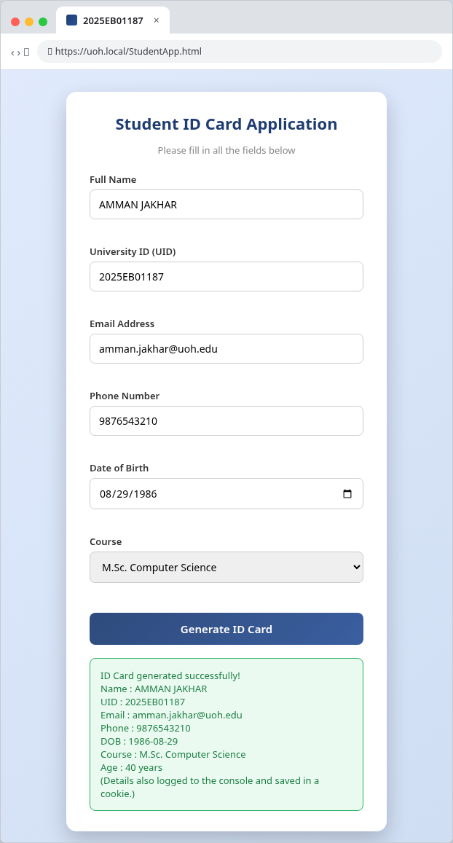
Figure 2 — The form right after a valid submission; the green banner is the success summary.

Output Screenshot — Console Log (Student object + cookie)
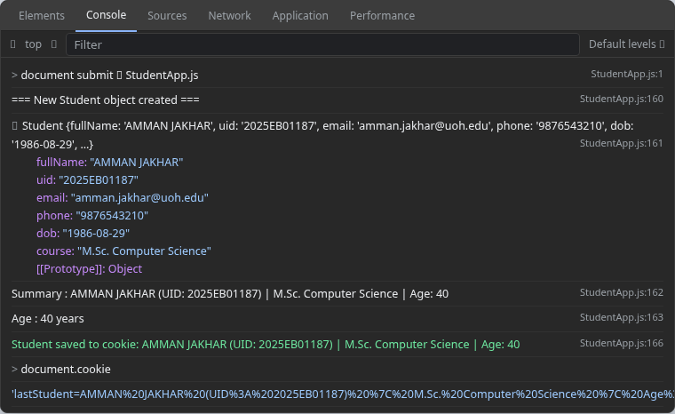
Figure 3 — The console: the Student object expanded, plus the lastStudent cookie read back with document.cookie.

Source — StudentApp.html
<!DOCTYPE html> <!-- standards-mode HTML5 -->
<!--
=====================================================================
QUESTION 2 - STUDENT ID CARD APPLICATION (the form page)
-----------------------------------------------------------------
Author : AMMAN JAKHAR | UID : 2025EB01187 | DOB : 29.08.1986
-----------------------------------------------------------------
This page is just the "shape" of the form. The marks for Q2 are in
the JavaScript, so I deliberately kept the styling short and inline
and moved ALL the behaviour (validation, the Student object, and
the cookie) into StudentApp.js. Each input has:
- a <label> (good for accessibility and for clicking),
- an id the JS can grab,
- an empty .error <div> the JS fills in if something is wrong.
=====================================================================
-->
<html lang="en">

<head>
<meta charset="UTF-8"> <!-- UTF-8 so names/symbols survive -->
<!-- responsive on phones; without this the form looks shrunk on mobile -->
<meta name="viewport" content="width=device-width, initial-scale=1.0">

<!-- Q2 rule again: the tab caption must be my UID -->
<title>2025EB01187</title>

<!-- CSS is inline on purpose: it is small and the JS file is the real deliverable -->
<style>
* { box-sizing: border-box; } /* count padding+border inside every width */

body { /* the page behind the form */
font-family: "Segoe UI", Tahoma, Arial, sans-serif; /* readable sans-serif ladder */
background: linear-gradient(135deg, #e0eafc 0%, #cfdef3 100%); /* same blue wash as Q1, for consistency */
margin: 0;
padding: 30px; /* keep the card off the window edges */
display: flex; /* flexbox just to... */
justify-content: center; /* ...centre the form horizontally */
}

.form-card { /* the white sheet the form sits on */
background: #ffffff;
width: 440px; /* narrow enough to read in one eye-line */
padding: 28px 32px;
border-radius: 14px; /* rounded, matching the Q1 card */
box-shadow: 0 12px 30px rgba(0, 0, 0, 0.2); /* float it above the page */
}

h1 { /* the form's title */
font-size: 22px;
color: #1e3c72; /* brand dark-blue */
margin: 0 0 4px 0;
text-align: center;
}

.subtitle { /* one grey helper line under the title */
text-align: center;
font-size: 13px;
color: #888;
margin-bottom: 22px; /* space before the first field */
}

.field { margin-bottom: 16px; } /* consistent gap between each field group */

label { /* the caption above each input */
display: block; /* force it onto its own line */
font-size: 13px;
font-weight: 600;
color: #333;
margin-bottom: 5px;
}

input, select { /* one shared style for every control */
width: 100%; /* fill the card's width */
padding: 10px 12px; /* comfortable to tap/type in */
font-size: 14px;
border: 1px solid #ccc; /* calm grey border at rest */
border-radius: 7px;
outline: none; /* I replace the default focus ring with my own colour */
transition: border-color 0.2s; /* animate the border when focus changes */
}

input:focus, select:focus { border-color: #2a5298; } /* blue edge tells you where the cursor is */

/* the JS adds .invalid to any control that fails its check */
input.invalid, select.invalid { border-color: #e74c3c; background: #fdf0ef; } /* red edge + pink tint = "fix me" */

.error { /* the little message that appears under a bad field */
color: #e74c3c; /* red = problem */
font-size: 12px;
min-height: 15px; /* reserve the row even when empty, so nothing jumps around */
margin-top: 4px;
}

button { /* the submit button */
width: 100%;
padding: 12px; /* big tap target */
margin-top: 6px;
font-size: 15px;
font-weight: 600;
color: #fff;
background: linear-gradient(135deg, #1e3c72 0%, #2a5298 100%); /* the brand gradient again */
border: none;
border-radius: 8px;
cursor: pointer; /* show a hand so it reads as clickable */
}

button:hover { opacity: 0.92; } /* a tiny dim on hover = "I'm interactive" */

.result { /* the green summary banner the JS reveals on success */
margin-top: 18px;
padding: 14px;
border-radius: 8px;
background: #eafaf1; /* pale green = success */
border: 1px solid #27ae60;
color: #1e7e44;
font-size: 13px;
display: none; /* hidden by default; JS flips this to block */
white-space: pre-line; /* so the "\n" line breaks I add in JS are honoured */
}
</style>
</head>

<body>

<div class="form-card"> <!-- the white panel -->
<h1>Student ID Card Application</h1> <!-- title -->
<p class="subtitle">Please fill in all the fields below</p> <!-- instruction -->

<!-- novalidate = switch OFF the browser's own popups so MY JavaScript is the only validator -->
<form id="studentForm" novalidate>

<!-- Field 1: Full Name -->
<div class="field">
<label for="fullName">Full Name</label> <!-- "for" links the label to the input id -->
<input type="text" id="fullName" placeholder="e.g. Amman Jakhar"> <!-- placeholder shows an example -->
<div class="error" id="err-fullName"></div> <!-- JS writes the error here, keyed by id -->
</div>

<!-- Field 2: University ID -->
<div class="field">
<label for="uid">University ID (UID)</label>
<input type="text" id="uid" placeholder="e.g. 2025EB01187">
<div class="error" id="err-uid"></div>
</div>

<!-- Field 3: Email -->
<div class="field">
<label for="email">Email Address</label>
<input type="text" id="email" placeholder="e.g. name@example.com">
<div class="error" id="err-email"></div>
</div>

<!-- Field 4: Phone -->
<div class="field">
<label for="phone">Phone Number</label>
<input type="text" id="phone" placeholder="10 digit mobile number">
<div class="error" id="err-phone"></div>
</div>

<!-- Field 5: Date of Birth (type=date gives a free calendar picker) -->
<div class="field">
<label for="dob">Date of Birth</label>
<input type="date" id="dob">
<div class="error" id="err-dob"></div>
</div>

<!-- Extra field: Course. It is a dropdown, and it is NOT one of the five graded validations. -->
<div class="field">
<label for="course">Course</label>
<select id="course">
<option value="">-- Select a course --</option> <!-- empty value = "nothing chosen yet" -->
<option value="M.Sc. Computer Science">M.Sc. Computer Science</option>
<option value="B.Tech. Mechanical">B.Tech. Mechanical</option>
<option value="MBA">MBA</option>
</select>
<div class="error" id="err-course"></div>
</div>

<button type="submit">Generate ID Card</button> <!-- type=submit is what fires the form's submit event -->
</form>

<!-- stays empty + hidden until a clean submission fills it in -->
<div class="result" id="result"></div>
</div>

<!-- the graded logic lives in this one external file -->
<script src="StudentApp.js"></script>
</body>
</html>

Source — StudentApp.js
/*
=====================================================================
QUESTION 2 - STUDENT ID CARD APPLICATION (the logic)
-----------------------------------------------------------------
Author : AMMAN JAKHAR | UID : 2025EB01187 | DOB : 29.08.1986
-----------------------------------------------------------------
This file carries the three things Q2 is marked on:
SECTION 1 five separate validation functions [5 marks]
SECTION 2 a Student class + an object I console.log [3 marks]
SECTION 3 cookie save + read helpers [2 marks]
SECTION 4 is the "glue": it waits for the page, listens for the
submit button, and calls the pieces above in order.

Design choice I made throughout: every validator RETURNS a string.
An empty string "" means "all good"; any other text is the exact
message to show the user. Returning instead of alert()-ing keeps
the checks pure and easy to reuse or test on their own.
=====================================================================
*/

"use strict"; // strict mode: turns silent mistakes into real errors early

/* ==================================================================
SECTION 1 : THE FIVE FIELD CHECKS [5 marks]
Each one takes the raw text from a field and hands back "" or a
message. I trim() first everywhere so stray spaces never pass by
accident (e.g. " " should still count as empty).
================================================================== */

// (1) Full name: letters and spaces only, and at least 3 characters.
function validateFullName(value) {
const name = value.trim(); // remove leading/trailing spaces first
if (name === "") { // guard the empty case before the regex
return "Full name is required.";
}
// ^...$ anchors the WHOLE string; [A-Za-z ] = letters or space; {3,} = three or more
if (!/^[A-Za-z ]{3,}$/.test(name)) {
return "Name must be at least 3 letters (alphabets and spaces only).";
}
return ""; // reached here => the name is fine
}

// (2) UID: the fixed shape 4 digits + 2 letters + 5 digits, e.g. 2025EB01187.
function validateUID(value) {
const uid = value.trim().toUpperCase(); // force caps so "eb" and "EB" are both accepted
if (uid === "") {
return "UID is required.";
}
// [0-9]{4} four digits, [A-Z]{2} two letters, [0-9]{5} five digits - nothing else allowed
if (!/^[0-9]{4}[A-Z]{2}[0-9]{5}$/.test(uid)) {
return "UID must look like 2025EB01187 (4 digits, 2 letters, 5 digits).";
}
return "";
}

// (3) Email: must have "something @ something . something" with no spaces.
function validateEmail(value) {
const email = value.trim();
if (email === "") {
return "Email is required.";
}
// [^\s@]+ = one-or-more chars that are NOT a space or @, repeated around an @ and a dot
if (!/^[^\s@]+@[^\s@]+\.[^\s@]+$/.test(email)) {
return "Please enter a valid email address.";
}
return "";
}

// (4) Phone: exactly ten digits - no +, no spaces, no dashes.
function validatePhone(value) {
const phone = value.trim();
if (phone === "") {
return "Phone number is required.";
}
if (!/^[0-9]{10}$/.test(phone)) { // {10} pins the length to ten, the ^$ forbid extras
return "Phone number must be exactly 10 digits.";
}
return "";
}

// (5) Date of birth: required, and it has to be a date that already happened.
function validateDOB(value) {
if (value === "") { // the date picker gives "" when untouched
return "Date of birth is required.";
}
const dob = new Date(value); // turn the "YYYY-MM-DD" string into a real Date
const today = new Date(); // "now", to compare against
if (dob >= today) { // being born today or in the future makes no sense
return "Date of birth must be in the past.";
}
return "";
}

/* Small UI helper (shared by all five checks above).
Given a field id and a message, it writes the message into that
field's .error box and toggles the red ".invalid" look on/off. */
function showError(fieldId, message) {
const input = document.getElementById(fieldId); // the input/select itself
const errorBox = document.getElementById("err-" + fieldId); // its matching error <div>
errorBox.textContent = message; // textContent (not innerHTML) = safe, no HTML injection
if (message === "") {
input.classList.remove("invalid"); // happy path: strip the red styling
} else {
input.classList.add("invalid"); // problem: paint it red
}
}

/* ==================================================================
SECTION 2 : THE STUDENT CLASS [3 marks]
A class is my blueprint; "new Student(...)" stamps out one object
from it. I gave it two methods so the object can describe itself.
================================================================== */

class Student {
// the constructor copies each argument onto the new object as a property
constructor(fullName, uid, email, phone, dob, course) {
this.fullName = fullName; // "this" = the specific object being built
this.uid = uid;
this.email = email;
this.phone = phone;
this.dob = dob; // kept as the raw "YYYY-MM-DD" string
this.course = course;
}

// method: turn the stored DOB into an age in whole years
getAge() {
const birth = new Date(this.dob); // parse the stored string
const now = new Date();
let age = now.getFullYear() - birth.getFullYear(); // first pass: just subtract the years
const monthDiff = now.getMonth() - birth.getMonth(); // how far we are into the year, by month
// if this year's birthday hasn't arrived yet, I counted one year too many, so take it back
if (monthDiff < 0 || (monthDiff === 0 && now.getDate() < birth.getDate())) {
age--;
}
return age;
}

// method: a compact one-liner about the student (I log and store this)
getSummary() {
// template literal (backticks) lets me drop values straight into the text with ${...}
return `${this.fullName} (UID: ${this.uid}) | ${this.course} | Age: ${this.getAge()}`;
}
}

/* ==================================================================
SECTION 3 : COOKIES [2 marks]
Two tiny helpers. setCookie writes one that expires in N days;
getCookie reads one back by name. I encode/decode the value so
spaces and symbols survive the trip (cookies dislike raw spaces).
================================================================== */

// write document.cookie = "name=value; expires=...; path=/"
function setCookie(name, value, days) {
const expires = new Date(); // start from now...
expires.setTime(expires.getTime() + days * 24 * 60 * 60 * 1000); // ...+ N days expressed in milliseconds
document.cookie = name + "=" + encodeURIComponent(value) + // encode makes the value cookie-safe
";expires=" + expires.toUTCString() + // the browser deletes it after this moment
";path=/"; // "/" = valid across the whole site
}

// read back a single cookie's value, or "" if that name isn't stored
function getCookie(name) {
const cookies = document.cookie.split(";"); // the whole cookie string -> ["a=1"," b=2", ...]
for (let i = 0; i < cookies.length; i++) {
const parts = cookies[i].trim().split("="); // trim the leading space, then split name from value
if (parts[0] === name) { // is this the cookie I asked for?
return decodeURIComponent(parts[1]); // undo the encoding from setCookie and return it
}
}
return ""; // fell through the loop => not found
}

/* ==================================================================
SECTION 4 : WIRING IT ALL TOGETHER
Nothing here runs until the HTML is parsed, so I wrap it in the
DOMContentLoaded event - otherwise getElementById could return
null because the form wouldn't exist yet.
================================================================== */

document.addEventListener("DOMContentLoaded", function () {

// On every load, peek at the cookie so a returning user is recognised.
const saved = getCookie("lastStudent");
if (saved !== "") { // only shout about it if there actually is one
console.log("Retrieved previously saved student from cookie: " + saved);
}

const form = document.getElementById("studentForm");

// the single event that drives the whole page: the form being submitted
form.addEventListener("submit", function (event) {
event.preventDefault(); // stop the browser's default "reload and clear" behaviour

// snapshot every field's current value
const fullName = document.getElementById("fullName").value;
const uid = document.getElementById("uid").value;
const email = document.getElementById("email").value;
const phone = document.getElementById("phone").value;
const dob = document.getElementById("dob").value;
const course = document.getElementById("course").value;

// run all checks once and keep each result under its field's name
const errors = {
fullName: validateFullName(fullName),
uid: validateUID(uid),
email: validateEmail(email),
phone: validatePhone(phone),
dob: validateDOB(dob),
// the dropdown isn't one of the five, but I still refuse an empty choice
course: course === "" ? "Please select a course." : ""
};

// paint every message (or clear it) and note if ANY field failed
let isValid = true; // optimistic until proven otherwise
for (const field in errors) { // loop the keys: fullName, uid, ...
showError(field, errors[field]); // reflect this field's result on screen
if (errors[field] !== "") { // a non-empty string means this field is bad
isValid = false;
}
}

// if anything was wrong, stop here - do NOT build an object from bad data
if (!isValid) {
console.log("Validation failed. Please correct the highlighted fields.");
return;
}

// ---- all clear: build the Student object from the clean inputs ----
const student = new Student(fullName, uid, email, phone, dob, course);

// show the object (and its derived info) in the browser console
console.log("=== New Student object created ===");
console.log(student); // logging the object itself lets me expand it in DevTools
console.log("Summary : " + student.getSummary());
console.log("Age : " + student.getAge() + " years");

// ---- remember this student for 7 days via a cookie ----
setCookie("lastStudent", student.getSummary(), 7);
console.log("Student saved to cookie: " + getCookie("lastStudent")); // read it straight back as proof

// ---- finally, reveal the green banner with a human-readable summary ----
const result = document.getElementById("result");
result.style.display = "block"; // flip it from hidden to visible
// each "\n" becomes a real line break because the CSS set white-space: pre-line
result.textContent =
"ID Card generated successfully!\n" +
"Name : " + student.fullName + "\n" +
"UID : " + student.uid + "\n" +
"Email : " + student.email + "\n" +
"Phone : " + student.phone + "\n" +
"DOB : " + student.dob + "\n" +
"Course : " + student.course + "\n" +
"Age : " + student.getAge() + " years\n" +
"(Details also logged to the console and saved in a cookie.)";
});
});

