Reframing Design Thinking for Business Strategy:
A Comparative Analysis

Chapter: Design Thinking and Other Approaches

Abstract
The contemporary business environment is characterised by unprecedented complexity, rapid technological change, and evolving stakeholder expectations. Traditional strategic frameworks, while providing essential analytical rigour, often fall short in addressing the multifaceted challenges that modern organisations face. This chapter presents a comprehensive comparative analysis of four foundational approaches to strategic decision-making: Analytical Decision-Making, Systems Thinking, Creative Thinking, and Design Thinking. By examining the theoretical underpinnings, methodological tools, and strategic applications of each approach, this chapter argues that Design Thinking serves as a powerful integrative framework capable of synthesising the strengths of analytical rigour, systemic awareness, and creative ideation into a cohesive, human-centred strategy. Drawing on real-world applications from product development, digital transformation, healthcare, entrepreneurship, and manufacturing, the analysis demonstrates how organisations that adopt an integrated framework achieve superior innovation outcomes, enhanced customer loyalty, and sustainable competitive advantage. The chapter further examines key challenges in implementation, including cultural resistance, scalability concerns, and process integration barriers, before concluding with future directions that emphasise the role of artificial intelligence, digital tools, and hybrid strategic frameworks in advancing integrated innovation methodologies.

Keywords: Design Thinking, Business Strategy, Systems Thinking, Analytical Decision-Making, Creative Thinking, Innovation, Human-Centred Design, Strategic Integration

1. The Landscape of Strategic Decision-Making

1.1 The Evolution of Business Strategy
The discipline of business strategy has undergone a profound transformation over the past five decades. The era of classical strategic planning, characterised by top-down, hierarchical models emphasising long-term forecasting and resource allocation, dominated corporate thinking from the 1960s through the 1980s [1]. Pioneering frameworks such as Porter's Five Forces and the BCG Growth-Share Matrix provided managers with structured tools for competitive analysis and portfolio management [2]. These models assumed a relatively stable and predictable business environment where past performance could reliably inform future direction.
However, the advent of globalisation, digital disruption, and the knowledge economy has fundamentally altered the strategic landscape. The concept of VUCA (Volatility, Uncertainty, Complexity, and Ambiguity), originally developed by the U.S. Army War College, has become a defining descriptor of the modern business environment [3]. In this context, organisations can no longer rely solely on historical data extrapolation or linear planning processes. The emergence of agile methodologies, lean startup principles, and innovation-driven models reflects a paradigm shift toward more adaptive, iterative, and human-centric approaches to strategy formulation [4].
The implications of this shift extend beyond methodology to encompass fundamental questions about the nature of strategic advantage in the twenty-first century. Where once competitive advantage could be sustained through superior resource positioning or cost leadership, contemporary markets increasingly reward organisations that demonstrate superior capability in understanding and responding to human needs. The proliferation of digital platforms, the democratisation of production technologies, and the increasing transparency of markets have collectively eroded traditional barriers to entry and shortened the lifespan of product-based advantages. In this environment, the capacity for continuous innovation — rooted in deep understanding of human experience — emerges as perhaps the most durable source of competitive differentiation available to modern organisations.
This evolution is not merely a theoretical exercise; it has tangible implications for organisational performance. Research indicates that companies embracing human-centred innovation practices outperform their peers by significant margins in revenue growth, shareholder returns, and market capitalisation [5]. The Design Management Institute's Design Value Index, for instance, demonstrated that design-led companies outperformed the S&P 500 by 219% over a ten-year period [6]. Such findings underscore the strategic imperative of integrating diverse thinking approaches into the fabric of organisational decision-making.
The shift from purely analytical frameworks to more holistic approaches also reflects a deeper epistemological change in how organisations conceptualise problems. Rather than viewing challenges as well-defined puzzles amenable to optimisation, progressive organisations increasingly recognise that their most pressing strategic issues are "wicked problems" — complex, interconnected, and resistant to straightforward solutions [7]. This recognition necessitates a multi-faceted strategic toolkit that combines the precision of analysis with the breadth of systemic understanding, the spark of creativity, and the empathy of human-centred design.
Moreover, the acceleration of technological change has compressed strategic planning horizons dramatically. Where five-year strategic plans were once standard practice, many organisations now operate on quarterly or even monthly planning cycles, recognising that the assumptions underlying longer-term plans become obsolete before they can be fully implemented. This temporal compression demands strategic approaches that enable rapid learning, flexible adaptation, and continuous recalibration — qualities that are inherent in the iterative, prototype-driven approaches discussed in this chapter. The organisations that successfully navigate this compressed timeline are those that have developed the capability to sense, interpret, and respond to environmental changes with speed and precision, drawing simultaneously on analytical insight, systemic understanding, creative imagination, and empathic connection with stakeholders.

1.2 Defining the Core Approaches
This chapter examines four distinct yet complementary approaches to strategic decision-making, each offering unique perspectives and methodological tools for navigating business complexity.
Analytical Decision-Making represents the most established tradition in strategic management. Rooted in the principles of rationality, evidence-based reasoning, and quantitative optimisation, this approach seeks to reduce uncertainty through systematic data collection, statistical analysis, and logical inference [8]. It provides the essential foundation of rigour and objectivity upon which sound strategic decisions are built.
Systems Thinking offers a holistic lens for understanding organisations as complex, dynamic entities embedded within broader environmental contexts. Drawing on cybernetics, general systems theory, and complexity science, this approach emphasises interconnectedness, feedback loops, emergence, and non-linear causality [9]. It enables strategists to see beyond immediate cause-and-effect relationships and understand the deeper structural forces shaping organisational behaviour.
The systems perspective is particularly valuable in an era of increasing organisational complexity, where decisions in one domain inevitably produce ripple effects across others. Supply chain disruptions, for instance, cannot be understood in isolation from geopolitical dynamics, environmental constraints, and technological dependencies. Similarly, human resource strategies interact with innovation capabilities, customer relationships, and financial performance in ways that linear analytical models often fail to capture. Systems thinking provides the conceptual vocabulary and analytical tools necessary to navigate this web of interdependencies.
Creative Thinking encompasses the cognitive processes and structured techniques that enable the generation of novel ideas, solutions, and perspectives. Grounded in research on divergent thinking, associative cognition, and cognitive flexibility, creative thinking provides the generative engine for innovation [10]. It enables organisations to break free from established mental models and explore previously unconsidered possibilities.
Design Thinking (DT) represents a human-centred, iterative, and empathetic problem-solving framework that has gained substantial traction in business contexts since its popularisation by IDEO and the Stanford d.school [11]. As illustrated in Figure 1, DT integrates elements of empathy, experimentation, and iteration into a cohesive methodology that bridges the gap between understanding user needs and delivering viable solutions.

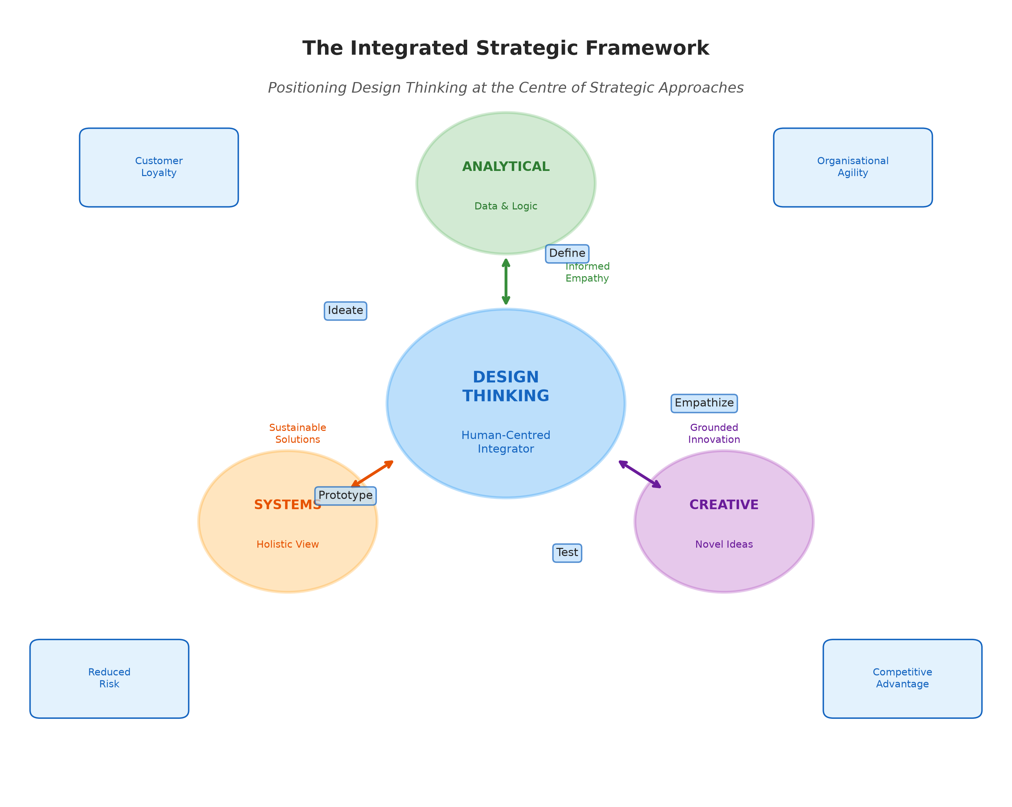
Figure 1: The Integrated Strategic Framework — Positioning Design Thinking at the Centre of Analytical, Systems, and Creative Approaches

1.3 The Need for Integration
While each of these approaches offers significant value individually, their true strategic power emerges through thoughtful integration. Analytical decision-making, when used in isolation, can lead to "analysis paralysis" and an overemphasis on quantifiable metrics at the expense of human insight and creative possibility [12]. Systems thinking, while providing valuable holistic understanding, may struggle to translate systemic insights into actionable solutions at the operational level [13]. Creative thinking, unbounded by constraints, can generate ideas that are brilliant in concept but impractical in implementation [14].
The limitations of siloed approaches are well documented in the strategic management literature. Mintzberg's critique of "the design school" of strategy formation highlighted how overly rational planning processes could disconnect strategy from the emergent, learning-based nature of organisational adaptation [15]. Similarly, Christensen's work on disruptive innovation demonstrated how established firms' reliance on analytical models optimised for current customers could blind them to transformative market shifts [16].
This chapter argues that Design Thinking, with its inherent emphasis on integration, iteration, and human-centredness, provides a natural framework for synthesising these complementary approaches. As demonstrated in Table 1, each approach contributes distinct strengths that, when combined through a DT-led integration, create a more robust and comprehensive strategic capability. The following sections will elaborate on this thesis through detailed examination of each approach and their synergistic potential.

Table 1: Comparative Overview of Four Strategic Approaches
Dimension | Analytical  Decision-Making | Systems  Thinking | Creative  Thinking | Design  Thinking
Core Focus | Data, logic,  optimisation | Interconnectedness,  feedback loops | Ideation, novelty,  divergent thinking | Human needs,  empathy, iteration
Primary Strength | Risk reduction,  evidence-based | Holistic understanding,  unintended consequences | Novel solutions,  breakthrough ideas | User-centred solutions,  rapid validation
Key Limitation | Analysis paralysis,  misses qualitative | Difficulty translating  to action | May lack feasibility  and grounding | Scalability,  cultural resistance
Strategic Role | Validation and  measurement | Contextual awareness  and sustainability | Innovation engine  and disruption | Integration and  human-centred strategy

2. A Deep Dive into Complementary Approaches

2.1 Analytical Decision-Making Models

2.1.1 Theory and Principles
Analytical decision-making has its intellectual roots in the Enlightenment tradition of rational inquiry, subsequently formalised through the development of operations research during World War II and the emergence of management science in the post-war era [17]. The foundational assumption is that optimal decisions can be derived through systematic application of logic, mathematics, and empirical evidence to well-defined problem spaces.
The theoretical framework rests on several key principles. First, the principle of bounded rationality, introduced by Herbert Simon, acknowledges that while decision-makers aspire to rational optimisation, cognitive limitations and information constraints mean that "satisficing" — finding a satisfactory rather than optimal solution — is often the practical reality [18]. Second, evidence-based management extends the principles of evidence-based medicine to organisational contexts, arguing that managerial decisions should be grounded in the best available empirical evidence rather than tradition, intuition, or anecdote [19].
The analytical tradition also encompasses Bayesian reasoning, which provides a formal framework for updating beliefs and predictions in light of new evidence [20]. This probabilistic approach to decision-making is particularly relevant in strategic contexts characterised by uncertainty, where managers must continuously revise their assumptions based on emerging market signals and competitive developments.
A further important principle is the distinction between programmed and non-programmed decisions. Programmed decisions are routine, repetitive, and amenable to standardised analytical procedures, while non-programmed decisions are novel, unstructured, and require judgment that extends beyond purely quantitative analysis. Strategic decisions, by their nature, tend toward the non-programmed end of this spectrum, suggesting that while analytical tools provide essential input, they cannot fully determine strategic choices without being complemented by other modes of thinking. This recognition of the inherent limitations of purely rational models has led to the development of behavioural decision theory, which integrates insights from psychology regarding cognitive biases, heuristics, and the affective dimensions of judgment into our understanding of how strategic decisions are actually made in practice.

2.1.2 Key Methodologies
The analytical toolkit available to strategic decision-makers is extensive and continually evolving. Traditional methods include cost-benefit analysis, which provides systematic comparison of the expected costs and benefits of alternative courses of action; SWOT analysis, which maps internal strengths and weaknesses against external opportunities and threats; and financial modelling, which projects future cash flows, returns, and risk profiles under various scenarios [21].
More contemporary analytical methods include predictive analytics, which leverages machine learning algorithms and large datasets to forecast future outcomes; decision tree analysis, which maps complex decision paths and their probabilistic outcomes; and Monte Carlo simulation, which models the impact of uncertainty by running thousands of randomised scenarios [22]. The emergence of big data and artificial intelligence has dramatically expanded the analytical capabilities available to organisations, enabling real-time analysis of customer behaviour, market trends, and operational performance at unprecedented scale and granularity [23].
As shown in Table 2, these methodologies can be categorised by their primary function, complexity level, and typical application context within strategic decision-making processes.

Table 2: Analytical Decision-Making Methodologies — Classification and Applications
Methodology | Primary Function | Complexity | Application Context
Cost-Benefit Analysis | Evaluation | Low-Medium | Project selection, investment decisions
SWOT Analysis | Assessment | Low | Strategic positioning, competitive analysis
Predictive Analytics | Forecasting | High | Market trends, customer behaviour
Decision Tree Analysis | Decision mapping | Medium | Complex decisions with multiple paths
Monte Carlo Simulation | Risk modelling | High | Financial planning, scenario analysis
Balanced Scorecard | Performance tracking | Medium | Strategy execution, KPI monitoring
Regression Analysis | Relationship modelling | Medium-High | Demand forecasting, causal analysis

2.1.3 Role in Strategy
Analytical decision-making plays an indispensable role in strategic management by providing the empirical foundation for informed action. It reduces decision risk by quantifying uncertainty, identifying patterns in historical data, and projecting likely outcomes of alternative strategies [24]. In capital-intensive industries such as aerospace, energy, and pharmaceuticals, where the cost of strategic error can be measured in billions, analytical rigour is not merely desirable but essential for organisational survival.
Furthermore, analytical approaches provide the metrics and measurement frameworks necessary for strategic accountability. Balanced scorecards, key performance indicators, and return-on-investment calculations enable organisations to track strategic progress, identify deviations from planned trajectories, and implement corrective actions [25]. Without this analytical infrastructure, strategic management becomes an exercise in wishful thinking rather than disciplined execution.
However, the limitations of purely analytical approaches become apparent when organisations face genuinely novel challenges — situations where historical data provides limited guidance, where the relevant variables are difficult to quantify, or where the problem itself is poorly defined. It is precisely in these contexts that the complementary perspectives of systems thinking, creative thinking, and design thinking become essential.
The growing recognition of these limitations has fuelled interest in what scholars term "decision quality" frameworks that acknowledge the multi-dimensional nature of good strategic decisions. A high-quality strategic decision requires not only analytical soundness but also creative framing of alternatives, systemic awareness of consequences, and alignment with the values and needs of key stakeholders. This multi-dimensional view of decision quality provides a natural bridge to the integrative framework advocated in this chapter, suggesting that the most effective strategic decisions emerge from processes that systematically engage multiple cognitive modes rather than privileging any single approach.

2.2 Systems Thinking

2.2.1 Theory and Principles
Systems thinking emerged from the interdisciplinary ferment of the mid-twentieth century, drawing on cybernetics, general systems theory, and the study of complex adaptive systems [26]. At its core, systems thinking is founded on the recognition that organisations are not collections of independent parts but rather integrated wholes whose behaviour emerges from the interactions and relationships among their constituent elements [27].
The key principles of systems thinking include interconnectedness — the recognition that all elements within a system are linked, often in non-obvious ways; feedback loops — both reinforcing (amplifying) and balancing (stabilising) loops that drive system behaviour; emergence — the appearance of properties and behaviours at the system level that cannot be predicted from the characteristics of individual components; and non-linearity — the recognition that small changes can sometimes produce disproportionately large effects, while large interventions may have surprisingly limited impact [28].
Peter Senge's influential work on the "learning organisation" brought systems thinking into mainstream management discourse, arguing that the inability to see systemic patterns is one of the primary barriers to organisational learning and adaptation [9]. Senge identified several "systems archetypes" — recurring patterns of behaviour such as "limits to growth," "shifting the burden," and "tragedy of the commons" — that help managers recognise familiar systemic dynamics in novel contexts.

2.2.2 Key Methodologies
The methodological toolkit of systems thinking includes several distinctive approaches. Causal loop diagrams provide visual representations of the feedback structures underlying system behaviour, enabling stakeholders to map the complex web of cause-and-effect relationships within and around an organisation [29]. Stock-and-flow models add quantitative rigour by modelling the accumulation and depletion of resources over time and the rates of change that govern system dynamics.
System dynamics modelling, pioneered by Jay Forrester at MIT, enables simulation of complex systems over extended time horizons, revealing counter-intuitive behaviours and unintended consequences that would be invisible to linear analytical approaches [30]. More recent developments include agent-based modelling, which simulates the behaviour of complex systems by modelling the decisions and interactions of individual agents, and network analysis, which maps and analyses the structure of relationships within and between organisations.
The concept of "leverage points" — places within a complex system where a small intervention can produce significant and lasting change — is particularly valuable for strategic decision-making [31]. Donella Meadows identified a hierarchy of leverage points ranging from relatively superficial interventions (such as adjusting numerical parameters) to profound systemic changes (such as shifting the goals or paradigms that govern system behaviour).

2.2.3 Role in Strategy
Systems thinking contributes to strategy by enabling leaders to understand the broader context within which their organisations operate and to anticipate the ripple effects of strategic decisions across multiple dimensions [32]. It guards against the common strategic pitfall of "fixing" one problem only to create or exacerbate others — a phenomenon known as "policy resistance" in systems dynamics literature.
In practice, systems thinking helps organisations identify root causes rather than symptoms, design strategies that account for delayed effects and unintended consequences, and recognise when short-term gains come at the expense of long-term systemic health [33]. For example, a systems perspective might reveal that aggressive cost-cutting, while improving short-term profitability, undermines employee morale, reduces innovation capacity, and ultimately erodes competitive position — a reinforcing loop that can lead to organisational decline.
The strategic value of systems thinking is particularly evident in contexts characterised by high complexity and stakeholder interdependence, such as sustainability initiatives, digital ecosystem strategies, and organisational transformation programmes [34]. In these contexts, the ability to see the "whole board" rather than isolated pieces provides a crucial strategic advantage, as illustrated in Figure 2.

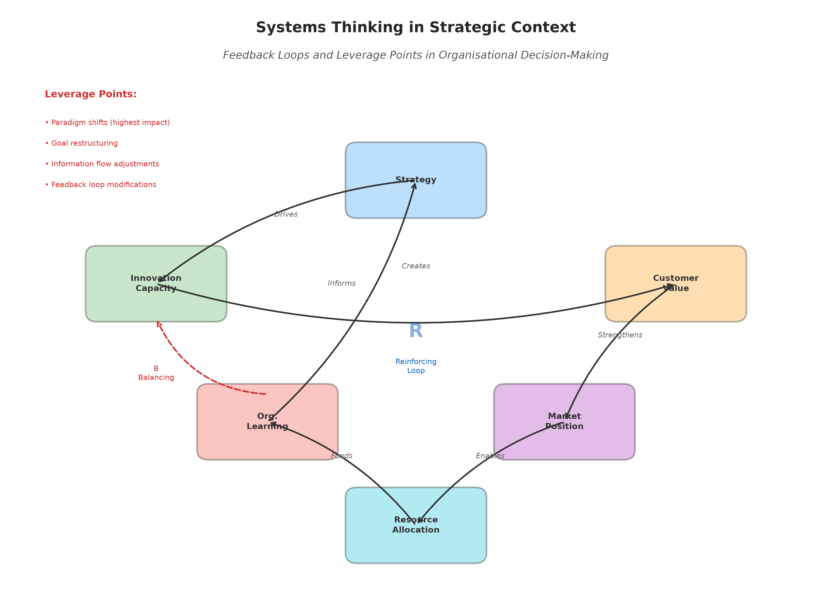
Figure 2: Systems Thinking in Strategic Context — Feedback Loops and Leverage Points in Organisational Decision-Making

2.3 Creative Thinking

2.3.1 Theory and Principles
Creative thinking as a field of study has its origins in Guilford's seminal 1950 address to the American Psychological Association, which called for systematic research into the nature of creative cognitive processes [35]. Since then, a rich body of research has illuminated the cognitive, social, and environmental factors that enable or inhibit creative ideation in organisational contexts.
The fundamental distinction between divergent thinking (the generation of multiple novel ideas) and convergent thinking (the evaluation and selection of the most promising ideas) provides the conceptual backbone of creative thinking methodology [10]. Effective creative processes require both modes — the uninhibited generation of possibilities followed by critical evaluation against relevant criteria — but these modes require different cognitive stances and environmental conditions.
Additional theoretical concepts include lateral thinking, introduced by Edward de Bono, which involves approaching problems from unconventional angles rather than following established logical sequences [36]; associative thinking, which generates novel ideas through unexpected combinations of previously unrelated concepts; and cognitive flexibility, the ability to shift between different mental frameworks and perspectives. Research on creative cognition has also highlighted the importance of incubation — the unconscious processing that occurs when attention is diverted from a problem — and the role of constraints in stimulating creative solutions [37].

2.3.2 Key Methodologies
The methodological landscape of creative thinking encompasses a diverse array of structured techniques designed to overcome cognitive fixedness and stimulate novel ideation. Classic brainstorming, as originally formulated by Alex Osborn, remains widely used despite ongoing debate about its effectiveness relative to individual ideation [38]. Contemporary variations include brainwriting, reverse brainstorming, and electronic brainstorming, each addressing specific limitations of the traditional approach.
Mind mapping provides a visual technique for exploring the associative connections between ideas, enabling non-linear exploration of problem spaces [39]. The SCAMPER technique (Substitute, Combine, Adapt, Modify, Put to other uses, Eliminate, Reverse) offers a structured framework for systematically transforming existing concepts into novel variations. Other notable methods include analogical reasoning, which draws insights from distant domains; morphological analysis, which systematically explores combinations of problem dimensions; and provocation techniques, which use deliberately unrealistic statements to trigger new thinking directions.
More recently, computational creativity tools powered by artificial intelligence have expanded the creative toolkit, enabling the generation of novel designs, texts, and solutions through generative adversarial networks, evolutionary algorithms, and large language models [40]. These tools represent a new frontier in creative thinking methodology, augmenting human creative capacity rather than replacing it.

2.3.3 Role in Strategy
Creative thinking serves as the generative engine of strategic innovation, enabling organisations to envision possibilities beyond the constraints of current assumptions and established practices [41]. In strategic contexts, creative thinking contributes at multiple levels: at the product level, it drives the development of novel offerings; at the business model level, it enables the reconceptualisation of value creation and capture mechanisms; and at the industry level, it can catalyse the emergence of entirely new market categories.
The strategic importance of creative thinking is amplified in hyper-competitive environments where sustainable advantage increasingly derives from the ability to innovate continuously rather than to exploit existing positions [42]. Research on ambidextrous organisations — those capable of simultaneously exploiting current capabilities while exploring new possibilities — highlights the critical role of creative thinking in maintaining the exploratory capacity essential for long-term organisational vitality.
The relationship between creative thinking and organisational culture deserves particular attention in strategic contexts. Organisations that systematically cultivate creative capabilities — through diverse hiring practices, cross-functional collaboration, dedicated innovation time, and tolerance of productive failure — develop what researchers term "creative capital" that compounds over time. This accumulated creative capacity becomes a strategic asset that enables rapid response to market disruptions and the identification of opportunities invisible to less creatively capable competitors. However, building and maintaining this creative capital requires sustained investment and leadership commitment, as creative capabilities are easily eroded by short-term efficiency pressures or risk-averse management practices.
However, creativity in isolation does not constitute strategy. Unbounded ideation without the discipline of analytical validation, systemic awareness, or user-centred grounding can produce solutions that are novel but impractical, exciting but unsustainable, or innovative but irrelevant to actual human needs. It is this recognition that motivates the integrative framework presented in the following section.

3. The Unifying Power of Design Thinking

3.1 The Human-Centred DT Process
Design Thinking, as a formalised methodology for innovation and problem-solving, has its roots in the design profession's long-standing practices of user research, iterative prototyping, and solution refinement [11]. However, its application has expanded far beyond traditional design contexts to encompass business strategy, organisational development, public policy, healthcare, and education [43]. The methodology's appeal lies in its ability to make the tacit practices of expert designers accessible and applicable to non-designers facing complex challenges.
The five-stage DT model — Empathize, Define, Ideate, Prototype, and Test — provides a structured yet flexible framework for navigating from problem understanding to solution implementation [6]. Each stage serves a distinct purpose while maintaining iterative connections to the others:
Empathize involves deep immersion in the experiences, perspectives, and needs of the people for whom solutions are being designed. This stage employs ethnographic methods, contextual inquiry, stakeholder interviews, and observational research to develop a rich, nuanced understanding of human needs that goes beyond surface-level preferences to uncover latent needs and unarticulated desires.
Define synthesises the insights gathered during empathy research into a clear, actionable problem statement — often expressed as a "How Might We" question that frames the challenge in a way that invites creative solutions while maintaining focus on genuine human needs.
Ideate is the generative phase where diverse teams produce a wide range of potential solutions without premature judgment. This stage deliberately leverages creative thinking techniques to maximise the breadth and novelty of ideas generated.
Prototype translates selected ideas into tangible, low-fidelity representations that can be experienced and evaluated. The emphasis is on rapid, inexpensive creation of "thinking tools" that externalise ideas and enable learning through making.
Test involves presenting prototypes to users and stakeholders, gathering feedback, and iterating based on what is learned. This stage closes the loop between solution development and user needs, ensuring that final solutions genuinely address the problems identified during the Empathize phase.
The iterative nature of this process is crucial — DT practitioners expect to cycle through these stages multiple times, with each iteration refining understanding and improving solutions. This tolerance for ambiguity and willingness to "fail forward" through rapid experimentation represents a fundamental departure from traditional linear planning approaches [4].
Importantly, the DT process is not merely a sequence of steps but an embodiment of a particular philosophical orientation toward problem-solving. It privileges action over deliberation, experimentation over prediction, collaboration over hierarchy, and learning over certainty. These values are not merely methodological preferences but reflect a fundamental reconceptualisation of how innovation happens in complex, uncertain environments. The DT practitioner accepts that perfect information is unavailable, that user needs are often tacit and evolving, and that the best path to a successful solution is not linear reasoning but iterative exploration. This orientation makes DT particularly well-suited to the VUCA environments that characterise contemporary business, where the ability to learn and adapt rapidly is often more valuable than the ability to plan comprehensively.

3.2 DT as a Synergistic Integrator
The central thesis of this chapter is that Design Thinking functions not merely as an alternative to analytical, systemic, and creative approaches but as a meta-framework capable of integrating their respective strengths into a cohesive strategic methodology. This integrative capacity arises from DT's fundamental characteristics: its iterative structure naturally accommodates different thinking modes at different stages; its human-centred focus provides a unifying criterion for evaluating diverse inputs; and its emphasis on prototyping and testing creates a pragmatic bridge between abstract thinking and concrete action.

3.2.1 DT + Analytical Decision-Making: Informed Empathy
The integration of analytical approaches with Design Thinking creates what might be termed "informed empathy" — a combination of quantitative rigour and qualitative depth that produces richer, more reliable insights than either approach alone [5]. Data analytics can identify patterns in user behaviour at scale, revealing needs and opportunities that qualitative research alone might miss. Simultaneously, empathic research provides the contextual understanding necessary to interpret data meaningfully and avoid the trap of mistaking correlation for causation.
In the Prototype and Test stages, analytical methods provide essential validation mechanisms. A/B testing, statistical significance analysis, and quantitative user metrics enable rigorous evaluation of solution effectiveness [22]. The analytical approach transforms the inherently subjective process of design evaluation into a more systematic and reliable assessment, while DT's emphasis on human outcomes ensures that the metrics chosen reflect genuine value creation rather than arbitrary quantification.
This synthesis is particularly powerful in contexts such as digital product development, where large-scale behavioural data can be combined with deep user research to create solutions that are both empirically validated and emotionally resonant. Companies like Netflix, Spotify, and Airbnb exemplify this integration, using sophisticated data analytics to inform and validate design decisions while maintaining a relentless focus on user experience [16].

3.2.2 DT + Systems Thinking: Sustainable Solutions
The integration of systems thinking with Design Thinking addresses one of the most common criticisms of DT — its potential to generate solutions that work at the individual user level but fail to account for broader organisational, environmental, or social contexts [13]. By incorporating systemic awareness into the DT process, practitioners can ensure that human-centred solutions are also systemically viable and sustainable.
This integration is particularly evident in the Define stage, where systems thinking helps frame problems within their broader context. Rather than defining a challenge narrowly in terms of individual user needs, a systems-informed DT approach considers how the problem is embedded within larger organisational processes, stakeholder networks, and environmental dynamics [27]. This broader framing leads to solutions that address root causes rather than symptoms and that anticipate potential unintended consequences.
Figure 3 illustrates how the integration of systems thinking and Design Thinking creates a multi-level framework for strategic innovation, connecting individual user needs with organisational capabilities and broader ecosystem dynamics.

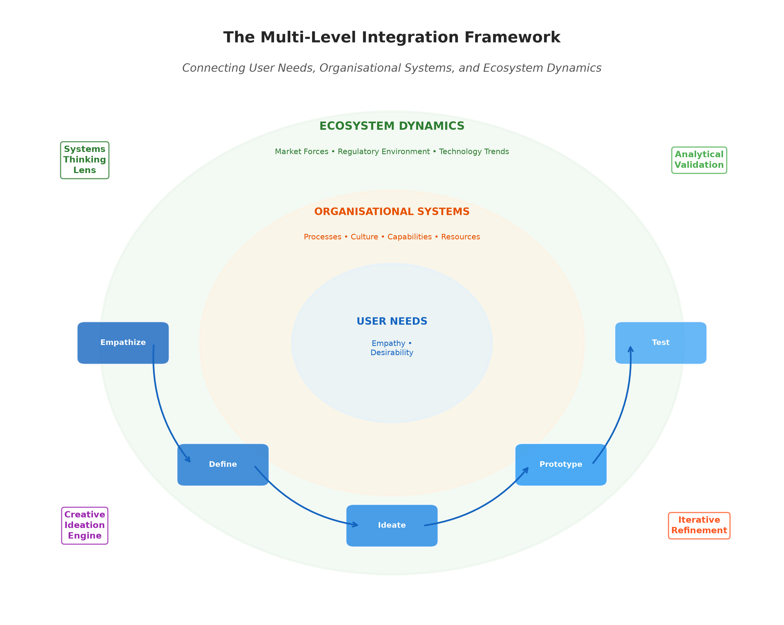
Figure 3: The Multi-Level Integration Framework — Connecting User Needs, Organisational Systems, and Ecosystem Dynamics through Design Thinking

In the Prototype and Test stages, systems thinking provides tools for evaluating whether proposed solutions will function effectively within the larger system. Causal loop diagrams can be used to model how a new product, service, or process will interact with existing organisational elements, identify potential resistance or unintended consequences, and design implementation strategies that account for systemic dynamics [29].

3.2.3 DT + Creative Thinking: Grounded Innovation
The relationship between Design Thinking and creative thinking is perhaps the most intuitive of the three integrations, as the Ideate stage of DT explicitly draws on creative thinking methodologies [38]. However, the integration is more nuanced than simple incorporation. DT provides creative thinking with something it often lacks when used in isolation: a clear set of human-centred constraints that channel creative energy toward genuinely valuable solutions rather than merely novel ones.
The DT framework grounds creativity in two critical ways. First, the insights generated during the Empathize and Define stages provide a rich understanding of user needs that serves as both inspiration and constraint for creative ideation [35]. Second, the Prototype and Test stages provide rapid feedback mechanisms that help creative teams distinguish between ideas that are merely novel and those that represent genuine innovation — defined as novelty combined with value.
This grounding effect addresses the common organisational frustration with creative processes that generate exciting ideas but fail to deliver practical results. By embedding creative thinking within the larger DT framework, organisations can harness the generative power of divergent thinking while maintaining the discipline necessary to translate creative possibilities into implemented innovations [41].
Table 3 presents a detailed mapping of how Design Thinking integrates with each complementary approach across the five stages of the DT process.

Table 3: Integration Matrix — How Design Thinking Synthesises Analytical, Systems, and Creative Approaches Across the Five DT Stages
DT Stage | Analytical  Contribution | Systems  Contribution | Creative  Contribution
Empathize | Quantitative user data,  behavioural analytics | Stakeholder mapping,  context analysis | Open observation,  assumption challenging
Define | Data-driven problem  scoping, metrics | Root cause analysis,  systemic framing | Reframing problems,  new perspectives
Ideate | Evidence-based  constraints | Ecosystem-aware  solution space | Divergent thinking,  novel combinations
Prototype | Testable hypotheses,  measurement criteria | System interaction  modelling | Rapid visualisation,  expressive forms
Test | Statistical validation,  A/B testing | Impact assessment,  feedback analysis | Iterative refinement,  alternative exploration

3.3 The Strategic Outcomes of DT
The strategic outcomes of implementing an integrated DT approach extend across multiple dimensions of organisational performance. Research consistently demonstrates positive associations between DT adoption and innovation outcomes, including increased patent activity, accelerated time-to-market, higher new product success rates, and greater customer satisfaction [5, 6].
Enhanced Customer Loyalty and Experience: By grounding strategic decisions in deep empathic understanding of customer needs, organisations create offerings that resonate at both functional and emotional levels. This emotional connection translates into stronger brand loyalty, higher customer lifetime value, and more positive word-of-mouth [43]. The iterative testing inherent in DT ensures that solutions are continuously refined based on actual user feedback rather than internal assumptions.
The depth of customer understanding enabled by DT-integrated approaches extends beyond traditional market research to encompass the full spectrum of human experience — emotional, social, cultural, and contextual dimensions that quantitative surveys alone cannot capture. This rich understanding enables organisations to create not merely functional solutions but meaningful experiences that build deep emotional bonds with customers. In an era where products are increasingly commoditised, this experiential differentiation represents one of the most powerful and sustainable sources of competitive advantage available.
Increased Organisational Agility: The iterative, experimental nature of DT cultivates organisational capabilities — such as comfort with ambiguity, rapid prototyping, and learning from failure — that are essential for agility in volatile environments [4]. Organisations that internalise DT principles develop a "muscle" for rapid adaptation that serves them well beyond individual innovation projects.
Reduced Risk Through Rapid Prototyping: Traditional approaches to strategy often involve large upfront investments in untested assumptions. DT's emphasis on low-fidelity prototyping and early user testing enables organisations to validate strategic hypotheses at minimal cost, reducing the risk of expensive failures and enabling more efficient resource allocation [11].
Sustainable Competitive Advantage Through Innovation: Perhaps most significantly, the integrated DT approach creates a renewable source of competitive advantage. While individual products or services can be imitated, the organisational capability for continuous, human-centred innovation is far more difficult for competitors to replicate [42]. This capability advantage is particularly valuable in knowledge-intensive industries where the pace of change renders product-based advantages increasingly transient.

4. Practice, Challenges, and Future Opportunities

4.1 Applications and Industry Examples
The practical application of the integrated DT framework spans diverse industries and organisational contexts, demonstrating its versatility and adaptability as a strategic methodology.
Product Development: In the consumer technology sector, companies such as Apple, Samsung, and Dyson have demonstrated the power of combining deep user empathy with analytical market research, systemic understanding of technology ecosystems, and creative design excellence [6]. Apple's product development process exemplifies the integration thesis, combining ethnographic user research, rigorous engineering analysis, awareness of ecosystem dynamics, and creative industrial design into a cohesive innovation methodology that has produced some of the most successful products in commercial history.
Digital Transformation: Organisations undertaking digital transformation initiatives have increasingly adopted DT as a guiding methodology for navigating the complex interplay of technology, process, and human factors [23]. IBM's Enterprise Design Thinking framework, for example, explicitly integrates user research, systemic process analysis, and creative ideation to guide the design of digital products and services at enterprise scale. The framework's emphasis on "Hills" (desired user outcomes), "Sponsor Users" (real people whose needs guide design), and "Playbacks" (iterative feedback sessions) demonstrates the practical application of DT principles in complex organisational contexts.
Healthcare: The healthcare sector presents particularly compelling examples of integrated DT application, given its combination of complex systemic challenges, critical human needs, and strict regulatory requirements [7]. The Mayo Clinic's Center for Innovation has pioneered the application of DT to healthcare delivery, using patient journey mapping, rapid prototyping of care processes, and systemic analysis of clinical workflows to develop innovations that improve both patient experience and clinical outcomes.
Entrepreneurship: The lean startup methodology, which has become the dominant framework for technology entrepreneurship, shares significant conceptual overlap with DT [4]. Both emphasise iterative development, early user feedback, and willingness to pivot based on learning. Successful startups such as Airbnb, which famously used DT techniques including immersive user research and rapid prototyping to transform its business model, demonstrate the strategic power of human-centred approaches in entrepreneurial contexts.
The entrepreneurial application of integrated DT is particularly instructive because it demonstrates the framework's value under conditions of extreme uncertainty and resource constraint. Entrepreneurs cannot afford the luxury of extensive analytical studies or comprehensive systemic modelling before acting; they must learn by doing, iterating rapidly based on market feedback. DT provides a structured yet lightweight framework for this rapid learning, enabling entrepreneurs to validate assumptions about customer needs through low-cost experiments rather than expensive product launches. The integration of analytical thinking (in the form of metrics-driven validation), systems thinking (in the form of business model canvas analysis), and creative thinking (in the form of rapid ideation and pivoting) within the DT framework creates a comprehensive yet agile approach to entrepreneurial strategy that has proven remarkably effective in practice.
Manufacturing: In manufacturing contexts, the integration of DT with systems thinking and analytical methods has driven advances in areas such as lean production, smart factory design, and sustainable manufacturing [34]. Toyota's production system, often cited as a pinnacle of manufacturing excellence, demonstrates many of the integrative principles discussed in this chapter — combining rigorous analytical methods (statistical process control), systemic thinking (value stream mapping), creative problem-solving (kaizen), and human-centred design (respect for people) into a cohesive operational philosophy.
Figure 4 provides a comparative visualisation of DT application outcomes across these five industry sectors, highlighting the common patterns of improvement in innovation metrics, customer satisfaction, and operational efficiency.

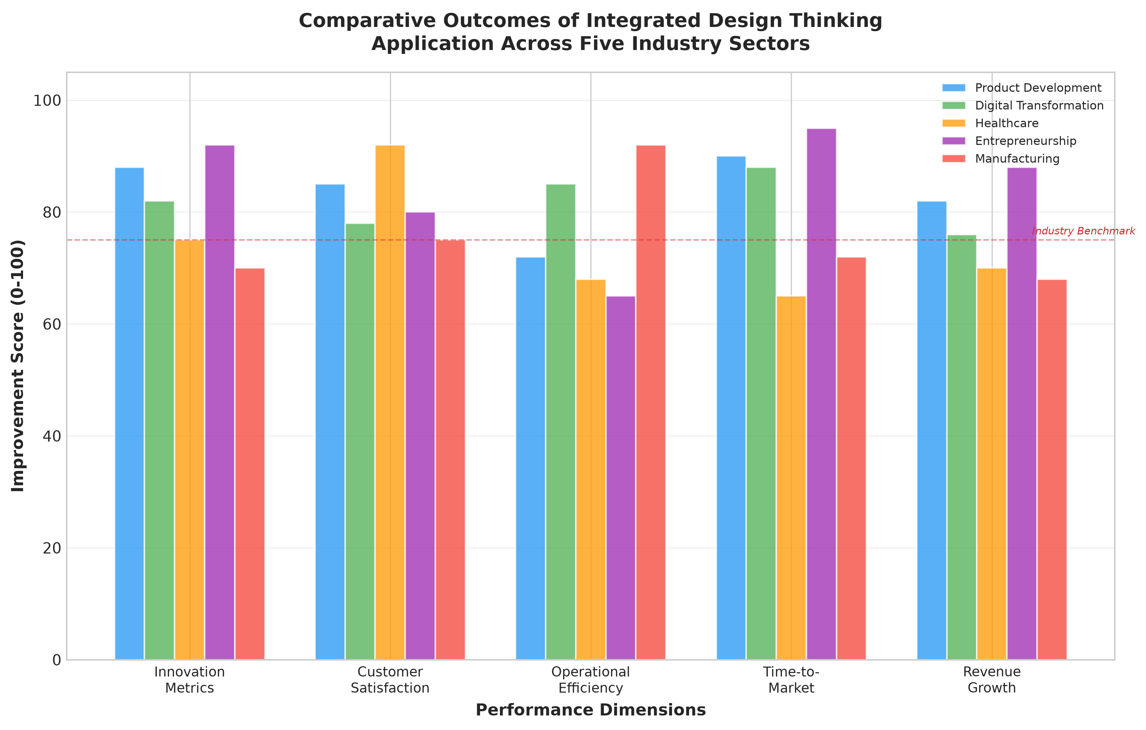
Figure 4: Comparative Outcomes of Integrated Design Thinking Application Across Five Industry Sectors

4.2 Key Challenges and Barriers
Despite the compelling case for integrated DT approaches, significant challenges remain in their effective implementation within established organisations.

4.2.1 Cultural and Leadership Challenges
The adoption of DT requires fundamental shifts in organisational culture that often encounter significant resistance. Traditional corporate cultures that prize certainty, efficiency, and predictability may find the ambiguity, iteration, and experimentation inherent in DT uncomfortable or even threatening [15]. Leaders accustomed to "command and control" management styles must develop new capabilities in facilitation, empowerment, and comfort with uncertainty.
Psychological safety — the shared belief that team members will not be punished for taking interpersonal risks — has been identified as a critical enabler of DT implementation [12]. Without psychological safety, the vulnerability required for genuine empathy, the risk-taking necessary for creative ideation, and the honesty essential for constructive testing feedback are all inhibited. Creating and maintaining psychological safety requires sustained leadership commitment and often represents a multi-year cultural transformation rather than a quick programmatic fix.
The "innovation theatre" phenomenon, where organisations adopt the superficial trappings of DT (sticky notes, workshops, design sprints) without the deeper cultural and structural changes necessary for genuine impact, represents a significant barrier to realising DT's strategic potential [14]. Effective DT implementation requires not just methodological training but fundamental shifts in how organisations define success, allocate resources, tolerate failure, and reward learning.

4.2.2 Process and Practice Challenges
At the operational level, several challenges complicate the integration of DT with existing organisational processes. The tension between the open-ended, exploratory nature of DT and the structured, milestone-driven requirements of traditional project management creates friction in many organisational contexts [25]. Finding the appropriate balance between creative freedom and operational discipline remains an ongoing challenge for DT practitioners.
Scalability represents another significant concern. While DT has demonstrated effectiveness at the project and team levels, scaling its principles across large, complex organisations presents substantial challenges [43]. Questions of governance, resource allocation, cross-functional coordination, and quality assurance become increasingly complex as DT initiatives expand beyond pilot projects to enterprise-wide transformation programmes.
The integration challenge itself — combining analytical, systemic, creative, and design thinking in practice — requires individuals and teams with broad cognitive repertoires and the ability to shift fluidly between different thinking modes [32]. Such "T-shaped" professionals — combining deep expertise in one domain with broad capability across multiple domains — remain relatively rare, creating talent constraints for organisations seeking to implement fully integrated approaches.
Table 4 summarises the key challenges and barriers to integrated DT implementation, categorised by domain, along with recommended mitigation strategies drawn from successful implementation cases.

Table 4: Key Challenges in Integrated Design Thinking Implementation and Mitigation Strategies
Challenge Domain | Specific Barrier | Impact Level | Mitigation Strategy
Cultural | Resistance to ambiguity  and experimentation | High | Leadership modelling, safe-to-fail  experiments, incremental adoption
Leadership | Command-and-control  mindset | High | Executive coaching, DT immersion  programmes, visible sponsorship
Process | Tension with existing  project management | Medium | Hybrid governance frameworks,  adaptive milestone structures
Scalability | Difficulty expanding  beyond pilot projects | Medium-High | Centres of excellence, DT  champion networks, toolkits
Talent | Shortage of T-shaped  professionals | Medium | Cross-functional rotations,  interdisciplinary education
Measurement | Difficulty quantifying  DT impact | Medium | Leading indicators, innovation  accounting, portfolio metrics

4.3 Future Directions and Hybrid Frameworks

4.3.1 The Role of Technology
The accelerating development of digital technologies, particularly artificial intelligence, is creating new possibilities for strengthening and extending integrated innovation frameworks [40]. AI-powered analytics can process vast quantities of user data to identify needs and patterns at scales impossible for human researchers alone, augmenting the Empathize stage of DT with quantitative breadth while human researchers provide qualitative depth.
Generative AI tools are beginning to augment the Ideate stage by producing diverse concept variations based on specified constraints, enabling design teams to explore solution spaces more rapidly and comprehensively than manual ideation alone allows [22]. Virtual and augmented reality technologies are transforming the Prototype and Test stages by enabling the creation of immersive, interactive prototypes that can be experienced and evaluated by users before physical production.
Digital twin technology, which creates virtual replicas of physical systems, represents a particularly promising integration point between systems thinking and DT [30]. Digital twins enable the simulation of how proposed design solutions will interact with complex organisational or physical systems, providing systemic validation before implementation and enabling rapid iteration on system-level design decisions.
Furthermore, the emergence of collaborative platforms that integrate user research tools, data analytics, systems modelling, creative ideation support, and prototyping capabilities into unified digital environments is reducing the practical barriers to integrated approaches [23]. These platforms enable cross-functional teams to move fluidly between analytical, systemic, creative, and design thinking modes within a shared digital workspace, supporting the kind of integrated practice that this chapter advocates.
The convergence of these technologies with integrated innovation methodologies represents more than incremental improvement — it has the potential to fundamentally transform how organisations approach strategic innovation. Real-time data streams can feed directly into empathy research, enabling continuous monitoring of user needs and behaviours. Machine learning algorithms can identify patterns across vast solution spaces, augmenting human creative capacity. Network simulation tools can model the systemic implications of proposed interventions before they are implemented. And collaborative digital environments can enable geographically distributed teams to engage in rich, multi-modal innovation processes that were previously possible only through co-located interaction. Together, these technological developments promise to make integrated innovation more accessible, more rigorous, and more effective than ever before.

4.3.2 Research Agenda
The academic and practitioner communities face several important research challenges in advancing the theory and practice of integrated strategic innovation. First, there is a need for more rigorous empirical research on the effectiveness of integrated approaches relative to single-methodology implementations [19]. While case studies and design-led performance indices provide suggestive evidence, controlled studies that isolate the contribution of integration are rare and methodologically challenging.
Second, the development of formal frameworks for "strategic integration intelligence" — the organisational capability to determine which combination of approaches is most appropriate for a given strategic challenge — represents a significant research opportunity [8]. Such frameworks would help organisations move beyond generic prescriptions to context-sensitive application of integrated methods.
Third, research on the cognitive and team-level processes that enable effective integration is needed to inform education and professional development programmes [37]. Understanding how individuals develop the cognitive flexibility to move between analytical, systemic, creative, and empathic thinking modes — and how teams coordinate these different modes effectively — would provide crucial foundations for scaling integrated approaches.
Fourth, the intersection of AI and integrated innovation methodologies presents a rich research frontier [40]. Questions include how AI tools can best augment human capabilities at each stage of the integrated process, what risks are associated with AI-mediated design decisions, and how the balance between human judgment and algorithmic recommendation should be calibrated in different contexts.
Finally, as the reference to Figure 1 earlier indicated, the theoretical model positioning DT as a central integrating framework requires ongoing refinement and validation across diverse organisational and cultural contexts. The framework presented in this chapter draws primarily on Western organisational contexts, and further research is needed to understand how cultural factors influence the effectiveness and appropriate adaptation of integrated approaches in different global settings [3].

5. Conclusion
This chapter has presented a comprehensive comparative analysis of four foundational approaches to strategic decision-making — Analytical Decision-Making, Systems Thinking, Creative Thinking, and Design Thinking — and argued for their thoughtful integration under the unifying umbrella of Design Thinking. The analysis has demonstrated that while each approach offers distinct and valuable contributions to strategic capability, their true power emerges through synergistic combination.
Design Thinking's unique characteristics — its human-centred orientation, iterative structure, emphasis on tangible prototyping, and inherent tolerance for ambiguity — position it as an effective meta-framework for integration. When combined with the empirical rigour of analytical approaches, the holistic perspective of systems thinking, and the generative power of creative thinking, DT enables organisations to develop strategies that are simultaneously desirable (meeting genuine human needs), viable (sustainable within systemic constraints), and feasible (technically and operationally achievable).
The tripartite criterion of desirability, viability, and feasibility — long recognised in design discourse — provides a particularly useful lens for understanding the integrative value of DT. Desirability is ensured through the empathic, human-centred orientation of DT itself. Viability is supported through the integration of systems thinking, which ensures that solutions are sustainable within broader organisational and environmental contexts. Feasibility is validated through the integration of analytical approaches, which provide rigorous assessment of technical and operational constraints. And the creative thinking dimension ensures that the solution space explored is sufficiently broad and novel to yield genuinely innovative outcomes rather than incremental improvements to existing offerings. This comprehensive coverage of the innovation value space represents one of the most compelling arguments for the integrated framework advocated in this chapter.
The practical applications reviewed across product development, digital transformation, healthcare, entrepreneurship, and manufacturing demonstrate both the versatility and the effectiveness of integrated approaches. However, significant challenges remain, particularly in the areas of cultural transformation, scalability, and talent development. As referenced in Figure 4, the outcomes across industries consistently show positive returns when integration is effectively achieved.
Looking forward, the convergence of advanced digital technologies, artificial intelligence, and evolving organisational models creates unprecedented opportunities for strengthening and extending integrated innovation frameworks. The organisations that will thrive in an increasingly complex and uncertain future will be those that develop robust capabilities across all four approaches and, crucially, the integration intelligence to combine them effectively in response to specific strategic challenges.
The vision this chapter advances is ultimately one of strategic pluralism — not the dominance of any single approach, but the mature, context-sensitive integration of multiple perspectives in service of creating value for people, organisations, and society. Design Thinking, with its deeply humanistic orientation and inherent integrative capacity, provides both the philosophical foundation and the practical methodology for realising this vision.
As organisations continue to grapple with increasing complexity, accelerating change, and rising stakeholder expectations, the ability to draw upon multiple strategic thinking approaches — and to integrate them effectively — will become an increasingly critical organisational capability. The framework presented in this chapter provides a conceptual and practical foundation for developing this capability, offering both the theoretical justification for integration and the methodological guidance for its implementation. The challenge for practitioners and scholars alike is to continue refining, testing, and extending this framework in response to the ever-evolving demands of the business environment, ensuring that our strategic thinking keeps pace with the complexity of the challenges we seek to address.

References
[1] Ansoff, H.I. (1965). Corporate Strategy: An Analytical Approach to Business Policy for Growth and Expansion. McGraw-Hill, New York.
[2] Porter, M.E. (1985). Competitive Advantage: Creating and Sustaining Superior Performance. Free Press, New York.
[3] Bennett, N. and Lemoine, G.J. (2014). What a difference a word makes: Understanding threats to performance in a VUCA world. Business Horizons, 57(3), pp.311-317.
[4] Ries, E. (2011). The Lean Startup: How Today's Entrepreneurs Use Continuous Innovation to Create Radically Successful Businesses. Crown Business, New York.
[5] Liedtka, J. (2018). Why Design Thinking Works. Harvard Business Review, 96(5), pp.72-79.
[6] Brown, T. (2009). Change by Design: How Design Thinking Transforms Organizations and Inspires Innovation. HarperBusiness, New York.
[7] Buchanan, R. (1992). Wicked Problems in Design Thinking. Design Issues, 8(2), pp.5-21.
[8] Davenport, T.H. (2009). Make Better Decisions. Harvard Business Review, 87(11), pp.117-123.
[9] Senge, P.M. (1990). The Fifth Discipline: The Art and Practice of the Learning Organization. Doubleday, New York.
[10] Guilford, J.P. (1967). The Nature of Human Intelligence. McGraw-Hill, New York.
[11] Kelley, T. and Kelley, D. (2013). Creative Confidence: Unleashing the Creative Potential Within Us All. Crown Business, New York.
[12] Edmondson, A.C. (2019). The Fearless Organization: Creating Psychological Safety in the Workplace. Wiley, New York.
[13] Meadows, D.H. (2008). Thinking in Systems: A Primer. Chelsea Green Publishing, Vermont.
[14] Verganti, R. (2009). Design Driven Innovation: Changing the Rules of Competition by Radically Innovating What Things Mean. Harvard Business Press, Boston.
[15] Mintzberg, H. (1994). The Rise and Fall of Strategic Planning. Free Press, New York.
[16] Christensen, C.M. (1997). The Innovator's Dilemma: When New Technologies Cause Great Firms to Fail. Harvard Business School Press, Boston.
[17] Simon, H.A. (1960). The New Science of Management Decision. Harper & Row, New York.
[18] Simon, H.A. (1997). Administrative Behavior: A Study of Decision-Making Processes in Administrative Organizations. 4th ed. Free Press, New York.
[19] Pfeffer, J. and Sutton, R.I. (2006). Hard Facts, Dangerous Half-Truths, and Total Nonsense: Profiting from Evidence-Based Management. Harvard Business School Press, Boston.
[20] Kahneman, D. (2011). Thinking, Fast and Slow. Farrar, Straus and Giroux, New York.
[21] Grant, R.M. (2016). Contemporary Strategy Analysis. 9th ed. Wiley, Chichester.
[22] Provost, F. and Fawcett, T. (2013). Data Science for Business. O'Reilly Media, Sebastopol.
[23] McAfee, A. and Brynjolfsson, E. (2017). Machine, Platform, Crowd: Harnessing Our Digital Future. W.W. Norton, New York.
[24] Bazerman, M.H. and Moore, D.A. (2013). Judgment in Managerial Decision Making. 8th ed. Wiley, New York.
[25] Kaplan, R.S. and Norton, D.P. (1996). The Balanced Scorecard: Translating Strategy into Action. Harvard Business School Press, Boston.
[26] von Bertalanffy, L. (1968). General System Theory: Foundations, Development, Applications. George Braziller, New York.
[27] Ackoff, R.L. (1981). Creating the Corporate Future: Plan or Be Planned For. Wiley, New York.
[28] Sterman, J.D. (2000). Business Dynamics: Systems Thinking and Modeling for a Complex World. McGraw-Hill, Boston.
[29] Kim, D.H. (1999). Introduction to Systems Thinking. Pegasus Communications, Waltham.
[30] Forrester, J.W. (1961). Industrial Dynamics. MIT Press, Cambridge.
[31] Meadows, D.H. (1999). Leverage Points: Places to Intervene in a System. The Sustainability Institute, Hartland.
[32] Jackson, M.C. (2003). Systems Thinking: Creative Holism for Managers. Wiley, Chichester.
[33] Gharajedaghi, J. (2011). Systems Thinking: Managing Chaos and Complexity. 3rd ed. Morgan Kaufmann, Burlington.
[34] Geissdoerfer, M., Savaget, P. and Evans, S. (2017). The Cambridge Business Model Innovation Process. Procedia Manufacturing, 8, pp.262-269.
[35] Guilford, J.P. (1950). Creativity. American Psychologist, 5(9), pp.444-454.
[36] De Bono, E. (1970). Lateral Thinking: Creativity Step by Step. Harper & Row, New York.
[37] Amabile, T.M. (1996). Creativity in Context: Update to the Social Psychology of Creativity. Westview Press, Boulder.
[38] Osborn, A.F. (1963). Applied Imagination: Principles and Procedures of Creative Problem-Solving. 3rd ed. Scribner's, New York.
[39] Buzan, T. and Buzan, B. (1993). The Mind Map Book. BBC Books, London.
[40] Colton, S. and Wiggins, G.A. (2012). Computational Creativity: The Final Frontier? Proceedings of the 20th European Conference on Artificial Intelligence, pp.21-26.
[41] Robinson, K. (2011). Out of Our Minds: Learning to be Creative. Capstone, Chichester.
[42] Teece, D.J. (2010). Business Models, Business Strategy and Innovation. Long Range Planning, 43(2-3), pp.172-194.
[43] Kolko, J. (2015). Design Thinking Comes of Age. Harvard Business Review, 93(9), pp.66-71.

