Chapter 3

Comparative and Structural Bioinformatics of Enzymes

Abstract
Enzymes represent critical molecular targets in drug discovery, and understanding their structural and functional properties through computational approaches has become indispensable in modern pharmaceutical research. This chapter presents a comprehensive overview of comparative and structural bioinformatics methodologies applied to enzyme characterization and drug target identification. Beginning with sequence retrieval, curation, and multiple sequence alignment strategies, the chapter progresses through phylogenetic analysis, conserved motif identification, and catalytic residue mapping. Structural bioinformatics approaches including homology modelling, structural alignment, active-site architecture elucidation, and druggability analysis are discussed in detail. The integrative analysis of enzyme-ligand interactions through binding-site prediction, molecular docking, interaction profiling, and molecular dynamics simulations is presented as a bridge between computational prediction and experimental validation. Finally, bioinformatics-guided strategies for selective drug target identification, structure-based and ligand-based lead optimization, and the integration of computational findings with experimental drug discovery pipelines are explored. The methodologies described herein provide a systematic framework for leveraging bioinformatics tools in enzyme-targeted therapeutic development, demonstrating how comparative sequence analysis, three-dimensional structural characterization, and computational chemistry converge to accelerate the identification and optimization of enzyme-targeted therapeutics across diverse disease areas.
Keywords: Comparative bioinformatics, structural bioinformatics, enzyme targets, homology modelling, molecular docking, drug discovery, phylogenetics, active-site analysis, molecular dynamics, virtual screening, druggability, lead optimization

3.1 Comparative Bioinformatics Approaches for Enzyme Characterization
Comparative bioinformatics has emerged as a cornerstone methodology in enzyme research, enabling researchers to decipher evolutionary relationships, identify conserved functional elements, and characterize catalytic mechanisms across diverse enzyme families [1]. The exponential growth of biological sequence databases, coupled with advances in computational algorithms, has transformed our ability to analyze enzyme sequences at an unprecedented scale [2]. Modern comparative approaches integrate sequence analysis, phylogenetic reconstruction, and motif discovery to provide comprehensive insights into enzyme function, substrate specificity, and evolutionary adaptation [3]. These computational strategies not only complement experimental biochemistry but increasingly guide hypothesis generation and experimental design in enzyme-targeted drug discovery programs [4]. The systematic application of comparative bioinformatics to enzyme characterization follows a logical progression from sequence acquisition through functional annotation, as illustrated in Figure 1, which presents the integrated workflow for comparative bioinformatics analysis of enzyme targets. The comparative approach is particularly powerful when applied across species boundaries, revealing enzyme features that are universally conserved versus those that exhibit lineage-specific adaptations amenable to selective therapeutic targeting.

3.1.1 Sequence Retrieval, Curation, and Multiple Sequence Alignment
The foundation of any comparative bioinformatics study lies in the rigorous retrieval and curation of enzyme sequences from public repositories. The National Center for Biotechnology Information (NCBI) protein database, UniProtKB/Swiss-Prot, and specialized enzyme databases such as BRENDA and CAZy serve as primary sources for enzyme sequence data [5]. The selection of appropriate query sequences and the implementation of sensitive search strategies using BLAST, PSI-BLAST, and HMMER algorithms are critical for assembling comprehensive sequence datasets that capture the full diversity of an enzyme family [6]. Sequence curation involves the removal of redundant entries, correction of annotation errors, filtering of fragmentary sequences, and validation against experimentally characterized orthologs and paralogs. The importance of thorough curation cannot be overstated, as errors propagated through comparative analyses can lead to incorrect functional annotations and misleading evolutionary conclusions that ultimately compromise drug target identification efforts.
Multiple sequence alignment (MSA) constitutes the analytical cornerstone upon which subsequent comparative analyses are built. Progressive alignment algorithms implemented in Clustal Omega, MUSCLE, and T-Coffee provide robust frameworks for aligning large enzyme sequence datasets [7]. For enzyme families exhibiting high sequence divergence, structure-informed alignment strategies using tools such as PROMALS3D and MAFFT with structural constraints significantly improve alignment quality in regions corresponding to conserved structural elements [8]. The quality of MSA directly impacts downstream analyses including phylogenetic inference, conservation scoring, and catalytic residue identification. Gap penalty optimization, iterative refinement, and manual curation of alignments around catalytic residues are essential steps in producing reliable alignments for enzyme comparative studies [9]. Recent advances in deep learning-based methods, including those leveraging protein language models such as ESM-2 and ProtTrans, have demonstrated improved accuracy in detecting remote homology and generating alignments for highly divergent enzyme sequences where traditional methods fail [10]. These neural network approaches learn evolutionary patterns from large-scale sequence databases without explicit alignment, capturing long-range dependencies that progressive algorithms miss.
The assessment of alignment quality through metrics such as sum-of-pairs scores, column conservation indices, and transitive consistency scores provides quantitative frameworks for evaluating and comparing alignments generated by different methods [11]. For enzyme families where structural information is available for representative members, the incorporation of structural superposition data as alignment benchmarks enables objective assessment of sequence-based alignment accuracy. Alignment uncertainty estimation, through methods such as posterior probability scoring and guide-tree perturbation, provides confidence measures for individual aligned positions that inform downstream analyses. Table 1 summarizes the principal tools and databases employed in enzyme sequence retrieval and multiple sequence alignment, along with their key features and typical applications in enzyme comparative bioinformatics. The selection of appropriate tools depends on dataset size, sequence divergence, and the specific requirements of downstream analyses.
Table 1: Tools and Databases for Enzyme Sequence Analysis and Multiple Sequence Alignment
Tool/Database | Category | Key Features | Application
UniProtKB/Swiss-Prot | Sequence Database | Manually curated, functional annotation | Reference sequence retrieval
NCBI RefSeq | Sequence Database | Comprehensive, non-redundant | Broad sequence collection
BRENDA | Enzyme Database | Enzyme-specific, kinetic data | Functional characterization
BLAST/PSI-BLAST | Search Algorithm | Iterative profile search, E-value filtering | Homolog identification
HMMER | Profile HMM | Sensitive remote homology detection | Family-level searches
Clustal Omega | MSA Tool | Scalable, progressive alignment | Large dataset alignment
MUSCLE | MSA Tool | High accuracy, iterative refinement | Medium datasets
MAFFT | MSA Tool | Multiple strategies, structure mode | Diverse sequence sets

The handling of taxonomic sampling strategies in enzyme sequence collection deserves particular attention, as the breadth and depth of taxonomic representation significantly influences the sensitivity of downstream conservation analyses and the accuracy of phylogenetic reconstruction. Stratified sampling approaches that ensure proportional representation of major taxonomic groups while avoiding overrepresentation of well-studied model organisms produce more balanced datasets for comparative analysis. The inclusion of sequences from extremophilic organisms, ancient lineages, and recently diverged species provides particularly valuable data for identifying universally conserved catalytic features versus lineage-specific adaptations. Furthermore, the integration of metagenomic sequence data expands enzyme family coverage to include representatives from unculturable organisms, potentially revealing novel sequence variants with unique catalytic properties or susceptibilities to inhibition that differ from characterized family members.

3.1.2 Phylogenetic Analysis and Evolutionary Conservation
Phylogenetic analysis provides the evolutionary framework essential for understanding enzyme diversification, functional divergence, and the emergence of novel catalytic activities [12]. The construction of robust phylogenetic trees for enzyme families enables the identification of functionally distinct clades, the prediction of substrate specificity from evolutionary patterns, and the recognition of horizontally transferred enzyme genes that may represent unique drug targets in pathogenic organisms [13]. Maximum likelihood methods implemented in RAxML and IQ-TREE, alongside Bayesian inference approaches using MrBayes and BEAST, provide statistically rigorous frameworks for phylogenetic reconstruction of enzyme families [14]. Model selection using criteria such as the Akaike Information Criterion (AIC) and Bayesian Information Criterion (BIC) ensures appropriate evolutionary models are applied to enzyme sequence datasets. The interpretation of branch support values, including bootstrap proportions and posterior probabilities, guides confidence assessment in inferred evolutionary relationships and the functional predictions derived from them.
Evolutionary conservation analysis, derived from MSA and phylogenetic information, serves as a powerful predictor of functional importance in enzyme sequences. Tools such as ConSurf, Rate4Site, and Evolutionary Trace map conservation scores onto three-dimensional structures, revealing patterns of constraint that distinguish catalytic residues, substrate-binding positions, and structurally essential framework residues [15]. The integration of evolutionary conservation with structural data enables the identification of positions under purifying selection that maintain catalytic function, positions under diversifying selection that modulate substrate specificity, and coevolving residue pairs that maintain structural or functional interactions [16]. These evolutionary signatures provide critical information for drug design, as highly conserved catalytic residues represent attractive targets for mechanism-based inhibitors, while variable regions may inform species-selective drug design strategies. The application of ancestral sequence reconstruction to enzyme families further provides insights into the evolutionary trajectory of catalytic functions and can reveal thermostable ancestral variants with enhanced properties for biotechnological applications. Coevolutionary analysis using direct coupling analysis and mutual information methods identifies functionally coupled residue pairs that maintain allosteric communication pathways within enzyme structures, representing potential targets for allosteric modulation.
The application of molecular clock analyses to enzyme phylogenies enables the estimation of divergence times between functionally distinct enzyme lineages, providing temporal context for the evolution of novel catalytic activities and substrate specificities. Reconciliation of gene trees with species trees distinguishes orthologs, which typically maintain conserved function, from paralogs that may have undergone neofunctionalization or subfunctionalization following gene duplication events. This distinction is critical for drug target identification, as paralogous enzymes within a pathogen genome may provide functional redundancy that renders individual targets less effective for therapeutic intervention. The detection of positive selection acting on specific enzyme residues through analysis of non-synonymous to synonymous substitution ratios identifies positions under adaptive evolution that may represent sites of substrate specificity diversification or immune evasion in pathogen enzymes, both of which have implications for drug design strategies targeting these dynamically evolving positions.

3.1.3 Identification of Conserved Motifs and Catalytic Residues
The identification of conserved sequence motifs within enzyme families provides direct insight into catalytic mechanisms, cofactor binding requirements, and substrate recognition determinants [17]. Motif discovery algorithms, including MEME, GLAM2, and Gibbs sampling-based approaches, complement profile-based methods such as Pfam domain identification and PROSITE pattern matching for comprehensive functional annotation of enzyme sequences [18]. The Catalytic Site Atlas (CSA) and M-CSA databases provide experimentally validated information on catalytic residues that serves as training data for computational prediction methods. Machine learning approaches trained on structural and sequence features of known catalytic sites, including CRpred and POOL, enable the prediction of catalytic residues in newly sequenced enzymes where experimental characterization is unavailable [19]. The sensitivity and specificity of these prediction methods have improved substantially with the incorporation of deep learning architectures that can capture complex non-linear relationships between sequence features and catalytic function.
The spatial clustering of conserved residues within enzyme three-dimensional structures frequently delineates active-site boundaries and identifies functionally important positions that may not be apparent from sequence analysis alone [20]. Conservation-weighted residue clustering approaches integrate positional conservation scores with structural proximity to identify putative functional sites with high sensitivity and specificity. Furthermore, the analysis of correlated mutations and coevolving residue networks within enzyme families reveals allosteric communication pathways and functionally coupled positions that represent potential targets for allosteric drug design [21]. The comprehensive workflow integrating sequence retrieval, alignment, phylogenetics, and motif analysis is depicted in Figure 1, demonstrating how these complementary approaches converge to provide a holistic understanding of enzyme function and druggability. The identification of conserved catalytic triads, metal-binding motifs, and cofactor-recognition sequences through pattern analysis provides mechanistic insights that directly inform the design of mechanism-based inhibitors and transition-state analogs. Additionally, the detection of subfamily-specific motifs enables the classification of newly discovered enzymes into functional categories and predicts their substrate preferences with high accuracy.

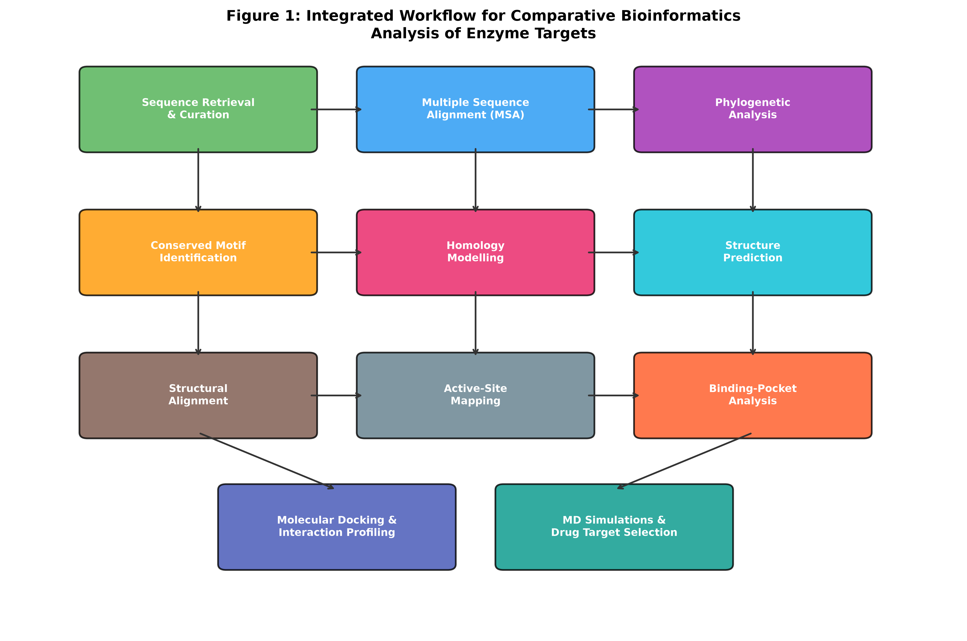
Figure 1: Integrated workflow for comparative bioinformatics analysis of enzyme targets, illustrating the progression from sequence retrieval and curation through multiple sequence alignment, phylogenetic analysis, and motif identification to molecular docking and drug target selection for therapeutic development.

3.2 Structural Bioinformatics of Enzyme Targets
Structural bioinformatics provides the three-dimensional context essential for understanding enzyme catalytic mechanisms, substrate recognition, and inhibitor binding [22]. The availability of high-resolution enzyme structures from X-ray crystallography, cryo-electron microscopy, and NMR spectroscopy, combined with powerful computational prediction methods, has created unprecedented opportunities for structure-based drug design targeting enzyme active sites and allosteric pockets [23]. The Protein Data Bank (PDB) currently contains over 200,000 experimentally determined structures, with enzymes representing a substantial proportion of these entries. This section explores the methodological framework for structural characterization of enzyme targets, from structure prediction through active-site analysis to druggability assessment, as comprehensively depicted in Figure 2. The integration of experimental structural data with computational prediction methods creates a powerful framework for characterizing enzyme targets at atomic resolution, even when experimental structures are unavailable for the specific target of interest.

3.2.1 Protein Structure Prediction and Homology Modelling
Homology modelling remains the most reliable computational approach for predicting enzyme three-dimensional structures when experimental structures are unavailable [24]. The methodology relies on the fundamental principle that evolutionarily related proteins adopt similar three-dimensional folds, and proceeds through template identification, target-template alignment, model building, loop refinement, and side-chain optimization stages. Programs such as MODELLER, SWISS-MODEL, and Phyre2 implement automated or semi-automated homology modelling pipelines that can generate models of sufficient quality for structure-based drug design when suitable templates sharing greater than 30 percent sequence identity are available [25]. The quality of homology models, assessed through tools such as PROCHECK, MolProbity, and QMEAN, determines their suitability for downstream applications including virtual screening and binding-site characterization. Critical assessment of model quality involves evaluation of stereochemical parameters, energy profiles, and packing quality to ensure that the predicted structure is reliable for structure-based drug design applications.
The revolutionary emergence of deep learning-based structure prediction methods, particularly AlphaFold2 and RoseTTAFold, has fundamentally transformed structural bioinformatics by achieving near-experimental accuracy for many protein targets [26]. The AlphaFold Protein Structure Database now provides predicted structures for essentially all known protein sequences, dramatically expanding the structural coverage of enzyme families and enabling structure-based analyses for previously uncharacterized targets. However, critical evaluation of predicted structures remains essential, particularly for enzyme active-site regions where local accuracy determines the reliability of subsequent docking and drug design studies [27]. Confidence metrics such as the predicted Local Distance Difference Test (pLDDT) and Predicted Aligned Error (PAE) guide the appropriate use of predicted structures in drug discovery applications. For enzyme targets where multiple conformational states are functionally relevant, ensemble approaches combining multiple templates or conformational sampling methods provide more complete structural representations of the conformational landscape accessible to the enzyme. The combination of AlphaFold predictions with molecular dynamics refinement has shown promise in generating conformational ensembles suitable for ensemble docking campaigns, particularly for enzymes that undergo significant conformational changes during their catalytic cycles.
The validation of predicted enzyme structures against experimental data represents a critical quality control step before their application in drug design. Cross-validation approaches comparing predicted active-site geometries with crystallographic data from related enzymes, assessment of predicted hydrogen-bonding networks against known catalytic mechanisms, and comparison of predicted binding-pocket properties with experimentally determined ligand-binding affinities all contribute to confidence assessment. For novel enzyme targets where no experimental structure exists for close homologs, the integration of evolutionary covariance data, small-angle X-ray scattering experiments, and cross-linking mass spectrometry provides orthogonal experimental constraints that validate and refine computational predictions. These multi-source validation strategies are particularly important for drug discovery applications where the accuracy of active-site geometry directly determines the reliability of virtual screening results.
The choice between homology modelling and AI-based structure prediction depends on several factors specific to the enzyme target under investigation. When high-quality templates with greater than 50 percent sequence identity are available, particularly templates co-crystallized with relevant ligands, traditional homology modelling may produce models with more accurate active-site geometries due to the template's known capacity to bind drug-like molecules. Conversely, for orphan enzyme targets with limited structural coverage of their families, AlphaFold2 predictions often provide superior overall fold accuracy. Hybrid approaches that combine AlphaFold backbone predictions with template-derived active-site refinement represent an emerging best practice that leverages the strengths of both methodologies. The increasing availability of enzyme structures determined by cryo-electron microscopy provides additional templates for modelling that capture physiologically relevant conformational states not always represented in crystal structures obtained under non-physiological conditions.

3.2.2 Structural Alignment and Active-Site Architecture
Structural alignment of enzymes belonging to the same family or superfamily reveals conserved architectural features that define the catalytic machinery and distinguish functionally distinct subfamilies [28]. Unlike sequence alignment, structural alignment can identify evolutionary relationships between highly divergent enzymes that share common folds despite minimal sequence similarity. Tools including DALI, TM-align, FATCAT, and CE implement diverse algorithms for structural superposition, ranging from rigid-body alignment to flexible structural comparison that accommodates domain movements and conformational changes associated with substrate binding [29]. The root-mean-square deviation (RMSD) of aligned atomic positions provides a quantitative measure of structural similarity, while structure-based sequence alignments generated from superpositions often reveal conserved positions missed by sequence-based methods. The TM-score metric provides a length-independent measure of structural similarity that enables meaningful comparison of enzymes of different sizes, with values above 0.5 generally indicating shared fold topology and values above 0.7 suggesting high structural similarity.
Active-site architecture analysis involves the detailed characterization of residues directly participating in catalysis, substrate binding, and transition-state stabilization [30]. The geometric arrangement of catalytic residues, the electrostatic environment of the active site, and the shape complementarity between the enzyme and its substrates collectively determine catalytic efficiency and substrate specificity. Structural comparison of active sites across enzyme family members, implemented through approaches such as CPASS, SiteEngine, and ProBiS, enables the identification of structurally conserved catalytic motifs and the detection of subtle architectural differences that confer distinct substrate specificities or inhibitor susceptibilities [31]. These structural insights are invaluable for the rational design of enzyme inhibitors that exploit specific active-site features of target enzymes while maintaining selectivity against related host enzymes. The analysis of active-site water networks through crystallographic and computational methods reveals structured water molecules that participate in catalysis and ligand recognition, providing additional opportunities for inhibitor optimization through strategic water displacement or water-mediated interaction formation. Table 2 presents a comprehensive comparison of structural bioinformatics tools commonly employed in enzyme structural analysis and their specific applications.
Table 2: Structural Bioinformatics Tools for Enzyme Analysis
Tool | Function | Algorithm/Approach | Output
MODELLER | Homology modelling | Spatial restraints satisfaction | 3D protein models
AlphaFold2 | Structure prediction | Deep learning, MSA + templates | High-accuracy structures
SWISS-MODEL | Automated modelling | Template-based pipeline | Quality-assessed models
DALI | Structural alignment | Distance matrix comparison | Structure superpositions
TM-align | Structure comparison | TM-score optimization | Structural similarity scores
PyMOL/VMD | Visualization | Molecular graphics rendering | Publication-quality figures
CASTp | Pocket detection | Alpha shape theory | Binding pocket volumes
FPocket/SiteMap | Druggability | Voronoi tessellation/energetics | Druggability scores

3.2.3 Molecular Surface, Binding-Pocket, and Druggability Analysis
The characterization of enzyme molecular surfaces and the identification of potential ligand-binding pockets constitute essential steps in assessing the druggability of enzyme targets [32]. Computational pocket detection algorithms, including CASTp, FPocket, SiteMap, and DoGSiteScorer, employ diverse geometric and energetic criteria to identify and rank potential binding sites on enzyme surfaces. These methods evaluate pocket properties including volume, depth, enclosure, hydrophobicity balance, and hydrogen-bonding capacity to predict the likelihood that a given pocket can accommodate drug-like molecules with sufficient binding affinity for therapeutic applications [33]. The druggability assessment of enzyme binding pockets integrates multiple physicochemical descriptors to estimate the probability that potent, selective, and drug-like inhibitors can be developed against specific sites. A druggable pocket typically exhibits a volume of 300-1000 cubic angstroms, appropriate hydrophobic character (40-60 percent non-polar surface), and sufficient enclosure to provide shape complementarity with drug-like molecules.
The concept of druggability has evolved from a simple binary classification to a continuous quantitative assessment that considers multiple dimensions of pocket quality. Modern druggability prediction tools integrate machine learning classifiers trained on large datasets of validated drug targets and known undruggable proteins to provide probabilistic assessments of therapeutic tractability. The consideration of pocket dynamics through ensemble-based analysis, where druggability is assessed across multiple conformational snapshots from MD trajectories, provides a more realistic assessment that accounts for the conformational heterogeneity inherent to enzyme binding sites. The development of fragment-based druggability assessment methods, where the binding of small organic probe molecules to enzyme surfaces is evaluated computationally or experimentally, provides direct evidence of pocket binding capacity that correlates with the potential for developing drug-like inhibitors with nanomolar binding affinities.
Beyond the primary active site, enzymes frequently possess allosteric sites, protein-protein interaction interfaces, and cryptic binding pockets that emerge through conformational dynamics [34]. The identification of these alternative druggable sites expands the therapeutic targeting options for enzyme-focused drug discovery programs. Molecular dynamics-based approaches, including mixed-solvent simulations and adaptive sampling methods, are particularly effective at revealing cryptic pockets that are not apparent in static crystal structures. Fragment-based mapping approaches using small organic probe molecules in MD simulations identify transiently accessible binding sites and characterize their physicochemical preferences for different chemical functionalities. The comprehensive analysis of enzyme surface properties, pocket characteristics, and druggability metrics provides the foundation for rational inhibitor design, as demonstrated in Figure 2, which illustrates the structural bioinformatics pipeline from model quality assessment through pocket analysis to flexibility profiling. The integration of pocket detection with evolutionary conservation analysis further prioritizes functionally relevant binding sites over spurious surface depressions that lack biological significance.

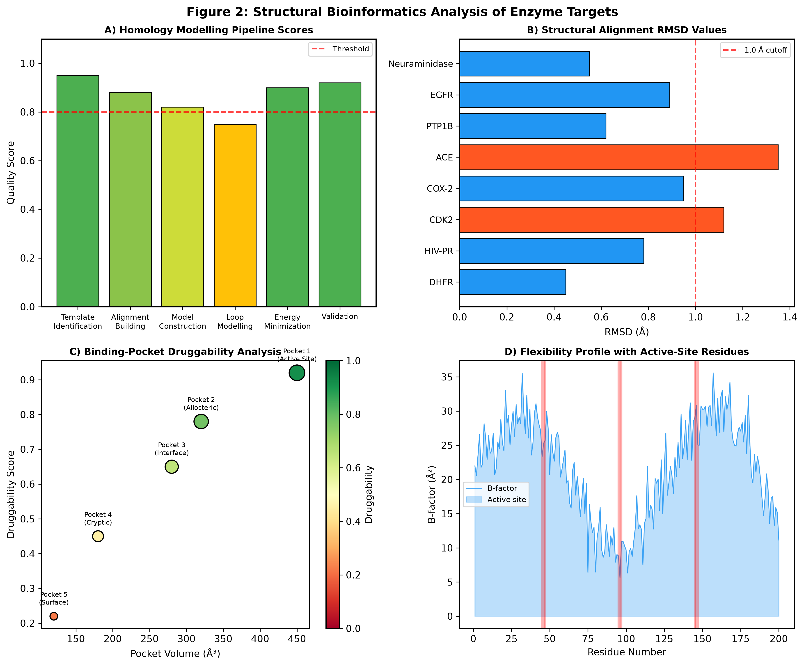
Figure 2: Structural bioinformatics analysis of enzyme targets showing (A) homology modelling quality scores across pipeline stages, (B) structural alignment RMSD values for representative enzyme drug targets, (C) binding-pocket druggability analysis with volume-druggability correlation, and (D) residue flexibility profile highlighting active-site positions.

3.3 Integrative Analysis of Enzyme-Ligand Interactions
The computational analysis of enzyme-ligand interactions represents a critical interface between structural bioinformatics and drug design, providing atomic-level insights into how small molecules interact with enzyme targets [35]. Modern integrative approaches combine binding-site prediction, molecular docking, interaction profiling, and molecular dynamics to construct comprehensive models of enzyme-ligand recognition that inform lead optimization and selectivity engineering. These computational methods complement and guide experimental biophysical techniques including X-ray crystallography, surface plasmon resonance, and isothermal titration calorimetry, creating an iterative framework for understanding and optimizing enzyme-inhibitor interactions. The accuracy of computational interaction analysis has improved substantially with advances in scoring functions, sampling algorithms, and the incorporation of explicit solvent effects and entropy contributions to binding free energy estimation. The development of physics-based scoring functions that explicitly model desolvation penalties and conformational strain energies has particularly improved the discrimination between true binders and false positives in virtual screening against enzyme targets with polar, solvent-exposed active sites.

3.3.1 Binding-Site Prediction and Ligand Recognition
Accurate prediction of ligand-binding sites on enzyme surfaces is prerequisite to structure-based virtual screening and rational inhibitor design [36]. Binding-site prediction methods integrate geometric features (pocket shape, volume, and depth), physicochemical properties (hydrophobicity, electrostatic potential, and hydrogen-bonding capacity), and evolutionary information (conservation patterns and covariation signals) to identify and rank potential binding sites. Energy-based methods such as Q-SiteFinder and GRID evaluate the interaction energetics between molecular probes and the enzyme surface to identify regions with favorable binding characteristics. Machine learning approaches, including deep learning architectures trained on large datasets of protein-ligand complexes from the PDB, have demonstrated superior performance in binding-site prediction, particularly for identifying novel sites not previously targeted by known ligands [37]. Graph neural network approaches that represent protein structures as graphs of residue interactions have shown particular promise in capturing the spatial relationships that define functional binding sites. The performance of binding-site prediction methods varies significantly depending on the enzyme family and the nature of the binding pocket, with enclosed active sites generally predicted more reliably than shallow surface pockets or allosteric sites located at domain interfaces.
Ligand recognition by enzymes involves a complex interplay of electrostatic complementarity, shape matching, desolvation effects, and conformational adaptation [38]. The molecular recognition process is frequently described through the induced-fit and conformational selection models, both of which have implications for computational docking strategies. For enzymes that undergo significant conformational changes upon ligand binding, ensemble docking approaches that consider multiple receptor conformations provide more realistic models of the recognition process. The characterization of pharmacophoric features essential for ligand recognition, including hydrogen-bond donors and acceptors, hydrophobic contacts, and ionic interactions, guides the design of novel inhibitors that satisfy the binding requirements of the enzyme active site while maintaining appropriate drug-like properties. The concept of molecular complementarity extends beyond simple shape fitting to encompass electrostatic complementarity, where the distribution of charges in the ligand mirrors the electrostatic potential surface of the binding pocket, and desolvation complementarity, where the energetic cost of removing water molecules from both binding partners is compensated by favorable protein-ligand interactions.

3.3.2 Molecular Docking and Interaction Profiling
Molecular docking has become an indispensable tool in enzyme-targeted drug discovery, enabling the computational prediction of binding modes, binding affinities, and interaction patterns between enzymes and potential inhibitors [39]. Docking programs including AutoDock Vina, GOLD, Glide, and DOCK implement diverse sampling algorithms and scoring functions to explore the conformational space available to ligands within enzyme binding sites. The accuracy of docking predictions depends critically on the treatment of receptor flexibility, the quality of the scoring function, and the appropriate consideration of solvation effects and entropic contributions to binding free energy. Ensemble docking, induced-fit docking, and covalent docking protocols address specific challenges associated with flexible enzymes, conformational adaptation, and mechanism-based inhibitors, respectively. The development of consensus scoring approaches that combine multiple scoring functions has improved the reliability of docking predictions by reducing method-specific biases and false-positive rates in virtual screening campaigns [39].
Virtual screening campaigns applying molecular docking to large compound libraries represent one of the most impactful applications of structural bioinformatics in drug discovery. High-throughput virtual screening (HTVS) protocols enable the rapid evaluation of millions of compounds against enzyme targets, prioritizing a manageable subset for experimental testing. The hierarchical application of increasingly rigorous docking protocols, from rapid screening modes to exhaustive sampling with flexible residues, balances computational efficiency with prediction accuracy. The validation of virtual screening protocols through retrospective analysis using known active and inactive compounds provides essential benchmarking that establishes the predictive performance of docking methods for specific enzyme targets and guides protocol selection for prospective campaigns. The enrichment metrics, including area under the receiver operating characteristic curve and early enrichment factors, quantify virtual screening performance and enable method comparison across different enzyme systems.
Interaction profiling extends beyond binding affinity prediction to characterize the specific molecular interactions that stabilize enzyme-inhibitor complexes. Protein-Ligand Interaction Fingerprints (PLIFs), implemented in tools such as PLIP, Arpeggio, and ProLIF, provide standardized representations of interaction patterns that enable systematic comparison across multiple docking poses or different inhibitor series [40]. The decomposition of binding interactions into hydrogen bonds, hydrophobic contacts, pi-stacking interactions, salt bridges, halogen bonds, and water-mediated contacts reveals the key pharmacophoric features driving enzyme-inhibitor recognition. These interaction profiles guide medicinal chemistry optimization by identifying interactions critical for binding affinity versus those that can be modified without activity loss. Table 3 provides a comparative overview of molecular docking tools and their specific capabilities for enzyme-ligand interaction analysis. The results of molecular docking and interaction profiling are comprehensively illustrated in Figure 3, which demonstrates docking score distributions, interaction type analysis, molecular dynamics stability assessment, and binding energy decomposition for representative enzyme targets.
Table 3: Molecular Docking and Interaction Analysis Tools for Enzyme Targets
Software | Docking Type | Scoring Function | Special Features
AutoDock Vina | Rigid/Flexible | Empirical + ML hybrid | Open-source, fast screening
GOLD | Flexible ligand | GoldScore/ChemScore/ASP | Genetic algorithm, water handling
Glide (Schrodinger) | SP/XP/IFD modes | GlideScore empirical | Induced-fit, covalent docking
DOCK 6 | Rigid/Flexible | Grid-based energy | Anchor-and-grow algorithm
SwissDock | Blind docking | CHARMM force field | Web-based, exhaustive search
HADDOCK | Data-driven | OPLS force field | Information-driven, flexible
rDock | Cavity-based | Empirical SF | High-throughput virtual screening
CovDock | Covalent binding | Prime MM-GBSA | Mechanism-based inhibitor design

3.3.3 Molecular Dynamics and Structural Stability Assessment
Molecular dynamics (MD) simulations provide the temporal dimension essential for understanding enzyme-ligand interactions in their full dynamic context [41]. Unlike static docking approaches, MD simulations capture the conformational fluctuations, induced-fit adaptations, and water-mediated interactions that govern enzyme-inhibitor binding kinetics and thermodynamics. All-atom MD simulations using force fields such as AMBER ff19SB, CHARMM36m, and OPLS-AA/M, implemented in packages including GROMACS, AMBER, NAMD, and Desmond, enable the assessment of complex stability, the identification of key interaction determinants, and the estimation of binding free energies through rigorous methods such as MM-PBSA, MM-GBSA, and free energy perturbation (FEP) calculations [42]. Standard MD simulation protocols for enzyme-inhibitor complexes typically involve system preparation including solvation, ion addition, and energy minimization, followed by equilibration under NVT and NPT ensembles, and production simulations of 100 nanoseconds to microsecond timescales depending on the biological question addressed.
The assessment of structural stability through RMSD analysis, root-mean-square fluctuation (RMSF) profiling, radius of gyration monitoring, and hydrogen-bond occupancy analysis provides comprehensive insight into the dynamic behavior of enzyme-inhibitor complexes. Comparative MD analysis of apo (unbound) and holo (ligand-bound) enzyme states reveals the conformational effects of inhibitor binding and identifies regions that undergo significant structural reorganization upon complex formation. Enhanced sampling methods, including replica exchange MD, metadynamics, and accelerated MD, overcome the time-scale limitations of conventional MD to explore rare conformational transitions and estimate free energy landscapes relevant to enzyme-ligand binding and unbinding processes [43]. The integration of MD-derived structural ensembles with binding site analysis and interaction profiling provides a dynamic view of enzyme druggability that complements static structure-based assessments. Principal component analysis of MD trajectories identifies the dominant collective motions of enzymes, revealing conformational states relevant to catalysis and inhibition that may represent distinct druggable conformations not captured in single crystal structures.
Binding free energy calculations from MD trajectories provide quantitative estimates of enzyme-inhibitor binding affinities that complement docking scores. The MM-PBSA and MM-GBSA methods decompose binding free energies into van der Waals, electrostatic, polar solvation, and non-polar solvation contributions, enabling identification of the energetic drivers of binding and guiding structure-activity relationship optimization. More rigorous alchemical free energy methods, including thermodynamic integration and free energy perturbation, achieve chemical accuracy in relative binding free energy predictions for congeneric inhibitor series, directly informing medicinal chemistry prioritization decisions. The systematic application of these computational approaches to enzyme-ligand systems enables the efficient exploration of chemical modifications that optimize binding affinity, selectivity, and drug-like properties simultaneously.
The analysis of protein-ligand unbinding kinetics through steered MD and metadynamics simulations provides valuable information about residence time, which correlates with in vivo efficacy for many enzyme targets. The concept of drug-target residence time has gained recognition as a critical parameter in drug optimization, as longer residence times can translate to sustained target engagement and improved therapeutic outcomes even when equilibrium binding affinity is moderate. Computational approaches that estimate unbinding barriers and pathways complement traditional affinity-focused methods by providing kinetic selectivity information that distinguishes compounds with similar thermodynamic binding but different kinetic profiles. The integration of kinetic modeling with thermodynamic binding analysis creates a comprehensive framework for optimizing both the strength and duration of enzyme-inhibitor interactions.

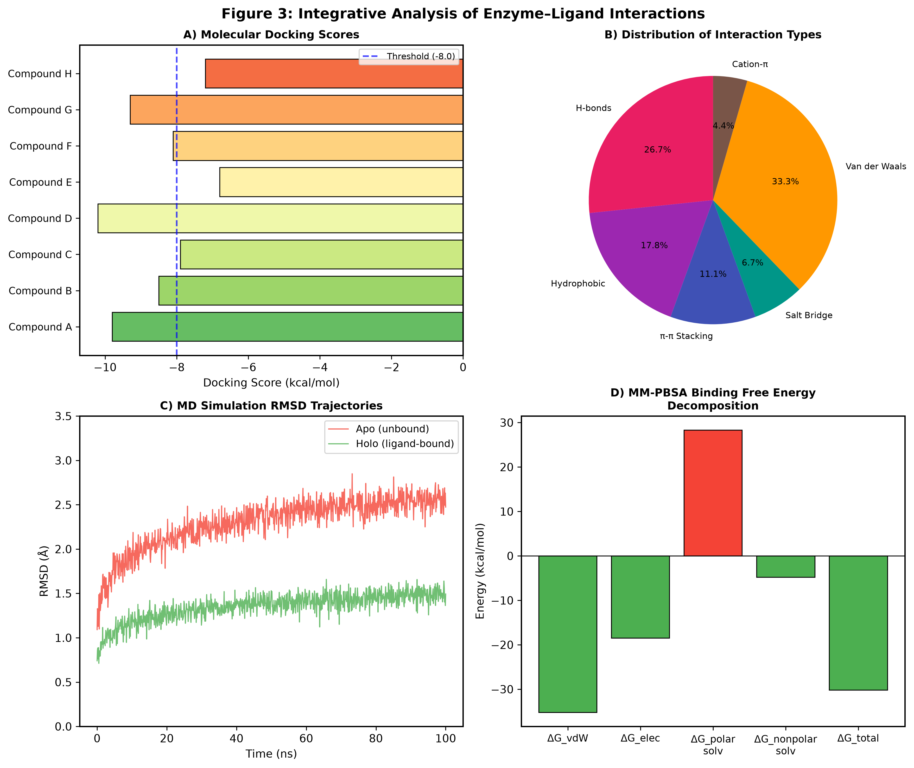
Figure 3: Integrative analysis of enzyme-ligand interactions showing (A) molecular docking scores for candidate compounds against enzyme target, (B) distribution of non-covalent interaction types in enzyme-inhibitor complexes, (C) molecular dynamics RMSD trajectories comparing apo and holo enzyme states, and (D) MM-PBSA binding free energy decomposition into individual energetic contributions.

3.4 Bioinformatics-Guided Enzyme Targeting for Drug Design
The translation of bioinformatics analyses into actionable drug design strategies represents the ultimate goal of computational enzyme characterization [35]. Bioinformatics-guided approaches enable the rational selection of enzyme targets, the identification of exploitable structural features, and the optimization of lead compounds through iterative computational-experimental cycles. This section explores how comparative and structural bioinformatics findings are integrated into comprehensive drug discovery programs targeting enzyme active sites and regulatory mechanisms. The overall framework for bioinformatics-guided drug design is presented in Figure 4, illustrating the progression from target identification through lead optimization to experimental validation, emphasizing the iterative nature of modern computational drug discovery and the critical feedback loops that connect experimental outcomes with computational refinement.

3.4.1 Comparative Identification of Selective Drug Targets
The comparative bioinformatics-based identification of selective drug targets exploits differences between pathogen and host enzyme sequences, structures, and mechanisms to identify positions where selective inhibition can be achieved [13]. Comparative genomics approaches, including ortholog analysis, essentiality prediction, and pathway reconstruction, enable the prioritization of enzyme targets based on their requirement for pathogen survival and their absence or sufficient divergence from host counterparts. Differential conservation analysis between pathogen and host enzyme orthologs identifies positions where sequence or structural divergence creates opportunities for selective inhibitor design. The integration of comparative sequence analysis with structural information enables the identification of species-specific binding-site features that can be exploited for selectivity optimization. Genome-scale metabolic modelling further contributes to target prioritization by identifying enzymes that catalyze essential reactions without alternative pathways, ensuring that inhibition of the target enzyme produces the desired phenotypic effect.
Multi-target approaches in enzyme drug discovery leverage comparative bioinformatics to identify conserved features across related enzyme families that enable the design of broad-spectrum inhibitors [16]. Conversely, selectivity profiling through structural comparison of closely related enzyme isoforms guides the design of isoform-selective inhibitors that minimize off-target effects. Network pharmacology approaches integrate enzyme target information with protein interaction networks and pathway analysis to identify optimal intervention points and predict potential resistance mechanisms. The systematic comparison of enzyme targets across therapeutic areas, including antimicrobial, anticancer, and anti-inflammatory drug discovery, reveals common principles and unique challenges in bioinformatics-guided enzyme targeting. Resistance prediction through analysis of natural sequence variation at drug-binding positions enables the prospective design of inhibitors with reduced susceptibility to resistance mutations, a critical consideration for antimicrobial and anticancer enzyme targets. Table 4 summarizes key enzyme families that have been successfully targeted through bioinformatics-guided approaches, along with their druggability characteristics and representative inhibitors.
The comparative analysis of enzyme target families across the phylogenetic spectrum reveals important patterns in druggability that inform target selection strategies. Enzymes with deep active-site clefts, such as proteases and kinases, generally exhibit high druggability due to favorable pocket geometries that readily accommodate drug-like molecules. In contrast, enzymes with shallow, solvent-exposed active sites or those that function through protein-protein interactions present greater challenges for conventional small-molecule drug design, often requiring innovative approaches such as stapled peptides, PROTACs, or molecular glues. The identification of allosteric sites through comparative structural analysis provides alternative targeting strategies for enzymes where active-site inhibition proves challenging, while the discovery of species-specific structural features through cross-species comparison enables the design of pathogen-selective inhibitors with minimal host toxicity. The integration of genomic essentiality data from genome-wide screens with structural druggability assessment creates a powerful prioritization framework that identifies targets that are both biologically essential and chemically tractable for therapeutic intervention.
Table 4: Enzyme Families Targeted Through Bioinformatics-Guided Drug Discovery
Enzyme Family | Therapeutic Area | Bioinformatics Approach | Druggability | Representative Drug
HIV Protease | Antiviral | Homology modelling + docking | High | Darunavir
Kinases (CDK) | Oncology | Structural alignment + SBVS | High | Palbociclib
DHFR | Antimicrobial | Comparative genomics + MSA | High | Trimethoprim
COX-2 | Anti-inflammatory | Active-site comparison | High | Celecoxib
Neuraminidase | Antiviral | SBDD + MD simulations | High | Oseltamivir
ACE | Cardiovascular | Zinc metalloprotease modelling | High | Lisinopril
PTP1B | Diabetes/Obesity | Pocket druggability analysis | Moderate | Trodusquemine
EGFR Kinase | Oncology | Mutation analysis + docking | High | Erlotinib

3.4.2 Structure-Based and Ligand-Based Lead Optimization
Structure-based lead optimization leverages detailed knowledge of enzyme-inhibitor interactions obtained through docking, MD simulations, and crystallographic data to guide systematic chemical modifications that improve potency, selectivity, and drug-like properties [24]. Fragment growing, fragment linking, and scaffold hopping strategies, informed by structural analysis of enzyme binding sites, enable the exploration of chemical space around initial hit compounds. The identification of unfilled binding-site sub-pockets, suboptimal hydrogen-bonding geometries, and opportunities for additional hydrophobic contacts through computational analysis guides medicinal chemistry optimization cycles. Water displacement strategies, informed by analysis of crystallographic and MD-derived water structures within enzyme binding sites, provide thermodynamic driving forces for affinity optimization [29]. The systematic analysis of protein-ligand complex structures through interaction fingerprinting reveals key pharmacophoric elements that must be maintained during optimization and identifies positions tolerant of chemical modification for property improvement.
Ligand-based approaches complement structure-based methods by exploiting structure-activity relationship (SAR) data accumulated during optimization campaigns. Quantitative structure-activity relationship (QSAR) models, pharmacophore hypotheses, and matched molecular pair analysis provide empirical frameworks for predicting the activity of novel compounds and prioritizing synthetic targets [30]. Three-dimensional QSAR methods, including CoMFA and CoMSIA, combine structural information with activity data to generate predictive models that guide optimization. The integration of structure-based and ligand-based approaches through consensus scoring, hybrid pharmacophore models, and machine learning ensembles provides robust predictions that leverage complementary information sources. Free energy perturbation calculations and thermodynamic integration methods enable rigorous prediction of relative binding affinities for congeneric series, guiding prioritization of synthetic candidates with high predicted affinity improvements [31]. Recent advances in generative deep learning models, including variational autoencoders and reinforcement learning frameworks, enable the de novo design of novel enzyme inhibitor scaffolds optimized for multiple objectives simultaneously, including binding affinity, selectivity, synthetic accessibility, and ADMET properties.
ADMET (absorption, distribution, metabolism, excretion, and toxicity) optimization represents a critical component of lead optimization that increasingly benefits from bioinformatics approaches. Structure-based prediction of metabolic liability, informed by computational analysis of cytochrome P450 enzyme active sites and substrate recognition patterns, enables the rational design of metabolically stable compounds [32]. Similarly, the computational prediction of off-target interactions through inverse docking and polypharmacology profiling leverages structural bioinformatics of enzyme families to anticipate selectivity challenges and toxicity risks during lead optimization. The prediction of drug-drug interaction potential through modeling of CYP450 inhibition and the assessment of hERG channel liability through structure-based approaches further integrate bioinformatics into the multiparameter optimization framework that characterizes modern lead optimization campaigns. The concept of ligand efficiency metrics, including ligand efficiency, lipophilic efficiency, and size-independent ligand efficiency, provides normalized measures of binding quality that guide optimization toward drug-like chemical space.

3.4.3 Integration of Bioinformatics with Experimental Validation and Drug Discovery
The successful translation of bioinformatics predictions into validated drug candidates requires systematic experimental confirmation of computational hypotheses [33]. The integration of bioinformatics with high-throughput experimental techniques, including biochemical screening, biophysical binding assays, and structural biology, creates iterative feedback loops that progressively refine computational models and guide experimental priorities. X-ray crystallography of enzyme-inhibitor complexes provides definitive experimental validation of computationally predicted binding modes, while simultaneously revealing structural details that inform further computational analysis. Cryo-EM has emerged as a complementary structural technique particularly valuable for large enzyme complexes and membrane-associated targets where crystallization is challenging [34]. The comparison of computationally predicted and experimentally determined binding modes provides essential benchmarking data that improves the accuracy of future computational predictions and identifies systematic biases in docking methods that can be corrected through method development.
Fragment-based drug discovery (FBDD) represents a paradigm where bioinformatics and experimental approaches are deeply integrated from the earliest stages of lead identification [36]. Computational fragment screening using molecular docking and pharmacophore matching guides the selection of fragment libraries, while experimental fragment screening by X-ray crystallography, NMR, or surface plasmon resonance provides structural starting points for elaboration. The structure-guided linking and growing of fragments, informed by binding-site topology analysis and interaction pattern prediction, exemplifies the synergistic integration of computational and experimental approaches in enzyme-targeted drug discovery. Machine learning integration with structural data has accelerated the prediction of enzyme inhibitor activities and ADMET properties, enabling more efficient design-make-test-analyze (DMTA) cycles [37]. Active learning frameworks that iteratively select the most informative compounds for synthesis and testing, guided by computational predictions, optimize the exploration of chemical space while minimizing experimental resources. The application of Bayesian optimization to multiparameter enzyme inhibitor design represents a sophisticated integration of computational prediction with experimental feedback that efficiently navigates the complex property landscapes characteristic of drug discovery campaigns.
The future of bioinformatics-guided enzyme targeting lies in the integration of multi-scale computational approaches with high-throughput experimental platforms. Advances in artificial intelligence, quantum mechanics/molecular mechanics (QM/MM) methods, and coarse-grained simulation approaches promise more accurate prediction of enzyme-inhibitor interactions and catalytic mechanisms [38]. The development of automated computational pipelines that integrate sequence analysis, structure prediction, binding-site characterization, virtual screening, and lead optimization within unified frameworks will further accelerate the application of bioinformatics to enzyme-targeted drug discovery. Cloud computing and GPU-accelerated simulations are democratizing access to computationally intensive methods, enabling smaller research groups to leverage sophisticated bioinformatics approaches that were previously accessible only to large pharmaceutical companies. The comprehensive framework presented in Figure 4 illustrates how these diverse computational approaches converge within an integrated drug discovery pipeline that bridges the gap between bioinformatics analysis and clinical translation.
The role of artificial intelligence in enzyme-targeted drug discovery extends beyond traditional structure-based approaches to encompass novel paradigms including generative chemistry, retrosynthetic planning, and autonomous laboratory integration. Deep generative models trained on enzyme-inhibitor structural data can propose novel molecular scaffolds that satisfy binding-site requirements while maintaining drug-like properties, representing a fundamentally new approach to inhibitor design that complements traditional medicinal chemistry intuition. The integration of natural language processing with scientific literature mining enables automated extraction of enzyme structure-function relationships from published research, creating knowledge graphs that connect sequence features, structural characteristics, and functional properties across entire enzyme superfamilies. These AI-driven approaches, combined with robotic laboratory platforms capable of autonomous synthesis and testing, are creating closed-loop drug discovery systems where computational prediction, compound synthesis, and biological evaluation operate in continuous iterative cycles with minimal human intervention.
The convergence of comparative genomics, structural bioinformatics, machine learning, and experimental validation represents a paradigm shift in enzyme-targeted drug discovery. The systematic application of these integrated approaches has already yielded numerous successful therapeutic agents, from HIV protease inhibitors designed through structure-based methods to kinase inhibitors identified through comparative analysis of kinase family structures. As computational methods continue to advance in accuracy, speed, and accessibility, and as experimental techniques provide increasingly detailed validation data, the iterative cycle of computational prediction and experimental confirmation will continue to accelerate the discovery of novel enzyme-targeted therapeutics across diverse disease areas [39, 40, 41, 42, 43]. The democratization of these tools through web servers, open-source software, and community databases ensures that bioinformatics-guided enzyme targeting will remain at the forefront of modern drug discovery for decades to come.
Looking forward, several transformative trends are reshaping the landscape of bioinformatics-guided enzyme targeting. The integration of multi-omics data, including transcriptomics, proteomics, and metabolomics, with structural bioinformatics enables context-dependent target prioritization that considers enzyme expression patterns, post-translational modifications, and metabolic flux distributions in disease states. The development of digital twin technologies that create comprehensive computational models of enzyme behavior under physiological conditions promises to bridge the gap between in vitro biochemical characterization and in vivo therapeutic efficacy. Furthermore, the application of explainable artificial intelligence methods to enzyme drug design provides mechanistic interpretability that builds confidence in computational predictions and facilitates communication between computational and experimental scientists. The standardization of bioinformatics workflows through FAIR (Findable, Accessible, Interoperable, Reusable) principles ensures reproducibility and enables meta-analyses across studies that collectively advance our understanding of enzyme druggability and inform the development of next-generation therapeutics targeting enzymatic pathways in cancer, infectious disease, neurological disorders, and metabolic syndromes.

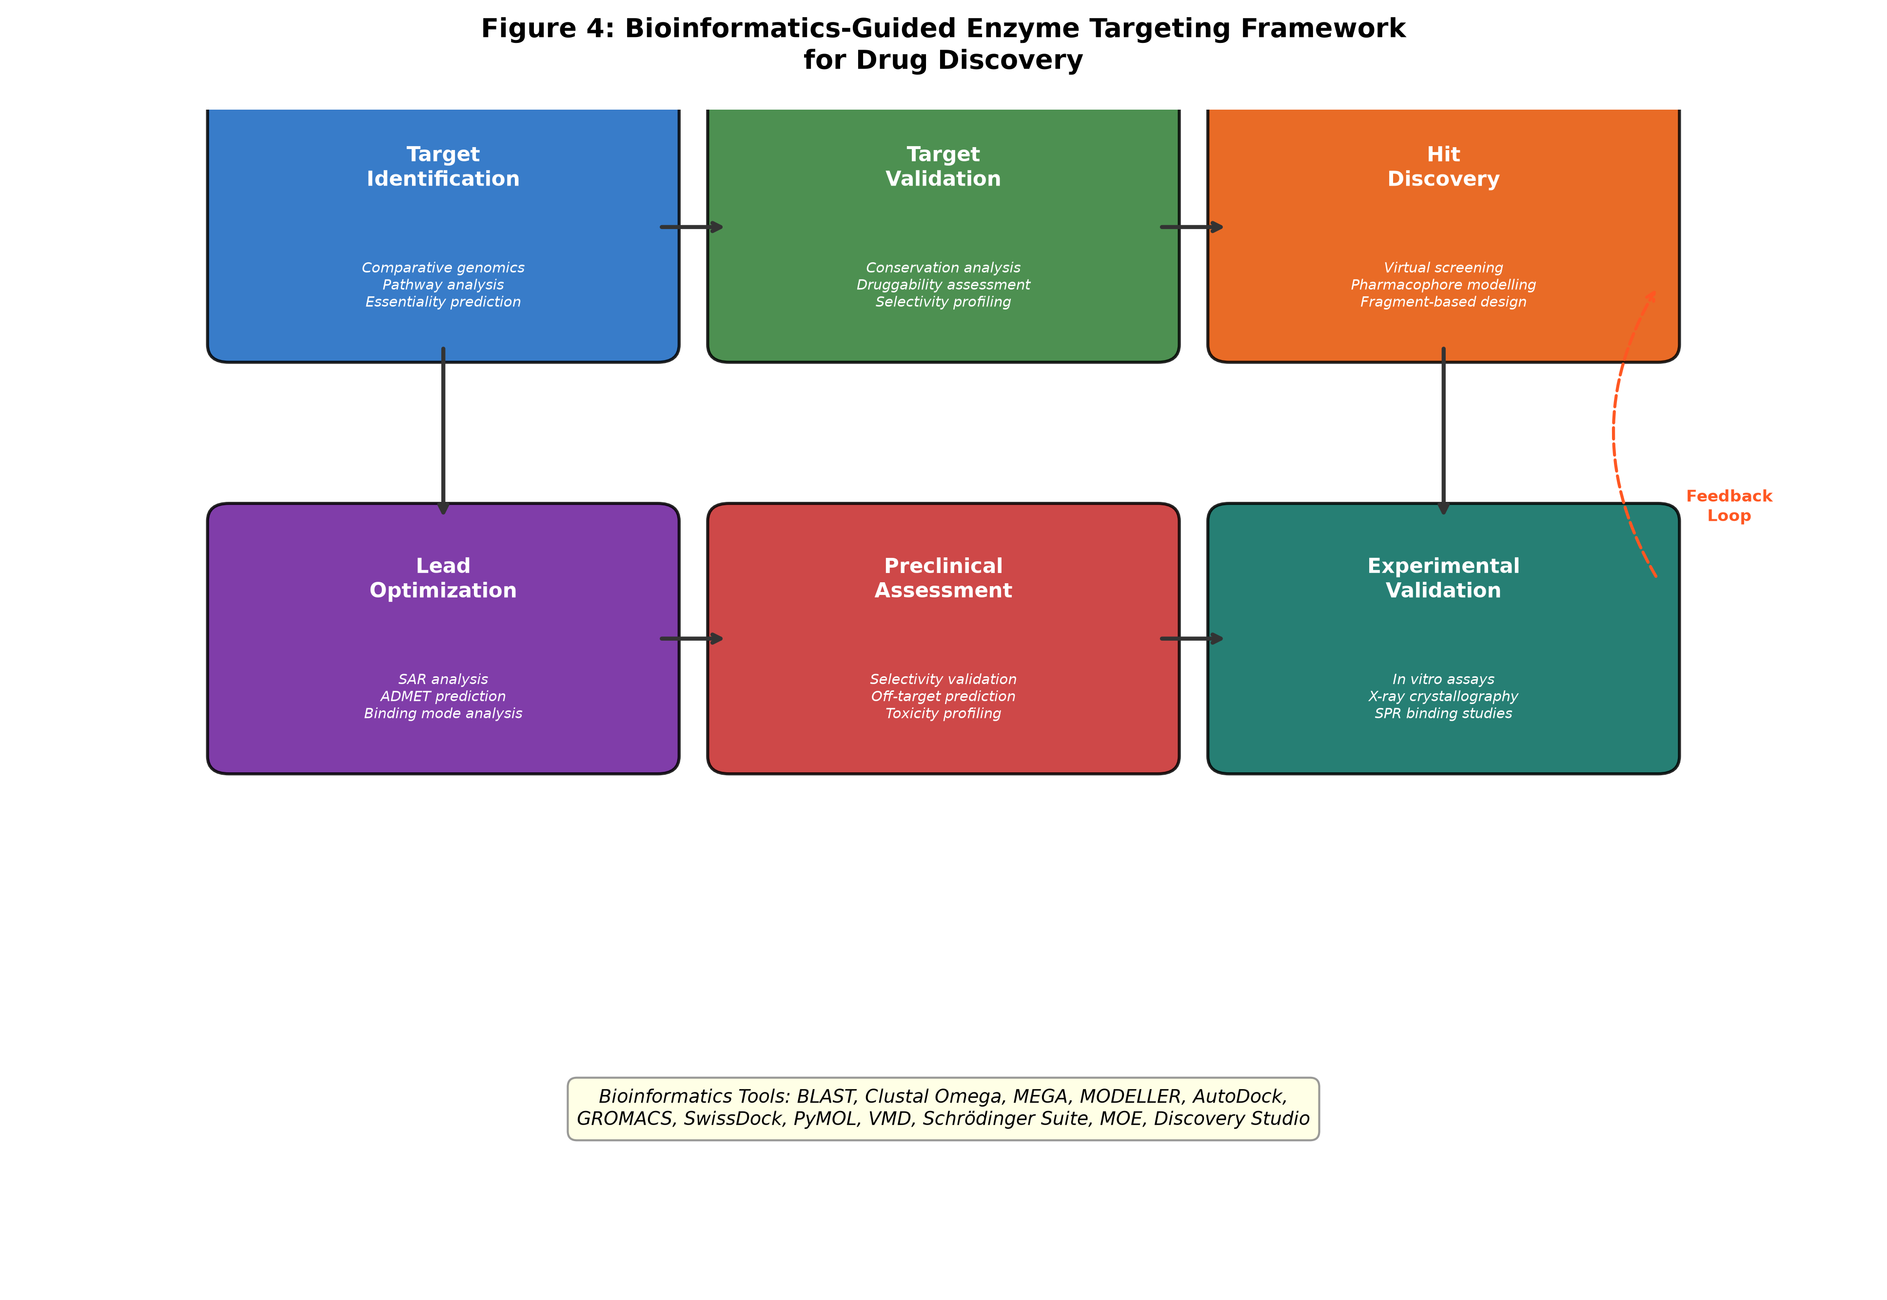
Figure 4: Bioinformatics-guided enzyme targeting framework for drug discovery, illustrating the complete pipeline from target identification and validation through hit discovery, lead optimization, preclinical assessment, and experimental validation, with iterative feedback loops enabling continuous refinement of computational predictions.

References
[1] Bairoch, A. (2000). The ENZYME database in 2000. Nucleic Acids Research, 28(1), 304-305.
[2] UniProt Consortium. (2021). UniProt: the universal protein knowledgebase in 2021. Nucleic Acids Research, 49(D1), D480-D489.
[3] Altschul, S.F., Madden, T.L., Schaffer, A.A., Zhang, J., Zhang, Z., Miller, W., & Lipman, D.J. (1997). Gapped BLAST and PSI-BLAST: a new generation of protein database search programs. Nucleic Acids Research, 25(17), 3389-3402.
[4] Oprea, T.I., Bologa, C.G., Brunak, S., Campbell, A., Gan, G.N., Gaulton, A., ... & Bhak, J. (2018). Unexplored therapeutic opportunities in the human genome. Nature Reviews Drug Discovery, 17(5), 317-332.
[5] Chang, A., Jeske, L., Ulbrich, S., Hofmann, J., Kublber, J., Kania, A., ... & Schomburg, D. (2021). BRENDA, the ELIXIR core data resource in 2021: new developments and updates. Nucleic Acids Research, 49(D1), D498-D508.
[6] Eddy, S.R. (2011). Accelerated profile HMM searches. PLoS Computational Biology, 7(10), e1002195.
[7] Sievers, F., Wilm, A., Dineen, D., Gibson, T.J., Karplus, K., Li, W., ... & Higgins, D.G. (2011). Fast, scalable generation of high-quality protein multiple sequence alignments using Clustal Omega. Molecular Systems Biology, 7(1), 539.
[8] Katoh, K., & Standley, D.M. (2013). MAFFT multiple sequence alignment software version 7: improvements in performance and usability. Molecular Biology and Evolution, 30(4), 772-780.
[9] Edgar, R.C. (2004). MUSCLE: multiple sequence alignment with high accuracy and high throughput. Nucleic Acids Research, 32(5), 1792-1797.
[10] Rives, A., Meier, J., Sercu, T., Goyal, S., Lin, Z., Liu, J., ... & Fergus, R. (2021). Biological structure and function emerge from scaling unsupervised learning to 250 million protein sequences. Proceedings of the National Academy of Sciences, 118(15), e2016239118.
[11] Thompson, J.D., Plewniak, F., & Poch, O. (1999). A comprehensive comparison of multiple sequence alignment programs. Nucleic Acids Research, 27(13), 2682-2690.
[12] Kumar, S., Stecher, G., Li, M., Knyaz, C., & Tamura, K. (2018). MEGA X: Molecular Evolutionary Genetics Analysis across computing platforms. Molecular Biology and Evolution, 35(6), 1547-1549.
[13] Doyle, M.A., Gasser, R.B., Woodcroft, B.J., Hall, R.S., & Ralph, S.A. (2010). Drug target prediction and prioritization: using orthology to predict essentiality in parasite genomes. BMC Genomics, 11(3), S9.
[14] Nguyen, L.T., Schmidt, H.A., von Haeseler, A., & Minh, B.Q. (2015). IQ-TREE: a fast and effective stochastic algorithm for estimating maximum-likelihood phylogenies. Molecular Biology and Evolution, 32(1), 268-274.
[15] Ashkenazy, H., Abadi, S., Martz, E., Chay, O., Mayrose, I., Pupko, T., & Ben-Tal, N. (2016). ConSurf 2016: an improved methodology to estimate and visualize evolutionary conservation in macromolecules. Nucleic Acids Research, 44(W1), W344-W350.
[16] Marks, D.S., Hopf, T.A., & Sander, C. (2012). Protein structure prediction from sequence variation. Nature Biotechnology, 30(5), 461-466.
[17] Bailey, T.L., Boden, M., Buske, F.A., Frith, M., Grant, C.E., Clementi, L., ... & Noble, W.S. (2009). MEME SUITE: tools for motif discovery and searching. Nucleic Acids Research, 37(suppl_2), W202-W208.
[18] Finn, R.D., Coggill, P., Eberhardt, R.Y., Eddy, S.R., Mistry, J., Mitchell, A.L., ... & Bateman, A. (2016). The Pfam protein families database: towards a more sustainable future. Nucleic Acids Research, 44(D1), D279-D285.
[19] Ribeiro, A.J.M., Holliday, G.L., Furnham, N., Tyzack, J.D., Sheringham, K., & Sheringham, J. (2018). Mechanism and Catalytic Site Atlas (M-CSA): a database of enzyme reaction mechanisms and active sites. Nucleic Acids Research, 46(D1), D618-D623.
[20] Capra, J.A., & Singh, M. (2007). Predicting functionally important residues from sequence conservation. Bioinformatics, 23(15), 1875-1882.
[21] Lockless, S.W., & Ranganathan, R. (1999). Evolutionarily conserved pathways of energetic connectivity in protein families. Science, 286(5438), 295-299.
[22] Berman, H.M., Westbrook, J., Feng, Z., Gilliland, G., Bhat, T.N., Weissig, H., ... & Bourne, P.E. (2000). The Protein Data Bank. Nucleic Acids Research, 28(1), 235-242.
[23] Anderson, A.C. (2003). The process of structure-based drug design. Chemistry & Biology, 10(9), 787-797.
[24] Webb, B., & Sali, A. (2016). Comparative protein structure modeling using MODELLER. Current Protocols in Bioinformatics, 54(1), 5.6.1-5.6.37.
[25] Waterhouse, A., Bertoni, M., Bienert, S., Studer, G., Tauriello, G., Gumienny, R., ... & Schwede, T. (2018). SWISS-MODEL: homology modelling of protein structures and complexes. Nucleic Acids Research, 46(W1), W296-W303.
[26] Jumper, J., Evans, R., Pritzel, A., Green, T., Figurnov, M., Ronneberger, O., ... & Hassabis, D. (2021). Highly accurate protein structure prediction with AlphaFold. Nature, 596(7873), 583-589.
[27] Varadi, M., Anyango, S., Deshpande, M., Nair, S., Natassia, C., Yordanova, G., ... & Velankar, S. (2022). AlphaFold Protein Structure Database: massively expanding the structural coverage of protein-sequence space with high-accuracy models. Nucleic Acids Research, 50(D1), D439-D444.
[28] Holm, L. (2020). DALI and the persistence of protein shape. Protein Science, 29(1), 128-140.
[29] Zhang, Y., & Skolnick, J. (2005). TM-align: a protein structure alignment algorithm based on the TM-score. Nucleic Acids Research, 33(7), 2302-2309.
[30] Gutteridge, A., & Thornton, J.M. (2005). Understanding nature's catalytic toolkit. Trends in Biochemical Sciences, 30(11), 622-629.
[31] Shulman-Peleg, A., Nussinov, R., & Wolfson, H.J. (2004). Recognition of functional sites in protein structures. Journal of Molecular Biology, 339(3), 607-633.
[32] Volkamer, A., Kuhn, D., Rippmann, F., & Rarey, M. (2012). DoGSiteScorer: a web server for automatic binding site prediction, analysis and druggability assessment. Bioinformatics, 28(15), 2074-2075.
[33] Halgren, T.A. (2009). Identifying and characterizing binding sites and assessing druggability. Journal of Chemical Information and Modeling, 49(2), 377-389.
[34] Cimermancic, P., Weinkam, P., Rettenmaier, T.J., Bichmann, L., Keedy, D.A., Wolber, G., ... & Sali, A. (2016). CryptoSite: expanding the druggable proteome by characterization and prediction of cryptic binding sites. Journal of Molecular Biology, 428(4), 709-719.
[35] Kitchen, D.B., Decornez, H., Furr, J.R., & Bajorath, J. (2004). Docking and scoring in virtual screening for drug discovery: methods and applications. Nature Reviews Drug Discovery, 3(11), 935-949.
[36] Erlanson, D.A., Fesik, S.W., Hubbard, R.E., Jahnke, W., & Jhoti, H. (2016). Twenty years on: the impact of fragments on drug discovery. Nature Reviews Drug Discovery, 15(9), 605-619.
[37] Gentile, F., Agrawal, V., Hsing, M., Ton, A.T., Ban, F., Norber, U., ... & Cherkasov, A. (2022). Artificial intelligence-enabled virtual screening of ultra-large chemical libraries with deep docking. Nature Protocols, 17(3), 672-697.
[38] Du, X., Li, Y., Xia, Y.L., Ai, S.M., Lactuca, J., Liu, J.F., ... & Li, J. (2016). Insights into protein-ligand interactions: mechanisms, models, and methods. International Journal of Molecular Sciences, 17(2), 144.
[39] Trott, O., & Olson, A.J. (2010). AutoDock Vina: improving the speed and accuracy of docking with a new scoring function, efficient optimization, and multithreading. Journal of Computational Chemistry, 31(2), 455-461.
[40] Salentin, S., Schreiber, S., Haupt, V.J., Adasme, M.F., & Schroeder, M. (2015). PLIP: fully automated protein-ligand interaction profiler. Nucleic Acids Research, 43(W1), W443-W447.
[41] Hollingsworth, S.A., & Dror, R.O. (2018). Molecular dynamics simulation for all. Neuron, 99(6), 1129-1143.
[42] Genheden, S., & Ryde, U. (2015). The MM/PBSA and MM/GBSA methods to estimate ligand-binding affinities. Expert Opinion on Drug Discovery, 10(5), 449-461.
[43] De Vivo, M., Masetti, M., Bottegoni, G., & Cavalli, A. (2016). Role of molecular dynamics and related methods in drug discovery. Journal of Medicinal Chemistry, 59(9), 4035-4061.

