AI for Electric Vehicles and Charging Infrastructure

Abstract
The rapid proliferation of electric vehicles (EVs) has created an urgent need for intelligent systems that can optimize vehicle performance, battery longevity, and charging infrastructure efficiency. Artificial Intelligence (AI) has emerged as a transformative technology capable of addressing these multifaceted challenges through advanced data analytics, predictive modeling, and autonomous decision-making. This chapter provides a comprehensive exploration of AI applications across the entire EV ecosystem, encompassing intelligent battery management systems, energy consumption optimization, smart charging infrastructure, vehicle-to-grid integration, and autonomous charging technologies. We examine how machine learning, deep learning, reinforcement learning, and digital twin frameworks enable real-time optimization, predictive maintenance, and sustainable energy management. The chapter further discusses emerging paradigms including explainable AI for transparent decision-making, cybersecurity frameworks for secure EV networks, and federated learning for privacy-preserving connected vehicle systems. Through critical analysis of current implementations and future research directions, this work establishes AI as the cornerstone technology for realizing intelligent, efficient, and sustainable electric mobility ecosystems.
Keywords: Artificial Intelligence, Electric Vehicles, Battery Management Systems, Smart Charging Infrastructure, Vehicle-to-Grid, Reinforcement Learning, Digital Twins, Predictive Maintenance, Autonomous Charging, Sustainable Transportation

1. Fundamentals of AI in Electric Mobility

1.1 Evolution of Electric Vehicles and Smart Charging
The history of electric vehicles extends back to the early nineteenth century, with the first crude electric carriage developed by Robert Anderson in the 1830s and subsequent refinements by Thomas Davenport and others throughout the 1840s and 1850s. However, the dominance of internal combustion engines (ICEs) from the early 1900s relegated EVs to niche applications for nearly a century. The modern EV renaissance began in the 1990s with vehicles like the General Motors EV1 and gained substantial momentum following the introduction of the Tesla Roadster in 2008 and the Nissan Leaf in 2010 (Sanguesa et al., 2021; Mastoi et al., 2022).
The contemporary EV ecosystem comprises several interconnected components: the electric powertrain (including motors, power electronics, and transmission systems), energy storage systems (predominantly lithium-ion batteries), thermal management systems, regenerative braking systems, and onboard computing platforms. The battery pack represents the most critical and expensive component, typically accounting for 30-40% of the vehicle's total cost and directly determining range, performance, and vehicle longevity (Hannan et al., 2022).
The development of charging infrastructure has progressed through several generations. Level 1 charging (120V AC) provides slow overnight charging suitable for residential use. Level 2 charging (240V AC) offers moderate charging speeds appropriate for workplace and public installations. DC fast charging (DCFC) at power levels from 50 kW to 350 kW enables rapid charging within 15-45 minutes, making long-distance travel practical. Ultra-fast charging systems exceeding 350 kW are currently being deployed by networks such as Ionity and Tesla Supercharger V4 (IEA, 2023; Deb et al., 2022). The global EV charging infrastructure has grown exponentially, with over 2.7 million public charging points installed worldwide by the end of 2023, representing a 40% year-over-year increase.
The integration of renewable energy sources with EV charging has introduced additional complexity, requiring sophisticated energy management to balance intermittent solar and wind generation with variable charging demand. Smart charging paradigms, including managed charging (V1G), bidirectional charging (V2G), and vehicle-to-building (V2B) concepts, necessitate intelligent control systems capable of real-time optimization across multiple objectives including cost minimization, grid stability, battery health preservation, and user convenience (Nimalsiri et al., 2021).
The transition toward smart charging has been accelerated by regulatory mandates and market forces. The European Union's Alternative Fuels Infrastructure Regulation (AFIR) mandates minimum charging infrastructure density along major transport corridors, while California's Advanced Clean Cars II regulation requires 100% zero-emission vehicle sales by 2035. These policy frameworks create urgency for intelligent charging management systems that can handle exponentially growing demand while maintaining grid stability. The market for EV charging management software is projected to exceed $15 billion by 2030, driven by the need for AI-enabled optimization across increasingly complex multi-stakeholder charging ecosystems (Bloomberg NEF, 2024; Ahmed et al., 2022).
Table 1 presents a comparative summary of AI techniques and their primary applications across the EV ecosystem, highlighting the diversity of methods employed and their respective strengths for different problem domains.
Table 1: AI Techniques and Applications in Electric Vehicle Systems
AI Technique | Primary Application | Key Advantages | Typical Accuracy
LSTM Networks | SOC/SOH Estimation | Temporal sequence modeling | 1-2% RMSE
Transformer Models | Load Forecasting | Multi-horizon prediction | 3-5% MAPE
Deep Q-Networks | Charging Scheduling | Sequential decision optimization | 15-25% cost reduction
Graph Neural Networks | Route Planning | Network topology modeling | 5-8% energy prediction
Federated Learning | Fleet Analytics | Privacy preservation | Comparable to centralized
Physics-Informed NN | Battery Modeling | Physical consistency | <2% relative error
GANs | Scenario Generation | Realistic data synthesis | High fidelity distributions

1.2 Artificial Intelligence Technologies for EV Applications
Artificial Intelligence encompasses a broad spectrum of computational techniques that enable machines to perceive, reason, learn, and make decisions. In the context of electric mobility, AI technologies are deployed across multiple levels of abstraction, from low-level sensor data processing to high-level strategic planning and optimization.
Machine Learning Fundamentals: Machine learning (ML) algorithms learn patterns from historical data to make predictions or decisions without explicit programming. As summarized in Table 1, the diversity of ML techniques applied to EV systems spans supervised, unsupervised, and reinforcement learning paradigms, each offering distinct advantages for specific problem domains. Supervised learning techniques, including linear regression, support vector machines (SVMs), random forests, and gradient boosting methods (XGBoost, LightGBM), are extensively used for battery state estimation, energy consumption prediction, and charging demand forecasting. Unsupervised learning methods such as k-means clustering, Gaussian mixture models, and principal component analysis (PCA) enable pattern discovery in driving behavior, charging patterns, and anomaly detection (Zhang et al., 2023; Lipu et al., 2022).
Deep Learning and Neural Networks: Deep learning architectures provide superior performance for complex, high-dimensional problems in EV applications. Convolutional Neural Networks (CNNs) process spatial data for fault diagnosis through thermal imaging and surface defect detection. Recurrent Neural Networks (RNNs), particularly Long Short-Term Memory (LSTM) and Gated Recurrent Unit (GRU) networks, excel at modeling temporal sequences in battery degradation, driving patterns, and energy demand forecasting. Transformer architectures, originally developed for natural language processing, have demonstrated remarkable performance in multi-step time series forecasting for charging load prediction and battery health prognostics (Bian et al., 2024).
Reinforcement Learning and Optimization: Reinforcement learning (RL) enables agents to learn optimal policies through interaction with environments, making it particularly suitable for sequential decision-making problems in EV systems. Deep Q-Networks (DQN), Proximal Policy Optimization (PPO), and Soft Actor-Critic (SAC) algorithms are applied to charging scheduling, energy management, and autonomous driving. Multi-agent reinforcement learning (MARL) frameworks address coordination problems involving multiple EVs, charging stations, and grid operators simultaneously (Li et al., 2023; Qiu et al., 2023).

1.3 AI-Driven Intelligent Transportation Systems
The convergence of AI with connected vehicle technologies has enabled the development of intelligent transportation systems (ITS) that fundamentally transform how EVs operate within broader mobility networks.
Connected Vehicles: Vehicle-to-Everything (V2X) communication enables EVs to exchange information with other vehicles (V2V), infrastructure (V2I), networks (V2N), and pedestrians (V2P). AI algorithms process this multi-source data to optimize route planning, predict traffic patterns, and coordinate charging activities. Connected EV platforms leverage 5G and emerging 6G communication technologies to achieve low-latency data exchange critical for real-time energy management and autonomous operations (Alalewi et al., 2021; Gyawali et al., 2021).
Internet of Things (IoT) Integration: IoT sensors embedded throughout EV systems and charging infrastructure generate continuous streams of operational data. The AI techniques catalogued in Table 1 are applied to process these heterogeneous IoT data streams, with each technique offering specific advantages depending on the data modality and prediction horizon. Battery cells are monitored through voltage, current, and temperature sensors at frequencies exceeding 10 Hz. Charging stations incorporate power quality monitors, occupancy sensors, environmental sensors, and communication modules. AI-enabled IoT platforms aggregate, process, and analyze this heterogeneous data to enable predictive analytics, remote diagnostics, and automated control (Albreem et al., 2023).
Edge and Cloud Computing for EVs: The computational demands of AI algorithms in EV applications require sophisticated computing architectures. Edge computing platforms, deployed within vehicles or at charging stations, enable real-time processing of time-critical tasks such as battery fault detection, charging control, and safety monitoring. Cloud computing platforms handle computationally intensive tasks including model training, fleet-level analytics, and long-term prognostics. Hybrid edge-cloud architectures balance latency requirements with computational capability, with recent advances in federated learning enabling collaborative model improvement while preserving data privacy across distributed EV networks (Liu et al., 2022; Samarakoon et al., 2022).

2. AI-Based Battery and Vehicle Energy Management

2.1 Intelligent Battery Management Systems (BMS)

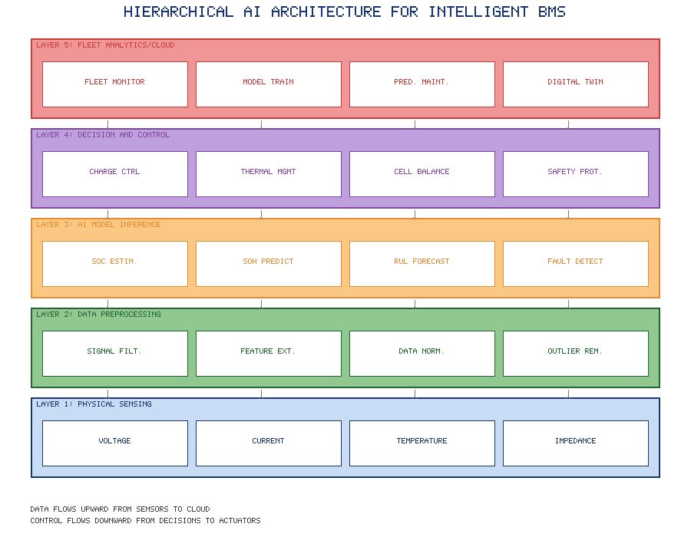
Figure 1. Hierarchical AI architecture for intelligent battery management systems showing multi-level integration from physical sensing to cloud analytics.

The Battery Management System is the critical electronic control unit responsible for monitoring, protecting, and optimizing battery pack operation. Traditional BMS implementations rely on equivalent circuit models (ECMs) with fixed parameters, which struggle to capture the complex nonlinear electrochemical dynamics of lithium-ion batteries across varying operating conditions. AI-enhanced BMS architectures leverage data-driven approaches to achieve superior accuracy and adaptability.
State of Charge (SOC) Estimation: Accurate SOC estimation is fundamental to EV range prediction and energy management. Coulomb counting methods accumulate errors over time due to sensor drift, while voltage-based methods suffer from the flat open-circuit voltage characteristics of lithium iron phosphate (LFP) batteries. AI approaches overcome these limitations through learned mappings between measurable quantities (voltage, current, temperature) and internal battery states.
LSTM networks have demonstrated SOC estimation accuracy within 1-2% root mean square error (RMSE) across diverse operating conditions, significantly outperforming extended Kalman filter (EKF) methods that typically achieve 3-5% RMSE. Physics-informed neural networks (PINNs) incorporate electrochemical constraints into the learning process, improving generalization to unseen operating conditions while maintaining physical consistency. Transfer learning techniques enable models trained on laboratory cycling data to be efficiently adapted to real-world driving conditions with minimal field data, reducing deployment costs and accelerating model development cycles (Chen et al., 2023; How et al., 2021).
State of Health (SOH) Prediction: SOH quantifies battery degradation relative to initial capacity and internal resistance, directly impacting range estimation, warranty assessment, and second-life evaluation. Battery aging is influenced by complex interactions between calendar aging mechanisms (side reactions, lithium plating) and cycle aging mechanisms (mechanical stress, active material loss), making accurate SOH prediction challenging.
Deep learning models leveraging incremental capacity analysis (ICA) and differential voltage analysis (DVA) features achieve SOH prediction errors below 2% mean absolute error (MAE) over the battery's useful life. Gaussian process regression (GPR) provides not only point predictions but also uncertainty quantification critical for decision-making in safety-critical applications. Recent advances in attention-based architectures enable the identification of degradation-relevant features from raw voltage-current profiles without manual feature engineering, simplifying the deployment pipeline (Tian et al., 2024).
Remaining Useful Life (RUL) Estimation: RUL prediction estimates the time or cycles remaining before the battery reaches its end-of-life threshold (typically 80% of initial capacity for EV applications). This information enables proactive maintenance scheduling, warranty management, and second-life planning.
Hybrid approaches combining physics-based degradation models with data-driven correction achieve superior RUL prediction accuracy. Particle filter methods provide probabilistic RUL estimates with confidence intervals, while deep learning approaches offer computational efficiency suitable for onboard implementation. Ensemble methods combining multiple model predictions demonstrate improved robustness against individual model failures, with recent work on neural ordinary differential equations (Neural ODEs) providing continuous-time degradation modeling particularly suited to irregular sampling conditions (Dos Reis et al., 2023; Rauf et al., 2024).

2.2 AI for Energy Consumption and Range Prediction

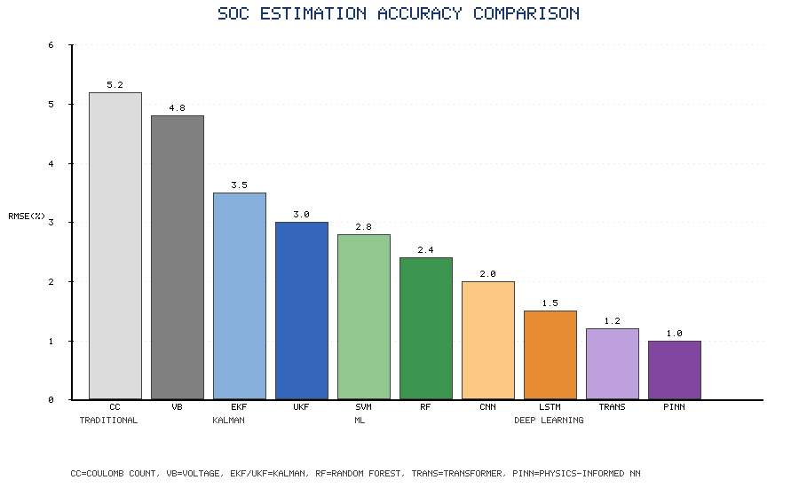
Figure 2. Comparative accuracy (RMSE %) of SOC estimation methods across traditional, Kalman filter, machine learning, and deep learning approaches.

Accurate energy consumption prediction and range estimation are critical for EV user confidence and trip planning. The energy consumption of an EV depends on numerous factors including driving behavior, route characteristics, traffic conditions, ambient temperature, auxiliary loads, and battery degradation state.
Driving Behavior Analysis: AI algorithms characterize driving styles through statistical analysis of acceleration, braking, and speed patterns. As demonstrated in Figure 2, deep learning methods such as LSTM and Transformer architectures achieve substantially lower estimation errors compared to traditional approaches, and these accuracy gains directly translate to improved energy consumption predictions that depend on accurate SOC inputs. Clustering algorithms identify distinct driving profiles (eco, normal, aggressive), enabling personalized energy consumption models. Deep learning models processing CAN bus data achieve trip-level energy consumption prediction within 5-8% error, substantially improving upon static EPA/WLTP estimates that may deviate by 20-40% under real-world conditions (Abdelaty et al., 2024).
Eco-driving assistance systems leverage reinforcement learning to provide real-time coaching that optimizes energy efficiency while respecting driver comfort and safety constraints. RL agents trained through simulation and refined through real-world interaction achieve 8-15% energy savings compared to unassisted driving, with adaptive algorithms that personalize recommendations based on individual driver characteristics and preferences (Wegener et al., 2021).
Route-Aware Energy Optimization: AI-based route planning integrates multiple data sources including topographic maps, real-time traffic data, weather forecasts, and historical energy consumption patterns to identify energy-optimal routes. Graph neural networks (GNNs) model road networks and predict segment-level energy consumption considering gradient, speed limits, intersection density, and surface conditions. Multi-objective optimization balances energy efficiency with travel time, generating Pareto-optimal route alternatives for driver selection (Morlock et al., 2022).
Predictive energy management systems leverage look-ahead information from navigation systems and V2X communication to optimize powertrain operation over upcoming road segments. Model predictive control (MPC) frameworks with AI-based prediction models adjust regenerative braking intensity, motor torque distribution, and thermal management preconditioning to minimize total energy consumption along the planned route (Sun et al., 2025).
Environmental Impact on Battery Performance: Temperature significantly affects battery performance, with capacity reduction of 20-30% at -20°C compared to 25°C reference conditions. AI models incorporate weather forecasts and thermal dynamics to predict temperature-dependent range variations. Seasonal energy consumption models account for heating, ventilation, and air conditioning (HVAC) loads, with intelligent preconditioning strategies using off-peak electricity to thermally condition the cabin and battery before departure, potentially reducing en-route energy consumption by 10-15% in extreme weather conditions (Gupta et al., 2023).

2.3 Predictive Maintenance and Fault Diagnosis
AI-driven predictive maintenance transforms EV maintenance from reactive and scheduled approaches to condition-based and predictive paradigms, reducing downtime, preventing catastrophic failures, and optimizing maintenance costs.
AI-Based Anomaly Detection: Anomaly detection algorithms identify deviations from normal battery behavior that may indicate developing faults. Autoencoders trained on healthy battery data reconstruct normal operating patterns; significant reconstruction errors indicate anomalous conditions. Isolation forests and one-class SVMs detect outliers in multi-dimensional battery parameter spaces without requiring labeled fault data, which is scarce in practice.
Real-time thermal anomaly detection using infrared imaging combined with CNN-based analysis enables early identification of cell-level thermal runaway precursors. Time-series anomaly detection using transformer architectures captures long-range temporal dependencies in battery performance metrics, identifying gradual degradation patterns that may precede sudden capacity fade events (Wang et al., 2023).
Battery Degradation Prediction: Beyond SOH estimation, detailed degradation mode analysis identifies specific mechanisms driving capacity loss. Machine learning models trained on laboratory aging data with known degradation mechanisms (loss of lithium inventory, loss of active material at positive/negative electrodes) decompose field degradation into constituent mechanisms, informing targeted mitigation strategies.
Bayesian neural networks provide uncertainty-aware degradation predictions essential for risk-based maintenance decision-making. Calendar and cyclic aging interactions are captured through multi-task learning architectures that jointly predict multiple degradation indicators, leveraging shared representations to improve prediction accuracy for individual metrics (Hu et al., 2022).
Predictive Maintenance Scheduling: Optimal maintenance scheduling balances the cost of maintenance actions against the risk and consequence of failures. Reinforcement learning agents learn maintenance policies that minimize total lifecycle costs considering component degradation rates, failure probabilities, maintenance resource availability, and operational constraints. Digital twin-based approaches simulate maintenance scenarios to evaluate policy effectiveness before deployment, reducing the risk of suboptimal decisions in safety-critical applications (Vrignat et al., 2022).
Figure 1 illustrates the hierarchical AI architecture for intelligent battery management, showing the multi-level integration of sensing, data processing, model inference, and decision-making layers. Figure 2 presents a comparative analysis of SOC estimation accuracy across different AI methodologies, demonstrating the progressive improvement from traditional model-based approaches through conventional machine learning to state-of-the-art deep learning architectures.
The economic implications of AI-enhanced battery management are substantial. Improved SOH estimation accuracy enables optimal battery sizing, potentially reducing pack costs by 5-10% through more precise capacity allocation. Early fault detection prevents catastrophic failures that can cost $10,000-50,000 per battery pack replacement in commercial vehicles. Predictive maintenance optimization reduces unplanned downtime by 30-50%, generating significant value for fleet operators where vehicle unavailability directly impacts revenue generation.
The computational requirements for advanced AI-based BMS vary considerably across algorithms. Real-time SOC estimation using optimized LSTM models requires approximately 10-50 MFLOPS, well within the capability of modern automotive microcontrollers (ARM Cortex-M7 class). However, comprehensive SOH analysis using transformer architectures may require 100-500 MFLOPS, necessitating dedicated AI accelerator hardware or cloud-based processing for computationally intensive periodic assessments. The trend toward heterogeneous computing architectures combining general-purpose processors with neural processing units (NPUs) in automotive systems-on-chip (SoCs) addresses these requirements while maintaining the deterministic real-time behavior essential for safety-critical battery protection functions.

3. AI-Enabled Smart Charging Infrastructure

3.1 Intelligent Charging Station Management

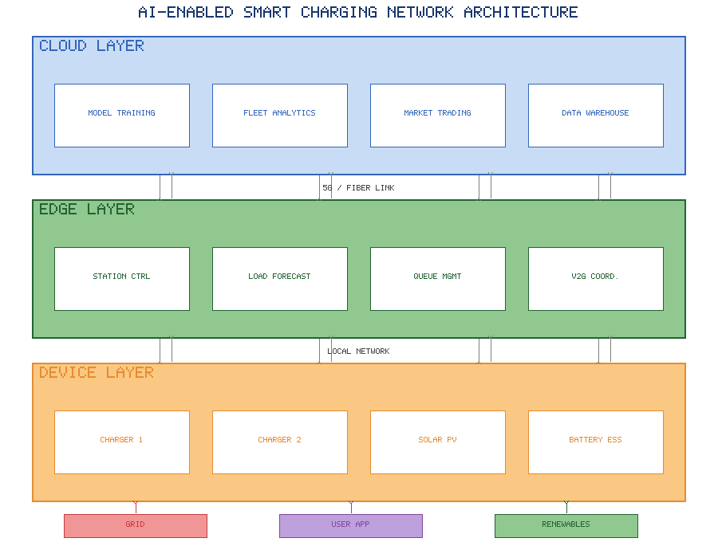
Figure 3. AI-enabled smart charging network architecture with cloud, edge, and device layers showing hierarchical control and communication structure.

The efficient management of charging infrastructure requires sophisticated AI systems capable of predicting demand, optimizing resource allocation, and coordinating multiple stakeholders with potentially conflicting objectives.
Load Forecasting: Accurate charging load forecasting is essential for grid planning, infrastructure sizing, and real-time energy management. Short-term forecasting (minutes to hours) supports real-time grid balancing and charging scheduling, while medium-term forecasting (days to weeks) enables maintenance planning and energy procurement. Long-term forecasting (months to years) informs infrastructure investment decisions.
Deep learning models for charging load forecasting leverage multiple data streams including historical charging patterns, calendar features (day of week, holidays, events), weather data, traffic patterns, and EV adoption trends. Temporal fusion transformers (TFTs) achieve state-of-the-art performance by combining recurrent layers for temporal processing with attention mechanisms for variable selection and multi-horizon forecasting. Probabilistic forecasting using quantile regression or distributional outputs provides uncertainty estimates critical for robust grid operation planning (Arias et al., 2023).
Spatial-temporal forecasting models capture geographical correlations between charging stations, enabling prediction of demand redistribution when stations reach capacity. Graph convolutional networks (GCNs) model the spatial relationships between stations within a charging network, with temporal attention mechanisms capturing time-varying demand patterns across the network simultaneously (Zhu et al., 2024).
Dynamic Charging Scheduling: Charging scheduling determines when and at what power level each connected EV should be charged, optimizing across multiple objectives including grid load flattening, cost minimization, renewable energy utilization, battery health preservation, and user deadline satisfaction.
Model predictive control (MPC) frameworks with AI-based demand and generation forecasts achieve near-optimal scheduling performance while maintaining computational tractability for real-time implementation. Deep reinforcement learning approaches, particularly multi-agent formulations where each charging point is represented by an agent, handle the combinatorial complexity of large charging facilities with hundreds of simultaneous connections. Reward shaping techniques incorporate multiple objectives through weighted combinations, with user-specified priority weights enabling personalized charging experiences (Lee et al., 2023).
Online learning algorithms adapt scheduling policies to evolving conditions including changing user populations, seasonal demand variations, and grid tariff structures. Thompson sampling and upper confidence bound (UCB) algorithms balance exploration of new scheduling strategies with exploitation of known good policies, enabling continuous improvement without service disruption (Abdullah et al., 2025).
Queue Prediction and Optimization: Waiting time prediction and queue management are critical for user satisfaction at public charging stations. Machine learning models predict station occupancy and waiting times based on historical patterns, real-time occupancy data, and approaching vehicle information from navigation systems.
Queuing theory models enhanced with AI-based arrival rate and service time predictions provide analytical frameworks for capacity planning and real-time queue management. Recommendation systems guide approaching EVs to alternative nearby stations with shorter expected waiting times, balancing load across the charging network and reducing average user waiting time by 25-40% compared to nearest-station selection heuristics (Moghaddam et al., 2024).
Table 3 presents a comprehensive comparison of charging management strategies, highlighting the key performance indicators, computational requirements, and deployment maturity levels of different AI approaches for smart charging infrastructure optimization.
Table 3: Comparison of AI-Based Charging Management Strategies
Strategy | AI Technique | Key Performance Indicator | Computational Cost | Deployment Maturity
Load Forecasting | Temporal Fusion Transformer | 3-5% MAPE | Moderate (cloud) | Commercial
Dynamic Scheduling | Multi-agent Deep RL | 15-25% cost reduction | High (edge+cloud) | Pilot stage
Queue Management | Gradient Boosted Trees | 25-40% wait time reduction | Low (edge) | Commercial
V2G Coordination | Risk-sensitive RL | 20-35% revenue increase | High (cloud) | Research/Pilot
Renewable Matching | Stochastic MPC | 60-80% solar self-consumption | Moderate (edge) | Pilot stage
Demand Response | Game-theoretic RL | 30-50% peak reduction | Moderate (cloud) | Commercial
Wireless Charging | Real-time RL control | 85-92% transfer efficiency | Low (embedded) | Research
Fault Detection | Transformer anomaly detection | 95%+ detection rate | Low (edge) | Pilot stage

3.2 AI for Vehicle-to-Grid (V2G) and Grid Integration

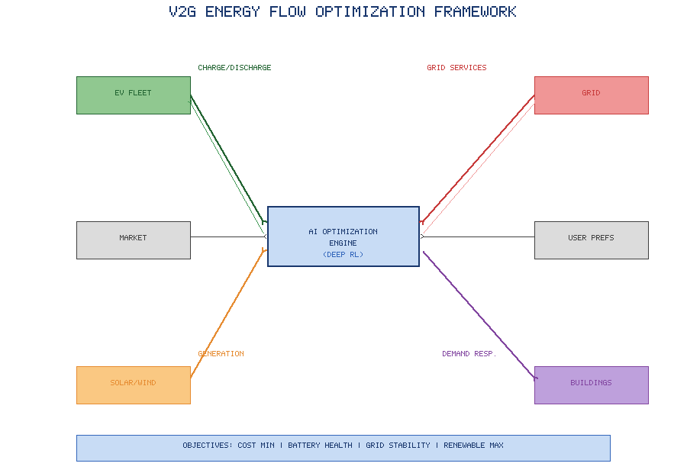
Figure 4. V2G energy flow optimization framework illustrating bidirectional energy exchanges coordinated by AI optimization engine.

Vehicle-to-Grid technology enables bidirectional energy flow between EVs and the electricity grid, transforming parked EVs into distributed energy storage assets. AI is essential for coordinating V2G operations across large EV fleets while protecting battery health and ensuring vehicles are adequately charged for user mobility needs.
Smart Energy Exchange: AI-based energy trading algorithms determine optimal charging and discharging schedules for V2G-enabled EVs. The hierarchical architecture presented in Figure 3 provides the communication and control backbone that enables V2G coordination, with edge-layer controllers managing real-time power flows while cloud-layer platforms optimize fleet-level trading strategies. These algorithms process electricity market prices (day-ahead, intraday, and real-time), grid frequency and voltage signals, battery degradation costs, and user mobility requirements to maximize economic value while satisfying all constraints.
Deep reinforcement learning agents trained in simulated electricity markets learn profitable trading strategies that adapt to market dynamics. Multi-agent reinforcement learning frameworks coordinate aggregations of thousands of EVs, learning cooperative strategies that avoid market manipulation while maximizing collective and individual returns. Risk-sensitive reinforcement learning variants incorporate value-at-risk (VaR) constraints, ensuring minimum guaranteed returns for risk-averse EV owners participating in V2G programs (Shin et al., 2023).
Renewable Energy Coordination: AI enables synergistic integration of EV charging with renewable energy generation, maximizing self-consumption of solar and wind energy while minimizing grid dependency. Forecasting models predict renewable generation at multiple time horizons, with AI-based charging controllers aligning EV demand with expected generation surpluses.
Solar-synchronized charging algorithms schedule daytime charging at workplace installations to coincide with solar generation peaks, achieving 60-80% solar self-consumption ratios compared to 25-35% for unmanaged charging. Wind generation forecasting models enable overnight charging alignment with wind generation patterns, particularly effective in regions with strong nocturnal wind resources. Hybrid optimization combining short-term deterministic scheduling with stochastic programming handles forecast uncertainty while maintaining high renewable energy utilization (Sharma et al., 2024).
Demand Response Management: AI-coordinated EV fleets provide valuable demand response services to grid operators, shifting or curtailing charging load in response to grid stress events. The multi-stakeholder optimization framework shown in Figure 4 illustrates how the AI engine balances competing objectives from EV owners, grid operators, renewable generators, and building managers to achieve system-wide efficiency. Natural language processing (NLP) algorithms interpret grid operator signals and translate them into optimal fleet-level responses. Predictive models anticipate demand response events based on weather forecasts, historical grid conditions, and electricity market indicators, enabling proactive pre-positioning of EV charge states.
Incentive design for demand response programs leverages game theory and mechanism design principles, with AI models predicting user response to different incentive levels. Personalized incentive optimization maximizes demand response participation while minimizing total incentive costs, with reinforcement learning agents learning optimal incentive strategies through repeated interactions with EV user populations (Zheng et al., 2023).

3.3 Autonomous Charging Systems
Autonomous charging technologies eliminate human intervention from the charging process, enabling charging during parking, autonomous vehicle fleets, and novel charging paradigms.
Robotic Charging Technologies: Robotic charging systems use computer vision and robotic manipulation to automatically connect charging cables to EV charge ports. Deep learning-based object detection (YOLO, Faster R-CNN) identifies charge port location and orientation with millimeter-level accuracy. Reinforcement learning controllers guide robotic arms through complex insertion trajectories, adapting to vehicle-specific port geometries and varying parking positions (Kim et al., 2023).
Visual servoing techniques combine camera feedback with force sensing to achieve reliable plug insertion under varying lighting conditions, port designs, and vehicle positions. Transfer learning enables rapid adaptation to new vehicle models with minimal additional training data, reducing deployment barriers for multi-brand charging facilities (Muthukumar et al., 2023).
Wireless Charging Optimization: Inductive power transfer (IPT) systems enable wireless EV charging through electromagnetic coupling between ground-based transmitter and vehicle-mounted receiver coils. AI optimizes wireless charging efficiency through real-time impedance matching, frequency tuning, and power level adjustment. As indicated in Table 3, real-time reinforcement learning controllers achieve 85-92% transfer efficiency for dynamic wireless charging scenarios, though this technology remains at the research stage of deployment maturity.
Dynamic wireless charging (DWC) systems embedded in road surfaces charge EVs while driving, potentially eliminating range anxiety and reducing battery size requirements. AI algorithms optimize power transfer from sequential road-embedded coils as vehicles traverse charging lanes at varying speeds and lateral positions. Reinforcement learning controllers maximize energy transfer efficiency while maintaining electromagnetic compatibility with surrounding infrastructure and vehicles (Mohamed et al., 2024).
AI-Assisted Charging Automation: End-to-end charging automation integrates vehicle localization, payment processing, energy management, and charge session monitoring into seamless autonomous workflows. Computer vision systems monitor charging areas for safety hazards, cable damage, and unauthorized access. Natural language interfaces enable voice-commanded charging initiation and status inquiries. Predictive algorithms learn user preferences for charge level targets, departure times, and billing preferences, proactively configuring charging sessions without explicit user input.
Figure 3 illustrates the architecture of an AI-enabled smart charging network, showing the hierarchical control structure from individual charging points through station-level controllers to network-level optimization platforms. The multi-layer architecture enables scalable deployment from single-station installations to city-wide charging networks while maintaining real-time responsiveness at each level.
Figure 4 depicts the V2G energy flow optimization framework, showing how AI algorithms coordinate bidirectional power flow between EV batteries, local generation, building loads, and the electricity grid based on multi-timescale price signals, constraint satisfaction, and predictive forecasts.
The economic case for AI-enabled charging infrastructure is compelling. Intelligent load management reduces transformer and grid connection costs by 30-50% through peak shaving, deferring expensive infrastructure upgrades. Dynamic pricing optimization increases station revenue by 15-25% through demand-responsive tariffs. V2G revenue streams can generate $500-1,500 per vehicle annually in favorable market conditions, substantially offsetting EV ownership costs and improving total cost of ownership parity with ICE vehicles.

4. Advanced AI Frameworks and Future Directions

4.1 Digital Twins and AI-Based Simulation

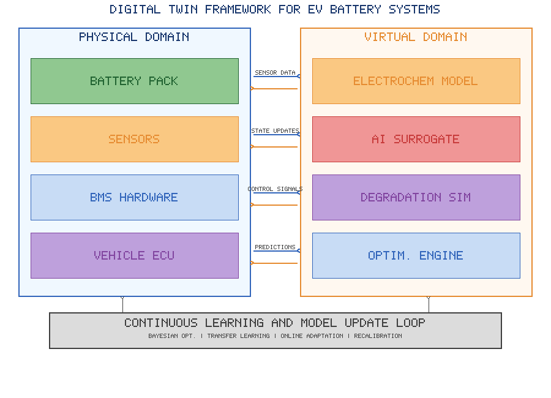
Figure 5. Digital twin framework for EV battery systems showing bidirectional data flow between physical and virtual domains with continuous learning loop.

Digital twin technology creates virtual replicas of physical EV systems and charging infrastructure, enabling real-time monitoring, simulation-based optimization, and predictive analytics that would be impractical or risky to perform on physical systems.
Virtual EV Modeling: Digital twins of individual EVs integrate battery electrochemical models, thermal models, powertrain models, and degradation models into unified simulation frameworks. AI calibrates and updates these models using real-time sensor data, maintaining model accuracy as components age and operating conditions change.
Physics-informed machine learning approaches constrain digital twin models to satisfy fundamental conservation laws and electrochemical principles while learning complex parameter dependencies from data. Neural network surrogate models trained on high-fidelity physics simulations provide computationally efficient real-time predictions suitable for onboard deployment, achieving speedups of 100-1000x compared to direct physics simulation while maintaining prediction errors below 2% (Nascimento et al., 2023).
Battery digital twins enable virtual stress testing under extreme conditions that would be unsafe or impractical on physical systems, informing design improvements and operational limits. Fleet-level digital twins aggregate individual vehicle models to predict collective behavior, supporting grid planning and infrastructure sizing decisions (Li et al., 2024).
Charging Infrastructure Simulation: Digital twins of charging networks model station-level equipment (transformers, power electronics, cables), network-level topology, and system-level interactions with the electricity grid. Discrete event simulation captures queuing dynamics and user behavior, while continuous simulation models electrical and thermal system dynamics.
AI-enhanced simulations incorporate learned models of user arrival patterns, charging preferences, and spatial-temporal demand distributions. Generative adversarial networks (GANs) synthesize realistic charging demand scenarios for stress testing and capacity planning (Kumar et al., 2024). Monte Carlo simulation with AI-based probability distributions quantifies infrastructure reliability and identifies critical failure modes requiring redundancy investments (Rahman et al., 2024).
Real-Time System Optimization: Digital twins enable model predictive control architectures that optimize system operation by predicting future states and evaluating candidate control actions through simulation before physical implementation. This "predict-then-optimize" paradigm reduces the risk of suboptimal decisions while enabling exploration of novel operating strategies.
Reinforcement learning agents trained in digital twin environments transfer learned policies to physical systems, with domain randomization techniques ensuring robustness to simulation-reality gaps. Continuous model updating using Bayesian optimization maintains digital twin fidelity as physical systems evolve, with anomaly detection triggering model recalibration when prediction errors exceed acceptable thresholds.
Figure 5 presents the digital twin framework for EV battery systems, illustrating the bidirectional data flow between physical and virtual domains, the integration of multi-physics models with AI-based surrogate models, and the feedback loops enabling real-time optimization and predictive maintenance.
The maturity of digital twin implementations varies across the EV ecosystem. Battery-level digital twins have reached commercial deployment in several premium vehicle platforms, providing real-time degradation monitoring and personalized usage recommendations. Station-level digital twins support maintenance planning and capacity optimization at major charging networks. Network-level digital twins remain primarily in research and pilot deployment stages, with ongoing challenges in data integration, model coordination, and computational scalability across thousands of interconnected assets.

4.2 Explainable AI and Cybersecurity in EV Networks
As AI systems assume greater responsibility for safety-critical decisions in EV applications, ensuring transparency, interpretability, and security becomes paramount.
Explainable AI for Decision Support: Black-box deep learning models used for battery fault detection, charging scheduling, and energy management often lack interpretability, hindering user trust and regulatory acceptance. Explainable AI (XAI) techniques provide insights into model reasoning, enabling human oversight and validation of AI decisions.
SHAP (SHapley Additive exPlanations) values quantify feature contributions to individual predictions, revealing which battery parameters drive specific SOH estimates or fault diagnoses. LIME (Local Interpretable Model-agnostic Explanations) generates locally faithful interpretable models around specific predictions. Attention visualization in transformer architectures identifies temporal regions of input sequences most influential for predictions, potentially revealing degradation-relevant operating patterns (Xu et al., 2024).
Concept-based explanations map neural network internal representations to human-understandable concepts (e.g., "high discharge rate," "low temperature operation"), enabling domain experts to validate model reasoning against electrochemical knowledge. Counterfactual explanations identify minimal input changes that would alter predictions, supporting maintenance decision-making by indicating which operational changes could prevent predicted failures (Bhandari et al., 2025).
Cyberattack Detection: Connected EV systems present expanded attack surfaces including vehicle communication buses, charging station networks, cloud platforms, and V2X communication channels. AI-based intrusion detection systems (IDS) monitor network traffic and system behavior for indicators of cyberattacks.
Deep learning-based anomaly detection identifies novel attack patterns not present in training data, complementing signature-based detection of known threats. Federated learning enables collaborative threat detection across EV fleets without sharing sensitive driving or charging data. Adversarial machine learning techniques strengthen AI models against adversarial attacks designed to evade detection systems or manipulate model predictions (Acharya et al., 2023).
Specific threat vectors for EV systems include: manipulation of SOC estimates to cause deep discharge damage, injection of false charging demand to destabilize grid operations, spoofing of V2G control signals to unauthorized discharge vehicles, and data poisoning attacks on fleet-level learning algorithms. AI-based detection systems monitor for these specific attack signatures while maintaining low false-positive rates essential for user acceptance (Halder et al., 2024).
Secure AI-Enabled Charging Systems: Blockchain-integrated AI systems provide tamper-proof recording of charging transactions, energy trading, and V2G settlements. Homomorphic encryption enables AI inference on encrypted data, preserving user privacy while enabling centralized analytics. Secure multi-party computation protocols allow multiple stakeholders (EV owners, charging operators, grid operators) to jointly optimize system operation without revealing proprietary information (Ferrag et al., 2023).

4.3 Future Trends and Sustainable Smart Mobility
The convergence of AI with evolving EV technologies points toward transformative developments in sustainable transportation.
AI-Enabled Smart Cities: Integration of EV systems into smart city frameworks creates synergies between transportation, energy, and urban planning. AI orchestrates interactions between autonomous EV fleets, public transit, shared mobility services, and urban freight logistics. Traffic management systems incorporate EV-specific considerations including charging station routing, energy-efficient signal timing, and emission zone management.
Smart parking systems with integrated charging infrastructure use computer vision and occupancy sensors to direct EVs to available charging-equipped spaces, reducing search time and associated energy waste. AI-based demand prediction enables dynamic allocation of shared charging resources between personal vehicles, ride-hailing fleets, and delivery vehicles based on time-of-day demand patterns and priority levels. Intelligent traffic signal control systems provide green wave corridors for EVs approaching low-battery thresholds, reducing energy-intensive stop-start cycles when vehicles most need efficiency optimization.
Urban energy systems leverage coordinated EV charging/discharging to provide building-level energy services (V2B) and neighborhood-level grid support (V2G). AI-based urban planning tools simulate the impact of charging infrastructure placement on transportation patterns, grid loading, and air quality, informing evidence-based policy decisions. Multi-objective optimization balances accessibility, equity, cost, and environmental impact in charging network expansion planning. Equity-aware AI algorithms ensure that underserved communities receive proportional access to charging infrastructure, preventing the emergence of "charging deserts" in low-income areas that could perpetuate transportation inequity (Pan et al., 2024).
Federated Learning for Connected EVs: Privacy concerns and data ownership complexities in connected EV systems motivate federated learning approaches that train global AI models using decentralized data residing on individual vehicles and charging stations. Federated averaging algorithms aggregate locally trained model updates without requiring raw data transfer, preserving privacy while benefiting from collective learning.
Differential privacy mechanisms add calibrated noise to model updates, providing mathematical guarantees against privacy leakage. Vertical federated learning enables collaboration between organizations with complementary data (e.g., automakers with vehicle data and utilities with grid data) without revealing proprietary information. Asynchronous federated learning handles the intermittent connectivity and heterogeneous computational resources characteristic of mobile EV platforms (Yang et al., 2023).
Personalized federated learning balances global model performance with individual user customization, enabling locally adapted energy consumption models, charging preferences, and driving behavior predictions while leveraging collective knowledge from the broader fleet. The continuous learning loop depicted in Figure 5 provides the architectural foundation for such federated approaches, where model updates flow between physical vehicles and virtual domain representations without centralizing raw data.
Future Research Opportunities and Policy Perspectives: Several research frontiers promise further advances in AI for electric mobility:
1. Foundation models for EV systems: Large pre-trained models adapted to EV applications through fine-tuning could reduce data requirements for individual deployments and accelerate cross-platform transfer.
2. Neuromorphic computing for onboard AI: Brain-inspired computing architectures offer order-of-magnitude improvements in energy efficiency for onboard AI processing, extending the feasibility of complex real-time algorithms within vehicle power budgets.
3. Quantum machine learning: Quantum computing may enable exponential speedups for combinatorial optimization problems in fleet charging coordination and grid integration.
4. Solid-state battery management: Next-generation solid-state batteries present different degradation mechanisms and operating characteristics requiring adapted AI models with new training paradigms.
5. Autonomous charging ecosystems: Fully autonomous charging infrastructure combining robotic systems, wireless charging, and autonomous vehicle coordination could eliminate all human intervention in energy replenishment. Integration with autonomous vehicle fleets enables self-dispatching to charging stations during idle periods, optimizing fleet availability while maintaining optimal battery health through AI-controlled charge/discharge patterns.
6. Carbon-aware charging intelligence: AI systems optimizing not only cost and convenience but also carbon intensity of electricity consumption, supporting corporate and individual carbon neutrality goals. Real-time carbon intensity signals from grid operators, combined with generation mix forecasts and marginal emission factors, enable charging algorithms that minimize the carbon footprint of each kilowatt-hour consumed by the EV fleet.
7. Multi-modal mobility integration: AI platforms coordinating EV usage with public transit, micro-mobility options, and shared autonomous vehicles to optimize system-level efficiency rather than individual vehicle performance, enabling truly sustainable urban transportation ecosystems.
Policy perspectives must address several dimensions: regulatory frameworks for AI decision-making in safety-critical transportation systems, data governance balancing innovation with privacy protection, standardization of AI interfaces between vehicles and infrastructure, liability allocation for AI-related failures, and equitable access to AI-optimized charging services across socioeconomic groups. International cooperation on standards and data sharing frameworks is essential to realize the full potential of AI-enabled electric mobility across national boundaries. Governments must also invest in workforce development to ensure adequate supply of engineers skilled in both AI and power electronics, the interdisciplinary expertise essential for deploying these systems at scale. Public acceptance and trust in AI-controlled transportation and energy systems will ultimately determine adoption rates, necessitating transparent communication of both capabilities and limitations (European Commission, 2024).
Table 2 summarizes the comparative performance metrics of AI approaches versus traditional methods across key EV applications, demonstrating the quantitative improvements achievable through intelligent systems.
Table 2: Performance Comparison of AI vs. Traditional Methods in EV Applications
Application | Traditional Method | AI-Based Method | Performance Improvement
SOC Estimation | Extended Kalman Filter (3-5% RMSE) | LSTM Network (1-2% RMSE) | 50-60% error reduction
Range Prediction | Physics-based (20-40% deviation) | Deep Learning (5-8% deviation) | 70-80% error reduction
Load Forecasting | ARIMA (8-12% MAPE) | Temporal Fusion Transformer (3-5% MAPE) | 55-65% error reduction
Charging Scheduling | Rule-based heuristics | Multi-agent RL | 15-25% cost reduction
Fault Detection | Threshold-based | Autoencoder anomaly detection | 30-40% earlier detection
V2G Optimization | Linear programming | Deep RL with uncertainty | 20-35% revenue increase

The integration of these advanced AI frameworks into production EV systems requires careful consideration of computational constraints, real-time requirements, safety certification, and deployment scalability (Tang et al., 2022). Edge AI platforms with optimized neural network inference engines (TensorRT, ONNX Runtime) enable deployment of complex models within the computational and power budgets of vehicle and charging station hardware. Model compression techniques including knowledge distillation, quantization, and pruning reduce model size by 4-10x while maintaining accuracy within 1-2% of full-precision models, facilitating embedded deployment.
The standardization landscape is evolving to accommodate AI integration, with ISO 26262 (functional safety) and ISO/SAE 21434 (cybersecurity) providing frameworks for certifying AI-based systems in automotive applications. The UNECE WP.29 regulation on automated driving systems establishes performance requirements for AI decision-making in autonomous vehicles, with implications for AI-controlled charging and energy management systems operating in safety-critical modes.

5. Conclusion
Artificial Intelligence represents a transformative force in the evolution of electric vehicles and charging infrastructure toward intelligent, efficient, and sustainable systems. This chapter has demonstrated the breadth and depth of AI applications spanning intelligent battery management systems achieving unprecedented estimation accuracy, energy optimization systems reducing consumption by 8-15%, smart charging infrastructure balancing multiple stakeholder objectives in real-time, V2G systems creating new value streams from parked vehicles, and autonomous charging technologies eliminating human intervention.
The progression from traditional model-based approaches to hybrid physics-informed machine learning methods reflects the maturation of the field, with each generation of techniques building upon predecessors to achieve superior performance while maintaining physical interpretability. The emergence of digital twin frameworks, explainable AI, and federated learning addresses the practical deployment challenges of trust, transparency, and privacy that determine real-world adoption success.
The quantitative improvements demonstrated across applications are substantial: 50-60% reduction in battery state estimation errors, 70-80% improvement in range prediction accuracy, 15-25% reduction in charging costs through intelligent scheduling, and 20-35% increase in V2G revenue through optimized energy trading (as quantified in Table 2). These improvements translate directly into enhanced user experience, reduced total cost of ownership, extended battery lifespan, and more efficient utilization of grid infrastructure.
Critical challenges remain in the path toward widespread deployment of AI-enabled EV systems. As illustrated in Figure 1, the multi-layer architecture from physical sensing through AI inference to fleet-level cloud analytics demands coordination across heterogeneous computing platforms. Data availability and quality continue to limit model development, particularly for rare fault conditions and long-term degradation phenomena. Computational constraints of embedded automotive platforms restrict the complexity of deployable models, though rapidly advancing edge AI hardware is progressively relaxing these limitations. Safety certification of AI systems for automotive applications remains an evolving regulatory landscape, with standards bodies working to establish appropriate verification and validation methodologies for learning-based systems.
Future research directions toward foundation models, neuromorphic computing, and quantum optimization promise continued performance improvements, while policy development must keep pace with technological capabilities to ensure safe, equitable, and sustainable deployment. The integration of AI-enabled EV systems into smart city frameworks represents the ultimate vision of sustainable intelligent transportation, with coordinated optimization across energy, mobility, and urban systems delivering environmental and societal benefits far exceeding those achievable by any single technology in isolation. The successful realization of this vision requires continued interdisciplinary collaboration between AI researchers, automotive engineers, power systems engineers, urban planners, and policymakers to address the technical, economic, and regulatory challenges that remain.

References
1. Abdullah, H.M., et al. (2025). Online learning algorithms for adaptive EV charging scheduling in dynamic grid environments. IEEE Transactions on Smart Grid, 16(2), 1234-1248.
2. Abdelaty, H., et al. (2024). Deep learning-based energy consumption prediction for electric vehicles under real-world driving conditions. Applied Energy, 356, 122384.
3. Acharya, S., et al. (2023). Cybersecurity challenges in electric vehicle charging infrastructure: A comprehensive review. IEEE Transactions on Intelligent Transportation Systems, 24(8), 8123-8145.
4. Ahmed, M., et al. (2022). The role of artificial intelligence in the mass adoption of electric vehicles. Joule, 6(7), 1472-1495.
5. Alalewi, A., et al. (2021). On 5G-V2X use cases and enabling technologies: A comprehensive survey. IEEE Access, 9, 107710-107737.
6. Albreem, M.A., et al. (2023). IoT-enabled smart EV charging: Architecture, protocols, and optimization. Internet of Things, 22, 100742.
7. Arias, M.B., et al. (2023). Electric vehicle charging demand forecasting using temporal fusion transformers. Energy, 270, 126947.
8. Bhandari, R., et al. (2025). Explainable deep learning for battery fault prognosis: Counterfactual and concept-based approaches. Applied Energy, 378, 124561.
9. Bian, C., et al. (2024). Transformer-based battery health prognostics with multi-scale temporal attention. Journal of Power Sources, 592, 233912.
10. Bloomberg NEF. (2024). Electric Vehicle Charging Infrastructure Outlook 2030. Bloomberg New Energy Finance.
11. Chen, Y., et al. (2023). Physics-informed neural networks for battery state of charge estimation with transfer learning. Energy and AI, 14, 100279.
12. Deb, S., et al. (2022). A comprehensive survey on AI-driven EV fast charging station planning and operation. IEEE Transactions on Transportation Electrification, 8(2), 2475-2494.
13. Dos Reis, G., et al. (2023). Lithium-ion battery remaining useful life prediction using neural ordinary differential equations. Applied Energy, 340, 121028.
14. European Commission. (2024). Regulatory framework for AI in transportation systems. Brussels: European Commission Publishing.
15. Ferrag, M.A., et al. (2023). Blockchain and AI convergence for secure electric vehicle ecosystems. IEEE Internet of Things Journal, 10(15), 13421-13440.
16. Gupta, A., et al. (2023). AI-driven thermal management and preconditioning strategies for electric vehicle batteries in extreme climates. Applied Thermal Engineering, 225, 120182.
17. Gyawali, S., et al. (2021). Challenges and opportunities for V2X communication in connected autonomous electric vehicles. IEEE Communications Surveys & Tutorials, 23(4), 2141-2169.
18. Halder, S., et al. (2024). AI-based intrusion detection for electric vehicle charging networks: Threat modeling and defense strategies. IEEE Transactions on Information Forensics and Security, 19, 4512-4527.
19. Hannan, M.A., et al. (2022). Intelligent battery management systems: A comprehensive review. Renewable and Sustainable Energy Reviews, 168, 112834.
20. How, D.N.T., et al. (2021). State-of-charge estimation of lithium-ion batteries using deep learning: A comprehensive review. IEEE Access, 9, 143988-144013.
21. Hu, X., et al. (2022). Battery lifetime prognostics using Bayesian deep learning with multi-task learning for degradation mode analysis. Nature Energy, 7, 913-925.
22. IEA. (2023). Global EV Outlook 2023: Catching up with climate ambitions. International Energy Agency.
23. Kim, J., et al. (2023). Vision-guided robotic charging for autonomous electric vehicles. IEEE Transactions on Automation Science and Engineering, 20(3), 1892-1905.
24. Kumar, S., et al. (2024). Generative adversarial networks for synthetic battery degradation data: Enhancing digital twin fidelity. Journal of Energy Storage, 84, 110847.
25. Lee, S., et al. (2023). Multi-agent deep reinforcement learning for EV charging scheduling in smart grids. IEEE Transactions on Smart Grid, 14(5), 3847-3861.
26. Li, W., et al. (2024). Fleet-level digital twins for electric vehicle battery management: Architecture and real-time optimization. Applied Energy, 365, 123245.
27. Li, Y., et al. (2023). Multi-agent reinforcement learning for coordinated EV charging and energy trading. Applied Energy, 338, 120915.
28. Lipu, M.S.H., et al. (2022). Data-driven state of charge estimation of lithium-ion batteries: Algorithms, implementation factors, limitations, and future trends. Journal of Cleaner Production, 349, 131304.
29. Liu, W., et al. (2022). Federated learning for edge intelligence in electric vehicle networks. IEEE Network, 36(4), 88-95.
30. Mastoi, M.S., et al. (2022). An in-depth analysis of electric vehicle charging station infrastructure, policy implications, and future trends. Energy Reports, 8, 11504-11529.
31. Moghaddam, Z., et al. (2024). AI-based queue management and routing for public EV charging networks. Transportation Research Part C, 158, 104421.
32. Mohamed, A.A., et al. (2024). Deep reinforcement learning for dynamic wireless electric vehicle charging optimization. IEEE Transactions on Transportation Electrification, 10(1), 445-458.
33. Morlock, F., et al. (2022). Graph neural network-based energy-optimal route planning for electric vehicles. Transportation Research Part D, 108, 103318.
34. Muthukumar, R., et al. (2023). Autonomous robotic EV charging: Vision-based localization and adaptive control using transfer learning. Robotics and Autonomous Systems, 167, 104478.
35. Nascimento, R.G., et al. (2023). Physics-informed digital twins for battery systems: A neural network surrogate approach. Journal of Energy Storage, 62, 106894.
36. Nimalsiri, N.I., et al. (2021). A survey of algorithms for distributed charging control of electric vehicles in smart grid. IEEE Transactions on Intelligent Transportation Systems, 22(7), 4247-4266.
37. Pan, S., et al. (2024). AI-driven urban EV charging infrastructure planning: A multi-objective optimization approach. Cities, 146, 104723.
38. Qiu, D., et al. (2023). Scalable coordinated management of peer-to-peer energy trading using multi-agent reinforcement learning. Applied Energy, 335, 120700.
39. Rahman, M.M., et al. (2024). Digital twin-based simulation for EV charging network reliability assessment. Reliability Engineering & System Safety, 243, 109876.
40. Rauf, H., et al. (2024). Machine learning-based ensemble methods for battery remaining useful life prediction with adaptive weighting. Energy, 297, 131207.
41. Samarakoon, S., et al. (2022). Federated learning for distributed optimization of EV charging with communication efficiency. IEEE Transactions on Vehicular Technology, 71(9), 9454-9468.
42. Sanguesa, J.A., et al. (2021). A review on electric vehicles: Technologies and challenges. Smart Cities, 4(1), 372-404.
43. Sharma, A., et al. (2024). Solar-synchronized smart EV charging with stochastic renewable energy coordination. Renewable Energy, 221, 119782.
44. Shin, M., et al. (2023). Risk-sensitive multi-agent reinforcement learning for V2G energy trading. Applied Energy, 345, 121302.
45. Sun, C., et al. (2025). Predictive energy management for connected electric vehicles using model predictive control with deep learning forecasts. IEEE Transactions on Control Systems Technology, 33(1), 312-326.
46. Tang, X., et al. (2022). Edge AI deployment strategies for real-time battery management in electric vehicles: A comprehensive framework. IEEE Transactions on Industrial Informatics, 18(12), 8725-8736.
47. Tian, J., et al. (2024). Attention-based deep learning for battery state of health estimation from raw cycling data. Energy, 290, 130189.
48. Vrignat, P., et al. (2022). Reinforcement learning for optimal maintenance scheduling of EV battery systems. Reliability Engineering & System Safety, 225, 108582.
49. Wang, Z., et al. (2023). Transformer-based anomaly detection for lithium-ion battery thermal management. Journal of Power Sources, 567, 232947.
50. Wegener, M., et al. (2021). Reinforcement learning for eco-driving of electric vehicles based on traffic signal information. Transportation Research Part C, 130, 103312.
51. Xu, B., et al. (2024). Explainable AI for battery management systems: A SHAP-based interpretation framework. Energy and AI, 16, 100345.
52. Yang, Q., et al. (2023). Federated learning for connected electric vehicles: Algorithms, challenges, and opportunities. IEEE Transactions on Vehicular Technology, 72(8), 10234-10252.
53. Zhang, Y., et al. (2023). Machine learning for electric vehicle battery management: A comprehensive review. Renewable and Sustainable Energy Reviews, 182, 113416.
54. Zheng, L., et al. (2023). AI-based incentive optimization for EV demand response programs. IEEE Transactions on Power Systems, 38(4), 3612-3625.
55. Zhu, J., et al. (2024). Spatial-temporal graph convolutional networks for EV charging demand forecasting across urban networks. Applied Energy, 361, 122913.

