AI-POWERED DIGITAL MARKETING FOR SUSTAINABILITY
Authors: Amman Jakhar¹,* and Sachin Kalsi¹
¹ Department of Mechanical Engineering, Chandigarh University, Mohali, Punjab-140301
*Corresponding Email: ammanjakhar5000734@gmail.com

Abstract
This chapter examines how artificial intelligence (AI) is reshaping digital marketing in response to an intensifying sustainability imperative, and it offers a balanced assessment of the resulting opportunities and risks. As climate change, resource depletion, and ecological degradation move to the center of public concern, consumers increasingly expect brands to demonstrate ethical behavior, transparency, and accountability rather than issue vague environmental claims. AI technologies—predictive analytics, natural language processing, computer vision, and recommendation engines—equip marketers to move beyond broadcast messaging toward hyper-personalized, context-aware communication that can be deliberately directed at encouraging pro-environmental behavior. The chapter analyzes concrete strategic applications, including the intelligent segmentation of eco-conscious audiences, dynamic pricing and personalized recommendation systems that lower the friction of sustainable choices, AI-assisted optimization of green communications, and real-time carbon-footprint labelling in electronic commerce. It then turns a critical lens on the double-edged character of these capabilities, examining algorithmic bias, data-privacy intrusions, and the sophisticated threat of AI-enabled greenwashing, before confronting the paradox that the computational infrastructure powering sustainable marketing carries a substantial energy and carbon footprint of its own. From this analysis the chapter derives a framework for responsible AI-driven sustainable marketing built on ethical design, radical transparency, consumer empowerment, and measurable impact assessment. Drawing on applications across the fashion, food, and e-commerce sectors, it concludes with practical recommendations for marketers, policymakers, and technology developers, and identifies priorities for future research. Four figures and four tables synthesize the conceptual and empirical material throughout.
Keywords: Artificial Intelligence; Digital Marketing; Sustainability; Green Consumer; Responsible AI; Greenwashing

1. The Intersection of AI, Marketing, and the Sustainability Imperative
The convergence of three powerful forces is redefining the contemporary marketplace. The first is an environmental and social imperative that no longer sits at the margins of commercial life but increasingly governs the terms on which businesses operate and earn public trust. The second is a profound transformation in consumer sensibility, as buyers come to treat the ecological and ethical consequences of their purchases as integral to the value they seek rather than as peripheral considerations. The third is the rapid maturation of artificial intelligence as a practical marketing instrument capable of understanding, predicting, and shaping behavior at a scale and granularity that earlier generations of marketers could scarcely imagine. Where these forces meet, a new field of practice is taking shape, one in which the tools of digital marketing are turned toward the promotion of sustainable consumption and the construction of credible, accountable brand relationships. This chapter maps that emerging field, tracing both its promise and its perils and proposing principles for its responsible development.
The argument proceeds in four movements. This opening section establishes the context by examining the evolving consumer-brand relationship and the specific capabilities that AI brings to marketing. The second section investigates the strategic applications through which AI is being used to encourage sustainable choices. The third section adopts a deliberately critical posture, analyzing the ethical hazards and the environmental cost of the technology itself. The fourth section moves from diagnosis to prescription, offering a framework for responsible practice together with sector-specific illustrations and concrete recommendations. Throughout, the aim is neither uncritical enthusiasm nor reflexive skepticism but a measured account of how a resource-intensive technology might be governed so that it advances genuine sustainability rather than merely the appearance of it.

1.1 The New Consumer-Brand Dynamic: Sustainability as a Core Expectation
The accumulating evidence of climate change, biodiversity loss, and resource depletion has reconfigured the expectations that consumers bring to the marketplace. Sustainability has shifted from a niche preference held by a committed minority toward a mainstream expectation that increasingly conditions brand choice, loyalty, and advocacy [1]. Consumers across many markets now express a willingness to favor products and companies that demonstrate environmental responsibility, and a corresponding readiness to penalize those perceived as indifferent or deceptive [2]. This reorientation of demand places sustainability at the heart of competitive strategy rather than at its edges, transforming what was once a matter of corporate philanthropy into a determinant of commercial viability [1].
Yet the relationship between stated environmental values and actual purchasing behavior is notoriously inconsistent, a phenomenon widely described as the attitude–behavior or intention–behavior gap [3]. Consumers who profess strong environmental commitments frequently fail to act on them at the point of purchase, deterred by higher prices, perceived performance trade-offs, limited availability, inconvenience, or simple skepticism about whether their choices make any difference [3]. Research on the drivers of green consumption has identified a dense web of psychological, social, and contextual factors that mediate the translation of concern into action, including perceived consumer effectiveness, social norms, trust, and the cognitive effort required to evaluate competing claims [4]. A recurring finding is that sustainable options are often saddled with a perceived liability—an implicit assumption that greener products must sacrifice quality, strength, or effectiveness—that suppresses adoption even among sympathetic buyers [5].
A further complication is that the salience of sustainability varies sharply across product categories and purchase occasions. Environmental considerations may weigh heavily in the choice of a durable appliance or a staple grocery item yet recede almost entirely in impulse or convenience purchases, so that the same individual behaves as a committed green consumer in one context and an indifferent one in another [3]. This situational variability frustrates any attempt to profile green consumers through fixed attributes and helps explain why broad environmental campaigns so often fail to move behavior: they address an abstraction rather than the concrete moment of decision in which competing considerations are actually weighed [4].
The modern green consumer is therefore best understood not as a fixed demographic category but as a spectrum of motivations and constraints that vary across individuals, products, and situations [4]. Some are driven by deep ecological conviction, others by health concerns, social signaling, or cost savings; many hold genuine intentions that founder on practical obstacles [5]. This heterogeneity has a direct strategic implication: brands cannot reach these consumers through undifferentiated messaging but must instead understand the specific barriers and motivations that operate for particular segments in particular contexts. At the same time, the rising demand for transparency and accountability means that communication must be credible and verifiable, because consumers increasingly scrutinize environmental claims and react sharply against those that appear exaggerated or unsubstantiated [2]. Firms that manage to align authentic environmental performance with trustworthy communication stand to earn durable loyalty, whereas those that overstate their credentials risk reputational damage that can outweigh any short-term gain [6]. It is precisely this combination of heterogeneous, hard-to-reach audiences and an exacting demand for credible transparency that creates both the need and the opening for more intelligent marketing tools.

1.2 The AI Advantage: Redefining Digital Marketing Capabilities
Artificial intelligence enters this landscape as a set of technologies that fundamentally extend what marketing can perceive, predict, and personalize. Four families of capability are especially consequential. Predictive analytics uses machine learning to forecast consumer behavior—propensity to purchase, likelihood of churn, responsiveness to particular appeals—from large and heterogeneous data streams [7]. Natural language processing (NLP) enables machines to interpret and generate human language, powering sentiment analysis, conversational agents, and the automated drafting and testing of marketing copy [8]. Computer vision allows systems to analyze images and video, supporting applications from visual search to the monitoring of brand presence and product use [9]. Recommendation engines synthesize behavioral and contextual signals to suggest products and content tailored to the individual, shaping discovery and choice at scale [7]. Table 1 summarizes these core technologies, their marketing functions, and their specific relevance to the promotion of sustainable consumption.
[Insert Table 1 here]
Table 1. Core AI Technologies and Their Application to Sustainable Marketing
AI Technology | Primary Marketing Function | Application to Sustainability
Predictive analytics | Forecasting behavior, segmentation, targeting | Identifying receptive audiences and timing pro-environmental appeals
Natural language processing | Sentiment analysis, content generation, chatbots | Optimizing green messaging and detecting greenwashing language
Computer vision | Image and video analysis, visual search | Verifying product provenance and enabling circular-economy platforms
Recommendation engines | Personalized product and content suggestions | Nudging adoption of eco-friendly alternatives and bundles
What distinguishes AI-enabled marketing from its predecessors is not merely automation but a qualitative shift toward personalization, context-awareness, and continuous learning [10]. Traditional marketing largely addressed broad segments with static messages; AI permits the tailoring of content, offers, and timing to the individual, adjusted dynamically as circumstances and responses change [8]. Systems can infer context—location, device, moment, mood as expressed in language—and adapt accordingly, producing communication that is more relevant and, potentially, more persuasive [10]. They also learn iteratively, using the outcomes of past interactions to refine future ones through continuous experimentation [11]. These capabilities have been examined extensively in the marketing literature, which documents both their transformative potential and the organizational and ethical complexities they introduce [12].
For sustainability, this capacity for nuance is strategically significant. Because the barriers to sustainable consumption are so varied and context-dependent, the ability to diagnose and address individual-level obstacles is precisely what generic green campaigns have lacked [11]. AI makes it feasible to identify which consumers are receptive to which appeals, to anticipate the moments at which a pro-environmental nudge is most likely to succeed, and to craft messages calibrated to specific motivations rather than relying on one-size-fits-all exhortation [12]. The remainder of this chapter examines how these capabilities are being applied, beginning with the strategic levers through which AI influences sustainable consumption.

2. Strategic Applications of AI for Sustainable Consumption
Building on the capabilities outlined above, this section examines how AI is deployed in practice to promote sustainable choices. Two broad domains of application are considered: the direct influence of consumer behavior through intelligent segmentation and incentivization, and the enhancement of transparency and communication so that sustainability messaging is clear, credible, and resistant to greenwashing.

2.1 Driving Consumer Action: Intelligent Segmentation and Incentivization
The first and most mature application lies in the intelligent segmentation of consumers. Machine learning enables marketers to move beyond crude demographic categories toward fine-grained behavioral segmentation that groups consumers by their actual patterns of engagement, purchase, and expressed value [13]. By analyzing transactional histories, browsing behavior, and social signals, these systems can identify clusters of eco-conscious consumers and, crucially, distinguish among the varieties of green motivation discussed earlier, separating the ethically committed from the cost-sensitive or the health-oriented [13]. This granular understanding allows messaging to be tailored to the specific values and barriers of each segment, addressing, for example, price anxiety for one group and performance skepticism for another, thereby directly attacking the attitude–behavior gap that undermines generic appeals [14].
Beyond segmentation, AI reshapes the economics of sustainable choice through dynamic pricing and personalized recommendation. Dynamic pricing systems, which use algorithms to adjust prices in response to demand, inventory, and individual willingness to pay, can be configured to lower the effective cost of sustainable options or to reward environmentally preferable behavior, such as off-peak energy use or the selection of consolidated, lower-emission delivery [15]. Personalized recommendation engines, meanwhile, can be tuned to surface eco-friendly alternatives, complementary sustainable products, or lower-impact bundles at the moment of decision, reducing the search effort that otherwise deters green purchasing [16]. Because recommendation systems exert a demonstrable influence on what consumers discover and ultimately buy, their deliberate orientation toward sustainable options represents a potent lever for shifting aggregate consumption patterns [16]. The strategic significance of this lever is amplified by its position in the decision process: by acting at the moment of discovery rather than after a preference has formed, recommendation can shape the choice set itself, making sustainable options the ones a consumer sees first and considers most seriously, and thereby circumventing the deliberative resistance that explicit persuasion often provokes [13]. Figure 1 situates these applications within the broader convergence of AI, marketing, and sustainability that frames the chapter.
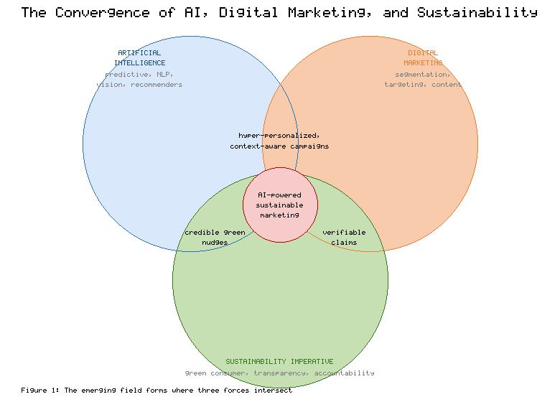
Figure 1. The Convergence of AI, Digital Marketing, and the Sustainability Imperative
These mechanisms draw heavily on insights from behavioral science, and their design reflects a deliberate architecture of choice. The emerging retail environment integrates AI-driven personalization throughout the customer journey, from discovery to post-purchase engagement, creating numerous points at which sustainable defaults and prompts can be introduced [17]. The theory of nudging holds that small changes in the way choices are presented—defaults, framing, salience, and the communication of social norms—can substantially influence behavior without restricting freedom of choice [18]. AI amplifies the precision of such nudges by personalizing them: descriptive social-norm messages indicating that similar consumers are choosing sustainable options can be targeted to those most susceptible to normative influence, and defaults can be set intelligently to favor lower-impact outcomes [18]. Field evidence suggests that appeals to descriptive norms can meaningfully shift consumption toward sustainable alternatives when they are well targeted and credible [19]. Table 2 maps the principal mechanisms of AI-driven incentivization to their behavioral rationale and illustrative sustainable outcomes.
[Insert Table 2 here]
Table 2. AI-Driven Mechanisms for Encouraging Sustainable Consumption
Mechanism | Behavioral Rationale | Illustrative Sustainable Outcome
Behavioral segmentation | Tailors appeals to specific motivations and barriers | Higher conversion among receptive eco-segments
Dynamic pricing | Adjusts cost to reward preferable behavior | Lower effective price of green options; off-peak demand
Personalized recommendation | Reduces search effort at point of decision | Greater discovery and uptake of eco-friendly products
Intelligent defaults and nudges | Leverages inertia and social norms | Lower-impact delivery, packaging, and product choices
The strategic promise of these applications is that they make sustainable consumption easier, cheaper, and more attractive at the individual level, converting latent environmental concern into realized behavior [14]. Yet the same mechanisms that can nudge consumers toward sustainability can equally be directed toward consumption-maximizing ends, and the ethical ambiguity of personalized persuasion is a theme to which the chapter returns in Section 3 [17].

2.2 Enhancing Transparency and Communication through AI
A second domain of application concerns the clarity, credibility, and integrity of sustainability communication. Because consumers are increasingly skeptical of environmental claims, the effectiveness of green marketing depends on its perceived authenticity, and here AI offers tools both to improve and to police communication [20]. Natural language processing enables the automated optimization of green messaging, testing variations of copy for clarity and resonance and identifying language that is likely to be read as vague, exaggerated, or misleading [21]. Greenwashing—the dissemination of false or unsubstantiated impressions of environmental responsibility—takes many forms, from outright fabrication to the selective disclosure of favorable information and the use of ambiguous or unverifiable language [22]. AI-based content analysis can flag the hallmarks of such communication, helping firms discipline their own claims and enabling watchdogs to detect deceptive messaging at scale [20].
The most consumer-facing of these transparency applications is real-time carbon-footprint labelling, particularly in electronic commerce. Carbon labelling seeks to render the environmental impact of products visible at the point of decision, converting an abstract and invisible externality into concrete, comparable information [23]. The potential of such labelling to shift behavior is well documented, yet its realization depends on methodological rigor, comprehensibility, and consumer trust, since labels that are confusing, inconsistent, or perceived as self-serving can fail to influence choice or even provoke backlash [24]. AI is increasingly central to making carbon labelling feasible at scale: machine learning can estimate product-level footprints from supply-chain data, update them dynamically as sourcing changes, and present them in personalized, intelligible formats within the e-commerce interface [23]. Realizing the promise of carbon labelling nonetheless requires careful attention to standardization and to the ways in which consumers actually interpret and act upon such information, lest the labels become another source of noise rather than a genuine aid to sustainable choice [25]. Figure 2 depicts the AI-enabled sustainable consumer journey, tracing how segmentation, recommendation, incentivization, and transparent communication combine across the stages of decision-making.
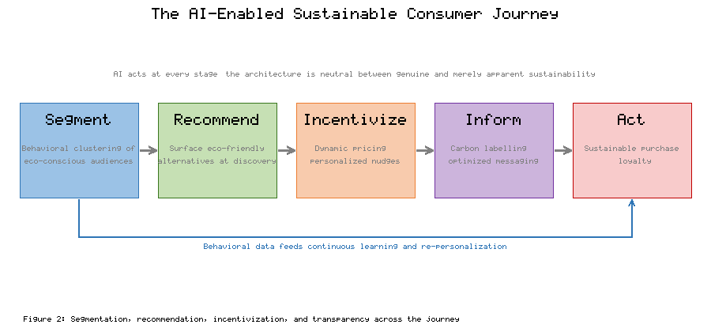
Figure 2. The AI-Enabled Sustainable Consumer Journey
Taken together, these transparency applications illustrate a constructive role for AI in raising the quality of sustainability communication: making claims clearer, grounding them in verifiable data, and exposing those that cannot withstand scrutiny [20]. The same analytical capacity that detects greenwashing in others, however, can be inverted to produce more sophisticated and persuasive forms of it, a danger examined next [22]. As Figure 2 makes clear, the architecture of the AI-enabled journey is normatively neutral; whether it advances sustainability or merely its appearance depends on the ends to which it is directed and the governance under which it operates [25].

3. The Double-Edged Sword: Navigating AI's Risks and Ethical Dilemmas
The applications surveyed in Section 2 carry significant promise, but a responsible treatment must weigh them against serious risks. This section adopts a critical perspective, examining first the ethical hazards of irresponsible AI marketing—bias, privacy intrusion, and AI-enabled greenwashing—and then the environmental paradox posed by the technology's own resource consumption.

3.1 The Perils of Irresponsible AI: Bias, Privacy, and Greenwashing
Algorithmic bias represents one of the most insidious hazards of AI-driven marketing. Machine learning systems learn from historical data, and where that data reflects existing social inequalities, the resulting models can reproduce or amplify them [26]. In a marketing context, biased systems may systematically exclude certain groups from beneficial offers, misrepresent or stereotype consumer segments, or deliver discriminatory pricing and targeting [26]. Documented cases from adjacent domains demonstrate the severity of the problem: a widely cited analysis found that an algorithm used to allocate healthcare resources systematically disadvantaged Black patients because it used past spending as a proxy for need [27], while audits of commercial facial-analysis systems revealed substantially higher error rates for darker-skinned and female faces, exposing how computer-vision applications can encode intersectional disparities [28]. In sustainable marketing specifically, bias risks narrowing the promotion of green products to already-advantaged consumers, thereby entrenching rather than broadening sustainable consumption [26].
Data privacy constitutes a second major concern. The personalization that makes AI marketing effective depends on the extensive collection and analysis of consumer data, raising acute questions about consent, surveillance, and the ethical limits of behavioral inference [29]. Consumers are frequently unaware of the extent to which their data is gathered and used, and the economic logic of data-driven marketing generates persistent incentives to collect more than is strictly necessary [30]. The regulatory environment has responded, most notably through the European Union's General Data Protection Regulation, which establishes requirements for consent, purpose limitation, data minimization, and individual rights over personal data [31]. Yet compliance with the letter of such regulation does not resolve the deeper ethical tension between the drive for ever-finer personalization and the consumer's legitimate interest in privacy and autonomy [29]. The paradox is sharpened in the sustainability context, where firms ask consumers to trust them on environmental matters while simultaneously engaging in data practices that may erode that very trust [30].
The third and most context-specific peril is AI-enabled greenwashing. The analytical and generative capabilities that can optimize honest communication can equally be used to manufacture persuasive but misleading sustainability narratives [32]. Natural language generation can produce voluminous, fluent, and personalized environmental claims whose very sophistication makes them harder to scrutinize, while targeting systems can direct green messaging precisely to those most likely to be reassured by it, regardless of its accuracy [32]. This represents a qualitative escalation of the greenwashing problem: where traditional greenwashing was constrained by the cost of producing and distributing content, AI lowers that cost toward zero and raises the apparent credibility of deceptive claims [22]. Perceived greenwashing, once detected, damages brand trust and can generate consumer backlash, so the strategy carries real risk; but the asymmetry between the ease of generating claims and the difficulty of verifying them tilts the near-term incentives toward abuse [32]. Table 3 summarizes these principal risks together with their mechanisms and candidate mitigations. The broader research agenda on AI for sustainability emphasizes that realizing benefits while containing such harms requires deliberate governance rather than reliance on market forces alone [33].
[Insert Table 3 here]
Table 3. Principal Risks of AI in Sustainable Marketing and Candidate Mitigations
Risk | Mechanism | Candidate Mitigation
Algorithmic bias | Models learn and amplify historical inequities | Bias audits, diverse data, fairness constraints
Data privacy intrusion | Personalization requires pervasive data collection | Data minimization, consent, regulatory compliance
AI-enabled greenwashing | Cheap generation of persuasive false claims | Claim verification, disclosure, independent audit
Environmental footprint | Energy-intensive training and inference | Efficient models, clean energy, impact accounting

3.2 The Environmental Footprint Paradox of AI Systems
The final and perhaps most self-implicating risk concerns the environmental cost of AI itself. There is a genuine paradox in deploying a resource-intensive technology to promote environmental sustainability, and intellectual honesty requires confronting it directly [34]. Training large AI models consumes substantial quantities of electricity and, depending on the energy mix, can generate considerable carbon emissions; an influential early analysis estimated that training a single large natural-language model could emit carbon on the order of several automobiles' lifetime emissions, drawing attention to a cost that had previously gone largely unexamined [34]. The pursuit of ever-larger models has intensified these concerns, prompting calls for "Green AI" that treats computational and environmental efficiency as a primary evaluation criterion alongside accuracy [35].
Subsequent work has refined the accounting and emphasized that the footprint of a given model depends heavily on hardware efficiency, data-center energy sourcing, and operational practices, such that comparable models can differ by large factors in their emissions [36]. Detailed life-cycle estimates for specific large models have improved transparency about where emissions arise, distinguishing the one-time cost of training from the recurring cost of inference, which, aggregated across millions of queries, can rival or exceed the training cost over a model's lifetime [37]. These model-level considerations sit within the larger energy picture of the digital economy: data centers account for a significant and growing share of global electricity demand, and although efficiency gains have so far moderated the growth of their total energy use, the rapid expansion of AI workloads threatens to outpace those gains [38]. The wider environmental impact of information and communication technology, encompassing manufacturing, networks, and devices as well as data centers, is substantial and subject to considerable uncertainty, underscoring the need for careful measurement rather than complacent assumption [39]. Figure 3 visualizes this footprint paradox, juxtaposing the environmental costs of the AI lifecycle against the sustainability benefits that well-governed applications can deliver.
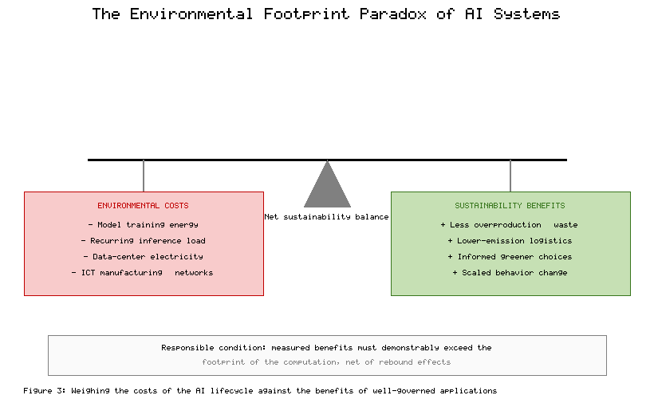
Figure 3. The Environmental Footprint Paradox of AI Systems
A related and frequently neglected dimension of the paradox is the rebound effect. Even where AI-driven marketing succeeds in promoting more efficient or lower-impact products, the efficiency gains and cost savings it generates may be partially offset if they stimulate additional consumption overall, so that the net environmental benefit is smaller than the per-unit improvement suggests [39]. A recommendation engine that successfully steers a consumer toward a sustainable product has nonetheless, in doing so, encouraged an act of consumption, and the aggregate effect of frictionless, perpetually personalized commerce may be to expand total throughput even as it greens its composition [33]. Responsible practice must therefore evaluate interventions against their full systemic consequences rather than against narrow per-transaction metrics, a demand that aligns with the measurable-impact principle developed in Section 4 [35].
The paradox does not invalidate the use of AI for sustainability, but it does impose a demanding condition: the environmental benefits generated by AI-driven sustainable marketing must demonstrably exceed the environmental costs of the computation that produces them [35]. This requires that firms account for the footprint of their AI systems with the same rigor they apply to other emissions, prefer efficient models and clean energy, and resist the temptation to deploy computationally extravagant solutions where simpler ones would suffice [36]. The footprint paradox thus reinforces the central argument of the chapter: that the responsible use of AI in sustainable marketing cannot be assumed but must be deliberately engineered and verified, a requirement that motivates the framework developed in the next section [39].

4. Towards a Responsible Future: Frameworks and Best Practices
The preceding analysis establishes that AI's contribution to sustainable marketing is conditional rather than guaranteed, depending on how the technology is designed, deployed, and governed. This final section moves from critique to construction, first proposing a framework for responsible practice and then grounding it in sector-specific applications and actionable recommendations.

4.1 A Framework for Responsible AI-Driven Sustainable Marketing
A coherent response to the risks identified above can be organized around the principles of responsible AI, a field that has coalesced over recent years into a set of broadly shared commitments. Surveys of the global landscape of AI ethics guidelines have found substantial convergence around principles such as transparency, justice and fairness, non-maleficence, responsibility, and privacy, even as their precise interpretation and implementation vary [40]. Influential frameworks have distilled these into actionable ethical foundations—beneficence, non-maleficence, autonomy, justice, and explicability—intended to guide the development of AI that serves the public good [41]. Translating these general commitments into the specific domain of sustainable marketing yields four core principles, which Figure 4 presents as an integrated framework.
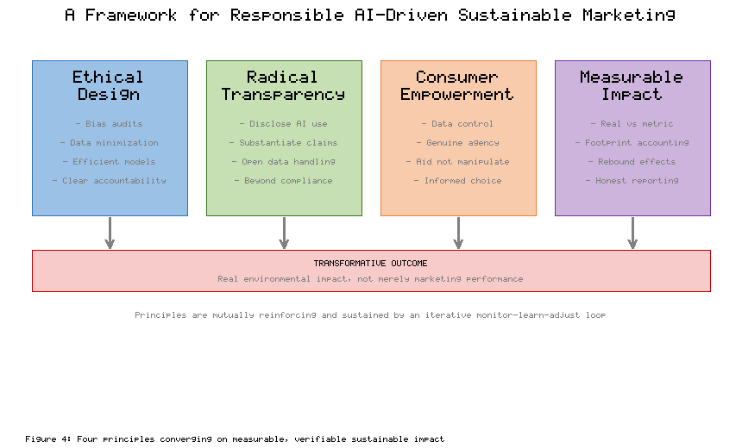
Figure 4. A Framework for Responsible AI-Driven Sustainable Marketing
The first principle is ethical design: embedding fairness, accountability, and environmental efficiency into AI systems from the outset rather than retrofitting them after harm has occurred [42]. This entails auditing systems for bias, minimizing data collection consistent with purpose, selecting computationally efficient models, and establishing clear lines of human responsibility for algorithmic decisions [42]. The second principle is radical transparency, extending beyond regulatory compliance to the proactive disclosure of how AI is used, how environmental claims are substantiated, and how consumer data is handled, so that trust rests on verifiable evidence rather than assertion [40]. The third principle is consumer empowerment: giving individuals genuine control over their data and meaningful agency over the choices presented to them, so that AI functions as an aid to autonomous decision-making rather than a tool of manipulation [43]. The fourth principle is measurable impact assessment, the systematic evaluation of whether campaigns produce real environmental and social change rather than merely improved marketing metrics, including honest accounting for the technology's own footprint [43]. As Figure 4 indicates, these principles are mutually reinforcing and are sustained by an iterative loop of monitoring, learning, and adjustment, so that responsibility is treated as an ongoing practice rather than a one-time certification. The governance of responsible AI, in this view, is not a constraint imposed from outside but an organizational capability that must be built and continuously exercised [42].

4.2 Real-World Impact and the Road Ahead: Case Studies and Recommendations
The practical value of this framework is best appreciated through its application across sectors where AI-driven sustainable marketing is already taking shape. In fashion, an industry long criticized for the environmental toll of fast production cycles, AI is being used to forecast demand more accurately and thereby reduce overproduction and waste, to power resale and rental platforms that extend garment lifecycles through computer-vision-based authentication and matching, and to personalize recommendations toward durable and responsibly sourced items [44]. In the food sector, AI supports the reduction of waste through demand forecasting and dynamic markdown of perishable goods, informs consumers through carbon and nutritional labelling, and personalizes nudges toward lower-impact dietary choices [44]. In e-commerce, which sits at the confluence of these dynamics, AI optimizes logistics to consolidate shipments and reduce delivery emissions, surfaces sustainable alternatives through recommendation, and integrates the real-time carbon labelling discussed earlier directly into the purchasing interface [45]. Table 4 synthesizes these sectoral applications, pairing each with its dominant sustainability objective and the principal risk it must guard against. Across these sectors, the broader evidence indicates that AI can make a meaningful contribution to sustainability goals, while cautioning that its net effect depends on governance, measurement, and the alignment of commercial incentives with environmental outcomes [45].
[Insert Table 4 here]
Table 4. Sectoral Applications of AI-Driven Sustainable Marketing
Sector | Representative AI Application | Dominant Sustainability Objective | Principal Risk to Manage
Fashion | Demand forecasting; resale and rental platforms | Reducing overproduction and extending product life | Greenwashing of "conscious" collections
Food | Waste reduction; carbon and nutrition labelling | Cutting waste and lowering dietary impact | Misleading or inconsistent labels
E-commerce | Logistics optimization; sustainable recommendation | Reducing delivery emissions and surfacing green options | Privacy intrusion and rebound effects
As Table 4 indicates, the sectoral logic is consistent even as the applications differ: in each case AI addresses a specific environmental objective while introducing a characteristic hazard that responsible governance must contain [44].
From this analysis, several recommendations follow for the principal stakeholders. Marketers should adopt the responsible-AI framework as an operational discipline, investing in bias audits, data governance, transparent claim substantiation, and rigorous impact measurement, and should resist the short-term temptations of AI-enabled greenwashing that research shows to be ultimately self-defeating once detected [44]. Policymakers should extend and harmonize the regulatory architecture, building on data-protection foundations to address algorithmic accountability, standardize carbon-labelling methodologies, and establish penalties for deceptive environmental claims that are sufficient to deter abuse at scale [45]. Technology developers should prioritize the development of efficient, interpretable, and auditable models, treating environmental and computational efficiency as first-order design objectives and providing the tooling that allows the footprint and fairness of AI systems to be measured and disclosed [45]. For researchers, several priorities emerge: rigorous measurement of the net sustainability impact of AI marketing interventions, including their rebound effects and their own footprint; the development of robust methods for detecting AI-generated greenwashing; and deeper investigation of how personalized persuasion can be reconciled with consumer autonomy and well-being [44]. A cross-cutting theme in these recommendations is the need for independent verification. Because the asymmetry between generating environmental claims and substantiating them lies at the root of the greenwashing hazard, no single stakeholder acting alone can resolve it; credible third-party audit of both sustainability claims and the AI systems that produce them is the mechanism most likely to realign incentives, converting transparency from a marketing posture into an enforceable commitment [42]. Standardized, comparable disclosure of model footprints and claim evidence would allow consumers, regulators, and civil-society watchdogs to distinguish substantive performance from persuasive presentation, and would reward the firms whose environmental claims withstand scrutiny [40]. Pursuing these directions will determine whether the convergence of AI, marketing, and sustainability fulfills its promise or succumbs to its hazards.

5. Conclusion
This chapter has argued that artificial intelligence occupies an ambivalent position in the pursuit of sustainable consumption, offering powerful tools that can either advance genuine environmental progress or lend new sophistication to its simulation. The transformation of consumer expectations has made sustainability a core determinant of brand relationships, yet the persistent gap between environmental intention and actual behavior has frustrated conventional green marketing. AI addresses this gap through capabilities that earlier approaches lacked: the intelligent segmentation of heterogeneous audiences, the personalization of incentives and recommendations that lower the friction of sustainable choice, and the enhancement of transparency through optimized communication and real-time carbon labelling. These applications demonstrate a constructive potential to convert latent concern into realized action at scale.
That potential, however, is inseparable from substantial risk. The same mechanisms that can nudge consumers toward sustainability can entrench bias, erode privacy, and manufacture persuasive deception, and the computational infrastructure on which they depend carries an environmental cost that must be weighed honestly against the benefits it is meant to produce. The double-edged character of the technology means that its contribution to sustainability cannot be assumed; it must be deliberately designed, governed, and verified. The framework advanced here—ethical design, radical transparency, consumer empowerment, and measurable impact assessment, sustained through continuous monitoring and adjustment—offers a practical foundation for doing so, and the applications emerging across the fashion, food, and e-commerce sectors show that responsible practice is achievable rather than merely aspirational.
The road ahead will be determined less by the raw capability of the technology than by the choices of those who wield it. If marketers treat responsibility as an operational discipline, if policymakers construct an accountability architecture equal to the technology's reach, if developers make efficiency and auditability first-order objectives, and if researchers supply the measurement and methods that distinguish real impact from marketing performance, then AI can become a genuine ally of sustainable consumption. The central task is to ensure that a resource-intensive technology is governed so that it serves the ends of sustainability in substance and not merely in appearance, honoring the trust that consumers increasingly demand and the planetary limits that make the entire enterprise necessary.

References
[1] White, K., Habib, R., & Hardisty, D. J. (2019). How to SHIFT consumer behaviors to be more sustainable: A literature review and guiding framework. Journal of Marketing, 83(3), 22–49.
[2] Peattie, K., & Crane, A. (2005). Green marketing: Legend, myth, farce or prophesy? Qualitative Market Research, 8(4), 357–370.
[3] ElHaffar, G., Durif, F., & Dubé, L. (2020). Towards closing the attitude–intention–behavior gap in green consumption: A narrative review of the situation and a guiding framework. Journal of Cleaner Production, 275, 122556.
[4] Testa, F., Pretner, G., Iovino, R., Bianchi, G., Tessitore, S., & Iraldo, F. (2021). Drivers to green consumption: A systematic review. Environment, Development and Sustainability, 23(4), 4826–4880.
[5] Luchs, M. G., Naylor, R. W., Irwin, J. R., & Raghunathan, R. (2010). The sustainability liability: Potential negative effects of ethicality on product preference. Journal of Marketing, 74(5), 18–31.
[6] Du, S., Bhattacharya, C. B., & Sen, S. (2010). Maximizing business returns to corporate social responsibility (CSR): The role of CSR communication. International Journal of Management Reviews, 12(1), 8–19.
[7] Davenport, T., Guha, A., Grewal, D., & Bressgott, T. (2020). How artificial intelligence will change the future of marketing. Journal of the Academy of Marketing Science, 48(1), 24–42.
[8] Huang, M.-H., & Rust, R. T. (2021). A strategic framework for artificial intelligence in marketing. Journal of the Academy of Marketing Science, 49(1), 30–50.
[9] Kietzmann, J., Paschen, J., & Treen, E. (2018). Artificial intelligence in advertising: How marketers can leverage artificial intelligence along the consumer journey. Journal of Advertising Research, 58(3), 263–267.
[10] Verma, S., Sharma, R., Deb, S., & Maitra, D. (2021). Artificial intelligence in marketing: Systematic review and future research direction. International Journal of Information Management Data Insights, 1(1), 100002.
[11] De Bruyn, A., Viswanathan, V., Beh, Y. S., Brock, J. K.-U., & von Wangenheim, F. (2020). Artificial intelligence and marketing: Pitfalls and opportunities. Journal of Interactive Marketing, 51, 91–105.
[12] Vlačić, B., Corbo, L., Costa e Silva, S., & Dabić, M. (2021). The evolving role of artificial intelligence in marketing: A review and research agenda. Journal of Business Research, 128, 187–203.
[13] Ma, L., & Sun, B. (2020). Machine learning and AI in marketing—Connecting computing power to human insights. International Journal of Research in Marketing, 37(3), 481–504.
[14] Kumar, V., Rajan, B., Venkatesan, R., & Lecinski, J. (2019). Understanding the role of artificial intelligence in personalized engagement marketing. California Management Review, 61(4), 135–155.
[15] den Boer, A. V. (2015). Dynamic pricing and learning: Historical origins, current research, and new directions. Surveys in Operations Research and Management Science, 20(1), 1–18.
[16] Jannach, D., & Jugovac, M. (2019). Measuring the business value of recommender systems. ACM Transactions on Management Information Systems, 10(4), 1–23.
[17] Shankar, V., Kalyanam, K., Setia, P., Golmohammadi, A., Tirunillai, S., Douglass, T., Hennessey, J., Bull, J. S., & Waddoups, R. (2021). How technology is changing retail. Journal of Retailing, 97(1), 13–27.
[18] Thaler, R. H., & Sunstein, C. R. (2008). Nudge: Improving decisions about health, wealth, and happiness. Yale University Press.
[19] Demarque, C., Charalambides, L., Hilton, D. J., & Waroquier, L. (2015). Nudging sustainable consumption: The use of descriptive norms to promote a minority behavior in a realistic online shopping environment. Journal of Environmental Psychology, 43, 166–174.
[20] Lyon, T. P., & Montgomery, A. W. (2015). The means and end of greenwash. Organization & Environment, 28(2), 223–249.
[21] Hartmann, J., Huppertz, J., Schamp, C., & Heitmann, M. (2019). Comparing automated text classification methods. International Journal of Research in Marketing, 36(1), 20–38.
[22] de Freitas Netto, S. V., Sobral, M. F. F., Ribeiro, A. R. B., & Soares, G. R. da L. (2020). Concepts and forms of greenwashing: A systematic review. Environmental Sciences Europe, 32(1), 19.
[23] Cohen, M. A., & Vandenbergh, M. P. (2012). The potential role of carbon labeling in a green economy. Energy Economics, 34, S53–S63.
[24] Rondoni, A., & Grasso, S. (2021). Consumers behaviour towards carbon footprint labels on food: A review of the literature and discussion of industry implications. Journal of Cleaner Production, 301, 127031.
[25] Taufique, K. M. R., Nielsen, K. S., Dietz, T., Shwom, R., Stern, P. C., & Vandenbergh, M. P. (2022). Revisiting the promise of carbon labelling. Nature Climate Change, 12(2), 132–140.
[26] Mehrabi, N., Morstatter, F., Saxena, N., Lerman, K., & Galstyan, A. (2021). A survey on bias and fairness in machine learning. ACM Computing Surveys, 54(6), 1–35.
[27] Obermeyer, Z., Powers, B., Vogeli, C., & Mullainathan, S. (2019). Dissecting racial bias in an algorithm used to manage the health of populations. Science, 366(6464), 447–453.
[28] Buolamwini, J., & Gebru, T. (2018). Gender shades: Intersectional accuracy disparities in commercial gender classification. Proceedings of Machine Learning Research, 81, 77–91.
[29] Martin, K. D., & Murphy, P. E. (2017). The role of data privacy in marketing. Journal of the Academy of Marketing Science, 45(2), 135–155.
[30] Acquisti, A., Taylor, C., & Wagman, L. (2016). The economics of privacy. Journal of Economic Literature, 54(2), 442–492.
[31] Voigt, P., & von dem Bussche, A. (2017). The EU General Data Protection Regulation (GDPR): A practical guide. Springer.
[32] Szabo, S., & Webster, J. (2021). Perceived greenwashing: The effects of green marketing on environmental and product perceptions. Journal of Business Ethics, 171(4), 719–739.
[33] Nishant, R., Kennedy, M., & Corbett, J. (2020). Artificial intelligence for sustainability: Challenges, opportunities, and a research agenda. International Journal of Information Management, 53, 102104.
[34] Strubell, E., Ganesh, A., & McCallum, A. (2019). Energy and policy considerations for deep learning in NLP. Proceedings of the 57th Annual Meeting of the Association for Computational Linguistics, 3645–3650.
[35] Schwartz, R., Dodge, J., Smith, N. A., & Etzioni, O. (2020). Green AI. Communications of the ACM, 63(12), 54–63.
[36] Patterson, D., Gonzalez, J., Le, Q., Liang, C., Munguia, L.-M., Rothchild, D., So, D., Texier, M., & Dean, J. (2021). Carbon emissions and large neural network training. arXiv preprint arXiv:2104.10350.
[37] Luccioni, A. S., Viguier, S., & Ligozat, A.-L. (2023). Estimating the carbon footprint of BLOOM, a 176B parameter language model. Journal of Machine Learning Research, 24(253), 1–15.
[38] Masanet, E., Shehabi, A., Lei, N., Smith, S., & Koomey, J. (2020). Recalibrating global data center energy-use estimates. Science, 367(6481), 984–986.
[39] Freitag, C., Berners-Lee, M., Widdicks, K., Knowles, B., Blair, G. S., & Friday, A. (2021). The real climate and transformative impact of ICT: A critique of estimates, trends, and regulations. Patterns, 2(9), 100340.
[40] Jobin, A., Ienca, M., & Vayena, E. (2019). The global landscape of AI ethics guidelines. Nature Machine Intelligence, 1(9), 389–399.
[41] Floridi, L., Cowls, J., Beltrametti, M., Chatila, R., Chazerand, P., Dignum, V., Luetge, C., Madelin, R., Pagallo, U., Rossi, F., Schafer, B., Valcke, P., & Vayena, E. (2018). AI4People—An ethical framework for a good AI society: Opportunities, risks, principles, and recommendations. Minds and Machines, 28(4), 689–707.
[42] Mikalef, P., Conboy, K., Lundström, J. E., & Popovič, A. (2022). Thinking responsibly about responsible AI and 'the dark side' of AI. European Journal of Information Systems, 31(3), 257–268.
[43] Dignum, V. (2019). Responsible artificial intelligence: How to develop and use AI in a responsible way. Springer.
[44] Di Vaio, A., Palladino, R., Hassan, R., & Escobar, O. (2020). Artificial intelligence and business models in the sustainable development goals perspective: A systematic literature review. Journal of Business Research, 121, 283–314.
[45] Vinuesa, R., Azizpour, H., Leite, I., Balaam, M., Dignum, V., Domisch, S., Felländer, A., Langhans, S. D., Tegmark, M., & Fuso Nerini, F. (2020). The role of artificial intelligence in achieving the Sustainable Development Goals. Nature Communications, 11, 233.

