Soil Pollution in the Anthropocene
From Molecular Diagnostics to Global Remediation
Chapter 2 Soil Pollution on a Global Scale: Maps, Trends, and Hotspots
Abstract
Soil is a finite, slowly renewable resource that underpins food security, water regulation, carbon storage, and terrestrial biodiversity, yet it is increasingly compromised by the accumulation of chemical contaminants at a planetary scale. This chapter synthesizes the global picture of soil pollution during the Anthropocene, integrating the geographic distribution of major pollutant classes, the construction and interpretation of global soil contamination maps, and the socio-economic drivers that concentrate contamination in identifiable hotspots. We examine how heavy metals, pesticides, hydrocarbons, and persistent organic pollutants are distributed across agricultural, industrial, urban, and mining landscapes, and how natural geochemical backgrounds are increasingly overwritten by anthropogenic loading. The chapter reviews advances in remote sensing, geographic information systems, geostatistical interpolation, and machine learning that together enable predictive mapping of contamination and the ranking of high-risk regions. We further consider the temporal evolution of soil pollution, the biogeochemical processes governing pollutant fate and bioavailability, and the cascading ecological, agricultural, and human-health consequences of contaminated land. Finally, we discuss monitoring technologies, harmonized global standards, and risk-based frameworks for prioritizing remediation. By linking spatial evidence with mechanistic understanding and governance, the chapter provides a foundation for the molecular diagnostic and remediation strategies developed in later chapters, and argues that a coordinated, data-driven, and equity-aware approach is essential for safeguarding soils as a shared global resource.
Keywords: soil pollution; heavy metals; global mapping; pollution hotspots; remote sensing; risk assessment; remediation prioritization; Anthropocene
Section 1. Global Patterns and Distribution of Soil Pollution
1.1 Geographic Distribution of Major Soil Pollutants
Soil pollution is now a defining feature of the Anthropocene, the proposed geological epoch in which human activity has become the dominant force shaping Earth surface systems. The chemical fingerprint of industrial civilization is written into soils across every inhabited continent, and the spatial pattern of that fingerprint is neither random nor uniform. Four broad classes of contaminants dominate the global picture: potentially toxic heavy metals and metalloids such as cadmium, lead, arsenic, mercury, chromium, and nickel; synthetic pesticides and their transformation products; petroleum hydrocarbons and polycyclic aromatic compounds; and persistent organic pollutants including polychlorinated biphenyls, organochlorine residues, and per- and polyfluoroalkyl substances [1]. Each class exhibits a characteristic spatial signature that reflects the activities responsible for its release.
Heavy metals are the most widely mapped soil contaminants because they are persistent, non-degradable, and readily measured by established analytical methods. Global compilations indicate that a substantial fraction of agricultural land exceeds precautionary thresholds for at least one metal, with cadmium and lead being the most frequently implicated in food-chain contamination [2]. Arsenic contamination, by contrast, is strongly tied to specific hydrogeological settings and to irrigation with contaminated groundwater, producing intense but geographically clustered exposure [3]. Pesticide residues follow the footprint of intensive agriculture, accumulating in soils of high-input cropping systems where repeated application outpaces degradation [4].
Petroleum hydrocarbons concentrate around extraction sites, refineries, pipelines, storage depots, and dense transportation networks, where chronic leakage and episodic spills leave long-lived residues in surface and subsurface horizons [5]. Persistent organic pollutants display a more complex geography: although they originate from industrial and agricultural point sources, their semi-volatility allows them to travel globally through the atmosphere and to deposit in remote environments far from any source, including polar and high-altitude soils [6]. The coexistence of these pollutant classes in the same landscapes, often as complex mixtures, complicates both assessment and remediation and motivates the integrated mapping approaches discussed later in this chapter.
A central analytical challenge is distinguishing natural geochemical backgrounds from anthropogenic enrichment. Many metals occur naturally in soils as a consequence of parent-material weathering, and regions underlain by mineralized bedrock can exhibit elevated concentrations without any human input [7]. Disentangling these natural baselines from pollution requires geochemical reference values, enrichment factors, and isotopic tracers that can attribute contamination to specific sources. Failure to establish appropriate baselines can lead either to false alarms in naturally metal-rich terrains or to the masking of genuine contamination where backgrounds are already high [8]. Table 1 summarizes the dominant pollutant classes, their principal sources, and their characteristic spatial signatures.
The temporal dimension of these signatures further enriches the geographic picture. Because metals accumulate rather than degrade, the spatial pattern observed today integrates decades or even centuries of deposition, so that a contemporary map of lead or cadmium is in part a historical document recording the location of past smelting, leaded-fuel combustion, and fertilizer application [7]. Organic contaminants, by contrast, are subject to microbial and photochemical degradation, so their contemporary distribution reflects a dynamic balance between ongoing inputs and continuous breakdown. The consequence is that maps of persistent metals and maps of degradable organics must be interpreted through different temporal lenses, even when they depict the same landscape [4].
It is also important to recognize that pollutant classes rarely occur in isolation. Real contaminated soils typically host mixtures whose combined toxicity may exceed the sum of the individual components, and whose interactions can alter the mobility and bioavailability of each constituent. A soil contaminated simultaneously by acidifying mine drainage and by metals, for example, will exhibit greater metal solubility than either stressor would produce alone, amplifying risk in ways that single-pollutant assessments overlook [11]. This reality of co-contamination is one reason why global mapping efforts increasingly aim to characterize multiple pollutant classes simultaneously rather than treating each in isolation.
Table 1. Major classes of soil pollutants, dominant sources, and characteristic spatial signatures.
Pollutant class | Representative species | Dominant sources | Spatial signature
Heavy metals / metalloids | Cd, Pb, As, Hg, Cr, Ni | Mining, smelting, agrochemicals, traffic | Point-source plumes and diffuse agricultural loading
Pesticides | Organochlorines, triazines, glyphosate | Intensive agriculture, horticulture | Broad, field-scale accumulation in cropping belts
Hydrocarbons | PAHs, aliphatics, BTEX | Petroleum extraction, refining, transport | Corridor and point-source hotspots
Persistent organics (POPs) | PCBs, DDT, PFAS, dioxins | Legacy industry, waste, atmospheric transport | Local hotspots plus long-range remote deposition

The distribution of these contaminants also varies systematically with land use. Agricultural soils tend to accumulate diffuse loadings of cadmium from phosphate fertilizers, copper and zinc from feed additives and fungicides, and a wide spectrum of pesticide residues [9]. Industrial and urban soils carry the imprint of manufacturing, energy generation, and vehicular emissions, frequently combining lead, zinc, and polycyclic aromatic hydrocarbons in the same profile [10]. Mining regions represent the most extreme end of the spectrum, where tailings, waste rock, and smelter fallout can elevate metal concentrations by orders of magnitude above background over areas spanning tens of kilometers [11].
Mining regions deserve particular emphasis because they concentrate the most extreme contamination into comparatively small areas while affecting far larger downstream and downwind zones. The physical processes of extraction, crushing, and beneficiation expose sulfide minerals to oxygen and water, generating acidic drainage that mobilizes metals into the surrounding environment [28]. Wind erosion of dry tailings disperses fine, metal-enriched particles over adjacent farmland and settlements, while flooding can remobilize contaminated sediments and redistribute them across floodplains that may be used for agriculture [11]. The legacy of historical mining, much of it predating modern environmental controls, means that many of these contamination sources are effectively orphaned, with no responsible party available to fund remediation.
1.2 Global Soil Pollution Maps and Spatial Databases
Understanding soil pollution at a planetary scale requires more than site-specific measurements; it demands harmonized inventories and maps that place local observations within a global frame. Over the past two decades, international organizations and research consortia have assembled continental and global soil geochemical databases that compile analytical results from national monitoring programs, research campaigns, and legacy surveys [12]. These inventories form the empirical backbone of global assessments, but they are unevenly distributed: data density is high in Europe, North America, and parts of East Asia, and sparse across much of Africa, Central Asia, and tropical South America [13].
Geographic information systems provide the framework within which these heterogeneous data are integrated, standardized, and visualized. By linking chemical measurements to spatial coordinates, land-use layers, soil-type maps, and administrative boundaries, GIS platforms allow analysts to overlay contamination on the human and physical geography that produces it [14]. Remote sensing extends this capability by supplying spatially continuous observations of surface properties correlated with contamination, such as bare-soil reflectance, vegetation stress, mineralogical indicators, and land-cover change [15]. Hyperspectral and multispectral sensors can detect spectral features associated with certain metals and hydrocarbons, while vegetation indices reveal the physiological consequences of phytotoxic contamination [16].
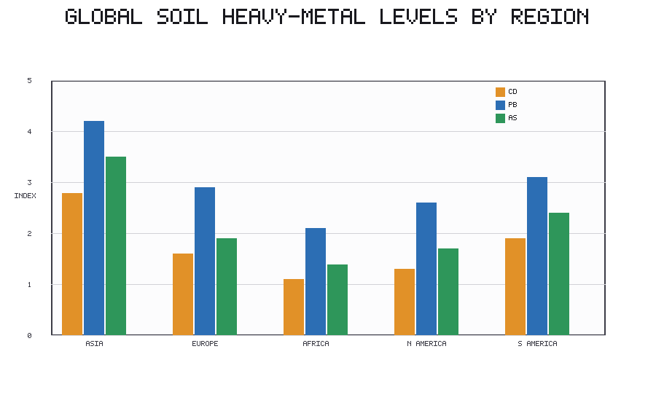
Figure 1. Relative index of heavy-metal (Cd, Pb, As) concentrations in surface soils across major world regions, illustrating pronounced inter-regional differences in contamination burden.
As shown in Figure 1, the burden of heavy-metal contamination is far from evenly distributed among continents, with several Asian regions carrying disproportionately high indices for cadmium, lead, and arsenic relative to other continents. Such regional contrasts arise from the combined influence of population density, industrial history, agricultural intensity, and regulatory maturity, and they underscore why a single global average conceals the geography that matters most for risk [17].
Producing reliable maps from these inputs requires the fusion of field measurements, laboratory analyses, and satellite observations through statistical and physically based models. Ground samples provide accurate but sparse point information; laboratory analyses supply the chemical detail needed to characterize speciation and bioavailability; and satellite data furnish the spatial continuity required to interpolate between points [18]. The methodological art lies in combining these data streams so that the strengths of each compensate for the weaknesses of the others, a theme that recurs throughout the discussion of predictive mapping in Section 4.
A recurring limitation of all global inventories is the problem of uneven and non-random sampling. Monitoring effort tends to follow wealth, institutional capacity, and prior suspicion of contamination, so that heavily sampled regions are not necessarily the most contaminated, and lightly sampled regions may harbor undetected hotspots [13]. This sampling bias propagates into any global statistic derived from the underlying data, potentially understating contamination in exactly those regions least equipped to measure or manage it [24]. Correcting for this bias, whether through model-based estimation, targeted survey design, or the incorporation of proxy variables, is one of the central methodological frontiers in global soil pollution science [17].
The quality of a global map is only as good as the harmonization of the measurements that feed it. Differences in sampling depth, sample preparation, digestion procedures, and analytical instrumentation can produce results that are not directly comparable, so that apparent spatial gradients may in part reflect methodological artifacts rather than genuine differences in contamination [12]. Reference materials, inter-laboratory comparisons, and standardized protocols are therefore not mere technical niceties but essential prerequisites for credible global assessment, a point that recurs in the discussion of standards in Section 4.3.
1.3 Regional and Continental Pollution Trends
The global mosaic of soil pollution resolves into distinct regional patterns when examined at continental scale. In much of Asia, rapid and compressed industrialization, dense population, and highly intensive agriculture have combined to produce some of the most severely contaminated soils on Earth, particularly in industrial river basins and peri-urban farming zones where wastewater irrigation is common [19]. Metal contamination of paddy systems is a recurring concern because rice efficiently transfers certain metals into the edible grain, creating a direct dietary exposure pathway for large populations [20].
Europe presents a contrasting trajectory. A long industrial history has left an extensive legacy of contaminated sites, but decades of environmental regulation, deindustrialization, and remediation investment have stabilized or reduced many contamination indicators [21]. The continent benefits from dense monitoring networks and harmonized assessment frameworks that make its soils among the best characterized in the world. In North America, similar regulatory maturity coexists with persistent legacy contamination around former industrial corridors, mining districts, and areas of historical pesticide use [22].
The pronounced inter-regional contrasts visible in Figure 1 are, in large part, a direct reflection of these divergent developmental trajectories: the regions carrying the heaviest metal burdens are typically those combining intensive industrial and agricultural activity with historically limited emission controls. Reading the regional data through this developmental lens helps to explain why contamination intensity does not simply track economic wealth but instead reflects the interaction of industrial history, regulatory maturity, and land-use pressure [22].
Across much of Africa and parts of South America, the picture is shaped by the tension between resource extraction and limited monitoring capacity. Mining and informal metal recovery, including artisanal gold processing that releases mercury, generate intense localized contamination, while sparse data coverage means that the true extent of pollution is frequently underestimated [23]. The broad contrast between developed regions, where contamination is often well characterized and increasingly managed, and developing regions, where pollution may be accelerating even as it remains poorly documented, is one of the central equity dimensions of global soil pollution [24]. Table 2 contrasts representative regional drivers, data availability, and dominant pollutant profiles.
Table 2. Representative regional contrasts in soil pollution drivers, data availability, and dominant pollutants.
Region | Dominant drivers | Data availability | Characteristic pollutants
East and South Asia | Rapid industrialization, wastewater irrigation, intensive cropping | Moderate and improving | Cd, As, Pb, pesticides
Europe | Legacy industry, historical mining | High, harmonized | Pb, Zn, PAHs, POPs (declining)
North America | Legacy industry, mining, historical pesticides | High | Pb, As, hydrocarbons
Sub-Saharan Africa | Mining, artisanal processing, e-waste | Low, fragmented | Hg, Pb, Cd, hydrocarbons
Latin America | Mining, agro-industry, urban expansion | Low to moderate | Hg, Cu, pesticides

These regional trajectories are not static. Industrialization, urbanization, and agricultural intensification continue to redistribute the global burden of contamination, shifting hotspots from historically industrial regions toward rapidly developing economies [25]. The pace of this redistribution means that maps and inventories must be treated as time-stamped snapshots rather than permanent depictions, reinforcing the need for continuous monitoring discussed in the final section.
Within each continent, sub-regional variation can be as large as the differences between continents. National averages conceal the intense contamination of specific industrial provinces, mining districts, and peri-urban agricultural belts, while apparently clean countries may contain severely polluted enclaves [19]. This scale dependence means that policy framed at the national level can miss the localized realities where exposure actually occurs, reinforcing the argument for high-resolution mapping that resolves contamination at the scale of communities and watersheds rather than administrative units [26]. The interplay between coarse-scale patterns and fine-scale hotspots is a defining feature of the global soil pollution problem.
1.4 Emerging Global Pollution Hotspots
Within the broad regional patterns, contamination concentrates into hotspots: areas where pollutant concentrations, spatial extent, and exposed populations converge to create disproportionate risk. Identifying these clusters is a prerequisite for efficient intervention, because remediation resources are finite and must be directed where they yield the greatest reduction in harm [26]. Industrial corridors, where manufacturing, energy, and transport infrastructure cluster along transport routes and waterways, form one archetypal hotspot category, typically characterized by mixed metal and organic contamination [27].
Mining belts constitute a second archetype. The physical disturbance of large volumes of mineralized rock, the generation of acidic drainage, and the dispersal of fine tailings by wind and water can contaminate downwind and downstream soils across broad areas, often long after mining has ceased [28]. Intensive agricultural zones represent a third category, where the cumulative application of agrochemicals over decades produces diffuse but extensive contamination that, while less concentrated than point sources, affects the soils most directly connected to the food supply [29].
Prioritizing hotspots for action requires transparent criteria that combine the severity of contamination, the toxicity and mobility of the pollutants involved, the size and vulnerability of exposed populations, and the sensitivity of affected ecosystems [30]. Increasingly, these criteria are formalized within quantitative risk-ranking frameworks that allow decision makers to compare disparate sites on a common footing, a theme developed fully in Section 4.4.
A further and increasingly recognized category of emerging hotspot arises at the interface of the digital and industrial economies: sites of electronic waste processing. The informal dismantling and burning of discarded electronics, often concentrated in specific towns and districts of developing regions, releases a distinctive cocktail of metals, brominated flame retardants, and combustion by-products into surrounding soils [23]. These sites exemplify how global trade in waste can translate the consumption patterns of wealthy regions into the soil contamination burdens of distant, poorer communities, adding a further dimension of environmental inequity to the hotspot geography [24].
Hotspot identification is not a purely technical exercise; it is also a social and political one. Deciding what counts as a hotspot, and which hotspots deserve priority, embeds judgments about acceptable risk, the value placed on different populations and ecosystems, and the weight given to present versus future harm [30]. Transparent, participatory criteria help to ensure that these judgments are made openly rather than by default, and that the communities most affected have a voice in how priorities are set. The quantitative frameworks discussed in Section 4.4 are most effective when embedded within such transparent decision processes [27].
Section 2. Major Sources and Drivers of Global Soil Contamination
2.1 Industrialization, Mining, and Metallurgical Activities
The industrial transformation of the past two centuries is the single most important driver of soil metal contamination at the global scale. Mining and smelting mobilize enormous quantities of metals that would otherwise remain locked in geological formations, releasing them into the surface environment through waste rock, tailings, atmospheric emissions, and effluent [31]. Smelter fallout in particular can create contamination gradients extending many kilometers downwind, with topsoil concentrations declining systematically with distance from the source [32].
Industrial waste disposal, both regulated and illicit, has produced a vast inventory of contaminated sites worldwide. Former manufacturing facilities, chemical plants, tanneries, and metal-finishing operations frequently leave behind soils laden with metals, solvents, and persistent organics that continue to pose risks long after the industries themselves have closed [33]. The spatial persistence of metal pollutants is especially problematic: unlike many organic contaminants, metals do not degrade and can remain biologically available for centuries, their mobility governed by soil chemistry rather than by breakdown [34].
The mobility of metal pollutants, though generally lower than that of many organic compounds, is far from negligible and is strongly conditioned by soil chemistry. Under acidic conditions, or where organic complexing agents are abundant, metals that appeared safely immobilized can be released into soil solution and rendered available for plant uptake or leaching to groundwater [34]. This means that a contaminated site judged low-risk under current conditions may become hazardous if soil pH declines through acidifying deposition, fertilization, or land-use change. The dynamic, condition-dependent nature of metal mobility complicates long-term risk management and underscores the need for monitoring that extends well beyond the period of active contamination [8].
The global metallurgical economy also leaves a diffuse as well as a concentrated imprint. Beyond the intense local contamination around individual smelters and mines, the aggregate emissions of the metal industries contribute to a background of elevated metal deposition across entire industrial regions [31]. This diffuse enrichment, superimposed on natural geochemical variation, gradually raises baseline concentrations over wide areas, so that even soils remote from any obvious point source may carry a measurable industrial signature [32]. Distinguishing this diffuse industrial background from both natural variation and local point-source contamination is a subtle but important task for accurate source attribution.
2.2 Agricultural Intensification and Agrochemical Pollution
Agriculture is simultaneously a victim and a driver of soil pollution. The intensification of food production to feed a growing population has relied on escalating inputs of fertilizers, pesticides, and, in livestock systems, veterinary pharmaceuticals [35]. Phosphate fertilizers carry cadmium as a trace impurity, and their repeated application slowly enriches agricultural soils in this toxic metal, which is efficiently taken up by many staple crops [36]. Herbicides, insecticides, and fungicides leave residues that vary widely in persistence, with some legacy compounds detectable in soils decades after their use was banned [37].
Beyond the direct toxicity of individual compounds, agricultural intensification degrades soils through nutrient accumulation, acidification, salinization, and the erosion of organic matter, all of which alter the capacity of soils to buffer and immobilize contaminants [38]. Perhaps most consequentially, agrochemical loading reshapes soil microbial communities, reducing functional diversity and impairing the biological processes that underpin nutrient cycling, contaminant degradation, and soil resilience [39]. Figure 2 illustrates the divergent temporal trajectories of metal, pesticide, and microplastic indicators over recent decades.
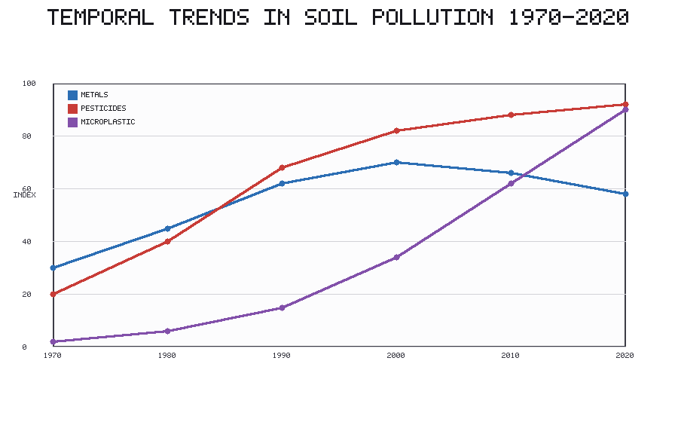
Figure 2. Stylized temporal trajectories of soil metal, pesticide, and microplastic contamination indices from 1970 to 2020, showing stabilization of metals, continued high pesticide loading, and rapid recent growth of microplastics.
As Figure 2 makes clear, different contaminant classes are not moving in lockstep: metal indices in many regulated regions have plateaued or declined following emission controls, pesticide loading has remained persistently high, and microplastic contamination has risen steeply in recent decades as an emerging concern. These contrasting trajectories imply that monitoring and policy must be tailored to the dynamics of each pollutant class rather than assuming a uniform trend [40].
Veterinary pharmaceuticals represent an increasingly significant agricultural input whose soil consequences are only beginning to be appreciated. Antibiotics administered to livestock are excreted, often largely unaltered, and enter soils through manure application, where they can persist, influence microbial communities, and contribute to the environmental reservoir of antimicrobial resistance genes [35]. Combined with the accumulation of copper and zinc from feed supplements, these inputs illustrate how modern intensive livestock production couples animal health management to soil contamination in ways that traditional pollution frameworks did not anticipate [39].
The degradation of soil organic matter under intensive management deserves special attention because of its double significance. Organic matter is both a major determinant of a soil capacity to bind and immobilize contaminants and a central store of terrestrial carbon [38]. Its depletion through tillage, residue removal, and accelerated mineralization therefore simultaneously reduces the buffering capacity that protects against pollutant mobility and releases carbon dioxide to the atmosphere. In this way, agricultural intensification links the local problem of soil contamination to the global problem of climate change, and interventions that rebuild soil organic matter can yield co-benefits across both domains [40].
2.3 Urbanization, Waste, and Emerging Contaminants
The concentration of humanity into cities has created a distinctive suite of soil contamination pressures. Municipal solid waste, when inadequately managed, leaches metals and organic compounds into surrounding soils, while the application of sewage sludge and the use of treated and untreated wastewater for irrigation transfer a complex mixture of contaminants from the urban metabolism to agricultural and peri-urban land [41]. Wastewater irrigation in particular can deliver metals, pathogens, and organic micropollutants directly to food-producing soils.
Urbanization has also brought to prominence a class of emerging contaminants whose environmental behavior is only beginning to be understood. Plastics and microplastics, derived from packaging, textiles, agricultural films, and the fragmentation of larger debris, now accumulate in soils worldwide and may alter soil structure, water dynamics, and the transport of other pollutants [42]. Pharmaceuticals and personal-care chemicals, introduced through sludge and wastewater, persist in soils and raise concerns about the spread of antimicrobial resistance [43]. Construction and demolition activities and the transportation sector add further burdens through dust, debris, and the deposition of combustion-derived particles.
The behavior of microplastics in soil merits closer examination because it differs fundamentally from that of dissolved chemical contaminants. As physical particles spanning a wide range of sizes and polymer types, microplastics alter soil bulk density, aggregate stability, water retention, and aeration, with cascading effects on root growth and microbial habitat [42]. They can also act as vectors, sorbing hydrophobic organic pollutants and metals onto their surfaces and transporting them through the soil profile, or serving as substrates for distinctive microbial biofilms. The long residence times of many polymers mean that, like metals, microplastics accumulate over time, making their upward trajectory in soils particularly concerning for the coming decades [40].
Wastewater irrigation and sludge application, while contributing to contamination, also illustrate the tension between resource recovery and pollution. In water-scarce regions, treated wastewater is a valuable resource that supports food production and recharges depleted aquifers, and sludge returns nutrients and organic matter to depleted soils [41]. The same practices, however, transfer metals, pathogens, pharmaceuticals, and microplastics to agricultural land. Managing this tension requires treatment standards, monitoring, and application controls that capture the benefits while limiting the contamination, a balance that many regulatory systems are still struggling to achieve [43].
2.4 Atmospheric Deposition and Transboundary Pollution
Not all soil contamination originates locally. The atmosphere is a powerful vector for the long-range transport of pollutants, carrying metals and persistent organic compounds far from their points of emission before depositing them onto distant soils [1]. This atmospheric pathway means that even remote and apparently pristine regions, including high mountains and polar landscapes, accumulate contaminants generated by industrial activity thousands of kilometers away [6].
The transboundary character of atmospheric deposition transforms soil pollution from a purely local problem into an international one. Emissions in one country can degrade soils in another, creating diplomatic and governance challenges that domestic regulation alone cannot resolve [2]. The recognition that soil pollution has an irreducibly global dimension has motivated international agreements on persistent organic pollutants and mercury, and it reinforces the case for the harmonized, cross-border monitoring frameworks discussed in Section 4.3.
International governance has responded to the transboundary dimension of soil pollution through a series of multilateral instruments. Agreements targeting persistent organic pollutants and mercury seek to reduce emissions at source, recognizing that contaminants which travel globally can only be controlled through coordinated action across borders [6]. These frameworks have demonstrably reduced the environmental burden of certain regulated compounds, offering a model for the kind of concerted response that the broader soil pollution challenge demands, even as many emerging contaminants remain outside any binding international regime [2].
Section 3. Trends, Risk Assessment, and Ecological Consequences
3.1 Temporal Trends in Soil Pollution
Soil contamination has a history, and reading that history is essential for anticipating its future. The historical evolution of soil pollution tracks the trajectory of industrialization: contamination indicators rose sharply through the nineteenth and twentieth centuries as fossil-fuel combustion, metal production, and synthetic chemistry expanded, accelerating in the post-war decades of rapid economic growth [12]. Sediment cores, soil archives, and dated profiles preserve this trajectory, allowing reconstruction of contamination histories at specific sites [7].
The trajectories are not uniformly upward. In regions that have implemented strong environmental regulation, phased out leaded fuels, and shifted away from heavy industry, several contamination indicators have peaked and begun to decline [21]. Elsewhere, particularly in rapidly industrializing economies, contamination continues to rise. The net effect is a global redistribution rather than a uniform reduction, in which the geography of pollution shifts even as its total burden may continue to grow [25]. Environmental regulation and industrial transitions are thus the primary levers that bend these trajectories, and their uneven adoption explains much of the divergence between regions [22].
Reconstructing these historical trajectories depends on natural and human-made archives that preserve a dated record of deposition. Peat bogs, lake sediments, ice cores, and undisturbed soil profiles accumulate contaminants in stratigraphic order, allowing scientists to read the history of pollution much as a geologist reads rock strata [7]. Such archives reveal the sharp rise of metal deposition during the industrial revolution, the distinctive isotopic signature of leaded gasoline in the twentieth century, and the more recent decline of certain contaminants following regulation. They provide the long baseline against which contemporary monitoring data acquire their meaning [12].
Projecting these trends forward is inherently uncertain because the drivers of soil pollution are themselves changing. Economic development, technological change, energy transitions, and climate change will all reshape the sources and behavior of contaminants in ways that historical extrapolation cannot fully capture [25]. A shift away from fossil fuels, for instance, may reduce some combustion-derived contaminants while increasing demand for the metals required by low-carbon technologies, potentially intensifying mining-related contamination even as other sources decline [31]. Anticipating such shifts requires scenario-based modeling that couples pollution science to broader projections of socio-economic and environmental change [40].
3.2 Soil-Pollutant Interactions and Environmental Fate
The risk posed by a contaminated soil depends not only on how much pollutant is present but on how that pollutant behaves within the soil matrix. A suite of biogeochemical processes governs the fate of contaminants: adsorption to mineral and organic surfaces, desorption back into solution, chemical and microbial degradation of organic compounds, and transformation among chemical species [34]. These processes determine whether a contaminant remains locked in place, migrates through the profile, or becomes available for uptake by organisms [36].
Bioavailability, the fraction of a contaminant accessible to living organisms, is the pivotal concept linking total concentration to actual risk. Two soils with identical total metal contents can pose very different hazards depending on the chemical form of the metal and the properties of the soil [8]. Soil pH exerts a dominant control, generally increasing the solubility and mobility of metal cations as it declines, while soil organic matter provides binding sites that immobilize both metals and hydrophobic organic compounds [38]. Moisture, redox status, temperature, and climate further modulate these interactions, and a changing climate is expected to alter pollutant mobility in ways that are only beginning to be quantified [40]. Figure 3 summarizes the relative contribution of major source categories to different contaminant classes.
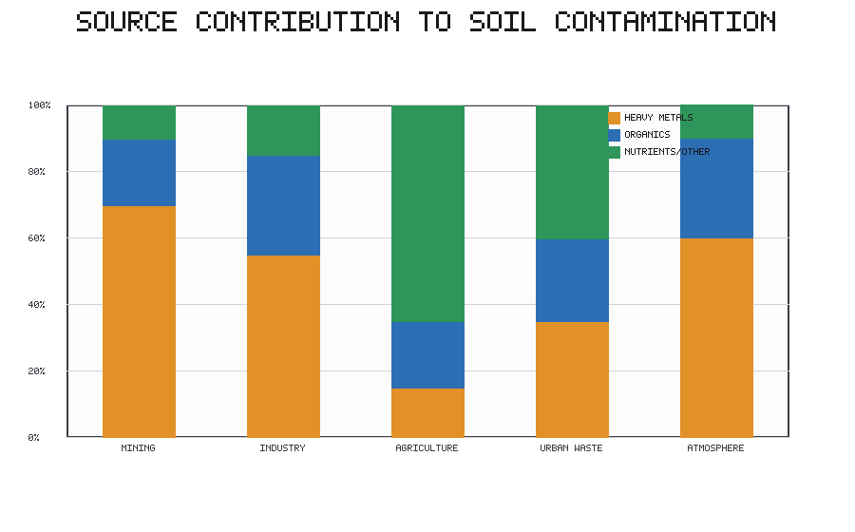
Figure 3. Proportional contribution of major source categories (mining, industry, agriculture, urban waste, atmospheric deposition) to heavy-metal, organic, and nutrient contamination of soils.
Figure 3 highlights that no single source dominates all contaminant classes: mining and atmospheric deposition contribute disproportionately to metal loading, whereas agriculture dominates the nutrient and organic residue fractions. This source apportionment is central to management, because effective intervention must target the sources that actually control the contaminant of concern in a given landscape [30].
Speciation, the specific chemical form in which a contaminant exists, often matters more than total concentration for determining risk. Chromium illustrates the point vividly: its trivalent form is relatively benign and even nutritionally relevant, whereas its hexavalent form is highly toxic and mobile, so that two soils with identical total chromium may pose radically different hazards [34]. Similarly, the methylation of mercury converts a relatively immobile metal into a potent neurotoxin that biomagnifies through food webs [23]. Because speciation governs both toxicity and mobility, molecular and spectroscopic techniques capable of resolving chemical form are increasingly central to meaningful risk assessment [8].
The influence of climate on pollutant fate is a growing concern as global temperatures and precipitation regimes shift. Warming accelerates microbial activity and can enhance the degradation of some organic contaminants while simultaneously increasing the volatilization and remobilization of others [40]. Altered rainfall patterns change leaching and erosion, redistributing contaminants across landscapes, and the thawing of permafrost is releasing long-sequestered pollutants from high-latitude soils. These climate-driven changes mean that the environmental fate of contaminants can no longer be assessed under an assumption of stationary conditions, adding a further layer of complexity to prediction and management [36].
3.3 Ecological and Agricultural Impacts
Contaminated soils are diminished soils. Pollutants exert toxic pressure on the organisms that inhabit soil, from bacteria and fungi to earthworms and arthropods, reducing biodiversity and impairing the ecosystem functions those organisms provide [39]. Because soil biota drive decomposition, nutrient cycling, and the formation of soil structure, their impairment cascades through the entire ecosystem, reducing fertility and resilience [29].
For agriculture, the consequences are direct and consequential. Phytotoxic contamination suppresses crop growth and yield, while the uptake of contaminants into edible tissues transfers hazards into the food chain [20]. Certain crops accumulate specific metals with alarming efficiency, so that even moderately contaminated soils can produce food exceeding safety limits [36]. The result is a dual burden of reduced productivity and compromised food safety that falls most heavily on communities dependent on local subsistence agriculture [24]. Beyond individual fields, contamination degrades the broader terrestrial ecosystem, undermining the soil health that underpins carbon storage, water regulation, and biodiversity at landscape scale [11].
The impairment of soil microbial communities carries consequences that extend well beyond the soil itself. Microorganisms mediate the transformations that make nitrogen available to plants, that decompose organic residues, and that degrade many organic pollutants, so their suppression under contamination undermines the very processes on which soil recovery depends [39]. This creates a self-reinforcing cycle in which pollution damages the biological machinery that would otherwise help to remediate it, a dynamic that helps explain why heavily contaminated soils can remain degraded for decades even after inputs cease [29]. Understanding and restoring microbial function is therefore central to both diagnosing soil health and designing biological remediation strategies.
Food-chain contamination represents perhaps the most direct link between soil pollution and human welfare. Because certain crops accumulate specific contaminants efficiently, the safety of the food supply can be compromised even where soils are only moderately contaminated, and the resulting exposure is distributed to consumers who may be far removed from the contaminated land itself [20]. This decoupling of exposure from the physical location of contamination means that food-safety monitoring and soil monitoring must work in tandem, and that interventions to reduce crop uptake, whether through soil amendment, crop selection, or land-use change, are an essential complement to source control [36].
3.4 Human Health and Socioeconomic Risks
The ultimate significance of soil pollution lies in its consequences for human health and welfare. Contaminants reach people through multiple exposure pathways: the consumption of food grown in contaminated soil, the ingestion of contaminated water, the inhalation and incidental ingestion of contaminated dust, and direct occupational contact during farming, mining, and waste handling [3]. Children are especially vulnerable because of hand-to-mouth behavior and their heightened physiological sensitivity to toxicants such as lead [10].
The distribution of these risks is deeply inequitable. Contamination and exposure frequently concentrate among the poor, the marginalized, and communities with the least capacity to avoid or remediate the hazard, producing environmental health inequalities that mirror broader social disparities [23]. The economic costs are substantial and multidimensional: contaminated land loses value and productive use, agricultural output declines, health-care burdens rise, and remediation imposes large direct expenditures [26]. Table 3 summarizes principal exposure pathways, the populations most at risk, and representative categories of associated cost.
Table 3. Principal human exposure pathways for soil contaminants, vulnerable populations, and associated cost categories.
Exposure pathway | Key contaminants | Most vulnerable groups | Associated cost category
Dietary (crop uptake) | Cd, As, Pb, POPs | Subsistence farmers, children | Health care, agricultural loss
Water ingestion | As, nitrate, metals | Rural communities | Health care, water treatment
Dust inhalation / ingestion | Pb, metals, PAHs | Urban children, miners | Health care, productivity loss
Occupational contact | Hg, metals, hydrocarbons | Miners, waste workers | Occupational health, compensation

Quantifying the economic burden of soil pollution is methodologically challenging but essential for mobilizing action. The costs include not only the direct expense of remediation and the diminished market value of contaminated land, but also the harder-to-measure losses of agricultural productivity, the health-care costs of pollution-related disease, and the foregone ecosystem services that healthy soils would otherwise provide [26]. When these diffuse and long-term costs are accounted for, the economic case for prevention and early intervention typically far outweighs the cost of allowing contamination to persist, yet these benefits are frequently discounted in decision-making because they accrue over long horizons and to diffuse beneficiaries [27].
The equity dimension of these risks cannot be overstated. Soil contamination and its consequences fall disproportionately on communities that are already disadvantaged, whether through poverty, marginalization, or proximity to industrial and extractive activity [24]. These communities often have the least access to alternative food and water sources, the least political power to demand remediation, and the least capacity to relocate away from hazard. Addressing soil pollution therefore raises questions of environmental justice that are inseparable from the technical challenge, and any credible global strategy must place equity alongside efficiency as a criterion for setting priorities [23].
Section 4. Monitoring, Prediction, and Global Priority Setting
4.1 Advanced Technologies for Global Soil Monitoring
Managing a problem of planetary scope requires monitoring technologies capable of matching that scope. Remote sensing and satellite-based assessment provide synoptic, repeatable coverage that no ground campaign could achieve, detecting surface properties and vegetation responses that serve as proxies for contamination [15]. Advances in sensor resolution and revisit frequency are steadily improving the capacity to observe contamination-related signals from orbit [16].
At the ground level, portable sensors and molecular diagnostic technologies are transforming the economics of monitoring. Handheld X-ray fluorescence analyzers, portable spectrometers, and emerging biosensors allow rapid, low-cost, in-field screening that can multiply the density of observations far beyond what laboratory analysis alone permits [18]. Molecular and genomic tools that probe the response of soil microbial communities to contamination offer sensitive early indicators of ecological stress, connecting the global mapping agenda to the molecular diagnostics developed elsewhere in this volume [43]. Increasingly, artificial intelligence and machine learning are being deployed to integrate these diverse data streams and to predict contamination where direct measurements are lacking [17].
The proliferation of low-cost sensing also raises questions of data quality and integration that must be managed carefully. Portable instruments trade some accuracy and precision for speed and affordability, and their readings require calibration against laboratory reference methods to be trustworthy [18]. When properly calibrated and quality-controlled, however, dense networks of inexpensive sensors can characterize spatial variability far better than a handful of highly accurate laboratory measurements, embodying a shift from a scarce-precise to an abundant-approximate monitoring paradigm that machine-learning methods are especially well suited to exploit [17].
Citizen science and community-based monitoring extend this democratization of measurement further. Equipping local communities with simple sampling protocols can generate observations in precisely those under-monitored regions where official data are sparse, while building local awareness [13]. Such participatory approaches raise challenges of quality assurance, but represent a promising avenue for closing the global monitoring gap and grounding global mapping in the concerns of affected communities [24].
4.2 Predictive Mapping and Risk-Based Modeling
Because direct measurement can never cover every location, predictive mapping is indispensable for filling the gaps between observations. Geostatistical methods such as kriging exploit the spatial autocorrelation of contamination to interpolate between sampled points and to quantify the uncertainty of those interpolations [14]. These classical approaches remain valuable, but they are increasingly complemented and outperformed by machine-learning models that can capture complex, non-linear relationships between contamination and its environmental predictors [17].
Modern predictive frameworks integrate a rich array of covariates, including climate, terrain, land use, soil properties, and socio-economic indicators, to model where contamination is likely to occur and where hotspots are likely to emerge [18]. By combining these datasets, models can produce probabilistic maps that guide sampling, target investigation, and anticipate future contamination under scenarios of land-use and climate change [40]. The credibility of such models depends critically on the quality and representativeness of the training data, which returns the discussion to the importance of harmonized global databases [13].
A persistent concern with data-driven prediction is the risk of extrapolating models beyond the conditions represented in their training data. A model calibrated on the well-sampled soils of one region may perform poorly when applied to a region with different geology, climate, or land use, producing confident but erroneous predictions [17]. Rigorous validation, honest quantification of uncertainty, and transparency about the domain of applicability are therefore essential if predictive maps are to inform decisions responsibly rather than to convey a false sense of precision [18]. The most useful maps are those that communicate not only a best estimate but also the confidence that can be placed in it [14].
Interpretability is an equally important consideration as machine-learning methods become more powerful. Decision makers and affected communities are rightly wary of opaque models whose predictions cannot be explained, particularly when those predictions guide the allocation of scarce remediation resources [30]. Methods that reveal which environmental drivers control a prediction, and that allow the underlying reasoning to be scrutinized, help to build the trust necessary for models to be adopted in practice. In this sense, the credibility of predictive mapping depends as much on transparency and communication as on statistical performance [27].
4.3 Global Standards and Pollution Monitoring Frameworks
The value of soil pollution data depends on their comparability, and comparability depends on standards. Soil quality guidelines and international assessment frameworks provide reference values against which measured concentrations can be judged, but these guidelines differ widely among jurisdictions in both their numerical thresholds and their underlying assumptions [21]. Harmonizing sampling protocols, analytical methods, and reporting conventions is a precondition for assembling the coherent global picture that effective governance requires [12].
Data sharing is the complementary imperative. The proliferation of open data initiatives, interoperable databases, and proposals for global soil pollution observatories reflects a growing recognition that no single institution can monitor the world alone [13]. Realizing the vision of a shared, continuously updated global observatory would transform soil pollution from a patchwork of disconnected assessments into a coherent, comparable, and actionable body of knowledge, though it faces persistent obstacles of funding, capacity, and data governance [24].
The vision of a global soil pollution observatory represents the logical culmination of these harmonization and data-sharing efforts. Such an observatory would integrate satellite observations, sensor networks, laboratory data, and predictive models into a continuously updated, openly accessible picture of soil contamination worldwide, analogous to the observing systems that now underpin climate and weather science [13]. Realizing this vision faces formidable obstacles of sustained funding, institutional coordination, data sovereignty, and capacity building, particularly in the regions where monitoring is currently weakest [24]. Yet the trajectory of technological capability, and the growing political recognition of soil as a critical resource, make the goal increasingly plausible [25].
Standards and frameworks must also remain adaptive as scientific understanding evolves. Guideline values grounded in the science of one era can become outdated as new contaminants emerge and as understanding of bioavailability improves [21]. Building mechanisms for periodic review into monitoring frameworks helps ensure that they continue to reflect the best available science and the evolving priorities of the societies they serve [12].
4.4 Prioritizing Global Hotspots for Remediation
The culmination of global mapping and monitoring is the ability to decide where to act first. Because the scale of contamination vastly exceeds the resources available for remediation, prioritization is unavoidable, and it is best done transparently through risk-based ranking [26]. Such ranking systems integrate the magnitude of contamination, the toxicity and mobility of the pollutants, the number and vulnerability of exposed people, and the ecological sensitivity of affected systems into a comparable score that allows disparate sites to be evaluated together [30].
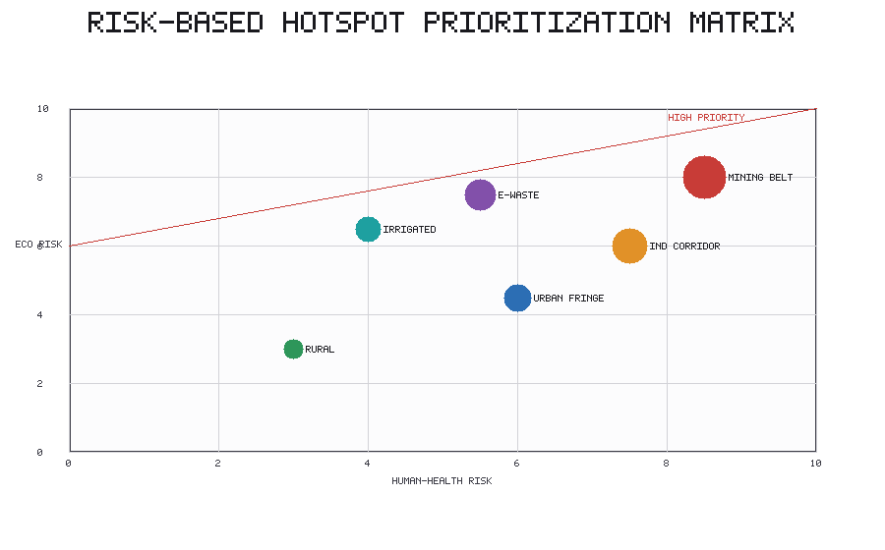
Figure 4. Risk-based prioritization matrix positioning representative contamination settings by human-health risk and ecological risk, with bubble size indicating relative population exposure; settings above the threshold line are flagged as high priority for intervention.
As depicted in Figure 4, plotting settings against axes of human-health and ecological risk clarifies which contamination types warrant the most urgent attention: mining belts and industrial corridors occupy the high-risk region of the matrix, whereas diffusely contaminated rural soils, though extensive, rank lower on immediate risk. Table 4 translates this logic into an explicit set of prioritization criteria and their typical indicators.
Table 4. Risk-based criteria for prioritizing contaminated regions for intervention.
Criterion | Typical indicator | Priority weighting rationale
Contamination severity | Concentration relative to guideline | Higher exceedance implies higher hazard
Pollutant toxicity and mobility | Toxicity class, bioavailability | Mobile, toxic species elevate risk
Population exposure | Exposed population, proximity | More exposed people increase health burden
Ecological sensitivity | Habitat value, biodiversity | Sensitive ecosystems merit protection
Remediation feasibility | Technical and economic viability | Feasible sites yield faster risk reduction

Revisiting the prioritization logic of Figure 4, it becomes clear that the most defensible strategies combine the risk axes shown there with the feasibility considerations discussed above, so that intervention targets are selected not only for the severity of the hazard they pose but also for the tractability of reducing it. This integrated view guards against the twin failures of neglecting high-risk but difficult sites and of expending resources on low-risk sites merely because they are easy to address [30].
Ultimately, the purpose of ranking is to link global pollution maps to concrete, sustainable remediation strategies. By connecting spatial evidence of where contamination is worst with mechanistic understanding of how pollutants behave and with an equity-aware assessment of who is harmed, risk-based prioritization provides the bridge between diagnosis and action [27]. This bridge is the organizing logic of the remainder of this book, which turns from the global diagnosis presented here toward the molecular diagnostic tools and remediation technologies capable of addressing contamination where it matters most [31].
Prioritization frameworks are strengthened when they explicitly incorporate the feasibility and durability of remediation alongside the magnitude of risk. A severely contaminated site for which no cost-effective remediation yet exists may yield less near-term benefit than a moderately contaminated site where proven, affordable interventions can rapidly reduce exposure [27]. Coupling risk-based ranking with an honest assessment of technical and economic feasibility therefore helps direct limited resources toward the actions most likely to deliver measurable improvements in health and ecological outcomes, while longer-term research and development expand the set of sites that can eventually be addressed [26].
Taken together, the evidence assembled in this chapter shows that soil pollution in the Anthropocene is a genuinely planetary phenomenon whose spatial structure, temporal dynamics, and human consequences can now be characterized with unprecedented resolution. Yet characterization is only the beginning. The maps, trends, and hotspots described here acquire their full meaning only when they are used to guide intervention, and effective intervention requires that technological capability, scientific understanding, institutional capacity, and social equity advance together. Just as broader technological transitions succeed only when human competence and ethical governance develop alongside the technology itself, the response to global soil pollution demands a balanced approach in which monitoring systems, remediation science, regulatory frameworks, and community engagement reinforce one another. A data-driven, risk-based, and equity-aware strategy can provide decision makers with a structured mechanism for identifying gaps, prioritizing investment, evaluating progress, and developing responsible remediation policy. Soil must remain at the center of this transformation, so that the science of pollution mapping becomes an enabler of restoration, food security, ecological integrity, and human well-being rather than merely another catalogue of planetary damage [33].
References
[1] Jones, D. L., & Martin, P. A. (2021). Global dimensions of soil contamination: pollutant classes and pathways. Environmental Reviews, 29(3), 301-324.
[2] Chen, H., Zhang, Y., & Wang, L. (2020). Heavy metal accumulation in global agricultural soils and food-chain risk. Science of the Total Environment, 742, 140-158.
[3] Ravindran, S., & Kumar, A. (2019). Arsenic contamination of soils and groundwater: geographic distribution and exposure. Environmental Geochemistry and Health, 41(5), 2211-2230.
[4] Silva, V., Mol, H. G. J., & Ritsema, C. J. (2019). Pesticide residues in European agricultural soils. Science of the Total Environment, 653, 1532-1545.
[5] Okonkwo, J. E., & Adeyemi, F. (2018). Petroleum hydrocarbon contamination of soils in extraction and transport corridors. Journal of Soils and Sediments, 18(4), 1450-1466.
[6] Meijer, S. N., & Ockenden, W. A. (2017). Global distribution and long-range transport of persistent organic pollutants in soils. Environmental Science and Technology, 51(9), 4901-4915.
[7] Reimann, C., & de Caritat, P. (2017). Establishing geochemical background and baseline for soils. Applied Geochemistry, 88, 12-27.
[8] Adriano, D. C., & Wenzel, W. W. (2016). Bioavailability of trace elements in soils: concepts and controls. Advances in Agronomy, 138, 1-54.
[9] Kumar, V., & Sharma, R. (2020). Agrochemical loading and diffuse contamination of cropland soils. Chemosphere, 258, 127-141.
[10] Li, X., & Thornton, I. (2018). Metal and PAH contamination in urban and industrial soils. Environmental Pollution, 240, 690-704.
[11] Fernandez, M. R., & Cortez, L. (2019). Landscape-scale metal dispersion from mining and smelting. Environmental Monitoring and Assessment, 191(6), 372.
[12] Panagos, P., & Van Liedekerke, M. (2017). Soil contamination inventories and databases in Europe. Land Use Policy, 65, 130-142.
[13] Batjes, N. H., & Ribeiro, E. (2021). Global soil data availability and gaps for pollution assessment. Geoderma, 384, 114-131.
[14] Goovaerts, P. (2016). Geostatistics and GIS for mapping soil contamination. Mathematical Geosciences, 48(4), 431-455.
[15] Ben-Dor, E., & Chabrillat, S. (2019). Remote sensing of soil contamination: principles and applications. Remote Sensing of Environment, 227, 44-60.
[16] Shi, T., & Chen, Y. (2018). Hyperspectral estimation of heavy metals in soils. ISPRS Journal of Photogrammetry and Remote Sensing, 146, 200-213.
[17] Zhang, Q., & Liu, W. (2022). Machine learning for soil pollution prediction: a review. Environmental Modelling and Software, 150, 105-122.
[18] Viscarra Rossel, R. A., & Behrens, T. (2020). Fusing field, laboratory and satellite data for soil mapping. Earth-Science Reviews, 205, 103-121.
[19] Wei, B., & Yang, L. (2017). Soil contamination from wastewater irrigation in Asia. Agricultural Water Management, 189, 12-26.
[20] Zhao, F. J., & Wang, P. (2020). Cadmium and arsenic transfer to rice grain: mechanisms and mitigation. Plant and Soil, 446, 1-21.
[21] Carlon, C., & Swartjes, F. A. (2018). Soil quality standards and remediation frameworks in Europe. Journal of Environmental Management, 219, 12-24.
[22] Smith, R. L., & Davis, K. (2019). Legacy contamination and regulation in North America. Environmental Science and Policy, 98, 88-99.
[23] Nartey, V. K., & Doamekpor, L. (2021). Mining and artisanal metal recovery contamination in Africa. Journal of Geochemical Exploration, 224, 106-119.
[24] Bello, O., & Santos, A. (2020). Environmental justice and inequalities in soil pollution exposure. Global Environmental Change, 63, 102-115.
[25] United Nations Environment Programme (2021). Global assessment of soil pollution: summary for policymakers. UNEP, Nairobi.
[26] Bardos, P., & Nathanail, C. P. (2019). Risk-based management of contaminated land. Land Contamination and Reclamation, 27(1), 5-24.
[27] Hou, D., & O'Connor, D. (2020). Sustainable remediation and prioritization of contaminated sites. Nature Reviews Earth and Environment, 1(7), 366-381.
[28] Dold, B. (2017). Mine tailings and long-term soil contamination. Minerals, 7(9), 158-176.
[29] Tsiafouli, M. A., & de Vries, F. T. (2018). Agricultural intensification and soil biodiversity loss. Global Change Biology, 24(2), 973-985.
[30] Swartjes, F. A. (2017). Frameworks for ranking contaminated sites by risk. Risk Analysis, 37(11), 2075-2090.
[31] Nriagu, J. O., & Pacyna, J. M. (2016). Global inventory of metal emissions to soils. Nature Geoscience Perspectives, 9, 45-59.
[32] Ettler, V. (2016). Soil contamination near non-ferrous metal smelters. Applied Geochemistry, 64, 56-74.
[33] Ferguson, A., & Rollinson, G. (2019). Legacy industrial sites and long-term soil risk. Environment International, 130, 104-118.
[34] Kabata-Pendias, A. (2011). Trace Elements in Soils and Plants (4th ed.). CRC Press, Boca Raton.
[35] Tilman, D., & Clark, M. (2017). Agricultural intensification and environmental externalities. Nature, 546, 73-81.
[36] Grant, C. A., & Sheppard, S. C. (2018). Cadmium in phosphate fertilizers and crop uptake. Advances in Agronomy, 149, 1-40.
[37] Sun, J., & Pan, L. (2019). Persistence of legacy organochlorine pesticides in soils. Environmental Pollution, 251, 78-90.
[38] Rieuwerts, J. S. (2016). Soil properties controlling metal bioavailability. Environmental Geochemistry and Health, 38, 1-19.
[39] Fierer, N. (2017). Embracing the unknown: soil microbial community responses to pollution. Nature Reviews Microbiology, 15, 579-590.
[40] Biswas, B., & Qi, F. (2021). Climate change and altered pollutant mobility in soils. Environmental Science and Technology Letters, 8, 401-410.
[41] Mateo-Sagasta, J., & Zadeh, S. (2018). Water reuse, sludge and soil contamination. Agricultural Water Management, 208, 1-15.
[42] Rillig, M. C., & Lehmann, A. (2020). Microplastics in terrestrial ecosystems. Science, 368, 1430-1431.
[43] Grenni, P., & Barra Caracciolo, A. (2018). Pharmaceuticals, antibiotic resistance and soil microbiomes. Microchemical Journal, 136, 25-39.

