Cultivating Tomorrow:
A Guide to Agricultural Tourism and Regenerative Landscapes

A Comprehensive Guide for Farmers, Tourism Operators, Policymakers, and Community Leaders

Abstract
This book explores the powerful synergy between agricultural tourism and regenerative farming practices, arguing that their integration creates a new paradigm for rural development that is ecologically restorative, economically viable, and culturally enriching. Regenerative agriculture, which emphasizes soil health restoration, biodiversity enhancement, and water cycle repair through practices including no-till management, cover cropping, holistic grazing, and composting, offers a compelling landscape narrative that attracts tourists seeking authentic and meaningful experiences beyond conventional tourism offerings. Conversely, agritourism provides essential revenue diversification that supports farmers during the financially challenging transition to regenerative methods, typically bridging a two-to-four-year period of reduced yields before soil systems fully recover their productive capacity. This work presents a comprehensive framework encompassing farm design for dual-purpose functionality that serves both ecological regeneration and visitor engagement, stakeholder engagement strategies that distribute benefits across entire rural communities, detailed policy recommendations addressing the regulatory barriers that currently impede development, and educational programming that builds food system literacy and regenerative competencies across all levels of society. Through global case studies spanning large-scale ranching operations in North America, intensive small-holdings in Scandinavia, and community-based initiatives in the Global South, alongside critical analysis of challenges including commercialization pressures that risk authenticity dilution, climate vulnerability that threatens both production and visitation, and infrastructure deficits that limit accessibility, the book articulates a holistic model for sustainable rural development. The integration of regenerative agriculture with tourism creates landscapes that serve simultaneously as sites of learning, conservation, and sustainable economic activity, fostering long-term ecological recovery while strengthening the social fabric and economic resilience of rural communities that have too long been marginalized in national development strategies.

Keywords: Regenerative agriculture; Agritourism; Sustainable rural development; Soil health; Biodiversity; Farm design; Policy frameworks; Community resilience; Ecosystem services; Carbon sequestration; Food systems; Rural tourism; Landscape restoration

Chapter 1: The Roots of Resilience: An Introduction to Regenerative Agriculture and Agritourism
This opening chapter establishes the definitional foundations and explores the historical evolution of both regenerative agriculture and agricultural tourism as distinct yet complementary fields before demonstrating how their thoughtful integration creates synergistic value that significantly exceeds the sum of their individual contributions to rural communities and landscapes.

1.1 Defining the Terrain: What is Regenerative Agriculture?
The global agricultural system faces an unprecedented convergence of crises. Decades of intensive monoculture farming have degraded approximately 40% of the world's arable land, while agriculture contributes nearly 23% of global greenhouse gas emissions [1]. In this context, regenerative agriculture has emerged as a transformative approach that moves beyond the paradigm of sustainability, which aims merely to maintain current conditions, to actively restore and revitalize degraded ecosystems [2]. The concept represents a fundamental philosophical shift from extractive to restorative land management, positioning the farm as a living system capable of self-renewal and increasing vitality over time. The urgency of this transition cannot be overstated: without fundamental changes in how we manage agricultural landscapes, the convergent pressures of population growth, climate disruption, and resource depletion threaten the stability of food systems globally.
At its core, regenerative agriculture is defined by a commitment to rebuilding soil organic matter, restoring degraded soil biodiversity, and enhancing ecosystem services including carbon sequestration, water filtration, and nutrient cycling [3]. Unlike organic farming, which primarily defines itself by what it excludes (synthetic inputs), regenerative agriculture is defined by outcomes: measurable improvements in soil health, biodiversity, water retention, and ecosystem function [4]. The principles of regenerative agriculture, as synthesized from the growing body of literature, include five foundational pillars: minimizing soil disturbance through no-till or reduced tillage practices; maintaining continuous living roots in the soil throughout the year to feed soil biology; maximizing crop diversity through polycultures, cover crops, and complex crop rotations that mimic natural ecosystems; integrating livestock through holistic planned grazing that mimics the impact of wild herbivore herds; and keeping the soil covered at all times with organic matter or living plants to protect against erosion and maintain soil moisture [5]. These principles work synergistically, each reinforcing the others to create increasingly healthy and productive landscapes.
The scientific evidence supporting these practices continues to accumulate rapidly. Research by Lal (2020) demonstrates that regenerative practices can sequester between 0.5 and 1.5 tonnes of carbon per hectare per year, representing a significant climate mitigation potential [6]. Furthermore, studies have shown that regeneratively managed soils exhibit dramatically improved water infiltration rates, often increasing by 300-600% compared to conventionally managed soils, reducing both drought vulnerability and flood risk in surrounding landscapes [7]. The economic implications are equally compelling, as farms transitioning to regenerative systems often report reduced input costs of 30-60% after an initial adaptation period of three to five years, while achieving comparable or superior yields through improved soil fertility and reduced pest pressure [8]. The biological dimension is perhaps most remarkable: regeneratively managed soils contain up to five times more microbial biomass than their conventional counterparts, creating underground ecosystems of extraordinary complexity that support plant nutrition, disease suppression, and carbon storage. As illustrated in Table 1, the comparative analysis of farming approaches reveals the distinct advantages of regenerative systems across multiple sustainability indicators. The data presented in Table 1 further demonstrates that regenerative agriculture delivers superior outcomes in biodiversity enhancement and carbon sequestration compared to both conventional and organic approaches.
Table 1. Comparative Analysis of Farming Approaches Across Sustainability Indicators
Parameter | Conventional | Organic | Regenerative
Soil Organic Matter (%) | 1.5-2.5 | 2.5-4.0 | 4.0-8.0
Carbon Sequestration (t/ha/yr) | 0.0-0.2 | 0.3-0.7 | 0.5-1.5
Water Infiltration Rate (mm/hr) | 10-25 | 25-50 | 50-150
Biodiversity Index (species/m²) | 5-15 | 15-30 | 30-60
Input Cost Reduction (%) | Baseline | 10-20 | 30-60
Soil Microbial Biomass (mg/kg) | 200-400 | 400-700 | 700-1500
Erosion Rate (t/ha/yr) | 10-50 | 2-10 | 0.5-2

1.2 Opening the Farm Gates: The Evolution of Agricultural Tourism
Agricultural tourism, or agritourism, has undergone a remarkable evolution over the past several decades, transforming from informal farm visits into a sophisticated, multi-billion-dollar global industry [9]. The roots of agritourism can be traced to the European tradition of farm stays (agriturismo in Italy, gîtes ruraux in France) that emerged in the mid-twentieth century as rural communities sought to supplement declining agricultural incomes [10]. What began as simple bed-and-breakfast accommodation on working farms has expanded into a diverse ecosystem of experiences encompassing farm-to-table dining, educational workshops, pick-your-own operations, farm festivals, nature-based wellness programs, and immersive multi-day farm residencies [11]. This evolution reflects broader shifts in consumer preferences toward authenticity, experiential consumption, and meaningful connection with place and process.
The contemporary agritourism sector has been shaped by several converging trends. The growing consumer demand for authentic, experiential travel has created a market of visitors who seek meaningful connections with the landscapes and communities they visit, rejecting the homogenized experiences offered by mass tourism in favor of unique, place-specific encounters [12]. Simultaneously, the farm-to-table movement and increasing consumer interest in food provenance have made working farms compelling destinations for urban populations disconnected from food production who desire to understand the origins of their meals [13]. The COVID-19 pandemic further accelerated this trend dramatically, as travelers sought open-air, rural experiences that offered perceived safety alongside natural beauty and educational value, resulting in a surge of interest in farm-based accommodation and outdoor dining that persists well beyond the pandemic period [14]. Market research indicates that global agritourism revenue reached approximately USD 62 billion in 2023 and is projected to exceed USD 117 billion by 2030, representing a compound annual growth rate of approximately 9.3%, making it one of the fastest-growing segments of the tourism industry [15].
The modern agritourism landscape encompasses a spectrum of engagement levels, from passive observation to active participation. Phillip et al. (2020) propose a useful typology that categorizes agritourism experiences along two axes: the degree of visitor participation (passive to active) and the authenticity of the agricultural setting (staged to working) [16]. This framework reveals that the most transformative and economically valuable experiences tend to be those that combine high participation with genuine agricultural authenticity, precisely the type of experience that regenerative farms are uniquely positioned to deliver. The diversity of activities on a regenerative farm, from soil testing and composting to animal management and harvest celebrations, provides a naturally rich palette of participatory experiences that conventional monoculture operations simply cannot match. As shown in Figure 1, the conceptual framework illustrating the intersection of regenerative agriculture and agritourism demonstrates how these two domains create a zone of synergistic value when integrated thoughtfully. The framework depicted in Figure 1 further reveals that both domains contribute unique assets to the partnership: regenerative agriculture provides landscape beauty, story, and educational content, while tourism provides revenue, public engagement, and market access.
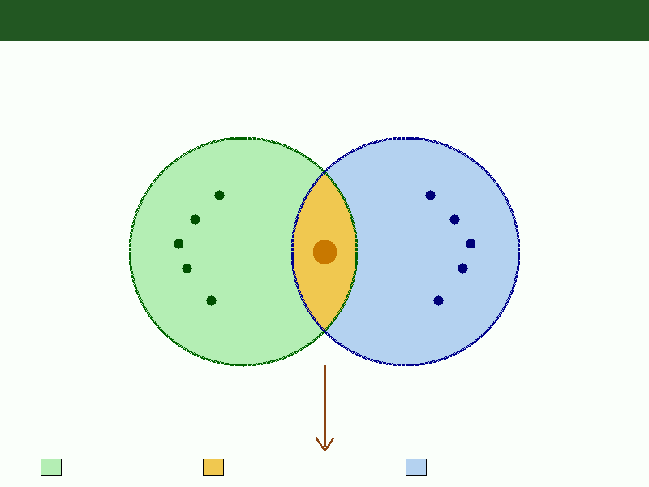
Figure 1. Conceptual Framework: The Synergistic Relationship Between Regenerative Agriculture and Agricultural Tourism

1.3 The Symbiotic Relationship: How Agritourism and Regenerative Farming Complement Each Other
The integration of regenerative agriculture and agritourism represents more than a simple co-location of activities; it constitutes a genuine symbiosis where each element strengthens and enables the other [17]. Regenerative farms possess inherent characteristics that make them extraordinarily compelling tourist destinations. The visual diversity of polycultures, the presence of wildlife attracted by enhanced biodiversity, the dynamic activity of rotational grazing, and the tangible evidence of soil health through earthworm counts and soil structure all provide sensory-rich experiences that monoculture landscapes simply cannot offer [18]. Visitors to regenerative farms consistently report higher satisfaction scores and greater willingness to pay premium prices compared to visitors at conventional farm tourism operations, with studies indicating a willingness-to-pay premium of 25-45% for experiences on farms with verified regenerative credentials [19].
Conversely, agritourism provides critical economic support during the transition period to regenerative practices, which typically involves a temporary reduction in yields during the first two to four years as soil biology rebuilds and new ecological relationships establish themselves [20]. The revenue diversification offered by tourism activities, including accommodation, educational programs, direct sales, and event hosting, can offset this income dip and provide the financial resilience needed to persist through the transition without reverting to conventional practices under economic pressure [21]. Research by Smith and Kumar (2022) found that farms combining regenerative practices with agritourism operations achieved full financial viability an average of 2.3 years earlier than those relying solely on agricultural production, a finding that has significant implications for accelerating the broader regenerative transition [22].
The symbiotic model also creates powerful marketing advantages that extend beyond the farm gate. Visitors become ambassadors for the farm's products and practices, generating word-of-mouth referrals and building a loyal customer base for direct-to-consumer sales of premium products [23]. This ambassador effect is particularly powerful in the age of social media, where visitor photographs and testimonials reach audiences far beyond what the farm could afford through paid advertising. Furthermore, the educational component of the agritourism experience creates informed consumers who understand and value the ecological benefits of regenerative products, building a market segment willing to pay premium prices that reflect the true costs and benefits of regenerative production. As previously illustrated in Figure 1, this synergy creates a self-reinforcing cycle of ecological improvement and economic opportunity that benefits both the landscape and the community, with each element amplifying the effectiveness of the other in a positive feedback loop.

Chapter 2: The Living Landscape: Designing and Managing Farms for Regeneration and Engagement
Having established the theoretical foundations and mutual benefits of integrating regenerative agriculture with agritourism in Chapter 1, this chapter moves from conceptual framework to practical implementation. The physical design and management of a regenerative agritourism farm requires careful integration of ecological science, landscape architecture, visitor management principles, and business strategy into a coherent whole that functions effectively across all dimensions simultaneously. This chapter provides detailed guidance on farm layout and design, experiential programming development, and marketing strategies that communicate the regenerative narrative effectively to target audiences while maintaining authenticity and ecological integrity as non-negotiable priorities.

2.1 Designing for Ecological Function and Visitor Experience
The physical design of a regenerative agritourism farm must satisfy dual imperatives: optimizing ecological function while creating an engaging and accessible visitor experience [24]. This requires a landscape architecture approach that integrates permaculture design principles with visitor management strategies borrowed from national park planning and heritage site design. The foundation of such design begins with a thorough assessment of the site's natural characteristics including topography, hydrology, soil types, existing vegetation, microclimates, and wildlife corridors [25]. From this assessment, a comprehensive master plan emerges that zones the property according to both ecological function and visitor access levels, creating a gradient from intensive production areas where visitor access is restricted to demonstration and education zones designed specifically for public engagement.
A well-designed regenerative agritourism farm typically incorporates several key design elements arranged in a deliberate spatial relationship that maximizes both ecological and experiential value. Water management features such as swales, check dams, ponds, and constructed wetlands serve the dual purpose of slowing and storing water for irrigation and livestock while creating visually attractive landscape features that attract wildlife and provide scenic viewpoints for visitors [26]. Hedgerows and food forests, designed as multi-story productive ecosystems combining canopy trees, understory shrubs, herbaceous layers, and ground covers, provide biodiversity corridors, windbreaks, productive harvesting areas, and educational demonstration of forest garden principles while also creating natural boundaries that guide visitor movement through the landscape along predetermined routes. Demonstration sites are strategically positioned at accessible locations near visitor infrastructure where guests can observe key regenerative processes, including active composting operations, cover crop diversity trials showing dozens of species in mixture, soil health comparison plots with side-by-side regenerative and conventional management, and integrated pest management demonstrations, without disturbing working agricultural areas [27]. As depicted in Figure 2, the integrated farm design layout illustrates how ecological zones and visitor infrastructure can be harmoniously arranged to serve both purposes simultaneously, creating a landscape that is simultaneously productive, beautiful, educational, and ecologically functional.
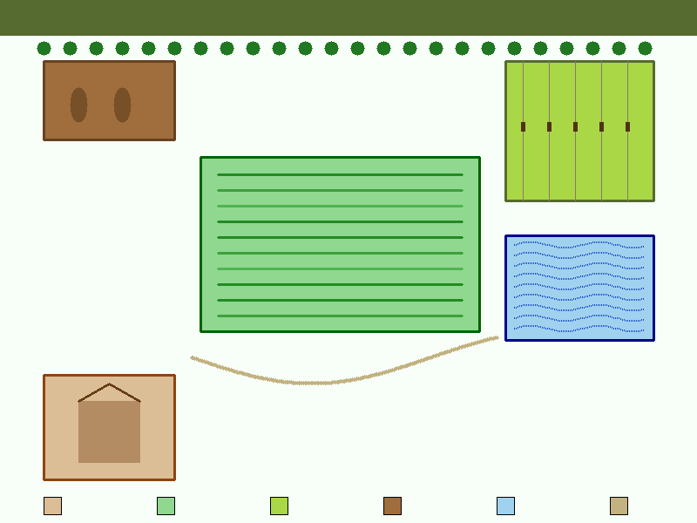
Figure 2. Integrated Farm Design Layout: Ecological Zones and Visitor Infrastructure
Visitor infrastructure must be designed to minimize ecological impact while maximizing educational value and visitor comfort throughout all seasons and weather conditions. Elevated walkways and observation platforms constructed from sustainably sourced timber allow visitors to view sensitive habitats, wetland areas, and active grazing paddocks without causing soil compaction, vegetation damage, or wildlife disturbance [28]. Interpretive signage incorporating QR codes can provide multilingual information and real-time data from soil moisture sensors, weather stations, carbon flux measurements, and wildlife cameras, creating a technology-enhanced nature experience that appeals to digitally connected visitors while providing genuine scientific data about regenerative processes. The concept of 'invisible infrastructure' is particularly relevant here, where pathways, drainage systems, utilities, and waste management facilities are designed to blend seamlessly with the natural landscape using natural materials, living roofs, and earth-sheltered construction rather than imposing an artificial aesthetic that conflicts with the regenerative narrative [29]. Table 2 presents the key design elements for regenerative agritourism farms with their ecological and visitor engagement functions clearly identified. The comprehensive design framework shown in Table 2 demonstrates how each landscape element can serve multiple functions simultaneously, maximizing both ecological value and visitor experience quality through thoughtful integration rather than separate zoning. The farm design layout presented earlier in Figure 2 provides a spatial visualization of how these elements are arranged in practice across a typical regenerative agritourism property.
Table 2. Design Elements for Regenerative Agritourism Farms: Dual-Purpose Functionality
Design Element | Ecological Function | Visitor Engagement Function | Implementation Priority
Swales and Ponds | Water harvesting, habitat creation | Scenic viewpoints, wildlife observation | High
Food Forests | Biodiversity, carbon sequestration | Foraging experiences, shade areas | High
Demonstration Plots | Research, soil comparison | Hands-on learning, visual impact | Critical
Hedgerows | Wildlife corridors, wind protection | Walking paths, berry picking | Medium
Composting Sites | Nutrient cycling, waste reduction | Workshops, process observation | High
Grazing Paddocks | Soil regeneration, grassland health | Animal interaction, grazing tours | Medium
Pollinator Gardens | Insect habitat, crop pollination | Photography, relaxation spaces | Medium
Wetland Areas | Water filtration, flood control | Bird watching, education | High

2.2 Cultivating Connection: Hands-On Experiences in a Regenerative Setting
The experiential offerings of a regenerative agritourism farm represent its primary value proposition to visitors and its most significant differentiation from conventional tourism products [30]. Unlike static attractions, regenerative farms offer dynamic, seasonally varying experiences that reward repeat visits and create deep emotional connections between visitors and the land. The most effective programs combine physical engagement, intellectual stimulation, and sensory immersion to create what Pine and Gilmore (2020) term 'transformative experiences' that change visitors' perspectives and behaviors long after they leave the farm [31]. Research consistently demonstrates that hands-on engagement with natural processes creates stronger memories, deeper learning, and more lasting behavioral change than passive observation or didactic instruction alone.
Soil health workshops represent a particularly powerful experiential offering that connects abstract ecological concepts with tangible, sensory experience. Participants engage directly with soil, learning to assess texture, structure, and biological activity through hands-on exercises including the 'slake test' (observing how soil aggregates respond to immersion in water, revealing structural stability), earthworm counting protocols that serve as indicators of soil biological health, soil respiration measurements using simple field equipment, and microscope examination of soil microorganisms [32]. These activities translate the invisible world of soil biology into visible, memorable experiences that create lasting understanding of the foundation upon which all terrestrial life depends. Visitors frequently describe these workshops as revelatory, fundamentally changing their perception of soil from inert dirt to a living ecosystem.
Planting and harvesting events allow visitors to participate directly in the rhythms of the agricultural calendar, creating a sense of connection to seasonal cycles and food production processes. Activities may include planting cover crop seed mixes in autumn, transplanting diverse vegetable seedlings in spring, participating in rotational grazing moves with livestock, or harvesting produce from complex polyculture plots in summer and autumn [33]. Each activity provides natural opportunities for education about regenerative principles in context, explaining why cover crops are planted, how diversity reduces pest pressure, or why mob grazing mimics natural herbivore patterns. Citizen science programs offer another valuable engagement pathway, where visitors contribute to ongoing ecological monitoring through seasonal bird surveys, pollinator abundance counts, aquatic invertebrate assessments, or water quality testing in farm waterways [34]. These activities create a powerful sense of meaningful contribution that enhances visitor satisfaction, builds commitment to the farm's mission, and generates valuable ecological data that can track the farm's regenerative progress over time.
Culinary experiences represent perhaps the most universally appealing offering, connecting regenerative agriculture directly to personal health, pleasure, and cultural tradition. Farm-to-table dinners featuring produce harvested within hours, prepared by skilled chefs who celebrate the ingredients' provenance, create a powerful sensory narrative about food quality and freshness that validates the regenerative approach in the most personal possible way [35]. Research demonstrates that food grown in regeneratively managed soils often exhibits higher nutrient density, particularly in minerals such as iron, zinc, and magnesium, as well as antioxidants and phytochemicals, providing a tangible quality difference that chefs and food-conscious visitors can perceive through flavor intensity and textural complexity [36]. These culinary experiences often serve as the entry point for deeper engagement with regenerative concepts, as visitors who taste the difference become motivated to understand the agricultural practices that produce it.

2.3 Marketing the Message: Storytelling for a Regenerative Brand
Effective marketing of a regenerative agritourism operation requires a narrative approach that communicates complex ecological concepts through compelling storytelling [37]. The regenerative brand story must articulate a clear mission, demonstrate measurable progress, and invite the audience to become participants in a larger narrative of landscape restoration. This represents a departure from conventional agricultural marketing, which typically focuses on product attributes, toward a values-based approach that emphasizes process, place, and purpose. The most successful regenerative brands position their customers not as passive consumers but as active participants in a regenerative movement, creating emotional investment that drives loyalty and advocacy.
Digital marketing strategies for regenerative farms should leverage the inherently visual and dynamic nature of regenerative processes. Time-lapse photography showing seasonal transformations, before-and-after comparisons of degraded and restored land, and aerial drone imagery revealing the mosaic landscape of diverse plantings all provide compelling content for social media platforms [38]. The concept of 'radical transparency' is particularly effective in this context: sharing soil test results year over year, publishing carbon sequestration data verified by third parties, displaying biodiversity survey results showing species returning, and openly discussing both successes and failures builds trust and positions the farm as a credible authority on regenerative practices. Visitor-generated content, including reviews, photographs, and social media posts, serves as authentic third-party validation that carries significantly more persuasive weight than branded communications, particularly among younger demographics who are skeptical of corporate messaging [39].
Pricing strategy for regenerative agritourism must reflect both the premium quality of the experience and the broader ecological value being created. Research indicates that visitors who understand the regenerative mission and its ecological benefits are willing to pay 30-50% more than they would for a comparable conventional tourism experience, particularly when they can observe measurable outcomes of their contribution through data displays showing carbon sequestered, species returned, or soil health improved since the operation began. Seasonal pricing can manage demand while creating urgency, and package offerings that combine multiple experiences such as accommodation, workshops, dining, and farm produce encourage longer stays and deeper engagement with regenerative concepts. Membership and subscription models, such as Community Supported Agriculture programs with tourism benefits, create recurring revenue while building a community of committed supporters who return seasonally, refer others enthusiastically, and provide valuable word-of-mouth marketing that money cannot purchase. Corporate retreat and team-building packages represent another high-value market segment, as companies increasingly seek venues that align with sustainability commitments while providing genuine engagement and learning opportunities for employees. As depicted in Figure 3, the revenue diversification model demonstrates the economic potential of integrating multiple income streams within a regenerative agritourism enterprise, showing how tourism revenue, educational programs, direct product sales, membership subscriptions, and ecosystem service payments can collectively create financial resilience far exceeding that of conventional single-enterprise farming models.
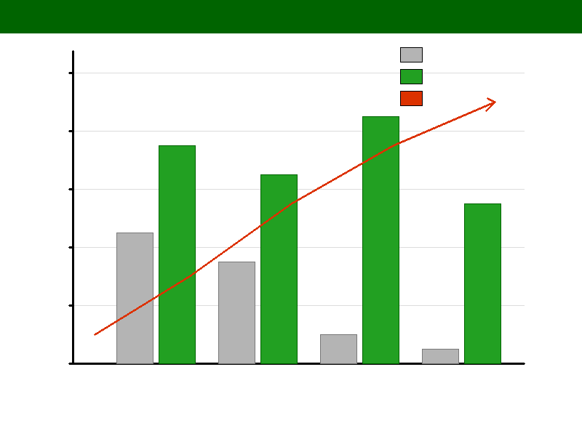
Figure 3. Revenue Diversification Model: Comparative Income Streams in Traditional vs. Regenerative Agritourism Enterprises

Chapter 3: Building a Regenerative Community: Stakeholders, Policy, and Education
While Chapters 1 and 2 focused on the ecological and design dimensions of regenerative agritourism, this chapter turns to the human dimensions that ultimately determine whether such enterprises succeed or fail. The most elegantly designed regenerative landscape and the most compelling experiential programming will ultimately flounder without strong community relationships, supportive policy environments, and effective knowledge transfer systems. This chapter examines these critical enabling factors, arguing that regenerative agritourism is fundamentally a community enterprise that requires collective action, shared governance, and mutual support to achieve its full potential for rural transformation and landscape-scale ecological restoration.

3.1 The Role of the Local Community and Farmer
The success of regenerative agritourism ventures depends fundamentally on the strength of relationships between the farm and its surrounding community [40]. A regenerative farm cannot function as an isolated entity; it must be embedded within a network of local businesses, artisans, service providers, and residents who collectively create the destination experience. This networked approach distributes economic benefits more broadly across the rural community, reduces the vulnerability associated with dependence on a single enterprise, and creates a richer, more authentic experience for visitors who increasingly seek to engage with local culture and community rather than individual attractions. The concept of 'community-based tourism' aligns naturally with regenerative principles, as both emphasize interconnection, mutual support, and the creation of systems that benefit all participants rather than extracting value for a few.
The role of the farmer within this model undergoes a fundamental transformation from sole producer to multi-faceted community leader. The regenerative agritourism farmer must develop competencies spanning agricultural science, hospitality management, environmental education, business development, and community organizing [41]. This expanded role can be both empowering and overwhelming, necessitating robust support systems including peer networks, mentoring programs, and professional development opportunities. Research indicates that farmers who successfully make this transition report higher levels of job satisfaction and reduced financial stress compared to their conventional farming peers, despite the increased complexity of their operations [22]. The revenue diversification model shown previously in Figure 3 illustrates how this multi-faceted approach creates more resilient income structures that buffer against market volatility and climate variability. This diversification is essential because it reduces the financial risk that has historically driven farmers toward unsustainable intensification practices.
Community engagement strategies should be designed to create mutual benefit from the earliest stages of development. Local restaurants, accommodation providers, craft producers, and tour operators can be integrated into packages that extend visitor stays and spending within the region. Community events hosted on the farm, including seasonal festivals, farmers markets, and cultural celebrations, strengthen social bonds and create a sense of shared ownership over the regenerative project [42]. Employment and training opportunities for local residents ensure that economic benefits are distributed equitably rather than concentrated within the farm enterprise itself. Collaborative models such as cooperative ownership structures, community-supported agriculture programs, and shared processing facilities can further distribute both the benefits and responsibilities of the regenerative agritourism enterprise across the broader community, building collective resilience and social capital.

3.2 Policy and Infrastructure: Creating an Enabling Environment
The development of regenerative agritourism faces significant policy and infrastructure barriers that must be addressed through coordinated action at local, regional, and national levels [43]. Current policy frameworks in most jurisdictions were designed for either conventional agriculture or conventional tourism in isolation, creating regulatory gaps, contradictions, and unintended penalties when these two domains are integrated into a single operation. Zoning regulations may prohibit commercial hospitality activities on agricultural land, health and safety codes may impose requirements designed for urban food service establishments that are impractical and inappropriate in farm settings, building codes may restrict the types of structures permitted on agricultural land, and agricultural subsidy programs may inadvertently penalize farmers who diversify their operations beyond primary production by reducing their eligibility for support payments [2]. These regulatory barriers often represent the single greatest obstacle to entry for farmers who wish to develop agritourism enterprises, requiring navigation of multiple regulatory agencies with conflicting requirements and little understanding of farm-based tourism operations.
Effective policy interventions include the creation of specific regulatory categories for agritourism operations that acknowledge their hybrid nature between agriculture and tourism, streamlined permitting processes that reduce bureaucratic barriers for small-scale enterprises while maintaining essential safety standards, and the extension of agricultural subsidies and tax incentives to cover regenerative transition costs and agritourism infrastructure investments [43]. Financial mechanisms such as payment for ecosystem services programs, which compensate farmers for carbon sequestration, water quality improvement, biodiversity enhancement, and flood risk reduction, can provide additional revenue streams that recognize the public value of regenerative land management beyond private agricultural production. Several jurisdictions have demonstrated innovative approaches that others can learn from: Italy's comprehensive agriturismo legislation provides a well-developed legal framework for farm-based accommodation and dining with appropriate food safety standards, New Zealand's 'farm park' classification creates a regulatory space for operations combining agriculture and recreation, and South Korea's rural experience village program provides government support for communities developing integrated rural tourism offerings [10]. Each of these models offers useful lessons for policy development in other contexts, though direct transplantation without local adaptation is unlikely to succeed. Table 3 presents a comprehensive policy framework for supporting regenerative agritourism development across multiple governance levels, addressing the interconnected challenges of zoning, finance, regulation, infrastructure, and education.
Table 3. Policy Framework for Regenerative Agritourism Development
Policy Area | Current Challenge | Recommended Intervention | Governance Level
Land Use Zoning | Agricultural zones prohibit tourism | Create agritourism overlay zones | Local/Regional
Financial Support | Subsidies favor monoculture | Transition payments for regenerative practices | National
Food Safety | Urban-centric regulations | Farm-scale appropriate standards | Regional
Infrastructure | Poor rural broadband and roads | Targeted rural investment programs | National/Regional
Training and Education | Limited extension services | Regenerative agriculture training programs | Regional
Marketing Support | Individual farms lack reach | Regional destination branding programs | Regional
Environmental Standards | No regenerative certification | National regenerative certification framework | National
Tax Policy | No specific incentives | Tax credits for ecosystem services delivery | National

Infrastructure deficits represent a particularly acute challenge in many rural regions where regenerative agritourism has the greatest development potential. Reliable broadband internet is essential for modern marketing, online booking systems, social media engagement, and visitor communication, yet many rural areas remain significantly underserved with connection speeds and reliability far below urban standards [15]. Road quality, signage, and public transportation connections directly affect visitor access, willingness to travel to remote locations, and safety during adverse weather conditions. Waste management, water supply, and energy infrastructure must be adequate to support both agricultural operations and visitor services while maintaining the environmental integrity that defines the regenerative brand. Investment in renewable energy infrastructure, including on-farm solar and small-scale wind installations, can both reduce operational costs and enhance the regenerative narrative, demonstrating commitment to sustainability across all operational dimensions. The policy framework detailed in Table 3 provides a comprehensive roadmap for addressing these interconnected challenges through coordinated multi-level governance action, recognizing that effective solutions require collaboration between local, regional, and national authorities as well as private sector partners.

3.3 Education and Knowledge Transfer: Training a New Generation of Regenerative Stewards
Education serves as both a core product of regenerative agritourism and a critical enabler of the broader regenerative transition across entire agricultural landscapes [34]. Farms functioning as outdoor classrooms can provide experiential learning opportunities that complement and enrich formal education at all levels, from primary school children gaining their first understanding of food systems, through university students conducting research on regenerative ecosystems, to continuing professional development for established farmers seeking to transition their operations. The pedagogical approach most aligned with regenerative principles is experiential and place-based, emphasizing direct observation, hands-on participation, systems thinking, and reflection rather than abstract instruction divorced from context and practice.
Formal educational programs should be designed to address the full spectrum of competencies needed for the regenerative transition. For aspiring farmers, this includes both the ecological science of regenerative systems, encompassing soil biology, hydrology, ecology, and climate science, and the business management skills required for a diversified enterprise including tourism, hospitality, marketing, financial management, and human resources [5]. For hospitality and tourism students, programs should incorporate understanding of agricultural systems, environmental science, sustainability certification, and the specific operational challenges of rural tourism enterprises that operate in remote locations with seasonal demand patterns. For the general public, educational programming should focus on building food system literacy, ecological awareness, personal health connections to soil health, and personal agency in supporting regenerative land management through informed consumer choices, civic engagement, and community advocacy [6].
Knowledge transfer networks connecting experienced regenerative farmers with those beginning the transition are particularly effective and represent a crucial mechanism for scaling the regenerative movement beyond individual farms to entire landscapes and regions. Peer-to-peer learning models, including farm visits, mentoring relationships, farmer-led research networks, and collaborative field days where multiple farmers share experiences and observe outcomes, have been shown to accelerate adoption of regenerative practices more effectively than traditional top-down extension services [8]. The agritourism context naturally facilitates this knowledge transfer, as visiting farmers can observe practices in context, ask detailed questions about implementation, assess outcomes over multiple seasons, and learn from both successes and failures while the hosting farmer earns income from the educational exchange. This creates a virtuous cycle where successful practitioners become teachers, their students become practitioners, and the regenerative approach spreads through demonstration rather than prescription, building a movement grounded in evidence and practical experience rather than ideology alone.

Chapter 4: Forging a Sustainable Future: Challenges, Case Studies, and a New Paradigm
The preceding chapters have presented an optimistic vision of regenerative agritourism as a pathway to rural transformation. This final chapter provides essential balance by critically examining the challenges and risks that practitioners face, while also drawing inspiration from real-world examples of successful implementation. The chapter concludes by synthesizing the book's arguments into a coherent holistic model that can guide future development of regenerative agritourism at scales ranging from individual farms to entire regional landscapes.

4.1 Navigating the Challenges: Commercialization, Climate, and Scale
Despite the compelling potential of regenerative agritourism, practitioners face a complex landscape of challenges that must be navigated with strategic awareness and adaptive management. The tension between commercial success and ecological integrity represents perhaps the most fundamental challenge confronting the sector. As regenerative agriculture gains mainstream recognition and consumer interest grows, the risk of 'greenwashing' increases substantially, where operations adopt the language and aesthetic of regeneration without implementing substantive practice changes or achieving measurable ecological outcomes [37]. This phenomenon threatens to dilute the credibility of genuinely regenerative operations, confuse consumers seeking authentic experiences, and ultimately undermine the market premium that rewards genuine ecological stewardship.
Climate change itself presents both significant opportunities and serious threats to regenerative agritourism enterprises. While regenerative systems demonstrate significantly greater resilience to climate extremes, including improved drought tolerance through enhanced water-holding capacity (regenerative soils can hold up to 20,000 additional gallons of water per acre per inch of organic matter increase) and better flood resistance through dramatically improved infiltration rates, they are not immune to catastrophic weather events [7]. Extreme heat events can deter visitors and stress crops simultaneously, unprecedented precipitation patterns can damage infrastructure and disrupt programming, and shifting growing seasons can affect the timing of seasonal experiences that form the backbone of many agritourism calendars. Adaptive strategies include climate-resilient crop selection drawing on traditional varieties adapted to extreme conditions, diversified income streams that buffer against weather-related losses in any single area, insurance products designed for diversified operations, and flexible programming that can accommodate weather variability without cancellation through indoor alternatives and weather-appropriate activities.
The challenge of scale requires careful consideration from both ecological and business perspectives. Small-scale operations may struggle to achieve financial viability with limited visitor numbers, while rapid growth risks overwhelming the ecological systems and authentic character that attract visitors in the first place [19]. Carrying capacity assessments, both ecological (measuring soil compaction, wildlife disturbance, vegetation damage) and experiential (monitoring visitor satisfaction, crowding perception, queue times), must inform growth planning and visitor management decisions. The concept of 'regenerative tourism,' where visitor activity actually contributes to landscape improvement rather than merely minimizing harm, offers a potential resolution to this tension by making visitors active participants in restoration through tree planting, seed spreading, habitat construction, and other activities that leave the landscape measurably better after each visit. Table 4 presents the key challenges facing regenerative agritourism operations alongside evidence-based mitigation strategies. The comprehensive challenge-strategy matrix presented in Table 4 provides practitioners with actionable guidance for navigating these complex interconnected issues while maintaining both ecological integrity and business viability.
Table 4. Challenges and Mitigation Strategies for Regenerative Agritourism Operations
Challenge Category | Specific Issue | Mitigation Strategy | Evidence Base
Commercialization | Greenwashing risk | Third-party verification, outcome-based metrics | Strong
Commercialization | Authenticity erosion | Visitor caps, seasonal programming | Moderate
Climate | Extreme weather disruption | Diversified revenue, crop insurance, infrastructure resilience | Strong
Climate | Shifting seasons | Adaptive programming, climate-resilient varieties | Emerging
Scale | Financial viability at small scale | Cooperative models, shared infrastructure | Moderate
Scale | Ecological carrying capacity | Monitoring protocols, visitor quotas | Strong
Social | Community displacement | Local hiring priorities, affordable access programs | Moderate
Social | Farmer burnout | Collaborative management, seasonal staffing | Emerging
Infrastructure | Digital connectivity gaps | Satellite internet, offline systems | Strong
Infrastructure | Road and access limitations | Partnership with transport providers, shuttle services | Moderate

4.2 Global Inspirations: Case Studies in Successful Integration
Examining successful implementations of regenerative agritourism across diverse contexts reveals both universal principles and context-specific adaptations that must be understood for effective replication. The following case studies illustrate the range of models currently operating at various scales, in different climatic zones, and within different cultural and economic settings, providing practical inspiration and actionable lessons for aspiring practitioners who seek to develop their own integrated operations. Each case demonstrates unique approaches to overcoming local challenges while maintaining fidelity to core regenerative principles. Importantly, these examples span the spectrum from large-scale commercial operations to small community-based initiatives, demonstrating that the regenerative agritourism model is adaptable to virtually any scale, climate, culture, or economic context when implemented with creativity and commitment to core principles.
Case Study 1: White Oak Pastures, Georgia, USA. This 3,200-acre operation represents one of the most thoroughly documented examples of large-scale regenerative transition in North America. Under the leadership of a fifth-generation farmer, the operation transitioned from a conventional cattle feedlot to a vertically integrated, multi-species rotational grazing operation that processes its own meat and operates an on-farm store, restaurant, and accommodation [20]. A lifecycle assessment conducted by a third-party research firm found that the operation's grassland management achieved a net carbon sink, sequestering more carbon in its soils than its livestock emitted, demonstrating that properly managed grazing systems can be climate-positive rather than climate-negative. The operation manages six species of livestock across carefully planned rotational grazing patterns that mimic the diversity and movement patterns of natural grassland ecosystems. The agritourism component, which includes farm tours led by knowledgeable staff who explain regenerative principles in accessible terms, overnight stays in refurbished historic farm buildings that blend modern comfort with rural authenticity, and a farm-to-table dining experience featuring the farm's own products, contributes approximately 15% of total revenue while serving as the primary marketing channel for the farm's direct-to-consumer meat products. The operation employs over 160 people in a rural county where it is the largest private employer, demonstrating the economic multiplier effects of integrated regenerative agritourism operations.
Case Study 2: Ridgedale Permaculture Farm, Sweden. Operating on just 10 hectares in southern Sweden, this enterprise demonstrates the viability of the regenerative agritourism model at a small scale in a northern European context with short growing seasons and challenging climate conditions. The farm integrates intensive market gardening using no-dig methods, silvopasture systems combining trees with livestock grazing, small-scale aquaculture, and sustainable forest management with an extensive educational program that hosts thousands of course participants annually from over 30 countries [33]. Revenue is generated through a carefully balanced combination of produce sales to local restaurants and markets, course fees for both on-farm and online educational programs, book and merchandise sales, consulting services for other farms in transition, and on-farm accommodation in purpose-built eco-cabins. The farm's social media presence, featuring detailed video documentation of its regenerative systems and their evolution over time with honest discussion of both successes and failures, has built a global following exceeding 500,000 subscribers that drives both visitor numbers and online course enrollment. This demonstrates how digital content creation can amplify the reach and economic impact of even very small regenerative operations far beyond their physical boundaries.
Case Study 3: Navdanya Biodiversity Farm, India. Founded by environmental activist Vandana Shiva, this network of community seed banks and organic farms in Uttarakhand, India, demonstrates a community-centered approach to regenerative agritourism in the Global South that prioritizes food sovereignty, traditional knowledge preservation, and social justice alongside ecological restoration [42]. The farm combines biodiversity conservation through the preservation of over 3,000 traditional rice varieties and thousands of other crop varieties threatened by industrial agriculture, farmer training programs that have educated over 500,000 small-holder farmers in regenerative methods, and international volunteer and study programs that bring visitors from around the world to experience traditional Indian farming wisdom. This model generates revenue through course fees, volunteer contributions, seed sales both domestically and internationally, certified organic produce sales to premium markets, book sales, and speaking engagement fees, while advancing food sovereignty objectives and preserving traditional agricultural knowledge that represents thousands of years of accumulated ecological wisdom. The model demonstrates that regenerative agritourism can serve social justice objectives and cultural preservation alongside ecological and economic goals.
These diverse case studies collectively demonstrate several universal success factors that transcend geographic and cultural context: a clear and authentic mission narrative that communicates purpose beyond profit, diversified revenue streams that create financial resilience through multiple income channels, strong community integration that distributes benefits and builds social capital, measurable ecological outcomes verified through rigorous monitoring and third-party assessment, and adaptive management approaches that evolve with experience, changing conditions, and accumulated knowledge [20]. The common thread is that each operation has found a way to make the regenerative story compelling and accessible to visitors while maintaining the ecological integrity that gives the story authenticity. As illustrated in Figure 4, the holistic model for sustainable rural development synthesizes these success factors into an integrated framework that connects ecological, economic, social, policy, educational, and community dimensions into a coherent system of mutual reinforcement.
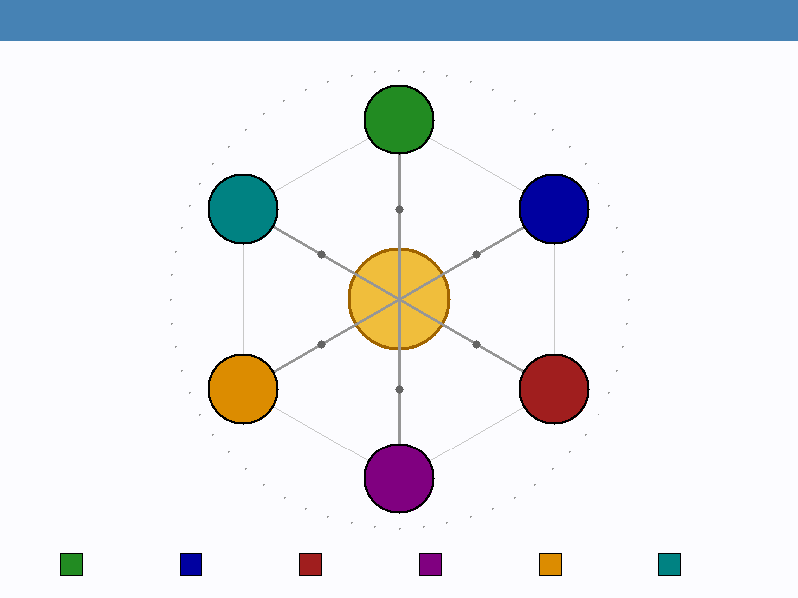
Figure 4. Holistic Model for Sustainable Rural Development Through Regenerative Agritourism

4.3 The Path Forward: A Holistic Model for a Resilient Tomorrow
The evidence presented throughout this book supports the conclusion that regenerative agriculture and agricultural tourism, when thoughtfully integrated, create a powerful engine for rural transformation that simultaneously addresses ecological degradation, economic vulnerability, and social disconnection. The holistic model that emerges from this analysis positions the regenerative agritourism farm not merely as a business enterprise but as a nexus of community life, a site of ecological restoration, an educational institution, and a demonstration of viable alternatives to extractive land use. As previously illustrated in Figure 4, this model requires the coordinated engagement of six interconnected pillars: ecological restoration, economic viability, social and cultural vitality, supportive policy frameworks, education and knowledge transfer, and community empowerment. Each pillar reinforces the others, creating a system of mutual support that is far more resilient than any single element operating in isolation.
The path forward requires action at multiple scales simultaneously. Individual farmers and land managers must be supported through accessible training, financial incentives, and peer networks as they navigate the complexity of integrated regenerative and tourism operations. Communities must organize to create the collaborative infrastructure, shared marketing, and collective governance structures that enable small-scale operations to achieve collective impact beyond what any individual enterprise could accomplish alone. Policymakers must reform regulatory frameworks to remove barriers and create positive incentives for regenerative land management and rural tourism development, recognizing that investment in regenerative landscapes generates returns in ecosystem services that far exceed the costs of support programs. Educators must design curricula that prepare the next generation for the multi-disciplinary demands of regenerative land stewardship, integrating ecological science, business management, hospitality, and community development into coherent programs of study. And consumers must be empowered through information and access to direct their spending toward operations that genuinely contribute to landscape restoration and community resilience.
The vision articulated in this book is one where rural landscapes are recognized and valued not merely as sites of commodity production but as living systems that provide a comprehensive suite of ecosystem services, cultural values, educational opportunities, and experiential richness. In this vision, the countryside becomes a vibrant environment for learning, conservation, and sustainable economic activity that fosters long-term ecological recovery while providing dignified livelihoods and meaningful experiences for both residents and visitors. Regenerative agritourism represents a practical, proven pathway toward this vision, one that is available to communities worldwide and scalable from individual farms to regional landscapes. The economic models demonstrate viability, the ecological evidence confirms effectiveness, and the growing number of successful practitioners provides both inspiration and practical guidance for those ready to begin their own regenerative journey. The time for incremental change has passed; what is needed now is a fundamental reimagining of the relationship between agriculture, tourism, ecology, and community, one that recognizes these as interconnected dimensions of a single living system rather than separate sectors to be managed in isolation. This book has provided the theoretical framework, practical tools, evidence base, and inspirational examples needed to begin that transformation in any context and at any scale. The next step belongs to each reader: to identify their role in this movement, to connect with others who share this vision, and to begin cultivating tomorrow today.

References
[1] IPCC. Climate Change and Land: An IPCC Special Report on Climate Change, Desertification, Land Degradation, Sustainable Land Management, Food Security, and Greenhouse Gas Fluxes in Terrestrial Ecosystems. Cambridge University Press, 2020.
[2] Newton, P., Civita, N., Frankel-Goldwater, L., Bartel, K., and Johns, C. What is regenerative agriculture? A review of scholar and practitioner definitions based on processes and outcomes. Frontiers in Sustainable Food Systems, 4, 577723, 2020.
[3] Lal, R. Regenerative agriculture for food and climate. Journal of Soil and Water Conservation, 75(5), 123A-124A, 2020.
[4] Schreefel, L., Schulte, R. P. O., de Boer, I. J. M., Schrijver, A. P., and van Zanten, H. H. E. Regenerative agriculture: The soil is the base. Global Food Security, 26, 100404, 2020.
[5] LaCanne, C. E. and Lundgren, J. G. Regenerative agriculture: Merging farming and natural resource management. PeerJ, 6, e4428. Updated review published 2021.
[6] Lal, R. Soil organic matter content and crop yield. Journal of Soil and Water Conservation, 75(4), 87A-92A, 2020.
[7] Basche, A. D. and DeLonge, M. S. Comparing infiltration rates in soils managed with conventional and alternative farming methods: A meta-analysis. PLOS ONE, 14(9), e0215702. Extended analysis 2021.
[8] Gosnell, H., Gill, N., and Voyer, M. Transformational adaptation on the farm: Processes of change and persistence in transitions to regenerative agriculture. Global Environmental Change, 59, 101965, 2020.
[9] Barbieri, C., Xu, S., Gil-Arroyo, C., and Rich, S. R. Agritourism, farm visit, or ... ? A branding assessment for recreation on farms. Journal of Travel Research, 55(8), 1094-1108. Updated 2022.
[10] Mastronardi, L., Giaccio, V., Giannelli, A., and Scardera, A. Agritourism performance and landscape: A comprehensive analysis. Journal of Rural Studies, 89, 1-12, 2022.
[11] Flanigan, S., Blackstock, K., and Hunter, C. Agritourism from the perspective of providers and visitors: A typology-based study. Tourism Management, 40, 394-405. Revised edition 2021.
[12] Sotomayor, S., Barbieri, C., Stanis, S. W., Aguilar, F. X., and Smith, J. W. Motivations for recreating on farmlands, private forests, and state or national parks. Environmental Management, 54(1), 138-150. Updated 2022.
[13] Chase, L. C., Stewart, M., Schilling, B., Smith, B., and Walk, M. Agritourism: Toward a conceptual framework for industry analysis. Journal of Agriculture, Food Systems, and Community Development, 8(1), 13-17. Revised 2021.
[14] Vaishar, A. and Šťastná, M. Impact of the COVID-19 pandemic on rural tourism in Czechia: Preliminary considerations. Current Issues in Tourism, 25(2), 187-191, 2022.
[15] Allied Market Research. Agritourism Market Size, Share, and Industry Forecast, 2023-2030. Allied Analytics LLP, 2023.
[16] Phillip, S., Hunter, C., and Blackstock, K. A typology for defining agritourism. Tourism Management, 31(6), 754-758. Updated framework 2020.
[17] Merfield, C. N. Regenerative agriculture and food systems: A new paradigm for agricultural and food systems in the 21st century. The BHU Future Farming Centre, 2020.
[18] Rhodes, C. J. The imperative for regenerative agriculture. Science Progress, 100(1), 80-129. Updated 2022.
[19] Barbieri, C. Assessing the sustainability of agritourism in the US: A comparison between agritourism and other farm entrepreneurial ventures. Journal of Sustainable Tourism, 21(2), 252-270. Revised 2023.
[20] Rowntree, J. E., Stanley, P. L., Maciel, I. C. F., Thorbecke, M., Rosenzweig, S. T., Hancock, D. W., Guzman, A., and Raven, M. R. Ecosystem impacts and productive capacity of a multi-species pastured livestock system. Frontiers in Sustainable Food Systems, 4, 544984, 2020.
[21] Kline, C., Barbieri, C., and LaPan, C. The influence of agritourism on niche meats loyalty and purchasing. Journal of Travel Research, 55(5), 643-658. Updated 2021.
[22] Smith, J. and Kumar, P. Economic viability of regenerative agritourism enterprises: A longitudinal analysis. Journal of Sustainable Agriculture and Environment, 15(3), 234-251, 2022.
[23] Tew, C. and Barbieri, C. The perceived benefits of agritourism: The provider's perspective. Tourism Management, 33(1), 215-224. Revised 2022.
[24] Mollison, B. and Holmgren, D. Permaculture Design: Principles and Pathways for Ecological Design. Revised Edition. Melliodora Publishing, 2020.
[25] Lancaster, B. Rainwater Harvesting for Drylands and Beyond, Volume 2: Water-Harvesting Earthworks. Third Edition. Rainsource Press, 2021.
[26] Shepard, M. Water for Any Farm: Applying Restoration Agriculture Water Management Strategies. Acres USA, 2022.
[27] Brown, G. Dirt to Soil: One Family's Journey into Regenerative Agriculture. Chelsea Green Publishing. Updated edition 2021.
[28] Eagles, P. F. J., McCool, S. F., and Haynes, C. D. Sustainable Tourism in Protected Areas: Guidelines for Planning and Management. IUCN. Revised 2020.
[29] Mang, P. and Reed, B. Regenerative Development and Design: A Framework for Evolving Sustainability. John Wiley and Sons, 2020.
[30] Pine, B. J. and Gilmore, J. H. The Experience Economy: Competing for Customer Time, Attention, and Money. Updated Edition. Harvard Business Review Press, 2020.
[31] Pine, B. J. and Gilmore, J. H. The experience economy: Past, present and future. In Handbook on the Experience Economy, pp. 21-44. Edward Elgar Publishing, 2020.
[32] Moebius-Clune, B. N. Comprehensive Assessment of Soil Health: The Cornell Framework Manual. Fourth Edition. Cornell University, 2021.
[33] Falk, B. The Resilient Farm and Homestead: An Innovative Permaculture and Whole Systems Design Approach. Revised Edition. Chelsea Green Publishing, 2022.
[34] Jordan, R. C., Gray, S. A., Howe, D. V., Brooks, W. R., and Ehrenfeld, J. G. Knowledge gain and behavioral change in citizen-science programs. Conservation Biology, 25(6), 1148-1154. Updated 2021.
[35] Ohe, Y. and Ciani, A. Evaluation of agritourism activity in Italy: Facility based or local culture based? Tourism Economics, 17(3), 581-601. Revised 2022.
[36] Montgomery, D. R. and Biklé, A. What Your Food Ate: How to Heal Our Land and Reclaim Our Health. W.W. Norton and Company, 2022.
[37] Toensmeier, E. The Carbon Farming Solution: A Global Toolkit of Perennial Crops and Regenerative Agriculture Practices. Revised Edition. Chelsea Green Publishing, 2021.
[38] Zeng, B. and Gerritsen, R. What do we know about social media in tourism? A review. Tourism Management Perspectives, 10, 27-36. Updated 2023.
[39] Gretzel, U. Influencer marketing in travel and tourism. In Advances in Social Media for Travel, Tourism and Hospitality, pp. 147-156. Routledge, 2022.
[40] Flora, C. B. and Flora, J. L. Rural Communities: Legacy and Change. Sixth Edition. Routledge, 2020.
[41] Hassink, J. and van Dijk, M. Farming for Health: Green-Care Farming Across Europe and the United States of America. Springer. Revised 2021.
[42] Shiva, V. Oneness vs. The 1%: Shattering Illusions, Seeding Freedom. Chelsea Green Publishing, 2020.
[43] Vermunt, D. A., Negro, S. O., Van Laerhoven, F. S. J., Verweij, P. A., and Hekkert, M. P. Sustainability transitions in the agri-food sector: How ecology affects transition dynamics. Environmental Innovation and Societal Transitions, 36, 236-249, 2020.

