SUSTAINABLE LAND MANAGEMENT TO ACHIEVE A LAND DEGRADATION NEUTRAL WORLD
Authors: Amman Jakhar¹,* and Sachin Kalsi¹
¹ Department of Mechanical Engineering, Chandigarh University, Mohali, Punjab-140301
*Corresponding Email: ammanjakhar5000734@gmail.com

Abstract
Land degradation threatens ecosystem integrity, agricultural productivity, biodiversity, and livelihoods while intensifying climate change. Sustainable land management (SLM) offers an integrated approach to preventing, reducing, and reversing degradation while advancing Land Degradation Neutrality (LDN). This chapter examines the principles, practices, and emerging technologies that underpin SLM and a land degradation–neutral world. It explores conservation agriculture, agroforestry, crop rotation, sustainable grazing, watershed management, soil conservation, and ecosystem restoration, which improve soil fertility and water retention, reduce erosion, sequester carbon, and strengthen climate resilience. It highlights remote sensing, geographic information systems, artificial intelligence, and digital platforms for assessing degradation and evaluating restoration. The chapter discusses climate-smart agriculture, community participation, Indigenous knowledge, policy, and sustainable financing, and presents the Sukhomajri watershed case study from India. It concludes that coordinated, inclusive action—integrating scientific innovation with inclusive governance—is essential for achieving LDN and climate resilience.
Keywords: Sustainable land management, Land Degradation Neutrality, climate change adaptation, soil restoration, carbon sequestration, watershed management

Learning Objectives
After studying this chapter, the reader should be able to:
• Explain land degradation as a coupled socio-ecological and climate challenge and describe its principal drivers, processes, and impacts.
• Define sustainable land management and the Land Degradation Neutrality framework, and articulate the avoid–reduce–reverse response hierarchy.
• Identify core SLM practices for soil, water, and ecosystem health and evaluate how they deliver climate adaptation and mitigation co-benefits.
• Describe how remote sensing, geographic information systems, artificial intelligence, and digital platforms support degradation assessment and LDN monitoring.
• Appraise the role of community participation, Indigenous knowledge, policy, and financing in achieving LDN, drawing lessons from a real-world watershed case study.

1. Introduction — Land Degradation, Climate Change, and the LDN Agenda

1.1 Land Degradation as a Coupled Socio-Ecological and Climate Challenge
Land degradation—the persistent reduction or loss of the biological and economic productivity of land—has become one of the most pervasive environmental challenges of the present era. A comprehensive global review concluded that the degradation of the Earth's land surface through human activities is undermining soil resources, food security, and the natural capital on which the well-being of a large share of humanity depends [1]. Authoritative syntheses estimate that a substantial fraction of the global ice-free land surface is already degraded to some degree, with the area affected expanding each year as cultivation, grazing, deforestation, and urban expansion intensify [2]. The problem is not confined to drylands or to the Global South; it spans humid and arid zones alike and manifests through a diversity of processes operating at different scales [3].
The drivers of land degradation are both proximate and underlying. Proximate drivers include unsustainable agricultural practices, overgrazing, deforestation, improper irrigation that induces salinization, and the sealing of soils by infrastructure. Underlying drivers include population growth, poverty, insecure land tenure, market failures, and weak governance that together shape how land is used and abused [1]. These drivers set in motion degradation processes—water and wind erosion, loss of soil organic carbon, nutrient depletion, salinization, acidification, compaction, and the loss of vegetation and biodiversity—whose cumulative effect is a decline in the capacity of land to deliver ecosystem services [3]. As summarized in Table 1, each driver is associated with characteristic processes and impacts that ripple across soil, water, biodiversity, and human livelihoods.
The consequences of degradation are far-reaching. Declining soil fertility and structure reduce agricultural yields and threaten food security, while the erosion of topsoil removes the thin, slowly renewable layer on which terrestrial productivity depends [4]. Degraded land retains less water, amplifying both drought stress during dry periods and runoff and flooding during intense rainfall, so that the hydrological cycle itself is destabilized at the catchment scale [5]. Biodiversity declines as habitats are fragmented and simplified, eroding the genetic and functional diversity that underpins ecosystem resilience [1]. For the hundreds of millions of people whose livelihoods depend directly on the land, these biophysical changes translate into lost income, deepened poverty, food insecurity, and, in extreme cases, displacement and migration [2]. The cascading pathway from drivers through processes to socio-economic impacts is depicted in Figure 1, which emphasizes that biophysical degradation and human vulnerability are mutually reinforcing rather than separable phenomena.
The entanglement of land degradation with climate change is especially consequential. Degradation and climate change are locked in a set of feedbacks: the loss of soil organic carbon and vegetation releases greenhouse gases that drive warming, while warming, altered precipitation, and more frequent extremes accelerate erosion, aridification, and the breakdown of soil structure [6]. Degraded landscapes are less able to buffer communities against droughts, floods, and heat, so that the same populations exposed to climatic hazards are often those whose land base has already been impoverished [5]. In regions such as India, where a large share of cultivable land is affected by water and wind erosion, soil degradation directly undermines the adaptive capacity of rural communities confronting an increasingly variable climate [7]. As Figure 1 makes clear, climate change acts as a threat multiplier that intensifies every stage of the degradation cascade, closing a vicious cycle between a destabilized climate and a deteriorating land base.
[Insert Table 1 here]
Table 1. Major Drivers of Land Degradation, Associated Processes, and Impacts
Driver | Dominant Degradation Process | Principal Impacts | Climate Linkage
Unsustainable cultivation | Water/wind erosion, nutrient depletion | Yield decline, topsoil loss | Reduced soil carbon; higher emissions
Overgrazing | Vegetation loss, compaction | Rangeland degradation, lower biomass | Lower sequestration; drought sensitivity
Deforestation | Loss of cover, soil exposure | Biodiversity loss, erosion | Large carbon release; altered rainfall
Improper irrigation | Salinization, waterlogging | Cropland abandonment | Heat and evaporative stress amplified
Urban expansion / sealing | Soil sealing, fragmentation | Loss of productive land | Reduced infiltration; flood risk

1.2 Conceptual Foundations of Sustainable Land Management and Land Degradation Neutrality
Sustainable land management is commonly defined as the use of land resources—including soils, water, animals, and plants—to meet changing human needs while simultaneously ensuring the long-term productive potential of these resources and the maintenance of their environmental functions. SLM is therefore not a single technique but an integrating framework that seeks to reconcile production, livelihoods, and ecosystem health across landscapes [8]. Its guiding principles include matching land use to land capability, maintaining and enhancing soil organic matter, protecting and harvesting water, sustaining vegetative cover, and embedding management within the social and institutional context of land users [9].
Land Degradation Neutrality provides the policy architecture within which SLM has acquired global salience. Adopted within the Sustainable Development Goals as Target 15.3, LDN is defined as a state whereby the amount and quality of land resources necessary to support ecosystem functions and services and to enhance food security remain stable or increase within specified temporal and spatial scales [9]. The scientific conceptual framework for LDN articulates a response hierarchy of avoid, reduce, and reverse: priority is given to avoiding new degradation through responsible planning, then to reducing ongoing degradation through improved management, and finally to reversing past degradation through restoration and rehabilitation [8]. Crucially, neutrality is to be achieved through a counterbalancing mechanism in which anticipated losses in land-based natural capital are offset by equivalent gains within the same land type, so that no net loss occurs [10]. This logic is illustrated in Figure 2, which presents the response hierarchy alongside the counterbalancing of losses and gains that defines neutrality.
The LDN concept has been operationalized through a small set of globally agreed indicators—land cover and land-cover change, land productivity dynamics, and soil organic carbon stocks—that together provide a transparent and measurable basis for tracking progress toward Target 15.3 [11]. Yet the framework has also prompted debate. Scholars have cautioned that neutrality must not become a license to degrade in one place while restoring in another, that the counterbalancing of losses and gains is ecologically and ethically fraught, and that the ambition of achieving zero net degradation confronts formidable measurement and governance challenges [11]. Achieving zero net land degradation, as some have argued, requires not only technical offsets but a fundamental reorientation of land governance toward prevention, because avoided degradation is almost always cheaper and more certain than attempted restoration [12]. These tensions, summarized in relation to Table 1's drivers, make clear that LDN is as much a social and institutional project as a biophysical one.
Understood in this way, SLM becomes the practical bridge between climate adaptation, mitigation, and sustainable development. By rebuilding soil carbon and vegetation, SLM contributes to climate mitigation; by enhancing water retention and productivity, it strengthens adaptation; and by securing livelihoods and food systems, it advances development [6]. The avoid–reduce–reverse hierarchy of Figure 2 thus maps directly onto a continuum of climate action, from protecting intact carbon-rich ecosystems to restoring degraded ones. The remainder of this chapter examines the practices, technologies, and governance arrangements through which this potential can be realized, before grounding the discussion in a specific watershed case study.
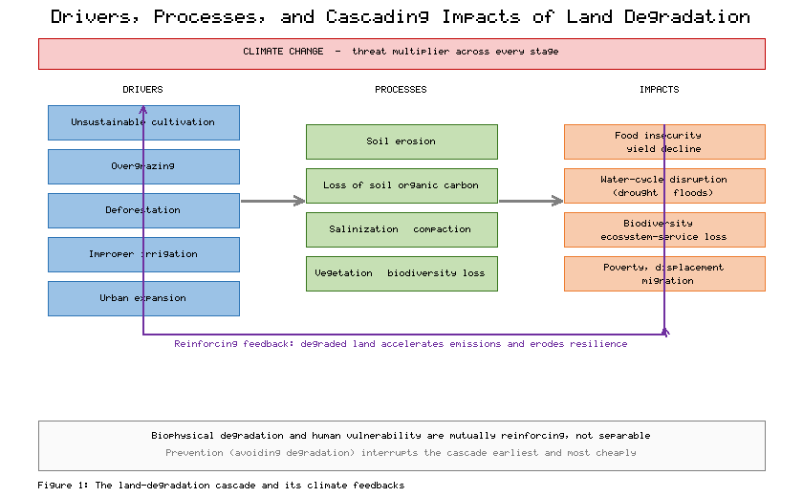
Figure 1. Drivers, Processes, and Cascading Impacts of Land Degradation under a Changing Climate

2. Sustainable Land Management Practices and Climate Resilience

2.1 Core SLM Practices for Soil, Water, and Ecosystem Health
A rich repertoire of SLM practices has been developed and tested across the world's agroecological zones, and a growing body of evidence demonstrates that nature-based approaches to land management frequently outperform purely engineered interventions in enhancing ecosystem services at lower cost and with greater co-benefits [13]. These practices can be grouped according to their primary focus on soil, water, or vegetation, though in practice they are most effective when combined within an integrated landscape approach. Table 2 synthesizes the principal practices together with their mechanisms and the soil, water, carbon, and climate-resilience benefits they confer.
Conservation agriculture is built on three interlocking principles: minimal soil disturbance through reduced or zero tillage, permanent organic soil cover through residue retention or cover crops, and diversified crop rotations. By protecting the soil surface and feeding soil biota, these practices reduce erosion, improve infiltration and water-holding capacity, and can rebuild soil organic matter over time. The evidence base is nuanced: a global meta-analysis found that the yield effects of conservation agriculture depend strongly on context, with the full combination of principles performing best in rainfed, dry environments while isolated no-till can depress yields where it is not accompanied by residue retention and rotation [14]. Similarly, claims that conservation agriculture reliably sequesters large quantities of soil carbon in tropical systems have been qualified by careful analysis showing that apparent gains are sometimes an artifact of shallow sampling and redistribution of carbon within the profile [15]. These caveats, reflected in Table 2, underscore that SLM practices must be adapted to local conditions rather than applied as universal prescriptions.
Crop rotation and residue management, beyond their role within conservation agriculture, independently sustain soil fertility by diversifying root architectures, interrupting pest and disease cycles, and returning organic matter and nutrients to the soil. Agroforestry—the deliberate integration of trees with crops and livestock—adds a particularly powerful tool, combining production with protection. Trees on agricultural land stabilize soils, recycle nutrients from deep horizons, provide fodder, fuel, and food, and store substantial quantities of carbon; a global analysis found that tree cover on agricultural land contributes a large and often overlooked share of the carbon stored in farming landscapes [16]. Sustainable grazing management, including rotational and adaptive multi-paddock systems, allows rangelands to recover between grazing events, restoring vegetative cover, soil structure, and the capacity of grasslands to cycle water and store carbon [17]. As Table 2 indicates, each of these practices simultaneously addresses several degradation processes at once.
Watershed management, soil conservation, and ecosystem restoration operate at the landscape scale to address the hydrological and erosional dimensions of degradation. Contour bunding, terracing, check dams, gully plugging, and vegetative barriers slow runoff, trap sediment, and recharge groundwater, converting erosive overland flow into stored soil moisture and aquifer recharge. Restoring soil quality through the addition of organic amendments, the reestablishment of vegetation, and the protection of regenerating land reverses the loss of organic carbon that lies at the heart of so much degradation [18]. Across these practices, the common thread is the rebuilding of natural capital: healthier soils retain more water and nutrients, vegetated catchments regulate flows and curb erosion, and restored ecosystems recover their biodiversity and productivity. The accumulation of soil organic carbon that these practices promote places them among the interventions shown to co-deliver food security, climate adaptation, and mitigation while combating degradation [19], and it is also among the most significant levers available for natural climate solutions, linking local land stewardship to global mitigation [20].
[Insert Table 2 here]
Table 2. Core SLM Practices and Their Soil, Water, Carbon, and Climate-Resilience Benefits
Practice | Primary Mechanism | Soil & Water Benefit | Climate-Resilience Benefit
Conservation agriculture | Reduced tillage, residue cover, rotation | Less erosion, better infiltration | Drought buffering; context-dependent carbon gain
Agroforestry | Trees integrated with crops/livestock | Soil stabilization, nutrient recycling | Shade, diversification, carbon storage
Crop rotation & residues | Diversified roots, organic returns | Restored fertility, pest breaks | Yield stability under variability
Sustainable grazing | Rest–rotation, stocking control | Vegetation recovery, soil structure | Rangeland carbon; drought recovery
Watershed & soil conservation | Bunds, check dams, terracing | Runoff control, groundwater recharge | Flood and drought moderation
Ecosystem restoration | Revegetation, organic amendment | Carbon rebuild, biodiversity recovery | Resilience through functional diversity

2.2 Climate-Smart Agriculture and Ecosystem-Based Adaptation
Climate-smart agriculture (CSA) provides an organizing framework that aligns SLM with the imperatives of a changing climate. CSA pursues three objectives simultaneously: sustainably increasing agricultural productivity and incomes, adapting and building resilience to climate change, and reducing or removing greenhouse gas emissions where possible [21]. Rather than prescribing specific technologies, CSA is a decision-making approach that evaluates practices against these three pillars in a given context, recognizing that the appropriate mix of interventions varies with agroecology, socio-economic conditions, and policy environments [22]. Many of the practices catalogued in Table 2—conservation agriculture, agroforestry, improved water management, and soil restoration—qualify as climate-smart when they advance productivity, adaptation, and mitigation together.
Experience from smallholder systems demonstrates both the promise and the complexity of CSA. In sub-Saharan Africa, portfolios of practices combining improved varieties, soil and water conservation, agroforestry, and diversified livelihoods have helped farmers manage climate variability while maintaining or improving yields, though adoption is constrained by access to inputs, information, labor, and finance [23]. The framework's insistence on context-specific assessment guards against the uncritical transfer of practices across dissimilar settings, a recurrent cause of failure in land management programs.
Ecosystem-based adaptation (EbA) complements CSA by harnessing biodiversity and ecosystem services as part of an overall strategy to help people adapt to the adverse effects of climate change. Restoring forests, wetlands, mangroves, and grasslands, and managing watersheds to regulate water flows, can reduce exposure to floods, droughts, and storms while delivering carbon sequestration, habitat, and livelihood benefits [24]. A systematic appraisal of nature-based interventions found robust evidence that well-designed ecosystem-based approaches can reduce the impacts of climate hazards on people, although outcomes depend heavily on how interventions are sited, governed, and maintained [25]. Prioritizing where restoration occurs is itself a scientific and political task; global analyses show that targeting restoration to the most suitable areas can multiply benefits for carbon, biodiversity, and cost-effectiveness several-fold compared with untargeted efforts [26].
These approaches are not without tensions. Synergies between productivity, adaptation, and mitigation are common but not automatic, and trade-offs arise—for example, where afforestation of grasslands stores carbon but reduces water yield or displaces pastoral livelihoods, or where intensification raises output at the expense of soil health. Navigating these trade-offs requires the kind of integrated, multi-objective evaluation that the avoid–reduce–reverse logic of Figure 2 encourages, weighing the full portfolio of ecosystem services rather than optimizing a single outcome. The convergence of CSA and EbA, when guided by this logic, offers a coherent pathway from degraded and vulnerable landscapes toward productive, resilient, and carbon-rich systems.
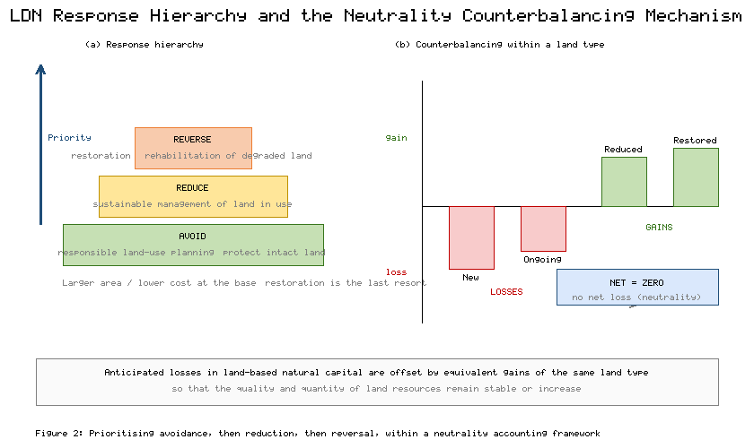
Figure 2. The LDN Response Hierarchy (Avoid–Reduce–Reverse) and the Neutrality Counterbalancing Mechanism

3. Science, Technology, and Participatory Governance for LDN

3.1 Remote Sensing, GIS, AI, and Digital Land-Monitoring Platforms
Achieving and tracking LDN at scale depends on the ability to assess the condition of land objectively, to identify where degradation is occurring, and to evaluate whether interventions are working. Geospatial science provides the essential tools for this task. Satellite remote sensing offers synoptic, repeated, and increasingly high-resolution observations of the land surface, enabling the detection of changes in vegetation cover, productivity, and land use across vast and often inaccessible areas. Vegetation indices derived from satellite imagery, most notably the Normalized Difference Vegetation Index, have long been used to monitor land productivity and to flag areas of persistent decline that may signal degradation [27]. As summarized in Table 3, these technologies differ in their spatial and temporal resolution, their data requirements, and the degradation indicators they are best suited to measure.
Remote sensing alone, however, cannot distinguish degradation driven by human mismanagement from the effects of climatic variability, nor can it directly measure below-ground properties such as soil organic carbon. Integrating satellite data with field measurements and ancillary information within a geographic information system (GIS) allows analysts to map soil properties, erosion risk, and degradation status across landscapes, as demonstrated by frameworks that combine reflectance data with systematic field sampling to predict soil condition and degradation risk over large regions [28]. GIS provides the spatial analytical environment in which diverse data layers—climate, terrain, soils, land use, and socio-economic information—are overlaid to identify vulnerable areas and to target interventions where they are most needed.
Artificial intelligence, and deep learning in particular, has transformed the capacity to extract meaningful information from the growing deluge of Earth observation data. Deep learning methods now achieve high accuracy in land-cover classification, change detection, and feature extraction, automating tasks that were previously labor-intensive and subjective [29]. A meta-analysis of deep learning in remote sensing documented rapid improvements in classification performance across a wide range of applications, while also cautioning that model performance depends on the quality and representativeness of training data [30]. Beyond classification, machine learning is increasingly coupled with process understanding to model complex Earth-system dynamics, offering the prospect of predictive tools that can anticipate degradation before it becomes irreversible [31]. As Table 3 indicates, AI functions less as a standalone technology than as an analytical layer that amplifies the value of remote sensing and GIS.
Digital platforms have democratized access to these capabilities. Cloud-based geospatial systems bring petabytes of satellite imagery together with the computing power needed to analyze them, allowing researchers and land managers to conduct planetary-scale analyses without maintaining local infrastructure [32]. Such platforms underpin operational monitoring of the LDN indicators, and internationally agreed good-practice guidance now specifies how land cover, land productivity, and soil organic carbon should be derived and combined to report on Sustainable Development Goal Indicator 15.3.1 in a consistent and comparable manner [33]. The methodological workflow by which raw observations are transformed into decision-relevant indicators of land condition is depicted in Figure 3, which traces the progression from data acquisition through analysis to decision support.
[Insert Table 3 here]
Table 3. Geospatial and Digital Technologies for Land-Degradation Assessment and LDN Monitoring
Technology | Primary Function | Degradation Indicator | Key Limitation
Optical remote sensing | Vegetation and land-cover monitoring | Land cover; productivity (NDVI) | Cannot resolve soil carbon directly
GIS integration | Spatial overlay and targeting | Erosion risk; vulnerability maps | Depends on data quality and scale
Field spectroscopy / sampling | Soil property measurement | Soil organic carbon; soil health | Labor-intensive; limited coverage
AI / deep learning | Classification, change detection | Land-cover change; early warning | Requires representative training data
Cloud geospatial platforms | Large-scale processing | SDG 15.3.1 reporting | Connectivity and capacity barriers

3.2 Community Participation, Indigenous Knowledge, Policy, and Sustainable Financing
Technology and science are necessary but not sufficient for achieving LDN; the durability of SLM depends ultimately on the people who manage the land. Decades of experience have shown that interventions imposed from above, without the engagement of land users, tend to be abandoned once external support is withdrawn, whereas approaches that build on local priorities and institutions prove far more resilient [34]. Reorienting land degradation toward sustainable management therefore requires linking the maintenance of ecosystem services to the livelihoods of the communities who depend on them, so that conservation and production reinforce rather than undermine one another [34]. The standardized documentation and evaluation of SLM technologies and approaches, accumulated through global knowledge networks, provides a valuable basis for matching proven practices to local contexts rather than reinventing solutions in each setting [35].
Participatory approaches that vest genuine decision-making authority in local communities, and that integrate land management across the sectors and scales relevant to a landscape, consistently outperform fragmented, single-sector interventions [36]. Integrated natural resource management recognizes that soil, water, vegetation, and livelihoods are interconnected and that governance must span the boundaries that conventionally separate them. Within such approaches, the knowledge held by Indigenous and local communities is an indispensable asset. Accumulated through generations of close observation and adaptive practice, this knowledge encompasses detailed understanding of local soils, water, vegetation, and climate, and it embodies time-tested strategies for managing variability and risk [37]. Weaving together Indigenous, local, and scientific knowledge systems on equitable terms produces more robust and context-appropriate strategies than reliance on any single knowledge system, provided that the rights and authority of knowledge holders are respected [37].
Supportive policy and institutional coordination form the enabling environment within which SLM and LDN can flourish. Secure land tenure gives land users the confidence to invest in long-term improvements; coherent policies align agricultural, environmental, and development objectives; and effective institutions coordinate action across the multiple actors and scales involved in managing a landscape. A global economic assessment of land degradation found that the costs of inaction substantially exceed the costs of action, and that investments in SLM generate attractive returns once the full value of ecosystem services is taken into account—yet these returns often accrue over longer horizons and to wider publics than the individual land user who bears the upfront cost [38]. This mismatch between who pays and who benefits is a central obstacle to adoption.
Sustainable financing mechanisms are therefore essential to close the gap between private costs and public benefits. Payments for ecosystem services, in which downstream or off-site beneficiaries compensate land users for the services their stewardship provides, offer one well-established instrument, as do blended public–private finance, land-restoration funds, and the integration of SLM into climate finance. Land-use planning that explicitly accounts for the services different landscapes provide—and for the trade-offs among competing uses—allows societies to direct scarce resources toward the interventions with the greatest combined benefit [39]. The decision-support outputs of the monitoring workflow shown in Figure 3 are most valuable when they feed directly into such participatory planning and financing decisions, closing the loop between assessment and action. The case study that follows illustrates how several of these enabling conditions—community institutions, benefit sharing, and soil-and-water conservation technology—came together in a single landscape.
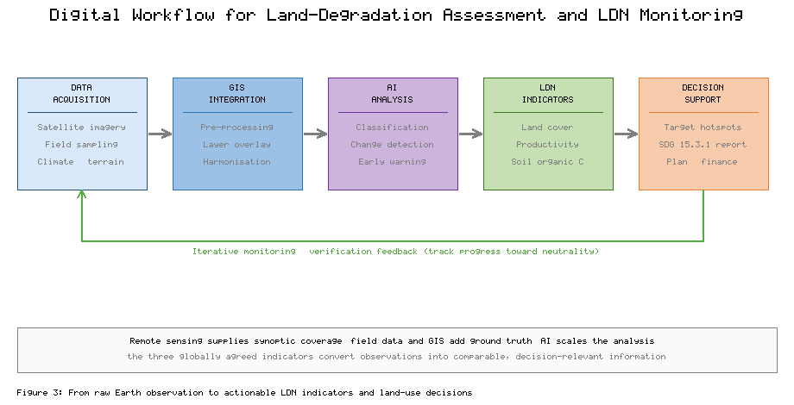
Figure 3. Digital Workflow for Land-Degradation Assessment and LDN Monitoring, from Data to Decision Support

4. Case Study, Challenges, and Pathways to a Land Degradation Neutral World

4.1 Illustrative Case Study: Participatory Watershed Management in Sukhomajri, India
The Sukhomajri experience in the Shivalik (Siwalik) foothills of Haryana, India, remains one of the most instructive examples of how participatory watershed management can reverse land degradation while improving livelihoods, and it illustrates in a single landscape many of the principles developed in the preceding sections. By the early 1970s the hills surrounding the hamlet of Sukhomajri had been severely degraded by deforestation and uncontrolled grazing. The denuded slopes shed enormous quantities of sediment—catchments in the Shivaliks were losing soil at rates reported in the hundreds of tonnes per hectare per year—and this sediment was silting up Sukhna Lake, the reservoir serving the city of Chandigarh downstream, which had lost a large fraction of its storage capacity [40]. Upstream, the villagers faced acute water scarcity, failing rainfed crops, and the progressive loss of the forest and grazing resources on which they depended.
The intervention, initiated in the mid-1970s by soil-conservation researchers working with the community, combined technical and institutional measures. A series of small earthen check dams was constructed across seasonal streams to harvest monsoon runoff, trap sediment, and store water for supplementary irrigation; over roughly a decade, around a dozen such structures were built, a substantial area of forest catchment was treated with soil-and-water conservation measures, and a considerable water-storage capacity was created to irrigate farmland in the valley. The social dimension proved decisive. Villagers agreed to a system of social fencing—a collectively enforced ban on free grazing and tree felling—and shifted to stall-feeding of livestock, allowing the hillsides to regenerate. To sustain cooperation, community institutions in the form of Hill Resource Management Societies were established, and water and forest benefits were shared equitably among all households, including the landless, through negotiated water rights and user charges that functioned as an early form of payment for ecosystem services. Table 4 summarizes the reported changes in key indicators before and after the intervention, and Figure 4 depicts the interventions together with their biophysical and socio-economic outcomes.
The results were striking. With grazing pressure removed and runoff controlled, vegetation recovered dramatically: tree density on the treated hills rose from a handful of trees per hectare in the mid-1970s to well over a thousand per hectare within about a decade and a half, dominated by valuable species such as khair (Acacia catechu) alongside bhabbar grass harvested for income [40]. Sediment delivery to the downstream reservoir fell sharply as the slopes stabilized, and the harvested water enabled a shift from precarious single-season rainfed cultivation to more secure irrigated agriculture, raising and diversifying incomes. Comparable Indian watershed programs that integrated such water-management interventions have documented improvements in groundwater recharge, cropping intensity, and rural livelihoods, corroborating the Sukhomajri pattern across a wider evidence base [41]. As the indicators in Table 4 show, the combined effect was a reversal of degradation across the soil, water, vegetation, and livelihood dimensions simultaneously—precisely the integrated outcome that SLM and LDN aspire to achieve.
Sukhomajri also offers sobering lessons about durability. Its early success led to replication in more than a hundred Sukhomajri-type projects across the Shivaliks of Haryana and Punjab, demonstrating the scalability of the model [40]. Yet in later decades, as external support waned and the community institutions weakened, maintenance of the check dams lapsed and several silted up, eroding some of the gains. As Figure 4 and the trajectory in Table 4 together suggest, the case demonstrates both that participatory, technically sound watershed management can reverse degradation and improve resilience, and that sustaining those gains requires enduring institutions, continued investment, and adaptive governance. These lessons transfer directly to SLM and LDN efforts in other degraded, climate-vulnerable regions.
[Insert Table 4 here]
Table 4. Reported Outcomes of the Sukhomajri Watershed Intervention (Approximate, Before vs. After)
Indicator | Before (mid-1970s) | After (by early 1990s) | Direction
Tree density on treated hills | ~13 trees per hectare | ~1,270 trees per hectare | Strong increase
Hillslope grazing pressure | Uncontrolled free grazing | Social fencing; stall-feeding | Controlled
Sediment delivery to reservoir | Very high (silting Sukhna Lake) | Sharply reduced | Decrease
Water availability for irrigation | Negligible; rainfed only | Stored runoff irrigates farmland | Increase
Household livelihoods | Subsistence, insecure | Diversified, higher incomes | Improved
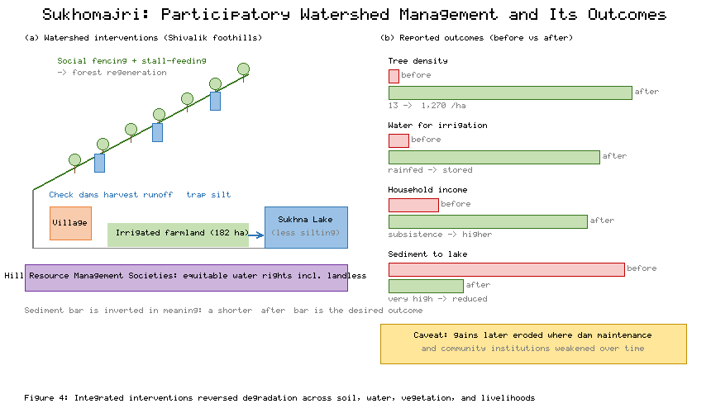
Figure 4. Participatory Watershed Management in Sukhomajri: Interventions and Their Biophysical and Socio-Economic Outcomes

4.2 Challenges, Enabling Conditions, and Conclusion
Despite compelling evidence that SLM can reverse degradation and build resilience, formidable challenges stand in the way of achieving a land degradation–neutral world. Population pressure and rising demand for food, fuel, and fiber intensify competition for finite land, pushing cultivation and grazing onto marginal and fragile areas and shortening the fallows and rest periods on which regeneration depends [2]. Competing land uses—agriculture, grazing, forestry, infrastructure, and conservation—generate trade-offs that are difficult to reconcile, particularly where land tenure is insecure and the rights of different users are contested [38]. Limited financial resources constrain both the upfront investment that SLM requires and the sustained maintenance that, as Sukhomajri showed, determines whether gains endure. Weak institutional coordination—across sectors, scales, and the boundary between upstream and downstream communities—repeatedly undermines interventions that are technically sound but institutionally unsupported [36].
Degradation science adds further cautions. In drylands in particular, the interaction of climatic stress with human pressure can push systems across thresholds into persistently degraded states that are costly or impossible to reverse, underscoring the priority that the avoid–reduce–reverse hierarchy of Figure 2 places on prevention [42]. Monitoring, too, remains a challenge: establishing credible national LDN baselines and detecting genuine trends against a background of climatic variability demands long and consistent data records and careful analysis, as experience with trend analysis of satellite productivity data has shown [43]. As the degradation cascade in Figure 1 and the drivers in Table 1 make plain, these challenges are interconnected, so that progress on any one front is constrained by the others.
The enabling conditions for overcoming these obstacles follow directly from the preceding analysis. Inclusive, participatory governance that grants communities genuine authority and shares benefits equitably—as the Hill Resource Management Societies did in the outcomes recorded in Table 4—builds the local ownership on which durable SLM depends. Scientific innovation, from the geospatial monitoring tools of Table 3 to improved practices and decision-support systems, sharpens the targeting and evaluation of interventions. Context-specific practices, matched to local agroecology and socio-economic realities rather than transferred uncritically, avoid the failures that doom standardized prescriptions. Sustained financing that bridges the gap between private costs and public benefits keeps interventions alive beyond the project cycle. A new generation of dryland and land-management scholarship emphasizes precisely this integration of empirical analysis, local knowledge, and adaptive institutions as the foundation of lasting progress [44], and global synthesis confirms that many SLM practices can simultaneously deliver food security, climate mitigation and adaptation, and the reversal of degradation when they are well designed and well governed [19]. Operationalizing zero net land degradation at the national scale thus represents the next stage in international efforts to combat desertification and to build a land degradation–neutral world [45].

Recommendations and Future Research Directions
• Prioritize the avoidance and prevention of degradation over later restoration, since preventing loss is consistently cheaper, more certain, and more protective of ecosystem function than attempting to rebuild degraded land.
• Embed participatory, benefit-sharing institutions and secure land tenure at the heart of every SLM programme, and provide for their long-term financing and maintenance so that early gains are not lost once external support ends.
• Advance integrated monitoring that fuses satellite remote sensing, field measurement, and artificial intelligence into operational, locally accessible decision-support platforms capable of tracking the full set of Land Degradation Neutrality indicators.
• Invest in long-term, context-specific field research that quantifies the climate adaptation and mitigation co-benefits and trade-offs of SLM practices across diverse agroecological and socio-economic settings.
• Strengthen cross-sectoral and upstream–downstream coordination and sustainable financing mechanisms, including payments for ecosystem services, to align the incentives of land users with the public benefits that healthy land provides.

Conclusions
Land degradation and climate change are deeply entangled challenges whose combined effects threaten ecosystems, food systems, and the livelihoods of billions of people. This chapter has argued that sustainable land management, organized around the Land Degradation Neutrality framework of avoiding, reducing, and reversing degradation, offers a coherent and practical pathway toward a healthier land base and a more climate-resilient world. The core practices of SLM—conservation agriculture, agroforestry, crop rotation, sustainable grazing, watershed management, soil conservation, and ecosystem restoration—rebuild the soil, water, and biodiversity on which productivity and resilience depend, and when organized through climate-smart agriculture and ecosystem-based adaptation they deliver adaptation, mitigation, and development benefits together. Modern geospatial science, artificial intelligence, and digital platforms now make it possible to assess degradation, target interventions, and monitor progress with unprecedented precision, while participatory governance, Indigenous knowledge, supportive policy, and sustainable financing provide the human and institutional foundations without which technical measures cannot endure. The Sukhomajri watershed demonstrates both the transformative potential of integrated, community-led land management and the fragility of gains that outlive the institutions sustaining them. Achieving a land degradation–neutral world will ultimately require coordinated action among governments, researchers, landowners, and local communities, integrating scientific innovation, inclusive governance, and context-specific management into a sustained collective endeavour.

Key Takeaways
• Land degradation is a coupled socio-ecological and climate problem: its drivers, processes, and impacts reinforce one another, and climate change acts as a threat multiplier across the degradation cascade.
• Land Degradation Neutrality provides a measurable policy framework structured around a response hierarchy that prioritizes avoiding degradation, then reducing it, and finally reversing it through restoration.
• Core SLM practices improve soil fertility, water retention, erosion control, and carbon sequestration simultaneously, but their benefits are context-dependent and must be matched to local conditions.
• Remote sensing, GIS, artificial intelligence, and cloud platforms enable objective assessment and monitoring of land condition and of the Land Degradation Neutrality indicators.
• Durable success depends on people: participatory institutions, Indigenous knowledge, secure tenure, supportive policy, and sustained financing determine whether SLM gains endure, as the Sukhomajri case vividly illustrates.

References
[1] Gomiero, T. (2016). Soil degradation, land scarcity and food security: Reviewing a complex challenge. Sustainability, 8(3), 281. https://doi.org/10.3390/su8030281
[2] Le, Q. B., Nkonya, E., & Mirzabaev, A. (2016). Biomass productivity-based mapping of global land degradation hotspots. In E. Nkonya, A. Mirzabaev, & J. von Braun (Eds.), Economics of land degradation and improvement—A global assessment for sustainable development (pp. 55–84). Springer. https://doi.org/10.1007/978-3-319-19168-3_4
[3] Prăvălie, R. (2021). Exploring the multiple land degradation pathways across the planet. Earth-Science Reviews, 220, 103689. https://doi.org/10.1016/j.earscirev.2021.103689
[4] Olsson, L., Barbosa, H., Bhadwal, S., Cowie, A., Delusca, K., Flores-Rentería, D., Hermans, K., Jobbagy, E., Kurz, W., Li, D., Sonwa, D. J., & Stringer, L. (2019). Land degradation. In P. R. Shukla et al. (Eds.), Climate change and land: An IPCC special report (pp. 345–436). Intergovernmental Panel on Climate Change. https://doi.org/10.1017/9781009157988
[5] Gibbs, H. K., & Salmon, J. M. (2015). Mapping the world's degraded lands. Applied Geography, 57, 12–21. https://doi.org/10.1016/j.apgeog.2014.11.024
[6] Webb, N. P., Marshall, N. A., Stringer, L. C., Reed, M. S., Chappell, A., & Herrick, J. E. (2017). Land degradation and climate change: Building climate resilience in agriculture. Frontiers in Ecology and the Environment, 15(8), 450–459. https://doi.org/10.1002/fee.1530
[7] Bhattacharyya, R., Ghosh, B. N., Mishra, P. K., Mandal, B., Rao, C. S., Sarkar, D., Das, K., Anil, K. S., Lalitha, M., Hati, K. M., & Franzluebbers, A. J. (2015). Soil degradation in India: Challenges and potential solutions. Sustainability, 7(4), 3528–3570. https://doi.org/10.3390/su7043528
[8] Cowie, A. L., Orr, B. J., Castillo Sanchez, V. M., Chasek, P., Crossman, N. D., Erlewein, A., Louwagie, G., Maron, M., Metternicht, G. I., Minelli, S., Tengberg, A. E., Walter, S., & Welton, S. (2018). Land in balance: The scientific conceptual framework for Land Degradation Neutrality. Environmental Science & Policy, 79, 25–35. https://doi.org/10.1016/j.envsci.2017.10.011
[9] Grainger, A. (2015). Is Land Degradation Neutrality feasible in dry areas? Journal of Arid Environments, 112, 14–24. https://doi.org/10.1016/j.jaridenv.2014.05.014
[10] Chasek, P., Akhtar-Schuster, M., Orr, B. J., Luise, A., Rakoto Ratsimba, H., & Safriel, U. (2019). Land degradation neutrality: The science-policy interface from the UNCCD to national implementation. Environmental Science & Policy, 92, 182–190. https://doi.org/10.1016/j.envsci.2018.11.017
[11] Akhtar-Schuster, M., Stringer, L. C., Erlewein, A., Metternicht, G., Minelli, S., Safriel, U., & Sommer, S. (2017). Unpacking the concept of land degradation neutrality and addressing its operation through the Rio Conventions. Journal of Environmental Management, 195, 4–15. https://doi.org/10.1016/j.jenvman.2016.09.044
[12] Stavi, I., & Lal, R. (2015). Achieving zero net land degradation: Challenges and opportunities. Journal of Arid Environments, 112, 44–51. https://doi.org/10.1016/j.jaridenv.2014.01.016
[13] Keesstra, S., Nunes, J., Novara, A., Finger, D., Avelar, D., Kalantari, Z., & Cerdà, A. (2018). The superior effect of nature based solutions in land management for enhancing ecosystem services. Science of the Total Environment, 610–611, 997–1009. https://doi.org/10.1016/j.scitotenv.2017.08.077
[14] Pittelkow, C. M., Liang, X., Linquist, B. A., van Groenigen, K. J., Lee, J., Lundy, M. E., van Gestel, N., Six, J., Venterea, R. T., & van Kessel, C. (2015). Productivity limits and potentials of the principles of conservation agriculture. Nature, 517(7534), 365–368. https://doi.org/10.1038/nature13809
[15] Powlson, D. S., Stirling, C. M., Thierfelder, C., White, R. P., & Jat, M. L. (2016). Does conservation agriculture deliver climate change mitigation through soil carbon sequestration in tropical agro-ecosystems? Agriculture, Ecosystems & Environment, 220, 164–174. https://doi.org/10.1016/j.agee.2016.01.005
[16] Zomer, R. J., Neufeldt, H., Xu, J., Ahrends, A., Bossio, D., Trabucco, A., van Noordwijk, M., & Wang, M. (2016). Global tree cover and biomass carbon on agricultural land: The contribution of agroforestry to global and national carbon budgets. Scientific Reports, 6, 29987. https://doi.org/10.1038/srep29987
[17] Teague, R., & Kreuter, U. (2020). Managing grazing to restore soil health, ecosystem function, and ecosystem services. Frontiers in Sustainable Food Systems, 4, 534187. https://doi.org/10.3389/fsufs.2020.534187
[18] Lal, R. (2015). Restoring soil quality to mitigate soil degradation. Sustainability, 7(5), 5875–5895. https://doi.org/10.3390/su7055875
[19] Smith, P., Calvin, K., Nkem, J., Campbell, D., Cherubini, F., Grassi, G., Korotkov, V., Le Hoang, A., Lwasa, S., McElwee, P., Nkonya, E., Saigusa, N., Soussana, J. F., Taboada, M. A., Manning, F. C., Nampanzira, D., Arias-Navarro, C., Vizzarri, M., House, J., ... Arneth, A. (2020). Which practices co-deliver food security, climate change mitigation and adaptation, and combat land degradation and desertification? Global Change Biology, 26(3), 1532–1575. https://doi.org/10.1111/gcb.14878
[20] Bossio, D. A., Cook-Patton, S. C., Ellis, P. W., Fargione, J., Sanderman, J., Smith, P., Wood, S., Zomer, R. J., von Unger, M., Emmer, I. M., & Griscom, B. W. (2020). The role of soil carbon in natural climate solutions. Nature Sustainability, 3(5), 391–398. https://doi.org/10.1038/s41893-020-0491-z
[21] Lipper, L., Thornton, P., Campbell, B. M., Baedeker, T., Braimoh, A., Bwalya, M., Caron, P., Cattaneo, A., Garrity, D., Henry, K., Hottle, R., Jackson, L., Jarvis, A., Kossam, F., Mann, W., McCarthy, N., Meybeck, A., Neufeldt, H., Remington, T., ... Torquebiau, E. F. (2014). Climate-smart agriculture for food security. Nature Climate Change, 4(12), 1068–1072. https://doi.org/10.1038/nclimate2437
[22] Food and Agriculture Organization. (2021). The state of food and agriculture 2021: Making agrifood systems more resilient to shocks and stresses. FAO, Rome. https://doi.org/10.4060/cb4476en
[23] Zougmoré, R. B., Partey, S. T., Ouédraogo, M., Torquebiau, E., & Campbell, B. M. (2018). Facing climate variability in sub-Saharan Africa: Analysis of climate-smart agriculture opportunities to manage climate-related risks. Cahiers Agricultures, 27(3), 34001. https://doi.org/10.1051/cagri/2018019
[24] Griscom, B. W., Adams, J., Ellis, P. W., Houghton, R. A., Lomax, G., Miteva, D. A., Schlesinger, W. H., Shoch, D., Siikamäki, J. V., Smith, P., Woodbury, P., Zganjar, C., Blackman, A., Campari, J., Conant, R. T., Delgado, C., Elias, P., Gopalakrishna, T., Hamsik, M. R., ... Fargione, J. (2017). Natural climate solutions. Proceedings of the National Academy of Sciences, 114(44), 11645–11650. https://doi.org/10.1073/pnas.1710465114
[25] Seddon, N., Chausson, A., Berry, P., Girardin, C. A. J., Smith, A., & Turner, B. (2020). Understanding the value and limits of nature-based solutions to climate change and other global challenges. Philosophical Transactions of the Royal Society B, 375(1794), 20190120. https://doi.org/10.1098/rstb.2019.0120
[26] Strassburg, B. B. N., Iribarrem, A., Beyer, H. L., Cordeiro, C. L., Crouzeilles, R., Jakovac, C. C., Braga Junqueira, A., Lacerda, E., Latawiec, A. E., Balmford, A., Brooks, T. M., Butchart, S. H. M., Chazdon, R. L., Erb, K. H., Brancalion, P., Buchanan, G., Cooper, D., Díaz, S., Donald, P. F., ... Visconti, P. (2020). Global priority areas for ecosystem restoration. Nature, 586(7831), 724–729. https://doi.org/10.1038/s41586-020-2784-9
[27] Yengoh, G. T., Dent, D., Olsson, L., Tengberg, A. E., & Tucker III, C. J. (2015). Use of the Normalized Difference Vegetation Index (NDVI) to assess land degradation at multiple scales. Springer. https://doi.org/10.1007/978-3-319-24112-8
[28] Vågen, T. G., Winowiecki, L. A., Tondoh, J. E., Desta, L. T., & Gumbricht, T. (2016). Mapping of soil properties and land degradation risk in Africa using MODIS reflectance. Geoderma, 263, 216–225. https://doi.org/10.1016/j.geoderma.2015.06.023
[29] Zhu, X. X., Tuia, D., Mou, L., Xia, G. S., Zhang, L., Xu, F., & Fraundorfer, F. (2017). Deep learning in remote sensing: A comprehensive review and list of resources. IEEE Geoscience and Remote Sensing Magazine, 5(4), 8–36. https://doi.org/10.1109/MGRS.2017.2762307
[30] Ma, L., Liu, Y., Zhang, X., Ye, Y., Yin, G., & Johnson, B. A. (2019). Deep learning in remote sensing applications: A meta-analysis and review. ISPRS Journal of Photogrammetry and Remote Sensing, 152, 166–177. https://doi.org/10.1016/j.isprsjprs.2019.04.015
[31] Reichstein, M., Camps-Valls, G., Stevens, B., Jung, M., Denzler, J., Carvalhais, N., & Prabhat. (2019). Deep learning and process understanding for data-driven Earth system science. Nature, 566(7743), 195–204. https://doi.org/10.1038/s41586-019-0912-1
[32] Gorelick, N., Hancher, M., Dixon, M., Ilyushchenko, S., Thau, D., & Moore, R. (2017). Google Earth Engine: Planetary-scale geospatial analysis for everyone. Remote Sensing of Environment, 202, 18–27. https://doi.org/10.1016/j.rse.2017.06.031
[33] Sims, N. C., England, J. R., Newnham, G. J., Alexander, S., Green, C., Minelli, S., & Held, A. (2019). Developing good practice guidance for estimating land degradation in the context of the United Nations Sustainable Development Goals. Environmental Science & Policy, 92, 349–355. https://doi.org/10.1016/j.envsci.2018.10.014
[34] Reed, M. S., Stringer, L. C., Dougill, A. J., Perkins, J. S., Atlhopheng, J. R., Mulale, K., & Favretto, N. (2015). Reorienting land degradation towards sustainable land management: Linking sustainable livelihoods with ecosystem services in rangeland systems. Journal of Environmental Management, 151, 472–485. https://doi.org/10.1016/j.jenvman.2014.11.010
[35] Schwilch, G., Liniger, H. P., & Hurni, H. (2014). Sustainable land management (SLM) practices in drylands: How do they address desertification threats? Environmental Management, 54(5), 983–1004. https://doi.org/10.1007/s00267-013-0071-3
[36] Tengberg, A., & Valencia, S. (2018). Integrated approaches to natural resources management—Theory and practice. Land Degradation & Development, 29(6), 1845–1857. https://doi.org/10.1002/ldr.2946
[37] Tengö, M., Hill, R., Malmer, P., Raymond, C. M., Spierenburg, M., Danielsen, F., Elmqvist, T., & Folke, C. (2017). Weaving knowledge systems in IPBES, CBD and beyond—Lessons learned for sustainability. Current Opinion in Environmental Sustainability, 26–27, 17–25. https://doi.org/10.1016/j.cosust.2016.12.005
[38] Nkonya, E., Mirzabaev, A., & von Braun, J. (Eds.). (2016). Economics of land degradation and improvement—A global assessment for sustainable development. Springer. https://doi.org/10.1007/978-3-319-19168-3
[39] Verburg, P. H., Crossman, N., Ellis, E. C., Heinimann, A., Hostert, P., Mertz, O., Nagendra, H., Sikor, T., Erb, K. H., Golubiewski, N., Grau, R., Grove, M., Konaté, S., Meyfroidt, P., Parker, D. C., Chowdhury, R. R., Shibata, H., Thomson, A., & Zhen, L. (2015). Land system science and sustainable development of the earth system: A global land project perspective. Anthropocene, 12, 29–41. https://doi.org/10.1016/j.ancene.2015.09.004
[40] Kerr, J. (2002). Watershed development, environmental services, and poverty alleviation in India. World Development, 30(8), 1387–1400. https://doi.org/10.1016/S0305-750X(02)00042-6
[41] Singh, R., Garg, K. K., Wani, S. P., Tewari, R. K., & Dhyani, S. K. (2014). Impact of water management interventions on hydrology and ecosystem services in Garhkundar-Dabar watershed of Bundelkhand region, Central India. Journal of Hydrology, 509, 132–149. https://doi.org/10.1016/j.jhydrol.2013.11.030
[42] Mirzabaev, A., Wu, J., Evans, J., García-Oliva, F., Hussein, I. A. G., Iqbal, M. H., Kimutai, J., Knowles, T., Meza, F., Nedjraoui, D., Tena, F., Türkeş, M., Vázquez, R. J., & Weltz, M. (2019). Desertification. In P. R. Shukla et al. (Eds.), Climate change and land: An IPCC special report (pp. 249–343). Intergovernmental Panel on Climate Change. https://doi.org/10.1017/9781009157988
[43] Gichenje, H., & Godinho, S. (2018). Establishing a land degradation neutrality national baseline through trend analysis of GIMMS NDVI time-series. Land Degradation & Development, 29(9), 2985–2997. https://doi.org/10.1002/ldr.3067
[44] Stringer, L. C., Reed, M. S., Fleskens, L., Thomas, R. J., Le, Q. B., & Lala-Pritchard, T. (2017). A new dryland development paradigm grounded in empirical analysis of dryland systems science. Land Degradation & Development, 28(7), 1952–1961. https://doi.org/10.1002/ldr.2716
[45] Chasek, P., Safriel, U., Shikongo, S., & Fuhrman, V. F. (2015). Operationalizing zero net land degradation: The next stage in international efforts to combat desertification? Journal of Arid Environments, 112, 5–13. https://doi.org/10.1016/j.jaridenv.2014.05.020

