Fixed-time stability of Cohen–Grossberg BAM neural networks with delayed destabilizing impulses
[Author names and affiliations to be added]

Abstract
This paper studies fixed-time stability (FXTS) of Cohen–Grossberg bidirectional associative memory neural networks (CGBAMNNs) whose states are hit by destabilizing impulses that use delayed state information, that is, x(t_{l}⁺)=ρ₁x(t_{l})+ρ₂x(t_{l}-d_{l}) with |ρ₁|+|ρ₂|>1. The work extends the recent result of Jamal, Kumar, Mukhopadhyay and Kwon (Neurocomputing 550 (2023) 126501), which showed that a three-term Lyapunov inequality Ẇ≤-aW^{α}-bW^{β}-cW makes FXTS possible under destabilizing impulses if the average impulsive interval (AII) satisfies τ_{a}>lnξ/c. We first show that this result does not carry over directly to delayed impulses: a trajectory that has already reached the origin can be re-excited by an impulse that samples its earlier, non-zero state, so the usual comparison function no longer bounds the Lyapunov function. We remove this obstruction with two new tools. The first is a hold-window majorant, a scalar comparison function that is frozen on each sampling window (t_{l}-d_{l},t_{l}] and therefore keeps a record of the value that the delayed impulse will use. The second is an active clock that removes the hold windows from the time axis and converts the AII of the impulse sequence into an effective AII τ̃=τ_{a}-d̄. With these tools we prove that the system is FXTS whenever τ_{a}>d̄+ln(ξ₁+ξ₂)/c, where d̄ is the largest impulse delay, and we give an explicit settling-time bound that depends on τ_{a}, d̄ and the elasticity number N₀. When the delay vanishes, the condition and the bound reduce exactly to those of the base paper. The general theorem is applied to CGBAMNNs with two continuous controllers, one with signum terms and one with odd-rational powers. Two numerical examples, a cyber-physical system under delayed deception attacks and a four-neuron CGBAMNN, confirm the theory, show the re-excitation effect, quantify the cost of impulse delay and show where the sufficient conditions are conservative. All simulations are reproducible with the accompanying pure-Python code.
Keywords: Fixed-time stability; Cohen–Grossberg BAM neural networks; delayed impulses; destabilizing impulses; average impulsive interval; comparison principle; settling time

1. Introduction
Artificial neural networks are used for associative memory, pattern recognition, optimization, signal and image processing and control [2–4]. In each of these uses the network computes through its dynamics, so the qualitative behaviour of the trajectories (stability, convergence speed, synchronization) decides whether a design works. Two network classes are central to this paper. Cohen and Grossberg [3] introduced a general competitive network whose neurons carry state-dependent amplification functions and behaved functions; Hopfield networks and many cellular networks are special cases. Kosko [2] introduced bidirectional associative memory (BAM) networks, which arrange neurons in two layers that are fully connected to each other but not within a layer, giving a hetero-associative memory. The Cohen–Grossberg BAM neural network (CGBAMNN) combines both ideas [4,14] and is a standard test bed for stability and control results.
Convergence speed matters as much as convergence. Asymptotic and exponential stability only guarantee that the state approaches the equilibrium as t→∞. Finite-time stability (FTS), formalised by Bhat and Bernstein [5], requires the state to reach the equilibrium exactly in a finite settling time. The FTS settling time usually grows without bound with the size of the initial state, which is a problem whenever the initial state is unknown. Polyakov [6] introduced fixed-time stability (FXTS), in which the settling time is bounded by a constant T_{max} that does not depend on the initial state. Since then FXTS has been established for many classes of nonlinear systems and neural networks [15,16,23,24,27,28], usually through Lyapunov inequalities of the form Ẇ≤-aW^{α}-bW^{β} with 0<α<1<β.
Impulsive effects add a further difficulty. Many systems combine continuous evolution with abrupt state jumps at discrete instants: switching circuits, sampled communication, biological spiking, and malicious data injections in cyber-physical systems [13,22]. An impulse with strength ξ multiplies a Lyapunov function by at most ξ. Impulses with ξ<1 are stabilizing. Impulses with ξ>1 are destabilizing, and they act as disturbances that the continuous dynamics must overcome. FXTS with stabilizing impulses is well understood [7–9], and impulsive FXTS results have been extended to inertial and memristive networks [17,26]. FXTS with destabilizing impulses was long treated as out of reach: several authors argued that with the two-term inequality above, the jumps can always undo the progress of the continuous flow [7,8]. Other works allowed destabilizing impulses but tied the allowed jump strength to the exponents α,β of the continuous part [10,11], which is conservative.
Jamal et al. [1] resolved this question for CGBAMNNs by adding a linear term to the Lyapunov inequality. Their three-term inequality Ẇ≤-aW^{α}-bW^{β}-cW, combined with the AII of Lu, Ho and Cao [12], gives FXTS under destabilizing impulses provided τ_{a}>lnξ/c, and it gives a settling-time bound that depends on the impulse sequence. Section 2 explains in detail why we chose this paper as the base of the present work.
The base paper, like most of the FXTS literature on impulsive systems, assumes that each impulse uses the current state: W(t_{l}⁺)≤ξW(t_{l}). In networked and cyber-physical settings this assumption often fails. An impulsive controller or an attacker works with measurements that have travelled through a network, been queued or been processed, so the jump at t_{l} depends on the state at an earlier instant t_{l}-d_{l}. Such delayed impulses have been studied for exponential stability [19–21] and, more recently, for finite-time stability of inertial networks [29]. We have not found a fixed-time result for delayed destabilizing impulses on CGBAMNNs. The base paper itself lists time-delay impulsive systems as future work [1].
Delayed impulses are not a cosmetic extension. A finite-time or fixed-time controller drives the state to zero exactly. If the state reaches zero at some instant T and an impulse occurs at t_{l}>T with t_{l}-d_{l}<T, the impulse reads the earlier non-zero state and pushes the trajectory away from the origin again. The comparison function that proves FXTS in the delay-free case has already reached zero by then, so it no longer bounds the Lyapunov function. This re-excitation effect is demonstrated numerically in Section 5. It means that a new proof technique is needed, not only new constants.
The contributions of this paper are as follows.
1. We identify the re-excitation effect of delayed impulses on fixed-time convergence and show that the delay-free comparison argument of [1] fails under it (Proposition 1).
2. We construct a hold-window majorant (Lemma 3), a scalar comparison function that is frozen during each sampling window, and an active clock (Lemma 4) that converts the AII τ_{a} of the impulse sequence into an effective AII τ̃=τ_{a}-d̄.
3. We prove a general FXTS theorem for nonlinear systems with delayed destabilizing impulses (Theorem 1). The sufficient condition τ_{a}>d̄+ln(ξ₁+ξ₂)/c has a direct interpretation: each impulse costs the controller lnξ/c units of time, and the delay adds at most d̄ units on top. When d̄=0 and ξ₂=0, the condition and the settling-time bound coincide with those of [1] (Corollary 1).
4. We apply Theorem 1 to CGBAMNNs with two continuous controllers, one with signum terms (Theorem 2) and one without signum terms (Theorem 3), and give explicit gain conditions.
5. We verify the results on a cyber-physical system under delayed deception attacks and on a four-neuron CGBAMNN, and we report the cases in which the conditions are conservative.
Section 2 analyses the base paper and the literature. Section 3 states the model and preliminaries. Section 4 contains the main results. Section 5 gives the numerical examples, Section 6 discusses the results and limitations, and Section 7 concludes.
Notation. ℝ, ℝ₊ and ℕ denote the real numbers, the non-negative reals and the positive integers. For v∈ℝ^{m}, ‖v‖₁=∑_{k}|v_{k}|. sign(·) is the signum function and ⌈v⌋^{γ}=sign(v)|v|^{γ}. D⁺W is the upper right Dini derivative. |𝒮| is the Lebesgue measure of a set 𝒮⊂ℝ. Throughout, r=1,…,n₁ indexes the X-layer, s=1,…,n₂ indexes the Y-layer and m=n₁+n₂.

2. Why the base paper was chosen: a critical analysis
A base paper for a follow-up study should be technically sound, recent and influential enough that an extension is useful to readers. It should also leave a gap that can be closed with a real contribution rather than a change of constants. We assessed candidate papers on five criteria, and this section explains how Jamal et al. [1] meets each of them and where its limitations lie.

2.1 Selection criteria
(C1) Topical centrality. The paper sits where three active lines of research meet: fixed-time stability, impulsive dynamical systems and Cohen–Grossberg BAM networks. Results at such a meeting point serve several research communities at once.
(C2) A clear, checkable core result. The main theorem of [1] is a scalar comparison result with an explicit sufficient condition, τ_{a}>lnξ/c, and an explicit settling-time formula. An explicit result can be checked, reproduced and generalised. We reproduced its settling-time formula to machine precision in Section 5.
(C3) Conceptual novelty with a simple mechanism. Earlier works [7–9] treated FXTS under destabilizing impulses as impossible for the two-term inequality Ẇ≤-aW^{α}-bW^{β}. The base paper explains why: when W is of moderate size, neither power term dominates the multiplicative jumps. It then shows that one extra linear term -cW is enough. The linear term gives the flow an exponential decay rate c at every scale, which the AII argument can trade against the jump growth rate lnξ/τ_{a}. A mechanism this simple suggests that the idea extends to other settings, and that is what this paper tests.
(C4) Methodological transferability. The proof in [1] uses three standard tools: the comparison principle, the substitutions P=M^{1-β} and P=M^{1-α} that turn the two power terms into linear impulsive equations, and the variation-of-parameters formula with the AII bounds of [12]. All three tools survive in the delayed setting once the comparison function is modified, which makes an extension feasible.
(C5) An explicit, recognised open problem. The conclusion of [1] names time-delay impulsive systems as future work. A literature search (Table 1) found finite-time and exponential results for delayed impulses [19–21,29] and fixed-time results for delay-free stabilizing and destabilizing impulses [1,18], nearly fixed-time results [30], but no fixed-time result for delayed destabilizing impulses on CGBAMNNs.
Table 1. Positioning of the present work against representative literature (entries are based on the published abstracts and main theorems; "–" means not addressed).
Reference | Stability type | Destabilizing impulses | Delayed impulses | Network class | Settling time depends on impulse sequence
Li et al. 2017 [7] | Fixed-time | No (argued infeasible) | No | General nonlinear | –
Li et al. 2018 [8] | Fixed-time | No | No | CGBAMNN | No
Yang et al. 2017 [9] | Fixed-time synchronization | No | No | Complex networks | –
Wang et al. 2021 [10] | Fixed-time | Yes (strength tied to α, β) | No | General nonlinear | Yes
Li, Ho, Cao 2019 [11] | Finite-time | Yes | No | General nonlinear | Yes
You et al. 2022 [18] | Fixed/predefined-time sync. | Yes (hybrid) | No | Complex-valued BAM | Yes
Kumar, Efimov 2023 [30] | Finite/nearly fixed-time | Yes | No | General, NNs | Yes
Chen, Zheng 2011 [20] | Exponential | Yes | Yes | Time-delay systems | –
NPL 2024 [29] | Finite-time | – | Yes | Inertial NNs | –
Jamal et al. 2023 [1] (base) | Fixed-time | Yes (strength independent of α, β) | No | CGBAMNN | Yes
This paper | Fixed-time | Yes | Yes | CGBAMNN | Yes (and on the delay)

2.2 Technical contributions of the base paper
The base paper has three technical contributions. The first is the three-term inequality (Theorem 1 of [1]) with the condition τ_{a}>lnξ/c. The second is a settling-time function that depends on τ_{a} and N₀. This corrects an earlier result [8], whose settling time does not depend on the impulse sequence, which the authors of [1] rightly call unrealistic. The third is a pair of continuous controllers for CGBAMNNs: a signum-type law with ⌈p⌋^{α} and ⌈p⌋^{β} terms and a law with odd-rational powers p^{α1/β1} and p^{α2/β2}, each with a linear feedback gain that supplies the -cW term.
The base paper also argues for the jump model W(t_{l}⁺)≤ξW(t_{l}) with ξ independent of α and β, which is less conservative than the model W(t_{l}⁺)≤ξ^{1/((1-α)(β-1))}W(t_{l}) used in [10,11]. We keep this design choice.

2.3 Critical appraisal
A useful extension also has to engage with the weaknesses of the base work. We found the following.
(L1) Current-state impulses only. Every impulse in [1] uses x(t_{l}). In the cyber-physical example of [1], the deception attack itself is modelled without delay. Real attacks and impulsive controllers act on stale data. This limitation motivates the present paper.
(L2) Gluing the two phases of the proof. The proof of Theorem 1 in [1] switches the comparison equation at M=1. It treats the phase M≥1 with -bM^{β}-cM and the phase M<1 with -aM^{α}-cM. Destabilizing jumps can push M back above 1 after the switch, and the proof does not discuss this. In our proof (Section 4.3) the second phase uses Ṁ≤-aM^{α}-cM, which holds for all M≥0, so the phases join without a gap.
(L3) Typographical and numerical inconsistencies. Some constants in the CGBAMNN example of [1] could not be reproduced from the stated formulas. For instance, with ϵ=ε=0.5 and the stated network data, the gain threshold for Ψ₁ in Theorem 3 of [1] evaluates to about 3.81 instead of the reported 0.47, so the chosen gain Ψ₁=2 does not satisfy the stated condition. The captions of Fig. 4(a) and 4(b) in [1] are swapped relative to the text, and Fig. 3(a) refers to system (43) instead of system (46). None of these affects the main theorem, but they show that the numerical sections need independent checking. All constants in Section 5 of the present paper are computed by the accompanying code rather than by hand.
(L4) Necessity of the linear term. Remark 7 of [1] illustrates numerically that the controller without the linear gains fails under destabilizing impulses. A sufficient condition cannot prove necessity, and our simulations (Section 5.2) show that the full controller also converges in some cases that violate the sufficient condition. The conditions are therefore conservative, and we quantify the conservatism instead of claiming sharpness.
Table 2 summarises the appraisal and shows how each item is handled in the present work.
Table 2. Appraisal of the base paper [1] and the response of the present work.
Aspect | Base paper [1] | Strength | Limitation | Response in this paper
Lyapunov inequality | Three terms −aW^α − bW^β − cW | Linear term absorbs destabilizing jumps | None for current-state jumps | Kept unchanged
Jump model | W(t_l+) ≤ ξ W(t_l) | ξ independent of α, β | No delayed state | W(t_l+) ≤ ξ1 W(t_l) + ξ2 W(t_l − d_l)
Impulse sequence | AII τ_a, elasticity N_0 | Settling time depends on sequence | Minimum interval θ unused | θ > d̄ used to separate windows
Comparison function | Standard impulsive ODE | Simple | Fails under re-excitation | Hold-window majorant (Lemma 3)
Phase switching | Switch at M = 1 | Clear two-phase bound | Jumps may cross M = 1 | Phase-2 inequality valid for all M
Controllers | Signum and odd-rational laws | Continuous, explicit gains | Some example constants not reproducible | Gains recomputed in code
Validation | Two examples | Shows failure for small τ_a | Necessity of linear term not proven | Conservatism measured (Table 5)

2.4 The research gap and the hypothesis of this paper
The analysis leads to a precise question. If each impulse uses the state d_{l} time units in the past, with 0≤d_{l}≤d̄, is FXTS still possible under destabilizing impulses, and how much do the condition and the settling time change? Our hypothesis was that the delay should act as a loss of control time: during the window (t_{l}-d_{l},t_{l}] the controller works on a state that the coming impulse will partly overwrite. If so, the condition should become τ_{a}-d̄>lnξ/c, that is, the AII minus the delay must exceed the time the controller needs to absorb one jump. Theorem 1 confirms this hypothesis, with ξ=ξ₁+ξ₂ measuring the combined strength of the current and delayed parts of the impulse.

3. Model formulation and preliminaries

3.1 CGBAMNN with delayed impulses
We consider the CGBAMNN
{
ẋ_{r}(t)=-a_{r}(x_{r}(t))[b_{r}(x_{r}(t))-∑_{s=1}^{n2}h_{rs}f_{s}(y_{s}(t))-I_{r}]+u_{r}(t),
ẏ_{s}(t)=-c_{s}(y_{s}(t))[d_{s}(y_{s}(t))-∑_{r=1}^{n1}w_{sr}g_{r}(x_{r}(t))-J_{s}]+v_{s}(t), t≠t_{l}, (1)
where x_{r} and y_{s} are the neuron states of the X-layer and Y-layer, a_{r},c_{s} are amplification functions, b_{r},d_{s} are behaved functions, h_{rs},w_{sr} are connection weights, f_{s},g_{r} are activation functions, I_{r},J_{s} are external inputs and u_{r},v_{s} are control inputs. Let (x⋆,y⋆) be an equilibrium of (1) with u=v=0; its existence and uniqueness follow under standard conditions [14]. At the impulse instants t_{l}, the deviations from the equilibrium jump according to
{
x_{r}(t_{l}⁺)-x_{r}⋆=ρ₁(x_{r}(t_{l})-x_{r}⋆)+ρ₂(x_{r}(t_{l}-d_{l})-x_{r}⋆),
y_{s}(t_{l}⁺)-y_{s}⋆=ω₁(y_{s}(t_{l})-y_{s}⋆)+ω₂(y_{s}(t_{l}-d_{l})-y_{s}⋆), l∈ℕ, (2)
where ρ₁,ρ₂,ω₁,ω₂ are constants and d_{l}≥0 is the delay of the l-th impulse. The base model of [1] is recovered with ρ₁=1+ϱ, ω₁=1+σ and ρ₂=ω₂=0. Solutions are left-continuous at t_{l}. The impulse sequence ζ={t_{l}} is increasing with t_{l}→∞, and the delays satisfy
0≤d_{l}≤d̄<θ≤t_{l}-t_{l-1}, l∈ℕ, (3)
where θ>0 is the minimum inter-impulse interval. Condition (3) means that each impulse samples the state after the previous impulse. Section 6 discusses how it might be relaxed.
Define the error variables
p_{r}(t)=x_{r}(t)-x_{r}⋆, q_{s}(t)=y_{s}(t)-y_{s}⋆, w(t)=(p^{T}(t),q^{T}(t))^{T}∈ℝ^{m}. (4)
Then (1)–(2) become
{
ṗ_{r}=-ã_{r}(p_{r})[b̃_{r}(p_{r})-∑_{s}h_{rs}f̃_{s}(q_{s})]+u_{r},
q̇_{s}=-c̃_{s}(q_{s})[d̃_{s}(q_{s})-∑_{r}w_{sr}g̃_{r}(p_{r})]+v_{s}, t≠t_{l}, (5)
{
p_{r}(t_{l}⁺)=ρ₁p_{r}(t_{l})+ρ₂p_{r}(t_{l}-d_{l}),
q_{s}(t_{l}⁺)=ω₁q_{s}(t_{l})+ω₂q_{s}(t_{l}-d_{l}), (6)
with ã_{r}(p_{r})=a_{r}(p_{r}+x_{r}⋆), b̃_{r}(p_{r})=b_{r}(p_{r}+x_{r}⋆)-b_{r}(x_{r}⋆), f̃_{s}(q_{s})=f_{s}(q_{s}+y_{s}⋆)-f_{s}(y_{s}⋆), and c̃_{s},d̃_{s},g̃_{r} defined in the same way.

3.2 Assumptions
(H1) The amplification functions are continuous and bounded:
0<â_{r}≤a_{r}(x)≤ǎ_{r}, 0<ĉ_{s}≤c_{s}(y)≤č_{s}, x,y∈ℝ. (7)
(H2) The behaved functions are differentiable with
0<b̂_{r}≤ḃ_{r}(x)≤b̌_{r}, 0<d̂_{s}≤ḋ_{s}(y)≤ď_{s}, x,y∈ℝ. (8)
(H3) The activation functions are Lipschitz:
|f_{s}(x)-f_{s}(y)|≤A_{s}|x-y|, |g_{r}(x)-g_{r}(y)|≤B_{r}|x-y|, x,y∈ℝ. (9)
(H4) The delays satisfy (3).
By the mean value theorem and (H2), b̃_{r}(p_{r})=ḃ_{r}(x_{r}⋆+ℓp_{r})p_{r} for some ℓ∈(0,1), so p_{r}b̃_{r}(p_{r})≥b̂_{r}p_{r}² and sign(p_{r})b̃_{r}(p_{r})≥b̂_{r}|p_{r}|. The same holds for d̃_{s}.

3.3 Definitions and lemmas
Definition 1 (FTS and FXTS [5,6]). The origin of (5)–(6) is globally finite-time stable if it is Lyapunov stable and, for every initial function, there is a settling time T(w₀)<∞ such that w(t)=0 for all t≥T(w₀). It is fixed-time stable if, in addition, there exists T_{max}<∞ with T(w₀)≤T_{max} for all initial data.
For delayed impulses the condition "w(t)=0 for all t≥T" is stronger than "w(T)=0", because a later impulse can read a non-zero past state. Definition 1 requires the stronger property.
Definition 2 (AII [12]). Let 𝒩(t,s) be the number of impulse instants in (s,t]. The sequence ζ has average impulsive interval τ_{a}>0 and elasticity number N₀≥0 if
(t-s)/(τ_{a})-N₀≤𝒩(t,s)≤(t-s)/(τ_{a})+N₀, t≥s≥0. (10)
Lemma 1 ([1]). For v₁,…,v_{m}≥0, 0<μ≤1 and ν>1,
∑_{k=1}^{m}v_{k}^{μ}≥(∑_{k=1}^{m}v_{k})^{μ}, ∑_{k=1}^{m}v_{k}^{ν}≥m^{1-ν}(∑_{k=1}^{m}v_{k})^{ν}. (11)
Lemma 2 (scalar comparison [22]). Let g:ℝ₊→ℝ be continuous and nonincreasing with g(0)=0. If D⁺W(t)≤g(W(t)) and Ṁ(t)=g(M(t)) on an interval [t₀,t₁) with W(t₀)≤M(t₀), then W(t)≤M(t) on [t₀,t₁). Since g is nonincreasing, the scalar equation has unique forward solutions and Mequiv0 after M first reaches 0.

3.4 The general impulsive system
The main stability result is stated for the general system
u̇(t)=F(u(t)), t≠t_{l}; u(t_{l}⁺)=J(u(t_{l}),u(t_{l}-d_{l})), l∈ℕ, (12)
where F and J are continuous with F(0)=0 and J(0,0)=0. System (5)–(6) under the controllers of Section 4 is a special case. Table 3 collects the main symbols.
Table 3. Main symbols.
Symbol | Meaning
t_l, d_l, s_l = t_l − d_l | Impulse instant, its delay and its sampling instant
d̄, θ | Largest delay and minimum inter-impulse interval, with d̄ < θ
τ_a, N_0 | Average impulsive interval and elasticity number of the impulse sequence
ξ_1, ξ_2, ξ = ξ_1 + ξ_2 | Strengths of the current and delayed parts of the jump
a, b, c, α, β | Coefficients and exponents of the Lyapunov inequality
H = ∪ (s_l, t_l] | Union of hold windows
σ(t) | Active clock: time spent outside the hold windows
τ̃ = τ_a − d̄, Ñ_0 | Effective AII and effective elasticity number
κ, κ′ | Net decay rates c − ln ξ/τ̃ and c − ln ξ/τ_a
M(t) | Hold-window majorant of the Lyapunov function

4. Main results

4.1 Re-excitation by delayed impulses
Let W be a positive definite, radially unbounded Lyapunov function for (12) that satisfies
D⁺W(u(t))≤-aW^{α}(u(t))-bW^{β}(u(t))-cW(u(t)), t≠t_{l}, (13)
W(u(t_{l}⁺))≤ξ₁W(u(t_{l}))+ξ₂W(u(t_{l}-d_{l})), l∈ℕ, (14)
with a,b,c>0, 0<α<1<β, ξ₁,ξ₂≥0 and ξ=ξ₁+ξ₂>1. Inequality (13) is the three-term inequality of [1]; inequality (14) is the delayed jump.
Proposition 1 (re-excitation). Suppose that W(u(T))=0 at some T∈(s_{l},t_{l}), where s_{l}=t_{l}-d_{l}, and W(u(s_{l}))>0. Then, for any jump map that attains (14) with equality,
W(u(t_{l}⁺))=ξ₂W(u(s_{l}))>0, (15)
although W(u(t))=0 on [T,t_{l}]. Consequently, any comparison function M̄ that obeys M̄̇=-aM̄^{α}-bM̄^{β}-cM̄ between impulses and M̄(t_{l}⁺)=ξM̄(t_{l}), and that reaches zero before t_{l}, fails to bound W after t_{l}.
Proof. Since W≥0 and D⁺W≤0, W stays at zero on [T,t_{l}], so (14) with equality gives (15). If M̄(t_{l})=0, then M̄(t_{l}⁺)=0<W(u(t_{l}⁺)). □
Proposition 1 is not hypothetical. Figure 3 in Section 5 shows a trajectory of a two-dimensional system that reaches zero at t=0.289, is re-excited to W=3.84×10⁻⁴ by the delayed impulse at t₁=0.5, and settles again at t=0.585. The delay-free comparison function reached zero at t=0.358 and is therefore violated. Figure 1 shows the timing structure that the following two lemmas exploit.
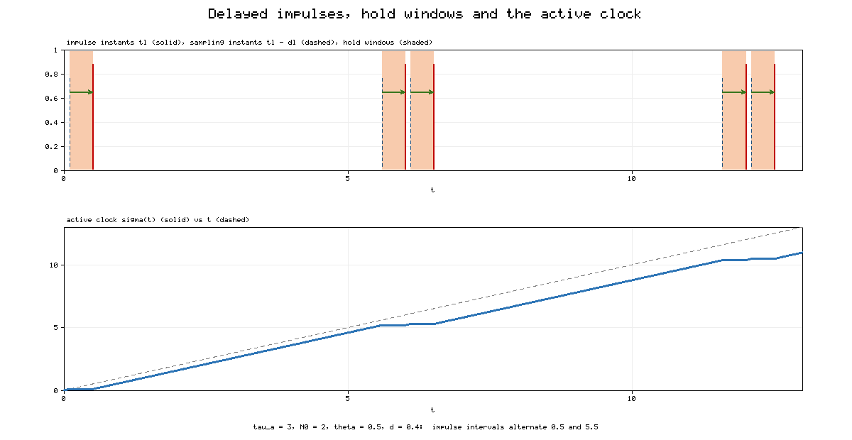
Figure 1. Timing structure of delayed impulses for τ_{a}=3, N₀=2, θ=0.5 and d_{l}=0.4. Top: impulse instants t_{l} (solid red), sampling instants t_{l}-d_{l} (dashed blue) and hold windows (t_{l}-d_{l},t_{l}] (shaded). Bottom: the active clock σ(t), which stops on every hold window, compared with real time t (dashed).

4.2 The hold-window majorant and the active clock
Let s_{l}=t_{l}-d_{l} and ℋ=⋃_{l}(s_{l},t_{l}]. By (3), the windows are pairwise disjoint and (s_{l},t_{l}]⊂(t_{l-1},t_{l}]. Define
g(M)=-aM^{α}-bM^{β}-cM, M≥0, (16)
and the hold-window majorant M(t) by M(0)=W(u(0)) and
{
Ṁ(t)=g(M(t)), t∉ℋ, t≠t_{l},
Ṁ(t)=0, t∈ℋ, t≠t_{l},
M(t_{l}⁺)=ξM(t_{l}), l∈ℕ. (17)
The majorant follows the worst-case flow outside the windows. Inside each window it freezes, which keeps the value that the delayed impulse is going to read.
Lemma 3. Under (3), (13) and (14), W(u(t))≤M(t) for all t≥0.
Proof. We argue by induction over the intervals (t_{l-1},t_{l}], with t₀=0. Suppose W(u(t_{l-1}⁺))≤M(t_{l-1}⁺). On (t_{l-1},s_{l}] no impulse occurs and Lemma 2 gives W≤M. On (s_{l},t_{l}], (13) implies D⁺W≤0, so W(u(t))≤W(u(s_{l}))≤M(s_{l})=M(t). At t_{l}, (14) and the monotonicity of W on (s_{l},t_{l}] give W(u(t_{l}⁺))≤ξ₁W(u(t_{l}))+ξ₂W(u(s_{l}))≤ξW(u(s_{l}))≤ξM(s_{l})=ξM(t_{l})=M(t_{l}⁺). □
Lemma 3 also shows that M cannot reach zero inside a hold window, because M is constant there. Once M is zero it stays zero: the flow keeps zero by Lemma 2, the hold keeps it, and jumps multiply it. By Lemma 3, W then stays at zero too. This is exactly the property that Definition 1 requires.
To analyse M we remove the hold windows from the time axis. Define the active clock
σ(t)=t-|ℋ∩(0,t]|, t≥0. (18)
The function σ is continuous and nondecreasing, increases with slope 1 outside ℋ and is constant on each window (Figure 1, bottom). In the variable σ, the majorant (17) is an ordinary impulsive system without holds, and its impulses occur at σ_{l}=σ(t_{l}). The following lemma shows that these impulses still satisfy an AII condition.
Lemma 4 (effective AII). Assume (3) and (10) with τ_{a}>d̄, and let 𝒩̃(u₂,u₁) be the number of σ_{l} in (u₁,u₂]. Then, for u₂≥u₁≥0,
𝒩̃(u₂,u₁)≤(u₂-u₁)/(τ̃)+Ñ₀, τ̃=τ_{a}-d̄, Ñ₀=(N₀τ_{a}+d̄)/(τ_{a}-d̄), (19)
𝒩̃(u₂,u₁)≥(u₂-u₁)/(τ_{a})-N₀. (20)
Proof. Choose real times s<t as the largest instants with σ(s)=u₁ and σ(t)=u₂. Then the impulses with σ_{l}∈(u₁,u₂] are exactly those with t_{l}∈(s,t], so 𝒩̃(u₂,u₁)=𝒩(t,s)=:N. The hold windows that meet (s,t] are the N windows ending in (s,t] and at most one window ending after t, each of length at most d̄. Hence
u₂-u₁≤t-s≤u₂-u₁+d̄ (N+1). (21)
The upper bound in (10) and the right inequality in (21) give N≤(u₂-u₁+d̄N+d̄)/τ_{a}+N₀, which rearranges to (19). The lower bound in (10) and the left inequality in (21) give (20). □
Inequality (19) is where the delay costs control time. Each impulse removes up to d̄ units of active time, so impulses appear more frequently on the active clock, with effective AII τ̃=τ_{a}-d̄.

4.3 Fixed-time stability of the general system
Theorem 1. Suppose that (3) holds, the impulse sequence satisfies (10), and a positive definite, radially unbounded W satisfies (13)–(14) with ξ=ξ₁+ξ₂>1. If
τ_{a}>d̄+(lnξ)/c, (22)
then the origin of (12) is fixed-time stable, and the settling time satisfies
T(u₀)≤T_{max}=(τ_{a})/(τ_{a}-d̄) (U₁+U₂)+d̄ Ñ₀, (23)
where, with κ=c-lnξ/τ̃>0 and κ'=c-lnξ/τ_{a}≥κ,
U₁=1/(κ(β-1))ln[1+κ/(b ξ^{Ñ0(1-β)})], (24)
U₂=1/(κ(1-α))ln[1+(κ' ξ^{(Ñ0+N0)(1-α)})/a]. (25)
Proof. By Lemma 3 it is enough to show that M reaches zero, and therefore stays at zero, at a real time no later than T_{max}. We work on the active clock u=σ(t), on which M obeys dM/du=g(M) between the impulses σ_{l} and jumps by the factor ξ at each σ_{l}.
Phase 1: reaching the unit ball. While M>0, let P=M^{1-β}. From (16),
dP/du=(β-1)M^{-β}(aM^{α}+bM^{β}+cM)≥(β-1)b+(β-1)cP, P(σ_{l}⁺)=ξ̂P(σ_{l}), (26)
with ξ̂=ξ^{1-β}∈(0,1). Let ψ solve the linear impulsive equation obtained from (26) with equality and ψ(0)=P(0). Then P≥ψ, and by variation of parameters, dropping the term with P(0)≥0,
ψ(u)≥(β-1)b∫₀^{u}ξ̂^{𝒩̃(u,v)}e^{(β-1)c(u-v)} dv. (27)
Because ξ̂<1, the upper bound (19) gives ξ̂^{𝒩̃(u,v)}≥ξ̂^{Ñ0}e^{-(β-1)lnξ (u-v)/τ̃}, so
P(u)≥b ξ^{Ñ0(1-β)} (e^{κ(β-1)u}-1)/κ. (28)
The right-hand side of (28) equals 1 at u=U₁ from (24). Hence M(σ⁻¹(U₁))≤1 for every initial state. The bound (28) does not depend on P(0); this is where the initial-state independence of fixed-time stability comes from.
Phase 2: reaching zero. From (16), g(M)≤-aM^{α}-cM for all M≥0. While M>0, let Z=M^{1-α}. Then
dZ/du≤-(1-α)a-(1-α)cZ, Z(σ_{l}⁺)=ξ̄Z(σ_{l}), Z(U₁)≤1, (29)
with ξ̄=ξ^{1-α}>1. Because this inequality holds for every M≥0, a jump that pushes M above 1 again does not invalidate it; this closes the gap (L2) noted in Section 2.3. Let r=u-U₁. Using the upper bound (19) on the free term and the lower bound (20) on the forcing term,
Z(u)≤ξ̄^{Ñ0}e^{-(1-α)κr}-(1-α)a∫₀^{r}ξ̄ ^{w/τa-N0}e^{-(1-α)cw} dw. (30)
The integral equals ξ̄^{-N0}(1-e^{-(1-α)κ'r})/((1-α)κ'). Since κ≤κ', e^{-(1-α)κ'r}≤e^{-(1-α)κr}, and therefore
Z(u)≤(ξ̄^{Ñ0}+(a ξ̄^{-N0})/(κ'))e^{-(1-α)κr}-(a ξ̄^{-N0})/(κ'). (31)
The right-hand side of (31) vanishes at r=U₂ from (25). The comparison Z≤ (right-hand side) holds while Z>0, so M reaches zero at an active time no later than U₁+U₂, and it stays at zero afterwards.
Back to real time. Let t∗ be the first real time with σ(t∗)=U₁+U₂. Real time equals active time plus the time spent in hold windows, and t∗ is not inside a window. By (19) at most (U₁+U₂)/τ̃+Ñ₀ windows end before t∗, so
t∗≤U₁+U₂+d̄((U₁+U₂)/(τ̃)+Ñ₀)=(τ_{a})/(τ_{a}-d̄)(U₁+U₂)+d̄ Ñ₀=T_{max}. (32)
Lyapunov stability. On [0,T_{max}], (17) gives M(t)≤ξ^{𝒩(t,0)}M(0)≤ξ^{Tmax/τa+N0}W(u₀), and Mequiv0 afterwards. Since W is positive definite and radially unbounded, ‖u(t)‖ is small for all t whenever ‖u₀‖ is small. □
Corollary 1 (consistency with [1]). If ξ₂=0, the hold windows are not needed and the proof runs with d̄=0. Then τ̃=τ_{a}, Ñ₀=N₀, κ=κ', condition (22) becomes τ_{a}>lnξ/c, and (23) becomes
T_{max}=(ln[1+κ b⁻¹ξ^{N0(β-1)}])/(κ(β-1))+(ln[1+κ a⁻¹ξ^{2N0(1-α)}])/(κ(1-α)), (33)
which is algebraically identical to the settling-time function of Theorem 1 in [1]. Table 4 confirms numerically that both formulas give T_{max}=9.650 for the data of Example 1.
Remark 1 (interpretation of (22)). During an active stretch of length Δ, the flow multiplies M by at most e^{-cΔ}, and each impulse multiplies M by ξ. Over a long interval with N impulses, the active time is at least N(τ_{a}-d̄), approximately, so the net exponent is N[lnξ-c(τ_{a}-d̄)]. Condition (22) states that this exponent is negative. The delay is charged once per impulse and at most d̄, regardless of how the delayed and current parts are split between ξ₁ and ξ₂.
Remark 2 (when the delay is free). Condition (22) charges the full delay even when ξ₂ is small. A refinement that interpolates between d̄ (for ξ₂>0) and 0 (for ξ₂=0) would require a majorant that holds only the fraction ξ₂/ξ of its value, that is, a two-component comparison system. We leave this refinement open.
**Remark 3 (the role of θ).** The minimum interval θ does not appear in (22) or (23). It enters only through (3), which guarantees that sampling windows do not overlap previous impulses. For the sequence (45) of [12] used below, θ is the short interval inside each burst of N₀ impulses.

4.4 CGBAMNN with a signum-type controller
For (5)–(6) we use the controller
{
u_{r}(t)=-k_{r}p_{r}(t)-k⁽¹⁾⌈p_{r}(t)⌋^{α}-k⁽²⁾⌈p_{r}(t)⌋^{β},
v_{s}(t)=-m_{s}q_{s}(t)-m⁽¹⁾⌈q_{s}(t)⌋^{α}-m⁽²⁾⌈q_{s}(t)⌋^{β}, (34)
with 0<α<1<β and positive gains.
Theorem 2. Let (H1)–(H4) hold and suppose the linear gains satisfy
k_{r}>B_{r}∑_{s=1}^{n2}č_{s}|w_{sr}|-â_{r}b̂_{r}, m_{s}>A_{s}∑_{r=1}^{n1}ǎ_{r}|h_{rs}|-ĉ_{s}d̂_{s}. (35)
Define η_{r}=k_{r}-B_{r}∑_{s}č_{s}|w_{sr}|+â_{r}b̂_{r}, μ_{s}=m_{s}-A_{s}∑_{r}ǎ_{r}|h_{rs}|+ĉ_{s}d̂_{s} and
δ=min{min_{r}η_{r},min_{s}μ_{s}}, φ=min{k⁽¹⁾,m⁽¹⁾}, ψ̃=min{k⁽²⁾,m⁽²⁾} m^{1-β}. (36)
Let ξ₁=max{|ρ₁|,|ω₁|}, ξ₂=max{|ρ₂|,|ω₂|} and ξ=ξ₁+ξ₂>1. If τ_{a}>d̄+lnξ/δ, then (1)–(2) under (34) is fixed-time stable, and the settling time is bounded by (23) with (a,b,c)=(φ,ψ̃,δ).
Proof. Take W(t)=∑_{r}|p_{r}(t)|+∑_{s}|q_{s}(t)|. Along (5) with (34), (H1)–(H3) and the mean value theorem give
D⁺W≤∑_{r}(B_{r}∑_{s}č_{s}|w_{sr}|-â_{r}b̂_{r}-k_{r})|p_{r}|+∑_{s}(A_{s}∑_{r}ǎ_{r}|h_{rs}|-ĉ_{s}d̂_{s}-m_{s})|q_{s}|-∑_{k}(φ|w_{k}|^{α}+min{k⁽²⁾,m⁽²⁾}|w_{k}|^{β}). (37)
By (35), (36) and Lemma 1, D⁺W≤-δW-φW^{α}-ψ̃W^{β}, which is (13). At t_{l}, (6) and the triangle inequality give
W(t_{l}⁺)≤∑_{r}(|ρ₁||p_{r}(t_{l})|+|ρ₂||p_{r}(s_{l})|)+∑_{s}(|ω₁||q_{s}(t_{l})|+|ω₂||q_{s}(s_{l})|)≤ξ₁W(t_{l})+ξ₂W(s_{l}), (38)
which is (14). Theorem 1 completes the proof. □

4.5 CGBAMNN with a controller without signum terms
The second controller avoids the signum function by using odd-rational powers:
{
u_{r}(t)=-Φ_{r}p_{r}(t)-k⁽³⁾p_{r}^{α1/β1}(t)-k⁽⁴⁾p_{r}^{α2/β2}(t),
v_{s}(t)=-Ψ_{s}q_{s}(t)-m⁽³⁾q_{s}^{α1/β1}(t)-m⁽⁴⁾q_{s}^{α2/β2}(t), (39)
where α₁,β₁,α₂,β₂ are odd positive integers with α₁<β₁ and α₂>β₂.
Theorem 3. Let (H1)–(H4) hold, let ϵ,ε>0, and suppose
Φ_{r}>∑_{s}((ǎ_{r}A_{s}|h_{rs}|)/(2ϵ)+(č_{s}B_{r}|w_{sr}|ε)/2)-â_{r}b̂_{r}, Ψ_{s}>∑_{r}((ǎ_{r}A_{s}|h_{rs}|ϵ)/2+(č_{s}B_{r}|w_{sr}|)/(2ε))-ĉ_{s}d̂_{s}. (40)
Let γ_{r} and λ_{s} be the margins in (40), Θ=min{min_{r}γ_{r},min_{s}λ_{s}}, Θ̃=2Θ, χ̃=min{k⁽³⁾,m⁽³⁾}2^{(α1+β1)/(2β1)} and ρ̃=min{k⁽⁴⁾,m⁽⁴⁾}2^{(α2+β2)/(2β2)}m^{(β2-α2)/(2β2)}. Let
ξ₁=max{(|ρ₁|+|ρ₂|)|ρ₁|,(|ω₁|+|ω₂|)|ω₁|}, ξ₂=max{(|ρ₁|+|ρ₂|)|ρ₂|,(|ω₁|+|ω₂|)|ω₂|}. (41)
If ξ=ξ₁+ξ₂>1 and τ_{a}>d̄+lnξ/Θ̃, then (1)–(2) under (39) is fixed-time stable, and the settling time is bounded by (23) with (a,b,c,α,β)=(χ̃,ρ̃,Θ̃,(α₁+β₁)/(2β₁),(α₂+β₂)/(2β₂)).
Proof. Take W=1/2∑_{r}p_{r}²+1/2∑_{s}q_{s}². The cross terms are bounded by Young's inequality,
ǎ_{r}A_{s}|h_{rs}||p_{r}||q_{s}|≤ǎ_{r}A_{s}|h_{rs}|(p_{r}²/(2ϵ)+(ϵq_{s}²)/2), č_{s}B_{r}|w_{sr}||q_{s}||p_{r}|≤č_{s}B_{r}|w_{sr}|((εp_{r}²)/2+q_{s}²/(2ε)). (42)
Since p·p^{α1/β1}=|p|^{(α1+β1)/β1}, Lemma 1 applied to v_{k}=w_{k}² with exponents (α₁+β₁)/(2β₁)<1<(α₂+β₂)/(2β₂) gives
Ẇ≤-Θ̃W-χ̃W^{(α1+β1)/(2β1)}-ρ̃W^{(α2+β2)/(2β2)}. (43)
At t_{l}, the weighted Cauchy–Schwarz inequality gives, for each component,
(ρ₁p+ρ₂p')²≤(|ρ₁|+|ρ₂|)(|ρ₁|p²+|ρ₂|p'²), (44)
and the same for q with ω₁,ω₂. Summing yields W(t_{l}⁺)≤ξ₁W(t_{l})+ξ₂W(s_{l}) with (41). Theorem 1 completes the proof. □
Remark 4. In Theorem 3, ξ=max{(|ρ₁|+|ρ₂|)²,(|ω₁|+|ω₂|)²}, the square of the strength in Theorem 2, because the Lyapunov function is quadratic. The decay rate Θ̃ is also measured on a quadratic scale, so the two conditions are comparable but not identical.

5. Numerical examples
All simulations use a fixed-step fourth-order Runge–Kutta scheme with step h=10⁻³. Delayed impulses are applied exactly at the grid points t_{l}, using the stored state at t_{l}-d_{l}. The settling time is measured as the last instant with ‖w(t)‖₁>10⁻³. Because ⌈v⌋^{α} is not Lipschitz at zero, the discrete scheme chatters in a band of about 2×10⁻⁸ around the origin instead of reaching zero exactly; values below 10⁻⁷ are treated as zero. Impulse instants follow the sequence of Lu, Ho and Cao [12],
t_{l}-t_{l-1}={
θ, l mod N₀≠0,
N₀(τ_{a}-θ)+θ, l mod N₀=0, (45)
which has AII τ_{a}, elasticity number N₀ and minimum interval θ. All tabulated numbers are produced by the script fxts_delayed_impulses_sim.py.

5.1 Example 1: cyber-physical system under delayed deception attacks
We revisit the cyber-physical model of [1], which is a special case of the attack model in [13], and let the attacker inject a combination of current and stale measurements:
{
ẋ_{i}(t)=0.1sinx_{3-i}(t)-0.2x_{i}(t)-0.4⌈x_{i}(t)⌋^{0.5}-1.2⌈x_{i}(t)⌋^{1.5}, t≠t_{l},
x_{i}(t_{l}⁺)=ξ₁x_{i}(t_{l})+ξ₂x_{i}(t_{l}-d_{l}), i=1,2, (46)
with ξ₁=1.0 and ξ₂=0.2, so ξ=1.2, the same total strength as in [1]. With W=|x₁|+|x₂|, the bound |sinv|≤|v| and Lemma 1 give D⁺W≤-0.1W-0.4W^{0.5}-0.8W^{1.5}, that is, (13) with a=0.4, b=0.8, c=0.1, α=0.5 and β=1.5 (the exact constant from Lemma 1 is 1.2·2^{-0.5}=0.849, and 0.8 is kept for comparability with [1]). The triangle inequality gives (14).
We use N₀=2, θ=0.5 and d_{l}=d̄=0.4. The delay-free threshold of [1] is ln1.2/0.1=1.823. Theorem 1 raises it to d̄+lnξ/c=2.223. We choose τ_{a}=3, so the impulse intervals alternate between 0.5 and 5.5. Table 4 lists the resulting constants: τ̃=2.6, Ñ₀=2.462, κ=0.0299, U₁=3.058, U₂=9.198 and T_{max}=15.13. The delay-free bound for the same data is 9.650, which matches the formula of [1] to machine precision, as Corollary 1 predicts.
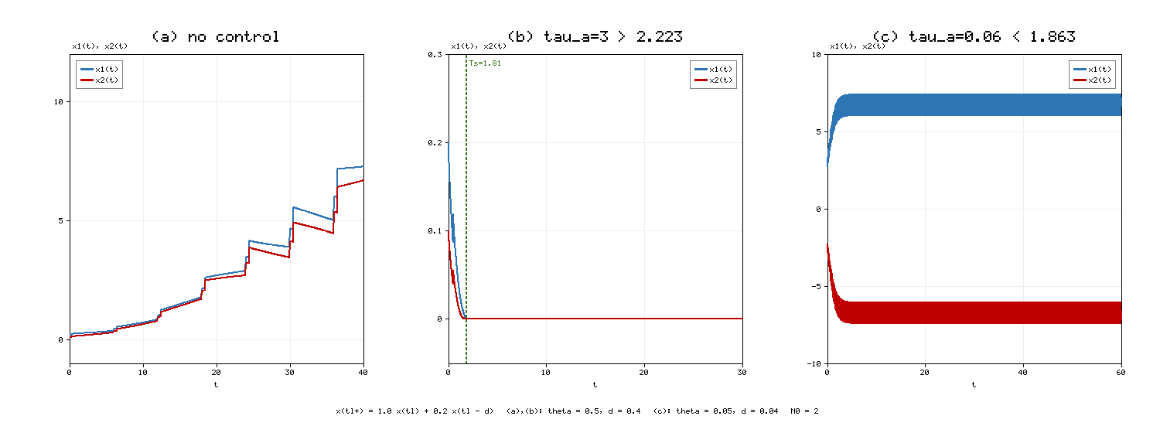
Figure 2. Example 1 with initial state (0.2,0.1) unless stated. (a) Without control, the delayed attacks drive the states away from the origin. (b) With the controller and τ_{a}=3>2.223, the states settle at T_{s}=1.82, well inside T_{max}=15.13. (c) With very frequent attacks (τ_{a}=0.06, θ=0.05, d=0.04), condition (22) fails and the controlled trajectory from (3,-2.5) is locked in a persistent oscillation with ‖x‖₁ between 11.7 and 14.8.
Figure 2(a) shows that without control the attacks make the states grow: each attack adds 20% of the state from 0.4 time units earlier, and the weak coupling cannot remove it. With the controller (Figure 2(b)) the trajectory settles at T_{s}=1.82. The bound T_{max}=15.13 is conservative by a factor of about 8. Most of the conservatism comes from the small net rate κ=0.03: the bound treats every interval as if the attacks arrived at the worst admissible moments, and it charges the full delay to every impulse. Figure 2(c) shows the opposite regime. When the attacks are dense (τ_{a}=0.06), the controller cannot absorb them. The trajectory does not diverge, because the β-power term dominates at large amplitudes, but it remains trapped in a band with 11.7≤‖x‖₁≤14.8. This matches the explanation of the base paper [1]: without enough time between jumps, the power terms alone cannot beat multiplicative jumps at moderate amplitudes.
Figure 3 tests the mechanism of the proof. We start from the small state (0.0035,-0.00175), which reaches the numerical zero at t=0.289, inside the sampling window (0.1,0.5] of the first attack.
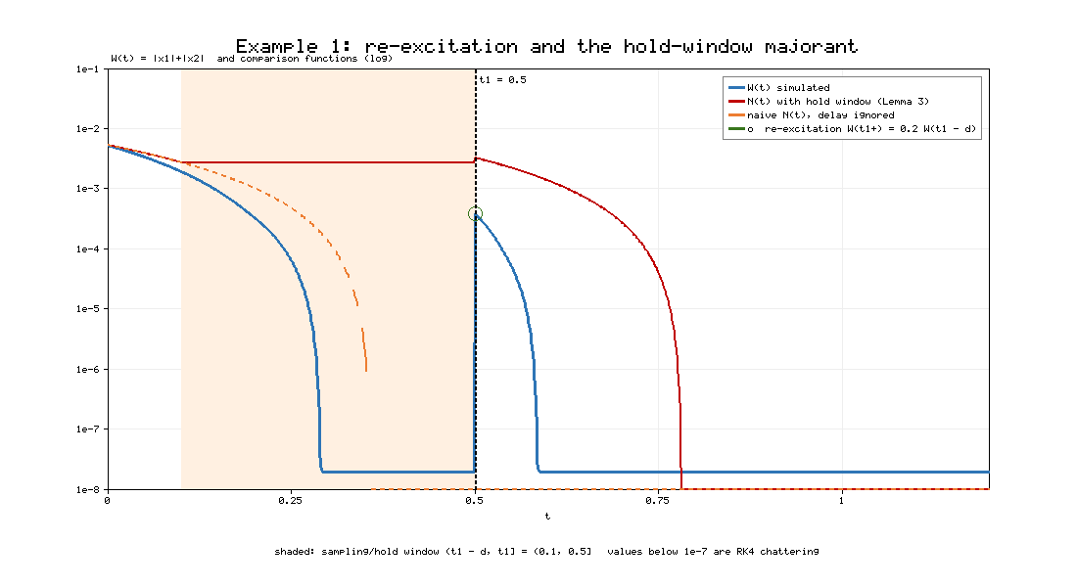
Figure 3. Re-excitation in Example 1 (logarithmic scale). The simulated Lyapunov function W (blue) reaches zero at t=0.289 and is pushed back to 3.84×10⁻⁴ by the delayed attack at t₁=0.5, which reads W(0.1). The naive delay-free majorant (orange, dashed) reaches zero at t=0.358 and is violated after t₁. The hold-window majorant of Lemma 3 (red) freezes on (0.1,0.5], jumps at t₁ and stays above W throughout; it reaches zero at t=0.783.
The delayed attack at t₁=0.5 reads the state at t=0.1 and re-excites the system to W(t₁⁺)=3.84×10⁻⁴. The system then settles again at t=0.585. The naive comparison function of [1], which ignores the delay, reached zero at t=0.358 and is exceeded by 3.84×10⁻⁴ after the attack. This is exactly the failure described in Proposition 1. The hold-window majorant stays above W at all times; the largest excess W-M found in the simulation is 1.9×10⁻⁸, the size of the numerical chattering band. The figure therefore supports both the need for Lemma 3 and its correctness in this example.

5.2 Example 2: a four-neuron CGBAMNN
Consider (1) with n₁=n₂=2, I_{r}=J_{s}=0, a₁(x)=0.8+0.2/(1+x²), a₂(x)=0.6+0.3/(1+x²), c₁(y)=1.4+0.6/(1+y²), c₂(y)=0.74+0.6/(1+y²), b₁(x)=0.5x, b₂(x)=0.74x, d₁(y)=0.2y, d₂(y)=0.3y, g_{r}(x)=1/2tanhx, f_{s}(y)=1/2(|y+1|-|y-1|), and
h=[-2.5 0.5; 0.3 -1.5], w=[-0.4 -1.3; 1.5 -0.4].
These data are those of Example 2 in [1]. The origin is an equilibrium, and (H1)–(H3) hold with â=(0.8,0.6), ǎ=(1,0.9), ĉ=(1.4,0.74), č=(2,1.34), b̂=b̌=(0.5,0.74), d̂=ď=(0.2,0.3) and A_{s}=B_{r}=1. Without control and without impulses, the network oscillates with ‖w‖₁ between 5.3 and 9.1 (Figure 4(a)), so control is needed even before impulses are added.
The impulses are delayed with ρ₁=1.05, ρ₂=0.15, ω₁=1.10, ω₂=0.15, d_{l}=0.1, θ=0.2 and N₀=2. All parts of the impulse are destabilizing in the sense that |ρ₁|+|ρ₂|>1 and |ω₁|+|ω₂|>1.
Controller (34). Condition (35) requires k₁>2.410, k₂>2.692, m₁>2.490 and m₂>1.628. With k_{r}=4, m_{s}=3, k⁽¹⁾=m⁽¹⁾=1.25, k⁽²⁾=m⁽²⁾=4, α=0.8 and β=1.8, we obtain δ=0.510, φ=1.25, ψ̃=1.320, ξ₁=1.10, ξ₂=0.15 and ξ=1.25. The threshold of Theorem 2 is d̄+lnξ/δ=0.538. With τ_{a}=0.8, Theorem 2 gives T_{max}=7.82 (Table 4).
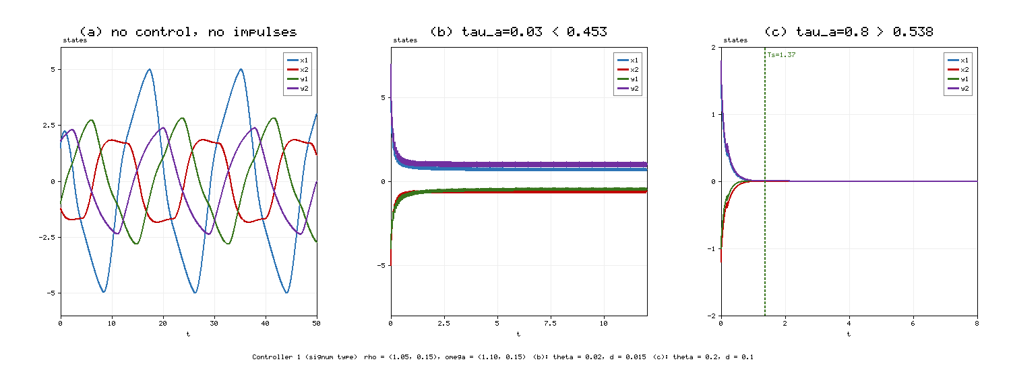
Figure 4. Example 2 with controller (34). (a) Free network without control or impulses: sustained oscillation. (b) Controlled network under very frequent delayed impulses (τ_{a}=0.03<0.453, θ=0.02, d=0.015) from (6,-5,-4,7): the states stall at non-zero values with ‖w‖₁ between 2.36 and 3.15. (c) Controlled network with τ_{a}=0.8>0.538 from (1.5,-1.2,-1.0,1.8): settling at T_{s}=1.37, inside T_{max}=7.82.
Figure 4(c) shows settling at T_{s}=1.37 when the condition holds. Figure 4(b) shows that dense impulses (τ_{a}=0.03 with d=0.015) defeat the controller: the states do not converge and remain in a band away from the origin.
Controller (39). With ϵ=ε=0.5, condition (40) requires Φ₁>3.303, Φ₂>1.960, Ψ₁>3.813 and Ψ₂>2.787. We choose Φ_{r}=4, Ψ=(5,4), k⁽³⁾=m⁽³⁾=0.5, k⁽⁴⁾=m⁽⁴⁾=1.5, α₁=3, β₁=7, α₂=9 and β₂=5. This gives Θ=0.698, Θ̃=1.395, χ̃=0.820, ρ̃=2.274, exponents 0.714 and 1.4, ξ₁=1.375, ξ₂=0.1875 and ξ=1.5625. The threshold is 0.420, and with τ_{a}=0.8 Theorem 3 gives T_{max}=7.23.
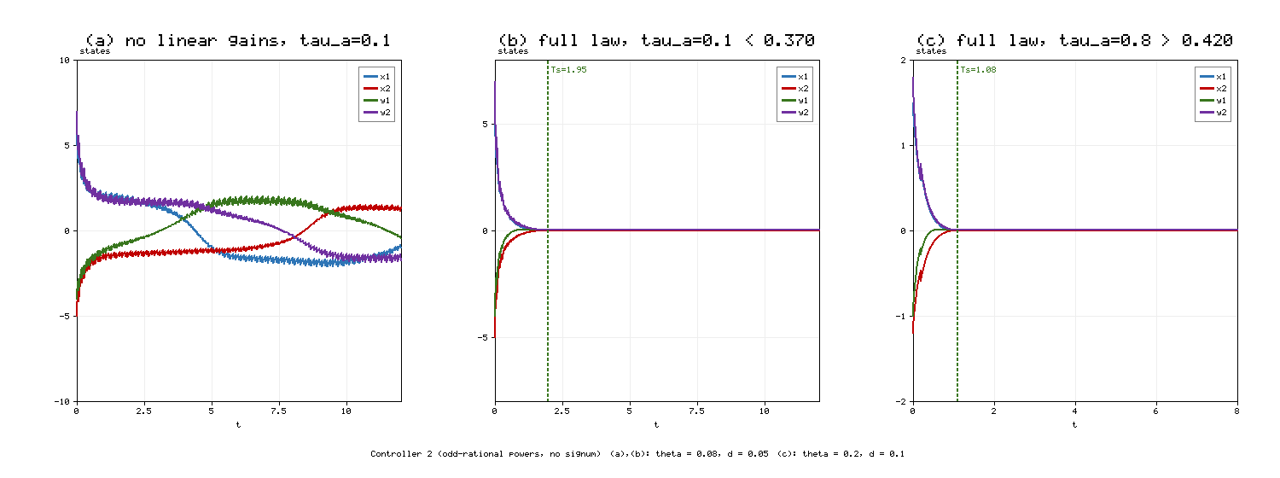
Figure 5. Example 2 with controller (39). (a) Without the linear gains Φ_{r},Ψ_{s} and with τ_{a}=0.1, θ=0.08, d=0.05: no convergence (‖w‖₁ between 3.7 and 6.2). (b) Full controller with the same impulses, which violate the condition (0.1<0.370): convergence at T_{s}=1.95. (c) Full controller with τ_{a}=0.8>0.420: settling at T_{s}=1.08, inside T_{max}=7.23.
Figure 5 separates two effects. Comparing panels (a) and (b), which use the same impulses, shows that the linear gains are what makes the difference in this case: without them the trajectories wander with ‖w‖₁ between 3.7 and 6.2, and with them the states settle at T_{s}=1.95. This supports the role of the linear term discussed in [1]. Panel (b) also shows that the sufficient condition is conservative, since τ_{a}=0.1 violates the threshold 0.370 and yet the system converges. Panel (c) confirms the theorem when its condition holds.
Table 4. Constants and settling-time bounds computed for the examples (N₀=2 throughout).
Quantity | Ex. 1 (Thm 1) | Ex. 1, d̄ = 0 | Ex. 2, Thm 2 | Ex. 2, Thm 3
(a, b, c) | (0.4, 0.8, 0.1) | (0.4, 0.8, 0.1) | (1.25, 1.320, 0.510) | (0.820, 2.274, 1.395)
(α, β) | (0.5, 1.5) | (0.5, 1.5) | (0.8, 1.8) | (0.714, 1.4)
(ξ_1, ξ_2) | (1.0, 0.2) | (1.2, 0) | (1.10, 0.15) | (1.375, 0.1875)
d̄, θ | 0.4, 0.5 | 0, 0.5 | 0.1, 0.2 | 0.1, 0.2
Threshold d̄ + ln ξ / c | 2.223 | 1.823 | 0.538 | 0.420
Chosen τ_a | 3.0 | 3.0 | 0.8 | 0.8
τ̃, Ñ_0 | 2.6, 2.462 | 3.0, 2.0 | 0.7, 2.429 | 0.7, 2.429
κ, κ′ | 0.0299, 0.0392 | 0.0392, 0.0392 | 0.191, 0.231 | 0.757, 0.837
U_1, U_2 | 3.058, 9.198 | 2.915, 6.735 | 1.319, 5.312 | 1.369, 4.749
T_max from (23) | 15.13 | 9.650 | 7.82 | 7.23
T_max from [1, Thm 1] | not applicable | 9.650 | not applicable | not applicable

5.3 The cost of delay and the fixed-time property
Figure 6(a) plots the bound T_{max} of Theorem 2 against the delay bound d̄ for three values of τ_{a}. For τ_{a}=0.8 the bound rises from 5.53 at d̄=0 to 7.82 at d̄=0.1 and 10.98 at d̄=0.175. For τ_{a}=0.6 the effective AII τ_{a}-d̄ approaches the critical value lnξ/δ=0.4375 as d̄→0.1625, and the bound blows up (63.6 at d̄=0.15). For τ_{a}=1.2 the delay costs little (5.33 to 7.45 over the same range). The delay therefore matters most when the impulses are already close to the limit that the controller can handle.
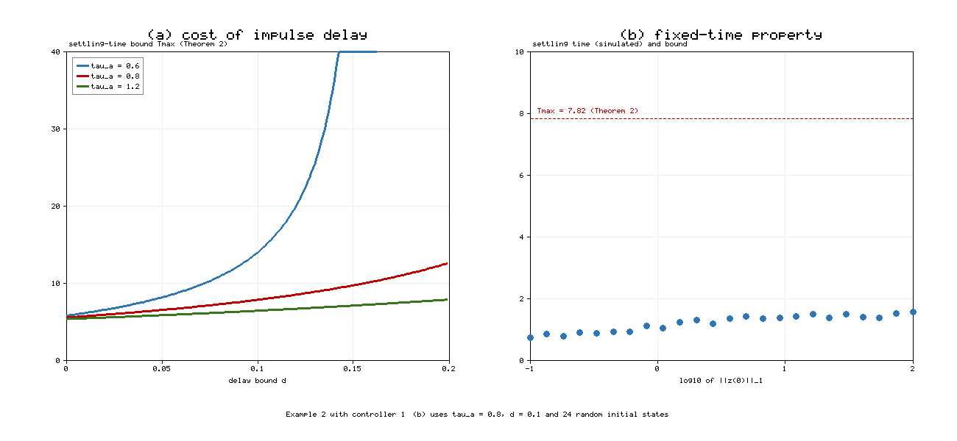
Figure 6. (a) Settling-time bound of Theorem 2 versus the delay bound d̄ for τ_{a}∈{0.6,0.8,1.2}; the curve for τ_{a}=0.6 ends where condition (22) fails. (b) Simulated settling times of Example 2 with controller (34) for 24 random initial states with ‖w(0)‖₁ from 0.1 to 100; all lie below T_{max}=7.82.
Figure 6(b) checks the fixed-time property directly. For 24 random initial states whose 1-norms range over three orders of magnitude, from 0.1 to 100, the simulated settling times grow only from 0.72 to 1.56 and stay well below the bound 7.82. A finite-time controller without the β-power term would show settling times growing without bound with the initial norm.
Table 5. Simulated settling times versus theoretical predictions. "None" means that the trajectory did not settle within the simulation horizon.
Case | τ_a | θ | d | Condition (22) | T_max | Simulated T_s
Ex. 1, controlled | 3.0 | 0.5 | 0.4 | holds (3.0 > 2.223) | 15.13 | 1.82
Ex. 1, dense attacks | 0.06 | 0.05 | 0.04 | fails (0.06 < 1.863) | – | None (‖x‖₁ in [11.7, 14.8])
Ex. 2, Thm 2, d = 0 | 0.8 | 0.2 | 0.0 | holds (0.8 > 0.438) | 5.53 | 1.35
Ex. 2, Thm 2, d = 0.05 | 0.8 | 0.2 | 0.05 | holds (0.8 > 0.488) | 6.50 | 1.36
Ex. 2, Thm 2, d = 0.10 | 0.8 | 0.2 | 0.10 | holds (0.8 > 0.538) | 7.82 | 1.37
Ex. 2, Thm 2, d = 0.15 | 0.8 | 0.2 | 0.15 | holds (0.8 > 0.588) | 9.70 | 1.38
Ex. 2, Thm 2, d = 0.19 | 0.8 | 0.2 | 0.19 | holds (0.8 > 0.628) | 11.91 | 1.40
Ex. 2, Thm 2, moderate | 0.1 | 0.08 | 0.05 | fails (0.1 < 0.488) | – | 2.35 (converges)
Ex. 2, Thm 2, dense | 0.03 | 0.02 | 0.015 | fails (0.03 < 0.453) | – | None (‖w‖₁ in [2.36, 3.15])
Ex. 2, Thm 3 | 0.8 | 0.2 | 0.1 | holds (0.8 > 0.420) | 7.23 | 1.08
Ex. 2, Thm 3, moderate | 0.1 | 0.08 | 0.05 | fails (0.1 < 0.370) | – | 1.95 (converges)
Ex. 2, Thm 3 without Φ, Ψ | 0.1 | 0.08 | 0.05 | not applicable | – | None (‖w‖₁ in [3.7, 6.2])
Table 5 shows three patterns. First, whenever condition (22) holds, the simulated settling time is below the bound, as the theory requires. Second, the delay increases the bound by a factor of 2.2 between d=0 and d=0.19, while the simulated settling time increases only from 1.35 to 1.40; the bound overestimates the cost of delay for this network. Third, the condition is sufficient but not necessary: two cases that violate it still converge, while the denser cases do not.

6. Discussion
What the delay costs. Theorem 1 gives a simple account of delayed destabilizing impulses: the delay reduces the effective AII from τ_{a} to τ_{a}-d̄. The account follows from the hold-window construction, not from a choice of constants. During a sampling window the controller cannot count on its progress, because the coming impulse will partly restore the state it had at the start of the window. The proof charges this loss as frozen time. When d̄=0, Corollary 1 shows that nothing is lost compared with [1]: the condition and the settling-time bound are identical.
Why a new comparison function was necessary. Proposition 1 and Figure 3 show that the obstacle is structural. A finite-time decaying comparison function cannot be bounded from below on a past window, because it may already be zero there, so no backward estimate of the form M(t_{l}-d_{l})≤CM(t_{l}) exists. The hold-window majorant avoids backward estimates altogether by storing the sampled value. We expect the same construction to apply to other comparison-based results for delayed impulses, for example predefined-time stability, where the same backward-estimate problem arises.
Conservatism. The numerical results show three sources of conservatism. (i) The bound treats every impulse as arriving at the worst moment and charges the full delay d̄ to each impulse even when ξ₂ is small (Remark 2). (ii) The Lyapunov rates δ and Θ̃ come from worst-case bounds on the coupling terms, so the real decay of the network is faster; in Example 2, convergence persists at τ_{a}=0.1, well below the threshold 0.488. (iii) The settling-time bound uses the AII bounds (19)–(20), which hold for every sequence with the given τ_{a} and N₀, not only the sequence simulated. The bounds are reliable but should be read as guarantees, not as predictions of the actual settling time.
Limitations. Assumption (3) requires the delay to be shorter than the minimum interval θ, so each impulse samples the state after the previous impulse. If a delayed impulse could sample a state before the previous impulse, the monotonicity of W on the sampling window would be lost, and the majorant would need to account for the intermediate jump. We expect a version of Lemma 3 with nested windows to work, but we have not proved it. The analysis also assumes constant impulse gains and an equilibrium that is known; hybrid impulses with time-varying gains, random impulse times as in [13], and transmission delays inside the network (1) are natural next steps. Networks with discontinuous activations would also require solutions in the sense of Filippov [25] and a non-smooth version of Lemma 3. Finally, the simulations use a fixed-step integrator, which chatters at the 10⁻⁸ level near the origin; this does not affect the reported settling times, which use a tolerance of 10⁻³, but exact finite-time convergence cannot be observed numerically.
Design guidance. The results suggest a simple procedure for a designer. First, choose the linear gains so that the decay rate δ (or Θ̃) satisfies δ>lnξ/(τ_{a}-d̄) for the worst impulse statistics that must be tolerated. The linear gain is the only part of the controller that appears in the frequency condition, so it should be sized first. Second, choose the power gains k⁽¹⁾,k⁽²⁾ (or k⁽³⁾,k⁽⁴⁾) to shape the settling time: by (24) and (25), the gain of the β-power term controls the time U₁ needed to enter the unit ball from any initial state, and the gain of the α-power term controls the time U₂ needed to reach zero from the unit ball. Third, if the delay d̄ can be reduced, for instance by faster measurement or by time-stamping injected data, the benefit is largest when τ_{a}-d̄ is close to lnξ/δ, as Figure 6(a) shows. When the impulses are rare compared with this limit, reducing the delay buys little. Finally, because the bounds are conservative, simulation remains a useful complement for estimating the actual settling time once the guarantee is in place.
Relation to the predefined-time problem. Recent work obtained predefined-time results for stabilizing impulses but only fixed-time results for destabilizing ones [31]. The present analysis suggests why: with destabilizing impulses, the settling time necessarily depends on the impulse statistics through τ̃ and Ñ₀, so it cannot be set freely without restricting the impulse sequence. Combining a time-varying gain with the active clock is a possible route, and we list it as future work.

7. Conclusion
We studied fixed-time stability of Cohen–Grossberg BAM neural networks under destabilizing impulses that use delayed state information. Building on the three-term Lyapunov inequality of Jamal et al. [1], we showed that delayed impulses can re-excite a trajectory that has already reached the origin, which invalidates the standard comparison argument. A hold-window majorant and an active clock remove this obstruction. They lead to the sufficient condition τ_{a}>d̄+ln(ξ₁+ξ₂)/c and to an explicit settling-time bound that depends on the impulse sequence and on the delay, and that reduces exactly to the result of [1] when the delay vanishes. Two continuous controllers for CGBAMNNs, with and without signum terms, satisfy the conditions under explicit gain inequalities. Simulations of a cyber-physical system under delayed deception attacks and of a four-neuron CGBAMNN confirm the results, show the re-excitation effect, and show that the bounds are reliable but conservative. Future work includes delays longer than the minimum impulse interval, hybrid and random impulses, networks with transmission delays, and predefined-time control under delayed destabilizing impulses.

Data and code availability
All figures and tabulated numbers are generated by fxts_delayed_impulses_sim.py in the same repository. The script uses only the Python standard library; the raw results are written to fxts_figures/results.json.

Declaration on the use of AI tools
[To be completed by the authors according to the target journal's policy. This draft was prepared with AI assistance; all theorems, proofs, constants and references must be checked independently by the authors before submission.]

CRediT authorship contribution statement
[To be completed.]

Declaration of competing interest
[To be completed.]

References
[1] M.A. Jamal, R. Kumar, S. Mukhopadhyay, O.-M. Kwon, Fixed-time stability of Cohen-Grossberg BAM neural networks with impulsive perturbations, Neurocomputing 550 (2023) 126501. https://doi.org/10.1016/j.neucom.2023.126501
[2] B. Kosko, Bidirectional associative memories, IEEE Trans. Syst. Man Cybern. 18 (1) (1988) 49–60.
[3] M.A. Cohen, S. Grossberg, Absolute stability of global pattern formation and parallel memory storage by competitive neural networks, IEEE Trans. Syst. Man Cybern. SMC-13 (5) (1983) 815–826.
[4] J. Cao, Q. Song, Stability in Cohen–Grossberg-type bidirectional associative memory neural networks with time-varying delays, Nonlinearity 19 (2006) 1601–1617.
[5] S.P. Bhat, D.S. Bernstein, Finite-time stability of continuous autonomous systems, SIAM J. Control Optim. 38 (3) (2000) 751–766.
[6] A. Polyakov, Nonlinear feedback design for fixed-time stabilization of linear control systems, IEEE Trans. Autom. Control 57 (8) (2012) 2106–2110.
[7] H. Li, C. Li, T. Huang, D. Ouyang, Fixed-time stability and stabilization of impulsive dynamical systems, J. Franklin Inst. 354 (2017) 8626–8644.
[8] H. Li, C. Li, T. Huang, W. Zhang, Fixed-time stabilization of impulsive Cohen–Grossberg BAM neural networks, Neural Netw. 98 (2018) 203–211.
[9] X. Yang, J. Lam, D.W.C. Ho, Z. Feng, Fixed-time synchronization of complex networks with impulsive effects via nonchattering control, IEEE Trans. Autom. Control 62 (11) (2017) 5511–5521.
[10] Z. Wang, J. Cao, Z. Cai, C. Xue, A novel fixed-time stability of nonlinear impulsive systems: a two-stage comparison principle method, Int. J. Syst. Sci. 52 (10) (2021) 2114–2128.
[11] X. Li, D.W.C. Ho, J. Cao, Finite-time stability and settling-time estimation of nonlinear impulsive systems, Automatica 99 (2019) 361–368.
[12] J. Lu, D.W.C. Ho, J. Cao, A unified synchronization criterion for impulsive dynamical networks, Automatica 46 (7) (2010) 1215–1221.
[13] W. He, F. Qian, Q.-L. Han, G. Chen, Almost sure stability of nonlinear systems under random and impulsive sequential attacks, IEEE Trans. Autom. Control 65 (9) (2020) 3879–3886.
[14] C. Bai, Stability analysis of Cohen–Grossberg BAM neural networks with delays and impulses, Chaos Solitons Fractals 35 (2) (2008) 263–267.
[15] C. Hu, J. Yu, Z. Chen, H. Jiang, T. Huang, Fixed-time stability of dynamical systems and fixed-time synchronization of coupled discontinuous neural networks, Neural Netw. 89 (2017) 74–83.
[16] C. Chen, L. Li, H. Peng, Y. Yang, L. Mi, H. Zhao, A new fixed-time stability theorem and its application to the fixed-time synchronization of neural networks, Neural Netw. 123 (2020) 412–419.
[17] L. Hua, H. Zhu, S. Zhong, Y. Zhang, K. Shi, O.-M. Kwon, Fixed-time stability of nonlinear impulsive systems and its application to inertial neural networks, IEEE Trans. Neural Netw. Learn. Syst. (2022). https://doi.org/10.1109/TNNLS.2022.3185664
[18] J. You, A. Abdurahman, H. Sadik, Fixed/predefined-time synchronization of complex-valued stochastic BAM neural networks with stabilizing and destabilizing impulse, Mathematics 10 (22) (2022) 4384. https://doi.org/10.3390/math10224384
[19] A. Khadra, X. Liu, X. Shen, Impulsively synchronizing chaotic systems with delay and applications to secure communication, Automatica 41 (9) (2005) 1491–1502.
[20] W.-H. Chen, W.X. Zheng, Exponential stability of nonlinear time-delay systems with delayed impulse effects, Automatica 47 (5) (2011) 1075–1083.
[21] X. Li, S. Song, Stabilization of delay systems: delay-dependent impulsive control, IEEE Trans. Autom. Control 62 (1) (2017) 406–411.
[22] V. Lakshmikantham, D.D. Bainov, P.S. Simeonov, Theory of Impulsive Differential Equations, World Scientific, Singapore, 1989.
[23] W. Lu, X. Liu, T. Chen, A note on finite-time and fixed-time stability, Neural Netw. 81 (2016) 11–15.
[24] A. Polyakov, D. Efimov, W. Perruquetti, Finite-time and fixed-time stabilization: implicit Lyapunov function approach, Automatica 51 (2015) 332–340.
[25] A.F. Filippov, Differential Equations with Discontinuous Righthand Sides, Kluwer, Dordrecht, 1988.
[26] M.A. Jamal, A. Mapui, S. Das, S. Mukhopadhyay, Further results on fixed-time synchronization of the memristor neural networks with impulsive effects, Commun. Nonlinear Sci. Numer. Simul. 118 (2023).
[27] Y. Huang, S. Qiu, S. Ren, Z. Zheng, Fixed-time synchronization of coupled Cohen–Grossberg neural networks with and without parameter uncertainties, Neurocomputing 315 (2018) 157–168.
[28] F. Kong, Q. Zhu, T. Huang, New fixed-time stability lemmas and applications to the discontinuous fuzzy inertial neural networks, IEEE Trans. Fuzzy Syst. 29 (12) (2021) 3711–3722.
[29] [Authors to be completed from the DOI record], Finite-time stability of inertial neural networks with delayed impulses, Neural Process. Lett. (2024). https://doi.org/10.1007/s11063-024-11476-5
[30] R. Kumar, D. Efimov, Finite/nearly fixed-time stability of nonlinear impulsive systems with destabilizing impulses and its application to neural networks, Commun. Nonlinear Sci. Numer. Simul. (2023) 107357. https://doi.org/10.1016/j.cnsns.2023.107357
[31] [Authors to be completed from the DOI record], Fixed/predefined-time stability and designing of terminal sliding mode control of impulsive dynamical systems, Int. J. Syst. Sci. 56 (1) (2025). https://doi.org/10.1080/00207721.2024.2388809

