AI IN PERSONALIZED HEALTHCARE
Book: AI in Precision Medicine: Predictive Modeling, Diagnostics, and Patient-Centric Care
Part I: Foundations of Precision Medicine — Chapter 2
Amman Jakhar ^{1,*} and Sachin Kalsi ¹
¹ Department of Mechanical Engineering, Chandigarh University, Mohali, Punjab-140301
* Corresponding Email: ammanjakhar5000734@gmail.com

Abstract
By supporting personalized treatment strategies, predictive analytics, and data-informed clinical decisions, Artificial Intelligence (AI) has emerged as a cornerstone of personalized healthcare, driving better patient outcomes. Precision medicine is a rapidly developing field that relies on the ability to integrate and interpret a variety of biomedical data sources, such as genomics, transcriptomics, proteomics, metabolomics, medical imaging, electronic health records, wearable sensor data and lifestyle information, to provide personalized healthcare interventions. The chapter provides a detailed account of AI applications in personalized healthcare, focusing on their contributions to the evolution of personalized healthcare in various aspects, including prevention, diagnosis, prognosis, treatment planning, and long-term disease management. It covers cutting-edge AI techniques such as machine learning, deep learning, natural language processing, computer vision, reinforcement learning, and generative AI, their applications, and their potential to discover biomarkers, predict disease risk, support clinical decision-making, guide precision diagnostics, and optimize therapeutic approaches. The chapter also delves into the use of AI-powered digital health platforms, virtual health assistants, remote patient monitoring, and the Internet of Medical Things (IoMT) to enable sustained health assessment and personalized care delivery. Special attention is given to recent advances in multimodal data integration, explainable AI, digital twins, and federated learning, which are promising technologies to improve prediction accuracy, model transparency, secure collaborative learning, and preserve patient privacy. Additionally, the chapter discusses important data quality and interoperability issues, algorithmic bias, ethical considerations, security, regulatory compliance, and clinical validation, all of which can impact the safe and effective adoption of AI in healthcare. Examples of clinical applications include oncology, cardiovascular diseases, diabetes, neurological disorders, and rare diseases, highlighting the transformative potential of AI in precision medicine. AI's application of cutting-edge computational intelligence, biomedical science and clinical practice allows for proactive, evidence-based, personalized healthcare. The chapter ends by discussing future research avenues and implementation plans for creating effective, scalable, human-centric and trustworthy AI systems that will aid precision medicine and enhance healthcare accessibility, efficiency and outcomes.
Keywords: Artificial intelligence; Personalized healthcare; Precision medicine; Clinical decision support; Predictive analytics

1. Introduction
The practice of medicine has historically been organized around population averages, in which diagnostic thresholds, therapeutic doses, and clinical guidelines are derived from the aggregated responses of large and often heterogeneous cohorts. While this population-based model has produced considerable public-health gains over the past century, it inevitably underserves the individual patient whose biology, environment, and behaviour deviate from the statistical mean. Two patients bearing the same diagnostic label may harbour distinct molecular drivers, respond differently to identical therapy, and follow divergent trajectories, yet the conventional model treats them as interchangeable members of a class. Precision medicine reframes this paradigm by seeking to tailor prevention and treatment to the specific characteristics of each person, taking into account individual variability in genes, environment, and lifestyle [1]. The ambition of precision medicine is not merely to classify patients more finely but to deliver the right intervention to the right patient at the right time, thereby maximizing therapeutic benefit while minimizing harm, cost, and waste.
Realizing this ambition requires computational methods capable of assimilating and reasoning over data of unprecedented volume, velocity, and variety. The quantity of biomedical information generated per patient has grown by orders of magnitude, spanning genome-scale molecular measurements, high-resolution images, and continuous physiological streams that no human clinician could manually synthesize. Artificial intelligence has emerged as the enabling technology that transforms this raw abundance into actionable clinical knowledge, converging with human expertise to raise the performance ceiling of medicine [2]. Advances in deep learning in particular have demonstrated performance rivalling or, in constrained tasks, exceeding that of human experts, from the interpretation of medical images to the detection of subtle physiological patterns imperceptible to the unaided eye [3]. These developments have shifted AI from a peripheral research curiosity to a central instrument in the pursuit of individualized care, prompting substantial investment from health systems, technology firms, and regulators alike.
Personalized healthcare, understood as the operational expression of precision medicine at the point of care, depends on the integration of diverse data modalities that collectively describe the patient. Multi-omics measurements characterize molecular state; medical imaging reveals anatomy and pathology; electronic health records capture the longitudinal clinical narrative; and wearable devices provide continuous, real-world physiological signals [4]. No single modality is sufficient in isolation, and the central analytical challenge lies in fusing them coherently into a unified representation of the individual. The promise of AI is precisely its capacity to learn such representations from data, discovering associations across modalities that would elude rule-based systems or manual analysis. At the same time, the deployment of AI in a domain where errors carry consequences for human life imposes demands for transparency, validation, and equity that distinguish healthcare from other application areas.
This chapter provides a structured account of how AI advances personalized healthcare across the full arc of clinical practice. The remainder is organized as follows. Section 2 surveys the biomedical data landscape that underpins precision medicine and the analytical properties of each modality. Section 3 introduces the principal families of AI techniques and their respective roles. Section 4 traces AI applications across the continuum of care, from prevention through prognosis and treatment planning. Section 5 examines specific clinical application domains that illustrate both promise and difficulty. Section 6 addresses digital health platforms, remote monitoring, and the Internet of Medical Things. Section 7 discusses emerging enablers, including multimodal integration, explainable AI, digital twins, and federated learning. Section 8 analyses the principal challenges to safe adoption. Section 9 outlines future research directions and implementation strategies, and Section 10 concludes.

2. The Data Foundations of Precision Medicine

2.1 Multi-Omics and Molecular Data
The molecular characterization of the individual patient constitutes the deepest and most fundamental layer of precision medicine. Genomics, the study of the complete DNA sequence, provides the most stable and heritable description of biological predisposition, and the dramatic fall in the cost of high-throughput sequencing has made genome-scale interrogation routine in research and increasingly feasible in clinical care [5]. Whereas the sequencing of the first human genome required years and billions of dollars, contemporary platforms deliver a whole genome in days at a fraction of the cost, generating data at a rate that outpaces the capacity of manual interpretation. Genomic variation—single-nucleotide variants, insertions, deletions, and structural rearrangements—encodes information about disease susceptibility, drug metabolism, and the molecular subtype of conditions such as cancer, but translating raw sequence into clinical meaning requires sophisticated computational inference.
Beyond the comparatively static genome, additional omic layers capture the dynamic and functional dimensions of biology. Transcriptomics quantifies gene expression, revealing which genes are active in a given tissue and context; proteomics measures the abundance, modification, and interaction of proteins, the effectors of cellular function; and metabolomics profiles the small-molecule products of metabolism, offering a near-real-time readout of physiological state. Each omic layer captures a different temporal and functional slice of the biological system, and their integration offers a systems-level view of health and disease that no single layer can provide [4]. The integrative analysis of multi-omics data—linking genotype to molecular phenotype to clinical outcome—is among the most demanding and rewarding applications of AI in precision medicine.
The analytical difficulty of omics data arises principally from its dimensionality. A single assay may report tens of thousands of features for each patient, while the number of patients in a study remains comparatively small, a configuration often described as the "large p, small n" regime. This imbalance challenges conventional statistical inference, which assumes many more observations than variables, and it motivates machine-learning methods capable of regularization, dimensionality reduction, and the discovery of latent structure. Techniques that impose sparsity, exploit prior biological knowledge, or learn compressed representations are consequently central to extracting reproducible biological signal from omic noise. Without such methods, the risk of spurious associations and overfitting is acute, and the reproducibility of molecular findings has been a persistent concern in the field.

2.2 Medical Imaging, Electronic Health Records, and Real-World Signals
Medical imaging—radiography, computed tomography, magnetic resonance imaging, ultrasound, and digital pathology—represents one of the richest and most information-dense modalities in medicine, and it has been the earliest and most conspicuously successful target of modern AI. A single imaging study contains millions of pixels or voxels whose spatial patterns encode diagnostic and prognostic information, and the pixel-level structure of images aligns naturally with the inductive biases of deep neural networks. The digitization of pathology, in which glass slides are converted into gigapixel whole-slide images, has further expanded the scope of computational analysis into the microscopic domain, enabling quantitative assessment of tissue architecture that was previously the exclusive province of expert human perception.
Electronic health records (EHRs) complement imaging with a longitudinal account of the patient's clinical course, encompassing structured diagnostic and procedure codes, laboratory values, medication histories, vital signs, and unstructured clinical narratives [6]. The scale of EHR data, spanning millions of patients across years of care, offers extraordinary opportunities for learning population-level patterns and individual trajectories alike. Yet EHR data also embed the biases, gaps, and inconsistencies of routine clinical documentation: values are missing not at random but as a function of clinical decisions, coding practices vary across institutions and reflect billing incentives, and the timing of observations is irregular and informative. Deep-learning methods have been developed specifically to accommodate these idiosyncrasies, modelling temporal irregularity and learning representations of patients directly from raw records rather than relying solely on hand-engineered variables [6].
A further and increasingly important layer of real-world evidence is supplied by wearable and ambient sensors that measure heart rate, physical activity, sleep, blood glucose, and other parameters continuously and unobtrusively, generating digital biomarkers that extend observation far beyond the episodic snapshot of a clinic visit [7]. These signals capture the patient in the context of everyday life, revealing patterns—circadian variation, response to activity, gradual deterioration—that intermittent measurement cannot. When consumer and medical-grade devices are networked into the Internet of Medical Things (IoMT), they create a persistent stream of physiological and behavioural data that can inform individual care and population surveillance alike [8]. The value and the challenge of these data lie in their volume and continuity, which exceed human review capacity and demand automated analysis. Table 1 summarizes the principal biomedical data modalities, their characteristics, and the analytical challenges they present.
Table 1. Biomedical Data Modalities in Precision Medicine and Their Analytical Characteristics
Data Modality | Representative Content | Temporal Nature | Principal Challenge | Typical AI Role
Genomics | DNA variants, mutations | Static, lifelong | High dimensionality, interpretation | Variant classification, risk scoring
Transcriptomics/Proteomics | Gene and protein expression | Dynamic, context-dependent | Noise, batch effects | Subtyping, biomarker discovery
Metabolomics | Small-molecule profiles | Highly dynamic | Sparse annotation | Pathway inference, phenotyping
Medical imaging | CT, MRI, pathology, retina | Episodic | Volume, annotation cost | Detection, segmentation, grading
Electronic health records | Codes, labs, notes | Longitudinal, irregular | Missingness, bias, heterogeneity | Prediction, phenotyping, NLP
Wearables and IoMT | Heart rate, glucose, activity | Continuous | Signal noise, privacy | Monitoring, anomaly detection

As Table 1 indicates, the value of precision medicine emerges not from any single modality but from the disciplined combination of complementary sources, each requiring tailored AI treatment. The heterogeneity catalogued in Table 1 also foreshadows the interoperability and data-quality challenges examined later in the chapter, for the diversity of formats, scales, and provenance that makes the data rich is precisely what makes their integration difficult. A recurring theme throughout this chapter is that the sophistication of an AI model cannot compensate for deficiencies in the data on which it is trained; the foundations described here therefore determine the ceiling of what personalized healthcare can achieve.

3. Artificial Intelligence Techniques for Personalized Healthcare

3.1 Machine Learning and Deep Learning
Machine learning, the discipline concerned with algorithms that improve their performance through exposure to data rather than through explicit programming, provides the methodological core of AI in medicine [9]. Its principal paradigms map naturally onto clinical problems. Supervised learning, which learns a mapping from labelled inputs to known outcomes, underlies most predictive and diagnostic applications, from estimating the probability of hospital readmission to classifying a lesion as benign or malignant. Unsupervised learning discovers latent structure without predefined labels, enabling the identification of disease subtypes or patient clusters that may correspond to distinct biological mechanisms. Semi-supervised and self-supervised approaches exploit the abundance of unlabelled clinical data alongside scarce and expensive expert annotations, a configuration that is especially valuable in medicine where labelling requires specialist time.
Classical machine-learning models—regularized logistic regression, support vector machines, random forests, and gradient-boosted decision trees—remain highly effective for structured, tabular data such as laboratory results and demographic variables, and they retain the substantial advantage of relative interpretability. For many clinical prediction tasks, these models perform competitively with more complex alternatives while offering transparency that facilitates validation and clinical acceptance. Their reliance on hand-crafted features, however, becomes a limitation when the relevant patterns are complex, high-dimensional, or poorly understood, as is the case for raw images, signals, and text.
Deep learning, a subfield employing multilayered neural networks that learn hierarchical representations directly from raw data, has driven the most dramatic recent advances [10]. By composing simple operations into deep architectures, these networks learn to transform low-level inputs into progressively more abstract and task-relevant features, eliminating the need for manual feature engineering. Convolutional neural networks, which exploit the spatial structure of images through local, weight-shared filters, have become the workhorse of medical image analysis, achieving expert-level performance in tasks such as lesion detection, organ segmentation, and disease grading across numerous specialties [11]. Recurrent networks and, more recently, transformer architectures model temporal and sequential dependencies, and have been applied to physiological waveforms, longitudinal EHR trajectories, and genomic sequences. The power of deep learning comes at the cost of a substantial appetite for data and computation, and a tendency toward opacity that complicates clinical interpretation.

3.2 Natural Language Processing, Computer Vision, and Reinforcement Learning
A substantial fraction of clinical knowledge is locked in unstructured text—progress notes, discharge summaries, radiology and pathology reports, and the vast biomedical literature. Natural language processing (NLP) extracts structured meaning from this text, enabling automated phenotyping, information retrieval, clinical documentation support, and the surfacing of evidence at the point of care. Domain-adapted transformer models, pretrained on biomedical corpora, have markedly improved the accuracy of tasks such as named-entity recognition, relation extraction, and question answering over clinical and scientific text [12]. Because clinical language is dense with abbreviation, negation, and context-dependent meaning, general-purpose language models often underperform until adapted to the medical domain, underscoring the importance of specialized pretraining.
Computer vision, closely allied to deep learning, interprets images and video and has produced some of the most clinically consequential AI systems to date. Its impact is exemplified by automated screening systems that detect disease from retinal photographs with sensitivity and specificity comparable to expert ophthalmologists, enabling scalable screening for conditions such as diabetic retinopathy in settings where specialists are scarce [13]. Analogous systems address dermatological lesions, radiological findings, and histopathological features, and the maturation of these tools has driven much of the regulatory and clinical engagement with medical AI.
Reinforcement learning (RL) addresses a distinct class of problems: sequential decision-making under uncertainty, in which an agent learns a policy that maximizes cumulative long-term reward through interaction with an environment. In medicine, RL is naturally suited to the optimization of treatment regimens, where interventions delivered over time jointly determine patient outcomes and where the consequences of a decision may unfold only after a delay. Illustrative work has derived data-driven strategies for the management of sepsis in intensive care, learning from historical patient trajectories which combinations of fluids and vasopressors are associated with improved survival [14]. Because RL policies ultimately act upon patients, they demand particularly rigorous off-policy evaluation, safety constraints, and human oversight before any clinical deployment; the gap between a policy that appears optimal on retrospective data and one that is safe in prospective use is wide and must be bridged with caution.

3.3 Generative AI and Foundation Models
The most recent inflection point in the field is the emergence of generative AI and large-scale foundation models—systems pretrained on vast and diverse corpora and subsequently adaptable to a wide range of downstream tasks with little or no task-specific retraining. Large language models fine-tuned or prompted with medical knowledge have demonstrated the ability to answer clinical questions, summarize patient records, and draft documentation, approaching expert performance on standardized medical examination benchmarks and encoding a surprising breadth of clinical knowledge [15]. These capabilities suggest applications in reducing documentation burden, supporting clinical reasoning, and democratizing access to medical information, though they also introduce novel risks of fluent but incorrect output.
Generative models extend beyond text. Generative adversarial networks and diffusion models synthesize realistic medical images, molecular structures, and synthetic patient records, supporting data augmentation for rare conditions, privacy-preserving data sharing, and hypothesis generation in drug discovery. Such synthetic data can partially alleviate the scarcity and privacy constraints that limit access to real clinical datasets, although care is required to ensure that generated data faithfully preserve the statistical properties of interest without leaking information about real individuals. Figure 1 presents an integrative conceptual framework linking biomedical data sources, the AI techniques introduced in this section, and their applications across the continuum of care, and Table 2 summarizes the techniques together with their representative healthcare applications and key considerations.
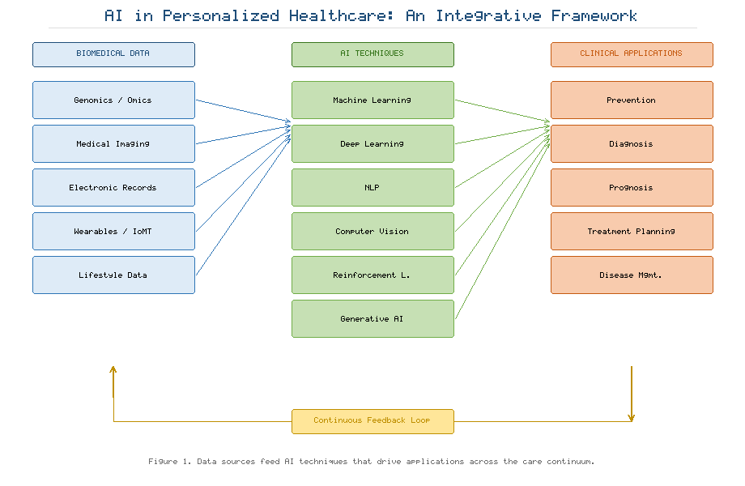
Figure 1. Conceptual Framework of AI in Personalized Healthcare: From Multimodal Data Sources through AI Techniques to Clinical Applications
Table 2. AI Techniques and Their Representative Applications in Personalized Healthcare
AI Technique | Core Capability | Representative Healthcare Application | Key Consideration
Classical machine learning | Prediction on structured data | Risk scoring, readmission prediction | Interpretability, feature engineering
Deep learning (CNN) | Image representation learning | Tumour detection, image segmentation | Data and annotation demand
Sequence models (RNN/Transformer) | Temporal and sequential modelling | Waveform analysis, EHR trajectories | Handling irregular sampling
Natural language processing | Text understanding | Clinical note phenotyping, coding | Ambiguity, documentation bias
Computer vision | Visual interpretation | Retinal and pathology screening | Domain shift across sites
Reinforcement learning | Sequential decision optimization | Treatment regimen optimization | Safety, off-policy validation
Generative AI / foundation models | Content generation, broad reasoning | Documentation, synthetic data, Q&A | Hallucination, grounding

As Figure 1 makes clear, these techniques are not competing alternatives but complementary components of an integrated pipeline in which data flow from acquisition through modelling to decision support and back again as new information accrues. The mapping in Table 2 further emphasizes that technique selection must be matched to the data type, the clinical task, and the tolerance for error inherent in the context: an interpretable model may be preferable to a marginally more accurate but opaque one in a high-stakes decision, and a technique's key consideration is often as decisive as its core capability in determining clinical suitability.

4. AI Across the Continuum of Care

4.1 Prevention and Risk Prediction
Personalized prevention aims to identify individuals at elevated risk before disease manifests, thereby enabling timely and targeted intervention. Whereas traditional risk scores rely on a handful of established factors applied uniformly across populations, AI models can integrate genomic, clinical, behavioural, and environmental data to stratify risk with far greater resolution, and the systematic discovery of predictive biomarkers is central to this effort [16]. By learning complex, non-linear interactions among many variables, machine-learning models can distinguish individuals whose aggregate risk profile warrants intensified surveillance from those for whom intervention would offer little benefit, allowing scarce preventive resources—screening, counselling, chemoprophylaxis—to be directed where they yield the greatest return.
Polygenic risk scores exemplify how molecular data can refine individual risk estimation for common, complex diseases. By aggregating the small individual effects of many genetic variants into a single quantitative measure, these scores identify individuals at the extremes of genetic risk who may benefit from earlier or more intensive prevention, and their integration with clinical and lifestyle variables through machine learning improves discrimination beyond what either genetic or clinical information achieves alone [17]. The clinical utility of such scores remains an active area of investigation, particularly regarding their transferability across ancestral populations, but they illustrate the broader principle that prevention becomes more effective as it becomes more individualized. AI thus shifts the emphasis of medicine upstream, from the treatment of established disease toward its anticipation and interception.

4.2 Diagnosis and Precision Diagnostics
Diagnosis is the domain in which AI has achieved its most visible and mature successes. Deep-learning systems now support the detection and characterization of disease across virtually every imaging modality, and clinical decision support systems (CDSS) synthesize heterogeneous inputs—laboratory values, imaging findings, clinical history, and guidelines—to assist clinicians in reaching accurate and timely diagnoses [18]. Well-designed decision support can reduce diagnostic error, surface considerations that a busy clinician might overlook, and standardize care, although poorly designed systems risk alert fatigue and the automation of existing biases; the manner of integration into clinical workflow is as important as the underlying algorithm.
Precision diagnostics extends beyond binary detection toward the fine-grained characterization that guides individualized treatment. In imaging, quantitative approaches such as radiomics convert images into high-dimensional feature sets that capture tumour heterogeneity, texture, and shape, and these features correlate with underlying molecular biology and prognosis, effectively transforming images into mineable data [19]. Such quantitative phenotyping allows non-invasive characterization of disease that complements or, in some cases, substitutes for invasive biopsy, and it links the imaging phenotype to the molecular profile that determines therapeutic options. Figure 2 illustrates how AI capabilities are distributed across the successive phases of care, showing that diagnostic support constitutes only one node in a larger network of interconnected decision points.
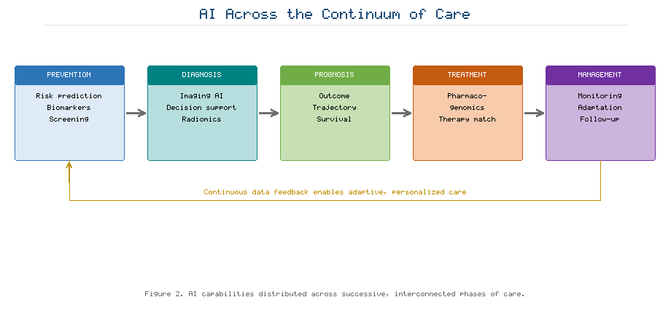
Figure 2. Application of AI Across the Continuum of Care: Prevention, Diagnosis, Prognosis, Treatment Planning, and Long-Term Disease Management

4.3 Prognosis, Treatment Planning, and Disease Management
Beyond diagnosis, AI informs prognosis by estimating disease trajectory and the probability of specific outcomes, thereby shaping the intensity and nature of intervention. Accurate prognostic models allow clinicians and patients to weigh the expected benefits and burdens of treatment, to plan resource allocation, and to engage in shared decision-making grounded in individualized estimates rather than population averages. In oncology and other fields, models integrating molecular and clinical features can predict recurrence, survival, and response, informing decisions about the aggressiveness of therapy.
In treatment planning, pharmacogenomics uses an individual's genetic profile to predict drug response and the risk of adverse reactions, allowing therapy to be individualized in both agent and dose and reducing the trial-and-error prescribing that characterizes conventional practice [20]. Machine-learning models integrate molecular, clinical, and historical data to recommend the therapies most likely to succeed for a given patient, moving beyond the one-size-fits-all prescription toward genuinely tailored regimens. As Figure 2 conveys, long-term disease management closes the loop: continuous monitoring feeds updated data back into predictive models, which in turn refine recommendations, enabling adaptive and responsive care that evolves with the patient's condition. This cyclical structure, visible in the right-hand portion of Figure 2, is what distinguishes personalized management from episodic, reactive treatment, and it depends on the continuous data streams and digital infrastructure examined in Section 6.

5. Clinical Application Domains
The transformative potential of AI in precision medicine is best appreciated through concrete clinical domains, each with distinctive data, tasks, stakes, and obstacles. In oncology, AI supports tumour detection, molecular subtyping, and the analysis of digital pathology, where computational examination of tissue slides reveals prognostic patterns beyond human perception and helps match patients to targeted and immunological therapies [21]. Computational pathology can quantify features such as tumour-infiltrating lymphocytes and grade tissue consistently across observers, addressing the inter-observer variability that has long limited histopathological assessment. Coupled with molecular profiling, these tools advance the vision of therapy selected on the basis of the specific biology of an individual tumour rather than its anatomical site of origin alone.
Cardiovascular medicine has embraced AI for the interpretation of electrocardiograms, echocardiograms, and other imaging, and deep-learning models have demonstrated the ability to infer cardiac dysfunction—and even to detect asymptomatic conditions—from routine, inexpensive signals such as the standard electrocardiogram [22]. By extracting information invisible to human interpreters, such models can transform ubiquitous tests into screening tools for conditions that would otherwise go undetected until symptomatic, enabling earlier and less costly intervention. Diabetes management illustrates the convergence of prediction and continuous monitoring: machine-learning models forecast glycaemic excursions from continuous glucose monitoring data and support closed-loop insulin delivery, improving glycaemic stability while reducing the cognitive burden of self-management [23]. This domain exemplifies the integration of real-world sensor data, predictive modelling, and automated action that characterizes mature personalized care.
In neurology, AI aids the early detection and monitoring of neurodegenerative and other disorders by extracting subtle imaging and behavioural markers that precede overt clinical decline. Deep-learning analysis of neuroimaging can classify disease status and predict progression in conditions such as Alzheimer's disease, potentially identifying candidates for intervention during the window when treatment is most likely to help [24]. Rare diseases, long neglected because of their individual scarcity despite their collective burden, benefit distinctively from AI's capacity to recognize characteristic patterns from limited data. Phenotyping systems that analyse facial images or aggregate sparse clinical features can shorten the protracted diagnostic odyssey that patients with rare genetic disorders otherwise endure, sometimes spanning years and numerous specialists [25]. Table 3 summarizes representative applications, benefits, and domain-specific challenges across these areas.
Table 3. Representative Clinical Application Domains of AI in Precision Medicine
Clinical Domain | Representative AI Application | Primary Benefit | Domain-Specific Challenge
Oncology | Digital pathology, tumour subtyping | Targeted therapy selection | Tumour heterogeneity, annotation
Cardiovascular | ECG and imaging interpretation | Early detection of dysfunction | Signal variability, validation
Diabetes | Glucose forecasting, closed-loop control | Improved glycaemic stability | Sensor reliability, adherence
Neurological disorders | Imaging and behavioural biomarkers | Early, objective detection | Slow progression, label scarcity
Rare diseases | Phenotyping, pattern recognition | Shorter diagnostic odyssey | Very small sample sizes

As Table 3 shows, the benefits of AI are accompanied in every domain by challenges rooted in data scarcity, heterogeneity, or the need for rigorous validation. The common thread is that clinical value is realized only when technical capability is matched to the specific realities of the domain—the heterogeneity of tumours, the variability of physiological signals, the slow evolution of neurodegeneration, or the extreme scarcity of data in rare disease. These domain-specific constraints, summarized in Table 3, motivate the emerging enablers and the attention to challenges discussed in the sections that follow.

6. Digital Health, Remote Monitoring, and the Internet of Medical Things
The extension of personalized healthcare beyond the walls of the clinic depends on a digital infrastructure that connects patients, devices, and providers in a continuous loop. AI-powered digital health platforms aggregate data from disparate sources—devices, records, and patient-reported inputs—and deliver tailored guidance, reminders, and risk alerts directly to patients, transforming static records into dynamic instruments of engagement and self-management [26]. In chronic disease, where outcomes depend heavily on day-to-day behaviour between clinical encounters, such platforms can sustain adherence, detect early warning signs, and personalize coaching in ways that periodic visits cannot, extending the reach of the care team into the patient's daily life.
Virtual health assistants and conversational agents, increasingly powered by large language models, provide accessible, round-the-clock triage, education, and behavioural support. A systematic assessment of conversational agents in healthcare has documented their growing use for tasks ranging from symptom checking to mental-health support, while emphasizing the need for rigorous evaluation of their safety and effectiveness [27]. These agents can lower barriers to access, particularly for populations underserved by traditional services, but their deployment in clinical contexts demands careful attention to accuracy, the risk of confidently stated errors, escalation to human clinicians, and the clear communication of their limitations to users.
Remote patient monitoring (RPM) uses connected sensors to observe patients continuously in their everyday environments, detecting deterioration early and reducing the need for in-person visits and hospitalization. Meta-analytic evidence indicates that RPM can improve clinical outcomes across a range of conditions, though the magnitude of benefit depends on implementation and patient selection [28]. When RPM devices are integrated into the IoMT, they form an ecosystem in which physiological signals are collected, transmitted, analysed, and acted upon in near real time [8]. AI is essential to this ecosystem because the sheer volume of continuous data far exceeds any human capacity for review; machine-learning models filter noise, detect clinically meaningful anomalies, and prioritize the alerts that genuinely warrant clinician attention, preventing both information overload and missed events. Figure 3 depicts the architecture of an AI-enabled IoMT and remote-monitoring ecosystem, tracing the flow of data from wearable and implantable sensors through edge and cloud analytics to clinical decision-making and back to the patient.
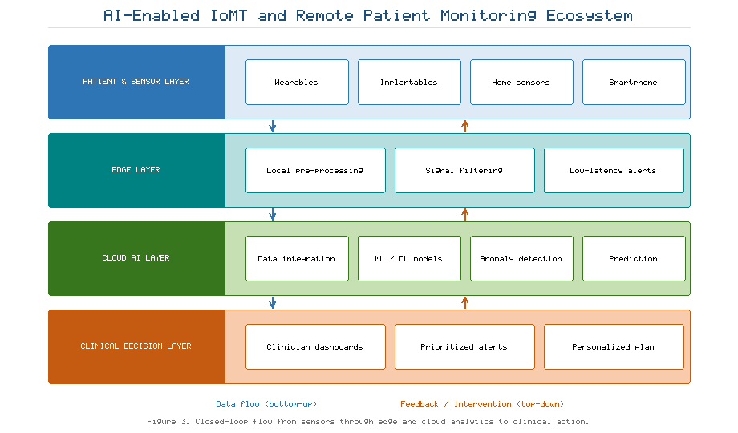
Figure 3. Architecture of an AI-Enabled Internet of Medical Things (IoMT) and Remote Patient Monitoring Ecosystem
The closed-loop structure shown in Figure 3 embodies the aspiration of sustained, personalized care: data collected at the periphery inform centralized and edge-based intelligence, whose outputs return to the patient as timely, individualized interventions. Distributing computation between edge devices and the cloud, as indicated in Figure 3, balances the need for low-latency response against the analytical power of centralized resources, while reducing the transmission of sensitive raw data. Realizing this vision at scale, however, magnifies the privacy, security, and interoperability concerns addressed in Section 8, because each additional connected device expands the potential attack surface, multiplies the volume of sensitive data in transit, and compounds the challenge of ensuring that heterogeneous systems can communicate reliably.

7. Emerging Enablers of Trustworthy Precision Medicine

7.1 Multimodal Data Integration
Because no single data modality fully describes a patient, the frontier of AI in precision medicine lies in multimodal integration—the fusion of imaging, omics, clinical, and sensor data into unified predictive models that mirror the holistic reasoning of an expert clinician. Multimodal models can capture complementary and synergistic information that unimodal systems miss, improving accuracy and robustness across a range of clinical tasks and enabling inferences that no single modality supports [29]. A model that jointly considers a tumour's imaging phenotype, its molecular profile, and the patient's clinical history can, in principle, predict response to therapy more reliably than any component alone. The technical challenges are substantial, encompassing the alignment of data collected at different scales and times, the handling of modalities that are missing for some patients, and the design of architectures that learn genuinely joint representations without allowing a dominant modality to overwhelm weaker but informative signals.

7.2 Explainable AI and Digital Twins
The opacity of high-performing deep models poses a persistent barrier to clinical trust, accountability, and regulatory approval. Explainable AI (XAI) seeks to render model reasoning intelligible to clinicians, whether through post-hoc attribution methods that highlight the features or image regions most influential to a prediction, or through the use of inherently interpretable models in the highest-stakes settings [30]. Transparent reasoning is not merely a regulatory nicety: it enables clinicians to detect when a model relies on spurious correlations or artefacts, to calibrate their reliance on model outputs, and to communicate the basis of decisions to patients. The appropriate form and degree of explanation remain debated, with some arguing that faithful interpretability should be built in rather than approximated after the fact, particularly where decisions materially affect patients.
A complementary innovation is the digital twin—a dynamic, computational replica of an individual patient that integrates continuous data to simulate physiology and predict responses to intervention. By enabling in-silico experimentation, a digital twin allows candidate treatments to be evaluated virtually before decisions are enacted on the real patient, supporting personalized optimization and reducing risk [31]. Although mature clinical digital twins remain largely aspirational, early applications in areas such as cardiology and oncology illustrate the concept's potential to transform planning from a static, one-time exercise into a continuously updated, predictive process that tracks the patient over time.

7.3 Federated Learning and Privacy-Preserving Collaboration
Training robust and generalizable models typically requires large, diverse datasets, yet privacy regulation, institutional competition, and the practical difficulty of moving sensitive data impede the pooling of patient records across sites. Federated learning resolves this tension by training models across multiple institutions without centralizing the underlying data: each site trains locally on its own data, and only model updates—not raw records—are exchanged and aggregated into a shared global model [32]. This approach enables collaborative learning that respects data locality and confidentiality, allowing models to benefit from the diversity of many institutions while patient data never leave their home systems. When combined with complementary techniques such as differential privacy, secure aggregation, and encryption, federated learning offers strong protection against the leakage of individual information, addressing both the technical and the governance obstacles to multi-institutional collaboration. Figure 4 illustrates how these emerging enablers—multimodal integration, explainable AI, digital twins, and federated learning—interlock to advance prediction accuracy, transparency, personalization, and privacy simultaneously.
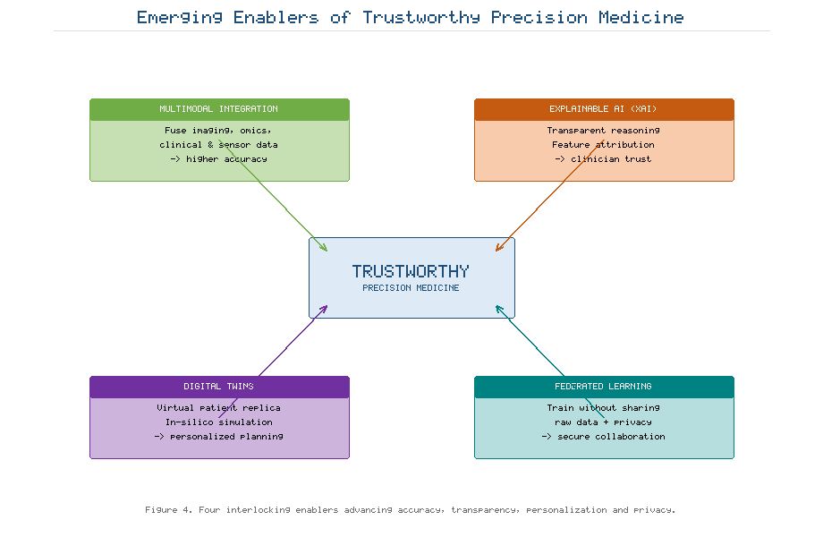
Figure 4. Emerging Enablers of Trustworthy Precision Medicine: Multimodal Integration, Explainable AI, Digital Twins, and Federated Learning
Taken together, the enablers depicted in Figure 4 represent a decisive shift in emphasis from raw predictive performance toward the qualities—transparency, privacy, robustness, and personalization—that determine whether AI systems can be trusted and adopted in practice. Each enabler addresses a distinct barrier: multimodal integration confronts the incompleteness of any single view, explainability confronts opacity, digital twins confront the limits of static planning, and federated learning confronts the tension between data hunger and privacy. As Figure 4 suggests, their combination, rather than any one in isolation, defines the trajectory toward clinically dependable precision medicine and lays the groundwork for confronting the challenges examined next.

8. Challenges to Safe and Effective Adoption

8.1 Data Quality, Interoperability, and Algorithmic Bias
The performance of any AI system is fundamentally bounded by the quality of the data on which it is trained, and clinical data are frequently incomplete, inconsistently coded, and fragmented across systems that do not readily communicate. This lack of interoperability remains one of the most stubborn obstacles to scalable precision medicine, and standards such as HL7 FHIR aim to alleviate the fragmentation by defining common formats and interfaces through which applications can exchange health data reliably [33]. Yet standards adoption is uneven, and much valuable information remains siloed within proprietary systems, limiting the diversity of data available for training and the portability of models across institutions.
Compounding these issues, models trained on non-representative data may learn and even amplify existing disparities. A widely cited analysis demonstrated that a commercial algorithm used to allocate additional care systematically disadvantaged Black patients because it used healthcare cost as a proxy for health need; because less is historically spent on Black patients at equivalent levels of illness, the algorithm underestimated their needs, illustrating how algorithmic bias can entrench inequity even in the absence of any explicit discriminatory intent [34]. Such failures are insidious precisely because they arise from seemingly reasonable design choices and remain invisible unless deliberately audited. Guarding against them requires representative training data, explicit fairness evaluation across demographic subgroups, and ongoing monitoring after deployment.

8.2 Ethics, Privacy, Security, and Regulation
The deployment of AI in healthcare raises profound ethical questions concerning autonomy, informed consent, accountability for error, and the fair distribution of benefits and harms across society [35]. Determining who bears responsibility when an AI-informed decision causes harm—the clinician, the developer, or the institution—remains legally and ethically unsettled, and the answer bears directly on how such systems should be designed and governed. Privacy and security are paramount given the extreme sensitivity of health data and the expanding attack surface created by connected devices and data sharing; techniques such as encryption, rigorous access control, and differential privacy are necessary to safeguard patient information against breach and misuse, and privacy-preserving machine learning has become an active field precisely because conventional approaches to data sharing are inadequate to the sensitivity of the domain [36].
Regulatory frameworks are evolving to address the distinctive characteristics of AI as a medical device, particularly the challenge posed by adaptive algorithms whose behaviour may change after deployment as they continue to learn. Regulators have begun to catalogue and approve AI-based medical devices and to develop oversight approaches suited to software that updates over time, seeking frameworks that ensure ongoing safety and effectiveness rather than certifying a fixed artefact once [37]. These frameworks must reconcile the imperative of patient safety with the pace of technological change, avoiding both the stifling of beneficial innovation and the premature deployment of inadequately validated systems.

8.3 Clinical Validation and Generalization
A recurring and sobering lesson is that impressive performance on retrospective, single-site data frequently fails to translate into prospective, multi-site clinical use. Rigorous clinical validation—including external validation on independent populations and, ideally, prospective and randomized evaluation of clinical impact—is essential before AI systems are entrusted with patient care, and the gap between algorithmic accuracy and demonstrated clinical benefit is one of the central challenges facing the field [38]. Reported performance metrics on curated datasets often overstate real-world utility, and evidence of improved patient outcomes remains comparatively scarce.
Models frequently degrade under distribution shift when applied to populations, imaging devices, laboratory methods, or clinical practices different from those on which they were trained, and ensuring generalization across heterogeneous settings remains a central scientific challenge; the assumption that a model validated in one context will perform equivalently elsewhere is often unwarranted [39]. Addressing this requires validation across diverse sites, continuous post-deployment monitoring for performance drift, and mechanisms for updating or withdrawing models whose performance deteriorates. Table 4 organizes the principal challenges discussed in this section together with their corresponding mitigation strategies.
Table 4. Principal Challenges to AI Adoption in Precision Medicine and Mitigation Strategies
Challenge | Manifestation | Consequence | Mitigation Strategy
Data quality | Missing, noisy, miscoded data | Unreliable predictions | Curation, standardized capture
Interoperability | Fragmented, siloed systems | Limited scalability | FHIR and common data models
Algorithmic bias | Non-representative training data | Inequitable outcomes | Bias audits, diverse datasets
Privacy and security | Sensitive, connected data | Breach, loss of trust | Encryption, federated learning
Regulatory compliance | Adaptive, evolving models | Uncertain oversight | Risk-based, lifecycle regulation
Clinical validation | Retrospective-only evidence | Failure in deployment | External and prospective validation

The mitigation strategies enumerated in Table 4 are not independent; robust governance requires their coordinated application, since addressing bias without validation, or ensuring privacy without interoperability, leaves the overall system vulnerable at its weakest point. As Table 4 implies, trustworthy AI is an emergent property of the whole sociotechnical system—encompassing data, models, workflows, institutions, and oversight—rather than a property of any single algorithm considered in isolation.

9. Future Directions
The trajectory of AI in personalized healthcare points toward increasingly general and capable systems. Foundation models trained across many data types promise a form of generalist medical AI that can flexibly address diverse tasks—interpreting images, reasoning over records, and answering questions—with minimal task-specific engineering, potentially lowering the barrier to deploying capable AI even in resource-limited settings [40]. Such models could reduce the fragmentation of the current landscape, in which each task requires a bespoke system, and could adapt rapidly to new problems. Realizing this promise responsibly, however, will require sustained attention to generalization, ensuring that these models perform equitably across the full diversity of patients, diseases, and care environments rather than only those well represented in their training data [39].
A parallel and pressing priority is the equitable distribution of benefit. If access to AI-enabled precision medicine is confined to well-resourced health systems and affluent populations, the technology risks widening rather than narrowing existing health disparities. Deliberate effort is therefore needed to extend accessibility, to design systems that function under the constraints of low-resource settings, and to direct AI toward the global-health challenges where the need is greatest, so that the benefits of precision medicine are shared broadly rather than concentrated [41]. Equity of access must be treated as an explicit design objective from the outset rather than as an afterthought to be addressed once the technology has matured.
Finally, the long-term success of AI in healthcare will depend less on incremental gains in raw predictive accuracy than on the establishment of trust. Human-centric design that keeps clinicians and patients meaningfully in control, coupled with transparency, reliability, and demonstrable safety, is the foundation upon which durable adoption rests, and clinician trust in particular is shaped by factors extending well beyond model performance [42]. Establishing the organizational, educational, and infrastructural conditions for trustworthy deployment—through clinician training, clear lines of accountability, workflow integration, and robust post-deployment monitoring—constitutes the essential implementation agenda for the coming decade, translating technical capability into sustained clinical value [43]. The maturation of the field will be measured not by benchmark performance but by the safe, equitable, and enduring integration of AI into everyday care.

10. Conclusion
Artificial intelligence has become indispensable to the realization of precision medicine, providing the computational means to integrate and interpret the diverse biomedical data that describe the individual patient. As this chapter has shown, AI techniques spanning machine learning, deep learning, natural language processing, computer vision, reinforcement learning, and generative foundation models contribute across the entire continuum of care, from personalized prevention and precision diagnosis through prognosis, treatment planning, and long-term disease management. Digital health platforms, remote monitoring, and the Internet of Medical Things extend these capabilities well beyond the walls of the clinic, while emerging enablers—multimodal integration, explainable AI, digital twins, and federated learning—promise to enhance accuracy, transparency, personalization, and privacy simultaneously.
Yet the transition from technical possibility to clinical reality is governed by challenges of data quality, interoperability, algorithmic bias, ethics, security, regulation, and validation that must be addressed with equal seriousness and coordinated effort. The clinical exemplars in oncology, cardiovascular disease, diabetes, neurology, and rare disease demonstrate both the transformative potential of these technologies and the practical demands of responsible deployment. The path forward lies in building AI systems that are not only accurate but also scalable, equitable, human-centric, and trustworthy—systems that augment rather than supplant clinical judgement, that earn the confidence of clinicians and patients, and that widen rather than narrow access to high-quality care. If these conditions are met, AI will fulfil its promise as a cornerstone of proactive, evidence-based, and genuinely personalized healthcare, improving outcomes, efficiency, and accessibility for patients and populations alike.

References
[1] Collins, F. S., & Varmus, H. (2015). A new initiative on precision medicine. New England Journal of Medicine, 372(9), 793–795.
[2] Topol, E. J. (2019). High-performance medicine: the convergence of human and artificial intelligence. Nature Medicine, 25(1), 44–56.
[3] Esteva, A., Robicquet, A., Ramsundar, B., Kuleshov, V., DePristo, M., Chou, K., et al. (2019). A guide to deep learning in healthcare. Nature Medicine, 25(1), 24–29.
[4] Hasin, Y., Seldin, M., & Lusis, A. (2017). Multi-omics approaches to disease. Genome Biology, 18(1), 83.
[5] Ashley, E. A. (2016). Towards precision medicine. Nature Reviews Genetics, 17(9), 507–522.
[6] Shickel, B., Tighe, P. J., Bihorac, A., & Rashidi, P. (2018). Deep EHR: a survey of recent advances in deep learning techniques for electronic health record analysis. IEEE Journal of Biomedical and Health Informatics, 22(5), 1589–1604.
[7] Dunn, J., Runge, R., & Snyder, M. (2018). Wearables and the medical revolution. Personalized Medicine, 15(5), 429–448.
[8] Joyia, G. J., Liaqat, R. M., Farooq, A., & Rehman, S. (2017). Internet of Medical Things (IoMT): applications, benefits and future challenges in healthcare domain. Journal of Communications, 12(4), 240–247.
[9] Rajkomar, A., Dean, J., & Kohane, I. (2019). Machine learning in medicine. New England Journal of Medicine, 380(14), 1347–1358.
[10] LeCun, Y., Bengio, Y., & Hinton, G. (2015). Deep learning. Nature, 521(7553), 436–444.
[11] Litjens, G., Kooi, T., Bejnordi, B. E., Setio, A. A. A., Ciompi, F., Ghafoorian, M., et al. (2017). A survey on deep learning in medical image analysis. Medical Image Analysis, 42, 60–88.
[12] Lee, J., Yoon, W., Kim, S., Kim, D., Kim, S., So, C. H., & Kang, J. (2020). BioBERT: a pre-trained biomedical language representation model for biomedical text mining. Bioinformatics, 36(4), 1234–1240.
[13] Gulshan, V., Peng, L., Coram, M., Stumpe, M. C., Wu, D., Narayanaswamy, A., et al. (2016). Development and validation of a deep learning algorithm for detection of diabetic retinopathy in retinal fundus photographs. JAMA, 316(22), 2402–2410.
[14] Komorowski, M., Celi, L. A., Badawi, O., Gordon, A. C., & Faisal, A. A. (2018). The Artificial Intelligence Clinician learns optimal treatment strategies for sepsis in intensive care. Nature Medicine, 24(11), 1716–1720.
[15] Singhal, K., Azizi, S., Tu, T., Mahdavi, S. S., Wei, J., Chung, H. W., et al. (2023). Large language models encode clinical knowledge. Nature, 620(7972), 172–180.
[16] Bhinder, B., Gilvary, C., Madhukar, N. S., & Elemento, O. (2021). Artificial intelligence in cancer research and precision medicine. Cancer Discovery, 11(4), 900–915.
[17] Torkamani, A., Wineinger, N. E., & Topol, E. J. (2018). The personal and clinical utility of polygenic risk scores. Nature Reviews Genetics, 19(9), 581–590.
[18] Sutton, R. T., Pincock, D., Baumgart, D. C., Sadowski, D. C., Fedorak, R. N., & Kroeker, K. I. (2020). An overview of clinical decision support systems: benefits, risks, and strategies for success. npj Digital Medicine, 3, 17.
[19] Gillies, R. J., Kinahan, P. E., & Hricak, H. (2016). Radiomics: images are more than pictures, they are data. Radiology, 278(2), 563–577.
[20] Relling, M. V., & Evans, W. E. (2015). Pharmacogenomics in the clinic. Nature, 526(7573), 343–350.
[21] Bera, K., Schalper, K. A., Rimm, D. L., Velcheti, V., & Madabhushi, A. (2019). Artificial intelligence in digital pathology — new tools for diagnosis and precision oncology. Nature Reviews Clinical Oncology, 16(11), 703–715.
[22] Attia, Z. I., Kapa, S., Lopez-Jimenez, F., McKie, P. M., Ladewig, D. J., Satam, G., et al. (2019). Screening for cardiac contractile dysfunction using an artificial intelligence-enabled electrocardiogram. Nature Medicine, 25(1), 70–74.
[23] Contreras, I., & Vehi, J. (2018). Artificial intelligence for diabetes management and decision support: literature review. Journal of Medical Internet Research, 20(5), e10775.
[24] Jo, T., Nho, K., & Saykin, A. J. (2019). Deep learning in Alzheimer's disease: diagnostic classification and prognostic prediction using neuroimaging data. Frontiers in Aging Neuroscience, 11, 220.
[25] Gurovich, Y., Hanani, Y., Bar, O., Nadav, G., Fleischer, N., Gelbman, D., et al. (2019). Identifying facial phenotypes of genetic disorders using deep learning. Nature Medicine, 25(1), 60–64.
[26] Kvedar, J. C., Fogel, A. L., Elenko, E., & Zohar, D. (2016). Digital medicine's march on chronic disease. Nature Biotechnology, 34(3), 239–246.
[27] Laranjo, L., Dunn, A. G., Tong, H. L., Kocaballi, A. B., Chen, J., Bashir, R., et al. (2018). Conversational agents in healthcare: a systematic review. Journal of the American Medical Informatics Association, 25(9), 1248–1258.
[28] Noah, B., Keller, M. S., Mosadeghi, S., Stein, L., Johl, S., Delshad, S., et al. (2018). Impact of remote patient monitoring on clinical outcomes: an updated meta-analysis. npj Digital Medicine, 1, 20172.
[29] Acosta, J. N., Falcone, G. J., Rajpurkar, P., & Topol, E. J. (2022). Multimodal biomedical AI. Nature Medicine, 28(9), 1773–1784.
[30] Tjoa, E., & Guan, C. (2021). A survey on explainable artificial intelligence (XAI): toward medical XAI. IEEE Transactions on Neural Networks and Learning Systems, 32(11), 4793–4813.
[31] Bjornsson, B., Borrebaeck, C., Elander, N., Gasslander, T., Gawel, D. R., Gustafsson, M., et al. (2020). Digital twins to personalize medicine. Genome Medicine, 12(1), 4.
[32] Rieke, N., Hancox, J., Li, W., Milletari, F., Roth, H. R., Albarqouni, S., et al. (2020). The future of digital health with federated learning. npj Digital Medicine, 3, 119.
[33] Mandel, J. C., Kreda, D. A., Mandl, K. D., Kohane, I. S., & Ramoni, R. B. (2016). SMART on FHIR: a standards-based, interoperable apps platform for electronic health records. Journal of the American Medical Informatics Association, 23(5), 899–908.
[34] Obermeyer, Z., Powers, B., Vogeli, C., & Mullainathan, S. (2019). Dissecting racial bias in an algorithm used to manage the health of populations. Science, 366(6464), 447–453.
[35] Char, D. S., Shah, N. H., & Magnus, D. (2018). Implementing machine learning in health care — addressing ethical challenges. New England Journal of Medicine, 378(11), 981–983.
[36] Kaissis, G. A., Makowski, M. R., Rückert, D., & Braren, R. F. (2020). Secure, privacy-preserving and federated machine learning in medical imaging. Nature Machine Intelligence, 2(6), 305–311.
[37] Benjamens, S., Dhunnoo, P., & Meskó, B. (2020). The state of artificial intelligence-based FDA-approved medical devices and algorithms: an online database. npj Digital Medicine, 3, 118.
[38] Kelly, C. J., Karthikesalingam, A., Suleyman, M., Corrado, G., & King, D. (2019). Key challenges for delivering clinical impact with artificial intelligence. BMC Medicine, 17(1), 195.
[39] Futoma, J., Simons, M., Panch, T., Doshi-Velez, F., & Celi, L. A. (2020). The myth of generalisability in clinical research and machine learning in health care. The Lancet Digital Health, 2(9), e489–e492.
[40] Moor, M., Banerjee, O., Abad, Z. S. H., Krumholz, H. M., Leskovec, J., Topol, E. J., & Rajpurkar, P. (2023). Foundation models for generalist medical artificial intelligence. Nature, 616(7956), 259–265.
[41] Wahl, B., Cossy-Gantner, A., Germann, S., & Schwalbe, N. R. (2018). Artificial intelligence (AI) and global health: how can AI contribute to health in resource-poor settings? BMJ Global Health, 3(4), e000798.
[42] Asan, O., Bayrak, A. E., & Choudhury, A. (2020). Artificial intelligence and human trust in healthcare: focus on clinicians. Journal of Medical Internet Research, 22(6), e15154.
[43] He, J., Baxter, S. L., Xu, J., Xu, J., Zhou, X., & Zhang, K. (2019). The practical implementation of artificial intelligence technologies in medicine. Nature Medicine, 25(1), 30–36.

