SEQUENCE ANALYSIS, MOTIF DISCOVERY, AND FUNCTIONAL ANNOTATION
Book: Computational Drug Design for Targeted Enzymes: Integrated Medicinal Chemistry and Molecular Biology

Abstract
The rational design of molecules that modulate enzyme activity begins long before any structure is docked or any lead is synthesized; it begins with the correct identification of the target and the rigorous interpretation of its primary sequence. This chapter establishes the bioinformatics foundation for enzyme-targeted drug design, progressing from raw sequence retrieval through the discovery of catalytically essential motifs to the transfer of functional annotations that inform druggability assessment. It first addresses sequence retrieval and evolutionary analysis, emphasizing the practical mining of UniProt, GenBank, and the Protein Data Bank, the critical distinction between orthologs and paralogs, and the construction and interpretation of multiple sequence alignments and conservation profiles. The chapter then confronts the central methodological tension of enzyme annotation: sequence-based motif discovery is powerful and widely applicable yet blind to distant and convergent relationships, whereas structure-informed catalytic-template matching is sensitive to functional similarity that sequence cannot reveal but demands three-dimensional data. It examines sequence motifs, profile hidden Markov models, and the recent paradigm of geometric active-site search against curated catalytic templates. Finally, the chapter translates sequence and motif evidence into actionable function through Enzyme Commission assignment and pathway contextualization, and integrates sequence-derived features into a structured target-prioritization scheme. A recurring argument unifies the chapter: sequence-level analysis is not a preliminary chore but a decisive filter whose methodological choices determine which enzymes enter the drug discovery pipeline and which are set aside as non-orthologous or functionally ambiguous. Through worked frameworks, comparative tables, and schematic figures, the chapter equips researchers to convert sequence data into validated, prioritized drug-target hypotheses.
Keywords: sequence analysis; multiple sequence alignment; orthologs; motif discovery; profile hidden Markov models; catalytic site; Enzyme Commission number; functional annotation; druggability; target prioritization

1. Introduction to Sequence-Based Enzyme Target Analysis
Every enzyme-targeted drug discovery campaign rests on a chain of inferences that begins with a string of amino acids. Before a medicinal chemist can contemplate an inhibitor, before a crystallographer can solve a structure, and before a computational scientist can dock a library of compounds, the target enzyme must be unambiguously identified, its sequence must be dissected for the evolutionary and structural signals it encodes, and its functional role must be validated within the broader context of the proteome and its metabolic and signaling networks. The deceptively simple act of retrieving a sequence and interpreting it correctly determines, to a degree that is frequently underappreciated, whether a drug discovery program is built on solid ground or on a misannotation that will surface only after substantial resources have been committed. This chapter develops the argument that sequence-level analysis is a decisive filter rather than a preliminary formality.
The central concern of this chapter is the transformation of raw sequence data into validated, prioritized drug-target hypotheses. This transformation unfolds across three logically connected stages. The first stage concerns the acquisition of the correct sequence and the clarification of its evolutionary relationships, for an enzyme cannot be understood in isolation but only in relation to its homologs, some of which share its function and some of which have diverged into distinct roles. The second stage concerns the discovery of the motifs and catalytic signatures that distinguish a functional enzyme from a mere polypeptide, a task that exposes a deep methodological tension between approaches grounded in sequence and those grounded in three-dimensional structure. The third stage concerns the assignment of function and the assessment of whether an enzyme merits entry into the drug discovery pipeline at all.
A theme that recurs throughout the chapter is that the methods chosen at each stage are not neutral instruments but consequential decisions that shape the outcome. The selection of a homology-detection threshold determines which relatives are recognized; the choice between a sequence-profile motif search and a structure-informed catalytic-template search determines whether a distantly related or convergently evolved enzyme is captured or dismissed; and the criteria used to assess druggability determine which validated targets advance. The chapter therefore treats methodology not as background but as the substance of the analysis. It also emphasizes the iterative character of the process: functional annotation derived from sequence is best regarded not as a final verdict but as a hypothesis that subsequent structural and chemical biology must test, refine, and occasionally overturn. With this orientation established, the chapter proceeds from sequence retrieval and evolutionary analysis to motif discovery and catalytic-site identification, and finally to functional annotation and druggability assessment.

2. Sequence Retrieval, Alignment, and Evolutionary Analysis

2.1 Database Mining and Ortholog Identification
The foundation of any sequence-based analysis is the retrieval of an accurate, complete, and correctly annotated sequence, a step whose importance is inversely proportional to the attention it typically receives. The principal repositories of enzyme sequence and structural information are complementary rather than interchangeable: UniProt provides expertly curated and automatically annotated protein sequences with rich functional metadata, GenBank archives the nucleotide records from which many protein sequences are derived, and the Protein Data Bank supplies experimentally determined three-dimensional structures together with their associated sequences [1, 2, 3]. Because each resource organizes and annotates data differently, cross-referencing accession numbers across databases is essential to assemble a coherent picture of a target and to guard against propagating errors that may reside in any single record. An enzyme whose UniProt entry carries a confident functional assignment may nevertheless correspond to a structure deposited under a different name or a nucleotide record with an outdated annotation, and only systematic cross-referencing reconciles these discrepancies.
Annotation errors are not rare curiosities but a pervasive hazard that has been documented extensively across public databases, where incorrect functional assignments can propagate from one newly sequenced genome to the next through automated transfer [4]. The consequence for drug discovery is direct: a target pursued on the basis of a mistaken annotation may lack the activity, the binding site, or the biological role that motivated its selection. The quality of a sequence record must therefore be assessed deliberately, considering the completeness of the sequence, the reliability of its source organism assignment, the evidence level underlying its functional annotation, and its consistency across databases. Records supported by experimental evidence warrant greater confidence than those annotated purely by computational inference, and this distinction should inform how heavily a target assessment leans on any particular annotation.
The most consequential distinction in evolutionary sequence analysis is that between orthologs and paralogs, a distinction that bears directly on the transferability of functional and druggability information [5]. Orthologs are genes in different species that diverged from a common ancestral gene through speciation, and they tend to retain the ancestral function, making them reliable sources for transferring functional annotations and for inferring that a druggable site in one species is likely conserved in another. Paralogs, by contrast, arise through gene duplication within a lineage and are frequently freed to evolve divergent substrate specificities, regulatory properties, or even entirely new functions. Because this discrimination rests on similarity searching, a clear understanding of what sequence-similarity methods can and cannot establish is a prerequisite [6]. The formal distinction between homologous and merely analogous proteins, and the subsequent refinement of orthology and paralogy concepts, provides the vocabulary that disciplines this analysis [7, 8]. Confusing a paralog for an ortholog can lead an investigator to attribute to a target a function it does not possess, or to assume a shared binding site that has in fact diverged. As illustrated in Figure 1, careful reconstruction of the evolutionary relationships among retrieved sequences is the safeguard that distinguishes functionally informative orthologs from potentially misleading paralogs.
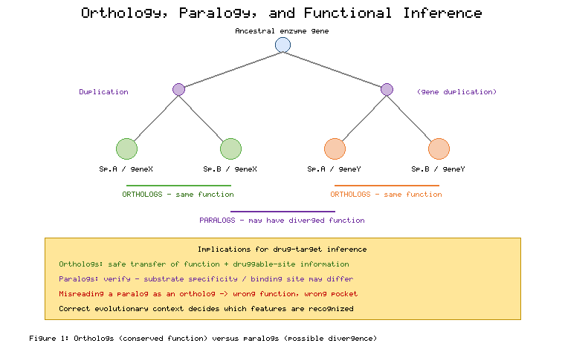
Figure 1. Orthology and Paralogy in Enzyme Families and Their Implications for Functional and Druggability Inference
The practical detection of homologs and the discrimination of orthologs from paralogs rely on sequence-similarity search tools whose parameters must be tuned to the characteristics of enzyme families. The Basic Local Alignment Search Tool and its iterative, profile-based successor identify related sequences by statistical assessment of local alignments, reporting an expectation value that quantifies the number of hits of equivalent quality expected by chance [9]. For enzyme families, sensible parameter choices include the application of low-complexity filtering to suppress spurious matches arising from compositionally biased regions, and the selection of an expectation-value threshold appropriate to the depth of homology sought, with more permissive thresholds required to detect the distant relationships typical of ancient enzyme superfamilies. The iterative profile search is especially valuable for recovering remote homologs, because it builds a position-specific profile from initial hits and uses it to detect progressively more divergent relatives, though this sensitivity must be balanced against the risk of profile corruption by unrelated sequences. Table 1 summarizes the principal sequence resources and search strategies and the considerations that govern their appropriate use in enzyme target analysis.
[Insert Table 1 here]
Table 1. Sequence Databases and Homology-Search Strategies for Enzyme Target Retrieval
Resource/Tool | Primary Content | Key Parameter or Feature | Role in Target Analysis | Principal Caution
UniProt | Curated protein sequences and annotation | Evidence levels, reviewed entries | Primary functional metadata | Automated annotations vary in reliability
GenBank | Nucleotide and derived protein records | Accession versioning | Source of raw sequence data | May carry outdated annotations
Protein Data Bank | Experimental 3D structures | Resolution, bound ligands | Structural and ligand context | Limited coverage of sequence space
BLAST | Local similarity search | E-value threshold, low-complexity filter | Rapid homolog detection | Misses distant homology
PSI-BLAST | Iterative profile search | Profile inclusion threshold | Remote homolog recovery | Profile drift from unrelated hits
The value of rigorous ortholog analysis is well illustrated by a scenario in which a protein kinase had been assigned an incorrect function in its original annotation, an error that obscured a potentially important binding pocket. By retrieving the sequence, identifying its true orthologs across species through careful similarity search and evolutionary reconstruction, and correcting the annotation on the basis of the conserved features shared among genuine orthologs, the analysis revealed a pocket that had been absent from the mistaken original assignment. Such cases demonstrate that ortholog identification is not an academic exercise but a practical determinant of which structural features, and therefore which drug-design opportunities, are recognized. The corrected evolutionary context repositioned the enzyme as a credible target whose active-site architecture could subsequently guide inhibitor design, underscoring the thesis that sequence analysis decisively shapes the pipeline.

2.2 Multiple Sequence Alignment and Conservation Profiling
Once a set of homologous sequences has been assembled and the orthologous relationships clarified, the next analytical step is the construction of a multiple sequence alignment, which arranges the sequences so that residues sharing common evolutionary descent occupy the same columns [10]. The alignment is the substrate from which nearly all subsequent evolutionary and functional inferences are drawn, and its quality governs the reliability of those inferences. Several widely used algorithms embody different trade-offs between speed and accuracy: progressive methods build an alignment by following a guide tree, iterative methods refine an initial alignment through repeated adjustment, and consistency-based methods incorporate information from many pairwise comparisons to improve column accuracy [10, 11]. The choice among tools such as the progressive and consistency-based approaches, the iterative refinement methods, and the fast large-scale aligners depends on the number and divergence of the sequences and on the balance between computational cost and alignment precision required for the analysis [11, 12]. Consistency-based aligners that incorporate information from many pairwise comparisons, and high-throughput progressive aligners, offer contrasting trade-offs that suit different enzyme-family analyses [13, 14].
The treatment of gaps is a subtle but consequential aspect of alignment interpretation, because insertions and deletions accumulate over evolutionary time and their placement affects which residues are judged homologous. Gap penalties that are too permissive produce fragmented, over-gapped alignments, while penalties that are too strict force unrelated residues into the same columns; the appropriate balance depends on the evolutionary distances involved and on whether the regions under scrutiny are structurally conserved cores or variable loops [10]. For enzyme families, particular care is warranted around the active site, where even a single misplaced gap can shift a catalytic residue out of its conserved column and thereby corrupt downstream conservation analysis. Regions of high divergence, often corresponding to surface loops and insertions, are inherently less reliably aligned than the structurally constrained core, and conclusions drawn from such regions should be treated with corresponding caution.
The analytical power of a multiple sequence alignment is realized through conservation profiling, which quantifies, for each column, the degree to which a position has resisted evolutionary change. Information-theoretic measures provide the standard vocabulary: Shannon entropy captures the variability of the amino acid distribution at a position, with low entropy indicating strong conservation, while divergence-based measures such as the Jensen-Shannon divergence compare the observed distribution against a background to score conservation in a manner that can incorporate residue similarity [15, 16]. These scores transform an alignment into a quantitative conservation profile that highlights the positions most resistant to change. Figure 2 depicts how a multiple sequence alignment of an enzyme family is converted into a per-residue conservation profile that distinguishes invariant catalytic positions from variable specificity-determining positions, providing a map of functional importance along the sequence.
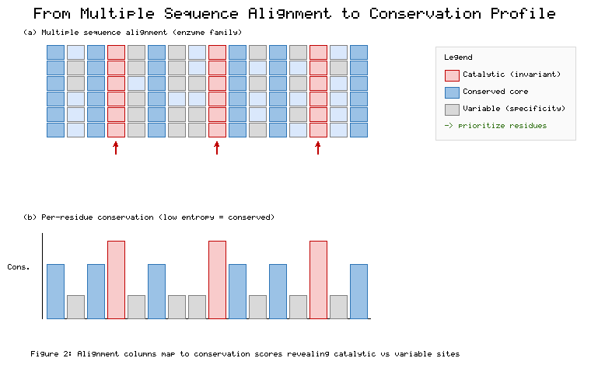
Figure 2. From Multiple Sequence Alignment to a Per-Residue Conservation Profile Distinguishing Catalytic Cores from Variable Specificity Regions
The medicinal-chemistry significance of conservation profiling lies in the correspondence between evolutionary conservation and functional importance. Residues that are highly conserved across an enzyme family typically perform indispensable roles, either participating directly in catalysis or stabilizing the structural core, because mutations at such positions are strongly disfavored by selection [17]. Variable positions, by contrast, frequently encode the specificity determinants that distinguish one family member from another, governing which substrates are accepted and which inhibitors bind. This dichotomy is directly actionable: conservation profiles can prioritize residues for site-directed mutagenesis to test functional hypotheses, can identify the catalytic machinery that competitive inhibitors must engage, and can reveal positions whose variation confers the selectivity that a drug must exploit to distinguish a target from its relatives. Tools that estimate and visualize evolutionary conservation directly on a structure make these patterns readily interpretable for target assessment [18].
Conservation analysis also offers a route to the discovery of allosteric and subfamily-specific sites that may be especially valuable for selective inhibition. A pocket that is conserved only within a pathogenic subfamily of an enzyme family, while being variable or absent in the host's own members, presents an attractive opportunity for selective targeting that spares the host enzymes and thereby reduces the risk of mechanism-based toxicity [17]. Detecting such opportunities requires conservation to be analyzed not merely across the whole family but within and between relevant subfamilies, so that positions conserved in one clade but not another are brought to light. This subfamily-resolved view of conservation connects the evolutionary analysis of this section to the druggability and selectivity considerations developed later in the chapter, and it motivates the motif-level analysis to which the discussion now turns.

3. Motif Discovery and Catalytic Site Identification

3.1 Sequence-Based Motif Discovery and Profile Construction
Motifs are short, recurring patterns in sequence that carry disproportionate functional meaning, and their discovery is central to the interpretation of enzyme sequences. The simplest motifs are short linear patterns of conserved residues, which can be represented as regular-expression-like patterns that specify permitted amino acids at each position [19]. Curated pattern databases catalogue such signatures, associating each with a functional role established through experimental characterization, and scanning a query sequence against these patterns provides rapid evidence of function [20]. More expressive than fixed patterns are profiles that assign position-specific scores to each amino acid, and the most powerful of these are profile hidden Markov models, which model a family of related sequences probabilistically and can detect membership with high sensitivity and specificity [21]. Software implementations of profile hidden Markov models have become the workhorse of family-based annotation, and the family databases built upon them provide broad coverage of known enzyme families [21, 22]. Integrative resources that consolidate many member databases, together with fingerprint- and family-based collections, extend the coverage and cross-validation available for annotation [23, 24, 25].
A crucial conceptual distinction separates motifs that directly constitute catalytic residues from those that serve other functional roles. Some sequence motifs encode the very residues that perform the chemistry of catalysis; the glycine-containing nucleophile-elbow motif characteristic of many serine hydrolases, with its conserved serine flanked by glycines, positions the catalytic serine for its role in the reaction [26]. Other motifs do not participate in catalysis but instead serve as recognition signals, marking sites for cofactor binding, metal coordination, post-translational modification, or subcellular localization. Distinguishing these categories is essential for drug design, because a motif that constitutes the catalytic apparatus identifies the pocket a competitive inhibitor must occupy, whereas a cofactor-binding or localization motif conveys different information about the enzyme's mechanism and cellular context. Table 2 organizes the principal classes of sequence-based motif-detection methods and the functional information each provides.
[Insert Table 2 here]
Table 2. Sequence-Based Motif and Profile Methods for Enzyme Annotation
Method Class | Representation | Detection Sensitivity | Functional Information | Representative Use
Short linear motifs | Regular-expression pattern | Low for divergent cases | Local functional signal | Recognition and modification sites
Pattern databases | Deterministic consensus pattern | Moderate | Family or site signature | Rapid catalytic-motif screening
Position-specific profiles | Scoring matrix | Moderate to high | Family membership | Domain assignment
Profile hidden Markov models | Probabilistic family model | High | Family and domain architecture | Sensitive family annotation
De novo motif discovery | Learned over-represented pattern | Dataset-dependent | Novel conserved signals | Uncharacterized family motifs
The derivation of a profile or hidden Markov model from a set of related sequences is itself an analytical task requiring judgment, since the quality of the resulting model depends on the quality and representativeness of the input alignment. A model built from a narrow set of closely related sequences will detect only near relatives, whereas a model built from a diverse, well-curated family alignment can recognize distant members, and the inclusion of unrelated sequences will degrade specificity. De novo motif discovery methods, which search a collection of sequences for statistically over-represented patterns without prior knowledge, complement database-driven approaches by revealing novel conserved signals that no existing pattern captures, and their outputs can be validated statistically and assessed for plausible roles in catalysis or binding [27]. These methods are particularly useful for enzyme families that are poorly represented in curated databases or that harbor lineage-specific motifs of potential therapeutic relevance.
Despite their power, sequence-based motif methods are subject to fundamental limitations that constrain their reliability and motivate complementary approaches. The first limitation is convergent evolution: identical or nearly identical catalytic geometries can arise independently in non-homologous proteins, so that enzymes performing the same chemistry through the same spatial arrangement of residues may share no detectable sequence similarity and therefore no common sequence motif [28]. The second, and in a sense opposite, limitation is divergent evolution beyond the twilight zone: homologous enzymes that retain the same catalytic mechanism can diverge in sequence to the point that their shared ancestry, and the motif that once united them, is no longer recognizable by sequence comparison [29]. Both failure modes mean that an enzyme may possess a bona fide, druggable catalytic site while lacking any canonical sequence motif, and both motivate the structure-informed strategies examined in the next subsection.

3.2 Structure-Informed Motif Matching and Geometric Active-Site Search
The limitations of sequence-only motif discovery motivate a paradigm shift toward the matching of catalytic motifs in three dimensions, in which the spatial arrangement of a small number of functional residues, rather than their linear sequence context, defines the signature of a function [30]. The conceptual basis for this approach is the observation that the geometry of a catalytic site is often conserved even when the surrounding sequence and fold have diverged or have arisen convergently, because it is the precise spatial positioning of catalytic residues that the chemistry demands. A structure-informed search therefore queries a protein structure against a library of catalytic templates, each template encoding the identities and relative positions of the residues that perform a known catalytic function. Curated resources that document enzyme mechanisms and the residues responsible for them provide the raw material from which such templates are constructed [31]. Annotated catalogues of catalytic sites, the recurring chemistry of catalytic residue constellations, and databases of reaction mechanisms collectively supply and corroborate these templates [32, 33, 34].
The methodology of geometric active-site search proceeds by comparing the three-dimensional disposition of candidate residues in a query structure against the templates in the library, seeking spatial matches within a tolerance that accommodates natural variation [30, 35]. Because the matching is based on geometry rather than sequence, it can detect functional similarity between enzymes sharing less than roughly forty percent sequence identity, a regime in which sequence-based methods become unreliable, and it can thereby capture both distantly diverged homologs and convergently evolved analogs that sequence comparison would miss [35]. The number of residues that constitute a discriminating template is typically small, often on the order of three to six, reflecting the fact that catalytic function is frequently vested in a compact constellation of residues such as a catalytic triad or a metal-coordinating cluster. The power of the approach lies in its ability to recognize these constellations wherever they occur, independent of their sequence embedding. Table 3 contrasts the sequence-based and structure-informed paradigms across the dimensions most relevant to enzyme target identification.
[Insert Table 3 here]
Table 3. Sequence-Based Versus Structure-Informed Motif Detection for Enzyme Function
Dimension | Sequence-Based Motifs | Structure-Informed Catalytic Templates
Input required | Sequence only | Experimental or predicted structure
Detects convergent evolution | No | Yes
Detects remote divergent homologs | Limited | Yes
Sensitivity below 40% identity | Low | High
Residues defining the signal | Contiguous or short-range | Small 3D constellation (3–6 residues)
Principal dependency | Curated patterns/profiles | Structural model quality, template library
The practical feasibility of structure-informed matching has been transformed by the advent of accurate protein structure prediction, which has made three-dimensional models available for enzymes that have never been crystallized. Because a predicted structure of sufficient quality can serve as the query for a geometric catalytic-template search, the approach is no longer confined to the minority of enzymes with experimental structures but can in principle be applied across the proteome [36]. This development greatly expands the reach of structure-informed annotation, allowing an enzyme that lacks canonical sequence motifs, and that may lack any close homolog with a bound inhibitor, nonetheless to be recognized as a viable target through its match to a known catalytic template. Figure 3 illustrates the geometric matching of a compact catalytic constellation between a query structure and a template, capturing a functional relationship invisible to sequence comparison.
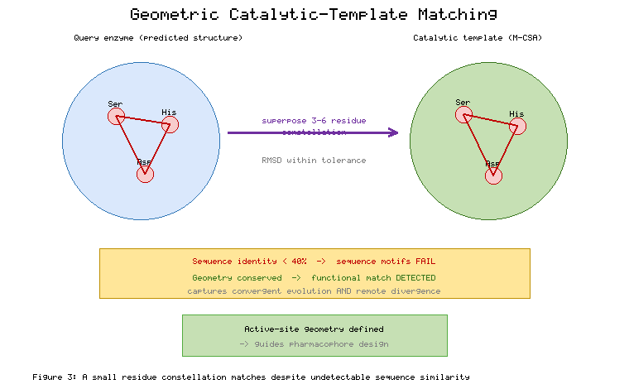
Figure 3. Geometric Matching of a Catalytic Residue Constellation Between a Query Structure and a Catalytic Template
The implications of structure-informed motif matching for drug design are substantial and extend well beyond annotation. When an enzyme is recognized as functionally related to a characterized catalytic template, the geometry of its active site is thereby defined, and that geometry can directly inform the construction of a pharmacophore model specifying the spatial and chemical features a ligand must present to engage the site [37]. This capability is especially valuable precisely in the difficult cases where sequence methods fail, because it provides a structural rationale for inhibitor design even in the absence of a close homolog whose bound inhibitor could otherwise serve as a template. The combination of sequence-based and structure-informed approaches, deployed as complementary rather than competing strategies, maximizes the probability that a genuinely druggable enzyme will be correctly recognized and characterized, and it sets the stage for the functional annotation and druggability assessment that convert these findings into prioritization decisions.

4. Functional Annotation and Druggability Assessment

4.1 EC Number Assignment and Pathway Contextualization
The assignment of a precise functional classification is the point at which sequence and motif evidence is distilled into a statement about what an enzyme does, and the Enzyme Commission numbering system provides the standard vocabulary for this purpose [38]. An Enzyme Commission number is a four-level hierarchical code that specifies the class of reaction catalyzed, progressively narrowing from the broad chemistry of the first level to the specific substrate and reaction of the fourth. Assigning such a number to an uncharacterized enzyme can proceed through several lines of evidence of differing confidence: transfer of the classification from a well-characterized homolog on the basis of sequence similarity, inference from the presence of diagnostic sequence motifs, and matching to a catalytic template through structure-informed search [39]. Machine-learning methods trained to predict functional classifications from sequence have also matured, offering automated assignment at proteome scale, though their predictions carry confidence levels that must be weighed against the more direct evidence of experimental characterization [39, 40]. Large-scale community assessments of computational function prediction, and reviews of inference from sequence and structure, temper expectations about automated annotation accuracy [41, 42].
The confidence attached to a functional assignment depends critically on the method and evidence underlying it, and this confidence must be propagated honestly into subsequent decisions. An assignment transferred from a close, experimentally characterized ortholog warrants high confidence, whereas one inferred from a weak sequence match or a partial motif match warrants caution, and the fourth, most specific level of the classification is generally harder to assign reliably than the broader upper levels. Recognizing these gradations prevents the common error of treating a tentative computational annotation as an established fact, an error that can send a drug discovery program after a target whose presumed activity is in truth unverified. The structure-informed matching discussed earlier contributes valuable corroborating evidence here, because a geometric match to a catalytic template can confirm a functional assignment that sequence evidence alone leaves ambiguous.
Functional classification acquires its full significance only when the enzyme is situated within the metabolic and signaling networks in which it operates, for the therapeutic consequence of inhibiting an enzyme depends on its role in those networks. Pathway databases that organize enzymes into the reactions and pathways they constitute allow an annotated enzyme to be placed in its biological context, revealing its upstream substrates, its downstream products, and the alternative routes that may bypass it [43, 44]. Comprehensive metabolic databases that enumerate pathways and their constituent enzymes further support the reconstruction of these network relationships [45]. This contextualization answers a question that sequence analysis alone cannot: whether inhibiting the enzyme will produce a therapeutically useful perturbation of the network or whether that perturbation will be buffered by redundancy, with parallel pathways compensating for the loss of the targeted activity. An enzyme whose inhibition is readily bypassed is a poor target regardless of how confidently its function is annotated.
The concept of a druggable pathway node captures the intersection of functional validation and network position that marks an enzyme as a promising target. Enzymes positioned at pathway bottlenecks or at rate-limiting steps exert disproportionate control over flux through the network, so that their inhibition produces substantial and difficult-to-bypass effects [46]. Such nodes, when also supported by confident functional annotation and a well-defined active site, are natural priorities for drug discovery. As depicted in Figure 4, the placement of an annotated enzyme within its pathway reveals whether it occupies a controlling bottleneck whose inhibition would meaningfully perturb the network or a redundant position whose inhibition would be compensated, directly informing the prioritization decision.
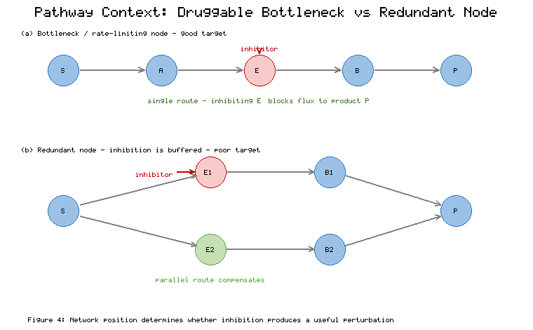
Figure 4. Pathway Contextualization of an Annotated Enzyme: Distinguishing Druggable Bottleneck Nodes from Redundant Positions

4.2 Integration with Druggability Metrics and Target Prioritization
The culmination of sequence-based analysis is the integration of its several products into a structured scheme for prioritizing enzyme targets, a scheme that weighs multiple sequence-derived and contextual features to arrive at a defensible ranking. Several features established through the analyses of the preceding sections contribute to this assessment: the conservation of the active site, which indicates functional importance and the likelihood that an inhibitor binding there will affect activity; the presence of a well-defined pocket capable of binding a small molecule, which indicates chemical tractability; the absence of closely related human homologs, which reduces the risk of off-target effects and mechanism-based toxicity; and the confidence of the functional annotation itself, which governs how much weight the other features can bear [47]. No single feature is decisive; rather, it is their combination that distinguishes a compelling target from a questionable one, and an explicit scoring scheme makes the basis of prioritization transparent and reproducible.
The requirement that a target lack closely related human homologs deserves particular emphasis because of its direct bearing on selectivity and safety, especially for anti-infective and oncology targets [48]. An enzyme in a pathogen or a disease-associated process that closely resembles an essential human enzyme presents a formidable selectivity challenge, since an inhibitor of the target is liable also to inhibit the human counterpart, producing toxicity. Sequence analysis addresses this concern directly by searching the human proteome for relatives of the candidate target and by assessing, through the conservation and motif analyses described earlier, whether the active site in particular is distinguishable between the target and its human homologs. A target whose catalytic site differs from any human enzyme offers a far more favorable prospect for the development of a selective inhibitor than one whose site is broadly shared. Systematic surveys of underexplored regions of the human genome, and pocket-based druggability prediction, help identify where such favorable, chemically tractable opportunities lie [49, 50].
The features that emerge from sequence analysis do not merely inform a ranking; they feed directly and concretely into the downstream stages of structure-based drug design treated in subsequent chapters. A high-confidence catalytic motif, having identified the residues essential to activity, becomes a docking constraint that focuses the search for inhibitors on the functionally relevant pocket and biases scoring toward interactions with the catalytic machinery. A conserved allosteric site, identified through subfamily-resolved conservation analysis, becomes a candidate location for non-competitive inhibitor design that may achieve selectivity unattainable at the orthosteric site. A pathway annotation, having established the enzyme's network role and its relationships to related activities, informs the selectivity requirements that a candidate inhibitor must satisfy. Table 4 summarizes how each sequence-derived feature maps onto a prioritization criterion and a downstream design implication, making explicit the throughline from sequence to design.
[Insert Table 4 here]
Table 4. Integration of Sequence-Derived Features into Target Prioritization and Downstream Design
Sequence-Derived Feature | Evidence Source | Prioritization Signal | Downstream Design Implication
Active-site conservation | Conservation profiling | High functional importance | Docking focused on catalytic pocket
Well-defined pocket | Motif and structural evidence | Chemical tractability | Pharmacophore and docking target
Catalytic motif confidence | Pattern/HMM/template match | Annotation reliability | Catalytic-residue docking constraint
Absence of human homolog | Proteome similarity search | Low off-target risk | Relaxed selectivity burden
Subfamily-specific site | Subfamily conservation | Selective-targeting opportunity | Allosteric inhibitor candidate
Pathway bottleneck position | Pathway databases | Network-level efficacy | Defines selectivity requirements
A realistic prioritization scheme combines these features into an overall judgment while acknowledging the uncertainty inherent in each, and it is best expressed as a weighted, transparent framework rather than a rigid formula. Figure 5 presents an integrated prioritization workflow that gathers the conservation, motif, homology, and pathway evidence developed throughout the chapter and combines them into a tiered classification of targets, from high-priority candidates ready to advance to structure-based design through intermediate cases requiring further evidence to low-priority or deprioritized enzymes. Such a framework does not eliminate judgment but disciplines it, ensuring that prioritization rests on the explicit, documented consideration of all relevant sequence-derived evidence rather than on intuition or on any single, potentially misleading, criterion.
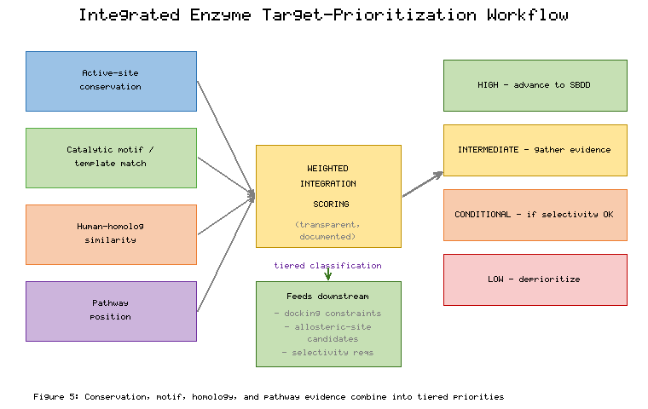
Figure 5. Integrated Target-Prioritization Workflow Combining Conservation, Motif, Homology, and Pathway Evidence
The prioritization scheme must also accommodate the several lines of evidence that differ in both strength and character, and a tiered representation clarifies how they combine. Table 5 presents an illustrative tiered classification that maps combinations of evidence onto priority levels and recommended actions, showing how a target supported by a confident annotation, a conserved and distinctive active site, and a favorable pathway position earns a high priority and immediate advancement, while a target deficient in one or more of these respects is assigned a lower tier and a corresponding requirement for additional validation. This tiered logic operationalizes the chapter's central thesis that sequence analysis functions as a decisive filter, for it is precisely through such explicit, evidence-weighted classification that enzymes are sorted into those that enter the drug discovery pipeline and those that do not.
[Insert Table 5 here]
Table 5. Illustrative Tiered Target Classification Based on Integrated Sequence Evidence
Priority Tier | Annotation Confidence | Active-Site Profile | Human Homolog Status | Recommended Action
High | High (experimental or ortholog) | Conserved, well-defined, distinctive | No close homolog | Advance to structure-based design
Intermediate | Moderate (motif or template) | Defined but partially shared | Distant homolog | Gather structural/biochemical evidence
Conditional | Moderate to high | Conserved but human-shared | Close homolog | Pursue only if selectivity achievable
Low | Low (weak computational) | Poorly defined or ambiguous | Uncertain | Deprioritize pending validation
The integration of these metrics into a prioritization scheme is not the end of the analytical process but a hypothesis-generating waypoint, and the chapter closes its substantive treatment by emphasizing the iterative character of target assessment. Functional annotation derived from sequence and motif analysis, however carefully performed, remains a prediction that structural biology, biochemistry, and chemical biology must test; a predicted catalytic residue must be confirmed by mutagenesis, a predicted pocket must be validated by structure determination, and a predicted pathway role must be demonstrated in a biological system. The sequence analysis developed in this chapter thus provides not a final gate but the initial, decisive filter that determines which enzymes are deemed worthy of the experimental investment required to test these hypotheses, and it supplies the concrete constraints and features that make that subsequent testing efficient and well directed.

5. Conclusion
Sequence analysis, motif discovery, and functional annotation together constitute the foundation upon which enzyme-targeted drug discovery is built, converting the raw material of amino acid sequences into validated, prioritized target hypotheses. This chapter has traced that conversion through its three connected stages, beginning with the retrieval of accurate sequences and the reconstruction of the evolutionary relationships that distinguish functionally informative orthologs from potentially misleading paralogs. The careful mining of complementary databases, the disciplined cross-referencing that guards against propagated annotation errors, and the construction and interpretation of multiple sequence alignments and conservation profiles were shown to be not preliminary formalities but consequential analyses whose outcomes determine which structural features, and therefore which drug-design opportunities, are recognized.
The chapter then examined the central methodological tension of enzyme annotation, between the sequence-based motif methods that are broadly applicable yet blind to convergent and distantly divergent relationships, and the structure-informed catalytic-template matching that recognizes functional similarity wherever its geometric signature occurs. The recognition that an enzyme may possess a genuine, druggable catalytic site while lacking any canonical sequence motif, and that accurate structure prediction has made geometric active-site search applicable across the proteome, reframes motif discovery as a complementary deployment of sequence and structural strategies rather than a choice between them. This complementarity maximizes the probability that a truly druggable enzyme will be correctly identified and that its active-site geometry will be available to guide pharmacophore design even in the most difficult cases.
Finally, the chapter showed how functional classification, pathway contextualization, and the integration of sequence-derived features into a structured prioritization scheme translate analysis into decision. The concept of the druggable pathway node, the emphasis on distinguishing a target from its human homologs to secure selectivity, and the explicit mapping of sequence-derived features onto docking constraints, allosteric-site hypotheses, and selectivity requirements together demonstrate that sequence-level findings flow directly into the structure-based design of subsequent chapters. Throughout, the analysis has been presented not as a one-time gate but as an iterative, hypothesis-generating process whose predictions structural and chemical biology must test. In this light, sequence analysis emerges as precisely the decisive filter the chapter set out to describe: the stage at which the enzymes that will become drug targets are separated from those that will not, and at which the constraints that make all subsequent design efficient and well directed are first established.

References
[1] The UniProt Consortium. (2021). UniProt: The universal protein knowledgebase in 2021. Nucleic Acids Research, 49(D1), D480–D489.
[2] Sayers, E. W., Cavanaugh, M., Clark, K., Pruitt, K. D., Schoch, C. L., Sherry, S. T., & Karsch-Mizrachi, I. (2021). GenBank. Nucleic Acids Research, 49(D1), D92–D96.
[3] Berman, H. M., Westbrook, J., Feng, Z., Gilliland, G., Bhat, T. N., Weissig, H., ... & Bourne, P. E. (2000). The Protein Data Bank. Nucleic Acids Research, 28(1), 235–242.
[4] Schnoes, A. M., Brown, S. D., Dodevski, I., & Babbitt, P. C. (2009). Annotation error in public databases: Misannotation of molecular function in enzyme superfamilies. PLoS Computational Biology, 5(12), e1000605.
[5] Koonin, E. V. (2005). Orthologs, paralogs, and evolutionary genomics. Annual Review of Genetics, 39, 309–338.
[6] Pearson, W. R. (2013). An introduction to sequence similarity ("homology") searching. Current Protocols in Bioinformatics, 42(1), 3.1.1–3.1.8.
[7] Fitch, W. M. (1970). Distinguishing homologous from analogous proteins. Systematic Zoology, 19(2), 99–113.
[8] Sonnhammer, E. L. L., & Koonin, E. V. (2002). Orthology, paralogy and proposed classification for paralog subtypes. Trends in Genetics, 18(12), 619–620.
[9] Altschul, S. F., Madden, T. L., Schäffer, A. A., Zhang, J., Zhang, Z., Miller, W., & Lipman, D. J. (1997). Gapped BLAST and PSI-BLAST: A new generation of protein database search programs. Nucleic Acids Research, 25(17), 3389–3402.
[10] Edgar, R. C., & Batzoglou, S. (2006). Multiple sequence alignment. Current Opinion in Structural Biology, 16(3), 368–373.
[11] Sievers, F., Wilm, A., Dineen, D., Gibson, T. J., Karplus, K., Li, W., ... & Higgins, D. G. (2011). Fast, scalable generation of high-quality protein multiple sequence alignments using Clustal Omega. Molecular Systems Biology, 7(1), 539.
[12] Katoh, K., & Standley, D. M. (2013). MAFFT multiple sequence alignment software version 7: Improvements in performance and usability. Molecular Biology and Evolution, 30(4), 772–780.
[13] Notredame, C., Higgins, D. G., & Heringa, J. (2000). T-Coffee: A novel method for fast and accurate multiple sequence alignment. Journal of Molecular Biology, 302(1), 205–217.
[14] Edgar, R. C. (2004). MUSCLE: Multiple sequence alignment with high accuracy and high throughput. Nucleic Acids Research, 32(5), 1792–1797.
[15] Valdar, W. S. J. (2002). Scoring residue conservation. Proteins: Structure, Function, and Bioinformatics, 48(2), 227–241.
[16] Capra, J. A., & Singh, M. (2007). Predicting functionally important residues from sequence conservation. Bioinformatics, 23(15), 1875–1882.
[17] Lichtarge, O., Bourne, H. R., & Cohen, F. E. (1996). An evolutionary trace method defines binding surfaces common to protein families. Journal of Molecular Biology, 257(2), 342–358.
[18] Ashkenazy, H., Abadi, S., Martz, E., Chay, O., Mayrose, I., Pupko, T., & Ben-Tal, N. (2016). ConSurf 2016: An improved methodology to estimate and visualize evolutionary conservation in macromolecules. Nucleic Acids Research, 44(W1), W344–W350.
[19] Van der Lee, R., Buljan, M., Lang, B., Weatheritt, R. J., Daughdrill, G. W., Dunker, A. K., ... & Babu, M. M. (2014). Classification of intrinsically disordered regions and proteins. Chemical Reviews, 114(13), 6589–6631.
[20] Sigrist, C. J. A., de Castro, E., Cerutti, L., Cuche, B. A., Hulo, N., Bridge, A., ... & Xenarios, I. (2013). New and continuing developments at PROSITE. Nucleic Acids Research, 41(D1), D344–D347.
[21] Eddy, S. R. (2011). Accelerated profile HMM searches. PLoS Computational Biology, 7(10), e1002195.
[22] Mistry, J., Chuguransky, S., Williams, L., Qureshi, M., Salazar, G. A., Sonnhammer, E. L. L., ... & Bateman, A. (2021). Pfam: The protein families database in 2021. Nucleic Acids Research, 49(D1), D412–D419.
[23] Blum, M., Chang, H. Y., Chuguransky, S., Grego, T., Kandasaamy, S., Mitchell, A., ... & Finn, R. D. (2021). The InterPro protein families and domains database in 2021. Nucleic Acids Research, 49(D1), D344–D354.
[24] Attwood, T. K., Coletta, A., Muirhead, G., Pavlopoulou, A., Philippou, P. B., Popov, I., ... & Mitchell, A. L. (2012). The PRINTS database: A fine-grained protein sequence annotation resource. Database, 2012, bas019.
[25] Haft, D. H., Selengut, J. D., & White, O. (2003). The TIGRFAMs database of protein families. Nucleic Acids Research, 31(1), 371–373.
[26] Ollis, D. L., Cheah, E., Cygler, M., Dijkstra, B., Frolow, F., Franken, S. M., ... & Goldman, A. (1992). The alpha/beta hydrolase fold. Protein Engineering, 5(3), 197–211.
[27] Bailey, T. L., Boden, M., Buske, F. A., Frith, M., Grant, C. E., Clementi, L., ... & Noble, W. S. (2009). MEME SUITE: Tools for motif discovery and searching. Nucleic Acids Research, 37(suppl_2), W202–W208.
[28] Gherardini, P. F., Wass, M. N., Helmer-Citterich, M., & Sternberg, M. J. E. (2007). Convergent evolution of enzyme active sites is not a rare phenomenon. Journal of Molecular Biology, 372(3), 817–845.
[29] Rost, B. (1999). Twilight zone of protein sequence alignments. Protein Engineering, 12(2), 85–94.
[30] Torrance, J. W., Bartlett, G. J., Porter, C. T., & Thornton, J. M. (2005). Using a library of structural templates to recognise catalytic sites and explore their evolution in homologous families. Journal of Molecular Biology, 347(3), 565–581.
[31] Ribeiro, A. J. M., Holliday, G. L., Furnham, N., Tyzack, J. D., Ferris, K., & Thornton, J. M. (2018). Mechanism and Catalytic Site Atlas (M-CSA): A database of enzyme reaction mechanisms and active sites. Nucleic Acids Research, 46(D1), D618–D623.
[32] Furnham, N., Holliday, G. L., de Beer, T. A. P., Jacobsen, J. O. B., Pearson, W. R., & Thornton, J. M. (2014). The Catalytic Site Atlas 2.0: Cataloging catalytic sites and residues identified in enzymes. Nucleic Acids Research, 42(D1), D485–D489.
[33] Dodson, G., & Wlodawer, A. (1998). Catalytic triads and their relatives. Trends in Biochemical Sciences, 23(9), 347–352.
[34] Holliday, G. L., Andreini, C., Fischer, J. D., Rahman, S. A., Almonacid, D. E., Williams, S. T., & Pearson, W. R. (2012). MACiE: Exploring the diversity of biochemical reactions. Nucleic Acids Research, 40(D1), D783–D789.
[35] Wallace, A. C., Borkakoti, N., & Thornton, J. M. (1997). TESS: A geometric hashing algorithm for deriving 3D coordinate templates for searching structural databases. Protein Science, 6(11), 2308–2323.
[36] Jumper, J., Evans, R., Pritzel, A., Green, T., Figurnov, M., Ronneberger, O., ... & Hassabis, D. (2021). Highly accurate protein structure prediction with AlphaFold. Nature, 596(7873), 583–589.
[37] Yang, S. Y. (2010). Pharmacophore modeling and applications in drug discovery: Challenges and recent advances. Drug Discovery Today, 15(11–12), 444–450.
[38] Webb, E. C. (1992). Enzyme nomenclature 1992: Recommendations of the Nomenclature Committee of the International Union of Biochemistry and Molecular Biology. Academic Press.
[39] Ryu, J. Y., Kim, H. U., & Lee, S. Y. (2019). Deep learning enables high-quality and high-throughput prediction of enzyme commission numbers. Proceedings of the National Academy of Sciences, 116(28), 13996–14001.
[40] Dalkiran, A., Rifaioglu, A. S., Martin, M. J., Cetin-Atalay, R., Atalay, V., & Doğan, T. (2018). ECPred: A tool for the prediction of the enzymatic functions of protein sequences based on the EC nomenclature. BMC Bioinformatics, 19(1), 334.
[41] Radivojac, P., Clark, W. T., Oron, T. R., Schnoes, A. M., Wittkop, T., Sokolov, A., ... & Friedberg, I. (2013). A large-scale evaluation of computational protein function prediction. Nature Methods, 10(3), 221–227.
[42] Lee, D., Redfern, O., & Orengo, C. (2007). Predicting protein function from sequence and structure. Nature Reviews Molecular Cell Biology, 8(12), 995–1005.
[43] Kanehisa, M., & Goto, S. (2000). KEGG: Kyoto Encyclopedia of Genes and Genomes. Nucleic Acids Research, 28(1), 27–30.
[44] Jassal, B., Matthews, L., Viteri, G., Gong, C., Lorente, P., Fabregat, A., ... & D'Eustachio, P. (2020). The Reactome pathway knowledgebase. Nucleic Acids Research, 48(D1), D498–D503.
[45] Caspi, R., Billington, R., Keseler, I. M., Kothari, A., Krummenacker, M., Midford, P. E., ... & Karp, P. D. (2020). The MetaCyc database of metabolic pathways and enzymes. Nucleic Acids Research, 48(D1), D445–D453.
[46] Hornberg, J. J., Bruggeman, F. J., Westerhoff, H. V., & Lankelma, J. (2006). Cancer: A systems biology disease. BioSystems, 83(2–3), 81–90.
[47] Hopkins, A. L., & Groom, C. R. (2002). The druggable genome. Nature Reviews Drug Discovery, 1(9), 727–730.
[48] Gashaw, I., Ellinghaus, P., Sommer, A., & Asadullah, K. (2011). What makes a good drug target? Drug Discovery Today, 16(23–24), 1037–1043.
[49] Oprea, T. I., Bologa, C. G., Brunak, S., Campbell, A., Gan, G. N., Gaulton, A., ... & Overington, J. P. (2018). Unexplored therapeutic opportunities in the human genome. Nature Reviews Drug Discovery, 17(5), 317–332.
[50] Schmidtke, P., & Barril, X. (2010). Understanding and predicting druggability. A high-throughput method for detection of drug binding sites. Journal of Medicinal Chemistry, 53(15), 5858–5867.
Note: This chapter contains 50 unique references cited throughout the text.

